Evidence for a left ear bias in incidence of Meniere’s disease

Faten S. Obeidat^{1*}; Alia A. Alghwiri²; Anas J. Mansieh³; Wala. Aqrabawi⁴; Steven L. Bell⁵

¹ Department of Hearing and Speech Sciences, School of Rehabilitation Sciences, University of Jordan.
² Department of Physiotherapy, School of Rehabilitation Sciences, University of Jordan.
³ Department of Audiology and Speech Pathology, School of Allied Medical Sciences, Al-Ahliyya Amman University.
⁴ Department of Hearing and Speech Sciences, School of Rehabilitation Sciences, University of Jordan.
⁵ Institute of Sound and Vibration Research, University of Southampton, Highfield, Southampton SO17 1BJ, United Kingdom.

* Corresponding author: Dr. Faten S. Obeidat, Department of Hearing and Speech Sciences, School of Rehabilitation Sciences, University of Jordan. Amman, 11942, Jordan. Email: faten.obeidat@ju.edu.

Abstract

Objective: To explore side of lesion differences in Meniere’s disease (MD).
Design: A retrospective review (2019-2021) was conducted of patients with definite MD, as defined by 2015 Bárány Society diagnostic criteria. Testing information included pure tone audiometry, tympanometry, and extra-tympanic electrocochleography (ECochG). Normative ECochG data from heathy subjects determined the 95% cut-off value for clinical abnormality.
Study sample: 107 patients with definite MD were included in the study and 40 healthy controls.
Results: The review identified 75 patients with unilateral MD and 32 patients with bilateral MD according to their clinical histories. 79% of unilateral cases were found to have MD on the L ear. 94% of bilateral MD cases had L ears more affected than R ears. Objective ECochG testing indicated a greater incidence of elevated SP/AP area curve and amplitude ratios in L ears. On binomial testing all results indicate a highly significant bias of MD to the L side.
Conclusions: Unilateral MD appears more common on the L side than the R, suggesting that the disease process underlying MD is not symmetrical. MD also appears more common in females than males. It appears that there is a physiological asymmetry in the progression/cause of MD.
Financial disclosures: This study was funded by Deanship of Scientific Research, the University of Jordan.
Disclosure statement: No potential conflict of interest was reported by the authors.

Keywords: Meniere’s disease; extra-tympanic electrocochleography; Ear asymmetry; Adults

Introduction

Meniere’s disease (MD) is a disorder that affects the inner ear and is associated with episodic cochlear symptoms that include low to medium frequency sensory-neural hearing loss (SNHL), fluctuating aural symptoms (hearing, tinnitus and the sensation of ear pressure or fullness in the ear) and vestibular symptoms, including recurrent spells of vertigo (Furman et al., 2010). Currently, there is no universal consensus about the cause of MD. However, based on post-mortem examination MD is thought to be an idiopathic form of endolymphatic hydrops (Merchant et al., 2005; Rauch et al., 1989).
To date, there is no internationally approved clinical test for the diagnosis of MD. Multiple clinical criteria have been proposed for diagnosis. A set of MD criteria proposed by the American Academy of Otolaryngology-Head and Neck Surgery (AAO-HNS), in 1972, and revised in 1985 and 1995, is widely used. It recognizes 4 MD categories: certain, definite, probable, and possible (Goebel, 2016; Lopez-Escamez et al., 2015). However, certain diagnosis of MD can be confirmed only post-mortem through temporal bone analysis. More recently in a multinational collaboration (with the Equilibrium Committee of the AAO-HNS, the Japan Society for Equilibrium Research, the European Academy of Otology and Neurotology and the Korean Balance Society), the Barany Society formulated diagnostic criteria to further refine the definition of MD (Lopez-Escamez et al., 2015). The classification includes two categories: definite MD and probable MD. The disease is classified as definite MD if an episodic spontaneous vertigo occurs in a period lasting from 20 minutes to 12 hours with documented low to medium frequency SNHL and fluctuating aural symptoms (hearing, tinnitus and/or fullness) in the affected ear (Lopez-Escamez et al., 2015). Patients are clinically classified as having probable MD if they have had episodic vestibular symptoms (vertigo or dizziness) with the presence of fluctuating aural symptoms occurring in a period from 20 minutes to 24 hours (Lopez-Escamez et al., 2015). The diagnosis of MD can be difficult, especially if vestibular symptoms occur in isolation, so objective balance tests may give complementary information to the patient history for the purpose of disease detection (Obeidat and Bell, 2019).
Electrocochleography (ECochG) has been used for over 45 years as an objective clinical test for the diagnosis and/or monitoring of endolymphatic hydrops in the cochlea. However, its clinical application remains controversial among researchers because its sensitivity ranges from 20% (Campbell et al., 1992) to 92% (Al-momani et al., 2009) for MD. Retrospective studies found that the sensitivity of ECochG in detecting MD was considerably improved by adding the summating potential/action potential (SP/AP) area under curve ratio measurement to the protocol in addition to the conventional SP/AP amplitude ratio (Al-momani et al., 2009; Devaiah et al., 2003). The use of the SP/AP area curve ratio has been reported to significantly improve ECochG sensitivity in the diagnosis of MD to 92%, while keeping specificity as high as 84% (Al-momani et al., 2009). However, there is still no consensus among researchers about the best method to establish SP/AP area measurement (Grasel et al., 2017). The clinical utility of EcochG in the diagnosis of MD is limited due to fluctuation in the disease process over time, distortion of ECochG components due to deterioration of cochlear hair cells in more advanced stages of the disease, and lack of standardization of aspects of the ECochG measurement such as the stimulus used, recording parameters and interpretation methods (Lamounier et al., 2014; Ferraro and Durrant, 2006). Further research is necessary to standardize EcochG recording and improve its clinical utility in the identification of the disease.
It has been proposed that cervical vestibular evoked myogenic potential (cVEMP) evoked by air conducted sound (ACS) may help in the diagnosis or monitoring of the cochleosaccular hydrops of MD (Rauch et al., 2004; Rosengren et al., 2010). For more details on cVEMP, see Rosengren et al. (2010) or Obeidat and Bell (2019). However, this testing is controversial and the recent clinical practice guidance on MD testing (Basura et al., 2020) specifically states that: ‘Clinicians should not routinely order vestibular function testing or electrocochleography (ECochG) to establish the diagnosis of Ménière’s disease’. ECochG still remains the only objective test that can identify endolymphatic hydrops in the cochlea (Lamounier et al., 2014).
It has previously been suggested that a preponderance of L ears appear to be affected by MD, although only in relatively small samples: a small retrospective study conducted by Devaiah et al. (2003) on 8 patients with unilateral possible MD defined by the AAO-HNS criteria suggested a side bias for MD and found that L ears were symptomatic in 7 out of the 8 patients. This was confirmed by a later study conducted by Obeidat and Bell (2019) on 15 patients (9 women and 6 men, with a mean age of 40 years) with bilateral definite MD as defined by 1995 AAO-HNS, which found that left (L) ears were more affected than right (R) ears in 11 out of 15 patients (again a strong bias). Patients had stronger subjective symptoms (tinnitus and ear pressure) and more severe hearing deterioration in the L ears, whereas they had either tinnitus or aural fullness and less severe hearing loss in the R ears. The authors examined patients using ACS cVEMP and ECochG. Both tests showed impairments in both ears of people with bilateral MD, with more deviations from the normal ranges seen in the L affected ears. ACS cVEMP showed impaired cVEMP frequency tuning for both ears in people with bilateral MD, but VEMP tuning appeared more disrupted on the L side. For ECochG, L ears showed raised SP/AP amplitude ratios in comparison to R ears. The increased probability of detecting patients with MD in the L ear was highly unlikely to be due to chance (p<0.0001 assuming a binomial distribution). However, the sample sizes of both studies were limited. Thus, larger studies are required to confirm this finding.
The aim of the current study was to test in a larger sample if there is a difference in the prevalence of MD between ears. It also explored whether there are differences seen in the objective ECochG measurement between ears.

Methods
A retrospective chart study was performed of all patients who were diagnosed with definite MD according to the Bárány Society diagnostic criteria and had undergone ECochG between 2019 and 2021 at different centers in Jordan-Amman (Dr. Tarek Khrais clinic, the Middle East Hearing and Balance Centre, and the hearing clinic at the School of Rehabilitation Sciences at the University of Jordan) and who had given consent for their medical information to be used for research purposes. All the patients were categorized as having definite MD according to the Bárány Society diagnostic criteria, and the severity of MD in each ear was rated from 1-4 according to the AAO-HNS criteria (see Table 1). This study employed a multicenter retrospective chart review design to determine if there is a prevalence in the side of lesion in people with MD. The experimental protocol for this study was approved by the ethics committee (Institutional Review Board-IRB) of the University of Jordan.
-INSERT TABLE 1-

Case review of MD patients
From the case review 107 patients were identified with definite MD (214 ears) and who had undergone ECochG testing with a system that allowed measurement of the area under the curve, with a mean age of 39 years (range 19-59), of whom 34 were males and 73 were females. We did not include records of patients who were determined to have middle or external ear pathology, allergy to alcohol swabs preventing ECochG testing, or who had ECochG performed using early systems without the software needed to measure the area ratio.
Audiometric data for stage classification of hearing level (using the air conduction (AC) pure-tone average at 0.5, 1, 2, and 3 kHz frequencies) were obtained. The worst audiometric results measured during the 6-month period prior to treatment were used for stage classification as in Table 1. All patients included in this study had undergone extra-tympanic ECochG testing to 90 dB nHL clicks, pure tone audiometry, and tympanometry.

Healthy control group to define ECochG normative ranges
40 healthy adults (80 ears) were approximately age matched to the clinical group, with a mean age of 37 years (range 19-49), of whom 15 were males and 25 were females. This control group was used to define normative ranges of ECochG responses. The 95% upper range of normal ECochG SP/AP amplitude and area curve ratios were established. All normal subjects had pure-tone thresholds of around or better than 20 dB HL at frequencies between 250 Hz and 8000 Hz and had normal tympanograms.

Extra-tympanic ECochG recording technique

All ECochGs were performed at different centers in Jordan using the Vivosonic Integrity™ V500. After careful otomicroscopic inspection of the external auditory meatus, the ear canal was irrigated with warm 0.9% saline solution and completely dried. A tympanic wick electrode (Sanibel) was inserted down the ear canal and placed on the tympanic membrane (TM) of the patient’s ear. ECochG recordings were performed using three surface electrodes: an active electrode (-) (also called TM wick electrode) was placed on the tympanic membrane of the patient’s ear (tested ear), the reference electrode (+) was placed on the earlobe of the non-tested ear, and the ground (common) electrode (±) was placed on the lower forehead. The impedance of the electrodes was maintained below 15 KΩ. The foam rubber of the ER-3A insert phone canal was placed in the tested ear. Stimuli consisted of alternating polarity broadband clicks (100-microsecond electrical pulses) presented at 90 dB HL at a rate of 11.3/second. A total of 1000 signal repetitions were averaged over a 10 ms post-stimulus time window. The averaging of two trials was performed to produce final waveform tracings.

Measurement of the SP/AP amplitude and area curve ratios

The amplitude of SP and AP and the SP/AP area under the curve were measured in a manner previously described by Ferraro (2000). SP and AP amplitudes were measured from the leading edge of both components (SP and AP), and the resultant values used to derive the SP/AP amplitude ratio.
The SP area was determined by measuring from response onset (defined as baseline start) to the next point in the waveform, where the waveform returned to baseline (defined as baseline end). The AP area was defined from the onset and the offset of the AP-N1, and the SP area was then divided by this value to establish the SP/AP area under the curve ratio.
A small number of patients who were positive on the Barany criterion had normal ECochG results. When comparing the prevalence of abnormal results between ears, we only included patients with abnormal ECochG.
Figure 1 shows an ECochG for a normal subject and how we determined the baseline (BL) start, BL end, SP, AP1, AP2 and AP peak and analysed the SP/AP amplitude and area curve ratios.

-INSERT FIGURE 1-
Figure 2 shows an example of ECochG result for a patient with endolymphatic hydrops.
-INSERT FIGURE 2-

Results

ECochG in healthy subjects

The normative data for SP/AP amplitude and area curve ratios were established in 40 adults (80 ears) with normal hearing and balance function to find the cut-off criteria for normal ECochG SP/AP amplitude and area ratios. For the control group, all 80 ears showed AP and SP. As there were no significant differences in the SP/AP amplitudes and area curve ratios between R and L ears based on paired samples t-test measures t (39) =-688, p=.496 and t (39) =-1.687, p=.099, respectively, data from both ears were combined. Mean SP/AP amplitude and area curve ratios were 0.20±0.055 and 1.43 ±0.25 (mean ± SD), respectively for the 80 ears. In this study, the variability in the SP/AP amplitude and area curve ratios was low, and thus the 95% ranges were fairly small compared to some previous studies. ECochG results exceeding the 95% upper range of the SP/AP amplitude and area curve ratios from the control group were classed as abnormal in the study (clinical) group. Upper cut off values (mean + 1.96×SD) were 0.31 and 1.93 for SP/AP amplitude and area curve ratios respectively. This was consistent with the data of Grasel et al. (2017).

Gender differences in MD prevalence

107 patients were included in the study, of whom 75 (70%) had unilateral definite MD, and 32 (30%) had bilateral definite MD. 34 were males and 73 were females. According to the binomial distribution, the probability of identifying 73 females and 34 males with MD, if the probability of MD in each gender is equally likely, is 0.00005. It is therefore highly unlikely that the higher number of females having MD is due to chance. Some demographic characteristics are listed in Table 2.

-INSERT TABLE 2-

Lateralization of MD

Unilateral MD

According to the Barany Society diagnostic criteria, 59 (79%) of the patients with unilateral MD were found to be affected in the L ears, while only 16 (21%) were affected in the R ear. According to the binomial distribution, the probability of finding 59 of 75 L ears with MD, if the probability of MD in each ear is equally likely, is < 0.00001.
Based on the ECochG area ratio parameter, 72 of 75 patients with unilateral MD had abnormal results. Of those 72 patients, 52 (72%) were affected in the L ear and 20 (28%) in the R. According to the binomial distribution, the probability of finding 52 of 72 L ears with MD, if the probability of MD in each ear is equally likely, is 0.00007. Based on the ECochG amplitude ratio parameter, 71 of 75 patients with unilateral MD had abnormal results. Of those 71 patients, 72% (n=51) were affected in the L ear and only 28% (n=20) in the R ear. According to the binomial distribution, the probability of finding 51 of 71 L ears with MD, if the probability of MD in each ear is equally likely, is 0.0001. It is therefore highly unlikely that the higher number of L ears having MD in the current study is due to chance.

Bilateral MD
In 30 out of the 32 patients (64 ears) with bilateral MD, L ears were found to be more affected than R ears (probability of result p<0.00001 assuming on a binomal distribution assuming equal likelihood of MD in each ear). Patients reported stronger subjective symptoms (tinnitus and ear pressure) and more severe hearing deterioration in their L ears, whereas they had either tinnitus or aural fullness and less severe hearing loss in the R ears, based on the Barany society diagnostic criteria. This is shown in Table 3. In line with the AAO-HNS guidelines, the AC pure tone average at frequencies of 0.5, 1, 2, and 3 KHz indicates the stage of the hearing level. In reviewing the audiometric data of patients with bilateral MD, the worst audiometric results during the 6 months period prior to treatment were used for stage classification. Based on these guidelines, L ears were classified as stage 3 and 2, while R ears were classified as stages 1 and 2. Thus, it appears that L ears are more affected than R ears in terms of the severity of the subjective symptoms (ear fullness, tinnitus) and the stage of hearing level.
-INSERT TABLE 3-
According to the results of the ECochG tests that had been carried out, 28 (88%) of the 32 patients with bilateral MD had elevated SP/AP area curve ratios in the L ears whereas 23 patients (72%) had elevated SP/AP area curve ratios in the R ears. The corresponding p values from the binomial test assuming equal distributions between ears were p<0.00001 and p<0.01 respectively. Similarly, 27 patients (84%) had elevated SP/AP amplitude ratios in the L ears, whereas 21 patients (66%) had elevated SP/AP amplitude ratios in the R ears. The corresponding p values from the binomial test assuming equal distributions between ears were p<0.00001 and p<0.05 respectively. Thus, the ECochG SP/AP results strongly suggested that in patients with bilateral MD L ears were more affected than R ears.

Differences in SP/AP amplitude ratio between ears

Unilateral MD

Using the cut-off value for abnormal SP/AP amplitude ratio,71 of 75 patients with unilateral MD had abnormal results. Of those 51 patients (72%) were found to have elevated SP/AP amplitude ratios on the L side and 20 patients (28%) on the R side. The SP/AP amplitude ratio for L ears was 0.48 (SD 0.24) and for R ears was 0.30 (SD 0.20). A Wilcoxon signed-rank test within the unilateral MD group showed that the MD L affected ears had significantly higher SP/AP amplitude ratios in comparison to MD R affected ears Z=-3.142, p=.002. Figure 3 compares SP/AP ratios for each ear of the unilateral MD cases and the control group.

Bilateral MD
Of the 32 patients with bilateral definite MD, 27 patients (84%) had elevated SP/AP amplitude ratios on the L side (0.60 (SD=0.23)) and 21 patients (66%) on the R side (0.41 (SD =0.20)). A Wilcoxon signed-rank test within the bilateral MD group also showed that the MD L ears had significantly higher SP/AP amplitude ratios in comparison to MD R ears Z=-3.126, p=.002.

Differences in SP/AP area curve ratio between ears

Unilateral MD

Using the cut-off value for abnormal the SP/AP area curve ratio, 52 patients (72%) were found to have elevated SP/AP area curve ratios on the L side and 20 patients (28%) on the R side. The SP/AP area curve ratio for L ears was 4.7 (SD=2.7) and for the R ears was 2.5 (SD =2.2). A Wilcoxon signed-rank test within the unilateral MD group showed that the MD L affected ears had significantly higher SP/AP area curve ratios in comparison to MD R affected ears Z=-3.969, p<.002. Figure 4 compares the SP/AP area ratios for each ear of the unilateral MD patients and the control group.

Bilateral MD
We also found that 28 patients (87% with bilateral definite MD) had elevated SP/AP area curve ratios on the L side, while 23 patients (72%) had elevated curve ratios on the R side. The SP/AP area curve ratio for MD L ears was 4.9 (SD=2.9) and for the MD R ears was 3.1 (SD =1.84). A Wilcoxon signed-rank test within the bilateral MD group showed that the MD L affected ears had significantly higher SP/AP area curve ratios in comparison to MD R affected ears Z=-2.403, p=.016.
-INSERT FIGURE 3-
-INSERT FIGURE 4-

Discussion

The objective of this study was to test if there is a difference in the prevalence of MD between L and R ears. We also aimed to explore if there are differences in ECochG measurements between ears.
As reported in previous studies, we found a higher preponderance of MD in women, consistent with the findings of Watanabe (1981). Morse and House (2001) hypothesized that the hormonal influence is responsible for the higher preponderance of MD in women. It is also possible that there may be gender differences in willingness to attend balance clinics, so there could be a self-selection bias in the study. Only by randomly sampling from the population would it be possible to rule out such a bias.
We also found that MD affects L ears more than R ears, both in terms of the prevalence of ears that were diagnosed with definite MD based on clinical histories and abnormal traces found in objective ECochG testing. In cases of both unilateral and bilateral MD identified from case histories, L ears were more likely to be affected. In objective ECochG testing, both SP/AP area curves and amplitude ratios were elevated for L ears compared to R for both unilateral and bilateral MD cases.
Functional asymmetry in the body is of course well known. The heart and the liver are not centrally located in humans. Functional cerebral hemispheric asymmetries have been found between the L and R side of the brain (Corballis, 2009). For example, most humans have a right-hemispheric dominance for visuo-spatial processing (Vogel et al., 2003) and a left-hemispheric dominance for production.
In terms of auditory function, it has been shown previously (Newmark et al 1997; Khalfa et al 1997; Driscol et al 1999; Khalfa and Collet, 2001) that there is an ear asymmetry in otoacoustic emissions (a test for cochlear function) in healthy subjects. The study by Keogh et al. (2001) revealed an ear asymmetry effect in 1003 schoolchildren, with R ears showing a higher mean signal-to-noise ratio (SNR) than L ears, which was also confirmed in a later study by Pavlovcinova et al. (2010). Moreover, Nageris et al. (2007) found that L ears are more susceptible to cochlear insult than R ears, so noise induced hearing loss is more severe in the L ears. It has been proposed that the asymmetry in hearing loss severity may result from differences in the amount of the efferent inhibition delivered to each cochlea. R ears receive relatively more efferent inhibition than L ears which reduces the the susceptibility of the R ears to cochlear damage (Nageris et al., 2007). Other studies have attributed the L/R differences in cochlear function to the prenatal asymmetry in the auditory system in the first trimester of pregnancy (Previc, 1991).
It appears likely that the observed ear asymmetry in incidence of MD seen in this study reflects asymmetry in the vestibular system. Whilst the study conducted is not able to explain the cause of this asymmetry, we think that it is an interesting observation that has not previously been well documented in the literature and further research is needed to identify the cause of this result. If the anatomical basis of the difference can be identified, this may have implications for treatment of MD. It may also suggest that focusing objective testing on the L ear would be most helpful in confirming cases of MD.
There are some limitations in the study. Random sampling from the population was not used, rather a review was made of patients who had attended vestibular clinics in Jordan. Whilst a clinical sample of over 100 patients was included and the asymmetries seen are highly unlikely to be due to chance, a review of a larger database of patients would be useful to confirm the findings.

Conclusion
This study adds to the evidence base that MD affects L ears more than R ears, indicating that there may be a physiological asymmetry in the progression/cause of the disease. This pattern was seen both in terms of the prevalence of ears that were diagnosed with definite MD based on clinical histories and in terms of the prevalence of ears that showed abnormal traces on objective ECochG testing. If the anatomical basis of the difference can be identified, this may have implications for diagnosis and treatment of MD. A large population study is required to confirm these findings.

Acknowledgement
Support for this work was provided by the Deanship of Scientific Research, the University of Jordan. The authors would like to acknowledge Dr. Tarek Khrais clinic and Dr. Mohammad Al-Masri from the Middle East Hearing and Balance Centre in Jordan-Amman for allowing review of their patient data for the current study. The authors would also like to thank the hearing clinic at the School of Rehabilitation Sciences at the University of Jordan for sharing their patient data for the current research. We also thank the audiologist Asmaa Abdelraheem from Dr. Tarek Khrais clinic for helping in collecting data for this study.

References

Al-momani, M. O., Ferraro, J. a, Gajewski, B. J., & Ator, G. (2009). Improved sensitivity of electrocochleography in the diagnosis of Meniere’s disease. International Journal of Audiology, 48(11), 811–819. doi:10.3109/14992020903019338.
Basura (G.J.) et al (2020). Clinical Practice Guideline: Ménière’s Disease Executive Summary. Otolaryngol Head Neck Surg ;162(4):415-434. doi: 10.1177/0194599820909439.
Bethmann, A., Tempelmann, C., De Bleser, R., Scheich, H., & Brechmann, A. (2007). Determining language laterality by fMRI and dichotic listening. Brain research, 1133, 145-157.‏ https://doi.org/10.1016/j.brainres.2006.11.057
Campbell, K. C., Harker, L. A., & Abbas, P. J. (1992). Interpretation of electrocochleography in Meniere's disease and normal subjects. Annals of Otology, Rhinology & Laryngology, 101(6), 496-500.
Corballis, M. C. (2009). The evolution and genetics of cerebral asymmetry. Philosophical Transactions of the Royal Society B: Biological Sciences, 364(1519), 867-879. https://doi.org/10.1098/rstb.2008.0232
Devaiah, A. K., Dawson, K. L., Ferraro, J. a, & Ator, G. a. (2003). Utility of area curve ratio electrocochleography in early Meniere disease. Archives of Otolaryngology--Head &Neck Surgery, 129(5), 547–551.http://doi.org/10.1001/archotol.129.5.547
Driscoll, C., Kei, J., Murdoch, B., McPherson, B., Smyth, V., Latham, S., & Loscher, J. (1999). Transient evoked otoacoustic emissions in two-month-old infants: a normative study. Audiology, 38(4), 181-186.‏
Furman, J. M., Cass, S. P., & Whitney, S. L. (2010). Vestibular disorders: a case-study approach to diagnosis and treatment. Oxford University Press, USA.
Ferraro, J. A. 2000. Clinical Electrocochleography: Overview of Theories, Techniques and Applications. https://www.audiologyonline.com/articles/clinical-electrocochleography-overview-theories-techniques-1275-1275. Accessed 14 July 2010.
Ferraro, J.A. and Durrant, J.D., 2006. Electrocochleography in the evaluation of patients with Meniere's disease/endolymphatic hydrops. Journal of the American Academy of Audiology, 17(01), pp.045-068. doi:10.3766/ jaaa.17.1.6.

Grasel, S. S., de Oliveira Beck, R. M., Loureiro, R. S. C., Rossi, A. C., de Almeida, E. R., & Ferraro, J. (2017). Normative data for TM electrocochleography measures. Journal of Otology, 12(2), 68-73.
Goebel, J. A. (2016). 2015 Equilibrium Committee amendment to the 1995 AAO-HNS guidelines for the definition of Meniere’s disease. Otolaryngology--Head and Neck Surgery, 154(3), 403-404.
Keogh, T., Kei, J., Driscoll, C., & Smyth, V. (2001). Distortion-product otoacoustic emissions in schoolchildren: effects of ear asymmetry, handedness, and gender. Journal of the American Academy of Audiology, 12(10).‏
Khalfa, S., & Collet, L. (1996). Functional asymmetry of medial olivocochlear system in humans. Towards a peripheral auditory lateralization. Neuroreport, 7(5), 993-996.‏
Khalfa, S., Morlet, T., Micheyl, C., Morgon, A., & Collet, L. (1997). Evidence of peripheral hearing asymmetry in humans: clinical implications. Acta oto-laryngologica, 117(2), 192-196.‏
Lopez-Escamez, J. A., Carey, J., Chung, W. H., Goebel, J. A., Magnusson, M., Mandalà, M., ... & Bisdorff, A. (2015). Diagnostic criteria for Menière's disease. Journal of vestibular research, 25(1), 1-7.
Lamounier, P., Souza, T. S. A. D., Gobbo, D. A., & Bahmad, F. (2017). Evaluation of vestibular evoked myogenic potentials (VEMP) and electrocochleography for the diagnosis of Ménière's disease☆. Brazilian journal of otorhinolaryngology, 83, 394-403.‏ doi:10.1016/ j.bjorl.2016.04.021.
Lamounier, P., Gobbo, D.A., Souza, T.S.A.D., Oliveira, C.A.C.P.D. and Bahmad Jr, F., 2014. Electrocochleography for Ménière's disease: is it reliable?. Brazilian journal of otorhinolaryngology, 80, pp.527-532. doi: 10.1016/j.bjorl.2014.08.010.
Margolis, R. H., Rieks, D., Fournier, E. M., & Levine, S. E. (1995). Tympanic electrocochleography for diagnosis of Meniere's disease. Archives of Otolaryngology–Head & Neck Surgery, 121(1), 44-55.
Merchant, S. N., J. C. Adams, and J. B. Nadol. 2005. “Pathophysiology of Meniere’s syndrome: are Symptoms Caused by Endolymphatic Hydrops?” Otology and Neurotology 26 (1): 74–81. doi:10.1097/00129492-200501000- 00013.
Morse, G. G., & House, J. W. (2001). Changes in Meniere’s disease responses as a function of the menstrual cycle. Nursing research, 50(5), 286-292.‏
Nageris, B. I., Raveh, E., Zilberberg, M., & Attias, J. (2007). Asymmetry in noise-induced hearing loss: relevance of acoustic reflex and L or Rhandedness. Otology & Neurotology, 28(4), 434-437.‏
Newmark, M., Merlob, P., Bresloff, I., Olsha, M., & Attias, J. (1997). Click evoked otoacoustic emissions: inter-aural and gender differences in newborns. Journal of basic and clinical physiology and pharmacology, 8(3), 133-140.‏
Obeidat, F. S., & Lewis Bell, S. (2019). Comparing the sensitivity and specificity of cervical vestibular-evoked myogenic potentials and electrocochleography in the diagnosis of Ménière’s disease. International journal of audiology, 58(11), 738-746.‏
Ocklenburg, S., Güntürkün, O., & Beste, C. (2011). Lateralized neural mechanisms underlying the modulation of response inhibition processes. Neuroimage, 55(4), 1771-1778.‏ https://doi.org/10.1016/j.neuroimage.2011.01.035
Ocklenburg, S., & Gunturkun, O. (2012). Hemispheric asymmetries: the comparative view. Frontiers in psychology, 3, 5.‏ https://doi.org/10.3389/fpsyg.2012.00005
Pavlovčinová, G., Jakubíková, J., Trnovec, T., Lancz, K., Wimmerová, S., Šovčíková, E., & Palkovičová, Ľ. (2010). A normative study of otoacoustic emissions, ear asymmetry, and gender effect in healthy schoolchildren in Slovakia. International journal of pediatric otorhinolaryngology, 74(2), 173-177.‏
Pou, A. M., Hirsch, B. E., Durrant, J. D., Gold, S. R., & Kamerer, D. B. (1996). The efficacy of tympanic electrocochleography in the diagnosis of endolymphatic hydrops. The American journal of otology, 17(4), 607-611.
Previc, F. H. (1991). A general theory concerning the prenatal origins of cerebral lateralization in humans. Psychological review, 98(3), 299.‏
Rosengren, S. M., Welgampola, M. S., & Colebatch, J. G. (2010). Vestibular evoked myogenic potentials: past, present and future. Clinical Neurophysiology: Official Journal of the International Federation of Clinical Neurophysiology, 121(5), 636–51. http://doi.org/10.1016/j.clinph.2009.10.016
Rauch, S. D., S. N. Merchant, and B. A. Thedinger. 1989. “Syndrome and Endolymphatic Hydrops: double-Blind Temporal Bone Study.” Annals of Otology, Rhinology and Laryngology 98 (11): 873–883. doi:10.1177/ 000348948909801108.
Vogel, J. J., Bowers, C. A., & Vogel, D. S. (2003). Cerebral lateralization of spatial abilities: a meta-analysis. Brain and cognition, 52(2), 197-204.‏ https://doi.org/10.1016/S0278-2626(03)00056-3
Watanabe, I. (1981). Meniere's disease in males and females. Acta oto-laryngologica, 91(1-6), 511-514.‏

List of Tables

Stage of hearing level | Four tone average
1 | <26 dB
2 | 26-40 dB
3 | 41-70 dB
4 | >70 dB

Table1: Stages of hearing level proposed by AAO-HNS measured by pure tone average at frequencies of 0.5, 1, 2, and 3 KHz.
 | Number | Mean age | Gender
Unilateral Definite MD | 75 | 37 | 67% Female
Bilateral Definite MD | 32 | 42 | 69% Female
Healthy controls | 40 | 37 | 63% Female

Table 2: Groups Demographics: Age and Gender.

Ears | Mean hearing threshold | Ears with tinnitus | Ears with aural fullness
R | 34 dB | 23 | 11
L | 55 dB | 30 | 30

Table 3: Data for patients with bilateral MD showing mean hearing thresholds and number of ears with tinnitus or bilateral fullness for each side.

List of Figures
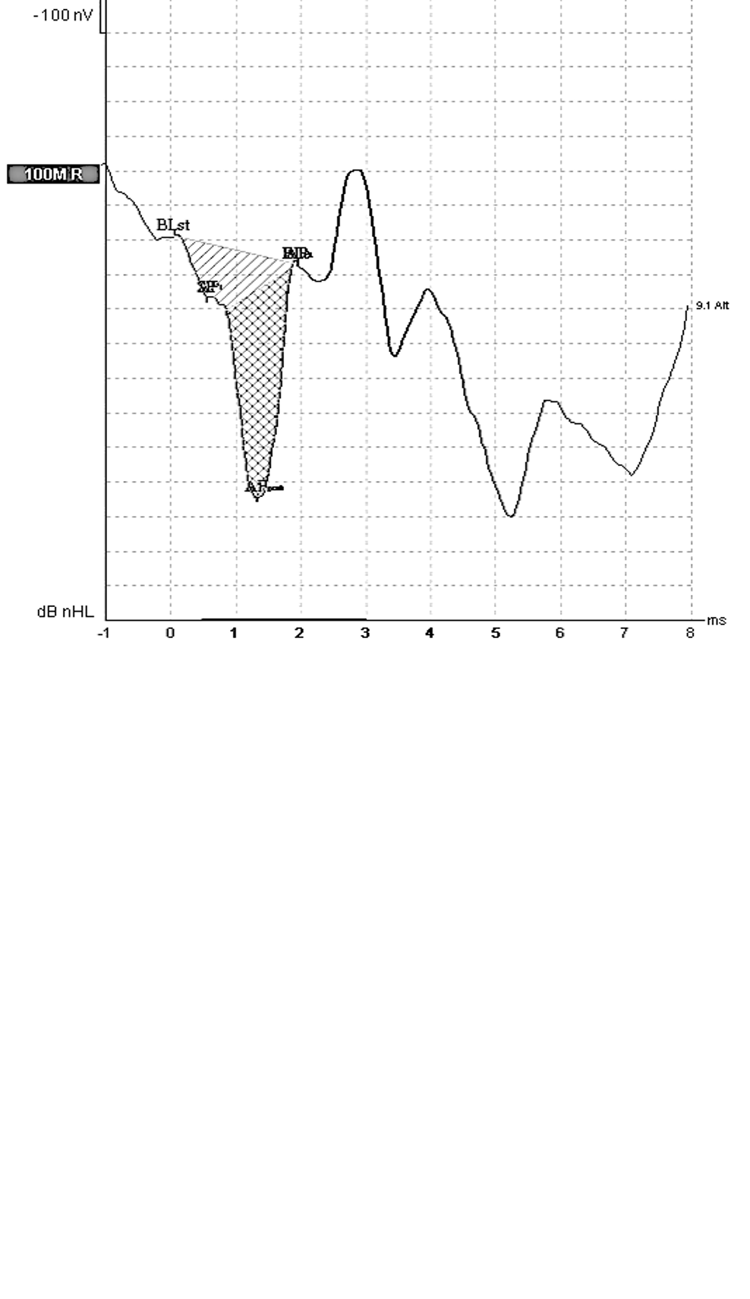

Figure 1: Measurement of the area and amplitude of the Summating Potential (SP – the area shown with diagonal lines) and Action Potential (AP – the area shown with cross hatching) from a control subject to click stimuli to derive the SP/AP area under the curve and amplitude ratios. BL_{start} and BL_{end} refer to the start and end of the deviations from Baseline. AP1 and 2 refer to the start and end of the AP area. The SP/AP amplitude and area ratios are normal (below 0.31 and 1.93 based on normative data).

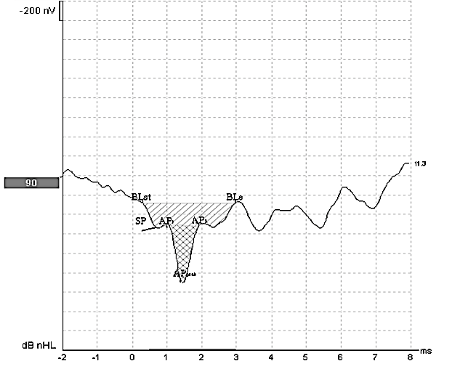
Figure 2: ECochG waveforms for a patient with endolymphatic hydrops. The SP/AP amplitude and area ratios are abnormal (0.40 and 2.6, respectively).
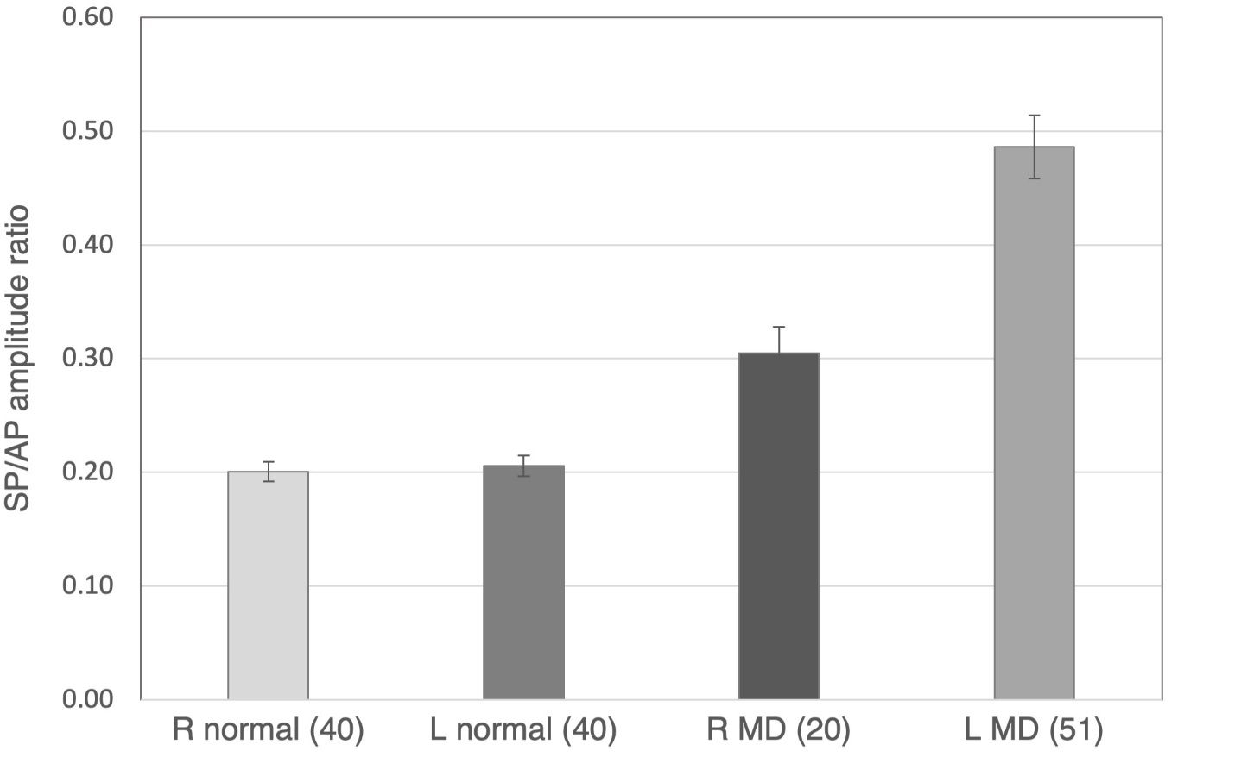
Figure 3: A comparison of ECochG amplitude ratio results for the R (n=40) and L (n=40) normal ears and L (n=51) and R (n=20) MD affected ears. Error bars represent ±1 SE of the mean.
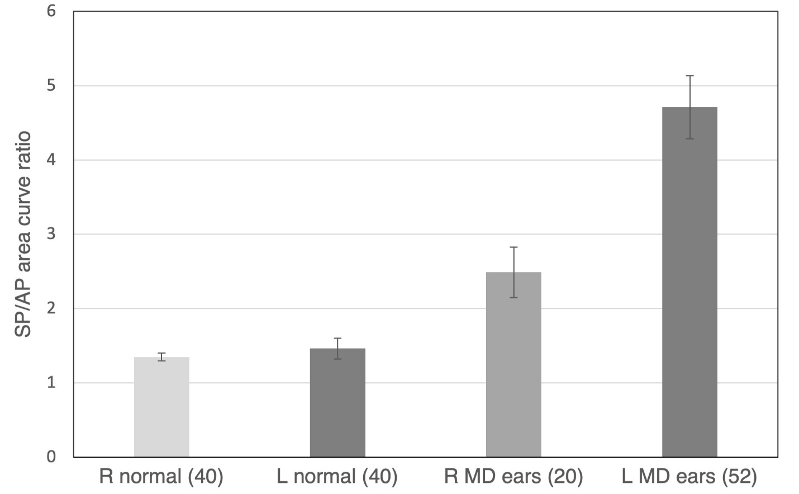
Figure 4: A comparison of ECochG area ratio results for the R (n=40) and L (n=40) normal ears
and L (n=52) and R (n=20) MD affected ears. Error bars represent ±1 SE of the mean.

