**Narcissism Moderates the Association**

**Between Basal Testosterone and Generosity in Men**

# Anna Z. Czarna1*, Magdalena Ziemiańska2, Piotr Pawlicki3,

# Justin M. Carré4, Constantine Sedikides5

1* Institute of Applied Psychology, Jagiellonian University, ul. Stanisława Łojasiewicza 4, 30-348 Kraków, Poland; Email: anna.czarna@uj.edu.pl

2 Institute of Applied Psychology, Jagiellonian University, ul. Stanisława Łojasiewicza 4, 30-348 Kraków, Poland; Email: magda.ziemianska@onet.pl

3 Center of Experimental and Innovative Medicine, University of Agriculture in Krakow, Redzina 1c, 30-248 Krakow, Poland; piotr.pawlicki@urk.edu.pl

4 Faculty of Arts and Sciences – Psychology, Nipissing University, North Bay, Ontario, Canada; Email: justinca@nipissingu.ca

5 School of Psychology, University of Southampton, Southampton SO17 1BJ, England, United Kingdom; Email: cs2@soton.ac.uk

*Corresponding Author: Anna Czarna

**Abstract**

Research has linked hormones to behavioral outcomes in intricate ways, often moderated by psychological dispositions. The associations between testosterone and antisocial or prosocial outcomes also depend on dispositions relevant to status and dominance. In two studies (N1 = 68, N2 = 83), we investigated whether endogenous testosterone, measured in saliva, and narcissism, a psychological variable highly relevant to status motivation, interactively predicted men’s preferences regarding resource allocation. Narcissism moderated the links between testosterone and social value orientation: among low narcissists testosterone negatively predicted generosity in resource allocation and probability of endorsing a prosocial (vs. pro-self) value orientation, whereas among high narcissists testosterone tended to positively predict generosity and the probability of endorsing a prosocial (vs. pro-self) value orientation. We discuss these results as examples of calibrating effects of testosterone on human behavior, serving to increase and maintain social status. We advocate the relevance of psychological dispositions, alongside situations, when examining the role of T in social outcomes.

*Keywords*: Basal Testosterone; Narcissism; Social Value Orientation; Resource Allocation; Generosity

**1.** **Introduction**

The steroid hormone testosterone (T) is associated with human competitive social behavior (Cheng and Kornienko, 2020; Eisenegger et al., 2011). This key androgen— regulated by the hypothalamic-pituitary-gonadal axis—facilitates, among various functions, the attainment of social status (henceforth: status). It readies and calibrates the organism for the pursuit and maintenance of status, and by doing so maximizes fitness across competitive contexts (Booth et al., 2006; Eisenegger et al., 2011; Knight and Mehta, 2014; Mazur and Booth, 1998). In contrast to early claims of a one-to-one link between T and human aggression, recent theorizing and studies implicate T more generally in activating a suite of competitive motivation, strategies, and behaviors that together coordinate a complex, integrated behavioral repertoire facilitating the pursuit and maintenance of status. This repertoire includes both antisocial and prosocial behaviors (Boksem et al., 2013; Cheng and Kornienko, 2020; Eisenegger et al., 2010, 2011). We address in two studies whether endogenous T interacts with narcissism, a psychological variable highly relevant to status motivation, to predict men’s preferences for resource allocation.

* 1. *Testosterone and Dominance-Related Outcomes*

T is linked to several processes relevant to competitiveness and status pursuit. Its levels are positively correlated with a range of cognitive states and behaviors that aid success in competitive situations and conflict. These states and behaviors include implicit power motivation, reduced sensitivity to threat, risk-taking, intuitive (rather than deliberative) and ‘hawkish’ decision-making, overconfidence, persistence, motivational drive, fearlessness, stress resilience, willingness to enter competitive interactions, and conspicuous consumption to increase perceived status—as evidenced in studies measuring endogenous T levels or natural T reactivity (Apicella et al., 2008; Carré and McCormick, 2008; Coates et al., 2009; Coates et al., 2010; Johnson et al., 2006; Mehta et al., 2017; Mehta and Josephs, 2006; Schultheiss et al., 2004; Schultheiss et al., 2005; Stanton and Schultheiss, 2009; Wu et al., 2017) or using exogenous T administration (Apicella et al., 2015; Hermans et al., 2006; Hermans et al., 2007; Knight et al., 2020; Nave et al., 2017, 2018).

*Antisocial and Prosocial Outcomes of Testosterone*

The literature suggests that T facilitates resource allocation that is optimal for securing high status within a group. Status can be pursued or achieved via either antisocial or prosocial means (Cheng and Tracy, 2014). In particular, T can enable competition for status (a) in dominance-based rank contests, where rank is a product of agonistic coercion, fear, or imposition (as demonstrated in studies on endogenous T and T reactivity: Carré et al., 2008; McDermott et al., 2007; Mehta et al., 2017; and review articles, e.g.: Terburg and van Honk, 2013), or (b) in prestige-based rank contests, where social rank results from winning respect by means of successful non-agonistic persuasion and prosociality (e.g., building social connections, fairness, sharing resources, and expertise; demonstrated in research on endogenous T and T reactivity: Edwards et al., 2006; and in T administration studies: Eisenegger et al., 2010; van Honk et al., 2012).

Research on economic games exemplifies the claim that T facilitates resource allocation that is calibrated to be optimal for securing high status within a group. This research has shown that T is related to strategic resource allocation, which can be instrumental in obtaining and maintaining high status. Some studies measuring endogenous T and T reactivity indicate that high T individuals assert their dominance by making disproportionate claims to shared resources (Mehta et al., 2017; Slatcher et al., 2011), whereas other studies connect T to more nuanced use of resource allocation that helps to ascend social hierarchies. The latter set of studies has included economic games in which decisions entail the potential exploitations of one’s trust. Though subject to moderation by gender, personality, and context (demonstrated both in T administration and endogenous T research: Bird et al., 2017, Carré et al., 2014, respectively), T has been linked to lower offers by proposers in ultimatum games and to lower investments in one-shot trust games for real monetary stakes with an anonymous partner (Boksem et al., 2013; Zak et al., 2009) as well as to decreased trustworthiness ratings of facial photographs among participants who received a single dose of T (Bos et al., 2010), as demonstrated in T administration studies. The trust-lowering pattern was particularly strong among those who normally display high levels of trust (Bos et al., 2010). Further, although the evidence is mixed and far from established (as indicated in T administration research: Cueva et al., 2016; Dreher et al., 2016; Kopsida et al., 2016), several studies showed that participants with high T repay their trust generously (T administration studies: Boksem et al., 2013; Eisenegger et al., 2010; van Honk et al., 2012), increase rejections of unfair offers (endogenous T studies: Burnham, 2007; Mehta and Beer, 2010), and are willing to sanction norm-violators at a personal cost (Dreher et al., 2016)—all alliance building behaviors in pursuit of status (Anderson and Kilduff, 2009). All these antisocial and prosocial outcomes of T are examples of adaptive calibrating effects of T on human behavior, serving to increase and maintain social status.

*Moderation of Testosterone Effects*

The links between T and dominance outcomes depend on situational (e.g., win–lose) context and, importantly, on personality traits related to dominance. For example, the effects of T on aggression and competition are stronger among participants who are higher in dominance (as shown in T administration research: Carré et al., 2017, Mehta et al., 2015, Geniole et al., 2019), higher in independent self-construal (Welker et al., 2017, endogenous T research), and lower in self-control (Carré et al., 2017). Contest winners have elevated T concentrations compared to losers (see meta-analysis by Geniole et al., 2017), especially among those with a personality style characterized by an implicit need for power and dominance (Schultheiss et al., 2005). Those endogenous T responses to competition are positively correlated with subsequent aggression, but only among men scoring low in trait anxiety (Norman et al., 2015). There is some evidence that exogenous T (i.e. T administration) can rapidly increase aggression in men with these select personality profiles (i.e., greater dominance, independent self-construal, lower self-control), because it upregulates the subjective pleasure these participants derive from aggression (Geniole et al., 2019). The influence of T on competitiveness, including competitive decision-making, is most robust among dominant individuals (T administration research: Mehta et al., 2015). Furthermore, exogenous T strengthens status-seeking motivation and competitive effort particularly among men with unstable low status (Losecaat Vermeer et al., 2020). Thus, T specifically boosts status-related motivation when there is an opportunity to improve one’s social status, and this conditional effect of T on effort is enhanced in highly dominant and power-hungry men.

*Narcissism as a Moderator of Testosterone Effects*

Narcissism stands out as a status-relevant trait (Grapsas et al., 2020; Sedikides, 2021; Sedikides and Campbell, 2017). This trait shares substantial overlap with the dominance-related personality profile found to facilitate T’s influence. For starters, narcissism is characterized by independent self-construal (Konrath et al., 2009), high approach motivation (Foster and Trimm, 2008), low impulse control (Vazire and Funder, 2006), and high implicit (and explicit) power motivation (Carroll, 1987; Grapsas et al., 2022). Further, it is associated with forceful and persistent status-striving, dominance, competitiveness, and sensitivity to cues of competition for status (Grapsas et al., 2020; Horton and Sedikides, 2009; Wallace et al., 2009). Notably, high narcissists (here also referred to as narcissists) often resort to aggression to defend and assert their position of dominance in the face of threat to it (Kjærvik and Bushman, 2021; Bettencourt et al., 2006; Rasmussen, 2016). Status concerns are chronically accessible among high narcissists, who are also often characterized by unstable state self-esteem and status (Benson and Giacomin, 2020; Gregg and Sedikides, 2011; Zeigler-Hill, 2006). Narcissists’ status motive overshadows other motives, such as their motive for affiliation, defined as catering to the welfare of one’s social environments or forming close interpersonal bonds (Campbell et al., 2002; Grapsas et al., 2020; Zeigler-Hill et al., 2018). Narcissists, then, may pursue status even at the cost of their social relationships.

Narcissists exhibit multiple behavioral similarities with high T individuals as is evident in their resource allocation behaviors. Research relying on economic games shows that high narcissists, similarly to high T individuals, engage in lower investments for real monetary stakes with an anonymous partner (Böckler et al., 2017), make disproportionate claims to shared resources (Campbell et al., 2005), punish others more harshly—especially for low offers—both when assuming the role of the receiver and observer (Böckler et al., 2017), and endorse a pro-self (i.e., competitive or individualistic) as opposed to prosocial (i.e., cooperative) social value orientation (Czarna et al., 2014, 2016). Furthermore, there are multiple parallels between other status-pursuing behaviors of narcissists and high basal T individuals. Narcissists (Horvath and Morf, 2009; Sedikides, 2021; Wallace et al., 2009), like people with high endogenous T (Josephs et al., 2006), are (1) more driven to gain and maintain high status, (2) more responsive to information about their status in particular situations, (3) overconfident in their expectations of success, and (4) respond with an attempt to restore status when their expectations are frustrated or their high status is threatened. Also, narcissism, like T (Geniole et al., 2019; Mehta et al., 2015), is higher among men than women (Grijalva et al., 2015). Lastly, similar to T (Eisenegger et al., 2011, Knight and Mehta, 2014), narcissism is associated with the successful navigation of hierarchies (Nevicka and Sedikides, 2021). Altogether, there are many reasons to draw parallels between narcissists and high T individuals.

Yet, despite the abovementioned similarities between T and narcissism, as well as relevant theorizing (Holtzman, 2018; Holtzman and Strube, 2011), the rather scarce literature has not detected a consistent straightforward relation between basal T and narcissism. One study reported a positive relationship between them (Pfattheicher, 2016), but several others reported null findings (Lobbestael et al., 2014; Mehta, 2007; Stenstrom et al., 2018). Also, some studies found a positive relationship between narcissism and T reactivity following a behavioral aggression or social evaluative task, such as telling a convincing lie (Dane et al., 2018; Lobbestael et al., 2014). Hence, narcissism and T are not mere proxies of each other. Narcissism is a complex personality trait, normally distributed in the population. It does not seem to have a unique physiological blueprint. Furthermore, although narcissism is higher among men than women, the gender difference is much smaller in magnitude (Cohen’s *d* = .26—small effect; Grijalva et al., 2015) than the gender difference in T level (Cohen’s *d* > 2.97; huge effect—Clark et al., 2019; Camacho, 2012; Lobotsky et al., 1964), with adult men having up to a 15-fold higher T level than adult women. Finally, although high narcissists and high T individuals are concerned with both self-enhancement and status, their relative emphasis on them differs. Whereas high narcissists focus relatively more on self-enhancement (i.e., egocentric exceptionalism and social selfishness), high T individual focus relatively more on preparing for social status competitions.

* 1. *Present Research*

We examined, in two studies testing male participants, whether narcissism moderates the associations that the endogenous T concentrations have with preferences regarding economic resource allocation (Figure 1). We measured basal T levels in men. We did not study women, as the function of T in women is less known; indeed, it is likely that estradiol, not T, plays a key role in dominance and status-pursuing motivation and behavior in women (Stanton and Schultheiss, 2009). We expected a synergistic interaction effect of narcissism and T on the preferences for resource allocation. Given that both high T and narcissism are linked to status striving, and that narcissists’ chronically active status and power motivation makes them acutely sensitive to situational status challenges and opportunities, and basal T level might function as a biological correlate of the desired status, we hypothesized that narcissism and T levels would produce a mutually reinforcing, amplifying effect on behavior. In particular, we hypothesized that T would be negatively related to resource allocations to others, especially among men high in narcissism. T would predict low generosity in resource allocation and higher endorsement of pro-self (i.e., competitive or individualistic as opposed to prosocial) social value orientation among high narcissists.

Both studies were approved by Jagiellonian University’s Institutional Bioethics Committee Board. All participants were Polish. Materials, data, and code needed to reproduce all analyses are available at https://osf.io/u9etq/?view_only=59959dfb566f4addb1ccb93226833e09.

1. **Study 1**

This study constituted a preliminary test of the hypothesis that narcissism moderates the relation between T and preferences regarding resource allocation (i.e., T is negatively associated with allocations to others, especially among men high in narcissism).

*2.1. Material and Methods*

*2.1.1. Participants*

We recruited a convenience sample of 70 men of whom 87% were students or graduates from southern Polish universities (*Myears* = 23.20, *SDyears* = 2.24), and compensated them with 25.00 Polish złoty ($8.00). We set to recruit (via e-mailing lists, advertisements on social networking websites, word-of-mouth advertising, or flyers) as many participants as possible within a given time period and budget constraints. Two of them failed to complete the social value orientation scale (see below), leaving a final *N* = 68. To maximize the measurement reliability of basal steroid hormone concentration in saliva, we applied the following exclusion criteria: endocrine disorders, chronic diseases and ongoing infections, use of hormonal treatment or supplementation, alcohol consumption within 12 hours before the test, BMI <19 or BMI> 30. Participants reported no discomfort.

*2.1.2. Procedure*

Participants completed personality measures online a day ahead of their laboratory visit. They were instructed to refrain from drinking alcohol for 10-12 hours before study participation, to wake up at least 2-3 hours before their laboratory appointment, and not to eat, drink, or chew gum an hour before participation. Testing sessions occurred between 10am and 5pm.

Participants were tested individually by a female experimenter. After filling out self-report measures (here and in Study 2, participants filled out also several self-report measures that were unrelated to the current research objectives), they provided saliva samples for immunoenzymatic testing. In particular, they received a disposable set consisting of a polypropylene straw and a dedicated sterile microcentrifuge polypropylene tube (SALI-TUBES, 1 ml) for steroid hormones collection. They were instructed how to collect a sample, and were left alone to ensure privacy. To form a more reliable basal T measurement, we measured T twice (here and in Study 2, we also assessed cortisol levels in saliva samples for an unrelated purpose) and identically, with a 20-minute interval between sampling during which participants completed more self-report measures. We stored samples immediately at -20 degrees Celsius.

*2.1.3. Measures*

*2.1.3.1. Narcissism*

We assessed narcissism with the 34-item Narcissistic Personality Inventory (NPI— Raskin and Hall, 1979; Polish version: Bazińska and Drat-Ruszczak, 2000; α = .88; e.g., “I am an extraordinary person”). The response scale ranged from 1 (*does not apply to me*) to 5 (*applies to me;* additionally, we assessed narcissism withthe Short Dark Triad or SD3 (α = .77; Jones and Paulhus, 2014; the SD3 results were very similar to the reported ones).

*2.1.3.2. Resource Allocation*

We assessed resource allocation with the 9-item Triple Dominance Measure (TDM; Van Lange et al., 1997; Polish version: Czarna et al., 2014). The TDM is commonly used for gauging social value orientation, that is, the weight people assign to their own versus others’ outcomes in interdependent situations (Messick and McClintock, 1968). It is based on decomposed games. Participants chose between options that allocated points to themselves versus another person across nine scenarios. The instructions read:

“In this task, please imagine that you have been randomly paired with another person, whom we will refer to simply as “Other.” This Other is someone you do not know and you will not knowingly meet in the future. Both you and the Other will be making choices by circling the letter A, B, or C. Your own choices will produce points for both yourself and the Other. Likewise, the Other’s choice will produce points for him/her and you. Every point has value: the more points you receive, the better for you, and the more points the Other receives, the better for him/her.”

The instruction was then followed by an example of a choice situation (Figure 2) with an elaborate explanation of all possible decisions. Choices reflected not only what participants wanted, but also what they wanted the Other to receive; therefore, the TDM measures social strategies. Based on allocation patterns (i.e., at least six consistent choices), each participant can be classified as prosocial, competitive, or individualist. *Prosocials* maximize outcomes for both themselves and others (i.e., cooperation) and minimize differences between outcomes for themselves and others (i.e., equality); *individualists* maximize their own outcomes with little or no regard for others' outcomes; and *competitors* maximize their own outcomes relative to others' outcomes, seeking relative advantage over others (Lange et al., 1997). The prosocial choice, an equal split of resources, is the most frequent and socially desirable one (Platow, 1994). To optimize the use of our data and retain all cases, we classified participants’ social value orientations on the basis of their most prevalent choices. In addition, we used a variable based on the sum allocated to Other. Theoretical minimum and maximum for Sum Allocated to Other are as follows: min = 900, max = 4490. Both of these approaches—categorical and continuous—have been used in the literature (Czarna et al., 2014; Jonason et al., 2010). In our study, 82.35% of participants made at least six consistent choices across the nine scenarios, and 55.88% of them chose the same type of answer (i.e., prosocial, competitive, or individualistic) across scenarios.

*2.1.3.3. Salivary T Measurement*

Collected samples were sealed off and stored at -20 degrees Celsius until they were assayed by hypotheses-blind staff at the Department of General Biochemistry, Jagiellonian University. Commercially-available enzyme immunoassay kits (DRG International) were used to quantify the level of T in saliva samples. Upon arrival in the laboratory, samples had to be deep frozen at least overnight. After freezing and thawing, the samples were centrifuged (at 3000 x g, 10 min) to separate mucins from clear and colorless supernatant. No dilution of specimens was applied. The assay was performed at room temperature. Seventy five μl of each saliva sample per well was used for analysis. All samples were assayed according to the test procedure provided with the kit, typical standard curve with concentration range 0 – 1000 pg/mL was applied. The intra- and inter-assay coefficients of variation (CVs) reported by DRG were below 10%, and the detection limit of the assay is 1.9 pg/ml (the intra-assay and inter-assay CVs could not be calculated because the raw data from the assay lab were no longer available from the assay lab. Hence we provide the values reported by the producer of the commercially-available assay kit, DRG: mean intra-assay and inter-assay CVs were 4.67% and 7.63%, respectively). Absorbance (OD) of each well was determined at 450 nm with a microtiter plate reader (Labtech LT-4000MS; Labtech International Ltd., Uckfield, UK), and concentrations were estimated via a 4-parameter curve computed using the standards included in the kit.

The two T measurements (T1 and T2) were highly inter-correlated (*r* = 0.80, *p* < 0.001), and hence we averaged them to create a basal T score for each participant. The pattern of results and conclusions remained the same regardless of whether we used T at T1, at T2, or its mean (see Supplementary Table S1 for all results and Table S1 for histogram of mean T).

*2.2. Results and Discussion*

In Table 1, we present descriptive statistics and zero-order correlations among variables. Of participants, 45.59 % manifested a prosocial social value orientation, 36.76% an individualistic orientation, and 17.65 % a competitive one.

The TDM (i.e., resources assigned to self vs. other) is continuous, but also convertible into a three-level categorical variable (i.e., social value orientation): prosocial/cooperative (focused on equality and maximizing joint gain), individualistic (focused on own gain exclusively), and competitive (focused on having an advantage over the other person, even at own expense). First, we present results on the continuous TDM. We regressed Sum Allocated to Other (i.e., generosity) on standardized mean T, standardized narcissism, and their interaction. We obtained a significant interaction (Table 2 upper panel) that alone accounted for 14.70% of the variance. We proceeded with simple slope analysis. Among low narcissists, T was a significant negative predictor of generosity (at -1 SD of narcissism: *b* = -373.178, *SE* = 180.996, *t* = -2.062, *p* = .043), whereas, among high narcissists, T was a significant positive predictor of generosity (at +1 SD of narcissism: *b* = 487.491, *SE* = 191.787, *t* = 2.542, *p* = .013; Figure 3 left). Johnson-Neyman analysis of regions of significance indicated that T significantly negatively predicted generosity at -.958 SD and below the narcissism mean, and significantly positively predicted generosity at +.614 SD and above the narcissism mean. We also present a 3D depiction of the effect (using mean T) in Figure 4 (left panel).We ran the same linear regression analysis after replacing mean T with T1 and next T2, and obtained similar results, which we report in Supplementary Table S1 (upper panel). We also ran analyses using mean T as a moderator and narcissism as a predictor and report the results in Supplementary Material (p.1).

Subsequently, to provide more fine-grained analysis, we ran a multinomial logistic regression of social value orientation taking the category prosocial as a baseline and mean T (unstandardized) and narcissism (standardized) as well as their interaction as predictors. The model had a good fit (-2 Log Likelihood = 124.95, *Χ*2[6, N = 68] = 15.416, *p* = .017) and explained a substantial portion of the variance, Nagelkerke = .232, McFadden Pseudo-R2 = .110 (60.30% of correct classifications). Likelihood ratio tests indicated that narcissism and the interaction of narcissism with T made significant contributions to the prediction of social value orientation (Table 3). The likelihood of expressing a competitive (vs. prosocial) orientation was significantly associated with the interaction of T and narcissism. The likelihood of showing an individualistic (vs. prosocial) orientation was marginally associated with narcissism and T (Table 4). We plotted the results so as to reflect probabilities of illustrating each social value orientation as predicted by T and narcissism (Figure 5, upper panel). T did not predict a competitive (vs. prosocial) orientation among participants low in narcissism (*b* = .012, *SE* = .008, Wald = 1.998, *df* = 1, *p* = .158, Exp[B] = 1.012). In contrast, for those high in narcissism, T negatively predicted a competitive (vs. prosocial) orientation (*b* = -.016, *SE* = .008, Wald = 4.047, *df* = 1, *p* = .044, Exp[B] = .984). T was unrelated to the probability of having an individualistic (vs. prosocial) orientation among participants low in narcissism (*b* = -.003, *SE* = .007, Wald = 0.117, *df* = 1, *p* = .732, Exp[B] = .998), and was marginally related to this probability among those high in narcissism (*b* = -.013, *SE* = .007, Wald = 3.067, *df* = 1, *p* = .080, Exp[B] = .988).

Logistic regression of a binary (i.e. dichotomized) social value orientation (prosocial vs pro-self) taking the category prosocial as a baseline and mean T (unstandardized) and narcissism (standardized) as well as their interaction as predictors also returned results indicating that narcissism and its interaction with T significantly predicted social value orientation (for results see upper panel in Supplementary Table S2).

In summary, we obtained a significant interaction between narcissism and T on resource allocation and on the probability of endorsing pro-self (as opposed to prosocial) value orientations. The interaction pattern, however, was inconsistent with our hypotheses. T was positively related to generosity and endorsement of prosocial social value orientation among men high in narcissism, and negatively among men low in narcissism.

1. **Study 2**

In Study 2, we tested the replicability of Study 1 findings, using an alternative measure of narcissism.

*3.1. Material and Methods*

*3.1.1. Participants*

We recruited a convenience sample of 84 men (*Myears* = 23.06, *SDyears* = 3.17). We excluded one participant for not providing a sufficient amount of saliva, leaving 83 in the final sample. We used the same recruitment method and exclusion criteria as in Study 1. Participants were mostly students and graduates from southern Polish universities (over 70%), but also young employees (circa 26%) and adult high school students (circa 4%). Participants were informed that they had the chance of winning a prize worth 200.00 Polish złoty ($53.50). The reason for this incentive structure was financial (i.e., limited funds). Yet, participants were from the same population (i.e., university) as in Study 1, did not differ on age or gender from their Study 1 counterparts, and the difference in mean amount of resources allocated to other (i.e., our dependent variable) was not significant across the two studies.

*3.1.2. Procedure*

The procedure was similar to that of Study 1.

*3.1.3. Measures*

*3.1.3.1. Narcissism*

We assessed narcissism with a subscale of the Dark Triad Dirty Dozen (DTDD; Jonason and Webster, 2010; Polish adaptation: Czarna et al., 2016). This brief and reliable (Rogoza et al., 2020) personality inventory allows the measurement of individual differences in narcissism, psychopathy, and Machiavellianism in sub-clinical populations. It consists of 12 items, four for each construct. The four items measuring narcissism were: “I want others to admire me”, “I seek prestige or status”, “I expect special favors from others”, “I want others to pay attention to me” (1 = *not at all*, 5 = *very much*). We averaged responses to create a narcissism index (α = .85). We opted for a shorter measure of narcissism (compared to Study 1’s) for practical (i.e., avoiding participants malaise and fatigue) and financial (i.e., limited fund availability) reasons. Nevertheless, the DTDD derives from the NPI (used in Study 1): The DTDD was based on the four highest-loading NPI items.

*3.1.3.2. Resource Allocation*

We measured resource allocation with the TDM, as in Study 1. This time 93.98% of respondents made at least six consistent choices in all scenarios, and 75.90% of them chose the same type of answer (i.e., prosocial, competitive, or individualistic) in all scenarios.

*3.1.3.3. Salivary T Measurement*

We used the same protocol and a kit from the same manufacturer for sample collection and measurement of salivary T. The samples were assayed in duplicates by a hypotheses-blind staff at the Endocrinology Department, Institute of Zoology and Biomedical Research, Jagiellonian University. The intra- and inter-assay coefficients of variation reported by DRG were below 10%, and the detection limit of the assay is 1.9 pg/ml. The intra-assay coefficient of variation for the current sample was 4.69% (inter-assay CVs were no longer available from the assay laboratory, but the commercially-available assay kit (DRG) reports this value to be approximately 7.63%). The two T measurements (T1 and T2) were highly inter-correlated (*r* = 0.83, *p* < 0.001), and hence we averaged them to create a basal T score for each participant. The results pattern remained the same regardless of whether we used T at T1, T at T2, or its mean (Supplementary Table S1 and Table S1 for histogram of mean T).

*3.2. Results and Discussion*

We display in Table 1 descriptive statistics and zero-order correlations among variables. Of participants, 57.83% had a prosocial social value orientation, 32.53% an individualistic one, and 9.64% a competitive one.

First, we regressed Sum Allocated to Other on standardized mean T, standardized narcissism, and the interaction of these two variables. Consistent with Study 1, we obtained a significant interaction between T and narcissism (Table 2 lower panel), which accounted for 7.00% of the variance. Among low narcissists T was a marginal negative predictor of generosity (at -1 SD of narcissism: *b* = -457.582, *SE* = 232.376, *t* = -1.969, *p* = .052), but among high narcissists T was unassociated with generosity (at +1 SD of narcissism: *b* = 208.132, *SE* = 140.049, *t* = 1.486, *p* = .141; Figure 3 right). Hence, the regression analyses replicated Study 1’s T effect among low narcissists (-1 SD), but not Study 1’s T effect among high narcissists (+1 SD). Johnson-Neyman analysis of regions of significance indicated that T significantly negatively predicted generosity at -1.047 SD of narcissism and below the narcissism mean, and significantly positively predicted generosity at +1.415 SD and above the narcissism mean. We also provide a 3D depiction of the effect (using mean T) in Figure 4 (right panel). We ran the same linear regression analyses after replacing mean T with T1 and, next, T2, and obtained the same pattern of results (Supplementary Table S1, lower panel). We also ran analyses using mean T as a moderator and narcissism as a predictor and report the results in Supplementary Material (p.1).

We proceeded to conduct a multinomial logistic regression of social value orientation taking the category prosocial as a baseline category, and mean T (unstandardized), narcissism (standardized) and their interaction as predictors. The model had a good fit (-2 Log Likelihood = 132.78, *Χ*2[6, *N* = 83] = 17.870, *p* = .007), accounting for a substantial part of the variance: Nagelkerke = .231, McFadden Pseudo-R2 = .119 (62.7 % of correct classifications). Likelihood ratio tests indicated that narcissism and the interaction of narcissism with T made significant contributions to the prediction of social value orientation (Table 5). The likelihood of expressing a competitive (vs. prosocial) orientation was significantly associated with the interaction of T and narcissism. The same occurred for individualistic (vs. prosocial) orientation (Table 6). We plotted the results so as to reflect probabilities of showing each social value orientation as predicted by T and narcissism (Figure 5, lower panel). T marginally positively predicted a competitive (vs. prosocial) orientation among participants low in narcissism (*b* = .022, *SE* = .013, Wald = 2.952, *df* = 1, *p* = .086, Exp[B] = 1.022), and was unrelated to a competitive (vs. prosocial) orientation among those high in narcissism (*b* = -.014, *SE* = .011, Wald = 1.550, *df* = 1, *p* = .213, Exp[B] = .987). Also, T positively predicted an individualistic (vs. prosocial) orientation among those low in narcissism (*b* = .020, *SE* = .009, Wald = 4.511, *df* = 1, *p* = .034, Exp(B) = 1.020; whereas among those high in narcissism the association was not significant: *b* = -.004, *SE* = .005, Wald = 0.607, *df* = 1, *p* = .436, Exp(B) = .996).

Logistic regression of a binary social value orientation (prosocial vs pro-self) taking the category prosocial as a baseline and mean T (unstandardized) and narcissism (standardized) as well as their interaction as predictors also returned results indicating that narcissism and its interaction with T significantly predicted social value orientation (for results see lower panel in Supplementary Table S2).

1. **General Discussion**

We examined if endogenous levels of T and individual differences in levels of narcissism relate to generosity and preferences regarding social value orientation. Drawing from existing literature both on effects of T administration (e.g., Zak et al. 2009) and associations of endogenous T with resource allocation outcomes (e.g., Mehta et al., 2017), we hypothesized that T and narcissism would have an interactive, amplifying effect expressed in lower generosity in resource allocation task and higher probability of endorsing pro-self social value orientation among men simultaneously high on endogenous T and trait narcissism. In particular, we expected T to be linked negatively to the amount of resources shared with the other in hypothetical scenarios among men high on narcissism.

Across two studies, narcissism indeed moderated the association between T and resource allocation. However, the interaction pattern and simple effects were inconsistent with the hypotheses. Specifically, T was related negatively to generosity in allocations between self and a stranger, and positively to endorsement of pro-self (competitive or individualistic) as opposed to prosocial social value orientation among men who were low on narcissism. Further, T was linked positively, albeit in Study 2 only directionally, to generosity and negatively to the probability of endorsing pro-self (competitive or individualistic) social value orientation among men high on narcissism.

Our findings align with some effects reported in the hormone administration literature. In particular, in a study on moderation of exogeneous T by digit ratio (2D:4D) and psychopathy (Carré et al., 2015), stronger T effects (impairment on the accuracy of “Reading the Mind in the Eyes” task) emerged among men with low scores on psychopathy (in particular on Factor 1: interpersonal/affective traits of psychopathy). Impaired ability to gain a perspective on another person’s emotions might be adaptive or helpful in a context where securing status requires direct confrontation or an agonistic interaction involving force, aggression, intimidation, or violence. In such circumstances, high empathy could be an obstacle. Hence, the lowering of mentalizing/perspective taking and affect recognition by T especially among men with low psychopathy might represent a T’s nuanced calibration effect on behavior. Across our two studies, we also found more consistent associations among men low on narcissism, a trait correlated with psychopathy (Paulhus et al., 2002): T predicted lower generosity among men low on narcissism (i.e., habitually more generous and empathetic). Low perspective-taking and empathy may underlie this effect, too: it is convenient to cast aside the other’s perspective when claiming more resources for self, instead of sharing resources equally. Particularly among low narcissists such an adjustment would be advantageous and conducive to assuming a pro-self social value orientation. High narcissists are deficient in empathy and perspective taking. Hence, we would not expect for T to influence substantially their behavior (as we observed). Research is needed to address these ideas.

In another study (Bos et al., 2010), sublingual administration of T decreased trust, specifically among high trusting women. The latter finding is often cited as an example of an adaptive calibrating effect of T on human behavior. In a similar vein, our findings that endogenous T is associated with lower generosity among less narcissistic—thus more trustful, less cynical, more generous, and less selfish individuals—can be viewed as an example of such adaptive calibration to interpersonal interactions. In parallel to Bos et al.’s (2010) findings, higher endogenous T is thus related to lower expectations of cooperation from others in social dilemmas (Pletzer et al., 2018a) among those who are habitually more prosocial and trustful. Correspondingly, the association of T with higher generosity among highly narcissistic men – hence, among those with reduced habitual prosocial decision making (Böckler et al., 2017), those with lower moral and ethical standards (Antes et al., 2007; Brown et al., 2010; Cooper and Pullig, 2013), those who volunteer less for the sake of others and invest less to help others (Brunell et al., 2014; Lannin et al., 2014), and those who routinely make more selfish and less prosocial choices (Campbell et al., 2005) – can also be interpreted as adaptive calibration, potentially reducing bargaining conflicts, smoothing exchanges, and increasing efficiency of social interactions. High T seems to have a compensating effect on prosocial decisions among highly narcissistic men, perhaps optimizing their social functioning. A few T administration studies demonstrated that T is linked to reputable status striving, using more ethical means. These include reduced lying for tangible benefits in men (Wibral et al., 2012), decreased deception even when honesty is economically disadvantageous in women (van Honk et al., 2016), and increased fair offers and generosity in rewarding collaboration (Dreher et al., 2016; Eisenegger et al., 2010; Mehta and Beer, 2010).  To summarize, T was negatively related to generosity among low narcissists and was (though inconsistently across studies) positively related to generosity among high narcissists. This pattern suggests an adaptive calibrating effect of T. Still, our results pertaining to the positive effect of T on generosity among high narcissists need to be viewed with caution given that the effect was significant in Study 1 and only directional in Study 2 (*p* = .141) among men who were one SD above the narcissism mean. More research is needed to establish the generosity-enhancing function of T. Also, although our models explained notable amounts of variance (8-15%), the effect sizes of the two interaction effects of interest were small (Study 2) to medium (Study 1).

Our findings can be viewed from a different perspective. Across studies, only at low T did narcissism consistently predict resource allocation, whereas at high T narcissism showed no significant association with resource allocation (see Figure 3 and simple slope analyses using mean T as a moderator and narcissism as a predictor [Supplementary Material, p. 1]). It would appear, then, that high T levels might render personality factors in resource allocations less impactful. Regardless, our findings contribute to uncovering the complex interplay of individual differences, T levels, and behavior by delineating the role of status-relevant personality characteristics in hormone-behavior relationships.

The current research is not free from limitations. The most important one is the use of hypothetical scenarios instead of real-life interactions with another person. Although TDM, one of the most common measures of social value orientation, based on decomposed games, has demonstrable validity in predicting real-life donation behavior (Van Lange et al., 2007) and even norm-violating deviant behavior (Pletzer et al., 2018b), literature also shows that real behaviors, in particular moral choices, can contradict responses to simple hypothetical moral probes (FeldmanHall et al., 2012). Future research could therefore do well by increasing the psychological realism of resource allocation decisions. This can be achieved by remunerating for participation dependent on actual choices made in social dilemmas, a practice increasingly more popular in behavioral economics (Vlaev, 2012).

Given that TDM offers only one prosocial option entangling maximization of the other’s share with an equal split of resources between self and other, another promising avenue for development would include employing a measurement of social value orientations that provides a clear-cut distinction between altruistic and egalitarian concerns. Alternatively, future studies on the topic could use economic game paradigms (e.g., hawk-dove game, trust game, ultimatum game) more commonly available in the T literature to facilitate comparison and integration with earlier research.

Although our work focused on social value orientation and generosity in relation to narcissism and T level, future research may place our findings in broader theoretical context Stanton and Schultheiss’ (2009) hormonal model of power motivation is a case in point. According to this model, implicitly power motivation is associated with basal T, and, in interactions with situational factors, predicts T changes. Narcissism entails status and power motivation (Grapsas et al., 2020; Sedikides and Campbell, 2017) including implicit power motivation (Carroll, 1987; Grapsas et al., 2022), which seems to render status concerns chronically accessible (e.g., hypersensitive to situational status threats; Hardaker et al., 2021; Horvath et al., 2009). Such motivation influences perceptions of situations, likely interacting with T levels to predict behavioral outcomes. As such, our findings are generally compatible with Stanton and Schultheiss’ model, although more refined designs (and larger samples) are needed to test it directly.

* 1. *Conclusions*

Our research examined the moderating role of narcissism in associations between T and resource allocations. Low (vs. high) narcissists’ endogenous T levels showed negative (vs. positive—though less consistently) associations with their generosity. Men who gave the most to others were those low in endogenous T and simultaneously low in narcissism, suggesting the synergistic effect of these variables in generosity. The finding that endogenous T is associated with lower generosity among less narcissistic—thus more trustful, less cynical, more habitually generous, and less selfish—men is an example of adaptive calibration to interpersonal interactions. From an alternative vantage point, though, whereas among men with low T levels narcissism predicted resource allocations, among men with high T levels narcissism lost its predictive power, with individual differences mattering less under high T levels.

The small-to-medium-in-size moderation by narcissism highlights the importance of considering personality and individual differences intervening with hormone-behavior relationships when examining the role of T on economic decisions or, more generally, social outcomes. Future studies involving larger samples could manipulate or measure implicit motives and situational factors (i.e., opportunities to increase status or challenges and threats to social standing) and assess their interactive influence on T reactivity and behavioral outcomes. Such studies promise to disentangle the effects of motives, situations, traits (i.e., narcissism), and T.

**Acknowledgments**

We are grateful to Małgorzata Kotula-Balak for expert technical assistance in immunoenzymatic assays.

**Funding**

This work was supported by National Science Center, Poland [grant no. 2016/23/G/HS6/01397] and the Polish National Agency for Academic Exchange [the Bekker programme, grant no. PPN/BEK/2019/1/00371/U/00001], both awarded to the first author. The funders played no role in the work.

**References**

Anderson, C., Kilduff, G.J., 2009. The pursuit of status in social groups. Curr. Dir. Psychol. Sci. 18 (5), 295–298. https://doi.org/10.1111/j.1467-8721.2009.01655.x

Antes, A.L., Brown, R.P., Murphy, S.T., Waples, E.P., Mumford, M.D., Connelly, S., Devenport, L.D., 2007. Personality and ethical decision-making in research: the role of perceptions of self and others. J. Empir. Res. Hum. Res. Ethics. 2 (4), 15–34. https://doi.org/10.1525/jer.2007.2.4.15

Apicella, C.L., Carré, J.M., Dreber, A., 2015. Testosterone and economic risk taking: a review. Adapt. Hum. Behav. Physiol. 1, 358–385. https://doi.org/10.1007/s40750-014-0020-2

Apicella, C.L., Dreber, A., Campbell, B., Gray, P. B., Hoffman, M., Little, A.C. 2008. Testosterone and financial risk preferences. Evol. Hum. Behav. 29 (6), 384–390. https://doi.org/10.1016/j.evolhumbehav.2008.07.001

Bazińska, R., Drat-Ruszczak, K., 2000. Struktura narcyzmu w polskiej adaptacji kwestionariusza NPI Ruskina i Halla.[The structure of narcissism in the Polish adaptation of Ruskin’s and Hall’s NPI questionnaire]. Czas. Psychol. 6 (3-4), 171–188.

Benson, A.J., Giacomin, M., 2020. How self-esteem and narcissism differentially relate to high and (un)stable feelings of status and inclusion. J. Pers. 88 (6), 1177–1195. https://doi.org/10.1111/jopy.12565

Bettencourt, B.A., Talley, A., Benjamin, A.J., Valentine, J., 2006. Personality and aggressive behavior under provoking and neutral conditions: a meta-analytic review. Psychol. Bull. 132 (5), 751–777. https://doi.org/10.1037/0033-2909.132.5.751

Bird, B.M., Geniole, S.N., Little, A.C., Moreau, B.J.P., Ortiz, T.L., Goldfarb, B., Bonin, P.L., Carré, J.M., 2017. Does exogenous testosterone modulate men’s ratings of facial dominance or trustworthiness ? Adapt. Hum. Behav. Physiol. 3 (4), 365–385. https://doi.org/10.1007/s40750-017-0079-7

Böckler, A., Sharifi, M., Kanske, P., Dziobek, I., Singer, T., 2017. Social decision making in narcissism: reduced generosity and increased retaliation are driven by alterations in perspective-taking and anger. Pers. Individ. Differ. 104, 1–7. https://doi.org/10.1016/j.paid.2016.07.020

Boksem, M.A.S., Mehta, P.H., Van den Bergh, B., van Son, V., Trautmann, S.T., Roelofs, K., Smidts, A., Sanfey, A.G., 2013. Testosterone inhibits trust but promotes reciprocity. Psychol. Sci. 24 (11), 2306–2314. https://doi.org/10.1177/0956797613495063

Booth, A., Granger, D. A., Mazur, A., Kivlighan, K. T., 2006. Testosterone and social behavior. Soc Forces, 85 (1), 167–191. <https://doi.org/10.1353/sof.2006.0116>

Bos, P.A., Terburg, D., Honk, J. Van, 2010. Testosterone decreases trust in socially naive humans. Proc. Natl. Acad. Sci. 107 (22), 9991-9995. https://doi.org/10.1073/pnas.0911700107

Brown, T.A., Sautter, J.A., Littvay, L., Sautter, A.C., Bearnes, B., 2010. Ethics and personality: empathy and narcissism as moderators of ethical decision making in business students. J. Educ. Bus. 85 (4), 203–208. https://doi.org/10.1080/08832320903449501

Brunell, A.B., Tumblin, L., Buelow, M.T., 2014. Narcissism and the motivation to engage in volunteerism. Curr. Psychol. 33(3), 365–376. https://doi.org/10.1007/s12144-014-9216-7

Burnham, T.C., 2007. High-testosterone men reject low ultimatum game offers. Proc. R. Soc. B Biol. Sci. 274 (1623), 2327–2330. https://doi.org/10.1098/rspb.2007.0546

Camacho, P.M., 2012. Evidence-Based Endocrinology. Lippincott Williams & Wilkins.

Campbell, W. K., Bush, C. P., Brunell, A. B., Shelton, J., 2005. Understanding the social costs of narcissism: the case of the tragedy of the commons. Pers. Soc. Psychol. Bull., 31 (10), 1358–1368. doi:10.1177/0146167205274855

Campbell, W.K., Rudich, E.A., Sedikides, C., 2002. Narcissism, self-esteem, and the positivity of self-views: two portraits of self-love. Pers. Soc. Psychol. Bull. 28, 358–368. <https://doi.org/10.1177/0146167202286007>

Carré, J.M., Archer, J., 2018. Testosterone and human behavior: the role of individual and contextual variables. Curr. Opin. Psychol. 19, 149–153. https://doi.org/10.1016/j.copsyc.2017.03.021

Carré, J.M., Baird-Rowe, C.D., Hariri, A.R., 2014. Testosterone responses to competition predict decreased trust ratings of emotionally neutral faces. Psychoneuroendocrinology 49, 79–83. https://doi.org/10.1016/j.psyneuen.2014.06.011

Carré, J.M., McCormick, C.M., 2008. Aggressive behavior and change in salivary testosterone concentrations predict willingness to engage in a competitive task. Horm. Behav. 54 (3), 403–409. https://doi.org/10.1016/j.yhbeh.2008.04.008

Carré, J.M., Ortiz, T.L., Labine, B., Moreau, B.J., Viding, E., Neumann, C.S., Goldfarb, B., 2015. Digit ratio (2D: 4D) and psychopathic traits moderate the effect of exogenous testosterone on socio-cognitive processes in men. Psychoneuroendocrinology 62, 319–326. https://doi.org/10.1016/j.psyneuen.2015.08.023

Carroll, L., 1987. A study of narcissism, affiliation, intimacy, and power motives among students in business administration. Psychol. Rep. 61 (2), 355–358. https://doi.org/10.2466/pr0.1987.61.2.355

Cheng, J.T., Kornienko, O., 2020. The neurobiology of human social behavior: a review of how testosterone and cortisol underpin competition and affiliation dynamics, in Granger, D.A., Taylor, M.K. (Eds.), Salivary Bioscience: Foundations of Interdisciplinary Saliva Research and Applications. Springer Nature, Basel, Switzerland, pp. 519–553.

Cheng, J.T., Tracy, J.L., 2014. Toward a unified science of hierarchy: dominance and prestige are two fundamental pathways to human social rank, in: Cheng, J.T., Tracy, J.L., Anderson, C. (Eds.), The Psychology of Social Status. Springer, New York, pp. 3–27. <https://doi.org/10.1007/978-1-4939-0867-7>

Clark, R.V., Wald, J.A., Swerdloff, R.S., Wang, C., Wu, F.C.W, Bowers, L.D., Matsumoto, A.M., 2019. Large divergence in testosterone concentrations between men and women: frame of reference for elite athletes in sex‐specific competition in sports, a narrative review. Clin. Endocrinol. 90 (1), 15-22. https://doi.org/10.1111/cen.13840

Coates, J.M., Gurnell, M., Rustichini, A., 2009. Second-to-fourth digit ratio predicts success among high-frequency financial traders. Proc. Natl. Acad. Sci. 106 (2), 623–628. https://doi.org/10.1073/pnas.0810907106

Coates, J.M., Gurnell, M., Sarnyai, Z., 2010. From molecule to market: steroid hormones and financial risk-taking. Philos. Trans. R. Soc. B: Biol. Sci. 365 (1538), 331–343. https://doi.org/10.1098/rstb.2009.0193

Cooper, M.J., Pullig, C., 2013. I’m number one! Does narcissism impair ethical judgment even for the highly religious? J. Bus. Ethics 112, 167–176. https://doi.org/10.1007/s10551-012-1239-0

Cueva, C., Roberts, R.E., Spencer, T.J., Rani, N., Tempest, M., Tobler, P.N., Herbert, J., Rustichini, A., 2017. Testosterone administration does not affect men’s rejections of low ultimatum game offers or aggressive mood. Horm. Behav. 87, 1–7. https://doi.org/10.1016/j.yhbeh.2016.09.012

Czarna, A.Z., Czerniak, A., Szmajke, A., 2014. Does communal context bring the worst in narcissists? Polish Psychol. Bull. 45, 464–468. https://doi.org/10.2478/ppb-2014-0056

Czarna, A.Z., Jonason, P.K., Dufner, M., Kossowska, M., 2016. The Dirty Dozen scale: validation of a Polish version and extension of the nomological net. Front. Psychol. 7,   
1–12. https://doi.org/10.3389/fpsyg.2016.00445

Dane, L.K., Jonason, P.K., McCaffrey, M., 2018. Physiological tests of the cheater hypothesis for the Dark Triad traits: testosterone, cortisol, and a social stressor. Pers. Individ. Dif. 121, 227–231. https://doi.org/10.1016/j.paid.2017.09.010

Dreher, J.-C., Dunne, S., Pazderska, A., Frodl, T., Nolan, J.J., O’Doherty, J.P., O’Doherty, J.P., 2016. Testosterone causes both prosocial and antisocial status-enhancing behaviors in human males. Proc. Natl. Acad. Sci. 113, 11633–11638. https://doi.org/10.1073/pnas.1608085113

Edwards, D.A., Wetzel, K., Wyner, D.R., 2006. Intercollegiate soccer: saliva cortisol and testosterone are elevated during competition, and testosterone is related to status and social connectedness with teammates. Physiol. Behav. 87, 135–143. https://doi.org/10.1016/j.physbeh.2005.09.007

Eisenegger, C., Haushofer, J., Fehr, E., 2011. The role of testosterone in social interaction. Trends Cogn. Sci. 15, 263–271. https://doi.org/10.1016/j.tics.2011.04.008

Eisenegger, C., Naef, M., Snozzi, R., Heinrichs, M., Fehr, E., 2010. Prejudice and truth about the effect of testosterone on human bargaining behaviour. Nature 463, 356–359. https://doi.org/10.1038/nature08711

FeldmanHall, O., Mobbs, D., Evans, D., Hiscox, L., Navrady, L., Dalgleish, T., 2012. What we say and what we do: the relationship between real and hypothetical moral choices. Cognition 123, 434–441. https://doi.org/10.1016/j.cognition.2012.02.001

Foster, J.D., Trimm IV, R.F., 2008. On being eager and uninhibited: narcissism and approach‑avoidance motivation. Personal. Soc. Psychol. Bull. 34, 1004–1017. https://doi.org/10.1177/0146167208316688

Geniole, S.N., Bird, B.M., Ruddick, E.L., Carré, J.M., 2017. Effects of competition outcome on testosterone concentrations in humans: an updated meta-analysis. Horm. Behav. 92, 37–50. https://doi.org/10.1016/j.yhbeh.2016.10.002

Geniole, S.N., Procyshyn, T.L., Marley, N., Ortiz, T.L., Bird, B.M., Marcellus, A.L., Welker, K.M., Bonin, P.L., Goldfarb, B., Watson, N. V., Carré, J.M., 2019. Using a psychopharmacogenetic approach to identify the pathways through which—and the people for whom—testosterone promotes aggression. Psychol. Sci. 30, 481–494. https://doi.org/10.1177/0956797619826970

Grapsas, S., Brummelman, E., Back, M.D., Denissen, J.J.A., 2020. The “why” and “how” of narcissism: a process model of narcissistic status pursuit. Perspect. Psychol. Sci. 15, 150–172. https://doi.org/10.1177/1745691619873350

Grapsas, S., Brummelman, E., Dufner, M., Denissen, J.J.A. (2022). Affective contingencies of narcissism. J. Pers. Soc. Psychol.Advance online publication.

https://doi.org/10.1037/pspp0000406

Gregg, A.P., Sedikides, C., 2010. Narcissistic fragility: rethinking its links to explicit and implicit self-esteem. Self Identity 9, 142–161. https://doi.org/10.1080/15298860902815451

Grijalva, E., Newman, D.A., 2014. Narcissism and counterproductive work behavior (CWB): meta-analysis and consideration of collectivist culture, Big Five personality, and narcissism ’s facet structure. Appl. Psychol. 64, 93–126. https://doi.org/10.1111/apps.12025

Grijalva, E., Newman, D.A., Tay, L., Donnellan, M.B., Harms, P.D., Robins, R.W., Yan, T., 2015. Gender differences in narcissism: a meta-analytic review. Psychol. Bull. 141 (2), 261–310. https://doi.org/10.1037/a0038231

Hardaker, M., Sedikides, C., Tsakanikos, E., 2021. Hypervigilance to self-threat: Further experimental evidence for the mask model of narcissism. Self Identity 20 (2), 297–310. https://doi.org/10.1080/15298868.2019.1667862

Hermans, E.J., Putman, P., Baas, J.M., Gecks, N.M., Kenemans, J.L., van Honk, J., 2007. Exogenous testosterone attenuates the integrated central stress response in healthy young women. Psychoneuroendocrinology 32 (8-10), 1052-1061. https://doi.org/10.1016/j.psyneuen.2007.08.006

Hermans, E.J., Putman, P., Baas, J.M., Koppeschaar, H.P., van Honk, J., 2006. A single administration of testosterone reduces fear-potentiated startle in humans. Biol. Psychiatry 59 (9), 872–874. https://doi.org/10.1016/j.biopsych.2005.11.015

Holtzman, N.S., 2018. Did narcissism evolve?, in: Hermann, A.D., Foster, J.D., Brunell, A.B. (Eds.), Handbook of Trait Narcissism, Springer, New York, pp. 173–181. https://doi.org/10.1007/978-3-319-92171-6

Holtzman, N.S., Strube, M.J., 2011. The intertwined evolution of narcissism and short-term mating: an emerging hypothesis, in: Campbell, W.K, Miller, J.D. (Eds), The Handbook of Narcissism and Narcissistic Personality Disorder: Theoretical Approaches, Empirical Findings, and Treatments., John Wiley & Sons, Inc, pp. 210–220. doi:10.1002/9781118093108

Honk, J. Van, Will, G., Terburg, D., Raub, W., Eisenegger, C., Buskens, V., 2016. Effects of testosterone administration on strategic gambling in poker play. Sci.Rep. 6 (1), 1–10. https://doi.org/10.1038/srep18096

Horton, R.S., Sedikides, C., 2009. Narcissistic responding to ego threat: when the status of the evaluator matters. J. Pers.77 (5), 1493–1526.   
https://doi.org/10.1111/j.1467-6494.2009.00590.x

Horvath, S., Morf, C.C., 2009. Narcissistic defensiveness: hypervigilance and avoidance of worthlessness. J. Exp. Soc. Psychol. 45 (6), 1252–1258. https://doi.org/10.1016/j.jesp.2009.07.011

Johnson, D.D.P., Mcdermott, R., Barrett, E.S., Cowden, J., Wrangham, R., Mcintyre, M.H., Rosen, S.P., 2006. Overconfidence in wargames: experimental evidence on expectations, aggression, gender and testosterone. Proc. Biol. Sci. 273 (1600), 2513–2520. https://doi.org/10.1098/rspb.2006.3606

Jonason, P.K., Webster, G.D., 2010. The Dirty Dozen: a concise measure of the dark triad. Psychol. Assess. 22 (2), 420–432. https://doi.org/10.1037/a0019265

Jones, D.N., Paulhus, D.L., 2014. Introducing the Short Dark Triad (SD3): a brief measure of dark personality traits. Assessment 21 (1), 28–41. https://doi.org/10.1177/1073191113514105

Josephs, R.A., Sellers, J.G., Newman, M.L., Mehta, P.H., 2006. The mismatch effect: when testosterone and status are at odds. J. Pers. Soc. Psychol. 90 (6), 999–1013. https://doi.org/10.1037/0022-3514.90.6.999

Kjærvik, S.L., Bushman, B.J., 2021. The link between narcissism and aggression: a meta‑analytic review. Psychol Bull. 147 (5), 477–503. https://doi.org/10.1037/bul0000323

Knight, E. L., McShane, B. B., Kutlikova, H. H., Morales, P. J., Christian, C. B., Harbaugh, W. T., Mayr, U., Ortiz, T. L., Gilbert, K., Ma-Kellams, C., Riečanský, I., Watson, N. V., Eisenegger, C., Lamm, C., Mehta, P. H., Carré, J. M., 2020. Weak and variable effects of exogenous testosterone on cognitive reflection test performance in three experiments: commentary on Nave, Nadler, Zava, and Camerer (2017). Psychol. Sci. 31 (7), 890–897. https://doi.org/10.1177/0956797619885607

Knight, E.L., Mehta, P.H., 2014. Hormones and hierarchies, in: Cheng, J.T., Tracy, J.L., Anderson, C. (Eds), The Psychology of Social Status. Springer, New York. pp. 269–301. https://doi.org/10.1007/978-1-4939-0867-7

Konrath, S., Bushman, B.J., Grove, T., 2009. Seeing my world in a million little pieces: Narcissism, self-construal, and cognitive-perceptual style. J. Pers. 77, 1197–1228. https://doi.org/10.1111/j.1467-6494.2009.00579.x

Kopsida, E., Berrebi, J., Petrovic, P., Ingvar, M., 2016. Testosterone administration related differences in brain activation during the Ultimatum Game. Front. Neurosci. 10, 66. https://doi.org/10.3389/fnins.2016.00066

Lannin, D.G., Guyll, M., Krizan, Z., Madon, S., Cornish, M., 2014. When are grandiose and vulnerable narcissists least helpful? Pers. Individ. Dif. 56, 127–132. https://doi.org/10.1016/j.paid.2013.08.035

Lobbestael, J., Baumeister, R.F., Fiebig, T., Eckel, L.A., 2014. The role of grandiose and vulnerable narcissism in self-reported and laboratory aggression and testosterone reactivity. Pers. Individ. Dif. 69, 22–27. https://doi.org/10.1016/j.paid.2014.05.007

Lobotsky, J., Wyss, H.I., Segre, E.J. Lloyd, C.W., 1964. Plasma testosterone in the normal woman. J. Clin. Endocr. 24 (12), 1261–1265.

Losecaat Vermeer, A.B., Krol, I., Gausterer, C., Wagner, B., Eisenegger, C., Lamm, C., 2020. Exogenous testosterone increases status-seeking motivation in men with unstable low social status. Psychoneuroendocrinology 113, 104552. https://doi.org/10.1016/j.psyneuen.2019.104552

Mazur, A., Booth, A., 1998. Testosterone and dominance in men. Behav. Brain Sci. 21 (3), 353–397.

McDermott, R., Johnson, D., Cowden, J., Rosen, S., 2007. Testosterone and aggression in a simulated crisis game. Ann. Am. Acad. Pol. Soc. Sci. 614 (1), 15–33. https://doi.org/10.1177/0002716207305268

Mehta, P.H., 2007. The endocrinology of personality, leadership, and economic decision making. (Doctoral dissertation). Univ. Texas Austin. http://hdl.handle.net/2152/3519

Mehta, P.H., Beer, J., 2010. Neural mechanisms of the testosterone – aggression relation : the role of orbitofrontal cortex. J. Cogn. Neurosci. 22(10), 2357–2368. https://doi.org/10.1162/jocn.2009.21389

Mehta, P.H., Lawless DesJardins, N.M., van Vugt, M., Josephs, R.A., 2017. Hormonal underpinnings of status conflict: testosterone and cortisol are related to decisions and satisfaction in the hawk-dove game. Horm. Behav. 92, 141–154. https://doi.org/10.1016/j.yhbeh.2017.03.009

Mehta, P.H., van Son, V., Welker, K.M., Prasad, S., Sanfey, A.G., Smidts, A., Roelofs, K., 2015. Exogenous testosterone in women enhances and inhibits competitive decision-making depending on victory-defeat experience and trait dominance. Psychoneuroendocrinology 60, 224–236. https://doi.org/10.1016/j.psyneuen.2015.07.004

Messick, D.M., McClintock, C.G., 1968. Motivational bases of choice in experimental games. J. Exp. Soc. Psychol. 4 (1), 1–25. https://doi.org/10.1016/0022-1031(68)90046-2

Nave, G., Nadler, A., Dubois, D., Zava, D., Camerer, C., Plassmann, H., 2018. Single-dose testosterone administration increases men’s preference for status goods. Nat. Commun. 9 (1), 2433. https://doi.org/10.1038/s41467-018-04923-0

Nave, G., Nadler, A., Zava, D., Camerer, C., 2017. Single-dose testosterone administration impairs cognitive reflection in men. Psychol. Sci. 28 (10), 1398–1407. https://doi.org/10.1177/0956797617709592

Nevicka, B., Sedikides, C., 2021. Employee narcissism and promotability prospects. J. Pers. 89, 847–862. https://doi.org/10.1111/jopy.12619

Norman, R.E., Moreau, B.J.P., Welker, K.M., Carré, J.M., 2015. Trait anxiety moderates the relationship between testosterone responses to competition and aggressive behavior. Adapt. Hum. Behav. Physiol. 1, 312–324. https://doi.org/10.1007/s40750-014-0016-y

Paulhus, D.L., Williams, K.M., 2002. The Dark Triad of personality: narcissism, Machiavellianism, and psychopathy. J. Res. Pers. 36, 556–563. https://doi.org/10.1016/S0092-6566(02)00505-6

Pfattheicher, S., 2016. Testosterone, cortisol and the Dark Triad: narcissism (but not Machiavellianism or psychopathy) is positively related to basal testosterone and cortisol. Pers. Individ. Dif. 97, 115–119. https://doi.org/10.1016/j.paid.2016.03.015

Platow, M.J., 1994. An evaluation of the social desirability of prosocial self—other allocation choices. J. Soc. Psychol. 134 (1), 61–68. https://doi.org/10.1080/00224545.1994.9710884

Pletzer, J.L., Balliet, D., Joireman, J., Kuhlman, D.M., Voelpel, S.C., Van Lange, P.A.M., 2018a. Social value orientation, expectations, and cooperation in social dilemmas: a meta-analysis. Eur. J. Pers. 32 (1), 62–83. https://doi.org/10.1002/per.2139

Pletzer, J.L., Voelpel, S.C., Van Lange, P., 2018b. Selfishness facilitates deviance: the link between social value orientation and deviant behavior. Acad. Manag. Proc. 2018, 12354. https://doi.org/10.5465/ambpp.2018.12354abstract

Rasmussen, K., 2016. Entitled vengeance: a meta-analysis relating narcissism to provoked aggression Aggress. Behav. 42 (4), 362–379. https://doi.org/10.1002/ab.21632

Rogoza, R., Cieciuch, J., 2019. Structural investigation of the Short Dark Triad questionnaire in Polish population. Curr. Psychol. 38 (3), 756–763. https://doi.org/10.1007/s12144-017-9653-1

Rogoza, R., Żemojtel-Piotrowska, M., Jonason, P.K., Piotrowski, J., Campbell, K.W., Gebauer, J.E., Maltby, J., Sedikides, C., Adamovic, M., Adams, B.G., Ang, R.P., Ardi, R., Atitsogbe, K.A., Baltatescu, S., Bilić, S., Bodroža, B., Gruneau Brulin, J., Bundhoo Poonoosamy, H.Y., Chaleeraktrakoon, T., Del Carmen Dominguez, A., Dragova-Koleva, S., El-Astal, S., Eldesoki, W.L.M., Gouveia, V. V., Gundolf, K., Ilisko, D., Jukić, T., Kamble, S. V., Khachatryan, N., Klicperova-Baker, M., Kovacs, M., Kozytska, I., Larzabal Fernandez, A., Lehmann, K., Lei, X., Liik, K., McCain, J., Milfont, T.L., Nehrlich, A., Osin, E., Özsoy, E., Park, J., Ramos-Diaz, J., Riđić, O., Qadir, A., Samekin, A., Tiliouine, H., Tomsik, R., Umeh, C.S., van den Bos, K., Van Hiel, A., Vauclair, C.M., Włodarczyk, A., 2021. Structure of Dark Triad Dirty Dozen across eight world regions. Assessment 28 (4), 1125–1135. https://doi.org/10.1177/1073191120922611

Stanton, S.J., Schultheiss, O.C., 2009. The hormonal correlates of implicit power motivation. J. Res. Pers. 43 (5), 942–949. https://doi.org/10.1016/j.jrp.2009.04.001

Schultheiss, O.C., Wirth, M.M., Torges, C.M., Pang, J.S., Villacorta, M.A., Welsh, K.M., 2005. Effects of implicit power motivation on men’s and women’s implicit learning and testosterone changes after social victory or defeat. J. Pers. Soc. Psychol. 88 (1), 174–188. https://doi.org/10.1037/0022-3514.88.1.174

Schultheiss, O.C., Wirth, M.M., Stanton, S.J., 2004. Effects of affiliation and power motivation arousal on salivary progesterone and testosterone. Horm. Behav. 46 (5), 592–599. https://doi.org/10.1016/j.yhbeh.2004.07.005

Sedikides, C., 2021. In search of Narcissus. Trends Cogn. Sci. 25 (1), 67–80. https://doi.org/10.1016/j.tics.2020.10.010

Sedikides, C., Campbell, W.K., 2017. Narcissistic force meets systemic resistance: the Energy Clash Model. Perspect. Psychol. Sci. 12 (3), 400–421. https://doi.org/10.1177/1745691617692105

Slatcher, R.B., Mehta, P.H., Josephs, R.A., 2011. Testosterone and self-reported dominance interact to influence human mating behavior. Soc. Psychol. Personal. Sci. 2 (5), 531–539. https://doi.org/10.1177/1948550611400099

Stanton, S.J., Schultheiss, O.C., 2009. The hormonal correlates of implicit power motivation. J. Res. Pers. 43 (5), 942. https://doi.org/10.1016/j.jrp.2009.04.001.

Stenstrom, E.P., Dinsmore, J.B., Kunstman, J.W., Vohs, K.D., 2018. The effects of money exposure on testosterone and risk-taking, and the moderating role of narcissism. Pers. Individ. Dif. 123, 110–114. https://doi.org/10.1016/j.paid.2017.10.035

Terburg, D., van Honk, J., 2013. Approach–avoidance versus dominance–submissiveness: a multilevel neural framework on how testosterone promotes social status. Emot. Rev. 5 (3), 296–302. https://doi.org/10.1177/1754073913477510

van Honk, J., Montoya, E.R., Bos, P.A., Van Vugt, M., Terburg, D., 2012. New evidence on testosterone and cooperation. Nature 485 (7399) , E4–E6 https://doi.org/10.1038/nature11136

Van Lange, P.A.M., Bekkers, R., Schuyt, T.N.M., Van Vugt, M., 2007. From games to giving: social value orientation predicts donations to noble causes. Basic Appl. Soc. Psych. 29 (4), 375–384. https://doi.org/10.1080/01973530701665223

Van Lange, P.A.M., De Bruin, E.M.N., Otten, W., Joireman, J.A, 1997. Development of prosocial, individualistic, and competitive orientations: theory and preliminary evidence. J. Pers. Soc. Psychol. 73 (4), 733–746. https://doi.org/10.1037/0022-3514.73.4.733

Vazire, S., Funder, D.C., 2006. Impulsivity and the self-defeating behavior of narcissists. Pers. Soc. Psychol. 10 (2), 154–165. https://doi.org/10.1207/s15327957pspr1002_4

Vlaev, I., 2012. How different are real and hypothetical decisions? Overestimation, contrast and assimilation in social interaction. J. Econ. Psychol. 33 (5), 963–972. https://doi.org/10.1016/j.joep.2012.05.005

Wallace, H.M., Ready, C.B., Weitenhagen, E., 2009. Narcissism and task persistence. Self Identity 8 (1), 78–93. https://doi.org/10.1080/15298860802194346

Welker, K.M., Roy, A.R.K., Geniole, S., Kitayama, S., Carré, J.M., 2019. Taking risks for personal gain: an investigation of self-construal and testosterone responses to competition. Soc. Neurosci. 14 (1), 99–113. https://doi.org/10.1080/17470919.2017.1407822

Wibral, M., Dohmen, T., Klingmüller, D., Weber, B., Falk, A., 2012. Testosterone administration reduces lying in men. PLoS One 7 (10), e46774. https://doi.org/10.1371/ journal.pone.0046774

Wu, Y., Eisenegger, C., Sivanathan, N., Crockett, M.J., Clark, L., 2017. The role of social status and testosterone in human conspicuous consumption. Sci.Rep. 7 (1), 1–8. https://doi.org/10.1038/s41598-017-12260-3

Zak, P.J., Kurzban, R., Ahmadi, S., Swerdloff, R.S., Park, J., Efremidze, L., Redwine, K., Morgan, K., Matzner, W., 2009. Testosterone administration decreases generosity in the ultimatum game. PLoS One 4 (12), e8330. https://doi.org/10.1371/journal.pone.0008330

Zeigler-Hill, V., 2006. Discrepancies between implicit and explicit self-esteem: implications for narcissism and self-esteem instability. J. Pers. 74 (1), 119–144. https://doi.org/10.1111/j.1467-6494.2005.00371.x

Zeigler-Hill, V., Vrabel, J.K., McCabe, G.A., Cosby, C.A., Traeder, C.K., Hobbs, K.A., Southard, A.C., 2019. Narcissism and the pursuit of status. J. Pers. 87 (2), 310–327. https://doi.org/10.1111/jopy.12392

**Table Captions**

Table 1. Descriptive Statistics and Zero-Order Correlations Between Variables in the Study 1 (Below the Diagonal) and Study 2 (Above the Diagonal).

Table 2. Results of Regressions of Allocation to Other on Narcissism and Mean T in Study 1 (Upper Panel) and Study2 (Lower Panel).

Table 3. Study 1. Multinomial Logistic Regression of Social Value Orientation. Likelihood Ratio Tests.

Table 4. Study 1. Parameter Estimates from Multinomial Logistic Regression of Social Value Orientation. The Reference (Baseline) Category is Prosocial Social Value Orientation.

Table 5. Study 2. Multinomial Logistic Regression of Social Value Orientation. Likelihood Ratio Tests.

Table 6. Study 2. Parameter Estimates from Multinomial Logistic Regression of Social Value Orientation. The Reference (Baseline) Category is Prosocial Social Value Orientation.

**Figure Captions**

Figure 1. Basal T will interact with narcissism to predict allocations to Other.

Figure 2. An example of a choice situation in the Triple Dominance Measure.

Figure 3. Allocations to Other as a function of narcissism and mean T in Study 1 (left) and Study 2 (right). Dependent variable is presented at its full observed range. Slopes are presented with 95% confidence bands.

Figure 4. Allocations to Other as a function of narcissism levels and mean T.

Figure 5. Probabilities of showing a competitive (left panel) or individualistic (right panel) social value orientations as opposed to prosocial SVO as a function of narcissism and T levels (44 and 148 pg/ml are reference levels for salivary T) in Study 1 (upper panel) and Study 2 (lower panel). Slopes are presented with 95% confidence bands.

Table 1

Descriptive Statistics and Zero-Order Correlations Between Variables in the Study 1 (Below the Diagonal) and Study 2 (Above the Diagonal).

|  |  |  |  |  |  |  |
| --- | --- | --- | --- | --- | --- | --- |
|  | **Narcissism** | **T1** | **T2** | **Allocations to Other** | **M (Study2)** | **SD**  **Study 2)** |
| Narcissism | - | .016 | .152 | -.203 | 2.816 | 1.01 |
| T1 | -.030 | - | .834*** | .016 | 124.250 | 60.591 |
| T2 | -.040 | .802*** | - | .010 | 151.793 | 69.403 |
| Allocations to Other | -.201 | .006 | .055 | - | 3520.600 | 1140.310 |
| M (Study1) | 3.137 | 94.383 | 110.224 | 3147.941 | - | - |
| SD (Study 1) | 0.474 | 59.137 | 86.294 | 1233.467 | - | - |

*Note*. * *p* < .05, \*\*\**p* < .001.

Table 2

Results of Regressions of Allocation to Other on Narcissism and Mean T in Study 1 (Upper Panel) and Study2 (Lower Panel).

|  |  |  |  |  |
| --- | --- | --- | --- | --- |
| **Study 1** | | | |  |
| R2=.188 (Adj. R2=.150) | ***b*** | ***t*** | ***p*** | ƒ2 |
| ZNarcissism | -205.18 | -1.47 | .147 | .040 |
| ZT_mean | 57.16 | 0.42 | .678 | .001 |
| ZNarcissism *ZT_mean | 430.33 | 3.41 | .001 | .147 |
| **Study 2** | | | |  |
| R2=.111 (Adj. R2=.077) |  |  |  |  |
| ZNarcissism | -194.65 | -1.583 | .118 | .039 |
| ZT_mean | -124.73 | -0.903 | .369 | .001 |
| ZNarcissism *ZT_mean | 332.86 | 2.499 | .015 | .070 |

*Note.* ZNarcissism = standardized narcissism, ZT_mean = standardized mean T (averaged across two measurements). *ƒ*2 = Cohen's *ƒ*2.

Table 3

Study 1. Multinomial Logistic Regression of Social Value Orientation. Likelihood Ratio Tests.

|  |  |  |  |  |
| --- | --- | --- | --- | --- |
| Effect | Model Fitting Criteria | Likelihood Ratio Tests |  |  |
|  | -2 Log Likelihood of Reduced Model | Chi-square | df | *p* |
| Intercept | 129.127 | 4.178 | 2 | .127 |
| T_Mean | 127.985 | 3.036 | 2 | .219 |
| ZNarcissism | 136.194 | 11.245 | 2 | .004 |
| T_Mean * ZNarcissism | 133.639 | 8.690 | 2 | .013 |
| *Note.* The chi-square statistic is the difference in -2 log-likelihoods between the final model and a reduced model. The reduced model is formed by omitting an effect from the final model. The null hypothesis is that all parameters of that effect are zero. ZNarcissism = standardized narcissism, T_mean = mean T (averaged across two measurements). | | | | |

Table 4

Study 1. Parameter Estimates from Multinomial Logistic Regression of Social Value Orientation. The Reference (Baseline) Category is Prosocial Social Value Orientation.

|  |  |  |  |  |  |  |  |  |  |
| --- | --- | --- | --- | --- | --- | --- | --- | --- | --- |
|  |  |  |  |  |  |  |  | 95% confidence interval for Exp(B) | |
|  |  | *B* | *SE* | *Wald* | *df* | *p* | *Exp(B)* | Lower Bound | Upper Bound |
| Competitive | Intercept | -0.860 | 0.781 | 1.211 | 1 | .271 |  |  |  |
| T_Mean | -0.002 | 0.006 | 0.157 | 1 | .692 | 0.998 | 0.986 | 1.009 |
| ZNarcissism | 2.142 | 0.774 | 7.671 | 1 | .006 | 8.519 | 1.871 | 38.799 |
| T_Mean * ZNarcissism | -0.014 | 0.006 | 6.009 | 1 | .014 | 0.986 | 0.975 | 0.997 |
| Individualistic | Intercept | 0.601 | 0.543 | 1.224 | 1 | .269 |  |  |  |
| T_Mean | -0.008 | 0.005 | 2.742 | 1 | .098 | 0.993 | 0.984 | 1.001 |
| ZNarcissism | 1.153 | 0.593 | 3.778 | 1 | .052 | 3.169 | 0.990 | 10.141 |
| T_Mean * ZNarcissism | -0.005 | 0.006 | 0.794 | 1 | .373 | 0.995 | 0.984 | 1.006 |

*Note.* ZNarcissism = standardized narcissism, T_mean = mean T (averaged across two measurements).

Table 5

Study 2. Multinomial Logistic Regression of Social Value Orientation. Likelihood Ratio Tests.

|  |  |  |  |  |
| --- | --- | --- | --- | --- |
| Effect | Model Fitting Criteria | Likelihood Ratio Tests |  |  |
|  | -2 Log Likelihood of Reduced Model | Chi-square | df | *p* |
| Intercept | 140.971 | 8.195 | 2 | .017 |
| T_Mean | 135.387 | 2.610 | 2 | .271 |
| ZNarcissism | 146.288 | 13.512 | 2 | .001 |
| T_Mean * ZNarcissism | 140.964 | 8.188 | 2 | .017 |
| *Note:* The chi-square statistic is the difference in -2 log-likelihoods between the final model and a reduced model. The reduced model is formed by omitting an effect from the final model. The null hypothesis is that all parameters of that effect are zero. ZNarcissism = standardized narcissism, T_mean = mean T (averaged across two measurements). | | | | |

Table 6

Study 2. Parameter Estimates from Multinomial Logistic Regression of Social Value Orientation. The Reference (Baseline) Category is Prosocial Social Value Orientation.

|  |  |  |  |  |  |  |  |  |  |  |  |  |  |  |  |  |  |
| --- | --- | --- | --- | --- | --- | --- | --- | --- | --- | --- | --- | --- | --- | --- | --- | --- | --- |
|  |  |  |  | |  | |  | |  | |  | | 95% confidence interval for Exp(B) | | | |  |
|  |  | *B* | *SE* | | *Wald* | | *df* | | *p* | | *Exp(B)* | | Lower Bound | | Upper Bound | |  |
| Competitive | Intercept | -2.385 | | 1.149 | | 4.311 | | 1 | | .038 | |  | |  | |  | |
| T_Mean | 0.004 | | 0.008 | | 0.288 | | 1 | | .591 | | 1.004 | | 0.989 | | 1.020 | |
| ZNarcissism | 2.700 | | 1.225 | | 4.857 | | 1 | | .028 | | 14.875 | | 1.348 | | 164.110 | |
| T_Mean * ZNarcissism | -0.018 | | 0.009 | | 3.928 | | 1 | | .047 | | 0.982 | | 0.965 | | 1.000 | |
| Individualistic | Intercept | -1.756 | | 0.804 | | 4.770 | | 1 | | .029 | |  | |  | |  | |
| T_Mean | 0.008 | | 0.005 | | 2.453 | | 1 | | .117 | | 1.008 | | 0.998 | | 1.018 | |
| ZNarcissism | 2.470 | | 0.842 | | 8.608 | | 1 | | .003 | | 11.817 | | 2.270 | | 61.513 | |
| T_Mean * ZNarcissism | -0.012 | | 0.005 | | 4.924 | | 1 | | .026 | | 0.988 | | 0.978 | | 0.999 | |

*Note.* ZNarcissism = standardized narcissism, T_mean = mean T (averaged across two measurements).

Figure 1

Basal T will interact with narcissism to predict allocations to Other.

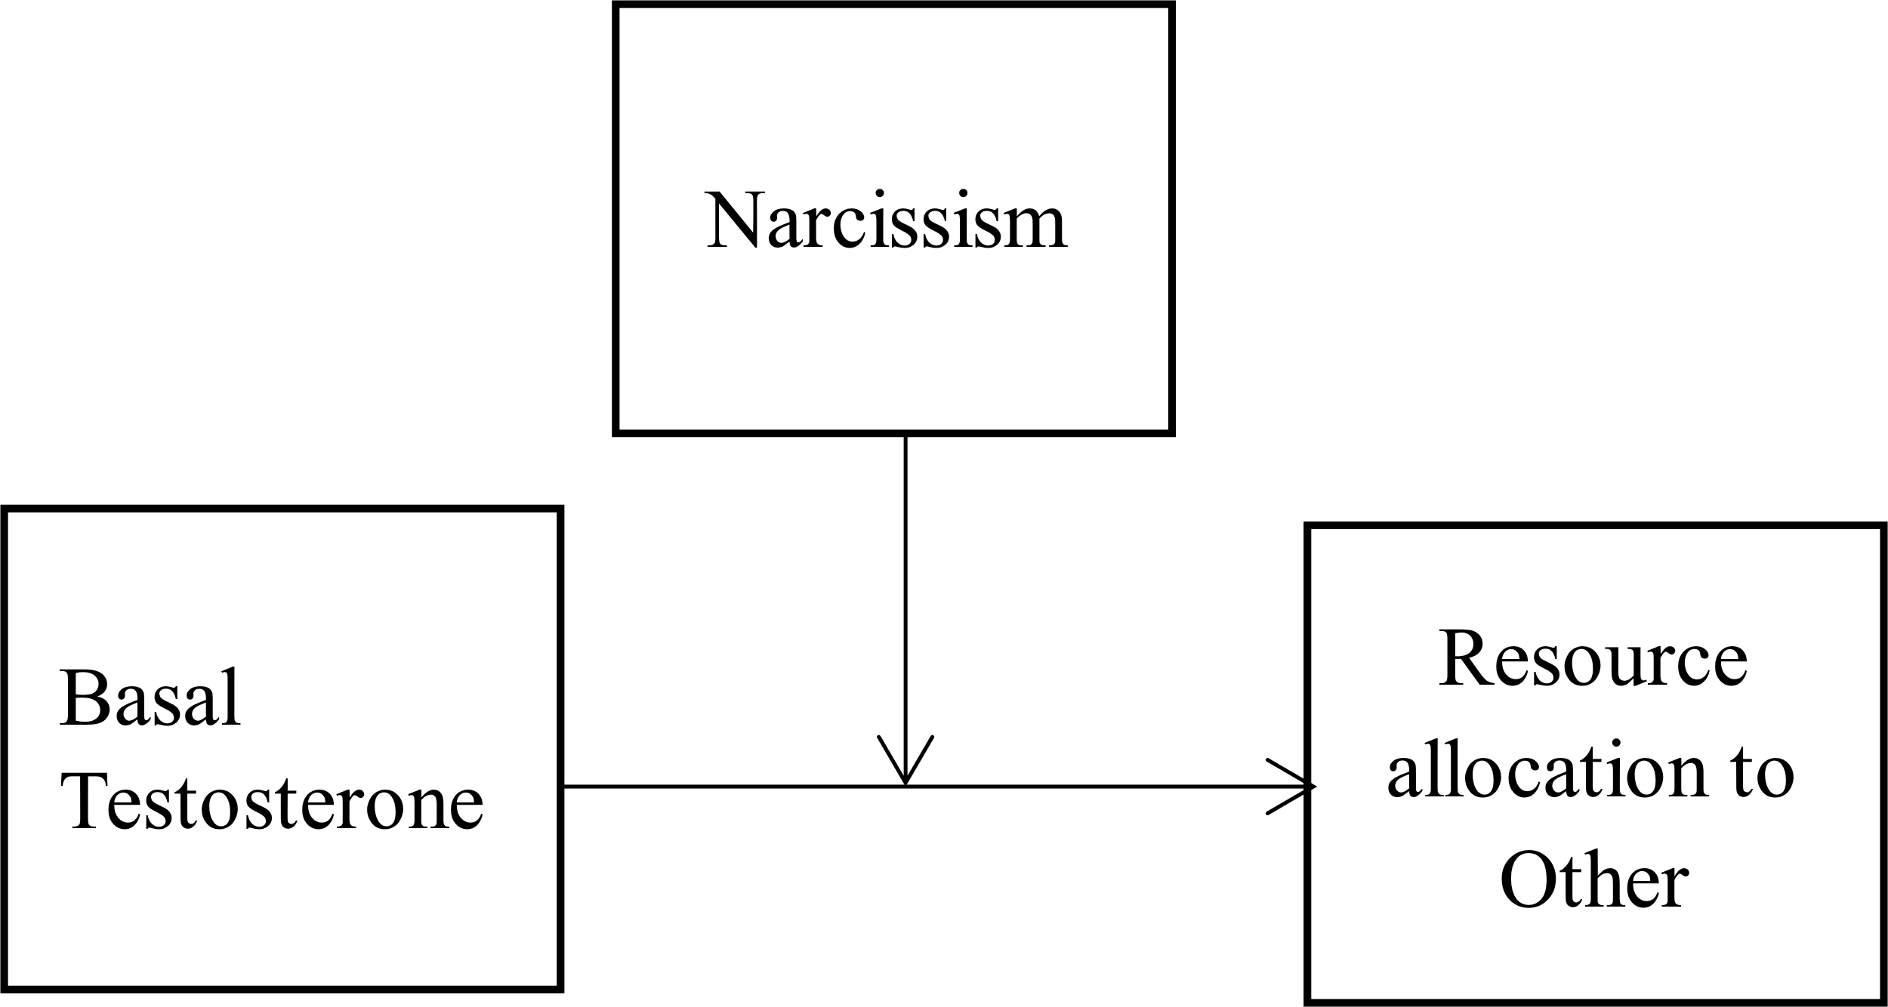

Figure 2

Example of a choice situation in the Triple Dominance Measure.

In this task we ask you to imagine that you have been randomly paired with another person, whom we will refer to simply as the "Other." This other person is someone you do not know and that you will not knowingly meet in the future. Both you and the "Other" person will be making choices by circling either the letter A, B, or C. Your own choices will produce points for both yourself and the "Other" person. Likewise, the other's choice will produce points for him/her and for you. Every point has value: The more points you receive, the better for you, and the more points the "Other" receives, the better for him/her.

Here's an example of how this task works:

|  |  |  |  |
| --- | --- | --- | --- |
|  | A | B | C |
| You get | 500 points | 500 points | 550 points |
| Other gets | 100 points | 500 points | 300 points |

In this example, if you chose A you would receive 500 points and the other would receive 100 points; if you chose B, you would receive 500 points and the other 500; and if you chose C, you would receive 550 points and the other 300. So, you see that your choice influences both the number of points you receive and the number of points the other receives.

Figure 3

Allocations to Other as a function of narcissism and mean T in Study 1 (left) and Study 2 (right). Dependent variable is presented at its full observed range. Slopes are presented with 95% confidence bands.

|  |  |
| --- | --- |
|  |  |

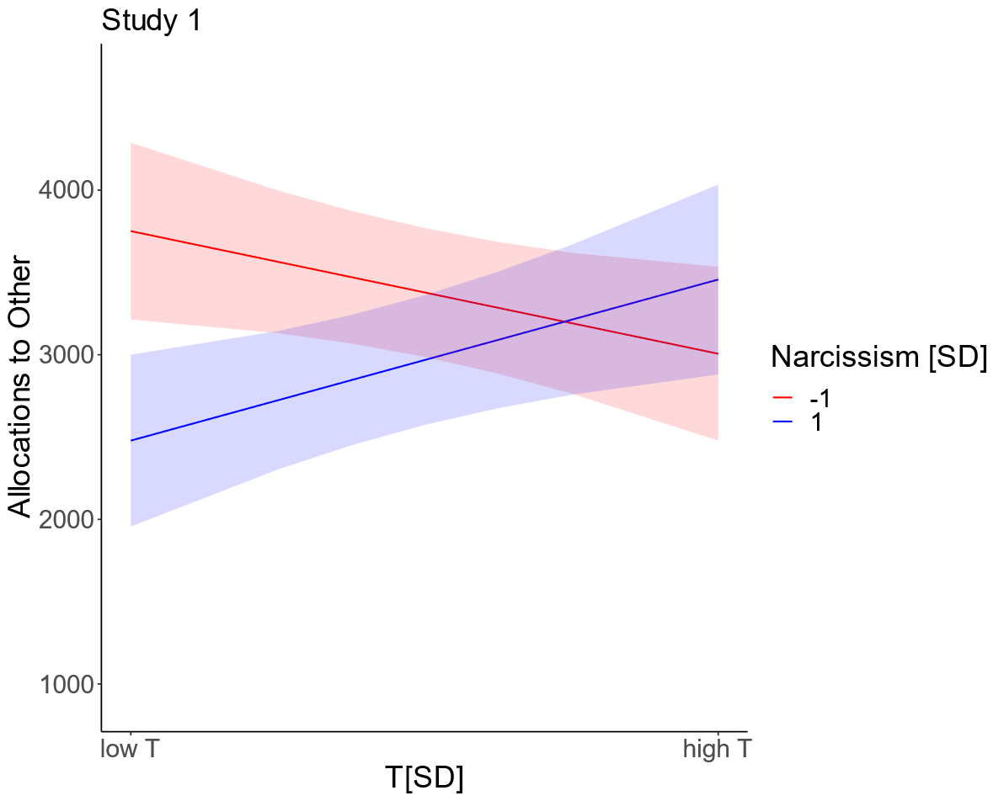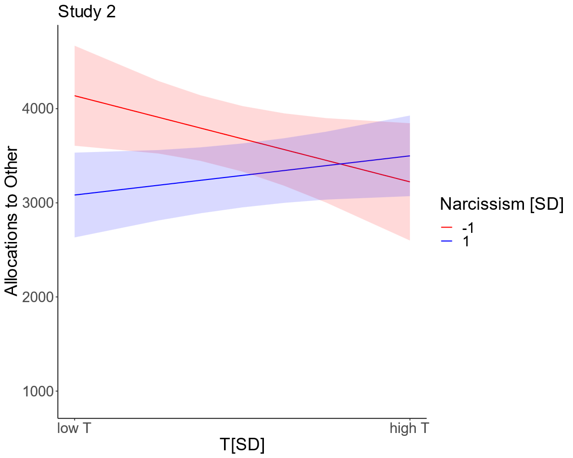

Figure 4

Allocations to Other as a function of narcissism levels and mean T.

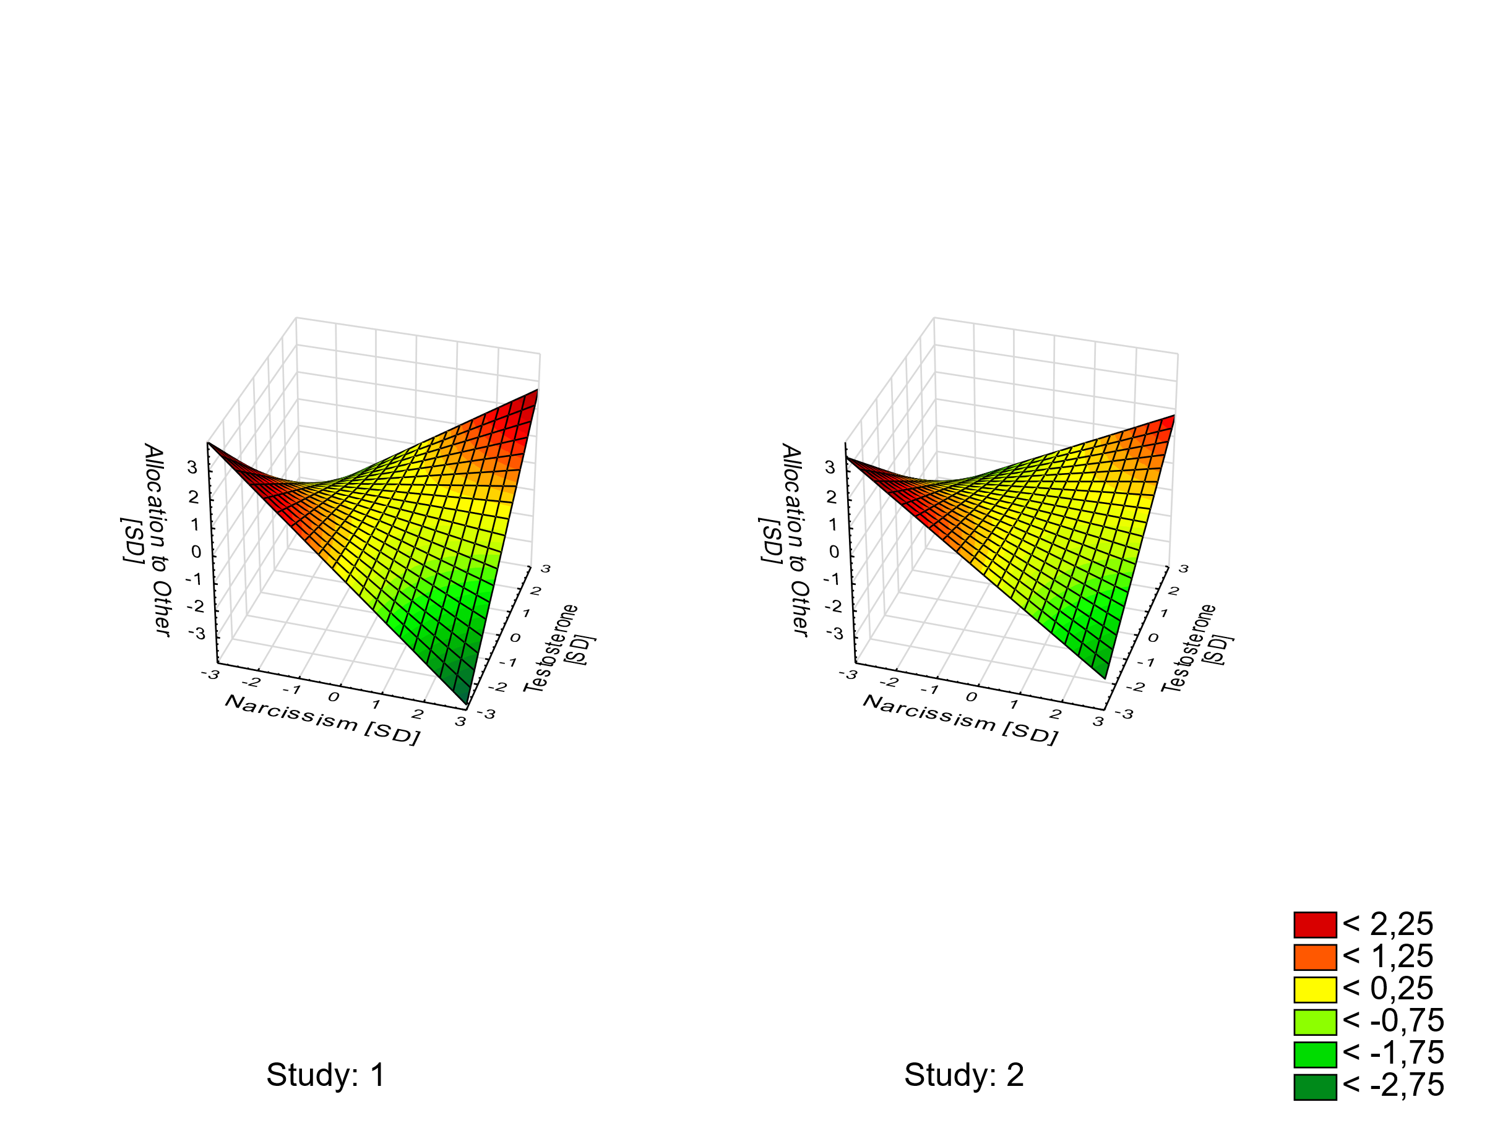

Figure 5

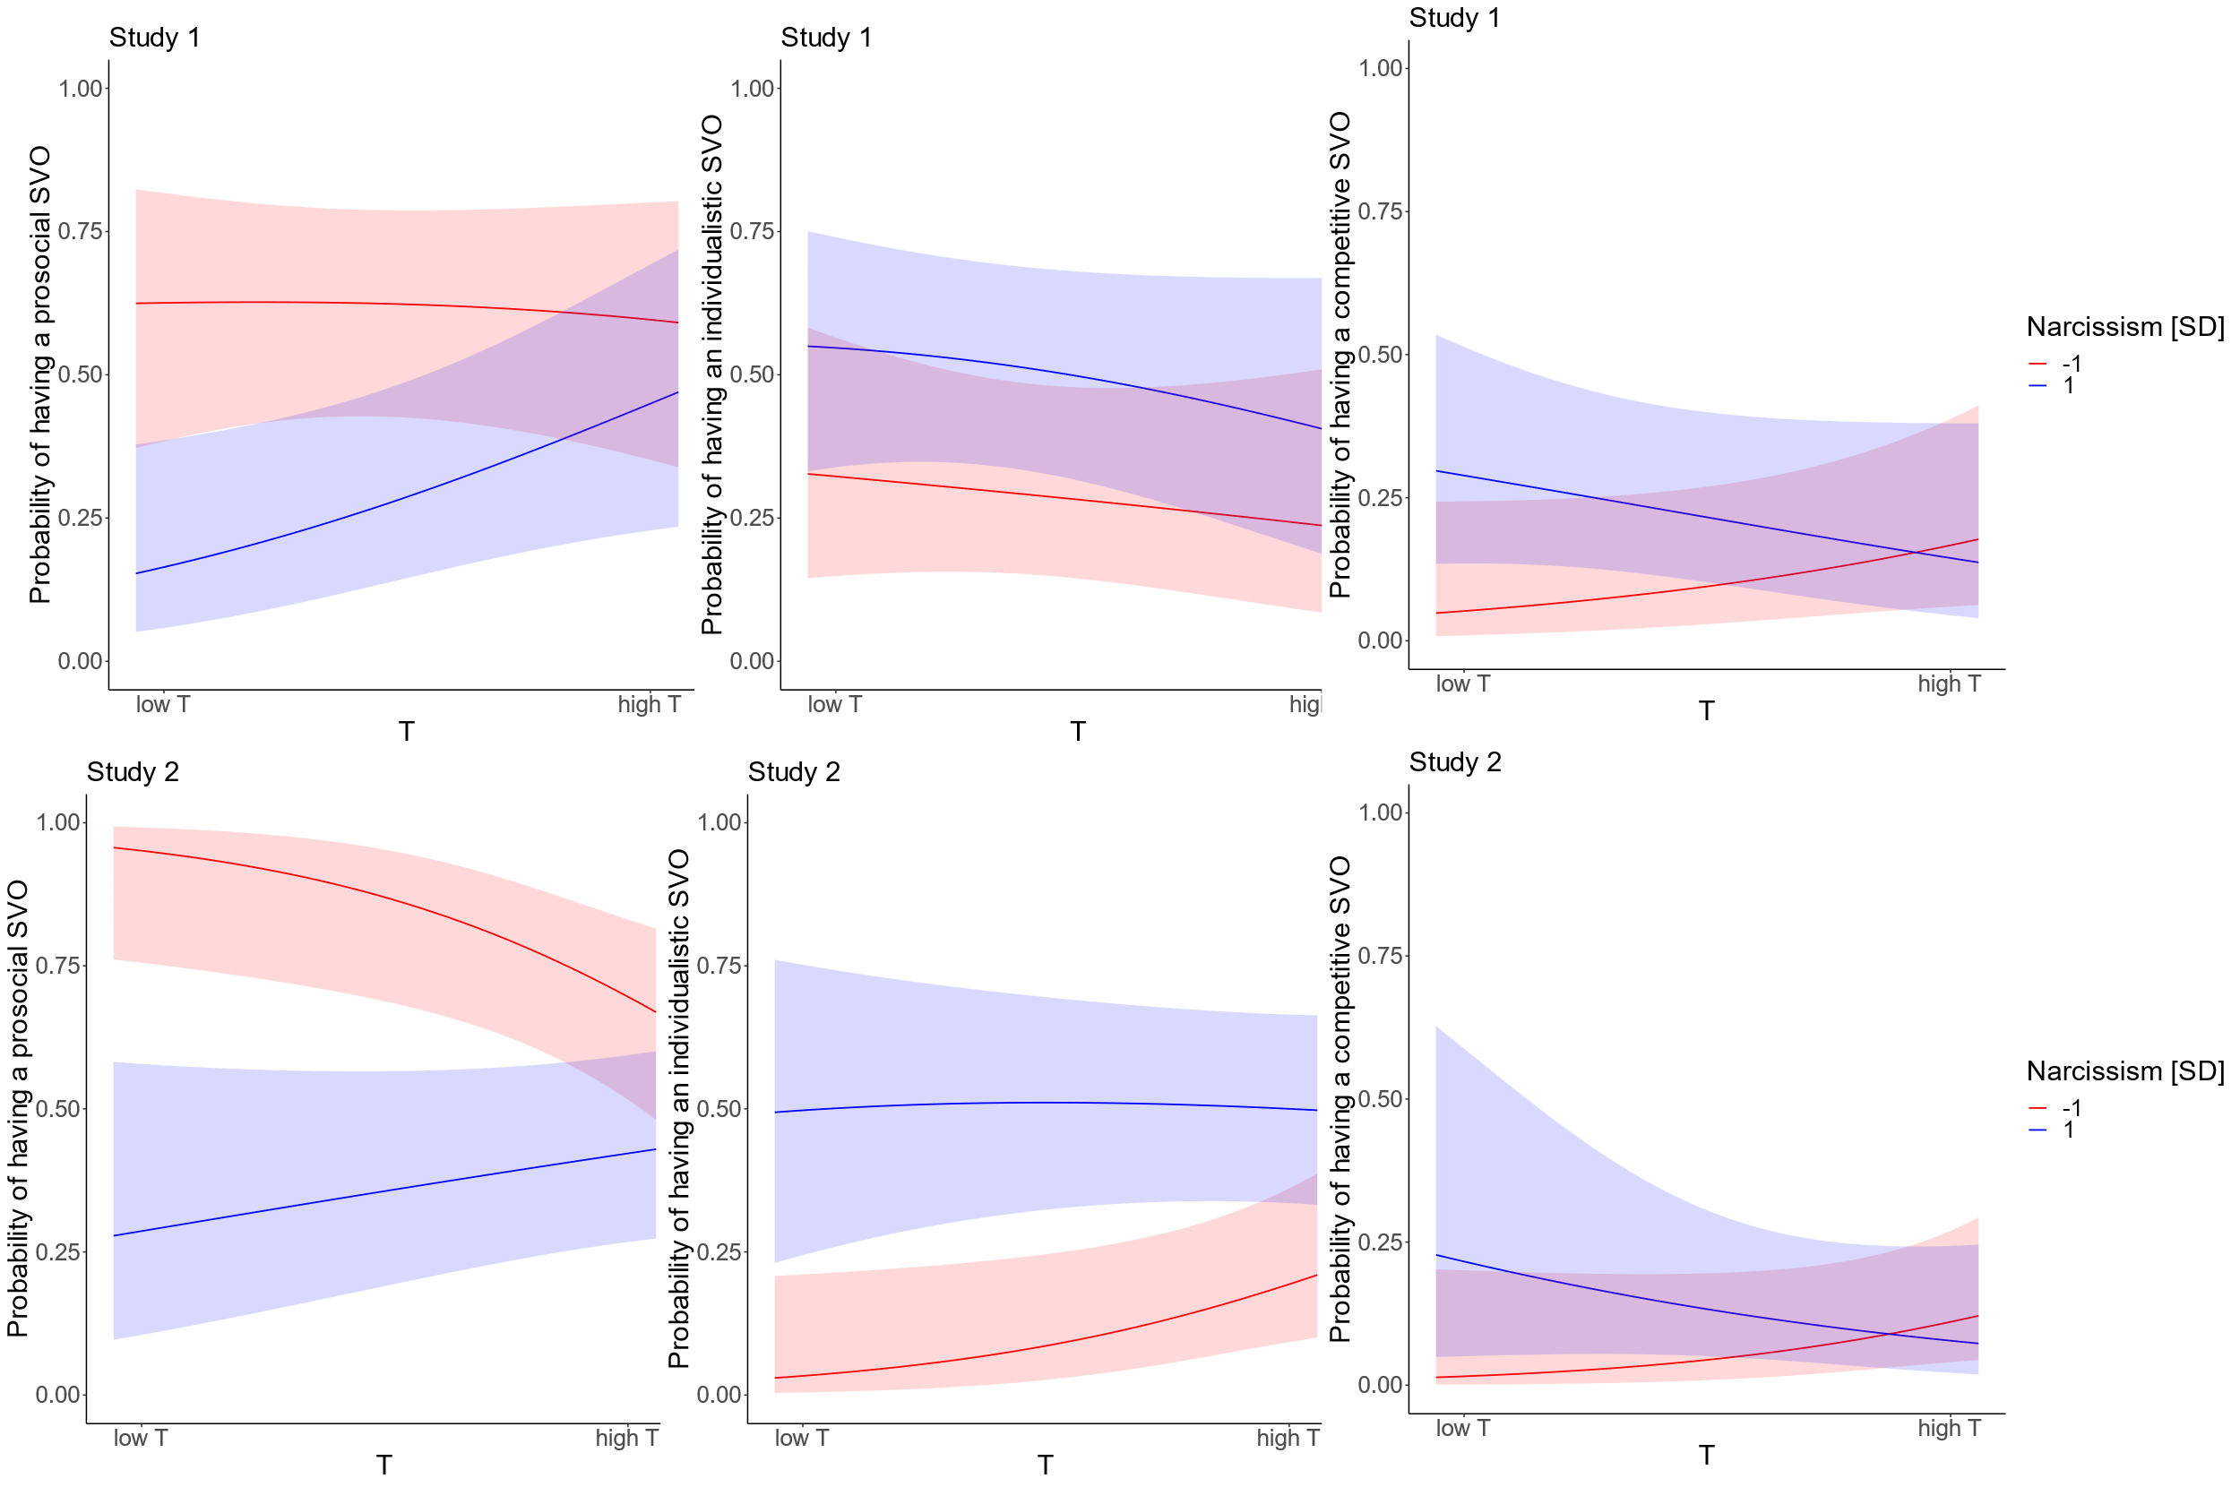Probabilities of showing a competitive (left panel) or individualistic (right panel) social value orientations as opposed to prosocial SVO as a function of narcissism and T levels (44 and 148 pg/ml are reference levels for low and high salivary T) in Study 1 (upper panel) and Study 2 (lower panel). Slopes are presented with 95% confidence bands.

**Supplementary Material**

**Appendix A**

1. **Ancillary Simple Slope Analyses Using Mean T as a Moderator and Narcissism as a Predictor**

**Study 1**

We followed up on the linear regression analysis with simple slope analysis using mean T as a moderator and narcissism as a predictor. Among low T individuals, narcissism was a significant negative predictor of generosity (at -1 SD of T: *b* = -635.516, *SE* = 180.000, *t* = -3.531, *p* = .001), whereas, among high T individuals, narcissism showed no significant association with generosity (at +1 SD of T: *b* = 225.153, *SE* = 196.202, *t* = 1.148, *p* = .255). Johnson-Neyman analysis of regions of significance indicated that narcissism significantly negatively predicted generosity at -.171 SD (which was equal to 90.50 pg/ml) and below the mean and significantly positively predicted generosity at +1.723 SD (which was equal to 221.49 pg/ml) and above the mean of T.

Similarly, following up on the logistic regression of a binary social value orientation (Table S2, upper panel), we found that, among low T individuals, narcissism was a significant positive predictor of binary SVO: proself (as opposed to prosocial) SVO (at -1 SD of T: *b* = 1.200, *SE* = .446, *Z* = 2.691, *p* = .007), whereas, among high T individuals, narcissism showed no significant association with binary SVO (at +1 SD of T: *b* = -.061, *SE* = .408, *Z* = -.148, *p* = .882).

**Study 2**

As in Study 1, we conducted linear regression analysis with simple slope analysis using mean T as a moderator and narcissism as a predictor. Among low T individuals, narcissism was a significant negative predictor of generosity (at -1 SD of T: *b* = -527.506, *SE* = 170.456, *t* = -3.095, *p* = .003), whereas, among high T individuals, narcissism showed no significant association with generosity (at +1 SD of T: *b* = 138.208, *SE* = 191.539, *t* = 0.722, *p* = .473). Johnson-Neyman analysis of regions of significance indicated that narcissism significantly negatively predicted generosity at -.146 SD (which was equal to 128.91 pg/ml) and below the mean and failed to positively predicted generosity at any value of T.

Likewise, following up on the logistic regression of a binary social value orientation (Table S2, lower panel), we found that, among low T individuals, narcissism was a significant positive predictor of binary SVO: proself (as opposed to prosocial) SVO (at -1 SD of T: *b* = 1.481, *SE* = .451, *Z* = 3.286, *p* = .001), whereas, among high T individuals, narcissism showed no significant association with binary SVO (at +1 SD of T: *b* = -.060, *SE* = .387, *Z* = -.156, *p* = .876).

Table S1

Results of regressions of Allocation to Other on narcissism and T1 (upper panel) and T2 (lower panel) in Study 1.

|  |  |  |  |
| --- | --- | --- | --- |
| **Study 1** | | | |
| Adj. R2=.178 | ***b*** | ***t*** | ***p*** |
| ZNarcissism | -227.19 | -1.659 | .102 |
| ZT1 | -36.10 | -0.263 | .793 |
| ZNarcissism *ZT1 | 457.32 | 3.767 | .000 |
| Adj. R2=.122 |  |  |  |
| ZNarcissism | -195.67 | -1.374 | .174 |
| ZT2 | 105.14 | 0.738 | .463 |
| ZNarcissism *ZT2 | 422.99 | 3.017 | .004 |
| **Study 2** | | | |
| Adj. R2=.043 | ***b*** | ***t*** | ***p*** |
| ZNarcissism | -190.37 | -1.517 | .133 |
| ZT1 | -59.48 | -0.452 | .653 |
| ZNarcissism *ZT1 | 240.32 | 1.819 | .073 |
| Adj. R2=.098 |  |  |  |
| ZNarcissism | -210.98 | -1.731 | .087 |
| ZT2 | -148.94 | -1.068 | .289 |
| ZNarcissism *ZT2 | 377.00 | 2.865 | .005 |
| *Note:* ZNarcissism = standardized narcissism, ZT1 = standardized first measurement T, ZT2 = standardized second measurement T | | | |

Table S2

Parameter Estimates from Logistic Regression of Binary Social Value Orientation (Prosocial vs. Proself). Prosocial was coded as 0 and Proself (i.e. Individualistic or Competitive) as 1.

|  |  |  |  |  |  |  |  |  |
| --- | --- | --- | --- | --- | --- | --- | --- | --- |
| **Study 1** | | | | | | | | |
|  |  |  |  |  |  |  | 95% confidence interval for Exp(B) | |
|  | *B* | *SE* | *Wald* | *df* | *p* | *Exp(B)* | Lower Bound | Upper Bound |
| Intercept | 0.792 | 0.510 | 2.409 | 1 | .121 | 2.207 |  |  |
| T_Mean | -0.006 | 0.004 | 2.044 | 1 | .153 | 0.994 | 0.986 | 1.002 |
| ZNarcissism | 1.487 | 0.552 | 7.246 | 1 | .007 | 4.425 | 1.498 | 13.068 |
| T_Mean * ZNarcissism | -0.009 | 0.004 | 4.484 | 1 | .034 | 0.991 | 0.983 | 0.999 |
| The model with all the predictors is significantly better than the constant only model [**χ2** (3, N = 68) = 11.743, *p* = 0.008]. The model explained between 15.9% (Cox and Snell R2) and 21.2% (Nagelkerke R2) of the variance in the binary SVO and correctly classified 61.8 % of cases. | | | | | | | | |
| **Study 2** | | | | | | | | |
| Intercept | -1.380 | 0.722 | 3.655 | 1 | .056 | 0.252 |  |  |
| T_Mean | 0.008 | 0.005 | 2.594 | 1 | .107 | 1.008 | 0.998 | 1.017 |
| ZNarcissism | 2.420 | 0.787 | 9.463 | 1 | .002 | 11.245 | 2.406 | 52.547 |
| T_Mean * ZNarcissism | -0.012 | 0.005 | 6.075 | 1 | .014 | 0.988 | 0.978 | 0.997 |
| The model with all the predictors is significantly better than the constant only model [**χ2** (3, N = 83) = 15.719, *p* = 0.001. The model explained between 17,3% (Cox and Snell R2) and 23.0% (Nagelkerke R2) of the variance in the binary SVO and correctly classified 67.5 % of cases. | | | | | | | | |

*Note.* ZNarcissism = standardized narcissism, T_mean = mean T (averaged across two measurements).

Figure S1

Histograms for mean T in Study 1 (left) and Study 2 (right)

|  |  |
| --- | --- |
|  |  |

