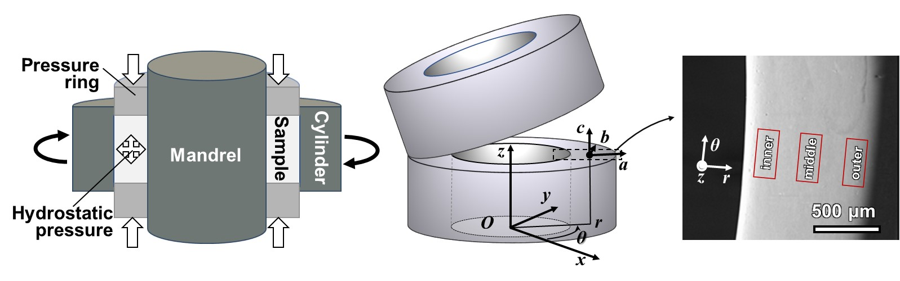
Figure 1. Illustration of the principle of t-HPS (left), the sample tube for t-HPS in cylindrical coordinates (center), half-height annular section of the tube wall with the observation regions: inner, middle and outer (right). Two sets of coordinate systems are defined: the macroscopic sample coordinate system is expressed in cylindrical coordinates r-θ-z and the local Cartesian coordinate system in terms of a-b-c. At any local position, these two coordinate systems always keep r parallel to a, θ parallel to b, and z parallel to c.

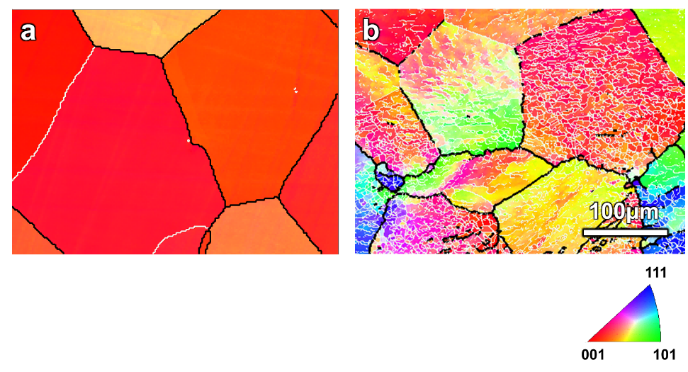
Figure 2. The Inverse pole figure (IPF) map obtained by EBSD showing (a) the fully-annealed coarse grains of 5N Al before t-HPS and (b) the sub-grain boundaries (white nets) formed in these coarse grains when the sample is subjected to a hydrostatic pressure of ~3 GPa. The scale bar is the same in (a) and (b).

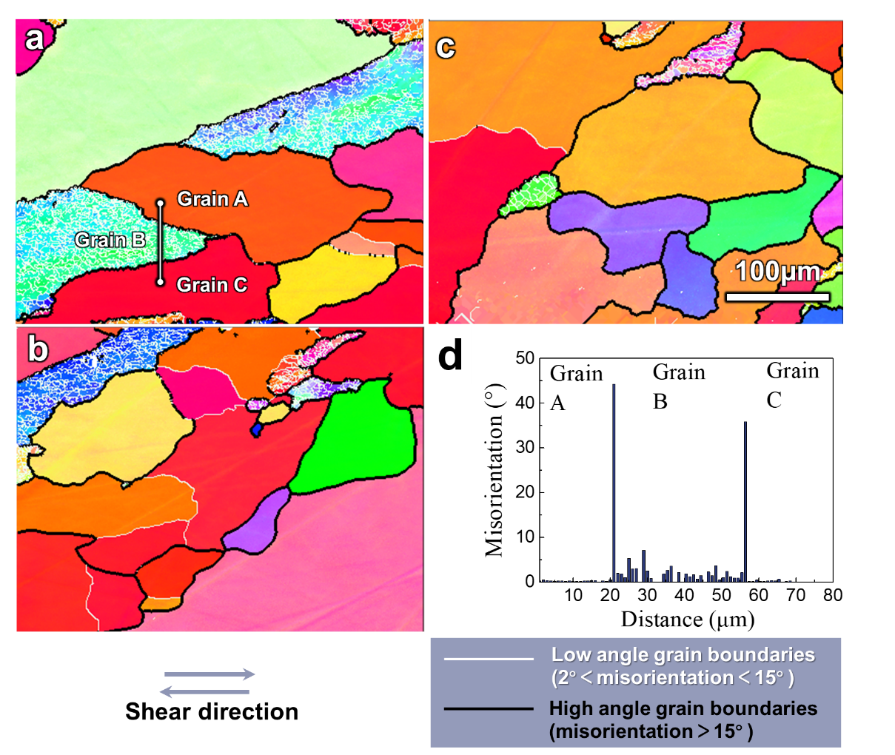
Figure 3. EBSD IPF maps from inner (a), middle (b) and outer (c) regions of the 5N Al processed by t-HPS to a rotation angle of π/6, and (d) the misorientation changes from grain A to C across B as shown in (a). The scale bar is the same in (a), (b) and (c).

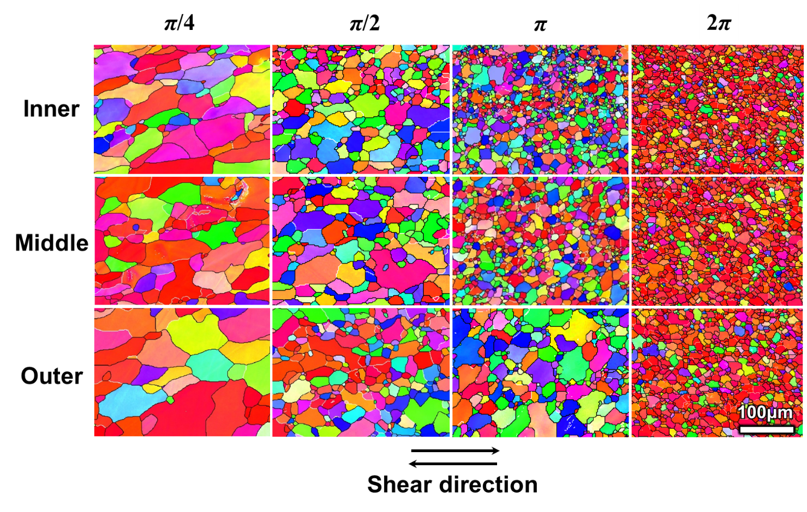
Figure 4. EBSD IPF maps from inner (top), middle (center) and outer (bottom) regions as indicated in Fig. 1 of the 5N Al processed by t-HPS to a rotation angle of π/4 (left), π/2 (center left), π (center right) and 2π (right). The scale bar is the same for all IPF maps.

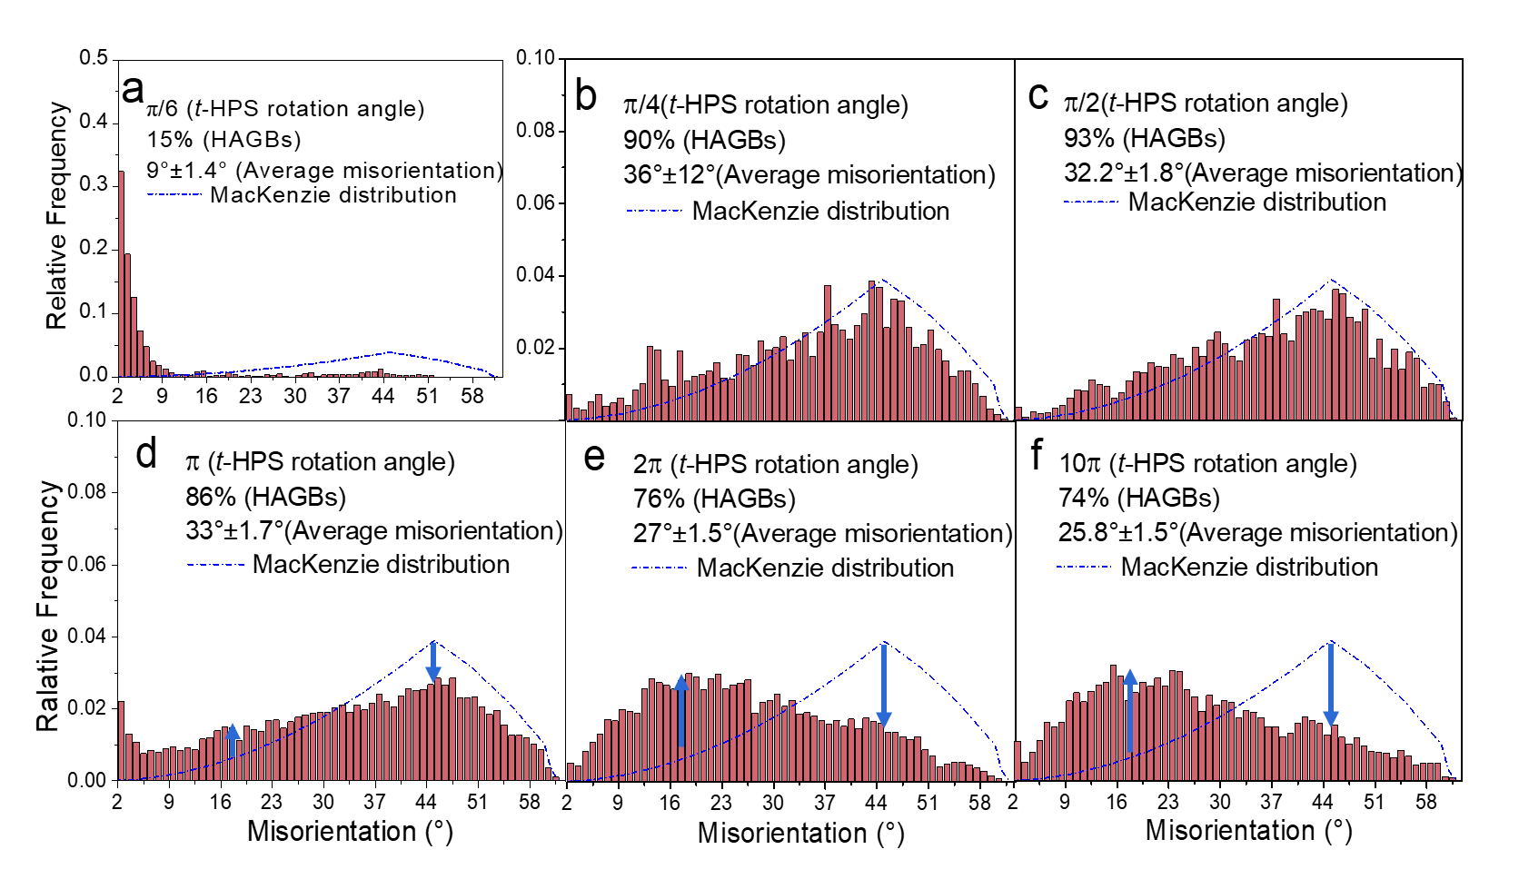
Figure 5. Evolution of grain boundary misorientation distributions upon increase of t-HPS rotation angle through (a) π/6, (b) π/4, (c) π/2, (d) π, (e) 2π and (f) 10π. It is important to note the different range of the vertical axis in (a).

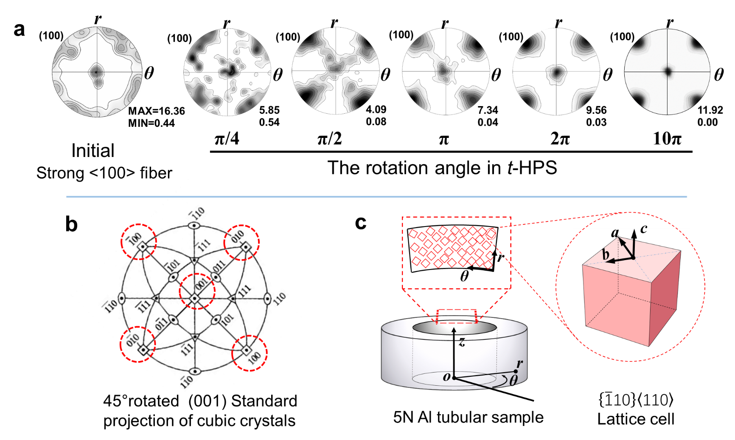
Figure 6. (a) (100) pole figures of the as-received 5N Al sample bar and after t-HPS processing; (b) 45°rotated (001) standard projection of cubic crystal and (c) illustration of an ideal {$\overline{\text{1}}\text{10}$}<110> lattice cell with its relation to the t-HPS tube sample.
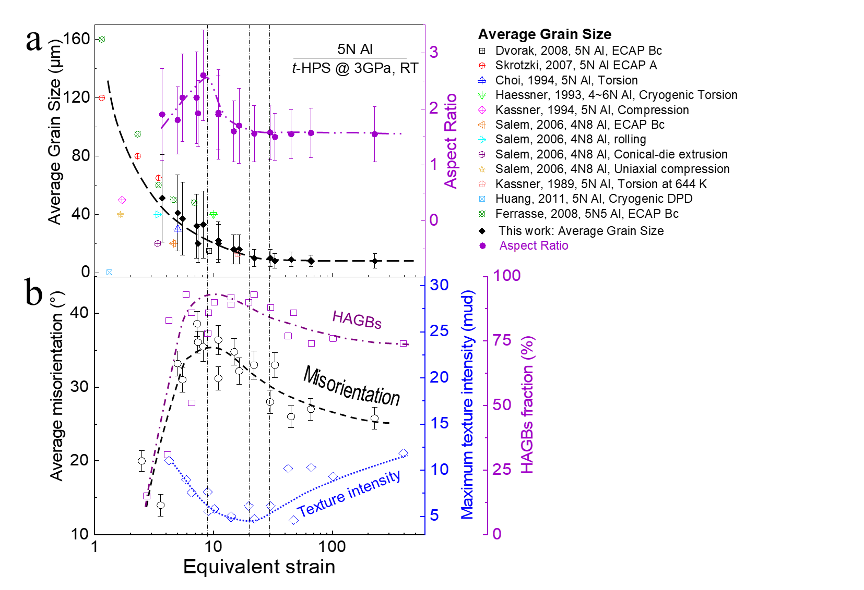
Figure 7. Evolution of microstructure parameters: (a) average grain sizes and grain aspect ratios, (b) average grain boundary misorientation, HAGB fractions and intensity of {$\overline{\text{1}}\text{10}$}<110> texture obtained from (111) pole figure upon increase of t-HPS equivalent strain: grain size data from the literature ^{36,51-58} are also included.

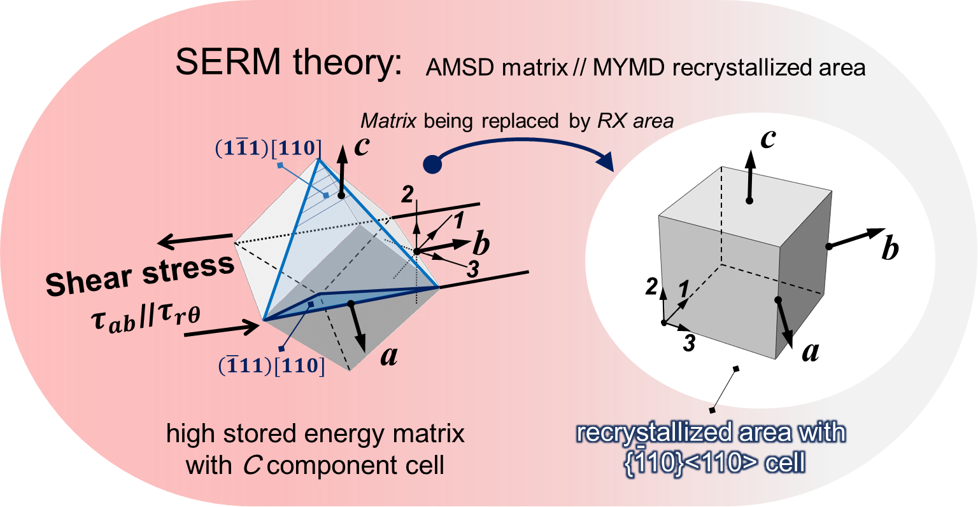

Figure 8. Illustration of the assumed C component 3D cubic cell in deformation state (left) and ideal {$\overline{\text{1}}\text{10}$}<110> component 3D cubic cell in the recrystallized state (right); the sample local Cartesian coordinate system a-b-c and stress principal coordinate 1-2-3 are illustrated, and the local Cartesian coordinates a, b and c are parallel to the sample cylindrical coordinates r, θ and z, respectively.

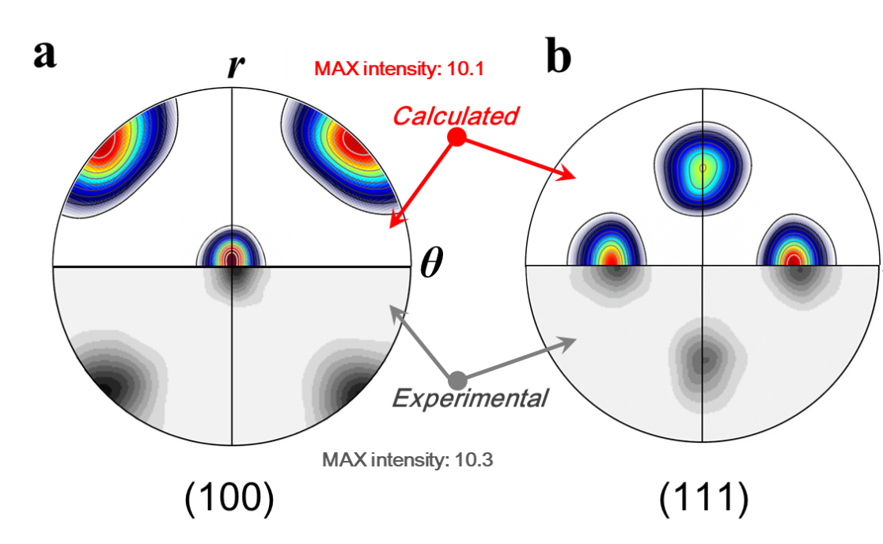
Figure 9. The (a) (100) and (b) (111) pole figures observed in 5N Al after t-HPS rotation to 2π (bottom) by comparison to those estimated (top) for the {$\overline{\text{1}}\text{10}$}<110> texture pole figure with a spreading of 27°.

Table 1. The equivalent strain after t-HPS (rotation angle π/6~10π) at different observation regions
Rotation angle | Regions
 | Inner | Middle | Outer | Average
π/6 | 5.5 | 3.6 | 2.5 | 3.8
π/4 | 8.2 | 5.5 | 3.7 | 5.7
π/2 | 16.5 | 11 | 7.4 | 11.3
π | 33 | 22 | 15 | 22.7
2π | 66 | 45 | 30 | 45.3
10π | 330 | 227 | 148 | 227

