Modelling of Hydrogen-Blended Dual-Fuel Combustion using Flamelet-Generated Manifold and Preferential Diffusion Effects

F. S. Almutairi¹, K.K.J. Ranga Dinesh^{1*}, J.A. van Oijen²

- Energy Technology Research group, School of Engineering, Faculty of Engineering and Physical Sciences, University of Southampton, Southampton, SO17 1BJ, UK.
- Combustion Technology Group, Department of Mechanical Engineering, Eindhoven University of Technology, Den Dolech 2, 5612 AZ Eindhoven, Netherlands.

Corresponding Author: dinesh.kahanda-koralage@soton.ac.uk
Tel: +44 (0) 2380598301

Revised Manuscript Prepared for the Submission of International Journal of Hydrogen Energy,
August 2022

Abstract
In the present study, Reynolds-Averaged Navier-Stokes simulations together with a novel flamelet generated manifold (FGM) hybrid combustion model incorporating preferential diffusion effects is utilised for the investigation of a hydrogen-blended diesel-hydrogen dual-fuel engine combustion process with high hydrogen energy share. The FGM hybrid combustion model was developed by coupling laminar flamelet databases obtained from diffusion flamelets and premixed flamelets. The model employed three control variables, namely, mixture fraction, reaction progress variable and enthalpy. The preferential diffusion effects were included in the laminar flamelet calculations and in the diffusion terms in the transport equations of the control variables. The resulting model is then validated against an experimental diesel-hydrogen dual-fuel combustion engine. The results show that the FGM hybrid combustion model incorporating preferential diffusion effects in the flame chemistry and transport equations yields better predictions with good accuracy for the in-cylinder characteristics. The inclusion of preferential diffusion effects in the flame chemistry and transport equations was found to predict well several characteristics of the diesel-hydrogen dual-fuel combustion process: 1) ignition delay, 2) start and end of combustion, 3) faster flame propagation and quicker burning rate of hydrogen, 4) high temperature combustion due to highly reactive nature of hydrogen radicals, 5) peak values of the heat release rate due to high temperature combustion of the partially premixed pilot fuel spray with entrained hydrogen/air and then background hydrogen-air premixed mixture. The comparison between diesel-hydrogen dual-fuel combustion and diesel only combustion shows early start of combustion, longer ignition delay time, higher flame temperature and NOx emissions for dual-fuel combustion compared to diesel only combustion.
Key Words: Hydrogen-blended dual-fuel combustion, Flamelet generated manifold hybrid combustion model, Preferential diffusion effects, Heat release rate, Auto-ignition delay time

Introduction
In recent decades, the diesel engine has become ubiquitous in heavy duty ground transportation, sea transportation, power generation and agriculture sectors owing to its better fuel economy, reliability and durability [1-2]. Unfortunately, diesel engines emit significant amount of harmful emissions such as oxides of nitrogen (NOx), particulate matters and greenhouse gas emissions such as carbon dioxide (CO₂) [3-5]. This has prompted searching for alternative zero carbon fuels for diesel engine applications.
Among zero carbon alternative fuels, hydrogen (H₂) is considered as a potential candidate for internal combustion engines (ICEs) due to various reasons. First, hydrogen can be produced from renewable sources using water electrolysis [6-7] and from non-renewables sources such as coal using gasification [8] and from natural gas via steam reforming [9]. Hydrogen can also be produced via ammonia cracking [10-11]. Second, the combustion of hydrogen does not produce carbon emissions hence support decarbonisation [12]. Third, hydrogen enhances the combustion intensity owing to its high diffusivity rate and high burning velocity and the wide flammability range of hydrogen fuel facilitates the combustion engine to be operated over a wide range of air-fuel mixtures with lean burn combustion hence maintaining or even improving engine performance [13-15].
The studies of hydrogen as a fuel for diesel engines is subject of intensive research at the present time. For example, there has been a significant amount of experimental and numerical modelling studies dedicated to the examination of hydrogen as a fuel for diesel compression ignition engines under dual-fuel (DF) combustion technology due to its potential to burn cleaner gaseous fuel at a thermal efficiency comparable to diesel only engine, but with substantially reduced emissions [16-17]. In the majority of previous studies on the topic of diesel-hydrogen DF combustion engines, the gaseous hydrogen fuel (i.e. the main fuel with higher auto-ignition temperature) is usually introduced via the intake manifold using port fuel injection, whereas a small amount of diesel fuel (i.e. the pilot fuel with lower auto-ignition temperature) is directly injected into the combustion chamber to initiate the auto-ignition [18]. This results in a hybrid combustion mode representing non-premixed combustion of the diesel pilot fuel and then premixed (or lean premixed) combustion of the hydrogen-air mixture.
Many laboratory scale experimental works have been carried out to elucidate the fundamental understanding of fuel injection, combustion performance and emissions with respect to hydrogen addition into diesel engines under dual-fuel combustion technology. For example, Saravanan et al. [19] carried out experimental investigation of combustion analysis in a direct injection diesel engine with hydrogen intake port injection. They found that hydrogen addition with diesel results in increased thermal efficiency and also NOx emission compared to diesel only case. Gatts et al. [20] measured hydrogen emissions characteristics of diesel-hydrogen DF engine and found that more unburned hydrogen emission is formed at low load operation compared to high load operation for same amount of hydrogen addition. This leads to incomplete combustion because the diesel spray plume creates insufficient and weak ignition centres to initiate the combustion for the lean hydrogen-air mixture at low load conditions. Lilik et al. [21] reported a study of hydrogen assisted diesel combustion with the pilot and main injection timing locked and showed that addition of hydrogen resulted in an increase of NOx emissions with NO₂ becoming the prominent NOx component in some combustion modes. More recently experimental studies carried out by Zhou et al. [22], Deb et al. [23], Karagoz et al. [24] and Tsujimura et al. [25] have evaluated engine performance and emissions of diesel-hydrogen DF engines with respect to different conditions such as hydrogen energy share, engine speed and engine loads. They all found that the diesel-hydrogen DF engine with substantial amount of hydrogen energy share can achieve higher thermal efficiency than a conventional diesel engine operation at relatively high engine load conditions. However, they also identified some drawbacks of diesel-hydrogen DF engine operation with respect to high hydrogen energy share. The two main drawbacks are the occurrence of pre-ignition before diesel fuel injection and its ignition at high engine load operation and poor combustion behaviour at low engine load operation. Dimitriou et al. [26] further studied the poor combustion efficiency at low engine load conditions due to high unburned hydrogen rates and concluded that very high hydrogen energy share should be avoided at low engine load conditions. Other techniques, such as cooled exhaust gas recirculation and advanced turbocharging methods have also been tested as emissions reduction methods in diesel-hydrogen DF engines [27-28].
In the past decade, numerous efforts have been taken to simulate dual-fuel combustion process via three-dimensional computational fluid dynamics (CFD) based engine combustion modelling. CFD modelling appears to be one of the key enabling tools in the development of engine technologies because it can provide efficient and flexible engine design guidelines before cut the metal to perform more expensive engine experiments. Many CFD modelling studies were carried out to investigate the combustion performance and emissions of dual-fuel engines including the application of different modelling approaches, turbulence models, combustion models, emissions models, simple chemistry and detailed chemistry mechanisms etc. For example, Liu et al. [29], Tripathi et al. [30] and Frankl et al. [31] have carried out numerical simulations of diesel-natural gas and diesel-hydrogen DF combustion engines using the SAGE finite rate detailed chemistry solver. They employed detailed chemistry and adaptive mesh refinement to resolve the key scalar variables in their calculation. Kahila et al. [32] numerically studied diesel-methane DF combustion and Hosseini et al. [13] and Ramsay et al. [33] simulated diesel-hydrogen DF combustion using the species transport model with final rate chemistry. Liu et al. [34] studied diesel-natural gas DF combustion using the partially stirred reactor (PaSR) combustion model. Jafarmadar et al. [35] and Wang et al. [36] simulated the combustion characteristics of diesel-hydrogen and diesel-natural gas DF engines using the 3-Zones extended coherent flame model. An et al. [37] numerically investigated diesel-hydrogen DF flame using the multi-zone combustion model while Wu et al. [38] simulated hydrogen-natural gas duel-fuel flame with diesel pilot ignition using the flamelet model.
Though great efforts have been made in modelling, comprehensive simulations of hydrogen blended diesel DF combustion are highly desirable to explain the complex multistage process of dual fuel combustion. For example, in the diesel-hydrogen DF flame, the heat release process can be classified into three modes; (1) the ignition of the pilot diesel fuel, (2) the combustion of the pilot diesel fuel with some hydrogen available within the diesel spray plume, (3) the combustion of hydrogen-air premixed mixture [39]. Therefore, the interplay between non-premixed combustion mode of the pilot liquid fuel and premixed combustion mode of the gaseous-air mixture presents a challenge for above noted combustion models to better capture the combustion characteristics of diesel-hydrogen DF combustion. For example, the recent investigation carried out by Tuchler et. al. [40] have highlighted that the multi-zone combustion model struggles to accurately predict hydrogen entrainment resulting in under-prediction of peak values of in-cylinder pressure and heat release rate in diesel-hydrogen DF combustion process. This finding highlights the importance of considering a comprehensive combustion model to simulate high hydrogen content diesel-hydrogen DF engine combustion.
Another crucial factor to be considered is preferential diffusion effects which is an important physical phenomenon for combustion and heat release of hydrogen-blended fuels in both premixed [41] and non-premixed combustion modes [42]. Preferential diffusion is usually described by the Lewis number, Le, defined as the ratio of thermal to mass diffusivity. Non-unity Lewis number leads to preferential diffusion between chemical species as well as between species and heat. Our previous investigations found that the high diffusivity of light chemical species such as atomic hydrogen (H) and H₂ affects high hydrogen content fuel burning, flame propagation speed and heat release through preferential diffusion in engine relevant conditions, for example high turbulence and elevated pressures [41-43]. Although, most of the aforementioned modelling studies focused on diesel-hydrogen DF combustion modelling with unity Lewis number assumption, there is still lack of fundamental understanding of preferential diffusion effects on combustion characteristics of hydrogen blended diesel-hydrogen DF combustion. There is a research gap in a detailed explanation of preferential diffusion effects on in-cylinder pressure, temperature, auto-ignition and chemical species formation such as unburned hydrogen and NOx emissions of hydrogen blended diesel-hydrogen DF combustion engines.
The objective of this study is to introduce a novel hybrid combustion model based on Flamelet Generated Manifold (FGM) incorporating preferential diffusion effects to predict a multistage process of high hydrogen content diesel-hydrogen DF combustion. The FGM technique enables reliable CFD predictions of combustion process incorporating detailed chemical reaction mechanisms with significantly low computational cost. The FGM combustion model has been extensively used to simulate turbulent premixed [44], non-premixed [45] and partially premixed flames [46]. However, the FGM combustion modelling approach coupling with preferential diffusion effects has not been applied to simulate hydrogen blended DF combustion process. The innovative interest of this paper is the further improvement of the FGM combustion model to simulate high hydrogen content diesel-hydrogen DF engine combustion by means of three-dimensional FGM in which the pre-computed chemistry databases is a function of mixture fraction (representing the stratification effects), progress variable (representing the chemistry evolution) and enthalpy (representing the heat loss) with the incorporation of preferential diffusion effects (representing the high diffusivity of hydrogen). The emphasis is put on assessing and interpreting applicability of the modified FGM hybrid combustion model coupling non-premixed flamelet generated manifold and premixed flamelet generated manifold with preferential diffusion effects to capture the multistage process of high hydrogen content diesel-hydrogen DF engine combustion. The modelling framework is validated against the experimental data of high hydrogen content diesel-hydrogen DF engine combustion carried out by Tsujimura et al. [25]. The incorporation of preferential diffusion effects is demonstrated by performing simulations with the unity Lewis number approach and the non-unity Lewis number approach. The work quantifies preferential diffusion effects on in-cylinder pressure, heat release rate, temperature, auto-ignition and radical chemical species formation such as unburned hydrogen and NOx emissions of high-hydrogen content diesel-hydrogen DF combustion. The results also contribute to improving modified FGM hybrid combustion model capability to predict dual-fuel combustion process, auto-ignition characteristics and species concentrations of pollutant emissions of dual-fuel combustion engines. The proposed modelling framework can be effectively used to accurately predict combustion characteristics of hydrogen-blended DF combustion over a wide range of industry scale applications such as dual-fuel internal combustion engines, gas turbines, burners and furnaces, with green alternative fuels such as ammonia and bio-fuels as well as conventional hydrocarbon fuels.

2. Numerical Methodology

2.1. Diesel-Hydrogen Duel-Fuel Engine Configuration for Model Validation
Engine type |  | Single cylinder
Displacement volume (L) |  | 1.3
Bore $×$ stroke (mm) |  | 115 $×$ 125
Compression ratio |  | 17.5:1
Fuel |  | Diesel fuel (direct injection)
 |  | Hydrogen (Port injection)
Engine speed (RPM) |  |  |  | 1500
Indicated mean effective pressure (MPa) |  |  |  | 0.9
Maximum hydrogen fraction (input energy base) (%) |  |  |  | 73
Intake gas pressure (kPa) |  |  |  | 160
Intake Oxygen (O₂) concentration by volume (%) |  |  |  | 18.6
Diesel fuel injection | Pattern |  | Double (pre/main)
Diesel fuel injection | Timing (deg. CA) ATDC |  | Pre | -9.9
Diesel fuel injection |  |  | Main | 6.1
Diesel fuel injection | Quantity (mm³/cycle) |  | Pre | 1.2
Diesel fuel injection |  |  | Main | 76-21
Diesel fuel injection | Pressure (MPa) |  |  | 116
Table 1. Diesel-Hydrogen dual fuel compression ignition engine specification and experimental conditions [25].
In the present study, we employed the single cylinder diesel-hydrogen DF compression ignition engine configuration experimentally conducted by Tsujimura et al. [25]. The newly extended FGM hybrid combustion model was applied to simulate two cases: pure diesel case with no hydrogen energy share (0% HES) and diesel-hydrogen DF case with 73% hydrogen energy share (73% HES) at high load condition. Since hydrogen has a very low volumetric energy density comparing volumes of the gaseous fuel to liquid fuel is not ideal. That is why we used input energy share for diesel-hydrogen DF case similar to the experimental investigation. This engine configuration has been employed in our previous numerical study of diesel-hydrogen DF engine performance and emissions under a novel constant volume combustion phase [33]. Table 1 provide the engine specification and experimental conditions of pure diesel (0% HES) case and diesel-hydrogen DF case (73% HES) at high engine load [25].

2.2 Flamelet generated manifold method for dual-fuel combustion modelling
In this study, the flamelet generated manifold tabulated combustion model is extended to predict the combustion of diesel-hydrogen DF combustion process. In tabulated FGM, the chemistry is represented by a few independent control variables (CV), implying that only the governing equations, along with the transport equations of control variables, are solved during the simulation run-time. The independent control variables such as mixture fraction, reaction progress variable, enthalpy can be added for a better description of the combustion process depend on the physical problem. In the FGM method, the flamelet system is pre-computed with the flamelet assumption and a database (i.e. FGM manifold) of thermochemical variables can be generated in a tabulated form. The laminar flamelet database is generated using a one-dimensional flamelet calculation with full kinetics and detailed transport. Modelling turbulent combustion using the FGM method consists of three steps: 1. laminar flamelet calculation, 2. construction of look up table for thermochemical variables, 3. coupling between look up table and CFD solver.
It has been recognised that the diesel-hydrogen DF flame with gaseous hydrogen intake injection consists of non-premixed (diffusion) combustion of diesel pilot fuel with air and with the presence of hydrogen gas in the vicinity of auto-ignition spots, and then premixed combustion of hydrogen-air mixture at later stage. In this work, an FGM hybrid model was developed by coupling non-premixed flamelet database and premixed flamelets database. The coupling approach was used to capture the auto-ignition of the diesel pilot fuel with air and with the presence of hydrogen gas in the vicinity of auto-ignition spots via non-premixed combustion and then the flame propagation of premixed hydrogen-air mixture via premixed combustion. Furthermore, the model incorporated preferential diffusion effects to better capture the auto-ignition process, flame propagation and heat release rate of high hydrogen content dual-fuel engine combustion. In order to account for preferential diffusion effects using FGM a two-step correction is implemented: laminar flamelet calculation incorporating preferential diffusion effects, and correction for the diffusion coefficients in the transport equations for the control variables incorporating preferential diffusion effects.

2.2.1. Control variables
To construct the FGM look-up table, we need one or more control variables. In this work, we use three control variables, reaction progress variable, mixture fraction and enthalpy.
The reaction progress variable is defined as a linear combination of species. The un-normalised progress variable is computed as:
 | $$Y_{c}= \sum_{k=1}^{N_{s}}{α_{k}}Y_{k},$$ | (1)

in which $α_{k}$ donates the weighting factor coefficients of species $k$. The species coefficients involved in Eq. (1) are $α_{CH_{2}O}=1/{M_{CH_{2}O}}$, $α_{CO}=1/{M_{CO}}$, $α_{{CO}_{2}}=1/{M_{{CO}_{2}}}$, $α_{H_{2}O}=1/{M_{H_{2}O}}$ and $α_{{HO}_{2}}=1/{M_{{HO}_{2}}}$, where $M$ is the molecular weight. This definition is applied to represent the hydrocarbon combustion by the first three species and to represent the hydrogen combustion by the rest. The progress variable definition has been used in many previous investigations and validated against the experimental data to study the combustion characteristics of premixed and partially premixed flames [44-46].
The mixture fraction is evaluated according to the definition proposed by Bilger et al. [47]:
 | $$ζ=\frac{2\left(\frac{Y_{C}^{e}-Y_{C,2}^{e}}{M_{C}^{e}}\right)+0.5\left(\frac{Y_{H}^{e}-Y_{H,2}^{e}}{M_{H}^{e}}\right)-\left(\frac{Y_{O}^{e}-Y_{O,2}^{e}}{M_{O}^{e}}\right)}{2\left(\frac{Y_{C,1}^{e}-Y_{C,2}^{e}}{M_{C}^{e}}\right)+0.5\left(\frac{Y_{H,1}^{e}-Y_{H,2}^{e}}{M_{H}^{e}}\right)-\left(\frac{Y_{O,1}^{e}-Y_{O,2}^{e}}{M_{O}^{e}}\right)}$$ | (2)
in which $Y_{k}^{e}$ stands for the elemental mass fraction of species $k$ and subscripts 1 and 2 donate the pure fuel and oxidizer, respectively.
The enthalpy is computed as:
 | $$h= \sum_{k=1}^{N_{s}}{h_{k}}Y_{k}$$ | (3)
where
 | $$h_{k}=h_{k}^{ref}+\int_{T^{ref}}^{T}{{cp}_{k}}\left(T^{'}\right){dT}^{'}$$ | (4)
in which and $h_{k}$ is the enthalpy of species $k$, $h_{k}^{ref}$ represents the enthalpy of formation of species $k$ at reference temperature, $T^{ref}$, ${cp}_{k}$ stands for the specific heat capacity of species $k$ at constant pressure.

2.2.2. The FGM database generation
In the FGM model, the construction of the low-dimensional manifold requires generating the pre-computed chemistry database by means of the solution of flamelet equations [48]. The flamelet equations derived from full 3D transport equations describing the conservation of mass, species concentration, and enthalpy, are solved using the well-established in-house one-dimensional CHEM1D [49] code in a curvilinear co-ordinate as follows:
 | $$\frac{∂ρ}{∂t}+\frac{∂}{∂s}\left(ρu\right)=- ρK,$$ | (5)
 | $$\frac{∂}{∂t}\left(ρY_{k}\right)+\frac{∂}{∂s}\left(ρuY_{k}\right)=\frac{∂}{∂s}\left(ρU_{k}Y_{k}\right)+{\dot{ω}}_{k}-ρKY_{k},$$ | (6)
 | $$\frac{∂}{∂t}\left(ρh\right)+\frac{∂}{∂s}\left(ρuh\right)=\frac{∂}{∂s}\left[-λ∇T+\sum_{k=1}^{N_{s}}{h_{i}ρY_{k}}U_{k}\right]-ρKh, k=1,…, N_{s},$$ | (7)

where $s$ is the spatial coordinate orthogonal to the flame front, $ρ$ is the mixture density, $h$ is enthalpy, and $K$ is the flame stretch rate $v$, is the velocity, $U_{k}$ is the diffusion velocity of species $K$, $Y_{k}$ is the mass fraction of species $K$, ${\dot{ω}}_{k}$ is the chemical production rate, $λ$ is the thermal conductivity, $c_{p}$ is the specific heat at constant pressure, and $N_{s}$ is the total number of species.
From the flamelet equations presented, the momentum equation is removed due the assumption of low Mach number. This means the pressure is a function of time [50] and therefore, the density is computed with the aid of the ideal gas law, whereas the continuity equation is used to find the velocity, which makes the momentum equation superfluous. In addition, this approximation results in neglecting the pressure gradient term in the energy equation, and moreover, as the viscous heating is extremely smaller than the heat released by combustion, it is neglected [49].
The discretisation scheme used in the one-dimensional calculations is exponential finite-volume, whereas a fully implicit temporal scheme as well as a modified Newton method are used to solve the non-linear differential equation. In terms of the numerical grid, the adaptive gridding procedure is used to ensure capturing the large gradients properly because it adaptively changes from a region to another in a way of assigning more grid points in the large gradient regions compared to the lower gradient regions.
To account for the preferential diffusion effects in one-dimensional flamelet calculations, the mixture-averaged transport model, which employs the binary diffusion coefficients, $D_{kj}$, via the Hirschfelder-Curtiss approach [51], is used. The diffusion velocity and mass diffusion coefficients are computed as:
 | $$U_{k}=-\frac{D_{k,m}}{X_{k}}∇X_{k} , D_{k,m}=\frac{(1-Y_{k})}{\sum_{j=1,j≠k}^{N_{s}}{\left({X_{k}}/{D_{kj}}\right)}}$$ | (8)
For unity Lewis number calculations, the diffusion velocity and mass diffusion coefficients are computed as:
 | $$U_{k,i}=-\frac{D_{k,m}}{Y_{k}}\frac{∂}{∂x_{i}}\left(Y_{k}\right), with D_{k,m}=\frac{λ}{ρ c_{p}}.$$ | (9)
Since the combustion process of the dual-fuel flame consists of non-premixed combustion mode of the pilot fuel and premixed combustion mode of the main fuel, the counter-flow diffusion flame representing the laminar non-premixed combustion mode and the freely propagating premixed flame representing the laminar premixed combustion mode are selected as model configurations for the laminar flamelet calculation.
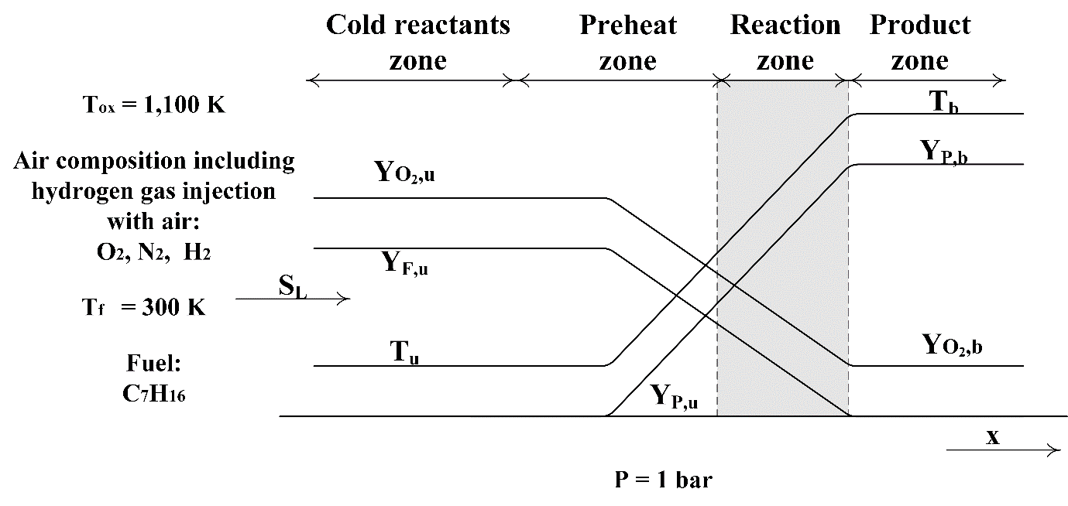
Fig.1 Freely propagating premixed flame configuration.
Fig 1 shows the freely propagating flame configuration which has been used to generate the laminar premixed flamelet database for thermo-chemical variables. The fuel (n-heptane, C₇H₁₆) and oxidiser temperature values were set to 300K and 1,100K respectively. The oxidiser temperature of 1,100K was chosen to represent the engine relevant higher oxidiser temperature towards the end of compression stroke. Here, the fuel-air equivalence ratio for the hydrogen-air mixture is 0.27, which is very lean. The laminar premixed flamelet database is generated by solving the flamelet equations with zero stretch rate.
For the freely propagating laminar premixed flame, fuel and oxidiser enter on the same side. Hence, Dirichlet boundary conditions are imposed on the inlet side;
 | $$Y_{i} \left(s → - ∞\right)=Y_{i,- ∞}, h \left(s → - ∞\right)=h_{- ∞},Z \left(s → -∞\right)=Z_{m},$$ | (10)
and Neumann boundary conditions are imposed on the outlet side:
 | $$\frac{{dY}_{i} }{ds}\left(s → ∞\right)=0, \frac{dh }{ds} \left(s → ∞\right)=0,\frac{dZ }{ds} \left(s → ∞\right)=0.$$ | (11)

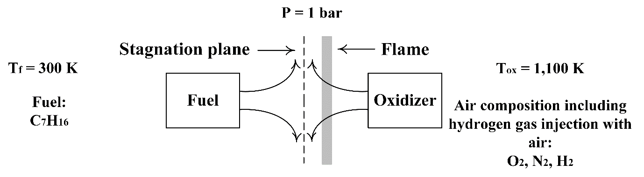
Fig.2 Counter-flow diffusion flame configuration.
Fig. 2 shows the counter-flow configuration employed to produce diffusion flamelets for thermos-chemical variables. The fuel and air temperature values were set to 300K and 1,100K respectively. In a counter-flow diffusion flamelet configuration, the fuel enters from one side, and the oxidiser enters from other side. However, in a diesel-hydrogen DF case, the main fuel (i.e. gaseous hydrogen) is injected via the intake manifold and hence mixes with the oxidiser stream, whereas a small amount of n-heptane pilot fuel is directly injected into the combustion chamber to trigger the combustion. Therefore, in the counter-flow diffusion flame configuration, hydrogen gas is introduced from the air side to represent the homogenous mixture of hydrogen-air, which presents in the combustion chamber before the pilot fuel injection. For the pure diesel case, the diffusion flamelets are generated using the counter-flow configuration in which n-heptane fuel is combusted with air.
For the counter-flow diffusion flame, the boundary conditions imposed on fuel side $\left(s → ∞\right)$ and oxidizer side $\left(s →-∞\right)$ are as follows:
 | $$Y_{i} \left(s → ∞\right)= Y_{i}^{fu} , h \left(s → ∞\right)= h^{fu} , Z \left(s → ∞\right)=1,$$ | (12)

 | $$Y_{i} \left(s → -∞\right)= Y_{i}^{x} , h \left(s → -∞\right)= h^{ox} , Z \left(s → -∞\right)=0,$$ | (13)

The diffusion flame is quenched at a certain strain rate. Thus, the diffusion flamelets are generated over a range of strain rates. Such an effect requires solving an additional transport equation, along with the flamelet equations, to describe the stretch field. This equation reads as:
 | $$\frac{∂}{∂s}\left(ρuK\right)=\frac{∂}{∂s}\left[μ \frac{∂K}{∂s}\right]-2ρK^{2}+ρa^{2},$$ | (14)

where $a$ stands for the applied strain rate at the oxidiser side and $μ$ donates the dynamic viscosity. The chemistry mechanism used in this study is based on n-heptane [52] and hydrogen [53] along with GRI 3.0 mechanism [54] with 48 species and 248 reactions.
Figs. 3 and 4 show non-premixed and premixed manifolds for temperature and species concentrations of OH (hydroxyl), H₂ and H radicals as a function of the mixture fraction and progress variable obtained from the one-dimensional flamelet calculations for the diesel-hydrogen DF test case with 73% HES. The FGM premixed and non-premixed manifolds were obtained using unity and non-unity Lewis number approaches. The FGM non-premixed manifolds were generated using 133 flamelets while FGM premixed manifolds were created using 8 flamelets for a limited mixture fraction range. In premixed flames, the fuel and oxidiser are mixed and the mixture fraction is roughly the constant. Therefore, the premixed flamelet were created for a limited mixture fraction range. As shown in Fig.3, for the laminar diffusion flame, the intermediate and high-temperature zones cover most of the region below the mixture fraction value of 0.2 for the non-unity Lewis number case, indicating a greater rise and wider distribution of the temperature over the domain compared to the unity Lewis number case. This behaviour can be attributed to the high consumption rates of the highly reactive species, which consequently increase the overall chemical reaction rate. For example, for the laminar diffusion flame, the mass fraction of H₂ distribution indicates that the preferential diffusion effects result in a smaller region over the domain, as well as earlier and greater consumption of H₂ below the mixture fraction of 0.15, causing the increase of the flame temperature. It is also observed that the equal-diffusive behaviour of species yields a high production of H₂ due to the restriction of H₂ reactivity for the unity Lewis number case, as opposed to the non-unity Lewis number case. For the H atom, its distributions with and without preferential diffusion effects are relatively similar; however, its production in the unity Lewis number case is greater as a result of the larger production of H₂ along with the restriction of its reactivity. By contrast, the OH radical is located in the high-temperature and high H₂ consumption regions in the diffusion flame and is widely distributed as a results of preferential diffusion effects, indicating the occurrence of higher reaction rates in these regions.
While the laminar diffusion flame shows more clear differences between unity and non-unity Lewis number approaches, the laminar premixed flame shows minor differences between the two approaches. Since we use a threshold value based on the mixture fraction to switch the data between the non-premixed manifold and the premixed manifold, the premixed manifold was created for a region of mixture fraction values equal or lower than 0.01. More details about selection of the threshold value and switching the data between the non-premixed manifold and the premixed manifold will discussion in the next section. In Fig.4 preferential diffusion effects yield a slightly earlier increase of temperature and a greater consumption rate of H₂ in the region of mixture fraction value greater than 0.004. Consequently, this results in earlier productions of OH and H radicals in the same regions in the non-unity Lewis number case. This is due to earlier activation of the chemistry as well as the strong chemical reaction rates throughout the domain owing to the highly diffusive mobility of H₂.
Fig. 5 shows flamelet generated non-premixed manifolds for temperature and species concentrations of OH, H₂ and H radicals as a function of the mixture fraction and progress variable obtained from the one-dimensional flamelet calculations with and without Lewis number effects for the pure diesel (0% HES) case. The non-premixed manifolds were created using 84 flamelets. It can be seen that the distributions of species concentrations of H₂, H and OH for the pure diesel case behave similar to the diesel-hydrogen DF case, but with significantly lower values. Even with the low diffusivity of the diesel-like n-heptane fuel, the temperature manifold of the laminar diffusion flame indicates that the highly diffusive species such as H and H₂ enhance the chemical reactions rates involved with these species, which result in wider high temperature spots and earlier increase of temperature due to preferential diffusion effects.

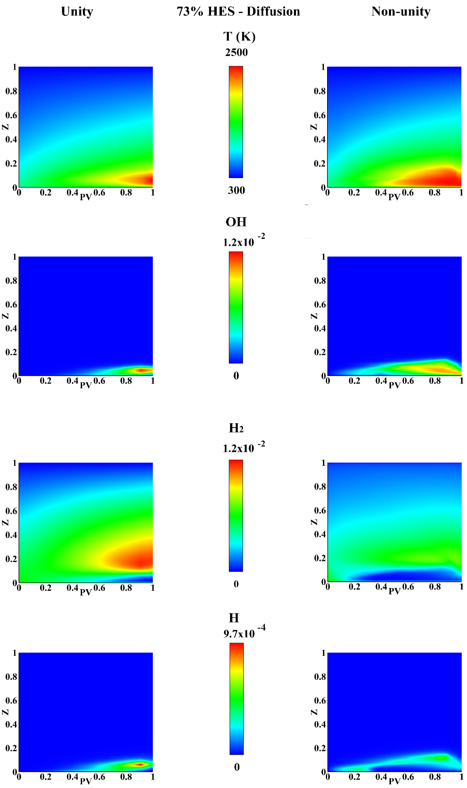

Fig.3. Non-premixed manifolds for temperature, OH, H₂ and H with unity Lewis number (left) and non-unity Lewis number (right) as a function of the mixture fraction and progress variable for the diesel-hydrogen case with 73% HES.
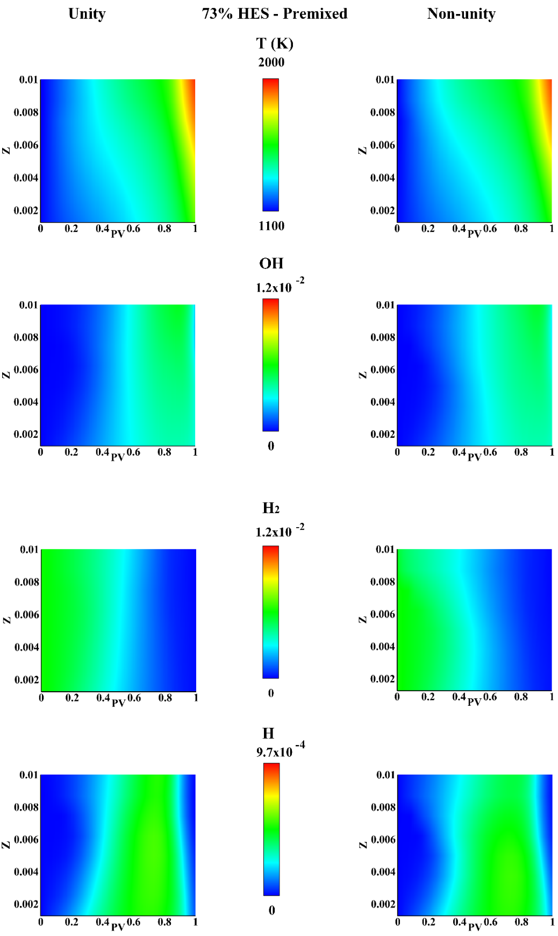
Fig.4. Premixed manifolds for temperature, OH, H₂ and H with unity Lewis number (left) and non-unity Lewis number (right) as a function of the mixture fraction and progress variable for the diesel-hydrogen case with 73% HES.
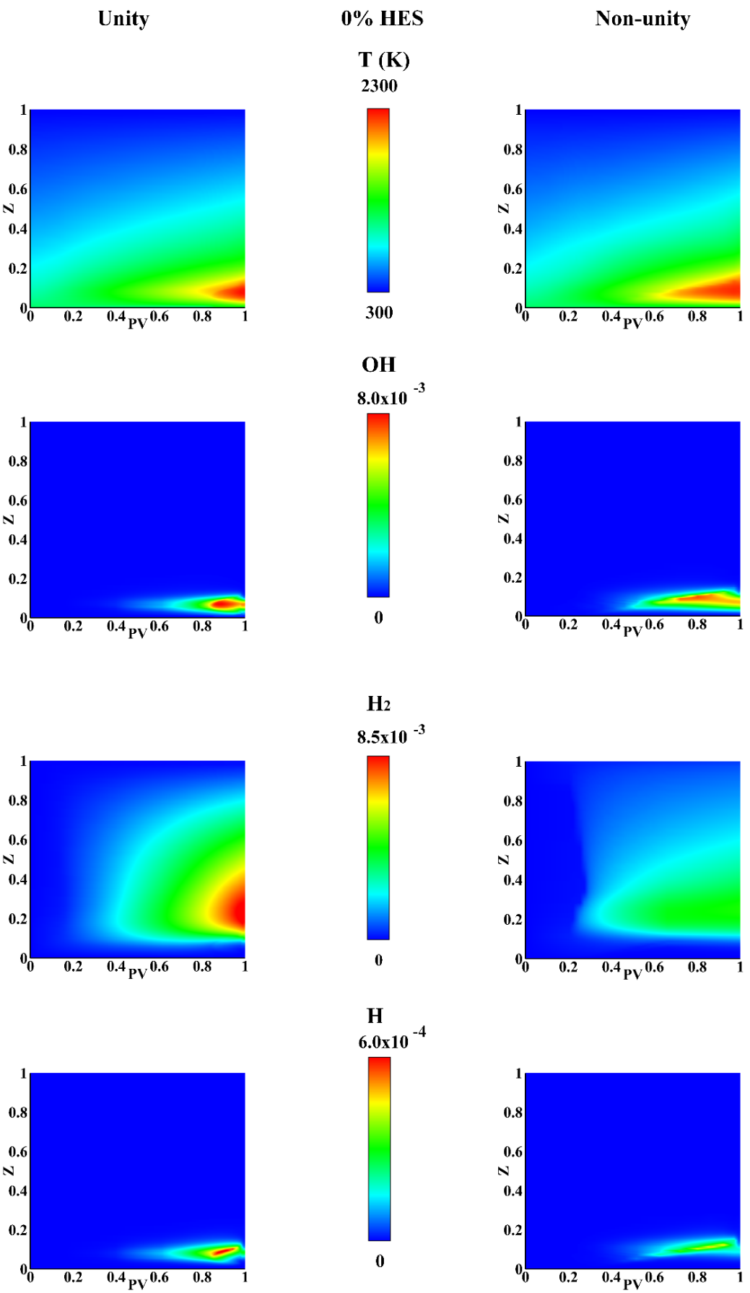
Fig.5 Non-premixed manifolds for temperature, OH, H₂ and H with unity Lewis number (left) and non-unity Lewis number (right) as a function of the mixture fraction and progress variable for the pure diesel case.
To accurately predict the combustion characteristics of the diesel-hydrogen DF flame with high hydrogen energy share, the laminar flamelet databases generated from non-premixed table and premixed table are coupled. A threshold value is used to switch the data between the non-premixed table and premixed table. In this work, we assumed that the flamelets with equal or greater than the mixture fraction value of 0.01 lie inside the spray of the pilot n-heptane fuel (i.e. high gradient of mixture fraction indicating non-premixed combustion), whereas flamelets with the mixture fraction values lower than 0.01 lie outside the spray plume (i.e. low gradient of mixture fraction indicating premixed combustion). The threshold value is selected depending on the mixture fraction value because it represents the quantity of fuel in the mixture. Therefore, in the coupled thermo-chemical database, flamelets with equal or higher value of the mixture fraction threshold are obtained from the laminar non-premixed flame and flamelets with values less than the mixture fraction threshold of 0.01 are obtained from the laminar premixed flame (see Figs. 3 and 4). Thus, the mixing process between the pilot fuel and the oxidiser stream along with the transition from mixing to ignition of the pilot fuel are represented by the mixture fraction and progress variable, respectively, obtained from the diffusion flamelets that were produced from the counter-flow configuration (see Fig. 2). On the other hand, the variation of the pilot fuel in the oxidiser stream along with the chemistry evolution of the premixed charge are represented by the mixture fraction and progress variable, respectively, obtained from the flamelets that were produced from the freely propagating flame configuration (see Fig. 1). To simulate the diesel only combustion, the thermochemical database is generated from FGM non-premixed combustion using the counter-flow diffusion flame configuration. For both diesel-hydrogen dual-fuel case and pure diesel case, the enthalpy is adopted as an additional control variable using Eq. 3 to describe the energy with non-adiabatic effects [55].

2.3. CFD Methodology
In this work, the numerical simulations were performed to model two-phase reacting flow using three-dimensional unsteady Reynolds Averaged Navier-Stokes (URANS) approach. The simulations were carried out using CFD software ANSYS Fluent on the University of Southampton IRIDIS 4 high performance computing cluster. The numerical set up solved the governing equations for mass, momentum, energy and transport equations for mixture fraction, un-normalised reaction progress variable and their variances. Solving the transport equation for the un-normalised reaction progress variable helps to specify the oxidizer boundary conditions more accurately at the oxidizer inlets and, besides, predicting the flame quenching because of reactant dilution [56]. The equations are written as follows:
Mass conservation:
 | $$\frac{∂}{∂t}\left(\overline{ρ}\right)+\frac{∂}{∂x_{i}}\left(ρ{\tilde{u}}_{j}\right)=S_{m}$$ | (15)
Momentum conservation:
 | $$\frac{∂}{∂t}\left(\overline{ρ}{\tilde{u}}_{i}\right)+\frac{∂}{∂x_{j}}\left(ρ{{\tilde{u}}_{i}\tilde{u}}_{j}\right)=-\frac{∂\overline{P}}{∂x_{i}}+\frac{∂}{∂x_{j}}\left({\overline{τ}}_{ij}-\overline{ρ}\tilde{u_{i}^{''}u_{j}^{''}}\right)+ S_{i}$$ | (16)
where
 | $$τ_{ij}=-μ\left[\left(\frac{∂{\tilde{u}}_{i}}{∂x_{j}}+\frac{∂{\tilde{u}}_{j}}{∂x_{i}}\right)-\frac{2}{3}δ_{ij}\frac{∂{\tilde{u}}_{k}}{∂x_{k}}\right]$$ | (17)
Energy conservation:
 | $$\frac{∂}{∂t}\left(\overline{ρ}\overline{h}\right)+\frac{∂}{∂x_{i}}\left(\overline{ρ}{\tilde{u}}_{i}\overline{h}\right)=\frac{∂}{∂x_{i}} \left(\frac{λ}{c_{p}}\frac{∂\overline{h}}{∂x_{i}}\right)+\frac{∂}{∂x_{i}} \left(d_{h}\frac{∂\overline{Y_{c}}}{∂x_{i}}\right)+\overline{\dot{ω_{φ}}}+ S_{h}$$ | (18)
Transport equations of mean mixture fraction, $\overline{ζ}$:and un-normalised progress variable, $\overline{Y_{c}}$:
 | $$\frac{∂}{∂t}\left(\overline{ρ}\overline{φ}\right)+\frac{∂}{∂x_{i}}\left(\overline{ρ}{\tilde{u}}_{i}\overline{φ}\right)=\frac{∂}{∂x_{i}} \left(\left(\frac{λ}{c_{p}}+\frac{μ_{t}}{{Sc}_{t}}\right)\frac{∂\overline{φ}}{∂x_{i}}\right)+\frac{∂}{∂x_{i}} \left(d_{φ}\frac{∂\overline{Y_{c}}}{∂x_{i}}\right)+\overline{\dot{ω_{φ}}}$$ | (19)
Transport equation of mixture fraction variance, $\overline{{ ζ}^{'}}$:
 | $$\frac{∂}{∂t}\left(\overline{ρ}\overline{ζ^{'}}\right)+\frac{∂}{∂x_{i}}\left(\overline{ρ}{\tilde{u}}_{i}\overline{ζ^{'}}\right)=\frac{∂}{∂x_{i}} \left(\left(\frac{λ}{c_{p}}+\frac{μ_{t}}{{Sc}_{t}}\right)\frac{∂\overline{ζ^{'}}}{∂x_{i}}\right)+C_{g}μ_{t}{\left(\frac{∂\overline{ζ^{'}}}{∂x_{i}}\right)}^{2}-C_{d}ρ\frac{ ε }{ k}\overline{ζ^{'}}$$ | (20)

Transport equation of un-normalised progress variable variance, $\overline{Y_{c}^{'}}$:
 | $$\frac{∂}{∂t}\left(\overline{ρ} \overline{Y_{c}^{'}}\right)+ \frac{∂}{∂x_{i}}\left(\overline{ρ}{\tilde{u}}_{i}\overline{Y_{c}^{'}}\right)= \frac{∂}{∂x_{i}} \left(\left(\frac{λ}{c_{p}}+\frac{μ_{t}}{{Sc}_{t}}\right)\frac{∂\overline{Y_{c}^{'}}}{∂x_{i}}\right)+2\overline{ρ}\frac{μ_{t}}{{Sc}_{t}}{\left(\frac{∂\overline{Y_{c}^{'}}}{∂x_{i}}\right)}^{2}-2 \overline{ρ}\frac{ ε }{ k}\overline{Y_{c}^{'}}$$ | (21)

in which $t$ is the time, ${\tilde{u}}_{j}$ stands for a component of the mean velocity vector, $u_{i}^{''}$ stands for a component of the fluctuating velocity vector, $x_{i}$ stands for a component of the position vector, $S_{m}$ stands for the source term accounting for mass added by fuel spray and ${\dot{ω}}_{φ}$ donates the source term of control variables. In addition, $φ$, $P$, $τ_{ij}$, $μ$ and $δ_{ij}$ refer to any control variable, pressure, stress tensor, molecular viscosity, and Kronecker delta, respectively. Moreover, $λ$ is the thermal conductivity, $d_{φ}$ is the preferential diffusion coefficient for the control variables, $μ_{t}$ is turbulent viscosity,$μ$ is laminar viscosity,$S_{i}$ is a component of the body, $S_{h}$ is the source term accounting for any further heat losses , $ε$ is dissipation rate of turbulent kinetic energy, $k$ is turbulent kinetic energy, $c_{p}$ is specific heat capacity of the fluid and ${Sc}_{t}$ is Schmidt number and equal to 0.5. Also, $C_{g}$ and $C_{d}$ are constants with default values of 2.86 and 2 respectively.
The nitric oxide is computed by solving the transport equation:
 | $$\frac{∂}{∂t}\left(\overline{ρ} {\overline{Y}}_{NO}\right)+ \frac{∂}{∂x_{i}}\left(\overline{ρ}{\tilde{u}}_{i}{\overline{Y}}_{NO}\right)= \frac{∂}{∂x_{i}} \left(\overline{ρ}D\frac{∂{\overline{Y}}_{NO}}{∂x_{i}}\right)+{\overline{ω}}_{NO}$$ | (22)

The implementation of preferential diffusion effects in the energy equation and the transport equations of the mixture fraction and progress variable is carried out via the second term (diffusion coefficients) on the on the right hand side of Eq. 18 and Eq. 19. The additional terms are included to compute the diffusion coefficients using the user-defined functions (UDF). To model such an effect by applying the chain rule, the three control variables, mixture fraction, progress variable and enthalpy, ($ζ$,$Y_{c}$,$h$) are assumed to be locally a function of $Y_{c}$, ($ζ$,$h$) $→$ ($ζ^{1D}$,$h^{1D}$). The model for the additional term to incorporate preferential diffusion is first constructed for the progress variable and then generalised for the other two control variables, mixture fraction and enthalpy. Thus, preferential diffusion coefficients,$d_{φ}$, for the three control variables are computed as follows [55]:
Progress variable
 | $d_{c}$ = $\frac{λ}{c_{p}}\sum_{k}^{N_{s}}{\left[α_{k}\left(\frac{1}{{Le}_{k}}-1\right)\left(\frac{∂Y_{k}}{∂Y_{c}}+\frac{∂Y_{k}}{∂h}\frac{dh^{1D}}{dY_{c}}+\frac{∂Y_{k}}{∂ζ}\frac{dζ^{1D}}{dY_{c}}\right)\right],}$ | (23)
Mixture fraction
 | $d_{ζ}$ = $\frac{λ}{c_{p}}\sum_{k}^{N_{s}}{\left[ζ_{k}\left(\frac{1}{{Le}_{k}}-1\right)\left(\frac{∂Y_{k}}{∂Y_{c}}+\frac{∂Y_{k}}{∂h}\frac{dh^{1D}}{dY_{c}}+\frac{∂Y_{k}}{∂ζ}\frac{dζ^{1D}}{dY_{c}}\right)\right],}$ | (24)
Enthalpy
 | $d_{h}$ = $\frac{λ}{c_{p}}\sum_{k}^{N_{s}}{\left[h_{k}\left(\frac{1}{{Le}_{k}}-1\right)\left(\frac{∂Y_{k}}{∂Y_{c}}+\frac{∂Y_{k}}{∂h}\frac{dh^{1D}}{dY_{c}}+\frac{∂Y_{k}}{∂ζ}\frac{dζ^{1D}}{dY_{c}}\right)\right],}$ | (25)
where $\frac{λ}{c_{p}}$ is computed as:
 | $$\frac{λ}{c_{p}}=2.58×{10}^{-5}{\left(\frac{T}{298}\right)}^{0.69},$$ | (26)

Where $ζ_{k}$ is the mixture fraction of species $k$, ${Le}_{k}$ is the Lewis number of species $k$ and $T$ is the temperature.
Here, Eqs. 23-25 are derived based on the assumption that, locally the control variable of the enthalpy is the function of the progress variable. Accordingly, the derivative terms can be evaluated directly in the one-dimensional flamelets assuming that the gradients of the control variables are not independent but are correlated as in the one-dimensional flamelets [50]. As shown in Eqs. 23-25, the only difference in the preferential diffusion coefficient among the three control variables lies in the coefficients of $α_{k}$, $ζ_{k}$ and $h_{k}$. The calculation of $α_{k}$ and $h_{k}$ are computed using Eq. 1 and Eq. 3, respectively. The coefficient $ζ_{k}$ is computed by converting the form of Eq. 2 to the form of Eq. 1 or Eq. 3. The use of this approach to incorporate the preferential diffusion effects is beneficial since the unity Lewis number assumption results in no incorporation of preferential diffusion effects present, as the coefficients are equal to zero $\left(d_{φ}=0\right)$.

Fig.6 Schematic of the look-up table generation procedure. $ϕ$ stands for the thermo-chemical variables.
The turbulence is modelled using the standard $k-ε$ turbulence model, and two additional transport equations were solved, one for the dissipation rate of turbulent kinetic energy,$ε$, and the other for turbulent kinetic energy,$k$. The liquid fuel spray injection is modelled using the discrete phase model. In the discrete phase model (DPM), wall film conditions were applied with the use of Stanton-Rutland impingement/splashing model at the solid boundaries. In the DPM model, the breakup, Kelvin-Helmholtz/Rayleigh-Taylor (KHRT), and stochastic collision models are used to track the injection droplet and predict their interactions with the flow.
The coupling of the FGM combustion model with the CFD flow solver is achieved via mixture fraction, progress variables and enthalpy by means of the probability density function (PDF) to link turbulence and chemistry. This PDF is constructed based on one joint flamelets dataset combining both premixed and non-premixed databases together by replacing the mixture fraction values less than 0.01 part in the non-premixed flamelets with the premixed flamelets. As seen in Fig. 6, the Beta PDF was applied for the mixture fraction and the progress variable, assuming that the mixture fraction and the progress variable are statistically independent. However, to account for the non-adiabatic effects (i.e. heat transfer to walls), the Delta function was convolved for the enthalpy – computed using Eq. 3 –, assuming that the enthalpy fluctuations are negligible.

2.4 Simulation details
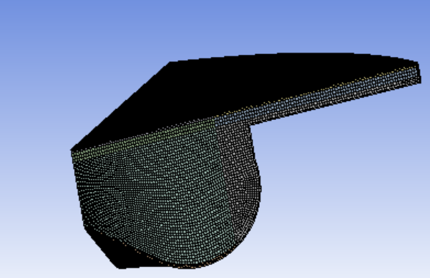
Fig.7 The section of the numerical grid at Top-dead centre (TDC).
All simulations were performed with the aid of three-dimensional geometry discretised with a fine mesh density as shown in Fig.7. A sector of 51.43 degree consisting of one injector, which represents a portion of a full engine with 7 injectors, was created by SOLIDWORK, whereas the meshing process was carried out using Ansys Workbench. The utilisation of sectors significantly reduces the computational costs and is highly applicable owing to the symmetrical injector holes in the combustion chamber. The piston bowl is refined to increase the mesh quality and inflation layers are added to enhance capturing the physics. The mesh type of the sector is predominately hex to decrease the numerical diffusion and increase the computational efficiency. The geometry consists of 1,190,215 elements. Comprehensive study on mesh sensitivity analysis was carried out in our previous study and we found that the present fine mesh well captures the in-cylinder pressure and heat release rate for the simulated test cases [33]. In IC engines, the cylinder volume changes throughout the engine cycle due to the piston movement, and accordingly, the mesh should change. Therefore, the rigid dynamic mesh is used to model the compression and expansion strokes, whereas the dynamic mesh is used due to its importance in determining the position of the boundaries of cell zones with respect to the other boundary of cell zones. The simulations were carried out from intake valve closed (IVC) to exhaust valve open (EVO). The constant temperature boundary condition of 500 K is used for the chamber main and top linear faces as well as the piston linear face. Additionally, a constant temperature of 600 K is applied to the piston bottom face and chamber top face. The periodic boundary conditions are applied over the side faces of the sector. No-slip conditions were prescribed on the solid walls. Hydrogen gas is injected via the intake port injection. For the diesel-hydrogen dual-fuel flame with 73% hydrogen energy share, the fuel-air equivalence ratio for the hydrogen-air mixture is 0.27. The diesel fuel spray is directly injected using the injection profiles employed in our previous simulations for the same test cases [33].

Description | Parameters | Method/Model/Value
Pressure-velocity coupling | Scheme | PISO
Pressure-velocity coupling | Skewness correction | 1
Pressure-velocity coupling | Neighbor correction | 1
Spatial discretisation | Gradient | Green-Gauss Node-based
Spatial discretisation | Pressure | Second order
Spatial discretisation | Density | Second order upwind
Spatial discretisation | Momentum | Second order upwind
Spatial discretisation | Turbulent Kinetic energy | Second order upwind
Spatial discretisation | Turbulent dissipation rate | Second order upwind
Spatial discretisation | Energy | Second order upwind
Spatial discretisation | Progress variable | Second order upwind
Spatial discretisation | Mean mixture fraction | Second order upwind
Spatial discretisation | Mixture fraction variance | Second order upwind
Spatial discretisation | Progress variable variance | Second order upwind
Temporal discretisation | Time | First order implicit
Table 2 Summary of numerical methods employed for the calculation.
The spatial discretisation is carried out using the finite volume method. The simulations are performed using the pressure-based solver. The spatial discretisation is carried out using the second-order UPWIND scheme while the time integration is performed using the first-order implicit scheme. The convergence criteria have been set with residuals of 10⁻⁶ for energy and 10⁻³ for other equations. Table 2 provides a summary of numerical methods employed in this study.

3. Results and discussion
In this study, novel modifications to the flamelet generated manifold combustion model coupling non-premixed combustion mode and premixed combustion mode were carried out to simulate the hybrid combustion process of diesel-hydrogen dual-fuel combustion. The model also incorporated preferential diffusion effects to identify its influence on predicting the combustion characteristics of high hydrogen content dual-fuel combustion process. The importance of considering preferential diffusion effects in the FGM hybrid combustion model to predict the combustion characteristics of high hydrogen content dual-fuel combustion process is demonstrated by comparing numerical simulations with and without Lewis number effects.
The following sections discuss validation of the FGM hybrid model with the experiential data and the role of preferential diffusion on combustion characteristics of high hydrogen content diesel-hydrogen dual-fuel combustion process.

3.1. Model validation
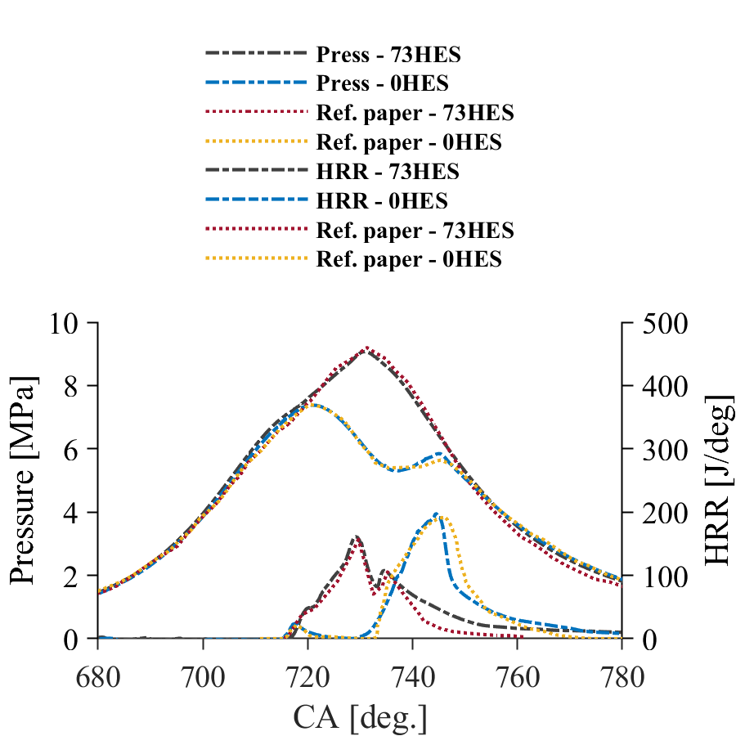
Fig.8 Validation of the FGM hybrid combustion model incorporating preferential diffusion effects. Comparison between experimental [25] and numerically predicted in-cylinder pressure and heat release rate for the diesel-hydrogen DF case with 73% HES and the pure diesel case with 0% HES.
Fig.8 shows a comparison of in-cylinder pressure and HRR between numerical results obtained from the modified FGM hybrid combustion model incorporating preferential diffusion effects and experimental results [25] for the pure diesel case ( 0% HES) and diesel-hydrogen dual-fuel case (73% HES). The computational and experimental findings during the compression, combustion and expansion strokes are in good agreements. For both cases, the numerically predicted in-cylinder pressure profiles compared well with the experimental data during compression, combustion and expansion. The in-cylinder pressure distribution indicates only minor differences for the peak pressure values and their crank angles (CA) between numerical predictions and the experimental data. For example, for the pure diesel case (0% HES) case, the first peak value is well predicted, whereas the second peak value is over-predicted by 0.11 MPa. For the diesel-hydrogen DF case (73% HES), the peak pressure value is under-predicted by 0.13 MPa and occurs slightly early by 0.5 CA. Furthermore, the in-cylinder pressure curves indicate that the peak pressure increases from 7 MPa for diesel only combustion to 9 MPa for diesel-hydrogen DF combustion which is about 28% increase in peak pressure when operate the engine with substantial hydrogen addition compared to diesel only operation.
From Fig. 8 it is seen that the peak HRR is over-predicted by 5.52 J and 4.31 J and also advanced by 1.63 CA and 1 CA for the pure diesel case and diesel-hydrogen case respectively. The HRR curve shows two major peaks for the DF flame with hydrogen addition while it shows only one major peak for the diesel only case. For the second peak for the DF flame, the calculated maximum pressure value is over-predicted by 3.1 J and occurs slightly later (0.76 CA) than the experimental value. In addition, the rate of HRR increase displays minor discrepancy between predicted and measured values in both cases. For example, numerically predicted rate of HRR increase is lower for the pure diesel case and higher for the diesel-hydrogen DF case compared to experimentally measured curves. These discrepancies may occur due to the auto-ignition characteristics of diesel only and diesel-hydrogen DF flames. Particularly, the addition of hydrogen results in fast reaction rate in the vicinity of the diesel pilot auto-ignition spots, hence influences the auto-ignition characteristics [57]. Also, the rate of HRR fall off is lower in predictions, which may be attributed to wall heat transfer. In general, the minor differences between numerical results and the experimental data may be attributed to several reasons, for example, the reduced chemistry mechanisms employed in CFD calculations, uncertainty of the theoretically calculated compression ratio etc. For example, the theoretically calculated compression ratio may slightly differ from the real compression rate. Therefore, it results in the over and/or under-predictions of in-cylinder pressure and HRR [58].

3.2. The role of preferential diffusion on combustion characteristics of hydrogen blended dual-fuel combustion
The intention of this section is to clarify the role of preferential diffusion during auto-ignition, combustion and flame propagation stages in a high hydrogen content diesel-hydrogen DF combustion engine. In this section, we compare the numerically predicted combustion characteristics between unity and non-unity Lewis number approaches to demonstrate the role of preferential diffusion during ignition and combustion in a high hydrogen content diesel-hydrogen DF engine. The effects of preferential diffusion on in-cylinder pressure, temperature, heat release rate, radical species concentrations, NOx emissions and auto-ignition delay response are analysed by comparing numerical results between unity and non-unity Lewis number approaches.
It is important to note that preferential diffusion effects are implemented using a two-step correction: non-unity Lewis number effects in the flamelet calculation using the mixture-averaged transport model and additional diffusion coefficients in the transport equations for the control variables. We found that only considering non-unity Lewis number effects in the flamelet calculation under-predict the peak values of the in-cylinder pressure and HRR. For example, Fig. 9 clearly shows that the FGM hybrid combustion model incorporating preferential diffusion effects in the flamelet calculation and the transport equations of the control variables (i.e. two-step correction) better captures the experimentally measured in-cylinder pressure and HRR profiles of diesel-hydrogen DF combustion with high accuracy compared to numerical results obtained from FGM hybrid combustion model incorporating preferential diffusion effects in the flamelet calculation only. This finding suggests that a two-step correction is needed for the proposed FGM hybrid combustion model to better capture preferential diffusion effects for hydrogen blended DF combustion modelling.
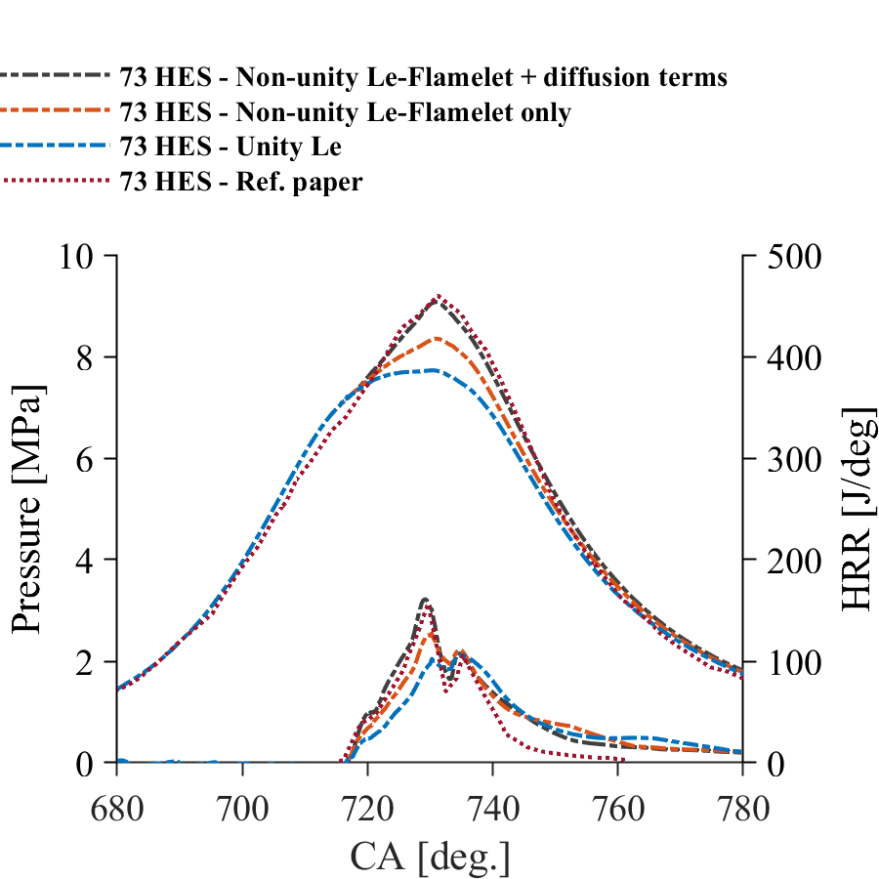
Fig.9 Comparison of in-cylinder pressure and heat release rate between non-unity Lewis number approach in the flamelet calculation and diffusion coefficients in the transport equations of the control variable, non-unity Lewis number approach in the flamelet calculation only, Unity-Lewis number approach, and the experimental data for the diesel-hydrogen DF case with 73% HES.

In-cylinder pressure and heat release rate
Fig.10 represents the in-cylinder pressure, and HRR between unity and non-unity Lewis number approaches for pure diesel and diesel-hydrogen DF cases. It is evident from Fig. 10 that the potential of preferential diffusion effects is significantly demonstrated in the DF case compared to the pure diesel case. For the pure diesel case, preferential diffusion does not play a major role in predicting in-cylinder pressure and HRR profiles due to nature of non-premixed combustion and slow diffusivity of diesel like N-heptane fuel. For example, we observed very minor differences for the peak pressure and peak HRR between unity and non-unity Lewis number approaches for the pure diesel case.
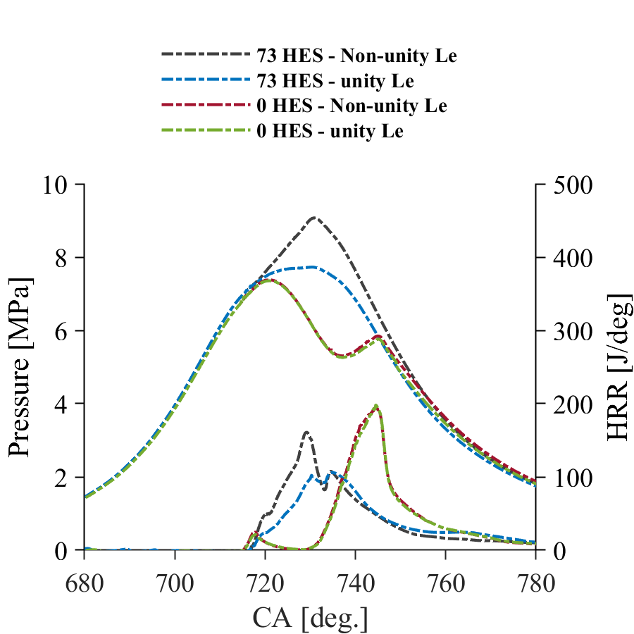
Fig.10 Comparison of in-cylinder pressure and heat release rate between non-unity Lewis number approach and Unity-Lewis number approach for the diesel-hydrogen DF case with 73% HES and the pure diesel case with 0% HES.
On the other hand, it is obvious that in Fig. 10 preferential diffusion plays a major role in predicting in-cylinder pressure and HRR profiles for diesel-hydrogen DF combustion. Both pressure and HRR profiles indicate that addition of hydrogen has an apparent effect on diesel combustion. This trend has been demonstrated by a sharp increase in peak in-cylinder pressure and peak HRR which is well captured by the FGM hybrid combustion model with preferential effects compared to the one without preferential diffusion effects. For example, there is a clear gap in peak in-cylinder pressure and peak HRR values between unity and non-unity Lewis number approaches which is about 1.34 MPa and 55.15 J for pressure and HRR respectively. Fig. 10 also revealed that the introduction of hydrogen leads to an early start of combustion compared to the pure diesel case which is well captured by the FGM hybrid model with preferential diffusion effects. The early start of combustion leads to high in-cylinder pressure for the diesel-hydrogen DF case compared to the pure diesel case. Also the rate of increase of HRR is greater for the non-unity Lewis number approach compared to the unity Lewis number approach for the diesel-hydrogen DF case.
Furthermore, the presence of hydrogen has a more pronounced effect on the peak values of HRR which are better captured by the FGM hybrid model with preferential diffusion effects. For example, the HRR profile obtained from the non-unity Lewis number approach exhibits two major peaks in HRR throughout for the DF flame. For the simulated DF flame with preferential diffusion effects, a first peak in HRR is located around 727 CA followed by a period of drop in HRR, beyond which there is an increase in HRR resulting in a second peak at around 735 CA. The first major peak in HRR at around 727 CA is characterised by the activation of high temperature chemistry with the influence of ambient hydrogen in the vicinity of the diesel fuel spray tip [59]. During this stage, the high temperature combustion chemistry of light radicals such as H and OH due to ignition of hydrogen along with preferential diffusion effects play an important role. The addition of hydrogen increases the productions of light radicals, and the incorporation of preferential diffusion effects result in considerable impacts of their distributions throughout the combustion chamber. The radicals such as H and OH are highly reactive species, enhancing the in-cylinder pressure, HRR, flame temperature and ignition delay. Furthermore, at this stage, the high diffusivity of hydrogen leads to increase the intrinsic flame instabilities such as thermo-diffusive instability which occurs due to due to an imbalance between chemical and sensible enthalpy fluxes from the reaction zone as a result of preferential diffusion (non-unity Lewis number) effects [41]. The impact of thermo-diffusive instability plays an important role in the ignition and combustion of diesel-hydrogen DF combustion process when lean hydrogen start to ignite and burn [59-61].
Beside the thermo-diffusive instability, the gas expansion known as hydrodynamic instability also plays a role and enhances the flame acceleration. The FGM hybrid model incorporating preferential diffusion effects in flame chemistry and transport equations of control variables was able to adequately predict the first major peak in HRR profile of diesel-hydrogen DF combustion with high hydrogen energy share as compared to the FGM hybrid model without preferential diffusion effects. The second major peak in HRR is represented by the oxidation of available hydrogen and premixed flame initiation [59]. This peak in HRR has been captured by the FGM hybrid model with and without preferential diffusion effects.

In-cylinder temperature
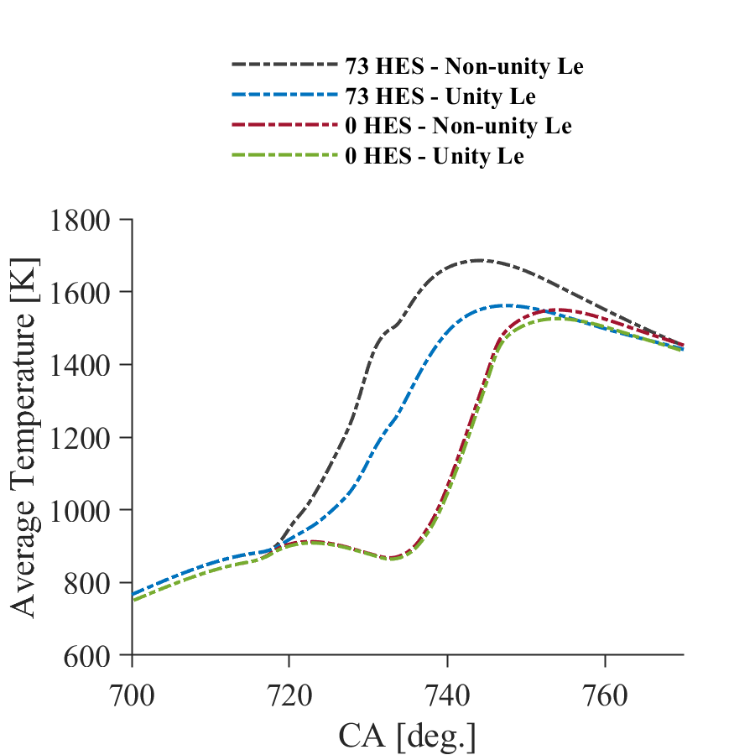
Fig.11 Comparison of the average in-cylinder temperature between non-unity Lewis number approach and Unity Lewis number approach for the diesel-hydrogen DF case with 73% HES and the pure diesel case with 0% HES.
Fig. 11 shows the average in-cylinder temperature for the diesel-hydrogen DF case and the pure diesel case with unity and non-unity Lewis number approaches. As seen from the in-cylinder pressure and HRR profiles, preferential diffusion effects the average temperature for the diesel-hydrogen DF case compared to the pure diesel case. The predicted results obtained from the FGM hybrid model with preferential diffusion effects show gradual increase of the average in-cylinder temperature during ignition, combustion and expansion compared to predictions obtained from the FGM hybrid model without preferential diffusion effects. As preferential diffusion effects the flame acceleration and radical species diffusive flux such as H and OH [41], the predicted average temperature curve shows higher temperature values and steep gradient for the non-unity Lewis number approach compared to the unity Lewis number approach. There is a clear difference for the peak temperature between the two approaches. The non-unity Lewis number approach shows higher peak temperature compared to the unity Lewis number approach due to the influence of preferential diffusion. This is linked with the high temperature combustion chemistry of light radical species such as H and OH. The radicals of H and OH will be discussed in the next section. Furthermore, the heat loss to walls seems to be slightly greater with the presence of preferential diffusion effects since the rate of temperature drop during the expansion stoke is steadily higher than that of the unity Lewis number case. For the pure diesel case, the average temperature is slightly greater with the incorporation of preferential diffusion effects, indicating that the effects of the highly reactive species are likely to dominate over the effects of low diffusivity of the diesel like N-heptane fuel.

Contour plots of temperature and species concentrations
The spatial distributions of in-cylinder temperature and unburned H₂, radicals such as OH and H and NO_{x} emissions at 730 CA and 750 CA for the diesel-hydrogen DF case with unity- and non-unity Lewis number approaches are shown in Fig.12. The contour plots of the diesel-hydrogen DF case indicate obvious differences between unity- and non-unity Lewis number approaches, demonstrating the role of preferential diffusion effects on in-cylinder flame temperature and key emissions associated with hydrogen combustion. For example, at 730 CA, which is about 12 CA after start of combustion (SOC), the flame propagates faster for the non-unity Lewis case as it distributes in a wider range and, also, its maximum temperature is greater in comparison with the unity Lewis number case. Particularly, at 730 CA which is predominately a diffusion controlled combustion in the DF flame, the flame temperature is higher for the non-unity Lewis number case compared to the unity Lewis number case, because the auto-ignition of pilot diesel fuel facilitates hydrogen to burn much faster in the vicinity of the diesel spray due to preferential diffusion effects. The contour plots of unburned hydrogen and radical H further support this observation which are discussed below. The same observations are also displayed at the end of combustion (EOC) - at 750 CA– for example, wider flame distribution with higher temperature for the simulated DF case with preferential diffusion effects compared to the one without preferential diffusion effects. This can be attributed to the faster flame front propagation of the hydrogen-air mixture during the premixed combustion mode in the DF flame owing to preferential diffusion effects, which greatly enhances the reaction rates and, hence, yields broader distributions of high and intermediate temperature spots. In contrast, the high flame temperature of the unity Lewis number case is narrower near the pilot fuel zone and becomes wider until roughly the middle of the geometry at 750 CA.
The effect of preferential diffusion is clearly demonstrated in the contour plot of unburned hydrogen gas. For example, at 730 CA, the rate of hydrogen consumption is higher for the non-unity Lewis number case, indicating greater reactivity rates. Furthermore, at 750 CA, the high hydrogen concentration is localised in a narrow region close to the cylinder wall for the non-unity Lewis number case, indicating faster turbulent flame propagation of the hydrogen premixed change compared to the unity Lewis number case. However, due to the slower flame propagation speed, the high hydrogen spots for the unity Lewis number case are centralised near the cylinder wall and the piston bowl.
For H and OH radicals, their maximum values and distributions appear to be wider with the presence of preferential diffusion effects, indicating that such effects promote the chemical reaction rates thus forming these highly reactive radicals in a wider area of the combustion chamber. These radicals significantly affect the SOC and EOC which will be discussed in the following section. Regarding NOx emission, its medium and high zones are more prevalent with preferential diffusion effects due to the higher consumption rate of hydrogen, which results in faster flame propagation throughout the combustion chamber and higher combustion temperatures.
These observations demonstrate that the effects of preferential diffusion results in (i) higher hydrogen consumption rate, (ii) higher and wider flame temperature distributions and faster flame propagation, (iii) wider formations of the light radicals such as OH and H, indicating higher chemical reaction rates and faster combustion process, respectively, for the diesel-hydrogen DF case.
Fig. 13 shows the spatial distribution of temperature, OH and NO_{x} emissions for the pure diesel case with unity and non-unity Lewis number approaches. Generally, there are some minor differences between the two approaches. For example, at 750 CA, the distribution of highest OH and NO_{x} emission slightly wider for the non-unity Lewis number approach compared to the unity Lewis number approach. Their causes may lie in the domination of highly reactive radicals at the end of combustion due to the diesel-like fuel, which results in slightly higher in-cylinder temperature.

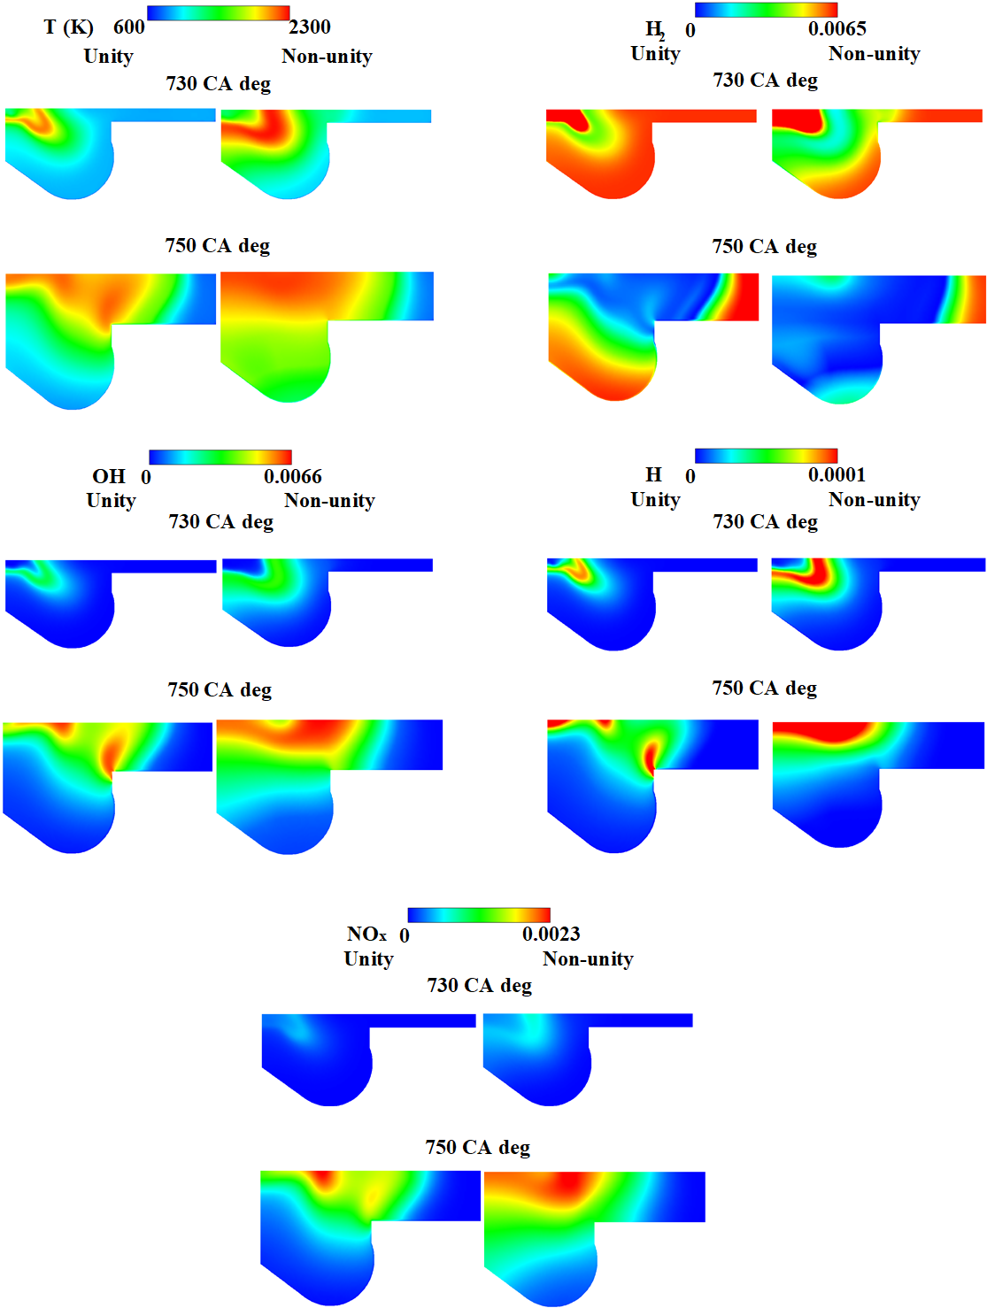
Fig.12. Contour plots of temperature, H₂, OH, H and NOx distributions at 730 CA and 750 CA between non-unity Lewis number approach and Unity Lewis number approach for the diesel-hydrogen DF case with 73% HES.
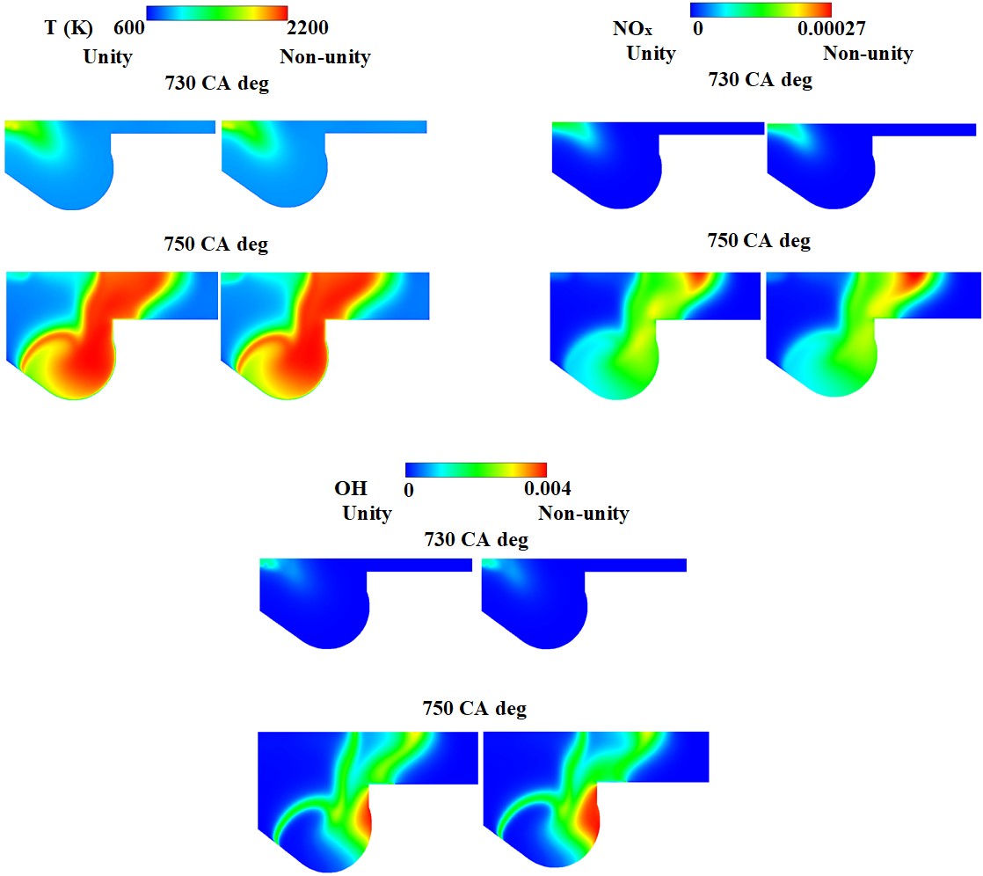
Fig.13. Contour plots of temperature, OH and NOx distributions at 730 CA and 750 CA between non-unity Lewis number approach and Unity Lewis number approach for the pure diesel case with 0% HES.

Ignition delay and combustion duration
Fig. 14 shows the effects of preferential diffusion on ignition delay and combustion duration for the diesel-hydrogen DF case and the pure diesel case. Here, the ignition delay is defined as the period from the start of injection (SOI) to SOC. The SOC can be evaluated from the total heat release rate (THRR) [62] or the rate of pressure rise variation [63]. In this work, SOC is computed as 3% of the THRR [62]. The combustion duration is the period from the SOC to EOC, which is 90% of THRR [61].
Fig. 14 (a) exhibits that the incorporation of preferential diffusion effects slightly advances the SOC for the diesel-hydrogen DF case compared to the one without preferential diffusion effects. This has resulted in the shorter ignition delay for the DF case with non-unity Lewis number approach compared to the unity Lewis number approach. This advancement in the SOC is caused by the higher temperature chemistry and faster flame propagation of the hydrogen-air mixture in the immediate vicinity of the diesel pilot spray due to preferential diffusion effects, which increase the overall combustion rate and the flame temperature. In addition, the highly reactive radicals such as OH and H are evident to increase due to preferential diffusion effects (see Fig.12) and enhance the combustion and flame propagation in the high hydrogen content DF case [62]. These radical species have significant effects on fuel ignition and combustion chemistry due to their high diffusivities. Thus, with preferential diffusion effects, their broader distributions as shown in Fig. 12 primarily enhance combustion by promoting the chain of chemical reactions and increasing the overall combustion rates. For the same reason, the diesel-hydrogen DF case with non-unity Lewis number approach has a shorter combustion duration as opposed to that of the unity Lewis number case by 15.7 CA. As shown in Fig. 14 (b), the incorporation of preferential diffusion effects does not play a major role for the pure diesel case as the ignition delay and the combustion duration are almost the same between unity- and non-unity Lewis number approaches. Furthermore, Fig. 14 (a) and (b) demonstrate that the ignition delay time is longer for the diesel-hydrogen DF case compared to the pure diesel case.

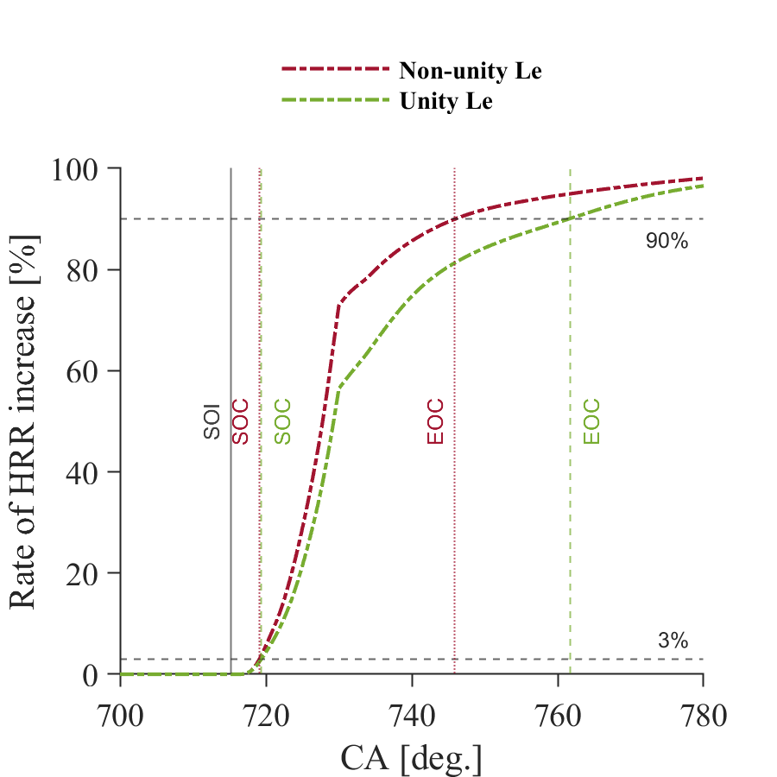
a
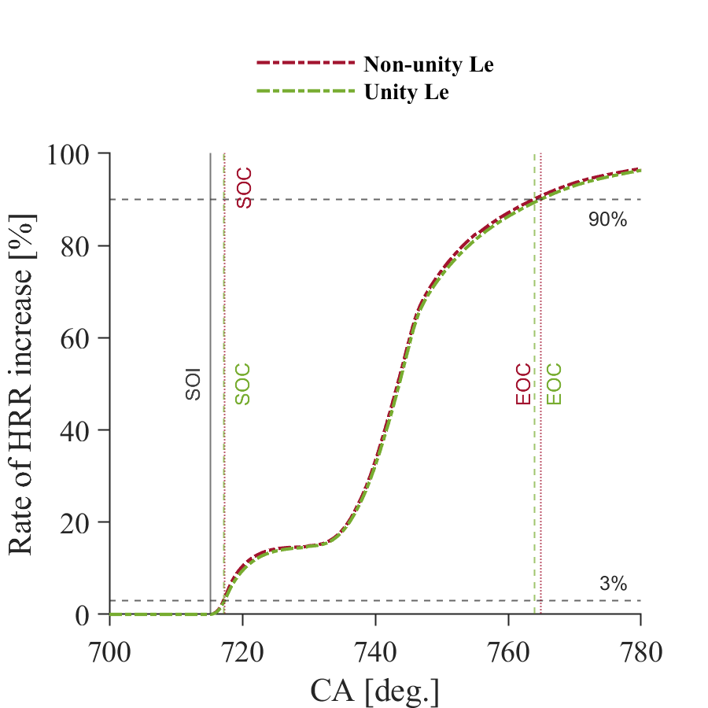
b
Fig.14 Ignition delay and combustion duration for the simulated cases with and without preferential diffusion effects, a) diesel-hydrogen DF case with 73% HES. b) pure diesel case with 0% HES.

4. Conclusions
In this study, a novel flamelet generated manifold hybrid combustion model incorporating preferential diffusion effects was applied to better capture the complex multiple combustion process of a hydrogen-blended diesel-hydrogen dual-fuel combustion engine. The FGM hybrid combustion model was developed by coupling flamelet databases obtained from diffusion flamelets and premixed flamelets. The model employed three control variables, namely, mixture fraction, reaction progress variable and enthalpy. The diffusion flamelet database was employed to capture the auto-ignition of the diesel pilot fuel with air and with the presence of hydrogen gas in the vicinity of the auto-ignition spots while the premixed flamelet database was used to predict the flame propagation of the premixed hydrogen-air mixture. A threshold value based on the mixture fraction was used to switch the data between diffusion flamelets and premixed flamelets. The preferential diffusion effects were accounted in the laminar flamelet solution and the diffusion coefficients in the transport equations of control variables. The numerical simulations were performed using the Reynolds-averaged Navier-Stokes approach. The simulations are based on the diesel-hydrogen dual-fuel engine configuration of Tsujimura et al. [25], enabling validation of the proposed FGM hybrid combustion model against experimental data on the in-cylinder parameters. We compared results for the diesel-hydrogen dual-fuel test case with 73% hydrogen energy share and pure diesel case at high engine load conditions. In order to demonstrate preferential diffusion effects, the simulations were carried out with unity- and non-unity Lewis number approaches.
The main findings of the study are listed in the following:
- The comparison between numerical results and the experimental data demonstrates that the FGM hybrid combustion model incorporating preferential diffusion effects well captures the combustion characteristics of the high hydrogen content diesel-hydrogen dual-fuel combustion process with high accuracy. The inclusion of preferential diffusion effects in the laminar flamelet calculation and the diffusion coefficients in the transport equations of control variables was shown to have significant effects on capturing all phases of the high hydrogen content dual-fuel combustion process.
- The analysis of in-cylinder pressure and heat release rate profiles indicates that addition of hydrogen has an apparent effect on diesel combustion. The sharp increase in in-cylinder pressure and early start of combustion are well predicted by the FGM hybrid combustion model with preferential diffusion effects. The occurrence of major peak heat release rate values due to activation of the high temperature chemistry with the influence of ambient hydrogen in the vicinity of the diesel fuel spray tip and the oxidation of available hydrogen under partially premixed combustion, as well as subsequent premixed combustion of the hydrogen-air mixture are better captured by the FGM hybrid model with preferential diffusion effects.
- The FGM hybrid combustion model with preferential diffusion effects predicts higher peak in-cylinder combustion temperature due to faster flame propagation of the premixed charge and high temperature combustion chemistry of light radical species such as H and OH. The consumption rate of hydrogen is much greater for the non-unity Lewis number approach owing to higher diffusivity rate which is better captured by the FGM hybrid model with preferential diffusion effects. The numerical results obtained with non-unity Lewis number approach show wider distribution of H and OH radicals, indicating high reactivity of light radicals. The NO_{x} emission is widely distributed in the non-unity Lewis number approach in comparison with that of unity Lewis number approach as a result of broader high and intermediate temperature values, which are caused by the faster hydrogen consumption rate.
- The preferential diffusion effects slightly advance the start of combustion for the dual-fuel case. This has resulted in the shorter ignition delay for the dual-fuel case with the non-unity Lewis number approach compared to the unity Lewis number approach. The advancement in the start of combustion is caused by the higher temperature chemistry and faster flame propagation of hydrogen-air mixture in the immediate vicinity of the diesel pilot spray due to preferential diffusion effects, which increase the overall combustion rate and the flame temperature. For the same reason, the diesel-hydrogen dual-fuel case with non-unity Lewis number approach has a shorter combustion duration compared to that of the unity Lewis number approach. The numerical results also demonstrate that the ignition delay time is longer for the diesel-hydrogen dual-fuel case compared to the pure diesel case.

References
[1] Kamimoto T , Kobayashi H. Combustion processes in diesel engines. Progress in Energy and Combustion Science. 1991;17(2):163-89. https://doi.org/10.1016/0360-1285(91)90019-J.
[2] Reitz RD , Rutland CJ. Development and testing of diesel engine CFD models. Progress in Energy and Combustion Science. 1995;21(2):173-96. https://doi.org/10.1016/0360-1285(95)00003-Z.
[3] Johnson TV. Diesel Emissions in Review. SAE International Journal of Engines. 2011;4(1):143-57. https://doi.org/10.4271/2011-01-0304.
[4] Tree DR , Svensson KI. Soot processes in compression ignition engines. Progress in Energy and Combustion Science. 2007;33(3):272-309. https://doi.org/10.1016/j.pecs.2006.03.002.
[5] Reşitoğlu İ. The pollutant emissions from diesel engine vehicles and exhaust aftertreatment systems. Clean Technologies and Environmental Policy. 2015;17:15–27. https://doi.org/10.1007/s10098-014-07939.
[6] Anwar S, Khan F, Zhang Y , Djire A. Recent development in electrocatalysts for hydrogen production through water electrolysis. International Journal of Hydrogen Energy. 2021;46(63):32284-317. https://doi.org/10.1016/j.ijhydene.2021.06.191.
[7] Shiva Kumar S , Himabindu V. Hydrogen production by PEM water electrolysis – A review. Materials Science for Energy Technologies. 2019;2(3):442-54. https://doi.org/10.1016/j.mset.2019.03.002.
[8] Midilli A, Kucuk H, Topal ME, Akbulut U , Dincer I. A comprehensive review on hydrogen production from coal gasification: Challenges and Opportunities. International Journal of Hydrogen Energy. 2021;46(50):25385-412. https://doi.org/10.1016/j.ijhydene.2021.05.088.
[9] Barelli L, Bidini G, Gallorini F , Servili S. Hydrogen production through sorption-enhanced steam methane reforming and membrane technology: A review. Energy. 2008;33(4):554-70. https://doi.org/10.1016/j.energy.2007.10.018.
[10] Green L. An ammonia energy vector for the hydrogen economy. International Journal of Hydrogen Energy. 1982;7(4):355-9. https://doi.org/10.1016/0360-3199(82)90128-8.
[11] Bell TE , Torrente-Murciano L. H2 Production via Ammonia Decomposition Using Non-Noble Metal Catalysts: A Review. Topics in Catalysis. 2016;59(15):1438-57. https://doi.org/10.1007/s11244-016-0653-4.
[12] Verhelst S , Wallner T. Hydrogen-fueled internal combustion engines. Progress in Energy and Combustion Science. 2009;35(6):490-527. https://doi.org/10.1016/j.pecs.2009.08.001.
[13] Hosseini SM , Ahmadi R. Performance and emissions characteristics in the combustion of co-fuel diesel-hydrogen in a heavy duty engine. Applied Energy. 2017;205:911-25. https://doi.org/10.1016/j.apenergy.2017.08.044.
[14] Sánchez AL , Williams FA. Recent advances in understanding of flammability characteristics of hydrogen. Progress in Energy and Combustion Science. 2014;41:1-55. https://doi.org/10.1016/j.pecs.2013.10.002.
[15] Akal D, Öztuna S , Büyükakın MK. A review of hydrogen usage in internal combustion engines (gasoline-Lpg-diesel) from combustion performance aspect. International Journal of Hydrogen Energy. 2020;45(60):35257-68. https://doi.org/10.1016/j.ijhydene.2020.02.001.
[16] Chintala V , Subramanian KA. A comprehensive review on utilization of hydrogen in a compression ignition engine under dual fuel mode. Renewable and Sustainable Energy Reviews. 2017;70:472-91. https://doi.org/10.1016/j.rser.2016.11.247.
[17] Dimitriou P , Tsujimura T. A review of hydrogen as a compression ignition engine fuel. International Journal of Hydrogen Energy. 2017;42(38):24470-86. https://doi.org/10.1016/j.ijhydene.2017.07.232.
[18] Yip HL, Srna A, Yuen ACY, Kook S, Taylor RA, Yeoh GH, et al. A Review of Hydrogen Direct Injection for Internal Combustion Engines: Towards Carbon-Free Combustion. Applied Sciences. 2019;9(22):4842. https://doi.org/10.3390/app9224842.
[19] Saravanan N, Nagarajan G, Sanjay G, Dhanasekaran C , Kalaiselvan KM. Combustion analysis on a DI diesel engine with hydrogen in dual fuel mode. Fuel. 2008;87(17):3591-9. https://doi.org/10.1016/j.fuel.2008.07.011.
[20] Gatts T, Li H, Liew C, Liu S, Spencer T, Wayne S, et al. An experimental investigation of H2 emissions of a 2004 heavy-duty diesel engine supplemented with H2. International Journal of Hydrogen Energy. 2010;35(20):11349-56. https://doi.org/10.1016/j.ijhydene.2010.06.056.
[21] Lilik GK, Zhang H, Herreros JM, Haworth DC , Boehman AL. Hydrogen assisted diesel combustion. International Journal of Hydrogen Energy. 2010;35(9):4382-98. https://doi.org/10.1016/j.ijhydene.2010.01.105.
[22] Zhou JH, Cheung CS , Leung CW. Combustion, performance, regulated and unregulated emissions of a diesel engine with hydrogen addition. Applied Energy. 2014;126:1-12. https://doi.org/10.1016/j.apenergy.2014.03.089.
[23] Deb M, Paul A, Debroy D, Sastry GRK, Panua RS , Bose PK. An experimental investigation of performance-emission trade off characteristics of a CI engine using hydrogen as dual fuel. Energy. 2015;85:569-85. https://doi.org/10.1016/j.energy.2015.03.108.
[24] Karagöz Y, Güler İ, Sandalcı T, Yüksek L , Dalkılıç AS. Effect of hydrogen enrichment on combustion characteristics, emissions and performance of a diesel engine. International Journal of Hydrogen Energy. 2016;41(1):656-65. https://doi.org/10.1016/j.ijhydene.2015.09.064.
[25] Tsujimura T , Suzuki Y. The utilization of hydrogen in hydrogen/diesel dual fuel engine. International Journal of Hydrogen Energy. 2017;42(19):14019-29. https://doi.org/10.1016/j.ijhydene.2017.01.152.
[26] Dimitriou P, Tsujimura T , Suzuki Y. Low-load hydrogen-diesel dual-fuel engine operation – A combustion efficiency improvement approach. International Journal of Hydrogen Energy. 2019;44(31):17048-60. https://doi.org/10.1016/j.ijhydene.2019.04.203.
[27] Lee C-f, Pang Y, Wu H, Hernández JJ, Zhang S , Liu F. The optical investigation of hydrogen enrichment effects on combustion and soot emission characteristics of CNG/diesel dual-fuel engine. Fuel. 2020;280:118639. https://doi.org/10.1016/j.fuel.2020.118639.
[28] Liew C, Li H, Liu S, Besch MC, Ralston B, Clark N, et al. Exhaust emissions of a H2-enriched heavy-duty diesel engine equipped with cooled EGR and variable geometry turbocharger. Fuel. 2012;91(1):155-63. https://doi.org/10.1016/j.fuel.2011.08.002.
[29] Liu X, Wang H, Zheng Z , Yao M. Numerical investigation on the combustion and emission characteristics of a heavy-duty natural gas-diesel dual-fuel engine. Fuel. 2021;300:120998. https://doi.org/10.1016/j.fuel.2021.120998.
[30] Tripathi G, Sharma P, Dhar A , Sadiki A. Computational investigation of diesel injection strategies in hydrogen-diesel dual fuel engine. Sustainable Energy Technologies and Assessments. 2019;36:100543. https://doi.org/10.1016/j.seta.2019.100543.
[31] Frankl S , Gleis S. Development of a 3D-Computational Fluid Dynamics Model for a Full Optical High-Pressure Dual-Fuel Engine. SAE International Journal of Engines. 2020;13(2):241-52. https://doi.org/10.4271/03-13-02-0017.
[32] Tekgül B, Kahila H, Kaario O , Vuorinen V. Large-eddy simulation of dual-fuel spray ignition at different ambient temperatures. Combustion and Flame. 2020;215:51-65. https://doi.org/10.1016/j.combustflame.2020.01.017.
[33] Ramsay CJ, Dinesh KKJR, Fairney W , Vaughan N. A numerical study on the effects of constant volume combustion phase on performance and emissions characteristics of a diesel-hydrogen dual-fuel engine. International Journal of Hydrogen Energy. 2020;45(56):32598-618. https://doi.org/10.1016/j.ijhydene.2020.09.021.
[34] Liu J, Guo Q, Guo J , Wang F. Optimization of a diesel/natural gas dual fuel engine under different diesel substitution ratios. Fuel. 2021;305:121522. https://doi.org/10.1016/j.fuel.2021.121522.
[35] Jafarmadar S. Exergy analysis of hydrogen/diesel combustion in a dual fuel engine using three-dimensional model. International Journal of Hydrogen Energy. 2014;39(17):9505-14. https://doi.org/10.1016/j.ijhydene.2014.03.152.
[36] Wang Z, Zhang F, Xia Y, Wang D, Xu Y , Du G. Combustion phase of a diesel/natural gas dual fuel engine under various pilot diesel injection timings. Fuel. 2021;289:119869. https://doi.org/10.1016/j.fuel.2020.119869.
[37] An H, Yang WM, Maghbouli A, Li J, Chou SK , Chua KJ. A numerical study on a hydrogen assisted diesel engine. International Journal of Hydrogen Energy. 2013;38(6):2919-28. https://doi.org/10.1016/j.ijhydene.2012.12.062.
[38] Wu N, McTaggart-Cowan GP, Bushe WK , Davy MH. Effects of Hydrogen Addition on High-Pressure Nonpremixed Natural Gas Combustion. Combustion Science and Technology. 2010;183(1):20-42. https://doi.org/10.1080/00102202.2010.496381.
[39] Karim GA. Combustion in Gas Fueled Compression: Ignition Engines of the Dual Fuel Type. Journal of Engineering for Gas Turbines and Power. 2003;125(3):827-36. https://doi.org/10.1115/1.1581894.
[40] Tüchler S , Dimitriou P. On the capabilities and limitations of predictive, multi-zone combustion models for hydrogen-diesel dual fuel operation. International Journal of Hydrogen Energy. 2019;44(33):18517-31. https://doi.org/10.1016/j.ijhydene.2019.05.172.
[41] Ranga Dinesh KKJ, Shalaby H, Luo KH, van Oijen JA , Thévenin D. High hydrogen content syngas fuel burning in lean premixed spherical flames at elevated pressures: Effects of preferential diffusion. International Journal of Hydrogen Energy. 2016;41(40):18231-49. https://doi.org/10.1016/j.ijhydene.2016.07.086.
[42] Ranga Dinesh KKJ, Jiang X, van Oijen JA, Bastiaans RJM , de Goey LPH. Hydrogen-enriched nonpremixed jet flames: Effects of preferential diffusion. International Journal of Hydrogen Energy. 2013;38(11):4848-63. https://doi.org/10.1016/j.ijhydene.2013.01.171.
[43] Ranga Dinesh KKJ, Shalaby H, Luo KH, van Oijen JA , Thévenin D. Heat release rate variations in high hydrogen content premixed syngas flames at elevated pressures: Effect of equivalence ratio. International Journal of Hydrogen Energy. 2017;42(10):7029-44. https://doi.org/10.1016/j.ijhydene.2016.11.205.
[44] van Oijen JA, Lammers FA , de Goey LPH. Modeling of complex premixed burner systems by using flamelet-generated manifolds. Combustion and Flame. 2001;127(3):2124-34. https://doi.org/10.1016/S0010-2180(01)00316-9.
[45] Vreman AW, Albrecht BA, van Oijen JA, de Goey LPH , Bastiaans RJM. Premixed and nonpremixed generated manifolds in large-eddy simulation of Sandia flame D and F. Combustion and Flame. 2008;153(3):394-416. https://doi.org/10.1016/j.combustflame.2008.01.009.
[46] Ramaekers WJS, van Oijen JA , de Goey LPH. A Priori Testing of Flamelet Generated Manifolds for Turbulent Partially Premixed Methane/Air Flames. Flow, Turbulence and Combustion. 2010;84(3):439-58. https://doi.org/10.1007/s10494-009-9223-1.
[47] Bilger RW. The structure of turbulent nonpremixed flames. Symposium (International) on Combustion. 1989;22(1):475-88. https://doi.org/10.1016/S0082-0784(89)80054-2.
[48] Oijen JAV , Goey LPHD. Modelling of Premixed Laminar Flames using Flamelet-Generated Manifolds. Combustion Science and Technology. 2000;161(1):113-37. https://doi.org/10.1080/00102200008935814.
[49] LMT S. The simulation of flat flames with detailed and reduced chemical models [PhD thesis]. Eindhoven University of Technology. 1994.
[50] van Oijen JA, Donini A, Bastiaans RJM, ten Thije Boonkkamp JHM , de Goey LPH. State-of-the-art in premixed combustion modeling using flamelet generated manifolds. Progress in Energy and Combustion Science. 2016;57:30-74. https://doi.org/10.1016/j.pecs.2016.07.001.
[51] Hirschfelder JO, Curtiss CF , Bird R. Molecular theory of gases and liquids. New York: Wiley; 1954.
[52] Jones WP , Lindstedt RP. Global reaction schemes for hydrocarbon combustion. Combustion and Flame. 1988;73(3):233-49. https://doi.org/10.1016/0010-2180(88)90021-1.
[53] Kéromnès A, Metcalfe WK, Heufer KA, Donohoe N, Das AK, Sung C-J, et al. An experimental and detailed chemical kinetic modeling study of hydrogen and syngas mixture oxidation at elevated pressures. Combustion and Flame. 2013;160(6):995-1011. https://doi.org/10.1016/j.combustflame.2013.01.001.
[54] Gregory PS, David MG, Frenklach M, Nigel WM, Eiteneer B, Goldenberg M, et al. GRI-Mech 3.0. 1999. http://combustion.berkeley.edu/gri-mech/version30/text30.html. [Accessed 12 Feb 2022].
[55] Zhang W, Karaca S, Wang J, Huang Z , Oijen Jv. Large eddy simulation of the Cambridge/Sandia stratified flame with flamelet-generated manifolds: Effects of non-unity Lewis numbers and stretch. Combustion and Flame. 2021;227:106-19. https://doi.org/10.1016/j.combustflame.2021.01.004.
[56] Bray K, Domingo P , Vervisch L. Role of the progress variable in models for partially premixed turbulent combustion. Combustion and Flame. 2005;141(4):431-7. https://doi.org/10.1016/j.combustflame.2005.01.017.
[57] Maghbouli A, Saray RK, Shafee S , Ghafouri J. Numerical study of combustion and emission characteristics of dual-fuel engines using 3D-CFD models coupled with chemical kinetics. Fuel. 2013;106:98-105. https://doi.org/10.1016/j.fuel.2012.10.055.
[58] Knop V, Benkenida A, Jay S , Colin O. Modelling of combustion and nitrogen oxide formation in hydrogen-fuelled internal combustion engines within a 3D CFD code. International Journal of Hydrogen Energy. 2008;33(19):5083-97. https://doi.org/10.1016/j.ijhydene.2008.06.027.
[59] Kahila H, Wehrfritz A, Kaario O , Vuorinen V. Large-eddy simulation of dual-fuel ignition: Diesel spray injection into a lean methane-air mixture. Combustion and Flame. 2019;199:131-51. https://doi.org/10.1016/j.combustflame.2018.10.014.
[60] Abtahizadeh E, de Goey P , van Oijen J. Development of a novel flamelet-based model to include preferential diffusion effects in autoignition of CH4/H2 flames. Combustion and Flame. 2015;162(11):4358-69. https://doi.org/10.1016/j.combustflame.2015.06.015.
[61] Poinsot T , Veynante D. Theoretical and numerical combustion. Philadelphia: Edwards; 2005.
[62] Merker G, Christian S , Teichmann R. Combustion Engines Development. Berlin: Heidelberg; 2009

[63] Jiang X, Pan Y, Liu Y, Sun W , Huang Z. Experimental and kinetic study on ignition delay times of lean n-butane/hydrogen/argon mixtures at elevated pressures. International Journal of Hydrogen Energy. 2017;42(17):12645-56. https://doi.org/10.1016/j.ijhydene.2017.03.196.

