Efficacy, Safety, and Immunogenicity of a Booster Regimen of Ad26.COV2.S Vaccine against COVID-19: Results of a Randomised, Double-blind, Placebo-controlled Phase 3 Trial
Karin Hardt, PhD,¹ An Vandebosch, PhD,¹ Jerald Sadoff, MD,² Mathieu Le Gars, PhD,² Carla Truyers, PhD,¹ David Lowson, MSc,³ Ilse Van Dromme, PhD¹, Johan Vingerhoets, PhD¹, Tobias Kamphuis, PhD,² Gert Scheper, PhD,² Javier Ruiz-Guiñazú, MD,¹ Professor Saul N. Faust, FRCPCH,⁴ Professor Christoph D. Spinner, MD,⁵ Hanneke Schuitemaker, PhD,² Johan Van Hoof, MD,² Macaya Douoguih, MD,² and Frank Struyf, MD¹ for the ENSEMBLE2 Study Group
¹Janssen Research and Development, Beerse, Belgium; ²Janssen Vaccines and Prevention, Leiden, The Netherlands; ³Janssen Research and Development, High Wycombe, UK; ⁴NIHR Southampton Clinical Research Facility and Biomedical Research Centre, Southampton, UK; Faculty of Medicine and Institute for Life Sciences, University of Southampton, Southampton, UK; ⁵Technical University of Munich, Munich, Germany

Corresponding Author: Frank Struyf, M.D.
Address: Turnhoutseweg 30 B-2340 Beerse, Belgium
Phone +32 14 641710
Email: FStruyf@ITS.JNJ.com

ABSTRACT
Background
Despite the availability of effective vaccines against coronavirus disease 2019 (COVID-19), booster vaccinations are needed to maintain vaccine-induced protection against variant strains and breakthrough infections. This study investigated the efficacy, safety, and immunogenicity of the Ad26.COV2.S vaccine as primary vaccination plus a booster dose.
Methods
ENSEMBLE2 is an ongoing, randomised, double-blind, placebo-controlled, phase 3 trial including crossover vaccination after emergency authorisation of COVID-19 vaccines. Adults aged ≥18 years without prior COVID-19 vaccination were randomised 1:1 via computer algorithm to receive intramuscularly administered Ad26.COV2.S as a primary dose plus a booster dose at 2 months or two placebo injections 2 months apart. The primary endpoint was vaccine efficacy against the first occurrence of molecularly-confirmed moderate to severe–critical COVID-19 with onset ≥14 days after booster vaccination, which was assessed in participants who received 2 doses of vaccine or placebo, were negative for SARS-CoV-2 by polymerase chain reaction (PCR) at baseline and on serology at baseline and day 71, had no major protocol deviations, and were at risk of COVID-19 (ie, had no PCR-positive result or discontinued the study before day 71). Safety was assessed in all participants; reactogenicity in terms of solicited local and systemic adverse events (AEs) was assessed as a secondary endpoint in a safety subset (approximately 6000 randomly selected participants).
Findings
The double-blind phase enrolled 31,300 participants, 14,492 of whom received two doses (7484 in the Ad26.COV2.S group and 7008 in the placebo group) and 11,639 of whom were eligible for inclusion in the assessment of the primary endpoint (6024 in the Ad26.COV2.S group and 5615 in the placebo group). The median (interquartile range [IQR]) follow-up post-booster vaccination was 36·0 (15·0-62·0) days. Vaccine efficacy was 75·2% (adjusted 95% CI, 54·6-87·3) against moderate to severe–critical COVID-19 (14 and 52 cases in the Ad26.COV2.S and placebo groups, respectively). Most cases were due to the variants Alpha and Mu; data collection for the primary analysis (November 16, 2020 through June 25, 2021) accrued before the global dominance of Delta or Omicron. The booster vaccine exhibited an acceptable safety profile. The overall frequencies of solicited local and systemic AEs (evaluated in the safety subset, n=6067) were higher among vaccine recipients than placebo recipients after the primary and booster doses. The frequency of solicited AEs in the Ad26.COV2.S group were similar following the primary and booster vaccinations (local AEs, 1676/3015 [55·6%] vs 896/1559 [57·5%]; systemic AEs, 1764/3015 [58·5%] vs 821/1559 [52·7%]). Solicited AEs were transient and mostly grade 1-2 in severity.
Interpretation
A homologous Ad26.COV2.S booster administered 2 months after primary single-dose vaccination in adults was safe and efficacious against moderate to severe–critical COVID-19. Studies assessing efficacy against newer variants and with longer follow-up are needed. Development of variant-specific vaccines based on the Ad26.COV2.S backbone may be considered.
Funding
Janssen Research and Development; ENSEMBLE2 ClinicalTrials.gov number, NCT04614948.

RESEARCH IN CONTEXT
Evidence before this study
We previously reported the final analysis of the phase 3 single-dose Ad26.COV2.S vaccine efficacy trial, which demonstrated 56·3% (95% confidence interval [CI], 51·3–60·8) efficacy against moderate to severe–critical COVID-19 and 74·6% (95% CI, 64·7–82·1) efficacy against severe–critical COVID-19. Although several authorised vaccines were efficacious in preventing COVID-19 illness, waning efficacy over time for mRNA vaccines, in particular, and the continued emergence of variants highlighted the need for booster vaccination. In a PubMed search on June 1, 2022 with no language or date restrictions, using the terms “COVID”, “vaccine”, and “booster OR third dose” and filtering for randomised controlled trials (RCTs), we retrieved 30 results. No phase 3 RCTs evaluating clinical efficacy of boosters were identified. The publications generally described acceptable safety profiles for booster vaccinations and demonstrated increased neutralizing antibody responses after boosting. Several publications compared the effect of boosting regimens among different COVID-19 vaccines. Although some reports have shown effectiveness and immunogenicity of a third (booster) dose of mRNA vaccines and inactivated whole virion vaccines, to date, no available publications describe large phase 3 clinical efficacy trials of booster regimens for Ad26.COV2.S.
Added value of this study
The current study evaluated the efficacy of a homologous booster dose of Ad26.COV2.S given 2 months after the primary dose in a large, multinational, randomised, double-blind, placebo-controlled phase 3 trial. Observed vaccine efficacy varied by severity: a booster dose provided 75·2% (adjusted 95% CI, 54·6–87·3) efficacy against moderate to severe–critical COVID-19 and 100% (95% CI, 33–100) efficacy against severe–critical COVID-19 by 14 days after boosting. We observed an increase in antibody titres post-boost, which coincided with increased efficacy, and reduced severity of illness in breakthrough cases. The variants Alpha and Mu were responsible for most COVID-19 cases detected during the study period (17 and 14 cases at least 14 days after booster vaccination in the per-protocol efficacy set, respectively). Data collection for the primary analysis (November 16, 2020 through June 25, 2021) took place prior to global dominance of Delta or Omicron. Median (IQR) follow-up post-booster was 36·0 days, and events accrued without any significant gaps. Although it was not possible to draw conclusions for all cases caused by specific variants, in part due to low case numbers, variant-dependent efficacy after primary immunisation and boosting was observed for Alpha and Mu variants. Because this global study was conducted while the variant landscape was rapidly evolving, these results provide valuable information on the use of Ad26.COV2.S as a booster vaccine in the context of the ongoing pandemic.
Implications of all available evidence
Despite the availability of vaccines in most developed countries, strategies are needed to manage COVID-19 surges, prevent the rise of new variants, and limit the impact of breakthrough infections. Available evidence suggests that homologous boosters are safe and effective, and Ad26.COV2.S represents a sound booster option. Additional studies and data are needed to evaluate vaccine efficacy against the current variants.

INTRODUCTION
The emergence of variant strains and breakthrough infections¹ requires the improvement and prolongation of vaccine-induced protection against severe acute respiratory syndrome coronavirus-2 (SARS-CoV-2) infection and coronavirus disease 2019 (COVID-19). The initial World Health Organization target profile recommended that COVID-19 vaccines should be highly efficacious as a single dose, with booster doses administered for long-term protection.² The Ad26.COV2.S vaccine is a recombinant, replication-incompetent human adenovirus type 26 (Ad26) vector encoding a prefusion conformation-stabilised, full-length, membrane-bound SARS-CoV-2 spike protein.³ In the phase 3 ENSEMBLE trial, vaccine efficacy against moderate to severe–critical COVID-19 at least 14 days after a single dose of Ad26.COV2.S was 56% (95% confidence interval [CI], 51.3–60.8).⁴ Results of an earlier phase 1/2a trial demonstrated that reactogenicity following a second dose of Ad26COV2.S was lower than after one dose.⁵ Ad26.COV2.S was first granted emergency use authorization in the United States on 27 February 2021 and in Europe on 11 March 2021 as a single-dose primary regimen, and has since been granted authorization in numerous countries globally. Additional doses of COVID-19 vaccines have become necessary to maximise protection against emerging variants. The purpose of the ENSEMBLE2 study was to evaluate the protection an Ad26.COV2.S booster may provide against COVID-19. We report here the results of the placebo-controlled double-blind portion of the phase 3 ENSEMBLE2 trial investigating the efficacy, safety, and immunogenicity of Ad26.COV2.S administered as primary vaccination plus a booster dose after a 56-day (2-month) interval.

METHODS

Study design and participants
ENSEMBLE2 is an ongoing, randomised, double-blind, placebo-controlled, phase 3 trial (including crossover vaccination for the placebo group after emergency authorisation of COVID-19 vaccines) to assess vaccine efficacy against molecularly-confirmed moderate to severe–critical COVID-19 with onset ≥14 days after booster vaccination. The study was conducted at public and private medical practices and hospitals in ten countries: Belgium, Brazil, Colombia, France, Germany, The Philippines, South Africa, Spain, the United Kingdom, and the United States.
The protocol and amendments were approved by ethics committees and institutional review boards per local regulations. All participants provided written informed consent. This trial adheres to the International Council for Harmonisation guidelines on Good Clinical Practice and Declaration of Helsinki principles.
Participants were adults aged ≥18 years, healthy or with stable and well-controlled comorbidities, and without receipt of a COVID-19 vaccine at any time prior to study vaccination or during the study (appendix p. 11). Participants with abnormal function of the immune system (except for well-controlled HIV infection) were excluded.

Randomisation and masking
Participants randomised 1:1 via computer-generated randomly permuted blocks received either two vaccine doses (referred to as a primary dose plus a booster dose of Ad26.COV2.S, each 5×10¹⁰ viral particles) as part of the vaccine group, or two doses of saline placebo (placebo group) as intramuscular injections into the deltoid (0·5 mL). Vaccinations (Ad26.COV2.S group) or placebo injections (placebo group) were given 56 days apart.
Participants and sites were blinded to assignment until the unblinding visit, which was implemented with protocol amendment 4 after emergency use authorisation (EUA) for some vaccines. Participants could be unblinded to enable vaccination of placebo recipients outside the study; once Ad26.COV2.S received EUA, placebo recipients without COVID-19 vaccination outside the study were offered open-label Ad26.COV2.S vaccination. The unblinding visit could occur at a scheduled (preferable) or unscheduled visit, as feasible for the participant.

Procedures
Efficacy assessments were performed using centrally molecularly-confirmed COVID-19 cases identified by molecular diagnostic tests based on real-time reverse transcriptase polymerase chain reaction-based or isothermic amplification technologies. Disease severity was assessed independently by a Clinical Severity Adjudication Committee (appendix p. 15). Participants reported COVID-19 symptoms using the electronic Symptoms of Infection with Coronavirus-19 questionnaire.⁶
Participants were assessed for suspected symptomatic COVID-19 if they experienced a positive RT-PCR result for SARS-CoV-2 or prespecified clinical manifestations including but not limited to: chest congestion, cough, runny nose, shortness of breath, sore throat, chills, fever, gastrointestinal symptoms, neurologic symptoms, red or bruised looking toes, taste loss or new or changing sense of smell, or any of symptoms suggestive of COVID-19 (see appendix p. 16 for a full list). Asymptomatic COVID-19 was identified by a positive RT-PCR result in the absence of symptoms or testing of blood samples collected at fixed visits (baseline, day 71, unblinding visit) using an enzyme-linked immunosorbent assay (ELISA) assay against the SARS-CoV-2 nucleocapsid protein (appendix p. 15).
Immunogenicity was evaluated by spike protein-specific binding antibodies by ELISA (ELISA Unit per millilitre [EU/mL]) against the Wuhan strain (NC_045512) using sera collected at days 1, 29, 57, and 71 (planned immunogenicity subset, n=400 total; n=200 each in the Ad26.COV2.S and placebo groups).
After each vaccination, a safety subset (planned n=6000 randomly selected participants, accounting for participant availability and site capacity) recorded solicited local and systemic AEs in an electronic diary for 7 days and unsolicited AEs for 28 days or until unblinding. In all participants, medically attended AEs were followed for 6 months after each vaccination; serious AEs (SAEs), AEs leading to study or vaccine discontinuation, and thrombosis with thrombocytopenia syndrome (TTS; an AE of special interest [as of protocol amendment 5]), were recorded throughout the study. AEs of clinical interest (not prespecified) were selected based on lists proposed by expert groups and regulatory authorities (appendix p. 17). A fatality was COVID-19–related if it was COVID-19–related according to the adjudication committee, or it had a fatal adverse event that was COVID-19–related after the onset of a PCR-confirmed COVID-19 episode.

Outcomes
The primary objective was to demonstrate the efficacy of Ad26.COV2.S versus placebo in the prevention of molecularly-confirmed moderate to severe–critical COVID-19 in SARS-CoV-2 seronegative adults. The primary endpoint was vaccine efficacy against the first occurrence of molecularly-confirmed moderate to severe–critical COVID-19 with onset ≥14 days after the booster vaccination. Secondary endpoints were solicited local and systemic adverse events (AEs) for 7 days after vaccination, serious AEs and AEs of special interest throughout the study, severe–critical COVID-19, asymptomatic SARS-CoV-2 infection, as well as the first occurrence at ≥14 days after booster vaccination of: COVID-19 requiring medical intervention, molecularly-confirmed mild COVID-19, COVID-19 by US FDA harmonised case definition, burden of disease symptomatic COVID-19, and any SARS-CoV-2 infection. The full list of prespecified objectives and endpoints are in Table S1 [appendix p.48].

Statistical Analysis
Unless stated otherwise, efficacy assessments are presented for the first occurrence of molecularly-confirmed COVID-19 with onset ≥14 days after booster vaccination in the per-protocol (PP) population. The PP set included participants who received 2 doses of vaccine/placebo in the double-blind phase. Participants were excluded from the PP set if they had a baseline PCR positive result, SARS-CoV-2 positive result by serology at baseline or day 71, or major protocol deviations before unblinding that might impact efficacy. Participants who became unblinded were thereafter excluded from the PP set. The full analysis set (FAS) comprised all randomised participants who received ≥1 dose of trial vaccine or placebo. The risk set for vaccine efficacy evaluations excluded participants from the PP set who had positive PCR result (regardless of central confirmation) or discontinued before day 71. The per-protocol first dose (PPFD) set received ≥1 dose of vaccine or placebo in the double-blind phase with no major protocol deviations impacting efficacy; participants with positive results at baseline by PCR or serology were excluded. Efficacy analyses were conducted in the at-risk population of the PP set for all evaluations post booster dose (main analysis set) and at-risk population of the PPFD set (for efficacy post dose 1). Immunogenicity analyses were conducted in the immunogenicity subset, and safety analyses were conducted in the FAS and safety subset (appendix p. 19). Statistical analyses were performed using SAS (version 9.4) and R 4.1.0 and above.
Sample size was based on an assumption of vaccine efficacy of 65% against molecularly-confirmed moderate to severe–critical SARS-CoV-2 infection, a type one error rate of 0·025 to evaluate vaccine efficacy, and a 1:1 randomisation ratio. In total, 104 events would provide approximately 90% power to reject the primary endpoint null hypothesis.
The primary analysis was triggered when ≥90% of participants were unblinded. The primary endpoint null hypothesis was vaccine efficacy of Ad26.COV2.S of 30% or lower (tested at a 0·025 one-sided significance level). If the null hypothesis was rejected, confirmatory secondary endpoints (any symptomatic infection [burden of disease], all SARS-CoV-2 infections, severe–critical COVID-19, asymptomatic SARS-CoV-2 infection, and COVID-19 requiring medical intervention, all evaluated with onset at least 14 days post-booster dose) were tested against a null hypothesis using a lower limit of efficacy ≤0%, employing a prespecified multiple testing strategy preserving the 0·025 family-wise error rate (and indicated with “adjusted 95% CI”; [appendix pp. 20 and 56]). All other endpoints or subgroup analyses were summarised descriptively with 95% CIs.
Efficacy and associated CI calculations were performed using exact Poisson regression.⁷ Estimated cumulative incidence rates to evaluate time to first occurrence of COVID-19 and vaccine efficacy over time were assessed by Kaplan-Meier methods. For any given endpoint, vaccine efficacy was derived from the ratio of the incidence of the endpoint (number of cases/person-years) in the vaccinated group relative to the incidence of the endpoint in the placebo group based on Poisson regression (appendix p. 21). Subgroup analyses were conducted according to various demographics and baseline risk factors and by variant; these were prespecified, except for presence or absence of each of the specific comorbidities.
To assess immunogenicity, the spike-specific binding antibody geometric mean concentration (ELISA) and responder rates were evaluated. A responder was identified by at least 1 of the following: (1) a baseline sample value less than or equal to the lower limit of quantification (LLOQ) with a post-baseline sample >LLOQ, (2) a baseline sample value >LLOQ and ≥4-fold increase from the baseline sample value.
The frequency of serious AEs, AEs of special interest, and medically attended AEs were summarised descriptively for the FAS. The frequency and severity of solicited and unsolicited AEs were summarised descriptively in the safety subset.

Role of the Funding Source
The sponsor was responsible for trial design, conduct, data collection, analysis, and interpretation, and authors employed by the sponsor contributed to the writing of the report and in the decision to submit for publication. Sponsor-funded medical writers assisted with drafting the manuscript.

RESULTS

Participants
Enrolment began November 16, 2020, and the primary analysis data cutoff was June 25, 2021 (before Delta became globally dominant and before the emergence of Omicron). Demographic and baseline characteristics are described for the FAS and PP sets in Table 1 and Table S2 (appendix p.51), respectively. Among the participants who were randomised and vaccinated, 16,751/31,300 (53·5%) received both doses (Ad26.COV2.S, n=8655; placebo, n=8096) with 14,492 included in the PP efficacy population (Figure 1). Most (28,836/31,300; 92·1%) participants in the FAS were still in the study up to the data cutoff date (see Table S3 [appendix p.53] for the PP population). Overall, 2459/31,300 (7·9%) participants withdrew from the study entirely and 5868/31,300 (18·7%) discontinued vaccination but remained in the study for further safety follow up. In the vaccine arm, 5/15,708 (0·03%) participants withdrew from the study due to an AE and 29/15,708 (0·18%) discontinued vaccination due to an AE. Unsolicited AEs leading to study or vaccine discontinuation in the safety subset are summarised in Table S4 (appendix p.55). After unblinding, more placebo recipients (3653/15,298 [23·9%]) discontinued vaccination and received another vaccine outside the study than Ad26.COV2.S recipients (417/15,472 [2·7%]). The median (interquartile range [IQR]) follow-up post-primary vaccination in the FAS was 70·0 (52·0-99·0) days. In the PP set, median (IQR) follow-up was 36·0 (15·0-62·0) days post-booster; 4245/14,492 (29·3%) participants had ≥2 months follow-up post-booster. Despite discontinuations, follow-up time in the double-blind phase between arms in the PP set and FAS was similar (Figure S1 [appendix p.23]).

Efficacy
Moderate to severe–critical COVID-19 ≥14 days after booster dose (primary endpoint)
The risk set for the analysis of the PP set (Ad26.COV2.S, n=6024; placebo, n=5615) excluded 2853 participants (Ad26.COV2.S, n=1460; placebo, n=1393) for either having a positive PCR test result or discontinuing participation prior to day 71. At the primary analysis of the double-blind phase, 14 molecularly-confirmed moderate to severe–critical COVID-19 cases with onset ≥14 days after booster vaccination were reported in the Ad26.COV2.S group and 52 in the placebo group, indicating a vaccine efficacy of 75·2% (adjusted 95% confidence interval [CI], using type I error control for multiple testing: 54·6-87·3) (Table 2). Efficacy including non-centrally confirmed cases was similar (Table S5 [appendix p.56]). The cumulative incidence curves of molecularly-confirmed moderate to severe–critical COVID-19 cases with onset ≥1 day began to separate 14 days post-primary vaccination (Figure S2A [appendix p.25]) and separated more widely shortly after booster vaccination (Figure 2).
Moderate to severe–critical COVID-19 attributable to variants
This study was conducted in multiple regions (North and South America, Africa, Europe, and Asia) at a time when new lineages of the virus were emerging and subsequently became dominant in most of the study countries. The Alpha variant became dominant in most countries, while the Mu variant became dominant in Colombia, the Gamma variant in Brazil, and the Beta variant in South Africa, all prior to the emergence of the Delta and Omicron variants. At the time of the analysis, sequencing data were available for 319/469 (68·0%) molecularly-confirmed infections in the FAS during the double-blind phase (Figure S3 [appendix p.30]). The reference sequence (Wuhan-Hu1 plus D614G) was present in 6·0% (19/319) of sequenced strains. No moderate to severe–critical cases involving the reference strain were reported after booster vaccination. Overall efficacy against moderate to severe–critical COVID-19 for pooled variants differing from the reference strain (“variant substitutions” were variants of concern/interest, excluding “Other” and “reference”) was 81·6% (95% CI, 57·9-93·1) (Figure S4 [appendix p.31]) with 94·2% (62·9-99·9) reported for Alpha (B.1.1.7) and 63·1% (−27·9-91·6) for Mu (B.1.621) variants during the follow-up period of case accrual for each of the respective variants (the last placebo event occurred 56 days and <84 days after booster vaccination for Alpha and Mu, respectively). Insufficient cases (<6) were available to analyse other variants, including Delta.
Severe–critical COVID-19 and medical intervention
Eight severe–critical COVID-19 cases were reported, all in the placebo group, for vaccine efficacy of 100% (adjusted 95% CI, 32·6-100·0%) (Table 2). No cases of COVID-19 requiring medical intervention occurred in the Ad26.COV2.S group versus five cases in the placebo group. COVID-19–related death was reported for no Ad26.COV2.S recipients and for one placebo recipient.
Moderate to severe–critical COVID-19 in subgroups
Consistent efficacy was observed for subgroups with sufficient numbers of cases (six or more cases); for example, participants aged 18-59 and ≥60 years or participants with and without comorbidities (Figure S5 [appendix p.33]). Low numbers of participants in some subgroups resulted in wide CIs, possibly confounded by differential distribution of variants across regions. In the United States, with the largest representation in the PP efficacy set (5290/14,492, 36·5%), efficacy against moderate to severe–critical COVID-19 was 93·7% (95% CI, 58·5-99·9); in Colombia, efficacy was 65·2% (6·4-88·9).
Symptomatic, asymptomatic COVID-19, and COVID-19 lasting >28 days
Vaccine efficacy against all infections, including asymptomatic, was 51·1% (adjusted 95% CI, 29·5-66·5); overall efficacy against asymptomatic infection was 34·2% (adjusted 95% CI, -6·4-59·8), and efficacy against symptomatic infection reached 75·6% (95% CI, 55·5-87·5) (Table 2). Ad26.COV2.S recipients with breakthrough infections had fewer symptoms, lower symptom severity, and fewer cases lasting >28 days versus placebo recipients (Figures S6-S7 [appendix pp.36-38]).
Moderate to severe–critical COVID-19 in single-dose recipients
The risk set for the analysis of the PPFD set (Ad26.COV2.S, n=13,316; placebo, n=13,286) excluded 598 participants (Ad26.COV2.S, n=262; placebo, n=336) because they either had a positive PCR test result or discontinued prior to day 15. Efficacy in the PPFD set (n=27,200) against moderate to severe–critical COVID-19 with onset from day 15 to 56 (representing those who received only one dose) was 67·0% (95% CI, 53·6-76·9) and efficacy against severe–critical COVID-19 was 86·6% (55·3-97·4; Table S6 [appendix p.57], Figure S2B-C [appendix p.26-27]). Efficacy against moderate to severe–critical COVID-19 caused by variants with onset from day 15 to 56 was 71·6% (43·2-86·9) for Alpha; and 43·9 (-43·4-79·6) for Mu (Figure S2D-E [appendix p.28-29]).

Immunogenicity
In the immunogenicity subset, geometric mean increases in spike-specific binding antibody concentrations were 7·2- and 40·5-fold from baseline to day 29 and day 71, respectively in the vaccine group (Figure S8 [appendix p.39]). Following a single vaccination, response rates were 91·9% (113/123) by day 29; after boosting, response rates reached 100% (68/68) by day 71. In the placebo group, geometric mean concentrations of spike-binding antibody were below the lower limit of quantification at all time points.

Safety
The Ad26.COV2.S booster had an acceptable safety and reactogenicity profile. More AEs were reported in the vaccine group than placebo. The overall frequencies of local and systemic solicited AEs were similar following first and booster vaccinations (Figure 3, Table S7 [appendix p.58]) for the Ad26.COV2.S group (local: 1676/3015 [55·6%] vs 896/1559 [57·5%] after first and booster vaccinations, respectively; systemic: 1764/3015 [58·5%] vs 821/1559 [52·7%]) and placebo group (local: 653/3052 [21·4%] vs 252/1425 [17·7%]; systemic: 1138/3052 [37·3%] vs 442/1425 [31·0%]). There was no increase in reactogenicity, and lower frequency, in older adults versus younger adults (Figure S9 [appendix p.40]).
The most frequently reported solicited local AE after both vaccinations in the Ad26.COV2.S and placebo groups was vaccination site pain (dose 1, 54·2% [1634/3015] and 18·2% [556/3052], respectively; booster, 56·3% [877/1559] and 15·8% [225/1425]). Most solicited AEs were grade 1 to 2 in severity. Grade 3 solicited local AEs were reported in 9/3015 (0·3%) Ad26.COV2.S recipients after dose one and 10/1559 (0·6%) recipients after boosting. No grade 4 local AEs were reported. Local reactogenicity was transient, with median duration for any solicited local AE 1 to 3 days after any vaccination.
The most frequently reported solicited systemic AEs were fatigue, headache, and myalgia (Figure 3, Table S7 [appendix p.58]). Fatigue was the most common systemic AE in the Ad26.COV2.S and placebo groups after both vaccinations (dose 1, 44·9% [1355/3015] and 24·9% [760/3052], respectively; booster, 41·1% [641/1559] and 20·6% [293/1425]). Grade 3 solicited systemic AEs were reported in 55/3015 (1·8%) Ad26.COV2.S recipients following dose one and 25/1559 (1·6%) post-booster. No grade 4 systemic AEs were reported. Systemic reactogenicity was transient, with median duration for any solicited systemic AE 1 to 2 days post-vaccination.
Most unsolicited AEs were grade 1 or 2 in severity; unsolicited AEs of grade ≥3 severity and unsolicited events considered related to vaccination are in Tables S8 and S9 [appendix pp.60-62].
Eleven participants experienced 13 SAEs considered related to the study vaccine (8/15,705 [0·1%] participants in the Ad26.COV2.S and 3/15,588 [<0·1%] participants in the placebo group (Table S10 [appendix p.65]).
AEs of clinical interest are summarised in Table S11 (appendix p.66). No participant in the vaccine group reported an event that met the pre-established criteria for TTS⁸ during the double-blind phase. One placebo recipient had deep vein thrombosis on day 27 followed by pulmonary embolism in combination with thrombocytopenia on day 29. No cases of Guillain-Barré syndrome, immune thrombocytopenia, or encephalitis were reported during the double-blind phase.
Numerical differences were observed during the double-blind phase for arthritis (38/15,705 [0·2%] participants in the Ad26.COV2.S group vs 22/15,588 [0·1%] in the placebo group) and tinnitus (9/15,705 [0·1%] vs 5/15,588 [<0·1%]) (see Table S11 [appendix p.66] for AEs within 28 days after each vaccination). Imbalances were seen for haemorrhagic disorders within 28 days after each vaccination (24/15,705 [0·2%] vs 14/15,588 [<0·1%] after dose one, and 17/8,646 [0·2%] vs 7/8,043 [<0·1%] post-booster), mostly due to local injection site AEs. Of these, eight were considered SAEs. No numerical differences were observed for convulsions/seizures, Bell’s Palsy, deep vein thrombosis, pulmonary embolism, myocarditis, or pericarditis. Furthermore, aside from events related to trauma, injury, or injection site AEs, no numerical differences between the Ad26.COV2.S group and placebo group were seen for any system organ class level within 28 days after any vaccination.
As of June 25, 2021, five participants in the FAS vaccine group discontinued the study due to an AE (cerebral haemorrhage, bipolar disorder/suicidal ideation, urticaria [non-serious and the only AE considered vaccine-related], benign prostatic hyperplasia, cervical vertebral fracture). As of the data cutoff date, 17 deaths were reported in the double-blind phase (four in the vaccine group [two post-dose one, and two post-booster] and 13 in the placebo-group). More deaths were COVID-19-related in the placebo group (7/13) than vaccine group (0). None of these deaths were considered related to study vaccine (Table S10 [appendix p.65]).

DISCUSSION
In this analysis of ENSEMBLE2 (COV3009), a primary dose plus a booster dose of Ad26.COV2.S administered at a 2-month interval elicited efficacy of 75·2% (adjusted 95% CI, 54·6-87·3) against moderate to severe–critical COVID-19 and 100% (32·6-100·0%) against severe–critical COVID-19 by ≥14 days after boosting. No cases of COVID-19 requiring medical intervention and no COVID-19-related deaths were observed in the active arm of the study. Additionally, vaccination reduced the duration, number, and severity of symptoms in breakthrough cases, suggesting a shift from more severe to milder COVID-19. Anamnestic response was demonstrated, as antibody titres increased from baseline approximately 40-fold by 2 weeks after the Ad26.COV2.S booster, as compared to 7·2-fold 4 weeks post-primary vaccination, coinciding with increased efficacy and suggesting that increased immunogenicity corresponds to increased protection.
The Ad26.COV2.S booster appeared to improve efficacy against SARS-CoV-2 variants in ENSEMBLE2. Efficacy estimates against moderate to severe–critical COVID-19 caused by Alpha and Mu variants after primary single-dose Ad26.COV2.S vaccination (day 15-56) were 71·6% (95% CI, 43·2-86·9) and 43·9% (-43·4-79·6), respectively. This was consistent with the phase 3 ENSEMBLE (COV3001) trial (70·1% [35·1-87·6] and 35·8% [1·5-58·6])⁴, which assessed efficacy outcomes after a single dose of Ad26.COV2.S and was the basis for licensure/conditional approval in many countries.⁹ After the booster dose in ENSEMBLE2, observed efficacy estimates against moderate to severe–critical COVID-19 with Alpha and Mu were higher (94·2% [95% CI, 62·9-99·9] and 63·1% [−27·9-91·6]), suggesting the benefit of boosting. In the United States, where Alpha became dominant during both studies,¹⁰ efficacy against moderate to severe–critical COVID-19 in the boosted population was 93·7% (95% CI, 58·5-99·9) in ENSEMBLE2 compared to 72·9% (65·7-78·7) in ENSEMBLE. In Colombia, where Mu was predominant, efficacy in the boosted population in ENSEMBLE 2 was 65·2% (95% CI, 6·4-88·9), compared to 51·6% (38·5-62·1 in ENSEMBLE.
When the Delta variant surged in the United States from May to August 2021, Ad26.COV2.S single-dose effectiveness against COVID-19 declined, but effectiveness against hospitalisation remained ≥80%.¹¹ During emergence of Omicron, an Ad26.COV2.S booster dose 6 to 9 months after primary vaccination in South Africans elicited 72%-74% vaccine effectiveness against hospitalisation.¹² These data support overall improved efficacy against these variants after the Ad26.COV2.S booster, although conclusions for specific variants are limited due to low case numbers. Attenuated protection in some countries or regions may be attributable to reduced vaccine efficacy against specific SARS-CoV-2 variants and low case numbers.¹³⁻¹⁵ The vaccine was also efficacious in participants with comorbidities in the current study.
Vaccine efficacy against moderate to severe–critical COVID-19 with onset ≥14 days after primary vaccination in ENSEMBLE2 (67·0% [95% CI, 53·6-76·9]) was consistent with efficacy at the same time point in the final analysis of the double-blind phase of ENSEMBLE (56·3% [51·3-61·8]).⁴ Between-study differences in efficacy may be attributed to differences in time, location, and epidemiologic pressure. Importantly, efficacy against severe–critical disease was high and consistent between the studies. Real-world data suggest these efficacies translate into clinical practice.^{12,16-19} Furthermore, Ad26.COV2.S elicited sustained CD8⁺ and CD4⁺ T-cell immune responses with cross-reactivity against Omicron,^{20,21} supporting the protection against this variant observed in a real-world study.
Previous studies have demonstrated that Ad26.COV2.S administered as either a homologous or heterologous booster can induce neutralizing antibody titres against the reference strain and the Delta and Omicron variants of concern.²²⁻²⁶ In these studies, both homologous and heterologous Ad26.COV2.S boosters had less effect on neutralizing antibody titres compared with boosters of mRNA vaccines; both Ad26.COV2.S and mRNA boosters generally yielded lower titres against Delta and Omicron variants relative to the wild-type or reference strains.^{22,24,25} Direct comparisons of immune responses elicited at a single, early point in time limits the interpretation of results reported in previous booster studies in the context of actual protection over time. For example, mRNA immune responses typically decline over time, whereas immune responses elicited by Ad26.COV2.S generally remain more stable over time. This principle has been demonstrated recently in the three-month analysis of the COV-BOOST trial in which the protection decay rate of the Ad26.COV2.S booster dose was lower than that of the BNT162b2 booster by three months post-boost.²⁷ Considering the difference in kinetics among vaccine types, real-world evidence may be a better indicator of booster performance. Both primary and booster vaccinations with Ad26.COV2.S have demonstrated real-world effectiveness against COVID-19–related hospital admissions, including those that require intensive care, during periods of Delta and Omicron predominance.^{12,18}
The Ad26.COV2.S booster demonstrated an acceptable safety profile in adults ≥18 years old. Local and systemic reactogenicity was similar to that seen after the first dose, with no increase in adverse reactions post-booster. In the primary analysis of ENSEMBLE, more venous thromboembolic and convulsions/seizure events were seen after Ad26.COV2.S versus placebo.⁹ Conversely, in ENSEMBLE2, more of these events occurred after placebo. Although more noninfectious arthritis events occurred after Ad26.COV2.S in ENSEMBLE2, the converse was seen in ENSEMBLE (more after placebo), and no signal has been identified in post-marketing data. The difference in numbers of haemorrhagic disorders between the vaccine and placebo groups in this study was mostly driven by events related to vaccine administration. These inconsistencies in AE occurrence between studies suggest differences may be attributable to chance.
There are limitations to this study. As ENSEMBLE2 was conducted at the peak of the COVID-19 wave of early 2021, when COVID-19 vaccines were first made available by EUA, it was no longer ethical to maintain the placebo control, leading to early unblinding. All participants could request unblinding to determine whether they qualified for COVID-19 vaccination outside the study and placebo recipients could receive the open-label crossover vaccination (timing varied by country). Unblinding/crossover reduced participant numbers receiving both doses and planned follow-up time in the double-blind phase and led to limited numbers of COVID-19 cases being available for evaluation of the booster dose compared to placebo; data within subgroups, including by variant, should be interpreted with caution. More participants in the placebo group than the Ad26.COV2.S group terminated prematurely, partly because after unblinding, placebo recipients terminated participation to receive another COVID-19 vaccine outside the study, and possibly due to non-study antibody testing. Most participants nevertheless completed the double-blind phase; with 66 cases under protocol assumptions, the study power remained 58%. The person-years of follow-up in the PP and FAS sets were generally similar, indicating that blinding was properly maintained and bias minimised. Moreover, vaccine efficacy estimation methods accounted for differences in follow-up. The results observed in this study suggest a benefit for booster vaccination, but more follow-up data will be needed to characterize the incremental booster effect over a longer follow-up period and within subgroups. Additionally, the primary analysis cutoff occurred prior to the global dominance of Delta and Omicron, and insufficient cases accrued to evaluate efficacy against these variants. Finally, the sample size of the immunogenicity subset was smaller than planned (157 participants vs 400 planned) due to delays in timely reconciliation of serum samples collected. However, this sample size is sufficient to understand the magnitude of the binding antibody responses elicited by Ad26.COV2.S as a booster dose given 2 months after the first dose.
A single dose of Ad26.COV2.S is efficacious against symptomatic COVID-19, and a booster administered 2 months later substantially increased vaccine efficacy, including against symptomatic and severe–critical COVID-19. A booster dose of Ad26.COV2.S has received authorisation in several countries, including from the FDA and EMA in October and December 2021, respectively.

DISCLOSURES
KH, AV, JS, MLG, JV, TK, GS, HS, JVH, MD, and FS are employees of Johnson & Johnson and hold Johnson & Johnson stock/stock options. FS is a former employee of GSK and holds shares from the GSK group of companies as part of past employee remuneration. CT and IVD are employees of Johnson & Johnson. DL is an employee of Johnson & Johnson and Cytel Inc. JRG is an employee of Johnson & Johnson and holds Johnson & Johnson stock/stock options; he is a former employee of GSK, holds GSK stock/stock options, and has received funding grants from GSK Vaccines. CS has received funding grants for research from Janssen-Cilag, AbbVie, Apeiron, B.Braun, Cepheid, Eli Lilly, GSK, Corat Therapeutics, Gilead, MSD, Roche, and ViiV Healthcare; received consulting fees from AbbVie, Cepheid, Formycon, Gilead, GSK, Molecular partners, MSD, Swedish Orphan Biovitrium, Roche, and ViiV Healthcare; received honoraria from AbbVie, Cepheid, Formycon, Gilead, GSK, Molecular partners, MSD, Swedish Orphan Biovitrium, Roche, and ViiV Healthcare; received travel support from AbbVie, Cepheid, Formycon, Gilead, GSK, Molecular partners, MSD, Swedish Orphan Biovitrium, Roche, and ViiV Healthcare. SF has received research grants to his institution from Janssen/Johnson & Johnson, Pfizer, Sanofi, GSK, Merck, AstraZeneca, and Valneva (no personal fees); consulting fees from Janssen/Johnson & Johnson and GSK CureVac; fees to his institution for participation on a data safety monitoring board or advisory board from AstraZeneca, Medimmune, Sanofi, Pfizer, Seqirus, Sandoz, Merck, and Janssen/Johnson & Johnson; and was chair of two UK NICE sessions (expenses paid per NICE financial regulations).

AUTHOR CONTRIBUTIONS
Trial investigators collected data and contributed to interpretation. All data were available to the authors, who vouch for data accuracy, completeness, and adherence to the study protocol. KH, JS, GS, SNF, CDS, HS, JVH, MD, and FS contributed to the study conceptualization. KH, AV, CT, DL, and IVD contributed to data curation. AV, MLG, CT, DL, IVD, JV, TK, JR-G and HS contributed to formal analysis. SNF and CDS collected data as study investigators. KH, AV, JS, HS, MD, and FS contributed to methodology. KH facilitated project administration. KH and JVH provided supervision. KH, AV, JS, MD, and FS contributed to writing the original draft. AV, CT, DL, IVD, and CDS accessed and verified the data. All authors contributed to writing (review and editing) and approve the final manuscript for submission.

ACKNOWLEDGMENTS
This work was funded by Janssen Vaccines & Prevention BV with support from the Biomedical Advanced Research and Development Authority (provision of vaccination supplies under Other Transaction Agreement HHSO100201700018C), the Department of Defense, the National Institutes of Health, and the COVID-19 Prevention Network. We thank the individuals who volunteered to participate in this trial, the staff members at the trial locations, the Data Safety Monitoring Board, all investigators at the clinical sites, members of the Clinical Severity Adjudication Committee (Brian T. Garibaldi, MD, MEHP; Timothy E. Albertson, MD, MPH, PhD; Christian Sandrock, MD, MPH; Janet S. Lee, M.D.; Mark R. Looney, MD; Victor F Tapson, MD; Charles Shey Wiysonge, MD, MPhil, PhD), and the COV3009 (ENSEMBLE2) study team (Luis Humberto Anaya Velarde, Daniel Backenroth, Jisha Bhushanan, Börries Brandenburg, Vicky Cárdenas, Bohang Chen, Fei Chen. Polan Chetty, Pei-Ling Chu, Kimberly Cooper, Jerome Custers, Hilde Delanghe, Anna Duca, Tracy Henrick, Jarek Juraszek, Catherine Nalpas, Monika Peeters, Jose Pinheiro, Sanne Roels, Martin F. Ryser, Jose Salas, Samantha Santoro Matias, Ilse Scheys, Pallavi Shetty, Georgi Shukarev, Jeffrey Stoddard, Willem Talloen, NamPhuong Tran, Nathalie Vaissiere, Elisabeth van Son-Palmen, Jiajun Xu, Erin A. Goecker; Alexander L. Greninger, Keith R. Jerome, Pavitra Roychoudhury, and Simbarashe G. Takuva). We also thank Kurt Kunz, MD, MPH, and Jill E. Kolesar, Ph.D, of Cello Health Communications/MedErgy for writing and editorial assistance funded by Janssen Global Services, LLC.

DATA SHARING STATEMENT
The data sharing policy of Janssen Pharmaceutical Companies of Johnson & Johnson is available at https://www.janssen.com/clinical-trials/transparency. As noted on this site, requests for access to the study data can be submitted through Yale Open Data Access (YODA) Project site at http://yoda.yale.edu.

REFERENCES
1. Centers for Disease Control and Prevention (CDC). SARS-CoV-2 variant classifications and definitions. https://www.cdc.gov/coronavirus/2019-ncov/variants/variant-info.html (accessed 11/30/21).
2. World Health Organization (WHO). WHO Target Product Profiles for COVID-19 Vaccines 2020 https://www.who.int/publications/m/item/who-target-product-profiles-for-covid-19-vaccines. (accessed 12/15/21).
3. Bos R, Rutten L, van der Lubbe JEM, et al. Ad26 vector-based COVID-19 vaccine encoding a prefusion-stabilized SARS-CoV-2 Spike immunogen induces potent humoral and cellular immune responses. NPJ Vaccines 2020; 5: 91.
4. Sadoff J, Gray G, Vandebosch A, et al. Final analysis of efficacy and safety of single-dose Ad26.COV2.S. N Engl J Med 2022; 386(9): 847-60.
5. Sadoff J, Le Gars M, Shukarev G, et al. Interim results of a phase 1-2a trial of Ad26.COV2.S COVID-19 vaccine. N Engl J Med 2021; 384(19): 1824-35.
6. Romano C, Mayorga M, Fehnel S, et al. Qualitative interviews from a cross-sectional study to support the content validity of a patient-reported outcome measure of COVID-19 signs and symptoms in adults. Presented at: The European Scientific Working Group on Influenza (ESWI) Eighth Influenza Conference; December 5, 2021; Salzburg, Austria.; 2021.
7. Natua J. Statistics in clinical vaccine trials. New York: Springer-Verlag; 2011.
8. Brighton Collaboration. Interim Case Definition of Thrombosis with Thrombocytopenia Syndrome (TTS). https://brightoncollaboration.us/thrombosis-with-thrombocytopenia-syndrome-interim-case-definition/ (accessed 1/4/22).
9. Sadoff J, Gray G, Vandebosch A, et al. Safety and efficacy of single-dose Ad26.COV2.S vaccine against Covid-19. N Engl J Med 2021; 384(23): 2187-201.
10. Centers for Disease Control and Prevention (CDC). Variants and Genomic Surveillance for SARS-CoV-2 2021 https://www.cdc.gov/coronavirus/2019-ncov/variants/variant-surveillance.html. (accessed 12/15/21).
11. Rosenberg ES, Dorabawila V, Easton D, et al. Covid-19 Vaccine Effectiveness in New York State. N Engl J Med 2022; 386: 116-27.
12. Gray G, Collie S, Goga A, et al. Effectiveness of Ad26.COV2.S and BNT162b2 vaccines against omicron variant in South Africa. N Engl J Med 2022.
13. Soh SM, Kim Y, Kim C, Jang US, Lee HR. The rapid adaptation of SARS-CoV-2-rise of the variants: transmission and resistance. J Microbiol 2021; 59(9): 807-18.
14. Kaku Y, Kuwata T, Zahid HM, et al. Resistance of SARS-CoV-2 variants to neutralization by antibodies induced in convalescent patients with COVID-19. Cell Rep 2021; 36(2): 109385.
15. Krause PR, Fleming TR, Longini IM, et al. SARS-CoV-2 Variants and Vaccines. N Engl J Med 2021; 385(2): 179-86.
16. Grannis SJ, Rowley EA, Ong TC, et al. Interim estimates of COVID-19 vaccine effectiveness against COVID-19–associated emergency department or urgent care clinic encounters and hospitalizations among adults during SARS-CoV-2 B.1.617.2 (Delta) variant predominance — nine states, June–August 2021. MMWR Morb Mortal Wkly Rep 2021; 70: 1291–3.
17. Polinski JM, Weckstein AR, Batech M, et al. Effectiveness of the single-dose Ad26.COV2.S COVID Vaccine. medRxiv 2021: 2021.09.10.21263385
18. Bekker LG, Garrett N, Goga A, et al. Effectiveness of the Ad26.Cov2.S Vaccine in Health Care Workers in South Africa (November 17, 2021). SSRN: https://ssrn.com/abstract=3979291 or http://dx.doi.org/10.2139/ssrn.3979291 (accessed January 5, 2022).
19. Cohn BA, Cirillo PM, Murphy CC, Krigbaum NY, Wallace AW. SARS-CoV-2 vaccine protection and deaths among US veterans during 2021. Science 2021: eabm0620.
20. Liu J, Chandrashekar A, Sellers D, et al. Vaccines elicit highly cross-reactive cellular immunity to the SARS-CoV-2 Omicron variant. medRxiv 2022.
21. Garcia-Beltran WF, St Denis KJ, Hoelzemer A, et al. mRNA-based COVID-19 vaccine boosters induce neutralizing immunity against SARS-CoV-2 Omicron variant. Cell 2022.
22. Lyke KE, Atmar RL, Islas CD, et al. SARS-CoV-2 omicron neutralization after heterologous vaccine boosting. medRxiv 2022: 2022.01.13.22268861.
23. Costa Clemens SA, Weckx L, Clemens R, et al. Heterologous versus homologous COVID-19 booster vaccination in previous recipients of two doses of CoronaVac COVID-19 vaccine in Brazil (RHH-001): a phase 4, non-inferiority, single blind, randomised study. Lancet 2022; 399(10324): 521-9.
24. Atmar RL, Lyke KE, Deming ME, et al. Homologous and heterologous covid-19 booster vaccinations. N Engl J Med 2022; 386: 1046-57.
25. Munro APS, Janani L, Cornelius V, et al. Safety and immunogenicity of seven COVID-19 vaccines as a third dose (booster) following two doses of ChAdOx1 nCov-19 or BNT162b2 in the UK (COV-BOOST): a blinded, multicentre, randomised, controlled, phase 2 trial. Lancet 2021; 398(10318): 2258-76.
26. Sablerolles RSG, Rietdijk WJR, Goorhuis A, et al. Immunogenicity and reactogenicity of vaccine boosters after Ad26.COV2.S priming. N Engl J Med 2022; 386(10): 951-63.
27. Liu X, Munro APS, Feng S, et al. Persistence of immunogenicity after seven COVID-19 vaccines given as third dose boosters following two doses of ChAdOx1 nCov-19 or BNT162b2 in the UK: Three month analyses of the COV-BOOST trial. J Infect 2022; 84(6): 795-813.

TABLES

Table 1. Baseline Characteristics of the Trial Participants (Full Analysis Set*)
Characteristic | Ad26.COV2.S  (N=15,708) | Placebo  (N=15,592) | Total  (N=31,300)
Age – no. (%) | 15,707 | 15,592 | 31,299†
18-59 yr | 10,089 (64·2) | 9,978 (64·0) | 20,067 (64·1)
≥60 yr | 5618 (35·8) | 5614 (36·0) | 11,232 (35·9)
Age − median (IQR), yr | 53 (42·0-62·0) | 53 (42·0-62·0) | 53 (42·0-62·0)
Sex – no. (%) | 15,707 | 15,592 | 31,299†
Female | 7391 (47·1) | 7429 (47·6) | 14,820 (47·3)
Male | 8314 (52·9) | 8160 (52·3) | 16,474 (52·6)
Undifferentiated | 2 (<0·1) | 3 (<0·1) | 5 (<0·1)
Race‡ – no. (%) | 15,708 | 15,592 | 31,300
American Indian or Alaskan Native§ | 393 (2·5) | 396 (2·5) | 789 (2·5)
Asian | 1379 (8·8) | 1353 (8·7) | 2732 (8·7)
Black or African American | 1309 (8·3) | 1245 (8·0) | 2554 (8·2)
Native Hawaiian or other Pacific Islander | 33 (0·2) | 43 (0·3) | 76 (0·2)
White | 11,974 (76·2) | 11,933 (76·5) | 23,907 (76·4)
Multiracial | 225 (1·4) | 219 (1·4) | 444 (1·4)
Not reported, unknown or missing | 395 (2·5) | 403 (2·6) | 798 (2·5)
Ethnicity‡ − no. (%) | 15,708 | 15,592 | 31,300
Hispanic or Latino | 2827 (18·0) | 2806 (18·0) | 5633 (18·0)
Not Hispanic or Latino | 12,430 (79·1) | 12,344 (79·2) | 24,774 (79·2)
Not reported, unknown or missing | 451 (2·9) | 442 (2·8) | 893 (2·9)
Country/region – no. (%) | 15,707 | 15,592 | 31,299†
Europe | 6416 (40·8) | 6416 (41·1) | 12,832 (41·0)
Belgium | 1489 (9·5) | 1492 (9·6) | 2981 (9·5)
France | 356 (2·3) | 358 (2·3) | 714 (2·3)
Germany | 51 (0·3) | 49 (0·3) | 100 (0·3)
Spain | 1563 (10·0) | 1569 (10·1) | 3132 (10·0)
United Kingdom | 2957 (18·8) | 2948 (18·9) | 5905 (18·9)
Latin America | 1325 (8·4) | 1324 (8·5) | 2649 (8·5)
Brazil | 251 (1·6) | 249 (1·6) | 500 (1·6)
Colombia | 1074 (6·8) | 1075 (6·9) | 2149 (6·9)
Philippines | 784 (5·0) | 788 (5·1) | 1572 (5·0)
South Africa | 1037 (6·6) | 1035 (6·6) | 2072 (6·6)
United States | 6145 (39·1) | 6029 (38·7) | 12,174 (38·9)
SARS-CoV-2 serostatus – no. (%) | 15,708 | 15,592 | 31,300
Positive | 1757 (11·2) | 1721 (11·0) | 3478 (11·1)
Negative | 13,803 (87·9) | 13,759 (88·2) | 27,562 (88·1)
Missing | 148 (0·9) | 112 (0·7) | 260 (0·8)
Body-mass index | 15,691 | 15,583 | 31,274
Median (IQR) | 26·5 (23·5-30·2) | 26·6 (23·6-30·1) | 26·6 (23·6-30·2)
≥30 – no. (%) | 4142 (26·4) | 4068 (26·1) | 8210 (26·3)
One or more comorbidity at baseline – no. (%) | 6519 (41·5) | 6434 (41·3) | 12,953 (41·4)
*The full analysis set included all participants who were randomised and received at least one documented dose of Ad26.COV2.S vaccine or placebo, regardless of protocol deviations and serostatus at enrolment.
†For one participant, screening occurred, but partial demographic data were missing; this participant was thus not included in the demographics dataset for specific characteristics.
‡Race and ethnicity were self-reported by participants.
§Participants responding “Yes” to American Indian or Alaska Native in the Ad26.COV2.S group were from Colombia (n=326), the United States (n=38), Spain (n=24), Brazil (n=2), the United Kingdom (n=2), and the Philippines (n=1); in the placebo group, participants were from Colombia (n=321), the United States (n=39), Spain (n=28), the United Kingdom (n=4), and Belgium, Brazil, France, and South Africa (n=1 each).
IQR, interquartile range; SARS-CoV-2, severe acute respiratory coronavirus 2.

Table 2. Vaccine Efficacy against Molecularly-Confirmed COVID-19 with Onset at Least 14 Days after the Administration of a Booster Vaccine or Placebo (Per-Protocol Set)*
 | At Least 14 Days after Booster Vaccination†
 | Ad26.COV2.S  (N=6024) |  | Placebo  (N=5615) |  | Vaccine Efficacy (95% CI)
 | no. of cases | person-yr | no. of cases | person-yr | %
Moderate to severe–critical COVID-19 ‡§ | 14 | 1730·0 | 52 | 1595·0 | 75·2 (54·6-87·3)§
18-59 yr | 10 | 1386·9 | 41 | 1276·4 | 77·6 (54·4-90·0)
≥60 yr | 4 | 343·1 | 11 | 318·6 | 66·2 (−14·0-92·2)
Symptomatic COVID-19 of any severity‖ | 14 | 1730·0 | 53 | 1594·9 | 75·6 (55·5-87·5)
Mild¶ | 0 | 1730·0 | 1 | 1594·9
Moderate¶ | 14 | 1730·0 | 44 | 1595·0 | 70·7 (45·5-85·2)
Severe–critical§‖ | 0 | 1730·7 | 8** | 1598·9 | 100·0 (32·6-100·0)§
All SARS-CoV-2 infections§‖ | 60 | 1729·4 | 113 | 1593·4 | 51·1 (29·5-66·5)§
Serologically confirmed and locally molecularly confirmed | 1 | 1729·9 | 2 | 1594·8
Serologically confirmed and not molecularly confirmed | 5 | 1729·5 | 2 | 1594·9 | −130·5 (−2321·0-62·3)
Asymptomatic SARS-CoV-2 infections§‖ | 40 | 1729·9 | 56 | 1593·5 | 34·2 (−6·4-59·8)§
COVID-19 requiring medical intervention/hospitalisation‖ | 0 | 1730·7 | 5 | 1599·1
All-cause mortality†† | 1 | 1730·7 | 1 | 1599·4
COVID-19 related deaths†† | 0 | 1730·7 | 1 | 1599·4
COVID-19, according to FDA harmonised definition ¶ | 12 | 1730·1 | 52 | 1595·1 | 78·7 (59·6-89·7)
Moderate to severe–critical COVID-19 by region or country††
Europe | 5 | 833·3 | 15 | 779·2 | 68·8 (9·8-91·1)
Latin America | 6 | 85·0 | 16 | 78·8 | 65·2 (6·4-88·9)
Philippines | 0 | 38·3 | 2 | 36·1
South Africa | 2 | 141·0 | 5 | 141·1 | 60·0 (-144·5-96·2)
United States | 1 | 632·4 | 14 | 559·7 | 93·7 (58·5-99·9)
By variant ††‡‡
Reference strain | 0 | 1730·0 | 0 | 1595·0
Variant substitution | 7 | 1730·0 | 35 | 1595·0 | 81·6 (57·9-93·1)
Alpha | 1 | 1730·0 | 16 | 1595·0 | 94·2 (62·9-99·9)
Mu | 4 | 1730·0 | 10 | 1595·0 | 63·1 (-27·9-91·6)
Other | 0 | 1730·0 | 3 | 1595·0
*Follow-up time was defined as the time between primary vaccination (Ad26.COV2.S or placebo) and the time of onset of the case (for participants with molecularly-confirmed COVID-19) or until the last available measurement or at the end of the double-blind phase/study discontinuation. If fewer than six cases were observed for an endpoint, vaccine efficacy was not determined.
†Data are from the at-risk population (defined as all participants of the Per Protocol Set excluding participants who had a positive PCR test between day 1 and 70 and participants who discontinued prior to 14 days post-booster dose).
‡Primary endpoint
§Adjusted 95% CI, which was calculated using type I error control for multiple testing and is presented upon meeting the prespecified testing conditions. The hypothesis for asymptomatic infections was not significant at the alpha level 1·25% (obtained from all SARS-CoV-2 infections). No hypothesis testing was performed for medical intervention, for which fewer than 6 cases were reported; therefore, no alpha was recycled for the hypothesis of asymptomatic infections.
‖Confirmatory secondary endpoint, included in the hypothesis testing, preserving the family-wise error rate.
¶Supportive secondary endpoint, not included in hypothesis testing.
**Sequencing of severe–critical COVID-19 cases with onset ≥14 days after booster or placebo identified one case caused by B.1.1.7 (Alpha), 2 caused by B.1.621 (Mu), and 1 caused by C.37 (Lambda); all others were not identified.
††Exploratory endpoint.
‡‡Vaccine efficacy against strains not considered variants based on their mutations is indicated as “Other.” The term “variant substitution” refers to all variants combined, except for Other and reference strain. The reference strain was the Wuhan-Hu1 variant including the D614G mutation (B.1 lineage).
CI, confidence interval; COVID-19, coronavirus disease 2019; FDA, US Food and Drug Administration; SARS-CoV-2, severe acute respiratory syndrome coronavirus 2; yr, year.

FIGURES

Figure 1. Participant Disposition.
Data cutoff for analysis was June 25, 2021. The full analysis set (FAS) included all participants who were randomised and received ≥1 dose of trial vaccine or placebo, regardless of protocol deviations or serostatus at enrolment. At the data cutoff, 28,836 participants in the FAS were ongoing on the study (2459 participants had terminated prematurely from the study, 4 had completed study participation, and 1 had missing demographic/study disposition data and could not be assigned as “completed”, “discontinued” or “ongoing”). The per-protocol set included participants in the FAS who received primary and booster doses of study vaccine; participants with positive results by serology at baseline or day 71, positive PCR results at baseline, or with major protocol deviations were excluded. The per-protocol first dose set included participants in the FAS who received ≥1 dose of vaccine/placebo in the double-blind phase; those with positive results by serology or PCR at baseline or with major protocol deviations were excluded. The safety subset included participants in the FAS who were monitored for solicited and unsolicited adverse events. *Participants could have more than one reason for exclusion.
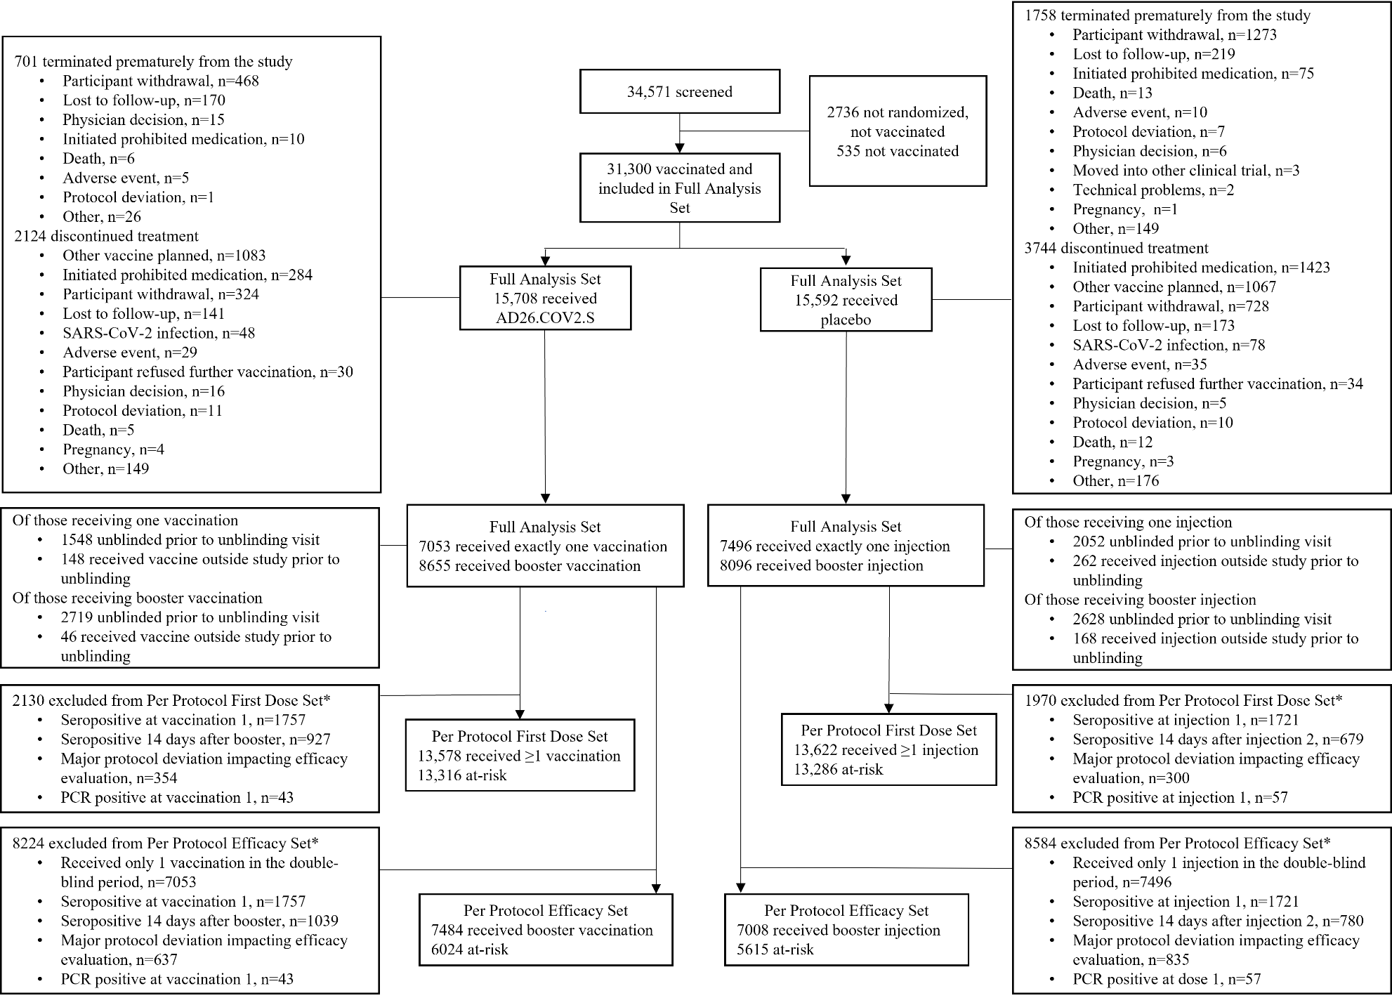

Figure 2. Cumulative Incidence of First Occurrence of Molecularly-Confirmed Moderate to Severe–Critical or Severe–Critical COVID-19 Cases with Onset at Least 1 Day After Booster Vaccination (Per-Protocol Set).
The cumulative incidence of molecularly-confirmed moderate to severe–critical cases of COVID-19 with onset at least 1 day after booster vaccination in the per-protocol (PP) set is shown in Panel A. The cumulative incidence of molecularly-confirmed moderate to severe–critical cases of COVID-19 with onset at least 1 day after booster vaccination and due to Alpha (B.1.1.7) and Mu (B.1.621) variants in the PP set are shown in panels B and C, respectively. Black arrows indicate administration of the booster vaccine or second placebo dose. Cases included for analysis were centrally confirmed cases in the PP set. The PP set included participants who received 2 doses of vaccine or placebo in the double-blind phase, who were seronegative (or missing) by serology at the time of the first vaccination (day 1) and at 14 days after the booster vaccination (day 71), who were negative by PCR at baseline, and who had no major protocol deviations before unblinding that were judged to possibly impact the efficacy of the vaccine. The number at risk includes the participants from the PP set who had not experienced a positive PCR before the booster dose and had not discontinued participation in the study. CI, confidence interval; COVID-19, coronavirus disease 2019; vp, viral particles. 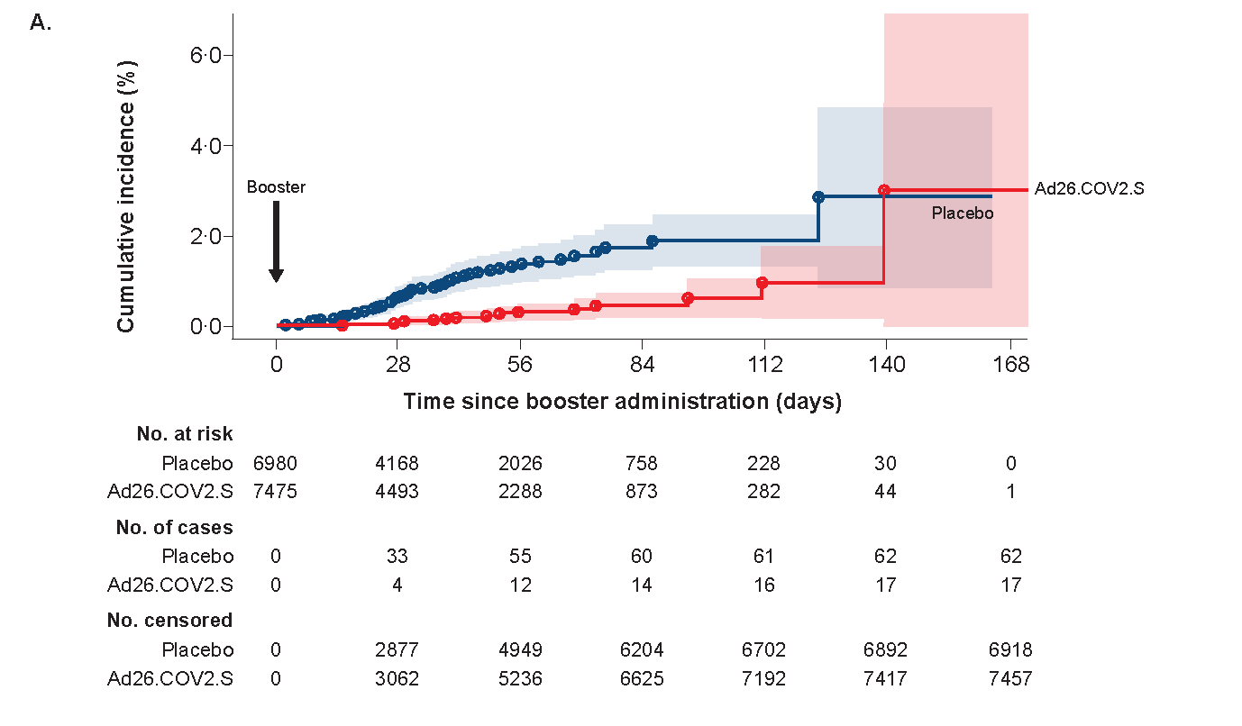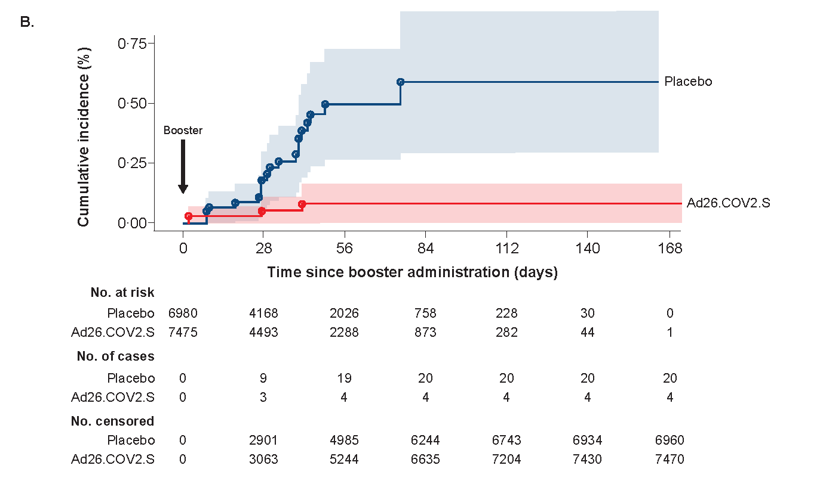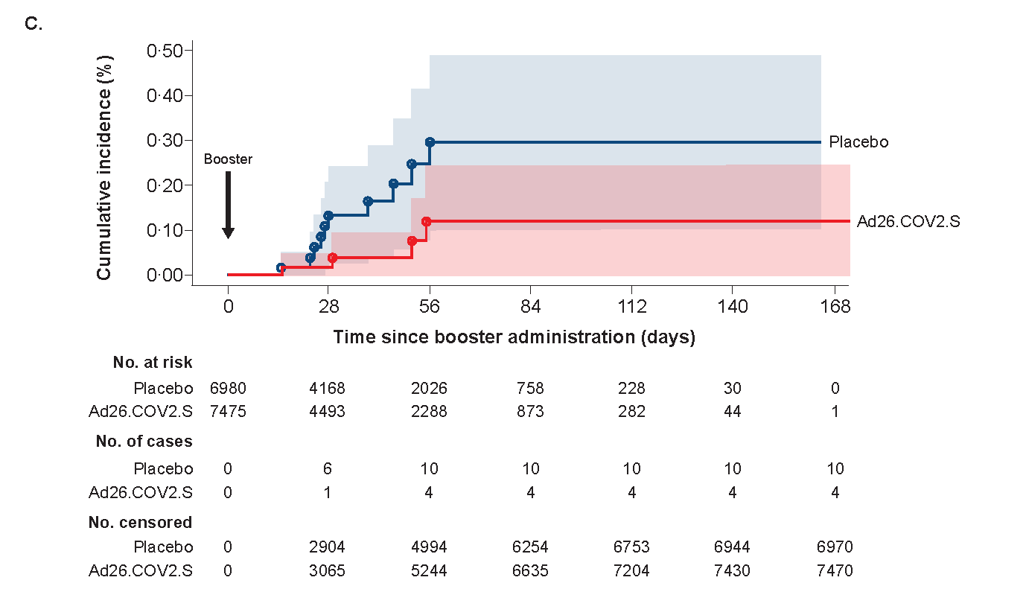

Figure 3. Solicited Local (A) and Systemic (B) Adverse Events Following Prime-Boost Vaccination Regimen in Adults (Safety Set).
Solicited local and systemic adverse events (AEs) were collected among the safety subset population in an electronic diary for 7 days after each vaccination or placebo injection. Symptom grading is described in the appendix on p. 17. Black bars represent the percentage of participants with AEs of any grade reported in the Ad26.COV2.S group; grey bars represent the percentage of participants with AEs of any grade reported in the placebo group. Percentages of participants specifically reporting grade 3 AEs are shown in orange above each column for the vaccine and placebo groups.
