Supporting information for
Neutral and cationic complexes of silicon(IV) halides with phosphine ligands.
Rhys P. Kingª, John M. Dykeª, William Levasonª and Gillian Reidª
ªSchool of Chemistry, University of Southampton, Southampton SO17 1BJ, UK; email: G.Reid@soton.ac.uk

Table S1 X-ray crystallographic data.
Compound | [SiI₃(PMe₃)₂][I]  ·CH₂Cl₂·0.5 C₆H₁₄ | [SiI₄{o-C₆H₄(PMe₂)₂}]  ·0.5C₆H₁₄ | [SiI₄{Et₂P(CH₂)₂PEt₂}] | [SiCl₃(PMe₃)₂][BAr^{F}] | [SiCl₂(PMe₃)₂(OTf)₂]
Formula | C₁₀H₂₇Cl₂I₄P₂Si | C₁₃H₂₃I₄P₂Si | C₁₀H₂₄I₄P₂Si | C₃₈H₃₀BCl₃F₂₄P₂Si | C₈H₁₈C₁₂F₆O₆P₂S₂Si
M | 815.84 | 776.978 | 741.953 | 1149.81 | 549.289
Crystal system | hexagonal | monoclinic | monoclinic | orthorhombic | monoclinic
Space group (no.) | P6₃/mmc (194) | P2₁/n (14) | Cc (9) | Pbca (61) | P2₁ (4)
a /Å | 18.1858(3) | 7.22644(14) | 12.8535(6) | 17.7948(7) | 7.98577(19)
b /Å | 18.1858(3) | 16.7515(3) | 8.8973(3) | 19.5965(6) | 12.3268(3)
c /Å | 13.4510(3) | 17.0301(4) | 17.8528(9) | 26.8774(11) | 10.7399(2)
α /° | 90 | 90 | 90 | 90 | 90
β /° | 90 | 101.887(2) | 103.382(5) | 90 | 92.284(2)
γ /° | 120 | 90 | 90 | 90 | 90
U /Å³ | 3852.56(15) | 2017.35(7) | 1986.24(16) | 9372.6(6) | 1056.39(4)
Z | 6 | 4 | 4 | 8 | 2
μ(Mo-K_{α}) /mm^{–1} | 5.223 | 6.387 | 6.480 | 0.415 | 0.787
F(000) | 2262 | 1423 | 1355 | 4592 | 558
Total no. reflns | 167082 | 52053 | 10249 | 66260 | 29360
R_{int} | 0.094 | 0.079 | 0.093 | 0.063 | 0.041
Unique reflns | 2407 | 6706 | 3943 | 14048 | 6701
No. of params, restraints | 52, 0 | 159, 0 | 158, 62 | 626, 3 | 250, 1
GOF | 1.079 | 1.084 | 1.013 | 1.012 | 1.044
R₁, wR₂ [I > 2σ(I)]^{b} | 0.097, 0.240 | 0.026, 0.059 | 0.079, 0.213 | 0.070, 0.180 | 0.026, 0.059
R₁, wR₂ (all data) | 0.116, 0.252 | 0.029, 0.060 | 0.082, 0.215 | 0.138, 0.237 | 0.030, 0.060
ª Common items: T = 100 K; wavelength (Mo-K_{α}) = 0.71073 Å; θ(max) = 27.5°; ^{b} R₁ = Σ||F_{o}|-|F_{c}||/Σ|F_{o}|; wR₂=[Σw(F_{o}²-F_{c}²)₂/ΣwF_{o}⁴]^{1/2}

Spectroscopic Data
Figure S1 [SiCl₄(PMe₃)₂]
Figure S1(a) ¹H NMR spectrum of [SiCl₄(PMe₃)₂] (CD₂Cl₂, 298 K)
Figure S1(b) ³¹P{¹H} NMR spectrum of [SiCl₄(PMe₃)₂] (CD₂Cl₂, 298 K)
Figure S1(c) ²⁹Si NMR spectrum of [SiCl₄(PMe₃)₂] (CD₂Cl₂, 298 K)

Figure S1(d) ²⁹Si NMR spectrum of [SiCl₄(PMe₃)₂] (CD₂Cl₂, 183 K)

Figure S2 [SiBr₄(PMe₃)₂]
Figure S2(a) ¹H NMR spectrum of [SiBr₄(PMe₃)₂] (CD₂Cl₂, 298 K)
Figure S2(b) ³¹P{¹H} NMR spectrum of [SiBr₄(PMe₃)₂] (CD₂Cl₂. 298 K)

Figure S2(c) ²⁹Si NMR spectrum of [SiBr₄(PMe₃)₂] (CD₂Cl₂. 298 K)

Figure S2(d) ²⁹Si NMR spectrum of [SiBr₄(PMe₃)₂] (CD₂Cl₂. 193 K)

Figure S3 [SiI₃(PMe₃)₂][I]
Figure S3(a) ¹H NMR spectrum of [SiI₃(PMe₃)₂][I] (CD₂Cl₂, 298 K) * [HPMe₃]⁺
*

Figure S3(b) ³¹P{¹H} NMR spectrum of [SiI₃(PMe₃)₂][I] (CD₂Cl₂, 298 K) * [HPMe₃]⁺
*

Figure S3(c) ³¹P{¹H} NMR spectrum of [SiI₃(PMe₃)₂][I] (CD₂Cl₂, 253 K) * [HPMe₃]⁺
*

Figure S3(d) IR spectrum of [SiI₃(PMe₃)₂][I] (Nujol/cm⁻¹)
Figure S4 [SiI₄(o-C₆H₄(PMe₂)₂]
Figure S4(a) ¹H NMR spectrum of [SiI₄(o-C₆H₄(PMe₂)₂] (CD₂Cl₂, 298 K)
Figure S4(b) ³¹P{¹H} NMR spectrum of [SiI₄(o-C₆H₄(PMe₂)₂] (CD₂Cl₂, 298 K)
Figure S4(c) ³¹P{¹H} NMR spectrum of [SiI₄(o-C₆H₄(PMe₂)₂] (CD₂Cl₂, 253 K)

Figure S4(d) IR spectrum of [SiI₄(o-C₆H₄(PMe₂)₂] (Nujol/cm⁻¹)

Figure S5 [SiI₄(depe)]
Figure S5(a) ¹H NMR spectrum of [SiI₄(depe)] (CD₂Cl₂, 298 K), * = monoprotonated ligand
*
*
Figure S5(b) ³¹P{¹H} NMR spectrum of [SiI₄(depe)] (CD₂Cl₂, 298 K), * = monoprotonated ligand
*
*

Figure S5(c) ³¹P{¹H} NMR spectrum of [SiI₄(depe)] (CD₂Cl₂, 183 K)
*
Figure S5(d) IR spectrum of [SiI₄(depe)] (Nujol/cm⁻¹)
Figure S6 [SiCl₃(PMe₃)₂][BAr^{F}]
Figure S6(a) ¹H NMR spectrum of [SiCl₃(PMe₃)₂][BAr^{F}] (CD₂Cl₂, 298 K)

Figure S6(b) ³¹P{¹H} NMR spectrum of [SiCl₃(PMe₃)₂][BAr^{F}] (CD₂Cl₂, 298 K)
Figure S6(c) ³¹P{¹H} NMR spectrum of [SiCl₃(PMe₃)₂][BAr^{F}] (CD₂Cl₂, 183 K)

Figure S6(d) ²⁹Si NMR spectrum of [SiCl₃(PMe₃)₂][BAr^{F}] (CD₂Cl₂, 298 K), * = SiCl₄ impurity
*

Figure S6(e) ²⁹Si NMR spectrum of [SiCl₃(PMe₃)₂][BAr^{F}] (CD₂Cl₂, 183 K)
Figure S6(f) IR spectrum of [SiCl₃(PMe₃)₂][BAr^{F}] (Nujol/cm⁻¹)
Figure S7 [SiBr₃(PMe₃)₂][BAr^{F}]
Figure S7(a) ¹H NMR spectrum of [SiBr₃(PMe₃)₂][BAr^{F}] (CD₂Cl₂, 298 K), * = [HPMe₃]⁺
*
Figure S7(b) ³¹P{¹H} NMR spectrum of [SiBr₃(PMe₃)₂][BAr^{F}] (CD₂Cl₂, 298 K), * = [HPMe₃]⁺
*
Figure S7(c) ³¹P{¹H} NMR spectrum of [SiBr₃(PMe₃)₂][BAr^{F}] (CD₂Cl₂, 183 K), * = [HPMe₃]⁺
*

Figure 7(d) ²⁹Si NMR spectrum of [SiBr₃(PMe₃)₂][BAr^{F}] (CD₂Cl₂, 183 K)

Figure 7(e) IR spectrum of [SiBr₃(PMe₃)₂][BAr^{F}] (Nujol/cm⁻¹)

Figure S8 [SiCl₃(PMe₃)₂(OTf)]
Figure S8(a) ¹H NMR spectrum of [SiCl₃(PMe₃)₂(OTf)] (CD₂Cl₂, 298 K), * = [HPMe₃]⁺
*
Figure S8(b) ¹⁹F{¹H} NMR spectrum of [SiCl₃(PMe₃)₂(OTf)] (CD₂Cl₂, 298 K)
Figure S8(c) ³¹P{¹H} NMR spectrum of [SiCl₃(PMe₃)₂(OTf)] (CD₂Cl₂, 298 K), * = [HPMe₃]⁺
*

Figure S8(d) ²⁹Si NMR spectrum of [SiCl₃(PMe₃)₂(OTf)] (CD₂Cl₂, 298 K)

Figure S8(a) IR spectrum of [SiCl₃(PMe₃)₂(OTf)] (Nujol/cm⁻¹)

Figure S9 [SiCl₂(PMe₃)₂(OTf)₂]
Figure S9(a) ¹H NMR spectrum of [SiCl₂(PMe₃)₂(OTf)₂] (CD₂Cl₂, 298 K), * = [HPMe₃]⁺; ^ = [SiCl₃(PMe₃)₂(OTf)]

*
Figure S9(b) ¹⁹F{¹H} NMR spectrum of [SiCl₂(PMe₃)₂(OTf)₂] (CD₂Cl₂, 298 K)

Figure S9(c) ³¹P{¹H} NMR spectrum of [SiCl₂(PMe₃)₂(OTf)₂] (CD₂Cl₂, 298 K), * = [HPMe₃]⁺; ^ = [SiCl₃(PMe₃)₂(OTf)]
^
*

Figure S9(d) ²⁹Si NMR spectrum of [SiCl₂(PMe₃)₂(OTf)₂] (CD₂Cl₂, 298 K)

Figure S9(e) IR spectrum of [SiCl₂(PMe₃)₂(OTf)₂] (Nujol/cm⁻¹)

Figure S10 Frontier Orbital representations for [SiF₄(PMe₃)₂]
HOMO (-7.06 eV) | LUMO (0.864 eV)
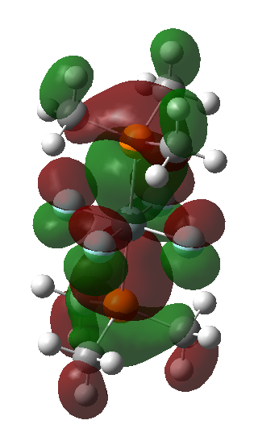 | 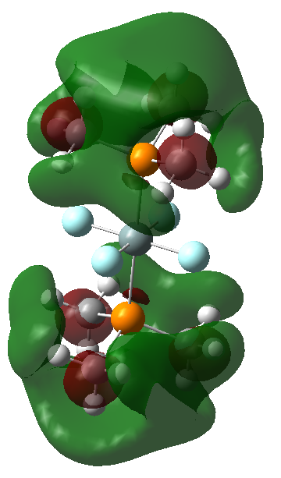
HOMO-1 (-7.58 eV) | LUMO+1 (0.930 eV)
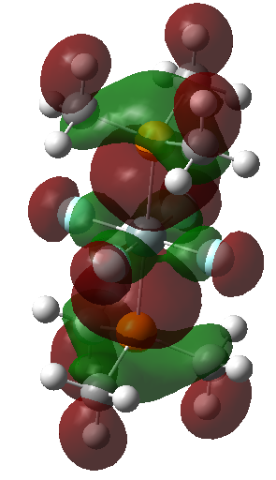 | 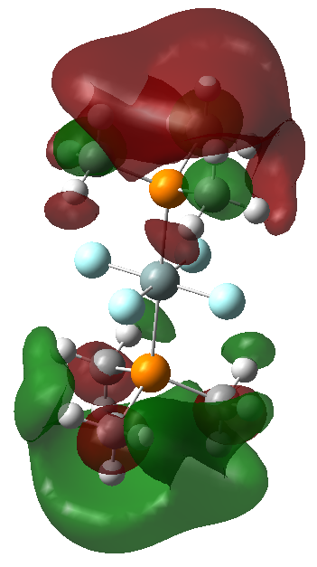
HOMO-2 (-8.30 eV) | LUMO+2 (1.32 eV)
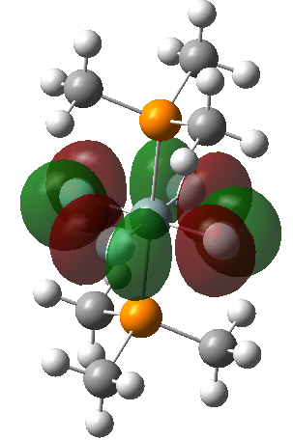 | 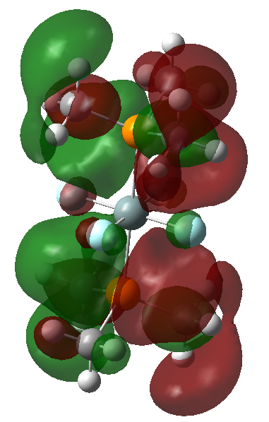

Figure S11 Frontier Orbital representations for [SiF₃(PMe₃)₂]⁺
HOMO (-11.7 eV) | LUMO(-2.97 eV)
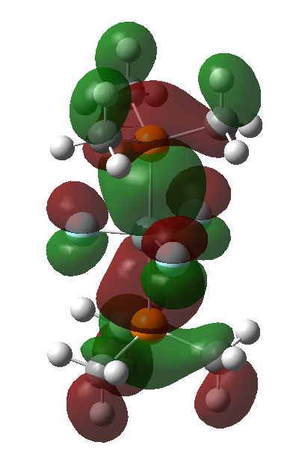 | 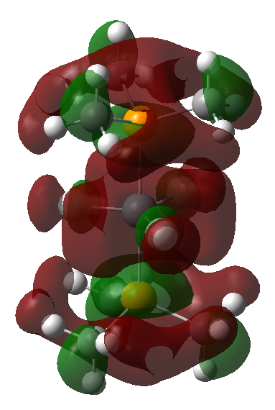
HOMO-1 (-12.0 eV) | LUMO+1 (-2.97 eV)
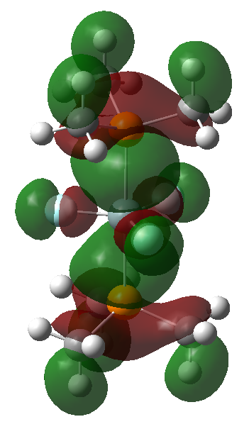 | 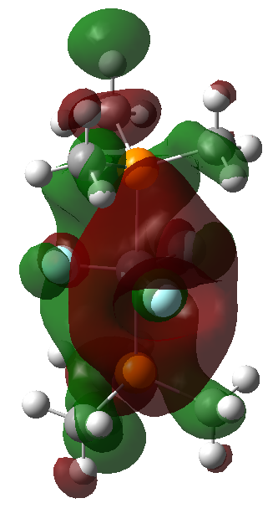
HOMO-2 (-13.6 eV) | LUMO+2 (-2.96 eV)
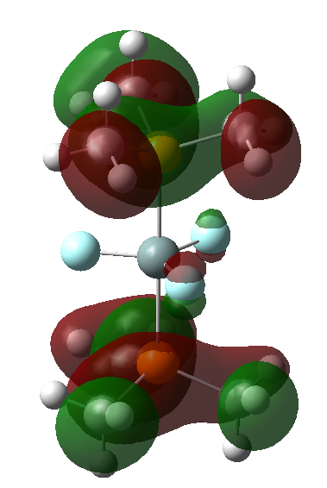 | 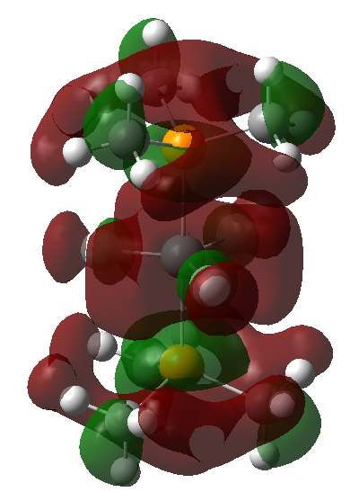

Figure S12 Frontier Orbital representations for [SiCl₄(PMe₃)₂]
HOMO (-6.90 eV) | LUMO (-1.35 eV)
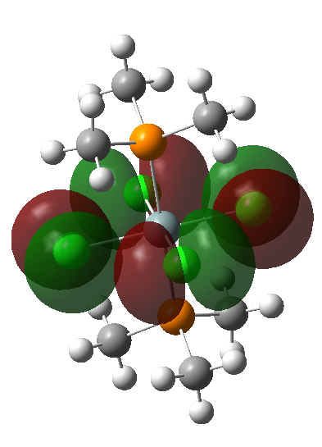 | 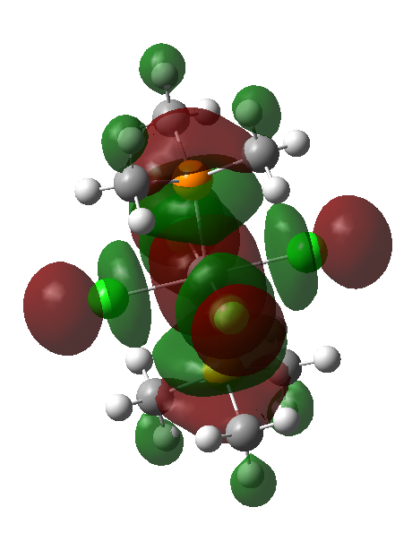
HOMO-1 (-7.40 eV) | LUMO+1 (0.629 eV)
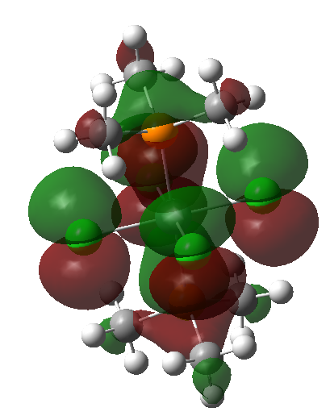 | 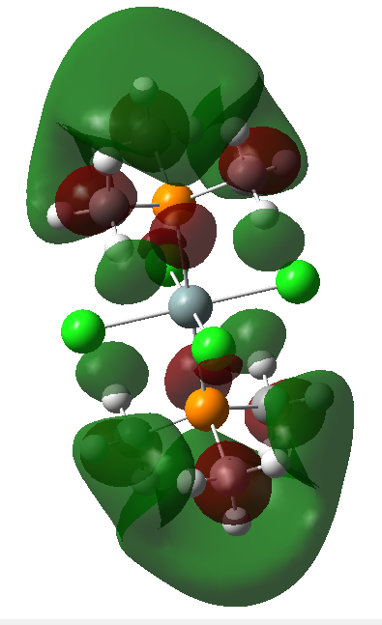
HOMO-2 (-7.57 eV) | LUMO+2 (0.660 eV)
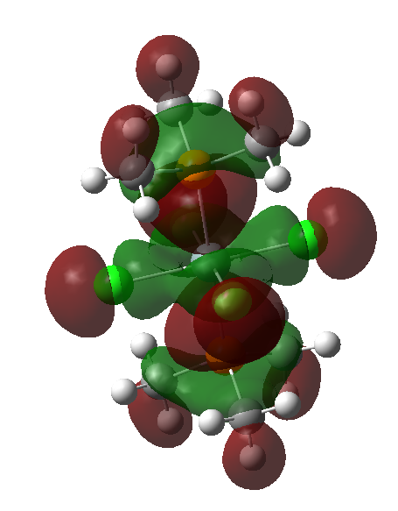 | 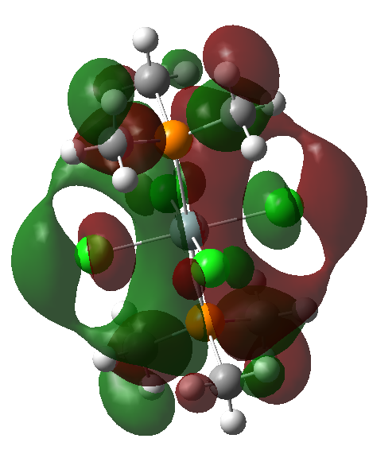

Figure S13 Frontier Orbital representations for [SiCl₃(PMe₃)₂]+
HOMO (-11.3 eV) | LUMO (-4.86 eV)
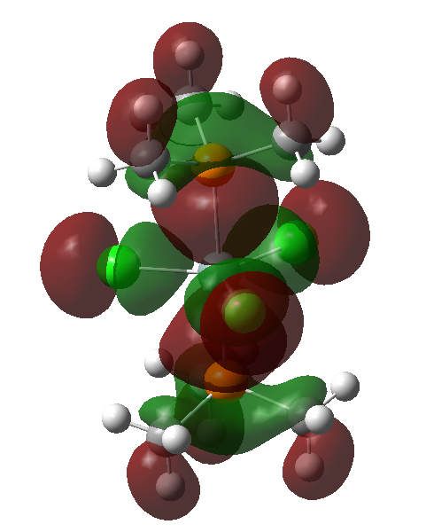 | 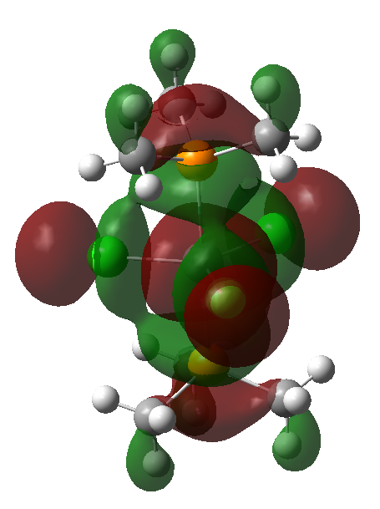
HOMO-1 (-11.4 eV) | LUMO+1 (-3.44 eV)
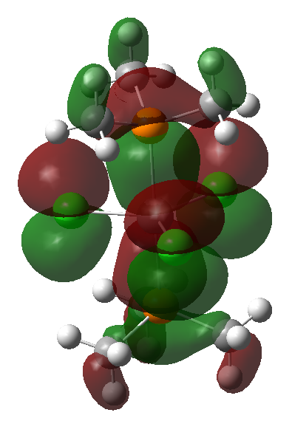 | 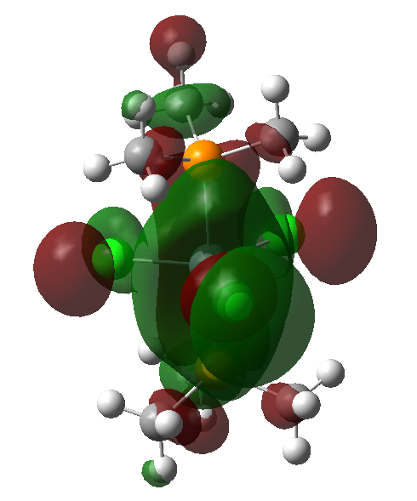
HOMO-2 (12.3 eV) | LUMO+2 (-3.44 eV)
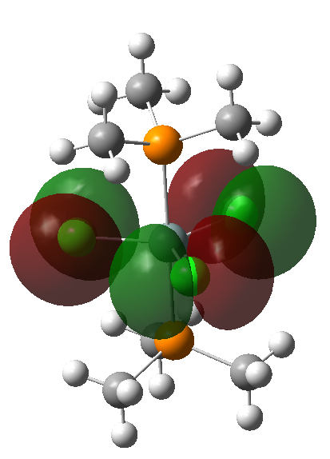 | 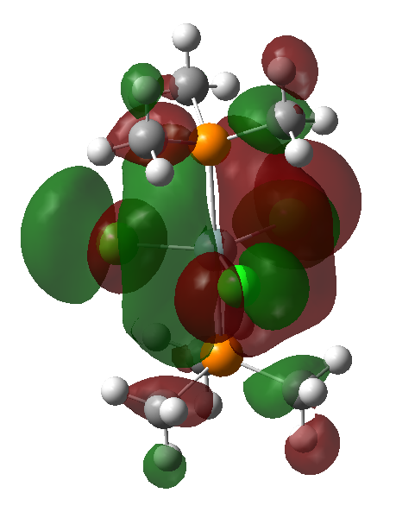

Figure S14 Frontier Orbital representations for [SiBr₄(PMe₃)₂]
HOMO (-6.28 eV) | LUMO (-0.245 eV)
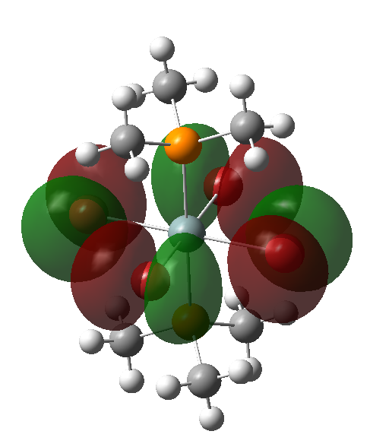 | 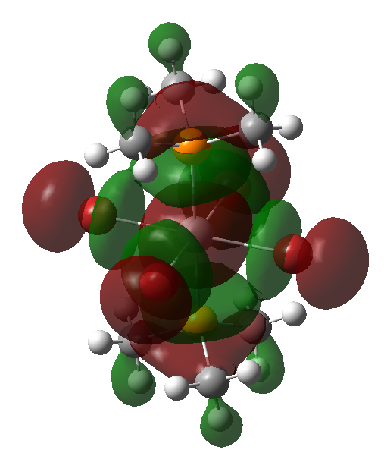
HOMO-1 (-6.92 eV) | LUMO+1 (0.127 eV)
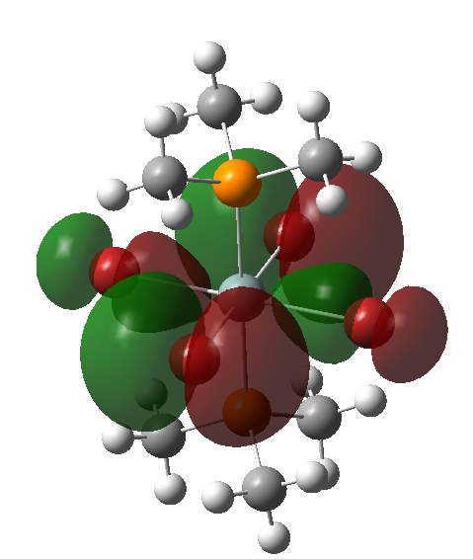 | 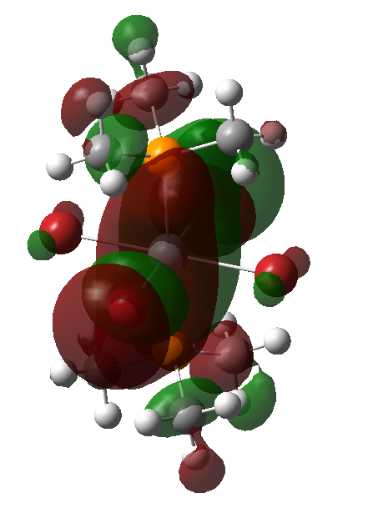
HOMO-2 (-6.94 eV) | LUMO+2 (0.140 eV)
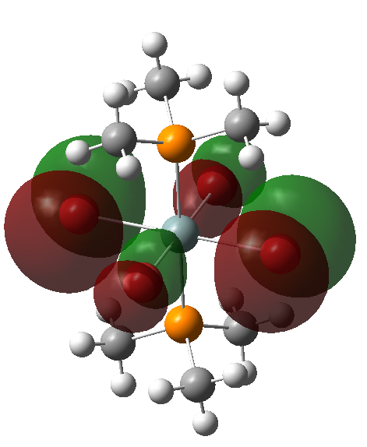 | 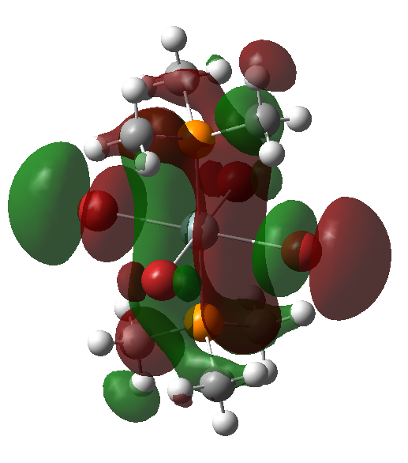

Figure S15 Frontier Orbital representations for [SiBr₃(PMe₃)₂]⁺
HOMO (-11.1 eV) | LUMO (-5.67 eV)
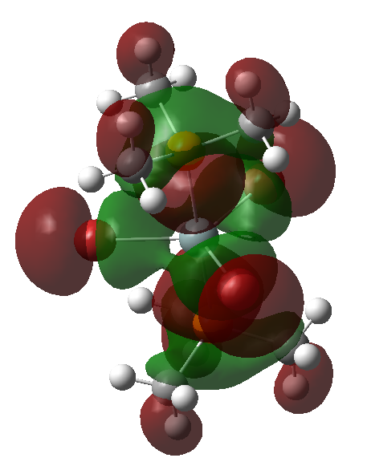 | 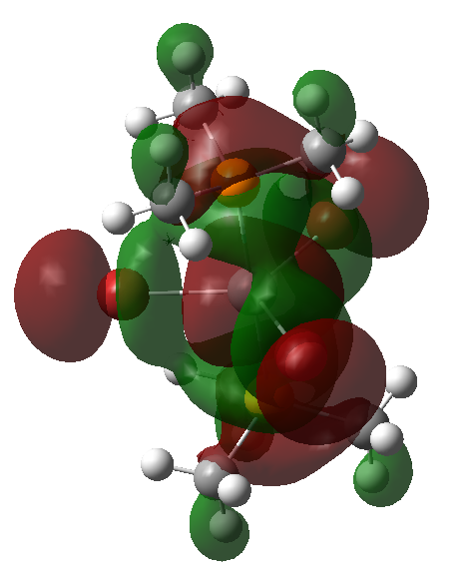
HOMO-1 (-11.1 eV) | LUMO+1 (-4.01 eV)
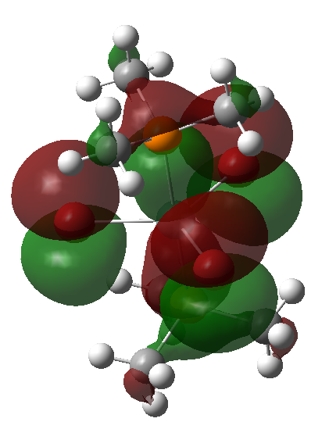 | 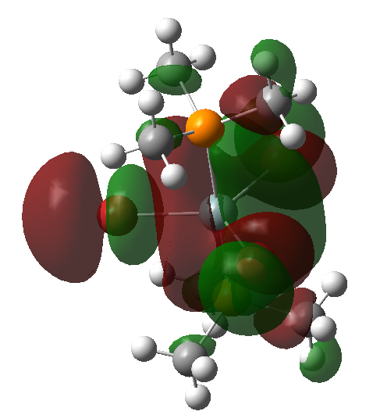
HOMO-2 (-11.4 eV) | LUMO+2 (-4.01 eV)
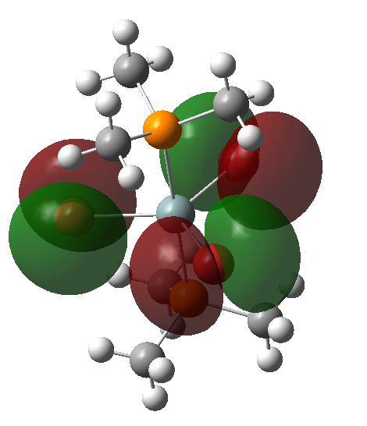 | 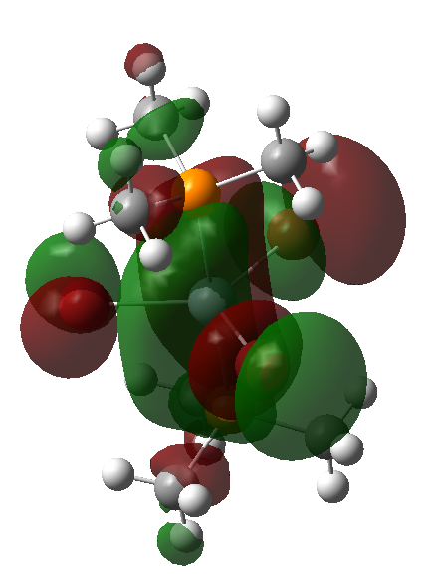

Figure S16 Frontier Orbital representations for [SiI₄(PMe₃)₂]
HOMO (-5.78 eV) | LUMO (-3.00 eV)
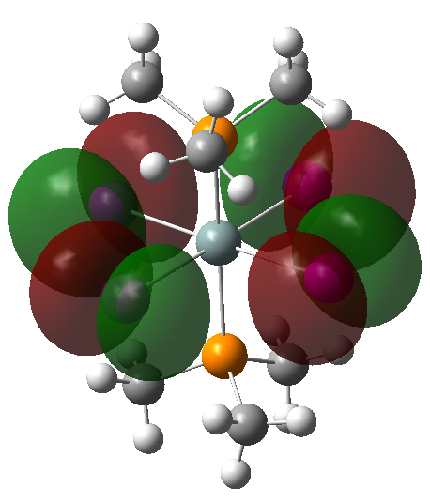 | 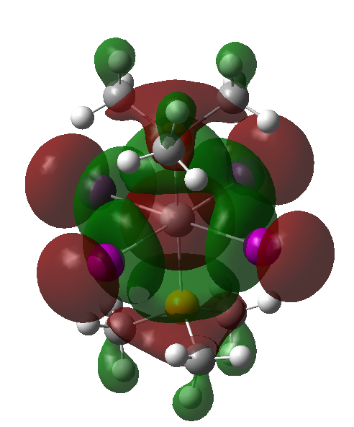
HOMO-1 (-6.42 eV) | LUMO+1 (-0.613 eV)
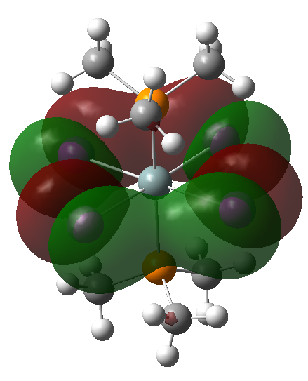 | 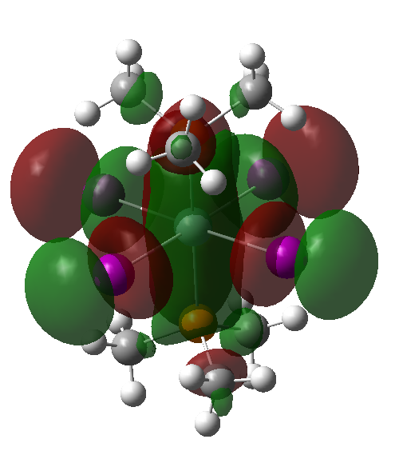
HOMO-2 (-6.47 eV) | LUMO+2 (-0.565 eV)
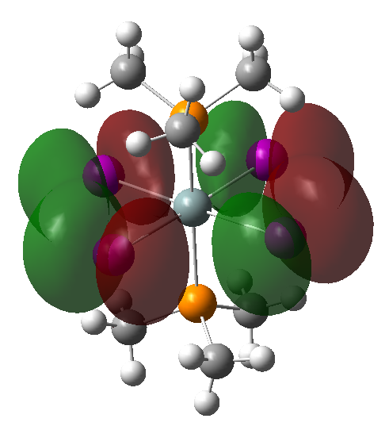 | 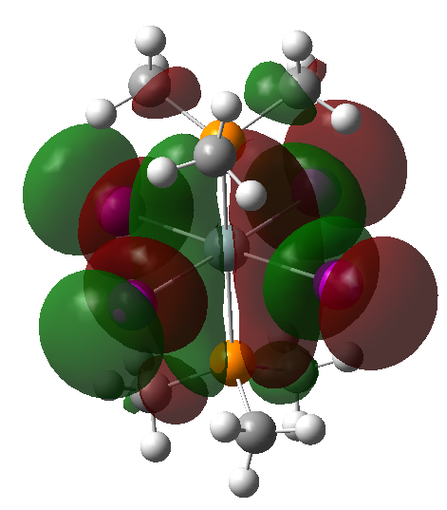

Figure S17 Frontier Orbital representations for [SiI₃(PMe₃)₂]⁺
HOMO (-10.5 eV) | LUMO (-6.30 eV)
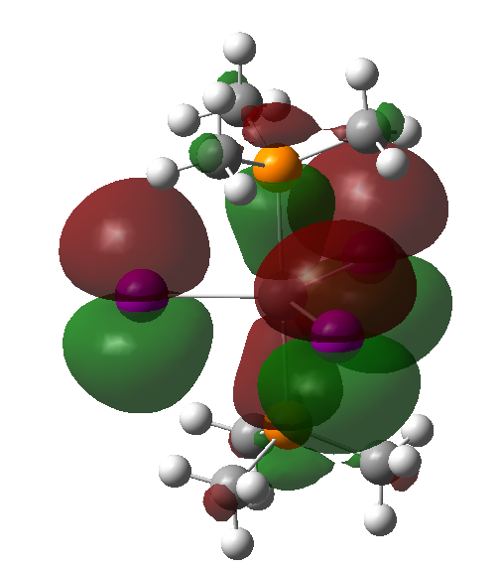 | 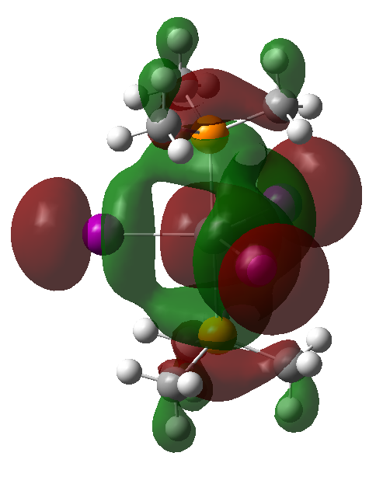
HOMO-1 (-10.5 eV) | LUMO+1 (-4.34 eV)
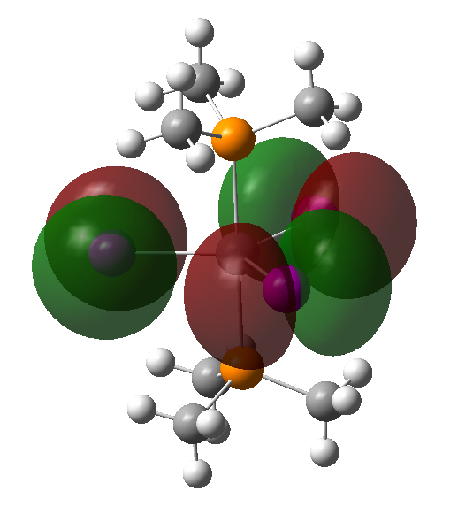 | 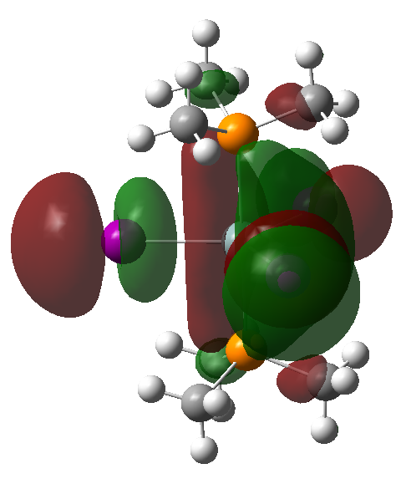
HOMO-2 (-10.6 eV) | LUMO+2 (-4.33 eV)
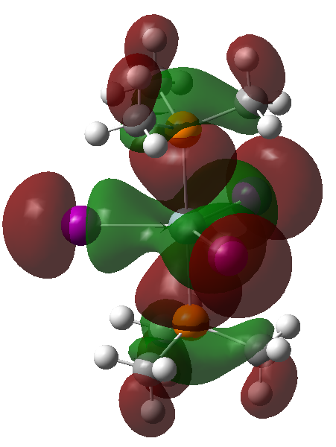 | 