Evidence of rapid functional benthic recovery following the Deepwater Horizon oil spill

Marisa L. Guarinello¹*
S. Kersey Sturdivant^{1,2}
Anna E. Murphy¹
Lorraine Brown^{1,3}
Jasmin A. Godbold⁴
Martin Solan⁴
Drew A. Carey¹
Joseph D. Germano¹

¹ INSPIRE Environmental, Newport, RI 02840, USA
² Division of Marine Science and Conservation, Nicholas School of the Environment, Duke University, Beaufort, NC, 28516, USA
³ Exa Data and Mapping, Poulsbo, WA, 98370, USA
⁴ Ocean and Earth Science, National Oceanography Centre Southampton, University of Southampton, Southampton, SO14 3ZH, UK
* Corresponding author, Marisa@INSPIREenvironmental.com

ABSTRACT: The 2010 Deepwater Horizon incident was a massive deep-sea oil spill and resulted in deposition of hydrocarbons at the seafloor surface. Soft sediment benthic macrofauna provide critical global ecosystem services, and little is known about their recovery trajectories from similar disturbances in the deep sea. Recent publications report an initial opportunistic benthic infaunal response and predict 50 – 100 years for recovery of species-level diversity, abundance, and composition. Sediment profile and plan view imaging data collected at depths from 1,040 to 1,689 m in 2011 and 2014 confirm this opportunistic response, but also indicate further stages of functional benthic recovery. The recovery trajectory mimicked benthic succession following organic enrichment that is widely recorded in coastal systems but not the deep sea. Bioturbating taxa were present deep in the sediment column in both years. In 2014, a decline in the relative abundance of opportunistic taxa and a positive rebound in the apparent redox potential discontinuity depth, an integrated measure of biogeochemical functioning, were recorded. These results suggest that bioturbation-mediated microbial degradation is a plausible mechanism by which rapid functional benthic recovery occurred. With oil and gas extraction prevalent in the deep sea, improving understanding of benthic recovery in these environments is critical.
KEYWORDS: macrofauna, deep sea, organic enrichment, succession, hydrocarbons, apparent redox potential discontinuity, bioturbation, sediment profile imaging
SYNOPSIS: Recent publications predict that the benthic macrofauna will require 50 – 100 years to recover from the Deepwater Horizon oil spill. This study reports indications of functional recovery within four years of the spill.
Introduction
The 2010 Deepwater Horizon oil spill presented an opportunity to study ecological responses to, and recovery from, a large-scale disturbance in the deep sea (depths > 1,000 m¹). Approximately 3.19 million barrels (134 million gallons) of crude oil² and significant volumes of natural gas³ were released from the subsurface reservoir into the waters of the Gulf of Mexico. Estimates indicate that approximately 2 to 20% of the released oil settled on the seafloor⁴, either as weathered residues⁵, as conglomerates mixed with drilling muds⁶ or as aggregates with marine snow⁴. With the Macondo well located at a depth of ~1,500 m, the spill was the first of such magnitude to occur in the deep sea. Much remains to be discovered about this marine realm^{7,8}, including the recovery trajectories of communities exposed to crude oil⁹ and benthic community response to large-scale disturbances^{10,11}. In examining results from scientific studies conducted in the wake of the Deepwater Horizon spill, it is important to consider that the incident represented uncharted territory¹², requiring acknowledgement of uncertainty and complexity as well as openness to results that may run counter to those expected¹³.
The Gulf of Mexico is a prolific hydrocarbon-rich deep-sea basin characterized by numerous natural seeps and widespread oil and natural gas development^{14,15}, and hydrocarbons are commonly found in surface sediments¹⁴. It is reasonable to expect that the benthic biota of this “leaky” deep-sea basin is evolutionarily positioned to respond to hydrocarbon fluxes, including oil spills. The availability of seep-sourced hydrocarbons to the benthic infaunal community, either directly as a food source or indirectly through trophic links with the microbial community, is an important factor in shaping communities proximal to natural seeps and may also influence those further away¹⁶. This ecological and evolutionary context should be considered when assessing how the deep-sea benthos may respond to an oil spill such as the Deepwater Horizon incident.
The deep-sea benthos is composed of multiple ecotones, taxa groups, and communities from microbes to megafauna and demersal fish¹⁷, which vary in their responses and resilience to disturbances such as the Deepwater Horizon oil spill¹⁸. These responses can be assessed through species, population, and system level inquiries. From a functional perspective, system level function may be inferred from community composition and diversity metrics or direct measurements of biomass, secondary production, nutrient cycling rates, sediment oxygen consumption, and fisheries production, among others^{17,19}. For this study, the functional response of the soft sediment benthos inclusive of microbial, meiofaunal, and macrofaunal communities to the Deepwater Horizon oil spill was evaluated by examining proxies for integrated biogeochemical processes and macrofaunal community composition across spatial and temporal gradients using imaging techniques.
Unlike traditional benthic community analysis that involves sieving, enumerating, and identifying benthic organisms, the sediment profile and plan view (SPI/PV) imaging approach used in this study records in situ visible evidence of biotic processes coupled with physical and biogeochemical attributes of the sediment column up to ~22 cm below the sediment-water interface ²⁰. Using these images, features diagnostic of the oil spill and containment deposition footprint, as well as organic enrichment, were recorded. To evaluate benthic functional response to the spill and related deposition, the apparent redox potential discontinuity depth (aRPD), maximum bioturbation depth, and metrics relating to feeding voids were used as proxies for benthic function²⁰. It was hypothesized that patterns of these response variables would track with physical evidence of the spill and containment activities, and a gradient of decreasing adverse effects with increasing distance from the wellhead would be observed.
Apparent RPD depth is a particularly useful proxy for benthic quality across ecosystems and disturbance types^{20,21}, with deeper aRPD values indicative of higher redox potential and dissolved oxygen content²². Although variable by system and context, aRPD depths greater than 1 cm typically indicate unimpaired benthic function²⁰. Measured aRPD depth is dependent on several factors including sediment porosity (grain size and water content dictating physical diffusion rates), infaunal mixing activity (bioturbation), and benthic respiration rates (combined respiration of the microbial and faunal communities within the sediment column)^{20,21}. The aRPD depth can be particularly useful in detecting the integrated biogeochemical response of the benthos to organic enrichment, including increased sediment oxygen demand concurrent with decreased bioturbation activity of large-bodied macrofauna^{21,24}. Because the Deepwater Horizon incident resulted in the release of organically enriched material (crude oil² and significant volumes of natural gas³), the deposition of this material was expected to decrease aRPD depths by increasing benthic respiration rates and disturbing or decreasing infaunal activity^{25,26}.
Biogenic structures, such as tubes and burrows, as well as maximum bioturbation depth, and metrics relating to feeding voids, provide indicators related to benthic community composition²⁰. Results indicate that infaunal recovery followed the classic model of soft sediment successional response to organic enrichment²⁴ that is well-established in coastal and shallow ecosystems^{20,27,28,} but not in the deep sea²⁹. This functional recovery occurred faster than predicted by studies focused on species-level diversity, abundance, and composition metrics as measures of recovery¹⁸.
Materials and Methods
Field Surveys. In 2011 and 2014, SPI/PV were collected at 802 stations (615 in 2011; 187 in 2014) as part of the Deepwater Horizon Natural Resources Damage Assessment investigations (Figure S1). These surveys were designed to map the type and spatial extent of deposits that may have been related to pre-spill drilling activities, the Deepwater Horizon spill, and/or post-spill Macondo well control activities and to evaluate changes in physical and biological benthic conditions between 2011 and 2014.
Analysis. Analyses presented in this study are restricted to the 468 stations located within 10 km of the wellhead (335 in 2011; 133 in 2014), because the area sampled beyond 10 km included a wide-ranging environment where a high degree of natural variability was expected, and because sampling was not systematic across years. Further, because physical evidence of the spill was recorded primarily within a 2 km radius of the wellhead, summary data are presented in distance intervals of < 2 km and 2-10 km (Table S1). The PV camera imaged an area of the seafloor of approximately 1 m² and the SPI camera sampled a 14.5 cm cross-section of the sediment column down to a maximum of 21.7 cm below the sediment-water interface.
For this study, variables indicative of benthic response to organic enrichment, those related to the functional characteristics of the benthic community, as well as depositional layers and features that might be related to drilling and spill containment activities were assessed. Differences in optical reflectance and/or color, as well as texture, permit the detection of these key variables and measurement of depositional layers from 0.1 to 21.7 cm (height of optical window) in profile images²⁰.
Variables and detection methods included the following nine parameters. [1] The mean thickness of a whitish gray allochthonous surface clay layer was measured. This clay layer is hypothesized to be either redeposited Pleistocene muds from top hole drilling efforts or to have been deposited on the seafloor as part of the well containment efforts. [2] The mean thickness of dark gray to black organically enriched depositional layer of reduced sediment at the sediment-water interface, often covered with an oxidized crust of settled, macrofloccular detritus, was measured. [3] The presence of non-soluble hydrocarbon inclusions, tiny droplets (1 mm or less in diameter) or larger amoeboid blobs (up to 4 mm in diameter) of dark liquid trapped within the sedimentary matrix, were noted. [4] The aRPD depth was determined by examining the optical shift from colored ferric hydroxide oxidized surface sediments to underlying gray to black reduced sediments³⁰⁻³². [5] The presence of sulfur-oxidizing thiophilic microbial colonies were noted. These bacteria have a diagnostic morphology³³ that has been documented in numerous SPI/PV surveys. [6] The relative density of tubes on the seafloor surface visible in PV were recorded. [7] The maximum bioturbation depth was measured as the maximum depth of infauna or burrow structures or feeding voids visible within the imaged sediment column: burrows were defined as open channels surrounded by brownish sediment and voids as water-filled pockets. [8] Metrics on feeding voids were also evaluated. The total number of feeding voids were counted, and minimum and maximum depths were measured. [9] The mean depth of the SPI prism penetration into the sediment column, with a maximum of 21.7 cm, was measured.
Statistical Analysis. The bin intervals for measurements shown on the maps were selected according to the data distribution for each variable using the k-means algorithm. This algorithm works by generating breaks in the data to create k groups such that the sum of squares within groups is minimized. The optimal number of groups (k) was subjectively determined for each variable based on how the breaks partitioned the distributions with the primary objective of isolating the two tails. The k-means algorithm uses an iterative process starting with an initial random selection as the k-group centers. Multiple random starts (n = 100) were used and the best solutions (the cutoffs producing the smallest within group sum-of-squares) were reported as final. The function classIntervals(style = “kmeans”, nstart = 100) was used from the classInt package³⁴ in R³⁵.
A chi-square test of independence was performed on the categorical values representing relative densities of tubes on the seafloor surface to test for significant differences between years. Pearson’s Chi-squared test with Yates’ continuity correction was performed to test for differences in the presence of organically enriched deposits between years. To test for differences in the depth of this deposit between years, a one-way ANOVA test was used. Data were log-transformed to account for heteroscedasticity of variances; differences in variances were tested using Levene’s test and data normality was assessed using Shapiro’s test. These tests were all conducted in R³⁵.
Ordinary kriging on aRPD depth for 2011 and for 2014 were performed independently in R³⁵ using the gstat package^{36,37}. Intrinsic stationarity was assumed for both years; therefore, it is appropriate to use a kriging technique for interpolation. Isotropy, directional spatial independence, was assumed after assessing directional empirical semivariograms. For both years, an empirical semivariogram was calculated and a parametric spherical model was fitted to the variogram. For 2011 data, the geostatistical model parameters were: nugget = 0, sill = 0.94, and range = 2.88 km. For 2014 data, the geostatistical model parameters were: nugget = 0.41, sill = 0.83, and range = 1.59 km.
A statistical model was used to estimate the distance from the wellhead where aRPD depths reached a threshold value (values no longer increased with distance from the wellhead). Stations that were not located on radial transects were excluded from the analysis because they were not random and could have biased the results; the radial gradient sampling design was balanced in all directions and is a better unbiased representation of conditions within 10km (n = 371 stations on transects with measurable aRPD depths). This analysis was completed using segmented regression to model the relationship between aRPD depth and distance from the wellhead using multiple line segments. Segmented regression (also known as “broken stick,” “hockey-stick,” or piecewise regression) can be thought of as ordinary least squares regression applied independently to two (or more) partitions of the data. The breakpoints for the two years of data were estimated for each year independently in R³⁵ using the lm() function and the segmented() function³⁸⁻⁴¹. Using these breakpoints, a single linear model with four segments for the two years of data was fit and the slopes and intercepts for the line segments below the breakpoints and beyond the breakpoints were contrasted between the two years. Simultaneous 95% confidence intervals for these contrasts were estimated using the glht() function from the multcomp package⁴².
Results and Discussion
Physical footprint of the incident. The physical footprint of the spill and containment activities was evident in SPI/PV within 2 km of the wellhead in 2011 and decreased in prevalence and spatial extent from 2011 to 2014 (Figure 1, Table S1). Visually distinct evidence included deposits of white and gray Pleistocene muds, related to the drilling muds used in containment efforts and distinct globules of non-soluble hydrocarbon inclusions near the sediment-water interface (Figure 1, Table S1), as well as distinct organic deposits as discussed below. It is possible that other materials and compounds related to the spill and containment activities, such as dispersants that settled as components of marine snow⁴³, were present in the sediment, but did not present with distinct optical signatures in the SPI/PV.
Pleistocene muds and non-soluble hydrocarbon inclusions were each present at approximately half of the stations within 2 km of the wellhead in 2011 (Figure 1, Table S1). Chemical signatures of slightly weathered Macondo oil and drilling muds were concentrated within 1.6 km of the wellhead and found just beyond 2 km as in sediment cores collected during separate 2010 – 2011 Natural Resources Damage Assessment surveys^{6,44}. Beyond this distance, severely weathered Macondo oil deposits were detected in the upper centimeter of the sediment in patches with an average decrease in concentration with increasing distance from the wellhead and were detected up to 30 km to the southwest⁴⁵. 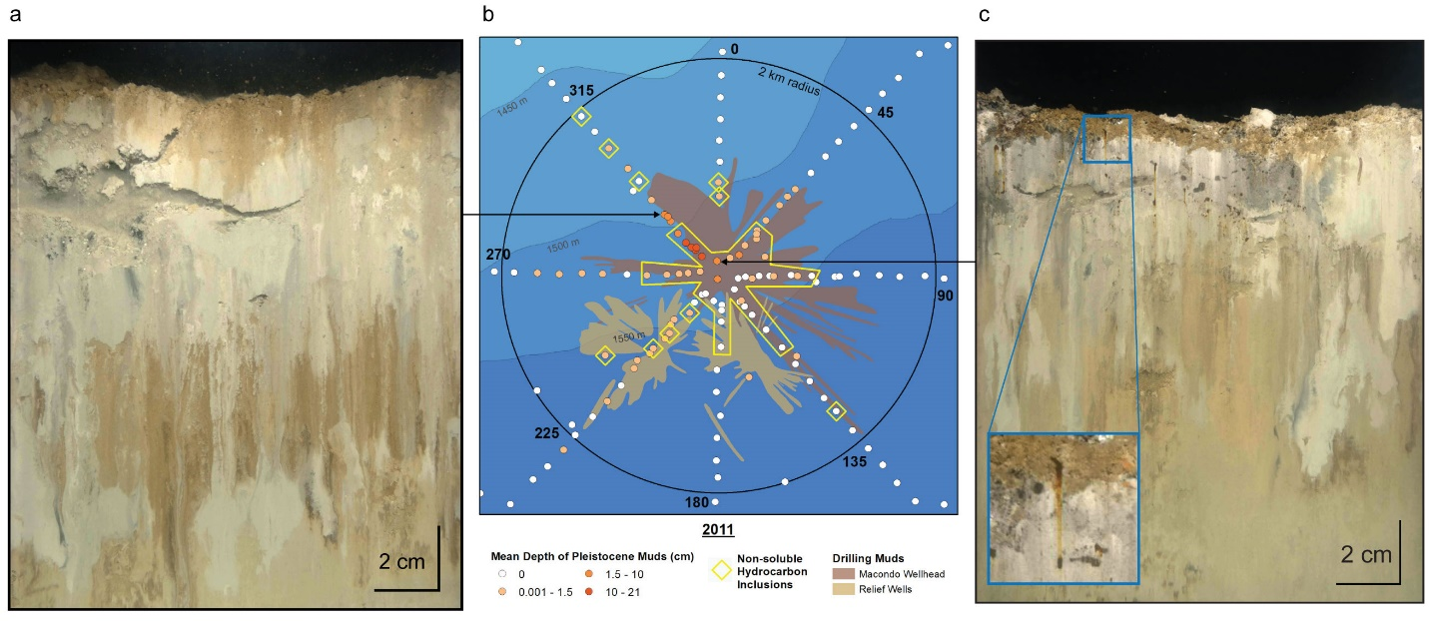 Figure 1. Physical evidence of Pleistocene muds and non-soluble hydrocarbon inclusions related to the Deepwater Horizon incident captured in 2011 SPI and correspondence with mapped drilling mud splays. The Pleistocene mud deposit (pale white/gray) related to well containment efforts shown in the example SPI (a) extends to ~6.5 cm below the sediment surface. Numerous non-soluble hydrocarbon inclusions (dark amoeboid blobs) are visible in the upper 5 cm of the sediment column in the example SPI (c).

Spatial patterns of non-soluble hydrocarbon inclusions and deposits of Pleistocene drilling muds in 2011 generally coincided with drilling mud splays related to containment activities at the Macondo well and two relief wells (Figure 1). Drilling mud splays were mapped in 2011 with an autonomous underwater vehicle equipped with geophysical instrumentation and a black-and-white digital camera⁴⁶. The depositional layer of Pleistocene muds (pale white/gray) related to well containment efforts was present and distinct from ambient sediments in 2011 with the thickest deposits (up to 20.7 cm) found to the northwest of the wellhead (Figure 1). These maximum depths exceed the 10 cm depth of sediment chemistry inquiry, which found drilling mud compounds present to this depth⁴⁴. Results from both SPI (mean 1.1 cm, SD ± 3.8 cm, Table S1) and chemical analyses found these indicators of Macondo deposition concentrated in the upper 3 cm of the sediment column⁴⁴.
In 2014 the distinct optical signatures of hydrocarbons and drilling mud deposition were almost entirely absent, with drilling mud deposits only observed at three stations (Table S1). Similarly, Macondo oil and drilling mud compounds significantly decreased in concentration and detected extent in 2014 sediment cores compared to 2011⁶.
Organic enrichment and biogeochemical response. The Deepwater Horizon spill and incident response resulted in deposition of organically enriched materials on the seafloor. Organically enriched deposits were optically distinct from ambient sediments, appearing as dark gray to black reduced sediments occurring at or just below the sediment-water interface, often covered with a dark brown oxidized crust of settled, macrofloccular detritus (Figure 2a). In 2011, these deposits were thickest (up to 3.5 cm) near the wellhead and became shallower further away (Figure 2a). The optical signature of these deposits was still visible in 2014, predominantly near the wellhead and to the southwest and northeast (Figure 2b). The thickest of these deposits were observed within ~ 500 m of the wellhead in both 2011 and 2014. The number of stations where organically enriched deposits were observed (2011: 81 of 615, 13.2%, 2014: 25 of 187, 13.4%) were statistically equivalent between 2011 and 2014 (X2 = 1.69, df = 1, p = 0.19). However, the depth to which organically enriched deposits extended into the sediment column was significantly deeper in 2014 compared with 2011 (ANOVA, F(1,465)= 6.97, p=0.009). This suggests bioturbating fauna may have incorporated the organic deposits deeper into the sediment column over the three years between data collection efforts^{20,21,47,48} (Figure 2b).
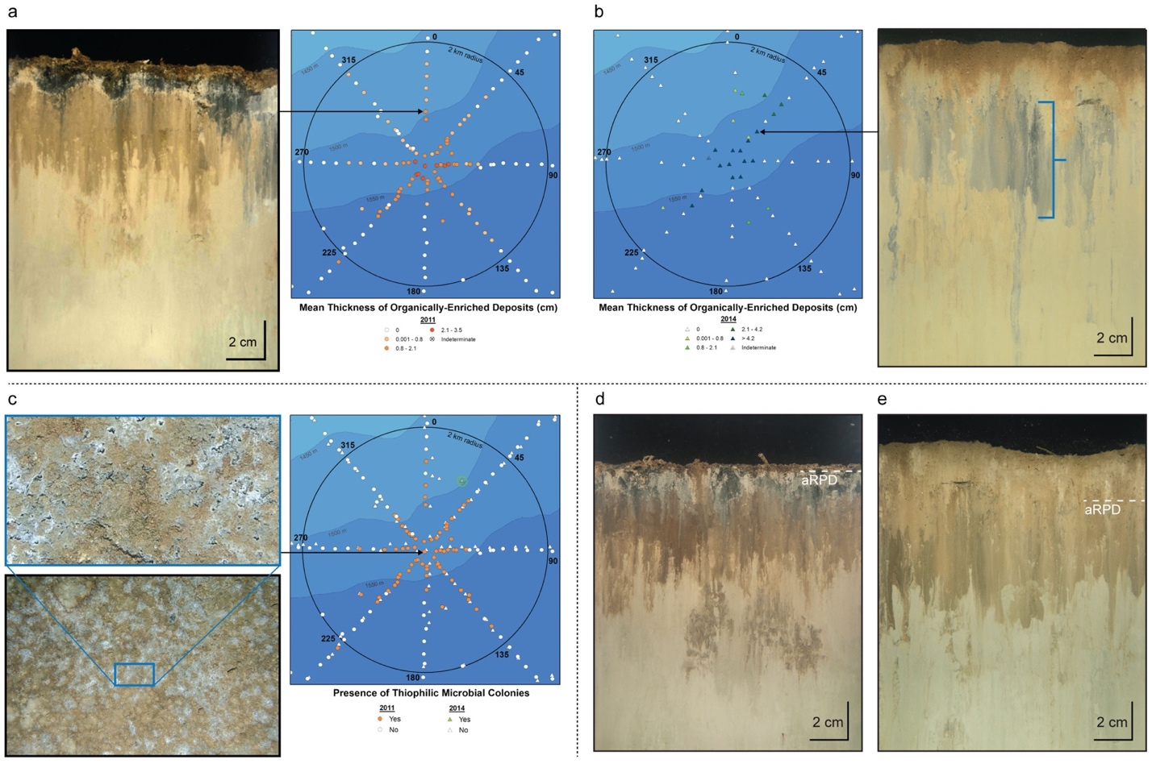
Figure 2. Evidence of excess organic enrichment in 2011 and a decrease in optical signatures of organic enrichment in 2014, as recorded in SPI and PV. The reduced organically enriched layer (dark gray/black material), which has a mean thickness of 1.34 cm in the 2011 example SPI (a) is covered by an oxidized crust of worm tubes, fecal pellets, and macrofloccular detritus (dark brown layer) that had settled out of the water column through natural depositional processes. The aRPD depth in the image is 0.64 cm. The 2014 example SPI (b) shows a less pronounced layer of the gray organically enriched deposit with 7.78 cm mean thickness brought deeper into the sediment column by bioturbating fauna. The aRPD depth in the image is 2.02 cm. The 2011 example PV (c) shows the characteristic white patterning of thiophilic microbial mats prevalent near the wellhead in 2011 and that were observed at one station (circled in green on map; ~1.2 km northeast of the wellhead between transects 0 and 45) in 2014. Representative SPI from 2011 from a station located 1.1 km southwest of the wellhead (d) showing evidence of excess organic loading and elevated sediment oxygen demand, indicated by a depositional layer of dark gray and black reduced sediment extending to a mean thickness of 1.42 cm below the sediment-water interface. The aRPD depth in the image is 0.32 cm. Representative SPI from 2014 (e) at the same sampling station showing a deep-sea sediment profile in the absence of excess organic enrichment. Reduced sediment (gray or black in color) is not visible in the sediment column, the aRPD depth is 2.82 cm, and surface tubes, thin shallow burrows, four feeding voids are present from a minimum depth of 2.11 cm to a maximum depth of 15.94 cm, and the recorded maximum bioturbation depth was 19.22 cm.

Beyond distinct organic deposits, other indications of excess organic enrichment and elevated benthic respiration rates were frequently observed in 2011; in 2014, this evidence was infrequent and less apparent. For example, in 2011, sulfur-oxidizing thiophilic microbial mats indicative of high sediment oxygen demand and hypoxic benthic boundary conditions^{33,49} were observed on the seafloor surface at 58.9% of the stations within 2 km of the wellhead (Figure 2c, Table S1). In 2014, these mats were only observed at a single station, 1.7% of stations within 2 km of the wellhead (Figure 2c, Table S1). Evidence of excess organic enrichment present in the sediment column also manifested as distinct optical signatures in SPI, including dark gray to black reduced sediment layers and shallow aRPD depths (Figure 2d). In contrast, images with aRPD depths deeper in the sediment column and an absence of dark reduced sediments reflected a balance between sediment oxygen demand and biological activity rather than excess enrichment (Figure 2e). The optical shift to a sediment column without signs of excess organic enrichment (measured by aRPD depth) may indicate that the microbial and macrobenthic communities had processed organic inputs through bioturbation activity^{6,47,48}, such that they were no longer discernable from ambient sediments²⁰. Radioisotope geochronology revealed initially high sedimentation rates with little to no bioturbation (2010–2011) with a decrease in sedimentation and return of bioturbation beginning as early as 2013⁵⁰.
The aRPD depth provided a robust spatial signal of functional benthic response to the mass organic enrichment pulse from the Deepwater Horizon incident (Figure 3). The spatial distributions of aRPD depths were quantitatively explored in two ways. Geostatistical exploration with spatial interpolation using ordinary kriging methods demonstrated that the aRPD depth measurements were shallower across the 10 km survey area in 2011 compared to 2014. In both years aRPD depths were also shallower at stations within 2 km of the wellhead and to the west beyond 2 km in 2011 (Figure 3a). The severely weathered Macondo oil that characterized deposits beyond 1.6 km⁴⁵ were also predominantly located to the west and northwest of the wellhead, which was the predominant direction of the deep-sea plume in the water column^{6,45}.
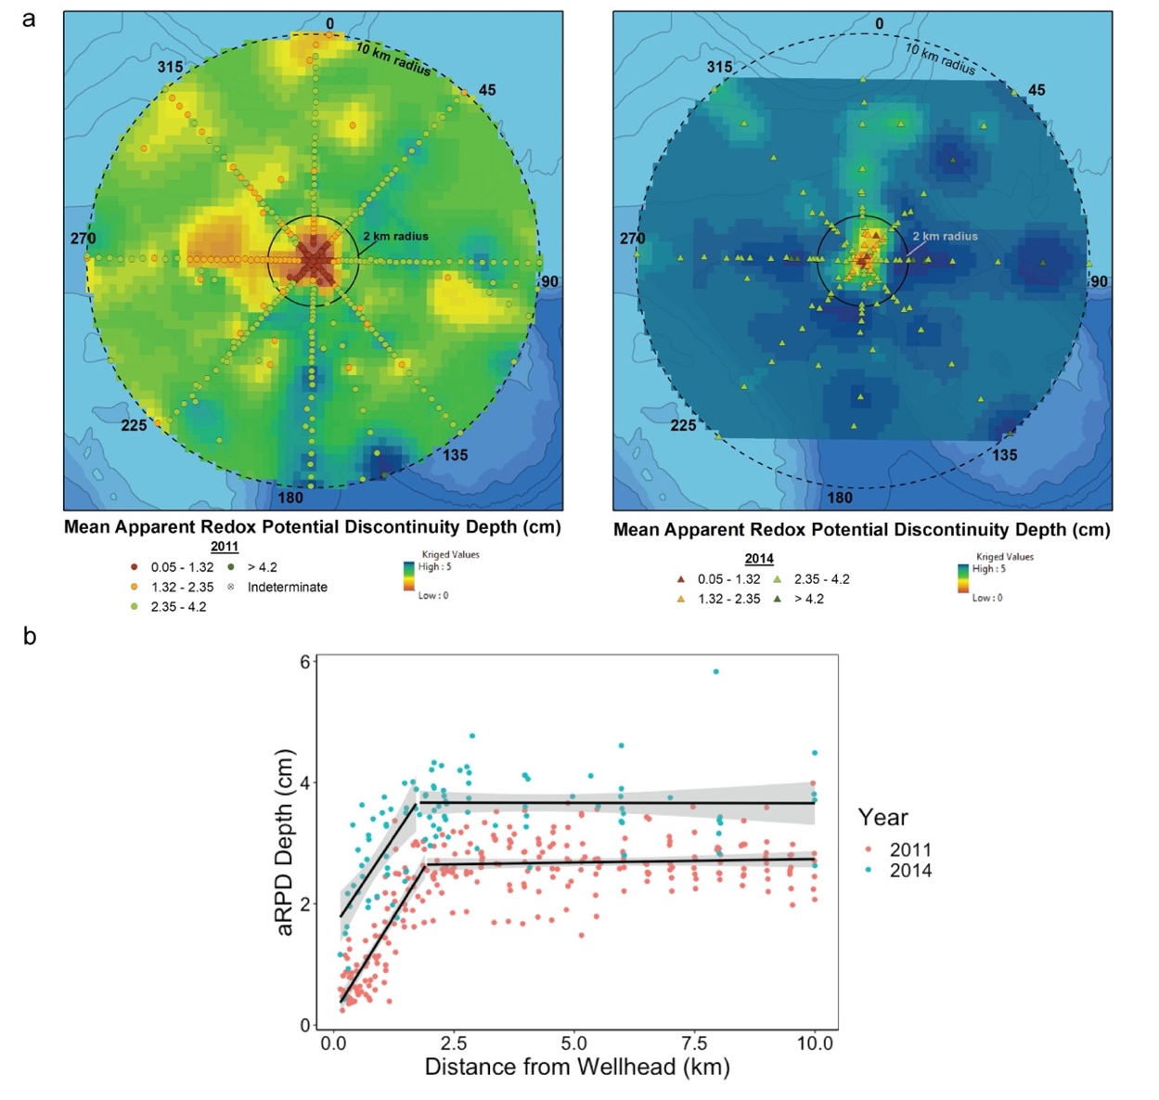
Figure 3. a) Interpolated aRPD depths from 2011 and 2014 within 10 km of the wellhead generated using ordinary kriging. b) Segmented regression of 2011 and 2014 aRPD depths regressed on distance from the wellhead for all transect stations out to 10 km. The gray area represents the 95% confidence interval around each regression segment.

The segmented regression analyses conducted to determine: 1) the effect of distance from the wellhead on aRPD depths, and 2) if, and how, this effect differed between the two sampling years, provided two distinct segments for each year (F_{(8, 362)}=1332; R² = 0.97) (Figure 3b). Specifically, aRPD depths closest to the wellhead were significantly lower in 2011 compared to 2014, with a 1.4 cm difference in intercept values, which were 0.2 cm in 2011 and 1.6 cm in 2014 (95% CI [-1.9, -0.95], p < 0.001). Under conditions of organic enrichment in many systems, aRPD depths less than 1 cm typically indicate impaired benthic function²⁰. Although the 2014 intercept was above this value, the regression analyses revealed aRPD depths were significantly affected by distance from the wellhead indicating the continued presence of a spatial gradient of effect. Benthic response to this gradient was evident in that measured aRPD depths significantly increased with distance from the wellhead in 2011 and 2014 out to 1.9 km (95% CI [1.74, 2.10], p < 0.001) and 1.7 km (95% CI [1.34, 2.11], p < 0.001), respectively (Figure 2b). These distances are similar to the spatial threshold of 1.6 km identified from chemical analyses; within this distance sediments experienced direct deposit of slightly weathered Macondo oil and drilling muds⁴⁴. Within these inflection points (1.9 and 1.7 km), the rate of change in aRPD depth relative to distance from the wellhead (regression slopes) were similar between 2011 and 2014 (p = 0.96). Together these results indicate that the benthic community within the upper sediment column within these spatial inflection points responded with similar rates of change to spatial disturbance gradients related to the wellhead and related deposition.
Beyond these inflection points 2011 and 2014 regressions also had similar slopes (p = 0.96), and there were no longer significant effects of distance from the wellhead on aRPD depths, with neither year’s regression slope being significantly different from zero (p₂₀₁₁ = 0.47, p₂₀₁₄ = 0.96) (Figure 3b). These spatial limits to the effect of distance on aRPD depths are likely due to the concurrent shift in deposition from slightly weathered Maconodo oil and drilling muds to severely weathered Macondo oil biodegraded within the deep-sea water column plume prior to deposition^{6,44,45}. The intercepts in these nearly flat portions of the aRPD regressions were also significantly different between the two years with 2011 having on average 1.1 cm shallower aRPD depths compared to 2014 (95% CI [-1.42, -0.67], p < 0.001).
The continued but declining presence and extent of degraded Macondo oil compounds in surface sediments in 2014^{6,45} likely contributed to the rebound in aRPD depths. This rebound was likely a combined result of microbial biodegradation of oil and drilling mud deposits (within 2 km) and the incorporation of these organic materials deeper into the sediment column by bioturbating macrofauna⁶ resulting in the near disappearance of visual indications of adverse organic enrichment by 2014. Temporal differences may also have been influenced by basin-wide variability unrelated to the Deepwater Horizon incident, for example natural interannual or seasonal variability of factors that influence biological mixing (infaunal recruitment, hypoxia, deposits of organic matter)^{21,25,47}.
Shifts in infaunal functional groups. High prevalence of opportunistic macrofauna, specifically high densities of tubicolous fauna at the sediment surface, were observed in 2011 SPI/PV (Figure 4, Table S1). This result is similar to previously published reports of benthic community composition following the Deepwater Horizon incident, as determined through benthic community analyses of sediment cores. These studies measured the meiofauna (0 – 3 cm; retained on 42-μm sieve) and macrofauna (0 – 10 cm; retained on a 0.3-mm sieve) communities in Fall 2010^{10,11,51,52} and Summer 2011⁵³. In these studies, reported meiofauna were primarily composed of nematodes and copepods^{10,51-53}, and macrofauna of polychaetes, molluscs, and crustaceans (Malacostraca) ^{10,11,52,53}. Additional taxonomic groups, such as oligochaetes (meiofauna) and sipunculids (macrofauna) among others, were present in lower abundance levels^{10,11,51-53}. Specifically, these studies reported high abundance of small disturbance-tolerant macrofaunal polychaetes (Dorvelleidae, Capitellidae, Maldanidae) consistent with early stages of succession²⁴ near the wellhead^{11,51,53}. The presence of these species, particularly Dorvelleidae, is not surprising given that members of this taxonomic family are omnivorous and graze on bacterial mats⁵⁴ and are often associated with organically enriched sediments in shallow systems²⁴, as well as with hydrocarbons⁵⁵, seeps, and other highly enriched and sulfidic environments in the deep sea⁵⁶.
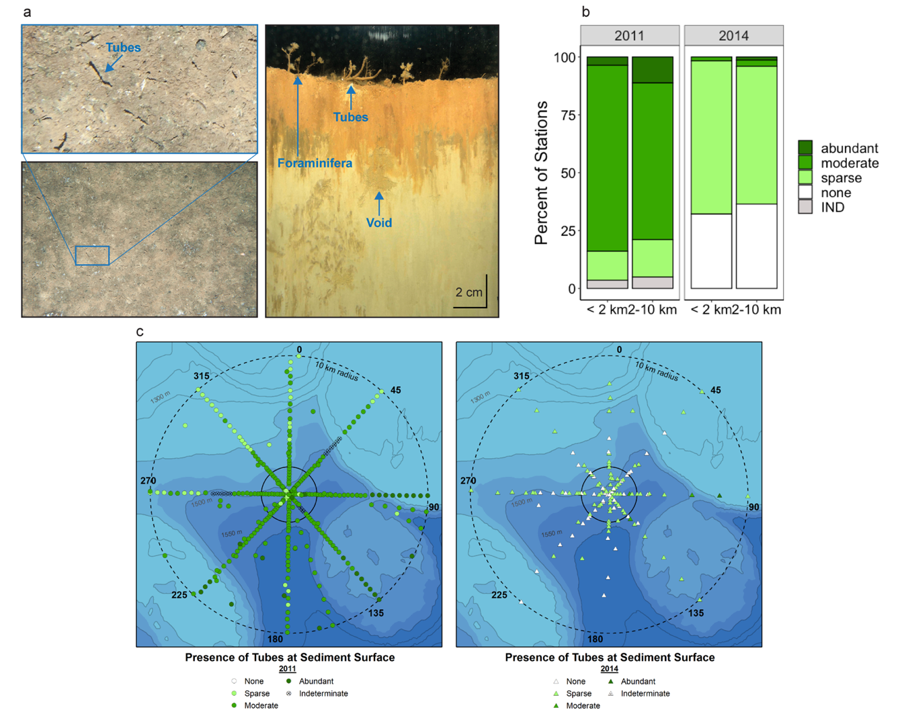
Figure 4. (a) Representative PV and SPI illustrating enhanced abundance of tubiculous infauna at the sediment surface, as well as subsurface feeding voids demonstrating how organic material is brought to depth by bioturbation activity. (b) Stacked bar plot and (c) maps showing opportunistic tubiculous fauna present predominantly at moderate levels and ranging from sparse to abundant in 2011 indicating an opportunistic response to organic enrichment. In 2014, most stations had sparse presence of these taxa indicating a decrease in the opportunistic stage of the benthic response to the organic enrichment event of the spill and containment.

The presence of tubicolous fauna captured by PV on the seafloor surface were greatly reduced in percent cover and prevalence in 2014 (Figure 4), a significant decrease in densities compared to 2011 (X² = 295.3, df = 4, p < 2.2 x 10⁻¹⁶). Similarly, a marked reduction in the abundance and dominance of opportunistic Dorvelleidae in the upper 10 cm of the sediment column was recorded in cores collected in 2014⁵⁷. This decrease in tubicolous, opportunistic fauna four years after the spill may signify a shift toward a less ephemeral benthic community²⁴.
SPI results recorded high prevalence of deep-burrowing taxa in both 2011 and 2014 as indicated by observation rates of feeding voids (maximums above 10 and means above 4 across sampling years and distance intervals, Table S1) and mean maximum void and bioturbation depths in excess of 13.5 cm and 15.9 cm, respectively (Table S1). Notably, greater maximum bioturbation depths (greater than 17.9 cm) and somewhat greater maximum feeding voids depths (greater than 13.8 cm) were measured in 2014 compared to 2011 (Figure 5, Table S1).
Feeding voids represent a subset of biogenic indicators of bioturbation that are easily recognizable to the untrained eye. However, they are present in lower frequency within the sediment column than burrows or sedimentary textures indicative of burrowing activity²⁰. SPI provides a two-dimensional view of the three-dimensional environment in which burrowers form extensive vertical and horizontal complexes inclusive of voids and burrows⁵⁸. Therefore, the measurement of bioturbation depth represents a more inclusive and comprehensive picture of infaunal bioturbation throughout the sediment column.

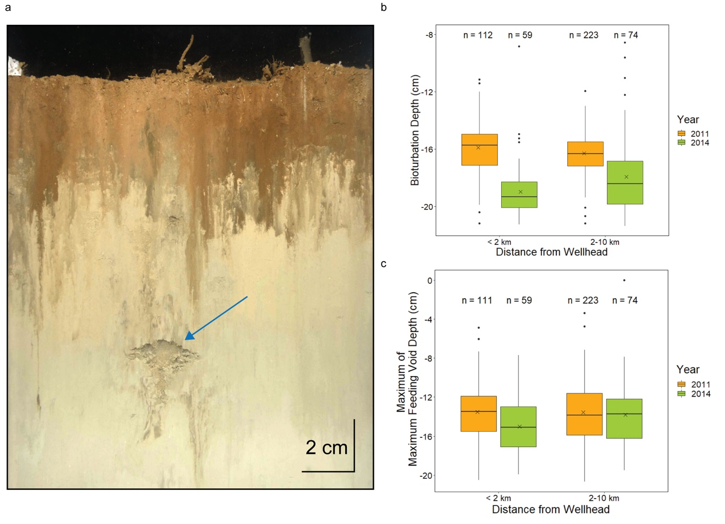
Figure 5. (a) Representative SPI from a station located 3,400 m directly east of the wellhead, showing a few tubes at the sediment-water interface, an aRPD of 2.89 cm, no organic deposits, biological reworking of organic material to ~ 4 cm, and a large feeding void at 12.7 cm (arrow). (b) Box plot showing the distribution of maximum bioturbation depths measured in SPI in 2011 and 2014 at stations within 2 km of the wellhead and those between 2 and 10 km of the wellhead. Images for which the maximum bioturbation depth was indeterminate were excluded from the analysis. This instance occurred at two stations where the SPI prism over-penetrated the sediment column, and the sediment-water interface was not visible. (c) Box plot showing the distribution of maximum feeding void depths measured in SPI in 2011 and 2014 at stations within 2 km of the wellhead and those between 2 and 10 km of the wellhead. One 2011 station within 2 km of the wellhead (GD3-01, 33 m from the wellhead center) did not capture any voids, therefore, the n for maximum void depth is 111 not 112. Replicate images for which voids were not identified and/or where depths were indeterminate were excluded from the analysis. In both (b) and (c), the box represents the interquartile range with the upper and lower edges representing the 75th and 25th percentile, respectively. The horizontal line denotes the median (50th percentile) and the “x” the mean. There were no discernible spatial patterns in maximum void and bioturbation depths measured 2011 or 2014.

Deep burrows and voids formed by subsurface biota are diagnostic of advanced successional taxa that mix sediments well below the sediment-water interface, introducing oxygen and increased water content to the pore space^{20,24}. Therefore, the spatial prevalence of deep-burrowing taxa following the spill indicates a benthos capable of bringing sediment oxygen consumption and excess organic material into balance^{30,46}. A distinct shift by these taxa in 2014 to greater maximum feeding void and bioturbation depths (Figure 5) suggests that organic matter and oxidants (oxygen) may have been available for consumption deeper in the sediment column compared to 2011.
Although temporal shifts are evident, there was not a significant effect of distance from the wellhead on void and bioturbation depth (Figure 5, Table S1). Because no baseline studies were conducted at the Macondo wellhead, it is unknown whether deep-burrowing taxa were present before the spill or colonized the sediment within the year before the 2011 SPI survey. Any deep-dwelling taxa present before the spill would have experienced a different disturbance event than those inhabiting the upper centimeters of the sediment column. Specifically, Macondo oil deposited both near and far from the wellhead were predominantly restricted to the upper 3 cm of the sediment column, and concentrations were markedly higher in the upper 1 cm⁴⁴. In 2011 beyond the immediate 1.6 km area of direct deposition, Macondo hydrocarbons mixed with ambient hydrocarbons in the 1-3 cm interval, and below 3 cm hydrocarbon signatures and concentrations were related to ambient sources (seeps, extraction) and were similar to those found throughout the study area⁴⁵. The presence of bioturbators deep within the sediment column throughout the surveyed area suggest a benthic macrofaunal community adapted to this persistent and ubiquitous presence of hydrocarbons.
Bioturbation as a mechanism of functional recovery. The widespread presence of deep-burrowing taxa in both 2011 and 2014 suggests a mechanism by which functional recovery occurred quickly following the spill. SPI/PV results support the hypothesis that oil-enhanced microbial degradation and infaunal bioturbation generated a positive feedback loop to accelerate benthic recovery facilitated by microbial and infaunal communities resilient to substantial and unpredictable hydrocarbon releases due to evolutionary adaptations conferred by an environment rich in hydrocarbons. These communities have experienced exposure to naturally occurring seeps over geological time scales^{9,16,59} and anthropogenic extraction activities over many decades⁶⁰.
Microbial consortia capable of degrading petroleum-based hydrocarbons increased rapidly while the Macondo well was releasing oil, and biodegradation was faster than expected in the deep hydrocarbon plume in the water column^{61,62}. Bioturbation enhances microbial biodegradation of organic matter in sediments^{47,63}, including the degradation of oil and oil-derived compounds⁶⁴. Specifically, experiments using Macondo-like crude oil found that oil additions stimulated microbial degradation, an effect that was enhanced in the presence of bioturbation^{64,65}. Experimental additions also indicated that short-term exposure to the water-accommodated fraction of oil did not affect bioturbation activity⁶⁶, and deep bioturbation has been suggested as an adaptive strategy in deep-sea environments that receive influxes of organic material^{66,67}. These findings paired with SPI results of bioturbation deep within the sediment column throughout the area suggest that a positive feedback loop between microbial degradation and bioturbation may be a plausible mechanism for benthic recovery from the Deepwater Horizon oil spill.
Rapid functional benthic recovery. The responses of deep-sea benthic communities to large volume anthropogenic organic enrichment events such as the Deepwater Horizon oil spill are not well understood^{8,68}. The SPI/PV data collected in 2011 and 2014 show a rapid benthic functional response to the Deepwater Horizon oil spill. The response variables that were measured tracked with the physical footprint of the spill. Adverse effects related to organic enrichment decreased along a spatial gradient away from the wellhead. Although the spatial signal of these effects was still significant and detectable in a few variables four years after the spill, the SPI/PV data indicate that significant and meaningful functional benthic recovery had occurred.
Although the patterns of change in aRPD depths with distance from the wellhead (the slopes and inflection points) were similar between 2011 and 2014, the aRPD depths overall were greater in 2014 compared to 2011 (Figure 3b). This temporal difference in aRPD depths visualized as the space between the two regression models (Figure 3b) can be viewed as a measure of functional benthic recovery. In 2014, the aRPD depth nearest the wellhead was 1.6 cm (y-intercept) and aRPD depths within the 1.7 km inflection point were generally between 2 and 4 cm (Figure 3), values that typically indicate unimpaired benthic function²⁰. These aRPD depth patterns area corroborated by decreased concentrations of drilling mud and Macondo oil compounds^{6,45} and by the distinct shift of deeper maximum bioturbation depths in 2014 (Figure 5).
The co-occurrence of abundant opportunistic surface-dwelling taxa and large deep burrowing macrofauna in 2011 indicates a possible rapid progression (within a year of the incident) from initial to advanced stages of infauna succession in which both stages coexist (Stage 1 on 3²³), a co-existence previously reported in the deep sea associated with relatively low intensity disturbance⁶⁹. While a few other studies note possible signs of benthic recovery in 2011^{11,52,53} and in 2014⁵⁷, the authors equate full recovery with a return to pre-spill taxonomic abundance and diversity metrics as measured from sediment samples. However, the 10 cm sieving depth used by these studies limits the ability to fully document the presence of deep-dwelling burrowing macrofauna (e.g., pectinid polychaetes, protobranch bivalves²³), taxa known for their influence on sediment dynamics⁷⁰ and sensitivity to disturbance gradients^{20,24}. Collection of sediment cores also disrupts burrowing structures⁷¹ and may only capture fractions of extensive burrow complexes, thereby underestimating the presence and influence of these taxa on benthic function⁵⁸. Increasing evidence has been reported that indicates that vertical burrowing is more extensive and likely influences rates of benthic respiration and nutrient flux to a greater degree than previously known^{58,72}. These studies report burrows below 10 cm at deep-sea cold seeps⁵⁸, in non-seep soft sediments⁵⁸, and in environments where frequent delivery of large amounts of labile organic carbon to the seafloor is promoted by hydrogeological features such as high bottom currents and turbidite flows^{66,67}. Burrows were even identified at up to 8 m depth in the fossil record within sand intrusions found in channel fills within submarine fans and lobe deposits on basin floors⁷².
It is clear from SPI results that macrobenthic infauna were present well below 10 cm within sediments that visibly contained hydrocarbons and other physical evidence of the Deepwater Horizon spill in 2011. In addition, these fauna may have facilitated burial and degradation of these organically enriched sediments through bioturbation⁶. These results suggest that the conclusions about the severity of the spill’s impacts on the benthos and predictions of up to 50 to 100 years for taxonomic recovery¹⁸ should be reconsidered. In addition to a reliance on taxonomic abundance and diversity metrics, the operational definition of recovery used by the synthesis authors¹⁸ presupposes that full macrobenthic taxonomic recovery will only occur when compounds related to the spill are fully buried and/or degraded. The predicted ~50 –100 years for recovery was based on expectations of very slow sediment accumulation, oil degradation, and metabolic rates in the deep sea¹⁸, expectations that are challenged by data supporting the hypothesis of rapid bioturbation-mediated microbial degradation of hydrocarbons.
The dichotomy between the conclusions of these other studies and the SPI/PV data presented here is likely due to differences in how benthic recovery is assessed. The SPI/PV approach does not document infaunal species diversity or abundance metrics, but rather functional status, which can be difficult to deduce from taxonomic data⁷³. Multiple studies have found parameters assessed from SPI, including the aRPD and biogenic structures, to be useful as predictors of benthic function and quality²⁰. Further, taxonomic analyses are limited (and potentially biased) by sieving depth and sieve size, and detailed analyses are required to reconstruct ecological relationships present in the sediment column⁷⁴. Key functions, such as bioturbation, are expected to be reduced with biodiversity loss, however the magnitude of these declines is directly related to the functional traits of species lost⁷⁴. Deep-sea benthic functioning (nutrient and carbon cycling) influences ocean health and productivity and is not strictly linked to specific taxonomic composition or diversity^{8,74}. As such, documenting changes in benthic functioning is critical to assessing benthic recovery after disturbance. This is particularly relevant here as benthic functioning, including bioturbation and benthic microbial respiration as evaluated using the proxies of aRPD, voids, and bioturbation depth, appears to be at least in part responsible for processing the high sediment deposition and organic enrichment pulse from the Deepwater Horizon incident^{33,62}.
Conclusions
In a relatively data-poor field, such as deep-sea benthic ecology^{8,18}, caution must be exercised in drawing conclusions about recovery and continued impact due to limited knowledge about the natural variability of the system⁷⁵. Given recent global interest in “ultra-deep” (>= 1,500 m) oil and gas exploration and development⁷⁶, it is also imperative to understand the effects of large-scale oil spills within the environmental, ecological, and evolutionary context of the deep sea. The collective understanding of the Deepwater Horizon incident and potential future effects of deep-sea oil spills on the benthos would benefit from detailed examinations of the roles seeps and organic enrichment events play in the deep sea. Such an improved understanding would assist the scientific community in knowing when to adapt macrofaunal sampling strategies to capture deeper burrowing taxa based on ecological and geographic context, as well as emerging science^{58,72}. Recovery patterns in the deep sea remain relatively understudied and emerging results and hypothesized models of recovery, including those presented here, provide the opportunity to challenge confirmation biases about deep-sea macrofauna and the long-term impact of deep-sea oil spills on these communities and the critical global ecosystem services they provide.

SUPPORTNG INFORMATION: Additional detailed materials and methods including field survey planning, relationship to other Natural Resources Damage Assessment Surveys, specific months of sampling, and a full sampling map; Results of within-2011 temporal analysis and decisions for data treatment; Summary Table S1 with summary statistics (minimum, maximum, mean, and standard deviation) for each variable; Short descriptor of provided full data set spreadsheet and metadata files; References for Supporting Information
ACKNOWLEDGMENT: Funding for this work was provided by the American Petroleum Institute, Oil Spill Emergency Preparedness and Response Subcommittee. We thank API's Science and Technology Work Group for their comments on the draft. The decision to incorporate such comments in the manuscript was at the discretion of the authors. The views expressed herein belong solely to the authors and may not represent the views of API or its members. Members of the Technical Advisory Committee provided input, review and comment on the approach, assumptions and data inputs as the study progressed. The authors appreciate the insightful and constructive comments made by the Technical Advisory Committee, which greatly contributed to the reliability, applicability, and relevance of the results.
Alexandria Rhoads conducted geospatial kriging analysis. Steve Sabo and Ben Taylor supported figure development. Further thanks go to David Browning and Raymond Valente who contributed to data collection and analysis, as well as the crew and all participants in the three field surveys during which these data were collected. We are grateful for the valuable reviews provided by Jean Martin, Melissa Simpson, Maarten Kuijper, Bea Stong, Oliver Pelz, and Colin Frazier.
FUNDING SOURCES: Funding for this work was provided by the American Petroleum Institute, Oil Spill Emergency Preparedness and Response Subcommittee.

REFERENCES
- A.G. Glover, C.R. Smith, The deep-sea floor ecosystem: current status and prospects of anthropogenic change by the year 2025. Env. Conserv. 30, 219–241 (2003).
- United States District Court for the Eastern District of Louisiana. Finding of Fact and Conclusions of Law Phase Two Trial: In re: Oil Spill by the Oil Rig “Deepwater Horizon” in the Gulf of Mexico on April 20, 2010. Eastern District of Louisiana | United States District Court. http://www.laed.uscourts.gov/sites/default/files/OilSpill/Orders/1152015FindingsPhaseTwo.pdf (accessed 08-17-2022), filed 2015.
- C.M. Reddy et al., Composition and fate of gas and oil released to the water column during the Deepwater Horizon oil spill. PNAS 109, 20229–20234 (2012).
- U. Passow, S. Stout, Character and sedimentation of “lingering” Macondo oil to the deep-sea after the Deepwater Horizon oil spill. Mar. Chem. 218, 103733 (2020).
- E.B. Overton, D.L. Wetzel, J.K. Wickliffe, P.L. Adhikari, “Spilled Oil Composition and the Natural Carbon Cycle: The True Drivers of Environmental Fate and Effects on Oil Spills” (Chap. 3) in Scenarios and responses to future Deep Oil Spills – fighting the next war; S.A. Murawski et al., Eds. (Springer, Cham, Denmark, 2020).
- S.A. Stout, J.R. Payne, Footprint, weathering, and persistence of synthetic-base drilling mud olefins in deep-sea sediments following the Deepwater Horizon disaster. Mar. Pollut. Bull. 118, 328–340 (2017).
- M.K. Taylor, C.N. Roterman, Invertebrate population genetics across Earth’s largest habitat: The deep-sea floor. Mol. Ecol. 26, 4872–4896 (2017).
- L.A. Levin et al., Global Observing Needs in the Deep Ocean. Front. Mar. Sci. 6, Article 241 (2019).
- C.R. Fisher, P.A. Montagna, T.T. Sutton, How did the Deepwater Horizon oil spill impact deep-sea ecosystems? Oceanography 29, 182–195 (2016).
- P.A. Montagna et al., Deep sea Benthic Footprint of the Deepwater Horizon Blowout. PLoS ONE 8, e70540 (2013).
- T. Washburn, A.E.C. Rhodes, P.A. Montagna, Benthic taxa as potential indicators of a deep-sea oil spill. Ecol. Indic. 71, 587 (2016).
- E.B. Kujawinski et al., The first decade of scientific insights from the Deepwater Horizon oil release. Nat. Rev.: E&E 1, 237–250 (2020).
- J.A. Wiens, Oil, Seabirds, and Science. BioScience 46, 587–597 (1996).
- M.C. Kennicutt, “Oil and Gas Seeps in the Gulf of Mexico” in Habitats and Biota of the Gulf of Mexico: Before the Deepwater Horizon Oil Spill, C. Ward, Ed. (Springer, New York, NY, 2017).
- S.D. Locker, A.C. Hine, “An Overview of the Geologic Origins of Hydrocarbons and Production Trends in the Gulf of Mexico” (Chap. 4) in Scenarios and responses to future Deep Oil Spills – fighting the next war; S.A. Murawski et al., Eds. (Springer, Cham, Denmark, 2020).
- L.A. Levin et al., Hydrothermal Vents and Methane Seeps: Rethinking the Sphere of Influence. Front. Mar. Sci. 3, Article 72 (2016).
- P.V.R. Snelgrove, The importance of marine sediment biodiversity in ecosystem processes. Ambio 26, 578-583 (1997).
- P.T. Schwing et al., A Synthesis of Deep Benthic Faunal Impacts and Resilience Following the Deepwater Horizon Oil Spill. Front. Mar. Sci. 7, Article 560012 (2020).
- A.R. Thurber, et al., Ecosystem function and services provided by the deep sea. Biogeosciences 11, 3941-3963 (2014).
- J.D. Germano, D.C. Rhoads, R.M. Valente, D. Carey, M. Solan, The use of Sediment Profile Imaging (SPI) for environmental impact assessments and monitoring studies: lessons learned from the past four decades. Oceanogr. Mar. Biol. 49, 247–310 (2011).
- L.R. Teal, E.R. Parker, M. Solan, Sediment mixed layer as a proxy for benthic ecosystem process and function. Mar. Ecol. Prog. Ser. 414, 27–40 (2010).
- T.C. Gerwing et al., Depth to the apparent redox potential discontinuity (aRPD) as a parameter of interest in marine benthic habitat quality models. Int. J. Sediment Res. 33, 149–156 (2018).
- D.C. Rhoads, J.D. Germano, Interpreting long-term changes in benthic community structure: a new protocol. Hydrobiologia 142, 291–308 (1986).
- T.H. Pearson, R. Rosenberg, Macrobenthic succession in relation to organic enrichment and pollution of the marine environment. Oceanogr. Mar. Biol. Ann. Rev. 16, 229–311 (1978).
- H.C. Nilsson, R. Rosenberg, Succession in marine benthic habitats and fauna in response to oxygen deficiency: analysed by sediment profile-imaging and by grab samples. Mar. Ecol. Prog. Ser. 197, 139–149 (2000).
- R.J. Diaz, D.C. Rhoads, J.A. Blake, R.K. Kropp, K.E. Keay, Long-term trends of benthic habitats related to reduction in wastewater discharge to Boston Harbor. Estuar. Coast. 31, 1184–1197 (2008).
- J.S. Gray, M. Elliott, Ecology of Marine Sediments: From Science to Management. 2nd edition. (Oxford University Press, Oxford, UK, 2009).
- C.M. Duarte et al., Paradigms in the Recovery of Estuarine and Coastal Ecosystems. Estuar. Coast. 38, 1202–1212 (2015).
- M.A. Rex, R.J. Etter, Deep-sea biodiversity: Pattern and scale. (Harvard University Press, Cambridge, Massachusetts, USA, 2010).
- T. Fenchel, The ecology of marine macrobenthos IV. Structure and function of the benthic ecosystem, its chemical and physical factors and the microfauna communities with special reference to the ciliated protozoa. Ophelia 6, 1–182 (1969).
- M. Lyle, The brown-green colour transition in marine sediments: a marker of the Fe (III) – Fe (II) redox boundary. Limnol. Oceanogr. 28, 1026–1033 (1983).
- S.K. Sturdivant, M.S. Shimizu, In situ organism-sediment interactions: bioturbation and biogeochemistry in a highly depositional estuary. PLoS ONE 12, e0187800 (2017).
- R. Rosenberg, R.J. Diaz, Sulfur bacteria (Beggiatoa spp.) mats indicate hypoxic conditions in the inner Stockholm Archipelago. Ambio 22, 32–36 (1993).
- R. Bivand, classInt: Choose univariate class intervals. R package version 0.1-21. http://CRAN.R-project.org/package=classInt (2013).
- R Core Team, R: A language and environment for statistical computing. R Project for Statistical Computing. http://www.R-project.org/ (accessed 08-17-2022).
- E.J. Pebesma, Multivariable geostatistics in S: the gstat package. Comput. Geosci. 30, 683–691 (2004).
- B. Gräler, E. Pebesma, G. Heuvelink, Spatio-Temporal Interpolation using gstat. The R Journal 8, 204–218 (2016).
- V.M.R. Muggeo, Estimating regression models with unknown break-points. Statist. Med. 22, S3055–3071 (2003).
- V.M.R. Muggeo, segmented: an R Package to Fit Regression Models with Broken-Line Relationships. R News 8/1, 20–25, https://cran.r-project.org/doc/Rnews/ (2008).
- V.M.R. Muggeo, Testing with a nuisance parameter present only under the alternative: a score-based approach with application to segmented modelling. J. of Stat. Comput. Simul. 86, 3059–3067 (2016).
- V.M.R. Muggeo, Interval estimation for the breakpoint in segmented regression: a smoothed score-based approach. Aust. NZ. J. Stat. 59, 311–322 (2017).
- H. Torsten, F. Bretz, P. Westfall, Simultaneous Inference in General Parametric Models. Biom. J. 50, 346–363 (2008).
- U. Passow, J. Sweet, A Quigg, How the dispersant Corexit impacts the formation of sinking marine oil snow. Mar. Pollut. Bull. 125, 139–145 (2017).
- S.A. Stout, J.R. Payne, Macondo oil in deep-sea sediments: Part 1 – sub-sea weathering o foil deposited on the seafloor. Mar. Pollut. Bull. 111, 365-380 (2016a).
- S.A. Stout, J.R. Payne, R.W. Ricker, G. Baker, C. Lewis, Macondo oil in deep-sea sediments: Part 2 – Distribution and distinction from background and natural oil seeps. Mar. Pollut. Bull. 111, 381-401 (2016b).
- C&C Technologies, Photomosaic Report Addendum. Macondo Seafloor and Environmental Abandonment AUV Survey. Blocks 206-210, 250-254, 294-299, 338-340, & 382-384. Mississippi Canyon Area. C&C Project No. 100967, submitted to BP America, Inc. January 2012. (2012).
- R.C. Aller, “The effects of macrobenthos on chemical properties of marine sediment and overlying water” in Animal-Sediment Relations, (Springer US, Boston, MA, 1982), pp. 53–102.
- M. Solan, B.D. Wigham, “Biogenic particle reworking and bacterial-invertebrate interactions in marine sediments” in Coastal and Estuarine Studies 60, Interactions between Macro- and Microorganisms in Marine Sediments, E. Kristensen et al., Eds. (Washington, DC: American Geophysical Union, 2005), pp. 105–124.
- B.B. Jorgensen, N.P. Revsbeck, Colorless sulfur bacteria, Beggiatoa spp. and Thiovulum spp. in O2 and H2S microgradients. Appl. Environ. Microbiol. 45, 1261-1270 (1983).
- R.A. Larson et al., “Characterization of the sedimentation associated with the Deepwater Horizon blowout: depositional pulse, initial response, and stabilization” (Chap. 14) in Deep oil spills: facts, fate, effects, S.A. Murawski et al., Eds. (Springer, Cham, Denmark, 2020).
- J.G. Baguley et al., Community response of deep-sea soft-sediment metazoan meiofauna to the Deepwater Horizon blowout and oil spill. Mar. Ecol. Prog. Ser. 528, 127–140 (2015).
- M.G. Reuscher, J.G. Baguley, P.A. Montagna, The expanded footprint of the Deepwater Horizon oil spill in the Gulf of Mexico deep-sea benthos. PLoS ONE 15, e0235167 (2020).
- P.A. Montagna, J.G. Baguley, C. Cooksey, J.L. Hyland, Persistent impacts to the deep soft-bottom benthos one year after the Deepwater Horizon event. Integr. Environ. Assess. Manage. 13, 342–351 (2017a).
- J. Zanol et al., The Current State of Eunicida (Annelida) Systematics and Biodiversity. Diversity 2021, 13, 74 (2021).
- J. Hyland et al., Effects of an oil spill on soft-bottom benthos of Arthur Harbour, Antarctica compared with long-term natural change. Antarct. 6, 37–44 (1994).
- L.A. Levin et al., Ecological release and niche partitioning under stress: lessons from dorvilleid polychaetes in sulfidic sediments at methane seeps. Deep-Sea Res. Pt. II 92, 214–233 (2013).
- M.G. Reuscher et al., Temporal patterns of Deepwater Horizon impacts on the benthic infauna of the northern Gulf of Mexico continental slope. PLoS ONE 12, e0179923 (2017).
- K. Seike, R.G. Jenkins, H. Watanabe, H. Nomaki, K. Sato, Novel use of burrow casting as a research tool in deep-sea ecology. Biol. Lett. 8, 648–651(2012).
- J. Coleman et al., Oil in the sea III: Inputs, fates, and effects. Committee on Oil in the Sea: Inputs and Effects, Ocean Studies Board and Marine Board, Divisions of Earth and Life Studies and Transportation Research Board, National Research Council. (National Academies Press, Washington, DC, USA, 2003).
- S.A. Murawski et al., Eds., Scenarios and responses to future Deep Oil Spills – fighting the next war. (Springer, Cham, Denmark, 2020a).
- T.C. Hazen et al., Deep-sea oil plume enriches indigenous oil-degrading bacteria. Science 330, 204–208 (2010).
- S.B. Joye, A.P. Teske, J.E. Kostka, Microbial Dynamics Following the Macondo Oil Well Blowout across Gulf of Mexico Environments. BioScience 64, 766–777 (2014).
- E. Kristensen, Organic matter diagenesis at the oxic/anoxic interface in coastal marine sediments, with emphasis on the role of burrowing animals. Hydrobiologia 426, 1–24 (2000).
- K.M. Dorgan et al., Investigating the sublethal effects of oil exposure on infaunal behavior, bioturbation, and sediment oxygen consumption. Mar. Ecol. Prog. Ser. 635, 9–24 (2020).
- B.N. Orcutt et al., Microbial response to oil enrichment in Gulf of Mexico sediment measured using a novel long-term benthic lander system. Elem. Sci. Anth. 5, 18 (2017).
- J. Aller, Benthic community response in temporal and spatial gradients in physical disturbance within a deep-sea western boundary region. Deep-Sea Res. Pt. I 44, 39–69 (1997).
- K. Olu et al., Cold-seep-like macrofaunal communities in organic- and sulphide-rich sediments of the Congo deep-sea fan. Deep-Sea Res. Pt. II 142, 180–196 (2017).
- C.R. Smith, F.C. De Leo, A.F. Bernardino, A.K. Sweetman, P.M. Arbizu, Abyssal food limitation, ecosystem structure and climate change. Trends Ecol. Evol. 23, 518–28 (2008).
- C.R. Smith, R.R. Hessler. 1987. Colonization and succession in deep-sea ecosystems. Trends Ecol. Evol. 2, 359-363 (1987).
- M. Solan et al., Worldwide measurements of bioturbation intensity, ventilation rate, and the mixing depth of marine sediments. Nature: Sci. Dat. 6, 58 (2019).
- C. Gaillard, Recent organism traces and ichnofacies on the deep-sea floor off New Caledonia southwestern Pacific. Palaios 6, 302–315 (1991).
- S. L. Cobain, D. M. Hodgson, J. Peakall, P. B. Wignall, M. R. D. Cobain, A new macrofaunal limit in the deep biosphere revealed by extreme burrow depths in ancient sediments. Sci Rep-UK 8, 261 (2018).
- M. Solan et al., Toward a greater understanding of pattern, scale and process in marine benthic systems: a picture is worth a thousand worms. J. Exp. Mar. Biol. Ecol. 285-286, 313–338 (2003).
- M. Solan et al., Extinction and Ecosystem Function in the Marine Benthos. Science 306, 1177–1180 (2004).
- K.R. Parker, J.A. Wiens, Assessing recovery following environmental accidents: environmental variation, ecological assumptions, and strategies. Ecol. Appl. 15, 2037–2051 (2005).
- S.A. Murawski, D.J. Hollander, S. Gilbert, A. Gracia, “Deep-water oil and gas production in the Gulf of Mexico, and related global trends” (Chap. 2) in Scenarios and responses to future Deep Oil Spills – fighting the next war; S.A. Murawski et al., Eds. (Springer, Cham, Denmark, 2020b).
Graphic for Table of Contents:
