Title:
How is oral isotretinoin prescribed for the treatment of acne vulgaris? Results from a UK Dermatology Clinical Trials Network (UKDCTN) and British Dermatological Nursing Group (BDNG) survey of health professionals

Authors:
Zahra Moledina¹, Margaret McPhee², Jane C Ravenscroft³, Eugene Healy⁴, Kathy Radley⁵, Kim S Thomas^{2*}, Esther Burden-Teh^{2*} on behalf of the Acne-ID trial development team

*Joint senior authors

Institutions:
- Department of Dermatology, Nottingham University Hospitals NHS Trust, UK
- Centre of Evidence Based Dermatology, School of Medicine, University of Nottingham, UK
- Department of Paediatric Dermatology, Nottingham Children’s Hospital, Nottingham University Hospitals NHS Trust, UK
- Dermatopharmacology, Faculty of Medicine, University of Southampton, UK
- Department of Clinical, Pharmaceutical and Biological Science, School of Life and Medical Sciences, University of Hertfordshire, UK

Word count: Abstract 118 words, Main report 998 words (excluding references)
Figure count: 3

Corresponding author: Dr Esther Burden-Teh
Email: esther.burden-teh@nottingham.ac.uk

Funding: None
Conflict of interest: None

What is already known about this topic?
Oral isotretinoin is an effective treatment for acne vulgaris. However, its side effect profile led to it being the focus of a Medicines Healthcare Products Regulatory Agency (MHRA) review. There is a paucity of evidence on the effectiveness of low dose isotretinoin regimens.

What does this study add?
This study focuses on clinicians’ views prescribing low dose oral isotretinoin regimens. The systematic review informing NICE guideline NG198 found that evidence for a lower daily dose of isotretinoin was scarce, with results almost exclusively from trials testing at least 0.5mg/kg/day, highlighting the need for further research. The results of this survey will be useful to inform a clinical trial.

Abstract

We undertook a survey of UK healthcare professionals through the UKDCTN and BDNG to understand clinicians’ routine practice prescribing oral isotretinoin for treatment of acne vulgaris (acne). We also wanted to understand clinicians’ experiences and views on prescribing low daily dose regimens. Overall, the survey showed that clinicians adopted a patient-centred approach when deciding isotretinoin dosing. The rationale for using a low-dose regimen varied, but was focused on patient wellbeing during treatment. Some clinicians were concerned that use of a low-dose regimen could be less effective and lead to longer treatment durations. The survey results will be useful to inform a clinical trial investigating the effectiveness and safety of low daily dose isotretinoin for the treatment of acne.

Introduction
Oral isotretinoin is an effective medication for treatment of acne¹. The side effect profile of potential adverse effects, from mucocutaneous dryness to teratogenicity and mood disturbance, are of concern to clinicians and patients. Treatment with isotretinoin has polarised views and it is currently the focus of a Medicines Healthcare Products Regulatory Agency (MHRA) review². The recent National Institute for Health and Care Excellence (NICE) guideline NG198 on management of acne supports the ongoing use of isotretinoin within the MHRA licensed indication³. An important research recommendation has been commissioned by the National Institute for Health Research Health Technology Assessment (NIHR HTA)⁴, to investigate the benefits and harms of reduced daily dose isotretinoin (<0.5mg/kg/day) for treatment of acne. Studies have indicated that daily doses of 0.1-0.3mg/kg may be preferential due to their fewer side effects and lower cost⁵. However, the systematic review informing the NG198 guideline found that evidence from randomised controlled trials for a lower daily dose of isotretinoin was scarce, with results almost exclusively from trials testing at least 0.5mg/kg/day³.

Report
To inform a large-scale clinical trial we conducted a survey of UK health professionals through the UK Dermatology Clinical Trials Network (UKDCTN) and British Dermatological Nursing Group (BDNG), with distribution lists of 1100 and 2198 members respectively at the time of the survey. We requested completion only by members with experience of starting or monitoring oral isotretinoin for acne. Hosted on SurveyMonkey, the survey consisting of 25 questions (multiple-choice and open-ended questions allowing free-text responses) was open for two weeks in October 2021. Our aim was to understand how clinicians routinely prescribe oral isotretinoin in relation to NICE guidance and understand their views on low dose treatment regimens.

A total of 126 responses were received and 48% of respondents had >15 years clinical experience. Clinicians from the following regions responded: Midlands (25% of respondents), London (14%), South West (12%), North East and Yorkshire (12%), East of England (9%), North West (7%), Scotland (7%), South East (7%), Republic of Ireland (5%) and Northern Ireland (2%). Approximately half of responses were from dermatology consultants (52%), followed by independently prescribing dermatology clinical nurse specialists (22%), dermatology trainees (14%), associate specialists/specialty doctors (6%), non-prescribing dermatology nurses (3%), and general practitioners or paediatricians with a specialist interest in dermatology (3%). Most respondents frequently initiate children/young people or adults on isotretinoin monthly (69% and 78% ≥ 1 patient/month respectively).

Most survey respondents prescribe isotretinoin in line with NICE guideline NG198. Of the 109 respondents who initiate treatment, 44% start after failure of one 12-week course of antibiotics and topical treatment and 46% following failure of two 12-week courses of oral antibiotics and topical treatment. As well as lack of response to previous treatments, clinicians’ decisions are also guided by other factors, including severity and risk of scarring/visible scarring present (Figure 1).

We also asked clinicians about their experience of assessing psychological health and access to mental health support. Clinicians use a combination of asking about mental health history, specific questions about self-harm and suicidal ideation and use of screening tools, including the Patient Health Questionnaire-9 (PHQ-9), Hospital Anxiety and Depression Scale (HADS) and Generalised Anxiety Disorder Assessment (GAD-7). Sources of support listed by respondents included general practitioners (20%), hospital psychiatry services (13%), child and adolescent mental health services (5%) and signposting to community services requiring self-referral (1%). 7% of respondents reported concerns about access to psychiatric support in their region. Only 2% mentioned direct access to psychological support.

In terms of isotretinoin dosage patterns, 61% of clinicians who initiate isotretinoin mirror NICE guidelines at 0.5mg/kg, with 17% starting a lower dose and 4% at 1mg/kg. 18% of clinicians initiate with a set dose regardless of weight at either 10mg or 20mg per day. 50% of clinicians were of the opinion that most of their patients reach 1mg/kg.

All clinicians considered the definition of a low-dose regimen to be less than 0.5mg/kg or less than 20mg per day (Figure 2). In rank order, respondents supported the following benefits of a lower dose isotretinoin regime: reduced mucocutaneous dryness and muscle ache (88%), improved quality of life whilst on medication (71%), reduced mood disturbance (69%), reduced significant mood disturbance and symptoms of depression/suicidal thoughts (62%), improved treatment satisfaction (56%), and minimised risk of a flare of acne (51%). Clinicians’ concerns about low dose were: extended treatment times (60%), use of additional resources (29%), patient inconvenience (23%), lack of effectiveness (21%) and increased risk of relapse (17%). A selection of clinicians’ opinions on low-dose isotretinoin are provided in Figure 3.

Discussion

Our survey highlights that clinicians involved in the treatment of acne with oral isotretinoin focus on patient-centred care. There are complexities in the reasons to start isotretinoin, and adaptions are made to dosing escalations. Although these can differ from the NG198 guideline, which had only recently been published at the time of the survey, it is not appropriate to draw conclusions on compliance, as this was not the purpose of the survey. Limited treatment options and assessment tools for acne may contribute to variation in the reasons for initiating isotretinoin. Our survey shows there are multiple reasons why clinicians feel a reduced daily dose may be beneficial. A future trial should try to evaluate these multifaceted advantages alongside important considerations such as effectiveness, risk of relapse and cost of treatment.

A limitation of this survey was that it was not sent to all UK health professionals involved in the initiation and monitoring of isotretinoin and although over 100 responses were received, it is not possible to calculate a response rate. However, it was disseminated via two large networks, and there was good geographical distribution and representation of different professional roles, providing confidence that this is a representative sample. Acne is an under-researched disease, and this survey provides an important insight into how an effective treatment for acne is being prescribed. The results are useful to inform the design of a clinical trial to provide much needed evidence on alternative dosing of isotretinoin for acne.

Learning points
- There is variability in clinicians’ practice prescribing isotretinoin, with most using a patient-centred approach and adapting dose accordingly.
- Perceived benefits of a low dose regimen include: reduced side-effects, improved quality of life during treatment and improved treatment satisfaction, but important concerns include reduced effectiveness, extended treatment times and possible higher risk of acne relapse.
- There is a need for a trial comparing standard dose with lower dose isotretinoin to inform future practice.

Acknowledgements
We would like to thank all members of the Acne-ID trial development team for their support – Mrs Trish Hepburn, Dr Carron Layfield, Prof Alison Layton, Dr Paul Leighton, Mr Simon Leng, Miss Eleanor Mitchell, Dr Guy Northover, Miss Grishma Ramesh, Dr Tracey Sach, Prof Miriam Santer, Prof Andrew Thompson, Dr Heather Whitehouse, Prof Hywel Williams. We would also like to thank the UK Dermatology Clinical Trials Network and British Dermatological Nursing Group for their support and distribution of the survey.

References
- Williams HC, Dellavalle RP, Garner S. Acne vulgaris. The Lancet. 2012 Jan 28;379(9813):361-72.
- Medicines and Healthcare products Regulatory Agency, 2021. Gov.uk. [Online]
Available at: https://www.gov.uk/guidance/isotretinoin-an-expert-review-of-suspected-psychiatric-and-sexual-side-effects
[Accessed 17 February 2022].
- NICE, 2021. [Online]
Available at: https://www.nice.org.uk/guidance/ng198
[Accessed 17 February 2022].
- NIHR. n.d. "National Institute for Health and Care Research." Accessed June 1, 2022. https://www.nihr.ac.uk/documents/21538-benefits-and-harms-of-reduced-dose-oral-isotretinoin-in-the-management-of-acne-vulgaris/28095.

- Sadeghzadeh‐Bazargan A, Ghassemi M, Goodarzi A, Roohaninasab M, Najar Nobari N, Behrangi E. Systematic review of low‐dose isotretinoin for treatment of acne vulgaris: Focus on indication, dosage, regimen, efficacy, safety, satisfaction, and follow up, based on clinical studies. Dermatologic Therapy. 2021 Jan;34(1):e14438.

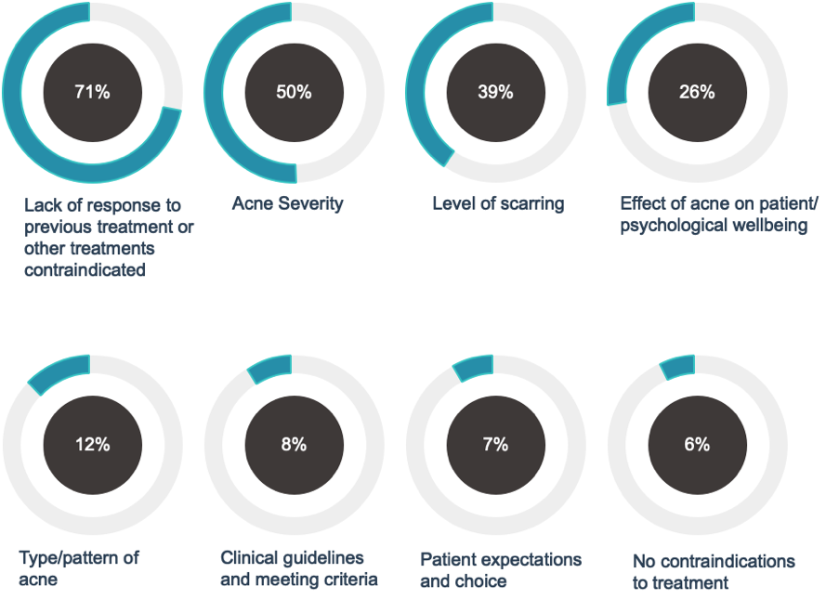
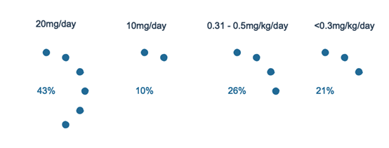
Figure 2: In a first course of isotretinoin, what would you prescribe as a reduced daily dose? Percentage of respondents

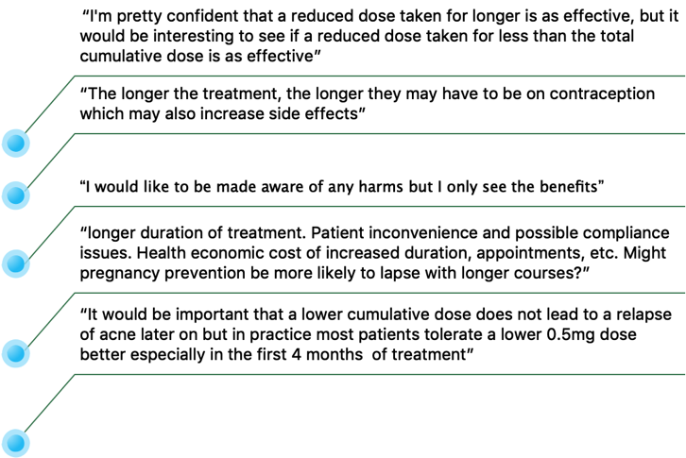
Figure 3: Selected clinicians' opinions on low dose oral isotretinoin treatment regimens

