Uromyces acetosae 0,I and other rust galls from Marbhig, Lewis, vc110
Paul A. Smith
During a spring visit to Lewis I ended up with a half day available (after the weather deterred me from using the other half). I decided to revisit Marbhig, on the east coast of Lewis, with the intention of adding to the list of rusts that I found there on a previous visit in 2007. This area of Lewis is unusual for the Outer Hebrides, because it contains (sometimes in small quantity) a suite of plant species that are not otherwise found in Lewis and Harris, although they are common in the Uists, including Hyacinthoides non-scriptus (L.) Chouard ex Rothm. (bluebell), Myrica gale L. (bog myrtle) and Alchemilla glabra Neygenf. (smooth lady’s-mantle). I thought I would try to find the bluebell rust Uromyces muscari (Duby) Niessl, to go with the bluebell record.
But, as so often, when you set out to look for something specific, you find some other interesting things instead. The most unusual of these was Uromyces acetosae J. Schröt. – not in itself an uncommon rust on Rumex acetosa L. (common sorrel), but in this case it was the spermogonial (0) and aecial (I) stages that were present, on swollen red spots on the leaves and stems (Fig. 1). Redfern et al. (2011) do not list this as a gall causer, but it seems clear that it is inducing some reaction in the host, and it is listed as a gall causer in these stages in Roskam (2019). U. acetosae is normally microcyclic, moving between uredinia (II) and telia (III), and in my experience even the uredinia are found much less often than the uredinia of Puccinia acetosae (Schumach.) Körn., which also infects the same host. Here a patch was heavily infected, with most leaves bearing aecia with yellow margins (which distinguishes U. acetosae from Puccinia phragmitis (Schumach.) Tul. which is also possible on this host, but has aecia with white margins) on both surfaces (Fig. 1).
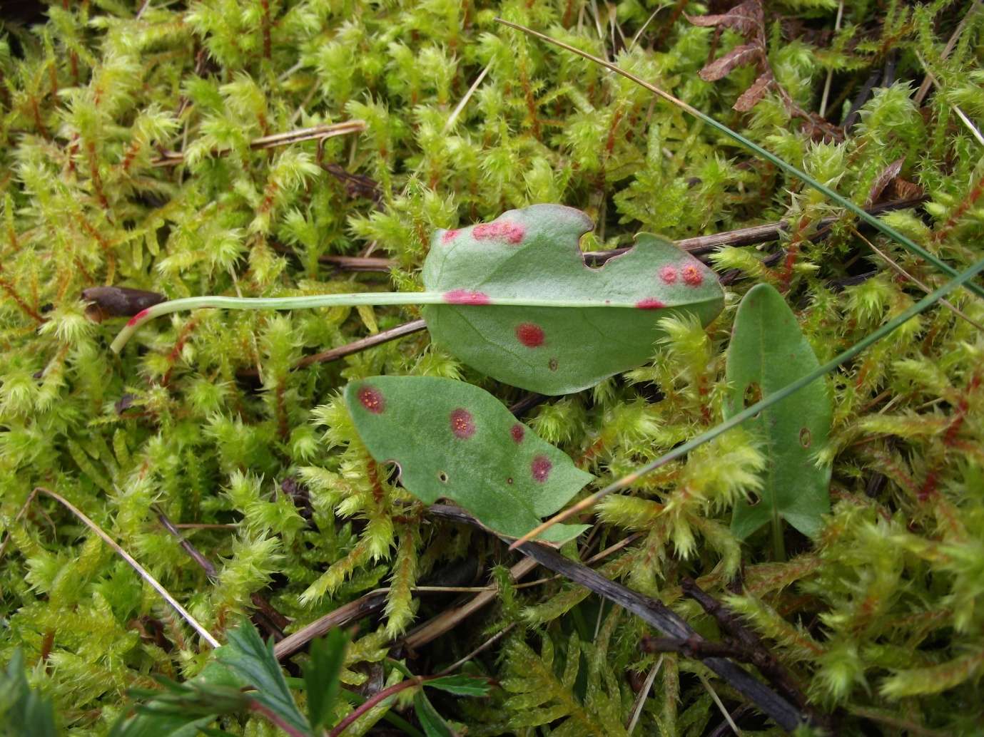
Figure 1: Uromyces acetosae 0,I galling the leaves of Rumex acetosa at Marbhig, Lewis, vc110.
It is an open question whether this was a local strain of the rust which has not lost the ability to generate the 0, I stages or whether their formation was induced by the conditions in 2022. Grove, in similar consideration of a finding on the Isle of Wight, considered that the aecia and uredinia resulted from teliospore germination, and supported this with other similar observations (of Uromyces sparsus (Kunze & J.C.Schmidt) Lév. and U. lineolatus (Desm.) J. Schröt. (as U. scirpi)) in the same year, 1933 (Grove & Chesters 1934). A corollary of this view would be that U. acetosae otherwise uredo-perennates (overwinters as uredinia, which form secondary infections the following year), but other species have reduced numbers of spore stages, so it may be the formation of 0,I which is rare, not the germination of teliospores. Some further observations in future years would be interesting.
There are only three other (distinct) records of the 0 and/or I stages of U. acetosae in the Fungus Records Database of Britain & Ireland (FRDBI) (Cannon 1998, British Mycological Society 2009), out of 73 records (including duplicates). The total number of records in FRDBI certainly underrepresents the distribution of U. acetosae in Britain and Ireland. There are also several published records for spermogonial and aecial stages of U. acetosae, and table 1 summarises all the records I have traced. They are concentrated in May and June, which is consistent with the latest observation, and also fits with the commonest pattern of rust phenology, but there is one record in September, which is an unusual time for aecia. Clearly, however, it is worth looking out for these unusual stages at any time.
Stage | Locality | vc | grid ref | date | collector | source
0,I | Pentere Point, N of Wadebridge | 2 | SW9280 | 8/5/1977 | EA Ellis | K(M)6366, FRDBI
I,II | Boniface Down, nr Ventnor | 10 | SZ5678 | 4/6/1933 | WB Grove | Grove & Chesters (1934)
I | Hickling | 27 | TG4124 | 16/9/1976 | EA Ellis | K(M)6948, FRDBI
I,II | Ringland Hills, Norfolk | 27 | TG1312 | 11/6/1934 | MB Ellis | Ellis (1934)
0,I,II,III | Crostwick Common | 27 | TG2516 | 28/6/1934 | EA Ellis | Ellis (1934)
I,II,III | Gundale area, near Pickering | 62 | SE88 | 5/1953 | Willis Bramley | FRDBI
I | Isle of May | 85 | NT69 | 1912 | W Evans | Wilson (1934)
0,I,II,III | Loch Lee | 90 | NO47 | 13/6/1949 | F Greig | Downie (1949)
I | Inverliever | 98 | NM80 | 5/1923 | M Wilson | Wilson (1934)
0,I | Marbhig | 110 | NB40899 18992 | 12/5/2022 | PA Smith
Table 1: Records of spermogonial and/or aecial stages of Uromyces acetosae in Britain. All records are on Rumex acetosa.
Marbhig also proved to be a home for a variety of gall-causing rusts. From my 2007 visit I already expected Puccinia primulae (DC.) Duby I on Primula vulgaris Hill (primrose) and Puccinia epilobii DC. III, and was not disappointed, as both were refound. Primula vulgaris is frequent around Marbhig, and many plants had substantially distorted leaves from the intensity of infection by Puccinia primulae (Fig. 2). Puccinia epilobii III was found infecting Epilobium obscurum Schreb. (short-fruited willowherb), though it is more normally on E. palustre L. in vc110. It distorts infected plants, making them taller and thinner than usual so that the spores are exposed.
In addition there were specimens of Puccinia festucae Plowr. 0,I on Lonicera periclymenum L. (honeysuckle) – in fact there was a patch (probably one sprawling plant) which was widely infected (Fig. 3). This is another curious species (in a similar way to Uromyces acetosae) in that the uredinia are common on Festuca spp (particularly F. rubra L. (red fescue) and F. vivipara (L.) Sm. (viviparous fescue) in the Outer Hebrides), but the spermogonia and aecia are much rarer (see Newbould 2021 for another recent record). The yellow spots on the upper surface give away the presence of the rust pustules and their galls on the lower surface – but you may have to look at a lot of leaves before you find them! Perhaps the appearance of aecia of both P. festucae and U. acetosae in the same place at the same time does signal an effect of local conditions on the development of these spore stages.
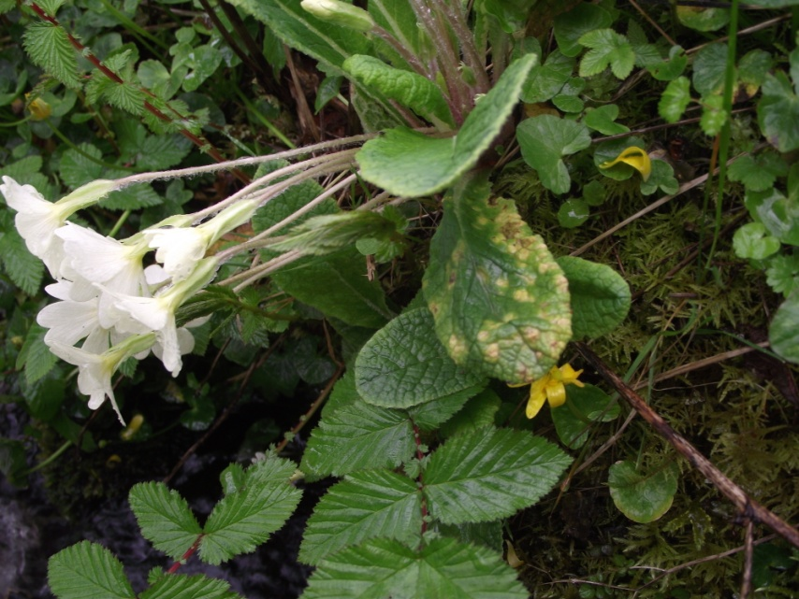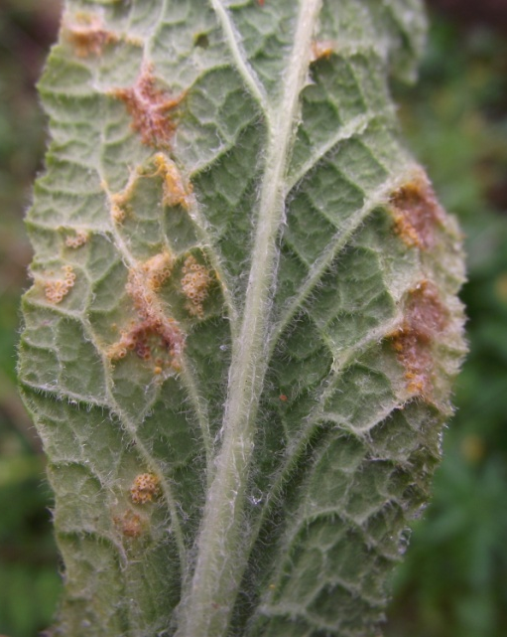
Fig.2: Puccinia primulae I galling the leaves of Primula vulgaris.
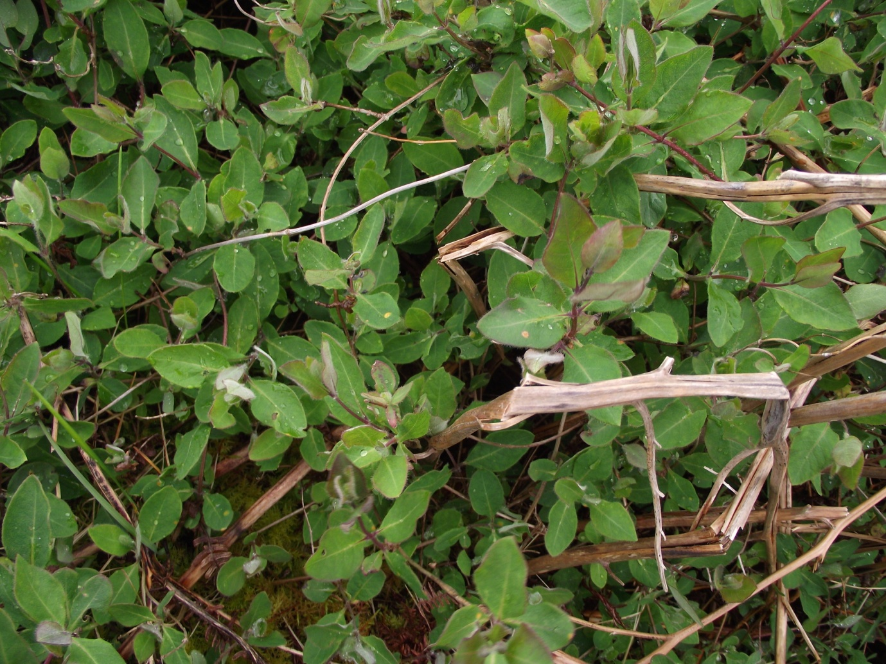
Fig 3: Puccinia festucae 0,I galling Lonicera periclymenum at Marbhig, Lewis. The yellow spots on the upper surface of the leaves (main picture) give away the presence of rust galls below (inset).
There was a further rust gall on Taraxacum fulvum Raunk., caused by Puccinia variabilis Grev. 0,I. T. fulvum seems to be particularly susceptible to this rust (and other Taraxacum (dandelion) species are often completely rust-free).
A final series of galls of Uromyces dactylidis G.H.Otth 0,I on Ficaria verna Huds. (lesser celandine), Puccinia sp. 0 on Caltha palustris L. (marsh marigold) (it is not possible to distinguish P. calthae Link and P. calthicola J. Schröt. with only the 0 spore stage) and Phragmidium violaceum (Schultz) Brockm. II on Rubus fruticosus agg. (bramble), completed the gall haul for the day (though there were a few additional, non-galling rusts too).

References
British Mycological Society (2009) Fungal Records Database of Britain and Ireland. http://www.frdbi.info/ [Accessed 21 May 2022].
Cannon, P. (1998) Database of British fungal records from literature sources. Mycologist 12 25-26.
Downie, D.G. (1949) Notes on the occurrence of two rare Uredineae. Transactions of the Botanical Society of Edinburgh 35 131.
Ellis, E.A. (1934) Flora of Norfolk, rust fungi (Uredinales). Transactions of the Norfolk Natural History Society 13 489-505.
Grove, W.B. & Chesters, C.G.C. (1934) Notes on British Uredinales, including one new to the British Isles. Transactions of the British Mycological Society 18 265-275.
Newbould, J. (2021) Puccinia festucae, a fungal gall on Lonicera periclymenum: a first record for vc9, Dorset. Cecidology 36 71-72.
Redfern, M., Shirley, P. & Bloxham, M. (2011) British plant galls, 2nd edition. Field Studies Council: Preston Montford.
Roskam, J.C. (2019) Plant galls of Europe, vol. 2. KNNV Publishing: Zeist.
Wilson, M. (1934) The distribution of the Uredineae in Scotland. Transactions of the Botanical Society of Edinburgh 31 345-449.

