One that got away – distortion of shoot tips in Teucrium scorodonia
Paul A. Smith
S3RI, University of Southampton, Highfield, Southampton, SO17 1BJ, UK. p.a.smith@soton.ac.uk

During the BPGS gall weekend in East Sussex the group spent some time in Footland Wood. As well as the good selection of galls recorded (see <Keith’s write-up, p??>) there were some more challenging finds, one of which was some pale shoot tips on a few vegetative shoots of Teucrium scorodonia L. (wood sage) at TQ 7642 2012 (Figs.1 & 2). The only plausible looking entry in Redfern et al. (2011) was the cecidomyid Dasineura teucrii (Tavares), but there was superficially no sign of any larvae.
A specimen was taken, and a more detailed look under a binocular microscope showed no sign of a chamber as illustrated at bladmineerders.nl. Instead the terminal leaves were abnormally hairy and appeared white, typical for a mite gall, but with no sign of any mites present. Looking in Roskam (2019, vol 2) pointed to an earlier report of similar distortion by Geisenheyner (1902) from two places in Germany. Geisenheyner classifies this as a mite-induced gall, but his description makes no other mention of the causer, and there is certainly no description. Did he see mites, or did he merely interpret the dense hairs as a mite gall? There is no way to know, and he did not formally describe it or name it, so Roskam keys it out only as “unidentified gall mite”. Without a name it is very challenging to track down any further reports in the literature.
So it cannot be concluded that the distortion of Teucrium scorodonia found at Footland Wood is a gall on the evidence currently available, and therefore it escaped from the list of recorded galls for the weekend. But it would be worth looking out for further examples and investigating whether there is a gall causer present, perhaps at a different time of year. Maybe there is a new mite (or some other causer) to be named.

References
Geisenheyner, L. (1902) Über einige neue und seltenere Zoocecidien aus dem Nahegebiete. Allgemeine Zeitschrift für Entomologie 7: 193-198, 246-251, 272-276, 306-312.
Redfern, M., Shirley, P. & Bloxham, M. 2011 British plant galls. Field Studies Council, Preston Montford.
Roskam, J. (2019) Plant galls of Europe, vol. 2. KNNV Publishing, Zeist.

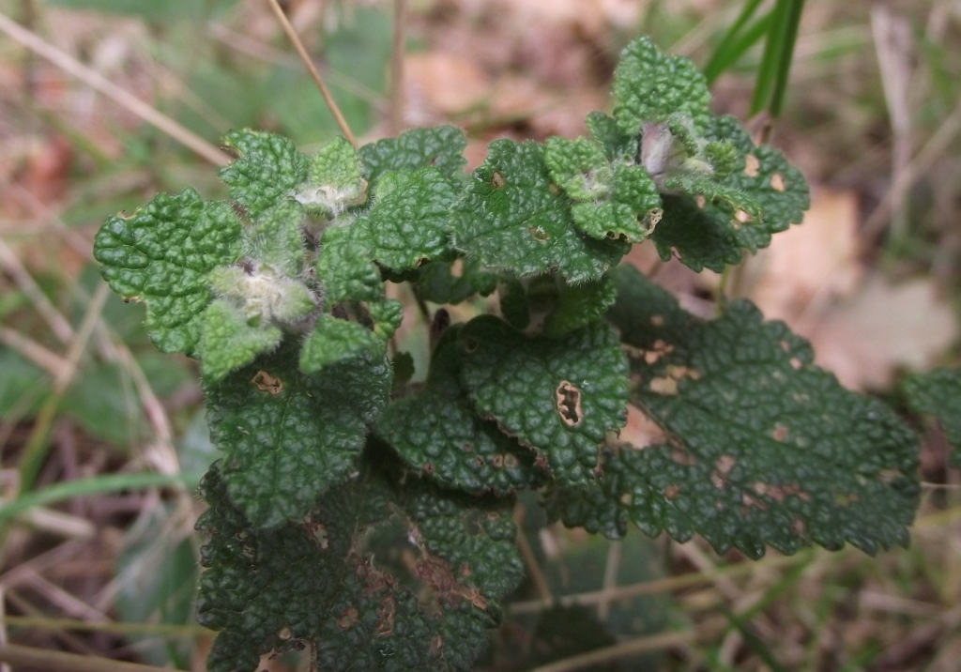
Figure 1: Distorted shoot tips of Teucrium scorodonia in Footland Wood.

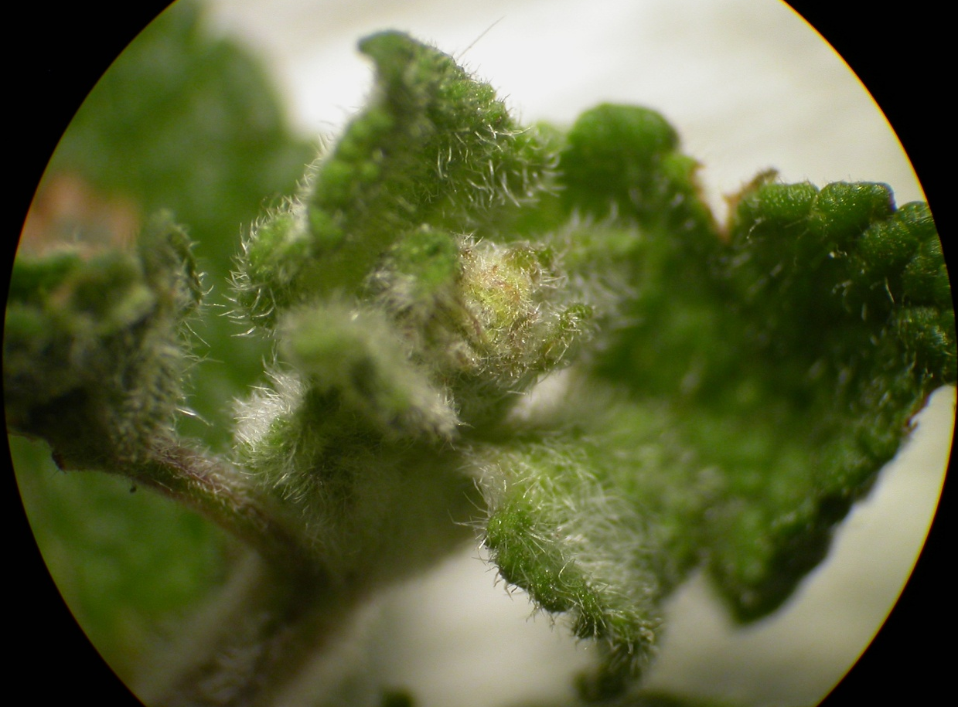
Figure 2: Close up showing shortened internodes and densely hairy leaves.

