Prenatal Diet, Plasma Micronutrients/Metabolome And Inflammatory Status Influence The Development Of Atopic Eczema In Early Childhood

Le Duc Huy Ta¹, James Chun Yip Chan^{2,3}, Gaik Chin Yap¹, Chiung-Hui Huang¹, Elizabeth Huiwen Tham^{1,4}, Evelyn Xiu Ling Loo^{1,5}, Noor H.A Suaini⁵, Lynette P.C. Shek^{1,5}, Neerja Karnani⁵, Anne Goh⁶, Hugo P. S. Van Bever^{1,4}, Oon Hoe Teoh⁶, Yiong Huak Chan⁷, Christophe Lay^{1,8}, Jan Knol^{9,10}, Fabian Yap⁶, Kok Hian Tan⁶, Yap-Seng Chong^{5,11}, Mary Foong- Fong Chong⁵, Shiao Yng Chan^{5,11}, Johan Gunnar Eriksson^{5,11,12,13}, Keith M. Godfrey¹⁴, Eric Chun Yong Chan¹⁵, Bee Wah Lee¹
¹ Department of Paediatrics, Yong Loo Lin School of Medicine, National University of Singapore
² Singapore Institute of Food and Biotechnology Innovation, A*STAR
³ A*STAR Skin Research Labs, A*STAR
⁴ Khoo Teck Puat-National University Children’s Medical Institute, National University Health System, Singapore
⁵ Singapore Institute for Clinical Sciences (SICS), Agency for Science, Technology and Research (A*STAR), Singapore, Singapore
⁶ Department of Paediatrics, KK Women’s and Children’s Hospital, Singapore
⁷ Biostatistics Unit, Yong Loo Lin School of Medicine, National University of Singapore, Singapore, Singapore
⁸ Danone Nutricia Research, Singapore
⁹ Danone Nutricia Research, Utrecht, The Netherlands
¹⁰ Wageningen University, Wageningen, The Netherlands
¹¹ Department of Obstetrics & Gynaecology, National University of Singapore, Singapore
¹² Folkhälsan Research Center, Helsinki, Finland and Department of General Practice and Primary Health Care, University of Helsinki, Finland
¹³ Department of General Practice and Primary Health Care, University of Helsinki, Helsinki, Finland
¹⁴ MRC Lifecourse Epidemiology Centre and NIHR Southampton Biomedical Research Centre, University of Southampton and University Hospital Southampton NHS Foundation Trust, Southampton, UK
¹⁵ Department of Pharmacy, Faculty of Science, National University of Singapore, Singapore

Word Count: 816
Main Tables/Figures: 2
Corresponding authors:
Bee Wah LEE. MD, FAAAAI, and Eric Chun Yong CHAN, PhD
MD1 - Tahir Foundation Building (MD1), Level 15, Department of Paediatrics, Allergy & Immunology Division, National University of Singapore (NUS), 12 Science Drive 2. Singapore 117549.
Tel.: +65-65161242
Fax: +65-67797486
E-mail: paeleebw@nus.edu.sg and eric.chan@nus.edu.sg

ACKNOWLEDGEMENTS
We would like to express our gratitude to members of the GUSTO group for their assistance which includes Allan Sheppard, Amutha Chinnadurai, Anne Rifkin-Graboi, Anqi Qiu, Arijit Biswas, Birit F.P. Broekman, Boon Long Quah, Borys Shuter, Chai Kiat Chng, Cheryl Ngo, Choon Looi Bong, Christiani Jeyakumar Henry, Cornelia Yin Ing Chee, Doris Fok, George Seow Heong Yeo, Helen Chen, Iliana Magiati, Inez Bik Yun Wong, Ivy Yee-Man Lau, Jeevesh Kapur, Jenny L. Richmond, Jerry Kok Yen Chan, Joanna D. Holbrook, Joshua J. Gooley, Krishnamoorthy Niduvaje, Leher Singh, Lin Lin Su, Lourdes Mary Daniel, Marielle V. Fortier, Mark Hanson, Mary Foong-Fong Chong, Mary Rauff, Mei Chien Chua, Michael Meaney, Mya Thway Tint, Ngee Lek, P. C. Wong, Pratibha Agarwal, Rob M. van Dam, Salome A. Rebello, Shang Chee Chong, Shirong Cai, Sok Bee Lim, Chin-Ying Stephen Hsu, Victor Samuel Rajadurai, Walter Stunkel, Wee Meng Han, Wei Wei Pang, Yin Bun Cheung and Yung Seng Lee. This research is supported by the Singapore Ministry of Health’s National Medical Research Council (NMRC), Singapore- NMRC/CIRG/1414/2014.

CONFLICT OF INTEREST
All authors declare no conflict of interest. Christophe Lay and Jan Knol are employees of Danone Nutricia Research. Keith M. Godfrey has received reimbursement for speaking at conferences sponsored by companies selling nutritional products, and is part of an academic consortium that has received research funding from Abbott Nutrition, Nestec, BenevolentAI Bio Ltd. and Danone, outside the submitted work. Keith M. Godfrey is supported by the UK Medical Research Council (MC_UU_12011/4), the National Institute for Health Research (NIHR Senior Investigator (NF-SI-0515-10042) and NIHR Southampton Biomedical Research Centre (IS-BRC-1215-20004)), the European Union (Erasmus+ Programme ImpENSA 598488-EPP-1-2018-1-DE-EPPKA2-CBHE-JP) and the British Heart Foundation (RG/15/17/3174, SP/F/21/150013). For the purpose of Open Access, the author has applied a Creative Commons Attribution (CC BY) licence to any Author Accepted Manuscript version arising from this submission.

AUTHOR CONTRIBUTION
L.D.H.T. performed the data analysis and manuscript writing. J.C.Y.C, G.C.Y., C-H.H., C.L., J.K., Y.H.C., and M.F.F.C contributed to the interpretation of the results. E.H.T., E.X.L.L., N.H.A.S., L.P.C.S., N.K., A.G., H.P.S.V.B., and O.H.T. were involved in the subject recruitment and sample collection. F.Y., K.H.T., Y-S.C., S.Y.C., J.G.E. and K.M.G. were involved in conceptualizing and designing the birth cohort. E.C.Y.C. and B.W.L. were involved in planning, supervising the project and revising the manuscript. All authors contributed to the article, approved the submitted version and agreed on the order in which their names will be listed in the manuscript.
To the Editor,
Atopic eczema is one of the commonest chronic inflammatory skin disorders in childhood. There is accumulating evidence demonstrating the associations of early life factors, including prenatal diet and micronutrient status on the risk for allergic diseases in the offspring. However, the evidence from intervention studies such as vitamin D and polyunsaturated fatty acids (PUFAs) supplementation is conflicting.¹ Little is known about the role of prenatal diet and micronutrient status in modulating maternal and fetal immunity, and childhood eczema risk.
The aims of this study were to determine and deconvolute the contribution of prenatal diet and micronutrient status in modulating the maternal and fetal immune responses and infer their roles in influencing atopic eczema risk. We leveraged on a case-control sub-cohort of atopic eczema (n=76) and controls (n=72) selected from the large well-defined Growing Up in Singapore Towards healthy Outcomes (GUSTO) cohort consisting of maternal-child dyads in which clinical atopic eczema outcomes in offspring were evaluated longitudinally till 36 months of age.
Methodology is provided in Appendix. A flowchart summarizing the subjects and their selection is shown in Figure S1. The target sample size of 120 subjects (60 in each group) for this study was calculated by considering type І error (α = 0.05), type ІІ error (β = 0.1), mean difference ± standard deviation (1.94 ± 3.21g per 1000kcal) of fiber intake between groups in a previous study gut microbiome.² We inflated the sample size to 72 and 76 for controls and atopic eczema group respectively to account for multivariate comparisons. The subjects characteristics are summarized in Table S1. The atopic eczema group had significantly more atopic parents compared to controls, and a higher proportion of maternal (34%) than paternal history of any atopic disease (27%), albeit not statistically significant. The effects of maternal environmental exposure during pregnancy, and/or immune interactions between mothers and their offspring in utero are plausible explanations for this observation. The stronger maternal influence, however has not been borne out consistently in some large studies.³
A prenatal diet characterized by low dietary fiber and potassium combined with low plasma levels of micronutrients (specifically potassium, vitamin B3 1-methylhistidine (1-MNA), B6 pyridoxal 5′-phosphate (PLP) and D), and enrichment of plasma metabolites (cystathionine) at 26th week of pregnancy was associated with an increased risk of developing childhood eczema. This maternal signature was associated with raised maternal C-reactive Protein (CRP) level, as well as increased pro-inflammatory markers in the infant cord blood (CRP, IL-6, IL-7, MIP3𝛼, VEGF-A and TGF𝛽1) and trigonelline compared to non-eczema controls (Figure 1).
Using integrated pathway analysis (Figure 2), we identified three plausible biological pathways that might collectively predispose to eczema in the offspring:
(1) Association between maternal dietary fiber, plasma vitamin B3 1-MNA, B6 PLP and cystathionine, maternal CRP and infant cord blood trigonelline. Current evidence indicate that dietary fiber affects the bioavailability of vitamin B, hence potentially facilitating gastrointestinal absorption of vitamin B.⁴ Vitamin B6 is an important co-enzyme required for the activity of key enzymes in tryptophan-kynurenine catabolic pathway resulting in the synthesis of vitamin B3 and trigonelline. When vitamin B6 is restricted, elevated cystathionine via homocysteine metabolism is observed. A low vitamin B6 intake is associated with impairment in differentiation and maturation of monocyte-derived macrophages and T lymphocytes and is linked to inflammation.⁵
(2) Association between maternal dietary potassium, plasma potassium and maternal CRP. There have been no prior reports of the negative association between low plasma potassium levels and high CRP levels in eczema. Potassium may have an anti-inflammatory role, as this negative association is seen in type 2 diabetes.⁶ Potassium also plays a significant role in keratinocyte differentiation and barrier homeostasis and reduced maternal potassium levels may adversely influence fetal epidermal barrier development.⁷
(3) Association between maternal plasma vitamin D and infant cord blood TGF𝛽1: Our data corroborates reports that prenatal vitamin D insufficiency/deficiency influences infant immune regulatory cells and cytokines TGF𝛽1 and inversely related to atopic diseases in early childhood.⁸
In tandem, these associations correlated with increased maternal plasma and infant cord blood CRP, increased levels of IL-6, IL-7, MIP3𝛼, VEGF-A and TGF𝛽1 and decreased level of trigonelline in the infant cord blood of the eczema group. Emerging research suggests that systemic pro-inflammation during pregnancy skews the fetal immune maturation towards atopy and increases the propensity to develop allergic diseases in the offspring.⁹
In conclusion, our findings provide preliminary yet novel evidence of a constellation of nutritional and molecular signatures identified during the prenatal period and at birth, and the plausible underlying biological mechanisms that predispose offspring to eczema in early life. A larger sample size might be required to validate the role of other nutrients beyond fiber and potassium which may also be associated with development of eczema. Nevertheless, these results may pave the way to design effective nutritional and dietary intervention enriched in fiber and potassium (plant-based food) during pregnancy to reduce the risk of eczema and its related disorders in the offspring.

REFERENCES
1. Venter, C.; Agostoni, C.; Arshad, S. H.; Ben-Abdallah, M.; Du Toit, G.; Fleischer, D. M.; Greenhawt, M.; Glueck, D. H.; Groetch, M.; Lunjani, N.; Maslin, K.; Maiorella, A.; Meyer, R.; Antonella, M.; Netting, M. J.; Ibeabughichi Nwaru, B.; Palmer, D. J.; Palumbo, M. P.; Roberts, G.; Roduit, C.; Smith, P.; Untersmayr, E.; Vanderlinden, L. A.; O'Mahony, L., Dietary factors during pregnancy and atopic outcomes in childhood: A systematic review from the European Academy of Allergy and Clinical Immunology. Pediatr Allergy Immunol 2020, 31 (8), 889-912.
2. Ta, L. D. H.; Chan, J. C. Y.; Yap, G. C.; Purbojati, R. W.; Drautz-Moses, D. I.; Koh, Y. M.; Tay, C. J. X.; Huang, C. H.; Kioh, D. Y. Q.; Woon, J. Y.; Tham, E. H.; Loo, E. X. L.; Shek, L. P. C.; Karnani, N.; Goh, A.; Van Bever, H. P. S.; Teoh, O. H.; Chan, Y. H.; Lay, C.; Knol, J.; Yap, F.; Tan, K. H.; Chong, Y. S.; Godfrey, K. M.; Kjelleberg, S.; Schuster, S. C.; Chan, E. C. Y.; Lee, B. W., A compromised developmental trajectory of the infant gut microbiome and metabolome in atopic eczema. Gut Microbes 2020, 12 (1), 1-22.
3. Lockett, G. A.; Huoman, J.; Holloway, J. W., Does allergy begin in utero? Pediatr Allergy Immunol 2015, 26 (5), 394-402.
4. Marcin Andrzej Kurek; Jarosław Wyrwisz; Sabina Karp; Agnieszka Wierzbicka, Particle size of dietary fiber preparation affects the bioaccessibility of selected vitamin B in fortified wheat bread. Journal of Cereal Science 2017, 77, 166-171.
5. Morris, M. S.; Sakakeeny, L.; Jacques, P. F.; Picciano, M. F.; Selhub, J., Vitamin B-6 intake is inversely related to, and the requirement is affected by, inflammation status. J Nutr 2010, 140 (1), 103-10.
6. Das, U. N., Molecular biochemical aspects of salt (sodium chloride) in inflammation and immune response with reference to hypertension and type 2 diabetes mellitus. Lipids Health Dis 2021, 20 (1), 83.
7. Lee, S. H.; Elias, P. M.; Proksch, E.; Menon, G. K.; Mao-Quiang, M.; Feingold, K. R., Calcium and potassium are important regulators of barrier homeostasis in murine epidermis. J Clin Invest 1992, 89 (2), 530-8.
8. Chiu, C. Y.; Huang, S. Y.; Peng, Y. C.; Tsai, M. H.; Hua, M. C.; Yao, T. C.; Yeh, K. W.; Huang, J. L., Maternal vitamin D levels are inversely related to allergic sensitization and atopic diseases in early childhood. Pediatr Allergy Immunol 2015, 26 (4), 337-43.
9. Sonnenschein-van der Voort, A. M.; Jaddoe, V. W.; Moll, H. A.; Hofman, A.; van der Valk, R. J.; de Jongste, J. C.; Duijts, L., Influence of maternal and cord blood C-reactive protein on childhood respiratory symptoms and eczema. Pediatr Allergy Immunol 2013, 24 (5), 469-75.
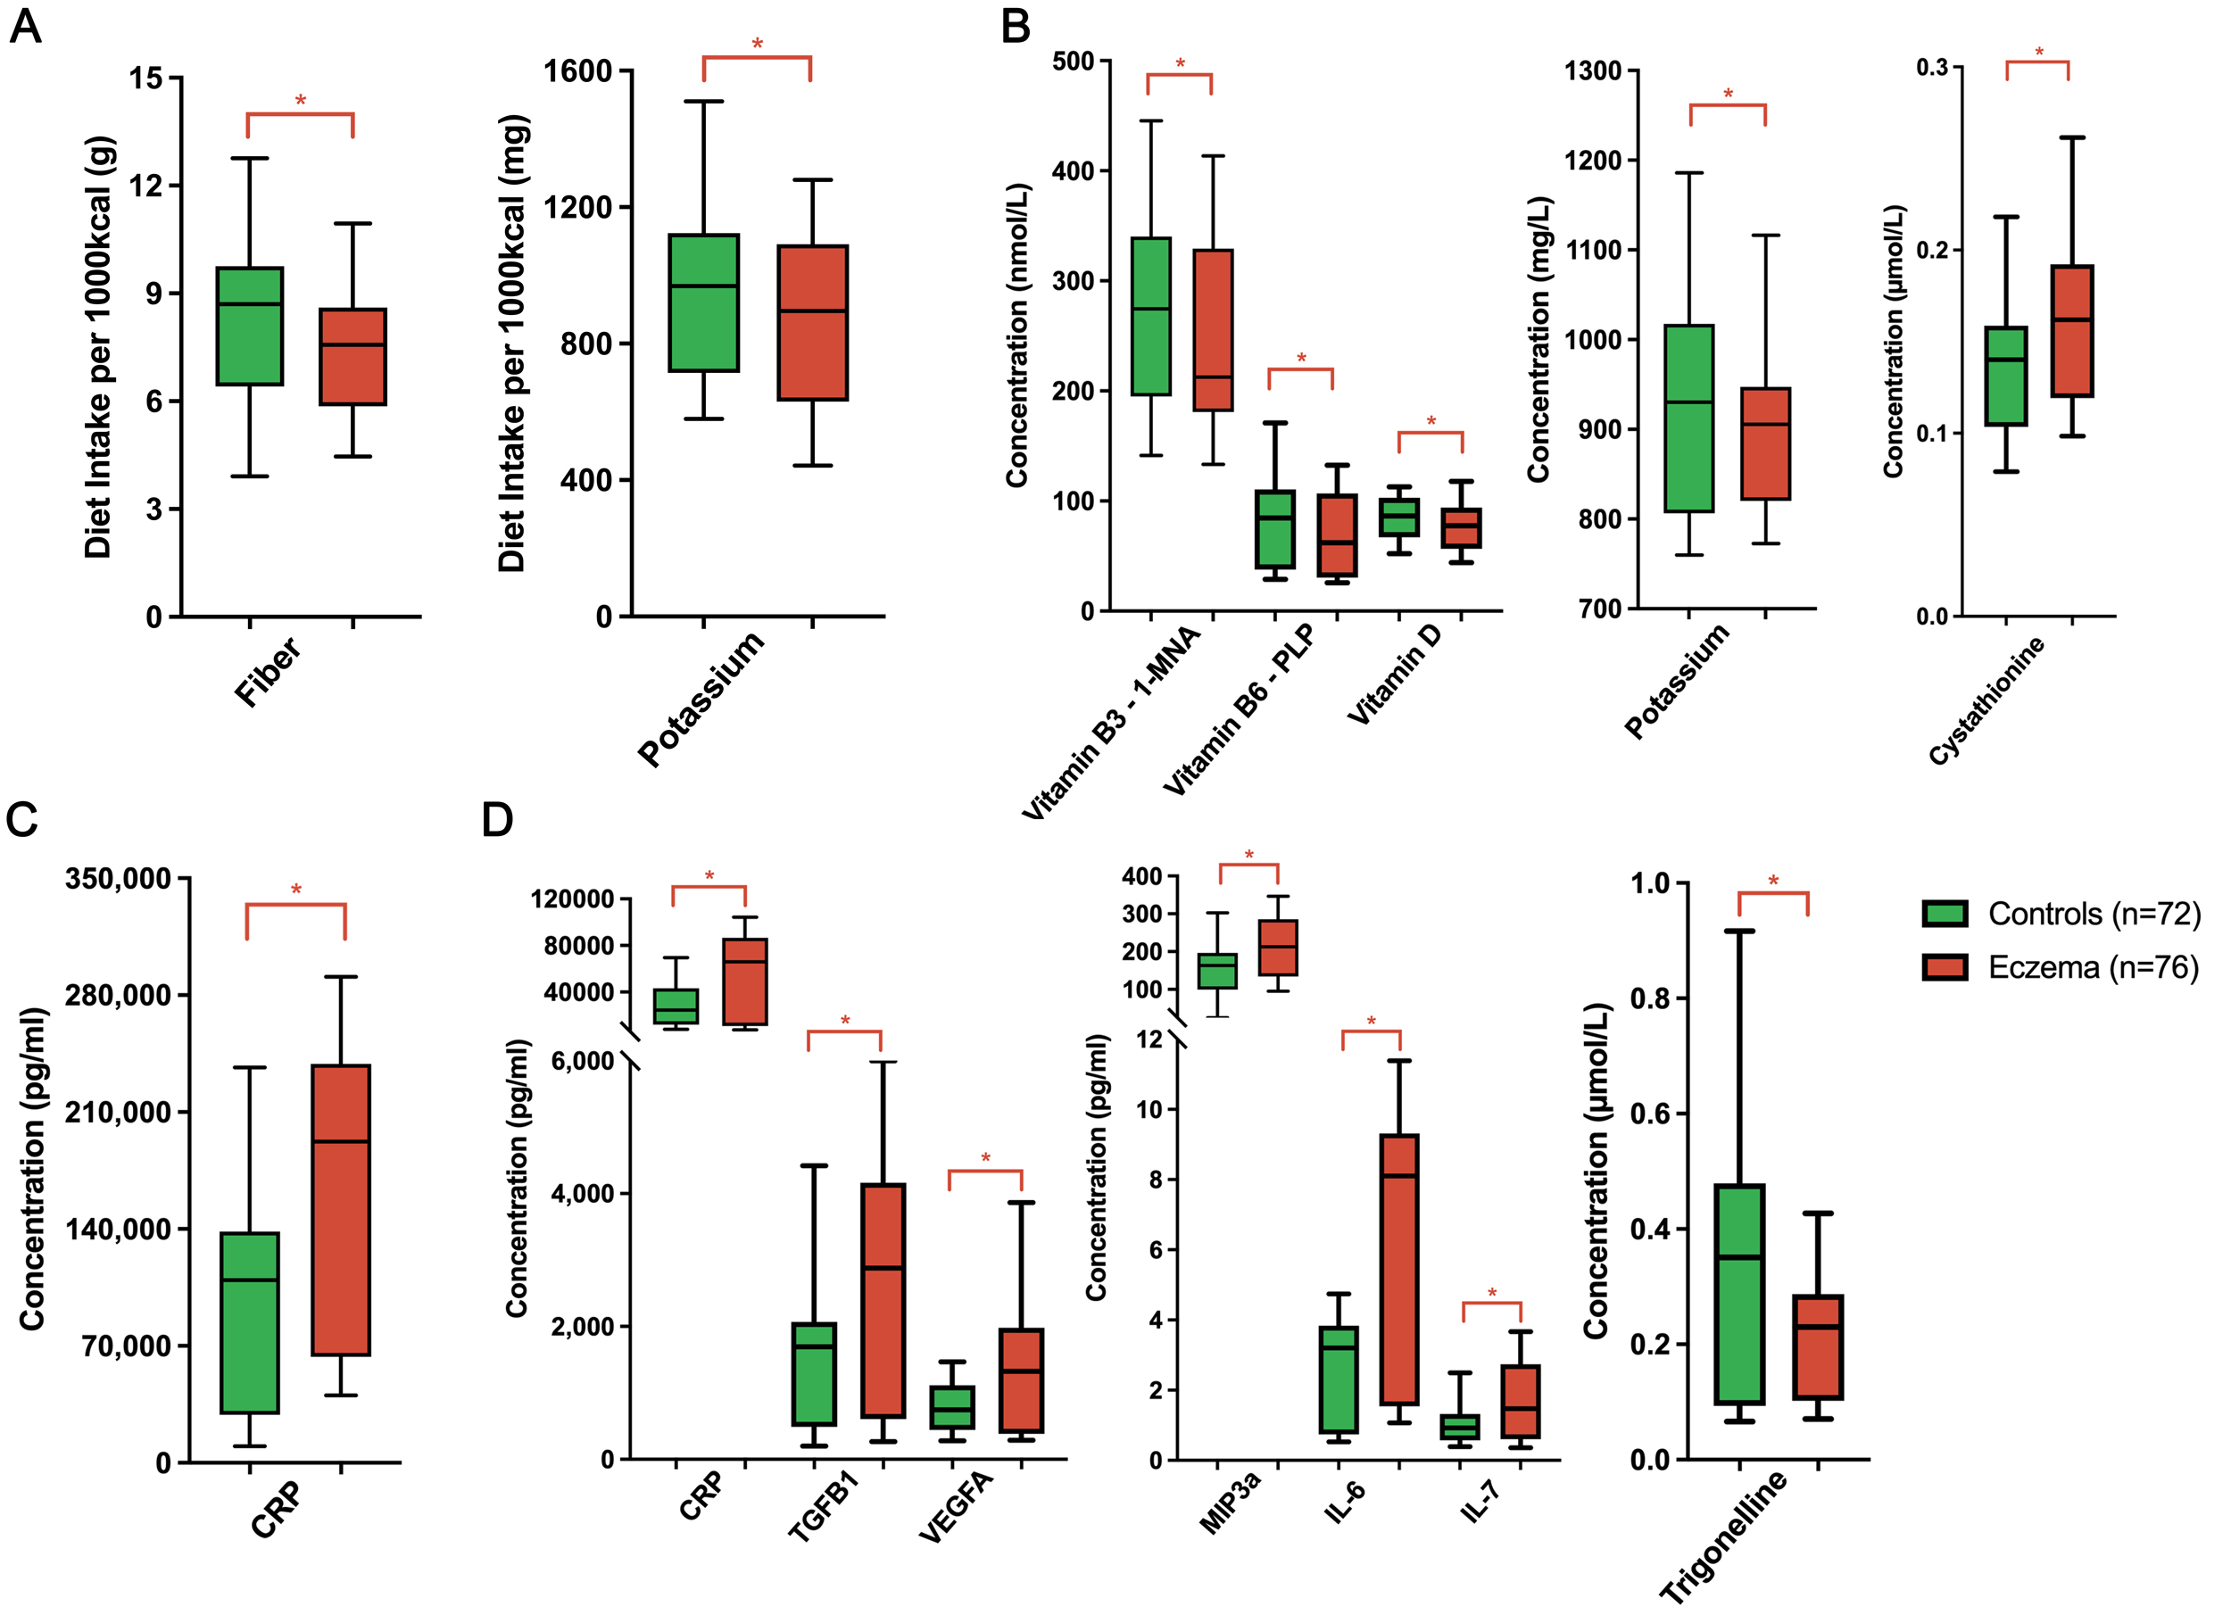

Figure 1: Comparison profile of significant (A) maternal dietary intake of fiber and potassium; (B) maternal plasma micronutrient/metabolite profiles of vitamins (B3, B6 and D), metabolites (copper, potassium, trimethyllysine, cystathionine, methionine and xanthurenic acid); (C) maternal inflammatory marker CRP and (D) infant cord blood cytokine, inflammatory marker and metabolites between groups. *Significance at p<0.05 between groups in multivariate analysis adjusting for maternal age, maternal education, ethnicity, child’s gender, child’s birth weight, child’s gestational age at birth, pet ownership, maternal parity, delivery mode and family history of atopic diseases. 10th, 25th, 75th, 90th percentile and mean were used for box and whisker plots.
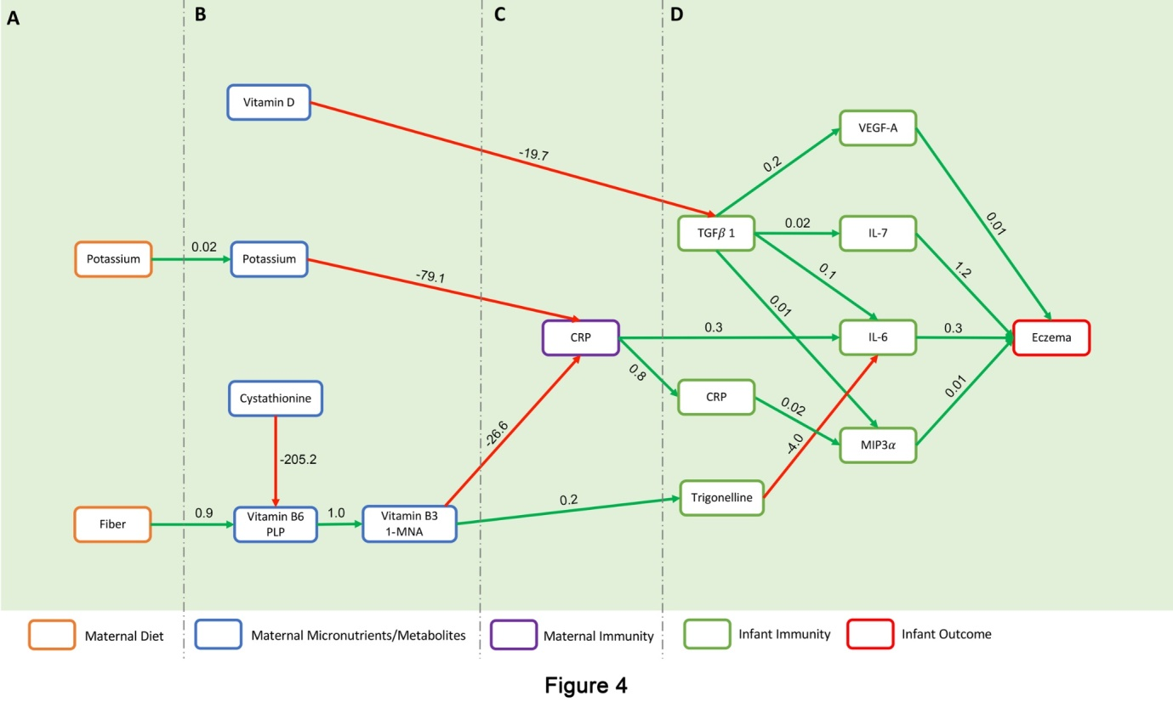
Figure 2: Final generalized structural equation model for associations between (A) maternal diet, (B) maternal plasma micronutrients/metabolites, (C) maternal immunity, (D) infant immunity and infant eczema outcome up to 36 months. Only significant paths and their estimates were shown in the model at P < 0.05. Green and red lines indicate the significant positive and negative associations respectively between variables.

