Supplementary Material

Supplementary Figures
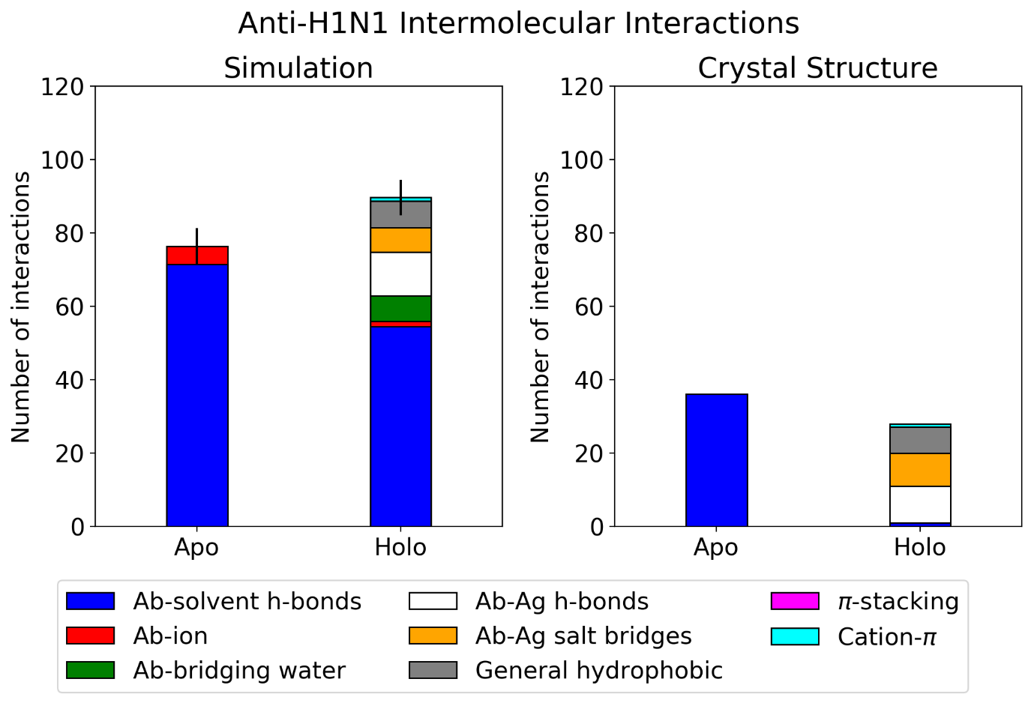
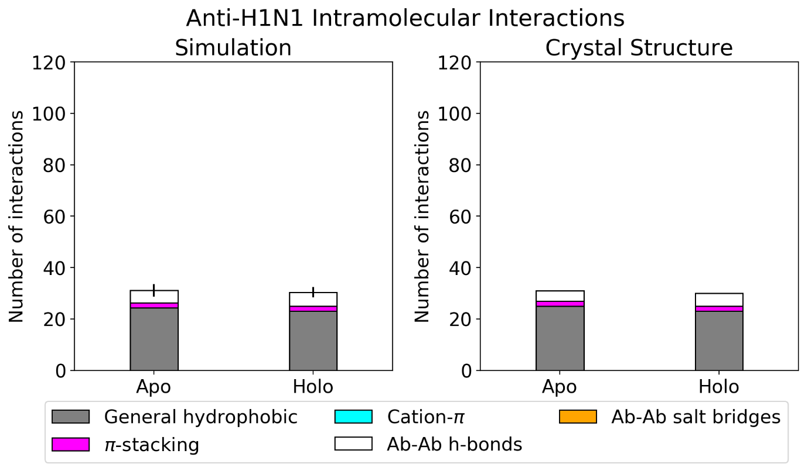
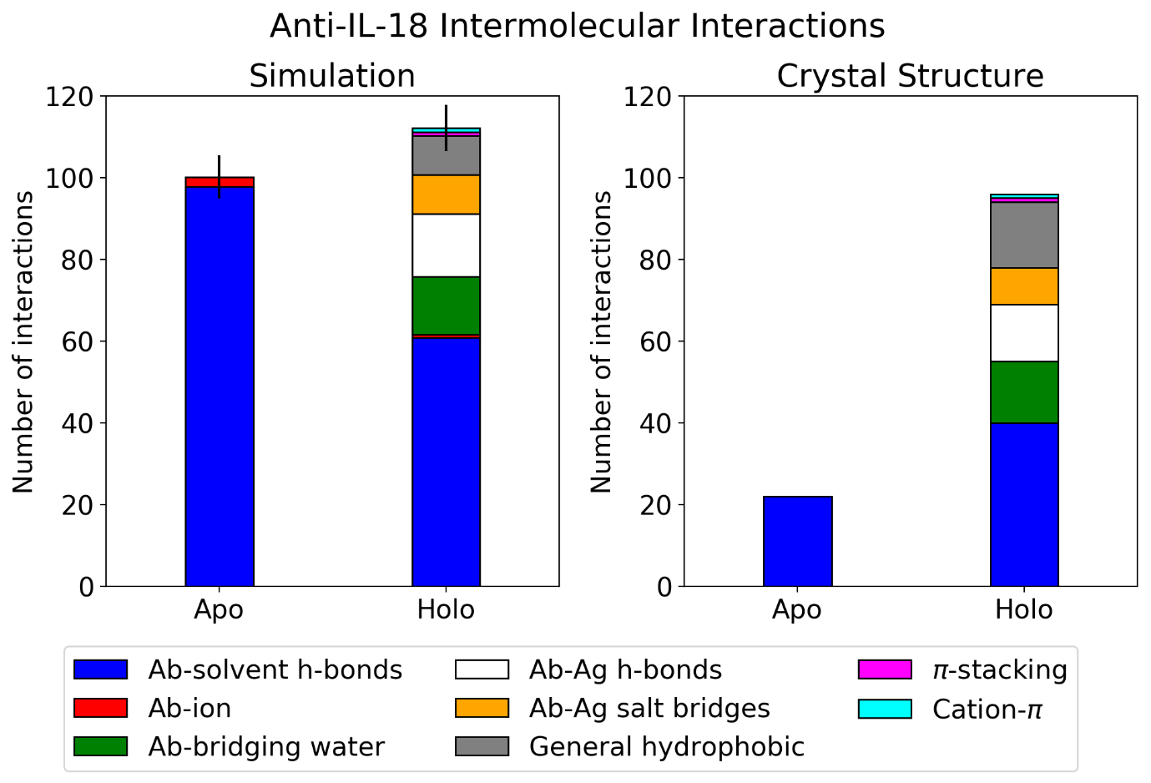
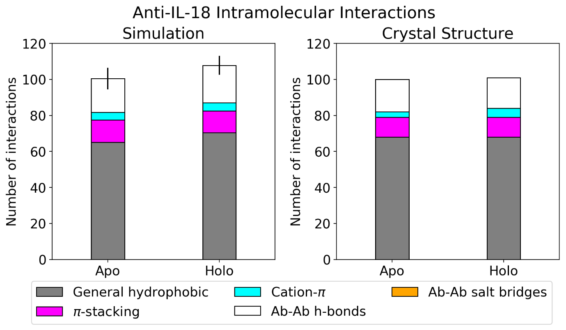
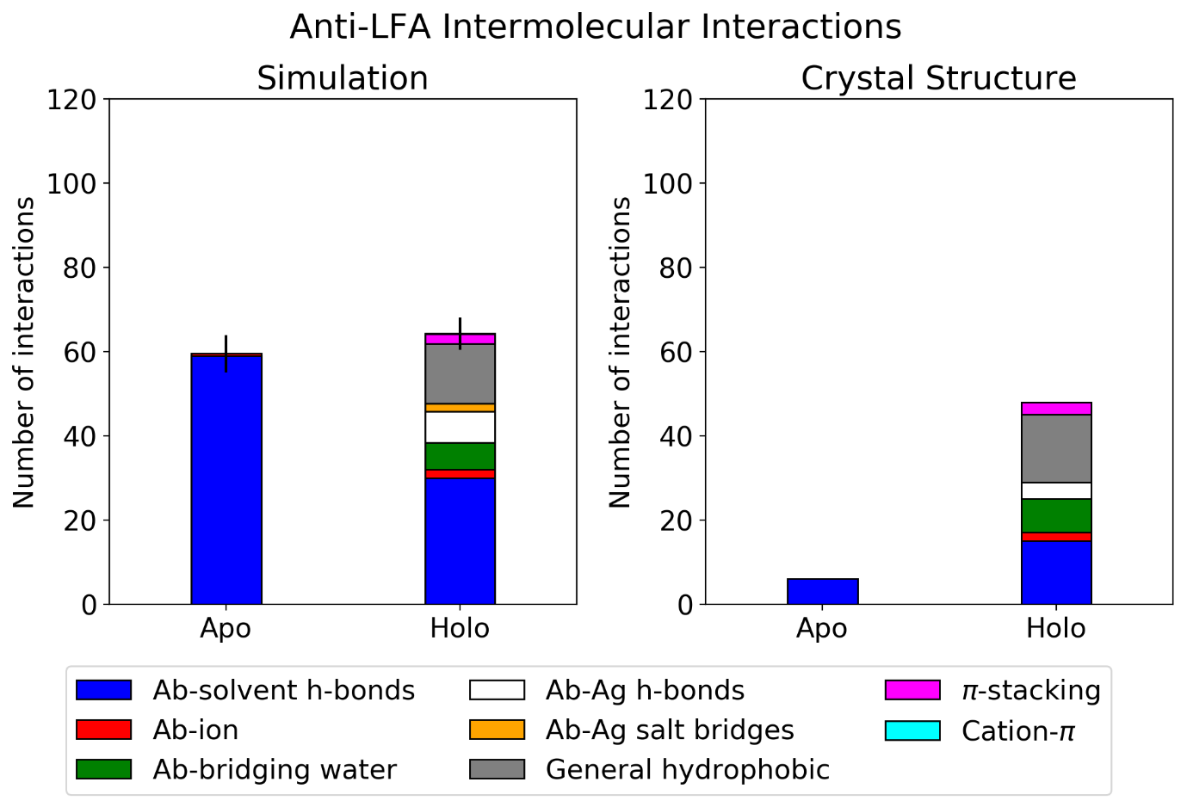
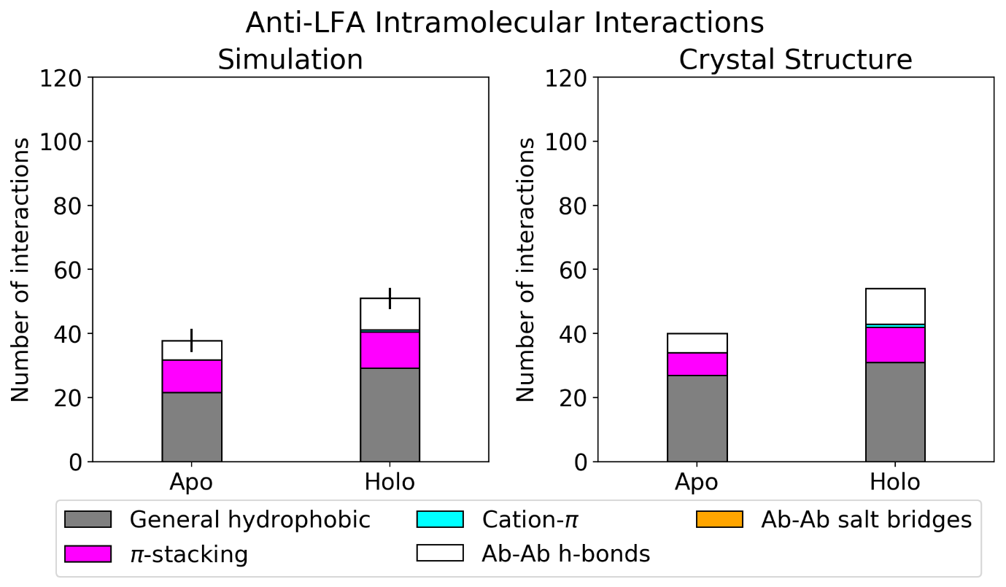
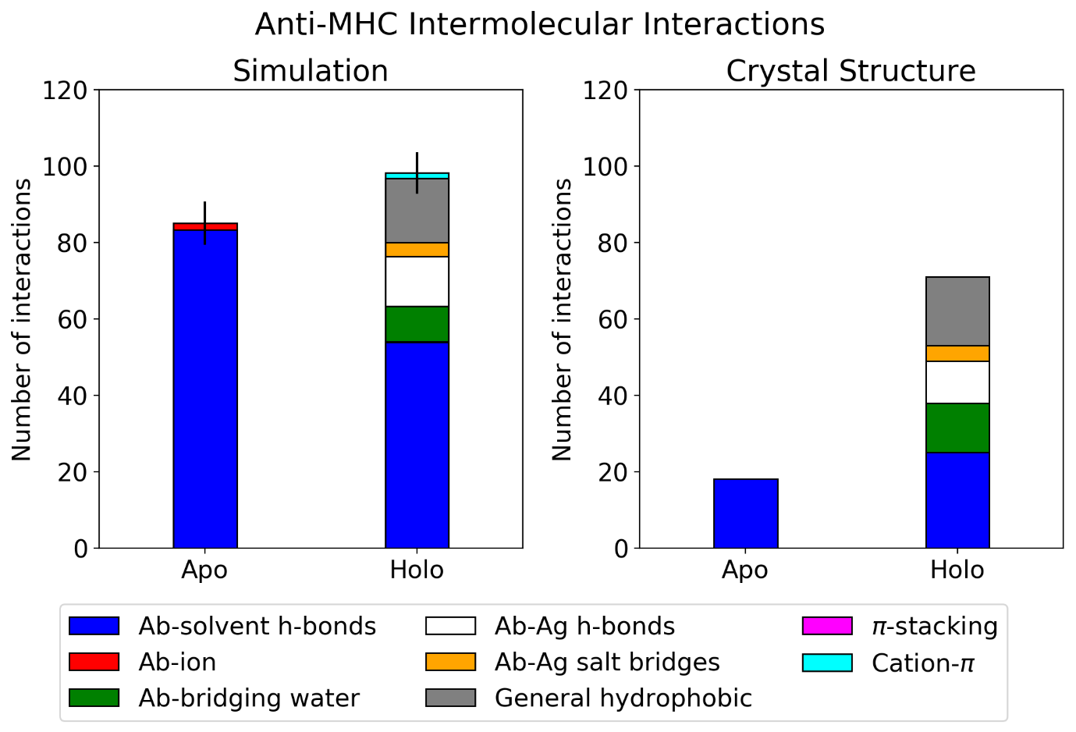
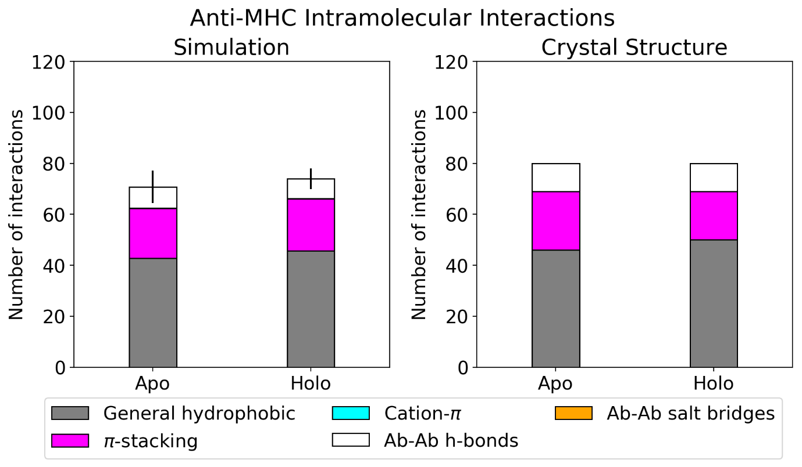
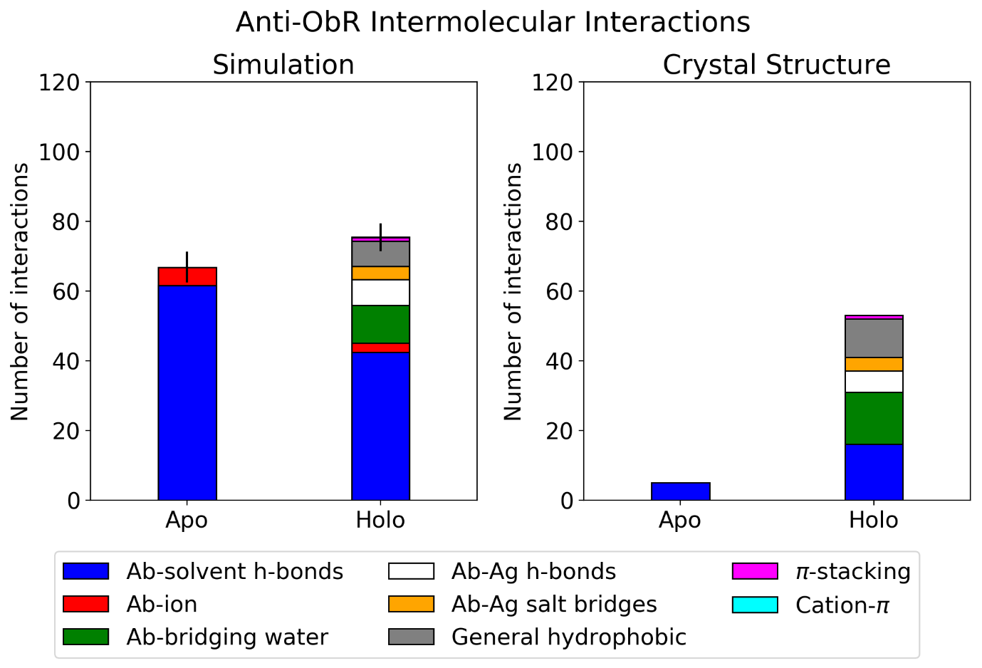
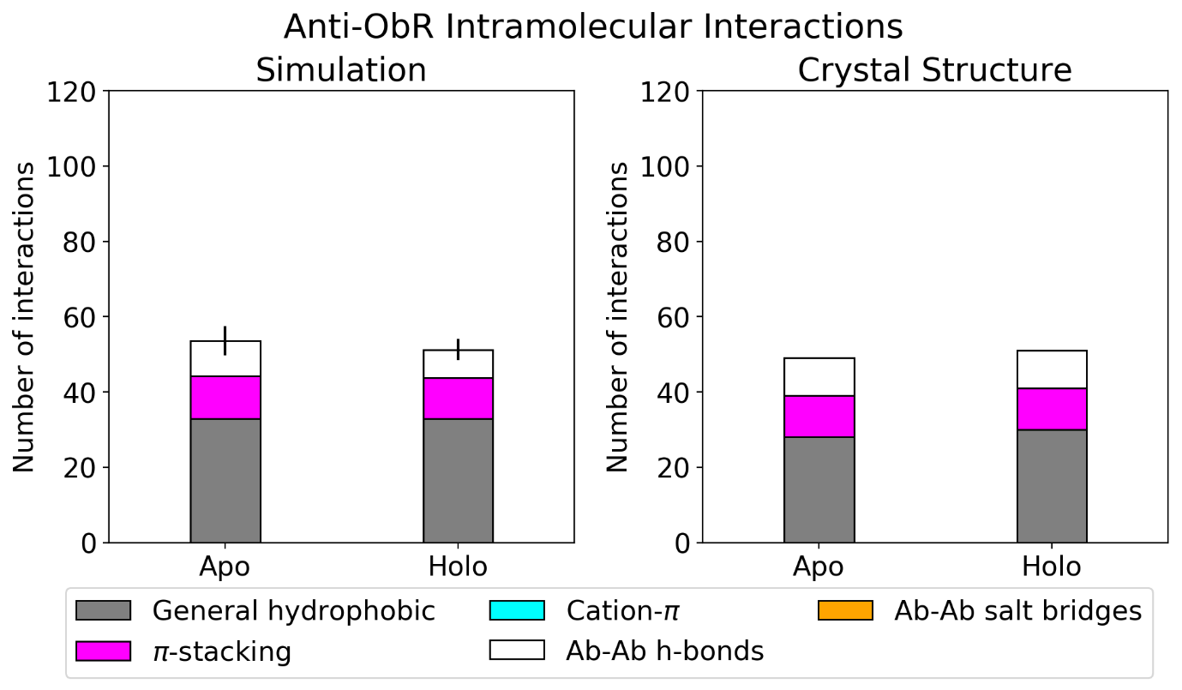
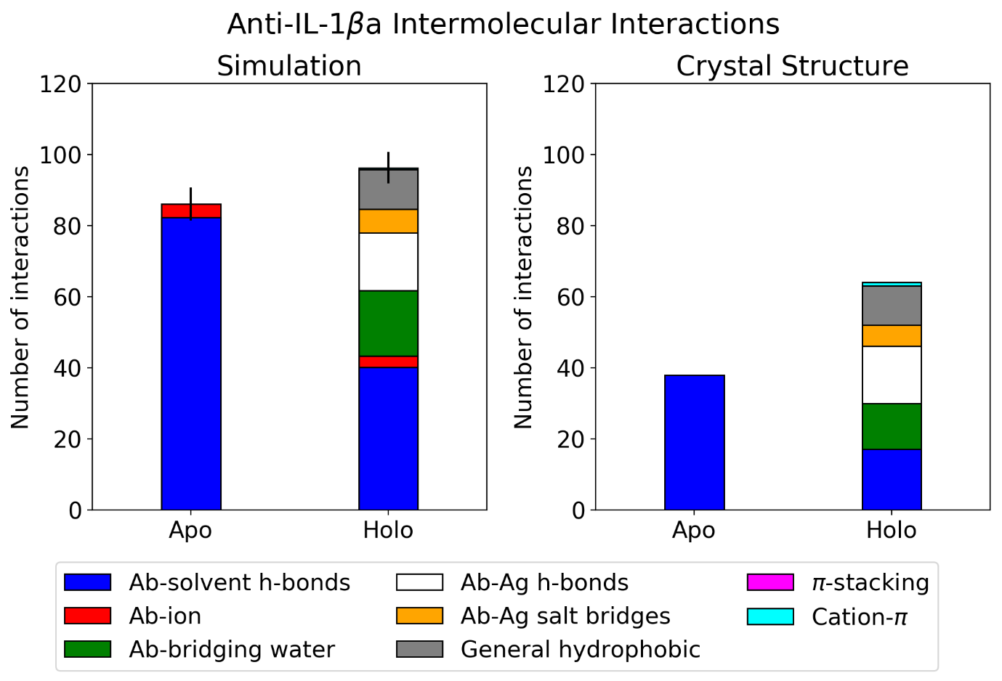
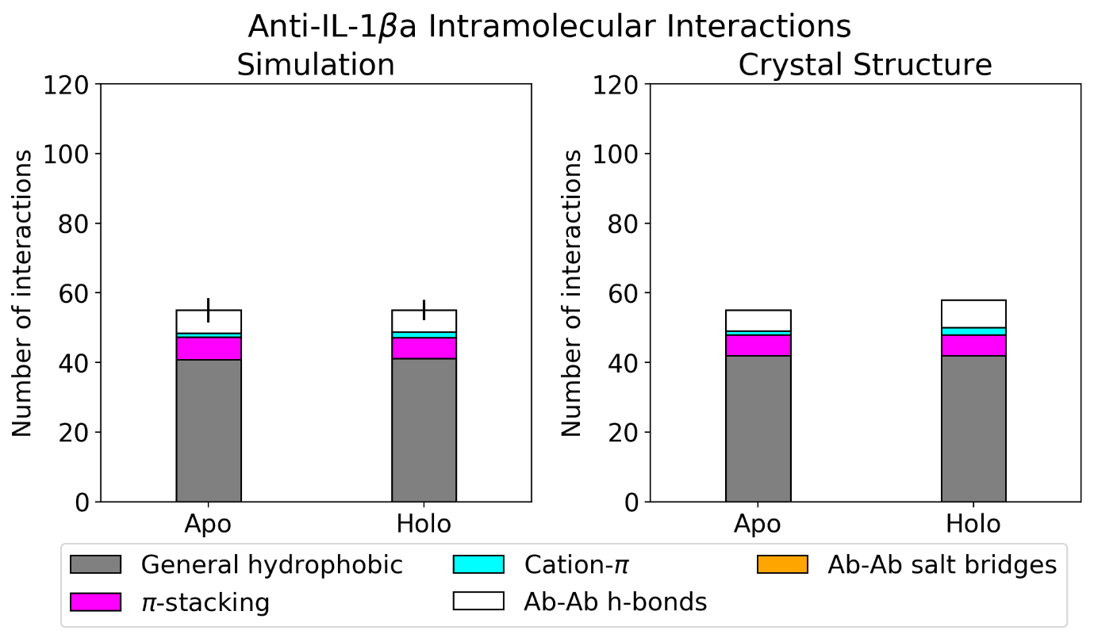
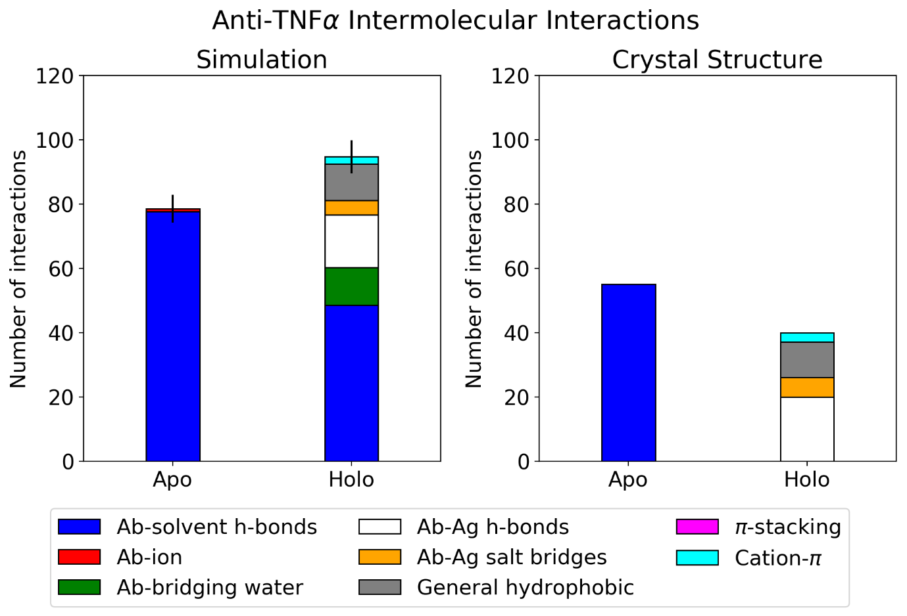
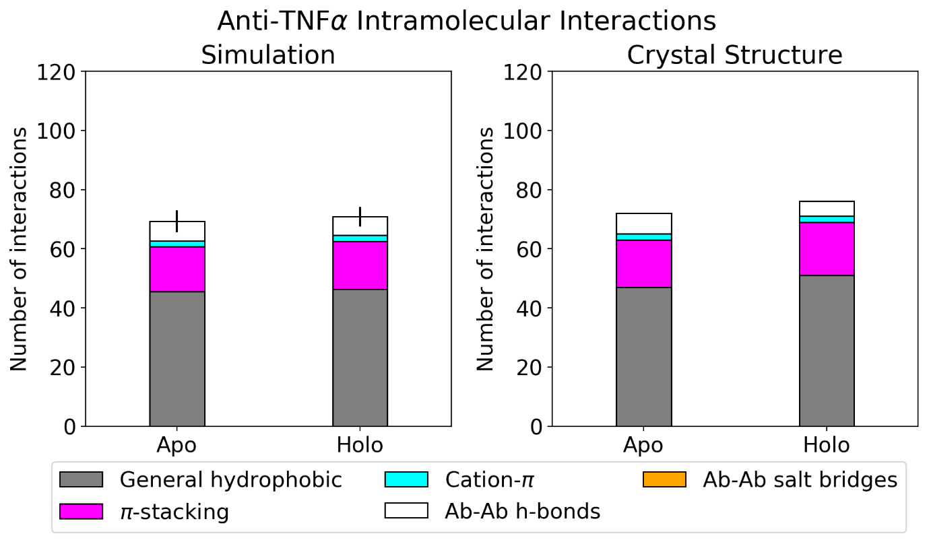
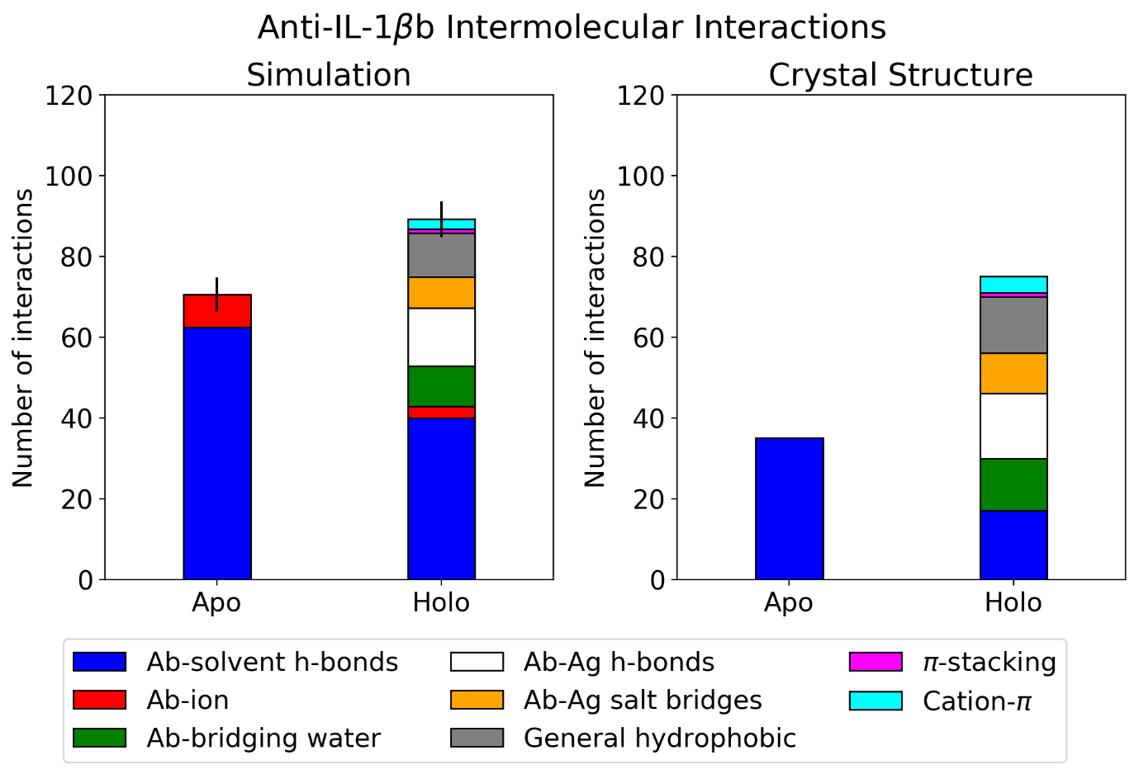
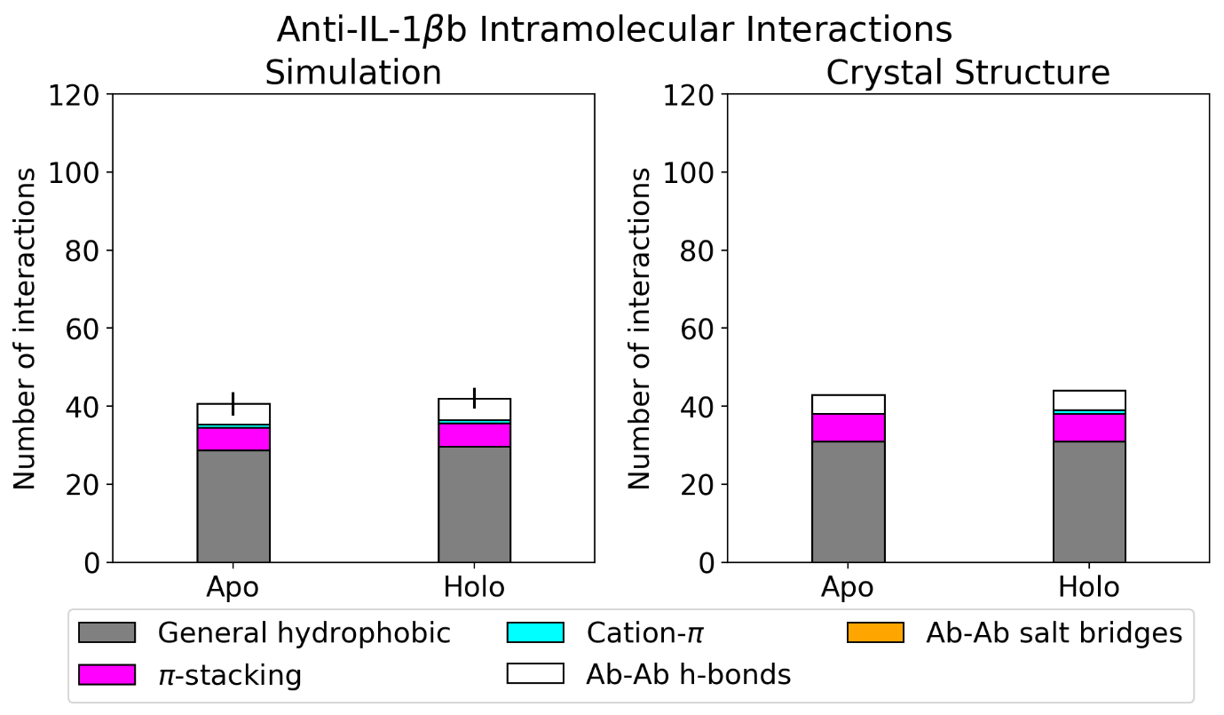
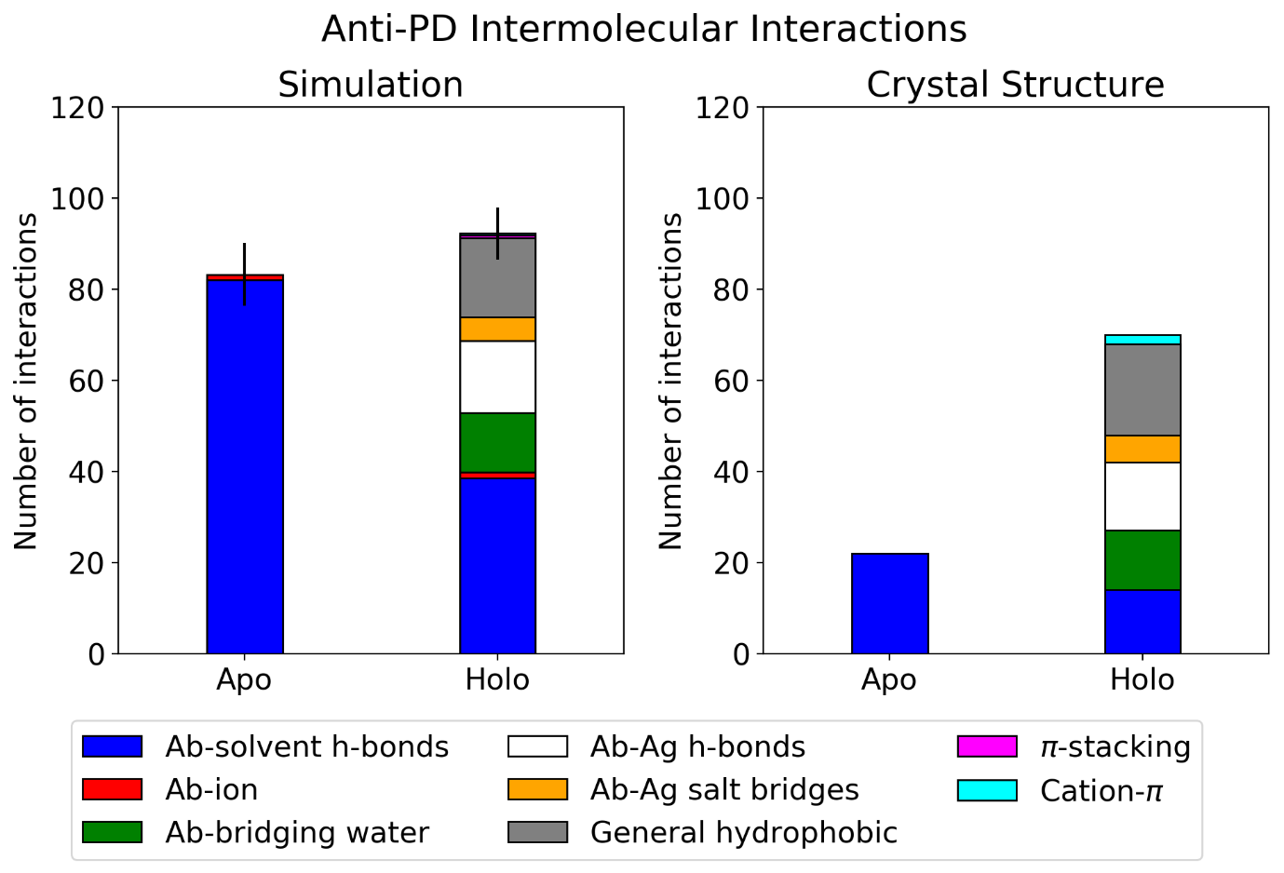
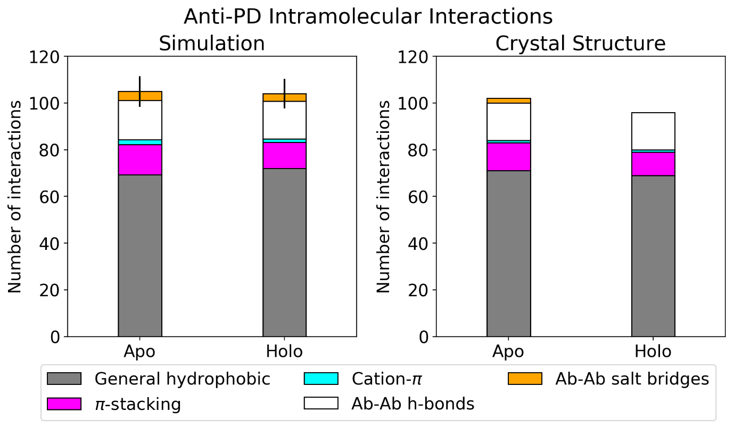
Supplementary Figure 1. Interface interaction plots for the antibody-antigen dataset. Error bars on the left plots represent one standard deviation of the total intermolecular or intramolecular interactions formed throughout the REST2 simulation. Crystal structure values for interactions with ions are zero as the solvent is added during simulation setup. The exception is anti-LFA, where the epitope involves a metalloprotein’s ion.

Anti-H1N1
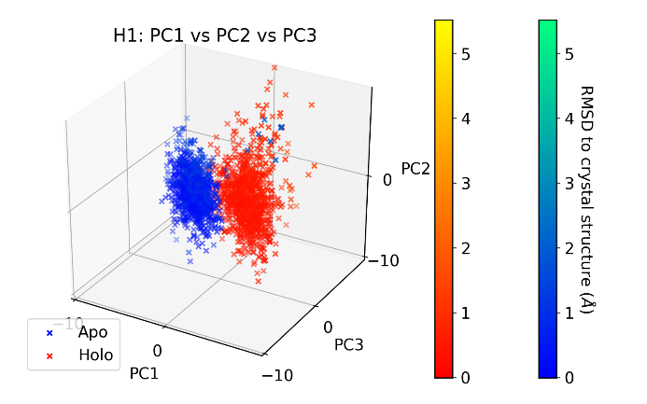 | 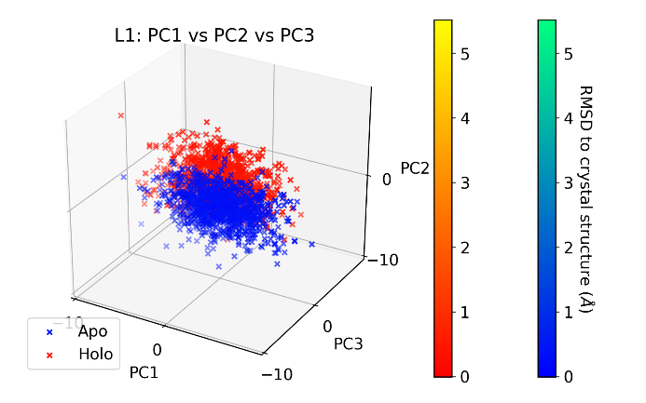
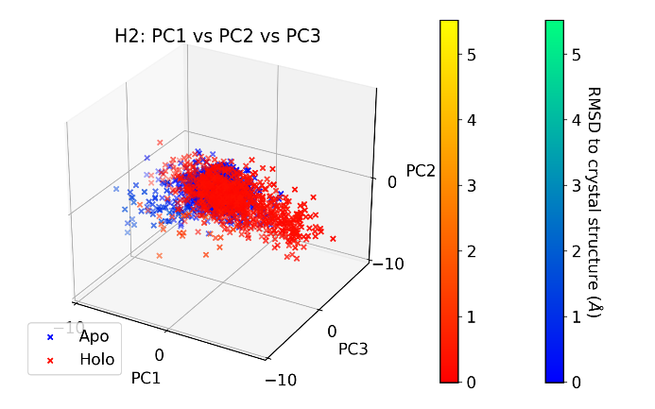 | 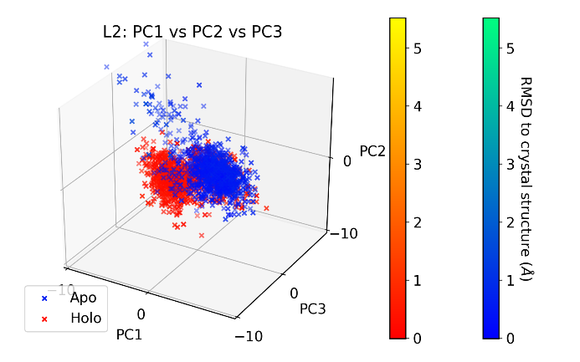
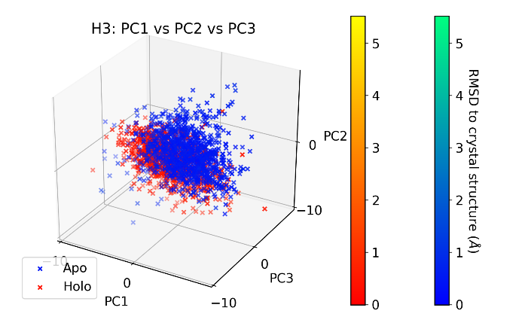 | 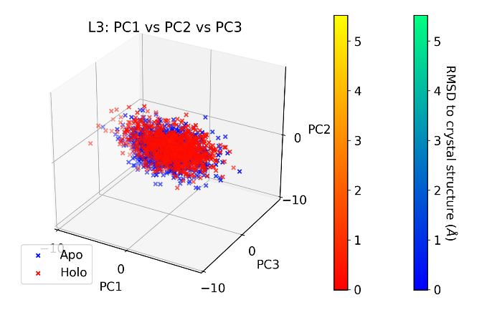

Anti-IL-18
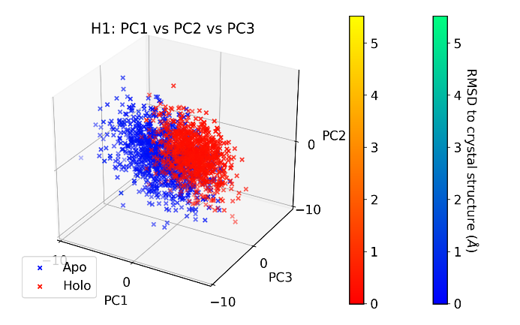 | 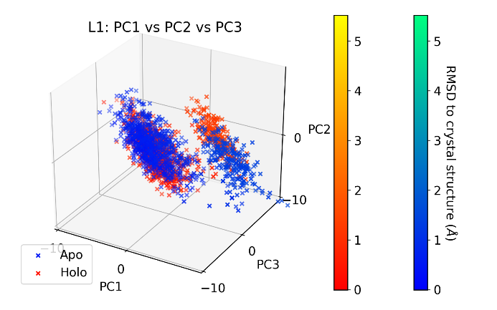
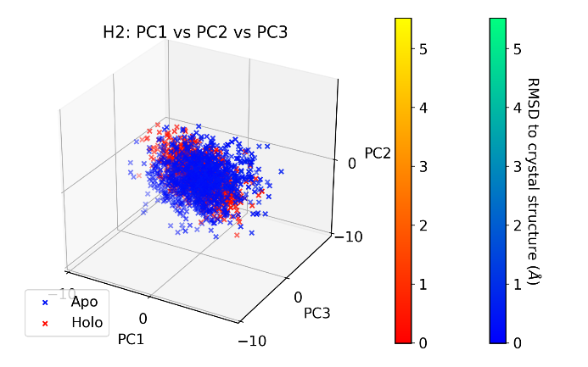 | 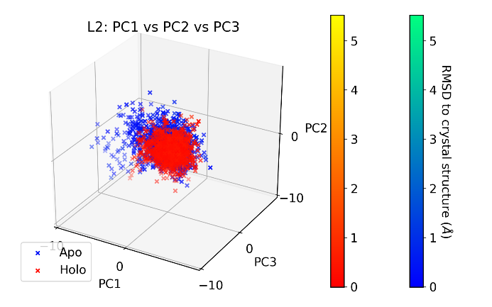
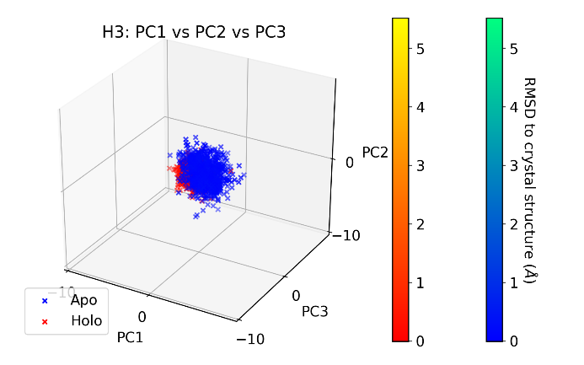 | 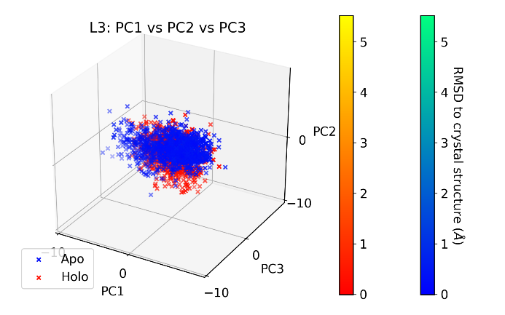

Anti-LFA
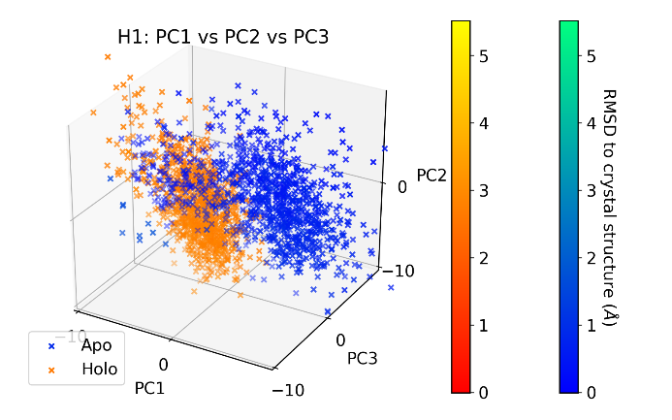 | 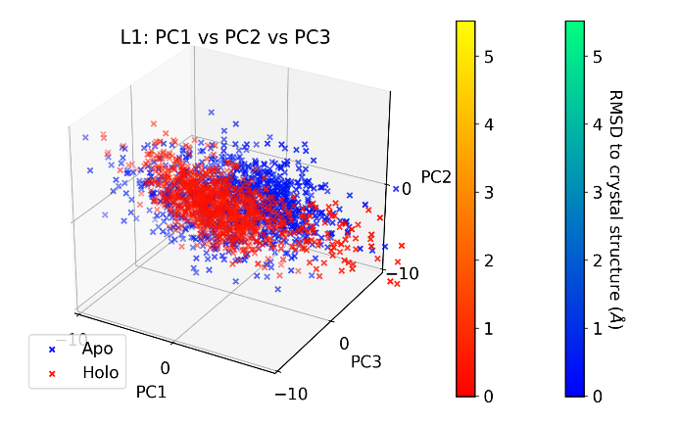
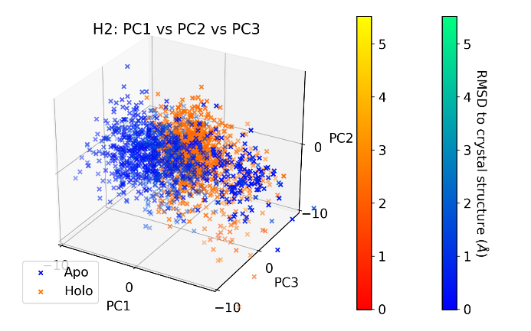 | 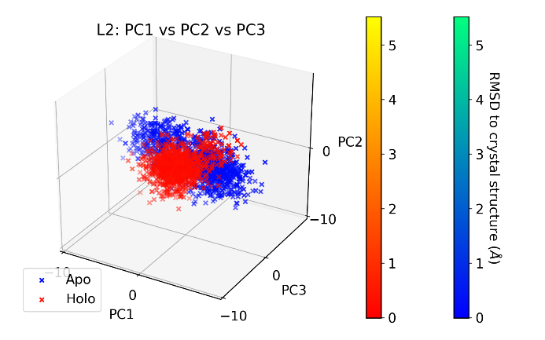
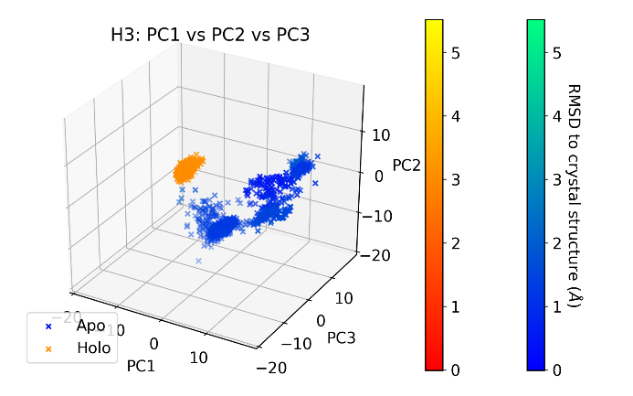 | 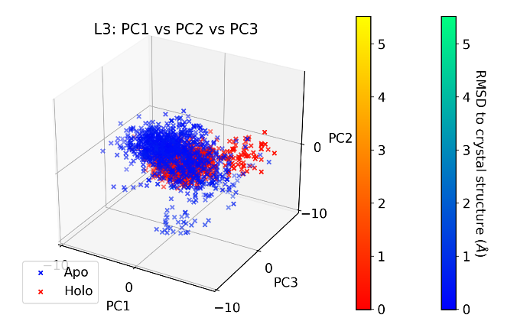

Anti-MHC
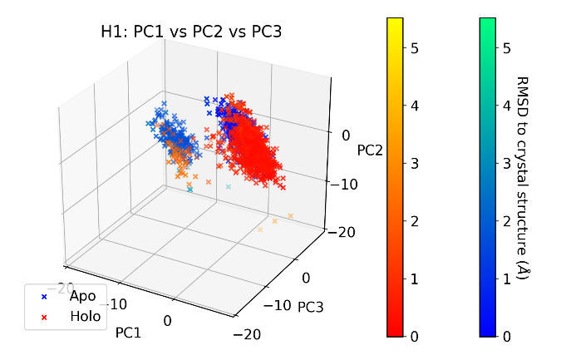 | 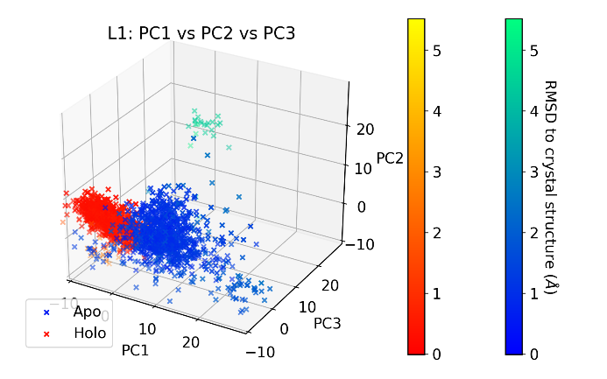
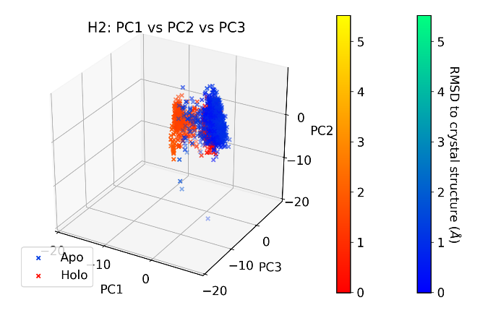 | 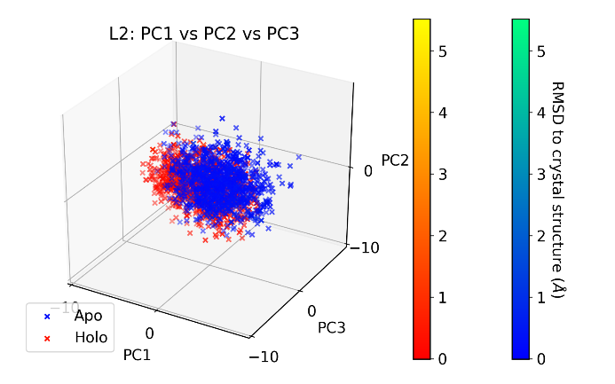
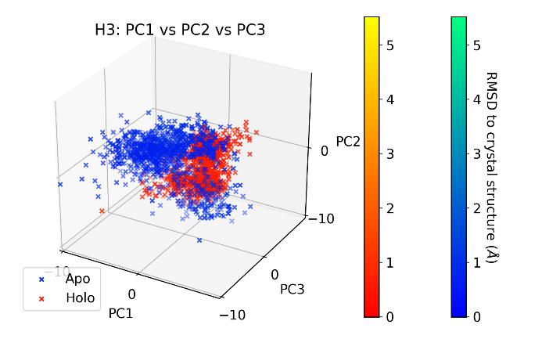 | 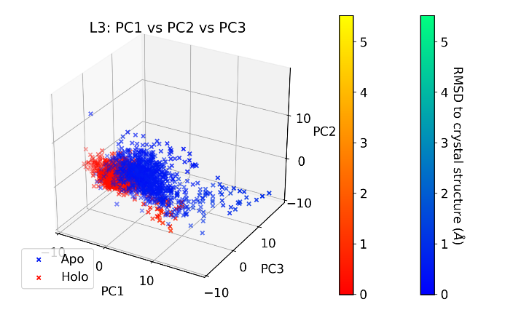

Anti-ObR
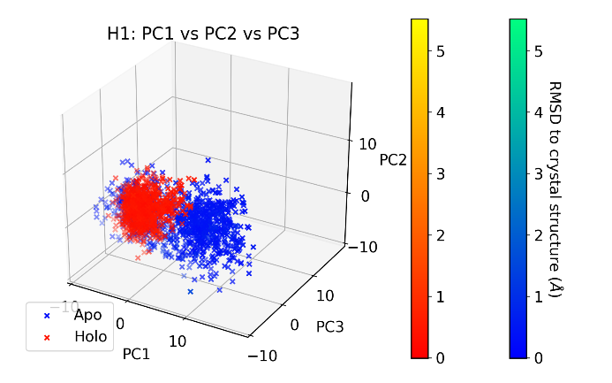 | 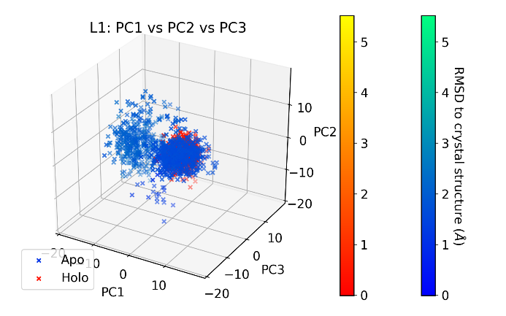
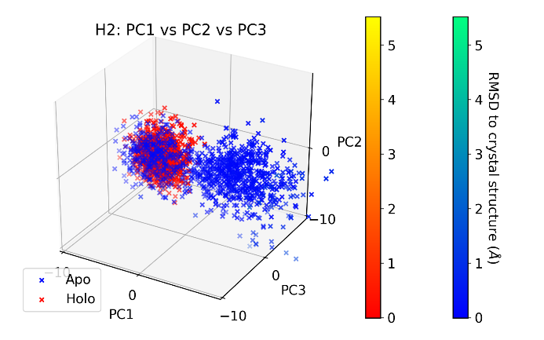 | 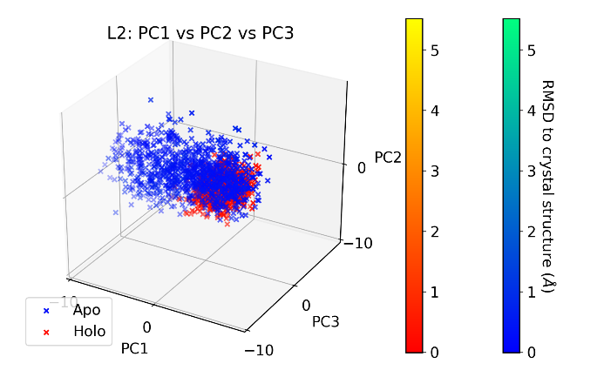
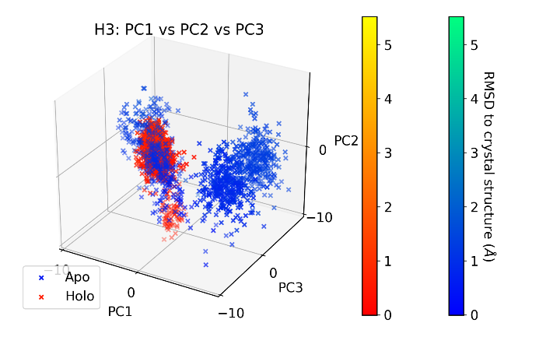 | 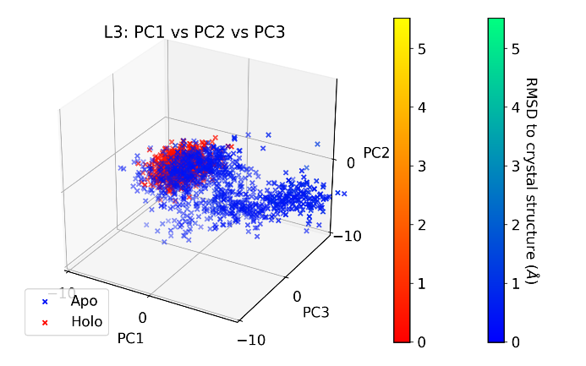

Anti-IL-1βa
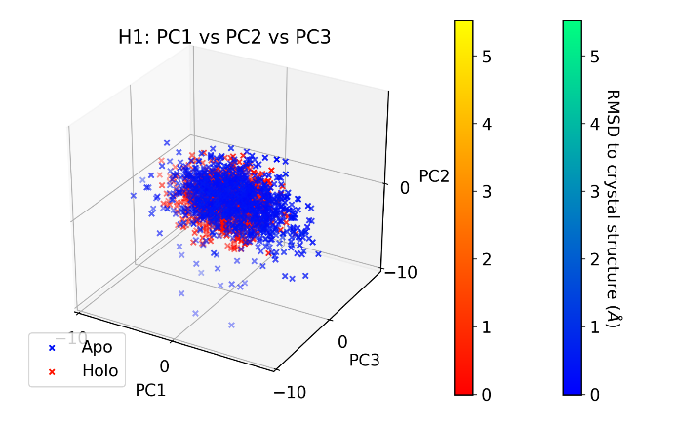 | 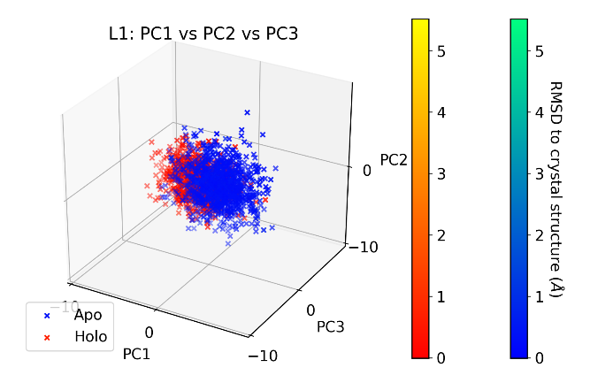
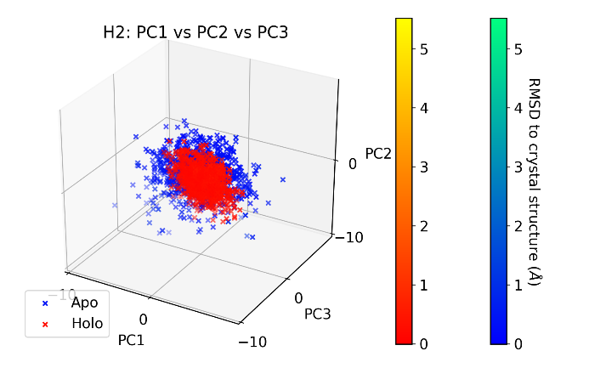 | 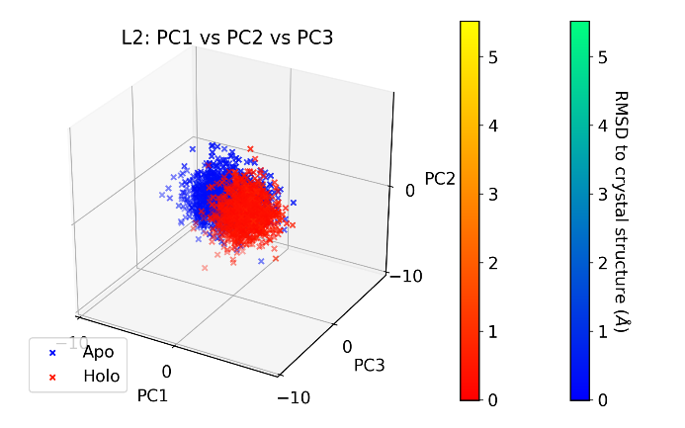
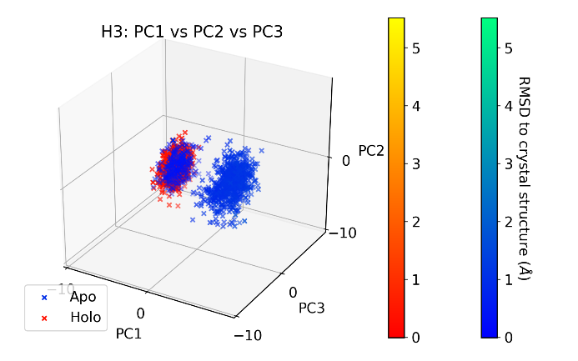 | 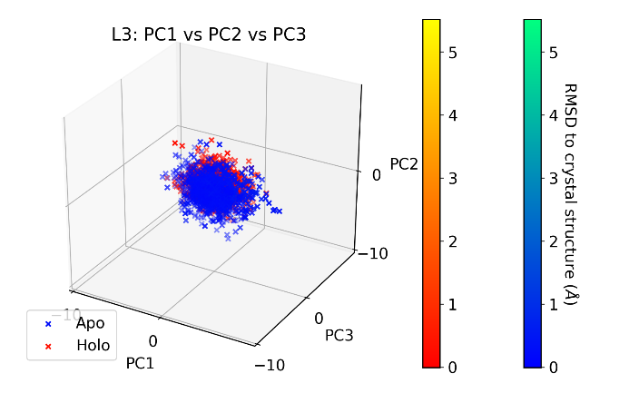

Anti-TNFα
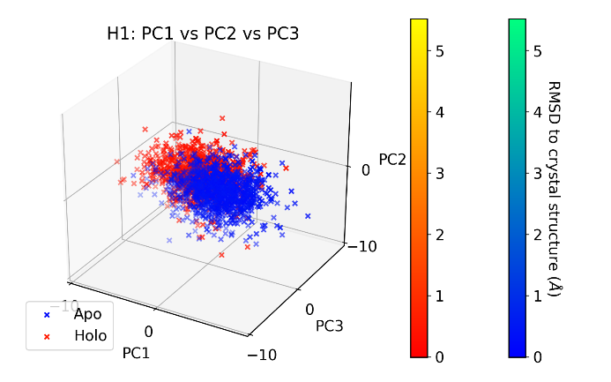 | 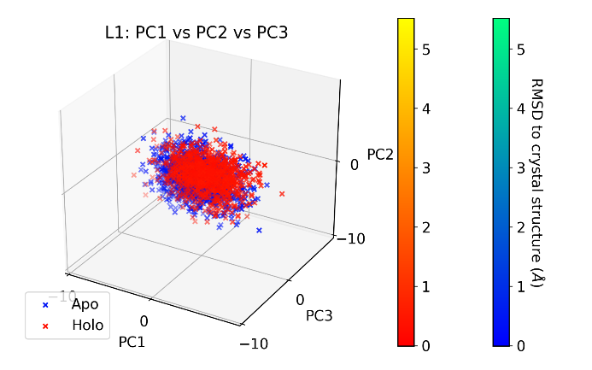
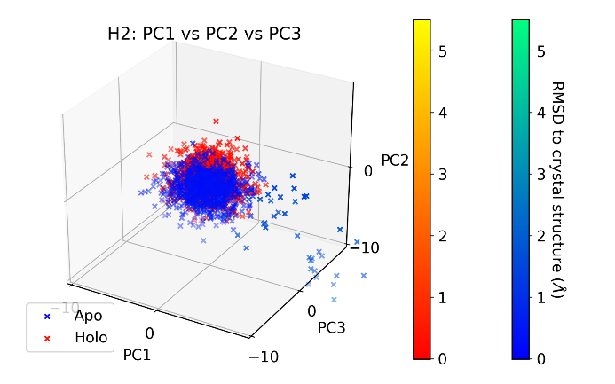 | 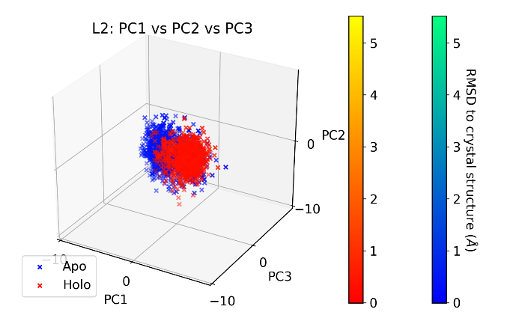
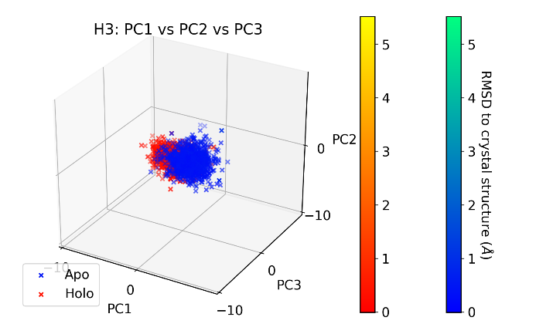 | 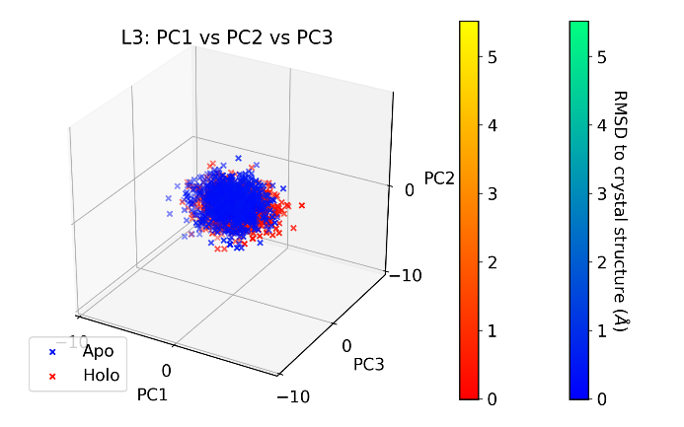

Anti-IL-1βb
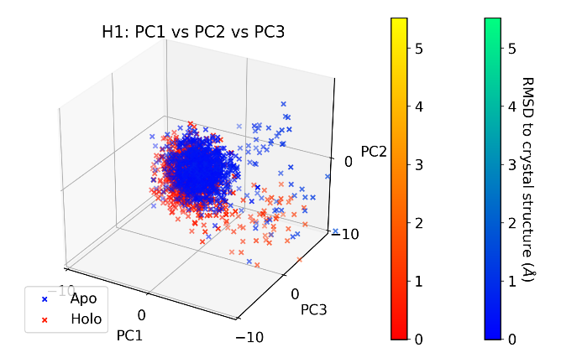 | 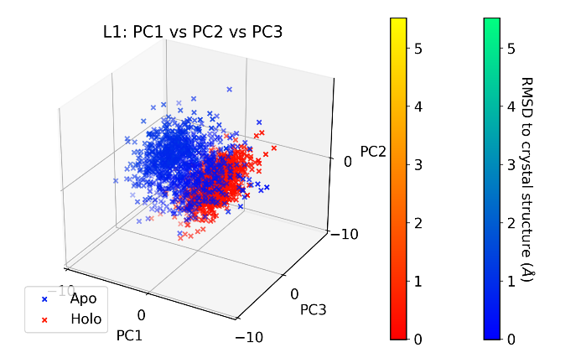
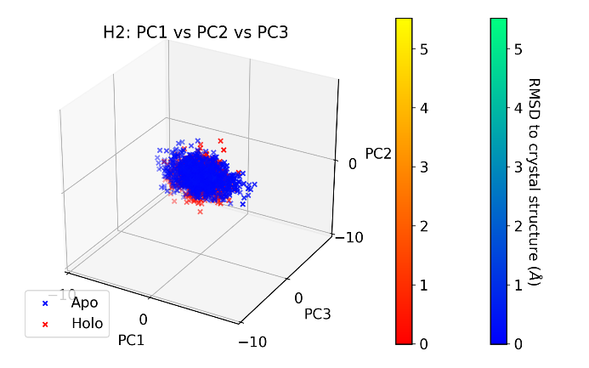 | 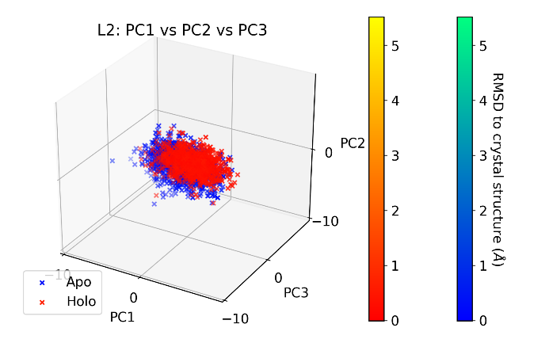
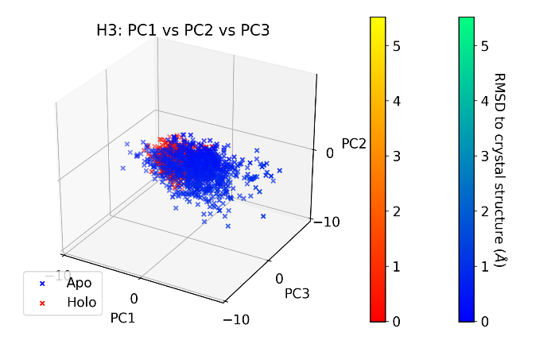 | 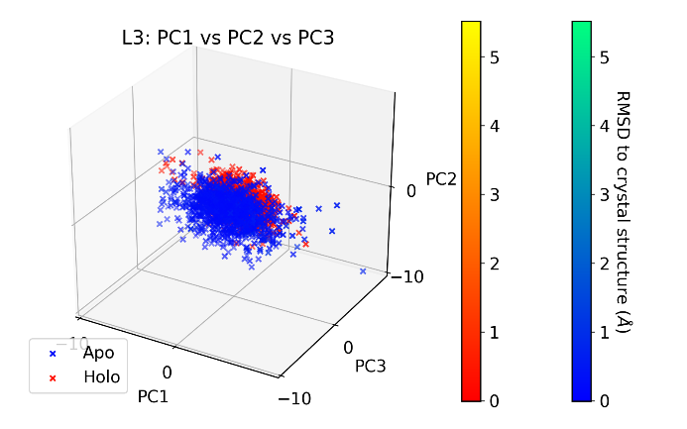

Anti-PD
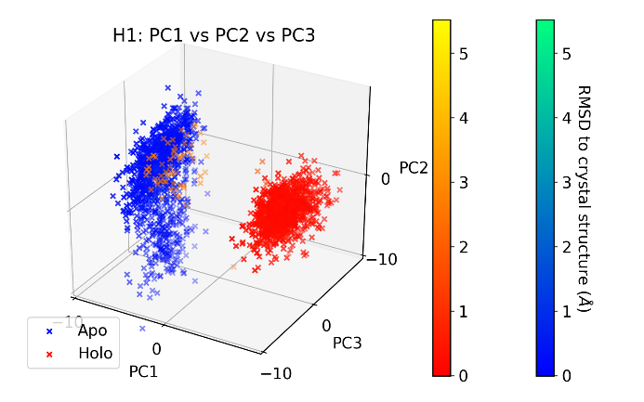 | 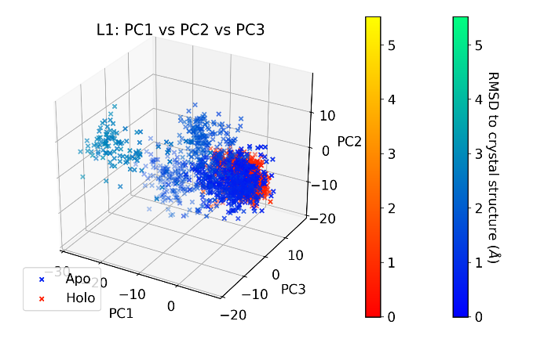
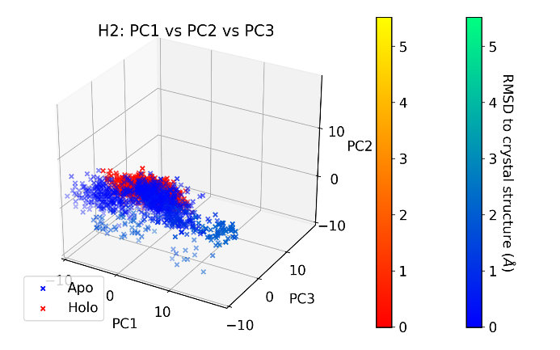 | 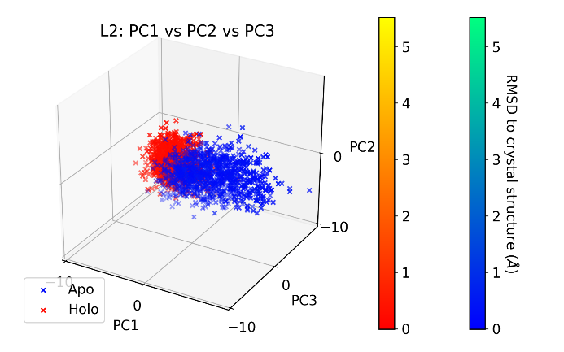
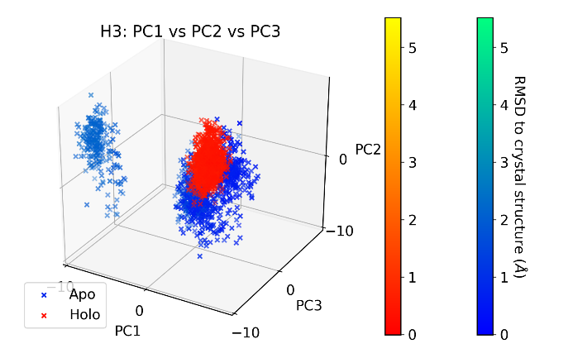 | 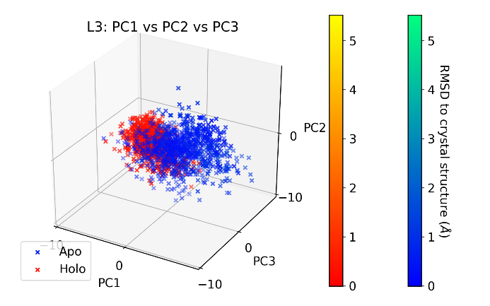

Supplementary Figure 2. Frames projected along PCs 1-3 for each CDR. Frames are colored by RMSD with respect to their crystal structure, with apo frames plotted in blue/green and holo frames plotted in red/yellow.

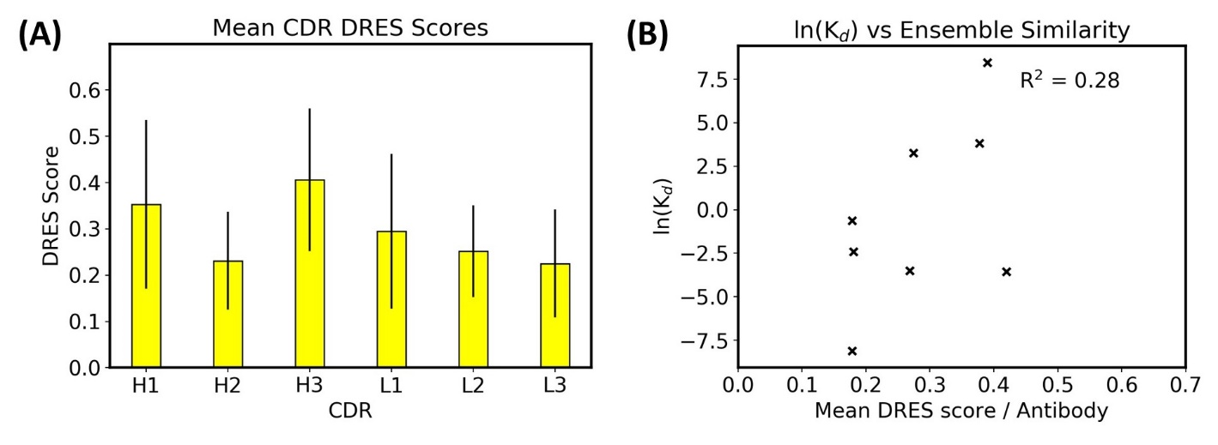
Supplementary Figure 3. DRES results. (A) Mean DRES scores for each CDR across the antibody-antigen dataset. Error bars are given to one standard deviation. (B) Mean DRES score for each antibody plotted against its experimental affinity, showing no correlation.

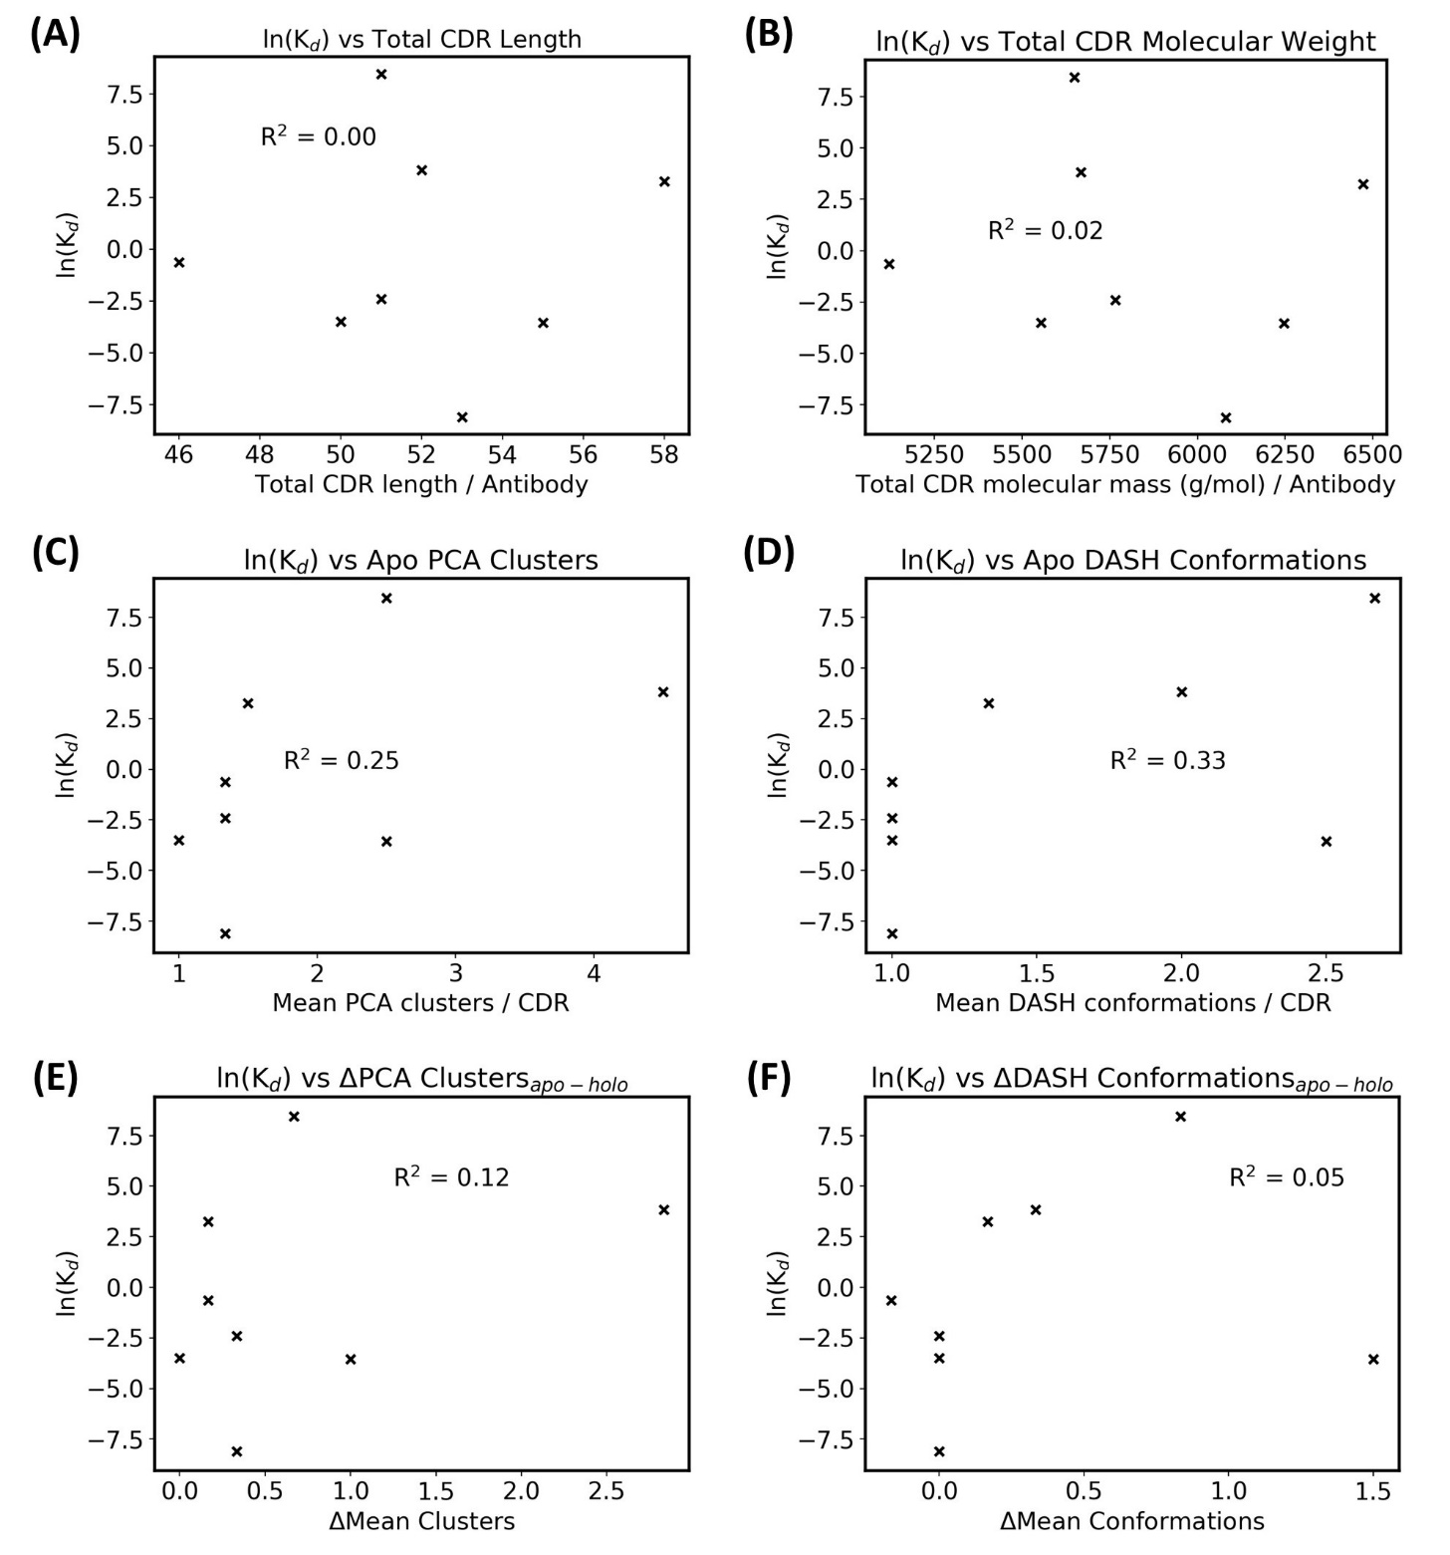
Supplementary Figure 4. Affinity against CDR characteristics. ln(K_{d}) is used as a proxy for affinity due to the Gibbs free energy equation of ΔGº = -RTln(K_{eq}), and natural logarithms of K_{d} values in nM are used (see main manuscript Table 1). Each antibody’s experimental affinity is plotted against (A) total CDR length, (B) total molecular weight, (C) mean apo PCA clusters, (D) mean apo DASH conformations, (E) difference between apo and holo PCA clusters, and (F) difference between apo and holo DASH conformations.

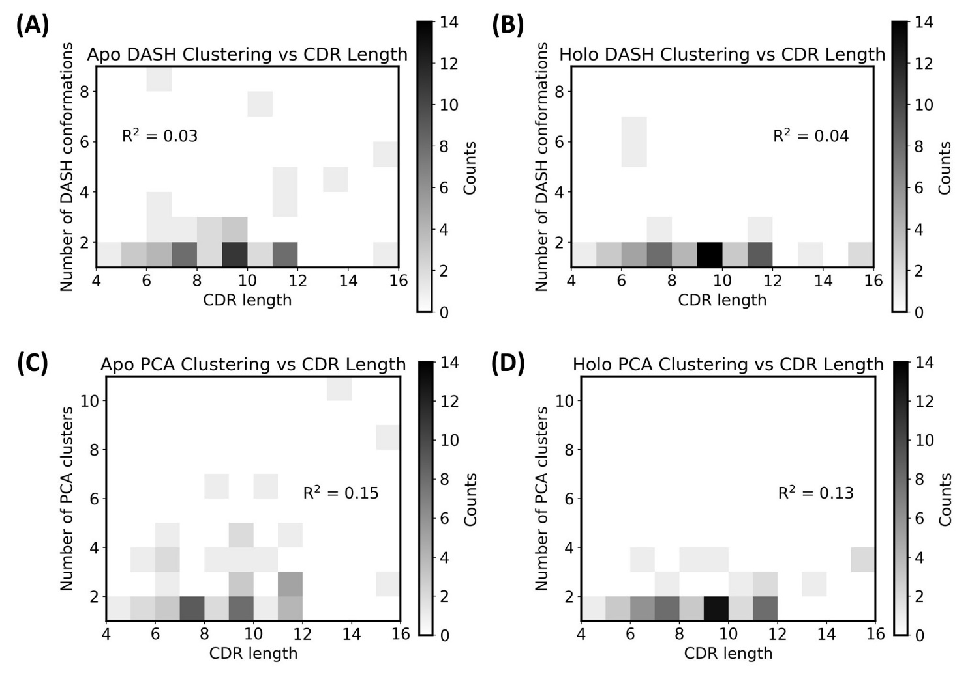
Supplementary Figure 5. Individual CDR clustering against CDR length. (A) and (B) plot CDR length against their DASH clusters, whereas (C) and (D) plot CDR length against PCA clusters.
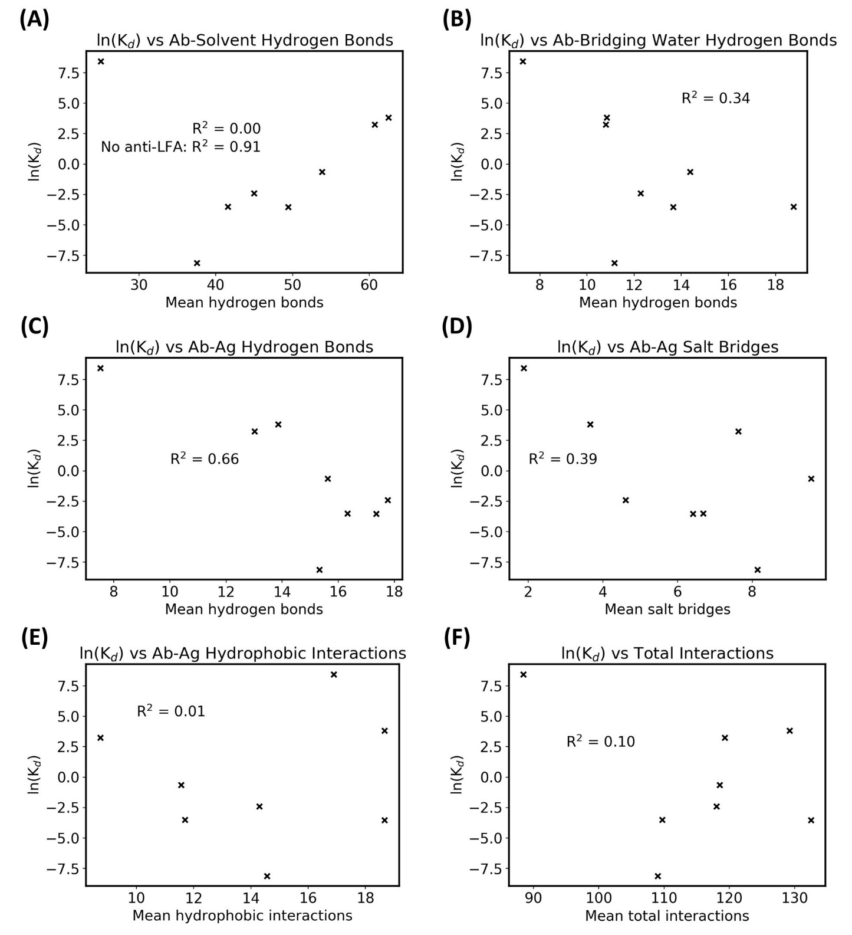
Supplementary Figure 6. Affinity vs antibody-antigen interaction counts for simulations using the fluctuating simulation interface.
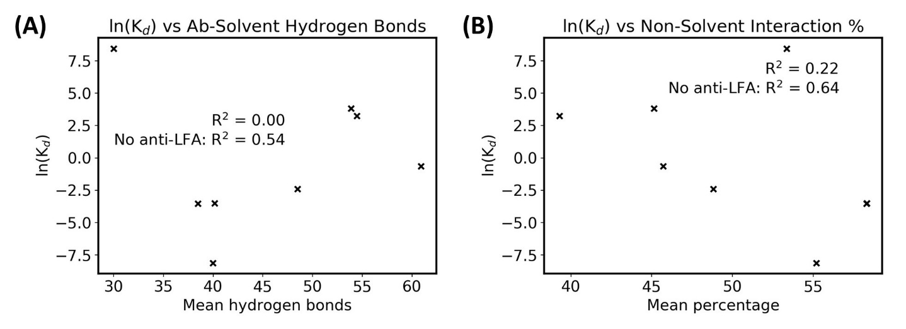
Supplementary Figure 7. Affinity vs antibody-solvent interactions for simulations using the crystal structure interface. (A) ln(K_{d}) against the mean number of hydrogen bonds that antibody interface atoms form with bulk solvent. (B) ln(K_{d}) against the percentage of antibody interface interactions that are not with bulk solvent. Note that there are two overlapping points at 58%.

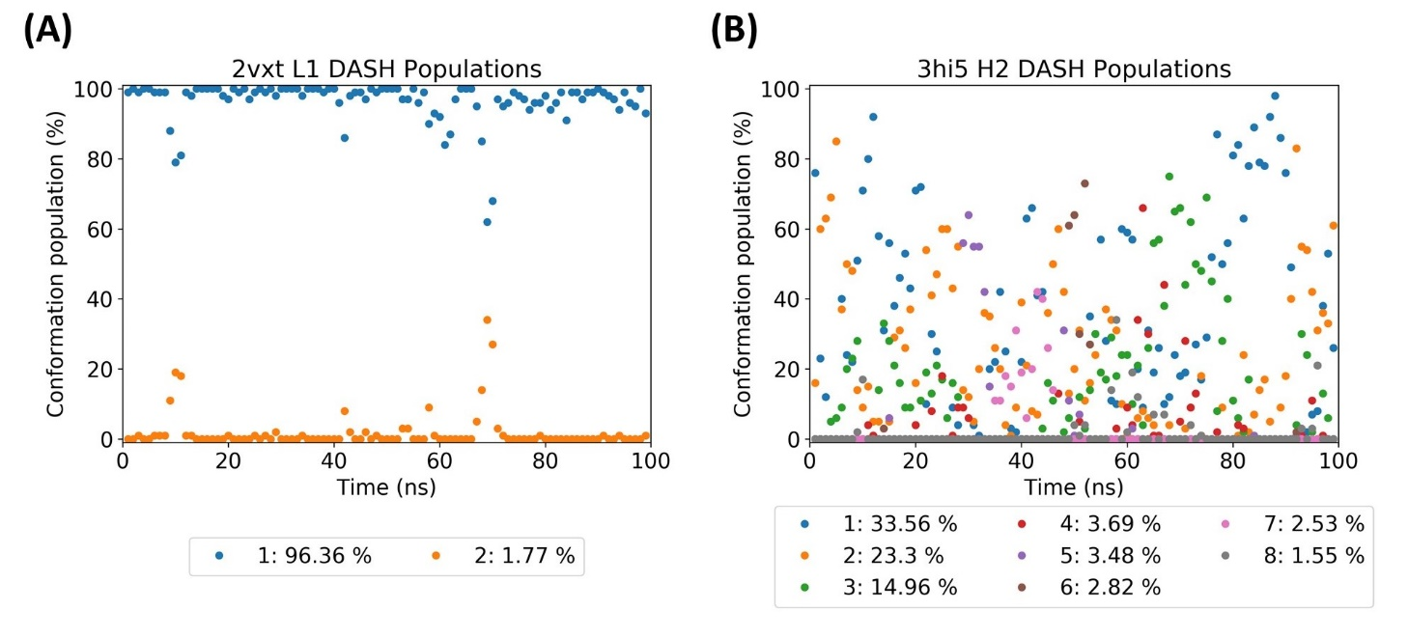
Supplementary Figure 8. Representative DASH population plots to check for convergence. Population is defined as the percentage of frames each DASH conformation occupies over a specified time period. Here the simulation trajectory is divided into a hundred 1 ns chunks, and the population for each conformation is calculated and plotted. (A) Example of a more converged CDR, where populations are relatively constant. (B) Example of a less converged CDR, where the populations show large variation.

Supplementary Tables

Supplementary Table 1. PCA hierarchical clustering counts.

Antibody | H1 |  | H2 |  | H3 |  | L1 |  | L2 |  | L3
 | Apo | Holo | Apo | Holo | Apo | Holo | Apo | Holo | Apo | Holo | Apo | Holo
Anti-H1N1 | 2 | 1 | 1 | 1 | 2 | 3 | 2 | 1 | 1 | 1 | 1 | 1
Anti-IL-18 | 2 | 1 | 1 | 1 | 1 | 1 | 2 | 2 | 1 | 1 | 1 | 1
Anti-LFA | 4 | 3 | 3 | 3 | 4 | 1 | 2 | 2 | 1 | 1 | 1 | 1
Anti-MHC | 6 | 3 | 4 | 1 | 3 | 2 | 10 | 2 | 1 | 1 | 3 | 1
Anti-ObR | 4 | 1 | 3 | 1 | 3 | 1 | 6 | 1 | 1 | 1 | 1 | 1
Anti-IL-1βa | 1 | 1 | 1 | 1 | 1 | 1 | 1 | 1 | 1 | 1 | 1 | 1
Anti-TNFα | 1 | 1 | 3 | 1 | 1 | 1 | 1 | 1 | 1 | 1 | 1 | 1
Anti-IL-1βb | 1 | 1 | 1 | 1 | 1 | 1 | 2 | 1 | 1 | 1 | 2 | 1
Anti-PD | 1 | 2 | 2 | 1 | 2 | 1 | 8 | 3 | 1 | 1 | 1 | 1

Supplementary Table 2. DASH dihedral clustering counts.

Antibody | H1 |  | H2 |  | H3 |  | L1 |  | L2 |  | L3
 | Apo | Holo | Apo | Holo | Apo | Holo | Apo | Holo | Apo | Holo | Apo | Holo
Anti-H1N1 | 2 | 1 | 1 | 1 | 1 | 1 | 1 | 1 | 2 | 2 | 1 | 1
Anti-IL-18 | 1 | 1 | 1 | 1 | 1 | 1 | 1 | 2 | 1 | 1 | 1 | 1
Anti-LFA | 1 | 1 | 8 | 6 | 3 | 1 | 1 | 1 | 1 | 1 | 2 | 1
Anti-MHC | 2 | 1 | 3 | 5 | 1 | 1 | 4 | 1 | 1 | 1 | 1 | 1
Anti-ObR | 1 | 1 | 1 | 1 | 2 | 1 | 7 | 1 | 1 | 1 | 1 | 1
Anti-IL-1βa | 1 | 1 | 1 | 1 | 1 | 1 | 1 | 1 | 1 | 1 | 1 | 1
Anti-TNFα | 1 | 1 | 1 | 1 | 1 | 1 | 1 | 1 | 1 | 1 | 1 | 1
Anti-IL-1βb | 1 | 1 | 1 | 1 | 1 | 1 | 1 | 1 | 1 | 1 | 1 | 1
Anti-PD | 1 | 1 | 2 | 1 | 4 | 1 | 5 | 1 | 1 | 1 | 2 | 1

Supplementary Table 3. DASH rare conformation percentages. The percentage of frames with rare states are summed for each CDR in this table.

Antibody | H1 |  | H2 |  | H3 |  | L1 |  | L2 |  | L3
 | Apo | Holo | Apo | Holo | Apo | Holo | Apo | Holo | Apo | Holo | Apo | Holo
Anti-H1N1 | 0.12 | 3.46 | 0 | 0 | 0 | 0 | 0 | 0 | 0 | 0 | 0 | 0
Anti-IL-18 | 0 | 0 | 0 | 0 | 0 | 0 | 2.33 | 1.87 | 0 | 0 | 0 | 0
Anti-LFA | 0 | 0 | 14.11 | 1.76 | 4.98 | 0 | 2.66 | 0 | 0 | 0 | 0.41 | 0
Anti-MHC | 1.36 | 0 | 1.54 | 3.22 | 0 | 0 | 17.51 | 0 | 0 | 0 | 0 | 0
Anti-ObR | 0 | 0 | 0 | 0 | 7.92 | 0 | 12.50 | 0 | 0 | 0 | 0 | 0
Anti-IL-1βa | 0 | 0 | 0 | 0 | 0 | 0 | 0 | 0 | 0 | 0 | 0 | 0
Anti-TNFα | 0 | 0 | 0 | 0 | 0 | 0 | 0 | 0 | 0 | 0 | 0 | 0
Anti-IL-1βb | 0 | 0 | 0 | 0 | 0 | 0 | 0.04 | 0 | 0 | 0 | 0 | 0
Anti-PD | 0 | 0 | 0 | 0 | 6.42 | 0 | 14.01 | 0 | 0 | 0 | 2.19 | 0.69

Supplementary Table 4. Apo and holo trajectories’ matched conformation percentages. States from apo and holo were considered matched if their circular similarity score was at least 0.80, i.e. 80% similar or above.

Antibody | H1 |  | H2 |  | H3 |  | L1 |  | L2 |  | L3
 | Apo | Holo | Apo | Holo | Apo | Holo | Apo | Holo | Apo | Holo | Apo | Holo
Anti-H1N1 | 0 | 0 | 100 | 100 | 100 | 100 | 100 | 100 | 100 | 100 | 100 | 100
Anti-IL-18 | 100 | 100 | 100 | 100 | 100 | 100 | 97.67 | 96.36 | 100 | 100 | 100 | 100
Anti-LFA | 100 | 100 | 73.37 | 89.54 | 0 | 0 | 97.34 | 100 | 100 | 100 | 89.20 | 100
Anti-MHC | 78.34 | 100 | 91.17 | 66.74 | 100 | 100 | 24.13 | 100 | 100 | 100 | 100 | 100
Anti-ObR | 100 | 100 | 100 | 100 | 56.61 | 100 | 5.67 | 100 | 100 | 100 | 100 | 100
Anti-IL-1βa | 100 | 100 | 100 | 100 | 100 | 100 | 100 | 100 | 100 | 100 | 100 | 100
Anti-TNFα | 100 | 100 | 100 | 100 | 100 | 100 | 100 | 100 | 100 | 100 | 100 | 100
Anti-IL-1βb | 100 | 100 | 100 | 100 | 100 | 100 | 99.96 | 100 | 100 | 100 | 100 | 100
Anti-PD | 0 | 0 | 80.57 | 100 | 22.19 | 100 | 40.06 | 100 | 100 | 100 | 88.38 | 99.31

Supplementary Methods – starting structure selection
The REST2 dataset was selected in June 2018. Given there are fewer therapeutic antibody structures than non-therapeutic ones, the former was curated first:
- Starting with the seventy-two therapeutic antibodies listed on the SAbDab database, only twenty-six were solved in their apo and holo forms;
- Of these twenty-six antibody-antigen structures, only six had both structures of < 2.5 Å resolution;
- Of the six antibodies solved in their apo and holo forms at high resolution, one had missing residues in its CDRs and two had peptide antigens; these were discarded.

This left three structures for the dataset, and the non-redundant search results were considered next:
- SAbDab filters were set to ensure only antibodies and antigens with less than 70% sequence identity would be considered non-redundant, and that the antibody-antigen structure had a resolution of < 2.5 Å. This gave a total of forty-one antibodies;
- Of these forty-one holo antibody-antigen structures, only ten had the antibody solved in its apo form at < 2.5 Å resolution;
- Of the ten antibodies solved in its apo and holo form, only seven had no missing residues in either the CDRs or large portions of the antigen;
- Of the seven antibodies with no missing residues in important regions of interest, one was a therapeutic and already chosen for the dataset, one was anti-ObR which was the antibody used to optimise our protocol, and all the remaining antibodies had experimental affinities in the nM region.

Four non-therapeutic antibodies were chosen from these final six due to their similar experimental affinity. The seven chosen therapeutic and non-therapeutic antibodies had binding affinities ranging from fM to nM, and another antibody was purposely selected for its high μM affinity (AL-57, PDBs 3hi6 and 3hi5) to increase the range further.

