Note: this is a draft of the journal article:

Nkemjika S. Abiakamᵃ, Hemalatha Jayabalᵃ, Kay Mitchellᵇ, Dan L. Baderᵃ and Peter R. Worsley (2022) “Biophysical and biochemical changes in skin health of healthcare professionals using respirators during COVID-19 pandemic.”

Skin Research and Technology, accepted
The final, fully proofed and peer-reviewed journal article is available from the publisher online,

Title: Biophysical and biochemical changes in skin health of healthcare professionals using respirators during COVID-19 pandemic

Nkemjika S. Abiakamᵃ, Hemalatha Jayabalᵃ, Kay Mitchellᵇ, Dan L. Baderᵃ and Peter R. Worsleyᵃ

ᵃ School of Health Sciences, University of Southampton, Southampton, UK
ᵇ University Hospital Southampton Foundation Trust, Southampton, UK

Corresponding Author: Nkemjika S. Abiakam
Address: Clinical Academic Facility, School of Health Sciences, University of Southampton, Southampton, UK.
Email: N.S.abiakam@soton.ac.uk Phone: +44(0)2381 208287

ABSTRACT
Introduction
Personal protective equipment, including respirator devices, has been used to protect healthcare workers (HCWs) during the COVID-19 pandemic. These are fitted to skin sites on the face to prevent airborne transmission but have resulted in reports of discomfort and adverse skin reactions from their continued usage. The present study addresses the objective changes in both the structural integrity and biological response of the skin following prolonged and consecutive use of respirators.
Methods
A longitudinal cohort study, involving 17 HCWs who wear respirators daily, was designed. Changes in the barrier properties and biological response of the skin were assessed at three facial anatomical sites, namely, the nasal bridge, left cheek and at a location outside the perimeter of respirator. Assessments were made on three different sessions corresponding to the first, second and third consecutive days of mask usage. Skin parameters included Transepidermal water loss (TEWL), stratum corneum hydration and erythema, as well as cytokine biomarkers sampled from sebum using a commercial tape.
Results
The cheek and the site outside the perimeter covered by the respirator presented minimal changes in skin parameters. By contrast, significant increases in both the TEWL (up to 4.8 fold) and stratum corneum hydration (up to 2.7 fold) were detected at the nasal bridge on the second consecutive day of respirator-wearing. There was a high degree of variation in the individual expression of pro-and anti-inflammatory cytokines. Increasing trends in nasal bridge TEWL values were associated with the body mass index (p < 0.05).
Conclusions
The most sensitive objective parameter in detecting changes in the skin barrier proved to be the increase in TEWL at the nasal bridge, particularly on the second day of consecutive respirator usage. By contrast, other measures of skin were less able to detect remarkable variations in the barrier integrity. Consideration for protecting skin health is required for frontline workers, who continue to wear respirators for prolonged periods over consecutive days during the pandemic.

KEYWORDS
Personal protective equipment (PPE), Respirator protective equipment (RPE), COVID-19, Skin health, Inflammatory biomarkers.

HIGHLIGHTS
- Changes in markers of skin integrity following prolonged use of respirator protective equipment (RPE) by healthcare workers.

- The largest changes in skin integrity were associated with the nasal bridge after two consecutive days of RPE usage

- The skin response to respirators was largely independent of the daily hours of PPE usage and the number of times the devices were doffed during a shift.

- Loaded sites expressed various levels of skin inflammatory markers following RPE application

INTRODUCTION
With the worldwide surge of the coronavirus pandemic, healthcare workers (HCWs) have been mandated to use respiratory protective equipment (RPE) to protect them from airborne COVID-19 particles. These typically involve disposable respirators ranging from a filtration level of 95 to 99%, which are tightly fitted to the face. If fitted correctly, they form an airtight seal around the mouth and nose. Respirators are manufactured according to generic designs and incorporate stiff materials, which can create a mismatch in both the underlying geometry of the face and stiffness of the skin and soft tissues (Bader et al. 2019). Due to the tight-fitting nature of these devices and their design principles, prolonged use could lead to changes in skin health, with a range of adverse reactions reported by HCWs (Abiakam et al. 2021). These skin responses can be a direct result of the elevated pressure and frictional forces applied to the skin interface (Lei et al. 2012), as well as the creation of an occlusive microenvironment, resulting in the accumulation of heat and humidity (Peko et al. 2021).
Various non-invasive bioengineering tools are available to objectively monitor changes in skin health following external challenges (Bader et al. 2018). These include physical sensors to monitor the mechanical and thermal skin contact conditions, biophysical parameters to evaluate barrier function and hydration, and biomarkers reflecting local skin physiology including inflammation and ischemia (Bader et al. 2018). Indeed, parameters such as transepidermal water loss (TEWL), stratum corneum (SC) hydration, skin erythema and surface pH have been used in studies following skin exposure to mechanical loading (Jayabal et al. 2021), moisture (Bostan et al. 2019) and chemical irritation (De Jongh et al. 2006). Recently, one randomized crossover study, evaluating N95 and surgical masks, reported increased levels of TEWL, SC hydration and pH following N95 respirator application (Hua et al. 2020). However, the study only involved a cohort of 20 healthy volunteers, who applied the masks for a maximum period of 4 hours, without performing any functional activities. In a similar study design, Peko et al (2021) measured facial contact forces, skin temperatures and sub-epidermal moisture (SEM) to evaluate the effects of surgical facemasks and N95 respirators on healthy volunteers. Their findings demonstrated that the respirators which require a tight seal created high contact forces and thermal loads at the skin interface compared to standard surgical facemasks. However, both studies do not reflect the clinical scenario where staff can apply the masks for in excess of 8 hours in a given working shift, performing various activities during their routine daily working. In those studies which included HCW participants, respirator application has been restricted to two hours. However, this was shown to be sufficient to create a statistically significant increase in TEWL, erythema and temperature (Park et al. 2021; Montero-Vilchez et al. 2021)
To date, no studies have utilised biochemical markers which reflect the health status of the skin (Bader et al. 2018). In particular, inflammatory markers sampled non-invasively from the sebum released at the skin surface, have been previously employed as early indicators of skin damage as a consequence of pressure and shear forces (Soetens et al. 2019; Hemmes et al. 2017; de Wert et al. 2019). This approach has enabled the quantification of a variety of pro-and anti-inflammatory cytokines. Indeed, upregulation of specific proteins including IL-1α and the receptor antagonist, IL-1RA, were reported in a study evaluating the effects of strap tension during non-invasive ventilation mask application (Worsley et al. 2016). Similar increases were also detected when the skin was subjected to either pressure alone or in combination with occlusion (Bostan et al. 2019). Given the similar nature of the respirators to the occlusive device’s studies to date, it is hypothesised that a similar upregulation of inflammatory biomarkers may be present following prolonged RPE application.
To date, research has focussed on respirator application on healthy volunteers and HCWs for short application periods, with parameters of skin health limited to biophysical assessments. There is a need for more empirical data pertaining to the skin responses to repeated application of respirators, as observed in a typical working week for HCWs. Accordingly, the present study aimed to investigate the biophysical and biomarker changes in skin health following RPE application using a longitudinal design over repeated clinical shifts in HCWs.

MATERIALS AND METHOD

PARTICIPANTS
Healthcare workers were recruited from COVID-19 high-risk departments of one UK University Hospital healthcare provider via poster advertisement and gatekeeper communication. Inclusion criteria consisted of individuals over 18 years of age, who employ FFP2/3 masks on a daily basis while attending to clinical commitments, who worked a minimum of three consecutive clinical shifts per week. Exclusion criteria included individuals with no active skin conditions at the facial sites of investigation, allergies or sensitivity to adhesive tape and the inability to attend a minimum of two out of the three assessment sessions. The study was approved by the UK Health Research Authority committee (IRAS 285764) and written informed consent was obtained from participants prior to commencing the study.

STUDY PROTOCOL
The study was conducted during the second wave of the COVID-19 pandemic in the UK (December 2020 to March 2021). Three anatomical locations on the face, namely an area outside the perimeter of respirator application (negative control denoted A), the bridge of the nose (B) and the left cheek (C), were investigated (Figure 1a). Participants who agreed to take part in the study were tested on three different occasions based on a standardised protocol, as summarised in Figure 1b. Participants were requested to avoid the application of any moisturizer and/or cosmetics on the face on each of the assessment days. During the test session, each participant acclimatized to an indoor environment and their face dried with paper towels (Tork®, Bedfordshire, UK) prior to commencing skin assessments. All test sessions were conducted in a temperature and humidity-controlled laboratory (room temperature of 22.5± 0.7⁰C and relative humidity of 42± 6%) before and after the participant’s working shift. Three distinct data collection sessions were used:

- Session 1: participant first day of mask usage following return to work after a period of absence (minimum of 24 hours)
- Session 2: second consecutive day of mask usage in a given working week
- Session 3: third consecutive day of mask usage in a given working week

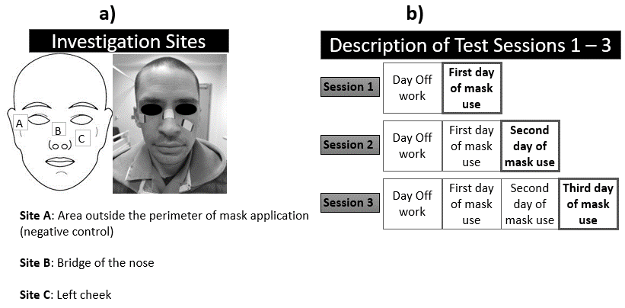
Figure 1. (A) Investigation sites associated with a control site ‘A’, and sites under the respirator mask, namely the bridge of the nose ‘B’ and left cheek ‘C’. (B) Study protocol including each test session and the corresponding repeated days of respirator application.

SKIN BIOPHYSICAL AND BIOCHEMICAL ASSESSMENT
At the start of the first test session demographic and anthropometric data were collected from each participant. This including age, gender, ethnicity, height, weight, body mass index (BMI), working hours, type of respirator used, number and frequency of respirator removal, and pain perception while wearing the device.
The facial skin health of participants was assessed during each test session pre- and post-respirator application, using three biophysical parameters. These included transepidermal water loss (TEWL), stratum corneum (SC) hydration and erythema. TEWL was investigated using a Tewameter (TM 300, Courage & Khazaka, Germany), which incorporates an open-chamber probe which was gently placed in contact with the skin for 1 minute during which equilibrium was achieved. SC hydration and erythema were assessed using the capacitance‐based Corneometer (CM 825, Courage & Khazaka, Germany) and the narrow‐band reflectance spectrophotometer Mexameter (MX18, Courage & Khazaka, Germany), respectively. Both devices were placed in contact with the test sites and the mean of 5 repeated measurements were recorded for each parameter. The outputs of the parameters were measured in g/h/m² for TEWL and arbitrary units (AUs) for both SC hydration and erythema. Participants' skin assessments were performed generally after 10 minutes following the removal of RPE, which corresponded to the time taken for the individual HCW to transfer from their various hospital departments to the controlled lab setting. All measurements were performed following recommended guidelines for their use (du Plessis et al. 2013).
Inflammatory skin biomarkers were evaluated non-invasively by collecting sebum from the skin surface of each participant, using commercial SebutapeTM patches (32x19 mm) (CuDerm, Dallas, TX, USA). The sebutapes were attached to the skin (Figure 1a), by means of tweezer and gloved hands, and held in place for 2 minutes prior to removal. Subsequently, they were placed in appropriate labelled sterile containers and stored at -80⁰C until biochemical analysis

BIOCHEMICAL ANALYSIS
The extraction of skin inflammatory biomarkers was performed following a standardized protocol (Perkins et al. 2001), optimised with the introduction of chemical and mechanical stimuli to improve the extraction efficiency. To review briefly, frozen Sebutape samples were thawed to room temperature, and a 0.85 mL solution of PBS (Sigma-Aldrich Co, St. Louis, Missouri, USA) and 0.1% dodecylmaltoside (DDM) (Thermo Fisher Scientific, UK) was added to each container. After 1 hour of vigorous shaking and immersion in the solution, the containers were sonicated for 5 minutes, the Sebutapes discarded, and 0.5 mL of the extraction buffer was transferred into vials for centrifugation. Subsequently, the vials were centrifuged for 10 minutes at 15000g, whilst being maintained at a constant temperature of 4⁰C. The supernatants were discarded and the pellets vortexed for 10 seconds. The samples were then processed using U-Plex immuno-assay kits (Meso Scale Diagnostics, USA) to quantify the concentration of inflammatory and anti-inflammatory biomarkers (e.g. IL-1α, TNF-α, IL-8 and IL-1RA) over the nasal bridge (site B) of the participants.

DATA ANALYSIS
Raw data were imported into Excel (Microsoft office package 2019, USA) for analysis. Values from TEWL, SC hydration, erythema and inflammatory biomarker concentrations were normalised to the baseline for each test session (post/pre-respirator application ratio) in order to enable comparisons of relative variations across the experimental time frame and between the participants (Henshaw et al. 2020; Bostan et al. 2019). Shapiro Wilk test and D’Agostino-Pearson were used to assess the distribution of the data. Accordingly, a parametric two-way analysis of variance (ANOVA) with replication was employed to evaluate the effect of repeated respirator application derived from each test session and the difference between measurement sites for each parameter. Paired samples t-Test was used to compare measurements taken between specific test sessions. Cluster analysis was conducted for normalised inflammatory biomarkers where combined cytokine rank for each participant was collated for each test session. The integrated cytokine response was estimated by ranking the absolute values of all four cytokines for each time point and summing them across all participants in the cohort (Bostan 2019). This would result in a maximum rank sum of 204, based on the number of time points (3), participants (17) and cytokines (4). Pearson correlation coefficient was used to examine possible associations between skin health and other demographic and anthropometric data. Differences were considered to be statistically significant at the 5% level (p < 0.05).

RESULTS
The study recruited 17 HCWs (15 females and 2 males), who use RPE (FFP2 or FFP3) on a regular basis during established clinical shift patterns (Table 1). One participant contracted COVID-19 during the study and was withdrawn for further assessment. The periods between consecutive test sessions varied for practical reasons, ranging between 1 to 8 weeks. The participants' age ranged between 22 and 61 years (mean age 33 ± 11 years), with a mean height and weight of 1.70 ± 0.1 m and 69.7 ± 17.1 kg, respectively. The mean corresponding body mass index (BMI) was 25.1 ± 5.4 kg/m². Participants included nurses (n=8), doctors (n=2) and other health-related professions (n=7). All participants were fit tested using a standardised procedure (HSE 2021) prior to employing respirators, except for the two who used the N95 device. Approximately one half of the participants (9/17) reported pain when employing RPE during clinical duties. The approximate frequency of breaks recorded by participants, as summarised in Table 1, were similar for each session of data collection, as they followed an established working pattern.

Table 1. Demographic and anthropometric data of study participants with detail of respirator use and any associated adverse reactions to the skin.
ID | PROFESSION | GENDER | ETHNICITY | AGE (Years) | BMI (kg/m²) | MASK MAKE | WORKING HOURS | BREAKS FROM MASK | ADVERSE REACTIONS TO RPE
1 | Nurse | Female | White | 29 | 20.3 | Aura 1863+ | 12 | 4 | Spots, dry skin
2 | Nurse | Female | White | 28 | 22.5 | Aura 1863+ | 12 | 2 | Itchiness, excessive sweating
3 | Doctor | Female | White | 41 | 23.1 | Aura 9330+ | 8 | 2 | Spots, itchiness
4 | Nurse | Female | White | 61 | 24.6 | Aura 1863+ | 8 | 2 | None
5 | Nurse | Female | White | 33 | 39.4 | Aura 1863+ | 12 | 3 | Spots, lumps
6 | Other | Female | White | 40 | 34.5 | Alpha Solway 3030v | 10 | 3 | None
7 | Nurse | Female | White | 28 | 22.3 | Aura 9330+ | 12 | 3 | Spots, itchiness
8 | Other | Male | White | 30 | 23.0 | N95 | 10 | 4 | Excessive sweating
9 | Other | Female | White | 22 | 25.1 | Aura 1863+ | 7.5 | 1 | Spots, dry skin
10 | Other | Female | Asian | 26 | 25.0 | 3M 8835+ | 8.5 | 1 | Spots, dry skin, excessive sweating, headaches
11 | Nurse | Female | White | 28 | 20.3 | Aura 9330+ | 12 | 2 | Itchiness, spots, excessive sweating
12 | Other | Female | White | 30 | 19.8 | N95 | 8 | 4 | None
13 | Other | Female | White | 26 | 25.1 | Aura 9330+ | 8 | 1 | Spots
14 | Nurse | Female | White | 57 | 25.2 | Aura 9330+ | 10 | 1 | None
15 | Other | Female | White | 23 | 33.5 | Aura 1863+ | 12 | 3 | Dry skin, rashes, spots, itchiness
16 | Doctor | Female | Asian | 35 | 20.2 | Aura 1863+ | 9 | 4 | Dry skin, spots, itchiness, rashes, excessive sweating
17 | Nurse | Male | White | 31 | 22.5 | Aura 9330+ | 12 | 3 | Dry skin
*Other includes healthcare assistants, operations managers and clinical trials assistants who were redeployed to COVID departments.

TRANSEPIDERMAL WATER LOSS
Variations in the skin barrier properties, as a function of the TEWL parameter, assessed across the test sessions are shown in Figure 2. Absolute TEWL values ranged from 5.7 to 66.9 g/h/m² at the different sites across the sessions. The data revealed relatively small within-participant variability between time points at site A (negative control), with ratio values ranging between 0.4 – 2.2. By contrast, increased ratio TEWL values were evident at site B (Figure 2), demonstrated by an increase in ratio from pre- to post-respirator application (Table 2). Analysis of the ratio TEWL values revealed differences which were statistically significant between the three test sites (p < 0.001), but not significant between the three test sessions (p > 0.05). However, on closer examination site B revealed significant differences in TEWL ratio values between sessions 1 and 2 (p < 0.05).
There was a high degree of variation in the response at the nasal bridge (Site B), with a sub-group of participants (#5, #6, #10, #13, #15) presenting with consistently high TEWL ratios following respirator application in each of the three sessions. By contrast, some participants (#1, #2, #3, #4, #14, #16) demonstrated correspondingly lower TEWL ratios (≤ 2.2 fold). Data revealed Site C demonstrated more consistent TEWL values, only 5 participants (#5, #6, #7, #10, #11 and #13) demonstrating any increases in the TEWL ratios.

SENSIVITIY ANALYSIS OF BIOPHYSICAL SKIN PARAMETERS
A sensitivity analysis was performed for each parameter associated with TEWL, SC hydration and erythema using arbitrary thresholds in the pre- to post-measurement ratios ranging from 1.0 to 3.0. Table 2 highlights the percentage of participants whose responses exceeded these thresholds at the different test sites. It confirms that the proportion of participants remained high with increasing thresholds for TEWL, particularly for the nasal bridge test site (B) for each of the test sessions. By contrast, with SC hydration and erythema, there was a marked reduction of these percentage values when the threshold was set above 1.0.
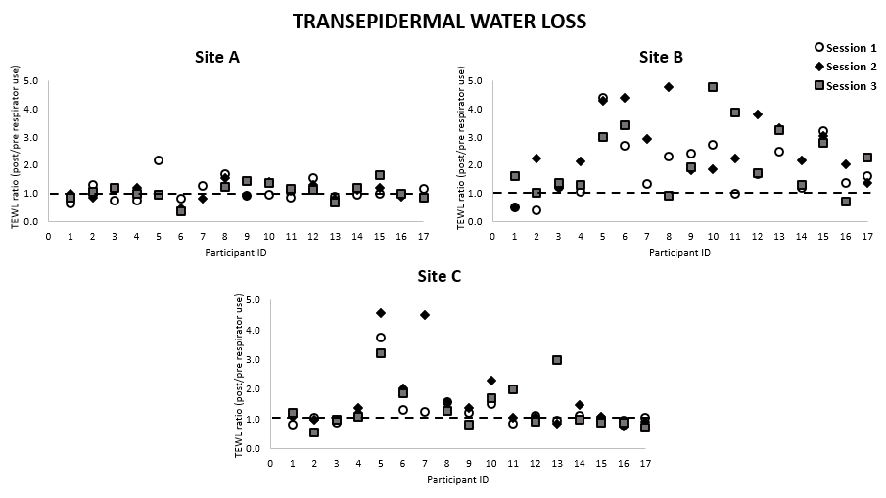
Figure 2. Ratio changes in TEWL values from pre- to post-respirator application for each participant on the three test sessions at sites A, B and C.

Table 2. Sensitivity analysis of the ratio changes in the three biophysical parameters at the three facial sites for each test session
PARAMETER | Threshold (ratio change) | Site A  % of participants according to threshold |  |  | Site B  % of participants according to the threshold |  |  | Site C  % of participants according to the threshold
 |  | Session  1 | Session  2 | Session  3 | Session  1 | Session  2 | Session  3 | Session  1 | Session  2 | Session  3
TEWL | < 1.0 | 41 | 41 | 25 | 12 | 6 | 12 | 18 | 18 | 37
 | ≥ 1.0 | 59 | 59 | 75 | 88 | 94 | 88 | 82 | 82 | 63
 | ≥ 1.5 | 18 | 6 | 13 | 53 | 82 | 63 | 18 | 35 | 31
 | ≥ 2.0 | 6 | 0 | 0 | 41 | 71 | 44 | 6 | 24 | 19
 | ≥ 2.5 | 0 | 0 | 0 | 29 | 41 | 38 | 6 | 12 | 13
 | ≥ 3.0 | 0 | 0 | 0 | 12 | 35 | 31 | 6 | 12 | 13
SC Hydration | < 1.0 | 12 | 24 | 25 | 35 | 24 | 19 | 18 | 18 | 31
 | ≥ 1.0 | 88 | 76 | 75 | 65 | 76 | 81 | 82 | 82 | 69
 | ≥ 1.5 | 6 | 12 | 6 | 35 | 47 | 25 | 12 | 18 | 19
 | ≥ 2.0 | 0 | 0 | 0 | 6 | 18 | 19 | 6 | 0 | 0
 | ≥ 2.5 | 0 | 0 | 0 | 6 | 6 | 6 | 0 | 0 | 0
 | ≥ 3.0 | 0 | 0 | 0 | 0 | 0 | 6 | 0 | 0 | 0
Erythema | < 1.0 | 18 | 24 | 12 | 35 | 47 | 37 | 12 | 0 | 12
 | ≥ 1.0 | 82 | 76 | 88 | 65 | 53 | 63 | 88 | 100 | 88
 | ≥ 1.5 | 0 | 0 | 0 | 24 | 0 | 6 | 6 | 0 | 0
 | ≥ 2.0 | 0 | 0 | 0 | 6 | 0 | 0 | 0 | 0 | 0
 | ≥ 2.5 | 0 | 0 | 0 | 0 | 0 | 0 | 0 | 0 | 0
 | ≥ 3.0 | 0 | 0 | 0 | 0 | 0 | 0 | 0 | 0 | 0

STRATUM CORNEUM HYDRATION
With respect to the SC hydration, a high degree of inter-participant variation was observed at sites A and C, with participants displaying absolute values, which ranged between 10.3 and 95.1 AUs across the test sessions. Some changes in SC hydration following respirator usage were observed for a sub-group of participants at site B (Table 2). As an example, participant #6 presented with elevated skin hydration values (2-fold change), which remained consistent throughout the test sessions. In addition, a sub-cohort of participants (#1, #5, #9, #10, #11, #15 and #17) demonstrated increased SC hydration at session 2, equivalent to ≥ 1.8 ratio change. Increase in skin hydration at session 3, was below 2-fold, except for one participant (#15) who demonstrated a 4-fold increase. Nonetheless, all the differences associated with anatomical sites and test sessions were not found to be statistically significant (p > 0.05 in all cases)

ERYTHEMA
There were few remarkable trends with relation to erythema, with participants demonstrating values, which ranged between 105.4 and 898.8 AUs at all sites across the test sessions. Indeed, for the vast majority of participants, erythema ratio changes were ≤1.5 at the anatomical sites for each of the test sessions (Table 2). The one exception involved participant #6, who presented with a 2- and 1.5 ratio increase at site B on sessions 1 and 3, respectively.

SKIN CYTOKINE RESPONSE
Changes in skin cytokine response were evaluated in the sebum sampled at the bridge of the nose (site B). Figure 3 reveals a considerable intra- and inter-inflammatory marker variability, with absolute cytokine concentrations for IL-1α and IL-1RA ranging from 10 to 347 pg/mL and 375 to 15591 pg/mL, respectively. The corresponding value for the low-abundance proteins, IL-8 and TNF-α, ranged from 0.2 to 63.3 pg/mL and 0.3 to 12.3 pg/mL, respectively. Close examination of the data highlighted that some individuals (#2, #10, #17) presented with higher ratio changes for each of the four cytokine biomarkers. By contrast, other participants (#1, #13, #15) exhibited no changes in the ratio values for any of the cytokines and the test sessions
Sensitivity analysis with respect to ratio change in biochemical markers are also summarised in Table 3. Differences were identified between specific biomarkers and the test sessions. For example, with IL-1α, IL-1RA and TNF-α, ratios were higher in test sessions 2 and 3 compared with test session 1. By contrast, there was little difference in the IL-8 response across the three sessions. In addition, a subset of participants demonstrated elevated biomarker responses i.e >1.5 ratio change, for some of the cytokines. For example, this threshold ratio change was exceeded during session 2 in 35%, 33% and 41% for IL-1α, IL-RA and TNF-α, respectively (Table 3).

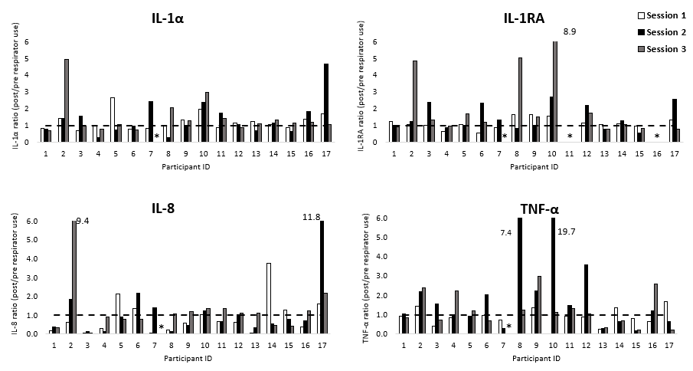
Figure 3: Ratio changes in four biomarkers for each participant at the nasal bridge site on the three test sessions (* indicates missing data).
Table 3. Sensitivity analysis of the ratio changes in four biomarkers at the three facial sites for each test session
Parameter | Threshold | Site B  % of participants according to the threshold
 |  | Session 1 | Session 2 | Session 3
IL-1α | < 1.0 | 41 | 47 | 31
 | ≥ 1.0 | 59 | 53 | 69
 | ≥ 1.5 | 18 | 35 | 19
 | ≥ 2.0 | 6 | 18 | 19
 | ≥ 2.5 | 6 | 6 | 13
 | ≥ 3.0 | 0 | 6 | 6
IL-1RA | < 1.0 | 33 | 40 | 36
 | ≥ 1.0 | 67 | 60 | 64
 | ≥ 1.5 | 20 | 33 | 43
 | ≥ 2.0 | 0 | 33 | 21
 | ≥ 2.5 | 0 | 13 | 21
 | ≥ 3.0 | 0 | 0 | 21
IL-8 | < 1.0 | 65 | 65 | 44
 | ≥ 1.0 | 35 | 35 | 56
 | ≥ 1.5 | 18 | 18 | 13
 | ≥ 2.0 | 12 | 12 | 13
 | ≥ 2.5 | 6 | 6 | 6
 | ≥ 3.0 | 6 | 6 | 6
TNF-α | < 1.0 | 76 | 41 | 44
 | ≥ 1.0 | 24 | 59 | 56
 | ≥ 1.5 | 6 | 41 | 25
 | ≥ 2.0 | 0 | 35 | 25
 | ≥ 2.5 | 0 | 18 | 13
 | ≥ 3.0 | 0 | 18 | 0

CORRELATIONAL ANALYSIS WITH RESPECT TO INTRINSIC AND EXTRINSIC FACTORS
The role of intrinsic factors (BMI) and extrinsic factors i.e., nature of daily respirator usage, on skin health was also investigated. TEWL at site B was selected as this represented the most sensitive skin parameter to be influenced by respirator application. The linear models revealed that there were positive correlations between BMI and TEWL ratios at the nasal bridge, as illustrated in Figure 4, which were statistically significant at sessions 1 (p<0.001) and 2 (p<0.05). Individual data also revealed that three participants (#5, #6, #15) in the obese BMI range (>30 kg/m²) presented with high TEWL values, with ratio increases ranging between 2.7 and 4.4, which were sustained throughout the three test sessions.
An equivalent analysis was performed with respect to daily hours and the number of breaks during respirator application (Figure 5). Data revealed considerable variability at each session, as exemplified by participants #6, #8, #10 across the three test sessions. Neither the working hours nor the number of breaks taken during shifts yielded a significant correlation with changes in TEWL (p>0.05). Indeed, some participants i.e. #2, #14 worked long shift periods (>10 hours) with limited breaks and demonstrated low TEWL ratio values. By contrast, other participants i.e. #9, #10, #13, who worked an 8 hour shift with a number of breaks demonstrated consistently higher TEWL ratio values.

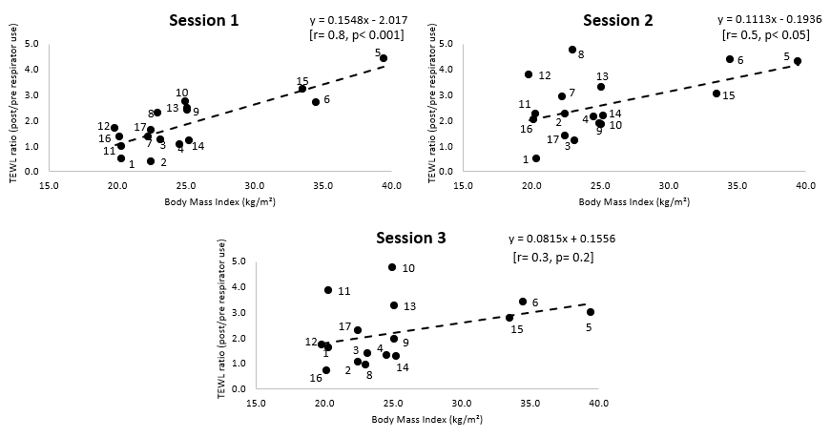
Figure 4. Correlations between BMI and TEWL ratio values at the nasal bridge site on the three test sessions. The data labels on the coloured dots indicate the participant ID.

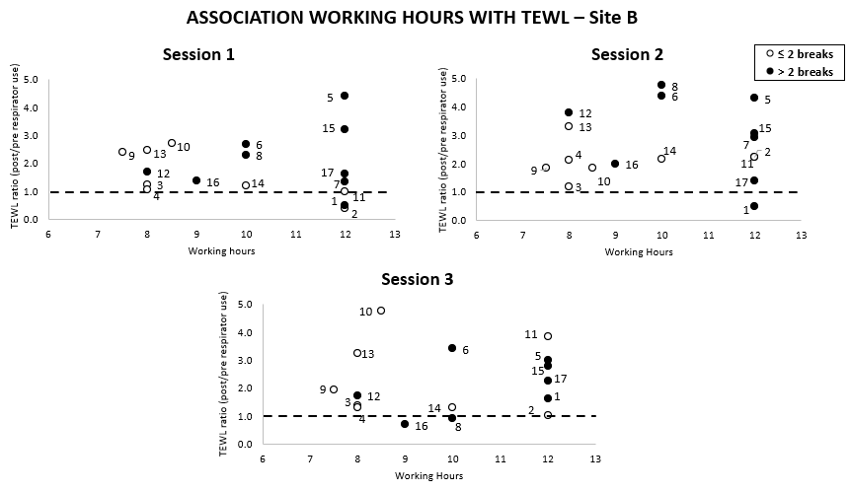
Figure 5. Correlations between the working hours and TEWL ratio values at the nasal bridge site on the three test sessions.
When correlating the integrated cytokine rank-sum with BMI (Figure 6A), the linear model was not found to be statistically significant (p>0.05). The analysis also confirmed a high degree of variability in the biomarker response with respect to the duration of the working hours and the number of breaks taken within a shift (Figure 6B), with no statistically significant trend (p>0.05).

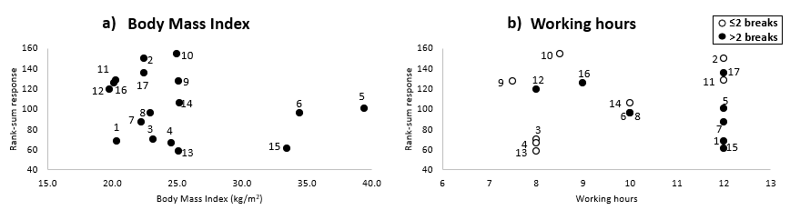
Figure 6. Relationship between a) BMI and b) Working hours on rank-sum response of the four biomarkers at the nasal bridge site on the three test sessions

DISCUSSION
One of the indirect consequences of the outbreak of coronavirus pandemic is the adverse skin reactions as a direct result of extensive use of personal protective equipment (PPE). Healthcare professionals are particularly affected, where the prolonged application has left them exposed to damaging mechanical and microclimate loads on the skin (Abiakam et al. 2021; Lan et al. 2020; Jiang et al. 2020). Although the nature and frequency of these adverse reactions have been extensively reported, there is little understanding of the effects of respiratory application on the integrity of skin sites of the face. In this context, the present study demonstrated how the integration of biophysical and biochemical markers could enable a comprehensive analysis of changes in local skin physiology and barrier function. Significant changes in skin parameters have been observed within this cohort of 17 HCWs, which were particularly pronounced following two consecutive days of respirator use.
The study used an array of parameters to monitor changes in skin health in a cohort of HCWs based atone UK acute care provider. These included TEWL, SC hydration, erythema and inflammatory biomarkers sampled non-invasively from the skin surface, during three consecutive sessions of respirator use. The consistency in TEWL and SC hydration values observed at the control site (A) for each test session provides confidence that the absolute changes at the sites in direct contact with the respirator (B and C) represented changes in skin barrier function. Indeed, the nasal bridge (site B) was most affected by the respirator application, as confirmed by the increased values in the biophysical parameters. For example, 35% of participants consistently demonstrated high TEWL values across the three test sessions (Table 2). These findings are consistent with previous studies, where a statistically increase in TEWL was reported at skin sites following 2 hours (Montero-Vilchez et al. 2021) and 8 hours (Han et al. 2021) of N95 respirator application. Indeed, due to the bony prominence and cartilaginous substrate, the nasal bridge has been regularly identified as a vulnerable site for skin damage (Worsley et al. 2016). Indeed, at this site, TEWL and SC hydration values were generally higher on the second consecutive day of mask application (session 2) with more than 70% of the participants presenting in excess of a two-fold change from basal values in TEWL post respirator usage (Table 2).
By contrast, the cheek (site C) presented fewer events (~12%) where the TEWL value was increased and revealed a few interesting trends in terms of SC hydration. This could be explained by the fact that the middle cheek and the nasolabial areas present with poor hydration compared to other facial sites (Voegeli et al. 2019). In addition, the cheek incorporates a higher proportion of soft tissues which can provide load-bearing capacity (Cyron et al. 2017). Although our findings contrast with a recent study which highlighted a significant SC hydration and TEWL increase at the cheek following the employment of respirators (Hua et al. 2020), these studies did not allocate breaks for respirator usage during their study design. This contrasts with the protocol adopted in the present study, where breaks were allowed (Table 1). The length of the breaks was different for each participant, ranging from 15 to minutes and they were part of established clinical work patterns, which were uncontrolled in the study. These breaks from respirator application could have restored the TEWL and skin hydration values toward basal (unloaded) levels, as well as influenced skin inflammatory biochemical processes.
It is of note that there were no remarkable differences observed in skin erythema, evaluated using the Mexameter device. This was surprising given that skin redness was visibly evident in the loaded sites of some participants and other studies have reported significant evidence of redness following respirator application (Han et al. 2021; Montero-Vilchez et al. 2021). This may be due to the lack of sensitivity in measurement system (Baquié et al. 2014; Kasraee 2017) and its dependence on skin pigmentation (Jayabal et al. 2021). The application of the Mexameter was also limited by the curved location of the nasal bridge, which could have introduced errors in the detection of erythema.
Biochemical marker analysis highlighted considerable variations between participants and across the test sessions (Figure 3). While some individuals expressed consistently higher responses in the candidate biomarkers in each of the test sessions, others showed minimal up-regulation following respirator usage. This suggests that individual sites of mechanical insult evoke a variable number of macrophages, which are responsible for the production of cytokines (Zhang et al. 2007). In addition, the up-regulation of IL-1 family of cytokines, namely IL-1α and IL-1RA, could be a direct result of their early synthesis and storage as precursor proteins which are released following inflammatory events. By contrast, IL-8 and TNF alpha are mainly associated with dendritic cells, and thus require the recruitment and the migration of these to the site exposed to external stimuli prior to being expressed (Feldmeyer et al. 2010). Accordingly, these cytokines are expressed in smaller concentrations. It is to be further noted that the interplay of pro- and anti-inflammatory markers is important in the process of skin inflammation (Jensen 2010). The present study indicated equivalent up-regulation in the pro-inflammatory (IL-1α) and the anti-inflammatory receptor antagonist (IL-RA) for sessions 1 and 2 (Table 3). In session 3, however, there is a higher proportion of participants who demonstrated an up-regulation in IL-RA. This might indicate that more time is required in order for this cytokine to migrate and be detectable at the skin surface. The biochemical parameters have highlighted the importance of cluster analysis, where sub-groups within a healthy cohort respond differently to given external stimuli, as has been demonstrated by previous studies from the host laboratory (Bostan et al. 2019; Jayabal et al. 2021).
The present study has examined any correlations between intrinsic and extrinsic factors and the ratio changes in TEWL and inflammatory cytokines. As an example, the ratio changes in TEWL were significantly associated with participants' BMI at the bridge of the nose (Figure 4). This association might be explained by the elevated perspiration generated within the occlusive micro-environment created by the devices, as a consequence of the combined effect of high body fat mass together with the adherence of HCWs to the demanding schedules in the COVID units. Indeed, exposure to elevated moisture at the skin interface can reduce the mechanical stiffness and strength of the stratum corneum thereby increasing its susceptibility to damage (Kottner et al. 2018). Changes in both the biophysical parameters and biochemical markers did not correlate to either the average daily working hours or the number of breaks taken by the participants during their clinical shifts (Figures 5 and 6). Indeed, the considerable variability in the responses across the cohort suggests that there are intrinsic factors coupled to other extrinsic factors which determine the skin tolerance to load-bearing. This contrast with findings from surveys, where HCWs subjectively reported skin reactions were associated with both the working shift time and the frequency of breaks (Abiakam et al. 2021). There were no associations between the changes in biophysical parameters and biomarkers following respirator application. This is perhaps not surprising given that each parameter was sensitive to different aspects of skin physiology and function. For example, while TEWL is used to assess the barrier properties of the skin which is a function of the SC integrity, the inflammatory biomarkers are derived from a complex biological response of dermal and epidermal cells and tissues to the mechanical and thermal insults associated with application of the respirator.
The study cohort was limited by the relatively small HCW cohort from a single UK acute care provider. In addition, most of the participants were female from white (Caucasian) ethnicity (Table 1). There were also only small variations with respect to the age and BMI of the participants. Furthermore, the data collection was conducted over the course of three sessions and except for the testing days, participants were allowed to use skin protective measures during their shifts. Although participants were required to avoid the application of moisturizers and/or creams, it is of note that the outputs of the parameters might be influenced by skin care behaviour on the days prior to the study assessments. In addition, due to practical reasons, data collection occurred over varying time periods (1-8 weeks), which might have impacted the nature of the skin response and in particular the inter-subject variability in the data. Lastly due to COVID-19 restrictions, which limited contact with the participants outside the work environment, it was not practicable to assess individual baseline during days off work.
Although it is essential to adopt RPE while working in COVID-19 high-risk units, strategies are required to protect skin health of heavily resourced healthcare workers. Indeed, what is initially seen as skin erythema and indentation marks could easily lead to skin breakdown, which could provide an access site to coronavirus, as well as other hospital-acquired infections. Regardless of the successful fit test (HSE 2021), HCWs still continue to report adverse skin reactions (Table 1) and discomfort while employing these devices. Therefore, healthcare organisations worldwide must acknowledge these issues and create policies to protect skin health. Collaboration with industry is required to develop new respirator designs to provide comfortable and effective respirator devices.

CONCLUSION
The current study used a multi-array approach to assess changes in the skin health of healthcare workers before and after the use of respiratory protective equipment in routine clinical shifts. Participants varied in their response, with the nasal bridge representing the anatomical site most affected by the devices. The study demonstrated that for a sub-group of healthcare workers, current respirators impair the barrier function of the skin and cause local inflammation which, if left untreated, could lead to changes in skin integrity. TEWL was the most sensitive parameter to change over the course of the longitudinal evaluation. Biochemical analysis showed an upregulation of IL-1α and the receptor antagonist, although considerable variability was observed, limiting comparisons between individual responses. Further studies are required to define relationships between mask designs, application periods and skin reactions.

ACKNOWLEDGEMENT
The authors wish to thank all the healthcare professionals who engaged with the study for their commitment even in these unprecedented times.
This work was supported by the European Union’s Horizon 2020 research and innovation programme under the Marie Skłodowska-Curie grant agreement No. 811965 (Project STINTS - Skin Tissue Integrity under Shear). The work is also covered within the EPSRC funded project BE-SAFE RPE (EP/V045563/1). Kay Mitchell is a National Institute for Health Research (NIHR) Senior Nurse and Midwife Research Leader. For the purpose of open access, the author has applied a CC BY public copyright licence to any Author Accepted Manuscript version arising from this submission.
CONFLICTS OF INTEREST
The authors have no conflicts of interest.

REFERENCES
Abiakam, N. S., Worsley, P. R., Jayabal, H., Mitchell, K., Jones, M., Fletcher, J., Spratt, F., and Bader, D. L. 2021. 'Personal protective equipment related skin reactions in healthcare professionals during COVID-19', International wound journal, 18: 312-22.
Bader, D. L., and Oomens, C. W. J. 2018. 'The Potential of Biomarkers in the Early Detection of Pressure Ulcers.' in.
Bader, D. L., Worsley, P. R., and Gefen, A. 2019. 'Bioengineering considerations in the prevention of medical device-related pressure ulcers', Clinical Biomechanics, 67: 70-77.
Bader, Dan L., and Worsley, Peter R. 2018. 'Technologies to monitor the health of loaded skin tissues', BioMedical Engineering OnLine, 17: 40.
Baquié, M., and Kasraee, B. 2014. 'Discrimination between cutaneous pigmentation and erythema: Comparison of the skin colorimeters Dermacatch and Mexameter', Skin Research and Technology, 20: 218-27.
Bostan, L. E., Worsley, P. R., Abbas, S., and Bader, D. L. 2019. 'The influence of incontinence pads moisture at the loaded skin interface', Journal of Tissue Viability, 28: 125-32.
Cyron, C. J., and Humphrey, J. D. 2017. 'Growth and Remodeling of Load-Bearing Biological Soft Tissues', Meccanica, 52: 645-64.
De Jongh, C. M., Verberk, M. M., Withagen, C. E. T., Jacobs, J. J. L., Rustemeyer, T., and Kezic, S. 2006. 'Stratum corneum cytokines and skin irritation response to sodium lauryl sulfate', Contact Dermatitis, 54: 325-33.
de Wert, L. A., Geerts, M., van der Brug, S., Adriaansen, L., Poeze, M., Schaper, N., and Bouvy, N. D. 2019. 'The Effect of Shear Force on Skin Viability in Patients with Type 2 Diabetes', Journal of Diabetes Research, 2019: 1973704.
du Plessis, J., Stefaniak, A., Eloff, F., John, S., Agner, T., Chou, T-C., Nixon, R., et al. 2013. 'International guidelines for the in vivo assessment of skin properties in non-clinical settings: Part 2. transepidermal water loss and skin hydration', Skin Research and Technology, 19: 265-78.
Feldmeyer, L., Werner, S., French, L. E., and Beer, H. D. 2010. 'Interleukin-1, inflammasomes and the skin', Eur J Cell Biol, 89: 638-44.
Han, H. S., Shin, S. H., Park, J. W., Li, K., Kim, B. J., and Yoo, K. H. 2021. 'Changes in skin characteristics after using respiratory protective equipment (medical masks and respirators) in the COVID-19 pandemic among healthcare workers', Contact Dermatitis, n/a: 1-8.
Hemmes, B., de Wert, L. A., Brink, P. R. G., Oomens, C. W. J., Bader, D. L., and Poeze, M. 2017. 'Cytokine IL1α and lactate as markers for tissue damage in spineboard immobilisation. A prospective, randomised open-label crossover trial', Journal of the Mechanical Behavior of Biomedical Materials, 75: 82-88.
Henshaw, F. R., Bostan, L. E., Worsley, P. R., and Bader, D. L. 2020. 'Evaluating the effects of sedentary behaviour on plantar skin health in people with diabetes', Journal of Tissue Viability, 29: 277-83.
HSE. 2021. 'Fit2Fit'.
Hua, W., Zuo, Y., Wan, R., Xiong, L., Tang, J., Zou, L., Shu, X., and Li, L. 2020. 'Short-term skin reactions following use of N95 respirators and medical masks', Contact Dermatitis, 83: 115-21.
Jayabal, H., Bates-Jensen, B. M., Abiakam, N. S., Worsley, P. R., and Bader, D. L. 2021. 'The identification of biophysical parameters which reflect skin status following mechanical and chemical insults', Clinical Physiology and Functional Imaging, 41: 366-75.
Jensen, L. E. 2010. 'Targeting the IL-1 family members in skin inflammation', Current opinion in investigational drugs (London, England : 2000), 11: 1211-20.
Jiang, Q. , Song, S. P. , Zhou, J. , Liu, Y. , Chen, A. , Bai, Y., Wang, J., et al. 2020. 'The Prevalence, Characteristics, and Prevention Status of Skin Injury Caused by Personal Protective Equipment Among Medical Staff in Fighting COVID-19: A Multicenter, Cross-Sectional Study', Advances in wound care, 9: 357-64.
Kasraee, Behrooz. 2017. 'The Measurement of Skin Color.' in Philippe Humbert, Ferial Fanian, Howard I. Maibach and Pierre Agache (eds.), Agache's Measuring the Skin: Non-invasive Investigations, Physiology, Normal Constants (Springer International Publishing: Cham).
Kottner, J., Black, J. M., Call, E., Gefen, A., and Santamaria, N. 2018. 'Microclimate: a critical review in the context of pressure ulcer prevention', Clinical Biomechanics, 59: 62-70.
Lan, J., Song, Z., Miao, X., Li, H., Li, Y., Dong, L., Yang, J., An, X., Zhang, Y., and Yang, L. 2020. 'Skin damage among health care workers managing coronavirus disease-2019', Journal of the American Academy of Dermatology, 82: 1215-16.
Lei, Z., Yang, J., and Zhuang, Z. 2012. 'Headform and N95 Filtering Facepiece Respirator Interaction: Contact Pressure Simulation and Validation', Journal of Occupational and Environmental Hygiene, 9: 46-58.
Montero-Vilchez, T., Martinez-Lopez, A., Cuenca-Barrales, C., Rodriguez-Tejero, A., Molina-Leyva, A., and Arias-Santiago, S. 2021. 'Impact of Gloves and Mask Use on Epidermal Barrier Function in Health Care Workers', Dermatitis, 32: 57-62.
Park, S. R., Han, J., Yeon, Y. M., Kang, N. Y., and Kim, E. 2021. 'Effect of face mask on skin characteristics changes during the COVID-19 pandemic', Skin research and technology : official journal of International Society for Bioengineering and the Skin (ISBS) [and] International Society for Digital Imaging of Skin (ISDIS) [and] International Society for Skin Imaging (ISSI), 27: 554-59.
Peko, L., Ovadia-Blechman, Z., Hoffer, O., and Gefen, A. 2021. 'Physiological measurements of facial skin response under personal protective equipment', Journal of the Mechanical Behavior of Biomedical Materials, 120: 104566.
Perkins, M. A., Osterhues, M. A., Farage, M. A., and Robinson, M. K. 2001. 'A noninvasive method to assess skin irritation and compromised skin conditions using simple tape adsorption of molecular markers of inflammation', Skin Research and Technology, 7: 227-37.
Soetens, J. F. J., Worsley, P. R., Bader, D. L., and Oomens, C. W. J. 2019. 'Investigating the influence of intermittent and continuous mechanical loading on skin through non-invasive sampling of IL-1α', Journal of Tissue Viability, 28: 1-6.
Voegeli, R., Gierschendorf, J., Summers, B., and Rawlings, A. V. 2019. 'Facial skin mapping: from single point bio‐instrumental evaluation to continuous visualization of skin hydration, barrier function, skin surface pH, and sebum in different ethnic skin types', International journal of cosmetic science, 41: 411-24.
Worsley, P. R., Prudden, G., Gower, G., and Bader, D. L. 2016. 'Investigating the effects of strap tension during non-invasive ventilation mask application: a combined biomechanical and biomarker approach', Medical devices (Auckland, N.Z.), 9: 409-17.
Zhang, J. M., and An, J. 2007. 'Cytokines, inflammation, and pain', International anesthesiology clinics, 45: 27-37.

