Insights into accuracy of social scientists' forecasts of societal change
Authors: Igor Grossmann^{1*}, Amanda Rotella^{2,1}, Cendri A. Hutcherson³, Konstantyn Sharpinskyi¹, Michael E. W. Varnum⁴, Sebastian Achter⁵, Mandeep K. Dhami⁶, Xinqi Evie Guo⁷, Mane Kara-Yakoubian⁸, David R. Mandel^{9,10}, Louis Raes¹¹, Louis Tay¹², Aymeric Vie^{13,14}, Lisa Wagner¹⁵, Matus Adamkovic^{16,17}, Arash Arami¹⁸, Patrícia Arriaga¹⁹, Kasun Bandara²⁰, Gabriel Baník¹⁶, František Bartoš²¹, Ernest Baskin²², Christoph Bergmeir²³, Michał Białek²⁴, Caroline K. Børsting²⁵, Dillon T. Browne¹, Eugene M. Caruso²⁶, Rong Chen²⁷, Bin-Tzong Chie²⁸, William J. Chopik²⁹, Robert N. Collins⁹, Chin W. Cong³⁰, Lucian G. Conway³¹, Matthew Davis³², Martin V. Day³³, Nathan A. Dhaliwal³⁴, Justin D. Durham³⁵, Martyna Dziekan³⁶, Christian T. Elbaek²⁵, Eric Shuman³⁷, Marharyta Fabrykant^{38,39}, Mustafa Firat⁴⁰, Geoffrey T. Fong^{1,41}, Jeremy A. Frimer⁴², Jonathan M. Gallegos⁴³, Simon B. Goldberg⁴⁴, Anton Gollwitzer^{45,46}, Julia Goyal⁴⁷, Lorenz Graf-Vlachy^{48,49}, Scott D. Gronlund³⁵, Sebastian Hafenbrädl⁵⁰, Andree Hartanto⁵¹, Matthew J. Hirshberg⁵², Matthew J. Hornsey⁵³, Piers D. L. Howe⁵⁴, Anoosha Izadi⁵⁵, Bastian Jaeger⁵⁶, Pavol Kačmár⁵⁷, Yeun Joon Kim⁵⁸, Ruslan Krenzler^{59,60}, Daniel G. Lannin⁶¹, Hung-Wen Lin⁶², Nigel Mantou Lou^{63,64}, Verity Y. Q. Lua⁵¹, Aaron W. Lukaszewski^{65,66}, Albert L. Ly⁶⁷, Christopher R. Madan⁶⁸, Maximilian Maier⁶⁹, Nadyanna M. Majeed⁷⁰, David S. March⁷¹, Abigail A. Marsh⁷², Michal Misiak^{24,73}, Kristian Ove R. Myrseth⁷⁴, Jaime M. Napan⁶⁷, Jonathan Nicholas⁷⁵, Konstantinos Nikolopoulos⁷⁶, Jiaqing O⁷⁷, Tobias Otterbring^{78,79}, Mariola Paruzel-Czachura^{80,81}, Shiva Pauer²¹, John Protzko⁸², Quentin Raffaelli⁸³, Ivan Ropovik^{84,85}, Robert M. Ross⁸⁶, Yefim Roth⁸⁷, Espen Røysamb⁸⁸, Landon Schnabel⁸⁹, Astrid Schütz⁹⁰, Matthias Seifert⁹¹, A. Timur Sevincer⁹², Garrick T. Sherman⁹³, Otto Simonsson^{94,95}, Ming-Chien Sung⁹⁶, Chung-Ching Tai⁹⁶, Thomas Talhelm⁹⁷, Bethany A. Teachman⁹⁸, Philip E. Tetlock^{99,100}, Dimitrios Thomakos¹⁰¹, Dwight C. K. Tse¹⁰², Oliver J. Twardus¹⁰³, Joshua M. Tybur⁵⁶, Lyle Ungar⁹³, Daan Vandermeulen¹⁰⁴, Leighton Vaughan Williams¹⁰⁵, Hrag A. Vosgerichian¹⁰⁶, Qi Wang¹⁰⁷, Ke Wang¹⁰⁸, Mark E. Whiting^{109,110}, Conny E. Wollbrant¹¹¹, Tao Yang¹¹², Kumar Yogeeswaran¹¹³, Sangsuk Yoon¹¹⁴, Ventura r. Alves¹¹⁵, Jessica R. Andrews-Hanna^{83,116}, Paul A. Bloom⁷⁵, Anthony Boyles¹¹⁷, Loo Charis¹¹⁸, Mingyeong Choi¹¹⁹, Sean Darling-Hammond¹²⁰, Zoe E. Ferguson¹²¹, Cheryl R. Kaiser⁴³, Simon T. Karg¹²², Alberto López Ortega¹²³, Lori Mahoney¹²⁴, Melvin S. Marsh¹²⁵, Marcellin F. R. C. Martinie⁵⁴, Eli K. Michaels¹²⁶, Philip Millroth¹²⁷, Jeanean B. Naqvi¹²⁸, Weiting Ng¹²⁹, Robb B. Rutledge¹³⁰, Peter Slattery¹³¹, Adam H. Smiley⁴³, Oliver Strijbis¹³², Daniel Sznycer¹³³, Eli Tsukayama¹³⁴, Austin van Loon¹³⁵, Jan G. Voelkel¹³⁵, Margaux N. A. Wienk⁷⁵, Tom Wilkening¹³⁶, & The Forecasting Collaborative¹

in press

Nature Human Behaviour
Affiliations:
¹Department of Psychology, University of Waterloo; Waterloo, Canada.
²Department of Psychology, Northumbria University, UK.
³Department of Psychology, University of Toronto Scarborough; Toronto, Canada.
⁴Department of Psychology, Arizona State University, Tempe, USA.
⁵Institute of Management Accounting and Simulation, Hamburg University of Technology; Hamburg, Germany.
⁶Department of Psychology, Middlesex University London; London, UK.
⁷Department of Experimental Psychology, University of California San Diego; San Diego, USA.
⁸Department of Psychology, Toronto Metropolitan University; Toronto, Canada.
⁹Defence Research and Development Canada; Ottawa, Canada.
¹⁰Department of Psychology, York University; Toronto, Canada.
¹¹Department of Economics, Tilburg University, Tilburg, Netherlands.
¹²Department of Psychological Sciences, Purdue University; West Lafayette, USA.
¹³Mathematical Institute, University of Oxford; Oxford, UK.
¹⁴Institute of New Economic Thinking, University of Oxford, Oxford, UK.
¹⁵Jacobs Center for Productive Youth Development, University of Zurich; Zurich, Switzerland.
¹⁶Institute of Psychology, University of Prešov; Prešov, Slovakia.
¹⁷Institute of Social Sciences, CSPS, Slovak Academy of Sciences; Bratislava, Slovakia.
¹⁸Department of Mechanical and Mechatronics Engineering, University of Waterloo; Waterloo, Canada.
¹⁹Iscte-University Institute of Lisbon, CIS; Lisbon, Portugal.
²⁰Melbourne Centre for Data Science, University of Melbourne; Melbourne, Australia.
²¹Faculty of Social and Behavioural Sciences, University of Amsterdam; Amsterdam, Netherlands.
²²Department of Food Marketing, Haub School of Business, Saint Joseph's University; Philadelphia, USA.
²³Department of Data Science and Artificial Intelligence, Monash University; Melbourne, Australia.
²⁴Institute of Psychology, University of Wrocław; Wrocław, Poland.
²⁵Department of Management, Aarhus University; Aarhus, Denmark.
²⁶Anderson School of Management, UCLA; Los Angeles, USA.
²⁷Department of Psychological and Brain Sciences, Colgate University; Hamilton, USA.
²⁸Department of Industrial Economics, Tamkang University; New Taipei City, Taiwan.
²⁹Department of Psychology, Michigan State University; East Lansing, USA.
³⁰Department of Psychology and Counselling, Universiti Tunku Abdul Rahman; Kampar, Malaysia.
³¹Department of Psychology, University of Montana; Missoula, USA.
³²Department of Economics, Siena College; Loudonville, USA.
³³Department of Psychology, Memorial University of Newfoundland; St. John's, Canada.
³⁴UBC Sauder School of Business, University of British Columbia; Vancouver, Canada.
³⁵Department of Psychology, University of Oklahoma; Norman, USA.
³⁶Faculty of Psychology and Cognitive Science, Adam Mickiewicz University; Poznań, Poland.
³⁷Department of Psychology, University of Groningen; Groningen, Netherlands.
³⁸Laboratory for Comparative Studies in Mass Consciousness, Expert Institute, HSE University; Moscow, Russia.
³⁹Faculty of Philosophy and Social Sciences, Belarusian State University; Minsk, Belarus.
⁴⁰Department of Sociology, Radboud University; Nijmegen, Netherlands.
⁴¹Ontario Institute for Cancer Research; Toronto, Canada.
⁴²Department of Psychology, University of Winnipeg; Winnipeg, Canada.
⁴³Department of Psychology, University of Washington; Seattle, USA.
⁴⁴Department of Counseling Psychology, University of Wisconsin - Madison; Madison, USA.
⁴⁵Department of Leadership and Organizational Behaviour, BI Norwegian Business School; Oslo, Norway.
⁴⁶Center for Adaptive Rationality, Max Planck Institute for Human Development; Berlin, Germany.
⁴⁷School of Public Health Sciences, University of Waterloo; Waterloo, Canada.
⁴⁸TU Dortmund University; Dortmund, Germany.
⁴⁹ESCP Business School; Berlin, Germany.
⁵⁰IESE Business School; Barcelona, Spain.
⁵¹School of Social Sciences, Singapore Management University; Singapore.
⁵²Center for Healthy Minds, University of Wisconsin-Madison; Madison, USA.
⁵³University of Queensland Business School; Brisbane, Australia.
⁵⁴Melbourne School of Psychological Sciences, University of Melbourne; Melbourne, Australia.
⁵⁵Department of Marketing, University of Massachusetts Dartmouth; Dartmouth, USA.
⁵⁶Faculty of Behavioural and Movement Sciences, Vrije Universiteit Amsterdam; Amsterdam, Netherlands.
⁵⁷Department of Psychology, Faculty of Arts, Pavol Jozef Šafárik University; Košice, Slovakia.
⁵⁸Cambridge Judge Business School, University of Cambridge; Cambridge, UK.
⁵⁹Hermes Germany GmbH; Hamburg, Germany.
⁶⁰University of Hamburg; Hamburg, Germany.
⁶¹Department of Psychology, Illinois State University; Normal, USA.
⁶²Department of Marketing and Logistics Management, National Penghu University of Science and Technology; Magong City, Taiwan.
⁶³Department of Psychology, University of Victoria; Victoria, Canada.
⁶⁴Centre for Youth and Society, University of Victoria; Victoria, Canada.
⁶⁵Department of Psychology, California State University - Fullerton; Fullerton, USA.
⁶⁶Center for the Study of Human Nature, California State University - Fullerton; Fullerton, USA.
⁶⁷Department of Psychology, Loma Linda University; Loma Linda, USA.
⁶⁸University of Nottingham; Nottingham, UK.
⁶⁹Department of Experimental Psychology, University College London; London, UK.
⁷⁰Singapore Management University; Singapore.
⁷¹Department of Psychology, Florida State University; Tallahassee, USA.
⁷²Department of Psychology, Georgetown University; Washington DC, USA.
⁷³School of Anthropology & Museum Ethnography, University of Oxford; Oxford, UK.
⁷⁴School for Business and Society, University of York; York, UK.
⁷⁵Department of Psychology, Columbia University; New York City, USA.
⁷⁶IHRR Forecasting Laboratory, Durham University; Durham, UK.
⁷⁷Department of Psychology, Aberystwyth University; Aberystwyth, UK.
⁷⁸School of Business and Law, Department of Management, University of Agder; Kristiansand, Norway.
⁷⁹Institute of Retail Economics; Stockholm, Sweden.
⁸⁰University of Silesia; Katowice, Poland.
⁸¹Computense University; Madrid, Spain.
⁸²Central Connecticut State University; New Britain, USA.
⁸³Department of Psychology, University of Arizona; Tucson, USA.
⁸⁴Faculty of Education, Institute for Research and Development of Education, Charles University; Prague, Czech Republic.
⁸⁵Faculty of Education; University of Prešov; Prešov, Slovakia.
⁸⁶School of Psychology, Macquarie University; Sydney, Australia.
⁸⁷Department of Human Service, University of Haifa; Haifa, Israel, ⁸⁸Promenta Center, Department of Psychology, University of Oslo; Oslo, Norway.
⁸⁹Department of Sociology, Cornell University; Ithaca, USA.
⁹⁰Institute of Psychology, University of Bamberg; Bamberg, Germany.
⁹¹IE Business School, IE University; Madrid, Spain.
⁹²Faculty of Psychology and Human Movement Science, University of Hamburg; Hamburg, Germany.
⁹³Department of Computer and Information Science, University of Pennsylvania; Philadelphia, USA.
⁹⁴Department of Clinical Neuroscience, Karolinska Institutet; Solna, Sweden.
⁹⁵Department of Sociology, University of Oxford; Oxford, UK.
⁹⁶Department of Decision Analytics and Risk, University of Southampton; Southampton, UK.
⁹⁷University of Chicago Booth School of Business; Chicago, USA.
⁹⁸Department of Psychology, University of Virginia; Charlottesville, USA.
⁹⁹Psychology Department, University of Pennsylvania; Philadelphia, USA.
¹⁰⁰Wharton School of Business, University of Pennsylvania; Philadelphia, USA.
¹⁰¹Department of Economics, National and Kapodistrian University of Athens; Athens, Greece.
¹⁰²School of Psychological Sciences and Health, University of Strathclyde; Glasgow, UK.
¹⁰³Department of Psychology, University of Guelph; Guelph, Canada.
¹⁰⁴Psychology Department, Hebrew University of Jerusalem; Jerusalem, Israel.
¹⁰⁵Department of Economics, Nottingham Trent University; Nottingham, UK.
¹⁰⁶Department of Management and Organizations, Northwestern University; Evanston, USA.
¹⁰⁷College of Human Ecology, Cornell University, Ithaca, USA.
¹⁰⁸Harvard Kennedy School, Harvard University; Cambridge, USA.
¹⁰⁹Computer and Information Science, University of Pennsylvania; Philadelphia, USA.
¹¹⁰Operations, Information, and Decisions Department, The Wharton School, University of Pennsylvania; Philadelphia, USA.
¹¹¹School of Economics and Finance, University of St. Andrews; St. Andrews, UK.
¹¹²Department of Management, Cameron School of Business, University of North Carolina; Wilmington, USA.
¹¹³School of Psychology, Speech and Hearing, University of Canterbury; Christchurch, New Zealand, ¹¹⁴Deparment of Marketing, University of Dayton; Dayton, USA.
¹¹⁵ISG Universidade Lusofona; Lisbon, Portugal.
¹¹⁶Cognitive Science, University of Arizona; Tucson, USA.
¹¹⁷Ephemer AI; Atlanta, USA.
¹¹⁸Questrom School of Business, Boston University; Boston, USA.
¹¹⁹Institute of Social Science Research, Pusan National University; Busan, South Korea, ¹²⁰Fielding School of Public Health, UCLA; Los Angeles, USA.
¹²¹Psychology Department, University of Washington; Seattle, USA.
¹²²Department of Political Science, Aarhus University; Aarhus, USA.
¹²³Faculty of Social Sciences, Vrije Universiteit Amsterdam; Amsterdam, Netherlands.
¹²⁴College of Science and Mathematics, Wright State University; Fairborn, USA.
¹²⁵Department of Psychology, Georgia Southern University; Statesboro, USA.
¹²⁶Division of Epidemiology, School of Public Health, University of California, Berkeley; Berkeley, USA.
¹²⁷Department of Psychology, Uppsala University; Uppsala, Sweden.
¹²⁸Department of Psychology, Carnegie Mellon University; Pittsburgh, USA.
¹²⁹School of Humanities & Behavioral Sciences, Singapore University of Social Sciences; Singapore.
¹³⁰Department of Psychology, Yale University; New Haven, USA.
¹³¹BehaviourWorks Australia. Monash University; Melbourne, Australia.
¹³²Institute of Political Science, University of Zurich; Zurich, Switzerland.
¹³³Department of Psychology, Oklahoma State University; Stillwater, USA.
¹³⁴Department of Business Administration, University of Hawaii - West Oahu; Kapolei, USA.
¹³⁵Department of Sociology, Stanford University; Stanford, USA.
¹³⁶Department of Economics, University of Melbourne; Melbourne, Australia.
*Corresponding author. Email: igrossma@uwaterloo.ca

Abstract
How well can social scientists predict societal change, and what processes underlie their predictions? To answer these questions, we ran two forecasting tournaments testing accuracy of predictions of societal change in domains commonly studied in the social sciences: ideological preferences, political polarization, life satisfaction, sentiment on social media, and gender-career and racial bias. Following provision of historical trend data on the domain, social scientists submitted pre-registered monthly forecasts for a year (Tournament 1; N=86 teams/359 forecasts), with an opportunity to update forecasts based on new data six months later (Tournament 2; N=120 teams/546 forecasts). Benchmarking forecasting accuracy revealed that social scientists’ forecasts were on average no more accurate than simple statistical models (historical means, random walk, or linear regressions) or the aggregate forecasts of a sample from the general public (N=802). However, scientists were more accurate if they had scientific expertise in a prediction domain, were interdisciplinary, used simpler models, and based predictions on prior data.

Keywords: forecasting; expert judgment; well-being; political polarization; prejudice; metascience

Main Text: Can social scientists predict societal change? Governments and the general public often rely on experts, based on a general belief that they make better judgments and predictions of the future in their domain of expertise. The media also seek out experts to render their judgments and opinions about what to expect in the future ^{1,2}. Yet research on predictions in many domains suggests that experts may not be better than purely stochastic models in predicting the future. For example, portfolio managers (who are paid for their expertise) do not outperform the stock market in their predictions ³. Similarly, in the domain of geopolitics, experts often perform at chance levels when forecasting occurrences of specific political events ⁴. Based on these insights, one might expect that experts would find it difficult to accurately predict societal change.
At the same time, social science researchers have developed rich, empirically-grounded models to explain social science phenomena. Examining sampled data, social scientists strive to develop theoretical models about causal mechanisms that, in ideal cases, reliably describe human behavior and societal processes ⁵. Therefore, it is possible that explanatory models afford social science experts an advantage in predicting social phenomena in their domain of expertise. Here, we test these possibilities, examining the overall predictability of trends in social phenomena such as political polarization, racial bias, or well-being, and whether experts in social science are better able to predict those trends compared to non-experts.
Prior forecasting initiatives have not fully addressed this question for two reasons. First, forecasting initiatives with subject matter experts have focused on examining the probability of occurrence for specific one-time events ^{4,6} rather than the accuracy of ex-ante predictions of societal change over multiple units of time. In a sense, predicting events in the future (ex-ante) is the same as predicting events that have already happened, as long as the experts (research participants) don’t know the outcome. Yet, there are reasons to think that future prediction is different in an important way. Consider stock prices: participants could predict stock returns for stocks in the past, except that they know many other things that have happened (conflicts, bubbles, Black Swans, economic trends, consumption trends, etc.). Post-hoc, those making those making predictions have access to the temporal variance/occurrence for each of these variables and hence are more likely to be successful in ex post predictions. Thus, predictions about past events end up being more about testing people's explanations, rather than their predictions per se. Moreover, all other things being equal, the likelihood of a prediction regarding a one-off event being accurate is by default higher than that of a prediction regarding societal change across an extended time period. Binary predictions for the one-off event do not require accuracy in estimating degree of change or the shape of the predicted time series, which are extra challenges in forecasting societal change.
Second, past research on forecasting has concentrated on predicting geopolitical ⁴ or economic events ⁷ rather than broader societal phenomena. Thus, in contrast to systematic studies concerning the replicability of in-sample explanations of social science phenomena ⁸, out-of-sample prediction accuracy in the social sciences remains understudied ^{9,10}. Similarly, little is known about the rationales and approaches social scientists use to make predictions for societal trends. For example, are social scientists more apt to rely on data-driven statistical methods or theory and intuitions when generating such predictions?
To address these unknowns, we performed a standardized evaluation of forecasting accuracy ⁹ among social scientists in well-studied domains for which systematic, cross-temporal data is available, namely subjective well-being, racial bias, ideological preferences, political polarization, and gender-career bias. With the onset of the COVID-19 pandemic as a backdrop, we selected these domains based on data availability and theoretical links to the pandemic. Prior research has suggested that each of these domains may be impacted by infectious disease ^{11–14} or pandemic-related social isolation ¹⁵. To understand how scientists made predictions in these domains, we documented the rationales and processes they used to generate forecasts, then examined how different methodological choices were related to accuracy.
Research Overview
We present results from two forecasting tournaments conducted through the Forecasting Collaborative—a crowdsourced initiative among scientists interested in ex-ante testing of their theoretical or data-driven models. Examining performance across two tournaments allowed us to test the stability of forecasting accuracy in the context of unfolding societal events, and to investigate how social scientists recalibrate their models and incorporate new data when asked to update their forecasts.
The Forecasting Collaborative was open to behavioral, social, and data scientists from any field who wanted to participate in the tournament and were willing to provide forecasts over 12 months (May 2020 – April 2021) as part of the initial tournament and, upon receiving feedback on initial performance, again after 6 months for a follow-up tournament (recruitment details in Methods and demographic information in supplementary Table S1). To ensure a “common task framework” ^{9,16,17}, we provided all participating teams with the same time series data for the US for each of the 12 variables related to the phenomena of interest (i.e., life satisfaction, positive affect, negative affect, support for Democrats, support for Republicans, political polarization, explicit and implicit attitudes towards Asian Americans, explicit and implicit attitudes towards African Americans, and explicit and implicit associations between gender and specific careers.
Participating teams received historical data that spanned 39 months (January 2017 to March 2020) for Tournament 1 and data that spanned 45 months for Tournament 2 (January 2017 to September 2020), which they could use to inform their forecasts for the future values of the same time series. Teams could select up to 12 domains to forecast, including domains for which team members reported a track record of peer-reviewed publications as well as domains for which they did not possess relevant expertise (see Methods for multi-stage operationalization of expertise). By including social scientists with expertise in different subject matters, we could examine how such expertise may contribute to forecasting accuracy above and beyond general training in the social sciences. Teams were not constrained in terms of the methods used to generate time-point forecasts. They provided open-ended, free-text responses for the descriptions of the methods used, which were coded later. If they made use of data-driven methods, they also provided the model and any additional data used to generate their forecasts (see Methods). We also collected data on team size and composition, area of research specialization, subject domain and forecasting expertise, and prediction confidence.
We benchmarked forecasting accuracy against several alternatives. First, we evaluated whether social scientists’ forecasts in Tournament 1 were better than the wisdom of the crowd (i.e., the average forecasts of a sample of lay participants recruited from Prolific). Second, we compared social scientists’ performance in both tournaments to naïve random extrapolation algorithms (i.e., the average of historical data, random walks, and estimates based on linear trends). Finally, we systematically evaluated the accuracy of different forecasting strategies used by the social scientists in our tournaments, as well as the effect of expertise.

Results
Following the a priori outlined analytic plan (osf.io/7ekfm; details in the Supplementary Methods) to determine forecasting accuracy across domains, we examined the mean absolute scaled error (MASE) ¹⁸ across forecasted time-points for each domain. MASE is an asymptotically normal, scale-independent scoring rule that compares predicted values against predictions of a one-step random walk. Because it is scale-independent, it is an adequate measure when comparing accuracy across domains on different scales. A MASE of 1 reflects a forecast that is as good out-of-sample as the naive one-step random walk forecast is in-sample. A MASE below 1.76 is superior to median performance in prior large-scale data science competitions ⁷. See Supplementary Materials for further details of the MASE method.
In addition to absolute accuracy, we also assessed the comparative accuracy of social scientists’ forecasts using several benchmarks. First, during the period of the first tournament, we obtained forecasts from a non-expert crowdsourced sample of US residents (N = 802) via Prolific ¹⁹ who received the same data as tournament participants and filled out an identically structured survey to provide a wisdom-of-the-(lay)-crowd benchmark. Second, for both tournaments we simulated three different data-based naïve approaches to out-of-sample forecasting using the time series data provided to participants in the tournament, including, 1) the historical mean, calculated by randomly resampling the historical time series data; 2) a naïve random walk, calculated by randomly resampling historical change in the time series data with an autoregressive component; 3) extrapolation from linear regression, based on a randomly selected interval of historical time series data (see Supplementary Information for details). This latter approach captures the expected range of predictions that would have resulted from random, uninformed use of historical data to make out-of-sample predictions (as opposed to the naïve in-sample predictions that form the basis of MASE scores).
How accurate were behavioral and social scientists at forecasting?
Fig. 1 shows that in Tournament 1, social scientists’ forecasts were, on average, inferior to in-sample random walks in nine domains. In seven domains, social scientists’ forecasts were inferior to median performance in prior forecasting competitions (Fig. S1 shows raw estimates; Fig. S2 reports measures of uncertainty around estimates). In Tournament 2, forecasts were on average inferior to in-sample random walks in eight domains and inferior to median performance in prior forecasting competitions in five domains. Even winning teams were still less accurate than in-sample random walks for 8 of 12 domains in Tournament 1, and one domain (Republican support) in Tournament 2 (Tables S1-S2 and Figs. S4-S9). One should note that inferior performance to the in-sample random walk (MASE > 1) may not be too surprising; errors of the in-sample random walk in the denominator concern historical observations that occurred before the pandemic, whereas accuracy of scientific forecasts in the numerator is compared concerns the data for the first pandemic year. However, average forecasting accuracy did not generally beat more liberal benchmarks such as the median MASE in data science tournaments (1.76) ⁷ or the benchmark MASE for "good" forecasts in the tourism industry (see Supplement). Except for one team, top forecasters from Tournament 1 did not appear among the winners of Tournament 2 (Tables S1-S2).
We examined the accuracy of scientific and lay forecasts in a linear mixed effect model. To systematically compare results for different forecasted domains, we tested a full model with expertise (social scientist versus lay crowd), domain, and their interaction as predictors, and log(MASE) scores nested in participants. We observed no significant main effect difference between accuracy of social scientists and lay crowds, F(11, 1747) = 0.88, P = .348, part R² < .001. However, we observed a significant interaction between social science training and domain, F(11, 1304) = 2.00, P = .026. Simple effects show that social scientists were significantly more accurate than lay people when forecasting life satisfaction, polarization, as well as explicit and implicit gender-career bias. However, the scientific teams were no better than the lay sample in the remaining eight domains (Figure 1 and Table 1). Moreover, Bayesian analyses indicated that only for life satisfaction there is substantial evidence in favor of the difference, whereas for eight domains evidence was in favor of the null hypothesis. See supplementary information online for further details and interpretation of the multiverse analyses of domain-general accuracy.
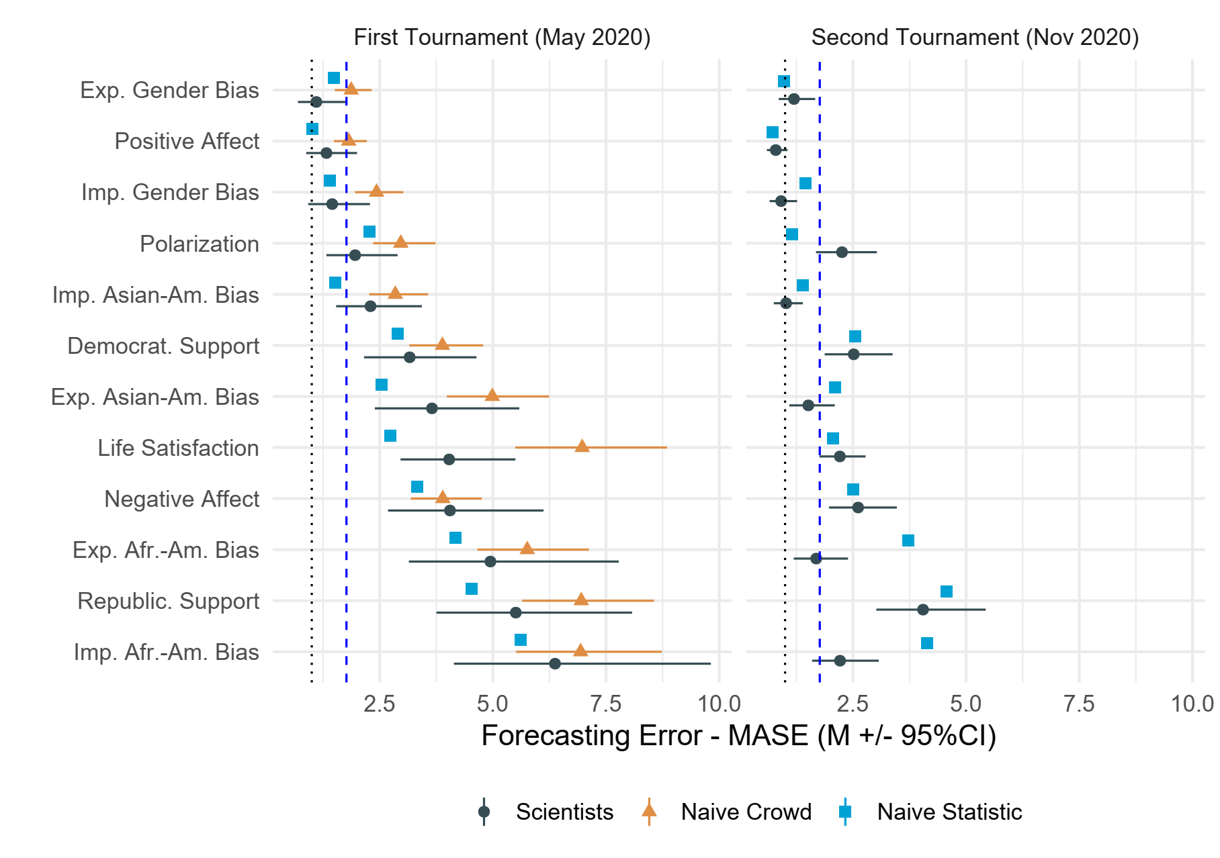
Figure 1: Social scientists’ average forecasting errors, compared against different benchmarks. We rank domains from least to most error in Tournament 1, assessing forecasting errors via mean absolute scaled error (MASE). Scientists = estimated means and 95% Confidence Intervals from a linear mixed model with domain as a predictor of forecasting error (MASE) scores nested in teams. To correct for right skew, we used log-transformed MASE scores, which are subsequently back-transformed when calculating estimated means. In each tournament, confidence intervals are adjusted for simultaneous inference of estimates for 12 domains in each tournament by simulating a multivariate t distribution²⁰. Benchmarks represent the naïve crowd and best performing naïve statistical benchmark (either historic mean, average random walk with an autoregressive lag of one, or linear regression). Statistical benchmarks were obtained via simulations (k = 10,000) with resampling (see Supplement). Scores to the left of the dotted vertical line show better performance than naïve in-sample random walk. Scores to the left of the dashed vertical line show better performance than median performance in M4 tournaments ⁷.

Table 1. Contrasts of Mean-level Inaccuracy (MASE) among Lay Crowds and Social Scientists
Domain | t-ratio | df | p-value | Cohen’s d [95% CI] | Bayes Factor | Interpretation
Life Satisfaction | 4.321 | 1725 | < .001 | 0.93 [0.32;1.55] | 22.72 | Substantial ev. for difference
Explicit Gender-career Bias | 3.204 | 1731 | .006 | 0.90 [0.10; 1.71] | 1.37 | Some evidence for difference
Implicit Gender-career Bias | 3.161 | 1747 | .006 | 0.88 [0.09; 1.67] | 2.49 | Some evidence for difference
Political Polarization | 2.819 | 1802 | .015 | 0.71 [-0.01; 1.42] | 0.77 | Not enough evidence
Positive Affect | 2.128 | 1796 | .080 | 0.54 [-0.18; 1.26] | 0.12 | Substantial ev. for no difference
Exp. Asian American Bias | 1.998 | 1789 | .092 | 0.53 [-0.23; 1.29] | 0.11 | Substantial ev. for no difference
Ideology Republicans | 1.650 | 1794 | .170 | 0.40 [-0.29; 1.08] | 0.06 | Substantial ev. for no difference
Ideology Democrats | 1.456 | 1795 | .204 | 0.35 [-0.34; 1.04] | 0.04 | Substantial ev. for no difference
Imp. Asian American Bias | 1.430 | 1802 | .204 | 0.36 [-0.36; 1.09] | 0.11 | Substantial ev. for no difference
Exp. African American Bias | 0.939 | 1747 | .218 | 0.26 [-0.53; 1.05] | 0.04 | Substantial ev. for no difference
Imp. African American Bias | 0.536 | 1780 | .646 | 0.14 [-0.63; 0.91] | 0.02 | Substantial ev. for no difference
Negative Affect | -0.271 | 1796 | .787 | 0.07 [-0.79; 0.65] | 0.02 | Substantial ev. for no difference
Note. Scores > 1: greater accuracy of scientific forecasts. Scores < 1: greater accuracy of lay crowds. Contrasts were obtained via emmeans package in R ²¹. To avoid skew, tests are performed on log-transformed scores. Degrees of freedom were obtained via Kenward-Roger approximation. P-values are adjusted for false discovery rate. CI = Confidence intervals of effect size (Cohen’s d), which are adjusted for simultaneous inference of 12 domains by simulating a multivariate t distribution²⁰. Interpretation of Bayes factor is in the right column. Bayes factors greater than 3 are interpreted as substantial evidence of a difference, values between 3 and 1 suggest some evidence of a difference, values between ⅓ and 1 indicate that there is not enough evidence to interpret, and values < ⅓ indicate substantial evidence in favor of the null hypothesis (no difference between groups).
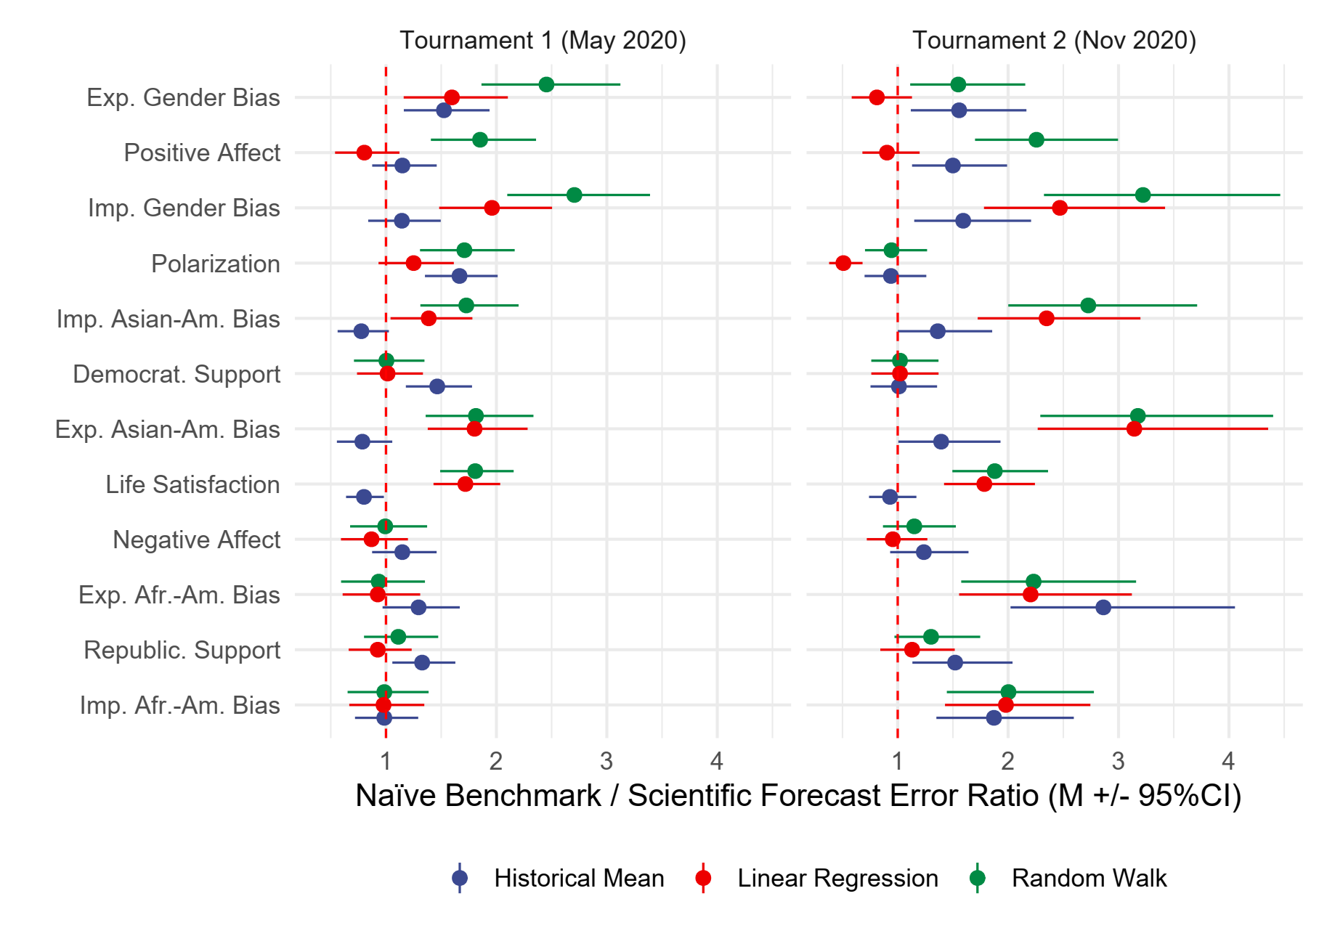Figure 2. Ratios of Benchmarks against Scientific Forecasts. Scores >1: greater accuracy of scientific forecasts. Scores <1: greater accuracy of naïve benchmarks. Domains are ranked from least to most error among scientific teams in Tournament 1. Error bars reflect 95% confidence intervals. Confidence intervals are adjusted for simultaneous inference of estimates for 12 domains in each tournament by simulating a multivariate t distribution²⁰.
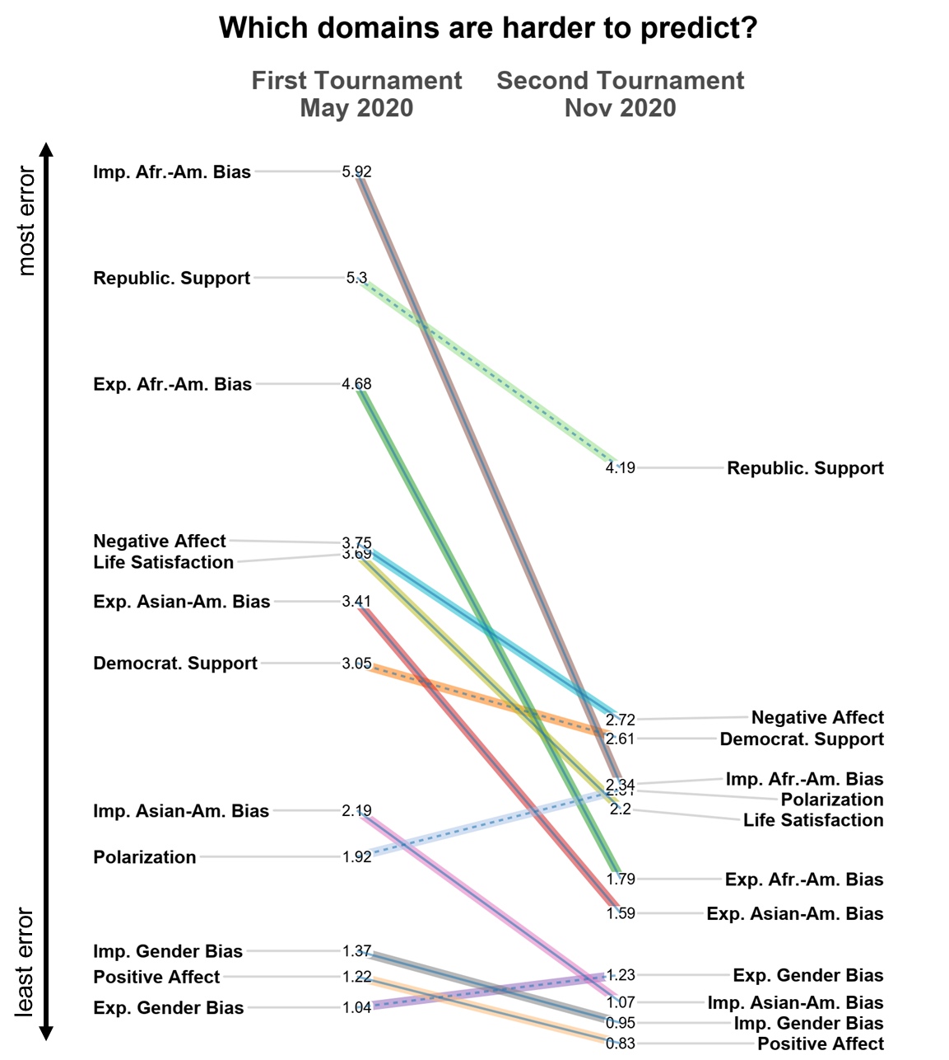
Figure 3: Slope graph showing consistency in the ranking of domains in terms of estimated mean forecasting error across all teams in each tournament, assessed via mean absolute scaled error, from most to least inaccurate forecasts across both tournaments. Solid line = change in accuracy between tournaments is statistically significant (P < .05); dashed line = non-significant change.
Next, we compared scientific forecasts against three naïve statistical benchmarks by creating benchmark/forecast ratio scores (a ratio of 1 indicates that the social scientists' forecasts were equal in accuracy to the benchmarks, with ratios greater than 1 indicating greater accuracy). To account for interdependence of social scientists’ forecasts, we examined estimated ratio scores for domains from linear mixed models, with responses nested in forecasting teams. To reduce the likelihood that social scientists’ forecasts beat naïve benchmarks by chance, our main analyses focus on performance across all three benchmarks (see Supplement for rationale favoring this method over averaging across three benchmarks), and by adjusting confidence intervals of the ratio scores for simultaneous inference of 12 domains in each tournament by simulating a multivariate t distribution²⁰. Figs. 1-2 and Fig. S2 show that social scientists in Tournament 1 were significantly better than each of the three benchmarks in only one out of twelve domains, which concerned explicit gender-career bias, 1.53 < ratio ≤ 1.60, 1.16 < 95%CI ≤ 2.910. In the remaining 11 domains, scientific predictions were either no different or worse than the benchmarks. The relative advantage of scientific forecasts over the historical mean and random walk benchmarks was somewhat larger in Tournament 2 (Fig. S1). Scientific forecasts were significantly more accurate than the three naïve benchmarks in five out of twelve domains. These domains reflected explicit racial bias: African-American bias, 2.20 < ratio ≤ 2.86, 1.55 < 95%CI ≤ 4.05; Asian-American bias, 1.39 < ratio ≤ 3.14, 1.01 < 95%CI ≤ 4.40; and implicit racial and gender career biases: African-American bias, 1.35 < ratio ≤ 2.00, 1.35 < 95%CI ≤ 2.78; Asian-American bias, 1.36 < ratio ≤ 2.73, 1.001 < 95%CI ≤ 3.71; gender-career bias, 1.59 < ratio ≤ 3.22, 1.15 < 95%CI ≤ 4.46. In the remaining seven domains, forecasts were not significantly different from naïve benchmarks. Moreover, as Fig. 2 shows, for political polarization scientific forecasts in Tournament 2 were significantly less accurate than estimates from a naïve linear regression, ratio = 0.51, 95%CI [0.38, 0.68]. Fig. 2 also shows that in most domains at least one of the naïve forecasting methods produced errors that were comparable or less than social scientists’ forecasts (11 out of 12 in Tournament 1 and 8 out of 12 in Tournament 2).
To compare social scientists’ forecasts against the average of three naïve benchmarks, we fit a linear mixed model with forecast/benchmark ratio scores nested in forecasting teams and examined estimated means for each domain. In Tournament 1, scientists performed better than the average of the naïve benchmarks in only three domains, which concerned political polarization, 95%CI [1.06; 1.63], explicit gender-career bias, 95%CI [1.23; 1.95], and implicit gender-career bias, 95%CI [1.17; 1.83]. In Tournament 2, social scientists performed better than the average of the naïve benchmarks in seven domains, 1.07 < 95%CIs ≤ 2.79, while they were statistically indistinguishable from the average of naïve benchmarks when forecasting the remaining five domains: ideological support for Democrats, 95%CI [0.76; 1.17], and for Republicans, 95%CI [0.98; 1.51], explicit gender-career bias, 95%CI [0.96; 1.52], and negative affect on social media, 95%CI [0.82; 1.25]. Moreover, in Tournament 2 social scientists’ forecasts of political polarization were inferior to the average of naïve benchmarks, 95%CI [0.58; 0.89]. Overall, social scientists tended to do worse than the average of the three naïve statistical benchmarks in Tournament 1. While scientists did better than the average of naïve benchmarks in Tournament 2, this difference in overall performance was small, M(forecast /benchmark inaccuracy ratio) = 1.43, 95%CI [1.26; 1.62]. Moreover, in most domains at least one of the naïve benchmarks was on par if not more accurate to social scientists’ forecasts.

Which domains were harder to predict?
Fig. 3 shows that some societal trends were significantly harder to forecast than others, Tournament 1: F(11,295.69) = 41.88, P < .001, R² = .450, Tournament 2: F(11,469.49) = 26.87, P < .001, R² = .291. Forecast accuracy was lowest in politics (underestimating Democratic and Republican support, and political polarization), well-being (underestimating life satisfaction and negative affect on social media), and overestimating racial bias against African Americans (also see Figs. S1). Differences in forecast accuracy across domains did not correspond to differences in quality of ground truth markers: Based on the sampling frequency and representativeness of the data, most reliable ground truth markers concerned societal change in political ideology, obtained via an aggregate of multiple nationally representative surveys by reputable pollsters, yet this domain was among most difficult to forecast. In contrast, some of the least representative markers concerned racial and gender-bias, which came from Project Implicit—a volunteer platform that is subject to self-selection bias—yet these domains were among the easiest to forecast. In a similar vein, both life satisfaction and positive affect on social media were estimated via texts on Twitter, even though forecasting errors between these domains varied. Though measurement imprecision undoubtedly presents a challenge for forecasting, it is unlikely to account for between-domain variability in forecasting errors (Figure 3).
Domain differences in forecasting accuracy corresponded to differences in the complexity of historical data: domains ranked more variable in terms of standard deviation (SD) and mean absolute difference (MAD) of historical data tended to have more forecasting error (as measured by the rank-order correlation between median inaccuracy scores across teams and variability scores for the same domain), Tournament 1: ρ(SD) = .19, ρ(MAD) = .20; Tournament 2: ρ(SD) = .48, ρ(MAD) = .36, and domain changes in variability of historical data across tournaments corresponded to changes in accuracy, ρ(SD) = .27, ρ(MAD) = .28.
Comparison of accuracy across tournaments
Forecasting error was higher in the first tournament than the second tournament (see Fig. 3), F(1, 889.48) = 64.59, P < .001, R² = .063. We explored several possible differences between the tournaments that may account for this effect. One possibility is that type of teams differed between tournaments (team size, gender, number of forecasted domains, field specialization and team diversity, number of PhDs on a team, prior experience with forecasting). However, the difference between the tournaments remained equally pronounced when running parallel analyses with team characteristics as covariates, F(1, 847.79) = 90.45, P < .001, R² = .062.
Another hypothesis is that forecasts for twelve months (Tournament 1) include further removed data points than forecasts for more immediate six months (Tournament 2), and it is the greater temporal distance between the tournament and the moment to forecast that results in greater inaccuracy at Tournament 1. To test this hypothesis, we zeroed in on Tournament 1 inaccuracy scores for the first and the last six months, while including domain type as a control dummy variable. By focusing on Tournament 1 data, we kept other characteristics such as team composition as a constant. Contrary to this seemingly straightforward hypothesis, error for the forecasts for the first six months was in fact significantly greater (MASE = 3.16, SE = 0.21, 95%CI [2.77, 3.60]) than for the last six months (MASE = 2.59, SE = 0.17, 95%CI [2.27, 2.95]), F(1, 621.41) = 29.36, P < .001, R² = .012. As Fig. S1 shows, for many domains, social scientists underpredicted societal change in Tournament 1, and this difference between predicted and observed values was more pronounced in the first versus last six months. This suggests that for several domains social scientists anchored (19) their forecasts on the most recent historical data. Supplementary analyses further show that many domains showed unusual shifts (vis-à-vis prior historical data) in the first six months of the pandemic and started to return to the historical baseline in the following six months (Fig. S15). For these domains, forecasts anchored on the most recent historical data were more inaccurate for the May-October 2020 forecasts compared to the November 2020-April 2021 forecasts.
Finally, we tested whether providing teams additional six months of historical trend capturing the on-set of the novel pandemic at Tournament 2 may have contributed to lower error compared to Tournament 1. To this end, we compared the inaccuracy of forecasts for the six months period of Nov 2020-April 2021 done in May 2020 (Tournament 1) and when provided with more data in October 2020 (Tournament 2). We focused only on participants who completed both tournaments to keep the number of participating teams and team characteristics constant. Indeed, Tournament 1 forecasts had significantly more error (MASE M = 2.54, SE = 0.17, 95%CI [2.23, 2.90]) than Tournament 2 forecasts (MASE M = 1.99, SE = 0.13, 95%CI [1.74, 2.27]), F(1, 607.79) = 31.57, P < .001, R² = .017. suggesting that it was availability of new (pandemic-specific) information rather than temporal distance that contributed to more accurate forecasts in the second compared to the first tournament.
Consistency in forecasting
Despite variability across scientific teams, domains, and tournaments, the accuracy of scientific predictions was highly systematic. Accuracy in one subset of predictions (ranking of model performance across odd months) was highly correlated with accuracy in the other subset (ranking of model performance across even months), first tournament: multilevel r_{across domains} = .88, 95% CI [.85; .90], t(357) = 34.80, P < .001; domain-specific .55 < .rs ≤ .99; second tournament: multilevel r_{across domains} = .72, 95% CI [.67; .75], t(544) = 23.95, P < .001; domain-specific .24 < .rs ≤ .96. Further, results of a linear mixed model with MASE scores in Tournament 1, domain, and their interaction predicting MASE in Tournament 2 showed that for eleven out of twelve domains accuracy in Tournament 1 was associated with greater accuracy in Tournament 2, Md(standardized β) = .26.
Moreover, the ranking of models based on performance in the initial 12-months tournament corresponds to the ranking of the updated models in the follow-up 6-months tournament (Fig. 3). Harder-to-predict domains in the initial tournament remained most inaccurate in the second tournament. Fig. 2 shows one notable exception. Bias against African Americans was easier to predict than other domains in the second tournament. Though speculative, this exception appears consistent with the idea that George Floyd’s death catalyzed movements in racial awareness just after the first tournament (supplementary Fig. S14 for a timeline of major historical events).
Which strategies and team characteristics promoted accuracy?
Finally, we examined forecasting approaches and individual characteristics of more accurate forecasters in the tournaments. In the main text, we focused on central tendencies across forecasting teams, whereas in the supplementary analyses we reviewed strategies of winning teams and characteristics of the top 5 performers in each domain (Figs. S4-S11). We compared forecasting approaches relying on 1) no data modeling (but possible consideration of theories); 2) pure data modeling (but no consideration of subject matter theories); 3) hybrid approaches. Roughly half of the teams relied on data-based modeling as a basis for their forecasts, whereas the other half of the teams in each tournament relied only on their intuitions or theoretical considerations (Fig. 4). This pattern was similar across domains (Fig. S3).
In both tournaments, pre-registered linear mixed model analyses with approach as a factor, domain type as a control dummy variable, and MASE scores nested in forecasting teams as a dependent variable revealed that forecasting approaches significantly differed in accuracy, first tournament: F(2, 149.10) = 5.47, P = .005, R² = .096; second tournament: F(2, 177.93) = 5.00, P = .008, R² = .091 (Fig. 4). Forecasts that considered historical data as part of the forecast modeling were more accurate than models that did not, first tournament: F(1, 56.29) = 20.38, P < .001, R² = .096; second tournament: F(1, 159.11) = 8.12, P = .005, R² = .084. Model comparison effects were qualified by significant model type X domain interaction; first tournament: F(11, 278.67) = 4.57, P < .001, R² = .045; second tournament: F(11, 462.08) = 3.38, P = .0002, R² = .028. Post-hoc comparisons in Table S4 revealed that data-inclusive (data-driven and hybrid) models were significantly more accurate than data-free models that did not include data in three domains (explicit and implicit racial bias against Asian-Americans and implicit gender-career bias) in Tournament 1 and two domains (life satisfaction, explicit gender-career bias) in Tournament 2. There were no domains where data-free models were more accurate than data-inclusive models. Analyses in Supplementary Materials further demonstrated that, in the first tournament, data-free forecasts of social scientists were not significantly better than lay estimates, t(577) = 0.87, P = .385, whereas data-inclusive models tended to perform significantly better than lay estimates, t(470) = 3.11, P = .006, Cohen’s d = 0.391.
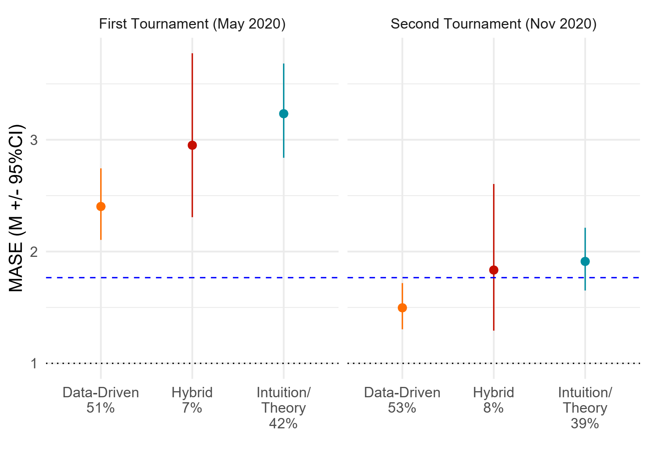
Figure 4: Forecasting errors by prediction approach. Estimates and 95% confidence intervals from linear mixed models with responses nested in scientific teams to account for interdependence. Scores below the dotted vertical line show better performance than naïve in-sample random walk. Scores below the dashed vertical line show better performance than median performance in M4 tournaments ⁷.
To examine the incremental contribution of specific forecasting strategies and team characteristics to accuracy, we pooled data from both tournaments in a linear mixed model with inaccuracy (MASE) as a dependent variable. As Fig. 5 shows, we included predictors representing forecasting strategies, team characteristics, domain expertise (quantified via publications by team members on the topic) and forecasting expertise (quantified via prior experience with forecasting tournaments). We further included domain type as a control dummy variable, and nested responses in teams.
The full model fixed effects explained 31% of the variance in accuracy (R² = .314), though much of it was accounted for by differences in accuracy between domains (non-domain R² [partial] = .043). Consistent with prior research ²², model sophistication—i.e., considering a larger number of exogenous predictors, COVID-trajectory, or counterfactuals—did not significantly improve accuracy (Fig. 5 and Table S5). In fact, forecasting models based on simpler procedures turned out to be significantly more accurate than complex models, B = 0.14, SE = 0.06, t (220.82) = 2.33, P = .021, R²(partial) = .010.
On the one hand, experts’ subjective confidence in their forecasts was not related to the accuracy of their estimates. On the other, people with expertise made more accurate forecasts. Teams were more accurate if they had members who published academic research on the forecasted domain, B = -0.26, SE = 0.09, t (711.64) = 3.01, P = .003, R²(partial) = .007, and who took part in prior forecasting competitions, B = -0.35, SE = 0.17, t (56.26) = 2.02, P = .049, R²(partial) = .010 (also see Table S5). Critically, even though some of these effects were significant, only two factors – complexity of the statistical method and prior experience with forecasting tournaments – showed a non-negligible partial effect size (R² above .009) ²³.
In the second tournament, we provided teams with the opportunity to compare their original forecasts (Tournament 1, May 2020) to new data at a later point of time and to update their predictions (22) (Tournament 2, Nov 2020). Therefore, we tested whether updating improved people’s predictive accuracy. Out of the initial 356 forecasts in the first tournament, 180 were updated in the second tournament (from 37% of teams for life satisfaction to 60% of teams for implicit Asian American bias). Updated forecasts in the second tournament (November) were significantly more accurate than the original forecasts in the first tournament (May), t(94.5) = 6.04, P < .001, Cohen’s d = 0.804, but so were forecasts from the 34 new teams recruited in November, t(75.9) = 6.30, P < .001, Cohen’s d = 0.816. Furthermore, updated forecasts were not significantly different from forecasts provided by new teams recruited in November, t(77.8) < 0.10, P = .928. This observation suggests that updating did not lead to more accurate forecasts (Table S6 reports additional analyses probing different updating rationales).

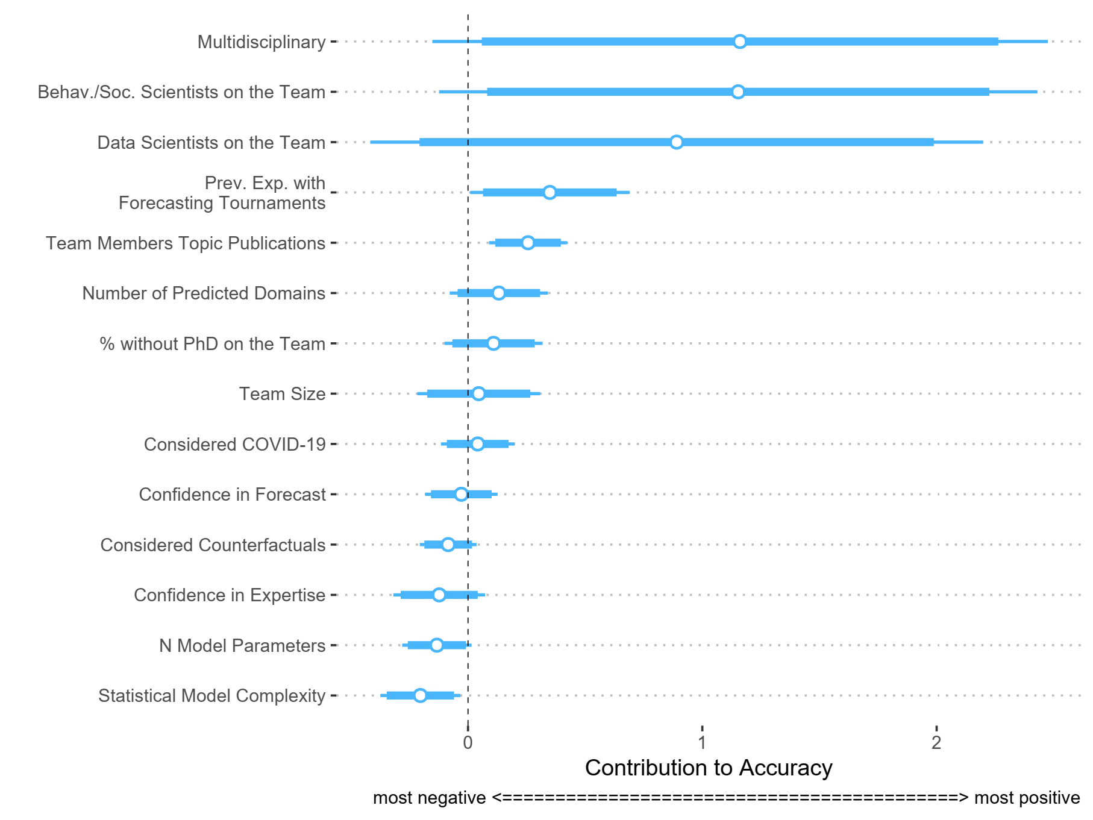
Figure 5: Contribution of specific forecasting strategies (n parameters, statistical model complexity, consideration of exogenous events and counterfactuals) and team characteristics for forecasting accuracy (reversed MASE scores), ranked in terms of magnitude. Scores to the right of the dashed vertical line contribute positively to accuracy, whereas estimates to the left of the dashed vertical line contribute negatively. Analyses control for domain type. All continuous predictors are mean-centered and scaled by 2 standard deviations, to afford comparability ²⁴. The reported standard errors are heteroskedasticity-robust. Thicker bands show 90% confidence interval, whereas thinner lines show at 95% confidence interval. Effects are statistically significant if the 95% confidence interval does not include zero (dashed vertical line).

Discussion
How accurate are social scientists’ forecasts of societal change? Results from two forecasting tournaments conducted during the first year of the COVID-19 pandemic show that for most domains social scientists’ predictions were no better than those from a sample of the (non-specialist) general public. Further, apart from a few domains concerning racial and gender-career bias, scientists’ original forecasts were typically not much better than naïve statistical benchmarks derived from historical averages, linear regressions, or random walks. Even when confining the analysis to the top 5 forecasts by social scientists per domain, a simple linear regression produced less error roughly half of the time (Figs. S5 and S9).
Forecasting accuracy systematically varied across societal domains. In both tournaments, positive sentiment and gender-career stereotypes were easier to forecast than other phenomena, whereas negative sentiment and bias toward African Americans were most difficult to forecast. Domain differences in forecasting accuracy corresponded to historical volatility in the time series. Differences in the complexity of positive and negative affect are well-documented ^{25,26}. Moreover, racial attitudes showed more change than attitudes regarding gender during this period (perhaps due to movements like Black Lives Matter).
Which strategies and team characteristics were associated with more effective forecasts? One defining feature of more effective forecasters was that they relied on prior data rather than theory alone. This observation fits with prior studies on the performance of algorithmic versus intuitive human judgments (25). Social scientists who relied on prior data also performed better than lay crowds and were overrepresented among the winning teams (Figs. S4 and S8).
Forecasting experience and subject matter expertise on a forecasted topic also incrementally contributed to better performance in tournaments (R² [partial] = .010). This is in line with some prior research on the value of subject-matter expertise for geopolitical forecasts ⁶ and for prediction of success of behavioral science interventions ²⁷. Notably, we found that publication track record on a topic, rather than subjective confidence in domain expertise or confidence in the forecast, contributed to greater accuracy. It is possible that subjective confidence in domain expertise conflates expertise and overconfidence ²⁸ (versus intellectual humility). There is some evidence that overconfident forecasters are less accurate ²⁹. These findings, along with a lack of domain-general effect of social science expertise on performance compared to the general public, invite consideration of whether what usually counts as expertise in social sciences translates into greater ability to predict future real-world trends.
The nature of our forecasting tournaments allowed social scientists to self-select any of the twelve forecasting domains, inspect three years of historical trends for each domain, and to update their predictions based on feedback on their initial performance in the first tournament. These features emulated typical forecasting platforms (e.g., metaculus.com). We argue that this approach enhances our ability to draw externally valid and generalizable inferences from a forecasting tournament. However, this approach also resulted in a complex, unbalanced design. Scholars interested in isolating psychological mechanisms fostering superior forecasts may benefit from a simpler design whereby all forecasting teams make forecasts for all requested domains.
Another issue in designing forecasting tournaments involves determination of domains one may want participants to forecast. In designing the present tournaments, we provided participants with at least three years of monthly historical data for each forecasting domains. An advantage of making the same historical data available for all forecasters is that it establishes a “common task framework” ^{9,16,17}, ensuring main sources of information about the forecasting domains remain identical across all participants. However, this approach restricts types of social issues participants can forecast. A simpler design without inclusion of historical data would have had an advantage of a greater flexibility in selecting forecasting domains.
Why were forecasts of societal change largely inaccurate, even though participants had data-based resources and ample time to deliberate? One possibility concerns self-selection. Perhaps participants in the Forecasting Collaborative were unusually bad at forecasting compared to social scientists as a whole. This possibility seems unlikely. We took efforts to recruit highly successful social scientists at different career stages and from different sub-disciplines (see Supplementary Materials). Indeed, many of our forecasters are well-established scholars. Thus, we do not expect members of the Forecasting Collaborative to be worse at forecasting than other members of the social science community. Nevertheless, albeit impractical, only a random sample of social scientists would have fully addressed the self-selection concern.
Second, it is possible that social scientists were not adequately incentivized to perform well in our tournaments. Though we provided reputational incentives by announcing winners and ranking of participating teams, like other big-team science projects ^{8,30} we did not provide performance-based monetary incentives ³¹, because they may not be key motivating factors for intrinsically motivated social scientists ³². Indeed, drop-out rate between Tournaments 1 and 2 was marginal, suggesting that participating teams were motivated to continue being part of the initiative. This reasoning notwithstanding, it is possible that stronger incentives for accurate forecasting (whether reputation-based or monetary) could have stimulated some scientists to perform better in our forecasting tournament, opening doors for future directions to address this question directly.
Third, social scientists often deal with phenomena with small effect sizes that are overestimated in the literature ^{8,30,33}. Additionally, social scientists frequently study social phenomena in conditions that maximize experimental control but may have little external validity, and it is argued that this not only limits the generalizability of findings but in fact reduces their internal validity. In the world beyond the laboratory, where more factors are at play, such effects may be smaller than social scientists might think based on their lab studies, and in fact, such effects may be spurious given the lack of external validity. Thus, social scientist may over(and mis)estimate the impact of the effects they study in the lab on real-world phenomena ³⁴
Fourth, social scientists tend to theorize about individuals and groups and conduct research at those scales. However, findings from such work may not scale up when predicting phenomena on a scale of entire societies ³⁹. Like other dynamical systems in economics, physics, or biology, societal level processes may also be genuinely stochastic rather than deterministic. If so, stochastic models will be hard to outperform.
Finally, training in predictive modeling is not a requirement in many social sciences programs ¹⁰. Social scientists often prioritize explanations over formal predictions ⁵. For instance, statistical training in social sciences typically emphasizes unbiased estimation of model parameters in the sample over predictive out-of-sample accuracy ⁴⁰. Moreover, typical graduate curricula in many areas of social science, such as social or clinical psychology, do not require computational training in predictive modeling. The formal empirical study of societal change is relatively uncommon in these disciplines. Most social scientists approach individual- or group-level phenomena in an a-temporal fashion ³⁹. Scientists may favor post-hoc explanations of specific one-time events rather than the future trajectory of social phenomena. Although time is a key theoretical variable for foundational theories in many subfields of social sciences, such as field theory ⁴¹, it has remained an elusive concept.
How can social scientists become better forecasters? Perhaps the first steps might involve probing the limits of social science theories by evaluating if a given theory is suitable for making societal predictions in the first place or if it is too narrow or too vague ^{5,42}. Relatedly, social scientists need to test their theories using representatively designed experiments. Moreover, social scientists may benefit from testing whether a societal trend is deterministic and hence can benefit from theory-driven components, or if it unfolds in a purely stochastic fashion. For instance, one can start by decomposing a time series into the trend, autoregressive, and seasonal components, examining each of them and their meaning for one’s theory and model. One can further perform a unit root test to examine whether the time series is non-stationary. Training in recognizing and modeling properties of time series and dynamical systems may need to become more firmly integrated into graduate curricula in the field. For instance, a classic insight in time series literature is that the mean of the historical time series may be among the best multi-step ahead predictor for a stationary time series ⁴³. Using such insights to build predictions from ground-up can afford greater accuracy. In turn, such training can open the door to more robust models of social phenomena and human behavior, with a promise of greater generalizability in the real-world.
Given the broad societal impact of phenomena like prejudice, political polarization or well-being, the ability to accurately predict trends in these variables would appear to be of crucial importance. But despite common beliefs that social science experts are best equipped to accurately predict these trends compared to non-experts ¹, the current findings suggest that the social and behavioral scientists have a lot of room for growth ³⁸. The good news is that forecasting skills can be improved. Consider the growing accuracy in forecasting models in meteorology in the second part of the 20th century ⁴⁴. Greater consideration of representative experimental designs, temporal dynamics, better training in forecasting methods, and more practice with formal forecasting all may improve social scientists’ ability to accurately forecast societal trends going forward.
Methods
The study was approved by the Office of Research Ethics of the University of Waterloo under protocol # 42142.
Pre-registration and deviations. Forecasts of all participating teams along with their rationales were pre-registered on Open Science Framework (https://osf.io/6wgbj/registrations). Additionally, in an a priori specific document shared with the journal in May 2020, we outlined the operationalization of the key dependent variable (MASE), operationalization of covariates and benchmarks (i.e., use of naive forecasting methods), along with the key analytic procedures (linear mixed model and contrasts being different forecasting approaches; osf.io/7ekfm). We did not pre-register the use of a Prolific sample from the general public as an additional benchmark before their forecasting data was collected, though we did pre-register this benchmark in early September of 2020, prior to data pre-processing or analyses. Deviating from the pre-registration, to protect against inflating p-values, we performed a single analysis with all covariates in the same model rather than performing separate analyses for each set of covariates. Further, due to scale differences between domains, we chose not to feature analyses concerning absolute percentage errors of each time point in the main paper (but see corresponding analyses on the GitHub site of the project https://github.com/grossmania/Forecasting-Tournament, which replicate the key effects presented in the main manuscript).
Participants & recruitment. We initially aimed for a minimum sample of 40 forecasting teams in our tournament after prescreening to ensure that participants possess at minimum a bachelor’s degree in behavioral, social, or computer sciences. To compare groups of scientists employing different forecasting strategies (e.g., data-free versus data-inclusive methods), we subsequently tripled the target size of the final sample (N = 120), the target we accomplished by the November phase of the tournament, to ensure sufficient sample for comparison of teams using different strategies (see Table S1 for demographics).
The Forecasting Collaborative website we used for recruitment (https://predictions.uwaterloo.ca/faq) outlined guidelines for eligibility and approach for prospective participants. We incentivized participating teams in two ways. First, prospective participants had an opportunity for a co-authorship in a large-scale citizen science publication. Second, we incentivized accuracy by emphasizing throughout the recruitment that we will be announcing winners and will share the ranking of scientific teams in terms of performance in each tournament (per domain and in total).
As outlined in the recruitment materials, we considered data-driven (e.g., model-based) or expertise-based (e.g., general intuition, theory-based) forecasts from any field. As part of the survey, participants selected which method(s) they used to generate their forecasts. Next, they elaborated on how they generated their forecasts in an open-ended question. There are no restrictions, though all teams were encouraged to report their education, as well as areas of knowledge or expertise. Participants were recruited via large scale advertising on social media, mailing lists in the behavioral and social sciences, decision sciences, and data science, advertisement on academic social networks including ResearchGate, and through word of mouth. To ensure broad representation across the academic spectrum of relevant disciplines, we targeted groups of scientists working on computational modeling, social psychology, judgment and decision-making, and data science to join the Forecasting Collaborative.
The Forecasting Collaborative started by the end of April 2020, during which time the U.S. Institute for Health Metrics and Evaluation projected the initial peak of the COVID-19 pandemic in the US. The recruitment phase continued until mid-June 2020, to ensure at least 40 teams joined the initial tournament. We were able to recruit 86 teams for the initial 12-month tournament (M _{age} = 38.18; SD = 8.37; 73% of forecasts made by scientists with a Doctorate degree), each of which provided forecasts for at least one domain (M = 4.17; SD = 3.78). At the six-month mark after 2020 US Presidential Election, we provided the initial participants with an opportunity to update their forecasts (44% provided updates), while simultaneously opening the tournament to new participants. This strategy allowed us to compare new forecasts against the updated predictions of the original participants, resulting in 120 teams for this follow-up six-month tournament (M _{age} = 36.82; SD = 8.30; 67% of forecasts made by scientists with a Doctorate degree; M _{forecasted domains} = 4.55; SD = 3.88). Supplementary analyses showed that updating likelihood did not significantly differ when comparing data-free and data-inclusive models, z = 0.50, P = .618.
Procedure. Information for this project was available on the designated website (predictions.uwaterloo.ca), which included objectives, instructions, and prior monthly data for each of the 12 domains they can use for modeling. Researchers who decided to partake in the tournament signed up via a Qualtrics survey, which asked them to upload their estimates for forecasting domains of their choice in a pre-programmed Excel sheet that presented the historical trend and automatically juxtaposed their point estimate forecasts against the historical trend on a plot (see Appendix S1) and answer a set of questions about their rationale and forecasting team composition. Once all data was received, de-identified responses were used to pre-register the forecasted values and models on the Open Science Framework (https://osf.io/6wgbj/).
Recent empirical forecasting competition also emphasize assessing prediction intervals along with point forecast estimates ⁷, employing metrics like MSIS and Cover rate to see how often the actual outcome falls within the estimated a priori prediction interval, as many decisions in real life setting are based in the intervals rather than the points forecasts. For pragmatic reasons, such prediction interval metrics were out of the scope of this specific research, but the interested reader can follow up the recent M4, M5, & M6 (ongoing) forecasting studies for further information
At the half-way point (i.e., at six months), participants were provided with a comparison summary of their initial point estimates forecasts vs. actual data for the initial six months. Subsequently, they were provided with an option to update their forecasts, provide a detailed description of the updates, and answer an identical set of questions about their data model and rationale for their forecasts, as well as the consideration of possible exogenous variables and counterfactuals.
Materials
Forecasting Domains and Data Pre-Processing. Computational forecasting models require enough prior time series data for reliable modeling. Based on prior recommendations ⁴⁵, in the first tournament we provided each team with 39 monthly estimates—from January 2017 to March 2020—for each of the domains participating teams chose to forecast. This approach enabled the teams to perform data-driven forecasting (should teams choose to do so) and to establish a baseline estimate prior to the U.S. peak of the pandemic. In the second tournament, conducted six months later, we provided the forecasting teams with 45 monthly timepoints—from January 2017 to September 2020.
Because of the requirement for rich standardized data for computational approaches to forecasting ⁹, we limited forecasting domains to issues of broad societal significance. Our domain selection was guided by the discussion of broad social consequences associated with these issues at the beginning of the pandemic ^{46,47}, along with general theorizing about psychological and social effects of threats of infectious disease ^{48,49}. Additional pragmatic consideration concerning the availability of large-scale longitudinal monthly time series data for a given issue. The resulting domains include affective well-being and life satisfaction, political ideology and polarization, bias in explicit and implicit attitudes towards Asian Americans and African Americans, as well as stereotypes regarding gender and career vs. family. To establish the “common task framework”—a necessary step for the evaluation of predictions in data sciences ^{9,17}, we standardized methods for obtaining relevant prior data for each of these domains, made the data publicly available, recruited competitor teams for a common task of inferring predictions from the data, and a priori announced how the project leaders will evaluate accuracy at the end of the tournament.
Further, each team had to 1) download and inspect the historical trends (visualized on an Excel plot; example in Appendix); 2) add their forecasts in the same document, which automatically visualized their forecasts against the historical trends; 3) confirm their forecasts; 4) answer prompts concerning their forecasting rationale, their theoretical assumptions, models, conditionals, and consideration of additional parameters in the model. This procedure ensured all teams, at the minimum, considered historical trends, juxtaposed them against their forecasted time series, and deliberated on their forecasting assumptions.
Affective Well-being and Life Satisfaction. We used monthly Twitter data to estimate markers of affective well-being (positive and negative affect) and life satisfaction over time. We rely on Twitter because no polling data for monthly well-being over the required time period exists, and because prior work suggests that national estimates obtained via social media language can reliably track subjective well-being ⁵⁰. For each month, we used previously validated predictive models of well-being, as measured by affective well-being and life satisfaction scales ⁵¹. Affective well-being was calculated by applying a custom lexicon ⁵² to message unigrams. Life satisfaction was estimated using a ridge regression model trained on latent Dirichlet allocation topics, selected using univariate feature selection and dimensionally reduced using randomized principal component analysis, to predict Cantril ladder life satisfaction scores. Such twitter-based estimates closely follow nationally representative polls ⁵³. We applied the respective models to Twitter data from January 2017 to March 2020 to obtain estimates of affective well-being and life satisfaction via language on social media.
Ideological Preferences. We approximated monthly ideological preferences via aggregated weighted data from the Congressional Generic Ballot polls conducted between January 2017 and March 2020 (projects.fivethirtyeight.com/congress-generic-ballot-polls), which ask representative samples of Americans to indicate which party they would support in an election. We weighed polls based on FiveThirtyEight pollster ratings, poll sample size, and poll frequency. FiveThirtyEight pollster ratings are determined by their historical accuracy in forecasting elections since 1998, participation in professional initiatives that seek to increase disclosure and enforce industry best practices and inclusion of live-caller surveys to cellphones and landlines. Based on this data, we then estimated monthly averages for support of Democrat and Republican parties across pollsters (e.g., Marist College, NBC/Wall Street Journal, CNN, YouGov/Economist).
Political Polarization. We assessed political polarization by examining differences in presidential approval ratings by party identification from Gallup polls (https://news.gallup.com/poll/203198/presidential-approval-ratings-donald-trump.aspx). We obtained a difference score in % of Republican versus Democrat approval ratings and estimated monthly averages for the time period of interest. The absolute value of the difference score will ensure possible changes following the 2020 Presidential election will not change the direction of the estimate.
Explicit and Implicit Bias. Given the natural history of the COVID-19 pandemic, we sought to examine forecasted bias in attitudes towards Asian American (vs. European-Americans). To further probe racial bias, we sought to examine forecasted racial bias in preferences for African American (versus European-American) people. Finally, we sought to examine gender bias in associations of female (vs. male) gender with family versus career. For each domain we sought to obtain both estimates of explicit attitudes ⁵⁴ and estimates of implicit attitudes ⁵⁵. To this end, we obtained data from the Project Implicit website (http://implicit.harvard.edu), which has collected continuous data concerning explicit stereotypes and implicit associations from a heterogeneous pool of volunteers (50,000 - 60,000 unique tests on each of these categories per month). Further details about the website and test materials are publicly available at https://osf.io/t4bnj. Recent work suggests that Project Implicit data can provide reliable societal estimates of consequential outcomes ^{56,57} and when studying cross-temporal societal shifts in U.S. attitudes ⁵⁸. Despite the non-representative nature of the Project Implicit data, recent analyses suggest that bias scores captured by Project Implicit are highly correlated with nationally representative estimates of explicit bias, r = .75, indicating that group aggregates of the bias data from Project Implicit can reliably approximate group-level estimates ⁵⁷. To further correct possible non-representativeness, we applied stratified weighting to the estimates, as described below.
Implicit attitude scores were computed using the revised scoring algorithm of the implicit association test (IAT) ⁵⁹. The IAT is a computerized task comparing reaction times to categorize paired concepts (in this case, social groups, e.g., Asian American vs. European American) and attributes (in this case, valence categories, e.g., good vs. bad). Average response latencies in correct categorizations were compared across two paired blocks in which participants categorized concepts and attributes with the same response keys. Faster responses in the paired blocks are assumed to reflect a stronger association between those paired concepts and attributes. Implicit gender-career bias was measured using the IAT with category labels of “male” and “female” and attributes of “career” / “family”). In all tests, positive IAT D scores indicate a relative preference for the typically preferred group (European-Americans) or association (men-career).
Respondents whose scores fell outside of the conditions specified in the scoring algorithm did not have a complete IAT D score and were therefore excluded from analyses. Restricting the analyses to only complete IAT D scores resulted in an average retention of 92% of the complete sessions across tests. The sample was further restricted to include only respondents from the United States to increase shared cultural understanding of attitude categories. The sample was restricted to include only respondents with complete demographic information on age, gender, race/ethnicity, and political ideology.
For explicit attitude scores, participants provided ratings on feeling thermometers towards Asian-Americans and European Americans (to assess Asian-American bias), and White and Black Americans (to assess racial bias), on a 7-point scale ranging from -3 to +3. Explicit gender-career bias was measured using 7-point Likert-type scales assessing the degree to which an attribute was female/male, from strongly female (-3) to strongly male (+3). Two questions assessed explicit stereotypes for each attribute (e.g., career with female/male, and, separately, the association of family). To match the explicit bias scores with the relative nature of the IAT, relative explicit stereotype scores were created by subtracting the “incongruent” association from the “congruent” association (e.g., [male vs. female-career] - [male vs. female-family]). Thus, for racial bias, -6 reflects a strong explicit preference for the minority over the majority (European-American) group, and +6 reflects a strong explicit preference for the majority over the minority (Asian American / African American) group. Similarly, for gender-career bias, counter-stereotype association (e.g., male-arts/female-science), and +6 reflects a strong stereotypic association (e.g., female-arts/male-science). In both cases, the midpoint of 0 represented equal liking of both groups.
We used explicit and implicit bias data for January 2017 – March 2020 and created monthly estimates for each of the explicit and implicit bias domains. Because of possible selection bias among the Project Implicit participants, we adjusted population estimates by weighting the monthly scores based on their representativeness of the demographic frequencies in the U.S. population (age, race, gender, education; estimated biannually by the U.S. Census Bureau; https://www.census.gov/data/tables/time-series/demo/popest/2010s-national-detail.html). Further, we adjusted weights based on political orientation (1 = “strongly conservative;” 2 = “moderately conservative;” 3 = “slightly conservative;” 4 = “neutral;” 5 = “slightly liberal;” 6 = “moderately liberal;” 7 = “strongly liberal”), using corresponding annual estimates from the General Social Survey. With the weighting values for each participant, we computed weighted monthly means for each attitude test. These procedures ensured that weighted monthly averages approximated the demographics in the U.S. population. We cross-validated this procedure by comparing weighted annual scores to nationally representative estimates for feeling thermometer for African American and Asian American estimates from the American National Election studies in 2017 and 2018.
An initial procedure was developed for computing post-stratification weights for African American, Asian and gender career bias (implicit and explicit) to ensure that the sample was representative of the US population at large as much as possible. Originally, we computed weights for the entire year, which were then applied to each month in the year. After receiving feedback from co-authors, a more optimal approach was adopted wherein weights were computed on monthly, as opposed to yearly basis. This was necessary as demographic characteristics varied from month to month each year. This meant that using yearly weights had the potential of amplifying as opposed to reducing bias. Consequently, our new procedure insured that sample representativeness was maximized. This insight affected forecasts from seven teams who provided them before the change. The teams were informed, and four teams chose to provide updated estimates using newly weighted historical data.
For each of these domains, forecasters were provided with 39 monthly estimates in the initial tournament (45 estimates in the follow-up tournament), as well as detailed explanation about the origin and the calculation of respective indices. Thereby, we aim to standardize the data source for the purpose of the forecasting competition ⁹. See Supplementary Appendix S1 for example worksheets provided to participants for submissions of their forecasts.
Forecasting Justifications. For each forecasting model submitted to the tournament, participants provided detailed descriptions. They described the type of model they computed (e.g., time series, game theoretic models, other algorithms), model parameters, additional variables they included in their predictions (e.g., COVID-19 trajectory, presidential election outcome), and underlying assumptions.
Confidence in forecast. Participants rated their confidence in their forecasted points for each forecast model they submitted on a 7-point scale from 1 (not at all) to 7 (extremely).
Confidence in expertise. Participants provided ratings of their teams’ expertise for a particular domain by indicating extent of agreement with the statement “my team has strong expertise on the research topic of [field],” on a 7-point scale from 1 (Strongly Disagree) to 7 (Strongly Agree).
COVID-19 Conditional. We considered the COVID-19 pandemic as a conditional of interest given links between infectious disease and the target social issues selected for this tournament. In Tournament 1, participants reported if they used the past or predicted trajectory of the COVID-19 pandemic (as measured by number of deaths or prevalence of cases or new infections) as a conditional in their model, and if so, provided their forecasted estimates for the COVID-19 variable included in their model.
Counterfactuals. Counterfactuals are hypothetical alternative historic events that would be thought to affect the forecast outcomes if they were to occur. Participants described the key counterfactual events between December 2019 and April 2020 that they theorized would have led to different forecasts (e.g., U.S.-wide implementation of social distancing practices in February). Two independent coders evaluated the distinctiveness of counterfactuals (interrater κ = .80). When discrepancies arose, they discussed individual cases with other members of the forecasting collaborative to make the final evaluation. In primary analyses, we focus on the presence of counterfactuals (yes/no).
Team Expertise. Because expertise can mean many things ^{2,60}, we used a telescopic approach and operationalized expertise in four ways of varying granularity. First, we examined broad, domain-general expertise in social sciences by comparing social scientists’ forecasts to forecasts provided by the general public without the same training in social science theory and methods. Second, we operationalized the prevalence of graduate training on a team as a more specific marker of domain-general expertise in social sciences. To this end, we asked each participating team to report how many team members have a doctorate degree in social sciences and calculated the percentage of doctorates on a team. Moving to domain-specific expertise, we instructed participating teams to report if any of their members had previously researched or published on the topic of their forecasted variable, operationalizing domain-specific expertise through this measure. Finally, moving to the most subjective level, we asked each participating team to report their subjective confidence in teams’ expertise in a given domain (see Supplementary Information)
General Public Benchmark. In parallel to the tournament with 86 teams, on June 2-3, 2020, we recruited a regionally, gender- and socio-economically stratified sample of US residents via the Prolific crowdworker platform (targeted N = 1,050 completed responses) and randomly assigned them to forecast societal change for a subset of domains used in the tournaments (a. wellbeing: life satisfaction, positive and negative sentiment on social media; b. politics: political polarization, ideological support for Democrats and Republicans; c. Asian American Bias: explicit and implicit trends; d. African American Bias: explicit and implicit trends; e. Gender-career Bias: explicit and implicit trends). During recruitment, participants were informed that in exchange for 3.65 GDP they have to be able to open and upload forecasts in an Excel worksheet.
We considered responses if they provided forecasts for 12 months in at least one domain and if predictions did not exceed the possible range for a given domain (e.g., polarization above 100%). Moreover, three coders (intercoder κ = .70 unweighted, κ = .77 weighted) reviewed all submitted rationales from lay people and excluded any submissions where participants either misunderstood the task or wrote bogus bot-like responses. Coder disagreements were resolved via a discussion. Finally, we excluded responses if participants spent under 50s making their forecasts, which included reading instructions, downloading the files, providing forecasts, and re-uploading their forecasts (final N = 802, 1,467 forecasts; Mage = 30.39, SD = 10.56, 46.36% female; education: 8.57% high school/GED, 28.80% some college, 62.63% college or above; ethnicity: 59.52% white, 17.10% Asian American, 9.45% African American/Black, 7.43% Latinx, 6.50% mixed/other; Md annual income = $50,000-$75,000; residential area: 32.37% urban, 57.03% suburban, 10.60% rural).
Exclusions of the General Public Sample. Table S7 outlines exclusions by category. In the initial step, we considered all submissions via the Qualtrics platform, including partial submissions without any forecasting data (N = 1,891). Upon removing incomplete responses without forecasting data, and removing duplicate submissions from the same Prolific IDs, we removed 59 outliers whose data exceeded the range of possible values in a given domain. Subsequently, we removed responses independent coders flagged as either misunderstood (n = 6) or bot-like bogus responses (n = 26). See Supplementary Appendix S2 for verbatim examples of each screening category and exact coding instructions. Finally, we removed responses where participants took less than 50 seconds to provide their forecasts (including reading instructions, downloading the Excel file, filling it out, re-uploading the Excel worksheet, and completing additional information on their reasoning about the forecast). Finally, one response was removed based on open-ended information where the participant indicated they made forecasts for a different country than the US.
Naïve Statistical Benchmarks. There is evidence from data science forecasting competitions that the dominant statistical benchmarks are the Theta method, ARIMA, and ETS ⁷. Given the socio-cultural context of our study, to avoid loss of generality we decided to employ more traditional benchmarks like naïve/Random walk, historical average, as well as the basic linear regression model—i.e., a method that is used more than anything else in practice and science. In short, we selected three benchmarks based on their common application in the forecasting literature (historical mean and random walk are most basic forecasting benchmarks) or the behavioral / social science literature (linear regression is the most basic statistical approach to test inferences in sciences). Furthermore, these benchmarks target distinct features of performance (historical mean speaks to the base rate sensitivity, linear regression speaks to sensitivity to the overall trend, whereas random walk captures random fluctuations and sensitivity to dependencies across consecutive time points). Each of these benchmarks may perform better in some but not in other circumstances. Consequently, to test the limits in scientists’ performance, we examine if social scientists’ performance is better than each of the three benchmarks. To obtain metrics of uncertainty around the naïve statistical estimates, we chose to simulate these three naïve approaches for making forecasts: 1) random resampling of historical data; 2) a naïve out-of-sample random walk based on random resampling of historical change; 3) extrapolation from a naïve regression based on a randomly selected interval of historical data. We describe each approach below.
Benchmark 1: Random resampling of historical data. One potential approach to prediction is to simply assume that future observations will resemble previous observations, with no assumptions about additional temporal structure. This approach essentially assumes that the COVID-19 pandemic should result in little change in a measure compared to historical values. To capture this kind of naïve approach, we predicted future values by randomly resampling 12 values for Tournament 1 and 6 values for Tournament 2, sampled with replacement from the observed historical data points in each domain. To determine the expected distribution of predictions based on this method, we simulated 10,000 predictions (12/6 observations each) per domain. We then calculated MASE scores for each simulation. Estimates from this approach are equivalent to the historical mean for each domain, but also give a sense of the expected range around that mean (see Supplement for additional details how resampled estimates compare to an estimate obtained via averaging of historical trends).
Benchmark 2: Naïve Auto-regressive Random-Walk. How dependent are the conclusions above on the specific choice of naïve prediction? We computed predictions from several other approaches to prediction. For Benchmark 2, we asked about predictions made by a forecaster who assumes that monthly changes will resemble previously observed monthly changes. In contrast to the naïve random resampling approach (which assumes no temporal autocorrelation over time points), the random walk approach attempts to capture the intuition that temporally close data points are autocorrelated, and thus change less markedly than points that are temporally distant. Thus, a naïve forecaster might try to take advantage of this autocorrelation structure from previous data. Rather than assuming any sort of specific distribution for these changes, we simulated naïve predictions in which 12/6 changes were drawn randomly with replacement from previously observed values of change in that measure. These changes were then added one by one to the previous time point, starting with April/October of 2020, until a random path prediction for 12/6 months had been obtained. We then calculated MASE scores for each of 10,000 simulations using this method. Finally, we compared these simulated MASE scores to observed MASE scores of our expert sample. Note that the results were nearly identical when using a similar approach, closer to the mathematical random walk, where the monthly changes were drawn from a Gaussian distribution fitting the mean and standard deviation of changes in previous data. We thus focus here on the version that makes fewer assumptions and denote for simplicity this first naïve method “random walk.”
Benchmark 3: Naïve Regression Based on Random Intervals. In the previous two approaches, we have assumed that a naïve prediction approach would use all the previous data at hand to predict future outcomes. However, an alternative strategy is to assume that change over a subset of time in the previous data might best resemble future change. For example, imagine a forecaster who believes that, since the upcoming months include a national election, then the period around the previous national election might provide the best window into how observations should change. Another forecaster might adopt a similar approach but assume instead that the relevant period for comparison dates back to a previous pandemic (e.g., the H1N1 outbreak). Thus, both forecasters might run a regression to determine how a particular measure changed over time from before to during the period of interest and use the slope of that change to extrapolate change in the current context. Of course, which forecaster is “correct” about the relevant comparison period is unclear, and it could be that selection of a time interval that resembles the current context could occur simply due to chance. To capture the naïve version of this approach, we simulated 10,000 predictions by first selecting a subset of the observed historical data, defined as a random continuous interval of 2 < n < 40 time points. For each simulation, we performed a regression on the observed data, using time as the predictor, and calculated the slope of change. Finally, we used this slope to predict linear change over the upcoming 12/6 months, starting with April/October of 2020 as the intercept. We then calculated MASE scores for each of 10,000 simulated forecasts using this method and compared these simulated MASE scores to observed MASE scores of our expert sample.
Analytic Plan
Categorization of Forecasts. We categorized forecasts based on modeling approaches. Two independent research associates categorize forecasts for each domain based on provided justifications: i. purely based on (a) theoretical model(s); ii. purely based on data-driven model(s); iii. a combination of theoretical and data-driven models – i.e., computational model relies on specific theoretical assumptions. See Appendix S3 for exact coding instructions and description of the classification (interrater κ = .81 unweighted, κ = .90 weighted). We further examined modelling complexity of approaches that relied on the extrapolation of time series from the data we provided (e.g., ARIMA, moving average with lags; yes/no; see Appendix S4 for exact coding instructions). Disagreements between coders here (interrater κ = .80 unweighted, κ = .87 weighted) and each coding task below were resolved through joint discussion with the leading author of the project.
Categorization of Additional Variables. We tested how the presence and number of additional variables as parameters in the model impact forecasting accuracy. To this end, we ensured that additional variables are distinct from one another. Two independent coders evaluated the distinctiveness of each reported parameter (interrater κ = .56 unweighted, κ = .83 weighted).
Categorization of Teams. We next categorized teams based on compositions. First, we counted the number of team members per team. We also sorted teams based on disciplinary orientation, comparing behavioral and social scientists to teams from computer and data science. Finally, we used information teams provided concerning their objective and subjective expertise level for a given subject domain.
Forecasting Update Justifications. Given that participants received both new data and a summary of diverse theoretical positions they can use as a basis for their updates, two independent research associates scored participants’ justifications for forecasting updates on three dummy-categories: i. new six months of data we provided; ii. new theoretical insights; iii. consideration of other external events (interrater κ = .63 unweighted/weighted). See Appendix S5 for exact coding instructions.
Statistical analyses. A priori (https://osf.io/6wgbj/) we specified a linear mixed model as a key analytical procedure, with MASE scores for different domains nested in participating teams as repeated measures. Prior to analyses, we inspected MASE scores to determine violations of linearity, which we corrected via log-transformation prior to performing analyses. For simple effects by domain, we applied Benjamini-Hochberg false discovery rate corrections. For 95% confidence intervals by domain, we simulating a multivariate t distribution²⁰ to adjust scores for for simultaneous inference of estimates for 12 domains in each tournament.

References
1. Hutcherson, C. et al. Estimating societal effects of COVID-19. (2021). doi:10.31234/osf.io/g8f9s
2. Collins, H. & Evans, R. Rethinking Expertise. (University of Chicago Press, 2009).
3. Fama, E. F. Efficient Capital Markets: A Review of Theory and Empirical Work. J. Finance 25, 383 (1970).
4. Tetlock, P. E. Expert Political Judgement: How Good Is It? (2005).
5. Hofman, J. M. et al. Integrating explanation and prediction in computational social science. Nature 595, 181–188 (2021).
6. Mandel, D. R. & Barnes, A. Accuracy of forecasts in strategic intelligence. Proc. Natl. Acad. Sci. 111, 10984–10989 (2014).
7. Makridakis, S., Spiliotis, E. & Assimakopoulos, V. The M4 Competition: 100,000 time series and 61 forecasting methods. Int. J. Forecast. 36, 54–74 (2020).
8. Open Science Collaboration. Estimating the reproducibility of psychological science. Science (80-. ). 349, aac4716–aac4716 (2015).
9. Hofman, J. M., Sharma, A. & Watts, D. J. Prediction and explanation in social systems. Science (80-. ). 355, 486–488 (2017).
10. Yarkoni, T. & Westfall, J. Choosing prediction over explanation in psychology : Lessons from machine learning. Perspect. Psychol. Sci. 12, 1100–1122 (2017).
11. Fincher, C. L. & Thornhill, R. Parasite-stress promotes in-group assortative sociality: The cases of strong family ties and heightened religiosity. Behav. Brain Sci. 35, 61–79 (2012).
12. Varnum, M. E. W. & Grossmann, I. Pathogen prevalence is associated with cultural changes in gender equality. Nat. Hum. Behav. 1, 3 (2016).
13. Schaller, M. & Murray, D. R. Pathogens, personality, and culture: Disease prevalence predicts worldwide variability in sociosexuality, extraversion, and openness to experience. J. Pers. Soc. Psychol. 95, 212–221 (2008).
14. van Leeuwen, F., Park, J. H., Koenig, B. L. & Graham, J. Regional variation in pathogen prevalence predicts endorsement of group-focused moral concerns. Evol. Hum. Behav. 33, 429–437 (2012).
15. Hawkley, L. C. & Cacioppo, J. T. Loneliness Matters: A Theoretical and Empirical Review of Consequences and Mechanisms. Ann. Behav. Med. 40, 218–227 (2010).
16. Salganik, M. J. et al. Measuring the predictability of life outcomes with a scientific mass collaboration. Proc. Natl. Acad. Sci. 117, 8398–8403 (2020).
17. Liberman, M. Reproducible Research and the Common Task Method. (2015).
18. Hyndman, R. J. & Koehler, A. B. Another look at measures of forecast accuracy. Int. J. Forecast. 22, 679–688 (2006).
19. Eyal, P., David, R., Andrew, G., Zak, E. & Ekaterina, D. Data quality of platforms and panels for online behavioral research. Behav. Res. Methods 1–20 (2021). doi:10.3758/s13428-021-01694-3
20. Genz, A. & Bretz, F. Computation of Multivariate Normal and t Probabilities. (Springer-Verlag, 2009).
21. Lenth, R., Singmann, H., Love, J. & Maxime, H. emmeans: Estimated Marginal Means, aka Least-Squares Means. (2020).
22. Green, K. C. & Armstrong, J. S. Simple versus complex forecasting: The evidence. J. Bus. Res. 68, 1678–1685 (2015).
23. Some teams included scholars from outside the US. Testing whether inclusion of US-based scientists influenced forecasting accuracy did not yield significant effects, F(1, 106.61) < 1, ns.
24. Gelman, A. Scaling regression inputs by dividing by two standard deviations. Stat. Med. 27, 2865–2873 (2008).
25. Grossmann, I., Huynh, A. C. & Ellsworth, P. C. Emotional complexity: Clarifying definitions and cultural correlates. J. Pers. Soc. Psychol. 111, 895–916 (2016).
26. Alves, H., Koch, A. & Unkelbach, C. Why Good Is More Alike Than Bad: Processing Implications. Trends Cogn. Sci. 21, 69–79 (2017).
27. Dimant, E. et al. Politicizing mask-wearing: predicting the success of behavioral interventions among republicans and democrats in the U.S. Sci. Rep. 12, 7575 (2022).
28. Dunning, D., Heath, C. & Suls, J. M. Flawed Self-Assessment. Psychol. Sci. Public Interes. 5, 69–106 (2004).
29. Mellers, B., Tetlock, P. E. & Arkes, H. R. Forecasting tournaments, epistemic humility and attitude depolarization. Cognition 188, 19–26 (2019).
30. Klein, R. A. et al. Many Labs 2: Investigating Variation in Replicability Across Samples and Settings. Adv. Methods Pract. Psychol. Sci. 1, 443–490 (2018).
31. Voslinsky, A. & Azar, O. H. Incentives in experimental economics. J. Behav. Exp. Econ. 93, 101706 (2021).
32. Cerasoli, C. P., Nicklin, J. M. & Ford, M. T. Intrinsic motivation and extrinsic incentives jointly predict performance: A 40-year meta-analysis. Psychol. Bull. 140, 980–1008 (2014).
33. Richard, F. D., Bond Jr., C. F. & Stokes-Zoota, J. J. One Hundred Years of Social Psychology Quantitatively Described. Rev. Gen. Psychol. 7, 331–363 (2003).
34. Cesario, J. What Can Experimental Studies of Bias Tell Us About Real-World Group Disparities? Behav. Brain Sci. 1–80 (2021). doi:10.1017/S0140525X21000017
35. Henrich, J., Heine, S. J. & Norenzayan, A. The weirdest people in the world? Behav. Brain Sci. 33, 61–83 (2010).
36. Yarkoni, T. The generalizability crisis. Behav. Brain Sci. 45, e1 (2022).
37. IJzerman, H. et al. Use caution when applying behavioural science to policy. Nat. Hum. Behav. 4, 1092–1094 (2020).
38. Makridakis, S. & Taleb, N. Living in a world of low levels of predictability. Int. J. Forecast. 25, 840–844 (2009).
39. Varnum, M. E. W. & Grossmann, I. Cultural Change: The How and the Why. Perspect. Psychol. Sci. 12, 956–972 (2017).
40. Breiman, L. Statistical Modeling: The Two Cultures (with comments and a rejoinder by the author). Stat. Sci. 16, (2001).
41. Lewin, K. Defining the ‘field at a given time.’ Psychol. Rev. 50, 292–310 (1943).
42. Turchin, P., Currie, T. E., Turner, E. A. L. & Gavrilets, S. War, space, and the evolution of Old World complex societies. Proc. Natl. Acad. Sci. 110, 16384–16389 (2013).
43. Brockwell, P. J. & Davis, R. A. Introduction to Time Series and Forecasting. (Springer International Publishing, 2016). doi:10.1007/978-3-319-29854-2
44. Hitchens, N. M., Brooks, H. E. & Kay, M. P. Objective Limits on Forecasting Skill of Rare Events. Weather Forecast. 28, 525–534 (2013).
45. Jebb, A. T., Tay, L., Wang, W. & Huang, Q. Time series analysis for psychological research: examining and forecasting change. Front. Psychol. 6, (2015).
46. Van Bavel, J. et al. Using social and behavioural science to support COVID-19 pandemic response. Nat. Hum. Behav. 4, 460–471 (2020).
47. Seitz, B. M. et al. The pandemic exposes human nature: 10 evolutionary insights. Proc. Natl. Acad. Sci. 117, 27767–27776 (2020).
48. Schaller, M. & Park, J. H. The behavioral immune system (and why it matters). Curr. Dir. Psychol. Sci. (2011). doi:10.1177/0963721411402596
49. Wang, I. M., Michalak, N. M. & Ackerman, J. M. Threat of Infectious Disease. in The SAGE Handbook of Personality and Individual Differences: Volume II: Origins of Personality and Individual Differences (eds. Zeigler-Hill, V., Shackelford, T. K., Zeigler-Hill, V. & Shackelford, T. K.) 321–345 (2018). doi:10.4135/9781526451200.n18
50. Luhmann, M. Using Big Data to study subjective well-being. Curr. Opin. Behav. Sci. 18, 28–33 (2017).
51. Schwartz, H. A. et al. Predicting individual well-being through the language of social media. in Biocomputing 2016 516–527 (2016). doi:10.1142/9789814749411_0047
52. Kiritchenko, S., Zhu, X. & Mohammad, S. M. Sentiment analysis of short informal texts. J. Artif. Intell. Res. 50, 723–762 (2014).
53. Witters, D. & Harter, J. In U.S., Life Ratings Plummet to 12-Year Low. (2020).
54. Axt, J. R. The Best Way to Measure Explicit Racial Attitudes Is to Ask About Them. Soc. Psychol. Personal. Sci. 9, 896–906 (2018).
55. Nosek, B. A. et al. Pervasiveness and correlates of implicit attitudes and stereotypes. Eur. Rev. Soc. Psychol. 18, 36–88 (2007).
56. Hehman, E., Flake, J. K. & Calanchini, J. Disproportionate Use of Lethal Force in Policing Is Associated With Regional Racial Biases of Residents. Soc. Psychol. Personal. Sci. 9, 393–401 (2018).
57. Ofosu, E. K., Chambers, M. K., Chen, J. M. & Hehman, E. Same-sex marriage legalization associated with reduced implicit and explicit antigay bias. Proc. Natl. Acad. Sci. 116, 8846–8851 (2019).
58. Charlesworth, T. E. S. & Banaji, M. R. Patterns of Implicit and Explicit Attitudes: I. Long-Term Change and Stability From 2007 to 2016. Psychol. Sci. 30, 174–192 (2019).
59. Greenwald, A. G., Nosek, B. A. & Banaji, M. R. Understanding and using the Implicit Association Test: I. An improved scoring algorithm. J. Pers. Soc. Psychol. 85, 197–216 (2003).
60. Gobet, F. The Future of Expertise: The Need for a Multidisciplinary Approach. 1, 7 (2018).

Acknowledgments: We thank Jordan Axt for providing monthly estimates of Project Implicit data.
Funding:
Basic Research Program at the National Research University Higher School of Economics (M.F.)
John Templeton Foundation grant 62260 (I.G.)
Kega 079UK-4/2021 (P.K.)
National Science Foundation RAPID Grant 2026854 (M.E.W.V.)
PID2019-111512RB-I00 (M.S.)
PRIMUS/20/HUM/009 (I.R.)
Slovak Research and Development Agency under contract no. APVV-20-0319 (M.A.)
Social Sciences and Humanities Research Council of Canada Insight Grant 435-2014-0685 (I.G.)
Social Sciences and Humanities Research Council of Canada Connection Grant 611-2020-0190 (I.G.)
Swiss National Science Foundation (O. Strijbis)
Author contributions:
Conceptualization: I.G., A.R., C.A.H., M.E.W.V., L.T., and P.E.T.
Data curation: I.G., K.S., G.T.S., and O.J.T.
Forecasting: S.A., M.K.D., X.E.G., M.J. Hirshberg, M.K.-Y., D.R.M., L.R., A.V., L.W., M.A., A.A., P.A., K.B., G.B., F.B., E.B., C.B., M.B., C.K.B., D.T.B., E.M.C., R.C., B.-T.C., W.J.C., C.W.C., L.G.C., M. Davis, M.V.D., N.A.D., J.D.D., M. Dziekan, C.T.E., S.E., M. Fabrykant, M. Firat, G.T.F., J.A.F., J.M.G., S.B.G., A.G., J.G., L.G.-V., S.D.G., S.H., A.H., M.J. Hornsey, P.D.L.H., A.I., B.J., P.K., Y.J.K., R.K., D.G.L., H.-W.L., N.M.L., V.Y.Q.L., A.W.L., A.L.L., C.R.M., M. Maier, N.M.M., D.S.M., A.A.M., M. Misiak, K.O.R.M., J.M.N., J.N., K.N., J.O., T.O., M.P.-C., S.P., J.P., Q.R., I.R., R.M.R., Y.R., E.R., L.S., A.S., M.S., A.T.S., O. Simonsson, M.-C.S., C.-C.T., T.T., B.A.T., D.T., D.C.K.T., J.M.T., L.U., D.V., L.V.W., H.A.V., Q.W., K.W., M.E.W., C.E.W., T.Y., K.Y., S.Y., V.r.A., J.R.A.-H., P.A.B., A.B., L.C., M.C., S.D.-H., Z.E.F., C.R.K., S.T.K., A.L.O., L.M., M.S.M., M.F.R.C.M., E.K.M., P.M., J.B.N., W.N., R.B.R., P.S., A.H.S., O. Strijbis, D.S., E.T., A.v.L., J.G.V., M.N.A.W., and T.W.
Formal analysis: I.G. and C.A.H.
Funding acquisition: I.G.
Investigation: I.G., A.R., and C.A.H.
Methodology: I.G., A.R., C.A.H., K.S., M.E.W.V., S.A., D.R.M., L.R., L.T., A.V., R.N.C., L.U., and D.V.
Project administration: I.G., A.R., M.E.W.V., M.K.-Y., and O.J.T.
Resources: I.G., A.R., J.N., and G.T.S.
Supervision: I.G.
Validation: K.S., X.E.G., and L.W.
Visualization: I.G. and M.K.D.
Writing - original draft: I.G.
Writing - review & editing: I.G., A.R., C.A.H., K.S., M.E.W.V., S.A., M.K.D., X.E.G., M.J. Hirshberg, M.K.-Y., D.R.M., L.R., L.T., A.V., L.W., M.A., A.A., P.A., K.B., G.B., F.B., E.B., C.B., M.B., C.K.B., D.T.B., E.M.C., R.C., B.-T.C., W.J.C., R.N.C., C.W.C., L.G.C., M. Davis, M.V.D., N.A.D., J.D.D., M. Dziekan, C.T.E., S.E., M. Fabrykant, M. Firat, G.T.F., J.A.F., J.M.G., S.B.G., A.G., J.G., L.G.-V., S.D.G., S.H., A.H., M.J. Hornsey, P.D.L.H., A.I., B.J., P.K., Y.J.K., R.K., D.G.L., H.-W.L., N.M.L., V.Y.Q.L., A.W.L., A.L.L., C.R.M., M. Maier, N.M.M., D.S.M., A.A.M., M. Misiak, K.O.R.M., J.M.N., K.N., J.O., T.O., M.P.-C., S.P., J.P., Q.R., I.R., R.M.R., Y.R., E.R., L.S., A.S., M.S., A.T.S., O. Simonsson, M.-C.S., C.-C.T., T.T., B.A.T., P.E.T., D.T., D.C.K.T., J.M.T., L.V.W., H.A.V., Q.W., K.W., M.E.W., C.E.W., T.Y., K.Y., and S.Y.
Competing interests: Authors declare that they have no competing interests.
Data and code availability: All data and code used in the main text and supplementary analysis is accessible on GitHub (https://github.com/grossmania/Forecasting-Tournament). All forecasting and analytic plan are available on Open Science Framework (https://osf.io/6wgbj/registrations). All materials presented to forecasters are available on https://predictions.uwaterloo.ca/.

Supplementary Information
for
Insights into accuracy of social scientists' forecasts of societal change
Igor Grossmann^{1*}, Amanda Rotella^{2,1}, Cendri A. Hutcherson³, Konstantyn Sharpinskyi¹, Michael E. W. Varnum⁴, Sebastian Achter⁵, Mandeep K. Dhami⁶, Xinqi Evie Guo⁷, Mane Kara-Yakoubian⁸, David R. Mandel^{9,10}, Louis Raes¹¹, Louis Tay¹², Aymeric Vie^{13,14}, Lisa Wagner¹⁵, Matus Adamkovic^{16,17}, Arash Arami¹⁸, Patrícia Arriaga¹⁹, Kasun Bandara²⁰, Gabriel Baník¹⁶, František Bartoš²¹, Ernest Baskin²², Christoph Bergmeir²³, Michał Białek²⁴, Caroline K. Børsting²⁵, Dillon T. Browne¹, Eugene M. Caruso²⁶, Rong Chen²⁷, Bin-Tzong Chie²⁸, William J. Chopik²⁹, Robert N. Collins⁹, Chin W. Cong³⁰, Lucian G. Conway³¹, Matthew Davis³², Martin V. Day³³, Nathan A. Dhaliwal³⁴, Justin D. Durham³⁵, Martyna Dziekan³⁶, Christian T. Elbaek²⁵, Eric Shuman³⁷, Marharyta Fabrykant^{38,39}, Mustafa Firat⁴⁰, Geoffrey T. Fong^{1,41}, Jeremy A. Frimer⁴², Jonathan M. Gallegos⁴³, Simon B. Goldberg⁴⁴, Anton Gollwitzer^{45,46}, Julia Goyal⁴⁷, Lorenz Graf-Vlachy^{48,49}, Scott D. Gronlund³⁵, Sebastian Hafenbrädl⁵⁰, Andree Hartanto⁵¹, Matthew J. Hirshberg⁵², Matthew J. Hornsey⁵³, Piers D. L. Howe⁵⁴, Anoosha Izadi⁵⁵, Bastian Jaeger⁵⁶, Pavol Kačmár⁵⁷, Yeun Jooon Kim⁵⁸, Ruslan Krenzler^{59,60}, Daniel G. Lannin⁶¹, Hung-Wen Lin⁶², Nigel Mantou Lou^{63,64}, Verity Y. Q. Lua⁵¹, Aaron W. Lukaszewski^{65,66}, Albert L. Ly⁶⁷, Christopher R. Madan⁶⁸, Maximilian Maier⁶⁹, Nadyanna M. Majeed⁷⁰, David S. March⁷¹, Abigail A. Marsh⁷², Michal Misiak^{24,73}, Kristian Ove R. Myrseth⁷⁴, Jaime M. Napan⁶⁷, Jonathan Nicholas⁷⁵, Konstantinos Nikolopoulos⁷⁶, Jiaqing O⁷⁷, Tobias Otterbring^{78,79}, Mariola Paruzel-Czachura^{80,81}, Shiva Pauer²¹, John Protzko⁸², Quentin Raffaelli⁸³, Ivan Ropovik^{84,85}, Robert M. Ross⁸⁶, Yefim Roth⁸⁷, Espen Røysamb⁸⁸, Landon Schnabel⁸⁹, Astrid Schütz⁹⁰, Matthias Seifert⁹¹, A. T. Sevincer⁹², Garrick T. Sherman⁹³, Otto Simonsson^{94,95}, Ming-Chien Sung⁹⁶, Chung-Ching Tai⁹⁶, Thomas Talhelm⁹⁷, Bethany A. Teachman⁹⁸, Philip E. Tetlock^{99,100}, Dimitrios Thomakos¹⁰¹, Dwight C. K. Tse¹⁰², Oliver J. Twardus¹⁰³, Joshua M. Tybur⁵⁶, Lyle Ungar⁹³, Daan Vandermeulen¹⁰⁴, Leighton Vaughan Williams¹⁰⁵, Hrag A. Vosgerichian¹⁰⁶, Qi Wang¹⁰⁷, Ke Wang¹⁰⁸, Mark E. Whiting^{109,110}, Conny E. Wollbrant¹¹¹, Tao Yang¹¹², Kumar Yogeeswaran¹¹³, Sangsuk Yoon¹¹⁴, Ventura r. Alves¹¹⁵, Jessica R. Andrews-Hanna^{83,116}, Paul A. Bloom⁷⁵, Anthony Boyles¹¹⁷, Loo Charis¹¹⁸, Mingyeong Choi¹¹⁹, Sean Darling-Hammond¹²⁰, Zoe E. Ferguson¹²¹, Cheryl R. Kaiser⁴³, Simon T. Karg¹²², Alberto López Ortega¹²³, Lori Mahoney¹²⁴, Melvin S. Marsh¹²⁵, Marcellin F. R. C. Martinie⁵⁴, Eli K. Michaels¹²⁶, Philip Millroth¹²⁷, Jeanean B. Naqvi¹²⁸, Weiting Ng¹²⁹, Robb B. Rutledge¹³⁰, Peter Slattery¹³¹, Adam H. Smiley⁴³, Oliver Strijbis¹³², Daniel Sznycer¹³³, Eli Tsukayama¹³⁴, Austin van Loon¹³⁵, Jan G. Voelkel¹³⁵, Margaux N. A. Wienk⁷⁵, Tom Wilkening¹³⁶ & Forecasting Collaborative¹

¹Department of Psychology, University of Waterloo; Waterloo, Canada, ²Department of Psychology, Northumbria University; Newcastle, UK, UK, ³Department of Psychology, University of Toronto Scarborough; Toronto, Canada, ⁴Department of Psychology, Arizona State University, Tempe, USA, ⁵Institute of Management Accounting and Simulation, Hamburg University of Technology ; Hamburg, Germany, ⁶Department of Psychology, Middlesex University London; London, UK, ⁷Department of Experimental Psychology, University of California San Diego; San Diego, USA, ⁸Department of Psychology, Toronto Metropolitan University; Toronto, Canada, ⁹Defence Research and Development Canada; Ottawa, Canada, ¹⁰Department of Psychology, York University; Toronto, Canada, ¹¹Department of Economics, Tilburg University, Tilburg, Netherlands, ¹²Department of Psychological Sciences, Purdue University; West Lafayette, USA, ¹³Mathematical Institute, University of Oxford; Oxford, UK, ¹⁴Institute of New Economic Thinking, University of Oxford, Oxford, UK, ¹⁵Jacobs Center for Productive Youth Development, University of Zurich; Zurich, Switzerland, ¹⁶Institute of Psychology, University of Prešov; Prešov, Slovakia, ¹⁷Institute of Social Sciences, CSPS, Slovak Academy of Sciences; Bratislava, Slovakia, ¹⁸Department of Mechanical and Mechatronics Engineering, University of Waterloo; Waterloo, Canada, ¹⁹Iscte-University Institute of Lisbon, CIS; Lisbon, Portugal, ²⁰Melbourne Centre for Data Science, University of Melbourne; Melbourne, Australia, ²¹Faculty of Social and Behavioural Sciences, University of Amsterdam; Amsterdam, Netherlands, ²²Department of Food Marketing, Haub School of Business, Saint Joseph's University; Philadelphia, USA, ²³Department of Data Science and Artificial Intelligence, Monash University; Melbourne, Australia, ²⁴Institute of Psychology, University of Wrocław; Wrocław, Poland, ²⁵Department of Management, Aarhus University; Aarhus, Denmark, ²⁶Anderson School of Management, UCLA; Los Angeles, USA, ²⁷Department of Psychological and Brain Sciences, Colgate University; Hamilton, USA, ²⁸Department of Industrial Economics, Tamkang University; New Taipei City, Taiwan, ²⁹Department of Psychology, Michigan State University; East Lansing, USA, ³⁰Department of Psychology and Counselling, Universiti Tunku Abdul Rahman; Kampar, Malaysia, ³¹Department of Psychology, University of Montana; Missoula, USA, ³²Department of Economics, Siena College; Loudonville, USA, ³³Department of Psychology, Memorial University of Newfoundland; St. John's, Canada, ³⁴UBC Sauder School of Business, University of British Columbia; Vancouver, Canada, ³⁵Department of Psychology, University of Oklahoma; Norman, USA, ³⁶Faculty of Psychology and Cognitive Science, Adam Mickiewicz University; Poznań, Poland, ³⁷Department of Psychology, University of Groningen; Groningen, Netherlands, ³⁸Laboratory for Comparative Studies in Mass Consciousness, Expert Institute, HSE University; Moscow, Russia, ³⁹Faculty of Philosophy and Social Sciences, Belarusian State University; Minsk, Belarus, ⁴⁰Department of Sociology, Radboud University; Nijmegen, Netherlands, ⁴¹Ontario Institute for Cancer Research; Toronto, Canada, ⁴²Department of Psychology, University of Winnipeg; Winnipeg, Canada, ⁴³Department of Psychology, University of Washington; Seattle, USA, ⁴⁴Department of Counseling Psychology, University of Wisconsin - Madison; Madison, USA, ⁴⁵Department of Leadership and Organizational Behaviour, BI Norwegian Business School; Oslo, Norway, ⁴⁶Center for Adaptive Rationality, Max Planck Institute for Human Development; Berlin, Germany, ⁴⁷School of Public Health Sciences, University of Waterloo; Waterloo, Canada, ⁴⁸TU Dortmund University; Dortmund, Germany, ⁴⁹ESCP Business School; Berlin, Germany, ⁵⁰IESE Business School; Barcelona, Spain, ⁵¹School of Social Sciences, Singapore Management University; Singapore, ⁵²Center for Healthy Minds, University of Wisconsin-Madison; Madison, USA, ⁵³University of Queensland Business School; Brisbane, Australia, ⁵⁴Melbourne School of Psychological Sciences, University of Melbourne; Melbourne, Australia, ⁵⁵Department of Marketing, University of Massachusetts Dartmouth; Dartmouth, USA, ⁵⁶Faculty of Behavioural and Movement Sciences, Vrije Universiteit Amsterdam; Amsterdam, Netherlands, ⁵⁷Department of Psychology, Faculty of Arts, Pavol Jozef Šafárik University; Košice, Slovakia, ⁵⁸Cambridge Judge Business School, University of Cambridge; Cambridge, UK, ⁵⁹Hermes Germany GmbH; Hamburg, Germany, ⁶⁰University of Hamburg; Hamburg, Germany, ⁶¹Department of Psychology, Illinois State University; Normal, USA, ⁶²Department of Marketing and Logistics Management, National Penghu University of Science and Technology; Magong City, Taiwan, ⁶³Department of Psychology, University of Victoria; Victoria, Canada, ⁶⁴Centre for Youth and Society, University of Victoria; Victoria, Canada, ⁶⁵Department of Psychology, California State University - Fullerton; Fullerton, USA, ⁶⁶Center for the Study of Human Nature, California State University - Fullerton; Fullerton, USA, ⁶⁷Department of Psychology, Loma Linda University; Loma Linda, USA, ⁶⁸University of Nottingham; Nottingham, UK, ⁶⁹Department of Experimental Psychology, University College London; London, UK, ⁷⁰Singapore Management University; Singapore, ⁷¹Department of Psychology, Florida State University; Tallahassee, USA, ⁷²Department of Psychology, Georgetown University; Washington DC, USA, ⁷³School of Anthropology & Museum Ethnography, University of Oxford; Oxford, UK, ⁷⁴School for Business and Society, University of York; York, UK, ⁷⁵Department of Psychology, Columbia University; New York City, USA, ⁷⁶IHRR Forecasting Laboratory, Durham University; Durham, UK, ⁷⁷Department of Psychology, Aberystwyth University; Aberystwyth, UK, ⁷⁸School of Business and Law, Department of Management, University of Agder; Kristiansand, Norway, ⁷⁹Institute of Retail Economics; Stockholm, Sweden, ⁸⁰University of Silesia; Katowice, Poland, ⁸¹Computense University; Madrid, Spain, ⁸²Central Connecticut State University; New Britain, USA, ⁸³Department of Psychology, University of Arizona; Tucson, USA, ⁸⁴Faculty of Education, Institute for Research and Development of Education, Charles University; Prague, Czech Republic, ⁸⁵Faculty of Education; University of Prešov; Prešov, Slovakia, ⁸⁶School of Psychology, Macquarie University; Sydney, Australia, ⁸⁷Department of Human Service, University of Haifa; Haifa, Israel, ⁸⁸Promenta Center, Department of Psychology, University of Oslo; Oslo, Norway, ⁸⁹Department of Sociology, Cornell University; Ithaca, USA, ⁹⁰Institute of Psychology, University of Bamberg; Bamberg, Germany, ⁹¹IE Business School, IE University; Madrid, Spain, ⁹²Faculty of Psychology and Human Movement Science, University of Hamburg; Hamburg, Germany, ⁹³Department of Computer and Information Science, University of Pennsylvania; Philadelphia, USA, ⁹⁴Department of Clinical Neuroscience, Karolinska Institutet; Solna, Sweden, ⁹⁵Department of Sociology, University of Oxford; Oxford, UK, ⁹⁶Department of Decision Analytics and Risk, University of Southampton; Southampton, UK, ⁹⁷University of Chicago Booth School of Business; Chicago, USA, ⁹⁸Department of Psychology, University of Virginia; Charlottesville, USA, ⁹⁹Psychology Department, University of Pennsylvania; Philadelphia, USA, ¹⁰⁰Wharton School of Business, University of Pennsylvania; Philadelphia, USA, ¹⁰¹Department of Economics, National and Kapodistrian University of Athens; Athens, Greece, ¹⁰²School of Psychological Sciences and Health, University of Strathclyde; Glasgow, UK, ¹⁰³Department of Psychology, University of Guelph; Guelph, Canada, ¹⁰⁴Psychology Department, Hebrew University of Jerusalem; Jerusalem, Israel, ¹⁰⁵Department of Economics, Nottingham Trent University; Nottingham, UK, ¹⁰⁶Department of Management and Organizations, Northwestern University; Evanston, USA, ¹⁰⁷College of Human Ecology, Cornell University, Ithaca, USA, ¹⁰⁸Harvard Kennedy School, Harvard University; Cambridge, USA, ¹⁰⁹Computer and Information Science, University of Pennsylvania; Philadelphia, USA, ¹¹⁰Operations, Information, and Decisions Department, The Wharton School, University of Pennsylvania; Philadelphia, USA, ¹¹¹School of Economics and Finance, University of St. Andrews; St. Andrews, UK, ¹¹²Department of Management, Cameron School of Business, University of North Carolina; Wilmington, USA., ¹¹³School of Psychology, Speech and Hearing, University of Canterbury; Christchurch, New Zealand, ¹¹⁴Deparment of Marketing, University of Dayton; Dayton, USA, ¹¹⁵ISG Universidade Lusofona; Lisbon, Portugal, ¹¹⁶Cognitive Science, University of Arizona; Tucson, USA, ¹¹⁷Ephemer AI; Atlanta, USA, ¹¹⁸Questrom School of Business, Boston University; Boston, USA, ¹¹⁹Institute of Social Science Research, Pusan National University; Busan, South Korea, ¹²⁰Fielding School of Public Health, UCLA; Los Angeles, USA, ¹²¹Psychology Department, University of Washington; Seattle, USA, ¹²²Department of Political Science, Aarhus University; Aarhus, USA, ¹²³Faculty of Social Sciences, Vrije Universiteit Amsterdam; Amsterdam, Netherlands, ¹²⁴College of Science and Mathematics, Wright State University; Fairborn, USA, ¹²⁵Department of Psychology, Georgia Southern University; Statesboro, USA, ¹²⁶Division of Epidemiology, School of Public Health, University of California, Berkeley; Berkeley, USA, ¹²⁷Department of Psychology, Uppsala University; Uppsala, Sweden, ¹²⁸Department of Psychology, Carnegie Mellon University; Pittsburgh, USA, ¹²⁹School of Humanities & Behavioral Sciences, Singapore University of Social Sciences; Singapore, ¹³⁰Department of Psychology, Yale University; New Haven, USA, ¹³¹BehaviourWorks Australia, Monash University; Melbourne, Australia, ¹³²Institute of Political Science, University of Zurich; Zurich, Switzerland, ¹³³Department of Psychology, Oklahoma State University; Stillwater, USA, ¹³⁴Department of Business Administration, University of Hawaii - West Oahu; Kapolei, USA, ¹³⁵Department of Sociology, Stanford University; Stanford, USA, ¹³⁶Department of Economics, University of Melbourne; Melbourne, Australia

Correspondence to: igrossma@uwaterloo.ca
Table of Contents
Supplementary Methods 39
Mean Absolute Scaled Errors (MASE) as a Marker of Forecasting Accuracy 39
Comparison of MASE against an alternative scale-free metric of forecasting precision 39
Were forecasting teams wrong for the right reasons? 41
Raw forecasts and ground truth markers 43
Top scorers and their strategies 44
Fig. S1. Forecasted models in the tournaments, and ground truth markers 50
Fig. S2. Average forecasting error, compared against benchmarks 51
Fig. S3. Distribution of forecasting methods by domain 52
Fig. S4. Error among top 5 teams in each domain in Tournament 1, by approach 53
Fig. S5. Error among top 5 teams in Tournament 1 versus statistical benchmarks 54
Fig. S6. Disciplinary affiliation of top 5 teams in each domain in Tournament 1 55
Fig. S7. Disciplinary affiliation of top 5 teams in each domain in Tournament 1 56
Fig. S8. Error among top 5 teams in each domain in Tournament 2, by approach 57
Fig. S9. Error among top 5 teams in Tournament 2 versus statistical benchmarks 58
Fig. S10. Disciplinary affiliation of top 5 teams in each domain in Tournament 2 59
Fig. S11. Disciplinary affiliation of top 5 teams in each domain in Tournament 2 60
Fig. S12. Social scientists’ forecasts compared to estimated means in Tournament 1 1
Fig. S13. Social scientists’ forecasts compared to estimated means in Tournament 2. 2
Fig. S14. Timeline of major historical events in the US during the tournament 3
Fig. S15. Forecasts and ground truth: Anchoring on the last few historical data points? 4
Fig. S16. Forecasts and ground truth: Anchoring on the last few historical data points? 5
Table S1. Demographic characteristics of forecasting teams. 6
Table S2. Top performers in each domain in Tournament 1. 7
Table S3. Top performers in each domain in Tournament 2. 8
Table S4. Inaccuracy of Data-inclusive vs. Data-free Models. 9
Table S5. Effect of strategies & individual characteristics on forecasting accuracy. 10
Table S6. Effects of different updating rationales for forecasting inaccuracy. 11
Table S7. Exclusions by category when processing the general public sample. 12
Table S8. Comparison of resampled historical mean and averaged historical mean in Tournament 1. 13
Table S9. Table of content for the main R Markdown analyses 14
Supplementary References 15
Appendix S1. Example submission forms. 16
Appendix S2. Screening Bogus / Low Comprehension Responses in the General Public 2
Appendix S3. Coding Instructions for Forecasting Method 3
Appendix S4. Coding Instructions for Model Complexity 4
Appendix S5. Coding Instructions for Updating Justifications 5

Supplementary Methods

Mean Absolute Scaled Errors (MASE) as a Marker of Forecasting Accuracy. Conventional measures of forecasting accuracy for time series typically relies on Mean Absolute Error (MAE) across timepoint estimate. Hereby, a forecast “error” is the difference between an observed value and its forecast. Because forecast errors are on the same scale as the data, MAE is therefore scale-dependent, as well, and cannot be used to estimate accuracy across time series involving different units ¹. To circumvent the scale-dependency, Hyndman and Koehler ² introduced scaled errors to afford comparability of forecast accuracy across series with different units. They proposed scaling the errors based on the training MAE from a simple forecast method representing a one-step naïve (random walk) forecast, resulting in Mean Absolute Scaled Error (MASE). By using this scaling factor as denominator, the resulting scores will be independent of the data scale:

$$MASE= \frac{MAE}{{MAE}_{in sample, naive}}$$

Here, a scaled error < 1 arises from a better forecast than the average one-step naïve forecast computed on the historical data. Conversely, a scaled error > 1 arises if the forecast is worse than the average one-step naïve forecast computed on the training data. Because MASE reflects a scaled version of the means in errors when comparing predictions against real trends, it is a standardized measure of mean-level error. Since its introduction, MASE has been adopted by most forecasting competitions ^{3,4}.
MASE below 1.38 can be considered a threshold for a good forecast in the context of homogeneous trends from the tourism industry (17). Results of a more heterogeneous M4 forecasting competition of 100,000 real-life time series suggest a threshold 1.89 for the out-of-sample naïve (random walk) statistical benchmark, a threshold of 1.70 for the Theta statistical benchmark, and a threshold of 1.77 when considering the median of all M4 forecasting teams ³. We used estimates of median performance in M4 as one possible benchmark in our tournament, because M4 tournament focused on a range of heterogeneous domains, including forecasts for industries, services, tourism, imports & exports, demographics, education, labor & wage, government, households, bonds, stocks, insurances, loans, real estate, transportation, and natural resources & environment. Due to their heterogeneity and content, we assumed at least some generalizability to social issues in our forecasting tournament.

Comparison of MASE against an alternative scale-free metric of forecasting precision. In addition to MASE as a measure of forecasting accuracy, one can examine forecasting precision across domains on different scales by testing the correlation between predicted time series and observed time series. Like MASE, a correlation-based marker of precision is also standardized. Yet, it is conceptually different from MASE in several ways. First, whereas MASE concerns mean-level error, a correlation-based marker can account for raters being sensitive to the variability of the outcome across time points, as reflected in the variability of their predictions across those same time points. Second, whereas MASE takes historical time series into account when computing the scaling factor in denominator, a correlation measure does not. Further, by definition, correlation can only be applied when variance in time series exist (SD > 0); if a forecaster predicts no change in time series over time, it would be impossible to calculate the correlation. In exploratory analyses, we examined convergence between a correlation-based marker of forecasting precision and MASE marker of forecasting accuracy, as well as to estimate average correlation between predicted and observed time series along with effects of domain-general expertise.
In the First Tournament, multi-level correlation with participant and domain as random factors revealed a significant negative association between scaled mean-level errors (MASE) and correlation-based precision marker among social scientists, r = -.14, 95% CI [-.25, -.03], t(298) = 2.44, P = .015, and a non-significant trend in the same direction among the general public, r = -.05, 95% CI [-.10, .01], t(1458) = 1.75, P = .081. Similar correlations in the Second Tournament revealed a non-significant negative trend among social scientists, r = -.07, 95% CI [-.16, .02], t(460) = 145, P = .148. Evaluating central tendencies of associations between two markers across domains revealed a small-moderate negative effect among social scientists in the First Tournament, M(r) = -.16; Md(r) = - .20, a negligible negative effect among the general public in the First Tournament, M(r) = -.08; Md(r) = -.09, and a very small negative effect among the social scientists in the Second Tournament, M(r) = -.10; Md(r) = -.05. Overall, participants with lower MASE tended to be somewhat more sensitive to accuracy in variability across time series. However, the effect size of this association is modest, suggesting that the markers are largely distinct.
In the First Tournament, average correlation between predicted and observed time series was small for the lay crowd, M = .06, 95%CI [.04, .08], and statistically indistinguishable from zero among social scientists, M = .05, 95%CI [-.01, .10]. Similarly, in the Second Tournament, average correlation between predicted and observed time series was very small among social scientists, M = .07, 95%CI [.02, .13].
Moreover, social scientists did not significantly differ from the lay crowd, F(1,1683.6) = 0.84, P = .358, nor was this effect qualified by a significant domain X expertise interaction, F(11, 1397.9) = 1.65, P = .080. Post-hoc analyses for each domain revealed no significant differences between social scientists and the lay crowd, ts < 1.83, Ps > .741, with one exception. For the domain of negative affect, lay people showed a positive correlation of predicted and observed time series, M = .15, 95%CI [.08, .21], whereas social scientists showed a negative correlation, M = -.12, 95%CI [-.27, .03], t(1719.4) = 3.61, P = .004.
Overall, using a theoretically and empirically distinct metric of forecasting accuracy (MASE) and precision (correlation-based marker), we confirm the general picture of negligible degree of forecasting accuracy among social scientists, as well as parallel results for lack of advantage for domain-general expertise for forecasting accuracy.

Distribution of Social Scientists’ MASE scores in each Tournament. Figures S12-S13 show that in most domains social scientists’ forecasts were right skewed. To account for the non-normal distributions, we transformed the MASE scores for linear mixed model analyses. Upon inspecting residuals from different models, we zeroed in on log(MASE) scores for analyses reported in Figure 1 and Table 1, back-transforming estimates (and 95% confidence intervals) for visualizations in Figure 1. Figures S12-S13 show estimated means from such linear mixed models in red crossed squares, overlayed on top of box-and-dot-plots: For most domain, these estimates were either very close to the median forecast or presented an overestimation of social scientists’ performance (lower MASE score than suggested by the medians – 3 domains in Tournament 1 / 2 domains in Tournament 2). Only in two cases (implicit African American bias in Tournament 1, Republican support in Tournament 2) median MASE scores were slightly lower than estimated model parameters, but these differences were negligible. Consequently, the present analyses take non-normal distribution into account such that possible outliers have limited weight for the overall estimation of social scientists’ performance.
Were forecasting teams wrong for the right reasons? We estimated the forecasting accuracy of the COVID-19 trajectory by evaluating MASE scores for COVID-19 cases and death against the actual number of cases and deaths. We use these conditional forecasting accuracy scores to evaluate accuracy of each of the targeted domains – a significant association between inaccuracy of predicted COVID-19 trajectory and societal predictions would speak to the possibility of participants being wrong for right reasons. Because both prediction inaccuracy (MASE) for COVID-19 and societal change were skewed, in each case we applied a log-transformation. We also included the domain as a set of dummy-covariates. The results showed no significant association between accuracy of COVID predictions and accuracy of predictions of societal change, B = -0.59, SE = 0.37, t(14.75) = 1.61, P = .130.
Multiverse analyses of domain-general accuracy. Our analyses comparing forecasting accuracy of social scientists and the general public yield little overall evidence of domain-general expertise affording greater accuracy. To interpret these findings, we used multiple methods as robustness checks to confirm these results. Here, we outline our analytic approach.
Linear mixed-effect models (LME). Scientists were invited to make predictions about any number of the 12 forecasting domains, which resulted in a nested (and somewhat imbalanced) LME design, with some teams making predictions for a few domains, others for many. Due to the imbalance, we examined the full model by considering both main effects and the interaction term between domain and expertise. Additionally, we performed linear mixed model analyses with lme4 package ⁵ with main effects of domain and expertise only, thereby treating domain as a dummy-coded set of covariates. These analyses resulted in slightly different results, with the question of possible differences between the scientist and lay groups depending on the inclusion of this interaction term in the full model. Specifically, in contrast to the full model results reported in the main text, results of analyses without accounting for the domain × expertise (lay crowd/scientist) interaction reveal a main effect of social scientists performing better than their lay counterparts, F(1, 628) = 17.67, P < .001, R² = 0.013. As reported in the main text, results of a full model revealed no main effect of expertise, but a significant interaction, F(11, 1304) = 2.00, P = .026. Simple effects show that social scientists were significantly more accurate than lay people when forecasting change in life satisfaction, political polarization, and both implicit and explicit gender-career bias. However, the scientific teams were no better in the remaining eight out of twelve domains (Table 1 and Fig. S2).
Bayes Factors. We computed Bayes Factor approximations using rstanarm ⁶ package in R ⁷. Following guidelines ⁸, we relied on weakly informative priors for our linear mixed model and used emmeans ⁹ and bayestestR ¹⁰ packages to obtain Bayes Factors for individual marginal means of social scientists and lay people. Only a single domain – life satisfaction – showed strong evidence in support of greater accuracy of scientists’ predictions compared to lay predictions, BF = 22.72 (see Table 1 in main text) and eight domains in support of the null hypothesis, where there was moderate to strong evidence that there were no differences between the predictive accuracy of scientist and lay people, BF ≤ 0.12. For the remaining three domains, there was either weak evidence in support of the difference (explicit and implicit gender career bias), or too little evidence of support for either hypothesis (political polarization).
Inspecting forecasts versus trends for each domain. The most elementary analysis of domain-gender accuracy involves inspecting trends for each group and comparing them against the ground truth and historical time series in each domain. Figure S15 allows us to inspect individual trends of social scientists and the naïve crowd per domain, along with historical and ground truth markers for each domain. For social scientists, one can observe the diversity of forecasts from individual teams (light blue) along with a lowess regression and 95% confidence interval around the trend (blue). For the naïve crowd, one can see an equivalent lowess trend and the 95% CI around it (salmon). In half of the domains – explicit bias against African Americans, implicit bias against Asian-Americans, negative affect, life satisfaction, as well as support for Democrats and Republicans –lowess curves from both groups were overlapping, suggesting that the estimates from both groups were identical. Moreover, except for the domain of life satisfaction, forecasts of scientists and the naïve crowd were close to far off the mark vis-à-vis ground truth. In one further domain— explicit bias against African Americans—the naïve crowd estimate was in fact closer to the ground truth marker than the estimate from the lowess curve of the social scientists. In other five domains, which concerned explicit and implicit gender career bias, explicit bias against Asian-Americans, positive affect and political polarization, social scientists’ forecasts were closer to the ground truth markers than the naïve crowd. We note, however, that these visual inspections may be somewhat misleading because the confidence intervals don’t correct for multiple tests. This caveat aside, the overall message is that for most domains social scientists’ predictions were either similar to or worse than the naïve crowd’s predictions.
Interpretation. These analyses reveal consistent results across different analytic approaches. There is support for greater accuracy of scientists’ predictions compared to lay people in some domains, but we caution the reader that there is little evidence in support of a difference between social scientists and lay people in most other domains.
Rationale for testing performance against three naïve benchmarks. We sought to test if social scientists perform better than the three naïve benchmarks. To this end, we examined performance against each benchmark (Figure 2 in the main text). To reduce the likelihood that social scientists’ forecasts beat naïve benchmarks by chance, our main analyses examine if scientists performed better than each of the three benchmarks. Further, we adjusted CI estimates for 12 domains in each tournament for simultaneous inference by simulating a multivariate t distribution²². We focused on performance across all three benchmarks in the spirit of quality control tests across a heterogeneous set of standards. As an analogy, consider three distinct benchmarks testing performance of a nuclear reactor. When such benchmarks probe against different aspects of overall performance, it would not be informative to know whether the reactor passes such tests on average—even if one of the tests is not passed, it may still lead to a nuclear meltdown. Additionally, if the number of tests is small and the likelihood of heterogeneity is high (which is the case when tests aim to examine different aspects of performance), measures of central tendency may be simply unreliable.
We selected the three benchmarks based on their prior use in forecasting and because they target distinct features of performance (historical mean addresses base rate sensitivity, linear regression speaks to the sensitivity to the overall trend, and random walk captures random fluctuations along consecutive time points). Each of these benchmarks may perform better in some but not other circumstances. Consequently, to test the limits in scientists’ performance, we examine if performance is better than each of the three benchmarks.
We recommend interested readers to start by examining whether scientists passed all three quality checks – if the performance was superior to all three benchmarks (Figures 1-2) and subsequently inspect performance against individual benchmarks (see Figures 2 and S2). Though we do not believe inspection of averages of benchmark MASE scores adds on informational value, we leave it up to the educated reader to draw their inferences. As Figure S16 shows, in the First Tournament, for 9 out of 12 domains scientist forecasts 95% CI included the naïve statistic average. In the Second Tournament, this was the case for 5 domains. These inferences are not that different from what we find if we examine if scientists performed better than all three benchmarks (T1: 10 out of 12; T2: 7 out of 12), which we report in the main text.
In our view, the main take home message from relevant analyses paints a similar picture to the one obtained when testing performance against the best of the three benchmarks: Social scientists’ forecasts are hardly better than naïve methods such as historical mean, random walk, or a linear regression.
Raw forecasts and ground truth markers. Figure S1 shows forecasts from both tournaments along with aggregated estimates, ground truth markers (i.e., measured societal change), and the last three historical data points preceding the start of the tournaments (also see Figure S15 with the whole historical time series forecasting teams received and the lowess estimate of the naïve crowd). As an example, consider the featured domain of negative affect on social media. As Fig. S1 shows, average forecasts differed widely from the observed estimates in negative affect over time: whereas the ground truth markers show a substantial swing of over 1 SD over the period of a year, average forecasts were less volatile over the same timeframe. Notably, both at the beginning of the first and the second tournament, the initial forecasts are in line with the ground truth and start to diverge over time.
Overall, Fig. S1 and Fig S.15 show large variability in forecasts among scientists’ teams in each domain . Though in some domains the average of the forecasts appeared close to the ground truth markers (e.g., gender stereotypes, life satisfaction), in many other domains forecasts were less accurate (e.g., negative affective sentiment on social media or ideological support for political parties). Additionally, for half of the domains the average forecasts were highly similar or nearly indistinguishable from the last historical data points (January-March) provided to forecasting teams .
Comparison of two naïve benchmarks: Resampled historical mean versus averaging of historical data. We used resampling of historical data as one of our three naïve statistical benchmarks. We randomly drew forecasting estimates for each of the 12 (Tournament 1) / 6 (Tournament 2) months from the past historical data participants received for respective domains and calculated MASE score for each, repeating this procedure 10,000 times. Our estimates were the averages of MASE scores obtained from resampling. Because of resampling, this approach can also provide an expected range around the mean. An alternative approach would be to average historical data for a given domain, and then estimate the MASE scores from this averaged historical prediction. This type of benchmark cannot capture the variability that one might expect due to chance from analyzing many teams making predictions in different ways, but it has the advantage of being extremely simple to calculate. As Table S8 demonstrates for Tournament 1 data, for each domain resampling produces almost identical predictions to the averaging of historical data. Further, for most domains, the MASE scores difference from the resampling mean and simple historical mean approaches was close to identical, too. We do note two domains where this pattern of MASE scores slightly diverged: for explicit gender bias and life satisfaction, the resampling approach produces noticeably less accurate forecasts (i.e., higher MASE scores) compared to the mean of the historical data, despite producing nearly identical mean predictions. Thus, similar performance of scientists to the resampled historical mean for explicit gender bias and poorer performance compared to resampled mean benchmark for life satisfaction (see Figure 2 and Figure S2) can be considered underestimations: For these domains, scientists on average did worse than one would have done by taking a historical average of the last 12 data points. Overall, resampling and averaging historical data yield close to identical benchmarks, and very similar degrees of forecasting errors. In domains where differences in forecasting errors were larger, resampling produced an underestimation of the benchmark performance and overestimation of scientists’ relative performance compared to this benchmark.
Societal change over the pandemic. We examined if societal change trends in each domain were unusual during the time immediately following the first pandemic lockdowns in the US. To this end, we computed the mean absolute difference between observations for the May-Oct 2020 6-month period (the first six months of the Tournament 1) and the average of the last 3 time points of the historical data (Jan-March 2020). We then repeated this procedure for the next 6 months period (Nov 2020-Apr 2021), again computing the difference from the average of the last 3 time points of the historical data (see Fig. S15 for historical trends). The results showed that the absolute difference was significantly higher across domains for the initial 6-month period than for the subsequent 6-month period, paired t-test across domains for the two time points (df = 11) = 2.474, P = .03.

Top scorers and their strategies. Who won the tournaments? As Tables S2-S3 show, Tournament 1 winners were not necessarily Tournament 2 winners, except for two overlaps (lmielin, and AbCdEfG). “Goodness” of forecasts is not an abstract entity and depends on the number of time points and the domain. Still, we can use 1.38 as a rough benchmark suggested by Athanasopoulos and Hyndman ¹¹ or the M4-based benchmark of 1.77 (the median teams in the tournament) ³, keeping in mind that there is no such thing as a universal threshold of what constitutes a good forecast.
In Tournament 1 (N = 86), we see that 8 domains have better (lower) scores than the Hyndman benchmark, and 9 domains had better (lower) scores than the M4 benchmark ³. Indeed, 4 of them – explicit and implicit gender-career bias, positive affect, and political polarization are < 1, i.e., these out of sample predictions perform better than in-sample naïve forecast (random walk) used as a scaling factor denominator. Four domains were relatively hard to predict: ideological support for Republicans, negative affect, explicit and implicit African American bias. In the Tournament 2 (N = 120), top predictions for all domains but one (ideological support for Republicans) did better than the in-sample naïve random walk forecast and better than benchmarks derived from prior forecasting competitions.
Overlap in top scorers across tournaments and domains. Except for one team, top forecasting teams from the first tournament did not appear among the winners of the same domains in the second tournament. Expanding the scope to top five forecasting teams, only in five out of 12 domains one top team from the first tournament appeared among the top five teams of a given domain in the second tournament: Compassionate Values for Explicit African American bias; fearfulastra for Explicit Gender-Career bias; FMTeam for Implicit Asian American bias; AbCdEfG for Ideological Support of Democrats; A Woman Scientist for Negative Sentiment; NYHC for political polarization. The remaining top five teams were unique across tournaments.
Some top five performers in one domain also performed well in other domains, First Tournament: n = 14; Second Tournament: n = 17. However, most of these repeats occurred only in one other domain, First Tournament: M = 1.62; Second Tournament: M = 1.67. In the First Tournament, 5 teams appeared in three top five domains, and 2 teams appeared in four top five domains. However, most of these teams also made predictions for a large number of domains (M = 7.75, SD = 3.94), thus their relative success across domains may be due to chance. Indeed, only one team among those who were among the top five in more than 2 domains had a reasonably small number of domains they made predictions for, such that they were in the top five in 4 out of 6 domains (67%). For other top five teams with success in more than two domains, number of hits (top five placements) were below half of the domains they were making predictions for.
In the Second Tournament, 2 teams appeared in three top five domains, and 1 team each appeared in four / five top five domains. Again, most of these teams also made predictions for many domains (M = 8.50, SD = 3.54), thus their relative success across domains may be due to chance. Indeed, only one team among those who were among the top five in more than 2 domains had a reasonably small number of domains they made predictions for, such that they were in the top five in 5 out of 9 domains (55.56%). For other top five teams with success in more than two domains, number of hits (top five placements) were at or below half of the domains they were making predictions for.
Modeling strategies and rationales in Tournament 1. The domains below are ranked from the most to least accurate domains, precising the characteristics of the best forecasting methods used in each domain:
- explicit gender bias (Time-series regression with monthly adjustments)
- implicit gender bias (assumption of steady/slow change in societal phenomena, linear interpolation from prior years, focus on -long-term trend, adjustment based on the domain and possibility of a domain-specific plateau)
- positive affect on social media (intuition-based forecast, considering covid deaths, unemployment, taking care of children, home-office, political changes, social changes in communication & groups prejudice, health problems connected with medical treatment, generalized fear & anxiety)
- political polarization (an ARIMA model, assumption that polarization of opinions increases before decision-making and decreases immediately after - but before the outcomes of the consequences of the decision have the time to unfold)
- life satisfaction (best was intuition/guess without any information; second/third best were data driven using insights about general trends in the past or mean reversion)
- explicit Asian American bias (assumption of steady/slow change in societal phenomena, linear interpolation from prior years, focus on -long-term trend, adjustment based on the domain and possibility of a domain-specific plateau)
- Implicit Asian American bias (data-driven; didn’t believe in strong effects on implicit Asian American bias since we doubt the reliability and validity of the measure. Tested seasonal monthly effects using cyclical p-spline in a GAM model. After rejecting the model, defaulted to a model using a constant value across the whole range)
- Democratic support -congressional ballot (data-driven; Vector autoregression with a constant and one lag term; Used the lower and upper end of the predictions to differentiate more between Republicans and Democrats assuming that the current affairs were going to turn out to be relevant)
- Republican support - congressional ballot (theory-based; Previous research has shown a tendency to gravitate towards conservatism when faced with system threatening events, be it terrorist attacks or a pandemic (Jost et al., 2017; Economou & Kollias, 2015; Berrebi & Klor, 2008; Canetti-Nisim et al., 2009; Schaller, 2015; Beall et al., 2016; Schaller et al., 2017). With this in mind, we believe that the COVID-19 outbreak, as a system-threatening event, will precipitate a shift towards supporting the Republican party. In addition, relative deprivation, the perception that one’s self or group does not receive valued resources, goals, or standards of living (Kunst & Obaidi, 2020) might play a role in ideological preferences. Assuming that Americans value their economic resources, and that they perceive themselves to be victims of their country’s challenging economic circumstances, this relative deprivation during COVID-19 may trigger supporting the Republican party to counter Americans lost economic resources. The Republican party, and not the Democratic party, could be more supported because it is perceived as the party that owns the economy.)
- Negative affect on social media (intuition-based forecast, considering covid deaths, unemployment, taking care of children, home-office, political changes, social changes in communication & groups prejudice, health problems connected with medical treatment, generalized fear & anxiety; second/third were also theory-based)
- Explicit African American bias (data-driven; Time-series Regression with Monthly Adjustments)
- Implicit African American bias (data-driven; Time series regression with monthly adjustments)
In total, among top 5 teams per domain, 62% were data-driven, 30% were based on intuition/theory, and 8% were hybrid. As Fig. S4 shows, by domain, intuition/theory dominated among top performers for positive affect, polarization, and negative affect, whereas data-driven models dominated for everything else (except for implicit African American bias where it was evenly split). Only for explicit gender bias, out of sample forecasts by top teams for implicit gender bias, polarization, and positive affect were as good/better than in-sample naïve forecasting models (red dotted line).
Benchmarking top teams against native statistical methods in Tournament 1. Fig. S5 shows comparison of top forecasts to out of sample naïve forecasts (linear regression and random walk). Results in this figure demonstrate whether top 5 forecasts in each domain had higher error (blue / triangle) or lower error (orange / circle) than naïve (linear regression / random walk) estimators. By sampling top five teams, we can evaluate if these teams are consistently more accurate (i.e., below the benchmark) than naïve estimators. Thus, we count performance as on-par or inferior to a naïve estimator if at least one of the top five teams produces more error than the benchmark. Following this analytic rationale, linear regression was better than at least one of the top 5 teams for half of the domains, whereas out-of-sample random walk was worse than all teams.
Disciplinary orientation of top teams in Tournament 1. Fig. S6 shows that data scientists and social scientists were most prevalent among top 5 teams (total: 38% social science, and 30% data/CS), whereas 15% were multidisciplinary. Social scientists dominated for political forecasts and forecasts of positive affect, whereas data scientists dominated among top forecasts of ethnic and gender bias. Behavioral (incl. decision-) scientists dominated among top scorers for negative affect and life satisfaction.
Forecasting experience among top teams in Tournament 1. Most of the top teams in Tournament 1 (78%) did not have prior forecasting experience. But note that for base rate (all submissions in Tournament 1), 83% did not have prior experience. In other words, top 5 teams had a 4% greater chance of having a prior forecasting experience compared to the base rate. Exceptions where majority of top performers have prior tournament experience: explicit gender bias, implicit Asian-American bias. For life satisfaction, 2 out of 5 teams had prior experience with tournaments.
Modeling strategies and rationales in Tournament 2. The domains below are ranked from the most to least accurate domains, precising the characteristics of the best forecasting methods used in each domain:
- Implicit African American bias - (data-driven; a statistical model to leverage autocorrelation in the data. Specifically, each estimated value is the weighted average of the previous five values of the same variable, where the weights are obtained through an ordinary least squares regression in which the current value is predicted from the five previous values. We further sought to leverage the correlations among the variables. To do this, we had each variable’s final [model-based] prediction result from a regularized regression (specifically a ridge regression) where each variable’s predicted value from the OLS described above is used to predict the current value of each variable.)
- Positive affect on social media - (intuition-based forecast, considering Biden winning election; US Presidential inauguration; Quieting of Trump rhetoric; COVID infections; COVID deaths; Family separation over the winter holidays; Vaccine development; Vaccine distribution; Lifting lockdowns; Return to normal; life Demographics of twitter users)
- Implicit Asian American bias - (hybrid; Critically, the measure used by PI is not a measure of generalized bias, but "Americanness" bias (or associating European American faces with domestic / not foreign concepts more easily than Asian American faces). We have previously conducted analysis on nearly a decade of Implicit Americanness Bias data from PI and have found that trends are generally conceivable as linear over sufficient time horizons. We thus assume that trends will eventually be linear. We layer in our theory about how trends will shift in the short term as conservative media entities lose incentive to depict COVID-19 as the "China Virus" and use like terminology that suggests China is responsible for the virus)
- Explicit African-American bias - (hybrid; I compared my estimates for the past 6 months with the actual data during that period and updated my estimates. I also used the past data to make the new estimates. Following discussions on Twitter, it seems to me that expressing negative attitudes toward African Americans is even less socially acceptable than before the death of George Floyd)
- Life satisfaction - (data-driven forecast; My predictions were simple and based on the idea that the past is a good prediction of the future. I took the current satisfaction during the pandemic and predicted that it would slowly shift back to the previous mean satisfaction prior to the pandemic. Essentially, I took the current satisfaction and predicted that it would slowly shift back to the previous mean satisfaction)
- Implicit gender bias – (data-driven; time series analysis - Holt Winters Exponential Smoothing)
- Explicit Asian American bias - (intuition-based forecast, considering covid deaths)
- Explicit gender bias - (data-driven; a statistical model to leverage autocorrelation in the data. Specifically, each estimated value is the weighted average of the previous five values of the same variable, where the weights are obtained through an OLS regression in which the current value is predicted from the five previous values. Leveraged the correlations among the variables: each variable’s final [model-based] prediction result from a regularized regression (specifically a ridge regression) where each variable’s predicted value from the OLS described above is used to predict the current value of each variable)
- Democratic support -congressional ballot - (data; I revised my earlier estimates by looking at how much I missed in the last six months (overlap period). I calculated the average error and corrected with this factor the previous estimates. After six months, I just keep my estimate constant.)
- Political polarization - (data-driven forecast, employed a standard LSTM model to predict the values for the next 12-months. The model uses data from the past 4 months to predict values for the next 4 months, and we iterate this process to obtain the forecasts for the next 12 months (i.e., forecasts of the first 4 months are used as inputs for the next 4 months, and so on)
- Negative affect on social media - (data-driven forecast, considering regression to the mean and introduction of COVID-19 vaccines)
- Republican support - congressional ballot - (data-driven; “We applied an auto-regressive integrated moving average (ARIMA) model. Before modeling the time series, we plotted the data, checked for the need to stabilize the variance, and automatically applied Box-Cox transformation (with and adjusted back-transformation to produce mean forecasts) if so. Then, we employed a variation of the Hyndman-Khandakar algorithm, implemented in the forecast::auto.arima() function. After estimating and selecting the best-fitting model (based on AICs), we checked for the autocorrelation of the residuals by plotting the ACF plot and the portmanteau test whether the residuals are consistent with white noise (randomness). In case the residuals showed a significant pattern of autocorrelation, we went on to determine the ARIMA model parameters and selecting a better model manually. If the autocorrelation of residuals test was non-significant at alpha = .05, we calculated numerical point-estimate forecasts for the next 12 months. We did not further adjust these estimates in any way. Given theoretical considerations and the examination of past data, we assumed stationarity (lack of prolonged time trends) and restricted the model search to non-seasonal models.[…] stationarity (including lack of seasonality) - we consider this variable a relatively stable population characteristic (at least in the short run of 12 months), that did not seem to be markedly affected by the rather heated 2020 U.S. presidential election campaigns.)
In total, among top 5 teams per domain, 65% were data-driven, 28% were based on intuition/theory, and 7% were hybrid. By domain, intuition/theory dominated among top performers for positive affect and negative affect, whereas data-driven models dominated for all other domains (Fig. S8). For most domains, out of sample top forecasts were as good/better than in-sample naïve random walk (below red dotted line); exception – Republican support.
Benchmarking top teams against native statistical methods in Tournament 2. Fig. S9 above shows comparison of top forecasts to out of sample naïve forecasts (linear regression and random walk). By sampling top five teams, we can evaluate if these teams are consistently more accurate (i.e., below the benchmark) than naïve estimators. Thus, we count performance as on-par or inferior to a naïve estimator if at least one of the top five teams produces more error than the benchmark. Following this analytic rationale, linear regression was better than at least one of the top 5 teams for 3 out of 12 domains, whereas in all domains random walk was worse than the top 5 teams.
Disciplinary orientation of top teams in Tournament 2. Fig. S10 shows that behavioral/decision scientists and social scientists were most prevalent among the top 5 teams (total: 52% social science & 18% behavioral science), whereas 15% were multidisciplinary, and 12% were data scientists. Social scientists dominated most domains except for negative affect (dominated by behavioral scientists), & polarization (dominated by multidisciplinary teams).
Forecasting experience among top teams in Tournament 2. Most (78%) top teams did not have prior forecasting experience. But note that the base rate (all submissions in Tournament 2), 85% did not have prior experience. In other words, among top 5 teams, we observe 6.65% more chance of having prior forecasting experience compared to the base rate. Also, at least one of the top performing teams had prior experience for most domains.
Code review process. Members of the Forecasting Collaborative performed an extensive code review during the preparation of the manuscript to assess the reproducibility of the code and cross-validation. Two members volunteered for the code review. The two code reviewers downloaded and ran the data and code in the “R Markdown file of the main analyses” shared through the GitHub repository of the project. The code reviewers carried out the code check on their own computers (i.e., using different operating system environments from where the code was initially developed), and let the main authors know that the code was possible to run, and the code did carry out the intended analyses. The shared code was divided into sections that correspond to the statistical output and visualization in the manuscript. If the code reviewers spotted an error, they were instructed to take a note of the line and then write a short description that explains what the potential issues are. Any typos and coding errors were reported to the main author prior to manuscript submission. The short description of the errors was emailed to the main authors and the code updates were pushed through GitHub. When needed, the code reviewers also made efforts to improve the readability of the code by breaking up long lines of code and adding comments.
Reproducibility. Reproducible code is available in the GitHub repository of the project. See Table S9 for the table of content (summary of outputs) for the main R Markdown analyses.

Fig. S1. Forecasted models in the tournaments, and ground truth markers
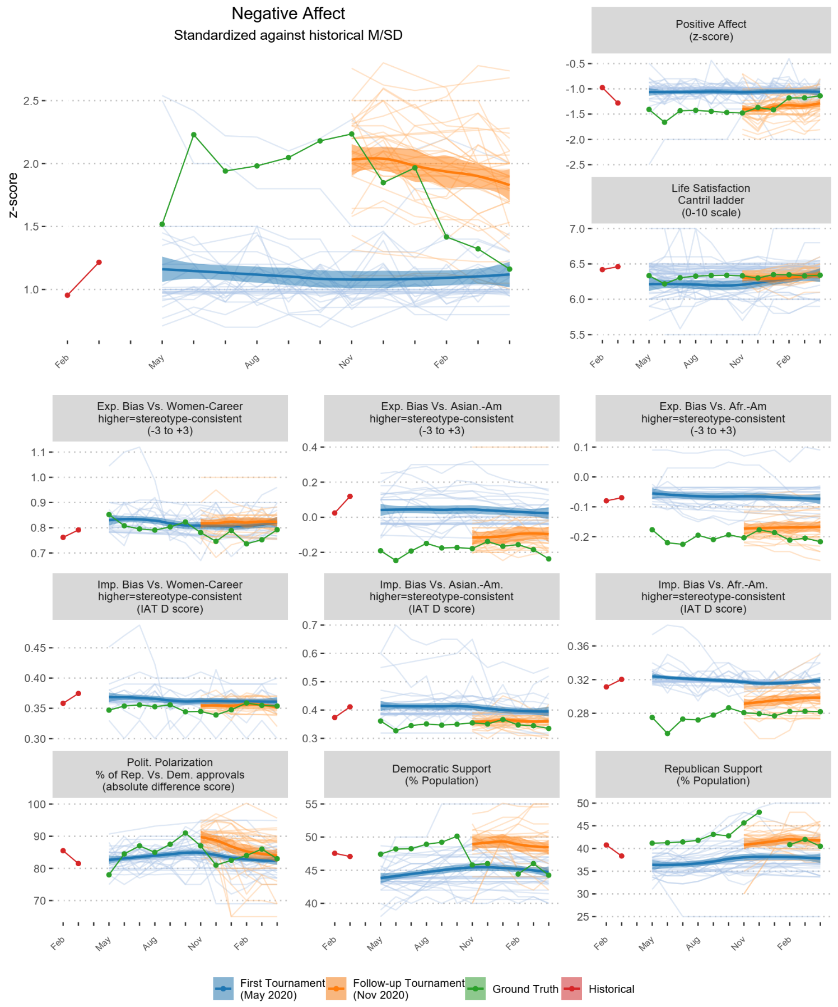
Forecasted models in the 12th and 6th-months tournaments, and ground truth markers, along with the last two historical data points teams received. Blue [orange] lines = forecasts in the May [November] 2020 Tournament. Aggregate trends (+/- 95% confidence band) obtained via a loess estimator. Negative affect is highlighted for visualization purposes.

Fig. S2. Average forecasting error, compared against benchmarks
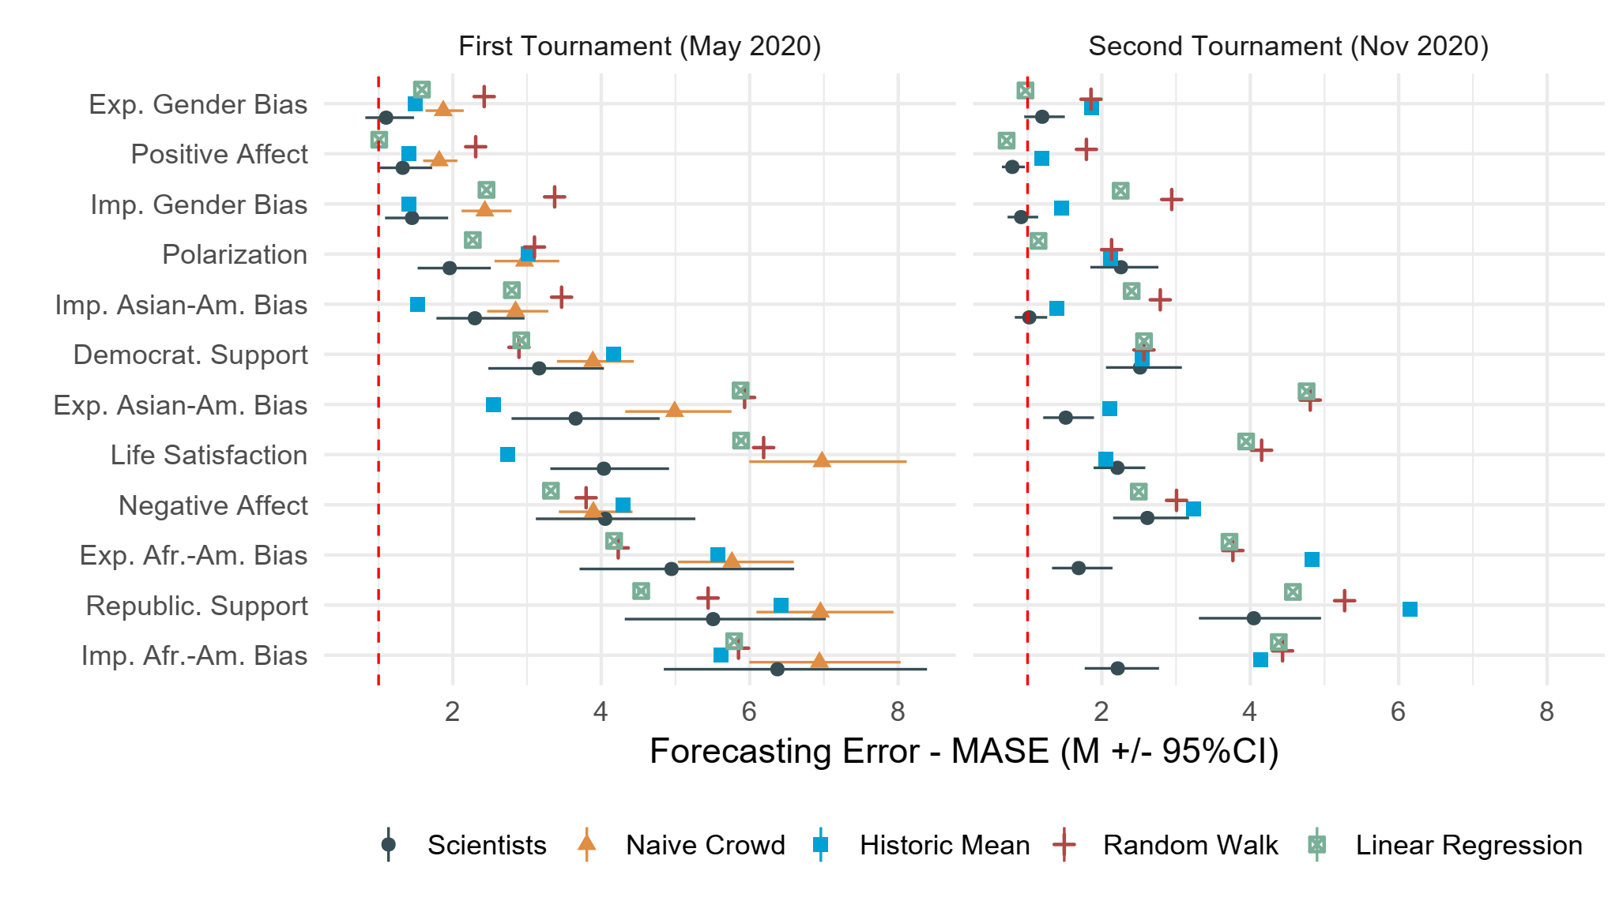
Average forecasting error, compared against benchmarks. We rank domains from least to most error in Tournament 1, assessing forecasting errors via mean absolute scaled error (MASE)². Scientists = estimated means and 95% Confidence Intervals from a linear mixed model with domain as a predictor of forecasting error (MASE) scores nested in teams. To correct for right skew, we used log-transformed MASE scores, which are subsequently back-transformed when calculating estimated means. In each tournament, confidence intervals are adjusted for simultaneous inference of estimates for 12 domains in each tournament by simulating a multivariate t distribution²². Benchmarks represent the historic mean, average random walk with an autoregressive lag of one, linear regression, and naïve crowd. Statistical benchmarks obtained via simulations (k = 10,000) with resampling. Dashed vertical line represents MASE = 1, with lower scores reflecting better performance than naïve in-sample random walk.

Fig. S3. Distribution of forecasting methods by domain

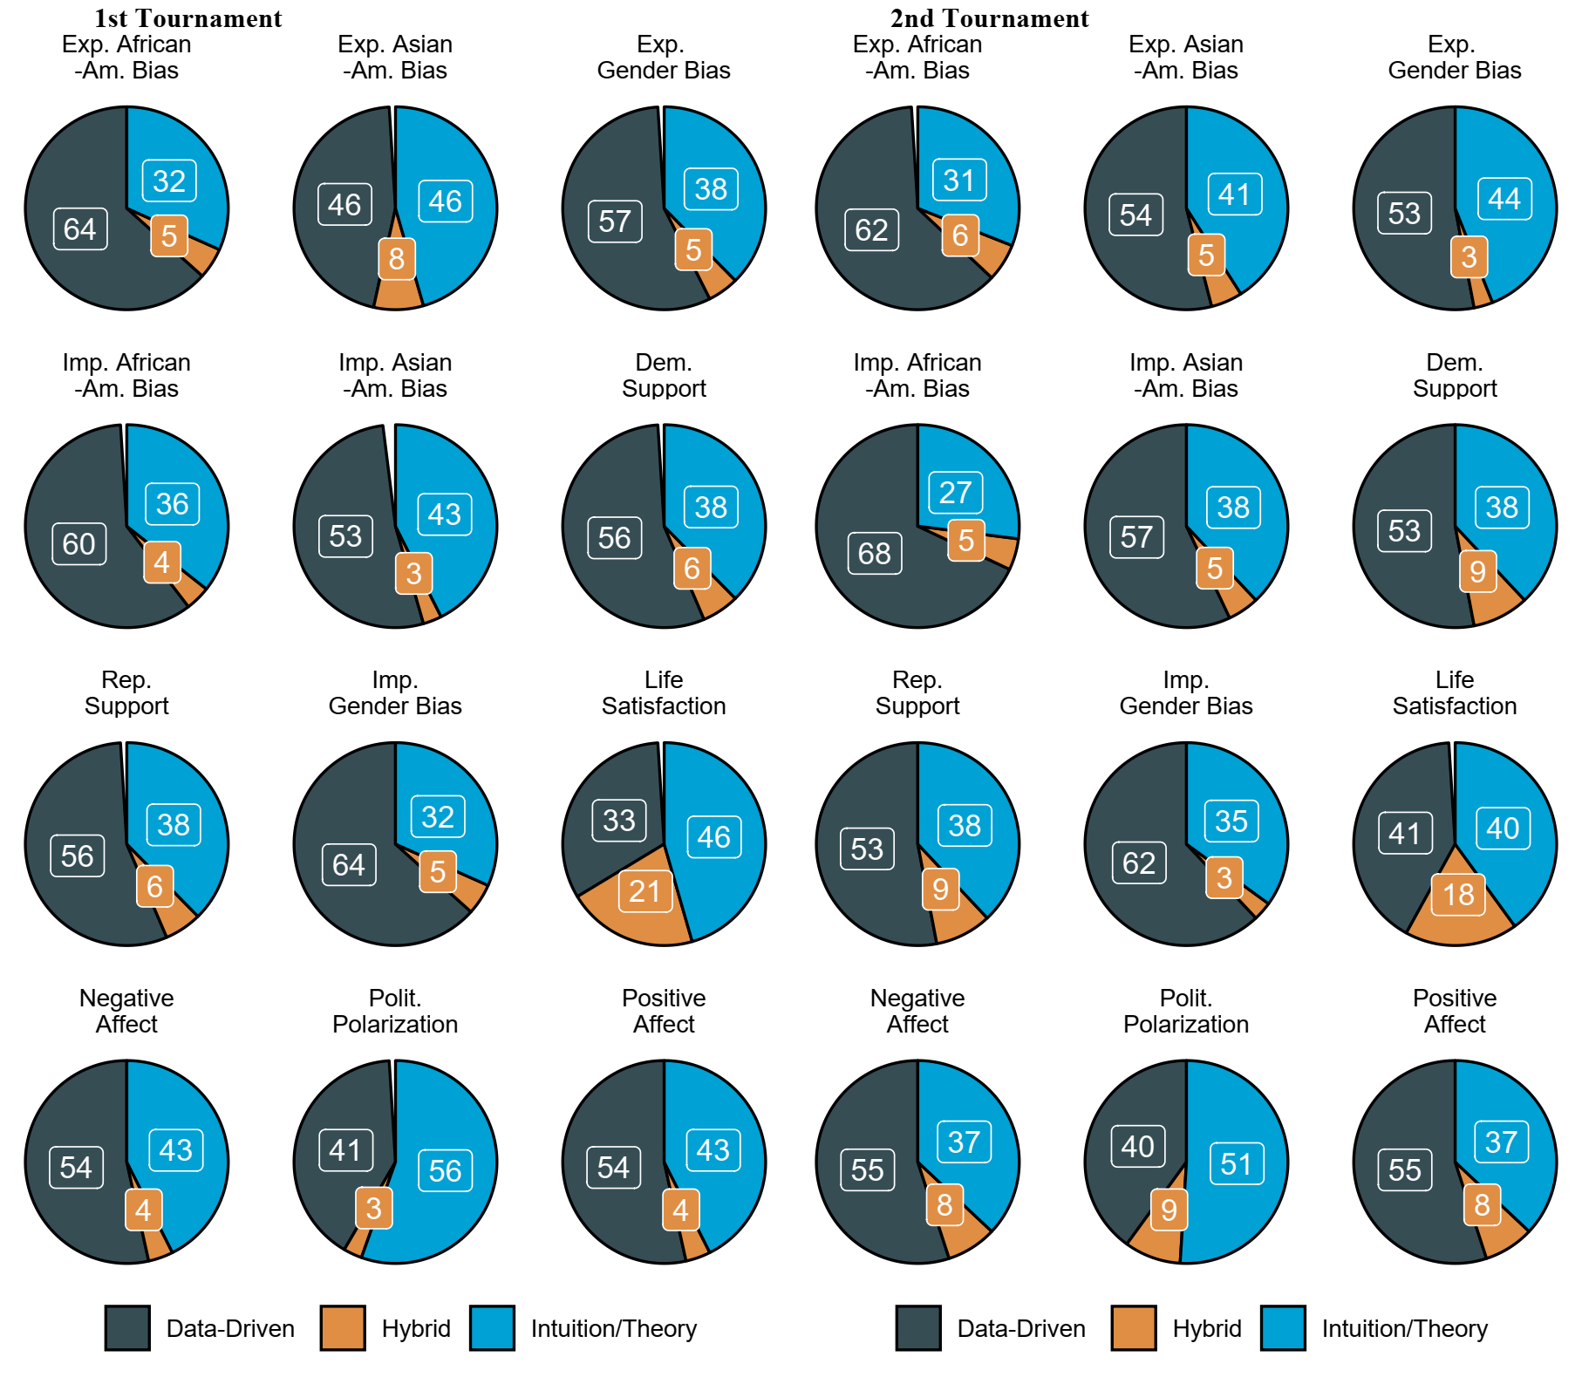
Distribution of forecasting methods -- data-driven / pure theory / hybrid (in %) – by domain

Fig. S4. Error among top 5 teams in each domain in Tournament 1, by approach
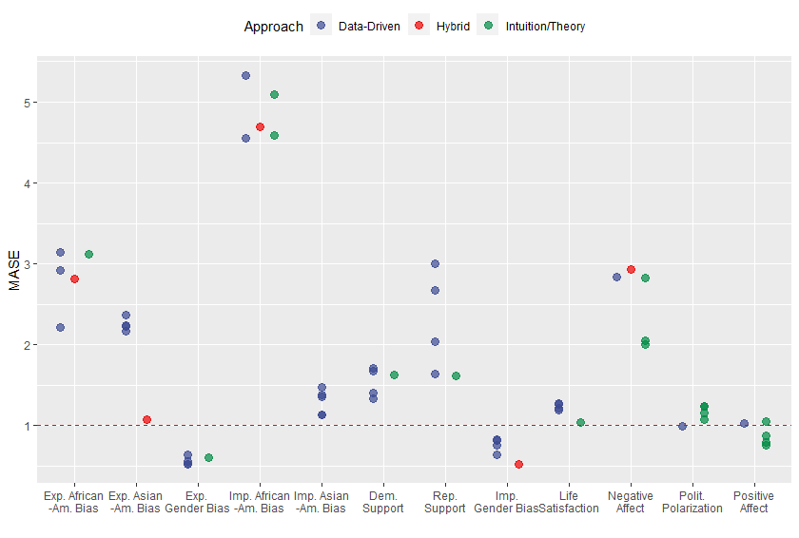
Error among top 5 teams in each domain in Tournament 1, by approach.

Fig. S5. Error among top 5 teams in Tournament 1 versus statistical benchmarks
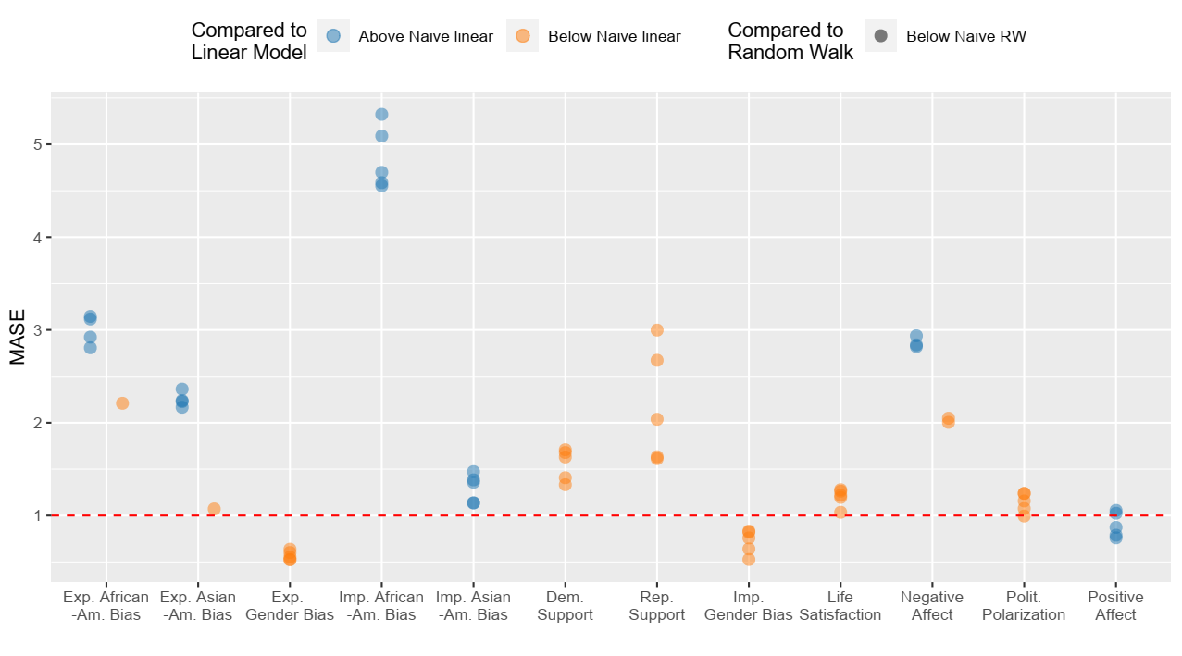
Error among top 5 teams in each domain in Tournament 1, contrasted with two naïve out of sample benchmarks - linear regression and random walk.

Fig. S6. Disciplinary affiliation of top 5 teams in each domain in Tournament 1
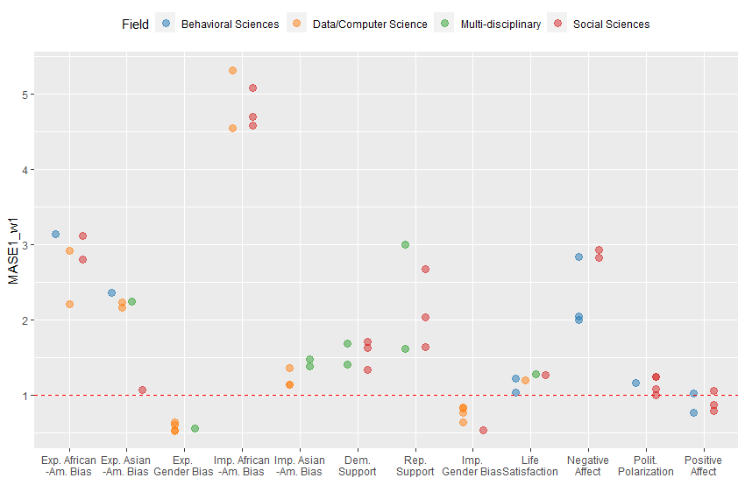

Disciplinary affiliation of top 5 teams in each domain in Tournament 1.

Fig. S7. Disciplinary affiliation of top 5 teams in each domain in Tournament 1
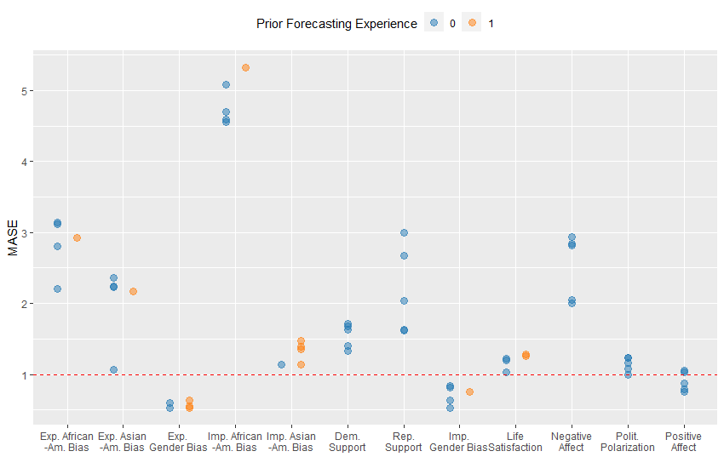
Disciplinary affiliation of top 5 teams in each domain in Tournament 1.

Fig. S8. Error among top 5 teams in each domain in Tournament 2, by approach
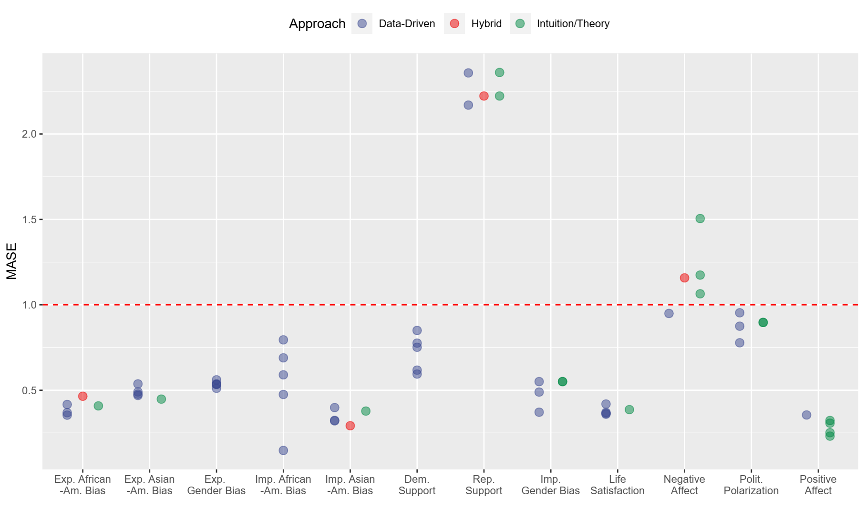
Error among top 5 teams in each domain in Tournament 2, by approach.

Fig. S9. Error among top 5 teams in Tournament 2 versus statistical benchmarks
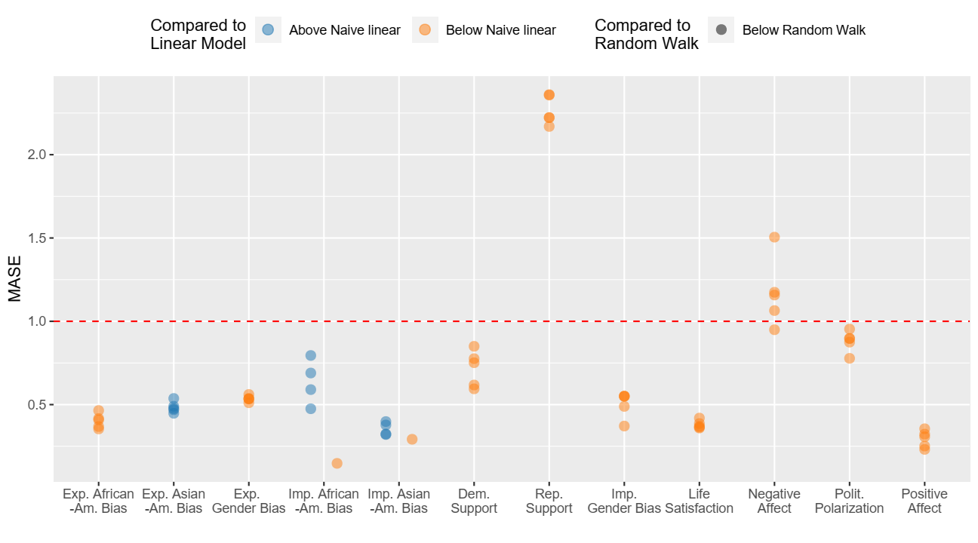
Error among top 5 teams in each domain in Tournament 2, contrasted with two naïve benchmarks - linear regression and random walk.

Fig. S10. Disciplinary affiliation of top 5 teams in each domain in Tournament 2
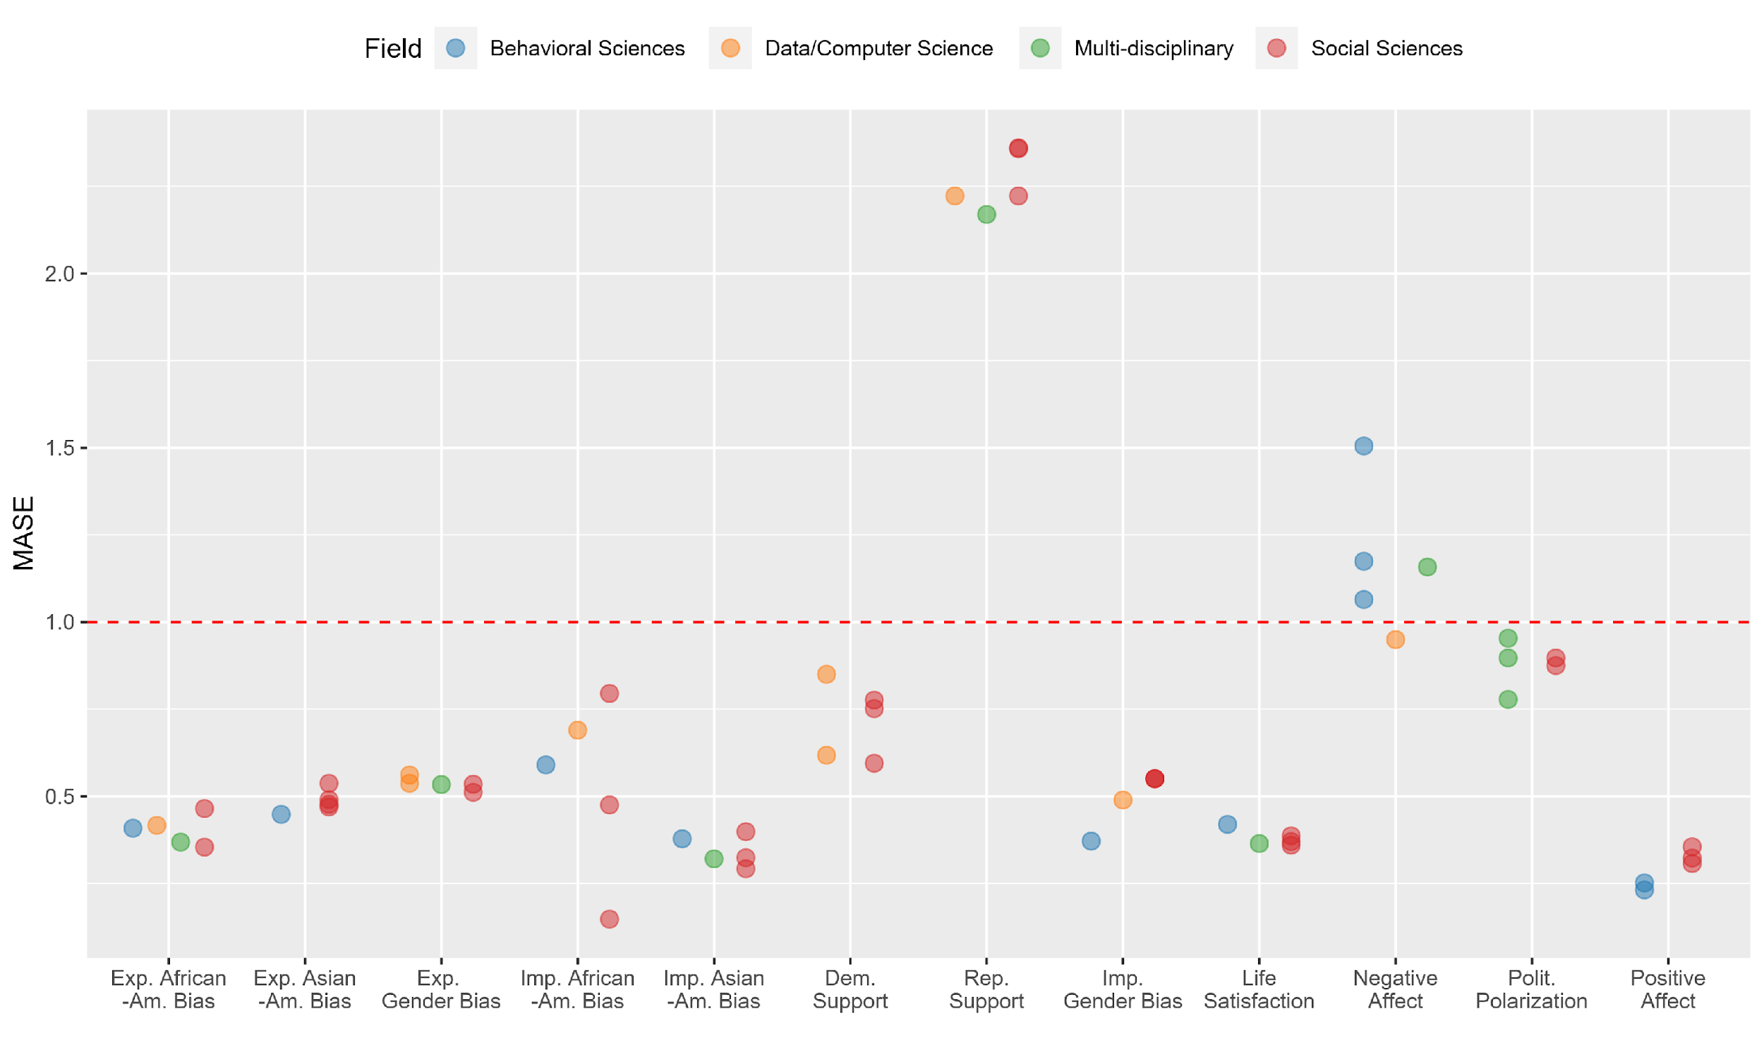
Disciplinary affiliation of top 5 teams in each domain in Tournament 2.

Fig. S11. Disciplinary affiliation of top 5 teams in each domain in Tournament 2
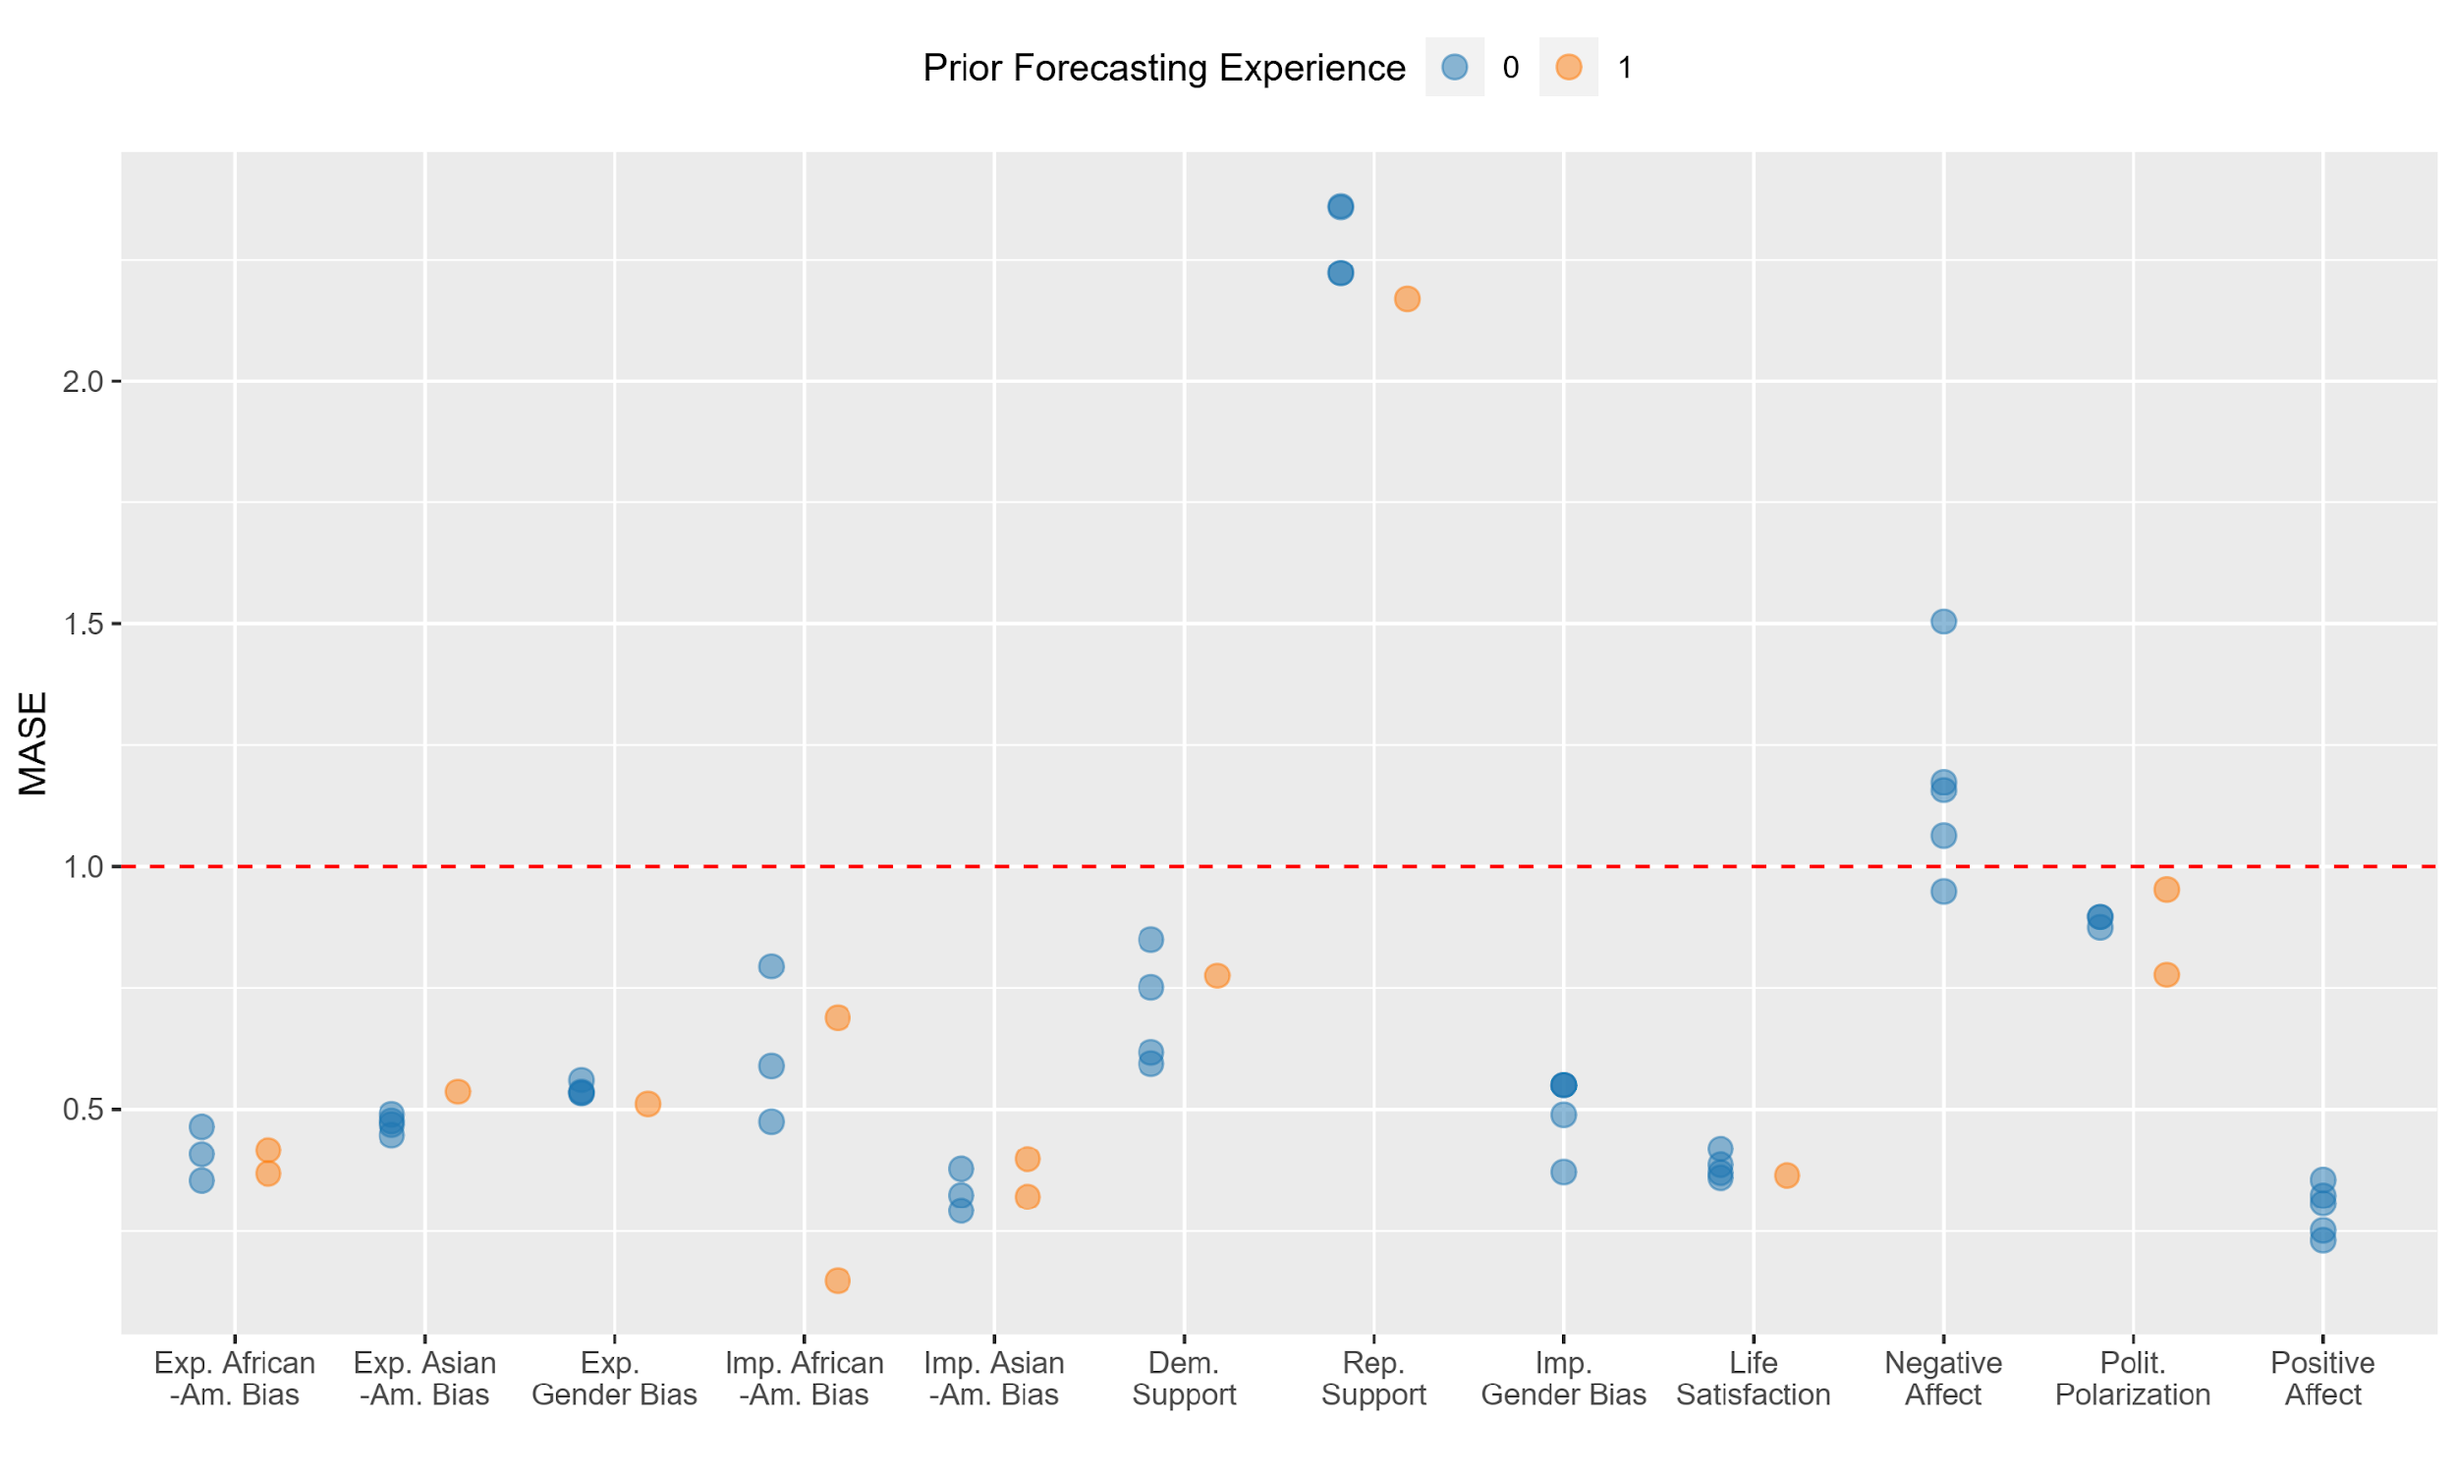
Disciplinary affiliation of top 5 teams in each domain in Tournament 2.

Fig. S12. Social scientists’ forecasts compared to estimated means in Tournament 1
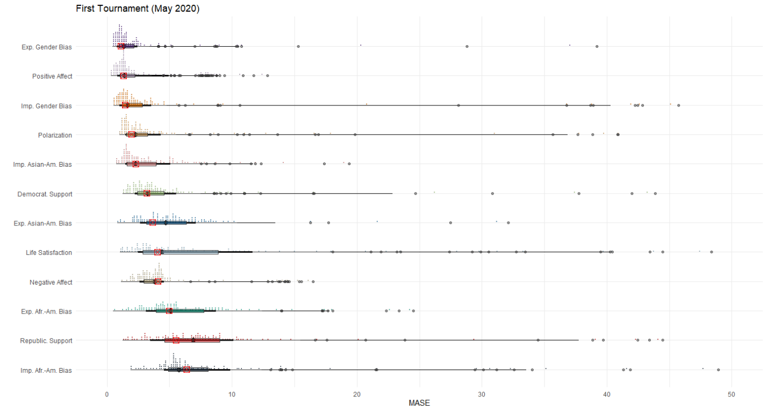
Boxplots and dot-plots with medians and outliers (round dots) and quantile intervals, as well as domain estimates from linear mixed model (red crossed square) in Tournament 1.

Fig. S13. Social scientists’ forecasts compared to estimated means in Tournament 2.
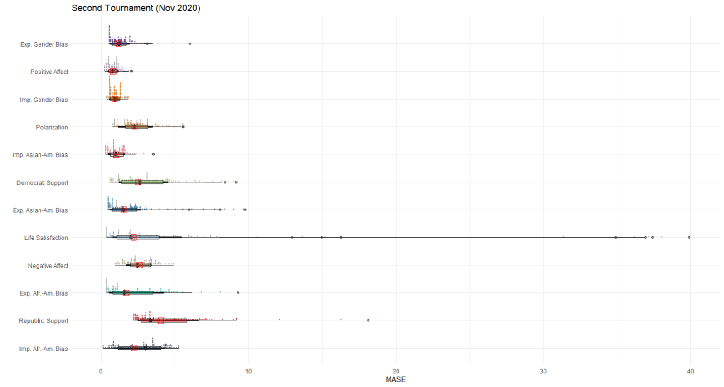

Boxplots and dot-plots with medians and outliers (round dots) and quantile intervals, as well as domain estimates from linear mixed model (red crossed square) in Tournament 2.

Fig. S14. Timeline of major historical events in the US during the tournament

Fig. S15. Forecasts and ground truth: Anchoring on the last few historical data points?

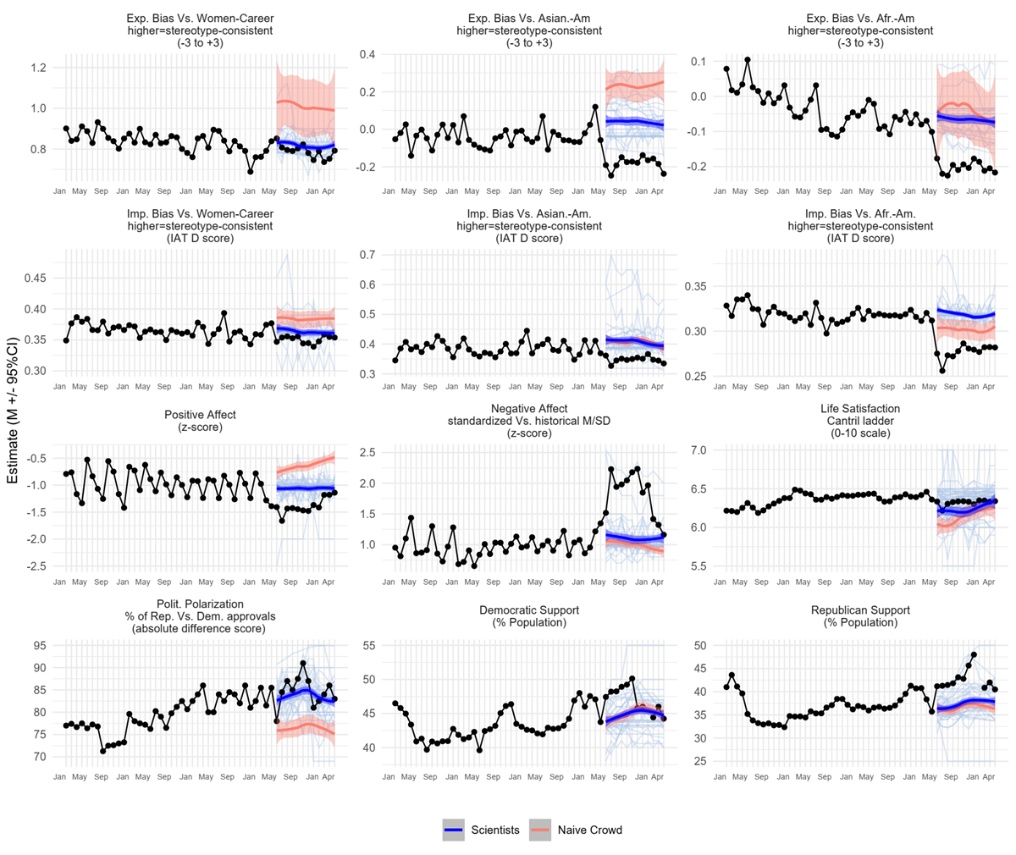

Historical time series (40 months before the Tournament 1) and ground truth series (12 months over the Tournament 1), along with forecasts of individual teams (light blue), lowess curve and 95% confidence interval across social scientists’ forecasts (blue), and lowess curve and 95% confidence interval across naïve crowd’s forecasts (salmon). For most domains, Tournament 1 forecasts of both scientists and the naïve crowd start near the last few historical data points they received prior to the tournament (January – March 2020). Note, April 2020 forecast was not provided to the participants.

Fig. S16. Forecasts and ground truth: Anchoring on the last few historical data points?
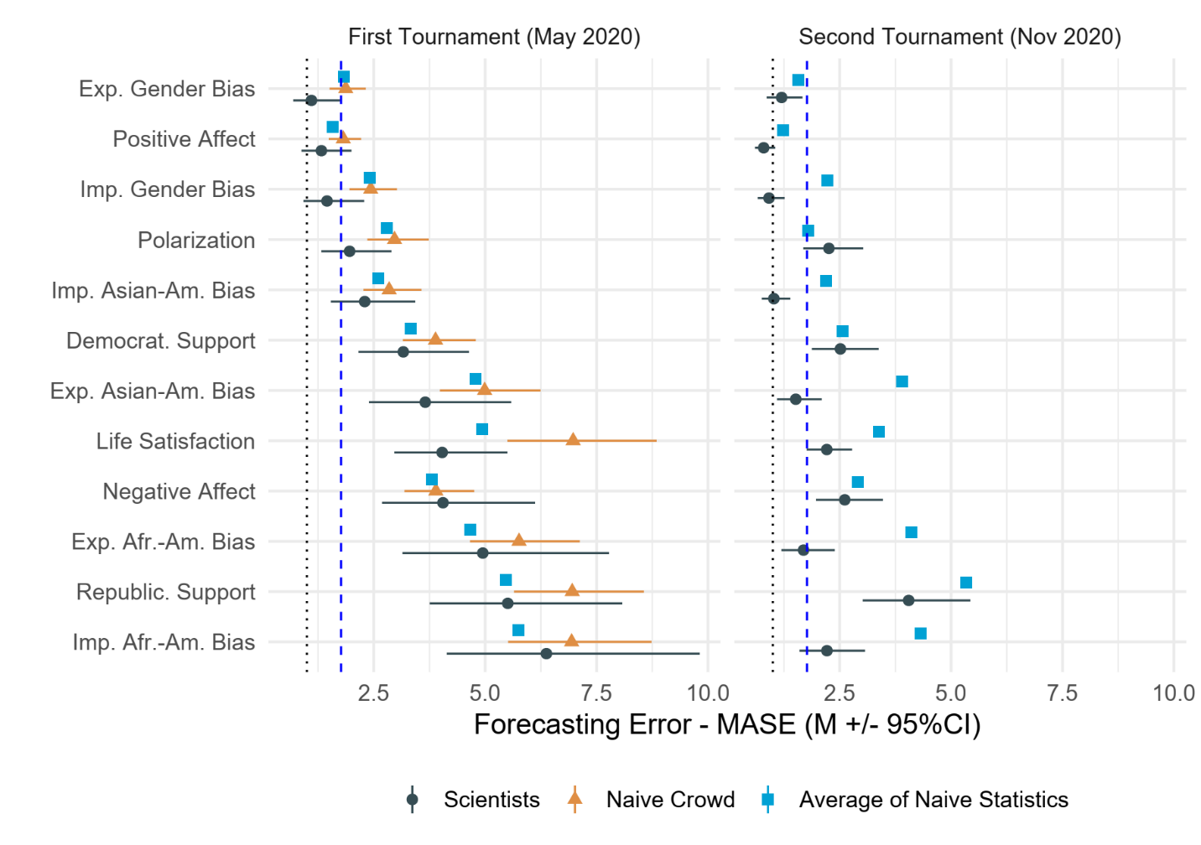
Social scientists’ average forecasting errors, compared against the average of different naïve statistical benchmarks. We rank domains from least to most error in Tournament 1, assessing forecasting errors via mean absolute scaled error (MASE). Scientists = estimated means and 95% Confidence Intervals from a linear mixed model with domain as a predictor of forecasting error (MASE) scores nested in teams. To correct for right skew, we used log-transformed MASE scores, which are subsequently back-transformed when calculating estimated means. In each tournament, confidence intervals are adjusted for simultaneous inference of estimates for 12 domains in each tournament by simulating a multivariate t distribution²⁰. Benchmarks represent the naïve crowd and the average of naïve statistical benchmarks (historic mean, average random walk with an autoregressive lag of one, or linear regression). Statistical benchmarks were obtained via simulations (k = 10,000) with resampling. Scores to the left of the dotted vertical line show better performance than naïve in-sample random walk. Scores to the left of the dashed vertical line show better performance than median performance in M4 tournaments.

Table S1. Demographic characteristics of forecasting teams.

 | First Tournament (May 2020) | Second Tournament  (Nov 2020)
N Teams | 86 | 120
N Participants | 135 | 190
Time size M (SD) | 1.57 (1.12) | 1.58 (1.10)
N Forecasted domains M (SD) | 4.17 (3.78) | 4.55 (3.88)
% Teams who predicted (published on):
Explicit gender-career bias | 24 (14) | 30 (14)
Implicit gender-career bias | 26 (9) | 31 (11)
Positive affect on social media | 33 (25) | 43 (33)
Political polarization | 37 (41) | 39 (43)
Life satisfaction | 66 (33) | 68 (37)
Explicit Asian American bias | 30 (12) | 31 (16)
Implicit Asian American bias | 35 (13) | 35 (19)
Democratic support -congressional ballot | 40 (41) | 39 (45)
Republican support - congressional ballot | 40 (41) | 39 (45)
Negative affect on social media | 33 (25) | 43 (33)
Explicit African American bias | 26 (18) | 27 (31)
Implicit African American bias | 29 (16) | 31 (27)
Age M (SD) | 38.18 (8.37) | 36.82 (8.30)
% without Doctoral Degree on a team M (SD) | 21.79 (39.58) | 25.59 (41.88)
% non-US on a team M (SD) | 59.69 (47.61) | 59.72 (47.82)
% non-male on a team M (SD) | 19.76 (36.36) | 21.78 (37.48)
% teams updated predictions in Nov 2020 | 44
Note. Percentage of forecasting teams with self-identified expertise—i.e., team members with publications on a particular topic—are relative to the total number of teams that chose to forecast a given topic.

Demographic characteristics of forecasting teams.

Table S2. Top performers in each domain in Tournament 1.

Rank | Domain | Scale of predicted value | 12m SD of observed data | 12m M absolute error | MASE | Team name
1 | explicit gender-career bias | Minus 6 (career is strongly female, whereas family is strongly male) to 6 (career is strongly male, whereas family is strongly female) | 0.033 | 0.02 | 0.52 | fearfulastra
2 | implicit gender-career bias | IAT D score (diff score of latencies / SD) | 0.006 | 0.01 | 0.53 | The Well-Adjusted R Squares
3 | positive affect on social media | z-scores, standardized on all prior time series data (M = 0.145 / SD = 0.0215) | 0.150 | 0.22 | 0.76 | Imielin
4 | political polarization | Abs difference of % support by Dem vs. Reps | 3.394 | 2.04 | 0.99 | Junesix
5 | life satisfaction | 0-10 scale | 0.036 | 0.03 | 1.04 | polarization-2020CO
6 | explicit Asian American bias | difference in majority - minority groups feeling t (0-100) | 0.032 | 0.06 | 1.07 | The Well-Adjusted R Squares
7 | implicit Asian American bias | IAT D score (diff score of latencies / SD) | 0.008 | 0.03 | 1.13 | NotGreatWithNamesTeam
8 | Democratic support -congressional ballot | % | 1.977 | 1.42 | 1.33 | AbCdEfG
9 | Republican support - congressional ballot | % | 2.286 | 1.57 | 1.61 | Erebuni
10 | Negative affect on social media | z-scores, standardized on all prior time series data (M = 0.145 / SD = 0.0215) | 0.372 | 0.39 | 2.00 | Imielin
11 | Explicit African American bias | difference in majority - minority groups feeling t (0-100) | 0.016 | 0.07 | 2.21 | fearfulastra
12 | Implicit African American bias | IAT D score (diff score of latencies / SD) | 0.011 | 0.03 | 4.55 | fearfulastra

Top performers in each domain in Tournament 1, ranked by accuracy across domains.

Table S3. Top performers in each domain in Tournament 2.

Rank | Domain | Scale of predicted value | 6m SD of observed data | 6m M absolute error | MASE | Team name
1 | Implicit African American bias | IAT D score (diff score of latencies / SD) | 0.010 | 0.001 | 0.15 | Polarization Disciples
2 | positive affect on social media | z-scores, standardized on all prior time series data (M = 0.145 / SD = 0.0215) | 0.094 | 0.062 | 0.23 | The Forecasting Four
3 | implicit Asian American bias | IAT D score (diff score of latencies / SD) | 0.011 | 0.007 | 0.29 | TAPE-Measurement
4 | Explicit African American bias | difference in majority - minority groups feeling t (0-100) | 0.018 | 0.011 | 0.35 | BlackSwan
5 | life satisfaction | 0-10 scale | 0.047 | 0.012 | 0.36 | Sociology
6 | Implicit gender-career bias | IAT D score (diff score of latencies / SD) | 0.005 | 0.004 | 0.37 | datamodelers
7 | Explicit Asian American bias | difference in majority - minority groups feeling t (0-100) | 0.033 | 0.026 | 0.45 | Imielin
8 | Explicit gender-career bias | −6 (career is strongly female, whereas family is strongly male) to 6 (career is strongly male, whereas family is strongly female) | 0.023 | 0.020 | 0.51 | Polarization Disciples
9 | Democratic support -congressional ballot | % | 0.944 | 0.632 | 0.59 | AbCdEfG
10 | political polarization | Abs difference of % support by Dem vs. Reps | 4.336 | 1.807 | 0.78 | BRTWN
11 | Negative affect on social media | z-scores, standardized on all prior time series data (M = 0.145 / SD = 0.0215) | 0.254 | 0.191 | 0.95 | Team Supreme Ignorance
12 | Republican support - congressional ballot | % | 0.822 | 2.204 | 2.17 | teamGreenLake

Top performers in each domain in Tournament 2, ranked by accuracy across domains

Table S4. Inaccuracy of Data-inclusive vs. Data-free Models.

Tournament | Domain | no data / data-inclusive Ratio | SE | df | t -ratio | P-value
First (May 2020) | Exp. African American Bias | 1.201 | 0.261 | 326.962 | 0.843 | . 515
 | Exp. Asian American Bias | 2.008 | 0.389 | 334.969 | 3.593 | .004
 | Explicit Gender-career bias | 1.729 | 0.372 | 329.761 | 2.542 | .103
 | Imp. African American Bias | 1.142 | 0.233 | 334.319 | 0.651 | .515
 | Imp. Asian American Bias | 2.237 | 0.414 | 333.967 | 4.356 | <.001
 | Ideology Democrats | 1.440 | 0.255 | 333.820 | 2.053 | .286
 | Ideology Republicans | 1.256 | 0.223 | 333.820 | 1.285 | .515
 | Implicit Gender-career Bias | 2.106 | 0.460 | 328.407 | 3.409 | .007
 | Life Satisfaction | 1.402 | 0.197 | 298.454 | 2.398 | .137
 | Negative Affect | 0.768 | 0.143 | 333.845 | -1.414 | .515
 | Political Polarization | 0.871 | 0.157 | 331.211 | -0.767 | .515
 | Positive Affect | 0.772 | 0.144 | 333.845 | -1.384 | .515
Second (Nov 2020) | Exp. African American Bias | 1.107 | 0.276 | 510.618 | 0.406 | .685
 | Exp. Asian American Bias | 1.125 | 0.252 | 521.995 | 0.527 | .685
 | Explicit Gender-career Bias | 2.089 | 0.463 | 519.138 | 3.321 | .011
 | Imp. African American Bias | 1.235 | 0.303 | 520.239 | 0.862 | .685
 | Imp. Asian American Bias | 1.276 | 0.273 | 520.237 | 1.140 | .685
 | Ideology Democrats | 1.611 | 0.325 | 521.668 | 2.368 | .182
 | Ideology Republicans | 1.167 | 0.235 | 521.668 | 0.768 | .685
 | Implicit Gender-career Bias | 1.145 | 0.259 | 515.449 | 0.596 | .685
 | Life Satisfaction | 2.067 | 0.322 | 478.215 | 4.663 | <.001
 | Negative Affect | 0.790 | 0.155 | 519.240 | -1.204 | .685
 | Political Polarization | 1.086 | 0.214 | 517.811 | 0.418 | .685
 | Positive Affect | 0.708 | 0.139 | 519.240 | -1.762 | .685
Note. Ratio = data-free MASE / data-inclusive MASE. Scores >1: greater accuracy of data-inclusive forecasts. Scores <1: greater accuracy of forecasts based on intuition / theory alone. Contrasts obtained via emmeans package ⁹ in R ⁷. To avoid skew, tests performed on log-transformed MASE scores. Degrees of freedom obtained via Kenward-Roger approximation.
Contrasts of Mean-level Inaccuracy (MASE) among Scientists Using Data-inclusive vs. Data-free Models.

Table S5. Effect of strategies & individual characteristics on forecasting accuracy.

 | Unstandardized Coefficients | Standardized Coefficients
(Intercept) | -1.96 ** | -2.15 **
 | (0.66) | (0.66)
N model parameters | -0.02 | -0.13
 | (0.01) | (0.08)
Statistical model complexity | -0.14 * | -0.20 *
 | (0.06) | (0.09)
Considered COVID-19 (yes/no) | 0.04 | 0.04
 | (0.08) | (0.08)
Considered counterfactuals (yes/no) | -0.08 | -0.08
 | (0.06) | (0.06)
Number of predicted domains | 0.02 | 0.13
 | (0.01) | (0.11)
Data Scientists on the team (yes/no) | 0.89 | 0.89
 | (0.67) | (0.67)
Behav.-Soc Scientists on the team (yes/no) | 1.15 | 1.15
 | (0.65) | (0.65)
Multidisciplinary | 1.16 | 1.16
 | (0.67) | (0.67)
Team size | 0.02 | 0.05
 | (0.06) | (0.13)
% Team members without a PhD | 0.001 | 0.11
 | (0.001) | (0.11)
Confidence in forecast | -0.01 | -0.03
 | (0.03) | (0.08)
Self-reported expertise | -0.03 | -0.12
 | (0.03) | (0.10)
Team members published in the forecasted domain (yes/no) | 0.26 ** | 0.26 **
 | (0.09) | (0.09)
Prior engagement with forecasting tournaments | 0.35 * | 0.35 *
 | (0.17) | (0.17)
N | 905
N (teams) | 120
AIC | 1940.35
BIC | 2074.97
R2 (fixed) | 0.31
R2 (total) | 0.58
Note: The model also includes domain as a set of 11 dummy-covariates. All continuous predictors are mean-centered. Standard errors, in parentheses, are heteroskedasticity robust. In the standardized model, predictors are scaled by 2 standard deviations. *** p < .001; ** p < .01; * p < .05.
Regression model coefficients demonstrating effects of forecasting strategies and individual characteristics predicting forecasting accuracy across two tournaments.

Table S6. Effects of different updating rationales for forecasting inaccuracy.

Variable | Est. | S.E. | t | df | P
Intercept | 0.359 | 0.117 | 3.068 | 48.213 | .004
Update based on Data Received | -0.135 | 0.169 | -0.801 | 61.505 | .426
Update based on theory | 0.782 | 0.662 | 1.181 | 78.712 | .241
Update based on consideration of external events | 0.081 | 0.167 | 0.484 | 98.156 | .630
N | 162
N (teams) | 38
AIC | 412.53
BIC | 431.06
R2 (fixed) | 0.02
R2 (total) | 0.17
Note: All continuous predictors are mean-centered. Standard errors, in parentheses, are heteroskedasticity robust. In the standardized model, predictors are scaled by 2 standard deviations. *** p < .001; ** p < .01; * p < .05.

Regression model coefficients demonstrating effects of different updating rationales for forecasting inaccuracy in the Second Tournament.

Table S7. Exclusions by category when processing the general public sample.

Data Filtering Step | Unique Participants | Participants Removed | N Predictions | Predictions Removed
Original N | 1891
Remove incomplete 12-month predictions | 1173 | 718 | 2638
Remove Duplicate submissions | 1155 | 18 | 2611 | 27
Remove Outliers | 1094 | 59 | 2448 | 163
Remove misunderstood responses | 1088 | 6 | 2426 | 22
Remove bogus responses | 1062 | 26 | 2330 | 96
Remove Responses below 50 sec | 803 | 259 | 1469 | 861
Removed flagged Covid responses* | 802 | 1 | 1467 | 2
Note. *Covid-related open-ended responses were not originally reviewed in the coding and were coded at a later stage. Two participants were flagged – one for indicating their predictions were based on Russia, not the U.S., and the other for responding in Spanish instead of English. One of these participants was already flagged in a previous step, which is why only one participant/responses were removed at this stage.

Breakdown of exclusions of the general public sample by category.

Table S8. Comparison of resampled historical mean and averaged historical mean in Tournament 1.
Domain | Historical Mean | Resample Mean | |Diff| | ln(MASE) historical mean | ln(MASE) resample mean | |Diff|
Explicit Prejudice –  Af Am | -0.035 | -0.035 | 0.000 | 1.718 | 1.713 | 0.005
Explicit Prejudice –  Asian | -0.037 | -0.037 | 0.000 | 0.932 | 0.925 | 0.006
Explicit Prejudice –  Gender | 0.837 | 0.837 | 0.000 | 0.184 | 0.381 | 0.197
Implicit Prejudice –  Af Am | 0.319 | 0.319 | 0.000 | 1.726 | 1.725 | 0.001
Implicit Prejudice –  Asian | 0.386 | 0.386 | 0.000 | 0.404 | 0.410 | 0.006
Implicit Prejudice –  Gender | 0.365 | 0.365 | 0.000 | 0.241 | 0.326 | 0.085
Support for Democrats | 43.291 | 43.299 | 0.008 | 1.348 | 1.414 | 0.066
Support for Republicans | 36.721 | 36.708 | 0.013 | 1.845 | 1.855 | 0.010
Life Satisfaction | 6.362 | 6.362 | 0.000 | 0.304 | 0.998 | 0.694
Negative Affect | 0.973 | 0.974 | 0.001 | 1.453 | 1.455 | 0.002
Polarization | 79.385 | 79.391 | 0.005 | 1.021 | 1.091 | 0.070
Positive Affect | -0.973 | -0.973 | 0.000 | 0.310 | 0.333 | 0.023
Note. Historical Mean was calculated by averaging all historical data per domain and using this value (repeated for each of the 12 months) as the forecast for computing MASE scores. Resample Mean was calculated by creating 10,000 simulated forecasts and computing the average MASE/ln(MASE) across these 10000 forecasts. Each forecast was created by sampling with replacement 12 values from the historical observations, then computing the MASE score for these 12 values compared to the observed domain values.

Table S9. Table of content for the main R Markdown analyses
Name of .Rmd chunks | Output / Specific Goal
Chunk 1 “setup” | Load R packages needed
Chunk 2 “setup working directory” | Setup working directory
Chunk 3 “Import data” | Import data
Chunk 4 “get simulated benchmark data & add RW to data” | MASE differences between the participants’ MASE and the MASE of random walk of Tournament 1 and 2.  Model comparison categories based on MASE cutoff scores.
Chunk 5 “set subsets of data for analyses” | Data subsets that fulfill certain conditions for later analysis. For instance, only Tournament 1 data, only Tournament 2 data, objective experts, etc.
Chunk 6 “create subsets for separate visualizations” | Dataset with labels that are close to natural language for data visualization.  Dataset with important statistics for visualization. For instance, mean, median, top performance for different domains and level of expertise
Chunk 7 “create a file to share with teams to announce how they did” | Prepare both tournament datasets to share with the academic teams about how they did (MASE) compared with the Ground truth marker and their rank.
Chunk 8 “visualize top performers” | Fig. S4. - Fig. S11. Error among top 5 teams in each domain in Tournament 1, by approach.
Chunk 9 “Inspect historical trends and calculate complexity” | Markers of complexity for the tournament, including sd, mad, and an supplementary metric of permutation entropy
Chunk 10 “PHASE 1 prep and simple visualizations of trends” | Fig. S1.
Chunk 11 “Phases 1 and 2 along with sims” | graph individual predictions and ground truth markers - Fig. S2 THE SUPPLEMENT in the PAPER, as well as one Figure 1 in the MAIN TEXT)  analyses of scientists versus lay people in tournament 1
Chunk 12 | statistical tests of difference from benchmark.  Figure 2.
Chunk 13 | compare scores from tournament 1 and tournament 2  test complexity associations
Chunk 14 | graph change in ranking.  Figure 3.
Chunk 15 “ranking in phase 1 and complexity” | ranking of domain by forecasting error and correlation to historical variability in trends
Chunk 16 | compare scores from tournament 1 - first six months vs. last six months
Chunk 17 | Consistency in forecasting
Chunk 18 | visualize by method (phase 1 and 2)  Figure 4
Chunk 19 | examine effects of covariates across both tournaments
Chunk 20 | Role of Updating - Phase 2
Chunk 21 | demographics Phase 1
Chunk 22 | demographics lay people

Supplementary References
1. Hyndman, R. J. & Athanasopoulos, G. Forecasting: principles and practice. (OTexts, 2021).
2. Hyndman, R. J. & Koehler, A. B. Another look at measures of forecast accuracy. Int. J. Forecast. 22, 679–688 (2006).
3. Makridakis, S., Spiliotis, E. & Assimakopoulos, V. The M4 Competition: 100,000 time series and 61 forecasting methods. Int. J. Forecast. 36, 54–74 (2020).
4. Makridakis, S., Spiliotis, E. & Assimakopoulos, V. The M5 competition: Background, organization, and implementation. Int. J. Forecast. (2021). doi:10.1016/j.ijforecast.2021.07.007
5. Bates, D., Mächler, M., Bolker, B. & Walker, S. Fitting Linear Mixed-Effects Models Using lme4. J. Stat. Softw. 67, (2015).
6. Goodrich, B., Gabry, J., Ali, I. & Brilleman, S. rstanarm: Bayesian applied regression modeling via Stan. (2020).
7. R Core Team. R: A Language and Environment for Statistical Computing. (2022).
8. Rouder, J. N. & Morey, R. D. Default Bayes Factors for Model Selection in Regression. Multivariate Behav. Res. 47, 877–903 (2012).
9. Lenth, R., Singmann, H., Love, J. & Maxime, H. emmeans: Estimated Marginal Means, aka Least-Squares Means. (2020).
10. Makowski, D., Ben-Shachar, M. & Lüdecke, D. bayestestR: Describing Effects and their Uncertainty, Existence and Significance within the Bayesian Framework. J. Open Source Softw. 4, 1541 (2019).
11. Athanasopoulos, G., Hyndman, R. J., Song, H. & Wu, D. C. The tourism forecasting competition. Int. J. Forecast. 27, 822–844 (2011).

Appendix S1. Example submission forms.
Time |  | Democrat |  | Republican
May-20 |  |  |  |  | ← | enter your monthly estimates in the box to the left
Jun-20 |  |  |  |  | ← | enter your monthly estimates in the box to the left
Jul-20 |  |  |  |  | ← | enter your monthly estimates in the box to the left
Aug-20 |  |  |  |  | ← | enter your monthly estimates in the box to the left
Sep-20 |  |  |  |  | ← | enter your monthly estimates in the box to the left
Oct-20 |  |  |  |  | ← | enter your monthly estimates in the box to the left
Nov-20 |  |  |  |  | ← | enter your monthly estimates in the box to the left
Dec-20 |  |  |  |  | ← | enter your monthly estimates in the box to the left
Jan-21 |  |  |  |  | ← | enter your monthly estimates in the box to the left
Feb-21 |  |  |  |  | ← | enter your monthly estimates in the box to the left
Mar-21 |  |  |  |  | ← | enter your monthly estimates in the box to the left
Apr-21 |  |  |  |  | ← | enter your monthly estimates in the box to the left
 | Data Source: |  | Aggregated weighted data from the Congressional Generic Ballot polls conducted between January 2017 and March 2020.
 |  |  | Congressional generic Ballot asks representative samples of Americans to indicate which party they would support in an election.
 |  |  | Obtained from projects.fivethirtyeight.com/congress-generic-ballot-polls

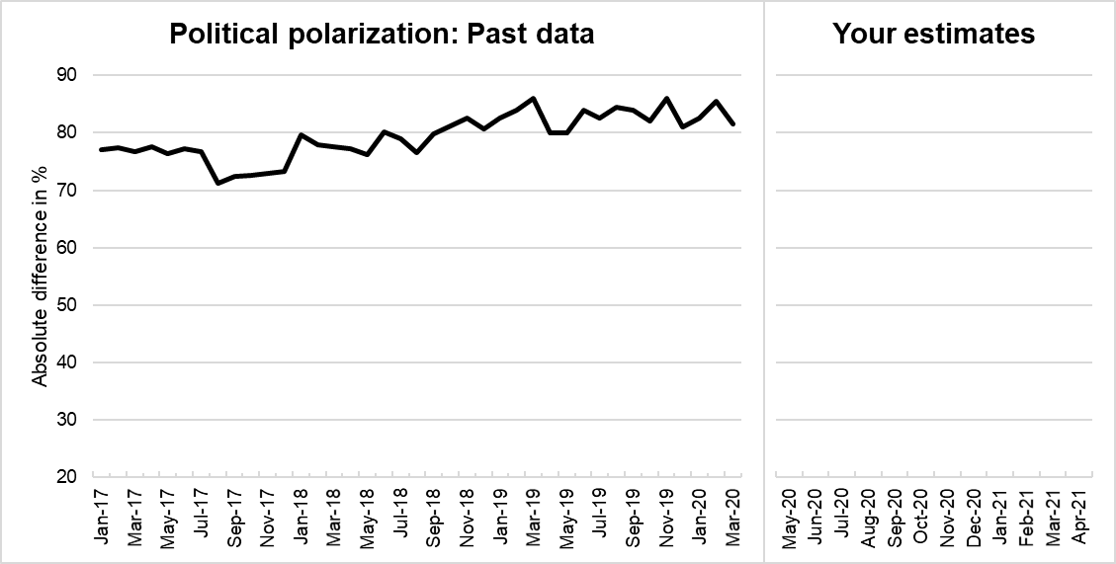
Time | Polarization Score
May-20 |  | ← | enter your monthly estimates in the box to the left
Jun-20 |  | ← | enter your monthly estimates in the box to the left
Jul-20 |  | ← | enter your monthly estimates in the box to the left
Aug-20 |  | ← | enter your monthly estimates in the box to the left
Sep-20 |  | ← | enter your monthly estimates in the box to the left
Oct-20 |  | ← | enter your monthly estimates in the box to the left
Nov-20 |  | ← | enter your monthly estimates in the box to the left
Dec-20 |  | ← | enter your monthly estimates in the box to the left
Jan-21 |  | ← | enter your monthly estimates in the box to the left
Feb-21 |  | ← | enter your monthly estimates in the box to the left
Mar-21 |  | ← | enter your monthly estimates in the box to the left
Apr-21 |  | ← | enter your monthly estimates in the box to the left

Data Source: | Aggregated data from the Gallup polls conducted between January 2017 and March 2020.
 | Data represents absolute value of the difference score in Presidential Job Approval by Party Identification (Democrat vs. Republican)
 | Obtained from news.gallup.com/poll/203198/presidential-approval-ratings-donald-trump.aspx

Appendix S2. Screening Bogus / Low Comprehension Responses in the General Public
Verbatim information provided to coders, including standardized information about the study.
Participants were asked to submit predictions of how they expected different domains to change over the course of a year. The 12 domains were: Life satisfaction; Affect (both positive and negative); Political polarization; Ideological preferences (Democrat & Republican); African American bias (implicit and explicit); Asian American bias (implicit and explicit); Gender-career bias (implicit and explicit). In addition to submitting their forecasts, we asked them to answer questions regarding how they went about creating those forecasts. Participants provided written responses to 3 different questions which are denoted by the following columns:
Column Name | Question Asked
Theory | Please describe your thought process for generating your predictions for life satisfaction.  If your forecast is based on theoretical assumptions, please describe your assumptions.
Parameters | Did you consider additional variables in your predictions?  By additional variables we mean variables other than prior data on life satisfaction itself. These variables can include single-shot events (e.g., political leadership change; implementation of a particular policy) or variables that change over time (e.g., COVID-19 deaths; unemployment rate). Describe your decision process when making your predictions.
Coviddesc | What is the role of COVID-19 pandemic trajectory in your Life Satisfaction forecast? Please, describe how you think this variable impacts your Life Satisfaction predictions.
Note. Not all participants were required to answer the Coviddesc question as it was only presented if they selected a particular response to a previous question.
Your task is to look at their written responses for these 3 columns and assign a value of 0 (no issue), 1 (did not understand), or 2 (bogus response) to each row.
2 Bogus responses are responses where the participant did not take the study seriously. For instance, participant wrote the following responses for each column:
Theory | Parameters | Coviddesc
“Ok” | “Ok” | “good”
In this case, the participant avoids answering all 3 questions and we cannot assume they took the survey seriously as a result.
1 Did not understand responses refer to participants who did not understand the question posed or the predictions they were supposed to make. Keep in mind that you are not coding them on the quality of their response. If their response includes a rationale that informed their prediction and doesn’t explicitly indicate they misunderstood the question, do not code as “didn’t understand.”
For instance, participant wrote the following responses for each column.
Theory | Parameters | Coviddesc
“The data seems to go up and down” | “I thought that maybe as more people are using Twitter currently it could be higher but will drop after lockdowns release” | “I thought it would make it go higher”
In this case, the participant’s responses indicate that they likely misunderstood what the data we provided was about. They are assuming that more Twitter users = higher life satisfaction (because the life satisfaction data was based on twitter data), but that’s not what we were asking them to predict!
0 No issue responses refer to responses where the participants responded in good faith and did not noticeably misunderstand the task. NOTE: rows can be flagged as “no issue” even if only one of the columns was responded to, so long as the response doesn’t come across as problematic.

Appendix S3. Coding Instructions for Forecasting Method

Teams could select multiple methods for their forecasts, including intuition, theory, simulation-based, data-driven, or others. For the chief analyses, we were interested in teams that relied on data-inclusive vs. data-free methods. Therefore, to cross-validate forecasting methods provided by teams, and to obtain markers of data-inclusive vs. data-free methods, two research assistants independently reviewed submission justifications and rationales. The following steps describe the process used to code participant submissions in terms of the type of forecasting method:

- Intuition – These are forecasts where the participant made their predictions by relying solely on their intuition.
- Participants who made such forecasts relied on their expert intuitions to estimate how they expected the variable to change over the next year.
- Example 1: The participant indicates that they “expected the difference between democrats and republicans to become larger toward November” because of the election.
- Example 2: The participant predicts that the holidays would lead to an increase in life satisfaction, followed by a decrease after the New Year.
- Theory – These were forecasts where the participant indicated that their predictions were guided by a particular theory.
- Example 1: The participant mentions that their predictions were based on “hedonic adaptation” theory, which predicts a return to baseline after a significant event such as the pandemic.
- Example 2: Participant mentions that their model is based on the “family stress model,” which predicts that great social disruption and economic fallout leads to significant drops in life satisfaction.
- Data-driven – These were forecasts where the participant indicated that they used one or more data-driven forecasting methods.
  - Participants may have indicated they used one or more methods of forecasting that can vary in complexity.
  - These methods ranged from simple mean of the data provided to complex autoregressive moving average (ARIMA) models or econometric models.
- Hybrid – These were forecasts that used Data-driven methods AND either Intuition and/or Theory.
  - If a participant indicated that they used both Theory and Intuition, but NOT Data, coders were instructed to mark it as Theory.
Because the number of participants who explicitly mentioned theory was underpowered (n = 9 in Tournament 1), we collapsed this category with intuition-based judgments.

Appendix S4. Coding Instructions for Model Complexity

Model complexity was coded on a 1-3 scale, indicating the complexity of the forecasting methods used by participants to develop their forecasts:
- Simple forecasting method
  - Simple forecasting methods referred to forecasting methods that did not account for any additional parameters or variables, such as regression to the mean, Intuition-based forecasts, and/or simple Drift models.
- Moderate forecasting method
  - Moderate forecasting methods referred to forecasting methods that used 1-3 additional parameters to develop their forecasts, such as univariate time series forecasting models, Holt-Winters seasonal corrections, & auto-regressions with time lags.
- Complex forecasting method
  - Complex forecasting methods refer to forecasting methods that use more than 3 additional parameters to develop their forecasts, such as ARIMA and dynamic econometric models.
Coders were instructed to consider the number of parameters teams used. They were also instructed to base their judgment on the method participants provided in their rationales (e.g., ARIMA) in cases where a participant mentioned a complex method but did not list any (or few) additional parameters. In case multiple models were mentioned, coders identified the model teams indicated they used for the actual forecast itself.

Appendix S5. Coding Instructions for Updating Justifications

Coders were provided with the following instructions:

“You will be presented with a data set containing participant responses with regards to the theory, methods, and parameters they considered in their forecast. All responses are from teams that had submitted a forecast 6 months prior, and who chose to update their forecasts after receiving a comparison of how their forecasts had compared so far to the actual results for the domains they predicted.
Your task is to review their responses and determine whether they meet the criteria for the following categories of justification:
- Updated based on data received: The team indicates they updated their data based on the updated data set we provided them.
  - To be coded for this category, the participants need to explicitly mention that they updated their response in response to the new data being provided.
  - E.g., “Updating my estimates based on the mean”
- Updated due to theoretical insights: The team indicates they updated their data based on an explicitly mentioned theory.
  - To be coded for this category, the participants must explicitly mention a theory as the reason for their updated forecast.
- Updated due to consideration of external events: The team indicates they updated their data based on events that have occurred in the 6 months since their original forecast.
  - To be coded for this category, the participants must explicitly mention an external event as the reason for updating their forecast.
  - E.g., “After testing for seasonality and discontinuity, we used the mean of new values after the onset of COVID-19 pandemic and racial protests in the USA.”
Each category is coded in a separate column as either a 1 (Justification present) or 0 (Justification not present). Please note, a response can be coded for multiple categories, in which case it would be marked as a 1 in each of the relevant columns.”

