An exploratory study provides insights into MMP9 and Aβ levels in the vitreous and blood across the lifecourse and in a subset of AMD patients

Lynn S.A^{1,+}, Soubigou F^{1,+}, Dewing J.M^{1,+}, Smith A², Ballingall J², Sass T², Nica I², Watkins C², Gupta B², Almuhtaseb H², Lash S.C², Yuen H.M³, Cree A¹, Newman T.A¹, Lotery A.J^{1,2,*}, Ratnayaka J.A^{1,*}

¹ Clinical and Experimental Sciences, Faculty of Medicine, University of Southampton, MP806, Tremona Road, Southampton SO16 6YD, UK

² Eye Unit, University Hospital Southampton NHS Foundation Trust, Southampton SO16 6YD, UK

³ Primary Care, Population Sciences and Medical Education, Faculty of Medicine, University of Southampton, MP 801, Tremona Road, Southampton, SO16 6YD

* Corresponding authors: Andrew J. Lotery and J. Arjuna Ratnayaka
⁺ These authors contributed equally to this work

Abstract

Matrix metalloproteinase-9 (MMP9) and total amyloid-beta (Aβ) are prospective biomarkers of ocular ageing and retinopathy. These were quantified by ELISA in the vitreous and blood from controls (n=55) and in a subset of age-related macular degeneration (AMD) patients (n=12) for insights and possible additional links between the ocular and systemic compartments. Vitreous MMP9 levels in control and AMD groups were 932.5±240.9 pg/ml and 813.7±157.6 pg/ml, whilst serum levels were 2228±193 pg/ml and 2386.8±449.4 pg/ml, respectively. Vitreous Aβ in control and AMD groups were 1173.5±117.1 pg/ml and 1275.6±332.9 pg/ml, whilst plasma Aβ were 574.3±104.8 pg/ml and 542.2±139.9 pg/ml, respectively. MMP9 and Aβ showed variable levels across the lifecourse, indicating no correlation to each other or with age nor AMD status, though the smaller AMD cohort was a limiting factor. Aβ and MMP9 levels in the vitreous and blood were unrelated to mean arterial pressure. Smoking, another modifiable risk showed no association with vitreous Aβ. However, smoking may be linked with vitreous (p=0.004) and serum (p=0.005) MMP9 levels in control and AMD groups, though this did not reach our elevated (p=0.001) significance. A bioinformatics analysis revealed promising MMP9 and APP/Aβ partners for further scrutiny, many of which are already linked with retinopathy.

Key words: MMP9, Amyloid beta (Aβ), age-related macular degeneration (AMD), biomarkers, lifecourse, lifestyle, smoking, mean arterial pressure

1. Introduction

The use of different types of biomarkers or combinations thereof presents an opportunity to evaluate ocular health across the lifespan and to predict the odds of developing blinding conditions or even gain insights into its rate of progression. The better the specificity of the biomarkers, the more accurately they can be used in combination with other indicators to determine the odds of developing complex retinopathies such as age-related macular degeneration (AMD). Signs of ageing and retinopathy can be ascertained by non-invasive retinal assessments such as spectral domain optical coherence tomography (SD-OCT) and fluorescence angiography, which provide structural readouts of individual retinal layers including the integrity of the retinal vasculature. Techniques such as fundus autofluorescence offer insights into the biochemistry of the retinal pigment epithelium (RPE), whilst microperimetry allows correlative studies between macular pathology and functional abnormalities. Collectively, these non-invasive methods are used to classify AMD [1,2].

The measurement of target molecules directly from the patient’s biological material however, provides the opportunity to refine these assessments even further. Hence, there is considerable interest in correlating specific proteins from ocular fluids such as the vitreous and aqueous humour, as well as from blood, with ageing and with distinct stages of AMD. These efforts have been facilitated by advances in the sensitivities of enzyme-linked immunosorbent assays (ELISAs), multiplex methodologies and other tools, which can yield valuable information from increasingly smaller sample volumes with high levels of reproducibility. Nonetheless, efforts to correlate disease-linked proteins across the lifecourse or with specific stages of AMD have not proved straightforward, as genetic backgrounds and lifestyle risk factors such as smoking and types of diet as well as other co-morbidities presents a mixture of confounding variables that must be taken into consideration.

In this exploratory study, we set out to gain further insights into the constraints of evaluating these parameters by quantifying the immature and active levels of matrix metalloproteinase 9 (MMP9), an AMD risk factor, in the vitreous and blood across the lifecourse and in a subset of AMD patients. We also quantified total levels of the Alzheimer’s-linked amyloid beta (Aβ) proteins in the vitreous and plasma in both groups, which is of considerable interest given its association with ageing and retinopathy [3,4], as well due to recent discoveries demonstrating close links between retinal and neuropathologies such as Alzheimer’s disease (AD) and dementia [5-9]. Our findings from a cohort of 55 control subjects across different ages and in a subset of 12 AMD patients revealed that MMP9 and Aβ levels in the ocular compartment and in the systemic circulation do not correlate with age or with AMD. There was also no correlation in MMP9 and Aβ between the retinal environment (vitreous) and systemic circulation (serum and plasma). Furthermore, no obvious association between MMP9 and Aβ levels in the ocular or systemic circulation could be attributed to mean arterial pressure in either control or AMD groups. Smoking, another modifiable AMD risk factor, also showed no correlation with vitreous or plasma Aβ in either group. The extent of smoking however, may have some relationship with vitreous or serum MMP9 levels in control and AMD groups. Collectively, our findings defined important inclusion and exclusion criteria for setting-up larger studies of this kind, and identified lifestyle and co-morbidity factors that should be taken into consideration, including the identity of other MMP9 and Aβ interacting proteins, which could increase the odds of delineating key biomarkers of ageing vs. the risks of developing retinopathy.

2. Results

2.1. Scrutiny of the control and AMD cohorts revealed a mixed picture of age, gender, ocular history and medication as well as lifestyle demographics

This study was undertaken over a 5 year period and recruited 55 control subjects from vitreoretinal clinics (see Table 1 for inclusion criteria). In addition, we included 12 patients with confirmed AMD who also attended these clinics. AMD patients were difficult to recruit, as their treatment does not require the specific removal of vitreous samples.

Inclusion Criteria | Exclusion Criteria
Age ≥ 50  Ethnicity: Caucasian origin  Control group  Diagnosis confirmed by a consultant ophthalmologist for at least one of the following pathologies:  • Cataract  • Epiretinal membrane  • Macular hole  • Vitreous floaters  • Vitreomacular traction syndrome  Experimental group  Diagnosis confirmed by a consultant ophthalmologist for AMD:  • Dry AMD  • Wet AMD  • Previous Wet AMD/Scar  • AMD classification according to AREDS categories 2-4:  Category 2: Multiple small drusen/single intermediate drusen (63-124μm) or RPE abnormalities.  Category 3: Extensive intermediate drusen, at least one large druse (≥125μm) or GA not involving centre of fovea.  Category 4: GA involving fovea and/or CNV. | Any ocular condition in which the vitreous proteome may be subject to systemic influence. Diagnosis confirmed by a consultant ophthalmologist for any of the following pathologies:  • Diabetic retinopathy  • Retinal haemorrhage  • Retinal detachment  • Vitreous haemorrhage  • Retinal vein occlusion  • Wet AMD with vitreous hemorrhage  Age < 50  Participants lacking capacity to consent.

Our work sought to evaluate whether levels of MMP9, a biomarker of AMD, or Aβ which is an indicator of ageing as well as neurodegeneration in the retina and the brain, change with age and AMD status. We also assessed any associations these may have with lifestyle risk factors. Furthermore, we sought to gain insights into potential links between ocular biomarkers of ageing and disease vs. their relative concentrations in the systemic circulation (Figure 1A). Funduscopy and OCT images were obtained during appointments. Representative retinal scans of a control subject (Figure 1B) and an AMD patient (Figure 1C) are shown.

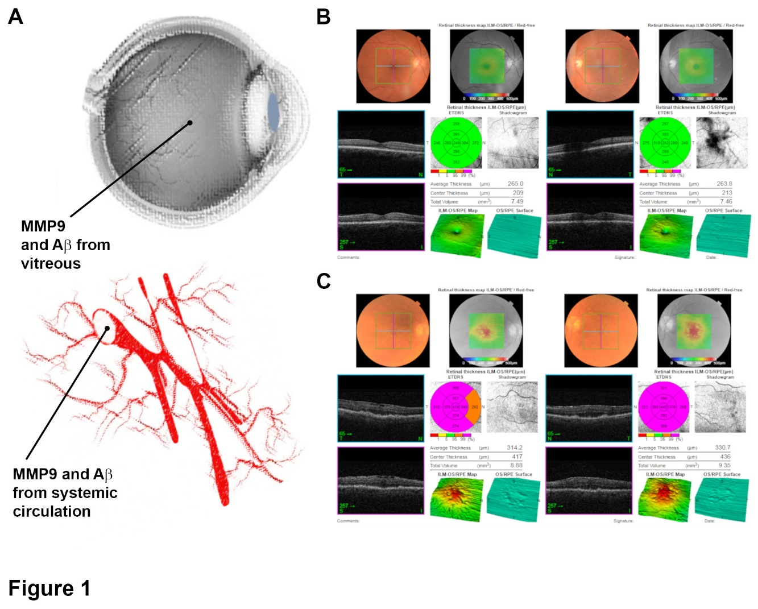

Further information on the participants were obtained from patient records including age, gender, smoking status and smoking pack years, which indicates the amount a subject has smoked over period of time. We also obtained a recording of mean arterial pressure, the primary cause of surgery, previous ocular history and medical history as well as medication (Supplementary table S1). AMD patients consisted of those presenting with both dry/geographic atrophy (GA) and wet/neovascular (NV) forms of the disease. Medical records described the following phenotypes in our AMD cohort; early AMD (n=4), GA (n=7) and NV (n=1). The age distribution amongst control subjects ranged from 52 to 90 years (mean: 71.3 years ± SEM 1.1; median: 72 years), whilst the age range in the AMD cohort was 68 to 93 years (mean: 79.25 years ± SEM 2.2; median: 79.5 years) (Figure 2A). The gender distribution amongst the control subjects was 38 females and 17 males, whilst the AMD cohort contained 7 females and 5 males. Scrutiny of smoking status revealed a mixed picture amongst control subjects, which was grouped as not declared (n=1), never smoked (n=23), ex-light smoker (n=15), ex-heavy smoker (n=8), light smoker (n=2) and heavy smoker (n=6). The smoking status in AMD patients was; never smoked (n=6), ex-light smoker (n=3) and ex-heavy smoker (n=3) (Supplementary table S1). Smoking pack years were recorded in 29 control subjects (mean: 7.7 ± 2.5 SEM; median: 1) and in 6 AMD patients (mean: 4.8 ± 3 SEM; median: 0.01) (Figure 2B). The mean arterial pressure was noted in 42 control subjects and ranged from 75.22 - 110.67 mm/Hg (mean: 95.7 mm/Hg ± 1.7 SEM; median: 96.5 mm/Hg). The mean arterial pressure was obtained from 10 AMD patients, which ranged between 85.33 - 127.33 mm/Hg (mean: 98.6 mm/Hg ± 4.1 SEM; median: 95.5 mm/Hg) (Figure 2C).

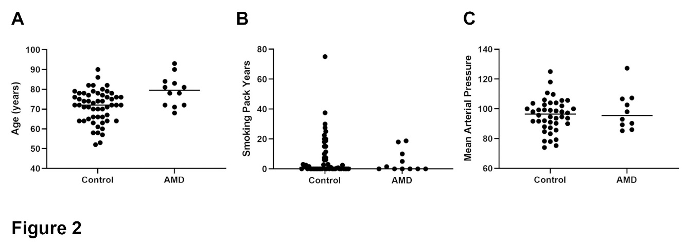

The primary cause of surgery amongst control subjects was as follows: cataract (CAT) (n=10), epiretinal membranes (ERM) (n=31), macular hole (MH) (n=13), vitreous floaters (VF) (n=3), vitreomacular traction (VMT) (n=7). Among the AMD cohort this was recorded as CAT (n=3), ERM (n=7), MH (n=2), retinal detachment (RD) (n=1), VMT (n=2). Some individuals reported multiple conditions in both control and AMD groups (Supplementary table S1). Scrutiny of previous ocular history among all participants revealed that some individuals had a history of these conditions but also pathologies such as glaucoma (GLA) and posterior vitreous detachment (PVD). Previous medical history and any medications were also recorded for all participants (Supplementary table S1).

2.2. Aβ and MMP9 levels in the vitreous and blood of control subjects and AMD patients showed variable levels across the lifespan, which was unrelated with advanced age or retinopathy

After obtaining vitreous and blood samples from participants, we quantified the amount of total Aβ (Aβ_{1-x}) by ELISA. The quantity of Aβ in the vitreous of control subjects ranged from 12.0 - 3086.91 pg/ml (mean: 1173.5 pg/ml ± 117.1 SEM; median: 971.5 pg/ml). Vitreous Aβ levels in AMD patients also displayed a wide distribution, ranging between 26.08 - 3240.12 pg/ml (mean: 1275.6 pg/ml ± 332.9 SEM; median: 833.4) (Figure 3A and Supplementary table S1). The distribution of Aβ levels in the blood of control subjects varied from 44.18 - 3102.18 pg/ml (mean: 574.3 pg/ml ± 104.8 SEM; median: 301.1). Aβ levels in the blood of AMD patients ranged from 156.9 - 1732.15 pg/ml (mean: 542.2 pg/ml ± 139.9 SEM; median: 411.9) (Figure 3B and Supplementary table S1). Measurements were obtained from a majority of subjects and only omitted when Aβ concentrations were below the threshold of the ELISA standard curve. Next, we used an ELISA to quantify the amount of MMP9 in the vitreous of subjects in the control cohort. MMP9 concentrations showed a wide distribution, which ranged between 0.45 - 4844.8 pg/ml (mean: 932.5 pg/ml ± 240.9 SEM; median: 400.7). The distribution of MMP9 in the vitreous of AMD patients varied from 469 - 1224.9 pg/ml (mean: 813.7 pg/ml ± 157.6 SEM; median: 780.5) (Figure 3C and Supplementary table S1). We also quantified levels of MMP9 in the blood of control subjects, which ranged between 487.8 - 5831.7 pg/ml (mean: 2228 pg/ml ± 193 SEM; median: 1780.7). MMP9 levels in the blood of AMD patients were between 1468.9 - 3264.2 pg/ml (mean: 2386.8 pg/ml ± 449.4 SEM; median: 2407) (Figure 3D and Supplementary table S1). MMP9 levels were thus recorded from a majority of participants and only omitted when concentrations were below the threshold of the ELISA standard curve.

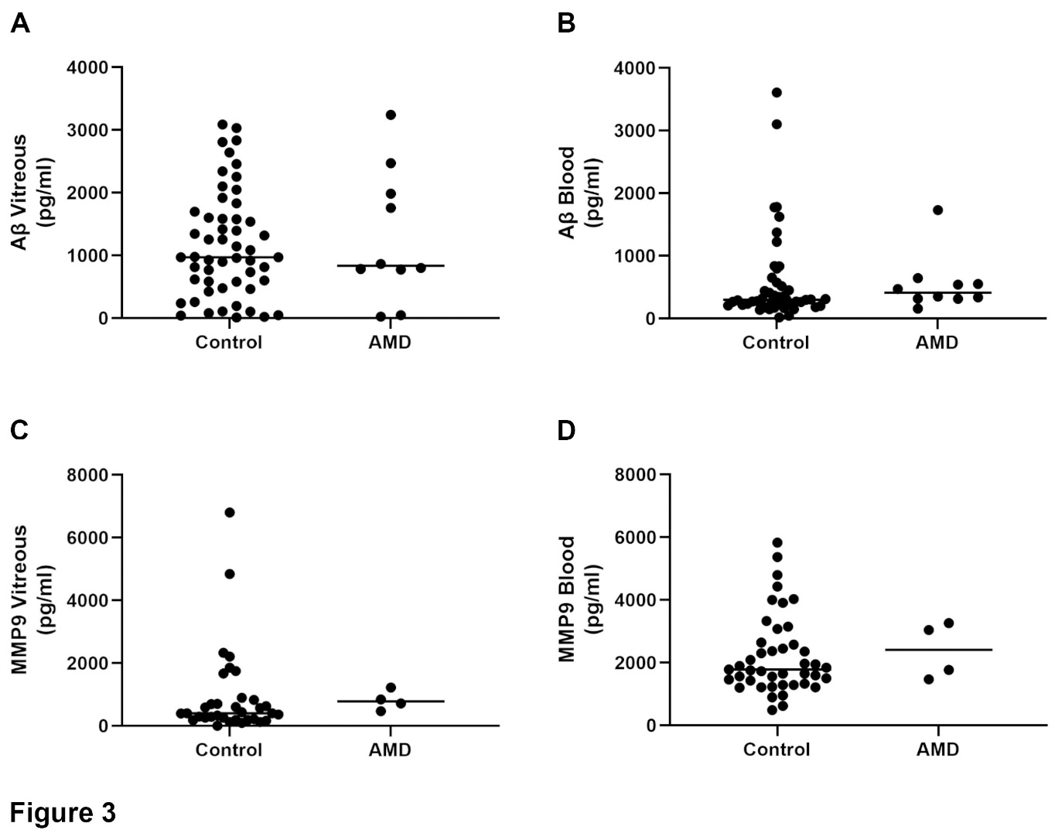

Correlation analyses, which jointly account for AMD and control patients in the statistical model, revealed no significant association between age and Aβ levels in the vitreous (p=0.963) or blood (p=0.694) from controls or AMD patients (Figure 4A, B). Similarly, age showed no correlation with MMP9 levels in the vitreous (p=0.882) or blood (p =0.37) in either group (Figure 4C, D).

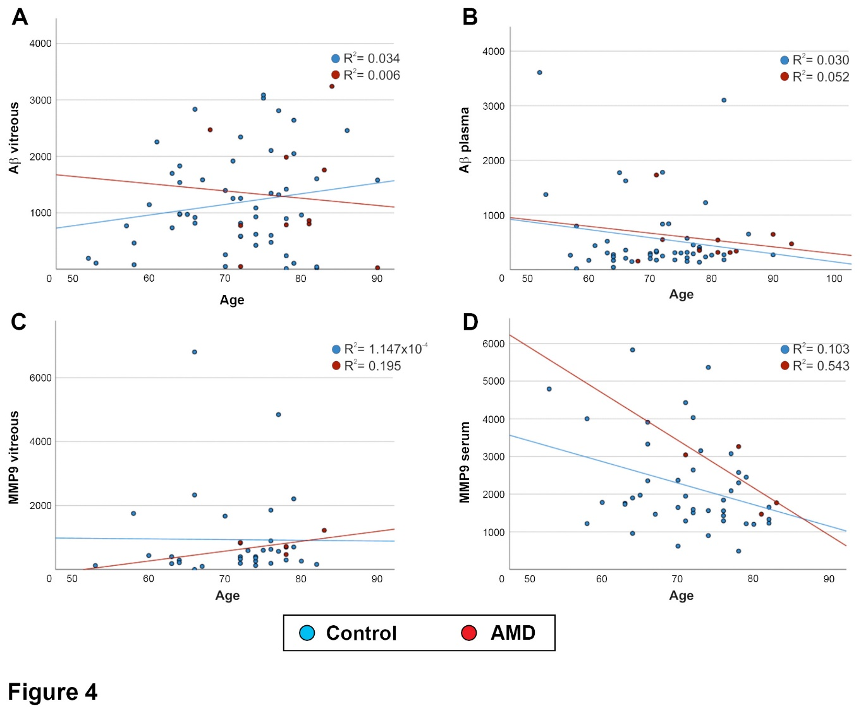

Next, we tested if Aβ vs. MMP9 levels in the ocular compartment and systemic circulation bore any correlation to each other. No association was found between MMP9 levels between the vitreous vs. serum (p=0.09) for control subjects or AMD patients (Figure 5A), or between vitreous MMP9 levels vs. vitreous Aβ levels (p =0.53) for either group (Figure 5B). There was also no correlation between serum MMP9 levels vs. Aβ levels in the vitreous for controls (p =0.33) or AMD patients (Figure 5C). Plasma Aβ levels showed no correlation with vitreous Aβ concentrations (p =0.32) for either group (Figure 5D). Comparison of plasma Aβ levels vs. serum MMP9 levels showed no correlation (p =0.73) for controls or AMD patients (Figure 5E), nor were there any apparent relationships between plasma Aβ levels vs. vitreous MMP9 concentrations (p =0.25) for either group (Figure 5F).

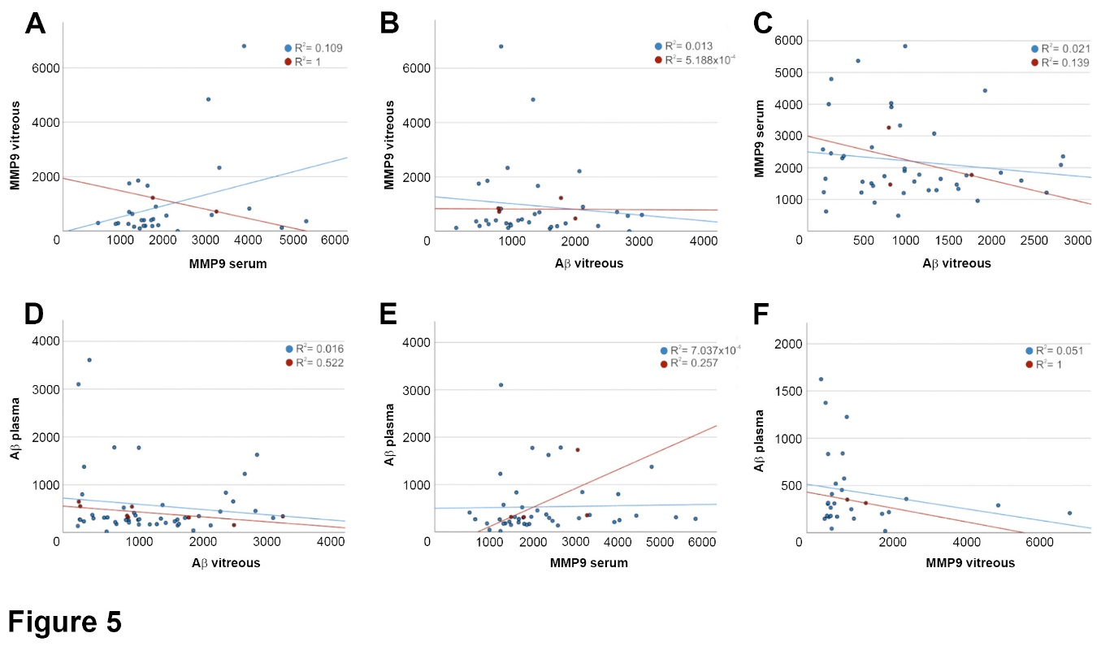

2.3. Aβ and MMP9 levels in the vitreous and blood were unrelated with mean arterial pressure and smoking

Given that mean arterial pressure and smoking pack years provide important information on lifestyle risks, we evaluated if these demonstrated any correlation with MMP9 and Aβ levels in the ocular compartment or in the systemic circulation. A comparison of vitreous Aβ levels vs. mean arterial pressure showed no correlation (p =0.791) for control subjects or AMD patients (Figure 6A). Plasma Aβ levels also showed no correlation with mean arterial pressure (p =0.660) in either group (Figure 6B). We also found no discernable relationship between MMP9 levels in the vitreous and mean arterial pressure (p =0.032) for controls or AMD patients (Figure 6C), or between serum MMP9 levels and mean arterial pressure (p =0.152) in either group (Figure 6D). Next, we examined the relationship between vitreous Aβ levels and smoking pack years, which showed no correlation (p =0.276) in control subjects or in AMD patients (Figure 6E). A comparison of plasma Aβ levels vs. smoking pack years also indicated no association (p =0.582) in either group (Figure 6F). Similarly, vitreous MMP9 concentrations did not show a significant correlation with smoking pack years (p =0.004) in controls and in AMD patients (Figure 6G). Serum MMP9 levels were also unrelated with smoking pack years (p =0.005) in both groups (Figure 6H). For scrutinising all aforementioned comparisons, we increased the threshold of significance from p=0.05 (Bonferroni) to p=0.001, to prevent the odds of accidental correlation due to evaluating multiple outcomes.
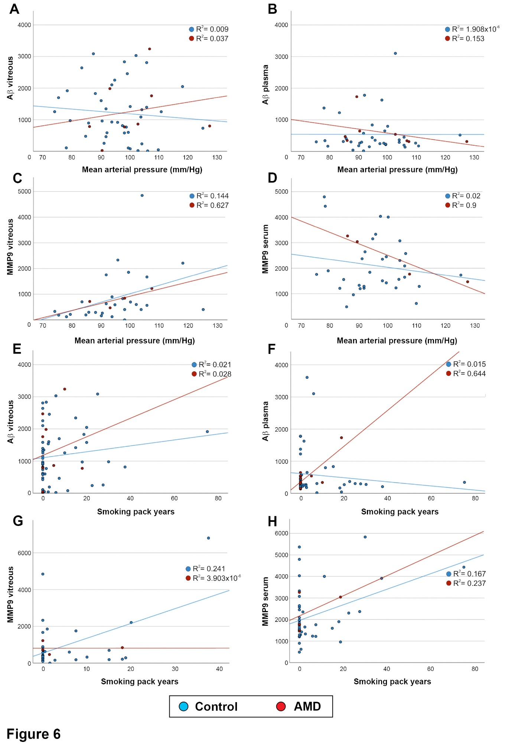

2.4. A bioinformatics analysis revealed promising MMP9 and APP/Aβ partners for further scrutiny, many of which are already linked with retinopathy

Although this study focused on elucidating the relationship of two potential biomarkers with age and AMD alongside lifestyle risk factors, both MMP9 and Aβ are also partners in a larger network of interactions with other proteins. We therefore used bioinformatics tools from the STRING database to identify protein partners of MMP9 (Figure 7A) and APP, the parent protein of Aβ (Figure 7B), with which they interact to varying extents, to identify other molecules that may contribute to AMD pathology. This analysis, which includes both putative and experimentally demonstrable protein-protein interactions, consist of molecules that jointly contribute to a shared function but without necessarily binding physically.
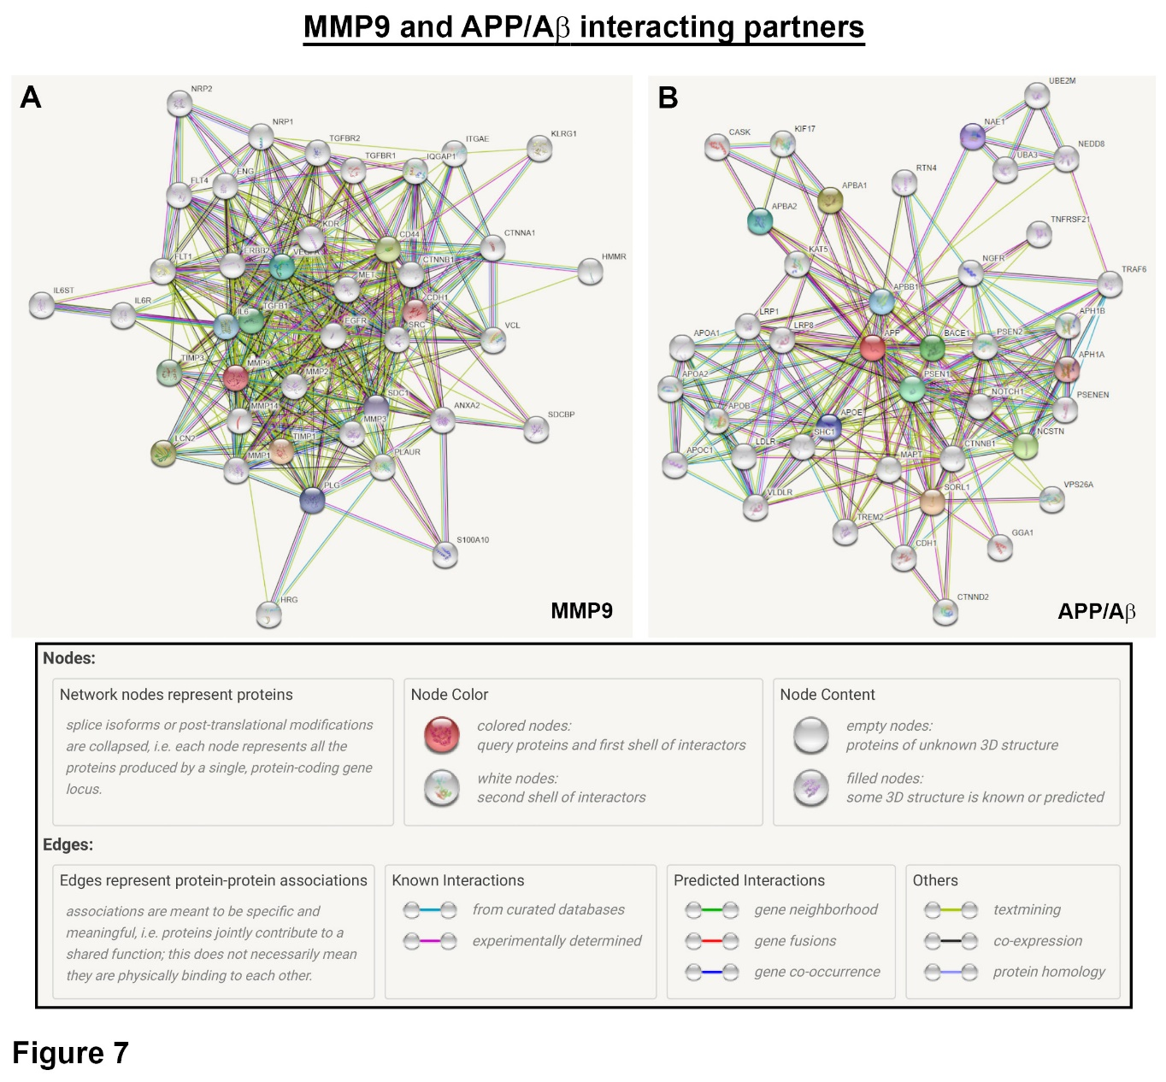
Mapping of MMP9 revealed potential targets such as cadherin-1 and related members, TIMP3, TGFBR1 and 2, as well as IL6 and its receptor subunits. VEGF-A and its receptor was also associated with MMP9. APP/Aβ partners included β-secretase and cadherin-1, as well as a molecules associated with lipid metabolism. The aforementioned proteins represent promising targets for future scrutiny in studies of this kind.

3. Discussion

This exploratory study was carried out to determine the likely association of two disease-linked proteins, MMP9 and Aβ, with age, as well as with the presence and severity of AMD in a subset of patients. We also sought to ascertain the effects of potential confounding factors such as mean arterial pressure and the extent of smoking in the methodology of designing larger studies of this kind. The pursuit of identifying biomarkers of ageing and retinopathy presents considerable challenges, some of which include, but are not limited to, (1) deciding the appropriate number of participants, (2) selecting suitable target molecules, (3) identifying the best source, whether from serum, plasma or the type of ocular fluid (tears, aqueous or vitreous) from which measurements can be taken, as well as (4) the method of evaluation (in-house developed vs. commercial ELISAs and multiplex assays). These considerations have to be offset by the number of participants that can realistically be recruited, the duration of the study and the technical constraints of measurements (for instance, some commercial ELISA-based methods are only optimised for measurements in certain types of samples such as cerebrospinal fluid). Another limitation includes instances where only partial information is available from patient records. An incomplete knowledge of the biology and the mechanisms of target molecules and their potential roles in complex diseases also pose challenges. Some studies collect information exclusively from non-invasive retinal scans, often involving large patient cohorts. Potential complications in setting-up such studies can be made even more difficult where ocular fluids and blood samples are also collected. However, the inclusion of biological material enables the direct measurements of chosen proteins to be determined at very high sensitivities, which adds considerable value, as we have demonstrated. Therefore, when powered sufficiently, studies of this kind can provide new insights into the biology of the ageing as well as the diseased retina.

Here, we assessed the levels of MMP9 and Aβ in vitreous and serum/plasma samples from across the lifecourse of a control cohort alongside a subset of AMD patients. The functions of MMPs include the degradation of extracellular matrix proteins/glycoproteins and membrane receptors, cytokines as well as growth factors [10]. Of the 28 different MMPs in vertebrates, MMP9, alongside MMP2, belong to a group containing three fibronectin-like inserts in the catalytic domain. MMP9 can act as collagenases and gelatinase, and appear to be a biomarker for carotid atherosclerosis [11], cancerous tumours [12] and is elevated in the plasma of Alzheimer’s patients [13]. Our previous work identified the rs42450006 variant upstream of MMP9 as being specifically associated with the NV but not the GA form of the disease [14]. Earlier work by another group had demonstrated diminished levels of active MMP9 in the Bruch's membrane of AMD patients leading to impaired matrix degradation [15]. Furthermore, hypoxic upregulation of MMP9 secretion, induced by pro-angiogenic vascular endothelial growth factor (VEGF) signalling, triggered the gene expression and secretion of VEGF in cultured RPE cells, indicative of a positive feedback mechanism between MMP9 and VEGF [16]. Our analysis of MMP9 in the vitreous and serum from controls and AMD patients showed no correlation with age or retinopathy. However, a major caveat is the limited number of individuals in the AMD cohort, as well as the small number of such patients from which measurements could be obtained. However, MMP9 levels were quantified in over 60% of the control cohort. To our knowledge, vitreous MMP9 levels across the lifecourse have not been reported before. Our data showed average values of 932.5 pg/ml and 813.7 pg/ml in the control and AMD groups, respectively. Serum MMP9 levels showed comparatively higher concentrations of 2228 pg/ml in control and 2386.8 pg/ml in AMD patients with no obvious correlations to aforementioned factors. An earlier study also showed no correlation of plasma MMP9 levels with increased age [17]. Serum MMP9 display a wide range of concentrations, with higher immature and active MMP9 levels alongside MMPs 1, 2, 7 and 8 compared to corresponding plasma samples [18], indicating potentially better sensitivities and outcomes from measurements in serum, which was also our preferred approach. A previous study which quantified MMP9 in the plasma of (a) controls, (b) patients with either large soft distinct drusen with pigmentary abnormalities, indistinct drusen or reticular drusen, or (c) NV AMD, reported values of 265 ng/ml, 659 ng/ml and 740 ng/ml, respectively, showing significantly elevated MMP9 in both early-intermediate AMD and NV groups vs. controls [19]. Another study which compared the plasma of control and AMD patients reported significantly higher MMP9 levels in GA patients (40 ng/ml vs. 76 ng/ml) [17]. The different outcomes of these studies compared to our findings may be due to several factors. For instance, both contained a lower number of control subjects compared to our study but had stratified AMD patients into two categories with each group having more patients. Differences may also arise as both studies used plasma whilst our work quantified MMP9 in serum. A further study reported increased levels of pro-MMP9 in plasma associated with NV AMD and with the risk allele of rs142450006 near MMP9 [20]. Of note, a study using serum from a Han Chinese cohort with large numbers for control, early and NV AMD groups respectively, reported no association between MMP9 levels and retinopathy. However, an increase in MMP2 and MMP9 were correlated with polypoidal choroidal vasculopathy, suggesting potentially different underlying mechanisms from AMD [21]. Additionally, immature/pro-MMP9 levels in tear samples were reported to be significantly elevated in conjunctivochalasis eyes relative to healthy controls [22]. However, the pre-analytical impact of blood collection requires careful consideration. For instance, the activity and concentration of MMP2 and TIMP2 showed no differences between plasma and serum, whilst levels and zymographic separation of MMP1, 8 and 9 as well as TIMP1 were strongly influenced by the presence of anticoagulants. Higher levels of TIMP1 and MMP1, 3 and 9 in serum compared to those in anticoagulant plasma suggested a release mechanism during coagulation and fibrinolysis. Hence, higher MMP levels in serum compared to plasma may not only relate to the disease status but also to the method of collecting blood samples [23]. Such considerations alongside the ability to quantify immature vs. active MMP9 levels to high sensitivities may provide better insights into its role across the lifecourse and in diseases such as AMD in the future.

The high concentrations of APP-derived fragments in ocular fluids also presented an opportunity to evaluate their relationships with age and retinopathy. The vitreous contains high Aβ levels relative to the aqueous [24], which prompted us to collect the former, although this also presented more difficulties in clinics. Cleavage of APP results in a mixture of Aβ polypeptides, predominantly Aβ₁₋₄₀ and Aβ₁₋₄₂, where different Aβ species show different solubility and biological properties. Aβ proteins are also found in various conformations including monomeric, oligomeric, prefibrillar and fibrillary forms which adds to their diversity [25]. Histopathological studies of donor eye tissues show that Aβ deposits correlate with increased drusen loads and with AMD [4,26-29]. Given the important role played by Aβ in AD, potential findings from quantifying total Aβ in the vitreous could not only provide insights into any shared pathology in the retina-brain axis, but their quantification in blood could also provide potential readouts in the systemic circulation. Although our results indicated that total Aβ in the vitreous had no correlation with age or AMD, another study reported high levels of Aβ₄₂ (a component of total Aβ) in the aqueous to be correlated with NV AMD [30]. Interestingly, vitreous Aβ₁₋₄₂ levels were diminished in glaucoma and diabetic retinopathy patients compared to control MH patients [31]. Lower levels of vitreous Aβ₁₋₄₀ and Aβ₁₋₄₂ were also reportedly correlated with poor cognitive function [32]. By contrast, elevated vitreous Aβ₁₋₄₀ and Aβ₁₋₄₂ were correlated with increased levels of neurofilament light chain in the vitreous [33]. The Aβ₄₂:Aβ₄₀ ratio of ~1:9 under normal physiological conditions in the brain is reported to shift to a higher percentage in favour of the latter in brains of familial AD patients. Interestingly, Aβ₁₋₄₀ and Aβ₁₋₄₂ directly interact and modify the behaviour of each other. Monomeric and fibrillar structures formed from Aβ₄₀ and Aβ₄₂ mixtures do not differ from those formed from either of these peptides alone. Instead, the co-assembly of Aβ₄₀ and Aβ₄₂ influences the aggregation kinetics by altering the pattern of oligomer formation [34]. The association of Aβ with worsening retinopathy and cognitive impairment is also reported in plasma and serum. For instance, serum APP and Aβ₁₋₄₀ but not Aβ₁₋₄₂ were correlated with GA [35]. Another study showed plasma Aβ₁₋₄₂ and the Aβ₁₋₄₂/Aβ₁₋₄₀ ratio to be correlated with late stages of AMD [36]. Analysis of Aβ levels in serum vs. plasma by one-dimensional SDS-PAGE revealed insights into the most suitable method of pre-analytical sample collection. Quantification of samples either immediately or after 24 and 48 hours at room temperature led to a significant loss of measurable peptide levels which was most evident during the first 24 hours of storage and more pronounced in serum compared to plasma. Hence, plasma may be more appropriate than serum for analysing Aβ [37] which was our chosen method for this study. Our findings show variable levels of total Aβ levels in the vitreous and serum of control patients that do not change significantly with age. Total Aβ concentrations in these fluids also do not appear to correlate with AMD status, although a major caveat is the relatively limited number of patients in our AMD subset. The study method may also have the unintended effect of influencing our data. For instance, AMD patients were generally older compared to control subjects, whilst all control subjects were patients at vitreoretinal clinics. To our knowledge, total Aβ levels across the lifecourse have not been reported before in the vitreous of non-AMD controls and in a subset of AMD patients. A previous study quantified soluble Aβ levels in the vitreous of 12 AMD patients vs. controls alongside levels of the receptor for advanced glycation end-products (RAGE) which serves as a receptor for Aβ. Soluble Aβ was detected in only 30% of AMD patients and 5% of controls. By contrast, the soluble RAGE receptor was detected in all samples but was significantly decreased in AMD patients [38]. Another study quantified Aβ₁₋₄₀ and Aβ₁₋₄₂ levels in the vitreous of healthy individuals (between the ages 55 to 101 years and within 12.5 ± 2 hours of death), which reported values of 126.6 ± 57.3 pmol/g and 15.6 ± 5.7 pmol/g, respectively [39]. In our study, the total Aβ levels in plasma recorded amongst the control cohort was broadly in-line with values reported by others in healthy subjects [40,41]. Collectively, however, these results suggest that the quantification of certain Aβ species or indeed their ratios rather than total Aβ may be more accurately correlated with specific disease conditions.

As the odds of developing AMD is closely associated with modifiable risks such as the intake of unhealthy foods and alcohol as well as smoking [42-47], we used patient records to obtain lifestyle information in our cohorts including mean arterial pressure, smoking status and smoking pack years. Previous studies have examined the effects of blood pressure on the odds of developing AMD with inconsistent results [48,49], where hypertension plays an incompletely defined role in this multifactorial disease. This view is further supported by a recent report showing insufficient evidence to suggest a correlation between blood pressure and AMD [46], which was consistent with our findings. By contrast, smoking is a well-established modifiable AMD risk factor which has been consistently demonstrated in many epidemiological studies carried out in different populations. Smoking is associated with increased oxidative stress, a reduction of antioxidants, changes in choroidal endothelial cells linked with neovascularisation, as well as atherosclerosis or vasoconstriction, and promoting pro-inflammatory conditions in the retina [50]. It is however, unclear how smoking affects the development of GA and NV phenotypes differently. A Mendelian randomisation approach was recently used to genetically predict smoking initiation and lifetime smoking with increased risks of developing advanced AMD. Similarly, cessation of smoking was linked with a decreased risk of advanced AMD. The study also revealed a greater potential association of smoking with NV AMD compared to GA [46]. Most studies have reported a dose-response effect between smoking and AMD. For instance, the Beaver Dam offspring study indicated that smoking 11 or more pack years was associated with early AMD [51], whilst the Rotterdam [52] and POLA [53] studies reported varying increased odds of developing advanced AMD in those who had smoked ≥10, ≥20, 20-39 or ≥40 pack years, with the risks of late AMD remaining high even 20 years after cessation of smoking. Our control and AMD cohorts contained a mixture of non-smokers and smokers with the latter group having smoked to varying extents. Although smoking was not correlated with vitreous or plasma Aβ levels, we observed a possible association with vitreous (p=0.004) and serum (p=0.005) MMP9 levels, though an increased threshold of p=0.001 in our study meant that this was statistically insignificant.

An analysis of protein-protein interactions using bioinformatics tools revealed an extensive network of molecules linked with MMP9 and Aβ. Cadherin-1 was shown to interact with MMP9. A variant of CDHR1, another member of the cadherin superfamily that is specific to photoreceptors, was reportedly associated with inherited retinal dystrophies [54,55] and is a possible target for further scrutiny. Other interacting partners of MMP9 included fellow members of the MMP family such as MMP1, 2, 3 and 14, where links with retinopathies have already been discussed. A notable MMP9 partner is TIMP3, which we and others have shown to be linked with AMD as well as with Sorsby fundus dystrophy [14,56-58]. Serum TIMP3 levels in control subjects were reportedly diminished compared to AMD patients and in those that were negative for complement factor H duplication or deletion [59]. Furthermore, plasma TIMP3 levels in AD patients were significantly lower compared to those in healthy controls [60]. Other putative partners of MMP9 include TGFBR1 which we have shown to be associated with AMD [61] and TGFBR2. Interleukin (IL)-6 receptor subunits α and β alongside IL6 were also shown to be linked with MMP9. The role of IL6 in AMD pathogenesis is well-established with a significant association of systemic IL6 levels with late AMD stages [62]. The VEGF receptor-1 [63] and 2 [64] alongside VEGF-A were also associated with MMP9, all of which are important elements of retinal homeostasis. Neuropilins-1 and 2 are co-receptors for VEGF, which our bioinformatics analysis showed to be associated with MMP9. Neuropilin-1 was expressed in 8/9 surgically excised choroidal neovascular membranes [65] with a recent report showing reduced choroidal and retinal NV in mice lacking endothelial neuropilin-1 [66]. Vinculin, another target linked with MMP9, showed elevated levels in plasma of AMD patients [67].

APP encodes a cell surface receptor and transmembrane precursor protein, which is cleaved by secretases, resulting in several fragments that also includes a family of Aβ peptides associated with neurodegeneration [25]. This generates a plethora of different interactions with a multitude of molecules, the full extent of which can only be discerned by mapping against the parent APP protein. Our search revealed a network of such targets, of which several with specific relevance to Aβ and AMD have been highlighted. Presenilin-1 and 2 as well as the γ-secretase subunit PEN-2 are catalytic subunits of the γ-secretase complex which generates Aβ. Although a PubMed search revealed no AMD studies specifically related to presenilin per se, knockout of β-secretase (BACE1) which also cleaves APP and was identified in our search, led to significant retinal pathology in a mouse model [68]. Triggering receptor expressed in myeloid Cells 2 (TREM2), considered to be involved in the clearance of Aβ, was reported to be significantly diminished in AMD retinas [69]. Our search also identified a family of molecules associated with lipid metabolism, which includes the very low-density lipoprotein receptor (VLDR), the low-density lipoprotein receptor (LDLR), apolipoproteins A-I and II, C-I, E as well as B. Dysregulated lipid metabolism is known to play an important role in retinal pathology [70] including mediating effects of poor nutrition, which is a modifiable AMD risk factor. For instance, we have previously shown how an unhealthy “Western-style” high fat diet alone causes salient early-intermediate AMD-like features in wildtype mice including changes to retinal lipids [47], and how AMD-linked disease pathways associated with an unhealthy diet can cause specific RPE dysfunction [71]. Dysregulated lipid metabolism also plays an important role in Alzheimer’s pathology [72]. Furthermore, our search identified the LDL receptor related protein-1 (LRP1) and 8 (LRP8), of which LRP1 is a major Aβ clearance transporter in the brain [73]. Other targets identified in this manner include members of the TNF receptor superfamily (TNFRSF21) and associated factor 6 (TRAF6) protein family, of which inhibition of the latter was shown to alleviate choroidal neovascularisation in a laser-induced mouse model [74]. Mapping APP partners identified cadherin-1, which interestingly, our bioinformatics analysis also showed to be associated with MMP9.

In summary, we report that immature/active MMP9 and total Aβ concentrations across the lifecourse in control subjects and in a subset of AMD patients showed variable levels, which were unrelated to increasing age or retinopathy. Moreover, Aβ and MMP9 quantities in the vitreous and blood were not associated with mean arterial pressure, a modifiable factor whose role in retinal degeneration remains inconclusive. Assessment of vitreous and plasma Aβ with smoking, another modifiable factor but one which is strongly associated with disease, also showed no correlation. Interestingly, there was a hint that increased smoking pack years in control and AMD groups may have an association with immature and active forms of MMP9 in the vitreous (p=0.004) and serum (p=0.005), though this did not reach our elevated significance (p=0.001) threshold. Close scrutiny of statistical parameters is therefore encouraged when evaluating reported associations. A PubMed search using the terms ‘age related macular degeneration’, ‘smoking’, ‘MMP9’ yielded no results. We suggest recruiting larger cohorts to investigate these relationships further, as a caveat to this work is the low sample numbers, particularly amongst AMD patients. Both control and AMD groups contained a mixture of ages, gender, ocular history, medication and lifestyle demographics, which could have the undesirable consequence of grouping heterogeneous phenotypes to mask potential effects. Furthermore, AMD patients were not genotyped, so may contain a mixture of risk genes. We recommend considering how certain lifestyle risks could influence biomarkers in different ways, and where possible grouping AMD subsets with distinct phenotypes and/or polymorphisms with which potential biomarkers could be mapped across the lifecourse. Obtaining additional information of modifiable factors such as diet from patient records, provided these are available, as well as categorisation by ethnicities and/or genotypes could refine efforts. For instance, similar studies in non-Caucasian populations could yield different outcomes. We also recommend the exploitation of bioinformatics tools to identify partner proteins. Herein we report links with molecules such as cadherin-1, MMPs, TGFBR1/2, IL6 and its receptor subunits, VEGF-A and its receptor as well as β-secretase and those involved in lipid metabolism alongside others, which could be assayed to provide additional insights into common mechanisms and shared pathways.

4. Materials and Methods

4.1 Ethical considerations for recruiting participants

The study was performed in accordance with the Research Governance Framework for Health and Social Care (2005) and the Declaration of Helsinki (2008) with approval by the local Research Ethics Committee (Rec Ref: 09/H0504/67) and Research and Development for University Hospital Southampton NHS Foundation Trust. In the majority of cases, participants received an information leaflet at least 24 hours prior to surgery. However, if deemed appropriate, for instance in emergency cases, patients were recruited onto the study up to 1 hour prior to surgery. Informed consent was obtained from all participants and the samples stored according to guidelines specified by the Human Tissue Act (HTA).

4.2 Study cohort eligibility and clinical examination

The study cohort was identified from vitreoretinal pre-operative lists of patients scheduled for vitrectomy, or vitrectomy following phacoemulsification and intraocular lens implantation at the University Hospital Southampton NHS Foundation Trust Eye Unit. The eligibility of patients was assessed via screening against the inclusion/exclusion criteria outlined in Table 1. Participants were recruited to the study only if the criteria were satisfied and were subject to informed consent. Funduscopy and OCT images from pre-operative assessments were examined independently by two ophthalmologists regarding AMD status. If the diagnoses were conflicting, the images were evaluated by a third consultant ophthalmologist. In total, 61 control subjects were recruited, however, 6 participants did not meet the study criteria (Table 1). The remaining 55 individuals did meet the inclusion criteria and were included in the study. We also recruited 12 AMD patients. The following information was obtained from patient records; age, gender and smoking status as well as smoking pack years (packs smoked per day x years smoked). Additional information collected from patient records included the mean arterial pressure, the primary cause of surgery, the ocular history of both eyes, medical history and information on medication (Supplementary table S1).

4.3 Sample processing

Undiluted core vitreous biopsies (~0.4ml) were obtained at the onset of pars planar vitrectomy. Prior to irrigation, the vitreous humour was manually aspirated from the centre of the vitreous cavity through a vitrectomy cutter into a 1ml syringe with infusion in the off position. The volume of the biopsies was kept constant to minimise the potential for accidental inclusion of additional components from outside the vitreous core, which could otherwise compromise the proteome composition of the sample [75,76]. Upon receipt, samples were immediately placed on ice, distributed into 100μl aliquots and stored at -80ºC. Serum and plasma samples were obtained via venous puncture into serum and EDTA tubes respectively, and centrifuged at 1013x g for 10 minutes within 2 hours of collection. The supernatants were collected and distributed into 500μl aliquots and stored at -80⁰C.

4.4 Enzyme-linked immunosorbent assay for quantifying MMP9

The levels of total MMP9 (immature and active MMP9 forms) in the vitreous humour and serum were quantified using a human solid-phase sandwich ELISA (ab100610, Abcam, Cambridge, UK) according to the manufacturer’s instructions. Prior to quantification, the samples were diluted 15-fold and 1000-fold for vitreous and serum, respectively. Briefly, 100μl of the sample and known MMP9 standards were applied to wells of a microtitre plate that was pre-coated with the capture antibody and incubated overnight at 4⁰C with gentle agitation. Following incubation, the plates were washed four times with wash solution, prior to applying 100μl of biotinylated MMP9 detection antibody for 1 hour at room temperature. Wells were washed an additional four times prior to the addition of 100μl HRP-streptavidin solution for 45 minutes at room temperature. The washing step was repeated and 100μl of TMB one-step substrate reagent applied for 30 minutes in the dark at room temperature. Finally, 50μl of stop solution was added and the optical density (O.D) measured at 450nm using a microtitre plate reader (FLUOstar Optima, BMG LABTECH, UK), which accounts for the 570nm wavelength correction. Three technical replicates were measured for each sample. Data was analysed using MARS data analysis software (BMG LABTECH, UK) and Microsoft Excel.

4.5 Enzyme-linked immunosorbent assay for quantifying Aβ

The level of total Aβ (Aβ₁₋₂₈, Aβ₁₋₄₀, Aβ₁₋₄₂) in the vitreous humour and plasma was quantified using a Human Aβ_{1-x} solid-phase sandwich ELISA (Cat # 27729, IBL, Japan) according to the manufacturer’s instructions. Samples were diluted 9-fold prior to quantification. Briefly, 100μl of the sample and known Aβ₁₋₄₀ standards were applied to wells of a microtitre plate that was pre-coated with the capture antibody and incubated overnight at 4⁰C. Following incubation, the plates were washed four times in wash buffer, before 100μl of the labelled antibody solution was added for 1 hour at 4⁰C. Wells were washed an additional five times and 100μl of the chromogen added for 30 minutes and the plates kept in the dark at room temperature. Finally 100μl of the stop solution was added and the O.D measured at 450nm in a microtitre plate reader (FLUOstar Optima, BMG LABTECH, UK), which accounts for a 570nm wavelength correction. Three technical replicates were included for each sample. Data was analysed using MARS data analysis software (BMG LABTECH, UK) and Microsoft Excel.

4.6 Bioinformatics analysis

Protein partners (known and predicted) that could interact with MMP9 and the Aβ parent amyloid precursor protein (APP), as well as the likelihood of interaction were mapped using bioinformatics tools from the STRING (Protein-Protein Interaction Networks Functional Enrichment Analysis) database (STRING Consortium 2021, Version 11.5 https://string-db.org/). ELIXIR Core Data Resources, Wellcome Genome Campus, Cambridgeshire, UK.

4.7 Statistical Analyses

Statistical analyses were performed in SPSS Software (version 25, IBM Statistics) under the guidance of a medical statistician. For linear variables, the distribution of data was assessed for normality prior to correlation assessments with either Spearman’s rank or Pearson’s correlation coefficient. Correlation test data are expressed as Spearman’s rank correlation coefficient (rs) and P values. Kruskal-Wallis tests with Hodges Lehmann estimator evaluated the association of linear variables with discrete data (2 groups or more) where data is presented as Median (Lower quartile, Upper quartile). The association between linear variables of interest and AMD status was then assessed via linear regression analyses taking into account previously identified potentially confounding variables, where outcomes are reported as B coefficients and p values. Due to the assessment of multiple outcomes, the cut-off point for the level of statistical significance was reduced from p=0.05 (Bonferroni) to p=0.001 to minimise type 1 error. Detailed descriptive statistics can be found in the Supplementary table S2.

Supplementary material: Supplementary information includes anonymised patient information as well as individual MMP9 and Aβ measurements in participants (Supplementary table S1) and the descriptive statistics (Supplementary table S1).

Funding: This work was funded by awards to J.A.R from the NC3R (National Centre for the Replacement Refinement & Reduction of animals in research: NC/L001152/1), Fight for Sight and Alzheimer’s Research UK (Ref: 24AZ172), Retina UK (GR590) and the Gift of Sight Appeal. We also acknowledge the NC3R Fellowship to S.A.L (NC/T002336/1) as well as the Alzheimer’s Research UK South Coast Network pump prime awards to S.A.L and J.M.D. The funders were not involved in designing this study, the collection of data, analysis and interpretation of data or in writing of this manuscript.

Acknowledgments: We thank all the study participants who generously provided samples for this work, without which this study would not have been possible.

Author contributions: J.A.R conceptualised this study. A.S, J.B, T.S, I.N, C.W, B.G, H.A and S.C.L provided the samples. S.A.L and F.S performed the experiments and with J.M.D analysed the data. H.M.Y provided statistical expertise. A.C, T.A.N, A.J.L and J.A.R supervised the research. S.A.L, J.M.D and J.A.R wrote the manuscript. F.S, H.M.Y, A.C, T.A.N and A.J.L revised the manuscript. J.A.R provided project administration and acquisition of funding. All authors have read and agreed to the published version of this manuscript.

Institutional review board statement: This study was carried out in accordance with ethical approval [REC reference number 09/H0504/57 (protocol 2), NHS National Research Ethics Service, Southampton and South West Hampshire Research Ethics Committee (B)], which was granted on the 12th of June 2009.

Informed consent statement: Informed consent was obtained from all the study participants. Patient information has been anonymised.

Data availability statement: All data have been included in the article and in the supplementary material. Reasonable requests for raw data will be considered by the authors before being made available to third parties.

Conflicts of interest: The authors declare no competing interests.

Tables

Table 1. Inclusion and exclusion criteria used for identifying suitable control and AMD candidates. The study cohort was recruited from patients requiring vitreoretinal surgery. Hence, healthy control subjects included patients with previous or present underlying ocular conditions, which were assessed unlikely to affect the vitreous proteome. Furthermore, patients with systemic influences which could affect the vitreous proteome, were also excluded from the control group. Patients with retinal vein occlusion and diabetic retinopathy were also excluded to prevent possible misdiagnosis with AMD. Abbreviations: AMD: Age-related macular degeneration; CNV: Choroidal neovascularisation; GA: Geographic atrophy.

Figure legends

Figure 1. Experimental plan and representative retinal scans of study participants. [A] Schematic diagram of the privileged ocular compartment vs. the systemic circulation from which vitreous and blood samples were collected, respectively. Enzyme-linked immunosorbent assays (ELISAs) quantified total Aβ and immature/active MMP9 levels in the vitreous and blood (serum/plasma) samples. [B] Representative retinal scans of a participant in the control cohort showing funduscopy and optical coherence tomography (OCT) images. [C] Scans from a participant with geographic atrophy AMD. OCT scans show diffuse drusen at the level of the retinal pigment epithelium in each eye. Both eyes also show the presence of an epiretinal membrane.

Figure 2. Characteristic features of the control and AMD cohorts. [A] The age distribution of control subjects (n=55) attending vitreoretinal clinics alongside a subset of AMD patients (n=12) were broadly similar, though ages in the latter group were clustered at the higher end of the spectrum. [B] A comparison of smoking pack years in the control (n=29) and AMD (n=6) cohorts showed no evidence of increased smoking in the latter group. A value of zero was recorded for participants who did not smoke, but provided this information. [C] A comparison of mean arterial pressure in the control (n=42) and AMD (n=10) groups indicated no differences.

Figure 3. ELISA measurements of Aβ and MMP9 protein levels in the vitreous and blood. [A] Total Aβ levels in the vitreous of control subjects (n=53) and AMD patients (n=10) as well as [B] in the blood/plasma of control (n=48) and AMD (n=10) groups, showed a wide and overlapping distribution. [C] Immature and active MMP9 levels in the vitreous of control (n=34) and AMD patients (n=4) as well as [D] in the blood/serum of control subjects (n=43) and AMD patients (n=4), showed a similar pattern of distribution.

Figure 4. Correlation analysis of MMP9 and Aβ levels in the vitreous and blood across mid-life to old age. [A] A comparison of total Aβ concentrations in the vitreous (p=0.963) or [B] plasma (p=0.694) with age revealed no associations in controls or in a subset of AMD patients. Similarly, a comparison of MMP9 levels in [C] the vitreous (p=0.882) or [D] serum (p=0.37) with age showed no associations in either group.

Figure 5. Correlation analysis of MMP9 vs. Aβ. [A] MMP9 levels in the vitreous vs. MMP levels in serum were compared to determine any association of this AMD risk factor between the ocular compartment vs. the systemic circulation. No association was found in either control subjects or in AMD patients (p=0.09). [B] A comparison of MMP9 levels in the vitreous vs. Aβ vitreous levels also showed no association in control subject or in AMD patients (p=0.53). [C] Similarly, there was no association between serum MMP9 levels with Aβ vitreous levels in controls or in AMD patients (p=0.33). [D] Aβ levels in the plasma vs. Aβ levels in the vitreous were compared to determine any association in this risk factor between the ocular compartment vs. the systemic circulation. No association was found in either control subjects or in AMD patients (p=0.32). [E] We also found no correlation between Aβ levels in plasma with MMP9 levels in serum of controls or AMD patients (p=0.73). [F] Similarly, no correlation was observed between Aβ levels in plasma with MMP9 levels in the vitreous of control subjects or AMD patients (p=0.25).

Figure 6. Correlation analysis of MMP9 and Aβ levels with mean arterial pressure and with the extent of smoking. [A] Evaluation of Aβ levels in the vitreous with mean arterial pressure showed no association in control subjects or in AMD patients (p=0.791). [B] Similarly, Aβ levels in the systemic circulation had no correlation with mean arterial pressure in either group (p=0.660). [C] A comparison of MMP9 levels in the ocular compartment with mean arterial pressure in control subjects and in AMD patients (p=0.032) showed no correlation. [D] Similarly, MMP9 levels in the serum had no correlation with mean arterial pressure in either group (p=0.152). We also studied the relationship between these biomarkers and the extent of smoking (smoking pack years). [E] Correlation analysis of vitreous Aβ levels with smoking pack years showed no association in control subjects or in AMD patients (p=0.276). [F] We also found no correlation between systemic Aβ levels and smoking pack years in controls or in AMD patients (p=0.582). [G] Evaluation of MMP9 levels in the vitreous with the extent of smoking indicated a possible association with both groups (p=0.004), but one which did not reach a statistical threshold of p=0.001. [H] Similarly, a possible link was observed between systemic MMP9 levels with smoking pack years in control and AMD patients (p=0.005). However, this also failed to achieve a p=0.001 threshold, inviting further scrutiny into this putative relationship.

Figure 7. Bioinformatics tools (STRING database) was used to map MMP9 and APP/Aβ interacting partners, which includes putative and experimentally demonstrable protein-protein interactions, containing molecules that jointly contribute to a shared function but without necessarily binding physically. [A] Notable MMP9 partners include several other members of the MMP family as well as TIMP3, all of which play important roles in retinopathies. Other partners include TGFBR1 and 2 as well as IL6 and its receptor subunits. VEGF-A and its receptor was also associated with MMP9. [B] Aβ partners were mapped to its parent precursor protein APP. Notable links were reported with β-secretase and a member of the TNF receptor family as well as an associated factor which are all linked with retinal degeneration. We also found links with molecules involved in the clearance of Aβ. Other APP/Aβ partners that were identified in this manner includes a group of proteins that are associated with lipid metabolism, which is known to be dysregulated in the ageing retina and in retinopathies. Interestingly, cadherin-1 was associated with both MMP9 and APP/Aβ. Collectively, our bioinformatics analyses revealed candidate proteins, some of which could be assayed in the future to refine markers of ageing vs. AMD.

References

1. Holz, F.G.; Sadda, S.R.; Staurenghi, G.; Lindner, M.; Bird, A.C.; Blodi, B.A.; Bottoni, F.; Chakravarthy, U.; Chew, E.Y.; Csaky, K., et al. Imaging Protocols in Clinical Studies in Advanced Age-Related Macular Degeneration: Recommendations from Classification of Atrophy Consensus Meetings. Ophthalmology 2017, 124, 464-478, doi:10.1016/j.ophtha.2016.12.002.
2. Wu, Z.; Pfau, M.; Blodi, B.A.; Holz, F.G.; Jaffe, G.J.; Liakopoulos, S.; Sadda, S.R.; Staurenghi, G.; Bjelopera, E.; Brown, T., et al. OCT Signs of Early Atrophy in Age-Related Macular Degeneration: Interreader Agreement: Classification of Atrophy Meetings Report 6. Ophthalmol Retina 2021, 10.1016/j.oret.2021.03.008, doi:10.1016/j.oret.2021.03.008.
3. Shoda, C.; Kitagawa, Y.; Shimada, H.; Yuzawa, M.; Tateno, A.; Okubo, Y. Relationship of Area of Soft Drusen in Retina with Cerebral Amyloid-β Accumulation and Blood Amyloid-β Level in the Elderly. J Alzheimers Dis 2018, 62, 239-245, doi:10.3233/jad-170956.
4. Lynn, S.A.; Keeling, E.; Munday, R.; Gabha, G.; Griffiths, H.; Lotery, A.J.; Ratnayaka, J.A. The complexities underlying age-related macular degeneration: could amyloid beta play an important role? Neural Regen Res 2017, 12, 538-548, doi:10.4103/1673-5374.205083.
5. Shi, H.; Koronyo, Y.; Rentsendorj, A.; Regis, G.C.; Sheyn, J.; Fuchs, D.T.; Kramerov, A.A.; Ljubimov, A.V.; Dumitrascu, O.M.; Rodriguez, A.R., et al. Identification of early pericyte loss and vascular amyloidosis in Alzheimer's disease retina. Acta Neuropathol 2020, 10.1007/s00401-020-02134-w, doi:10.1007/s00401-020-02134-w.
6. Ratnayaka, J.A.; Lynn, S. Alzheimer’s-Related Amyloid Beta Peptide Aggregates in the Ageing Retina: Implications for Sight Loss and Dementia, 1 ed.; D, M., Ed. Intech Publishing: Croatia, 2016; Vol. 1, pp. 546.
7. Le, J.T.; Agrón, E.; Keenan, T.D.L.; Clemons, T.E.; Brenowitz, W.D.; Yaffe, K.; Chew, E.Y. Assessing bidirectional associations between cognitive impairment and late age-related macular degeneration in the Age-Related Eye Disease Study 2. Alzheimers Dement 2021, 10.1002/alz.12473, doi:10.1002/alz.12473.
8. Wen, L.Y.; Wan, L.; Lai, J.N.; Chen, C.S.; Chen, J.J.; Wu, M.Y.; Hu, K.C.; Chiu, L.T.; Tien, P.T.; Lin, H.J. Increased risk of Alzheimer's disease among patients with age-related macular degeneration: A nationwide population-based study. PLoS One 2021, 16, e0250440, doi:10.1371/journal.pone.0250440.
9. Anisetti, B.; Youssef, H.; Elkhair, A.; Lin, M. Age-Related Macular Degeneration is Associated with Cerebral Amyloid Angiopathy (S35.003). Neurology 2022, 98, 2860.
10. Laronha, H.; Caldeira, J. Structure and Function of Human Matrix Metalloproteinases. Cells 2020, 9, doi:10.3390/cells9051076.
11. Silvello, D.; Narvaes, L.B.; Albuquerque, L.C.; Forgiarini, L.F.; Meurer, L.; Martinelli, N.C.; Andrades, M.E.; Clausell, N.; dos Santos, K.G.; Rohde, L.E. Serum levels and polymorphisms of matrix metalloproteinases (MMPs) in carotid artery atherosclerosis: higher MMP-9 levels are associated with plaque vulnerability. Biomarkers 2014, 19, 49-55, doi:10.3109/1354750x.2013.866165.
12. Huang, H. Matrix Metalloproteinase-9 (MMP-9) as a Cancer Biomarker and MMP-9 Biosensors: Recent Advances. Sensors (Basel) 2018, 18, doi:10.3390/s18103249.
13. Lorenzl, S.; Albers, D.S.; Relkin, N.; Ngyuen, T.; Hilgenberg, S.L.; Chirichigno, J.; Cudkowicz, M.E.; Beal, M.F. Increased plasma levels of matrix metalloproteinase-9 in patients with Alzheimer's disease. Neurochem Int 2003, 43, 191-196, doi:10.1016/s0197-0186(03)00004-4.
14. Fritsche, L.G.; Igl, W.; Bailey, J.N.; Grassmann, F.; Sengupta, S.; Bragg-Gresham, J.L.; Burdon, K.P.; Hebbring, S.J.; Wen, C.; Gorski, M., et al. A large genome-wide association study of age-related macular degeneration highlights contributions of rare and common variants. Nat. Genet 2015, ng.3448 [pii];10.1038/ng.3448 [doi], doi:ng.3448 [pii];10.1038/ng.3448 [doi].
15. Hussain, A.A.; Lee, Y.; Zhang, J.J.; Marshall, J. Disturbed matrix metalloproteinase activity of Bruch's membrane in age-related macular degeneration. Invest Ophthalmol Vis Sci 2011, 52, 4459-4466, doi:10.1167/iovs.10-6678.
16. Hollborn, M.; Stathopoulos, C.; Steffen, A.; Wiedemann, P.; Kohen, L.; Bringmann, A. Positive feedback regulation between MMP-9 and VEGF in human RPE cells. Invest Ophthalmol Vis Sci 2007, 48, 4360-4367, doi:10.1167/iovs.06-1234.
17. Krogh Nielsen, M.; Subhi, Y.; Rue Molbech, C.; Nilsson, L.L.; Nissen, M.H.; Sorensen, T.L. Imbalances in tissue inhibitors of metalloproteinases differentiate choroidal neovascularization from geographic atrophy. Acta Ophthalmol 2018, 10.1111/aos.13894, doi:10.1111/aos.13894.
18. Jonsson, A.; Hjalmarsson, C.; Falk, P.; Ivarsson, M.L. Levels of matrix metalloproteinases differ in plasma and serum - aspects regarding analysis of biological markers in cancer. Br J Cancer 2016, 115, 703-706, doi:10.1038/bjc.2016.127.
19. Chau, K.Y.; Sivaprasad, S.; Patel, N.; Donaldson, T.A.; Luthert, P.J.; Chong, N.V. Plasma levels of matrix metalloproteinase-2 and -9 (MMP-2 and MMP-9) in age-related macular degeneration. Eye (Lond) 2007, 21, 1511-1515, doi:6702722 [pii];10.1038/sj.eye.6702722 [doi].
20. Lauwen, S.; Lefeber, D.J.; Fauser, S.; Hoyng, C.B.; den Hollander, A.I. Increased pro-MMP9 plasma levels are associated with neovascular age-related macular degeneration and with the risk allele of rs142450006 near MMP9. Mol Vis 2021, 27, 142-150.
21. Zeng, R.; Wen, F.; Zhang, X.; Su, Y. Serum levels of matrix metalloproteinase 2 and matrix metalloproteinase 9 elevated in polypoidal choroidal vasculopathy but not in age-related macular degeneration. Mol Vis 2013, 19, 729-736.
22. Acera, A.; Vecino, E.; Duran, J.A. Tear MMP-9 levels as a marker of ocular surface inflammation in conjunctivochalasis. Invest Ophthalmol Vis Sci 2013, 54, 8285-8291, doi:10.1167/iovs.13-12235.
23. Mannello, F. Serum or plasma samples? The "Cinderella" role of blood collection procedures: preanalytical methodological issues influence the release and activity of circulating matrix metalloproteinases and their tissue inhibitors, hampering diagnostic trueness and leading to misinterpretation. Arterioscler Thromb Vasc Biol 2008, 28, 611-614, doi:10.1161/atvbaha.107.159608.
24. Prakasam, A.; Muthuswamy, A.; Ablonczy, Z.; Greig, N.H.; Fauq, A.; Rao, K.J.; Pappolla, M.A.; Sambamurti, K. Differential accumulation of secreted AbetaPP metabolites in ocular fluids. J. Alzheimers. Dis 2010, 20, 1243-1253, doi:300XU67452Q8MX67 [pii];10.3233/JAD-2010-100210 [doi].
25. Benilova, I.; Karran, E.; De, S.B. The toxic Abeta oligomer and Alzheimer's disease: an emperor in need of clothes. Nat. Neurosci 2012, 15, 349-357, doi:nn.3028 [pii];10.1038/nn.3028 [doi].
26. Anderson, D.H.; Talaga, K.C.; Rivest, A.J.; Barron, E.; Hageman, G.S.; Johnson, L.V. Characterization of beta amyloid assemblies in drusen: the deposits associated with aging and age-related macular degeneration. Exp. Eye Res 2004, 78, 243-256, doi:S0014483503003440 [pii].
27. Luibl, V.; Isas, J.M.; Kayed, R.; Glabe, C.G.; Langen, R.; Chen, J. Drusen deposits associated with aging and age-related macular degeneration contain nonfibrillar amyloid oligomers. J. Clin. Invest 2006, 116, 378-385, doi:10.1172/JCI25843 [doi].
28. Isas, J.M.; Luibl, V.; Johnson, L.V.; Kayed, R.; Wetzel, R.; Glabe, C.G.; Langen, R.; Chen, J. Soluble and mature amyloid fibrils in drusen deposits. Invest Ophthalmol. Vis. Sci 2010, 51, 1304-1310, doi:iovs.09-4207 [pii];10.1167/iovs.09-4207 [doi].
29. Dentchev, T.; Milam, A.H.; Lee, V.M.; Trojanowski, J.Q.; Dunaief, J.L. Amyloid-beta is found in drusen from some age-related macular degeneration retinas, but not in drusen from normal retinas. Mol. Vis 2003, 9, 184-190, doi:v9/a27 [pii].
30. Zhu, J.; Su, T.; Wang, M.; Li, M.; Liu, L.; Wang, F. Highly Expressed Amyloid Beta-42 Of Aqueous Humor In Patients With Neovascular Macular Degeneration. Semin Ophthalmol 2021, 36, 9-13, doi:10.1080/08820538.2021.1883679.
31. Yoneda, S.; Hara, H.; Hirata, A.; Fukushima, M.; Inomata, Y.; Tanihara, H. Vitreous fluid levels of beta-amyloid((1-42)) and tau in patients with retinal diseases. Jpn J Ophthalmol 2005, 49, 106-108, doi:10.1007/s10384-004-0156-x.
32. Wright, L.M.; Stein, T.D.; Jun, G.; Chung, J.; McConnell, K.; Fiorello, M.; Siegel, N.; Ness, S.; Xia, W.; Turner, K.L., et al. Association of Cognitive Function with Amyloid-β and Tau Proteins in the Vitreous Humor. J Alzheimers Dis 2019, 68, 1429-1438, doi:10.3233/jad-181104.
33. Subramanian, M.L.; Vig, V.; Chung, J.; Fiorello, M.G.; Xia, W.; Zetterberg, H.; Blennow, K.; Zetterberg, M.; Shareef, F.; Siegel, N.H., et al. Neurofilament light chain in the vitreous humor of the eye. Alzheimers Res Ther 2020, 12, 111, doi:10.1186/s13195-020-00677-4.
34. Pauwels, K.; Williams, T.L.; Morris, K.L.; Jonckheere, W.; Vandersteen, A.; Kelly, G.; Schymkowitz, J.; Rousseau, F.; Pastore, A.; Serpell, L.C., et al. Structural basis for increased toxicity of pathological abeta42:abeta40 ratios in Alzheimer disease. J. Biol. Chem 2012, 287, 5650-5660, doi:M111.264473 [pii];10.1074/jbc.M111.264473 [doi].
35. Lashkari, K.; Teague, G.C.; Beattie, U.; Betts, J.; Kumar, S.; McLaughlin, M.M.; López, F.J. Plasma biomarkers of the amyloid pathway are associated with geographic atrophy secondary to age-related macular degeneration. PLoS One 2020, 15, e0236283, doi:10.1371/journal.pone.0236283.
36. Guymer, R.; Cipriani, T.; Rittenhouse, K.D.; Lim, L.; Robman, L.D.; Li, W.; Wang, W.; Deng, S.; Banerjee, P. Plasma levels of amyloid beta and other proinflammatory mediators in patients with age-related macular degeneration. Graefes Arch. Clin. Exp. Ophthalmol 2015, 253, 1347-1354, doi:10.1007/s00417-015-2970-x [doi].
37. Bibl, M.; Welge, V.; Esselmann, H.; Wiltfang, J. Stability of amyloid-β peptides in plasma and serum. Electrophoresis 2012, 33, 445-450, doi:10.1002/elps.201100455.
38. Fan, F.; Montemari, A.L.; Rossi, S.; Parisi, G.; Lamoke, F.; Facchiano, F.; Ripandelli, G.; Bartoli, M. Up-regulation Of Soluble Amyloid Beta And Down-regulation Of Soluble RAGE In The Vitreous Of Age-related Macular Degeneration Patients. Investigative Ophthalmology & Visual Science 2012, 53, 6423-6423.
39. Parthasarathy, R.; Chow, K.M.; Derafshi, Z.; Fautsch, M.P.; Hetling, J.R.; Rodgers, D.W.; Hersh, L.B.; Pepperberg, D.R. Reduction of amyloid-beta levels in mouse eye tissues by intra-vitreally delivered neprilysin. Exp Eye Res 2015, 138, 134-144, doi:10.1016/j.exer.2015.06.027.
40. Huang, C.W.; Wang, S.J.; Wu, S.J.; Yang, C.C.; Huang, M.W.; Lin, C.H.; Cheng, I.H. Potential blood biomarker for disease severity in the Taiwanese population with Alzheimer's disease. Am J Alzheimers Dis Other Demen 2013, 28, 75-83, doi:10.1177/1533317512467674.
41. Dodel, R.C.; Du, Y.; Depboylu, C.; Hampel, H.; Frölich, L.; Haag, A.; Hemmeter, U.; Paulsen, S.; Teipel, S.J.; Brettschneider, S., et al. Intravenous immunoglobulins containing antibodies against beta-amyloid for the treatment of Alzheimer's disease. J Neurol Neurosurg Psychiatry 2004, 75, 1472-1474, doi:10.1136/jnnp.2003.033399.
42. Chiu, C.J.; Chang, M.L.; Zhang, F.F.; Li, T.; Gensler, G.; Schleicher, M.; Taylor, A. The relationship of major American dietary patterns to age-related macular degeneration. Am. J. Ophthalmol 2014, 158, 118-127, doi:S0002-9394(14)00219-0 [pii];10.1016/j.ajo.2014.04.016 [doi].
43. Seddon, J.M.; Cote, J.; Rosner, B. Progression of age-related macular degeneration: association with dietary fat, transunsaturated fat, nuts, and fish intake. Arch Ophthalmol 2003, 121, 1728-1737, doi:10.1001/archopht.121.12.1728.
44. Hogg, R.E.; Woodside, J.V.; McGrath, A.; Young, I.S.; Vioque, J.L.; Chakravarthy, U.; de Jong, P.T.; Rahu, M.; Seland, J.; Soubrane, G., et al. Mediterranean Diet Score and Its Association with Age-Related Macular Degeneration: The European Eye Study. Ophthalmology 2017, 124, 82-89, doi:10.1016/j.ophtha.2016.09.019.
45. Merle, B.M.J.; Colijn, J.M.; Cougnard-Gregoire, A.; de Koning-Backus, A.P.M.; Delyfer, M.N.; Kiefte-de Jong, J.C.; Meester-Smoor, M.; Feart, C.; Verzijden, T.; Samieri, C., et al. Mediterranean Diet and Incidence of Advanced Age-Related Macular Degeneration: The EYE-RISK Consortium. Ophthalmology 2019, 126, 381-390, doi:10.1016/j.ophtha.2018.08.006.
46. Kuan, V.; Warwick, A.; Hingorani, A.; Tufail, A.; Cipriani, V.; Burgess, S.; Sofat, R. Association of Smoking, Alcohol Consumption, Blood Pressure, Body Mass Index, and Glycemic Risk Factors With Age-Related Macular Degeneration: A Mendelian Randomization Study. JAMA Ophthalmol 2021, 139, 1299-1306, doi:10.1001/jamaophthalmol.2021.4601.
47. Keeling, E.; Lynn, S.A.; Koh, Y.M.; Scott, J.A.; Kendall, A.; Gatherer, M.; Page, A.; Cagampang, F.R.; Lotery, A.J.; Ratnayaka, J.A. A High Fat "Western-style" Diet Induces AMD-Like Features in Wildtype Mice. Mol Nutr Food Res 2022, 10.1002/mnfr.202100823, e2100823, doi:10.1002/mnfr.202100823.
48. Katsi, V.K.; Marketou, M.E.; Vrachatis, D.A.; Manolis, A.J.; Nihoyannopoulos, P.; Tousoulis, D.; Vardas, P.E.; Kallikazaros, I. Essential hypertension in the pathogenesis of age-related macular degeneration: a review of the current evidence. J Hypertens 2015, 33, 2382-2388, doi:10.1097/hjh.0000000000000766.
49. Cougnard-Grégoire, A.; Delyfer, M.N.; Korobelnik, J.F.; Rougier, M.B.; Malet, F.; Le Goff, M.; Dartigues, J.F.; Colin, J.; Barberger-Gateau, P.; Delcourt, C. Long-term blood pressure and age-related macular degeneration: the ALIENOR study. Invest Ophthalmol Vis Sci 2013, 54, 1905-1912, doi:10.1167/iovs.12-10192.
50. Velilla, S.; García-Medina, J.J.; García-Layana, A.; Dolz-Marco, R.; Pons-Vázquez, S.; Pinazo-Durán, M.D.; Gómez-Ulla, F.; Arévalo, J.F.; Díaz-Llopis, M.; Gallego-Pinazo, R. Smoking and age-related macular degeneration: review and update. J Ophthalmol 2013, 2013, 895147, doi:10.1155/2013/895147.
51. Klein, R.; Cruickshanks, K.J.; Nash, S.D.; Krantz, E.M.; Nieto, F.J.; Huang, G.H.; Pankow, J.S.; Klein, B.E. The prevalence of age-related macular degeneration and associated risk factors. Arch. Ophthalmol 2010, 128, 750-758, doi:128/6/750 [pii];10.1001/archophthalmol.2010.92 [doi].
52. Vingerling, J.R.; Hofman, A.; Grobbee, D.E.; de Jong, P.T. Age-related macular degeneration and smoking. The Rotterdam Study. Arch Ophthalmol 1996, 114, 1193-1196, doi:10.1001/archopht.1996.01100140393005.
53. Delcourt, C.; Diaz, J.L.; Ponton-Sanchez, A.; Papoz, L. Smoking and age-related macular degeneration. The POLA Study. Pathologies Oculaires Liées à l'Age. Arch Ophthalmol 1998, 116, 1031-1035, doi:10.1001/archopht.116.8.1031.
54. Charbel Issa, P.; Gliem, M.; Yusuf, I.H.; Birtel, J.; Müller, P.L.; Mangold, E.; Downes, S.M.; MacLaren, R.E.; Betz, C.; Bolz, H.J. A Specific Macula-Predominant Retinal Phenotype Is Associated With the CDHR1 Variant c.783G>A, a Silent Mutation Leading to In-Frame Exon Skipping. Invest Ophthalmol Vis Sci 2019, 60, 3388-3397, doi:10.1167/iovs.18-26415.
55. Ba-Abbad, R.; Robson, A.G.; Mahroo, O.A.; Wright, G.; Schiff, E.; Duignan, E.S.; Michaelides, M.; Arno, G.; Webster, A.R. A clinical study of patients with novel CDHR1 genotypes associated with late-onset macular dystrophy. Eye (Lond) 2021, 35, 1482-1489, doi:10.1038/s41433-020-1045-3.
56. Warwick, A.; Gibson, J.; Sood, R.; Lotery, A. A rare penetrant TIMP3 mutation confers relatively late onset choroidal neovascularisation which can mimic age-related macular degeneration. Eye (Lond) 2016, 30, 488-491, doi:eye2015204 [pii];10.1038/eye.2015.204 [doi].
57. Dewing, J.M.; Carare, R.O.; Lotery, A.J.; Ratnayaka, J.A. The Diverse Roles of TIMP-3: Insights into Degenerative Diseases of the Senescent Retina and Brain. Cells 2019, 9, doi:10.3390/cells9010039.
58. Hongisto, H.; Dewing, J.M.; Christensen, D.R.G.; Scott, J.; Cree, A.J.; Nättinen, J.; Määttä, J.; Jylhä, A.; Aapola, U.; Uusitalo, H., et al. In vitro stem cell modelling demonstrates a proof-of-concept for excess functional mutant TIMP3 as the cause of Sorsby Fundus Dystrophy. J Pathol 2020, 10.1002/path.5506, doi:10.1002/path.5506.
59. Sharma, K.; Tyagi, R.; Singh, R.; Sharma, S.K.; Anand, A. Serum Levels of TIMP-3, LIPC, IER3, and SLC16A8 in CFH-Negative AMD Cases. J Cell Biochem 2017, 118, 2087-2095, doi:10.1002/jcb.25837.
60. Park, J.H.; Cho, S.-J.; Jo, C.; Park, M.H.; Han, C.; Kim, E.-J.; Huh, G.Y.; Koh, Y.H. Altered TIMP-3 Levels in the Cerebrospinal Fluid and Plasma of Patients with Alzheimer&rsquo;s Disease. Journal of Personalized Medicine 2022, 12, 827.
61. Fritsche, L.G.; Chen, W.; Schu, M.; Yaspan, B.L.; Yu, Y.; Thorleifsson, G.; Zack, D.J.; Arakawa, S.; Cipriani, V.; Ripke, S., et al. Seven new loci associated with age-related macular degeneration. Nat. Genet 2013, 45, 433-432, doi:ng.2578 [pii];10.1038/ng.2578 [doi].
62. Nahavandipour, A.; Krogh Nielsen, M.; Sørensen, T.L.; Subhi, Y. Systemic levels of interleukin-6 in patients with age-related macular degeneration: a systematic review and meta-analysis. Acta Ophthalmol 2020, 10.1111/aos.14402, doi:10.1111/aos.14402.
63. Uemura, A.; Fruttiger, M.; D'Amore, P.A.; De Falco, S.; Joussen, A.M.; Sennlaub, F.; Brunck, L.R.; Johnson, K.T.; Lambrou, G.N.; Rittenhouse, K.D., et al. VEGFR1 signaling in retinal angiogenesis and microinflammation. Prog Retin Eye Res 2021, 84, 100954, doi:10.1016/j.preteyeres.2021.100954.
64. Örnek, N.; Örnek, K.; Aydin, S.; Yilmaz, M.; Ölmez, Y. Serum vascular endothelial growth factor receptor-2 and adropin levels in age-related macular degeneration. Int J Ophthalmol 2016, 9, 556-560, doi:10.18240/ijo.2016.04.13.
65. Cui, J.Z.; Hinz, B.J.; Greve, M.D.; Potter, M.J.; Hornan, D.; Samad, A.; To, E.; Matsubara, J.A. Expression of neuropilin-1 in choroidal neovascular membranes. Can J Ophthalmol 2003, 38, 41-45, doi:10.1016/s0008-4182(03)80007-8.
66. Fernández-Robredo, P.; Selvam, S.; Powner, M.B.; Sim, D.A.; Fruttiger, M. Neuropilin 1 Involvement in Choroidal and Retinal Neovascularisation. PLoS One 2017, 12, e0169865, doi:10.1371/journal.pone.0169865.
67. Kim, H.J.; Woo, S.J.; Suh, E.J.; Ahn, J.; Park, J.H.; Hong, H.K.; Lee, J.E.; Ahn, S.J.; Hwang, D.J.; Kim, K.W., et al. Identification of vinculin as a potential plasma marker for age-related macular degeneration. Invest Ophthalmol. Vis. Sci 2014, 55, 7166-7176, doi:iovs.14-15168 [pii];10.1167/iovs.14-15168 [doi].
68. Cai, J.; Qi, X.; Kociok, N.; Skosyrski, S.; Emilio, A.; Ruan, Q.; Han, S.; Liu, L.; Chen, Z.; Bowes Rickman, C., et al. beta-Secretase (BACE1) inhibition causes retinal pathology by vascular dysregulation and accumulation of age pigment. EMBO Mol Med 2012, 4, 980-991, doi:10.1002/emmm.201101084.
69. Bhattacharjee, S.; Zhao, Y.; Dua, P.; Rogaev, E.I.; Lukiw, W.J. microRNA-34a-Mediated Down-Regulation of the Microglial-Enriched Triggering Receptor and Phagocytosis-Sensor TREM2 in Age-Related Macular Degeneration. PLoS One 2016, 11, e0150211, doi:10.1371/journal.pone.0150211.
70. Handa, J.T.; Cano, M.; Wang, L.; Datta, S.; Liu, T. Lipids, oxidized lipids, oxidation-specific epitopes, and Age-related Macular Degeneration. Biochim Biophys Acta Mol Cell Biol Lipids 2017, 1862, 430-440, doi:10.1016/j.bbalip.2016.07.013.
71. Keeling, E.; Chatelet, D.S.; Johnston, D.A.; Page, A.; Tumbarello, D.A.; Lotery, A.J.; Ratnayaka, J.A. Oxidative Stress and Dysfunctional Intracellular Traffic Linked to an Unhealthy Diet Results in Impaired Cargo Transport in the Retinal Pigment Epithelium (RPE). Mol Nutr Food Res 2019, 10.1002/mnfr.201800951, e1800951, doi:10.1002/mnfr.201800951.
72. Zhu, T.B.; Zhang, Z.; Luo, P.; Wang, S.S.; Peng, Y.; Chu, S.F.; Chen, N.H. Lipid metabolism in Alzheimer's disease. Brain Res Bull 2019, 144, 68-74, doi:10.1016/j.brainresbull.2018.11.012.
73. Ramanathan, A.; Nelson, A.; Sagare, A.; Zlokovic, B. Impaired vascular-mediated clearance of brain amyloid beta in Alzheimer’s disease: The role, regulation and restoration of LRP1. Frontiers in Aging Neuroscience 2015, 7, doi:10.3389/fnagi.2015.00136.
74. Ding, D.; Zhu, M.; Liu, X.; Jiang, L.; Xu, J.; Chen, L.; Liang, J.; Li, L.; Zhou, T.; Wang, Y., et al. Inhibition of TRAF6 alleviates choroidal neovascularization in vivo. Biochem Biophys Res Commun 2018, 503, 2742-2748, doi:10.1016/j.bbrc.2018.08.034.
75. Skeie, J.M.; Mahajan, V.B. Dissection of human vitreous body elements for proteomic analysis. J Vis Exp 2011, 10.3791/2455, doi:10.3791/2455.
76. Angi, M.; Kalirai, H.; Coupland, S.E.; Damato, B.E.; Semeraro, F.; Romano, M.R. Proteomic analyses of the vitreous humour. Mediators Inflamm 2012, 2012, 148039, doi:10.1155/2012/148039.

