Angus Gray-Stephens
Department of Naval Architecture, Ocean & Marine Engineering, The University of Strathclyde,
Glasgow G4 0LZ, UK e-mail: angus.gray-stephens@strath.ac.uk
Tahsin Tezdogan
Department of Naval Architecture, Ocean & Marine Engineering, The University of Strathclyde,
Glasgow G4 0LZ, UK e-mail: tahsin.tezdogan@strath.ac.uk
Sandy Day
Department of Naval Architecture, Ocean & Marine Engineering, The University of Strathclyde,
Glasgow G4 0LZ, UK e-mail: sandy.day@strath.ac.uk

Minimizing Numerical Ventilation in Computational Fluid Dynamics Simulations of High-Speed Planning Hulls
Numerical ventilation (NV) is a well-known problem that occurs when the volume of ﬂuid method is used to model vessels with a bow that creates an acute entrance angle with the free surface, as is typical for both planing hulls and yachts. Numerical ventilation may be considered one of the main sources of error in numerical simulations of planning hulls and as such warrants an in-depth analysis. This paper sets out to bring together the available work, as well as performing its own investigation into the problem to develop a better understanding of numerical ventilation and present alternate solutions. Additionally, the success and impact of different approaches are presented in an attempt to help other researchers avoid and correct for numerical ventilation. Interface smearing caused by the simulation being unable to track the free surface is identiﬁed as the main source of numerical ventilation. This originates from the interface between the volume mesh and the prism layer mesh. This study investigates this interface, presenting a novel solution to prism layer meshing that was found to minimize numerical ventilation. Through the implementation of a modiﬁed high-resolution interface capture (HRIC) scheme and the correct mesh reﬁnements, it is possible to minimize the impact of numerical ventilation to a level that will not affect the results of a simulation and is acceptable for engi- neering applications. [DOI: 10.1115/1.4050085]

Keywords: computational ﬂuid dynamics, hydrodynamics, planing hulls, numerical ventilation, free surface modeling

Introduction
The use of computational ﬂuid dynamics (CFD) as a tool for the hydrodynamic assessment of ships has grown considerably in the past 20 years. This is accountable for an increase in the availability of high-performance computers, leading to the development of more accurate CFD codes. Additionally, users have become more conﬁdent in employing CFD as it has become more reliable and established as a design tool. These factors have led to a signiﬁcant increase in the associated accuracy of simulations, with statistical analysis of the 2010 Gothenburg workshop, which investigated the Kriso Container Ship (KCS) displacement ship, revealing that
all simulations larger than 3 M cells were within 4% of the mea- sured resistance data, with a mean comparison error of −0.1%, and a mean standard deviation of 2.1% [1]. With such high conﬁ- dence levels in the results and its far superior post-processing abil- ities, it is undeniable that CFD is becoming an ever more important
tool in the design process of conventional ships.
Unfortunately, the same cannot be said for high-speed craft or other non-conventional vessels for which it is well known that resis- tance prediction simulations are less accurate. The International Towing Tank Conference (ITTC) noted that it is more difﬁcult to assess the accuracy of CFD for these vessels due to the scarcity of relevant publications [2]. Despite this, they found that for 0.3 < Fr < 0.5, a mean prediction error of 10% is achievable. This is in line with several other papers published, who reported similar levels of error as follows:
- Brizzolara and Serra concluded that the level of accuracy for CFD predictions is expected to be around 10% [3]

- Veysi et al. do not present their maximum and minimum errors but state that the average error was 10% [4]
- Mancini et al. found resistance errors of 4.5–9.5% [5]
- De Marco et al. found error in the resistance predictions of 1.9–16.7% [6]
- Frisk and Tegehall were able to achieve resistance predictions
with errors below 10% [7]
- De Luca et al. found an error of between 1.2 and 9.3%. They concluded that they were able to reach comparison error values below 7.5% [8].

The difﬁculties in accurately simulating high-speed craft in the fully planing condition are attributable to a number of causes. Briz- zolara and Serra reason that these difﬁculties in resistance predic- tion arise from the fact that both the pressure and viscous components are related to the dynamic lift and trim moment in a nonlinear way [3]. Therefore, the accurate prediction of resistance is linked to the accurate prediction of the running trim, sinkage, and hence the lift force acting upon the hull. This is expanded upon by De Luca et al. who state that the largest errors in resistance evaluation arise from errors in the dynamic trim [8]. Their statement is based upon observed errors in numerically calculated trim, and the relationship between dynamic trim and resistance is put forward by Ref. [9], showing that the induced resistance component of total resistance varies with the dynamic trim angle. Additionally, as planing hulls are typically subject to small trim angles, a small difference in the predicted trim will lead to large variations in the wetted surface, and as such, an incorrectly calculated trim angle will affect both the pressure and viscous components resistance components.
In order to predict the trim and resistance of a hull, the pressure
distribution and forces acting upon the hull must be calculated accurately. To do this, it is vital that a ﬂuid of the correct properties occupies the cells adjacent to the walls. A common problem in

simulations of high-speed planing hulls that prevents this from hap- pening is that of numerical ventilation (NV).

Numerical Ventilation
Numerical ventilation, or streaking, is a well-known problem when modeling planing hulls using the volume of ﬂuid (VOF) model; however, it is rarely discussed in-depth by scientiﬁc papers [10], with some failing to mention the phenomenon alto- gether. It can be considered one of the main sources of error in numerical simulations of planning hulls [6,8]. Böhm points out that the lack of discussion on this topic is attributable to the fact numerical ventilation only occurs with speciﬁc bodies, typically with a bow that forms a small, acute entrance angle with the free surface as is typical for yachts and high-performance vessels [11]. There is a relative scarcity of ongoing research focusing on these hullforms when compared to conventional vessels, for which this problem does not occur. As such, there is limited discussion upon NV. It is noted that studies containing meaningful information on
the topic do not often set out to discuss the issue, with the exception of Böhm’s work [11], and as such, the details contained within them are not always immediately apparent.
Numerical ventilation occurs when the free surface interface is not properly captured. Particles of air become trapped in the bound- ary layer in the ﬁrst few cells nearest the wall and are transported under the hull. Olin reasons that this is introduced in the forward most spray area due to the fact that at some point along the hull, where the spray thickness approaches zero, the local cell size will be the same order of magnitude as the spray thickness [12]. The reﬁnement in this area will not be sufﬁcient to resolve the spray sheet, and as such, no spray sheet will form forward of the stagna- tion line. As opposed to forming a spray sheet, the information in these cells will be supplied under the hull and cause NV.
Another presented explanation focuses upon the interface captur- ing method that is employed by the simulation. One of the most common and successful advection schemes employed by CFD codes is the High-Resolution Interface Capturing (HRIC) scheme. This is based upon the Compressive Interface Capturing Scheme for Arbitrary Meshes and was introduced by Ref. [13] before being developed by Ref. [14]. STAR CCM+ takes the standard HRIC scheme and blends it with the upwind differencing (UD) scheme based upon an upper and lower value of the local
Courant–Friedrichs–Lewy (CFL) number. This blending is intro- duced to bring stability and robustness to the scheme; however, it is noted that the interface is more “smudged” when a blended scheme is employed. It is, however, recommended that for a steady-state solution, a pure HRIC scheme is implemented [15].
Further to this recommendation, Anderillion and Alessandrini showed the local CFL-dependent scheme to cause a loss of sharp- ness in the free surface interface [16]. De Luca et al. propose the use of this blended scheme as the potential main cause of NV [8]. If NV occurs, it has a notable effect on the calculation of the vessel’s frictional resistance [10,12]. The CFD code will compute
a lower value for the shear stress as this component is calculated
using the velocity and viscosity of the elements in the boundary layer. If NV has occurred this cell may contain a mixed ﬂuid, and thus, the properties of this mixed ﬂuid (which has lower viscosity) will be used as opposed to those of water. Reference [10] presents a detailed examination of this effect. It will also have an impact on the calculation of the pressure distribution and the trim of the hull. Any error introduced into the trim has a large impact on both the pressure and frictional component resistance, as previously discussed.
A number of strategies to minimize the problem of numerical ventilation have been proposed:
- Viola et al. found that using ﬁrst-order discretization for the convection terms lead to an increase in NV [10]. It also found that using ﬁrst-order discretization lead to an increase in numerical diffusion and an increase in the computed resis- tance. The interface between water and air became less
sharp and the transition occurred over a greater number of cells.
- Viola et al. also found that the time-step had an impact on whether NV was present or not [10]. As the time-step was increased so did the effects of NV.
- Viola et al. proposed a method to artiﬁcially suppress NV [10]. A source term is included in the transport equation for the air phase for the cells adjacent to the wall boundary layer. This removes the air mass from affected cells and replaces it with water. De Luca et al. note that this strategy may introduce errors in the conservation properties of mass and momentum [8]; however, Ref. [10] states that despite the violation of the continuity equation, the effect on results is negligible.
- Olin found that it was possible to reduce, but not suppress the NV through mesh reﬁnement. The author states that a reﬁned mesh close to the hull is not signiﬁcantly reduced NV; however, a free surface reﬁnement upstream of the hull has a positive impact [12].
- Böhm reasons that as simulations of towing tank procedures seek a steady-state solution, the robustness of the HIRC scheme due to its local CFL dependency is not required. As such, it is possible to modify this scheme to remove the switch that blends it with the upwind differencing (UD) scheme, as it is known that the UD scheme leads to interface smearing [16]. Böhm found that this approach was well suited and gave a much sharper free surface interface, result- ing in the minimization of numerical ventilation [11], as did De Luca et al. [8]. It was also found that this approach had a positive impact on the calculated wave patterns due to the fact there was less interface smearing.
Böhm has performed the most extensive work on NV, comparing artiﬁcial suppression as suggested by Ref. [10] with both his mod- iﬁed HRIC scheme and the standard HRIC scheme [11]. He found artiﬁcial suppression to be the most successful method at removing NV, however, advised caution as it introduces errors into the con- servation properties of mass and momentum. It was also found that whilst not as impressive as artiﬁcial suppression, the modiﬁed HRIC scheme was far superior to the standard HRIC scheme.
Whilst the artiﬁcial suppression method is the most successful at eradicating NV, it should be noted that it is not always possible to utilize this approach. This is especially true when working with hulls for which air is purposefully introduced to the ﬂow (such as stepped-hulls or air-lubricated hulls). In these cases, artiﬁcial sup- pression would be unable to differentiate between air accountable to NV and air that has been purposefully introduced. For these cases, other methods must be investigated and a deeper understand- ing of the causation of NV developed.

Aims
It is apparent that NV is a problem that simulations of planning hulls must overcome. There is a range of methods to minimize the effects; however, there is no deﬁnitive solution to the problem and limited work in the public domain discussing it. Most studies that include a detailed discussion on the topic do not set out to investigate it, and so the information contained within them is not apparent when studying the literature in relation to NV. This paper sets out to bring together the available work, comprehensively discussing the literature. It aims to develop the understanding of the causes of NV, discussing these in detail so the ﬁndings may be easily implemented and applied to many cases. Novel solutions to help suppress NV are then explored, based upon the determined root causes. The success and impact of different approaches are pre- sented. The overall aim of this paper is to present a detailed discus- sion of the causes of NV and to investigate and evaluate solutions to this, forming a guide to researchers who encounter NV over the course of their work.

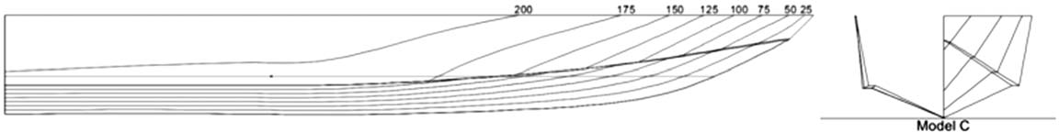

Fig. 1 Lines plan of Model C

Methodology
The study will use the published calm water experimental results of a series of high-speed hard chine planing hulls, generated by Taunton et al. at Southampton University. For details on how these were generated please refer to Ref. [17]. Model C, shown in Fig. 1, was selected at a speed of 9.21 m/s as a benchmark case. The model was 2 m in length, with a beam of 0.46 m. This case was selected as it had a Froude number of 3.12, which is in line with the upper Froude numbers of similar studies investigating planing hulls through CFD.
Simulations will be setup using CD Adapco’s STAR CCM+ CFD solver and run on the ARCHIE-WeST High Performance Com-
puter, hosted by the University of Strathclyde.
This study primarily followed a qualitative methodology in its assessment of how successful a strategy was in minimizing NV. This assessment was be made based upon the VOF plots of the hull. These VOF plots are presented in the Appendix so that the readers may make their own judgment on the impact that a given method has. Following this, a quantitative assessment was underta- ken for the strategies identiﬁed as the most successful. No numerical evaluation metric was identiﬁed that could quantify the amount of NV that was present, so the resistance, trim, and sinkage results were used as a measure of the accuracy of the simulation. As such, the changes in results used in the quantitative assessment may not be solely accountable for the reduction in numerical venti- lation, with some changes potentially being attributable to changes in the meshing strategy or other altered factors. Despite this, it pro- vides a good measure of the level of accuracy of each case, and when combined with the qualitative assessment of the VOF plots an indisputable case may be made for the successful strategies.
efﬁciency. When the VOF model is used, a new variable is intro- duced to deﬁne the spatial distribution of each phase at a given time. This is known as the volume fraction. A volume fraction of
0.5 represents a cell that contains 50% water and 50% air, and as such, this is used to deﬁne the free surface. To help ensure that there was a sharp interface between the phases a second-order dis- cretization scheme was used, as suggested by Ref. [15]. This agrees with the work of Viola et al. who found a second-order convective discretization scheme to minimize NV and improve the accuracy of the simulation [10].
An all wall y+ wall treatment was selected. This is a hybrid approach that emulates a low y+ wall treatment for ﬁne meshes (y+ > 1) and the high y+ wall treatment for coarse meshes (y+ < 30). It is capable of producing reasonable answers for meshes of intermediate resolution (1 < y+ < 30) through the use of a blending
function.
An average y+ of 40 was achieved on the wetted hull. This meant that for the wetted surface the viscous sublayer was not resolved, and instead, wall functions are used to obtain the boundary condi- tions of the continuum equations. The main advantage of the high y+ wall treatment is that there are signiﬁcant savings in com- putational time due to the reduction in the number of near-wall cells [15].

Time-step. The time-step can be selected either to satisfy the CFL condition or to resolve the ﬂow features of interest. The ITTC recommend that for standard pseudo-transient resistance simulations, a time-step that will satisfactorily resolve the ﬂow fea- tures is a function of the vessels speed and the length of the hull, such that [28]

Numerical Modeling
t = 0.005 ∼ 0.01 L
U
Δ

(1)

This section will provide details upon the numerical simulation approaches utilized by this study; however, it will not provide detailed information upon the numerical workings of the CFD code. Detailed information on the inner workings of CFD can be found in Ref. [18].

Physics Modeling. Larson et al. state that the two-equation tur-
An extensive study was undertaken to determine the appropriate time-step. The results are employed in a formal veriﬁcation study to assess the levels of numerical uncertainty accountable to the tem- poral discretization later in the paper. This study found that a time- step that was coarser than the ﬁnest ITTC recommendation was sui- tably accurate. The selected time-step was 0.00304 and was deter- mined using the following equation:

bulence models have been shown to give accurate predictions in ship hydrodynamics [19]. The ITTC concluded from their analysis
t = 0.02 L
U
Δ
(2)

of the entries to Gothenburg 2010 Workshop that there was no visible improvement in accuracy for resistance prediction when tur- bulence models that are more advanced than the two-equation models were used [1]. It was found that k − ω was by far the most applied turbulence model with 80% of the submissions for
the workshop using some form of variation of it. The ITTC also concluded that for resistance calculations the turbulence modeling has little effect on the prediction accuracy [2].
A review of other studies using CFD for planing hull perfor- mance prediction found that the majority of simulations use either k − ɛ [8,20–24] or k − ω shear stress transport (SST) [5–7,25–27]. Whilst both models are comparable in terms of resistance predic- tion, the k − ω SST is known to be superior at predicting separating
ﬂows and wake patterns [1,2]. As such, this model was selected
despite the fact that it is more computationally expensive.
The VOF method was used to model and track the position of the free surface. This simple-multiphase model is well suited for simu- lating ﬂows of immiscible ﬂuids and is known for its numerical
The ITTC deﬁne L as the length between perpendiculars of the vessel. For this study, L in the time-step calculation was taken to be the wetted length of the keel of the vessel.
The time-step study also showed that satisfying the CFL condi- tion for all cells resulted in an unjustiﬁable increase in computa- tional time with a negligible impact upon the results. While only the resistance results are shown, a time-step of 0.00044 produced results within 0.24% (for all measures) of the selected time-step of 0.00304. Satisfying the CFL condition also had a negligible impact on the levels of NV.

Computational Domain. It is well known that when using CFD the domain must be an appropriate size, with boundaries being placed sufﬁciently far from the hull to ensure they have no effect on the solution. The ITTC recommends that the inlet and exterior
boundaries are located 1–2 L from the hull, with the outlet being placed 3–5 L downstream [19]. Care was taken to ensure that the

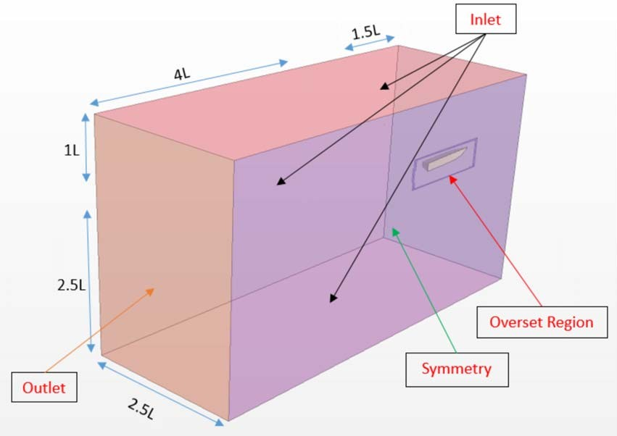
Fig. 2 Boundary conditions and domain sizes

wake of the hull would not intersect with the exterior boundary. The size of the computational domain was selected in accordance with the ITTC recommendations [19] and can be seen in Fig. 2. As is common practice in calm water marine resistance simulations, the solution was assumed to be symmetrical with only half of the hull being modeled in conjunction with a symmetry condition on the center plane. This halves the computational demand over modeling the whole hull.

Boundary Conditions. In all CFD simulations, the selection of appropriate boundary conditions is vital for both the determination of an accurate solution and the prevention of unnecessary computa- tional costs.
A study was carried out to determine the effects of boundary con- ditions on the level of NV, as detailed in Table 1. It was found that the selection of boundary conditions had no discernable impact upon the level of NV; however, the impact upon accuracy and runtime for the various combinations of boundary conditions will be presented in this section. It should be noted that the boundary condition study was done using one of the preliminary meshes used to establish the ﬁnal setup used for this study; however, it remained constant for the duration of the boundary condition study. It is commonplace in marine CFD to model the far-ﬁeld bound- aries as free ﬂow. A boundary may be considered far-ﬁeld if it is in deep water and is over one ship length from the hull for Froude numbers over 0.2 [19]. Different authors implement this free ﬂow condition at the far-ﬁeld boundaries through the use of the inlet, slip wall, and symmetry conditions. As such, the investigation looked at the impact of using these boundary conditions. An addi- tional condition of non-slip walls was also included to determine if it had an impact on the level of NV. This was studied using the ITTC domain size so that only one parameter was altered. While this condition was not physically representative of the model tests, it did show that this selection had no impact on the level of NV. Implementing this non-slip condition increased the mesh

Table 1 Boundary conditions tested
count signiﬁcantly as prism layer mesh was required on each wall surface. It is generally accepted that for far-ﬁeld boundaries, this level of ﬁdelity does not signiﬁcantly alter the results, and that mod- eling a free ﬂow condition is sufﬁciently accurate [19]. The bound- ary condition combinations were tested.
The tank test results of Ref. [17] were used as a reference when calculating percentage errors. In all cases, modeling free ﬂow at the boundary, there is a 0.041% variation in resistance error, 0.078% in trim, and 0.070% for sinkage. As mentioned, there was also no impact upon the numerical ventilation present in the simulation. The only discernable difference caused by the choice of boundary condition was the runtime of the simulation. As such, the inlet con- dition was selected for use in all other simulations as it was the fastest.
The non-slip case showed a slightly larger variation in results than the free ﬂow cases. It was discounted as it was not physically representative of the problem being modeled due to the domain being ITTC size, rather than the same as the test tank. As men- tioned, the purpose of investigating this was to look at impact upon NV, however, a future study into the sensitivity of a planning hull simulation with regard to domain size when modeled with non-slip walls may be of interest.
The VOF wave damping option was utilized to apply a damping zone of 1.25 L, as recommended by Ref. [29], to the side and outlet in order to reduce wave reﬂections and the inﬂuence of the bound- aries on the solution. This damping introduces a vertical resistance to vertical motion and suppresses waves.
A preliminary simulation was run with wave damping included and excluded. It was found to have minimal effects on the results (−0.016% error in resistance, 0.048% in trim, and 0.012% in sinkage), which is the conﬁrmation that the boundaries were placed far enough from the hull for wave reﬂection to have
minimal inﬂuence. Interestingly, it was found that the inclusion of wave damping reduced the runtime of the simulation by 1.77%.

Computational Grid. The dynamic ﬂuid body interaction (DFBI) module allows a simulation to include the motion of a vessel in response to the shear and pressure forces exerted by the ﬂow, and to any additional forces that are user-deﬁned. STAR CCM+ calculates the force and moments that act upon the vessel before solving the governing equations of rigid body motion to determine the new position of the vessel. This model allows a body to have up to six degrees of motion, however, to sim- plify the simulation the vessel will only be free to move in two—
pitch and heave. The equilibrium motion option is employed to
achieve a quasi-steady-state equilibrium position of the vessel. This option means the body motion is calculated between longer intervals to reduce the time required to achieve a steady position [15]. The hydrodynamic ﬁeld generated by a planning hull is far more complex than that of a conventional displacement hull with a small error in the predicted trim having a large impact upon the total resis- tance. There are a number of approaches that may be considered non-conventional for calm water resistance simulations that allow the mesh to change dynamically with the motion of the hull when implemented. These approaches help simulations maintain numeri-
cal accuracy while the hull is in inclined positions [30].
The most complex and computationally demanding of the

approaches is the Chrimea grid or overset mesh. Overset meshes

Case

Side boundary

Top boundary

Bottom boundary
Central processing unit (CPU)
Hours
typically involve a background mesh that is tailored to the environ- ment, and one or more overset grids that are tailored and attached to the body, which overlaps with the background mesh. An overset mesh approach is very useful when dealing with moving bodies

Non-slip Non-slip wall Inlet Non-slip wall 388
Symmetry Symmetry Symmetry Symmetry 369
Inlet and Symmetry Inlet Inlet 363
symmetry
Slip Slip wall Slip wall Slip wall 361
Inlet Inlet Inlet Inlet 350
and ﬂuid–structure interaction (FSI) as it offers far greater ﬂexibility over standard meshing techniques. The approach’s key advantage is that the grid system around the hull moves with the motion of the
hull. This means that the re-meshing or deformation of elements is not required, and the mesh remains consistent in terms of element quality. It is well known to be capable of modeling the

large motions of a planing hull and is recommended for

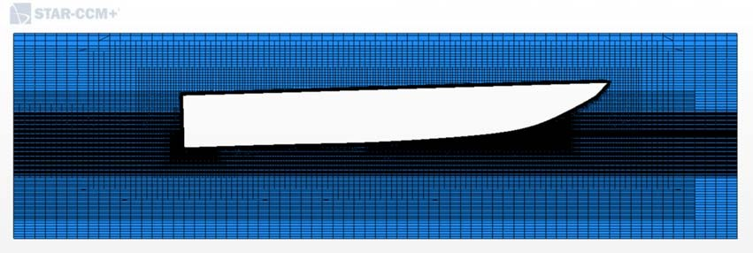
Fig. 3 Overset region

conﬁgurations involving body-motion [19]. As such, it was decided to implement an overset mesh approach.
There is no deﬁnitive recommendation made on the sizing of the overset zone. This zone should be large enough so that the ﬂow fea- tures of interest remain within the overset domain and do not have to pass through the donor cells to the background mesh. It is vital the overlapping cells between the overset and background regions are of similar sizes to prevent interpolation errors as data are passed between them. The size of the overset domain was selected to be in line with similar studies. These studies all featured the same length of 1.5 L, breadth ranging from 1.5B to 5B, and heights ranging from 2.5D to 6D [6,8,29,31]. The overset region that was generated was 1.75 L in length, 4B in width, and 4D in height. It can be seen in Fig. 3; however, due to the density of the mesh, it is somewhat difﬁcult to make out the bow, stern, and ﬁnest free surface reﬁnements.
The mesh was generated using the automated meshing capability of STAR CCM+, which relies upon the Cartesian cut-cell method. The trimmed cell mesher presents a robust and efﬁcient method of pro- ducing a high-quality grid, predominantly made up of unstructured hexahedral cells with polyhedral cells next to the surface. It con- structs a template mesh from the target sizes and then trims this using the input surfaces. It allows for a large degree of control
through the use of local surface and volumetric controls that
Table 2 Grid reﬁnement zones

Reﬁnement zone | X | Y | Z
Surface mesh | 50% | 50% | 50%
Hull box (near) | 50% | 50% | 50%
Hull box (mid) | 100% | 100% | 50%
Hull box (far) | 200% | 200% | 100%
Overset interface | 200% | 200% | 100%
Wake box (near) | 100% | 100% | 100%
Wake box (mis) | 200% | 200% | 200%
Wake box (far) | 400% | 400% | 400%
Free surface (upstream) | 800% | 800% | 3.125%
Free surface (near) | 800% | 800% | 12.5%
Free surface (mid) | 800% | 800% | 25%
Free surface (far) | 800% | 800% | 50%
Bow | 6.25% | 6.25% | 6.25%
Stern | 6.25% | 6.25% | 6.25%

was 1.25% L. This is in line with similar studies, for which base size ranged from 1.3% L to 4.7% L [5,6,15,29]. All reﬁnement zones were sized as a percentage of this base size. The sizing’s for the ﬁnal simulation were as follows:
When undertaking the mesh study, the base size was changed so that the mesh strategy and relative sizes remained constant, whilst the sizes of the cells increased or decreased.
The prism layer mesher was used in conjunction with the trimmed cell mesher to generate orthogonal prismatic cells next to the hull. Utilizing the prism layer mesher generates high-aspect ratio cells that are aligned with the ﬂow next to the wall. This allows the software to resolve high-velocity gradients that are asso- ciated with the boundary layer and increases the accuracy of the simulation. The initial thickness of the prism layer was calculated as the thickness of the turbulent ﬂow over a ﬂat plate, as given by

allow the user to increase or decrease the mesh density. Growth parameters can also be used to ensure that there is a smooth transi- tioning of the mesh and to prevent the introduction of numerical
1
δ = 0 37R− 5
. _{n}
x

(3)

errors.
The mesh was setup with areas of progressively reﬁned mesh to ensure each area of interest was sufﬁciently ﬁne. Three layers of reﬁnement were used for the free surface, the hull box, and the wake region. Additional reﬁnements were included for the bow, the stern, and the free surface upstream of the hull, as will be dis- cussed later. The reﬁnements can be seen in Fig. 4, with the sizing of the cells in each reﬁnment detialed in Table 2. Care was taken to follow the overset guidelines as laid out by Ref. [15]. Of key importance was to ensure that cells in the overlapping region between the overset and background meshes are of similar sizes. This helps reduce any interpolation errors to be of the same order as other discretization errors.
For the generation of the mesh, a base size of 0.025 m was selected. This was chosen as a function of the vessel length and

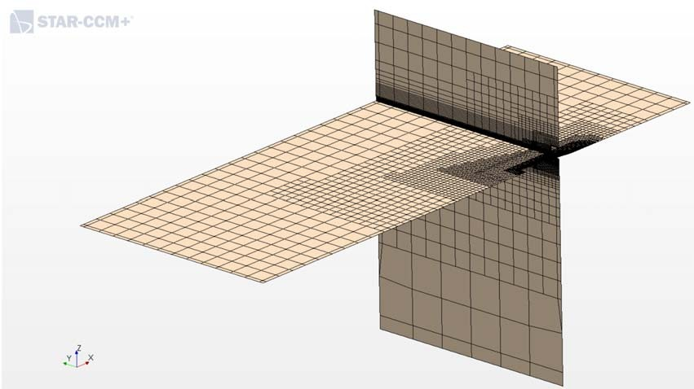
Fig. 4 Computational grid
A stretching ratio of 1.2 as suggested by Ref. [19] was utilized, with a ﬁrst wall cell height that was calculated to give a y+ of 40. The thickness of each layer of the cells in the prism layer was cal- culated, and the layer of a size that would naturally grow into the cell size of the volume mesh was chosen as the ﬁnal prism layer. Whilst this meant that the prism layer thickness was 0.015 m as opposed to 0.020 m, it ensured there was a far smoother transition in the mesh. Without this alteration, the outer prism layer cells
would have been larger than the volume mesh beside them.
To investigate numerical ventilation, a number of meshes were used ranging from 2.5 M to 6 M cells. The ﬁnal mesh that was developed and will be used for the continuation of this work con- tained 6-m cells. This mesh density was established through a mesh study as presented in the following section, utilized the ﬁnal simulation developed as a result of this study to assess the associ- ated levels of numerical uncertainty.

Veriﬁcation
Before employing the simulations developed over the course of this study, it is vital to undertake a comprehensive veriﬁcation study so that the level of numerical uncertainty is understood, and the results may be used with conﬁdence. While this paper aimed to investigate, in more general terms, strategies to minimize NV and the simulations are not used to produce further data, the veriﬁ- cation study of the ﬁnal simulation is included in the following section.
Guidelines on the best practice when performing a veriﬁcation study in relation to a numerical marine analysis have been published by the ITTC [32]. An overview of this procedure will be given; however, for further details, please refer to the aforementioned

Cell count

√–_
√2_
√2_
Table 3 Grid convergence study

– 5,904,385 2,774,176 1,368,383 –
Parameter | r_{G} | EFD | S₁ | S₂ | S₃ | R_{G} | U_{G} U′G
 |  |  |  |  |  |  | – –
Resistance (N) |  |  | 76.675 | 77.013 | 77.639 | 0.539 | 0.510 | 0.665%
Sinkage (m) |  |  | 0.05417 | 0.05419 | 0.05557 | 0.015 | 0.000042 | 0.077%
Trim (deg) | 2 1.73 |  | 2.066 | 2.064 | 2.017 | 0.173 | 0.003567 | 0.173%

69.98
0.05

Table 4 Time-step convergence study
Parameter r_{T} EFD S₁ S₂ S₃ R_{T} U_{T} U′T

Time-step (s)
 |  |  |  |  |  | – | – –
Resistance (N) |  | 69.98 | 76.675 | 76.775 | 77.079 | 0.331 | 0.151 | 0.197%
Sinkage (m) |  | 0.05 | 0.05417 | 0.05415 | 0.05411 | 0.536 | 0.000033 | 0.060%
Trim (deg) | 2 | 1.73 | 2.066 | 2.064 | 2.062 | 0.871 | 0.031627 | 1.531%

√–_
√_2_
√_2_
– 3.04E-03 4.30E-03 6.08E-02

document. Before continuing with this overview, it is ﬁrst beneﬁcial to deﬁne veriﬁcation.
Veriﬁcation is the quantitative assessment of the numerical uncertainty (U_{SN}) and, when conditions permit, estimating the sign and magnitude of the numerical error (δ∗SN ) and the uncertainty (U_{S}CN ) in that estimate. It is used to determine if a computational simulation accurately represents the conceptual model [33].
The recommendations made in Ref. [32] are based upon the work of Ref. [34] and follow an approach in which the errors and uncer- tainties are deﬁned in a manner that is consistent with the uncer- tainty analysis of experimental work. The simulation error (δ_{S}) is
deﬁned as the difference between a simulation’s result (S) and the truth (T ) and is made up of modeling (δ_{SM}) and numerical (δ_{SN})
errors.
The analysis relies upon Richardson extrapolation (RE), which forms the basis for existing quantitative numerical uncertainty and error estimates for both grid and time-step convergence [35]. The error is expanded in a power series, with integer powers of grid spacing or time-step taken as a ﬁnite sum. When it is assumed that the solutions lie within the asymptotic range, it is acceptable that only the ﬁrst term is considered, leading to a so-called triplet study.
The Correction Factor approach was employed, providing a quantitative measure of deﬁning how far from a solution is from the asymptotic range, and then approximately accounting for the effects of higher-order terms. This is based upon veriﬁca- tion studies for one-dimensional (1D) wave equations and two- dimensional (2D) Laplace equation analytical benchmarks, which showed one-term RE error estimates to be poor when out with the asymptotic range, however, that these could be improved by multiplying them by a correction factor. Following this veriﬁcation process allows the numerical uncertainty to be assessed.

Veriﬁcation Case. Having developed the ﬁnal simulation setup (Case 4 in Table 5), a veriﬁcation study was undertaken, with both grid and time-step studies being conducted. The grid and time-step
studies employed a reﬁnement ratio of √2 as suggested by
Ref. [32].
The triplet studies for both mesh density and time-step produced results that displayed monatomic convergence. The speciﬁc uncer- tainties were calculated following the correction factor approach, as detailed in Ref. [32]. Prior to the undertaking of triplet studies, it was ensured that the iterative uncertainty was negligible and did not contaminate the results. The calculated uncertainties are shown in Tables 3 and 4.
When the uncertainty accountable to both temporal and spatial discretization are combined the total numerical uncertainty for resis- tance is 0.20%, sinkage is 0.06%, and trim is 1.53%. These values are all suitably small, indicating that the simulation may be
considered accurate in the sense that only small uncertainties are introduced from the choice of temporal and spatial discretization.

Results and Discussion
Following the initial run of the simulation, it was conﬁrmed that it suffered from a signiﬁcant amount of NV and was incapable of producing accurate results as is visible in Fig. 5. Through the course of the study, the problem of NV was minimized from a level that made the simulation invalid, to a level that was acceptable for engineering applications and had minimal effect on the results. The progressive improvments due to the different stratagies are
shown in Figs. 6–9. Through a combination of the modiﬁed HRIC scheme and the correct mesh reﬁnement, it was possible to minimize NV to two thin streaks containing 96–98% water.
The following section will discuss the potential solutions that
were tested and their degree of success, as well as discussing the root causes of NV.

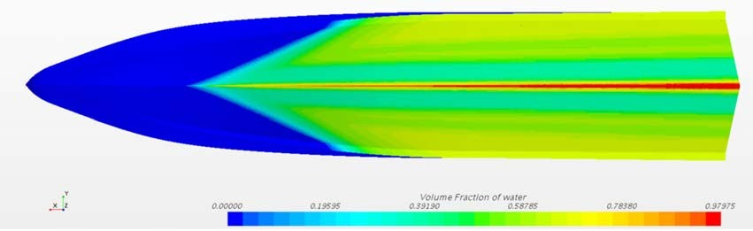
Fig. 5 Inadaquate mesh
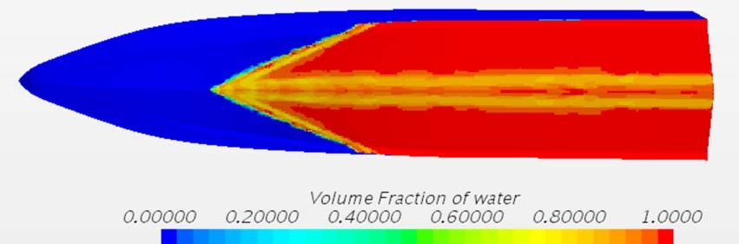
Fig. 6 Simulation with Standard HRIC scheme

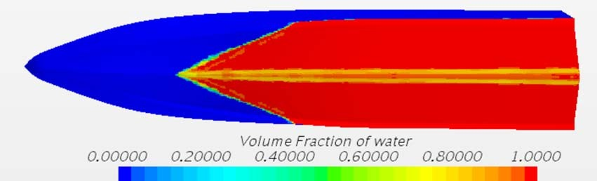
Fig. 7 Simulation with modiﬁed HRIC scheme

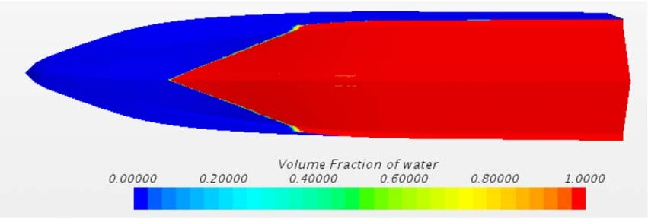

Fig. 8 Simulation with modiﬁed HRIC scheme and mesh reﬁnement
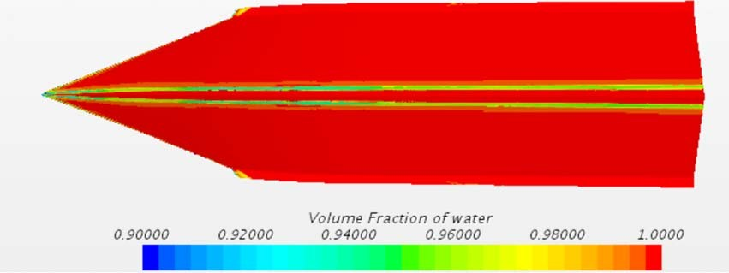
Fig. 9 Simulation with modiﬁed HRIC scheme and mesh reﬁne- ment zoomed in (90–100% water)

Modiﬁed HRIC Scheme. As was suggested by Böhm and uti- lized by several other authors investigating high-speed planing hulls through the use of CFD, a modiﬁed HRIC scheme was employed [11]. Due to the removal of the CFL dependency and the blending with a UD scheme, the ability of the simulation to capture the interface between the two phases was improved. This led to a signiﬁcant reduction in the NV as well as giving the remain- ing NV a far sharper interface. This improvement can be seen as the change from Figs. 6 and 7.

Lowering Courant–Friedrichs–Lewy Number. The CFL number is the ratio of the time-step to the mesh convection time- scale. It essentially deﬁnes the number of cells that a particle of
ﬂuid will pass through in each time-step. It is recommended that the CFL number is less than or equal to 1 for numerical stability, however as a calm water resistance simulation is seeking a steady-state solution, larger CFL numbers give equally accurate
results. It was theorized that a large CFL number at the point of hull entry would result in the code “losing track” of the air partials and introduce them into the ﬂow under the hull due to the fact they were traveling through multiple cells in every time-step. A range of CFL numbers were tested, and it was found to have little to no effect
on NV. In the time-step study, the smallest time-step had a CFL of around 12 at the point of hull entry, whilst the largest time-step had a CFL of around 100. There was no noticeable effect on the NV between the two.
As a ﬁnal check, the CFL was lowered to have a value of 0.5 at the point of hull entry, which required a time-step 20 times smaller than the ITTC formulation. This was found to reduce the percentage of air in the streaks from 3.5% to 2%, a small improvement; however, it did not justify the extra computational time.

Boundary Conditions. As part of the boundary condition (BC) study, the NV was also checked. It was found that the choice of BC’s had no impact upon the NV that was present.

Domain Size. A smaller domain of the same dimensions as the towing tank in which the tests were originally carried out was also tested. This resulted in a domain that 2.375 m wide and 1.68 m deep. The distance from the hull to the inlet and outlet remained constant. The domain size was also found to have no impact upon the NV.
Turbulence Model. The k − ɛ turbulence model was tested; however, it was found to have no impact upon the NV.

Sharpening Factor. The sharpening factor attempts to reduce numerical diffusion and improves the resolution of the interface between phases. It does this by introducing a new anti-diffusion velocity term into the VOF transport equation. A known problem with increasing the sharpening factor is that it may result in a non- physical alignment of the free surface with the gridlines, which was found to result in a much ﬂatter wake. A sharpening factor of 0.2 was included but it was found to be detrimental. Rather than shar- pening the interface and preventing NV, it was found to sharpen the interface of the NV under the hull, resulting in more clearly deﬁned streaking.

Mesh Reﬁnement. Mesh reﬁnement was the best solution to the NV problem, after the modiﬁed HRIC scheme. The root cause of NV is when the free surface interface becomes blurred. The modi- ﬁed HRIC scheme helps prevent this, which is accountable to its success. An inadequate mesh may also result in interface smearing through a number of causes.
The ﬁrst cause of interface smearing accountable to the mesh arises from the prism layer. As was discussed earlier, NV only occurs for speciﬁc bodies, typically with a bow that forms a small, acute entrance angle with the free surface. When bodies such as these have meshed, the prism layer mesh and the volume mesh have a small angle between them, as seen in Fig. 10. In the case of a conventional ship, this angle would be large, possibly even 90 deg. Due to this, the cells in the prism layer mesh are not aligned with the ﬂow. It is well known that when the free surface is not aligned with the mesh, numerical diffusion will occur. This results in interface smearing at the point of entry of the hull, as seen in Fig. 10. It can also be seen that air is transported under the hull in the near-wall cells, resulting in NV.
Any meshing strategy that prevented interface smearing in the prism layer resulted in a vast improvement on NV. The number of prism layers had a large effect. It is normally advisable to have the last cell of the prism layer and the ﬁrst cell of volume mesh of comparable sizes; however, implementing this was found to be detrimental. As can be seen in Fig. 10, the last layer of the prism layer appears to be too large; however, adding more prism layers was found to result in further interface smearing. The thickness of the prism layer also had a large effect on NV. A thick prism layer meant that the free surface had a considerably larger zone in which interface smearing occurred as more cells were misaligned with the ﬂow. A strategy to minimize this was developed, in which the prism layer thickness was reduced to 0.25 of the original value at the point of hull entry, as seen in Fig. 11. This was found to signiﬁcantly reduce NV that was introduced due to interface blur- ring as a result of the prism layer cells.
The second cause of free surface blurring arose from inadequate mesh reﬁnements. The ﬁrst reﬁnement strategy was to increase the
resolution of the mesh in the bow area. This ensures that the mesh is capable of resolving the thin spray root that forms and prevents air from being dragged under the hull. The bow reﬁnement on its own, however, was found to be detrimental to the NV due to the fact that the z-sizing of the bow reﬁnement was ﬁner than the z- sizing of the upstream free surface reﬁnement. This resulted in

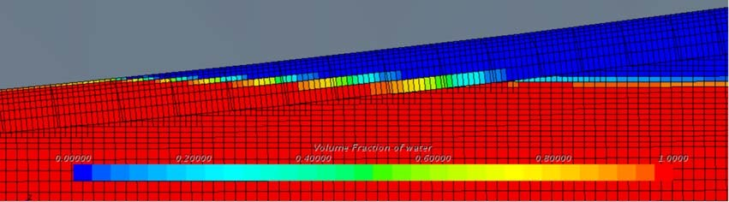
Fig. 10 Prism layer mesh

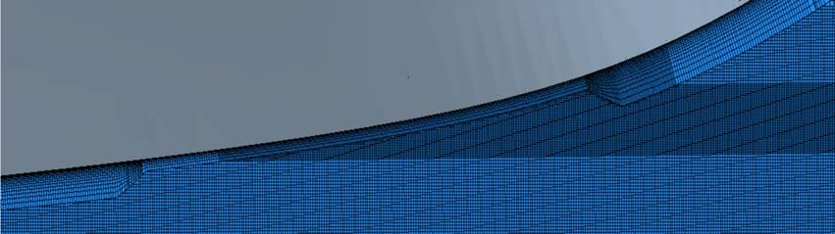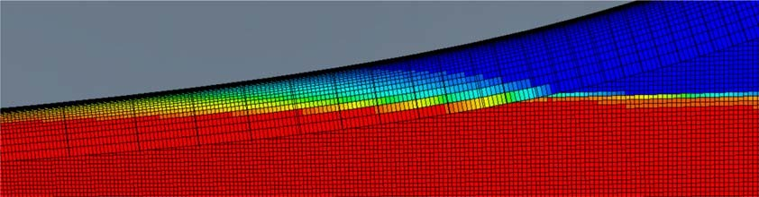

Fig. 11 Collapsing prism layer
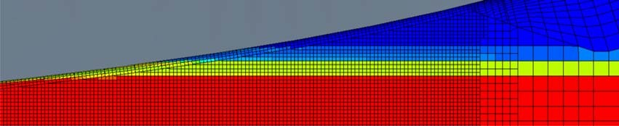
Fig. 12 Interface smearing due to downstream z-reﬁnement

interface smearing as where the free surface was modelled by one cell in the upstream free surface reﬁnement zone, it was spread across multiple cells in the bow reﬁnement zone, as seen in Fig. 12. It is therefore necessary to ensure that the z-sizing of the bow reﬁnement zone is equal to that of the upstream free surface reﬁnement zone, or to include an additional upstream free surface reﬁnement. This is in agreement with what was found by Olin, who stated that upstream reﬁnement had the largest positive impact [12].
Adding upstream free surface reﬁnement had a larger effect than the bow reﬁnement. This is accountable to how STAR CCM+ gener- ates the mesh. When an upstream reﬁnement is added, the reﬁne- ment is projected through the prism layer mesh onto the hull surface mesh as well in the zone where the upstream reﬁnement meets the hull. This means that when a free surface reﬁnement is implemented, it essentially adds a surface reﬁnement to the hull in the area in which it intersects with the hull. Adding a bow reﬁne-
ment in addition to the upstream reﬁnement helps ensure that the reﬁned area is sufﬁciently large to capture the ﬂow characteristics in the entry region. Having a bow reﬁnement was found to further minimize NV over an upstream free surface reﬁnement alone.
When the levels of reﬁnement were varied for each of the two zones, it was found to have a large effect on the NV. The level of bow reﬁnement had less impact as the free surface reﬁnement pro- jects onto the hull at the intersection zone, but it still showed some effect. The level of free surface reﬁnement had a notable effect on the NV. There appears to be a “sweet spot” for the level of both
reﬁnements that was found by making systematic variations. If
they are more or less reﬁned than this “sweet spot,” then the NV becomes worse. Of interest is that this “sweet spot” is relative to the rest of the mesh, rather than absolute sizes. This was noted
during a mesh study when the sizing of the entire mesh was altered but the level of NV remained constant despite the fact that the absolute size within the bow and upstream reﬁnements had changed. Previously changing the absolute sizes in these zones and leaving the mesh constant had resulted in increased NV.
During the preliminary setup of the simulation, a low y+ wall
treatment was initially attempted. This setup had a combination of a large number of prism layers and an inadequate free surface mesh in which the bow z-reﬁnement was ﬁner than the free surface z-reﬁnement. The loss of the water–air interface due to this setup is seen in Fig. 13. It should be noted that a modiﬁed
HRIC has not been implemented in this setup. This is a worst-case scenario in which the potential to cause large amounts of NV is dis- played. The same simulation was setup with a high y+ wall treat- ment, the only difference being the number of prism layers. This too suffered from a large amount of NV; however, it was consider- ably less than for the low y+ case, which reinforces the idea that reducing the number of prism layers plays a large part in preventing NV. The effect of the high y+ case of this inadequate setup on the VOF plot of the hull is shown in Fig. 5.
Fig. 13 Low y+ wall treatment interface smearing
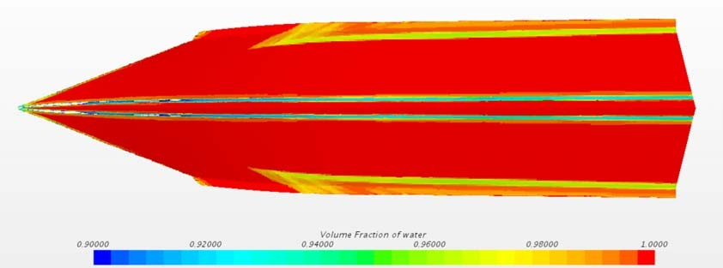
Fig. 14 Second source of NV
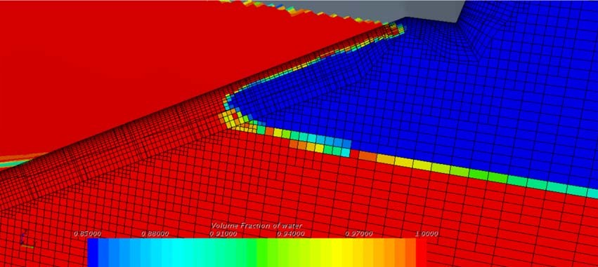
Fig. 15 Interface smearing at second source of NV

Whilst altering the mesh, the second source of NV was discov- ered further aft of the bow entry point. This resulted in two addi- tional streaks as seen in Fig. 14.
This was once again the result of interface smearing where the volume mesh met the prism layer. In this case, the volume mesh cells were considerably larger than the prism layer, which lead to smearing as seen in Fig. 15. As the slice used to generate the scene was systematically moved aft the interface, smearing could be seen as it was developed into a bubble that was drawn into the prism layer. Here, it moved inward until it smeared on the hull. The solution to this second source was to ensure that the volume and prism layer mesh were of comparable sizes until the free surface met the chine. In a practical sense, this was resolved by extending the upstream free surface reﬁnement aft until it met the chine.

Quantitative Analysis. In addition to the qualitative assessment that is has been presented so far, it is possible to carry out a quan- titative assessment for the four main cases as presented in Figs. 5 to 8. The changes implemented in the progression of these ﬁgures are the key strategies to ensure numerical ventilation is reduced. A summary of each of the ﬁgures is given before the results are presented.

- Figure 5 (Case 1) has an inadequate mesh setup in which there is a ﬁner z-reﬁnement in the bow-reﬁnement zone than the upstream free surface z-reﬁnement. This causes the free sur-
face to be spread over several cells, which then suffers from a large degree of numerical diffusion in the prism layer as seen in Fig. 13. Note that Fig. 13 is a low y+ case, and Fig. 5 is a high y+ case; however, the same phenomena is occurring.
- Figure 6 (Case 2) is the same as Fig. 5; however, aforemen- tioned problems with the mesh were been corrected so that
the simulation may be considered adequate.

Table 5 Quantitative results
Case Resistance (N) Trim (deg) Sinkage (m) Case 1 53.19 23.99% 2.141 −23.78% 0.0563 12.70%
Case 2 75.53 −7.93% 2.190 −26.57% 0.0545 9.09%
Case 3 76.17 −8.85% 2.068 −19.54% 0.0544 8.83%
Case 4 76.67 −9.57% 2.066 −19.41% 0.0542 8.34%
Table 6 Summary of investigated strategies

Strategy Effectiveness
Modiﬁed HRIC scheme 1
Lowering CFL number 3
Boundary conditions 3
Domain size 3

Turbulence model 3
Sharpening factor 3

- Figure 7 (Case 3) is the same as Fig. 6; however, a modiﬁed HRIC scheme has been implemented.
- Figure 8 (Case 4) is the same as Fig. 7; however, the prism
Mesh reﬁnement—bow reﬁnement 2
Mesh reﬁnement—upstream free surface reﬁnement 1
Mesh reﬁnement—thickness of prism layer at free surface 1
Mesh reﬁnement—number of prism layers 1

layer has been collapsed at the point of entry and suitable mesh reﬁnements have been added in the bow and upstream free surface regions.
As can be seen, the results for Case 1 contain signiﬁcant errors when compared to the experimental data, conﬁrming that this simu- lation is inadequate and is incapable of producing reliable results due to the prevalence of NV.
When the mesh is corrected so that the free surface interface is no longer spread over several cells in Case 2, the amount of NV is observed to reduce dramatically. This causes the resistance results to improve signiﬁcantly. This case is now far more physically repre- sentative of what is happening in real life as there is no longer a mixture of air and water under the hull.
From Case 2 to Case 4, the changes are far smaller than the jump from Cases 1 and 2. The resistance is seen to increase as the amount of NV reduces. This is to be expected as the ﬂuid properties of the near-wall cells will change as they contain less air, increasing fric- tional resistance. While the error in comparison with the experimen- tal results is seen to grow as the NV is reduced, this should not be considered a negative thing. The NV is not physically there in the real-world case, and as such, the simulations where it is eradicated are far more representative of this. While the simulations with NV present appear to be more accurate in terms of resistance, this is only due to an error that is introduced into the simulation. More accurate methods of turbulence modeling or other changes to the simulation may improve the accuracy further; however, it is always desirable to minimize NV as much as possible.
The trim and sinkage are both seen to progressively improve in accuracy as the NV is reduced. This is because the forces
acting upon the hull and the pressure distributions are more accu- rately modeled in the cases where there is no mixture of ﬂuids on the hull.
One of the key requirements when setting up CFD simulations is to sufﬁciently balance computational cost with simulation accuracy. This is a judgment that must be made on a case-by-case basis. Fol- lowing this, the uncertainty must be assessed through a veriﬁcation study. There was a 1.61% increase when the modiﬁed HRIC scheme was employed. This is a computationally inexpensive method of improving the accuracy of the simulation. It is recom- mended that this approach be followed regardless of the availability of computational resources. When the prism layer was collapsed at the point of entry, and additional bow and upstream free-surface reﬁnements were included 500 k, cells were added to the mesh, which lead to an increase of 9.25% in runtime. As this work was performed on an HPC, this led to an increase of 47 min, which was not considered signiﬁcant, and therefore, the merit in accuracy was considered worth the

Summary. The effectiveness of each of the investigated methods has been summarized and is presented in Table 6. They have been ranked in effectiveness from 1 to 3 with one being very effective and three being ineffective. The strategies deemed to be effective have been conﬁrmed through both qualitative assess- ments of their results, and quantitative assessment of the VOF plots. There was no quantitative assessment undertaken for strategies deemed to be ineffective based upon qualitative analysis of their
Mesh reﬁnement—prism layer to volume mesh size 1
difference

VOF plots. These VOF plots are presented in the Appendix so that the reader may make their own judgment as to the effectiveness of each strategy. It should be noted that a strategy being classiﬁed as effective does not mean it will be sufﬁcient on its own and that mul- tiple methods may need to be employed to minimize the NV. It should also be noted that strategies classiﬁed as ineffective may be effective with further investigation; however, they were not found to be in the scope of this study.

Conclusion
This study undertook a systematic study to establish strategies for minimizing the levels of NV in a CFD simulation of a planning hull. Both qualitative and quantitative analyses were used to establish the strategies that were the most effective, giving conﬁdence to the con- clusions. Additionally, a complete veriﬁcation study was underta- ken to ensure that the numerical uncertainty associated with the temporal and spatial discretization of the simulations was under- stood. This further enhances the conﬁdence in the results.
The main cause of NV identiﬁed in this study is when interface smearing occurs due to the simulation being incapable of tracking the free surface. This may be accountable to either the interface cap- turing scheme or the mesh. When the mesh was at fault, NV was introduced to the hull from two different sources:
- at the point of entry and
- as streaks nearer the chine.
When a more detailed understanding of the problem was devel- oped and both sources were investigated, it was found that they both originated from the same cause—the interface between the prism layer mesh and the volume mesh. This is primarily account-
able for the fact that the prism layer cells are not aligned with the free surface, which results in numerical diffusion. Whilst there is no way to avoid this, several solutions were tested. It was found that whilst it is not possible to eradicate NV, it is possible to reduce it to a level at which it will have little to no bearing on the results and is acceptable for engineering applications. Through the course of this study, the NV present in the simulation was reduced from two 0.055-m-wide streaks with 90% air content, to two 0.011-m-wide streaks of 4% to 2% air content.
Previous work that presented solutions to NV was compiled, and the applicability of each was tested. It was found that Bohm’s mod- iﬁed HRIC [11] and Olin’s upstream reﬁnements [12] were the most capable; however, from the literature, it is suggested to use Viola et al.’s artiﬁcial suppression where applicable [10].
It was found that the time-step and the CFL of the free surface
had little impact when trying to reduce NV. Additionally, several other solutions were tried to help gain a better understanding of NV and to help future researchers save time by establishing what is and is not successful.
It was found that reducing the level of numerical ventilation, in this case, was slightly detrimental to the resistance results. The simulation was found to overpredict resistance and when the NV

was removed through the implementation or the proposed strategies the ﬂuid properties in the near-wall cells changed, and the frictional resistance increased. While this increased the error in the resistance results, this was in fact more physically representative of the real- world case and it is necessary to reduce it as much as possible in all simulations. Further enhancements to the simulation through the changes to the turbulence approach may further improve the accuracy. Reducing the NV was found to improve the trim and sinkage results as the pressures and forces acting upon the hull were calculated more accurately.
A novel solution of reducing the thickness of the prism layer at the point of water entry was developed and deemed successful. Through the investigation into the effects of mesh parameters on NV and by laying out clearly how interface smearing may be intro- duced through an inadequate mesh, it is hoped that the understand- ing of the NV will be further developed. A more detailed and widespread understanding of NV will hopefully increase the accu- racy of high-speed planning hull simulations, and by minimizing the problem, it will ensure that all future work is more reliable. Future work in the area should investigate the interface capturing scheme settings in more detail. Whilst it is possible to minimize numerical ventilation through the mesh reﬁnement, it may not be possible to eradicate it using this approach.

Acknowledgment
The results were obtained using the ARCHIE-WeSt High Perfor- mance Computer¹ based at the University of Strathclyde.

Nomenclature
Fr = Froude number
L = length between perpendiculars R_{n} = Reynolds number
R_{T} = total resistance Rv = viscous resistance U = ship speed
x = plate length
δ = boundary layer thickness
Δt = time step

Appendix
To view Appendices please visit: https://strathprints.strath.ac.uk/ 75387/. Alternately it may be accessed by searching “Appendix A for ‘Minimizing Numerical Ventilation in CFD Simulations of High-Speed Planning Hulls’” on the University of Strathclyde’s online portal.²

References
- Larson, L., Stern, F., and Visonneau, M., 2014, Numerical Ship Hydrodynamics—An Assessment of the Gothenburg 2010 Workshop, Springer Netherlands, The Netherlands.
- ITTC Specialist Committee on CFD in Marine Hydrodynamics, 2014, “Specialist Committee on CFD in Marine Hydrodynamics Final Report and Recommendations to the 27th ITTC,” https://ittc.info/media/6097/sc-cfd.pdf,
Accessed December 11, 2018
- Brizzolara, S., and Serra, F., 2007, “Accuracy of CFD Codes in the Prediction of Planning Surfaces Hydrodynamic Characteristics,” Proceedings of 2nd International Conference on Marine Research and Transportation, Ischia, Naples, Italy, June 28–30, pp. 147–158.
- Veysi, S. T. G., Bakhtiari, M., Ghassemi, H., and Ghiasi, M., 2015, “Toward Numerical Modeling of the Stepped and Non-stepped Planing Hull,” J. Braz. Soc. Mech. Sci. Eng., 37(6), pp. 1635–1645.
- Mancini, S., De Luca, F., and Ramolini, A., 2017, “Towards CFD Guidelines for Planning Hull Simulations Based on the Naples Systematic Series,” Proceedings of 7th International Conference on Computational Methods in Marine
Engineering, MARINE 2017, Nantes, France, May 15–17, pp. 1071–1085.

¹www.archie-west.ac.uk ²https://pureportal.strath.ac.uk/en/home/index/
- De Marco, A., Mancini, S., Miranda, S., Scognamiglio, R., and Vitiello, L., 2017, “Experimental and Numerical Hydrodynamic Analysis of a Stepped Planning Hull,” Appl. Ocean Res., 64, pp. 135–154.
- Frisk, D., and Tegehall, L., 2015, “Prediction of High-Speed Planning Hull Resistance and Running Attitude – A Numerical Study Using Computational Fluid Dynamics,” Masters Thesis, Report. X – Department of Shipping and Marine Technology, Chalmers University ofTechnology, Gothenburg, Sweden.
- De Luca, F., Mancini, S., Miranda, S., and Pensa, C., 2016, “An Extended Veriﬁcation and Validation Study of CFD Simulations for Planning Hulls,” J. Ship Res., 60(2), pp. 101–118.
- Sottorf, W., “Experiments With Planning Surfaces,” National Advisory
Committee for Aeronautics Technical Memorandums 661, March, Mar. 1934, https://ntrs.nasa.gov/search.jsp?R=19930094677, Accessed January 3,
2019.
- Viola, I. M., Flay, R. G. J., and Ponzini, R., 2012, “CFD Analysis of the Hydrodynamic Performance of Two Candidate America’s Cup AC33 Hulls,” Int. J. Small Craft Technol., 154(1), pp. 1–12.
- Böhm, C., 2011, “A Velocity Prediction Procedure for Sailing Yachts With a
Hydrodynamic Model Based on Integrated Fully Coupled Ranse-Free-Surface Simulations,” Delft University of Technology, Delft, The Netherlands.
- Olin, L., 2015, “Numerical Modeling of Spray Sheet Deﬂection on Planning Hulls,” KTH Royal Institute of Technology, Stockholm.
- Ubbink, O., 1997, “Numerical Prediction of Two Fluid Systems With Sharp Interfaces,” University of London and Diploma of Imperial College, London, UK.
- Muzaferija, S., and Peric, M., 1999, “Computation of Free Surface Flows Using Interface-Tracking and Interface Capturing Methods,” Nonlinear Water Wave Interaction, WIT Press, Southampton.
- CD Adapco, 2018, “Simcenter STAR-CCM+ Documentation,” https:// documentation.thesteveportal.plm.automation.siemens.com/starccmplus_latest_en/ index.html#page/connect%2Fsplash.html, Accessed January 7, 2019
- Andrillon, Y., and Alessandrini, B., 2003, “A 2D + T VOF Fully Coupled Formulation for Calculation of Breaking Free Surface Flow,” Twenty-Fourth Symposium on Naval Hydrodynamics, National Academies Press, Washington,
DC.
- Taunton, D. J., Hudson, D. A., and Shenoi, R. A., 2010, “Characteristics of a Series of High Speed Hard Chine Planing Hulls—Part 1: Performance in Calm Water,” Int. J. Small Craft Technol., 152, pp. 55–75.
- Ferziger, J. H., and Perić, M., 2002, Computational Methods for Fluid Dynamics, 3rd ed., Springer, Berlin.
- ITTC—Recommended Procedures and Guidelines, 2011, “Practical Guidelines for Ship CFD,” https://ittc.info/media/1357/75-03-02-03.pdf, Accessed January 3, 2019.
- Brizzolara, S., and Villa, D., 2010, “CFD Simulation of Planning Hulls,” Proceedings of Seventh International Conference On High-Performance Marine Vehicles, Melbourne, FL, Oct. 13–15, pp. 16–24.
- Lotﬁ, P., Ashraﬁzaadeh, M., and Esfahan, R. K., 2015, “Numerical Investigation of a Stepped Planning Hull in Calm Water,” Ocean Eng., 94, pp. 103–110.
- Bakhtiari, M., Veysi, S., and Ghassemi, H., 2016, “Numerical Modeling of the Stepped Planning Hull in Calm Water,” Int. J. Eng., 29(2), pp. 236–245.
- Sukas, O. F., Kinaci, O. K., Cakici, F., and Gokce, M. K., 2017, “Hydrodynamic Assessment of Planning Hulls Using Overset Grids,” Appl. Ocean Res., 65, pp. 35–46.
- Dashtimanesh, A., Esfandiari, A., and Mancini, S., 2017, “Performance Prediction of Two-Stepped Planning Hulls Using Morphing Mesh Approach,”
J. Ship Prod. Des., 34, pp. 236–248.
- Ghassemi, H., Kamarlouei, M., and Veysi, S. T. G., 2015, “A Hydrodynamic Methodology and CFD Analysis for Performance Prediction of Stepped Planning Hulls,” Pol. Marit. Res., 22(2), pp. 23–31.
- Wang, S., Su, Y., Zhang, X., and Yang, J., 2012, “RANSE Simulation of High- Speed Planning Craft in Regular Waves,” J. Mar. Sci. Appl., 11(4), pp. 447–452.
- Castiglione, T., Stern, F., Bova, S., and Kandasamy, M., 2011, “Numerical
Investigation of the Seakeeping Behavior of a Catamaran Advancing in Regular Head Waves,” Ocean Eng., 38(16), pp. 1806–1822.
- 26th ITTC Specialist Committee on CFD in Marine Hydrodynamics, 2014,
“Practical Guidelines for Ship CFD Applications,” http://ittc.info/media/1357/ 75-03-02-03.pdf, Accessed May 1, 2018.
- Tezdogan, T., Demirel, Y. K., Kellett, P., Khorasanchi, M., Incecik, A., and Turan, O., 2015, “Full-Scale Unsteady RANS CFD Simulations of Ship Behaviour and Performance in Head Seas Due to Slow Steaming,” Ocean Eng., 97, pp. 186–206.
- Begovic, E., Bertorello, C., and Mancini, S., 2015, “Hydrodynamic Performances of Small Size Swath Craft,” Brodogradnja/Shipbuilding, 66(4), pp. 1–22.
- Sukas, ÖF, and Gökçe, M. K., 2016, “Prediction of Hydrodynamic Aspects of a Catamaran Using Overset Grid Design,” Proceedings of Thirteenth International Conference on Marine Sciences and Technologies Black Sea.
- Resistance Committee of 25th ITTC, 2008, “Uncertainty Analysis in CFD Veriﬁcation and Validation Methodology and Procedures,” http://ittc.info/ media/4184/75-03-01-01.pdf
- American Institute of Aeronautics and Astronautics, Inc., 1998, Guide for the Veriﬁcation and Validation of Computational Fluid Dynamics Simulations, American Institute of Aeronautics and Astronautics, Inc., Washington, DC.
- Stern, F., Wilson, R., and Shao, J., 2006, “Quantitative V&V of CFD Simulations and Certiﬁcation of CFD Codes,” Int. J. Numer. Methods Fluids, 50(11), pp. 1335–1355.
- Xing, T., and Stern, F., 2010, “Factors of Safety for Richardson Extrapolation,”
ASME J. Fluids Eng., 132(6), p. 061403.

