Body-mediated bioelectronics for zero-powered ion release and electrical stimulation
Sungwon Jung^{a†}, Hyungseok Yong^{b†}, Sohyeon Parkª, Dongchang Kim^{b}, Seokgyu Ryu^{c}, Yang-Hee Kim^{d}, Bumgyu Choiª, Woojin Choiª, Joon-Seok Lee^{b}, Jeeyoung Yoo^{c}, Jinkee Hongª* and Sangmin Lee^{b}*
ªSchool of Chemical & Biomolecular Engineering, Yonsei University, 50 Yonsei-ro, Seodaemun-gu, Seoul, 03722, Republic of Korea
^{b}School of Mechanical Engineering, Chung-Ang University, 84 Heukseuk-ro, Dongjack-gu, Seoul, 06974, Republic of Korea
^{c}School of Energy Engineering Kyungpook National University, 80 Daehak-ro, Buk-gu, Daegu, 41566, Republic of Korea
^{d}Bone and Joint Research Group, Centre for Human Development, Stem Cells and Regeneration, Institute of Developmental Sciences, University of Southampton, Southampton SO16 6YD, United Kingdom
AUTHOR INFORMATION
Corresponding Author
* Correspondence: slee98@cau.ac.kr and jinkee.hong@yonsei.ac.kr

ABSTRACT
Development of bioelectronics that can be used permanently in daily life without additional power sources is an important research goal. To this end, myriad permanent systems based on energy harvesting have been reported; however, there are still limitations, such as restrictions regarding specific installations and connections to lines. Herein, we present a new type of bioelectronics based on body-mediated energy transfer for zero-powered ion release and electrical stimulation. The body-mediated bioelectronics (BMB) is a new system that transfers electrical energy generated by various human activities (e.g., walking, using laptop) through the human body without energy loss. To apply the BMB to human skin, a biocompatible and skin-adhesive soft ion-diffusive hydrogel (IDH) was utilized as the bioelectrode. Finally, a BMB patch composed of IDHs with an iontophoretic structure was applied to the human body and zero-powered electrical stimulation as well as active ion emission were implemented in daily life.
TOC GRAPHICS
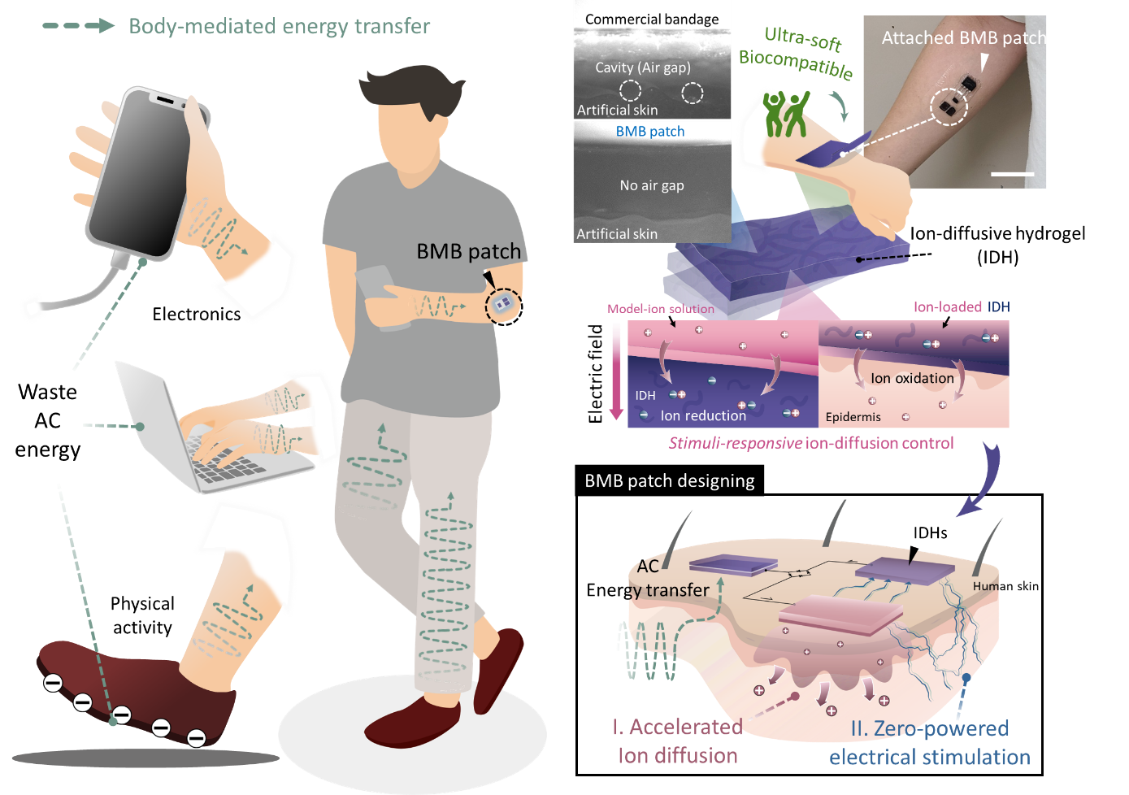
MAIN TEXT
Bioelectronics are emerging devices that are a promising solution to meet the global demands for self-care and smart healthcare¹⁻⁸. Among them, non-invasive bioelectronics are considered as the realistic and feasible medical applications for minimizing anxiety in patients with toxicity problems⁹⁻¹¹. However, non-invasive treatments show significantly low efficiencies because the drug or electrical signals must penetrate the dermis, epidermis, and keratin layers to reach the target. This results in ineffective control of the therapeutic effects of bioelectronics and limits their usability. The development of multifunctional bioelectrodes is also a big challenge of non-invasive bioelectronics. In particular, it is essential that non-invasive bioelectronics utilize flexible and stretchable conductive materials that can remain in close contact with the skin with a wrinkled surface and large strain¹². Recently, various bioelectronic devices have utilized hydrogels as conductive materials to satisfy these requirements¹³⁻¹⁵, but most of them are only mechanically or electrically optimized for each application field. Such biased optimizations of hydrogels are incompatible for various other medical applications and have limited their versatility.
Meanwhile, conventional bioelectronics utilized external power sources to control and maximize the therapeutic effects. Despite the recent advances in battery energy density, it is a difficult task to provide stable and sustainable power supply. Small and affordable commercial batteries still require frequent replacement or recharging, and other related issues, such as toxic substances constituting both electrodes and electrolytes cannot be ignored in healthcare¹⁶⁻¹⁷. To address these issues, various energy harvesting system-based bioelectronics have been introduced to maintain fully autonomous operation independent of the battery¹⁸⁻²⁰. However, the existing energy harvesting approaches are limited to placement on specific body parts; for example, piezo and triboelectric nanogenerators must be placed in areas of physical motion²¹⁻²⁴ or extra wiring is required for such energy to be utilized as power sources. These limitations restrict physical movements and require special environmental conditions that ultimately prevent commercialization of bioelectronics.
In order to minimize the incidental batteries and wiring, a new approach, material-mediated energy transfer, has been attempted in various fields²⁵⁻²⁸. The material-mediated energy transfer utilizes a waste AC energy that polarizes the surrounding material by time-varying electric potential from moving electrons (Figure 1a). From this perspective, electronic devices using AC energy sources generate a low-frequency and sinusoidal alternating potential (50-60 Hz according to national utility frequency) that polarize surrounding materials and dissipate in the form of AC electric fields. In addition, the triboelectrification in human physical activities (gait cycle) generates a low-frequency and non-sinusoidal alternating potential (0-6 Hz).²⁹ These waste AC energies can be transferred through various dielectric materials as follow equation (1).²⁶
$$-∇∙(ϵ_{0}ϵ_{r}∇V)= ρ ⋯ (1)$$
Herein, we introduce a new concept for bioelectronics that utilize the body-mediated energy transfer to accelerate iontophoresis, and simultaneously stimulate electricity without any batteries or wiring. Because cytoplasm and extracellular fluid in biological tissue has high relative permittivity below ~1 kHz,³⁰ the human body can effectively transmit the low-frequency energy loss occurring in electronic devices and physical activities (body-mediated energy transfer) as shown in Figure 1b. The body-mediated bioelectronics (BMB) patch was fabricated using the optimized ion-diffusive hydrogel (IDH) developed for this purpose which has three kinds of features, skin-adhesiveness, ultra-softness and stimuli-responsive ion-control property. Therefore, physical activity or contact with the electronic device enables 1) realization of zero-powered electrical stimulation and 2) increased ion-delivery and skin penetration efficiency (Figure 1c). The mechanically and electrically optimized IDH is biocompatible and can be compactly attached to the skin to increase the performance of the non-invasive bioelectronic device.

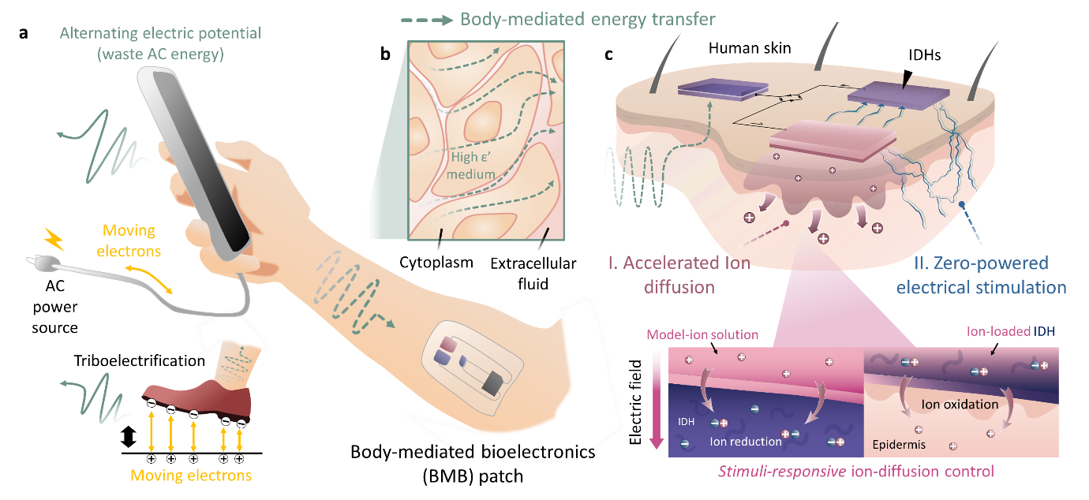
Figure 1. Body-mediated bioelectronics (BMB). (a) Concept of waste AC energy in electronics system and in physical activities. (b) Potential transfer via high relative permittivity biological medium (cytoplasm, extracellular fluid). (c) Multifunctional electrical stimuli-responsive ion-diffusive hydrogel as bioelectrode and dual functions for skin stimulation of BMB patch.

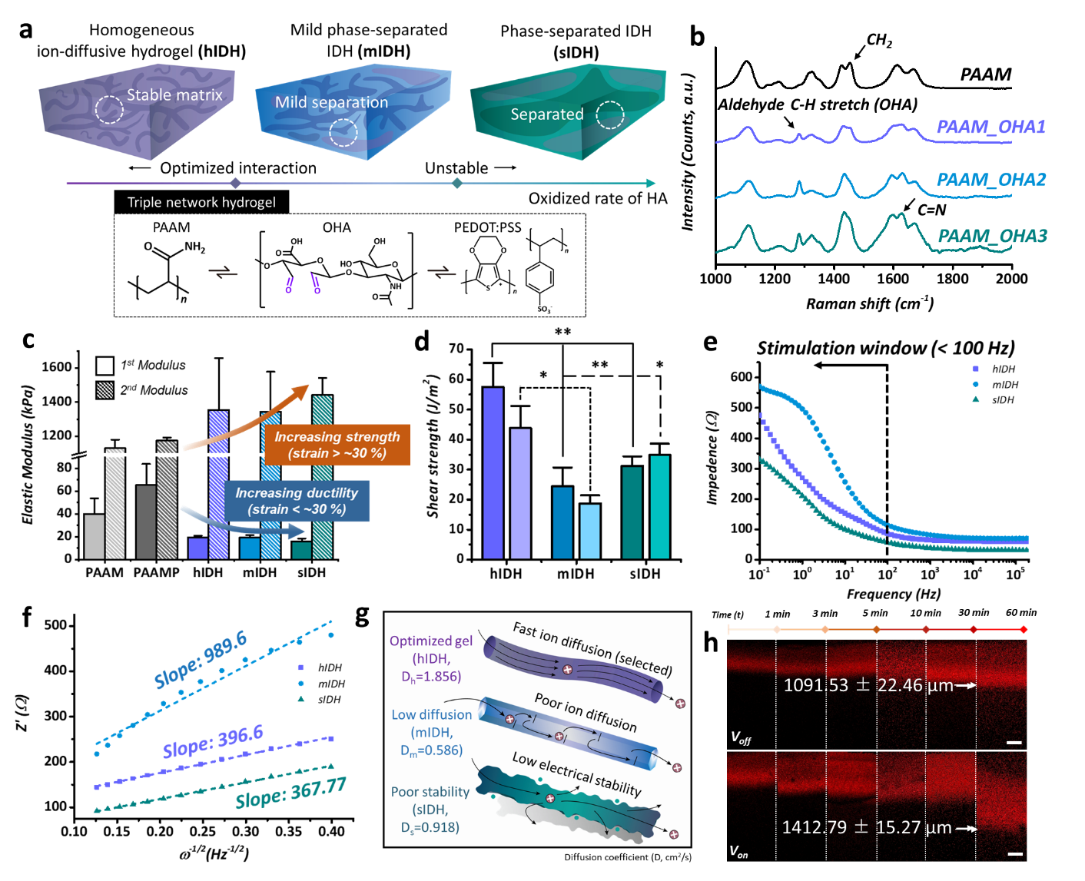
Figure 2. Characterization of ion-diffusive hydrogels (IDHs). a Schematic illustration of different properties between three kinds of IDHs. b Raman spectroscopy analysis of each type of PAAM and PAAM_oxidized hyaluronic acid (OHA) gel according to degree of oxidation (DO). c Investigation of elastic modulus of PAAM gel, PAAMP (PAAM gel with PEDOT:PSS), and IDHs. d Measurements of shear adhesion forces of IDHs with different substrates (left bar: NH₂-functionalized substrate, right bar: bare substrate). e Linear fitting indicates relationship between impedance (Ω) and frequency (Hz) and f Z’ and ω^{-1/2} and of IDHs. g Illustration of ion-diffusion kinetics difference of each IDHs. h Cross-section confocal image of ion penetration to IDHs without electrical stimulation (V_{off}) and with electrical stimulation (V_{on}) (scale: 400 μm) and data analysis (right); data are presented as mean ± standard deviation (SD); *P<0.05, **P<0.01 (t-test, all experiments were conducted independently).
The ion-diffusive hydrogel (IDH) was fabricated by using three kinds of materials, acrylamide (PAAM), oxidized hyaluronic acid (OHA) and PEDOT:PSS (Figure. 2a). The key material for hydrogel ultra-softness is oxidized hyaluronic acid (OHA) which can form shiff-base bonding with PAAM. As the proof of concept, three types of OHA were synthesized with different degrees of oxidation (DO), and three types of IDHs were fabricated for each OHA. The prepared hydrogel using OHA1 was named as homogenous IDH (hIDH), gel using OHA2 was named as mild phase-separated IDH (mIDH), and gel using OHA3 was named as phase-separated IDH (sIDH). As the DO of OHA used during gelation increased, the peaks of the aldehyde C-H stretched and C=N bonds increased in each hydrogel (Figure. 2b), while the IDHs with PEDOT:PSS showed dominant PEDOT:PSS peaks (Figure S1a). Interestingly, unlike the rheometric results without PEDOT:PSS (Figure S1b), hIDH shows similar G’ to that of the PAAM hydrogel and even has a higher G’ than the PAAM hydrogel with PEDOT:PSS (PAAMP) (Figure S1c). This is attributed to uniform bonding by PAAM, OHA, and PEDOT:PSS during gelation. As shown in Figure S2, the IDHs exhibit hyperelastic behaviors³¹⁻³² for tension and compression. In particular, since the strain of the skin normally does not exceed 30 %, this strain is a criterion for the acceptance and limitation of skin deformation for sustainable treatment. Since OHA reduces the force required to uncoil the polymer chain, IDH reduces the 1st tangent modulus of PAAM with a strain of less than 30% (increasing ductility). Meanwhile, the easy uncoiling of the chain extends the hardening region for large deformations, thereby increasing the 2nd tangent modulus of the PAAM (increasing strength, Figure. 2c). The overall mechanical characteristics indicate that hIDH has a suitable range of elastic modulus (E) values for human skin and tissues without causing discomfort (Figure S3).³³
The shear adhesion forces of the IDHs were measured using two kinds of substrates, namely bare substrates, and NH₂-functionalized substrates (Figure S4a). Consequently, hIDH and mIDH showed higher shear strengths in NH₂-functionalized substrates owing to schiff-base bonding between the NH₂ groups of the substrates and residual C=O groups of the OHA (Figure 2d, Figure S4b). In contrast, sIDH showed higher shear adhesion strength in bare PETG owing to phase separation and unstable structure of the hydrogel. The hIDH had the highest shear adhesion force of about 57 J/m² on the NH₂-functionalized substrate which is higher than commercial bioadhesives.³⁴
Then, the electrochemical properties of the IDHs were further studied by cyclic voltammetry (CV) to analyze the oxidative/reductive reactions of each IDH. The PAAMP and sIDH showed unstable current densities for all cycles, and oxidative/reductive peaks were not observed for mIDH. In contrast, hIDH shows stable and broad oxidative as well as reductive peaks in all cycles (Figure S5). The body-mediated energy transfer mainly uses waste AC energy from human physical activities and electronics, which are in the low-frequency region (~60 Hz). The IDHs showed around 60–550 Ω n the electrical stimulation window (~100 Hz), which is acceptable impedance for body-attached electrodes (Figure. 2e). From the relationship between Z’ and ω^{-1/2} (ω = 2π × f) in the low-frequency region, hIDH demonstrates a lower slope that explains its optimized ion-diffusion kinetics (Figure. 2f).³⁵ On the other hand, sIDH shows the lowest slope, which is attributed to the effects of the unstable and unbound PEDOT:PSS. To quantitatively identify the hypothesis, the diffusion coefficient (D) of each IDH was calculated according to the Randles–Sevcik equation (5):
$i_{p}=(2.69 ×{10}^{5})n^{3/2}AD^{1/2}C_{0}ν^{1/2}⋯$ (5)
where i_{p} is the peak current, n is the electron transfer number, A is the surface area of the IDH (measured by a porosimeter, Figure S6), C₀ is the reactant concentration, and ν is the scan rate. D_{h} was calculated as 1.856 cm²/s, which is the highest diffusion coefficient among the IDHs (D_{m} = 0.586 cm²/s, D_{s} = 0.918 cm²/s), indicating that homogenously structured IDH has optimized ion-diffusion kinetics (Figure. 2g). Based on the mechanical properties and ion-diffusion kinetics results, determined the hIDH is the most suitable for bioelectrode that the ionic model drug molecule could electrochemically doped into the PEDOT inside of hIDHs.³⁶⁻³⁸ Before investigating ion release in the low-frequency region, active ion loading was conducted using hIDH by attaching it to the electrode substrate with an external power source (the detailed setup is explained in the supporting information). The rhodamine 6G (R6G) was used as dopant ion for the hIDH and cross-sectional confocal imaging of the hIDH was used to investigate the loading depth of ions according to the time point. The hIDH shows a higher ion-loading efficiency under an external power supply (Figure 2h), which indicates that the diffusion of the model ions in hIDH can be accelerated by external electrical stimulation, stably bound and electrochemically polymerize to the gel matrix by reduction reactions. The prepared hIDH also shows high biocompatibility with human dermal fibroblasts and macrophage (Figure S7).
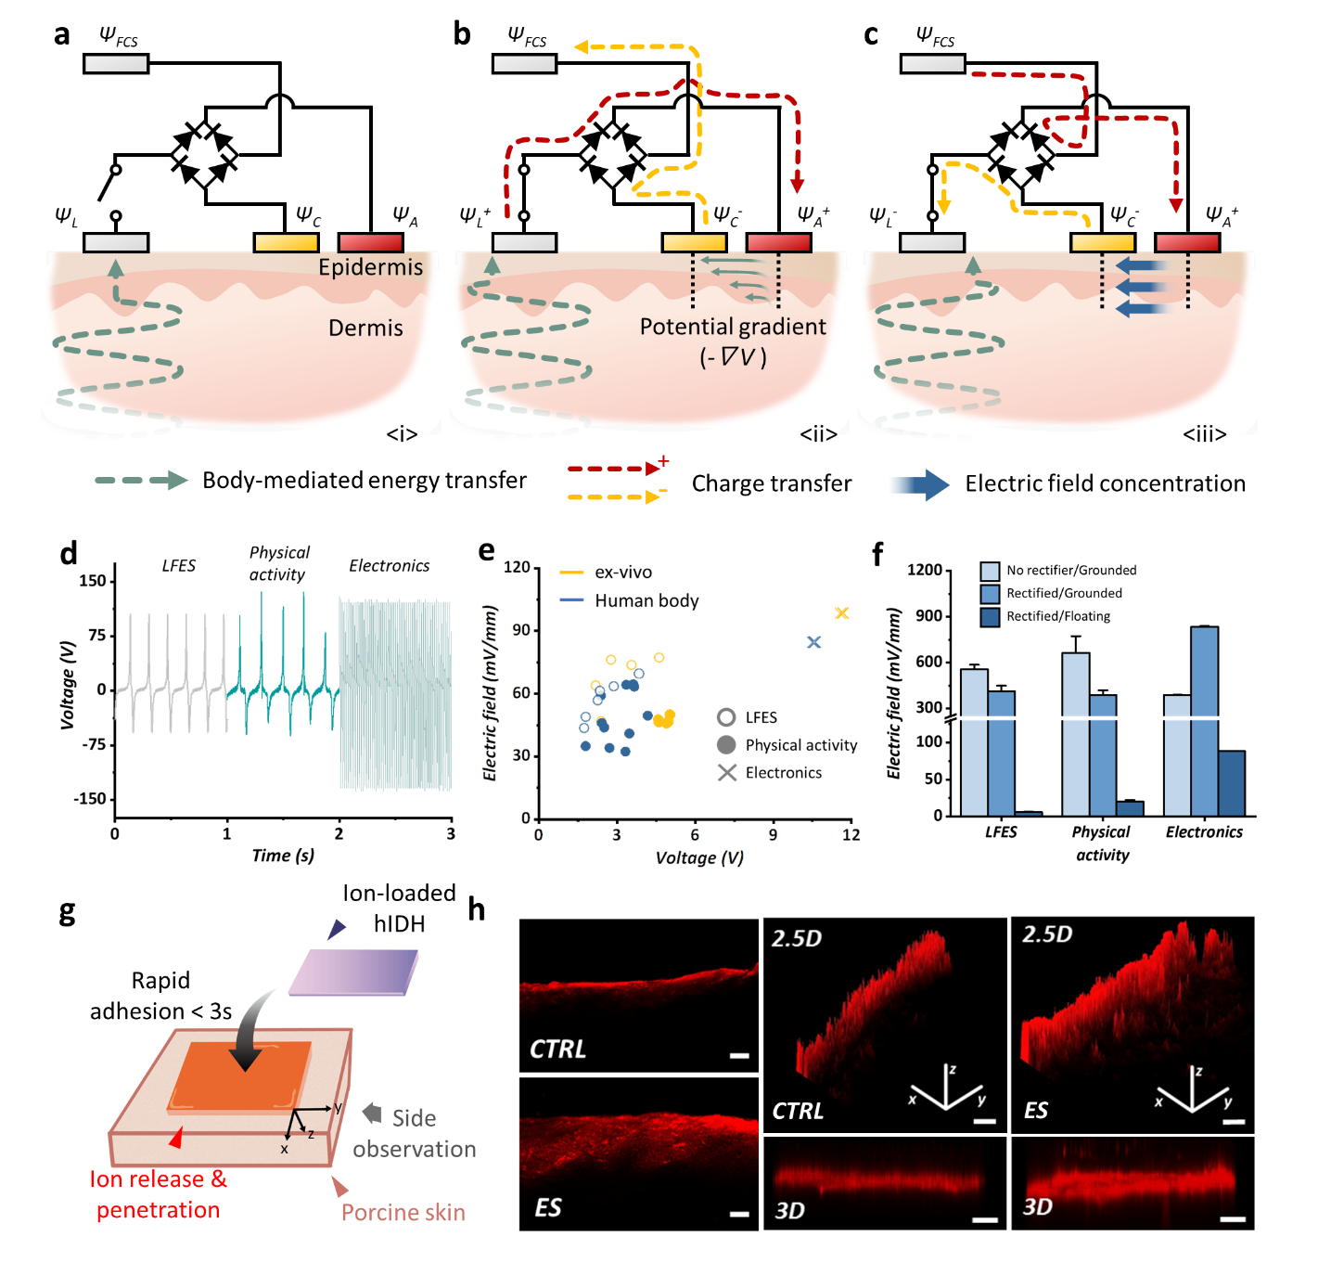
Figure 3. Characterization of BMB in ex-vivo experiments. (a) Schematic of the BMB including the rectifier (active electrode – red, counter electrode – yellow, passive electrodes - gray). (b-c) Energy transfer and electric field concentration via BMB when positive and negative potential is transmitted, respectively. (d) Voltage of waste AC energy according to type. Low-frequency electrical signaling (LFES) – regular and non-sinusoidal wave (6 Hz, 100 V). Physical activity – irregular and non-sinusoidal wave (6 Hz, 100 V). Electronics – regular and sinusoidal wave (60 Hz, 120 V). (e) Correlation between converted AC energy (voltage between passive hIDHs) and DC electric field (electric field between active and counter hIDHs). (f) Changes in strengths of DC electric fields according to rectifier and method of electrical grounding for free charge source. (g) Illustration of experimental setup for ion penetration of porcine skin. (h) Confocal image of ion-penetrated porcine skin (CTRL: control group, ES: electrical stimulated group, 2.5 D means 2.5 dimensions, 3 D means 3 dimensions) (scale: 400 μm).
As shown in Figure 3a, the BMB patch includes an active electrode connected to the anode of the rectifier (red, Ψ_{A}) and a counter electrode (yellow, Ψ_{C}) connected to the cathode of the rectifier. Additionally, there are two passive electrodes (gray): an electrode that is directly attached to skin and receives the potential from waste AC energy (Ψ_{L}); a free charge source with a different potential (Ψ_{FCS}) than the attached electrode. The waste AC energy forms an alternating potential (Ψ_{L}) on the attached electrode. If the circuit of BMB patch is connected, a potential difference (Ψ_{FCS} - Ψ_{L}) is formed between the attached electrode and free charge source, which is converted to usable AC energy (Figure 3b and S8). The converted AC energy is rectified to DC energy through a bridge diode. Thereafter, a pulse-type DC potential difference (Ψ_{A} - Ψ_{C}) is formed between the active and counter electrodes, which are connected to the anode and cathode of the rectifier, respectively (Figure 3c and S8b). Since the gradient of the electric potential forms an electric field as following equation (3):
$$E=-∇V ⋯ (3)$$
This continuously changing pulsed DC potential difference forms a pulse-type DC electric field concentration for ion emission and electrical stimulation in the skin (Figure S8c).
The DC electric field formed by the BMB patch is directly affected by the type of waste AC energy and strength of the converted voltage between passive hIDHs. To compare and analyze these correlations, the effects of the types of waste AC energies and performance of the BMB patch were confirmed in an ex-vivo setup and on the human body. As shown in Figure 3d, three types of alternating potentials were used for the waste AC energy: low-frequency electrical signaling (LFES; regular and non-sinusoidal waves, 6 Hz), physical activity (irregular and non-sinusoidal waves, 5–6 Hz), and electronics (regular and sinusoidal waves, 60 Hz). The non-sinusoidal waves with a peak output of about 100 V were converted to usable energy of 1.5–6 V in both the ex-vivo setup and human body (Figure 3e). The converted energy formed the DC electric field with an intensity of 30–90 mV/mm. Meanwhile, sinusoidal waves with an output of about 120 V create usable energy of 11–12 V and form the DC electric field with an intensity of 90–110 mV/mm. The strengths of these electric fields are in the range that can vitalize the calcium-ion channels of the fibroblasts for wound healing.³⁹⁻⁴² Since the human body is a complex system of electrolytes and organic matter, it is particularly difficult to confirm the electrical properties with high uniformity and reproducibility. Nevertheless, a tendency was observed where sinusoidal waves with higher frequencies and amplitudes form higher AC energy and DC electric field than non-sinusoidal waves. This means that the more the waste AC energy, the greater are the converted energy and DC electric field.
In addition, the intensity of the DC electric field may be affected by the designs of IDHs in the BMB patch. Although the effects of the rectifier on the converted AC energy were not observed, there is a clear difference when the free charge source is earth-grounded or floated (Figure 3f and S9). Since the free charge source is close to the human body, the potential difference from the attached electrode is not large, and this shows smaller electric field than the ground. However, the ultimate purpose of the BMB patch is to be driven independently from any power line or battery. Hence, the free charge source is used as a floating electrode that is not grounded to earth. In addition, these results show the possibility that the maximum intensity of the electric field can be adjusted by not only adjusting the waste AC energy but also grounding or increasing the potential difference between the passive IDHs. Furthermore, the ion-loaded hIDH was attached to porcine skin and ion-release experiments were conducted with a low-frequency electrical signaling (LFES) machine with rectifier (Figure S10). The ion-release specimen was prepared with an iontophoretic structure that offers the advantage of high-efficiency skin penetration (Figure. 3g). Further, cross-sectional confocal imaging was performed after ion release and acceleration, which showed increased ion penetration of porcine skin (Figure 3h).

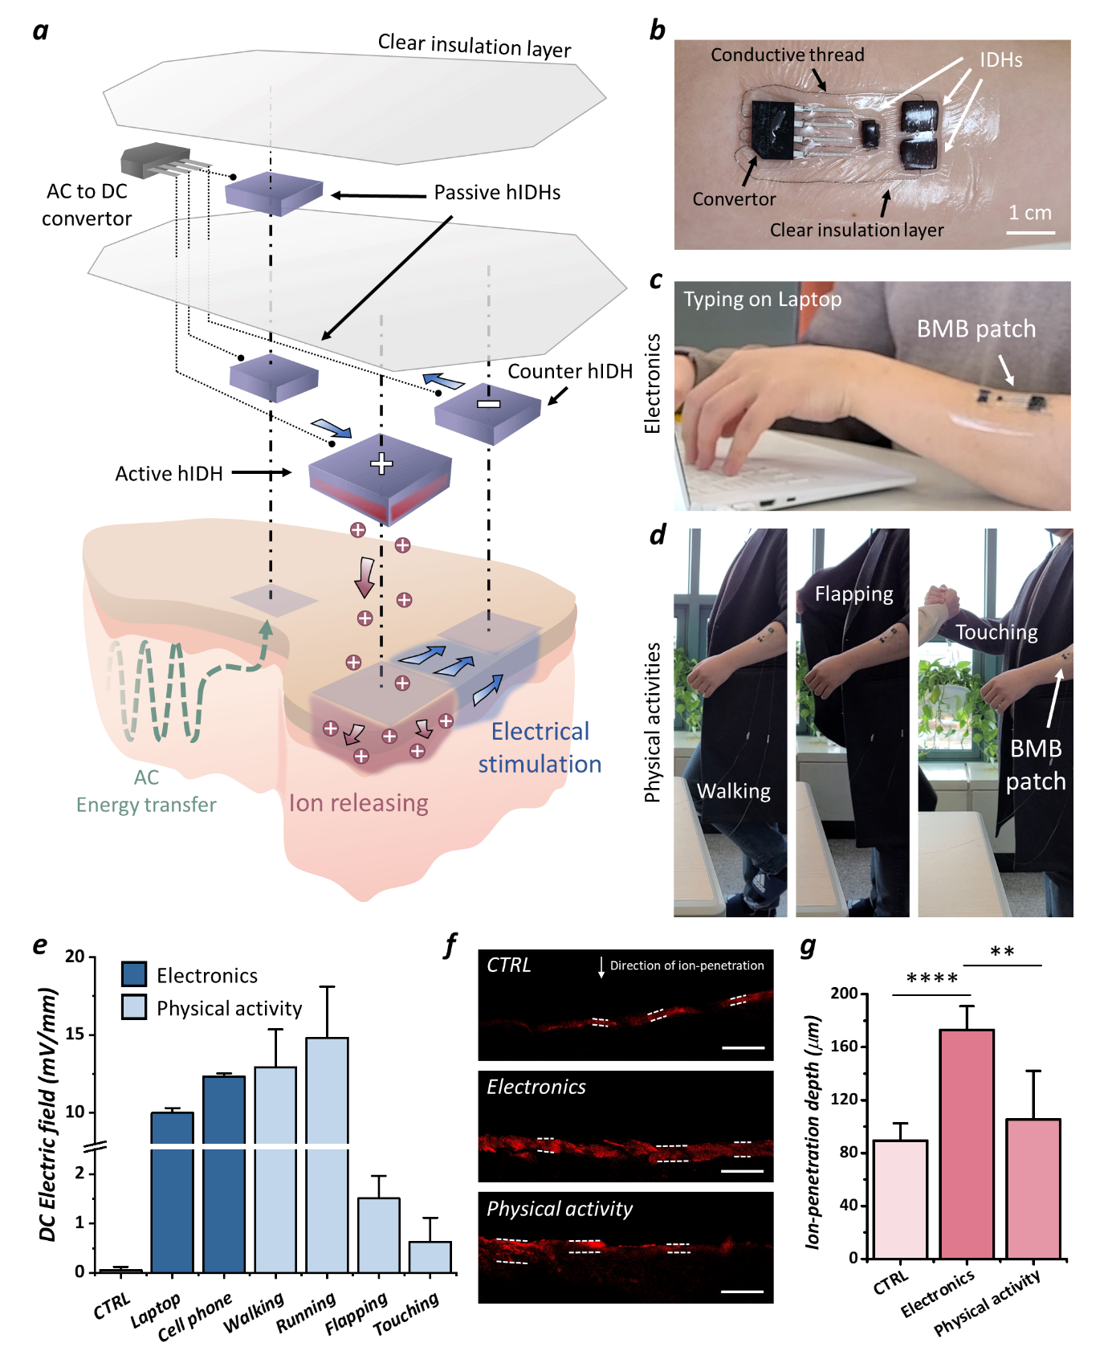
Figure 4. BMB patch utilization in daily life. (a) Blueprint of the BMB patch for zero-powered electrical stimulation and ion release. (b) Image of BMB patch on human skin. (c) Image of typing on a laptop when wearing the BMB patch. (d) Image of performing physical activities (walking, flapping, and touching) when wearing the BMB patch. (e) Strength of DC electric field formed by human activities (typing on laptop, holding cell phone, walking, running, flapping clothes, touching others). (f) Confocal images of ion-penetrated porcine skin with BMB patch (scale: 400 μm). (g) Ion penetration depth by BMB patch; data are presented as mean ± standard deviation (SD); *P<0.05, **P<0.01, ***P<0.001, ***P<0.0001 (t-test, all experiments were conducted independently).
The proposed BMB patch that can be used in daily life was realized through a laminated design of the IDHs, rectifier, and insulating layer (Figure 4a and S11). The BMB patch is miniaturized for easy attachment to the skin without any repulsion or restrictions (Figure 4b). Moreover, when the BMB patch is attached and waste AC energy, such as contact with electronic devices or resulting from physical activities, is generated, the DC electric field is measured in real time (Figure 4c and d). A DC electric field of about 10–13 mV/mm is formed when typing on a laptop or holding a cell phone (Figure 4e and S12a, and Video S1). In addition, a DC electric field of about 10–20 mV/mm is formed during physical activities, such as walking or running, and about 0.3–2 mV/mm is formed when flapping clothes, touching another person, shaking hands, or by holding hands with another walking person (Figure S12b and S13, Video S2, and Video S3). The ion-release effect by the BMB patch was confirmed in the ex-vivo condition because its intensity and tendency for formation of the DC electric field are similar to that of the human body (Figure 3e). When the waste AC energy is applied to the forelimb with an ion-loaded BMB patch, the ion-penetration thickness increases more than two times (Figure 4f and g). In particular, although the higher output in physical activity was measured than using AC electronics, the ion-penetration efficiency in the BMB patch according to the input generated from the using AC electronics was higher. The result indicates that because the stable output generated from AC electronics was effective than the instantaneous output from human activity for ion-penetration. Overall results suggest that sustainable and on-demand non-invasive treatment can be achieved by attaching the fully independent BMB patch to the skin without any restrictions from external batteries or power lines.
We present a new concept of bioelectronics (BMBs) based on body-mediated energy transfer for continuous operation without any restrictions on daily life behaviors. The realized BMB patch was applied to the human body to verify that the electric field was locally concentrated according to various human activities (e.g., walking, running, using electronics, shaking hands) without additional power sources or power lines. Thus, the BMBs can provide both internal electrical stimulation and ion-release (drug) using human activities as the source of energy, which can never be exhausted. Our proposed BMBs overcome the drawbacks of conventional non-invasive bioelectronics and can pave the path to zero-powered bioelectronics with permanent operation.

ASSOCIATED CONTENT
Supporting information
Methods, materials, and experimental procedures; Supplementary Figures S1 – S23, and Supplementary Videos 1-3

AUTHOR INFORMATION
Corresponding Authors
Jinkee Hong - School of Chemical & Biomolecular Engineering, Yonsei University, 50 Yonsei-ro, Seodaemun-gu, Seoul, 03722, Republic of Korea; Email: jinkee.hong@yonsei.ac.kr
Sangmin Lee - School of Mechanical Engineering, Chung-Ang University, 84 Heukseuk-ro, Dongjack-gu, Seoul, 06974, Republic of Korea; Email: slee98@cau.ac.kr
Authors
Sungwon Jung, Sohyeon Park, Woojin Choi, Beomgyu Choi - School of Chemical & Biomolecular Engineering, Yonsei University, 50 Yonsei-ro, Seodaemun-gu, Seoul, 03722, Republic of Korea
Hyungseok Yong, Dong Chang Kim, Joonseok Lee - School of Mechanical Engineering, Chung-Ang University, 84 Heukseuk-ro, Dongjack-gu, Seoul, 06974, Republic of Korea
Seokgyu Ryu, Jeeyoung Yoo - School of Energy Engineering Kyungpook National University, 80 Daehak-ro, Buk-gu, Daegu, 41566, Republic of Korea
Yang-Hee Kim - Bone and Joint Research Group, Centre for Human Development, Stem Cells and Regeneration, Institute of Developmental Sciences, University of Southampton, Southampton SO16 6YD, United Kingdom
Notes
The authors declare no competing financial interest.

ACKNOWLEDGEMENT
This research was supported by Basic Science Research Program through the National Research Foundation of Korea (NRF) funded by the Ministry of Science and ICT (NRF-2017R1E1A1A01074343) and National Research Foundation of Korea (NRF) grant funded by the Korea government (MSIT) (No. 2021R1A4A3030268).

REFERENCES
(1) Sim, K.; Ershad, F.; Zhang, Y.; Yang, P.; Shim, H.; Rao, Z.; Lu, Y.; Thukral, A.; Elgalad, A.; Xi, Y.; Tian, B.; Taylor, D. A.; Yu, C. An epicardial bioelectronic patch made from soft rubbery materials and capable of spatiotemporal mapping of electrophysiological activity. Nat. Electron. 2020, 3 (12), 775-784.
(2) Kalidasan, V.; Yang, X.; Xiong, Z.; Li, R. R.; Yao, H.; Godaba, H.; Obuobi, S.; Singh, P.; Guan, X.; Tian, X. Wirelessly operated bioelectronic sutures for the monitoring of deep surgical wounds. Nat. Biomed. Eng. 2021, 5 (10), 1217-1227.
(3) Shin, J.; Yan, Y.; Bai, W.; Xue, Y.; Gamble, P.; Tian, L.; Kandela, I.; Haney, C. R.; Spees, W.; Lee, Y. Bioresorbable pressure sensors protected with thermally grown silicon dioxide for the monitoring of chronic diseases and healing processes. Nat. Biomed. Eng. 2019, 3 (1), 37-46.
(4) Song, E.; Xie, Z.; Bai, W.; Luan, H.; Ji, B.; Ning, X.; Xia, Y.; Baek, J. M.; Lee, Y.; Avila, R. Miniaturized electromechanical devices for the characterization of the biomechanics of deep tissue. Nat. Biomed. Eng. 2021, 5 (7), 759-771.
(5) Chen, Y.; Zhang, Y.; Liang, Z.; Cao, Y.; Han, Z.; Feng, X. Flexible inorganic bioelectronics. npj Felx. Electron. 2020, 4 (1), 1-20.
(6) Chittibabu, S. K.; Chintagumpala, K.; Chandrasekhar, A. Porous dielectric materials based wearable capacitance pressure sensors for vital signs monitoring: A review. Mater. Sci. Semicond. Process. 2022, 151, 106976.
(7) Mathew, A. A.; Chandrasekhar, A.; Vivekanandan, S. A review on real-time implantable and wearable health monitoring sensors based on triboelectric nanogenerator approach. Nano Energy 2021, 80, 105566.
(8) Venugopal, K.; Panchatcharam, P.; Chandrasekhar, A.; Shanmugasundaram, V. Comprehensive review on triboelectric nanogenerator based wrist pulse measurement: Sensor fabrication and diagnosis of arterial pressure. ACS sensors 2021, 6 (5), 1681-1694.
(9) Baik, S.; Lee, H. J.; Kim, D. W.; Kim, J. W.; Lee, Y.; Pang, C. Bioinspired adhesive architectures: from skin patch to integrated bioelectronics. Adv. Mater. 2019, 31 (34), 1803309.
(10) Wang, C.; Shirzaei Sani, E.; Gao, W. Wearable Bioelectronics for Chronic Wound Management. Adv. Funct. Mater. 2021, 2111022.
(11) Lim, C.; Hong, Y. J.; Jung, J.; Shin, Y.; Sunwoo, S.-H.; Baik, S.; Park, O. K.; Choi, S. H.; Hyeon, T.; Kim, J. H. Tissue-like skin-device interface for wearable bioelectronics by using ultrasoft, mass-permeable, and low-impedance hydrogels. Sci. Adv. 2021, 7 (19), eabd3716.
(12) Li, Y.; Li, N.; De Oliveira, N.; Wang, S. Implantable bioelectronics toward long-term stability and sustainability. Matter 2021, 4 (4), 1125-1141.
(13) Fu, F.; Wang, J.; Zeng, H.; Yu, J. Functional conductive hydrogels for bioelectronics. ACS Mater. Lett. 2020, 2 (10), 1287-1301.
(14) Yuk, H.; Lu, B.; Zhao, X. Hydrogel bioelectronics. Chem. Soc. Rev. 2019, 48 (6), 1642-1667.
(15) Fu, X.; Hosta-Rigau, L.; Chandrawati, R.; Cui, J. Multi-Stimuli-Responsive Polymer Particles, Films, and Hydrogels for Drug Delivery. Chem 2018, 4 (9), 2084-2107.
(16) Ohayon, D.; Inal, S. Organic bioelectronics: from functional materials to next‐generation devices and power sources. Adv. Mater. 2020, 32 (36), 2001439.
(17) Sheng, H.; Zhang, X.; Liang, J.; Shao, M.; Xie, E.; Yu, C.; Lan, W. Recent advances of energy solutions for implantable bioelectronics. Adv. Healthc. Mater. 2021, 10 (17), 2100199.
(18) Kim, S. J.; Lee, H. E.; Choi, H.; Kim, Y.; We, J. H.; Shin, J. S.; Lee, K. J.; Cho, B. J. High-performance flexible thermoelectric power generator using laser multiscanning lift-off process. ACS nano 2016, 10 (12), 10851-10857.
(19) Yu, Y.; Nassar, J.; Xu, C.; Min, J.; Yang, Y.; Dai, A.; Doshi, R.; Huang, A.; Song, Y.; Gehlhar, R. Biofuel-powered soft electronic skin with multiplexed and wireless sensing for human-machine interfaces. Sci. Robot. 2020, 5, eaaz7946.
(20) Zou, Y.; Tan, P.; Shi, B.; Ouyang, H.; Jiang, D.; Liu, Z.; Li, H.; Yu, M.; Wang, C.; Qu, X. A bionic stretchable nanogenerator for underwater sensing and energy harvesting. Nat. Comm. 2019, 10 (1), 1-10.
(21) Sheng, H.; Zhang, X.; Liang, J.; Shao, M.; Xie, E.; Yu, C.; Lan, W. Recent Advances of Energy Solutions for Implantable Bioelectronics. Adv. Healthc. Mater. 2021, 10 (17), e2100199
(22) Wu, C.; Jiang, P.; Li, W.; Guo, H.; Wang, J.; Chen, J.; Prausnitz, M. R.; Wang, Z. L. Self‐Powered Iontophoretic Transdermal Drug Delivery System Driven and Regulated by Biomechanical Motions. Adv. Funct. Mater. 2019, 30 (3)
(23) Ouyang, Q.; Feng, X.; Kuang, S.; Panwar, N.; Song, P.; Yang, C.; Yang, G.; Hemu, X.; Zhang, G.; Yoon, H. S.; Tam, J. P.; Liedberg, B.; Zhu, G.; Yong, K.-T.; Wang, Z. L. Self-powered, on-demand transdermal drug delivery system driven by triboelectric nanogenerator. Nano Energy 2019, 62, 610-619.
(24) Park, S.; Heo, S. W.; Lee, W.; Inoue, D.; Jiang, Z.; Yu, K.; Jinno, H.; Hashizume, D.; Sekino, M.; Yokota, T.; Fukuda, K.; Tajima, K.; Someya, T. Self-powered ultra-flexible electronics via nano-grating-patterned organic photovoltaics. Nature 2018, 561 (7724), 516-521.
(25) Li, J.; Dong, Y.; Park, J. H.; Yoo, J. Body-coupled power transmission and energy harvesting. Nat. Electron. 2021, 4 (7), 530-538.
(26) Yong, H.; Heo, D.; Kim, B.; Moon, H.; Choi, K.; Kim, D.; Lee, S. Versatile energy loss conversion for recovering waste alternating potential through polarization transfer medium. Nano Energy 2020, 69, 104400.
(27) Kim, T.; Yong, H.; Kim, B.; Kim, D.; Choi, D.; Park, Y. T.; Lee, S. Energy-loss return gate via liquid dielectric polarization. Nat. Comm. 2018, 9 (1), 1437.
(28) Lai, Y.-C.; Lu, H.-W.; Wu, H.-M.; Zhang, D.; Yang, J.; Ma, J.; Shamsi, M.; Vallem, V.; Dickey, M. D. Elastic Multifunctional Liquid–Metal Fibers for Harvesting Mechanical and Electromagnetic Energy and as Self-Powered Sensors. Adv. Energy Mater. 2021, 11 (18), 2100411.
(29) Crowell, H. P.; Boynton, A. C.; Mungiole, M. In Exoskeleton Power and Torque Requirements Based on Human Biomechanics, 2002.
(30) Gabriel, C.; Gabriel, S.; Corthout, E. The dielectric properties of biological tissues: I. Literature survey. Phys. Med. Biol. 1996, 41 (11), 2231-2249.
(31) Zhu, Y.; Lu, W.; Guo, Y.; Chen, Y.; Wu, Y.; Lu, H. Biocompatible, stretchable and mineral PVA–gelatin–nHAP hydrogel for highly sensitive pressure sensors. RSC Adv. 2018, 8 (65), 36999-37007.
(32) Lee, D.; Zhang, H.; Ryu, S. Elastic Modulus Measurement of Hydrogels. In Cellulose-Based Superabsorbent Hydrogels; 2018; Chapter Chapter 60-1, pp 1-21.
(33) Guimarães, C. F.; Gasperini, L.; Marques, A. P.; Reis, R. L. The stiffness of living tissues and its implications for tissue engineering. Nat. Rev. Mater. 2020, 5 (5), 351-370.
(34) Chen, X.; Yuk, H.; Wu, J.; Nabzdyk, C. S.; Zhao, X. Instant tough bioadhesive with triggerable benign detachment. PNAS 2020, 117 (27), 15497-15503.
(35) Li, L.; Zhang, Y.; Lu, H.; Wang, Y.; Xu, J.; Zhu, J.; Zhang, C.; Liu, T. Cryopolymerization enables anisotropic polyaniline hybrid hydrogels with superelasticity and highly deformation-tolerant electrochemical energy storage. Nat. Comm. 2020, 11 (1), 1-12.
(36) Bansal, M.; Dravid, A.; Aqrawe, Z.; Montgomery, J.; Wu, Z.; Svirskis, D. Conducting polymer hydrogels for electrically responsive drug delivery. J. Control. Release 2020, 328, 192-209.
(37) Svirskis, D.; Travas-Sejdic, J.; Rodgers, A.; Garg, S. Electrochemically controlled drug delivery based on intrinsically conducting polymers. J. Control. Release 2010, 146 (1), 6-15.
(38) Chapman, C. A. R.; Cuttaz, E. A.; Goding, J. A.; Green, R. A. Actively controlled local drug delivery using conductive polymer-based devices. Appl. Phys. Lett. 2020, 116 (1).
(39) Thrivikraman, G.; Boda, S. K.; Basu, B. Unraveling the mechanistic effects of electric field stimulation towards directing stem cell fate and function: A tissue engineering perspective. Biomaterials 2018, 150, 60-86.
(40) Deans, J. K.; Powell, A. D.; Jefferys, J. G. Sensitivity of coherent oscillations in rat hippocampus to AC electric fields. J Physiol 2007, 583 (Pt 2), 555-65.
(41) Nuccitelli, R. A Role for Endogenous Electric Fields in Wound Healing. 2003; pp 1-26.
(42) McCullen, S. D.; McQuilling, J. P.; Grossfeld, R. M.; Lubischer, J. L.; Clarke, L. I.; Loboa, E. G. Application of low-frequency alternating current electric fields via interdigitated electrodes: effects on cellular viability, cytoplasmic calcium, and osteogenic differentiation of human adipose-derived stem cells. Tissue. Eng. Part C. Methods 2010, 16 (6), 1377-86.

