Historic palaeobotanical collection reveals in situ microspores and pollen from Early Carboniferous (Tournaisian) ovules from the Ballagan Formation of Scotland

Emma Reeves^{1*}, John E. A. Marshall¹, Carys Bennett², Sarah Davies², Timothy Kearsey³ and David Millward³

¹School of Ocean and Earth Science, University of Southampton, National Oceanography Centre, European Way, Southampton SO14 3ZH, UK
²School of Geography, Geology and the Environment, University of Leicester, University Road, Leicester LE1 7RH, UK
³British Geological Survey (Scotland), The Lyell Centre, Research Avenue South, Edinburgh EH14 4AP, UK

*ejr1g12@soton.ac.uk

Keywords: Carboniferous, in situ microspores, pollen, ovules, Scotland

ABSTRACT

Ovules from the Albert Long Collection were investigated for in situ microspores and pollen. The ovule Genomosperma kidstoni contains Prolycospora claytonii a trilete microspore previously attributed to the lycopods. Already reported associations between Colatisporites decorus and Stamnostoma huttonense, Colatisporites denticulatus and Lyrasperma scotica and Remysporites magnificus and Protopitys scotica were verified. This demonstrates the importance of historic collections and particularly ovules for determining the palaeobotanical affinities of dispersed miospores and pollen.

- Introduction

For over a century, fossil plants have been described from Ballagan Formation (Tournaisian, Early Carboniferous) sites in Scotland. This included a series of publications by Long (e.g. 1960a, 1960b, 1960c, 1966, 1969, 1977a and 1977b) that described many new genera and species of ovules from permineralised specimens. However, the associations between ovules and their in situ microspores and pollen have generally been unknown despite Long frequently figuring microspores or pollen within them. An extensive study into new Tournaisian tetrapod sites investigated the fossils and environments of this ‘Romer’s Gap’ time interval that is crucial to our understanding of the fish to tetrapod transition. In order to establish the timeframe for the Romer’s Gap interval, the Norham West Mains Farm (NWMF) borehole was drilled at Norham though 500 m of the Tournaisian Ballagan Formation. Miospores and pollen were systematically recorded through the borehole to reconstruct the palaeoenvironment and to reveal how the Tournaisian vegetation recovered after the End Devonian Mass Extinction (EDME or the Hangenberg Crisis). However, this revealed that the in situ microspores and pollen were unknown for many of the most abundant miospores and pollen in the assemblage. But, it was evident from the many illustrations and descriptions of Long that microspores and pollen were not uncommon in the ovules. Many of these appeared quite simple in morphology and were difficult to place within dispersed miospore and pollen species, especially from peels and thin sections. In an attempt to better identify these microspores and pollen, slides were studied from the Albert Long Collection held in the Hunterian Museum, Glasgow.
Comparisons were made between the microspores and pollen found in the ovules and the dispersed miospores identified from the NWMF borehole. All of the plant fossils had been found in localities that are now encompassed in the Ballagan Formation, including the Cementstone Group of the Calciferous Sandstone Series (now the Strathclyde Group of Cameron & Stephenson, 1985; Figure 1; Table 1). One new seed-microspore association was established and two previously identified but undocumented plant-microspore associations and one plant-pollen association were confirmed.

- Material and methods

The material for this study was collected by Long (1960a; 1960b; 1960c) from Berwickshire (Genomosperma kidstoni; Stamnostoma huttonense; Lyrasperma scotica respectively) and by Walton (1957) from Dunbartonshire (Protopitys scotica). The localities in Berwickshire where the material was collected, from fine grained calcareous sandstone, are shown in Figure 1 (Long, 1960a).
Employing the cellulose acetate peel method of Joy et al. (1956), Long prepared more than a hundred specimens of Genomosperma (G. kidstoni and G. latens), 800 sections of S. huttonense and 46 petrified specimens of L. scotica (Long, 1960a; 1960b; 1960c respectively). Additionally, Walton prepared 139 cellulose nitrate peels of the Protopitys scotica type specimen using the Walton (1928) technique (Walton, 1957).
The material that was examined at the Hunterian Museum, Glasgow for the present study is shown in Table 2. The material that is used in this paper was sourced from the following slides:
- Genomosperma kidstoni FSC1116 K5
- Stamnostoma huttonense FSC1148
- Stamnostoma huttonense FSC1061 Loch Humphrey Burn
- Lyrasperma scotica FSC1411
- Protopitys scotica type FSC1372 Plate 7 Fig 1

To investigate the Albert Long slides, an Olympus BHS-313 transmitted light microscope was used with photographs taken with a Canon EOS 70D DSLR camera mounted on a trinocular head. As the specimens were too large to be captured in their entirety at the required magnification, image mosaics were taken in series with overlapping portions subsequently photo-stitched.
To produce the composite image of Genomosperma kidstoni (Plate I), slide FSC1116 K5 was placed on the microscope stage and the uppermost edge of the nucellus was located (x4 objective). Photographs (as JPEG files) were then taken at 1 mm increments of the mechanical stage along the y axis, to ensure overlap between successive images. Once a transect of the nucellus had been completed, the stage was moved along the x axis before starting a further transect overlapping as before.
The resultant 67 photomicrographs were photo-stitched into one large image using Adobe Photoshop CS6. Batches of 10 photographs were opened (to minimise the computer processing time) and dragged, in order, onto the new document to produce a series of layers. Each image layer was aligned manually by reducing the opacity and dragging it into position. The opacity was restored before manipulating the next photograph. When complete, the layers were selected (excluding the background layer) and ‘Auto-Blended’. Each batch was saved in JPEG format and further photo-stitched into a single image as above. Owing to its size, this was saved in TIFF format. Single microspores and pollen within the ovule were photographed under oil at x100 using multiple images at different focus depths and then Z-stacked using the ‘Auto-Blend’ function.

- Systematic descriptions

Anteturma: PROXIMEGERMINANTES Potonié, 1970
Turma: TRILETES (Reinsch) Dettmann, 1963
Suprasubturma: ACAMERATITRILETES Neves & Owens, 1966
Infraturma: APICULATI (Bennie & Kidston) Potonié & Kremp, 1954
Subinfraturma: VERRUCATI Dybová & Jachowicz, 1957
Genus: Prolycospora Turnau 1978
Species: Prolycospora claytonii Turnau 1978
Etymology: pro = ‘before’ (Latin), lycos = ‘wolf’ (Greek), spora = ‘seed/sowing’ (Greek), claytonii = after Professor Geoffrey ‘Clayton’
Type locality: Katsina 1 borehole, north-western Poland
Holotype: Prolycospora claytonii Turnau, 1978
Studied material: West Mains Farm near Norham, Berwick-upon-Tweed, grid ref. NT 91589 48135, BGS borehole ID: NT94NW20
Stratigraphic horizon: 369.66 m depth (slide SSK38190)
Diagnosis: Turnau (1978) diagnosed the type miospores of P. claytonii as trilete, 20 to 55 µm in diameter with a rounded triangular or subcircular amb. The exine is ornamented with grana, rugulae, coni, pila, bacula and verrucae, but the sculptural elements are characteristically finer on the proximal face than on the distal face. Also, apical papillae may be present.
Description: The dispersed P. claytonii miospores from the NWMF borehole are radial, trilete, with a subcircular amb of 23 to 33 µm (mean = 28 µm) in diameter and a thin exine. The proximal face is diagnostically laevigate or infragranulate, whereas the distal face has discrete, closely and evenly spaced verrucae of 0.5 to 2.5 µm height. The suturae are straight, often with narrow labra.
Comparison: The miospores from the NWMF borehole conform closely to those of Turnau (1978).
Remarks: The specimens from the NWMF borehole often occur in pairs and tetrads.

Anteturma: PROXIMEGERMINANTES Potonié, 1970
Turma: TRILETES (Reinsch) Dettmann, 1963
Suprasubturma: CAMERATITRILETES Neves & Owens, 1966
Infraturma: MONOPSEUDOSACCITI Smith & Butterworth, 1967
Genus: Colatisporites Williams In: Neves et al., 1973
Species: Colatisporites decorus (Bharadwaj & Venkatachala) Williams In: Neves et al., 1973
Etymology: colati = ‘cultivated’ (Latin), sporites = ‘seed/sowing’ (Greek), decorus = ‘beauty’ (Latin)
Type locality: Pyramidenberg, Spitzbergen
Holotype: Colatisporites decorus (Bharadwaj & Venkatachala) Williams In: Neves et al., 1973
Studied material: West Mains Farm near Norham, Berwick-upon-Tweed, grid ref. NT 91589 48135, BGS borehole ID: NT94NW20
Stratigraphic horizon: 110.11 m depth (slide SSK39149)
Emended diagnosis: Williams In: Neves et al. (1973) diagnosed C. decorus as trilete and variably camerate with a circular, subcircular or oval amb and suturae that are simple or have thin, low labra that are straight or wavy. The intexine is laevigate with a distinct margin that is more or less conformable with the equatorial outline. The exoexine is strongly infrapunctate.
Description: The dispersed C. decorus miospores from the NWMF borehole are radial, trilete, camerate, with a circular to oval amb, 34 to 70 µm (mean = 50 µm) in diameter. The intexine is thin, laevigate and conformable with the amb and the exoexine is thin with small, uniformly and densely distributed grana. The suturae are distinct, either simple or with thin labra that are straight or sinuous.
Comparison: The miospores from the NWMF borehole conform closely to those of Williams In: Neves et al. (1973).

Anteturma: PROXIMEGERMINANTES Potonié, 1970
Turma: TRILETES (Reinsch) Dettmann, 1963
Suprasubturma: CAMERATITRILETES Neves & Owens, 1966
Infraturma: MONOPSEUDOSACCITI Smith & Butterworth, 1967
Genus: Colatisporites Williams In: Neves et al., 1973
Species: Colatisporites denticulatus Neville In: Neves et al., 1973
Etymology: colati = ‘cultivated’ (Latin), sporites = ‘seed/sowing’ (Greek), denticulatus = ‘small tooth’ (Latin)
Type locality: Pyramidenberg, Spitzbergen
Holotype: Colatisporites decorus (Bharadwaj & Venkatachala) Williams In: Neves et al., 1973
Studied material: West Mains Farm near Norham, Berwick-upon-Tweed, grid ref. NT 91589 48135, BGS borehole ID: NT94NW20
Stratigraphic horizon: 501.18 m depth (slide SSK37853)
Emended diagnosis: Neville In: Neves et al. (1973) diagnosed C. denticulatus as trilete and camerate, 43 to 72 µm (mean = 59 µm) in diameter with a circular, subcircular or oval amb, straight simple suturae and occasionally curvaturae. The intexine is laevigate, conformable with the exoexine and may possess compression folds. The exoexine is densely infrapunctate and ornamented with spinae, coni, bacula and grana across the distal surface and in the subequatorial regions of the proximal face, but the contact areas are unornamented.
Description: The dispersed C. denticulatus miospores from the NWMF borehole are radial, trilete and camerate with a circular to oval amb of 30 to 49 µm (mean = 42 µm) in diameter. The intexine is thin, laevigate, conformable with the amb, and sometimes possesses compression folds. The exoexine is thin, with densely and uniformly distributed spinae, coni, bacula and grana of a height < 1 µm. The suturae are simple and straight.
Comparison: The miospores from the NWMF borehole conform closely to those of Neville In: Neves et al. (1973) though Neville’s specimens are larger in diameter, 43 to 72 µm (mean = 59 µm).
Remarks: C. denticulatus differs from C. decorus by bearing a dense sculpture of spinae, coni and bacula rather than grana.

Anteturma: POLLENITES R. Potonié, 1931
Turma: SACCITES Erdtman, 1947
Subturma: MONOSACCITES (Chitaley) Potonié & Kremp, 1954
Infraturma: EXTRORNATI Butterworth & Williams, 1958
Genus: Remysporites Butterworth & Williams, 1958
Species: Remysporites magnificus (Horst) Butterworth & Williams, 1958
Etymology: Remy = after Dr Winfried ‘Remy’ who first demonstrated the affinity of this pollen, sporites = ‘seed/sowing’ (Greek), magnificus = ‘magnificent’ (Latin)
Genotype locality: Limestone Coal Group and Upper Limestone Group, from boreholes in Darnley, Caldercuilt and Queenslie Bridge in Glasgow, Brucefield in Fife, Kincardine Bridge in Clackmannanshire and Monkton House, East Lothian, Scotland
Holotype: Endosporites magnificus Horst, 1955
Studied material: West Mains Farm near Norham, Berwick-upon-Tweed, grid ref. NT 91589 48135, BGS borehole ID: NT94NW20
Stratigraphic horizon: 290.75 m and 430.37 m depths (slides SSK38434 and SSK38075 respectively)
Emended diagnosis: Butterworth & Williams (1958) diagnosed R. magnificus as trilete, approximately 120 to 250 µm in diameter, with a circular to oval amb and straight, narrow, simple suturae. The central body (i.e. intexine) is circular and distinct. The bladder (i.e. exoexine) is variable in appearance, commonly laevigate but may be distinctly microreticulate. Compression folds are common.
Description: The dispersed R. magnificus pollen from the NWMF borehole are monosaccate, radial, trilete and camerate with a subcircular amb of 68 to 200 µm (mean = 129 µm) in diameter. The intexine is thin, laevigate and conformable with the amb. The exoexine is thin with densely distributed verrucae and coni and compression folds are common. The suturae are simple and straight.
Comparison: The dispersed pollen from the NWMF borehole conform closely to those of Butterworth & Williams (1958) although the exoexine does not exhibit microreticulate ornamentation.
Remarks: If separated from its exoexine, the intexine resembles Punctatisporites (Ibrahim) Ibrahim, 1933 miospores.

Order: LAGENOSTOMALES Seward, 1917
Family: GENOMOSPERMACEAE Long, 1975
Genus: Genomosperma (Long) Meade et al., 2020
Species: Genomosperma kidstoni (Calder) Meade et al., 2020
Synonym: Genomosperma latens Long, 1960a
Etymology: gínomai = ‘become’ (Greek), spérma = ‘seed’ (Greek), kidstoni = after the discoverer Dr Robert ‘Kidston’
Type locality: Langton Burn about 400 yards (366 metres) north of Gavinton near Duns, Berwickshire (Calder, 1938) grid ref. NT 772526 (Long, 1960a)
Holotype: Genomosperma kidstoni (Calder) Meade et al., 2020
Additional material: Hutton Bridge (grid ref. NT 915546), Hutton Castle Mill (grid ref. NT 907549; Long, 1960a)
Studied material: A mature Genomosperma kidstoni nucellus (central part of ovule) from Langton Burn, slide FSC1116 K5 Albert Long Collection, Hunterian Museum, Glasgow
Stratigraphic horizon: Calciferous Sandstone Series (Cementstone Group; Calder, 1938)
Emended diagnosis: Meade et al. (2020) diagnosed Genomosperma kidstoni as an ovule with lobate integument 6 to 11 mm long of typically 8 (rarely 6 to 11) lobes which can diverge or converge apically. Lobes typically fused for the basal 0.1 to 0.9 mm; level of fusion can vary within a single ovule. Elongated nucellus, entirely free, with apical pollen chamber with parenchymatous central column and short salpinx. Pedicel up to 8 mm long, widens towards the chalaza.
Description: No further descriptive work was undertaken in this study.

Order: LAGENOSTOMALES Seward, 1917
Family: GENOMOSPERMACEAE Long, 1975
Genus: Stamnostoma Long, 1960b
Species: Stamnostoma huttonense Long, 1960b
Etymology: stamnos = ‘jar’ (Greek), stoma = ‘mouth’ (Greek), huttonense = after ‘Hutton Mill’ the place of its discovery
Locality: North bank of River Whitadder, on shingle, a quarter of a mile (402 m) above Hutton Mill, Berwickshire (grid ref. NT 915546; Long, 1960b)
Holotype: Stamnostoma huttonense Long, 1960b
Studied material: Ovules of Stamnostoma huttonense from Hutton Bridge and Loch Humphrey Burn, slides FSC1148 and FSC1061 respectively Albert Long Collection, Hunterian Museum, Glasgow
Stratigraphic horizon: Calciferous Sandstone Series (Cementstone Group; Long, 1960b)
Diagnosis: Long (1960b) diagnosed Stamnostoma huttonense as a radially symmetrical seed, circular in cross section, but slightly hexagonal at the base, maximum dimensions: length 3.75 mm, width 1.5 mm. The basal vascular strand divides into about six integumental bundles which run to the level of the plinth. The upper part of the integument shows no lobing and forms a relatively wide ‘micropyle’. The salpinx is short, relatively wide, and inserted below the ‘micropyle’. Its base is invaginated into the top of the lagenostome forming a marked flange. A well-developed central column is present with a wide circular base. The mature female gametophyte has three archegonia near a domed ‘tent-pole’. Cupules are paired, on a naked bifurcated cylindrical stalk, and measure 14 mm in length and 4 mm in width. Each cupule shows evidence of four seeds but some may have been abortive. The cupule is formed of cylindrical axes dichotomizing in successive planes at right angles. Placentation is parietal and marked by abscission scars.
Description: No further descriptive work was undertaken in this study.
Remarks: The following have been found in association with Stamnostoma huttonense:
- The frond Aneimites acadia Dawson, 1860 (Retallack & Dilcher, 1988)
- The petiole Lyginorachis papilio Kidston, 1924 (Retallack & Dilcher, 1988)
- The cupule Calathiops sp. (Göppert) Benson, 1935 (Retallack & Dilcher, 1988)
- The sporangium Telangium sp. Benson, 1904 (in petrifaction) and Telangiopsis sp. Eggert & Taylor, 1971 (in compression; Retallack & Dilcher, 1988)
- The microspores Colatisporites decorus (Bharadwaj & Venkatachala) Williams In: Neves et al., 1973 (Retallack & Dilcher, 1988)

Additionally, Lyginorachis papilio petioles and Stamnostoma huttonense ovules have been associated with Pitus primaeva Witham, 1833 (Long, 1963; 1979).

Order: LAGENOSTOMALES Seward, 1917
Family: CALAMOPITYACEAE Meyen, 1984
Genus: Lyrasperma Long, 1960c
Species: Lyrasperma scotica (Calder) Long, 1960c
Synonym: Samaropsis bicaudata (Kidston) Kidston, 1902
Etymology: lyra = ‘lyre’ (Latin), spérma = ‘seed’ (Greek), scotica = ‘Scottish’
Localities: Langton Burn, 400 yards (366 m) North-Northeast of Gavinton, in loose blocks around Hanna's Bridge, Berwickshire, also in situ on the right bank 20 yards (18 m) above Hanna’s bridge and in loose blocks in nearby Mill Lade, Berwickshire (grid ref. NT 772526; Long, 1960c)
Holotype: Lyrasperma scotica (Calder) Long, 1960c
Additional material: Broomhouse (grid ref. NT 800566), Burnmouth (grid ref. NT 958612), Cumledge (grid ref. NT 793566), Edrom (grid ref. NT 827561), Horse Roads (grid ref. NT 791716), Langton Glen (grid ref. NT 752531), Marden (grid ref. NT 810567), Marden, West Blanerne (grid ref. NT 816566; Long, 1960c), Edrom Church (grid ref. NT 827558; Kidston, 1902), Willie's Hole (grid ref. NT 878547; Kidston, 1901), Gavinton (grid ref. NT 767521; Calder, 1938).
Studied material: Ovule of Lyrasperma scotica from Gavinton, slide FSC1411 Albert Long Collection, Hunterian Museum, Glasgow
Stratigraphic horizon: Calciferous Sandstone Series (Cementstone Group; Long, 1960c)
Emended description: Long (1960c) described Lyrasperma scotica as externally resembling an elm samara with two attenuated and diverging horns representing the free apices of two integumental lobes. The largest specimen measures 12 mm wide and 18 mm from the seed base to the tips of the horns, the nucellus is 5 mm wide, the wings 3 mm wide and in the minor plane the seed width is 2.7 mm.
The integument forms two lobes each with a single vascular bundle close to their inner angle. In the main body the two integumental lobes are adnate to one another and to the nucellus. Above, the lobes diverge to form the horns of the seed. Opposite the vascular bundles the outward tissue of each lobe forms a pronounced keel so that, except at the apex, the nucellus is surrounded by a flattened wing-like extension. At the base of the seed a short pedicel, 1-5 mm long, contains a single vascular bundle, which divides to form two integumental bundles.
The nucellus is adnate to the integument but partly separates near the top of the megaspore and below the pollen chamber on the two sides adjacent to the wings. Above, the nucellus is differentiated into a lagenostome enclosing the pollen chamber around a disc-like central column and a wide funnel-like ‘salpinx’, 1.1 mm to 1.75 mm in diameter. At its base, the salpinx invaginates into the top of the lagenostome forming a flange.
The prothallus follows the contour of the nucellus, narrowing at the upper end forming a cylindrical region that projects up into the pollen chamber where it terminates in contact with the central column. This upper region has a low dome-shaped projection at its apex or a cavity (archegonium) near the apex. The number of archegonia vary, they are spherical or ovoid and measure 0.22 mm in diameter.
Description: No further descriptive work was undertaken in this study.
Remarks: As Lyrasperma scotica and Samaropsis bicaudata are considered to be similar in morphology and as they are found in rocks of the same age in the same area, Long (1960c) regarded them as two forms of preservation of the same seed. The name S. bicaudata is, therefore, used when it is preserved as a compression and L. scotica as a petrifaction.

Additionally, the following have been found in association with Lyrasperma scotica:
- The stem Stenomyelon tuedianum (Kidston & Gwynne-Vaughan) Long, 1964 (Long, 1960c, Retallack & Dilcher, 1988)
- The petiole Kalymma tuediana Calder 1938 (Long, 1960c, Retallack & Dilcher, 1988)
- The leaves Sphenopteridium pachyrrachis (Göppert 1852) Potonié, 1899 (Retallack & Dilcher, 1988)
- The microspores Colatisporites denticulatus Neville In: Neves et al., 1973 (Retallack & Dilcher, 1988)

Order: PROTOPITYALES Walton, 1957
Family: PROTOPITYACEAE Solms-Laubach, 1893
Genus: Protopitys (Göppert) Walton, 1957
Species: Protopitys scotica Walton, 1957
Etymology: protopítys = ‘pioneers’ (Greek), scotica = ‘Scottish’
Type locality: Small tributary on south side of Loch Humphrey Burn, Kilpatrick Hills, Dunbartonshire (grid ref. NS 479747)
Holotype: Protopitys buchiana Göppert, 1850
Studied material: Protopitys scotica type from Loch Humphrey Burn, slide FSC1372 Albert Long Collection, Hunterian Museum, Glasgow
Stratigraphic horizon: Sedimentary beds below Clyde Plateau Lavas, Calciferous Sandstone Series (Cementstone Group; Walton, 1957)
Diagnosis: Walton (1957) diagnosed Protopitys scotica as a fertile shoot with distichous sporophylls attached alternately on opposite sides of the stem. The stem in cross section exhibiting a parenchymatous elliptical medulla with four primary xylem strands, two at each end. The protoxylem in each strand separated from the medulla by a few centripetal metaxylem elements. Below a node, each of the pair of metaxylem strands at that side of the stem divides and supplies a strand which passes outwards. These two strands combine to form the double leaf trace. The metaxylem of the two strands unites to form the leaf trace which is in the form of a curved strand, adaxially concave, with protoxylem elements on its adaxial face. Structure of the secondary wood similar to that of P. buchiana Göppert, 1850. Sporophyll dichotomously and pinnately divided. The sporangia borne terminally on the ultimate divisions. Sporangia beaked, about 3 mm long or more, dehiscing down one side. No distinct annulus.
Description: No further descriptive work was undertaken in this study.
Remarks: The following have been found in association with Protopitys scotica:
- The sporangium Paracalathiops stachei Remy, 1954 (Remy, 1954)
- The frond Rhodeopteridium sp. (Zimmermann) Purkynová, 1970 (formerly Rhodea sp. Stur, 1875; Remy, 1954).

Additionally, Remysporites magnificus pollen have been identified in Paracalathiops stachei sporangia (Butterworth & Williams, 1958, p. 387; Smith 1962, p. 232).

- Results

- Prolycospora claytonii – Genomosperma kidstoni association

Multiple specimens of Prolycospora claytonii microspores were identified inside the ovules of Genomosperma kidstoni (Plate I, 3–5). These have been identified based on the combination of the sculpture of verrucae on the distal face (Plate I, 4) and the infragranular ornamentation of the proximal side (Plate I, 5).
The dispersed ovule Genomosperma kidstoni was originally described by Calder (1938) as Calymmatotheca kidstoni. Long (1960a) emended the genus to Genomosperma, added a new species G. latens and provided more detailed descriptions of both species. A series of acetate peels from the Long collection was used by Meade et al., (2020) to reconstruct Genomosperma in three dimensions. This confirmed its identity as a hydrasperman pteridosperm and amongst the most primitive known seeds (Meade et al., 2020).
Both species of Genomosperma (G. kidstoni and G. latens) have been found together (Long, 1960a) and it was suggested that both share similar anatomies, apart from the shapes and lengths of their integumentary lobes (Prestianni et al., 2013). Subsequent study has revealed that G. kidstoni and G. latens represent a single species with morphological variations and, as such, they were synonymised (Meade et al., 2020).
G. kidstoni represents permineralised seeds (Long, 1960a) with the parent plant yet to be identified. Therefore, a full reconstruction is not possible currently.

- Colatisporites decorus – Stamnostoma huttonense association

Multiple specimens of Colatisporites decorus microspores were found within the ovule of Stamnostoma huttonense. These were first illustrated on a line drawing in Retallack & Dilcher (1988) and this association is verified here (Plate II, 1–3).
The main diagnostic features of C. decorus are cameration with only a small gap between the intexine and the exoexine, a thin laevigate intexine and a thin exoexine with small grana and distinct suturae.
Petrified pteridosperm seeds and cupules of Stamnostoma huttonense have been described from blocks of calcareous sandstone found along the River Whiteadder (Figure 1; Long, 1960b). These blocks incorporated other species of pteridosperm seeds, including Genomosperma kidstoni (Long, 1960b).
However, unlike G. kidstoni, the parent plant of S. huttonense has been identified as Pitus primaeva Witham, 1833 (Long, 1963). Information from specimens found in Berwickshire enabled the petioles of Lyginorachis papilio Kidston, 1924 and the cupulate ovules of Stamnostoma huttonense to be associated with Pitus primaeva (Long, 1963). Pitus is described as a large, tree-sized pteridosperm (Long, 1979).

- Colatisporites denticulatus – Lyrasperma scotica association

Multiple specimens of Colatisporites denticulatus microspores were located within ovules of Lyrasperma scotica. These were first illustrated on a line drawing in Retallack & Dilcher (1988) and this association is verified here (Plate II, 5–6).
The main diagnostic features of C. denticulatus are a thin, laevigate intexine and a thin exoexine with spinae, coni, bacula and grana. C. denticulatus differs from C. decorus by its dense sculpture of spinae, coni and bacula rather than grana only.
As Samaropsis bicaudata and Lyrasperma scotica resemble each other morphologically and are found together, Long (1960c) interpreted them as representing two states of preservation of the same seed. Therefore, Samaropsis bicaudata (Kidston) Kidston, 1902 is used for seeds preserved as compressions and Lyrasperma scotica (Calder) Long, 1960 is used for seeds preserved as petrifactions (Long, 1960c).
The petrified seeds of Lyrasperma scotica were described from loose blocks, as single seeds recovered from the modern river sediment and in situ from various locations in Berwickshire (Figure 1) near the base of the Ballagan Formation (Long, 1960c). Additionally, L. scotica had been described previously from two other Ballagan Formation localities (8 and 9 Figure 1; Kidston, 1901).
Lyrasperma scotica seeds have been found in association with both the stems of Stenomyelon tuedianum Kidston In: Kidston & Gwynne-Vaughan, 1912 and the petioles of Kalymma tuediana Calder, 1938 in several localities (Long, 1960c). A composite reconstruction of the parent plant incorporating the stems of S. tuedianum and the petioles of K. tuediana was produced with the added microspore-containing ovules of Lyrasperma scotica (Retallack & Dilcher, 1988). The reconstruction was endorsed to represent the whole-plant species (Hilton & Bateman, 2006). Named as Lyrasperma scotica, a hydrasperman pteridosperm (Cleal et al., 2009), it is described as a small bush, with stiff, fern-like leaves (Retallack & Dilcher, 1988).

- Remysporites magnificus – Protopitys scotica association

Multiple specimens of Remysporites magnificus pollen have been found with Protopitys scotica and this association is verified here.
Originally, Protopitys scotica, represented by unnamed stems with branches and the sporangium Paracalathiops stachei, was found partly petrified from the Ballagan Formation at Loch Humphrey Burn, Dunbartonshire (Walton, 1957). Remy (1954) described and figured the (unnamed) pollen of P. stachei that Butterworth & Williams (1958) later confirmed as Remysporites magnificus.
The main diagnostic features of Remysporites magnificus are the thin laevigate intexine which is conformable with the amb and the thin exoexine with verrucae and coni.
It was, however, noted that, in addition to complete pollen grains, detached exoexines had been found following maceration (Smith, 1962). Therefore, it was suggested by Smith that had the intexines been found as sporae dispersae they would be placed into separate miospore species (Smith, 1962). Following a review of the type specimen of P. scotica Walton, 1957 at the Hunterian Museum, Glasgow (as studied by Smith), three pollen grains of R. magnificus were found in series that clearly show how the intexine can indeed separate from the exoexinal layer to leave a ‘microspore’ that resembles Punctatisporites (Ibrahim) Ibrahim, 1933 (see Plate III, 1–3). This could, therefore, lead to an over-representation of Punctatisporites-type miospores and an under-representation, or absence, of R. magnificus pollen in the fossil record, which could have implications for the phytogeographic record of their respective parent plants and for palaeoenvironmental reconstructions.
Protopitys has also been found in association with other genera of arborescent plants including Pitus (Scott et al., 1994). P. scotica is regarded as an arborescent species of a progymnosperm (Namboodiri & Beck, 1968; Galtier & Scott, 1990; Decombeix et al., 2005) that is known from Europe and Australia (Decombeix et al., 2015).

- Conclusions

Knowledge of plant-microspore and plant-pollen associations are important to map phytogeographic ranges through time and for palaeoenvironmental reconstructions. This is especially informative when determining the pattern of recovery in the terrestrial environment following mass extinction events. Also, collating information on associations between botanic structures is important for informing a reconstruction of the whole plant.
Study of microspores and pollen found within ovules from the Albert Long Collection has revealed that:
- Prolycospora claytonii microspores are newly identified from the ovules of Genomosperma kidstoni, thereby forming a direct association. However, the parent plant of G. kidstoni, a pteridosperm, is currently unknown.
- The previously identified association between Colatisporites decorus and Stamnostoma huttonense (by Retallack & Dilcher, 1988) is confirmed and documented with the microspores illustrated. The parent plant of S. huttonense is Pitus primaeva, a large, tree-sized pteridosperm (Long, 1963; 1979).
- The known association between Colatisporites denticulatus and Lyrasperma scotica (by Retallack & Dilcher, 1988) is also substantiated and documented. The parent plant of S. huttonense has also been named as Lyrasperma scotica and was a small bushy pteridosperm.
- The association between Remysporites magnificus and Protopitys scotica, originally linked by the sporangium Paracalathiops stachei (by Remy, 1954, Walton, 1957 and Butterworth & Williams, 1958) is verified. P. scotica was an arborescent progymnosperm.

This investigation of previously identified but unclassified microspores and pollen within the ovules of fossil plants, has yielded important information on the parent plants of those dispersed miospores and pollen. Further investigation into other historic palaeobotanical collections could, doubtless, provide additional such information, which is so valuable to our understanding of the plant life, environments and climate of the geological past.

Funding

This work was supported by the Natural Environment Research Council (NERC) Consortium Grant The Mid-Palaeozoic biotic crisis: setting the trajectory of tetrapod evolution, led by the late Professor Jennifer Clack (University Museum of Zoology, Cambridge) and involved the Universities of Cambridge [NE/J022713/1], Leicester [NE/J020729/1], Southampton [NE/J021091/1], the British Geological Survey [NE/J021067/1] and the National Museum of Scotland [NE/J020621/1].

Acknowledgements

We thank Neil Clark (Hunterian Museum, Glasgow) for facilitating access to the Albert Long Collection.

References

Bennie, J. & Kidston, R., 1886. On the occurrence of spores in the Carboniferous formation of Scotland. Royal Physical Society.
Benson, M., 1904. Telangium scotti, a new species of Telangium (Calymmatotheca) showing structure. Ann. Bot., 18, p. 161.
Benson, M., 1935. The ovular apparatus of Sphenopteridium affine and bifidum and of Diplopteridium (Sphenopteridium) teilianum (Walton). New Phytologist, 232-244.
Bharadwaj, D.C., Venkatachala, B.S., 1962. Spore assemblage out of a Lower Carboniferous shale from Spitzbergen. The Palaeobotanist, 10, 18-47.
Butterworth, M.A., Williams, R.W., 1958. The small spore floras of coals in the Limestone Coal Group and Upper Limestone Group of the Lower Carboniferous of Scotland. Trans. Roy. Soc. Edin., 63, 353-390.
Calder, M.G., 1938. On some undescribed Species from the Lower Carboniferous Flora of Berwickshire; together with a note on the genus Stenomyelon Kidston. Trans. Roy. Soc. Edin., 59, 309-331.
Cameron, I.B., Stephenson, D., 1985. British regional geology: The Midland Valley of Scotland. Third edition. Reprint 2014. Keyworth, Nottingham: British Geological Survey.
Chitaley, S.D., 1951. Fossil Microflora from the Mohgaon Kalan Beds of the Madhya Pradesh, India. Proc. National Inst. Sciences of India 18, 373-381.
Cleal, C.J., Shute, C.H., Hilton, J., Carter, J., 2009. A revision of the Pennsylvanian‐aged Eremopteris‐Bearing Seed Plant. Int. J. Plant Sci., 170, 666-698.
Dawson, J.W., 1860. On an undescribed fossil fern from the lower Coal Measures of Nova Scotia. Geol. Soc. London Quart. Jour., 17.
Decombeix A-L., Galtier, J., Prestianni, C., 2015. The Early Carboniferous progymnosperm Protopitys: new data on vegetative and fertile structures and on its geographic distribution. Hist. Biol., 27, 345–354.
Decombeix, A-L., Meyer-Berthaud, B., Rowe, N., Galtier, J., 2005. Diversity of large woody lignophytes preceding the extinction of Archaeopteris: new data from the middle Tournaisian of Thuringia (Germany). Rev. Palaeobot. Palynol., 137, 69-82.
Dettmann, M.E., 1963. Upper Mesozoic microfloras from south eastern Australia. Roy. Soc. Victoria, 77, 1-148.
Dybová, S. & Jachowicz, A., 1957. Microspores of the Upper Silesian coal measures. Ins. Geol. Warsaw, 328 pp.
Eggert, D.A., Taylor, T.N., 1971. Telangiopsis gen. nov., an Upper Mississippian pollen organ from Arkansas. Bot Gaz., 132, 30–37.
Erdtman, G., 1947. Literature on Palynology. X. (Literature on Pollen-Statistics and Related Topics published January 1, 1945–September 25, 1946). Geologiska Föreningen i Stockholm Förhandlingar, 69, 24-40.
Galtier, J., Scott, A., 1990. On Eristophyton and other gymnosperms from the Lower Carboniferous of Castleton Bay, East Lothian, Scotland. Geobios, 1, 5-19.
Göppert, H.R, 1850. "Fossilen Coniferen", Natuurk. Verh. Holland Maatsch. Wet., 6, Leiden, 229.
Göppert, H.R., 1852. Fossile Flora des Ubergangsgebirges. Nov. Act. Acad. Leop. Car., 22, 1-299.
Göppert, H.R., 1864. Die fossile Flora der permischen Formation. Palaeontographica, 12, 316 pp.
Hilton, J., Bateman, R.M., 2006. Pteridosperms are the backbone of seed-plant phylogeny. J. Torrey Bot. Soc., 133, 119-168.
Horst, U., 1955. "Die Sporae dispersae des Namurs von Westoberschlesien und Mahrisch-Ostrau". Palaeontographica, Abt. B, 98, 137-236.
Ibrahim, A.G., 1932. Beschreibung von Sporenformen aus Flöz Ägir. In: Potonié, R. Sporenformen aus den Flözen Ägir und Bismarck des Ruhrgebietes, Neues Jahrb., Beilage-Band 67, Abt. B, 447-449.
Ibrahim, A.G., 1933. Sporenformen des Ägirhorizontes des Ruhrreviers, Dissertation TH Berlin 1932, 1-46.
Joy, K.W., Willis, A.J., & Lacey, W.S., 1956. A rapid cellulose peel technique in palaeobotany. Annals of Botany, 635-637.
Kidston, R. & Gwynne-Vaughan, D. T., 1912. On the Carboniferous flora of Berwickshire—Part 1, Stenomyelon tuedianum Kidston. Trans. Roy. Soc. Edin., 48, 263-271.
Kidston, R., 1901. Notes on Carboniferous Plants from Berwickshire. Summ. Progr. Geol. Surv., 1900, 174-175.
Kidston, R., 1902. Report on Fossil Plants from the Calciferous Sandstones of the Berwickshire Border. Summ. Progr. Geol. Surv. Lond., 178, 1901.
Kidston, R., 1924. Fossil plants of the Carboniferous Rocks of Great Britain. Mem. Geol. Surv. Great Britain, Palaeontology, 2, 444-454.
Long, A.G., 1960a. On the structure of Calymmatotheca kidstoni Calder (emended) and Genomosperma latens gen. et sp. nov. from the Calciferous Sandstone Series of Berwickshire. Trans. Roy. Soc. Edin., 64, 29-44.
Long, A.G., 1960b. Stamnostoma huttonense gen. et sp. nov. – A Pteridosperm seed and cupule from the Calciferous Sandstone Series of Berwickshire. Trans. Roy. Soc. Edin., 64, 201-215.
Long, A.G., 1960c. On the structure of Samaropsis scotica Calder (emended) and Eurystoma angulare gen. et sp. nov., petrified seeds from the Calciferous Sandstone Series of Berwickshire. Trans. Roy. Soc. Edin., 64, 262-280.
Long, A.G., 1963. Some specimens of Lyginorachis papilio Kidston associated with stems of Pitys. Trans. Roy. Soc. Edin., 65, 211-224.
Long, A.G., 1964. Some species of Stenomyelon and Kalymma from the Calciferous Sandstone series of Berwickshire. Trans. Roy. Soc. Edin., 65, 435-447.
Long, A.G., 1966. Some Lower Carboniferous Fructifications from Berwickshire, together with a Theoretical Account of the Evolution of Ovules, Cupules, and Carpels. Earth and Environmental Science Transactions of The Royal Society of Edinburgh, 66, 345-375.
Long, A.G., 1969. Eurystoma trigona sp. nov., a Pteridosperm ovule borne on a frond of Alcicornopteris Kidston. Earth and Environmental Science Transactions of The Royal Society of Edinburgh, 68, 171-182.
Long, A.G., 1975. Further Observations on some Lower Carboniferous Seeds and Cupules. Earth and Environmental Science Transactions of The Royal Society of Edinburgh, 69, 267-293.
Long, A.G., 1977a. Lower Carboniferous pteridosperm cupules and the origin of angiosperms. Earth and Environmental Science Transactions of The Royal Society of Edinburgh, 70, 13-35.
Long, A.G., 1977b. Some Lower Carboniferous pteridosperm cupules bearing ovules and microsporangia. Earth and Environmental Science Transactions of The Royal Society of Edinburgh, 70, 1-11.
Long, A.G., 1979. Observations on the Lower Carboniferous genus Pitus Witham. Trans. Roy. Soc. Edin., 70, 111-127.
Meade, L.E., Plackett, A.R.G., Hilton, J., 2020. Reconstructing development of the earliest seed integuments raises a new hypothesis for the evolution of ancestral seed-bearing structures. New Phytologist. nph.16792
Meyen, S. V., 1984. Basic features of gymnosperm systematics and phylogeny as evidenced by the fossil record. Botanical Review 50, 1-111.
Namboodiri, K.K., Beck, C.B., 1968. A comparative study of the primary vascular system of conifers. III. Stelar evolution in gymnosperms. Amer. J. Bot., 55, 464-472.
Neves, R. & Owens, B., 1966. Some Namurian camerate miospores from the English Pennines. Pollen et Spores, 8, 337-360.
Neville, R.S.W. In: Neves, R., Gueinn, K.J., Clayton, G., Ioannides, N.S., Neville, R.S.W. & Kruszewska, K., 1973. Palynological correlations within the Lower Carboniferous of Scotland and Northern England. Trans. Roy. Soc. Edin., 69, 23-70.
Potonié, H., 1899. Lehrbuch der Pflanzenpalaeontologie mit besonderer Rücksicht auf die Bedürfnisse des Geologen. F. Dümmlers verlagsbuchhandlung.
Potonié, R. & Kremp, G., 1954, Die Gattungen der paläeozoischen Sporae dispersae und ihre Stratigraphie. Geol. Jb., 69, 111-194.
Potonié, R., 1931. Zur Mikroskopie der Braunkohlen. Tertiäre Sporen- und Blütenstaubformen. Z. Braunkohle 27, 554-556.
Potonié, R., 1970. Die fossilen Sporen. Ihre morphologische (phylogenetische) neben der morphographischen Ordnung (Vol. 2108). Alexander Doweld.
Prestianni, C., Hilton, J., Cressler, W. L., 2013. Were all Devonian seeds cupulate? A reinvestigation of Pseudosporognonites hallei, Xenotheca bertrandii and Aglosperma spp. Int. J. Plant Sci., 174, 832-851.
Purkynová, E., 1970. Die Unternaturflora des Beckens von Horni Slezsko (CSSR). Paläontol. Abh. Abt. B, Paläobot. 3, 129-268.
Reinsch, P.F., 1881. Neue Untersuchungen über die Mikrostruktur der Steinkohle des Carbon, der Dyas und Trias: Beiträge zur Aufhellung des Ursprunges und der Zusammensetzung dieser Mineralkörper, sowie zur Kenntniss des einfachsten Pflanzenlebens der Vorwelt. T.O. Weigel.
Remy, W., 1954. "Die Systematik der Pteridospermen unter Beriicksichtigung ihrer Pollen", Z. Geol., 3, 312-325.
Retallack, G.J., Dilcher, D.L., 1988. Reconstruction of selected seed ferns. Ann. Missouri Bot. Gard., 75, 1010-1057.
Scott, A.C., Brown, R., Galtier, J., Meyer-Berthaud, B., 1994. Fossil plants from the Viséan of East Kirkton, West Lothian, Scotland. Trans. R. Soc. Edinburgh: Earth Sci., 84, 249-260.
Seward, A.C., 1917. Fossil Plants, Vol. 3, Camb. Univ. Press, Lond. 656 p.
Smith, A.H.V. & Butterworth, M.A., 1967. Miospores in the coal seams of the Carboniferous of Great Britain, Special papers in Palaeontology No. 1, The Palaeontological Association, London, 309-311.
Smith, D.L., 1962. Three fructifications from the Scottish Lower Carboniferous. Palaeontology, 5, 225-237.
Solms-Laubach H. Grafen zu., 1893. Über die in den Kalksteinen des Kulm von Glätzsich-Falkenberg in Schlesien erhaltenen Structur bieten den Pflanzenreste. In: Solms-Laubach H Grafen zu, Wortmann J, editors. Botanische Zeitung. Leipzig: Felix A, 197–210.
Stur, D., 1875. Die Culm-Flora des mährisch-schlesischen Dachschiefers. Abh. Kais.-Kön. Geol. Reichsanst. 8, 1-106.
Turnau, E., 1978. Spore zonation of Uppermost Devonian and Lower Carboniferous deposits of Western Pomerania. Meded Rijks Geol Dienst, 30, 1-35.
Walton, J., 1928. A method of preparing sections of fossil plants contained in coal balls or in other types of petrifaction. Nature, 122 (3076), 571-571.
Walton, J., 1957, On Protopitys (Göppert): with a description of a fertile specimen Protopitys scotica sp. nov. from the Calciferous Sandstone Series of Dunbartonshire. Trans. Roy. Soc. Edin., 63, 333-340.
Williams, J.E. In: Neves, R., Gueinn, K.J., Clayton, G., Ioannides, N.S., Neville, R.S.W. & Kruszewska, K., 1973. Palynological correlations within the Lower Carboniferous of Scotland and Northern England. Trans. Roy. Soc. Edin., 69, 23-70.
Witham, H.T.M., 1833. The Internal Structure of Fossil Vegetables. p. 37-39. Edinburgh: Adam and Charles Black.
Zimmermann, F., 1959, Die Phylogenie der Pflanzen, 2nd ed., Stuttgart, Gustav Fischer.

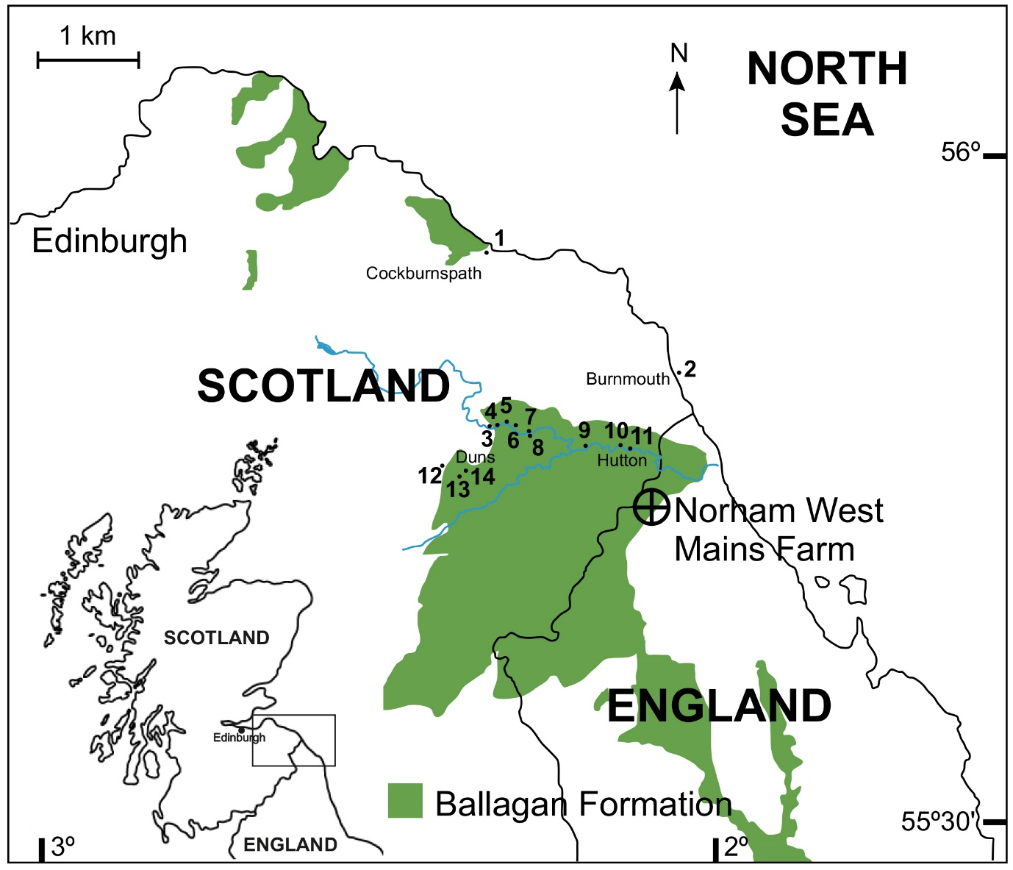Figure 1. Location map of the Norham West Mains Farm borehole and plant specimens found in the Tournaisian Ballagan Formation of the United Kingdom. Refer to Table 1 for more information.

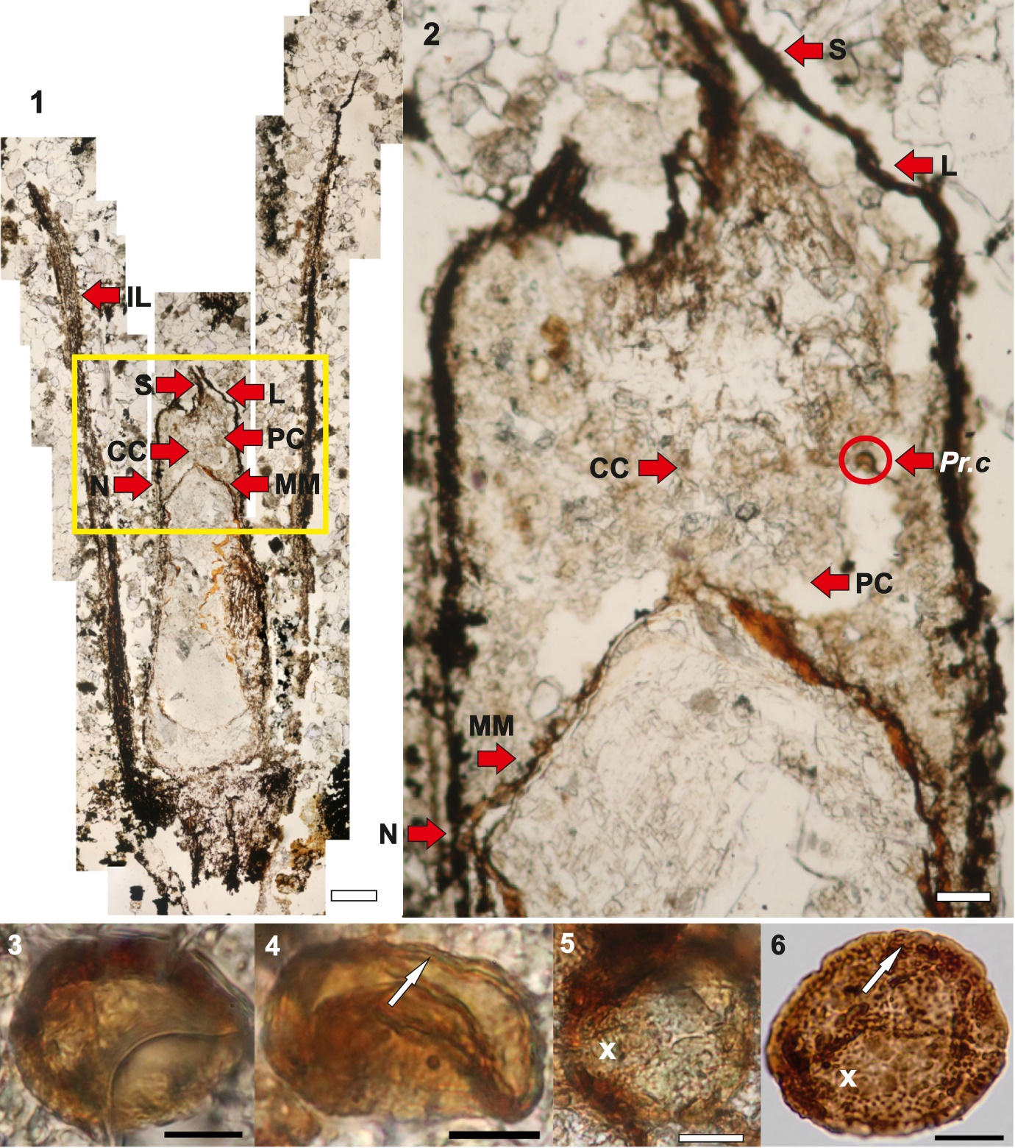
Plate I. 1. Labelled composite photograph of a mature Genomosperma kidstoni nucellus (central part of ovule) from Langton Burn (slide FSC1116 K5 Albert Long Collection, Hunterian Museum, Glasgow). Scale bar = 500 µm. 2. Close up of the pollen chamber with an in situ Prolycospora claytonii microspore (3.) circled in red. Scale bar = 100 µm. Abbreviations: IL=integument lobe, S=salpinx, CC=central column, N=nucellus, L=lagenostome, PC=pollen chamber, MM=megaspore membrane, Pr. c=Prolycospora claytonii. 3–5. P. claytonii microspores from inside an ovule of Genomosperma kidstoni (slide FSC1116 K5 Albert Long Collection, Hunterian Museum, Glasgow). 6. A P. claytonii miospore from the NWMF borehole (slide SSK38190) for comparison. The arrow in 4 indicates the outline of the verrucae on the distal face (as shown in 6). The x inside 5 highlights the infragranular sculpture of the proximal face (as shown in 6). Scale bars = 10 µm.
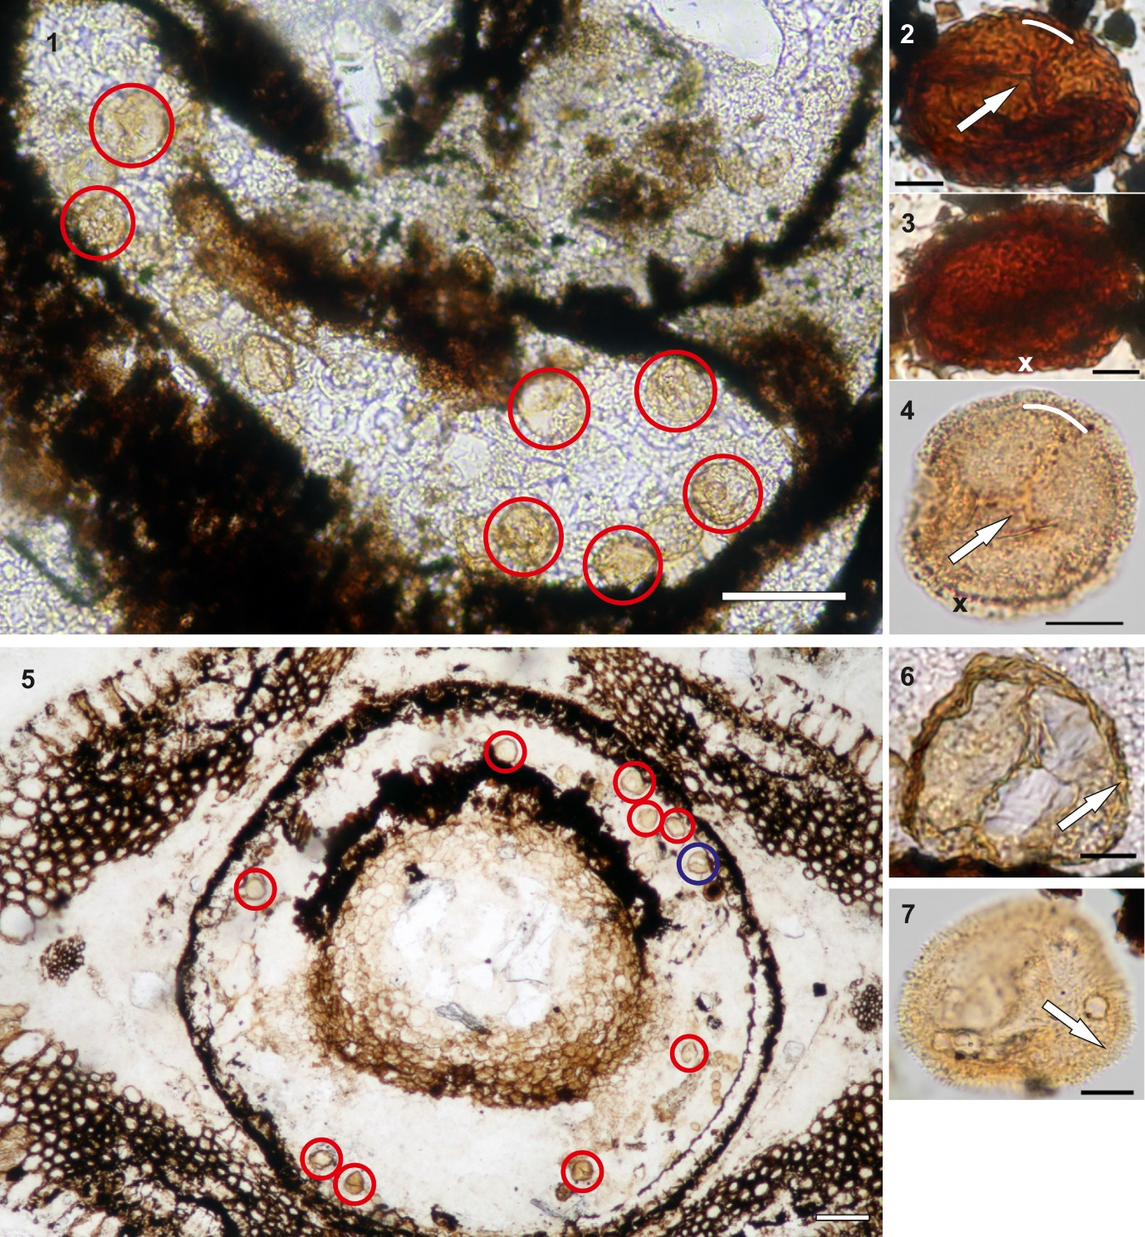
Plate II. 1. Photomicrograph of part of an ovule (pollen chamber) of Stamnostoma huttonense (slide FSC1148 Albert Long Collection, Hunterian Museum, Glasgow) containing multiple specimens of Colatisporites decorus microspores; some highlighted in red circles. Scale bar = 100 µm. 2–3. C. decorus microspores from inside an ovule of Stamnostoma huttonense from Loch Humphrey Burn (slide FSC1061 Albert Long Collection, Hunterian Museum, Glasgow). 4. A C. decorus miospore from the NWMF borehole (slide SSK39149) for comparison. The arrow in 2. indicates the distinct suturae and the white arc highlights the cameration (as shown in 4). The x in 3. highlights the sculpture of small grana (as shown in 4 in black). Scale bars = 10 µm. 5. Photomosaic of part of the ovule of Lyrasperma scotica from Gavinton (slide FSC1411 Albert Long Collection, Hunterian Museum, Glasgow) containing multiple specimens of Colatisporites denticulatus microspores; some highlighted using circles with specimen 6 in blue. Scale bar = 100 µm. 6. A specimen of C. denticulatus from part of the ovule of Lyrasperma scotica from Gavinton (slide FSC1411 Albert Long Collection, Hunterian Museum, Glasgow). 7. A C. denticulatus miospore from the NWMF borehole (slide SSK37853) for comparison. The arrow in 6 indicates the sculpture of spinae, coni, bacula and grana (as shown in 7). Scale bars = 10 µm.
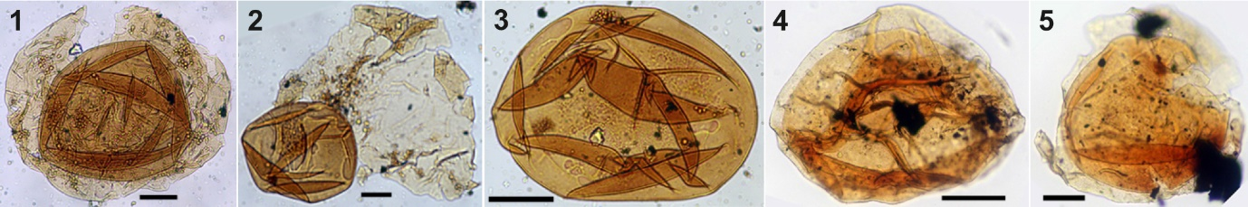
Plate III. 1–3. Three pollen grains of Remysporites magnificus from the Protopitys scotica type (slide FSC1372 Albert Long Collection, Hunterian Museum, Glasgow). 1. A complete specimen of R. magnificus with the laevigate inner body (centre) inside the laevigate to finely sculptured exoexine. 2. A laevigate Punctatisporites-type inner body (left-hand side) with laevigate to finely sculptured exine partially surrounding the inner body (right-hand side). 3. A laevigate Punctatisporites-type inner body. 4–5. Two intact specimens of R. magnificus from the NWMF borehole (slides SSK38434 and SSK38075 respectively) for comparison. Scale bars = 50 µm.

Site | Grid ref. | Locality name | Plant(s) | Siting | Reference
1. | NT 791716 | Horse Roads | L. scotica | Ex situ | Long, 1960c
2. | NT 958612 | Burnmouth | L. scotica | Ex situ | Long, 1960c
3. | NT 793566 | Cumledge | L. scotica | Ex situ | Long, 1960c
4. | NT 800566 | Broomhouse | L. scotica | Ex situ | Long, 1960c
5. | NT 810567 | Marden | L. scotica | Ex situ | Long, 1960c
6. | NT 816566 | Marden, West Blanerne | L. scotica | Ex situ | Long, 1960c
7. | NT 827561 | Edrom | L. scotica | Ex situ | Long, 1960c
8. | NT 827558 | Edrom Church | L. scotica | In situ | Kidston, 1902
9. | NT 878547 | Willie's Hole | L. scotica | Ex situ | Kidston, 1901
10. | NT 907549 | Hutton Castle Mill | G. kidstoni | Ex situ | Long, 1960a
11. | NT 915546 | Hutton Bridge | G. kidstoni and | Ex situ | Long, 1960a
 |  |  | S. huttonense |  | Long, 1960b
12. | NT 752531 | Langton Glen | L. scotica | Ex situ | Long, 1960c
13. | NT 767521 | Gavinton | L. scotica | Ex situ | Calder, 1938
14. | NT 772526 | Hanna’s Bridge | G. kidstoni and | In situ and ex situ | Long, 1960a
 |  |  | L. scotica |  | Long, 1960c
15. | NS 479747 | Loch Humphrey Burn | P. scotica  (not shown) | In situ | Walton, 1957

Table 1. Localities of ovules from the Ballagan Formation of the Scottish Borders shown in Figure 1.
Slide label | Reference
Genomosperma kidstoni FSC1100 | Long, 1960a
Genomosperma kidstoni FSC1114 | Long, 1960a
Genomosperma kidstoni FSC1116 K5 | Long, 1960a
Stamnostoma huttonense FSC1061 Loch Humphrey Burn | Long, 1979
Stamnostoma huttonense FSC1146 | Long, 1960b
Stamnostoma huttonense FSC1148 | Long, 1960b
Lyrasperma scotica FSC1404 Slice 3 | Long, 1960c
Lyrasperma scotica FSC1405 | Long, 1960c
Lyrasperma scotica FSC1406 | Long, 1960c
Lyrasperma scotica FSC1411 | Long, 1960c
Protopitys scotica FSC1371 Scot Plate 7 Fig 3 | Walton, 1957
Protopitys scotica type FSC1372 Plate 7 Fig 1 | Walton, 1957

Table 2. The material that was examined at the Hunterian Museum, Glasgow for the present study. FSC = Figured Slide Collection.

