Qualitative and Quantitative Methods
of Capsaicinoids: A Mini-Review

Saiful Arifin Shafiee^{1,2}, Wan Hazman Danial^{1,2,3*}, Samuel C. Perry⁴, Zaherul Imran Ali¹, Mohamad Afiq Mohamed Huri⁵, and Awis Sukarni Mohmad Sabere⁶
¹Department of Chemistry, Kulliyyah of Science, International Islamic University Malaysia, 25200 Kuantan, Pahang, Malaysia
²Sustainable Chemistry Research Group (SUSCHEMRG), Department of Chemistry, Kulliyyah of Science, International Islamic University Malaysia, 25200 Kuantan, Pahang, Malaysia
³Synthesis and Functional Materials Research Group (SYNTOF), Department of Chemistry, Kulliyyah of Science, International Islamic University Malaysia, 25200 Kuantan, Pahang, Malaysia
⁴Department of Chemistry, University of Southampton, University Rd, Southampton SO17 1BJ, United Kingdom
⁵Department of Chemistry, Faculty of Science, Universiti Teknologi Malaysia, 81310 Skudai, Johor, Malaysia
⁶Department of Pharmaceutical Chemistry, Kulliyyah of Pharmacy, International Islamic University Malaysia, 25200 Kuantan, Pahang, Malaysia
*Corresponding author: whazman@iium.edu.my

Abstract
The interest in capsaicinoids increased recently due to its potential for commercial use, including food products, dietary supplements, pharmaceutical, and self-defence products. Hence, there is an urge to develop an efficient qualitative and quantitative method of capsaicinoids so as to protect the consumer right and upright the regulation regarding their concentration in the aforementioned products. Therefore, this mini review is aimed at assisting readers in choosing the best analytical method for detecting capsaicinoids in a variety of samples, which includes selected recent journals. HPLC, NMR spectroscopy, and electrochemical sensors are among the analytical methods chosen in this review. The advantages, disadvantages, and limitations of each analytical method is thoroughly examined. It also discusses the validation methods such as the accuracy, precision, sensitivity, selectivity, and detection limits of the techniques. This mini review is believed to benefit not only researchers, but also the related regulatory institutions in the determination of capsaicinoids.

Keywords: Capsaicinoids, Mini review, HPLC, NMR spectroscopy, Electrochemical detection

1. Introduction
Recently, David Julius was awarded with the Nobel prize in physiology or medicine 2021 for his discovery of receptors for temperature (The Nobel Assembly at Karolinska Institutet, 2021). His group utilised capsaicin to probe a sensor in the nerve endings of the skin that reacts to heat (Caterina et al., 1997). Capsaicin (trans-8-methyl-N-vanillyl-6-nonenamide) is one of the main components of pepper and is widely used throughout the world, especially in pepper sprays for self-defence (Oliveira Junior et al., 2019). Capsaicin and its derivatives such as dihydrocapsaicin, homodihydrocapsaicin, nordihydrocapsaicin, and homocapsaicinis are collectively known as capsaicinoids (Kumar et al., 2018). However, capsaicin and dihydrocapsaicin (Figure 1) are the most abundant type of capsaicinoids in nature, representing over 90% of the total capsaicinoids (Han et al., 2020; Mokhtar et al., 2016). As shown in Figure 1, their chemical structure consists of amides of vanillylamine with branched-chain fatty acids. Capsaicinoids are a group of unique molecules characteristic of chili peppers and commonly found in the genus of pepper (Capsicum annum) (Lalić et al., 2022). Besides, peppers have rapidly become an essential component of most cuisines throughout the world due to their popularity as a spice and vegetable (Biradar et al., 2022). In chillies, it has been reported that the average ratio between capsaicin and dihydrocapsaicin is 6:4 (Usman et al., 2014). Though capsaicin is commonly used in food products, many research has been devoted to study capsaicin due to the growing demand for pharmaceutical uses. Numerous studies have shown that capsaicin possesses analgesic, anti-cancer, anti-inflammatory, anti-diabetic, anti-coagulant, and hypolipidemic activity (Al-Samydai et al., 2019; De Lourdes Reyes-Escogido et al., 2011; Ding et al., 2016; Kumar et al., 2018). Capsaicin is an irritant compound that induces a burning sensation when administered in any tissue (Rollyson et al., 2014). While it is hydrophobic and crystalline, capsaicin is more pungent than other related compounds which include capsaicinoids (Kumar et al., 2018). The earliest method of determining capsaicin pungency is using Scoville Heat Units (SHU) (Scoville, 1912). The weakness of this method is that it depends on the human sense of taste which is inaccurate and may be biased. Hence, many modern analytical techniques have been used for the determination and detection of capsaicininoids in sample compounds, such as high-performance liquid chromatography (HPLC), nuclear magnetic resonance (NMR), and electrochemical detection which will be discussed further later herein. This review discusses the qualitative and quantitative methods of capsaicinoids detection.

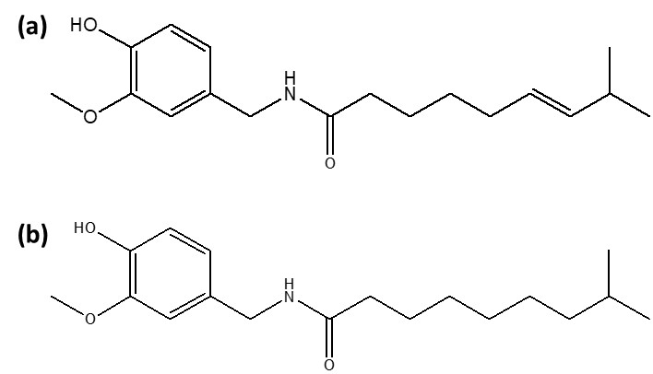

Figure 1: Chemical structure of a) Capsaicin and b) dihydrocapsaicin.

2. High-Performance Liquid Chromatography
HPLC is the currently accepted standard and it has been acknowledged by the American Spice and Trade Association (ASTA) as one of the chosen methods to determine the quality and pungency of chili plants (Woodman & Negoescu, 2019). Despite of its versatility on great separation power and detection level, HPLC requires sample preparation and pre-treatment steps with the addition of longer analysis times typically 10 minutes run for each analysis (da Silva Antonio et al., 2019; Woodman & Negoescu, 2019).

HPLC has been used for the detection of capsaicinoids in numerous studies including the evaluation of natural capsaicin in pepper spray by Oliveira Junior et al., (2019), capsaicin in Capsicum annum by Al-Samydai et al., (2019), and capsaicinoids in dietary supplements (Werner et al., 2021). In the study by Oliveira Junior et al., (2019), the analysis of capsaicin in pepper spray has validated precision by showing similar retention times (r.t. = 4.87 minutes) for three samples of pepper spray (natural capsaicin dissolved in ethyldiglycol and water). The chromatogram (Figure 2) presented peak areas of 69% for capsaicin, 26% for dihydrocapsaicin, and 5% for other detected capsaicinoids. The three samples were performed in similar conditions using acetonitrile/H₂O as the eluent, a flow rate of 1 mL per minute, an injection of 10 µL and a column temperature of 25°C. Unfortunately, the study does not discuss other method validations of HPLC, such as the validation of sensitivity, the detection wavelength, inter and intra assay and also method recovery. Apart from that, the authors only state that HPLC had a lower range power than gas chromatography (GC-MS) and NMR spectroscopy, which was also utilized in the study for the identification and quantification of capsaicin.

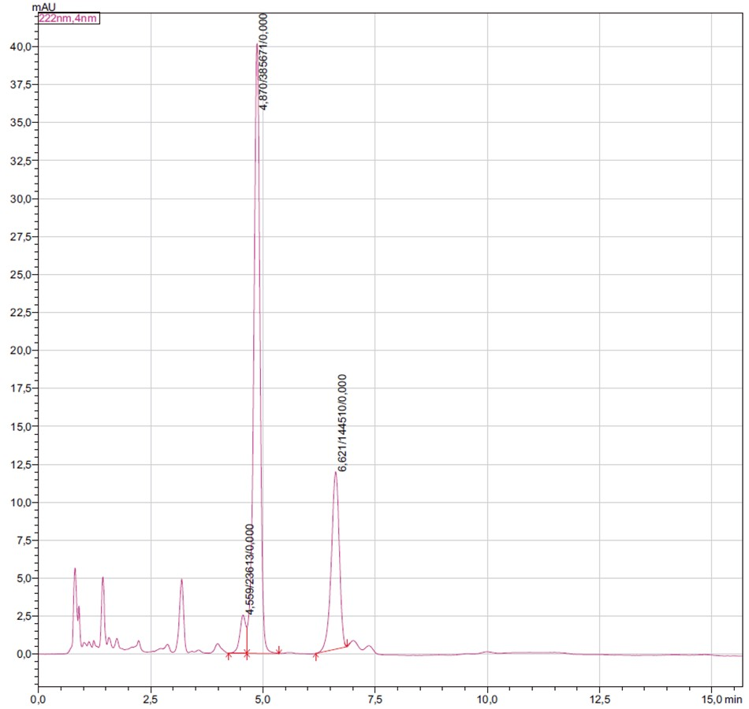
Figure 2: HPLC chromatogram of pepper spray reproduced from Oliveira Junior et al., (2019).

In other study by Al-Samydai et al., (2019), it presents a clear list of method validation developments. The detection of capsaicin was optimized at 220 nm after several trials of different wavelengths for determination of its sensitivity. Various ratios and constitutions of mobile phases were tested in the study with 80:20 methanol-acetonitrile mobile phase ratio at the flow rate of 0.5 mL per minute were successfully optimized to produce a very good resolution of detection (Al-Samydai et al., 2019). The study performs other parameters of validations including the specificity, linearity, and precision. System suitability parameters presented the retention time of capsaicin eluted at 3.22 minutes, suggesting short run times is required using the optimized method proposed by the study. The specificity was shown by a chromatograph, which gave the peak of capsaicin at r.t. = 3.22 minutes and standard deviation of 0.566183, indicating no interference of the mentioned mobile phase. Excellent linearity (R² = 0.997) was obtained through calibration curves using peak areas plotting at six different concentrations varying from 0.03125 mg/mL to 1.00 mg/mL. The study also showed an excellent repeatability by testing three injections of capsaicin and having a relative standard deviation, lower than 2%. However, a similar lack of information from both aforementioned studies is in regard to the limit of detection (LOD), limit of quantification (LOQ), and recovery percentage which are really important in quantitative analysis which demands a precise and accurate analysis.

Werner et al., (2021) and Kuzma et al., (2019) utilized both HPLC-UV and HPLC-fluorescence detector (HPLC-FLD) along with an ultrasound-assisted extraction procedure for the analysis of capsaicinoids (Capsaicin and Dihydrocapsaicin) from dietary supplement products. The method is said to be precise, accurate and had shown functional recovery of capsaicin, along with being cost-effective. Compared to HPLC-UV, the main advantage of fluorescence detection is that the detector can offer a remarkably higher sensitivity (Linear range: 15-1000 µg L⁻¹) compared to the UV detector (Linear range: 250-10000 µg L⁻¹). The UV detection wavelength was optimized at 228 nm whereas the fluorescence detection wavelength was optimized at 280 nm for the excitation and 310 nm for the emission (Werner et al., 2021). The study also utilized response surface methodology (RSM) to determine the optimum percentage of the solvent and extraction time required for effective extraction of capsaicinoids. An external standard method was used for both capsaicinoids for the quantitative analysis of the actual dietary supplement samples. The method was validated for linearity, detection and quantification limits. Meanwhile, recovery and precision were only done using HPLC-FLD possibly due to the instrument offer better detection and quantification limits. Unfortunately, the study falls short in reporting the method’s specificity, accuracy, repeatability, and reproducibility, which are also valuable data in any analytical validation. The time of analysis was relatively fast with elution time for all analytes less than 5 minutes (Capsaicin: 2.31 minutes, Dihydrocapsaicin: 2.68 minutes) per analysis with a good correlation coefficient (R² > 0.995) for both compounds and instruments. The study also showed excellent detection (HPLC-UV: 69 - 73 µg L⁻¹, HPLC-FLD: 3-4 µg L⁻¹), quantification limit (HPLC-UV: 231-243 µg L⁻¹, HPLC-FLD: 11 - 14 µg L⁻¹), recovery (77.0 - 96.1%) and precision (0.2 - 5.9%). In the analysis of actual dietary supplement products, the study found discrepancy between the declared and found amount of capsaicin which indicated a lack of quality control due to lack of enforcement of appropriate legislation for dietary supplements.

In a study by Woodman & Negoescu, (2019), the authors state that short-run HPLC tests have a tendency not to differentiate certain capsaicinoids components of Capsicum samples (Capsicum chinense, Capsicum annuum, and Capsicum baccatum). For example, the chromatographic peak of capsaicin might include nordihydrocapsaicin (N-[(4-hydroxy-3-methoxyphenyl)methyl]-7-methyloctanamide). An alternative approach to clearly separate the peaks is to perform longer elution times, increase the column length or reduce the size particle of stationary phase or column diameter which has not yet to be seen in any studies which warrant for future optimization using HPLC as the instrumentation for analysis of capsaicinoid components of Capsicum samples.
From the discussion, it is shown that HPLC in every mentioned study has been able to provide a great separation power for determination of capsaicin. However, most of the mentioned studies were not able to provide important information requires in the aspect of quantitative analysis such as not providing full validation analysis including determination of LOD and LOQ, intra and inter assay analysis as well as recovery percentage of the study. In addition of above inference, analysis of capsaicin using HPLC may be rendered its efficiency due to limitation of internal standards to counter the matric effect restriction which has not been discussed in all findings. Future study should be done on the analysis of capsaicin metabolites which could be very useful especially for the determination of capsaicin in toxicological specimen.

3. Nuclear Magnetic Resonance (NMR) Spectroscopy
NMR spectroscopy is an analytical technique used to observe external magnetic fields subjected to targeted molecules around the nucleus of an atom that exhibits nuclear spin. Three main pieces of data on an NMR spectrum consist of chemical shifts (in ppm unit), peak integration and peak splitting. In recent studies on capsaicin, proton nuclear magnetic resonance or ¹H-NMR has been the preferred method for the abundance of protium (Hydrogen-1 isotope), whether using deuterated solvents (Bora et al., 2021) or non-deuterated solvents (Valim et al., 2019; Woodman & Negoescu, 2019). Information on the chemical environments of every hydrogen for a targeted molecule is observed. Studies suggest that NMR is an excellent option for chilli analyses, although ignored and has not been used extensively (Woodman & Negoescu, 2019). Internal standards similar to the studied analytes and highly pure reference standards are not required by NMR, other than allowing the detection of low analyte concentrations and allowing a rapid, non-destructive analysis with simple preparations of samples (Valim et al., 2019). Other advantages include short run times and better confirmation for molecular structures (Bora et al., 2021).

A study was done by Oliveira Junior et al., (2019) using ¹H-NMR for relative quantification of capsaicin. It was possible to interpret all the signals of the main compounds in Oleoresin Capsicum (OC) samples, including the all-important capsaicin. The signal of capsaicin was unhindered by the use deuterated chloroform (CD₂Cl₂), deuterated water (D₂O), and maleic acid (Z-but-2-enedioic acid). In conjunction, the NMR spectrum was acquired swiftly with a straightforward preparation step and detected 66% of the capsaicin present in the samples, although the authors did not state the whole duration of the experiment of the method used.

Woodman & Negoescu, (2019), in their study on capsaicinoids levels in Capsicum samples (Capsicum chinense, Capsicum annuum, and Capsicum baccatum), state that the NMR analysis did not require calibration because the signal integration is assumed to be proportional to the analyte content. Spectra exhibited significant peaks of capsaicin, which were shown not to overlap with signals from other capsaicinoids in Capsicum sample compounds since capsaicinoids have notably similar structures – having vanillyl, amide, and vinyl groups. Samples were measured by NMR three times to ensure precision. As for the reproducibility, samples were analysed using different NMR instruments (400 MHz Avance III, 500 MHz Avance III and 500 MHz Propulse) (Woodman & Negoescu, 2019). Maleic acid as a standard for NMR analysis provides many advantages. Maleic acid is preferable to avoid the overlapping of signals because of having only one single resonance. Doublet peaks by the methyl signal of capsaicin in the spectrum were shown at 0.95 ppm, while the singlet of maleic acid was at 6.33 ppm.

Woodman & Negoescu, (2019) also practised method development. They implemented variations of relaxation time delay and found that 20 seconds was the sufficient minimum for NMR to validate integration peaks. Six capsaicin-made solutions (ranging from 0.027 mg/mL to 0.491 mg/mL) were analysed three times over the course of a few days. The NMR plotted linear regression of derived concentration versus the actual concentration of made solutions has shown R² = 0.9997. The linear range of the method exceeded the 95% confidence limit (± 2 standard deviation). The sensitivity of the NMR method was enhanced using Fourier transformation, allowing multiple scans and an increase in the signal-to-noise ratio. Based on 16 scans by the 500 MHz Avance III spectrometer, the limit of detection of signal-to-noise for the sample with the lowest concentration and with the highest concentration were 15:1 and 275:1, respectively, with an acquired time of about 6 minutes. A ratio of 10:1 was accepted for the limit of quantification (LOQ). Overall, this method should perform a maximum of five minutes for capsaicin determination. The method was assayed with 30 samples (three extracts for each of the 10 cultivars), with an R² of 0.997. Nonetheless, the assay showed small variations due to the presence of extra peaks from minor capsaicinoids in real chilli samples. Figure 3 shows the H NMR spectra of capsaicinoids analysed by Woodman & Negoescu, (2019).

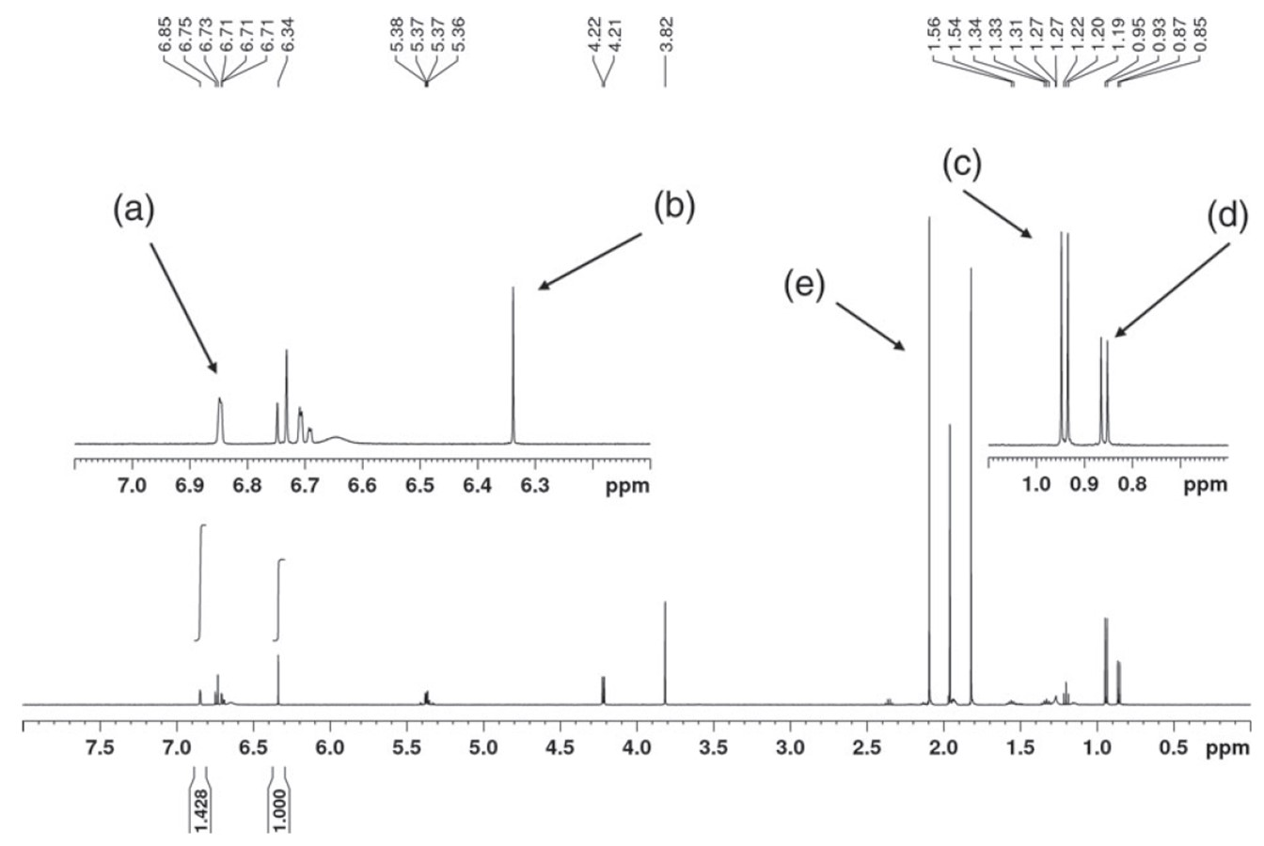
Figure 3: ¹H NMR spectra showing (a) Aromatic signal from capsaicinoids used for integration, (b) maleic acid, (c) capsaicin methyl signal, (d) dihydrocapsaicin methyl signal and (e) suppressed acetonitrile signal. The figure reproduced from (Woodman & Negoescu, 2019).

Valim et al., (2019) validated the methods of the study using selectivity, linearity, limits of detection, and quantification, accuracy, precision, and robustness. Earlier in the study, non-overlapping signals were 2.0 ppm and 5.4 ppm for capsaicin, but 5.4 ppm was chosen due to too many signals from other compounds detected within the range of 1.0 ppm to 5.2 ppm. Another signal chosen was at 6.4 ppm by the aromatic hydrogens of capsaicin. Excellent linearity, with a correlation coefficient (R) of 0.9967, was achieved by the establishment of a calibration curve for six different concentrations of capsaicin ranging from 0.5 mg/mL to 5 mg/mL. The linearity was also tested by analysis of variance (ANOVA) and the Cochran test, which indicated positive results for the method. Further validation gave detection and quantification limits from 0.639 mg/mL to 2.633 mg/mL, respectively, in line with excellent precision below 1.10%. As for the accuracy, however, only samples with a concentration greater than 3 mg/mL showed an error rate close to 3%, due to the possibility of a low number of scans and long interscan delays. The solution was to increase the number of scans and reduce interscan delays by 14 seconds.

Robustness tests were done after the samples were stored in refrigerators at a temperature of -3°C. Results showed an extreme minimum of variations, indicating a pass for robustness. The method was also evaluated and applied to real pepper samples of Malagueta (Capsicum frutescens), Habanero (Capsicum chinense), Bhut Jolokia (hybrid of Capsicum frutescens and Capsicum chinense), and Capsicum chinense cultivar (Trinidad Scorpion/Carolina Reaper peppers). However, the calculation of values from the method cannot directly be to Scoville Heat Units (SHU) due to different concentrations of fresh peppers, preserved canned peppers, and diluted pepper sauces.

A study on capsaicin quantification of northeast India chilli from 15 land races was done by Bora et al., (2021). Their method used benzene as the internal standard and validated specificity, linearity, sensitivity, accuracy, and precision. Specificity was tested on four different samples, namely dry Bhot jolokia, dry Jati jolokia, commercial dry red chilli and red chilli powder (Capsicum annum). Linearity was assayed using pure capsaicin in the range of 0.05 to 5.0 mg, added to a fixed quantity of benzene (0.5 mg) in deuterated chloroform (CDCl₃) and maintaining a total volume of 600 µL for the assay. The linear regression with R² of 0.999. The detection limit and quantification limit values were 4.4 µg/mL and 14.8 µg/mL (signal of 0.94 ppm) and 16.3 µg/mL and 54.3 µg/mL (signal of 4.35 ppm), respectively. The accuracy and precision of the method were tested on three different concentrations of capsaicin (0.1, 2.0 and 4.0 mg in total volume 600 µL). Percentage recoveries were 106.50%, 100.06%, and 98.51%, respectively. % RSD of the different concentrations were found to be 2.23, 0.42 and 1.71%, respectively. Percentage recovery represented accuracy, while % RSD represented precision. The study presents high capsaicin content for races with high oleoresin content, but not for every one of the tested samples. Some of the samples had an exceptionally low content of capsaicin in their oleoresin, such as Bhekuri jolokia, Dimapur land race and Bullet jolokia (< 0.5%, 0.47%, 0.30% and 0.22%, respectively). Capsaicin was not detected at all in Shimla mirch (Capsicum annuum), though having high amounts of oleoresin. Heat map visualizations explained that different clades for different land races were the reason for different amounts of capsaicin with varying amounts of oleoresin. Bora et al., (2021) also did studies on Woodman & Negoescu, (2019) and Valim et al., (2019) as references. The authors claim that the study of Woodman & Negoescu, (2019) did not explain capsaicin quantification, which was agreed.

Non-deuterated solvents have certain advantages over deuterated solvents in aspects of time reduction and cost reduction. NMR requires solvent removal if deuterated solvents are used. The cost of deuterated solvents is higher than that of non-deuterated solvents. Moreover, deuterated solvents carry the problem of huge solvent peaks as a possibility. Non-deuterated solvents allowed NMR to run samples in unlocked mode because no signal lock caused by deuterated solvents occurs. Nonetheless, NMR has reduced running time, as compared to the longer HPLC analyses.

4. Electrochemical Detection
A variety of electrochemical electrode sensors have been developed and modified to increase the sensitivity towards capsaicinoids detection. The mode of detection is through the oxidation of capsaicin at the electrode surface, with a two-electron oxidation to the o-benzoquinone, with a subsequent two-electron reduction also possible to catechol. This is evidenced in the cyclic voltammetry. Similar to other reports, (Supchocksoonthorn et al., 2021) demonstrated a single peak in the first cycle (Figure 4(a), peak I) and the emergence of a second peak after the first cycle (Figure 4(a), peak III). Peak I corresponded to the oxidation of capsaicin and the hydrolysis of 2-methoxy group of the capsaicin to become o-benzoquinone. Peak II corresponded to two-electron reduction of o-benzoquinone to form catechol. Meanwhile, peak III is present due to the oxidation of catechol to o-benzoquinone. Figure 4(b) illustrates the full redox reaction mechanisms.

Peak III only appeared in the second cycle because catechol was not present in the solution initially; catechol is only formed after the reduction of o-benzoquinone during the first cycle. Peak I for the first cycle is smaller than that for the second cycle, which may be due to the depletion of capsaicin in the test solution and the inhibition of the electrode surface. This is an important consideration for electrochemical sensors, as the mechanism must be considered in order to reliably relate the sensor current to the capsaicinoid concentration.
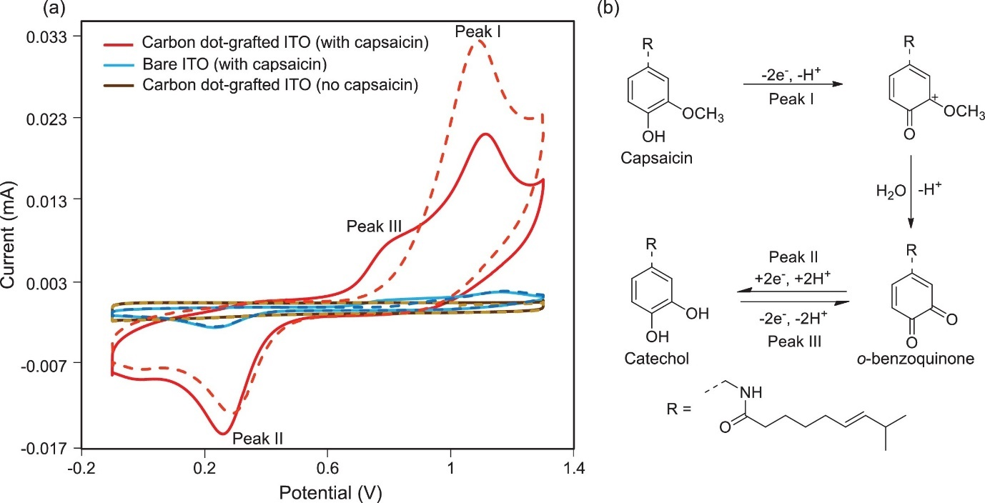
Figure 4: (a) Cyclic voltammograms of carbon dot-grafted ITO (red) and bare ITO (blue) in 0.1 M Na₂SO₄ + 50 μM capsaicin and also the cyclic voltammogram for the blank solution (brown) recorded with the carbon dot-grafted ITO at 50 mV s⁻¹; dash line = 1st scan & solid line = 2nd scan). They used Ag/AgCl (3 M NaCl) as the reference electrode. (b) Redox reaction mechanisms for the oxidation of capsaicin. The figure was reproduced from Supchocksoonthorn et al. (Supchocksoonthorn et al., 2021).

As mentioned in the introduction, capsaicin and dihydrocapsaicin are the most abundant types of capsaicinoids that can naturally be found. The voltammetric features of capsaicin and dihydrocapsaicin such as the peak potentials are quite similar to one another because the location of the double bond present in capsaicin molecules is very far from the electroactive group (Moreno et al., 2020). Signals from an electrochemical sensor in the presence of multiple capsaicinoids would therefore provide a single value for the total capsaicinoid concentration only. Distinction between different caspacinoids would therefore require modifications to the sensor in order to produce a species-selective surface although, to the best of our knowledge, this has not yet been achieved. Discussion from this point therefore focus on the detection of total capsaicinoid concentration.

Electrochemical sensors boast numerous benefits, such as simplicity, portability, and inexpensiveness (Kim et al., 2019; Naskar et al., 2019). Developments in electrochemical capsaicinoid detection often use surfactants or nanoparticles to modify conventional carbon electrodes (Naskar et al., 2019). The electrochemical properties of electrodes are commonly investigated and validated using cyclic voltammetry (CV) and electrochemical impedance spectroscopy (EIS) (Kim et al., 2019). The greatest electrochemical sensitivity values are usually reported using pulse techniques such as square wave (SWV) or differential pulse voltammetry (DPV) (Chen & Shah, 2013; Moreno et al., 2020). These techniques provide effective removal of the background signal, allowing the user to resolve the detection signal for much lower capsaicinoid concentrations. In fact, careful design of pulse voltammetry waveforms allows for high levels of capsaicinoids at simple and unmodified electrode surfaces (Søpstad et al., 2019). Further increases in sensitivity are possible via adsorptive stripping voltammetry, where capsaicinoids are allowed to accumulate on an adsorptive electrode surface for analysis (Chaisiwamongkhol et al., 2017). This can be combined with pulse voltammetry to reach very low levels of detection (Lyu et al., 2019).

Table 1 summarises the electrochemical parameters, conditions, techniques, features, and results for various electrochemical probes found in the literature between 2017 and 2021. A high performing and relatively simple electrode uses carbon dots grafted on indium tin oxide (ITO) electrodes (Supchocksoonthorn et al., 2021). The carbon dot-ITO electrodes exhibit a wide linear range from 0.05 to 500 μM and a low LOD of 5.4 nM. The capsaicin peak potential was 1.12 V vs. Ag/AgCl (Peak I, Figure 4(a)), which is more positive than most other sensors, most likely due to the more resistive ITO relative to conductive carbons. Although this comes with a slight energy increase, this is still within the solvent window and so should not significantly impact the sensor operations.

Most electrochemical capsaiconoid sensors are built upon high surface area carbon scaffolds, such as carbon black (Deroco et al., 2020), carbon nanotubes (Ziyatdinova et al., 2019), reduced graphene oxide (Zhong et al., 2019) or graphene nanoplatelets (Soleh et al., 2020). Many groups enhance high surface area carbon electrodes with metal oxidise nanoparticles to catalyse oxidations. A study on modified GPE with Y₂O₃ nanoparticles by Naskar and colleagues (Naskar et al., 2019) showed good repeatability, stability, sensitivity, and selectivity towards capsaicin. The authors employed Y₂O₃ nanoparticles for their high surface area and an electrocatalytic activity towards capsaicin. They reported a linear range between 1 µM and 80 µM for capsaicin in phosphate buffer, although selectivity of the electrodes versus known interfering compounds was not studied. Importantly, the materials showed promising robustness, with low deviations across repeated measurements over one month. Many other metal oxides have been used as catalytic sites for electrochemical capsaicinoid detection, including but not limited to TiO₂ (Sarma & del Valle, 2020), Bi₂O₃ (Verma & Jain, 2017) and CeO₂ (Ziyatdinova et al., 2020).

Kim et al., (2019) used an ionic liquid (IL) enhanced graphene-titania-Nafion composite graphene composite electrode (GCE) to detect capsaicin. The advantages of using IL are that they have a low volatility and high electrical conductivity. Reduced graphene can disperse easily through hand-casting of the composite solutions in small aliquots onto the GCE, indicating a simple preparation of tools. Scanning electron microscope (SEM) images (Figure 5) of the graphene-titania-Nafion composite combined with the IL 1-hexyl-3-methylimidazolium hexafluorophosphate (HMIHP) demonstrated a highly porous material. This allows a rapid diffusion of capsaicin through the composite structure and a large electrode surface area, increasing the electrochemical response. Adding the HMIHP and graphene reduces the resistance of the modified electrode. This improves the sensitivity of the sensor, as evidenced by an increase in the peak current by two orders of magnitude.

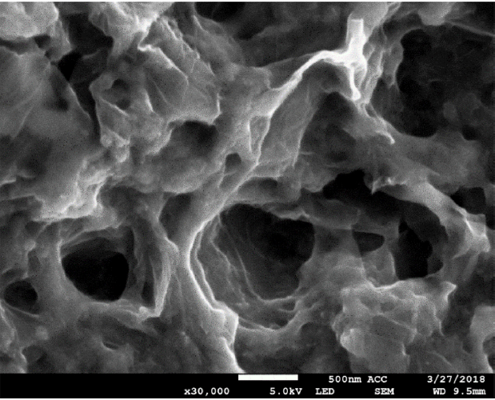
Figure 5: SEM image of graphene-titania-Nafion composite combined with 1-hexyl-3-methylimidazolium hexafluorophosphate (HMIHP) with the magnification of 30,000x where the scale bar indicates 500 nm. The figure was reproduced from Kim et al., (2019).

A popular route to selectivity is to decorate the electrode surface with species that selectively adsorb to capsaicinoids. This has a dual benefit of enhancing the sensor signal as well as blocking surface sites to lessen background processes. Díaz de León Zavala et al. demonstrated that cyclodextrins form complexes with capsaicinoids at graphite paste electrode surfaces (Díaz de León Zavala et al., 2018), with β-cyclodextrin modified sensors giving a LOD of 210 nM. Ziyatdinova et al., (2019) achieved the same effect by modifying multiwalled CNTs with poly(gallic acid), with an impressive LOD of 2.9 nM for capsaicin. Many other polymer modifications have been studied in order to provide a highly lipophilic electrode surface to favour capsaicinoid interactions, such as poly(pyrrole) (Verma & Jain, 2017), poly(aniline) (Temcheon et al., 2019), and ionic surfactants (Ziyatdinova et al., 2020). Jerga et al. furthered this by using ex situ voltammetry on a carbon electrode with a hydrophobic phospholipid layer (Jerga et al., 2020). The electrode was immersed into a test solution so capsaiciniods could enter the phospholipid layer but hydrophilic interfering compounds could not. The electrode was then transferred into a second clean electrolyte, so that subsequent stripping voltammetry only detected the incorporated capsaicinoids.

A key advantage to electrochemical detection versus other analytical techniques such as HPLC, GC, capillary electrophoresis, and colorimetry is a comparatively low cost and portability. Many preliminary tests have drop cast catalyst materials onto simple carbon electrodes, which allows for up-scaling through screen printing techniques (Y. Wang et al., 2017), and applications onto disposable paper electrodes for rapid and cost effective analysis (Deroco et al., 2020). This has lead to a number of prototype devices recently being produced (Kachoosangi et al., 2008; Soleh et al., 2020; Søpstad et al., 2019). Further details in the device fabrication and other hyphenated techniques can be found in a recently published review (Crapnell & Banks, 2021). One research gap that can be identified is that not many groups have probed the species of interest using metal nitride electrodes. Metal nitride electrodes have a high potential for many electrochemical reactions (Shafiee et al., 2018, 2020)

Table 1: Electrochemical conditions, features, and responses for various electrodes as reported in the literature in between 2017 and 2020.
Electrode material | Analyte | Medium | pH | Technique | Onset potential vs. Ag/AgCl / V | Oxidation peak potential vs. Ag/AgCl / V | Linear range / µM | LOD / nM | Ref
PGA/ MWCNT/ GCE | C | BR | 2 | CV | 0.6 | 0.65 | - | - | (Ziyatdinova et al., 2019)
 | DHC |  |  |  | 0.58 | 0.62 | - | -
 | NV |  |  |  | 0.5 | 0.6 | - | -
 | C |  |  | DPV | 0.53 | 0.6 | 0.01 - 50 | 2.9
 | DHC |  |  |  | 0.53 | 0.6 | 0.025 – 75 | 5.9
 | NV |  |  |  | 0.53 | 0.6 | 0.05 - 75 | 6.1
CeO₂-CPB/ SWCNT-COOH/ GCE | C | BR | 2 | CV | 0.6 | 0.73 | - | - | (Ziyatdinova et al., 2020)
 |  |  |  | DPV | 0.58 | 0.65 | 0.1 – 7.5 | 28
 |  |  |  |  |  |  | 7.5 – 500 | 92
graphite SPE | C | BR | 2 | CV | 0.48 | 0.6 | - | - | (Søpstad et al., 2019)
GCE | C | 0.1 M PBS | 7 | DPV | 0.156 | 0.306 | 0.66 – 20.9 | 198 | (Moreno et al., 2020)
β-cyclodextrin  carbon paste  electrodes | C | HClO₄ | - | CV | 0.646 | 0.736 | 1.38 – 59.77 | 271 | (Díaz de León Zavala et al., 2018)
 | C |  |  | SWV |  |  | 1.3 – 10 | 210
 | DHC |  |  |  |  |  | 0.7 – 6.8 | 94
Y₂O₃ / GPE | C | - M  PBS | 6 | CV | 0.5 | 0.6 | 1 – 80 | - | (Naskar et al., 2019)
IL composite | C | 0.04 M  BR | 1 | LSV | 0.606 | 0.716 | 0.03 – 10 | 3.2 | (Kim et al., 2019)
Pd NPs/ reduced  graphene oxide | C | 0.04 M  BR | 2 | Cyclic  SWV | 0.645 | 0.745 | 0.32 – 64 | 100 | (Zhong et al., 2019)
Carbon black  SPE | C | 0.1 M  H₂SO₄ | 1 | CV | 0.45 V vs Ag ink | 0.59 V vs Ag ink | - | - | (Deroco et al., 2020)
 |  |  |  | SWV | 0.42 V vs Ag ink | 0.5 V vs Ag ink | 0.2 – 8 | 85
 |  |  |  | DPV |  |  | 0.08 – 6 | 28
PSS-functionalized graphite/ SPE | C | 0.05 M  BR | 1 | CV | 0.686 | 0.746 | - | - | (Y. Wang et al., 2017)
 |  |  |  | DPSV | 0.626 | 0.706 | 0.3 – 70 | 100
Polypyrrole/ Bi₂O₃/ GO/ GCE nanocomposite | C | 0.1 M KCl  + BR | 8.8 | CV | 0.4 | 0.6 | 0.26 – 2.61 | 58.9 | (Verma & Jain, 2017)
Manganese  diselenide  nanoparticles/ GCE | C | 0.05 M PBS | 7 | CV | 0.3 | 0.5 | 0 – 0.566 | - | (Sukanya et al., 2018)
 |  |  |  | DPV | 0.2 | 0.45 | 5 – 128.03 | 50
Carbon-dots-  grafted Indium Tin Oxide | C | 0.1 M  Na₂SO₄ | 7 | CV | 0.606 | 1.126 | 0.05 – 500 | 5.4 | (Supchocksoonthorn et al., 2021)
TiO₂ nanoparticles modified graphite | C | 0.2 M  Glycine  buffer +  0.1 M KCl | 2.5 | CV | 0.2 | 0.43 | 5.34 – 138 | 5,340 | (Sarma & del Valle, 2020)
MWCNT- molecular imprinted polymers | C | BR | 2 | CV | 0.6 | 0.74 | 0.05 – 100 | 20 | (M. Wang et al., 2020)
N-doped graphene nanoplatelets | C | BR | 2 | CV | 0.4 V vs Ag/AgCl ink | 0.5 V vs Ag/AgCl ink |  |  | (Soleh et al., 2020)
 |  |  |  | DPV | 0.05 V vs Ag/AgCl ink | 0.18 V vs Ag/AgCl ink | 1 - 40 | 370
 |  |  |  |  |  |  | 40 - 100
Ru NPs/ CNT/ GCE | C | 0.1 M PBS | 4 | CV | 0.5 | 0.62 |  |  | (Baytak & Aslanoglu, 2017)
 |  |  |  | SWV | 0.25 | 0.3 | 0.01 – 0.41 | 2.5
Tin-reduced graphene oxide SPE | C | 0.01 M  sodium  acetate  buffer | 3 | CV | 0.3 | 0.4 | 0.2 – 22 | 5 | (Numphud et al., 2020)
Electrode material: GCE – glassy carbon electrode; CNT – carbon nanotube; MWCNT – multiwall carbon nanotube; TiO₂ – titanium dioxide; PSS – polystyrene sulfonate; BiO₂ -bismuth (III) oxide; GO – graphene oxide; Pd – palladium; NPs – nanoparticles; IL – ionic liquid; Y₂O₃ – yttrium (III) oxide; PGA – poly(gallic) acid; SWCNT-COOH – carboxylated single walled carbon nanotube; SPE – screen-printed electrode; PSS-grp – poly(sodium 4-styrenesulfonate) functionalized graphite
Analyte: C – capsaicin; DHC – dihydrocapsaicin; NV - nonivamide
Medium: BR – Britton-Robinson buffer solution; PBS – phosphate buffer solution
Technique: CV – cyclic voltammetry; DPV – differential pulse voltammetry; SWV – square wave voltammetry; LSV – linear sweep voltammetry; DPSV – differential pulse stripping voltammetry

5. Summary
The comparison between HPLC, NMR and electrochemical detection of capsaicinoids is summarised in Table 2.

Table 2: Comparison between HPLC, NMR and electrochemical detection.
 | HPLC | NMR | Electrochemical detection
Limit of detection (LOD) | 3 – 4 µg/L (HPLC-FLD)  69 – 73 µg/L (HPLC-UV) | 4.4 µg/mL – 0.960 mg/mL | 2.5 – 5,340 nM
Limit of quantification (LOQ) | 11-14 µg/L (HPLC-FLD)  231-243 µg/L (HLPC-UV) | 16.3 µg/mL – 2.246 mg/mL | -
Recovery | 77.0 – 96.1 % | 66.0 – 106.5 % | -
Precision | 0.2 – 5.9 % | 0.33 – 2.23 % | -
Advantage | Can separate the capsaicinoids components.  high sensitivity and can detect component at very low concentration. | Does not require calibration.  Shorter running time. | Simple experimental preparation, easy to handle, low cost, and portable.
Disadvantage | No internal standards.  Lengthy run time. | Cannot be used at very low concentration. Less sensitive compared to HPLC and electrochemical sensors. | Less sensitive compared to HPLC.

6. Concluding Remarks and Future Perspective
This work provided a mini review of qualitative and quantitative methods of capsaicinoids. Different analytical methods for capsaicinoids each have their own advantages and disadvantages. For instance, HPLC undoubtedly possessed a very high sensitivity, good stability and selectivity, as well as affordable cost per run. However, the run time is quite lengthy than those of NMR spectroscopy and electrochemical sensors. Some of HPLC studies fall short for method’s specificity, accuracy, repeatability, and reproducibility. While the analysis of capsaicin has benefited more from NMR by the use of non-deuterated solvents, minimum error percentages, no requirement of calibration and short run times, the operation cost for the NMR can be very expensive, and require experts for the operation. Besides, the NMR is much less sensitive as compared to HPLC and electrochemical sensors. Unlike NMR, the electrochemical sensors can be portable, cheap, and do not require skilled experts. A range of electrochemical electrode sensors have been modified and developed for capsaicinoids detection. Among various electrode materials, the PGA/MWCNT/GCE is among the best electrode material for capsaicinoids detection using DPV with fairly wide linear range, sensitive and low overpotentials. Nonetheless, the electrochemical sensors are not very sensitive as compared to HPLC, and the lack of studies for electrochemical sensors in terms of selectivity needs to be addressed. On the other hand, we believe that this review will provide a better understanding for the tailoring of optimum and sensitive analytical methods for capsaicinoids and pave the way for more innovative developments in the future.

Data availability
All data generated or analysed during this study are included in this published article.

Acknowledgement
The authors would like to thank the Ministry of Higher Education, Malaysia, and Department of Chemistry, Kulliyyah of Science, International Islamic University Malaysia.

Funding
This work was financially supported by Fundamental Research Grant Scheme (FRGS19-015-0623), Ministry of Higher Education (MOHE), Malaysia and RMC Grant 2020 (RMCG20-038-0038).

Compliance with Ethical Standards
Conflict of Interest
On behalf of all authors, the corresponding author states that there is no conflict of interest.

Ethical Approval
This article does not contain any studies with human participants or animals performed by any of the authors.

Informed Consent
Informed consent not applicable.

References

Al-Samydai, A., Aburjai, T., Alshaer, W., Azzam, H., & Al-Mamoori, F. (2019). Qualitative and quantitative analysis of capsaicin from capsicum annum grown in Jordan. International Journal of Research in Pharmaceutical Sciences, 10(4), 3768–3774. https://doi.org/10.26452/ijrps.v10i4.1767
Baytak, A. K., & Aslanoglu, M. (2017). Sensitive determination of capsaicin in pepper samples using a voltammetric platform based on carbon nanotubes and ruthenium nanoparticles. Food Chemistry, 228, 152–157. https://doi.org/https://doi.org/10.1016/j.foodchem.2017.01.161
Biradar, K., Singh, J., Pillai, S. S., Crosby, K. M., & Patil, B. S. (2022). Separation of nordihydrocapsiate from capsiate and major capsaicinoid analogues using ultra high performance liquid chromatography. Food Chemistry, 382, 132585. https://doi.org/10.1016/j.foodchem.2022.132585
Bora, P. K., Kemprai, P., Barman, R., Das, D., Nazir, A., Saikia, S. P., Banik, D., & Haldar, S. (2021). A sensitive 1H NMR spectroscopic method for the quantification of capsaicin and capsaicinoid: morpho-chemical characterisation of chili land races from northeast India. Phytochemical Analysis, 32(1), 91–103. https://doi.org/10.1002/pca.2934
Caterina, M. J., Schumacher, M. A., Tominaga, M., Rosen, T. A., Levine, J. D., & Julius, D. (1997). The capsaicin receptor: A heat-activated ion channel in the pain pathway. Nature, 389(6653), 816–824. https://doi.org/10.1038/39807
Chaisiwamongkhol, K., Batchelor-McAuley, C., Sokolov, S. V., Holter, J., Young, N. P., & Compton, R. G. (2017). Optimising carbon electrode materials for adsorptive stripping voltammetry. Applied Materials Today, 7, 60–66. https://doi.org/10.1016/j.apmt.2017.02.003
Chen, A., & Shah, B. (2013). Electrochemical sensing and biosensing based on square wave voltammetry. Analytical Methods, 5(9), 2158–2173. https://doi.org/10.1039/c3ay40155c
Crapnell, R. D., & Banks, C. E. (2021). Electroanalytical overview: the pungency of chile and chilli products determined via the sensing of capsaicinoids. Analyst, 146(9), 2769–2783. https://doi.org/10.1039/D1AN00086A
da Silva Antonio, A., Wiedemann, L. S. M., & da Veiga Junior, V. F. (2019). Food Pungency: the Evolution of Methods for Capsaicinoid Analysis. Food Analytical Methods, 12(6), 1327–1345. https://doi.org/10.1007/s12161-019-01470-2
De Lourdes Reyes-Escogido, M., Gonzalez-Mondragon, E. G., & Vazquez-Tzompantzi, E. (2011). Chemical and pharmacological aspects of capsaicin. Molecules, 16(2), 1253–1270. https://doi.org/10.3390/molecules16021253
Deroco, P. B., Fatibello-Filho, O., Arduini, F., & Moscone, D. (2020). Electrochemical determination of capsaicin in pepper samples using sustainable paper-based screen-printed bulk modified with carbon black. Electrochimica Acta, 354, 136628. https://doi.org/10.1016/j.electacta.2020.136628
Díaz de León Zavala, E., Torres Rodríguez, L. M., Montes-Rojas, A., Torres Mendoza, V. H., & Liñán González, A. E. (2018). Study of electrochemical determination of capsaicin and dihydrocapsaicin at carbon paste electrodes modified by β-cyclodextrin. Journal of Electroanalytical Chemistry, 814, 174–183. https://doi.org/10.1016/J.JELECHEM.2018.02.055
Ding, C., Xu, L., Zhou, N., Chen, Y., Li, D., Xu, N., Hu, Y., Cao, Y., & Wang, C. (2016). Genetic Algorithm–Artificial Neural Network Modeling of Capsaicin and Capsorubin Content of Chinese Chili Oil. Food Analytical Methods, 9(7), 2076–2086. https://doi.org/10.1007/s12161-015-0392-3
Han, J., Lee, H. H., Lee, S., Baek, S. Y., Ha, J. H., Seo, H. Y., & Kim, B. (2020). Development of Isotope Dilution-Liquid Chromatography/Mass Spectrometry for the Accurate Determination of Capsaicinoids in Fermented Cabbage Kimchi. Food Analytical Methods, 13(8), 1603–1612. https://doi.org/10.1007/s12161-020-01782-8
Jerga, R., Rajcová, A., Müllerová, V., Barták, P., Cankař, P., Navrátil, T., & Skopalová, J. (2020). Phospholipid modified glassy carbon electrode for determination of chili peppers pungency by ex-situ extraction voltammetry. Journal of Electroanalytical Chemistry, 858, 113790. https://doi.org/10.1016/j.jelechem.2019.113790
Kachoosangi, R. T., Wildgoose, G. G., & Compton, R. G. (2008). Carbon nanotube-based electrochemical sensors for quantifying the “heat” of chilli peppers: The adsorptive stripping voltammetric determination of capsaicin. Analyst, 133(7), 888–895. https://doi.org/10.1039/b803588a
Kim, D. H., Nam, S., Kim, J., & Lee, W. Y. (2019). Electrochemical determination of capsaicin by ionic liquid composite-modified electrode. Journal of Electrochemical Science and Technology, 10(2), 177–184. https://doi.org/10.5229/JECST.2019.10.2.177
Kumar, V., Bhatt, V., & Kumar, N. (2018). Amides From Plants: Structures and Biological Importance. In Studies in Natural Products Chemistry (Vol. 56, pp. 287–333). https://doi.org/10.1016/B978-0-444-64058-1.00009-1
Kuzma, M., Fodor, K., Almási, A., Mózsik, G., Past, T., & Perjési, P. (2019). Toxicokinetic study of a gastroprotective dose of capsaicin by HPLC-FLD method. Molecules, 24(15), 2848. https://doi.org/10.3390/molecules24152848
Lalić, M., Soldić, A., Lalić, A., Lalić, Z., & Sertić, M. (2022). Development and Validation of an HPLC Method for Simultaneous Determination of Capsaicinoids and Camphor in Over-the-Counter Medication for Topical Use. Molecules, 27(4), 1261. https://doi.org/10.3390/molecules27041261
Lyu, W., Zhang, X., Zhang, Z., Chen, X., Zhou, Y., Chen, H., Wang, H., & Ding, M. (2019). A simple and sensitive electrochemical method for the determination of capsaicinoids in chilli peppers. Sensors and Actuators, B: Chemical, 288, 65–70. https://doi.org/10.1016/j.snb.2019.02.104
Mokhtar, M., Russo, M., Cacciola, F., Donato, P., Giuffrida, D., Riazi, A., Farnetti, S., Dugo, P., & Mondello, L. (2016). Capsaicinoids and Carotenoids in Capsicum annuum L.: Optimization of the Extraction Method, Analytical Characterization, and Evaluation of its Biological Properties. Food Analytical Methods, 9(5), 1381–1390. https://doi.org/10.1007/s12161-015-0311-7
Moreno, M. T., Brito, R. E., Córdoba, M., & Mellado, J. M. R. (2020). A simple and rapid electrochemical determination of pungency: Application to aqueous and ethanolic extracts of Capsicum annuum cubana red: Https://Doi.Org/10.1177/1747519820930965, 45(1–2), 111–115. https://doi.org/10.1177/1747519820930965
Naskar, H., Ghatak, B., Biswas, S., Tudu, B., Bandyopadhay, R., & Pramanik, P. (2019). Electrochemical Detection of Capsaicin Using Yttrium Oxide Nanoparticles Modified Graphite Paste Electrode (Y2O3/GPE). ISOEN 2019 - 18th International Symposium on Olfaction and Electronic Nose, Proceedings, 1–3. https://doi.org/10.1109/ISOEN.2019.8823183
Numphud, W., Chienthavorn, O., & Siriwatcharapiboon, W. (2020). Cyclic voltammetric determination of capsaicin by using electrochemically deposited tin and reduced graphene oxide on screen-printed carbon electrodes. SCIENCEASIA, 46(5), 586-+.
Oliveira Junior, N., Padulla, V., Flores, I., Annunciação, D., Neiva, M., & Brant, V. (2019). Evaluation of Natural Capsaicin (N.Cap) in Pepper Spray by GC-MS/FID, NMR and HPLC as an Alternative to the Use of Oleoresin Capsicum (OC). Human Factors and Mechanical Engineering for Defense and Safety, 3(1), 8. https://doi.org/10.1007/s41314-019-0024-6
Rollyson, W. D., Stover, C. A., Brown, K. C., Perry, H. E., Stevenson, C. D., McNees, C. A., Ball, J. G., Valentovic, M. A., & Dasgupta, P. (2014). Bioavailability of capsaicin and its implications for drug delivery. Journal of Controlled Release, 196, 96–105. https://doi.org/10.1016/j.jconrel.2014.09.027
Sarma, M., & del Valle, M. (2020). Improved Sensing of Capsaicin with TiO2 Nanoparticles Modified Epoxy Graphite Electrode. Electroanalysis, 32(2), 230–237. https://doi.org/https://doi.org/10.1002/elan.201900400
Scoville, W. L. (1912). Note on Capsicums. The Journal of the American Pharmaceutical Association (1912), 1(5), 453–454. https://doi.org/10.1002/jps.3080010520
Shafiee, S. A. Bin, Hector, A. L., & Denuault, G. (2018). Solid Molybdenum Nitride Microdisc Electrodes: Fabrication, Characterisation, and Application to the Reduction of Peroxodisulfate. Electrochimica Acta, 293, 184–190. https://doi.org/10.1016/j.electacta.2018.10.046
Shafiee, S. A., Perry, S. C., Hamzah, H. H., Mahat, M. M., Al-lolage, F. A., & Ramli, M. Z. (2020). Recent advances on metal nitride materials as emerging electrochemical sensors: A mini review. Electrochemistry Communications, 120, 106828. https://doi.org/https://doi.org/10.1016/j.elecom.2020.106828
Soleh, A., Saisahas, K., Promsuwan, K., Thavarungkul, P., Kanatharana, P., & Limbut, W. (2020). N-Doped Graphene Nanoplatelets for Direct Capsaicin Detection in Chili Pepper Samples. ACS Applied Nano Materials, 3(10), 10094–10104. https://doi.org/10.1021/acsanm.0c02079
Søpstad, S., Imenes, K., & Johannessen, E. A. (2019). Hybrid electrochemical sensor platform for capsaicin determination using coarsely stepped cyclic squarewave voltammetry. Biosensors and Bioelectronics, 130, 374–381. https://doi.org/10.1016/J.BIOS.2018.09.036
Sukanya, R., Sakthivel, M., Chen, S.-M., Chen, T.-W., Al-Hemaid, F. M. A., Ajmal Ali, M., & Elshikh, M. S. (2018). Synthesis and characterization of manganese diselenide nanoparticles (MnSeNPs): Determination of capsaicin by using MnSeNP-modified glassy carbon electrode. Microchimica Acta, 185(6), 313. https://doi.org/10.1007/s00604-018-2851-1
Supchocksoonthorn, P., Thongsai, N., Wei, W., Gopalan, P., & Paoprasert, P. (2021). Highly sensitive and stable sensor for the detection of capsaicin using electrocatalytic carbon dots grafted onto indium tin oxide. Sensors and Actuators B: Chemical, 329, 129160. https://doi.org/https://doi.org/10.1016/j.snb.2020.129160
Temcheon, P., Chienthavorn, O., Siriwatcharapiboon, W., & Hasin, P. (2019). In situ formation of nitrogen doped mesoporous carbon via directly carbonizing polyaniline as an efficient electrocatalyst for determination of capsaicin. Microporous and Mesoporous Materials, 278, 327–339. https://doi.org/10.1016/j.micromeso.2019.01.001
The Nobel Assembly at Karolinska Institutet. (2021). The Nobel Prize in Physiology or Medicine 2021 [Press release]. https://www.nobelprize.org/uploads/2020/10/press-medicine2020.pdf
Usman, M. G., Rafii, M. Y., Ismail, M. R., Malek, M. A., & Latif, M. A. (2014). Capsaicin and Dihydrocapsaicin Determination in Chili Pepper Genotypes Using Ultra-Fast Liquid Chromatography. Molecules 2014, Vol. 19, Pages 6474-6488, 19(5), 6474–6488. https://doi.org/10.3390/MOLECULES19056474
Valim, T. C., Cunha, D. A., Francisco, C. S., Romão, W., Filgueiras, P. R., Bezerra Dos Santos, R., Borges, W. de S., Conti, R., Lacerda, V., & Neto, A. C. (2019). Quantification of capsaicinoids from chili peppers using 1H NMR without deuterated solvent. Analytical Methods, 11(14), 1939–1950. https://doi.org/10.1039/c9ay00292h
Verma, A., & Jain, R. (2017). Ultrasensitive Voltammetric Quantification of Antioxidant Capsaicin at Platform Polypyrrole/Bi2O3/Graphene Oxide in Surfactant Stabilized Media. Journal of The Electrochemical Society, 164(13), H908–H917. https://doi.org/10.1149/2.1221713jes
Wang, M., Gao, B., Xing, Y., & Xiong, X. (2020). Preparation of an Electrochemical Sensor Based on Multi- Walled Carbon Nanotubes/Molecularly Imprinted Polymers for the Detection of Capsaicin in Gutter Oil by Differential Pulse Voltammetry. International Journal of Electrochemical Science, 8437–8449. https://doi.org/10.20964/2020.09.09
Wang, Y., Huang, B. Bin, Dai, W. L., Xu, B., Wu, T. L., Ye, J. P., & Ye, J. S. (2017). Sensitive electrochemical capsaicin sensor based on a screen printed electrode modified with poly(sodium 4-styrenesulfonate) functionalized graphite. Analytical Sciences, 33(7), 793–799. https://doi.org/10.2116/analsci.33.793
Werner, J., Frankowski, R., Grześkowiak, T., & Zgoła-Grześkowiak, A. (2021). High-Performance Liquid Chromatography with Fluorescence Detection for the Determination of Capsaicin and Dihydrocapsaicin in Fat-Burning Dietary Supplements. Analytical Letters, 54(13), 2097–2112. https://doi.org/10.1080/00032719.2020.1839759
Woodman, T. J., & Negoescu, E. (2019). A simple 1 H NMR based assay of total capsaicinoid levels in Capsicum using signal suppression in non-deuterated solvent. Journal of the Science of Food and Agriculture, 99(4), 1765–1771. https://doi.org/10.1002/jsfa.9368
Zhong, F., Liu, Z., Han, Y., & Guo, Y. (2019). Electrochemical Sensor for Sensitive Determination of Capsaicin Using Pd Decorated Reduced Graphene Oxide. Electroanalysis, 31(6), 1182–1188. https://doi.org/10.1002/elan.201900048
Ziyatdinova, G., Kozlova, E., Budnikov, H., & Davletshin, R. (2019). Selective Determination of Total Capsaicinoids in Plant Material Using Poly(Gallic Acid)-modified Electrode. Electroanalysis, 31(2), 222–230. https://doi.org/10.1002/ELAN.201800455
Ziyatdinova, G., Ziganshina, E., Shamsevalieva, A., & Budnikov, H. (2020). Voltammetric determination of capsaicin using CeO2-surfactant/SWNT-modified electrode. Arabian Journal of Chemistry, 13(1), 1624–1632. https://doi.org/10.1016/J.ARABJC.2017.12.019

