Exploring developmental trajectories of children with autism spectrum disorder without intellectual disability in adolescence

ABSTRACT
Understanding the developmental trajectories of children with autism spectrum disorder (ASD) without intellectual disability (ID) throughout adolescence and across different domains of functioning offers opportunities to improve long-term outcomes. The present prospective study explored the evolution of children with ASD-without ID on socio-adaptative skills, learning behaviors, executive functioning (EF) and internalizing/externalizing problems, in comparison to typically developing (TD) peers. Forty-five children with ASD without ID and 37 children with TD (age 7–11) were assessed at baseline and after five years. Parents and teachers completed measures on theory of mind (ToM), socialization, daily-living skills, learning style, EF and behavior/emotional difficulties at both time points. On all the domains assessed, the ASD group differed from the TD group, both at childhood and adolescence. Some specific changes were noted between baseline and follow-up assessment on adaptive skills, prosocial behavior, emotional control, inhibit, working memory and monitor. Group membership was influenced by peer relationships and inhibit variables. Possible implications for clinical and school settings are suggested.
KEYWORDS: autism; theory of mind; adaptive skills; mental health problems; learning behaviors; prospective

Introduction
Autism Spectrum Disorder is being increasingly recognized, with an estimated prevalence of 0.7-1% (Fombonne, 2009; Hill et al., 2014) [1-2], representing the subgroup without intellectual disability (ID) about two-thirds of that figure (Baio et al., 2018) [3]. Systematic reviews have reported poor social integration, less employment prospects and more co-occurring mental health difficulties in adults with ASD, although there is also a varied pattern of fair improvements on different domains of functioning (Howlin and Magiati, 2017; Steinhausen et al., 2016) [4-5]. Nevertheless, autism is characterized by a considerable heterogeneity in its course, that is not necessarily correlated with the intellectual quotient (IQ) (Szatmari et al., 2015) [6]. An average or above IQ does not prevent from significant academic, socio-adaptive, executive and mental health difficulties (Rosello et al., 2021) [7].
Adolescence is a particularly high-demanding developmental stage with increased expectations, requiring special attention to meet the needs of young people with ASD-without ID. In a cohort study (Stark et al., 2021) [8], fewer autistic (57%) than non-autistic (86%) individuals qualified for upper secondary education. According to parents’ perception, adolescents with ASD-without ID had lower academic achievement, poor self-esteem, confidence, and motivation compared to their peers with typical development (TD). In the classroom setting, they showed difficulties in abstraction, an inflexible style of learning, less perseverance and poor engagement (Baixauli et al, 2021) [9]. Despite its significance, the trajectory of learning behavior in ASD has not been investigated.
Theory of mind (ToM) referred to the ability to attribute mental states to people is considered a nuclear characteristic of the disorder (Baron-Cohen, 2000) [10]. Cross sectional data informs that children and adolescents with ASD-without ID seem to be able to master the theoretical principles of advanced mental state reasoning, but still fail to apply them in everyday social interactions (Scheeren et al, 2013) [11]. Longitudinal research comparing the performance of ASD and TD groups in ToM false belief tasks, also showed the persistence of difficulties over the time in ASD (Cantio et al., 2018; Pellicano et al, 2010) [12-13].
A limited ToM development may partially explain the characteristic impairments of individuals with ASD in sociocommunicative and daily living skills that make difficult the independence and educational achievement (Tillmann et al., 2019) [14]. Children with ASD-without ID acquire adaptive skills, but at a lower rate compared to TD peers and to children with other neurodevelopmental disorders (Mouga et al., 2015) [15]. To date, the few studies that have explored adaptive trajectories from childhood to adolescence in ASD children with average intelligence, found overall impairments in these skills that did not significantly improve over time (Farmer et al., 2018; Pugliese et al., 2016; Szatmari et al., 2009) [16-18]. In particular, parents provide a perception of continuity in adaptive behavior while teachers show a slight worsening of children’s communication skills during the transition to secondary school (Mandy et al., 2016) [19]. IQ contributes to differentiate classes of growth trajectories in communication, daily living skills, and socialization in ASD since adolescents within the better adaptive behavior class have higher IQs and lower autism symptom severity (Tomaszewski et al., 2019) [20].
EF are involved in self-regulation and self-directed behaviors in many every-day activities (Diamond, 2013) [21]. Studies using tasks that assessed a range of executive components inform of some improvement in adolescence (O´Hearn et al., 2008) [22]. Nevertheless, the performance in inhibition, working memory or flexibility tasks of ASD individuals does not reach normative levels (Andersen et al., 2015; Kouklar et al., 2019) [23-24]. In other words, the EF impairments of children with ASD tend to persist in comparison to same-age typical peers. The ecological assessment, based on parents’ ratings on the emotional regulation and metacognition indexes of the BRIEF (Behavior Rating Inventory of Executive Function; Gioia et al., 2000) [25], also indicated continuity for EF impairments (Vogan et al., 2018) [26].Therefore, regardless of the domain and assessment procedure used, EF deficits in ASD-without ID have a general nature extending to real-life activities and they do not appear to normalize from childhood into adolescence.
Individuals with ASD experience high levels of co-occurring mental health difficulties, also present in early adulthood (Woodman et al., 2016) [27]. On the SDQ, both parents and teachers identified high levels of psychopathology at childhood and adolescence (Simonoff et al., 2013) [28], but none of the problems seemed to raise in the transition from primary to secondary education (Mandy et al., 2016) [19]. More specifically in another study, rates of comorbid disorders globally decreased 20% from childhood to adolescence in individuals with ASD: anxiety, attention deficit disorder, oppositional defiant disorder and conduct disorder. Only the rate of major depression slightly increased from childhood to adolescence (Verheij et al., 2015) [29].
To our knowledge, previous prospective studies explored outcomes of individuals with ASD with a broad range of ages and/or IQ or analyzed a specific domain of functioning such as adaptative skills or EF, instead of adopting an overall perspective by including multiple domains. The studies often did not include an age-matched control group, exploring the evolution between the baseline and follow-up assessments throughout a short time period. In summary, the literature focused specifically on understanding the complex trajectories of adolescents with ASD-without ID is scarce.
The present study examined the developmental trajectories of individuals with ASD-without ID from childhood into adolescence, compared to a neurotypical group. The selected outcome domains were: 1) socio-adaptive: daily living skills, socialization, theory of mind, prosocial behavior; 2) learning: motivation, attitude, persistency and flexibility; 3) executive: inhibit, shift, emotional control, initiate, working memory, plan/organize, organization of materials, and monitor; 4) internalizing/externalizing problems: emotional, conduct, hyperactivity and peer problems. Based on the scarce literature, we hypothesized that individuals with ASD compared to same age and IQ peers with TD would show improvements across 5 years, but they would remain more impaired in all domains than controls, both in childhood and adolescence. The longitudinal comparison of this age population with TD peers across multiple functional domains would be particularly useful to inform targeted clinical assessments and interventions.
Methods
Participants
52 children with ASD-without ID and 37 children with TD were sampled at baseline, aged between 7 and 11 years old, and their intellectual functioning was within the normal range according to the Kaufman Brief Intelligence Test (K-BIT¸ Kauffman and Kauffman, 2000) [30]. Both groups of participants were matched on age (t(87) = –0.15, p = 0.88), parental education level [F (1,43 ) = 1.18, p = 0.31], and vocabulary, assessed with the subtest from the Wechsler Intelligence Scale for Children (WISC-IV) [31] (t(87) = 1.89 p = 0.07). The clinical group had received a clinical diagnosis of ASD in child and adolescent mental health and neurology services in the Valencian Community. Additionally, the research team administered the social communication questionnaire (SCQ; Rutter, Bailey and Lord, 2003) [32] and the revised autism diagnostic interview (ADI-R; Rutter, Le Couteur and Lord, 2003) [33] to confirm the diagnosis. All the children also met diagnostic criteria for ASD from the DSM-5 (APA, 2013) [34], based on parental information collected through interviews with the researchers. The TD participants were in the same schools as the clinical sample and they had no prior history of mental health problems. Exclusion criteria were any neurological or genetic diseases, brain damage, sensory/auditory/motor deficits, and an IQ below 80.
The five-year follow-up assessment included 45 adolescents with ASD-without ID and 27 adolescents with TD (retention rate of 86.5% and 72.9%, respectively), aged between 12 and 15. The sample loss was due to families that could not be reached or declined the invitation to attend the evaluations. In the clinical group, no significant differences in IQ, gender or ASD symptom severity were found among those who remained in the study and those who did not. See Table 1.

Table 1. Demographic characteristics of the sample (Mean (standard deviation)).
 | Baseline |  |  | Follow-up
Participants | ASD (n = 52) | TD (n = 37) | t/χ² | ASD (n = 45) | TD (n = 27) | t/χ²
Age | 8.6 (1.3) | 8.5 (1.2) | −0.15 | 12.9 (0.9) | 12.7(1.0) | 0.65
Gender (% males) | 92.3% | 62.1% | 12.17* | 91.1% | 66.6% | 6.81*
Full IQ | 101.4 (12.6) | 102.1 (8.9) | 0.28 | 101.5 (12.9) | 101.1 (8.2) | −0.13
SCQ-Total | 22.9 (6.5) | 3.1 (2.7) | −17.4* | 14.2 (5.2) | 2.6 (1.6) | −11.0*
ADI-R A | 13.4 (2.7)
ADI-R B | 8.9 (2.4)
ADI-R C | 4.7 (1.9)
Educational Support | 96.1% | 0.0% | 81.1* | 77.7% | 7.4% | 33.4*
Psych. Medication (% yes) | 32.7% | 0.0% | 14.9* | 40.0% | 0.0% | 14.4*
* p-values < .05. Abbreviations: ADI-R A= qualitative alterations in reciprocal social interaction, ADI-R B= qualitative alterations in communication, ADI-R C= restricted repetitive behaviors, ASD= Autism Spectrum Disorder, Psych= psychiatric, SCQ= Social Communication Questionnaire, TD= Typical Development.
Measures
Socio-adaptive domain. Theory of mind was assessed with the advanced subscale of the ToM Inventory (Hutchins, Prelock, Bonazinga-Bouyea, 2014) [35]. Parents evaluate participants´ competence to make second-order inferences, and complex social judgements. Each item is rated from “definitely not” to “definitely”, with higher scores indicative of good ToM development. The inventory has an excellent sensitivity (.9), specificity (.9) (Hutchins et al., 2014) [35] and internal consistency in a Spanish sample (Cronbach’s α= .96) (Pujals et al., 2016) [36]. Socialization and daily living skills were evaluated with the Vineland Adaptive Behavior Scale (VABS-II) (Sparrow et al., 2005) [37], a parent reported semi-structured interview with high reliability (α = .98). Daily living skills include personal (e.g., eating, dressing, hygiene), domestic (e.g., household activities), and community (e.g., using money) tasks. Socialization items refer to interpersonal relationships, play/leisure, and coping skills. Prosocial behavior was measured with the corresponding subscale of the SDQ (Goodman., 2001) [38], completed by parents. In our sample this subscale obtained α= .81.
Learning-related behaviors domain. The learning behavior scale (LBS; McDermott, Green and Francis, 2001) [39], completed by teachers, reports on motivation/competence, attitude toward learning, persistence/attention and learning strategy/flexibility. High scores indicate good learning behavior. Internal consistency coefficients in our sample were high (.70 -.87) for the subscales.
Executive domain. Teachers filled out the BRIEF (Gioia et al., 2000) [25], comprised of 86 items rated on a three-point Likert-type scale, assessing inhibit, shift, emotional control, initiate, working memory (WM), plan, organization of materials, and monitor. Higher scores indicate worse EF. In this study, Cronbach’s α was between .78 for the initiate subscale and .83 for the inhibition subscale.
Internalizing and externalizing problems domain. The parent version of the emotional, hyperactivity/attention, conduct and peer relationships problems subscales of the SDQ (Goodman, 2001) [38] was used. The questionnaire has good statistical and psychometric properties (.7), confirmed in the Spanish population (.7) (Rodriguez-Hernandez et al., 2012) [40]. In the present study, internal consistency was between α=.80 for the subscale of hyperactivity/attention and α =.63 for peer problems.
Statistical analyses
All statistical analyses were undertaken in SPSS 26. Firstly, descriptive statistics were calculated for all variables in the study. Secondly, Repeated Measures MANOVAs for mean comparisons were performed to test for the effects of Time and Group on the different response variables. MANOVAs were employed because there were several correlated measures in every domain studied, and therefore we had better control for multiple comparisons. Fin ally, a stepwise logistic regression was used in order to predict group membership (normal development vs. ASD). The interest of this stepwise regression is to understand which of the variables (and domains) under study are better predictors of group membership. The selection of predictors was made with a statistical procedure, stepwise logistic regression, that keeps the number of predictors to a minimum, given that only those statistically significant within the multivariate model are retained. All results were declared statistically significant if p< .05.
Results
MANOVA on socio-adaptive domain
A Repeated Measures MANOVA was estimated to test for the effects of Time, Group and Time x Group on the four variables in the socio-adaptive domain (daily living skills, socialization, theory of mind, prosocial behavior). Time had a significant impact on the scores of this domain (F(4, 67)= 6.39, p< .001, η²= .276). Type of participant (Group) also had a significant and large effect on the social domain: F(4, 67)= 92.16, p< .001, η²= .846. Finally, the interaction (Time x Group) was not statistically significant: F(4, 67)= 2.47, p= .053, η²= .129. Table 2 shows the follow-up ANOVAs on each of the dependent variables.
Table 2. Follow up ANOVAs for the variables in the social domain
Factor | DV | dfn | dfd | F | p | η² | $${\overline{X}}_{1}$$ | $${\overline{X}}_{2}$$ | d
Time
 | Daily living | 1 | 70 | 20.64 | <.001 | .228 | 36.5 | 38.8 | 0.98
 | Socialization | 1 | 70 | 16.11 | <.001 | .187 | 34.7 | 36.9 | 0.34
 | ToM | 1 | 70 | 1.02 | .314 | .014 | 11.8 | 12.5 | 0.06
 | Prosocial | 1 | 70 | 7.46 | .008 | .096 | 6.93 | 7.7 | 0.33
Group
 | Daily living | 1 | 70 | 74.55 | <.001 | .516 | 42.5 | 33.6 | 1.69
 | Socialization | 1 | 70 | 167.4 | <.001 | .705 | 42.3 | 31.9 | 2.22
 | ToM | 1 | 70 | 344.3 | <.001 | .831 | 17.7 | 8.8 | 3.30
 | Prosocial | 1 | 70 | 39.18 | <.001 | .359 | 8.8 | 6.4 | 1.33
Time x Group
 | Daily living | 1 | 70 | 0.19 | .664 | .003 | - | - | -
 | Socialization | 1 | 70 | 3.22 | .077 | .044 | - | - | -
 | ToM | 1 | 70 | 6.52 | .013 | .085 | - | - | -
 | Prosocial | 1 | 70 | 1.92 | .170 | .027 | - | - | -

Notes: Mean 1 for group corresponds to normal development and mean 2 to ASD; Mean 1 for Time is the first occasion and mean 2 the second time point.

The follow-up ANOVAs have shown that time had a significant effect on all variables in the social domain, with the exception of ToM. Regarding the effects of group, all of them were statistically significant and again very large. As it happened before, the interaction terms were not statistically significant except the one for ToM. Figure 1 shows the means for both groups in the two occasions.
Figure 1. Graph of means for the groups in the two time points with confidence intervals 95%
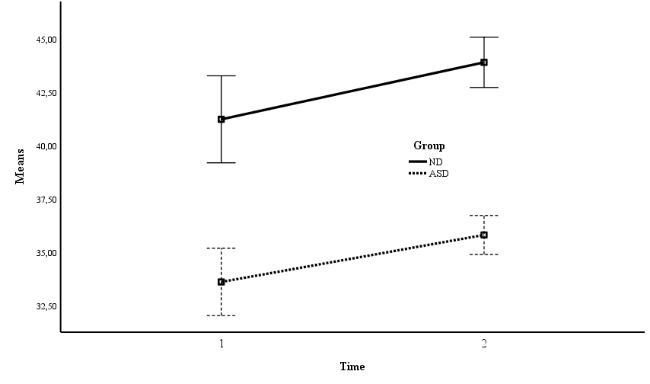  Daily living skills | 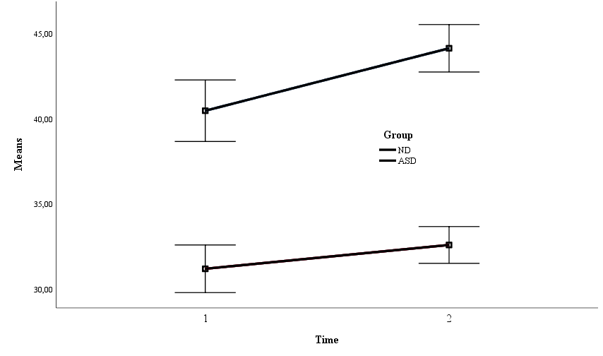  Socialization
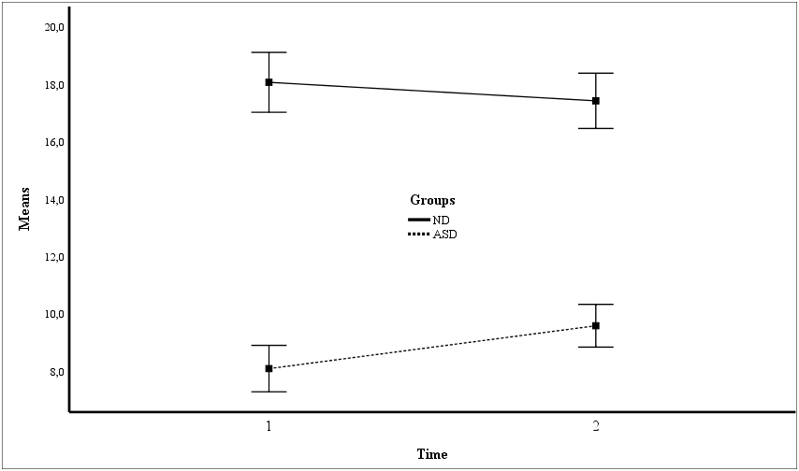  ToM | 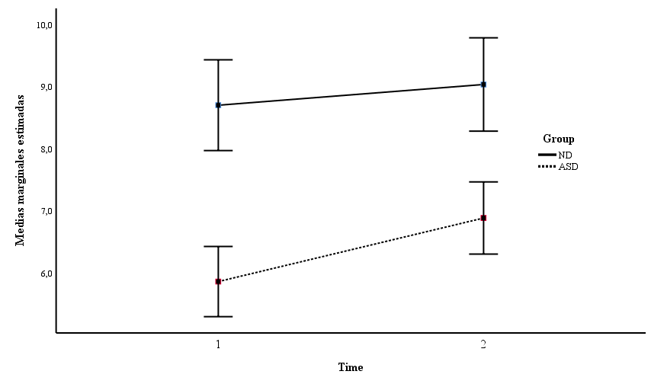  Prosocial behavior
MANOVA on learning domain
A Repeated Measures MANOVA was estimated to test for the effects of Time, Group and Time x Group on the four measures of learning-related behaviors (motivation, attitude, persistence and flexibility). Time had not a significant impact on the scores of learning (F(4, 65)= 0.85, p= .497, η²= .050). Group had a significant and large effect on learning: F(4, 65)= 15.18, p< .001, η²= .483. Finally, the interaction (Time x Group) was not statistically significant: F(4, 65)= 1.36, p= .255, η²= .078. Table 3 shows the follow-up ANOVAs for the four learning dependent variables.
Table 3. Follow up ANOVAs for the variables in learning
Factor | DV | dfn | dfd | F | p | η² | $${\overline{X}}_{1}$$ | $${\overline{X}}_{2}$$ | d
Time
 | Motivation | 1 | 70 | 0.70 | .405 | .010 | 10.54 | 11.19 | 0.18
 | Attitude | 1 | 70 | 0.08 | .928 | .000 | 12.89 | 12.86 | 0.01
 | Persistence | 1 | 70 | 0.10 | .747 | .002 | 9.43 | 9.67 | 0.08
 | Flexibility | 1 | 70 | 1.78 | .186 | .026 | 9.08 | 9.70 | 0.20
Group
 | Motivation | 1 | 68 | 24.64 | <.001 | .266 | 12.72 | 9.69 | 0.90
 | Attitude | 1 | 68 | 35.35 | <.001 | .342 | 15.24 | 11.38 | 1.13
 | Persistence | 1 | 68 | 27.78 | <.001 | .290 | 11.10 | 8.52 | 0.99
 | Flexibility | 1 | 68 | 60.01 | <.001 | .469 | 11.72 | 7.93 | 1.59
Time x Group
 | Motivation | 1 | 70 | 2.56 | .114 | .036 | - | - | -
 | Attitude | 1 | 70 | 0.01 | .911 | .000 | - | - | -
 | Persistence | 1 | 70 | 6.21 | .309 | .015 | - | - | -
 | Flexibility | 1 | 70 | 2.06 | .155 | .029 | - | - | -
Notes: Mean 1 for group corresponds to normal development and mean 2 to ASD; Mean 1 for Time is the first occasion and mean 2 the second time point.
Follow-up ANOVAs showed no statistically significant effect of Time (see Table 3). The effect of group on the means of the four dependent variables was always statistically significant and large. Finally, no interaction resulted statistically significant. Again, and with descriptive purposes, Figure 2 shows the four graphs for the (statistically non-significant) interactions.
Figure 2. Graph of means for the groups in the two time points with confidence intervals 95%
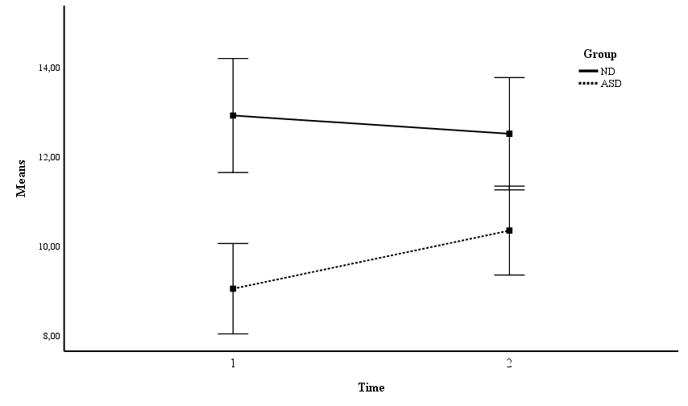  Motivation | 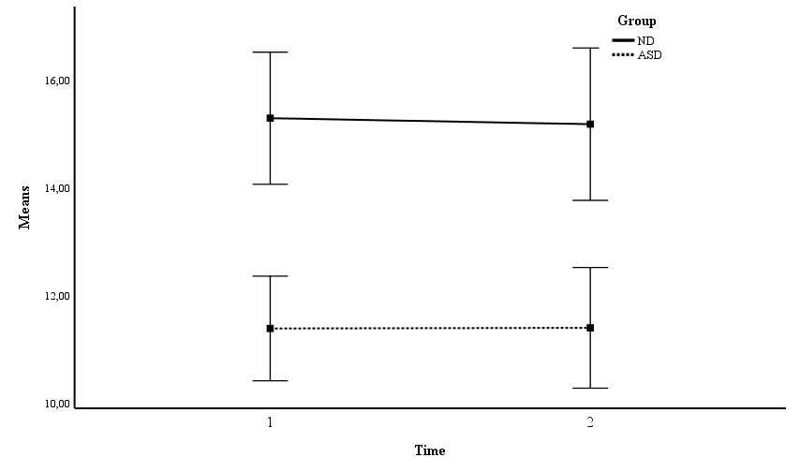  Attitude
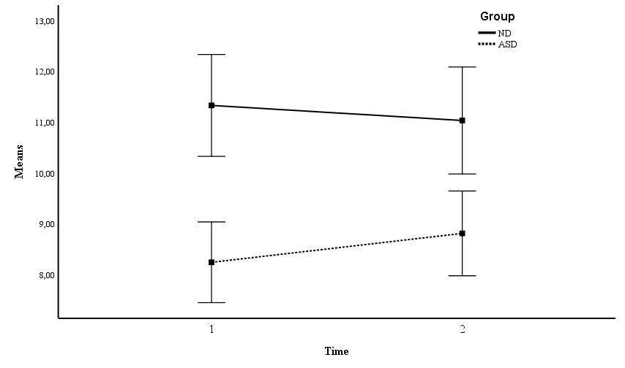  Persistence | 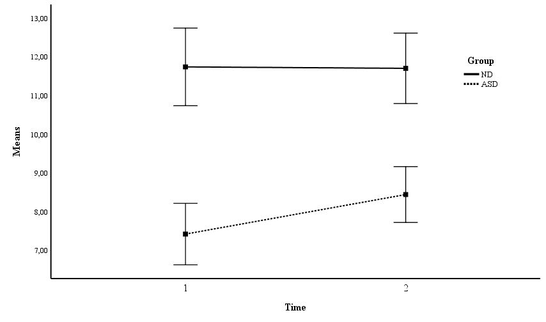  Flexibility

MANOVA on Executive Domain
A Repeated Measures MANOVA was estimated to test for the effects of Time, Group and Time x Group on the eight dimensions of executive domain (inhibit, shift, emotional control, initiate, WM, plan, organization of materials, and monitor). Time had a significant impact on the scores of this domain (F(8, 61)= 2.35, p= .028, η²= .236). Group also had a significant and large effect on the executive domain: F(8, 61)= 27.89, p< .001, η²= .677. Finally, the interaction (Time x Group) was not statistically significant: F(8, 61)= 0.647, p= .735, η²= .078. Table 4 shows the follow-up ANOVAs for the eight dependent variables in the executive domain.
Table 4. Follow up ANOVAs for the variables in the executive domain
Factor | DV | dfn | dfd | F | p | η² | $${\overline{X}}_{1}$$ | $${\overline{X}}_{12}$$ | d
Time
 | Inhibit | 1 | 68 | 3.13 | .081 | .044 | 16.17 | 15.01 | 0.21
 | Shift | 1 | 68 | 9.01 | .004 | .117 | 18.00 | 16.21 | 0.36
 | Emotional control | 1 | 68 | 5.77 | .019 | .078 | 15.10 | 13.71 | 0.28
 | Initiate | 1 | 68 | 7.77 | .007 | .103 | 13.37 | 12.17 | 0.34
 | Working memory | 1 | 68 | 6.27 | .015 | .084 | 17.50 | 15.63 | 0.37
 | Plan | 1 | 68 | 2.64 | .108 | .037 | 16.10 | 17.35 | 0.24
 | Organization | 1 | 68 | 3.32 | .073 | .047 | 11.14 | 10.05 | 0.29
 | Monitor | 1 | 68 | 9.18 | .003 | .119 | 18.35 | 16.34 | 0.45
Group
 | Inhibit | 1 | 68 | 27.87 | <.001 | .291 | 12.46 | 17.55 | 1.07
 | Shift | 1 | 68 | 77.22 | <.001 | .532 | 13.07 | 19.64 | 1.79
 | Emotional control | 1 | 68 | 28.29 | <.001 | .294 | 11.37 | 16.31 | 1.14
 | Initiate | 1 | 68 | 80.57 | <.001 | .542 | 9.98 | 14.52 | 1.51
 | Working memory | 1 | 68 | 56.26 | <.001 | .453 | 12.94 | 18.83 | 2.40
 | Plan | 1 | 68 | 57.35 | <.001 | .458 | 13.01 | 19.05 | 1.47
 | Organization | 1 | 68 | 36.34 | <.001 | .348 | 8.50 | 11.90 | 1.08
 | Monitor | 1 | 68 | 91.50 | <.001 | .574 | 13.13 | 20.01 | 1.74
Time x Group
 | Inhibit | 1 | 68 | 0.18 | .672 | .003 | - | - | -
 | Shift | 1 | 68 | 0.42 | .518 | .006 | - | - | -
 | Emotional control | 1 | 68 | 0.06 | .941 | .000 | - | - | -
 | Initiate | 1 | 68 | 0.09 | .754 | .004 | - | - | -
 | Working memory | 1 | 68 | 0.89 | .349 | .013 | - | - | -
 | Plan | 1 | 68 | 1.27 | .263 | .018 | - | - | -
 | Organization | 1 | 68 | 0.22 | .634 | .003 | - | - | -
 | Monitor | 1 | 68 | 0.01 | .978 | .000 | - | - | -
Notes: Mean 1 for group corresponds to normal development and mean 2 to ASD; Mean 1 for Time is the first occasion and mean 2 the second time point.
The eight ANOVAs showed in Table 4 exhibit a clear pattern of results. The two groups were significantly different in all of the dependent variables and the effect sizes were always very large. There were also many significant changes in the two occasions, as only planning and organization did not show significant differences. Nevertheless, the effect sizes for Time were much lower than those for group. Finally, there was no evidence whatsoever for interaction in the eight variables in the cognitive domain. With descriptive purposes, all interaction graphs are shown in Figure 3.
Figure 3. Graph of means for the groups in the two time points with 95% confidence intervals
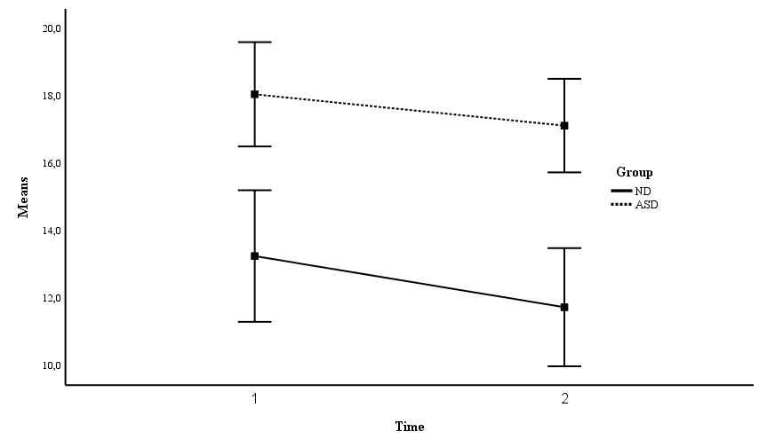  Inhibit | 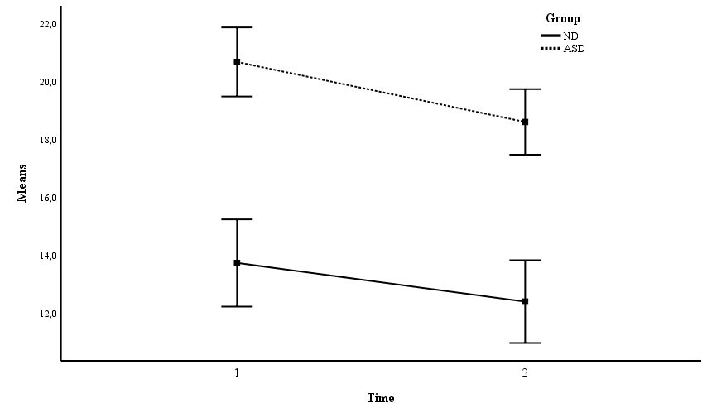  Shift
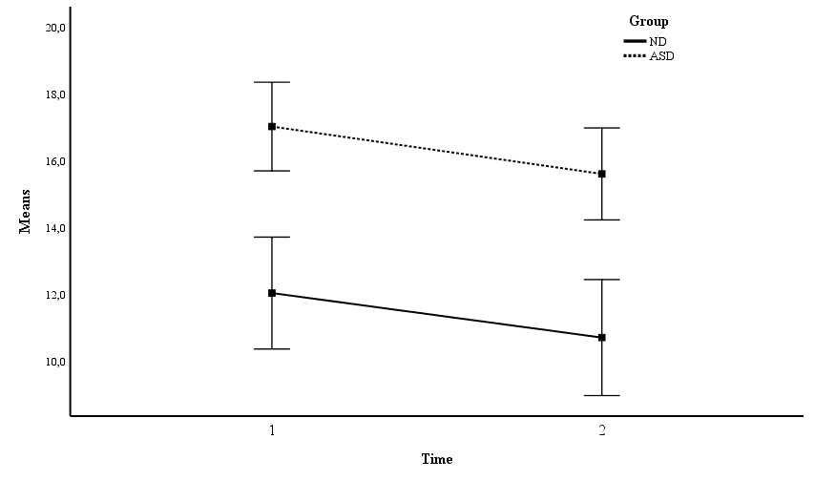  Emotional control | 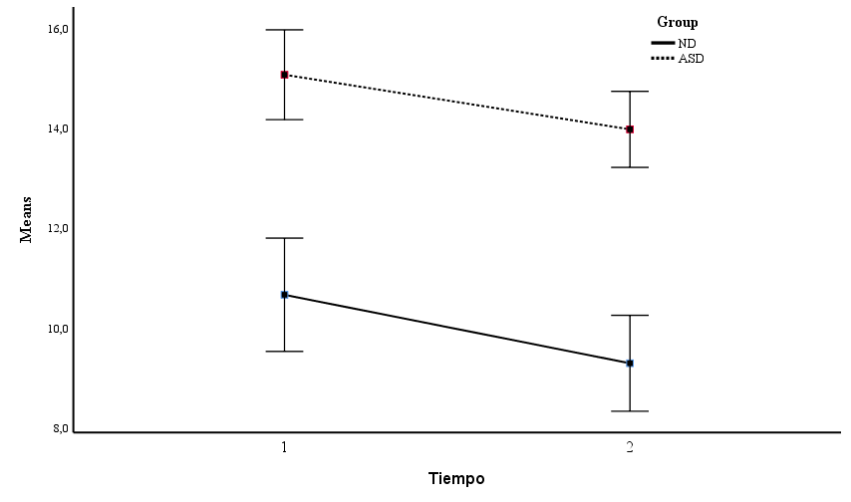  Initiate
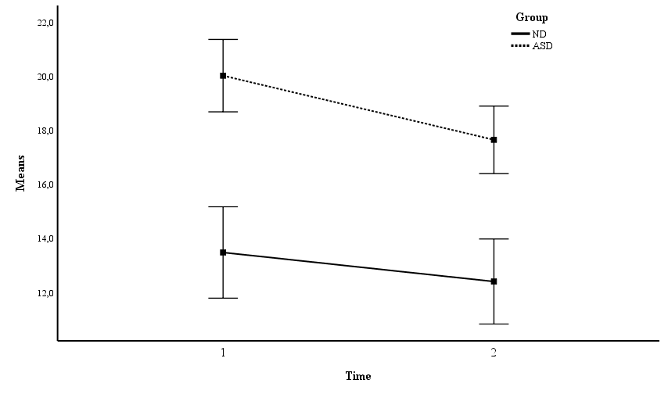  Working memory | 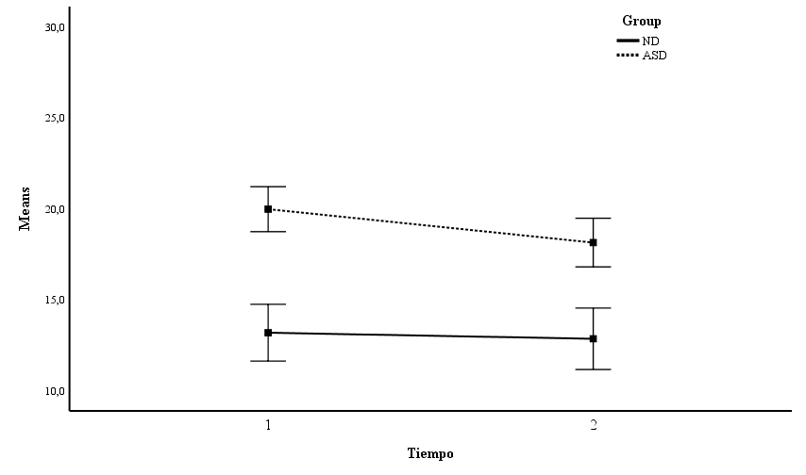  Plan
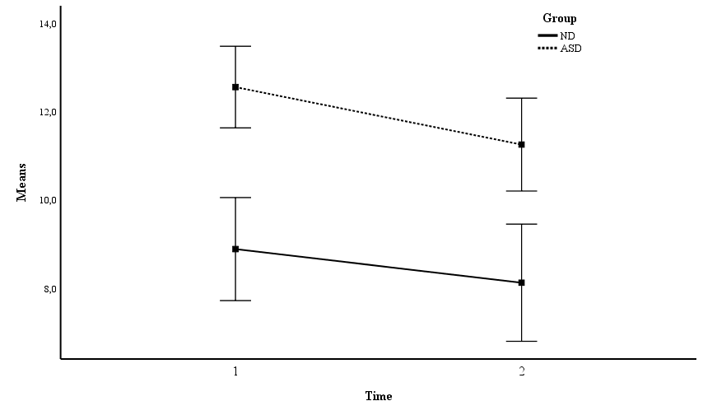  Organization | 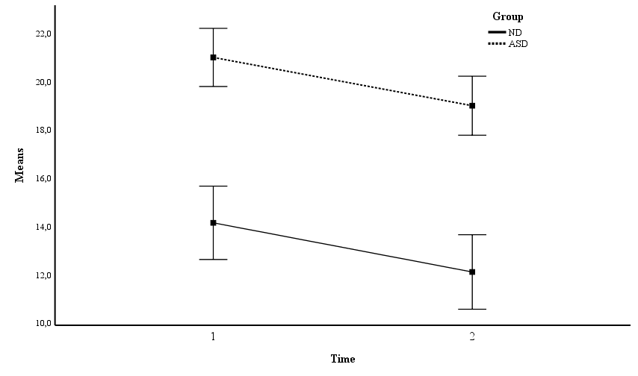  Monitor

MANOVA on internalizing/externalizing problems
A Repeated Measures MANOVA was estimated to test for the effects of Time, Group and Time x Group on the two dimensions of internalizing/externalizing problems (emotional, hyperactivity, peer relationships, conduct). Time had not a significant impact on the scores of the internalizing/externalizing problems (F(4, 67)= 1.12, p= .352, η²= .063). On the other hand, group had a significant and large effect on internalizing/externalizing problems: F(4, 67)= 66.60, p< .001, η²= .799. Finally, the interaction (Time x Group) was not statistically significant: F(4, 67)= 2.01, p= .103, η²= .107. Table 5 shows the follow-up ANOVAs for the dependent variables in internalizing/externalizing problems.
Table 5. Follow up ANOVAs for the variables in the internalizing/externalizing domain
Factor | DV | dfn | dfd | F | p | η² | $${\overline{X}}_{1}$$ | $${\overline{X}}_{2}$$ | d
Time
 | Emotional symptoms | 1 | 70 | 0.01 | .898 | .00 | 3.51 | 3.57 | 0.02
 | Hyperactivity | 1 | 70 | 16.11 | <.001 | .187 | 4.69 | 4.31 | 0.35
 | Peer relationships | 1 | 70 | 0.89 | .343 | .013 | 3.72 | 3.93 | .070
 | Conduct problems | 1 | 70 | 2.68 | .106 | .037 | 2.41 | 1.93 | 0.25
Group
 | Emotional symptoms | 1 | 70 | 50.76 | <.001 | .420 | 1.57 | 4.72 | 2.02
 | Hyperactivity | 1 | 70 | 49.65 | <.001 | .415 | 2.33 | 5.80 | 2.03
 | Peer relationships | 1 | 70 | 258.5 | <.001 | .787 | 0.59 | 5.76 | 3.07
 | Conduct problems | 1 | 70 | 18.23 | <.001 | .207 | 1.27 | 2.71 | 1.65
Time x Group
 | Emotional symptoms | 1 | 70 | 0.06 | .798 | .001 | - | - | -
 | Hyperactivity | 1 | 70 | 5.51 | .022 | .073 | - | - | -
 | Peer relationships | 1 | 70 | 0.26 | .611 | .004 | - | - | -
 | Conduct problems | 1 | 70 | 1.42 | .236 | .020 | - | - | -
Notes: Mean 1 for group corresponds to normal development and mean 2 to ASD; Mean 1 for Time is the first occasion and mean 2 the second time point.
Although in the overall MANOVA time had not a significant effect, in the follow-up ANOVAs, there was a time effect for the hyperactivity variable of a moderate effect size. On the other hand, the group effect was statistically significant and large for all dependent variables. Regarding the interaction effect, this effect was only significant for hyperactivity. Post-hoc Sidak test showed that there was no significant change from time 1 to time 2 for the normal development group, while the change in the ASD group was statistically significant (p = .016). This interaction may be seen graphically in Figure 4.
Figure 4. Graph of means for the groups in the two time points with confidence intervals 95%
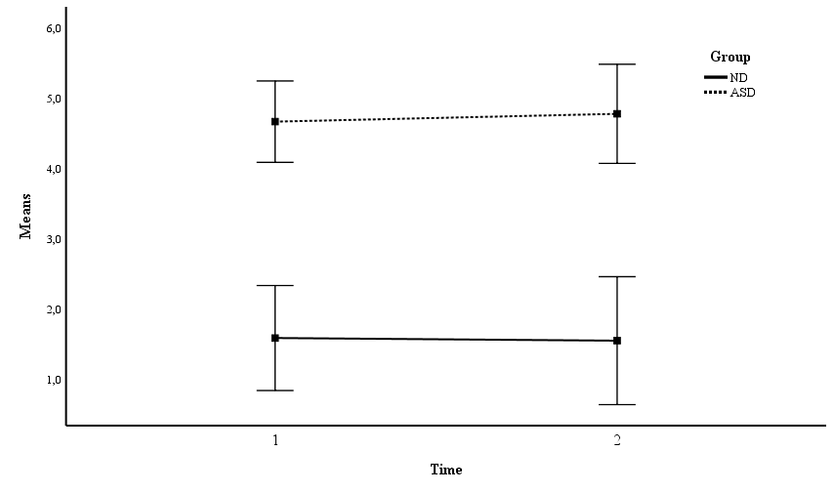  Emotional symptoms | 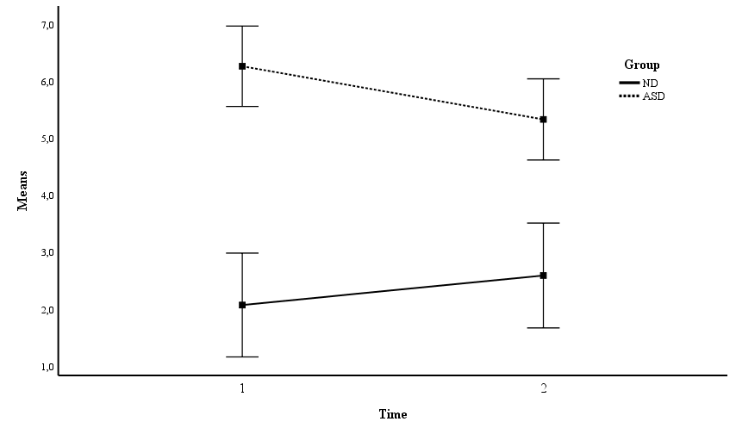  Hyperactivity
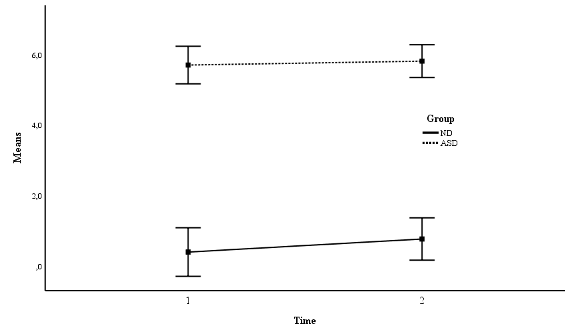  Peer relationships | 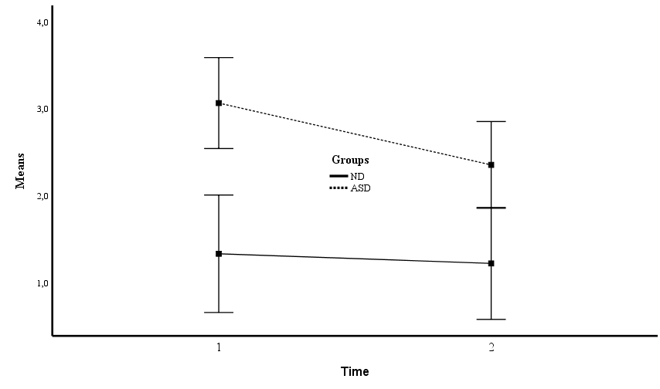  Conduct problems

Best predictors of group membership
Finally, a stepwise logistic regression was used in order to predict group membership (normal development vs. ASD). The interest of this stepwise regression is to understand which of the variables under study are better predictors or better predict group membership. The logistic regression was made stepwise because sample sizes advises against using all predictors at once. The logistic regression found two predictors as relevant. The predictors were: inhibition (B= 0.954, W= 3.45, p= .063, OR= 2.59); and SDQ peer relationships (B= 3.026, W= 4.25, p= .038, OR= 20.6). Overall, the R-square of Cox and Snell was .704.
Discussion
The study showed that the scores of children with ASD-without ID across the various domains assessed, that is socio-adaptive, executive, internalizing/externalizing and learning functioning, in general remained unchanged when they reached adolescence. However, some improvements from childhood to adolescence were noted in specific EF such as working memory and emotional control, daily living skills and prosocial behavior. When compared to TD peers, the difficulties of ASD were significantly higher in all outcome variables and in the two assessment points which highlights the challenges that they face at secondary school transition.
Adaptive behavior is a prognostic factor in adulthood, even more than cognitive levels (Farley et al., 2009) [41]. In this cohort of individuals with ASD with average or above IQ, adaptive skills tended to improve slightly over time, although the comparison to TD peers revealed that the progression did not reach normative levels. Other findings observed discrepancies between the expected level of adaptive functioning and intellectual ability (Alvares et al., 2020) [42].
Daily living skills was the variable in the socio-adaptive domain with the largest effect size for time, followed by socialization which is consistent with the expected profile in individuals with ASD (Tillman et al., 2019) [14]. ToM was the variable of this domain that did not change significantly from childhood to adolescence, highlighting the need to strengthen these skills at early stages given its positive influence on social-communicative symptoms (Jones et al., 2018) [43]. The observed effect for the interaction (Group x Time) in the ToM variable indicated a different tendency among groups. In any case, despite the slight decrease experienced by TD adolescents, their scores were higher than those of the ASD participants (Cantio et al., 2018; Pellicano et al, 2010) [12-13]. It is possible that TD adolescents showed less room for ToM skills improvement as they develop and master these abilities since childhood (Wellman et al., 2001) [44]. Parent-rated prosocial behaviors globally improved at adolescence, although the scores of the ASD group did not match their TD peers, reflecting the characteristic social challenge in an ASD diagnosis (Russell et al., 2012) [45].
Teacher´s report on motivation/competence, attitude toward learning, persistence/attention and learning strategy/flexibility revealed no significant change over time, however there was a significant effect for group. Difficulties in social interaction and behavioral problems observed at school in young people with ASD (Chiang et al., 2018) [46] could impact their learning behaviors. Most of the adolescents with ASD surveyed viewed autism as negatively impacting their high school experiences by feeling apart and different (Bottema-Beutel et al., 2020) [47]. This view of themselves may in turn carry on more isolation and less interest in schoolwork. Training school professionals to consider these aspects could benefit young people with ASD in the school transition.
Developmental trajectories of EF have interest by their association with factors contributing to social, academic, and adaptive outcomes of individuals with ASD (Pugliese et al, 2020) [48]. Our results on EF evidenced a significant effect of group, and the participants with ASD showed more impaired scores across behavioral regulation and metacognitive components. According to teachers’ ratings, children with ASD seemed to have persistent and generalized EF deficits in their adolescence as the improvements were not enough for them to reach normative levels of TD peers. The larger effect sizes concerned to shift, initiate and monitor subscales. These difficulties can be easily perceived in school scenarios, since they result in scarce flexibility in solving problems, remarkable avoidance to begin a task and difficulty to assess own performance.
A significant effect of time on the majority of EF components was found in our analysis. The scores of shift, emotional control, initiate, working memory and monitor improved across timepoints, but they were not normalized. By the contrary, the scores of inhibition, planning and organization of materials did not show significant differences in both assessments. The findings are consistent with other research that demonstrated the impairment and stability of executive dysfunction in children and adolescents with ASD using laboratory tasks of inhibition, working memory or flexibility (Andersen y Kouklari,) [23-24]. Even more, our results are in line with the few studies (Alsaedi 2020; Rosenthal, 2013 [49-50]; Vogan et al., 2018) [26] that collected information from everyday settings through parent ratings, reporting relatively stable executive impairments in children and adolescents with ASD, compared to TD peers. Finally, there was no significant Group × Time interaction on any EF subtest scores which suggested a parallelism in the developmental trajectories of ASD and TD groups.
Children and adolescents with ASD had significantly more emotional, hyperactivity and conduct problems as well as peer relationship difficulties compared to TD participants in both timepoints. The present study supports with a control group other longitudinal findings that noted metal health difficulties to be common in young people with ASD (Mandy et al., 2016) [19]; Simonoff et al., 2013) [28]. Emotional and peer difficulties were the areas with the most notable score differences between the ASD and TD groups. A possible explanation might be that individuals with ASD-without ID, characterized for experiencing social-communication deficits, could avoid interpersonal situations and struggle to express their emotions and seek social support, paired with being aware of their challenges to meet social and academic goals (Hallett et al., 2010) [51]. Moreover, cognitive inflexibility might be another explanatory factor of the maintenance of emotional problems across their lifespan (Hollocks et al., 2021) [52]. By contrast, hyperactivity and conduct problems slightly decreased from childhood assessment in the ASD group. Despite this, hyperactivity and conduct scores were still remarkable and require attention as they are associated with adaptive functioning impairments (Sikora et al., 2012) [53].
The exploration of possible variables implicated in group membership revealed additional information to the developmental trajectories of the ASD and the TD groups. The results suggested that inhibition and peer relationships play a main role to discriminate among groups. Inhibition is involved in the control of irrelevant stimuli in order to pursue specific goals and peer relationships are implicated in quality of life, mental health and academic achievement (Rodda & Estes, 2018) [54].
Geurts, van den
Bergh, and Ruzzano [2014]’s meta-analysis examined
the executive function component of inhibition and
concluded that individuals with ASD exhibited impair-
ments in prepotent response inhibition (with an effect
size of 0.55) and interference control (with an effect
size of 0.31), both of which are domains of inhibition
There are limitations to the study that need to be addressed. For the assessment, we used questionnaires which is less robust than standardized interviews. The sample size may not have sufficient statistical power to detect all meaningful effects. The predominance of males and the inclusion of average or above IQ participants may limit the generalization of the results to the whole population with ASD, even though the gender ratio of this study reflects that commonly seen in CAMHS and it is similar to the ratio of many studies including clinical samples. Moreover, data about the different interventions received over the years could not be collected in detail due to its heterogeneity and considering their effect on the outcomes of this study was not possible. The strengths of the current study include a prospective design with a follow-up period of five years throughout mid-childhood and adolescence where attrition was low, the inclusion of a TD control group, and an assessment of multiple functional domains with various tools filled out by parents and teachers.
As anticipated, the overall outcomes of individuals with ASD-without ID in comparison to their TD peers were lower at childhood and adolescence. Across timepoints, adaptive skills and specific EF tended to show slight improvement, although other functional domains which are key in this developmental stage remain unchanged or poor. Recent research concluded that the initial score in different domains (socialization, communication, daily living skills, internalizing/externalizing behaviors) was strongly associated to best developmental outcomes in mid-childhood (Szatmari et al. (2021) [55]. In this line, our findings also support tailoring early interventions to address specific needs of individuals with ASD, identified in the evaluation process. They emphasize comprehensive and supportive care plans from a multidisciplinary perspective, including evidence-based interventions to target deficits in ToM, adaptive skills and emotional distress in clinical settings, coupled with strategies to optimize EF and foster learning-related behaviors and social interactions in the school context.

References
1.Fombonne E (2009). Epidemiology of pervasive developmental disorders. Pediatr. Res. 65 (6): 591–598
2.Hill AP, Zuckerman K, Fombonne E (2014). Epidemiology of autism spectrum disorders. In: Volkmar, F.R., Rogers, S.J., Paul, R., Pelphrey, K.A. (Eds.), Handbook of Autism and Pervasive Developmental Disorders. Diagnosis, Development, and Brain Mechanisms, 4th ed., Volume 1. Wiley, New York, pp. 57–96.
3.Baio J, Wiggins L, Christensen DL, et al (2018). Prevalence of autism spectrum disorder among children aged 8 years - autism and developmental disabilities monitoring network, 11 sites, United States, 2014. Surveill Summ. 67 (6): 1–23 pmid:29701730.
4.Howlin P, Magiati I (2017) Autism spectrum disorder: outcomes in adulthood. Curr Opin Psychiatry. 30: 69–76.
5.Steinhausen HC, Mohr Jensen C, Lauritsen MB (2016) A systematic review and meta-analysis of the long-term overall outcome of autism spectrum disorders in adolescence and adulthood. Acta Psychiatr Scand. 133: 445–452. https://doi.org/ 10.1111/acps.12559.
6. Szatmari P, Georgiades S, Duku E. Bennett TA, Bryson S, Fombonne E, et al (2015) Developmental trajectories of symptom severity and adaptive functioning in an inception cohort of preschool children with autism spectrum disorder. JAMA Psychiatry. 72(3): 276–283. https://doi.org/10.1001/jamapsychi atry.2014.2463.
7. Rosello R, Martinez-Raga J, Mira A, Girela B, Cortese S (2021) Developmental outcomes in adolescence of children with autism spectrum disorder without intellectual disability: A systematic review of prospective studies. Neurosci Biobehav Rev. 126:590-603.
8. Stark I, Liao P, Magnusson C, Lundberg M, Rai D, et al (2021) Qualification for upper secondary education in individuals with autism without intellectual disability: Total population study, Stockholm, Sweden. Autism, 25(4), 1036-1046
9. Baixauli I, Rosello B, Berenguer C, Tellez M, Miranda A (2021) Reading and Writing Skills in Adolescents With Autism Spectrum Disorder Without Intellectual Disability. Front Psychol. 19;12:646849
10. Baron-Cohen S (2000) Theory of mind and autism: A review. Int Rev Res Ment Retard 23, 169–184.
11. Scheeren AM, de Rosnay M, Koot HM, Begeer S (2013) Rethinking theory of mind in high-functioning autism spectrum disorder. J Child Psychol Psychiatry 54(6):628-35.
12. Cantio, C., White, S., Madsen, G.F., Bilenberg, N., Jepsen, J.R.M., 2018. Do cognitive deficits persist into adolescence in autism? Autism Res. 11 (9), 1229–1238. https:// doi.org/10.1002/aur.1976.
13. Pellicano E (2010). Individual differences in executive function and central coherence predict developmental changes in Theory of Mind in autism. De. Psychol. 46 (2): 530–544.
14. Tillmann J, San Jose Caceres A, Chatham CH, Crawley D, Holt R, Oakley B et al (2019) The EU-AIMS LEAP group. Investigating the factors underlying adaptive functioning in autism in the EU-AIMS Longitudinal European Autism Project. Autism Res.12:645-657. https://doi.org/10.1002/aur.2081
15. Mouga S, Almeida J, Cafe C, Duque F,Oliveira G (2015). Adaptive Profiles in Autism and Other Neurodevelopmental Disorders. J Autism Dev Disord. 45: 1001–1012. https://doi.org/10.1007/s10803-014-2256
16. Farmer C, Swineford L, Swedo SE, Thurm A (2018). Classifying and characterizing the development of adaptive behavior in a naturalistic longitudinal study of young children with autism. J Neurodevelop Disord. 10 1. https://doi.org/10.1186/s11689-017-9222-9
17. Pugliese CE, Anthony LG, Strang JF, Dudley K, Wallace GL, Naiman DQ, Kenworthy L (2016). Longitudinal Examination of Adaptive Behavior in Autism Spectrum Disorders: Influence of Executive Function. J Autism Dev Disord. 46: 467–477 https://doi.org/10.1007/s10803-015-2584-5
18. Szatmari P, Bryson S, Duku, E, Vaccarella L, Zwaigenbaum L, Bennett T, Boyle MH (2009). Similar developmental trajectory in autism and Asperger syndrome: From early childhood to adolescence. J Child Psychol Psychiatry. 50: 1459–1467.
19. Mandy W, Murin M, Baykaner O, Staunton S, Cobb R, Hellriegel J, Skuse D (2016). Easing the transition to secondary education for children with autism spectrum disorder: an evaluation of the Systemic Transition in Education Programme for Autism Spectrum disorder (STEP- ASD). Autism. 20 (5): 580–590. https://doi.org/10.1177/1362361314562616.
20. Tomaszewski B, Smith DaWalt L, Odom SL (2019) Growth mixture models of adaptive behavior in adolescents with autism spectrum disorder. Autism. 23:1472–1484
21. Diamond A (2013). Executive Functions. Annu Rev Psychol. 64: 135-168.http://dx.doi.org/10.1146/annurev-psych-113011-143750
22. O’Hearn K, Asato M, Ordaz S, Luna B (2008). Neurodevelopment and executive function in autism. Dev Psychopathol. 20:1103–1132
23. Andersen PN, Skogli EW, Hovik KT, Egeland J, Oie M (2015). Associations among symptoms of autism, symptoms of depression and executive functions in children with high-functioning autism: a 2 year follow-up study. J. Autism Dev. Disord. 45: 2497–2507. https://doi.org/10.1007/s10803-015-2415-2418.
24. Kouklari EC, Tsementseli, Monks CP ( 2019). Developmental trends of hot and cool executive function in school aged children with and without autism spectrum disorder: links with theory of mind. Dev Psychopathol. 31: 541–556. https://doi. org/10.1017/S0954579418000081.
25. Gioia G, Isquith PK, Guy SC, Kenworthy L (2000). Behavior rating inventory of executive function. Child Neuropsychol. 6: 235–238. https://doi.org/10.1076/ chin.6.3.235.3152.
26. Vogan VM, Leung RC, Safar K, Martinussen, R, Smith M, Taylor MJ (2018). Longitudinal examination of everyday executive functioning in children with ASD: relations with social, emotional, and behavioral functioning over time. Front Psychol. 9, 1774.
27. Woodman AC, Mailick MR, Greenberg JS (2016). Trajectories of internalizing and externalizing symptoms among adults with autism spectrum disorders. Devel Psychopathol. 28(2): 565–581. https://doi.org/10.1017/S095457941500108X
28. Simonoff E, Jones C, Baird G, Pickles A, Happe F, Charman T (2013). The persistence and stability of psychiatric problems in adolescents with autism spectrum disorders. J. Child Psychol. Psychiatry. 54 (2): 186–194. https://doi.org/ 10.1111/j.1469-7610.2012.02606.x.
29. Verheij C, Louwerse A, van der Ende J, Eussen M, Van Gool A (2015). The stability of comorbid psychiatric disorders: a 7-year follow up of children with pervasive developmental disorder-not otherwise specified. J. Autism Dev. Disord. 45 (12): 3939–3948.
30. Kaufman AS, Kaufman N (2000) K-BIT: Test Breve de Inteligencia de Kauffman; Pearson: Madrid, Spain.
31. Wechsler D (2003).Wechsler Intelligence Scale for Children (WISC-IV), 4th ed.; The Psychological Corporation: San Antonio, TX, USA.
32. Rutter M, Bailey A, Lord C (2003). Social Communication Questionnaire;Western Psychological Services: Los Angeles, CA, USA..
33. Rutter M, Le Couteur A, Lord C (2003). ADI-R. Austin diagnostic interview revised. Manuel. Psychological Services.
34. American Psychiatric Association (APA) (2013). Diagnostic and Statistical Manual of Mental Disorders, 5th ed.; American Psychiatric Association: Washington, DC, USA.
35. Hutchins TL, Prelock PA, Bonazinga-Bouyea L. (2014). Technical Manual for the Theory of Mind Inventory and Theory if Mind TaskBattery. Available online: Theoryofmindinventory.com (accessed on 30 March 2021).
36. Pujals E, Batlle S, Camprodon E, Pujals S, Estrada X, et al. (2016). Brief report: Translation and adaptation of the Theory of Mind Inventory to Spanish. J. Autism Dev Disord. 46: 685–690.
37. Sparrow SS, Cicchetti DV, Balla DA (2005). Vineland Adaptive Behavior Scales–Second Edition (Vineland–II); American Guidance Service:Circle Pines, MN, USA,
38. Goodman R (2001). Psychometric properties of the strengths and difficulties questionnaire. J Am Acad Child Adolesc Psychiatry. 40: 1337–1345.
39. McDermott, P.A., Green, L.F., & Francis, J.M (2001). Learning behaviour scale, Philadelphia, PA: Edumetric and Clinical Service.
40. Rodriguez Hernandez PJ, Betancort M, Ramırez-Santana GM, Garcıa R, Sanz-Alvarez EJ, De las Cuevas C (2012). Psychometric properties of the parent and teacher versions of the strength and difficulties questionnaire (SDQ) in a Spanish sample. Int J Clin Health Psychol. 12: 265–279.
41. Farley MA, McMahon WM, Fombonne E, Jenson WR, Miller J, et al (2009) Twenty-year outcome for individuals with autism and average or near-average cognitive abilities. Autism Res 2(2):109-18
42. Alvares GA, Bebbington K, Cleary D, Evans K, Glasson EJ et al (2020) The misnomer of 'high functioning autism': Intelligence is an imprecise predictor of functional abilities at diagnosis. Autism 24(1):221-232. doi: 10.1177/1362361319852831
43. Jones CRG, Simonoff E, Baird G, Pickles A, Marsden AJS et al (2018) The association between theory of mind, executive function, and the symptoms of autism spectrum disorder. Autism Res 11(1):95-109
44. Wellman HM, Cross D, Watson J (2001) Meta-analysis of theory-of-mind development: the truth about false belief. Child Dev 72(3):655-84. doi: 10.1111/1467-8624.00304
45. Russell G, Golding J, Norwich B, Emond A, Ford T, Steer C. Social and behavioural outcomes in children diagnosed with autism spectrum disorders: a longitudinal cohort study. J Child Psychol Psychiatry. 2012 Jul;53(7):735-44. doi: 10.1111/j.1469-7610.2011.02490.x.
46. Chiang HL, Kao WC, Chou MC, Chou WJ, Chiu YN et al (2018) School dysfunction in youth with autistic spectrum disorder in Taiwan: The effect of subtype and ADHD. Autism Res 11(6):857-869. doi: 10.1002/aur.1923.
47. Bottema-Beutel K, Kim SY (2021) A Systematic Literature Review of Autism Research on Caregiver Talk. Autism Res. 14(3):432-449. doi: 10.1002/aur.2461.
48. Pugliese CE, Wallace GS, Gutermuth L, Kenworthy L (2020) Understanding executive function challenges in autism In S.W. White, B.M. Maddox and C.A. Mazefsky (Eds) The Oxford Handbook of Autism and Co-occurring Psychiatric Conditions (pp.305-326). Oxford Library of Psychology Series. doi: 10.1093/oxfordhb/ 9780190910761.001.000
49. Alsaedi RH, Carrington S, Watters JJ (2020) Behavioral and Neuropsychological Evaluation of Executive Functions in Children with Autism Spectrum Disorder in the Gulf Region. Brain Sci 10(2):120. doi:10.3390/brainsci10020120
50. Rosenthal M, Wallace GL Lawson R et al (2013) Impairments in real-world executive function increase from childhood to adolescence in autism spectrum disorders. Neuropsychol 27(1):13-18. doi:10.1037/a0031299
51. Hallett V, Lecavalier L, Sukhodolsky DG, Cipriano N, Aman MG (2013) Exploring the manifestations of anxiety in children with autism spectrum disorders. J Autism Dev Disord 43(10):2341-52
52. Hollocks MJ, Charman T, Baird G, Lord C, Pickles A, Simonoff E (2021) Exploring the impact of adolescent cognitive inflexibility on emotional and behavioural problems experienced by autistic adults. Autism. doi: 10.1177/13623613211046160.
53. Sikora DM, Vora P, Coury DL, Rosenberg D (2012) Attention-deficit/hyperactivity disorder symptoms, adaptive functioning, and quality of life in children with autism spectrum disorder. Pediatrics 2:S91-7.
54. Rodda A, Estes A. (2018). Beyond Social Skills: Supporting Peer Relationships and Friendships for School-Aged Children with Autism Spectrum Disorder. Semin Speech Lang 39(2):178-194. doi: 10.1055/s-0038-1628369.
55. Szatmari P, Cost, KT, Duku E, Bennett T, Elsabbagh M et al (2021). Association of child and family attributes with outcomes in children with autism. JAMA Network Open, 4(3), Article e212530. doi: 10.1001/jamanetworkopen.2021.2530

