Attachment: The What, The Why, and the Long-Term Effects

Abi M. B. Davis¹, Katherine B. Carnelley²

¹School of Psychology, University of Lincoln, Lincoln, United Kingdom
²School of Psychology, University of Southampton, Southampton, United Kingdom

ABSTRACT
The bond between a child and the child’s caretaker is special. Such bonds are important for human survival. This special early bond is called an attachment. Scientists have shown that children can have one of four attachment styles, based on their relationship with the main person who looks after them. Each attachment style can have unique effects on children that can sometimes (though not always) carry on through teenage years and into adulthood. In this article, we explain what attachment is, what it looks like throughout a person’s lifetime, and what the effects of each attachment style are.
KEYWORDS: attachment, psychology, bonding, caregiver, relationship

Number of words: 1,486
Number of figures: 2
WHAT IS ATTACHMENT?
Attachment is a powerful emotional bond between two people. Usually, the first attachment that we experience is an attachment to a parent when we are babies (often, though not always, to mothers at first). This person means safety and security for infants, who look to their caregiver for protection, comfort, and emotional support. Young children usually get very upset when they are apart from their first caregiver. When children get older, they begin to form attachments with other people, like grandparents or other caregivers. Scientists think that humans (and other animals, too) develop attachments because it helps us to stay alive. If a caregiver and a child have a deep emotional connection to each other, then the caregiver feels a strong drive to make sure that the child is safe and protected [1]. This is very important for human survival, as babies can’t do very much for themselves!

WHO CAN CHILDREN BE ATTACHED TO?
Children and babies can be attached to anyone who gives them ongoing care. In most cultures in the West, the main or first attachment figure is usually a child’s mother, but for 5–20% of children, the main attachment figure is the father [2]. Attachment isn’t even limited to parents—children can be attached to adoptive parents, grandparents, and other family members.

AN INTRODUCTION TO ATTACHMENT STYLES
After scientists started exploring attachment, they realised that most children can be grouped into one of four attachment styles, depending on their experiences with their primary (main) caregiver. These styles look quite different from each other, so scientists can determine which style a child has.
Most children have a secure attachment to their caregiver. If a child has a secure attachment style, it means that they are mostly well taken care of—meaning that the person who looks after them is comforting when the child needs them. This teaches the child that they can rely on their caregiver for emotional support and protection. If a child is not securely attached, they are said to have an insecure attachment style. There are three insecure styles: anxious/preoccupied, dismissive/avoidant, and disorganised.

HOW DO INSECURE ATTACHMENT STYLES FORM?
Each attachment style is unique and can be caused by various circumstances. Although many things can affect attachment styles, each one has a main cause.
Anxious attachment styles develop when a caregiver is not very easy to predict, meaning it is difficult to guess what the caregiver might do, and the way the caregiver acts might change day to day. For example, if mum or dad is sometimes very involved in supporting the child and sometimes not, this can cause confusion for the child, which may lead to the child feeling anxious.
Avoidant attachment styles usually develop when a child doesn’t have their emotional needs met but instead experiences neglect, rejection, or unkindness when they need support.
Disorganised attachment styles develop when a child is treated very badly by a caregiver or has experienced abuse. This means that a child has been purposely harmed by their attachment figure, sometimes over a long period of time. This is rare—most children have one of the other three styles.

WHO CAME UP WITH ALL OF THIS?
Attachment theory was originally developed by a psychologist named John Bowlby. Bowlby worked at the Child Guidance Clinic in London and came across lots of children with emotional and behavioural difficulties. Because of his job, Bowlby began to think about whether the relationships the children had with their mums caused some of these difficulties. Later, a scientist named Mary Ainsworth worked on developing this idea. Ainsworth wrote many books and chapters about attachment and developed a procedure to measure it, which we will discuss next.

HOW ARE ATTACHMENT STYLES MEASURED?
Scientists measure attachment styles using an experiment developed by Mary Ainsworth called the Strange Situation Procedure. In the experiment, toddlers play with their main caregiver (for example, their mum) in a scientific lab. While the toddler and mum are playing, a stranger comes into the room. Next, mum leaves the room, and the toddler stays with the stranger. Then mum comes back into the room. Scientists video record this experiment so they can look carefully at what happened.
By looking at the behaviour of the child in these videos, scientists can find out which attachment style the child has. Figure 1 shows the ways children with specific attachment styles act during the Strange Situation Procedure. Since Mary Ainsworth’s work was developed, thousands of researchers have published scientific papers about attachment, and scientists still use Ainsworth’s Strange Situation Procedure to measure attachment styles, 50 years after it was developed!

Attachment style | Behaviour when caregiver leaves | Behaviour around stranger | Behaviour on caregiver’s return | Caregiver’s behaviour
Secure | Notices and shows discomfort | Comfortable with mother present | Happy/positive | Responds well to the child/is happy to see them
Anxious/Preoccupied | Severely uncomfortable | Not comfortable around stranger | Rejects caregiver | Not consistent
Avoidant/Dismissive | Not uncomfortable with the absence | Comfortable around stranger | Does not engage with caregiver | Ignores/rejects the child
Disorganised | Not consistent – child might be angry or withdrawn | Not consistent | Often worried around caregiver | Not consistent or scary

Figure 1 – Child and caregiver behaviours during the Strange Situation Procedure.

HOW DOES ATTACHMENT AFFECT US LATER IN LIFE?
Attachment can affect us in all kinds of ways throughout our lives. Children who have a secure attachment style are often more comfortable with their friends than children who have insecure attachment styles, and children with insecure attachment styles can struggle with their actions and emotions [3]. Teenagers who have secure attachments don’t have as many emotional problems as those who have insecure attachments, and this often carries on until they are adults.
Normally, adults who had secure attachment styles are better at dealing with their negative emotions than are those who had insecure attachments when they were growing up. Furthermore, research that follows people over many years, called longitudinal research, has shown that attachment can affect the way the brain develops. Human beings develop to have an attachment to a caregiver no matter how good or bad the care they get is. However, when children experience trauma or abuse, this can affect their wellbeing. Because of this, insecurely attached children are often more likely to experience mental health problems later in life than are securely attached children [4].

WHAT ABOUT ADULT RELATIONSHIPS?
Attachment affects us even in our adult relationships. Our early attachment experiences lead us to form ideas about what relationships should be like. This is known as an internal working model, and it becomes a ‘guide’ for how we expect our future relationships to be. Because of their internal working model of attachment, people with insecure attachment styles might be more likely to choose boyfriends or girlfriends who are not very good at listening or caring about them. They might even choose someone who is unkind to them if this is what they experienced from their own parents during childhood. On the other hand, a securely attached person will develop an internal working model that includes being treated well and kindly, so they will expect this type of behaviour in romantic relationships. Research has shown that people who have secure attachment styles in childhood are more likely to have happier, longer-lasting relationships than people with insecure attachment styles [5]. Although childhood attachment often carries on into adult romantic relationships, attachment styles in adults look different than they do in children (Figure 2).
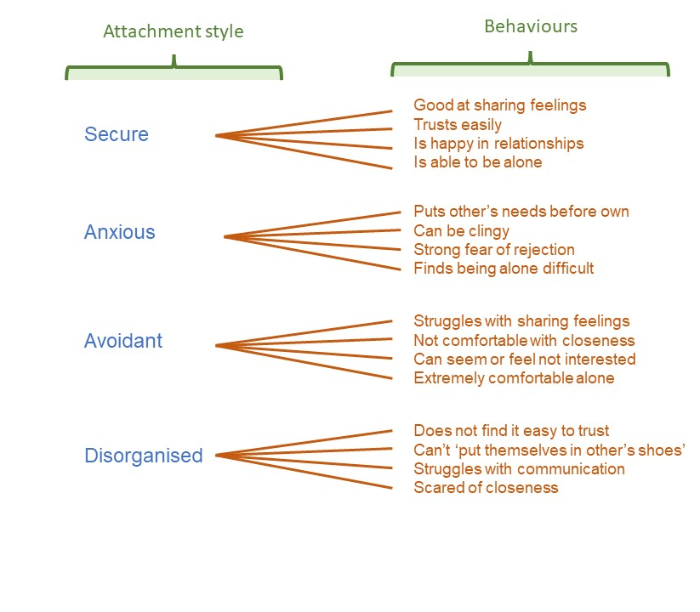
Figure 2 – The attachment styles that children develop can influence their relationship behaviours in adulthood.
DOES THIS MEAN ATTACHMENT STYLES ARE FOREVER?
Are we “stuck” with our attachment styles for our whole lives? The short answer is that we often are, but we don’t have to be. Scientists have found that internal working models often stay the same throughout a person’s life. This is known as continuity. However, research has shown that lots of adults with insecure attachment styles can still have long-lasting, happy relationships. Recently, scientists explored attachment over a 59-year period and found that attachment anxiety goes down as people get older. The scientists think that this is because, as we get older, we can have lots of good relationships (friendships, partners, pets). This makes us realise that relationships and friendships can be good, and so the internal working models held by insecurely attached adults change over time due to these positive experiences.
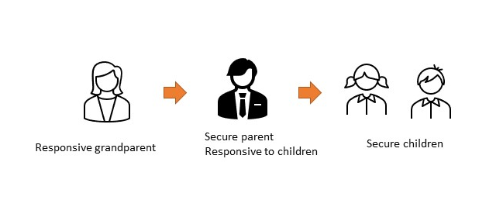
Attachment can also carry on throughout entire families. This is called intergenerational continuity and it means that grandmas and great grandmas and great-great grandmas might all have the same attachment style (Figure 3). This happens because one parent has an internal working model about how relationships should be, acts the same way when parenting their child, and so the pattern carries on. However, this isn’t always the case. Sometimes, parents are better at providing good care to their children than their own parents were, and this can break the cycle of insecure attachment.
Figure 3 – Attachment styles are often “passed down” through families. This is known as intergenerational continuity.
Overall, scientists think that secure attachments are the most likely to continue across life and through generations, but there’s a bit more wiggle room for the insecure styles. With enough good experiences, adults who have developed insecure attachment styles can avoid some of the problems and begin to experience more secure attachments.
SUMMARY
In summary, attachment means a close bond between two people, and attachments are developed in the first few years of life. Having an insecure attachment style can have a negative effect on wellbeing and experiences in relationships. However, although attachment styles often stay the same throughout life, and even across generations, they can change over time. For scientists, understanding attachment is important for exploring the ways that people form and experience relationships. It plays an important in child development, and the ways that adults feel with people who are close to them.

Glossary
Attachment: A close bond between two people. For young children and babies, this is the bond between themselves and their main caregiver.
Attachment Styles: The ways that people interact with and feel about other people that they have close relationships with—usually a caregiver in childhood and a romantic partner in adulthood.
Longitudinal Research: Research that follows the same participants across a period of time: weeks, months, years, or even decades.
Internal Working Model: An idea formed by a child about what relationships should look like, based on their early interactions with their primary caregiver. This can impact their future relationships.
Intergenerational Continuity: Anything that affects people across generations of a family. Attachment styles are often “passed down” through many generations.
Neglect: A type of abuse in which a caregiver does not properly look after a child. This can include not providing food, emotional care, medical care, or clothes.

Conflict of interest

The authors declare that the research was conducted in the absence of any commercial or financial relationships that could be construed as a potential conflict of interest.

References
[1] Bowlby, J. 1958. The nature of the child’s tie to his mother. Int J Psychoanal. 39:350-373.
[2] Freeman, H., and Brown, B. B. 2001. Primary attachment to parents and peers during adolescence: Differences by attachment style. J Youth Adolesc. 30(6):653-74. https://doi.org/10.1023/A:1012200511045
[3] Ding, Y. H., Xu, X., Wang, Z. Y., Li, H.R., and Wang, W. P. 2014. The relation of infant attachment to attachment and cognitive and behavioural outcomes in early childhood. Early Hum Dev. 2014 90(9):459-64. doi: 10.1016/j.earlhumdev.2014.06.004.
[4] Khan, F., Fraley, R. C., Young, J. F., and Hankin, B. L. 2018. Developmental trajectories of attachment and depressive symptoms in children and adolescents. Attach Hum Dev. 22(4):391-408. https://doi.org/10.1080/14616734.2019.1624790
[5] Banse, R. 2004. Adult attachment and marital satisfaction: Evidence for dyadic configuration effects. J Soc Pers Relat. 21(2):273-282. https://doi.org/10.1177/0265407504041388

AUTHOR BIOGRAPHIES


ABI M. B. DAVIS
Abi Davis is a Ph.D. researcher at the University of Lincoln. Abi’s work involves lots of time spent with mums and babies, and her research focusses on bonding, early mother-infant relationships, and later language development.



KATHERINE B. CARNELLEY
Katherine Carnelley is an associate professor at the University of Southampton. She has published a large body of work on attachment, with a primary focus on adult attachment and relationships.

