Comparative Biology and Ecology of Apicomplexans and Dinoflagellates: a unique meeting of minds and biology

Ross F. Waller¹, Catharina Alves-de-Souza², Phillip A. Cleves³, Jan Janouškovec⁴, Ehsan Kayal⁵, Thomas Krueger¹, Jeremy Szymczak⁶, Norico Yamada⁷ and Laure Guillou⁶.

¹ Department of Biochemistry, University of Cambridge, Cambridge, CB2 1QW, UK
² Center for Marine Science, University of North Carolina Wilminton, Wilminton, NC 28409, USA
³ Carnegie Institute of Washington, Baltimore, MD 21218, USA
⁴ School of Biological Sciences, University of Southampton, Southampton, SO17 1BJ, UK
⁵ Department of Ecology, Evolution and Organismal Biology, Iowa State University, Ames, IA, USA
⁶ Sorbonne Université, Station Biologique de Roscoff, Roscoff, 29680, France
⁷ Department of Biology, University of Konstanz, Konstanz, 78457, Germany

The commonalities and convergences shared in apicomplexans and dinoflagellates are continuously becoming more and more apparent, yet researchers across this myzozoan supergroup seldom meet at scientific meetings. The Conférence Jacques Monod meeting entitled ‘From Parasites to Plankton and Back: Comparative Biology and Ecology of Apicomplexans and Dinoflagellates’ sought to change this. Held at the Roscoff Marine Station in France in Sept 2022, researchers spanning organisms, disciplines, and perspectives met to immerse themselves in the latest developments and discoveries across the group. The outcome was an exciting and stimulating view of the synergies, revelations and opportunities enabled by expanding one’s view and network across this vast, spectacular and important biological group.

The development of tunnel vision is a natural, almost inescapable phenomenon in most scientific fields. The complexities of biological systems and the tools and theories used to investigate them often lead us towards increasingly exclusive research communities, bodies of literature and suites of technologies. But this comes with the danger of also constraining our thoughts, ideas, and conclusions. The constant challenge of scientists is to work against such forces that can limit our work, its vision and opportunities.

Addressing this challenge was the overarching aim of the Conférence Jacques Monod meeting ‘From Parasites to Plankton and Back: Comparative Biology and Ecology of Apicomplexans and Dinoflagellates’ held in early September at the Roscoff Marine Station on the beautiful Brittany coast in France. Apicomplexans (including chromerids and colpodellids) and dinoflagellates (including perkinsids and syndinians) represent two major sister lineages of unicellular eukaryotes that have far-reaching impacts on both human and environmental health and function, particularly on a changing planet. Collectively they form the Myzozoa whose name is derived from the common apical complex structures known to be used for host cell invasion and myzocytotic feeding within both lineages. However, the research communities that study these two important groups seldom meet due to their general focus on either human and animal parasitic diseases or the biology and ecology of aquatic systems, respectively. But as both lineages are derived from a common ancestor, they maintain many shared traits. The meeting addressed six major themes to capture and explore this common biology: 1) diversity, phylogeny, and biogeography, 2) life cycles and sexual reproduction, 3) genome and organelle evolution, 4) cell biology and host-symbiont interactions, 5) functional ecology, and 6) new model systems, tools, and databases. Under these umbrellas, a remarkable spread of organisms, techniques, questions, and discoveries were presented and discussed.

Diversity is the key to understanding Myzozoa

A clear theme that emerged during the meeting was how dependent our understanding of myzozoan biology is on our knowledge of the diversity of organisms found in these lineages. Figure 1 represents the spectacular diversity of organisms presented as study subjects during the meeting which demonstrated how much we drawn on this breadth for our insights. But there are still many gaps yet to fill. The keynote address by Patrick Keeling (University of British Columbia) illustrated recent notable gains that have been made in our knowledge of both apicomplexans, where gregarines are emerging as major components of diversity, and dinoflagellates, where new heterotrophic species are also uncovering significant evolutionary trajectories. Further talks illustrated how the deep-branching lineages of both groups are also expanding, with squirmids and eleftherids both recently discovered as new basal groups that inform on further diversity within each major lineage. Collectively these new organisms are redefining our understanding of the relationships within these groups. For example, gregarines are now recognised as multiple lineages, whereas Cryptosporidium’s true relationship within Apicomplexa remains uncertain. Further major myzozoan diversity was revealed by both Cécile Lepère (Université Clermont Auvergne) and Sebastian Metz (Station Biologique de Roscoff) who showed that perkinsids, best known as parasites of marine molluscs and phytoplankton, are also much more diverse than previously appreciated. Evidence of perkinsids is now widely found in freshwater habitats as well as soil, and represent new diverse and often habitat-specific lineages. A common theme for much of the new diversity is the lack of culturability of these organisms, or even their physical observation where eDNA surveys are the only evidence of their existence. This challenges our understanding of ecological roles that this myzozoan diversity fulfils, and points to much work still to be done.

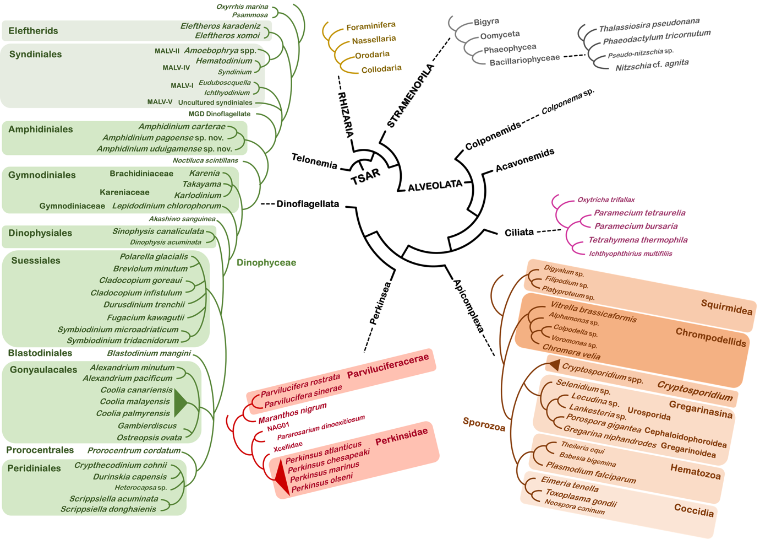
Figure 1: The diversity of a meeting. Phylogeny of major clades of Myzozoa: dinoflagellates (green), perkinsids (red) and apicomplexans (orange), showing in enlarged bold font all the organisms that were subjects of presentations during the course of the meeting. Even further diversity was presented in the form of undescribed but major myzozoan clades currently known only from meta-genomic sequence data.

Ancestral states and parallelisms

From the appreciation of Myzozoan diversity, two further themes of the meeting emerged: 1) how pervasive common characters are, but also 2) how parallelisms have repeatedly occurred across the group. The common perception of parasitism evolving only once early in apicomplexans is overturned by the discovery of the repeated emergence of parasitism in Apicomplexa presented by both Patrick Keeling and Jan Janouškovec (University of Southhampton). Furthermore, Sonja Rueckert’s (Edinburgh Napier University) address explored if some gregarines might actually be mutualists providing positive benefits to their hosts rather than negative. Of course, parasitism is also found throughout perkinsids and dinoflagellates. Laure Guillou (Station Biologique de Roscoff) illustrated how the dinoflagellate parasite Amoebophyra displays superb adaptations for parasitism where it invades its host, initially establishes a parasitophorous vacuole, and then remodels the host’s nucleus where it ultimately resides, feeds and replicates. This dinoflagellate even selectively sustains the energy producing capacity of its photosynthetic host to achieve greater parasite replication. The sophistication of this parasite-host interaction, and its parallels to the better studied apicomplexans, reveal how dispersed such complex traits are across the group. Indeed, versatility of trophic modes was a central theme of myzozoan biology and evolution explored at the meeting, with multiple shifts between phototrophy, heterotrophy and parasitism found. Victoria Jacko-Reynolds (University of British Columbia) showed examples of photoparasitic dinoflagellates of the genus Blastodinium in the throes of conversion from autotrophy to parasitism, showing that these shifts are contemporary and ongoing.

A common element of myzozoan cells that might explain these core themes of their biology is the ancestral apical complex structure linked to both feeding and invasion. Dominique Soldati-Favre (University of Geneva) and Markus Meissner (Ludwig Maximilians Universität) both presented superb studies of the assembly, structure, and function of the Toxoplasma conoid and apical complex using the molecular and cell biology tools that only such a well-developed model organism can allow. Maryse Lebrun (Université de Montpellier) further revealed the molecular machinery for rhoptry apical secretion during Toxoplasma invasion. Notably, her group discovered elements of this machinery through its conservation with ciliates, hinting that these processes are ancient rather than new. Moreover, Jeremy Szymczak (Sorbonne Université) tantalized us with images of similar apical complex structures in the parasitic dinoflagellate Amoebophyra, and such structures have been widely observed in all myzozoan groups including both parasites, predatory heterotrophs and even autotrophs. Collectively these studies reveal the deep ancestry of these common cellular machineries for interactions with other cells and organisms and that serve multiple different lifestyles. In turn, the theme of mixotrophy, cells that are both photosynthetic and heterotrophic, was discussed as greatly understudied in Myzozoa but is likely central to both the ecological functions of this group and its propensity to oscillate between different trophic modes.

Symbiosis is another topic where parallelism was a clear theme. Fabrice Not (Station Biologique de Roscoff) illustrated how the perception of Symbiodiniaceae being the primary dinoflagellate symbiotic group is misleading, with taxa found across dinoflagellate diversity forming partnerships with a wide variety of other organisms. Both he and Senjie Lin (University of Connecticut) touched on some of the cellular and genomic adaptations seen upon entering into such relationships, but both showed that this is an underexplored area where much further work is needed. Myzozoan organisms as the hosts of endosymbiotic partners is another major theme of diversity and parallelism in this group. The plastid in both photosynthetic and non-photosynthetic myzozoans has been a topic of strong interest for several decades, but still new discoveries and revisions are being made. Elisabeth Hehenberger (Czech Academy of Sciences) showed that parallel loss of plastid function is ever more apparent than was realized when wider surveys of taxa are made. Even parallel loss of the organelle genome or the organelle itself, both considered exceedingly rare events, are now evident. Miroslav Obornik (University of South Bohemia) illustrated how we still cannot even be sure of a simple ancestry of the myzozoan plastid(s). His group’s work argues for lateral gain of a chlorophyll c-containing plastid from eustigmatophytes, and possible subsequent early parallel plastid replacement in dinoflagellates, as still credible possibilities. From ancient to new, Noriko Yamada (University of Konstanz) demonstrated how much we can learn from recent cases of plastid uptake in dinoflagellates. She has developed multiple cell models bearing nascent diatom endosymbionts offering new insights into the patterns and processes of these developing relationships. Similar to plastids, mitochondrial evolution in Myzozoa also follows these patterns of parallelism. Varsha Mathur (University of Oxford) exploited single-cell transcriptomics of unculturable gregarines to illuminate patterns of parallel functional loss in mitochondria, notably of complex III and IV of the electron transport chain. Moreover, mitochondrial parallel adaptations also span the group with independent fragmentation and relocation of cox1 seemingly having occurred in some gregarines (Varsha Mathur) as well as the dinoflagellate Amoebophyra (Ehsan Kayal, Station Biologique de Roscoff).

In this backdrop of parallelism, resolving the state of ancestral features can be challenging. Gliding motility is closely associated with parasitism in Apicomplexa, and Isabelle Tardieux (Université Grenoble Alpes) dazzled us with her biophysical studies of force delivery mechanisms driving the well-studied gliding patterns of Toxoplasma. However, some of the champions of gliding speed are found in the gregarines, and genomic analysis of Podospora by Isabelle Florent (Muséum National d’Histoire Naturelle) showed that the identifiable molecular signatures of gliding are relatively limited when considered more broadly. The fascinating but open questions of when and how gliding developed in Myzozoa is thus a challenge to investigate by genomics alone. Complex cell cycles are another trait that reaches across all groups. Differentiated sexual stages are often key to transmission and persistence, and Oliver Bilker (Umeå University) showed his use of genetic screens in Plasmodium to identify a wide range of fertility-related genes. While sex in the nearest photosynthetic relatives, Chromera and Vitrella, is less well understood, the generation of motile zoospores was shown by Jitka Richtová (Czech Academy of Sciences) to be equally carefully controlled and likely responsive to both metabolic and environmental signals. Jeremy Szymczak also demonstrated that transmissive stages of parasitic dinoflagellates can employ distinct differentiated spore forms, although the significance of these is also yet to be elucidated. Similarly, Rosa Figueroa (Instituto Español de Oceanografia) summarized the lifecycle complexities of bloom-forming dinoflagellates in general, and how much is still to be learned of the strategies and control of the different sexual and lifecycle stages in this group. Finally, Shauna Murray (University of Technology Sydney) discussed secondary metabolite production in dinoflagellates and how both gene expansion and lateral gene transfer contribute to the wide range of toxins that many produce, often with major impacts on food chains and ecosystems. The complex evolution of these traits, however, remains difficult to unpick, and the secondary metabolism in apicomplexans is substantially unexplored, further confounding comparisons or the derivation of common principles.

Tools and technologies and the path forward

A final core theme of the meeting was how new tools and technologies are driving the opportunities for discovery and understanding in Myzozoa. Of course, not all organism systems are equal, and the disparity was stark between those that can be cultured and genetically manipulated, versus those that must be field-isolated for samples or are even only detectable as meta-genomic traces from the environmental. Dominique Soldati-Favre championed the role of observation in scientific discovery, and her group’s use of Ultrastructure Expansion Microscopy (U-ExM) demonstrated how new resolution should be achievable across the field where cells can be collected. Markus Meissner’s engineered filamentous actin-detecting chromobodies have also unveiled a new era for understanding actin dynamics and function, and testing for conservation of these processes should also now be available in all genetically transformable groups. A noteworthy breakthrough in model organism development has been that for Cryptosporidium led by Boris Striepen’s group (University of Pennsylvania). Through this they provide a revised understanding of this important parasite’s lifecycle including sexual commitment, and knowledge of new cell compartments driving host-interactions, all of which can now be interrogated through reverse genetics.

Sequencing technologies remain at the heart of much of myzozoan research, particularly where cells cannot be cultured. Single-cell genomics and transcriptomics have enabled remarkably penetrating insights, in some cases where only a few tens of cells have ever been seen and collected (e.g., the eleftherids presented by Elisabeth Hehenberger). Single-cell RNA SEQ of cell populations is also giving stunningly resolved detail of the transcriptional programs of lifecycles and differentiated states, and these were shown in several presentations. A common challenge, however, is the ‘dark genetic matter’, the unique genes and proteins either within myzozoan groups as a whole, or in individual lineages. Isabelle Florent lamented this challenge in interpreting gregarine genomes, and Lucie Bittner (Muséum National d’Histoire Naturelle) and others are tackling it with sequence similarity networks (SSN), structure similarity networks (e.g., via AlphaFold), gene correlation with ecosystems and biogeography, and machine learning to shed light on the ‘dark proteome’. A different strategy to illuminate the function of new, derived, and unstudied proteins is the ‘LOPIT’ method of spatial proteomics employed by Ross Waller’s group (University of Cambridge). This method is only limited by the culturability of an organism and provides genome-level resolution of the subcellular distribution of a cell’s proteins, and enables comparative cell biology across Myzozoa and beyond. Forward genetic screens to identify the molecules of function are also starting to be applied more widely in Myzozoa. While the use of targeted mutations in Toxoplasma and Plasmodium allowed screening for proteins involved in actin networks and sex functions by Markus Meissner and Oliver Billker, respectively, Ugo Cenci (University of Lille) demonstrated that lack of experimental genetics is not a barrier to forward genetics. Using UV-based mutation and genome sequencing in Chromera he is identifing the genes for starch synthesis in this otherwise genetically intractable system. The wide potential of ‘omics’ data, and increasingly its correlation with ‘metadata’, was reinforced by David Roos’s (University of Pennsylvania) eloquent description of the origins and current state of the VEuPathDB.org databases and tools. The challenge for Myzozoa, however, is to span this entire group with integrated tools, and the importance of this was recognised by all.

In a changing planet where myzozoan ecosystems are literally as vast as the oceans, computational tools are also essential and being applied to understanding and predicting organism dynamics and responses. Catharina Alves-de-Souza (University of North Carolina Wilmington) showed us how she is tackling the question of how two parasites with very different parasitic strategies (Amoebophyra and Parvilucifera) are able to coexist while exploiting overlapping hosts. Drawing on experimental data, she showed how population modelling is required to identify the complex roles of both biotic and abiotic factors that shape the dynamics of these systems. Cécile Jauzein (IFREMER) further explored how host programmed cell death and generation of allelopathic compounds might be further incorporated into these models. Both presentations stress the importance of assessing host-parasite dynamics in plankton assemblages from a community point of view instead of relying on the pairwise comparison based on networking analyses of metabarcoding data. Even Garvang (University of Oslo) similarly built epidemiological models to predict the best experimental strategies to study the impacts of parasitic dinoflagellates on copepods. In doing so, he reminded us that copepods are the most abundant arthropods on the planet and enormously important for ocean food webs. Finally, Raffaele Siano (IFREMER) stunned the audience by describing how he has developed methods to revive dinoflagellate cysts from sediments over 150 years old. His group pursue paleoecology studies that integrate revived dinoflagellates and their physiology examination, with sediment DNA sequencing and metabolomics. Using these tools, they have been able to determine the impacts on coastal protist communities by major historical environmental disturbances such as World War II and changing agricultural practices affecting the Brittany coast.

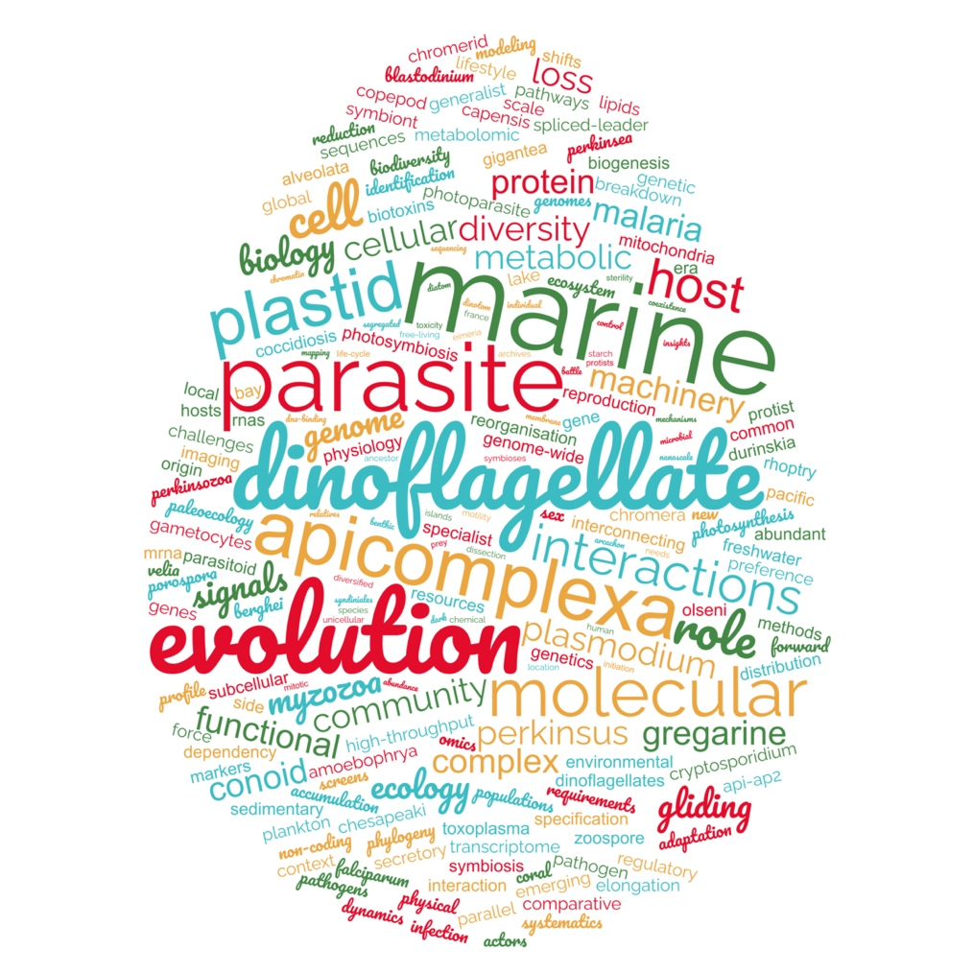 Figure 2: Word cloud of key terms listed in titles and abstracts from across the meeting.

Perspectives and outstanding challenges

While this report cannot comprehensively cover all the wonderful biology and science that was presented at this meeting, nor fully convey the excitement of many for this convergence of systems and minds, it seeks to illustrate the success of bringing diverse researchers working across myzozoan biology together. The wealth of shared biology was obvious when viewed en masse. But it was also clear that the interpretations that we make in individual groups are rarely complete without recognition of equivalent or differing states amongst the relatives. It was powerful to see how different tools have been developed, adapted, and exploited across different systems, and there is clear potential for the wider application of many of these tools and techniques across this group. New partnerships were formed, and it was pleasing to observe one Plasmodium researcher slipping a dinoflagellate culture in their luggage before departure. But the challenges were also brought into focus. There is vast diversity still to be discovered and/or identified at an organism level, and gaps in our interpretation of this important group will remain while this is the case. For example, much of the Marine Alveolate (MALV) groups remain completely uncharacterized, and predatory heterotrophs are also shown to be under-sampled and under-studied in general. The limited culturability of many taxa is a huge challenge, as is the lack of widely available experimental genetic tools, and these are challenges that we must continue to tackle. While much biology is shared, the lineage-specific differences must also be accounted for and understood, with challenges of interpreting the aberrant molecular genetics of dinoflagellates and perkinsids one example and theme of several presentations. This field is exciting and spectacular and there is still so much work to be done. And it is with great excitement that we announce that organizers of Conférence Jacques Monod have now offered to host this meeting on an ongoing three-year cycle. If you missed out this time, be sure not to for the next.

Acknowledgements
We thank the Gordon and Betty Moore Foundation for sponsoring this meeting.

