Enhanced erosion resistance of anti-reflective TiO₂/SiO₂ coatings induced by Zr-oxide doping

Dario F. Zambrano-Mera ^{a, *}, Rodrigo Espinoza-González ª, Andreas Rosenkranz ª, Terry J. Harvey ^{b,} Tomas Polcar ^{b, c}, Paulina Valenzuela ^{d}, William Gacitúa ^{d}

ª Departamento de Ingeniería Química, Biotecnología y Materiales, Facultad de Ciencias Físicas y Matemáticas, Universidad de Chile, Chile
^{b} National Centre for Advanced Tribology at Southampton (nCATS), University of Southampton, Southampton, SO17 1BJ, UK
^{c} Advanced Materials Group, Department of Control Engineering, Czech Technical University in Prague, Technická 2, 16000, Prague 6, Czech Republic
^{d} Departamento de Ingeniería en Maderas, Universidad del Bio-Bio, Chile
* Corresponding authors: dzambrano@ing.uchile.cl
Abstract
The usage of renewable energy is an effective countermeasure against the occurring climatic change. In this regard, solar energy has been shown to be one of the best ways to tackle this issue. However, it has been discovered that the effectiveness of the solar panel is significantly influenced by environmental issues (dust, sand, contaminations, among others), which may induce surface erosion thus reducing the overall optical efficiency. We explored the possibility to enhance the erosion resistance for magnetron-sputtered antireflective TiO₂/SiO₂ coatings by Zr-oxide doping and thermal annealing. When thermally annealed at 400°C, these coatings demonstrated excellent mechanical (in dynamic conditions) and optical properties compared with the glass substrate. Moreover, laboratory sandstorm testing verified that the coating doped with 1 at.-% Zr and annealed at 400 °C displayed the highest erosion resistance (decreased erosion rate of 98 %). Consequently, doped and thermally annealed ARCs offer a unique and promising option to protect the photovoltaic glass cover against erosive wear thus enhancing the longevity and efficiency (optical and electrical) of commercially available solar panels.
Keywords: Anti-reflective coatings; PV glass Cover; Zr-oxides doping; Optical properties; Mechanical properties; Resistance against erosive wear.

Introduction

Over the last years, combating climatic change has been one of greatest global challenges [1]. Through improvements and the extended use of photovoltaic (PV) panels and modules, solar energy has gained significance as an alternative solution to burning fossil fuels, which can help to tackle this problem. In Chile, the energy generation from renewable sources has notably increased. In 2009, only 8.3 TWh have been produced by renewable energies, while this number shows an 8-fold increase in 2020 [2]. In this regard, solar-based technologies are the most prevalent ones in Chile (48 % of the nation's installed capacity of non-conventional renewable energy technologies), which are primarily located in the north of Chile, where they take advantage of the favourable meteorological conditions of the Atacama Desert [2,3].
The performance of solar power plants highly depends on the quality of the installed panels, which rely on the ability to absorb the solar radiation (PV effect) and their positional stability. To improve their efficiency, plants are frequently located in deserts due to the considerable amount of collectable sun light. However, sand and dust particles in the air are an undesirable natural occurrence, which can erode the panels’ surfaces. Surface abrasion induced by the impact of these particles as well as by the cleaning procedures needed to remove deposited particles can lead to a permanent loss of the optical transmittance (up to a 36% drop in transmittance) [4,5].
Moreover, the use of anti-reflective coatings (ARCs) on the front cover glass of solar modules has greatly expanded as industry shifts towards improved efficiencies and reduced manufacturing costs [6]. Over 70% of the silicon PV modules are now projected to have ARCs [6,7]. Many conventional coatings rely on single-layer porous silica, which is generated via dip-coating [8–11]. Typically, these coatings obtain their mechanical strength through high-temperature sintering during the tempering process of the PV glass cover. Nevertheless, ARC glasses with greater durability and long-term performance are desired, which holds particularly for systems operating in medium to high soiling environments, where PV modules are susceptible to degradation by airborne particles and/or frequent cleaning [12,13].
The mechanical strength of porous coatings currently used in PV glass covers is significantly lower than that of the same coating material having a higher density and lower porosity, since pores are filled with air and the bonds between the substrate and the coating are weaker. Consequently, more porous coatings become more susceptible to greater damage than bare glass. Recently, however, it has been shown that multilayer ARCs composed of TiO₂/SiO₂ offer superior mechanical characteristics over porous SiO₂ coatings. Additionally, these coatings have an excellent optical performance, which makes them good candidates to be used in PV solar panels [14–16].
To evaluate the durability of coated glass surfaces, different tests can be realized to simulate the climatic conditions typical for desert regions. It is important to point out that Wiesinger et al. [17] demonstrated that the existing abrasion standards (MIL-STD-810G [18], ASTMD968-05 [19], and ASTMF1864-05 [20]) do not realistically mimic the impact of sand and dust particles on surfaces in desert environments since the physical parameters present in natural sand and dust storms are not adequately reflected. Nevertheless, some authors have investigated the effect of erosion on coated glass, evaluating impact velocity, angle of impact, and particle properties on the amplitude of erosion [21,22]; Houmy et al. [23] and Mahdaoui et al. [24]. Furthermore, there are recent studies that have investigated the effects of sand erosion on ARCs of the surrounding glass tubes, which are a crucial component of solar collectors with parabolic troughs [25]. However, the erosion behavior of multi-layer TiO₂/SiO₂ ARCs on the glass cover of PV solar panels with enhanced mechanical properties have been scarcely investigated [16,17,26]. Consequently, the optical efficiency (transmittance and reflectance) and durability (erosion rate) of ARCs based on TiO₂/SiO₂ doped with Zr-oxides on glass are evaluated under realistic testing conditions that simulate a sandstorm in the laboratory. For this purpose, the approach outlined by Wiesinger [17] regarding the wear resistance of ARCs under harsh desert conditions has been followed and utilized.

Materials and Methods

Sample Preparation
The studied ARCs are multilayer (4-layer) systems made up of S/TiO₂/SiO₂/TiO₂/SiO₂ doped with Zr-oxides, where S stands for the glass substrate. In this regard, the design is based on the alternation of oxides having a high (TiO₂) and low (SiO₂ and SiO₂ doped) refractive index. The ARCs have been deposited by magnetron sputtering with a nominal coating thickness of 250 nm on a glass substrate (5 cm × 5 cm) having a low iron concentration and a thickness of 50 mm. These systems are referred to as "ARZr-X", for which X is 15, 20, 25, or 30 and relates to the power (in Watts) supplied to the ZrO₂ target to adjust the Zr-content in the sample, sample that have been annealed (at 400°C) have a ‘-400’ suffix. Table 1 summarizes the terminology used for the 10 distinct samples. Using X-ray photoelectron spectroscopy (XPS), the proportion of Zr present in the doped layers and the type of oxide have been determined [15].
Table 1. ARZr-X multilayer coatings (X = 0.15, 20, 25, and 30 Watts applied to the ZrO₂ target during co-sputtering of the Zr-oxide doped SiO₂ layer) without heat treatment (RT) and thermal annealing at 400°C using various power ratios between the SiO₂ and ZrO₂ targets.
Power ratio SiO₂: ZrO₂ target | Samples
 | ARZr without heat treatment (RT) | ARZr with thermal annealing at 400°C | Zr-content (at %)
100 W:0 W | ARZr-0 | ARZr-0-400 | 0.0
100 W:15 W | ARZr-15 | ARZr-15-400 | 1.1
100 W:20 W | ARZr-20 | ARZr-20-400 | 3.1
100 W:25 W | ARZr-25 | ARZr-25-400 | 6.3
100 W:30 W | ARZr-30 | ARZr-30-400 | 11.5

Elastoplastic Property Characterization under Dynamic Conditions
Using a nanoindenter (Hysitron Ti900), the elastoplastic characteristics of ARZr systems were studied. The coatings’ hardness (H) and Young’s modulus (E) were measured using a Berkovich indenter, and the data were analyzed using the Oliver and Pharr model [27]. Each indentation was comprised of 16 loading-unload cycles with the maximum load per cycle (P_{max}) rising from 0.5 to 8.0 mN to achieve effective indentation depths between 75 and 270 nm. In an unloading segment, P_{max} was maintained for 5 s and afterwards reduced to 55% of P_{max} of the previous load cycle (Figure 1 (a)). As illustrated in Figure 1 (b), five distinct sections of the sample were evaluated to generate statistically significant data. The elastoplastic characteristics of the samples were examined under dynamic conditions (load cycles) to assess the mechanical behavior when the surface is impacted by particles (sandstorm) that generate erosive wear. In this regard, the parameter H³/E², which can be associated to the plastic deformation resistance and the plasticity index (R_{p}), was considered. According to equation 1, R_{p} is determined by dividing the irreversible indentation work (W_{p}) by the overall indentation work (W_{total}) [28]. In this work, R_{p} was approximated using the penetration depths using the following equation:
$R_{p}= \frac{W_{p}}{W_{total}} ≈1-\frac{h_{max}-h_{res}}{h_{max}}$ Eq. (1)
where h_{max} is the penetration depth at the maximum load applied during the cycle and h_{res} reflects the residual indentation depth determined using the unloading curve fit following the Oliver and Pharr approach. It should be emphasized that R_{p} is the complement of the elastic recovery of the material (R_{e} = 1 - R_{p}), and, consequently, this parameter will be zero when the indentation remains purely elastic [28].
Figure 1. Methodology for measuring elastoplastic behavior under dynamic conditions: (a) Increase in the maximum load applied (P_{max}) between each cycle (between 0.5 and 8.0 mN) to evaluate the mechanical properties of the coatings at different indentation depths (h_{f}) between 75 and 250 nm, and (b) diagram of the sample zones that were cyclically (16 cycles) indented for statistical purposes.

Sandstorm-like Accelerated Erosion Testing
To simulate the conditions of a sandstorm and to assess the effectiveness of the created multilayer systems, an erosion equipment based on the ASTM G-76 standard was utilized [29]. After the test, the samples were cleaned with isopropyl alcohol in an ultrasonic bath for 15 minutes to remove remaining sand particles. According to ISO 12103-1A4 [30], commercial sand with a maximum particle size of 350 μm in diameter was employed for this test. Combining the average sand concentration c, the test duration t, and the wind speed v, the quantity of accumulated sand mass per unit area, M_{a} in (g.cm ²) can be calculated as:
$M_{a}=\frac{m }{A}= c·v·t$ Eq. (2)
where m is the mass of the sand being impacted and A stands for the area of the sample [25]. The parameters used to simulate a sandstorm under accelerated conditions are summarized in Table 2.
Parameter | Value
Velocity (m/s) | 25.7
Sand mass (g) | 15.0
Impact angle (°) | 30.0
Exposure time (min) | 10.0

Table 2. Summary of the used parameters to conduct accelerated erosion tests designed to mimic a sandstorm.
Additionally, the optical effectiveness of the coatings is analyzed using equation 3 and expressed in terms of the defect rate per area ($γ$), where $ρ$ is the change in transmittance (loss) during the erosion test and M_{a} stands for the accumulated sand mass per unit area [17].
$ρ={γ.M}_{a}$ Eq. (3)

Topographic characterization and optical properties after erosive wear
The samples were characterized in both their original and post-erosion states as listed in Table 1. Optical microscopy (Olympus BX51M microscope) and UV-Visible spectroscopy (Ocean Optics HR 2000 + ES) were used to analyze the influence of the erosion-induced surface damage on the topography and the optical properties to estimate the durability and performance of the glass with multilayer coatings. Using optical micrographs obtained after accelerated erosion testing, the geometry of developing flaws was analyzed using Image JTM processing software. First, background noise reduction and threshold-based defect threshold correction were used prior to transforming the micrographs into grew-scale images. To segment the defects of the binarized micrographs (Figure S1), the digital analysis of the images was realized using the Huang method [31]. Utilizing equation 4, these segmented defects were filtered based on their circularity.
$Circularity=4π\frac{\left|Area\right|}{{\left|Perimeter\right|}^{2}}$ Eq. (4)
A circularity of 1.0 denotes a perfect circle, while numbers closer to 0.0 reflect increasingly elongated forms. In each sample, 20 points were examined to calculate mean values and standard deviations. A wear mechanism [17] was assigned to each of the circularities of 1.0, 0.8, 0.6, 0.4, and 0.2 used to segment the various kinds of defects, as illustrated in Figures S2(a) - (e) in the supporting information. It is important to note that the defects are caused by erosive wear. In the second step, using scanning electron microscopy, these wear processes were further described (SEM, FEI Quanta 250). Additionally, to investigate the influence of erosion on the optical performance of the glass with multilayer ARCs with and without doping, reflectance, and transmittance tests in the wavelength range between 380 and 750 nm were performed. In accordance with the ASTM E903 standard [32], the experimental apparatus for UV-Vis spectroscopy consisted of a spectrophotometer and a deuterium-halogen light source.
Following the erosion tests, the erosion rate (ER) of the samples was calculated using the volume loss induced by the particle impact divided by average particle size (350 µm size particle in accordance with ISO 12103-1A4). ER was calculated using the equation 5 [33].
$ER= \frac{V_{l}πd^{3}}{6Q_{υ}tC_{υ}}$ Eq. (5)
Where where V_{l} is the target volume loss, d is the mean particle diameter, t is the test duration, $C_{υ}$ is the particle volume fraction and $Q_{υ}$ is the volumetric flow rate of slurry (0.03 g/s).

Using white light interferometry (WLI), the samples topography was characterized (Rtec Multi-functional tribometer MFT-5000). The micrographs collected by WLI were processed with Mountains 9® software to generate a 3D image thus determining the volume loss, the greatest depth of damage, and the resulting roughness.

Results and Discussion
To adjust mechanical and optical properties, the reference sample without doping (Figure 2(a)) and sample doped with a different content of Zr-oxides (Figure 2(b)) was subjected to thermal annealing at 400°C [14,15]. Without the use of Zr-oxide doping, the heat treatment enhanced the anatase formation in the TiO₂ layers and densified the film, which was reported in previous works (Figure 2(c)) [14,15], which helps to enhance the mechanical characteristics under static conditions [14]. However, previous work [15] has shown the best mechanical characteristics of the ARCs were produced without affecting the corresponding optical performance when applying doping and heat treatment together (an example for this work is shown in Figure 2(d)).
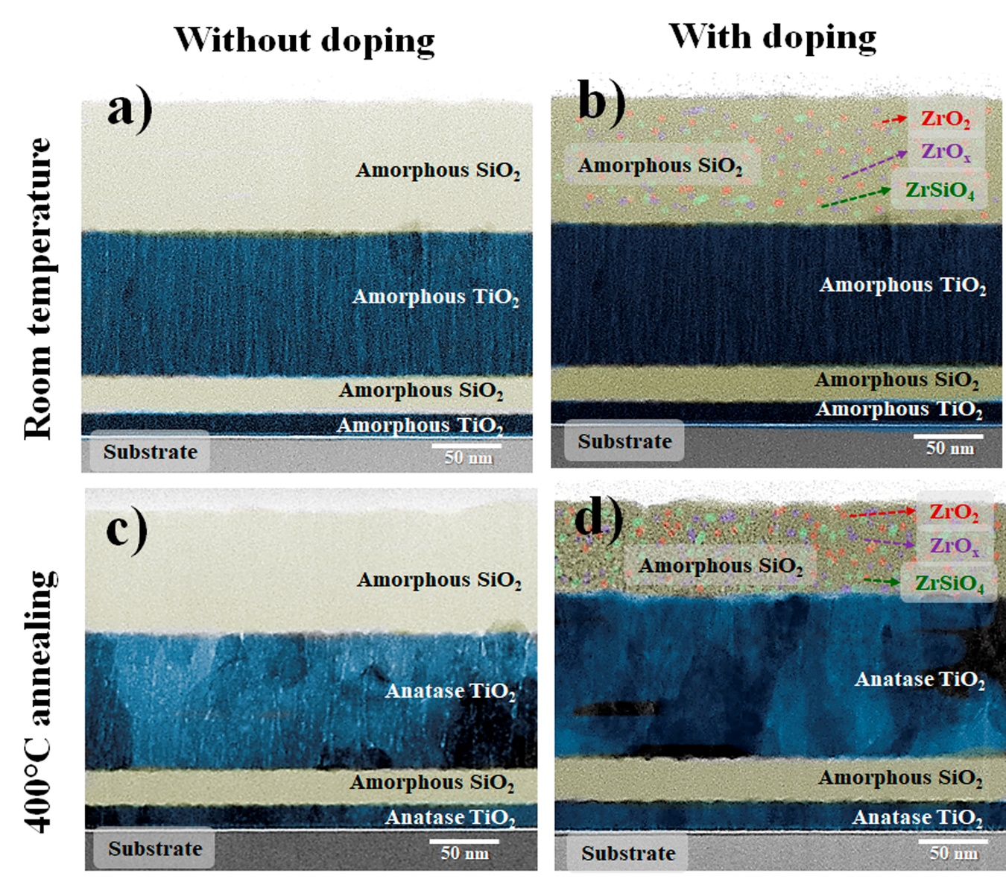
Figure 2: Cross-sectional TEM micrographs of the different (a and c) undoped and (b and d) doped multilayer Zr-doped ARZr (a and b) without and (c and d) with thermal annealing at 400 °C [14,15].

Dynamic Elastoplastic Behavior of the ARZr Systems
Cyclic indentations were performed to characterize the resistance against plastic deformation (parameter H³/E²) and the plasticity index (R_{p}) as a function of the number of load cycles thus assessing the elastoplastic behavior of the multilayer ARZr coatings (Figure 3). In this regard, the substrate influences the value of the hardness and the modulus of elasticity, which needs to be considered when discussing the real properties of the coating systems.
Figure 3 (a) and (c) illustrate that the number of load cycles had a greater effect on the H³/E² and R_{p} parameters of ARZr-0 compared to the other samples . This behavior can be attributed to fracture mechanisms of the TiO₂ layer due to its inter-columnar porosity observed by transmission electron microscopy (TEM) [14,34,35], which may lead to a total fracture of the coating. This reduces the resistance against plastic deformation, allowing the structure (remaining porosity) to withstand lower loads as a consequence of the compressive stresses created by the indenter [28,36–39]. With increasing Zr content, H³/E² slightly decreased (at 1 load cycle). For a Zr concentration of 11 at. -% (ARZr-30 [15]), a greater plasticity index and lower H³/E² were reported for a reduced number of cycles, thus matching with the observed plastic deformation. However, as the number of cycles increased, the hardening may occur due to an increased dislocation density, thus leading to a decreased plasticity index, and increased H³/E² parameter [28,38].
The mechanical properties of the thermally treated materials (Figures 3(b) and 3(d)) confirm an increase in H³/E² and a decrease in R_{p}. Moreover, a more stable behaviour with increasing load cycles can be observed when compared to the untreated samples (Figures 3(a) and 3(c)). This implies that the ductile-brittle transition occurs more slowly in the annealed samples than in untreated samples. This phenomenon may be explained to the phase transition of the TiO₂ layer (from amorphous to anatase) and a denser microstructure in the ARZr system. Consequently, the system can disperse impact energy more effectively due to the described microstructural characteristics (preferred orientation and densification), which also improved mechanical performance and made the system more durable and resistant with increasing load cycles [14,15,37,38].
Figure 3. (a and b) Resistance against plastic deformation (H³/E²) and (c and d) plasticity index (R_{p}) of the ARZr samples (a and c) without and (b and d) with thermal annealing.

Surface damage characterization of eroded ARZr systems

Using the 3D reconstructed micrographs produced by WLI (Figure 4), the depth of the flaws caused by the impact of the sand particles was determined. Figure 4 demonstrates that the maximum defect depth in ARZr-0 (Figure 4(a)) is similar than in ARZr-15 (Figure 4(b)). Nonetheless, ARZr-30 with the greatest Zr concentration (11% at) and without heat treatment (Figure 4 (c)) demonstrates an increased defect depth of up 25% compared to ARZr-15. In contrast, the defect depth is significantly reduced for the samples after thermal annealing. ARZr-0-400 (Figure 4(d)) exhibited a reduction of 24 % compared to ARZr-0, while ARZr-15-400 (Figure 4(e)) showed a 20 % reduction in defect depth compared to ARZr-15. Consequently, ARZr-15-400 demonstrated the smallest average defect depth among all samples analyzed (102 ± 20 nm). In this regard, the sample (ARZr-15-400) doped with 1% Zr and thermally treated demonstrated a reduction in the maximum depth of the defect 16% compared to ARZr-30-400 (Fig. 4(f)). By raising the resistance to plastic deformation (H³/E²) and reducing the plasticity index (R_{p}), the depth of the damage can be reduced [28]. Nevertheless, it is noteworthy that there are localized zones where the depth reaches up to 800 nm, which can be formed by particles with larger angular dimensions and a higher impact velocity than the calculated average [5,38,40].
Figure 4. White light interferometric micrographs for (a) ARZr-0, (b) ARZr-15, (c) ARZr-30, (d) ARZr-0-400, (e) ARZr -15-400, and (f) ARZr-30-400, which are used to evaluate surface damage induced by erosive wear.

It is important to point out that all samples demonstrate less damage compared to the substrate (Figure S3 (a)). In addition, ARZr-20 (Figure S3 (b)) and ARZr-25 (Figure S3 (c)) exhibit an increased surface degradation in comparison to ARZr-15. However, it is less pronounced compared to ARZr-30 (Figure S3 (b and c)). This tendency can be also found in the heat-treated samples ARZr-20-400 and ARZr-25-400 (Figure S3(d and e)).
To complement the WLI results, Figures S4 (a) and (b) illustrate the results of the circularity-based defect segmentation and quantification resulting from digital image analysis of the optical micrographs. This analysis of the sample flaws was conducted to further characterize the evaluation of erosion-induced surface damage. Additionally, the circularity of the flaws may be associated with wear processes such as delamination, cracking, or plastic deformation [17].
Figure S4 (a) demonstrates that thermally annealed samples had a lower number of defects than reference samples without thermal annealing (Figure S4 (b)). In this regard, ARZr-30 had the maximum number of defects per area (proportion of occurrence) with a circularity of 1.0, at 45 %, in contrast to ARZr-30-400, which had a proportion of occurrence of 33%. This defect reduction observed for ARZr-30-400 may be attributed to the denser and more aligned microstructure induced by thermal annealing (Figure 2), which enhanced the resulting mechanical properties (Figures 3 (b) and (d)). However, the proportion of circular flaws in ARZr-15-400 is 9 % lower than ARZr-0-400 and the glass substrate. Therefore, ARZr-15-400 contains the lowest amount of defects caused by elasto-plastic deformation, fractures, and craters on the surface, which is associated to an improved coating’s integrity and service life [17,25,37].
The principal erosive wear processes caused by the impact of sand particles on the ARZr samples have been analysed. When a brittle material is hit by particles traveling at a low velocity (less than 100 m/s) [33,41], surface microcracks can be observed. However, as velocity increases, the surface may experience brittle fractures via lateral crack propagation as a result of elastic recovery stresses [41]. Regarding surfaces of more ductile materials, such as ARZr-30 (Figure 5 (a) – (d)), a significant elasto-plastic deformation caused by the impact has been observed [5,25]. Additionally, the constant impact of the particles on the surface would result in detachment (or, in the case of coatings, delamination) or material loss, resulting from subsurface fatigue. Consequently, the proportion of occurrence (Figures S4 (a) and S4 (b)) in the samples directly correlated to the increased elastoplastic deformation, delamination, and brittle fracture [41]. This suggests that elongated flaws (circularity of 0.2) can be connected to abrasive wear, while larger circular defects (circularity of 0.8 and 1.0) can be associated to brittle fracture and plastic deformation failure (Figure S2) [17,41].
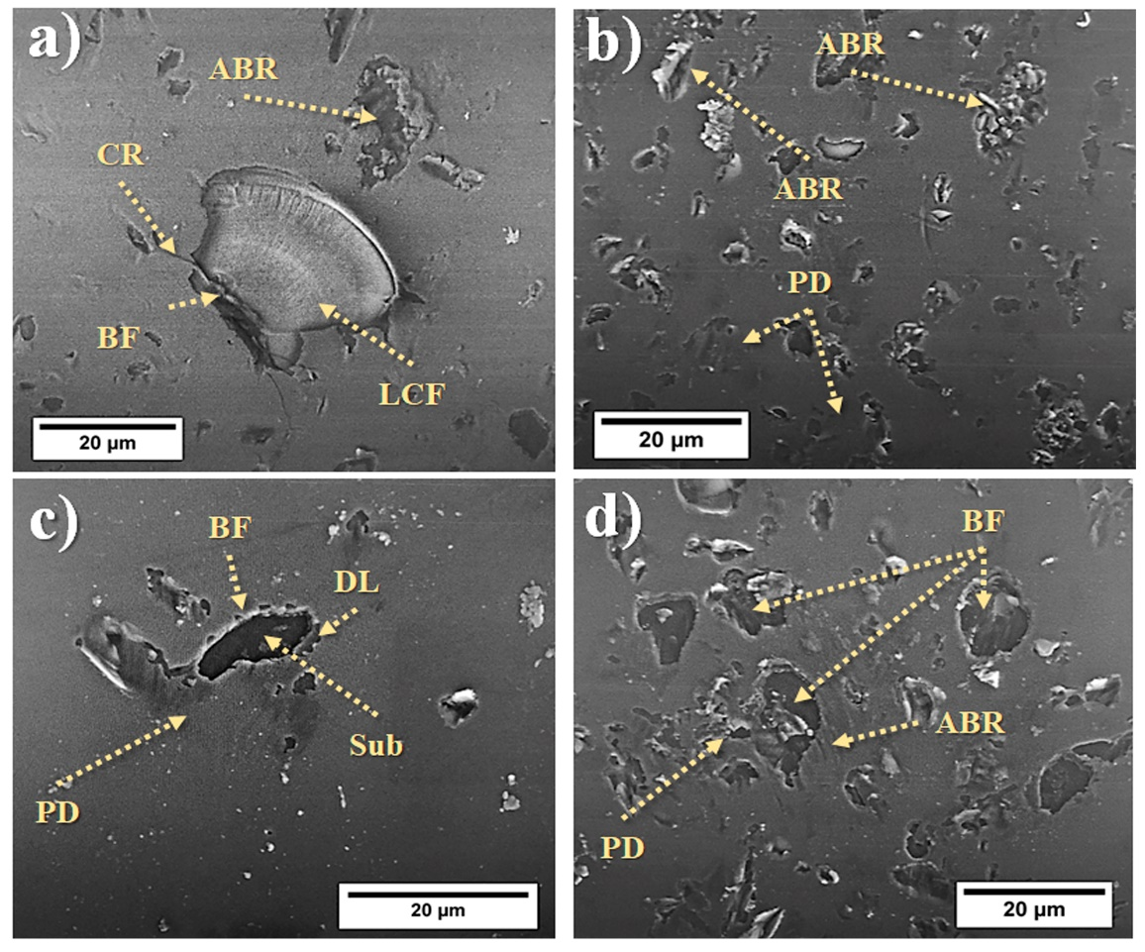

Figure 5. SEM micrographs of typical wear mechanisms (brittle fracture (BF), plastic deformation (PD), lateral crack failure (LCF), abrasion (ABR), delamination (DL) and exposure glass substrate (sub) observed in four different zones along the wear track of the ARZr-30 sample including (a) the center, (b) the upper edge, (c) the lower edge, and (d) the intermediate zone between the center and the upper edge.

Optical properties of eroded ARZr systems
Figure 6 shows the optical performance (transmittance and reflectance) of each ARZr sample and the glass substrate prior to and after accelerated erosion testing. Regardless of the degree of doping, the transmittance of all unheated samples (Figure 6 (a)) is greater than that of glass substrate in the visible range (between 450 to 700 nm wavelength). This experimental tendency (Figure 6(a)) has been also observed for thermally annealed samples (Figure 6(b)), except for ARZr-30-400, whose transmittance increased between 450 and 750 nm. Additionally, a redshift (between 325 to 400 nm) of all coatings produced mainly by the absorption of TiO₂ layer can be observed [14,42,43]. Moreover, the broadband of the ARZr samples (from 400 to 750 nm of wavelength [15]) without thermal treatment prior to and after erosion exhibits a redshift. The observed redshift is reduced for the annealed samples. A reduction in reflectance in the UV region (330 to 400 nm), which was inversely proportional to the Zr content, is observed for the samples without heat treatment (Figure 6(c)). In contrast, the thermally annealed samples kept their reflectance in the UV spectrum, although having a reflectance that was roughly 15% lower than previously examined samples without deterioration [15]. Consequently, their ability to block UV radiation, which is the overall purpose of the created ARCs, reduces with erosion, which was more significant for samples without heat annealing.
On the other hand, figures 6 (e) and (f) reveal a more significant effect on the optical behavior (transmittance and reflectance) of the ARZr compared to the glass substrate for a wavelength centered on 550 nm. The optical properties prior to the erosion test are shown in Figure 6(e). Due to their greater density, the formation of anatase, and the quantity of Zr present in the coatings, the optical properties (reflectance and transmittance) of the ARZr samples have changed [44–46]. Moreover, Figure 6(f) shows the optical response of the samples after erosive wear. The transmittance of the bare glass decreased from 88.0 (prior to erosion) to 61.5 % (after erosion) as a result of light scattering induced by surface imperfections associated with wear [5,25], as seen in Figure 5. Also, both samples with and without erosion had an antireflective tendency in this situation. The optical characteristics of the annealed samples, however, degraded more slowly than those of the non-annealed samples. However, the loss of transmittance (28 %) in all samples is significantly induced by the deterioration of the glass substrate.
This behavior has also been observed in previous antireflective experiments, by Wiesinger et al. [25], however, the chemical composition of the ARCs was not been discussed. They determined that the ARCs enhanced the transmittance of glass (made of boron silicates) by up to 4.9%. However, when exposed to particle erosion simulating sandstorm conditions, their optical performance rapidly degraded. Furthermore, the need of putting an ARC onto glass to increase the optical performance is discussed, since untreated glass also saw a drop in transmittance after erosion [25].
Although ARZr samples tend to decrease their efficiency in both UV (330 - 400 nm wavelength) and visible range (400 - 750 nm wavelength) due to erosion, we infer that these systems can help to slow down the crystallization and degradation of the adhesive polymer due to excess UV [47] thus allowing a greater amount of available light to be absorbed by the silicon solar cell [48,49] compared to the eroded glass without ARCs [49–51].
Figure 6. Effect of erosion on the optical characteristics of ARZr. (a and b) Optical transmittance and (c and d) reflectance (a and c) without and (b and d) with thermal annealing in a wavelength range of 330 to 750 nm after erosion testing. Summary of the optical properties (transmittance and reflectance) centered at 550 nm prior to (e) and after (f) erosion testing.

Resistance against sandstorm erosion of ARZr systems

Figure 7 correlates the topography of the doped and thermally treated samples after the erosion test with their roughness (average roughness (R_{a})) and root mean square roughness (Rq) (Figure 7(a)), optical efficiency (Figure 7(b)), and erosion rate (Figure 7(c)) as well as their overall wear resistance. As can be seen in Figure 7(a), the glass substrate has the highest relationship Ra/Rq values with the greatest variability when compared to the ARZr samples. In this context, the appearance of more severe craters on the surface owing to brittle fracturing induced by the propagation of lateral fractures is a plausible reason for this observation. In contrast, the roughness (Ra/Rq) of ARZr-0-400 lower by 11% compared with the glass substrate. In case of ARZr-15-400, Ra/Rq lower by 35%, while these values show a 9% increase for ARZ-30-400 compared with ARZr-15-400. The increased roughness could be attributed to the poor mechanical characteristics of ARZr-30-400 (low resistance to plastic deformation). In addition, the Rq value increased 6 to 9 times in the thermally treated samples compared to the initial roughness of the glass substrate (10 ± 2 nm) before erosion test. Wiesinger et al. [25] also reported this effect, observing a 10-fold rise in Rq for all samples following erosion simulating sandstorms. Moreover, according to Bousser et al. [38], the surface change caused by plastic deformation and the following material loss due to erosion closely relate to the mechanical properties. This holds particularly true for the H/E parameter, while an increasing hardness helps to notably decrease the resulting erosion rate.

Figure 7. Correlation between the surface damage and wear resistance of ARZr samples (with and without annealing at 400 °C exposed to erosion tests) as measured by (a) the relationship between average roughness (Ra) and root mean parameters square roughness (Rq), (b) the defect rate due to change in optical properties (optical efficiency), and (c) the erosion rate (ER) due to sand impact.

Related to the rate of defects per area (Figure 7(b)) in terms of optical efficiency (transmittance loss due to surface damage), it can be observed that the annealed samples show a better performance. Moreover, ARZr-15-400 (1 at-% Zr) and ARZr-25-400 (6 at-% Zr)) exhibit the highest resistance to flaws (lowest defect rate) and, consequently, a higher optical efficiency. Additionally, Figure 7 (c) underlines that samples that have been thermally annealed tend to have an improved erosion resistance. In this regard, ARZr-0-400 and ARZr-15-400 increase the protection of the glass substrate by decreasing the rate of erosion (82 and 98 %, respectively). When comparing with the values of the defect rate reported in literature [17], it can be observed that our values for the ARZr samples with the best performance (range between 0.3 and 0.9 % g⁻¹.cm⁻²) are comparable with the existing state-of-the-art as shown by Wiesinger et al. [17] (range between 0.3 and 0.5 percent g⁻¹.cm⁻²) under similar laboratory conditions.
A synergy between the mechanical, optical, and tribological characteristics is seen, resulting in an improvement in the optical performance (efficiency) and erosion resistance (durability) of the PV glass cover in ARC based on TiO₂/SiO₂ doped with Zr-oxides can equal and even surpass the characteristics of commercial and traditional ARCs. In other words, the discovered materials operate as multifunctional coatings that are suitable candidates for usage in the components of solar panels/modules and produce an economic effect by decreasing maintenance costs on an industrial and commercial level. This results in entire or partial component repair, which contributes to the 2030 target of a longer usable life for the module and electronics (> 35 years) and reduced efficiency deterioration (0.3% per year) [1].
Conclusions
This study aimed at evaluating the effect of thermal annealing and Zr-oxide doping on the optical, mechanical, and tribological properties of TiO₂/SiO₂ multilayers with the overall purpose to use them as optically efficient and erosion-resistant ARCs under harsher conditions (sandstorms). Our results demonstrated that 250 nm thick, thermally annealed TiO₂/SiO₂ ARCs with a low doping concentration of Zr showed the best resistance against erosion (decrease in the rate of defects and erosion). In this regard, the sample doped with 1% Zr and thermally treated at 400°C (ARZr-15-400) exhibited enhanced optical (67% reduced defect rate per area) and tribological (89% reduced erosion rate) properties compared to the substrate and all other samples. Therefore, the increase in resistance to plastic deformation (better mechanical characteristics) induced by thermal annealing and doping with Zr-oxides is essential to improve the erosion resistance, which notably helps to extend their service life.

References
[1] S. Chu, Y. Cui, N. Liu, The path towards sustainable energy, Nat Mater. 16 (2017) 16–22. https://doi.org/10.1038/nmat4834.
[2] B. Dudley, BP statistical review of world energy, BP Statistical Review, London, UK. (2020) 65.
[3] CNE, Reporte mensual ERNC CNE (Comision Nacional de Energía-Chile), Chile, 2020.
[4] S.C. Pop, V. Abbaraju, B. Brophy, Y.S. Yang, S. Maghsoodi, P. Gonsalves, A highly abrasive-resistant, long-lasting anti-reflective coating for PV module glass, 2014 IEEE 40th Photovoltaic Specialist Conference, PVSC 2014. (2014) 2715–2719. https://doi.org/10.1109/PVSC.2014.6925490.
[5] M. Humood, A. Beheshti, J.L. Meyer, A.A. Polycarpou, Normal impact of sand particles with solar panel glass surfaces, Tribology International. 102 (2016) 237–248. https://doi.org/10.1016/j.triboint.2016.05.022.
[6] S.C. Pop, V. Abbaraju, B. Brophy, Y.S. Yang, S. Maghsoodi, P. Gonsalves, A highly abrasive-resistant, long-lasting anti-reflective coating for PV module glass, in: 2014 IEEE 40th Photovoltaic Specialist Conference (PVSC), IEEE, 2014: pp. 2715–2719.
[7] S.P. V Group, International technology roadmap for photovoltaic, (2017).
[8] Y. Yuan, G.H. Yan, S.H. Huang, R.J. Hong, Preparation of hydrophobic SiO2/PMHS sol and ORMOSIL antireflective films for solar glass cover, Solar Energy. 130 (2016). https://doi.org/10.1016/j.solener.2016.01.060.
[9] J. Moghal, J. Kobler, J. Sauer, J. Best, M. Gardener, A.A.R. Watt, G. Wakefield, High-performance, single-layer antireflective optical coatings comprising mesoporous silica nanoparticles, ACS Appl Mater Interfaces. 4 (2012) 854–859.
[10] F. Chi, D. Liu, H. Wu, J. Lei, Mechanically robust and self-cleaning antireflection coatings from nanoscale binding of hydrophobic silica nanoparticles, Solar Energy Materials and Solar Cells. 200 (2019) 109939.
[11] C. Ballif, J. Dicker, D. Borchert, T. Hofmann, Solar glass with industrial porous SiO2 antireflection coating: measurements of photovoltaic module properties improvement and modelling of yearly energy yield gain, Solar Energy Materials and Solar Cells. 82 (2004) 331–344.
[12] D. Adak, R. Bhattacharyya, H.C. Barshilia, A state-of-the-art review on the multifunctional self-cleaning nanostructured coatings for PV panels, CSP mirrors and related solar devices, Renewable and Sustainable Energy Reviews. 159 (2022) 112145.
[13] K. Midtdal, B.P. Jelle, Self-cleaning glazing products: A state-of-the-art review and future research pathways, Solar Energy Materials and Solar Cells. 109 (2013) 126–141.
[14] D.F. Zambrano, R. Villarroel, R. Espinoza-González, N. Carvajal, A. Rosenkranz, A.G. Montaño-Figueroa, M.J. Arellano-Jiménez, M. Quevedo-Lopez, P. Valenzuela, W. Gacitúa, Mechanical and microstructural properties of broadband anti-reflective TiO2/SiO2 coatings for photovoltaic applications fabricated by magnetron sputtering, Solar Energy Materials and Solar Cells. 220 (2021) 110841.
[15] D.F. Zambrano-Mera, R. Espinoza-González, R. Villarroel, A. Rosenkranz, N. Carvajal, M.I. Pintor-Monroy, A.G. Montaño-Figueroa, M.J. Arellano-Jiménez, M. Quevedo-López, P. Valenzuela, Optical and mechanical properties of Zr-oxide doped TiO2/SiO2 anti-reflective coatings for PV glass covers, Solar Energy Materials and Solar Cells. 243 (2022) 111784.
[16] M. Mazur, D. Wojcieszak, D. Kaczmarek, J. Domaradzki, S. Song, D. Gibson, F. Placido, P. Mazur, M. Kalisz, A. Poniedzialek, Functional photocatalytically active and scratch resistant antireflective coating based on TiO2 and SiO2, Applied Surface Science. 380 (2016) 165–171. https://doi.org/10.1016/j.apsusc.2016.01.226.
[17] F. Wiesinger, F. Sutter, A. Fernández-García, J. Reinhold, R. Pitz-Paal, Sand erosion on solar reflectors: Accelerated simulation and comparison with field data, Solar Energy Materials and Solar Cells. 145 (2016) 303–313.
[18] M.K. Thompson, MIL-STD-810G environmental engineering considerations and laboratory tests, US Department of Defense: Washington, DC, USA. (2008).
[19] ASTM_D968-05, Standard Test Methods for Abrasion Resistance of Organic Coatings by Falling Abrasive, (2010). https://doi.org/10.1520/D0968-22.
[20] ASTM_F1864-21, Standard Test Method for Dust Erosion Resistance of Optical and Infrared Transparent Materials and Coatings, (2021). https://doi.org/10.1520/F1864-21.
[21] C. Sansom, P. Comley, P. King, H. Almond, C. Atkinson, E. Endaya, Predicting the effects of sand erosion on collector surfaces in CSP plants, Energy Procedia. 69 (2015) 198–207.
[22] M. Karim, S. Naamane, C. Delord, A. Bennouna, Laboratory simulation of the surface erosion of solar glass mirrors, Solar Energy. 118 (2015) 520–532.
[23] H. Houmy, A. Khaldoun, H. Ennaceri, A. Ghennioui, A. Ennaoui, Towards a simple sand and dust abrasion and soiling prediction on solar components: Design of a sand and dust accelerated abrasion chamber based on a vertical particle blower, in: 2016 International Renewable and Sustainable Energy Conference (IRSEC), IEEE, 2016: pp. 1182–1187.
[24] T. Mahdaoui, N. Bouaouadja, M.A. Madjoubi, C. Bousbaa, Study of the effects of sand blasting on soda lime glass erosion, International Review of Mechanical Engineering. 1 (2007) 502–510.
[25] F. Wiesinger, G. San Vicente, A. Fernandez-Garcia, F. Sutter, A. Morales, R. Pitz-Paal, Sandstorm erosion testing of anti-reflective glass coatings for solar energy applications, Solar Energy Materials and Solar Cells. 179 (2018) 10–16.
[26] M. Mazur, D. Wojcieszak, J. Domaradzki, D. Kaczmarek, S. Song, F. Placido, TiO 2/SiO 2 multilayer as an antireflective and protective coating deposited by microwave assisted magnetron sputtering, Opto-Electronics Review. 21 (2013) 233–238.
[27] G.M. Pharr, W.C. Oliver, Measurement of thin film mechanical properties using nanoindentation, Mrs Bulletin. 17 (1992) 28–33.
[28] E. Bousser, L. Martinu, J.E. Klemberg-Sapieha, Solid particle erosion mechanisms of hard protective coatings, Surface and Coatings Technology. 235 (2013) 383–393.
[29] ASTM_G76-04, Standard test method for conducting erosion tests by solid particle impingement using gas jets, (2004).
[30] ISO_12103-1, Arizona Test Dust Contaminants A4 Coarse grades, (2016).
[31] L.-K. Huang, M.-J.J. Wang, Image thresholding by minimizing the measures of fuzziness, Pattern Recognit. 28 (1995) 41–51.
[32] ASTM E903-12, Standard Test Method for Solar Absorptance , Reflectance , and Transmittance of Materials Using Integrating Spheres 1, (2012) 1–17. https://doi.org/10.1520/E0903-12.2.
[33] R.J.K. Wood, The sand erosion performance of coatings, Mater Des. 20 (1999) 179–191.
[34] Y. Gaillard, V.J. Rico, E. Jimenez-Pique, A.R. González-Elipe, Nanoindentation of TiO2 thin films with different microstructures, Journal of Physics D: Applied Physics. 42 (2009) 145305.
[35] E.C. Romero, A.H. Macías, J.M. Nonell, O.S. Canto, M.G. Botero, Mechanical and tribological properties of nanostructured TiAlN/TaN coatings deposited by DC magnetron sputtering, Surface and Coatings Technology. 378 (2019) 124941.
[36] M. Jaroš, J. Musil, S. Haviar, Interrelationships among macrostress, microstructure and mechanical behavior of sputtered hard Ti (Al, V) N films, Materials Letters. 235 (2019) 92–96.
[37] J. Lin, J. Jang, I. Park, R. Wei, Structure and properties of CrSiCN coatings deposited by pulsed dc magnetron sputtering for wear and erosion protection, Surface and Coatings Technology. 287 (2016) 44–54.
[38] E. Bousser, L. Martinu, J.E. Klemberg-Sapieha, Solid particle erosion mechanisms of protective coatings for aerospace applications, Surface and Coatings Technology. 257 (2014) 165–181.
[39] S. Zhang, D. Sun, Y. Fu, H. Du, Toughening of hard nanostructural thin films: a critical review, Surface and Coatings Technology. 198 (2005) 2–8.
[40] S. Bouzid, N. Bouaouadja, Effect of impact angle on glass surfaces eroded by sand blasting, J Eur Ceram Soc. 20 (2000) 481–488.
[41] S.J. Bull, Using work of indentation to predict erosion behavior in bulk materials and coatings, Journal of Physics D: Applied Physics. 39 (2006) 1626.
[42] H. Sun, J. Weickert, H.C. Hesse, L. Schmidt-Mende, UV light protection through TiO2 blocking layers for inverted organic solar cells, Solar Energy Materials and Solar Cells. 95 (2011) 3450–3454.
[43] P.B. Nair, V.B. Justinvictor, G.P. Daniel, K. Joy, K.C.J. Raju, D.D. Kumar, P. v Thomas, Optical parameters induced by phase transformation in RF magnetron sputtered TiO2 nanostructured thin films, Progress in Natural Science: Materials International. 24 (2014) 218–225.
[44] S. Sério, M.E.M. Jorge, M.J.P. Maneira, Y. Nunes, Influence of O2 partial pressure on the growth of nanostructured anatase phase TiO2 thin films prepared by DC reactive magnetron sputtering, Materials Chemistry and Physics. 126 (2011) 73–81.
[45] B.S. Richards, Single-material TiO2 double-layer antireflection coatings, Solar Energy Materials and Solar Cells. 79 (2003) 369–390.
[46] A. Melninkaitis, T. Tolenis, L. Mažulė, J. Mirauskas, V. Sirutkaitis, B. Mangote, X. Fu, M. Zerrad, L. Gallais, M. Commandré, Characterization of zirconia–and niobia–silica mixture coatings produced by ion-beam sputtering, Applied Optics. 50 (2011) C188–C196.
[47] D.L. King, M.A. Quintana, J.A. Kratochvil, D.E. Ellibee, B.R. Hansen, Photovoltaic module performance and durability following long‐term field exposure, Progress in Photovoltaics: Research and Applications. 8 (2000) 241–256.
[48] W.G. Van Sark, Methods of deposition of hydrogenated amorphous silicon for device applications, in: Handbook of Thin Films, Elsevier, 2002: pp. 1–102.
[49] S. Sharma, K.K. Jain, A. Sharma, Solar Cells: In Research and Applications—A Review, Materials Sciences and Applications. 06 (2015) 1145–1155. https://doi.org/10.4236/msa.2015.612113.
[50] A. Wang, J. Zhao, M.A. Green, 24% efficient silicon solar cells, Applied Physics Letters. 57 (1990) 602–604.
[51] M.A. Green, The path to 25% silicon solar cell efficiency: History of silicon cell evolution, Progress in Photovoltaics: Research and Applications. 17 (2009) 183–189. https://doi.org/10.1002/pip.892.

