Supply chain followership:

The case of Tetra Pak’s recyclers in China

Yu Gong
School of Economics and Management, Yan’an University, Shaanxi Province, China, 716000;
Southampton Business School, University of Southampton, Southampton, SO17 1BJ, UK

Fu Jia
College of Business Administration, Capital University of Economics and Business, Beijing, China
School for Business and Society, University of York, York, YO10 5GD, UK

Steve Brown
University of Sussex Business School, University of Sussex, Brighton, BN1 9RH, UK

Abstract
Purpose – The purpose of this paper is to explore an under-researched topic of supply chain followership in the context of recycling chains.
Design/methodology/approach – Following a multiple case study approach, we conducted interviews with Tetra Pak senior managers and recyclers who recycle used beverage cartons in China.
Findings - Based on the dimensions of critical thinking and active engagement, we classify supply chain followership into four types. Focal companies could evaluate their suppliers’ behaviours and followership types to initiate corresponding strategies to better manage their relationships. In addition, we found supply chain followership to be a dynamic concept, which can be constantly evaluated.
Originality - This study is one of the earliest efforts to empirically explore the concept of supply chain followership. The paper extends the followership concept from an individual level to an organizational level in the recycling chain context, and presents a useful concept of followership for companies seeking to manage their supply chain relationships.
Keywords: supply chain; followership; supply chain followership; recycling chain
Paper type: Research paper

1. Introduction
Supply chain management (SCM) has been explored for more than three decades, the initial focus being predominantly on the basic structure of buyer-supplier dyadic relationships; however more attention has been paid to supply chain focal firms (assuming their leadership role) than to their suppliers, and even less from a followership perspective (Miemczyk et al., 2012). To date, supply chain followership (SCF) remains an unfamiliar phrase in the domain of SCM, denoting those groups of supply chain members who willingly exhibit behaviours to help the supply chain leader organization and the overall supply chain to achieve their goals (Defee et al., 2010).
It is not possible to discuss SCF without first discussing supply chain leadership (SCL). The concept of SCL has been present ever since the concept of SCM was introduced (Bowersox and Closs, 1996; Lambert et al., 1998a, b; Gosling et al., 2016). Although the early researchers did not provide explicit definitions or explanations for the concepts, supply chain leaders were believed to have coordinated the whole chain to improve efficiency, manage risks, and contribute to supply chain integration and overall performance (Lambert et al., 1998a, b).
Not surprisingly, within the research on leadership and followership, leadership received far more attention than followership. For example, entering “supply chain leadership” and “supply chain followership” in Google Scholar on 28 August 2022, returned 1,980 and 19 results, respectively, suggesting that the volume of research on SCL is 100 times more than that on SCF. Mokhtar et al.’s (2019) literature review on “Supply chain leadership” included 51 papers, with only a handful papers mentioning followership. The results suggest that research on the supply chain focal companies’ leadership role is starting to emerge, but has received far more attention than the followership role of non-focal organizations.
The very concept of supply chain leaders originated from marketing research on channel leadership (Etgar, 1977). In more recent years, leading SCM scholars suggested that organization theories can be brought into the SCM field to advance the research (Ketchen Jr and Hult, 2007; 2011; Sarkis et al., 2011). Theories originally applied to individuals could also be applied to explain supply chain relationships and predict supply chain outcomes (Defee et al., 2010). A promising area of research is leadership and followership theory (Bass and Riggio, 2006; Uhl-Bien et al., 2014).
Pioneer research (e.g., Defee et al., 2009a, b; 2010) elevated both leadership and followership concepts from an individual level to an organizational level, suggesting that the concepts can also be applied to explain the buyer-supplier relationships in an SCM context. In the sustainable SCM (SSCM) research field, Gosling et al. (2016), Blome et al. (2017) and Jia et al. (2019) applied the concept of SCL and proposed that supply chain focal companies play a critical leadership role in engaging suppliers in proactive sustainable initiatives in SCM.
However, there are no leaders without the presence of followers (Kelley, 2008); similarly, there will be no focal organizations without their supply chain partners (Defee et al., 2009b; 2010; Jia et al., 2019). In order to fully understand supply chain performance, although the role of supply chain leaders is important, the role of supply chain followers cannot be neglected. Defee et al. (2009b) suggested that the fit between supply chain leader and supply chain follower styles (transformational or transactional) may be a determining factor in overall supply chain performance. Defee et al. (2010) further proposed that supply chain follower organizations may actually have greater influence over operational performance than the supply chain leader. For example, Gong et al. (2021) illustrated that, in order to implement sustainable cotton initiatives, IKEA tends to rely on Tier 1 suppliers to carry out supply chain mapping activities, and further relies on them to disseminate sustainable cotton knowledge and requirements along the multi-tier cotton textile supply chain.
Overall, followership is a research topic that lacks scholarly attention (Kelley, 2008) not to mention the concept of SCF. As Defee et al. (2009b, p.65) claimed, “The lack of research documenting the contributions of supply chain followers represents a significant unexplored gap worthy of attention”. Thus, in this paper, we attempt to advance the theory of SCF and aim to explore the following research questions:

RQ1: What does supply chain followership entail?
RQ2: How are different types of supply chain followers determined?

We answer the RQs by investigating Tetra Pak China’s recycling suppliers. Based on our data analysis, we find that followership can be applied at an organizational level in the recycling chain context. We propose that four SCF styles can be identified based on the supply chain followers’ behaviours on two dimensions of critical thinking and active engagement. The SCF styles are dynamic and may change overtime. We also found that supply chain leaders have an expectation for followers to actively engage during collaboration, while followers need to enhance their critical thinking in the longer term to achieve better performance, and that external environment can moderate this relationship.
We make novel contributions to the SCF literature in the following ways: first, we operationalize SCF constructs to discuss followership at an organizational level in the recycling chain context; second, we empirically examine how SCFs shape supplier performance; and third, we position SCF within and contribute to the supply chain relationship literature by providing a novel lens for investigating SCF.
The rest of the paper is organized as follows: first, we provide an overview of recycling chain, SCL and SCF concepts (Section 2); second, we describe and justify the detailed case study design (Section 3); third, the backgrounds of the case companies are presented (Section 4); fourth, we undertake a cross-case analysis to compare the SCF styles of three selected recyclers (Section 5); fifth, we discuss our findings on SCF and make propositions (Section 6); and finally, we offer conclusions in Section 7.

2. Literature review
This section provides a literature review on the concept of SCF. Before this, we first review the research context of recycling chains, and introduce SCL, given that SCL and SCF are interrelated concepts: without followers there will be no leaders, and vice versa (Defee et al., 2009b).

2.1 Recycling chain
In this research, we discuss SCF in a recycling chain context. During the last two decades, SSCM has become a hot research topic in the SCM field. Organizations tend to adopt sustainability in their operations with a trend to achieve a circular economy, shifting from the traditional “take-make-dispose” linear approach (Farooque et al., 2019). Recycling is an important and essential approach to achieving a circular economy, which has been discussed along with reverse logistics/supply chain, closed-loop supply chain, circular supply chain or circular economy (Zhang et al., 2021; Gong et al., 2018; 2022).
Pagell et al. (2007) presented early research on recycling chains, proposing a framework with supply chain implications which firms could adopt when recycling end-of-life products. Firms could either outsource the recycling processes or actively participate in them.
Batista et al. (2019) carried out a comparative study on used beverage carton (UBC) packaging recycling between China and Brazil under the lens of circular supply chain. Their research suggests that both emerging countries had advantages and disadvantages in their recycling chain systems, and could learn from each other.
Gong et al. (2022), in their recent study on recycling chains, suggest that blockchain technology can be applied in the traditional recycling chain. The unique features of blockchain technology may enable the whole recycling industry to be more transparent, smart, fair and inclusive.
Overall, the recycling chain presents a unique research context. Focal firms do not normally carry out recycling activities directly, but have to rely on recycling service providers. There may be a supply chain distance between the focal firm and the recyclers, with other players such as distributors and consumers in between. Focal firms may need to take extended producer responsibility which recycling service providers can help fulfil. The recyclers may occupy a border line, providing both public and private services, which means that even without the company’s support or sustainability efforts, the recycler may still carry out their recycling activities. Here the focal firm and recycler present a unique buyer-supplier relationship. The engagement of the two parties depends on the focal firm’s sustainability strategy, regulation requirements, etc. Focal firms may influence the recyclers which they play a SCL role, while SCF can be adopted to explore recyclers’ interactive behaviours.

2.2 Supply Chain Leadership (SCL)
Compared with SCF, the concept of SCL has received far more academic attention. Gosling et al. (2016) reviewed the SCL papers with a sustainability focus and developed a conceptual framework for supply chain focal firms (i.e. leaders) to implement sustainability initiatives in their supply chain networks. Mokhtar et al. (2019) carried out a systematic literature review on SCL, including in total 51 papers from 2000 to 2017. They identified an emerging research interest in SCL, with around 43% of papers published between 2015 and 2017, discussing SCL together with supply chain performance, buyer-supplier relationships and, more recently, sustainability practices.
In general, “the concept of SCL is relatively new and immature” (Mokhtar et al., 2019, p.267). There have been different levels of discussion on SCL, for instance, at the individual level, Lockstrom et al. (2010, p.275) defined SCL as “[…] the ability to influence one’s own organisation and the suppliers’ organisations in order to establish and accomplish common goals and objectives”, focusing on the leadership role of supply chain managers. SCL has also been discussed at team level; for example, Hult and Nichols (2009) focused on the leadership role of the purchasing team and suggested that team orientation is influenced by transformational leadership and strategic business unit users' mental models, which in turn affects customer orientation, relationship commitment and purchasing cycle time. Practitioners have also discussed SCL at an industry level, Gartner ranking the multinational companies every year and selecting the leading supply chain companies (Gartner, 2019). Finally, SCL has also been discussed at an organizational level where the leadership role of focal firms in the supply chain network is explored (Defee et al., 2010; Jia et al., 2019; Mokhtar et al., 2019), and the influence they have on their supply chain partners is emphasized.
Thus far, there have only been a few SCL definitions. We adopt that of Mokhtar et al. (2019, p.257), where SCL is described as “a set of behaviours exhibited by a firm in influencing and orchestrating the actions and behaviours of its own supply chain partners”, which is more general than Defee et al. (2010, p. 766), and focuses on the inter-organizational level, which is what we propose to follow.

2.3 Supply chain followership
Traditionally, the word “follower” has a negative meaning, being associated with someone who needs constant direction from leaders, is weak and timid, and possibly incapable of being a leader themself (Chaleff, 2003; Kelley, 2008). However, some research has developed new insights regarding followers. For example, it has been suggested that followers and leaders are both individually and collectively responsible for the actions of their organization, and that both roles have equal weight (Potter et al., 2001; Kelley, 2008). Followers are important to organizational success (Chaleff, 2003); up to 80% of organizational success is based on followers’ contributions (Kelley, 1992). Followers have their own identity and will only endorse a leader who shares the same values (Wang and Howell, 2012). Baker (2007) concluded that followers can be active, and not merely passive; that followers and leaders are roles, not genetic dispositions; and finally, that followers and leaders share a common purpose, and that the follower-leader relationship is interdependent.
Similar to an individual level of followership, SCF at an inter-organizational level has received even less attention from the academic world. Defee et al. (2009b, 2010) were the first to explore followership at an inter-organizational level in the supply chain context. Through the method of interactive simulation, they suggested that supply chain followers contribute more to supply chain performance, particularly in a rapidly changing environment. They argued that more research was needed to understand the concept. Jia et al. (2014) discussed the followership of international purchasing offices (IPOs) and proposed a typology of IPOs’ followership styles.
Of the papers on SCF, two themes emerged during the literature review: definitions of SCF, and SCF styles. Only Defee et al. (2010, p. 767) provided a definition on SCF as:
“A relational concept between leader and follower supply chain organizations in which the follower organization exhibits behaviours intended to help the leader organization and the supply chain achieve goals so long as they are aligned with the follower organization’s own goals, and the overall vision and long-term objectives of the supply chain.”

On followership styles, at the individual level, Kelley (1992) classified followers along two behavioural dimensions – critical thinking and active engagement. Critical thinkers tend to be innovative and creative, while non-critical ones tend to accept a leader’s thinking. Active followers take initiatives in decision-making, while a passive follower’s involvement is limited to being told what to do. Four types of followers are identified: alienated, conformist, passive, and exemplary. Alienated followers demonstrate high-level, independent thinking, but are passive and require more direction when completing tasks. Conformist followers are the “yes people” of organizations. They are very active in doing the organization’s work and will actively follow orders, but tend to lack original ideas. Passive followers rely on leaders to do the thinking for them, require constant direction, and are neither independent nor active in their role. Exemplary followers are independent, innovative, and willing to question the leadership; they know how to work well with other cohorts and present themselves consistently to all who come into contact with them (Kelley, 1992; Defee et al., 2009b).
Potter et al. (2001) also identified four different types of followers at the individual level, but with two other two dimensions – performance initiatives and relationship initiatives. Performance initiatives consider ways of getting the job done, willingness to cooperate with peers, whether to take on leadership roles as needed, and attitude toward environmental and organizational changes. Relationship initiatives consider ways to identify the leader’s vision, to gain the leader’s trust through behaviour, whether to communicate honestly with leaders and how far to negotiate differences with the leader. Followers who perform highly in both dimensions are labelled as partners, while those who perform low in both dimensions are labelled subordinates. High-performance initiatives and low relationship initiatives belong to the contributor; reversed, this belongs to the politician.
Defee et al. (2009b) used four dimensions to define the domains of SCF: style of thinking, scope of responsibility, desire to collaborate, and commitment. The first two were adopted from Kelley (1992), the last two being similar to Potter et al. (2001). Each dimension has two behavioural orientations. Style of thinking can be either critical or directed. Critical thinkers are always looking for better ways to accomplish their tasks (Kelley, 1992), actively participating in organizational transformation (Chaleff, 2003). A directed thinker prefers to maintain the status quo and tries to avoid significant change. The scope of responsibility can either be expanded or stable, depending on whether followers take on extra or additional activities to those required. The desire to collaborate can either be active or passive, and depends on the followers’ willingness to collaborate; passive collaborators may limit their efforts when they achieve their own greatest benefit. Finally, commitment can be divided into ‘group’ or ‘self’, depending on whether followers commit to shared purpose or assigned tasks.
Defee et al. (2009b) then proposed the concepts of transformational and transactional followership, which can be distinguished based on the four sets of characteristics. Transformational followers are closely associated with critical thinking ability, expanded scope of responsibilities, active collaboration, and commitment to group (supply chain) goals; this type of follower is more accepting of change. Transactional followers, on the other hand, are more directed thinkers, interested in maintaining their existing scope of responsibilities, being passive collaborators, and committed to individual goals. This type of follower prefers a stable environment (Defee et al., 2009b).
Defee et al. (2010) attempted to operationalize the followership constructs from individual levels to supply chain organizational levels. Building upon Kelley’s followership style questionnaire, they developed 10 constructs. However, they did not specify which followership dimension each construct belonged to. Defee et al. (2010) further suggested that leadership style should match followership style, so that the fit between the two can lead to better supply chain performance, which can be measured through efficiency and effectiveness.

--- Insert Table 1 about here ---

Table 1 draws a comparison of the major works on different classifications of followership. To conclude, SCL is beginning to attract academic attention, while SCF is only just emerging, and empirical study devoted to it is lacking. The research on SCF is descriptive and lacks theoretical depth. Hence more research is needed to expand the concept and contribute to SCM theories (Jia et al., 2019; Ketchen Jr and Hult, 2011).

3. Research methodology
In order to answer the research questions, we employed a case study research method. “A case study is an empirical enquiry that investigates a contemporary phenomenon within its real life context, especially when the boundaries between phenomenon and context are not clearly evident” (Yin, 2009, p.13). Given the fact that limited research has been done on SCF, it was appropriate to explore the research questions using a case study method. We further employed a qualitative interviewing technique to explore the constructs of SCF, as this is deemed useful for exploratory theory building to allow major themes to emerge from the data (Carsten et al., 2010).
A multinational company, Tetra Pak China (hereafter, TP China) and its recycling suppliers were selected for this study. TP China plays a SCL role in establishing a used beverage carton (UBC) recycling chain in China. It is dedicated to sustainability globally, both within its operations and along its supply chain. One of its sustainable supply chain initiatives is to recycle UBCs, which have low value, even for waste pickers in emerging countries (Batista et al., 2019). The concept of SCF emerged during our contact with the company, more data being collected from its recyclers to further explore the concept.
Semi-structured interviews were employed as the main data source. Interviews were carried out with TP China senior managers who had in-depth knowledge on recycling issues and the company’s relationship with various recyclers. Further interviews were then conducted with five recyclers who dealt with UBCs as their core business. The interviews were carried out between September 2014 and November 2017 in various cities in China, with both face-to-face interviews and telephone interviews according to the interviewees’ preference. Table 2 provides the list of interviewees.

--- Insert Table 2 about here ---

In total, 14 interviews were carried out, all of which were conducted in Chinese Mandarin. Each interview lasted one hour on average and was digitally recorded. Transcripts were converted into text for data analysis. Plant visits were also paid to four recyclers (Recycler A, B, C and E) in different cities in China. Photos were taken during the visits to recall the experience. Secondary data were also collected alongside the interview process; these included internal company documents (particularly company annual reports and annual sustainability reports), company website, news express and third party consulting reports.
Based on the data analysis, and by following a theoretical case selection approach, we selected three recyclers (A, B and C) for discussion, representing the different SCF types. We found that these three recyclers clearly exhibited distinct SCF styles. The interviews with the other recyclers (E and F) further validated our findings on these three. We identified Recycler D during our interviews as representing one type of recycler who took part in recycling but failed and was phased out during the process. Recycler D had only operated for a short period of time, and was thus adopted in the case analysis as a dummy case company for illustration. Table 3 provides a summary of Recyclers A, B and C, and Figure 1 provides their recycling volume of UBCs between 2011 and 2015.

--- Insert Table 3 about here ---

--- Insert Figure 1 about here ---

After data collection, the data were coded and analysed. Based on Miles et al. (2013) within-case analysis was first conducted, followed by cross-case analysis. Codes were applied in the within-case analysis with a focus on followership styles, taking into account the references of Kelley (1992), Potter et al. (2001) and Defee et al. (2010). These references provided a way to identify the recyclers’ behaviours. We also let the themes emerge for themselves, thus following an abductive approach for data analysis. The coding was done via an iterative process with both the interview transcripts and secondary data. The final coding structure is shown in Figure 2. Next the cross-case analyses were applied to draw comparisons on the recyclers’ different followership styles.

--- Insert Figure 2 about here ---

We validated our findings with the four tests suggested by Yin (2009). Construct validity was ensured by multi sources of evidence, including interview data, field notes and observations, secondary data, and being corroborated by different perspectives of supply chain members, following Yin (2009, p. 34), who suggested tactics of using “multiple sources of evidence” and having “key informants to review draft case study report”. Internal validity was ensured by matching the pattern with the predicted one developed from the literature. We requested key informants from each recycler and TP China to validate the interview transcripts. We further presented our findings to senior managers at TP China who verified our conceptual model in January 2022. The approaches further enhanced the construct and external validity of the study. Reliability was ensured by rigorous use of the case study protocol and developing a case study database.

4. Case companies’ background
4.1 Recycler A
Recycler A started its business in 1998 in Shanghai with its own recycling technology. Then with TP China’s help, Recycler A further developed and patented its technology. Unlike Recyclers B and C, instead of separating the raw material commodities from UBCs, Recycler A deals with entire UBCs and transforms them into wood plastic combination products such as durable waste bins, park benches, fencing and furniture. Recycler A’s major customers are government and pioneer companies with a proactive environmental attitude. Recycler A applies an open door policy to collect UBCs from various channels such as dealers and informal waste pickers. It has joined the ‘Green account’ programme launched by the Shanghai Government in 2015. This programme encourages citizens in Shanghai to separate their daily household waste, rewarding them with bonus points, which they can enter into a prize draw or exchange with collaborating brands. The programme is beneficial for waste classification and could potentially be Recycler A’s UBC collection source. Recycler A has gradually shifted its focus from collecting and recycling UBCs to providing collection services for the Shanghai Government, as the latter has a bigger market and contributes more to its revenue.

4.2 Recycler B
Recycler B has been based in Beijing since 2006. The plant applies the same technology as Recycler C to separate the UBC into its original raw material categories of paper, plastic and aluminium. The owner is a committed environmental protector. Recycler B has been selected by the Government as an education site, and has a showroom presenting the whole UBC collection and manufacturing processes to the public. Step by step, Recycler B has developed around 50 collection partners in Beijing. Learning from TP China, and based on its partners’ conditions, Recycler B has given them balers either free of charge, or to be paid for gradually in instalments. Recycler B collaborates with dairy processors, who sell waste beverage cartons from their production lines (e.g., faulty products or products with wrong packaging information) to Recycler B. It also collaborates with waste treatment centres, requesting that they separate and pick out the UBCs. As Beijing has strict requirements on environmental management, Recycler B is facing greater pressure from the local government policy. It hopes to rely on TP China to help solve the issue. It has also entered the bottleneck stage of collecting more UBCs from the public. According to the founder, “we have done the easy part, it costs more to collect the extra volume”.

4.3 Recycler C
The founder and CEO of Recycler C set up the company as a small paper manufacturer in 1994 in Fu Yang (now a district of Hangzhou city), Zhejiang Province. Recycler C was a tiny player surrounded by more than 300 paper mills at the beginning. The founder had always been creative among his peers; by chance, he found that UBCs contained high-quality paper fibre, so he modified his equipment to recycle the UBCs on a small scale. In 2004, the founder met TP China’s former environmental manager who encouraged him to collaborate with TP China. During the collaboration, Recycler C encountered numerous problems in production, while at the same time trying to build up its collection network by various means. One initiative the founder took was to hold education events at local schools. The activities gained local and provincial government support, which also made him decide to devote himself to a recycling career. With the subsidies of the discounted Tetra Pak plants’ waste material and the extra profit from the plastic and aluminium mixture separation line (TP China’s technical support), the founder was able to strengthen the company’s collection channels. He set up a reward scheme, and even provided financial support to the creditable collection partners. He segmented the collection sources, and paid different prices according to their classification and cleanness levels.
As has been the case with other businesses, the recent global economic downturn has also impacted recycling businesses in recent years. With lower market prices, fewer waste pickers were collecting UBCs from the public, and the traditional informal waste collection channels were shrinking. Once again, the founder identified new channels of collaboration with sanitation companies to carry out the sorting of UBCs at their plants.

4.4 Recycler D
We identified Recycler D during our data analysis process as representing one type of recycler which had only operated for a short period of time and demonstrated the last type of supply chain follower. Recycler D was based in Beijing, it had formed an established waste-paper recycling network with informal waste pickers. With TP China’s encouragement and support, the company had made a try at collecting UBCs. However, it soon identified challenges in the new business, that waste pickers were more willing to collect high value waste rather than low value waste such as UBCs. It needed to identify new and limited customers to sell the dealt UBCs, rather than its traditional paper manufacturers. Due to the different technology, and small and unstable volume of UBCs, it quit TP China’s UBC recycling network after only a few months’ worth of attempts.

5. Cross-case analysis
This section reports the cross-case analysis. Based on the literature review, Table 4 presents a comparison of the constructs, with quotations from Recyclers A, B and C, which emerged from the cross-case analysis. Following Kelley (1992), Potter et al. (2001) and Defee et al. (2010), we found that the recyclers were distinctive in two dimensions of critical thinking and active engagement.

--- Insert Table 4 about here ---

5.1 SCF on critical thinking
The cross-case analysis suggests that the recyclers exhibited different behaviours on the following two critical thinking factors:
Innovate on recycling technology. Recycler A was proud of inventing its technology and obtaining patents, which was also the reason that it had become the first recycler partner of TP China. Compared with Recycler A, Recyclers B and C tended to rely on TP China’s technology support. However, Recycler C was more open to change, and later worked with universities and research centres to further advance its technology and improve its environmental performance.
Innovate to create a recycling network. Each year, TP China agrees a recycling rate with the recyclers in order to meet its 2020 recycling target: double the global recycling rate for UBCs by the end of 2020 to 40% (Tetra Pak, 2013). Based on the recyclers’ performance TP China provides further support. A very important task for the recyclers to meet their recycling target is by creating a solid UBC waste collection network. Recycler A opened its doors to the public to purchase UBCs from any channels. It has taken part in major public events in Shanghai to promote the collection of UBCs, gradually moving towards the upstream waste collection business and shifting its focus from the low value-added UBCs. Recycler B focuses on business to business (B2B) relationships by building direct business links with factories and working with collection partners. Approximately half of its UBC recycling is obtained from factory waste and the rest from the public. Recycler C has adopted a more proactive approach to creating a national network of different channels: promoting environmental protection and waste sorting at schools; setting a high purchasing price and providing incentives to collection partners; and working with municipal incineration plants to pick out the UBCs.

5.2 SCF on active engagement
The cross-case analysis also suggests that the recyclers exhibited different behaviours on the following seven active engagement initiatives, the first five associated with TP China, the sixth among the recyclers, and the last one towards other supply chain members (such as public consumers, researchers):
Vision alignment. Recycler A clearly expressed its doubts about the achievement of Tetra Pak’s 2020 recycling goal. The CEO thought it impossible to meet the goal. Recycler B was supportive, believing that although the goal was challenging, it was achievable in the longer term. Recycler C believed that, as a global company, Tetra Pak’s goal was its strategic direction; thus the company would make all efforts to achieve it.
Commitment to SC strategy. The three recyclers exhibited distinct levels of commitment to the long-term development of the business towards the leader’s (TP’s) supply chain strategy. Recycler A focused on developing the upstream business of household waste collection, thus moving away from its original focus on UBCs. Recycler B was constrained by tighter environment restrictions in Beijing, and was looking for solutions: to move to other regions outside the Capital, or to focus on other types of business, with the hope that TP China would provide a solution. On the other hand, Recycler C was expanding its capacity to construct another plant with the support of local and national governments.
Attitude towards TP China’s support. All the recyclers expressed their gratitude to TP China for supporting their growth. However, as reflected by Recycler A, that support came with conditions, some of which it did not want to follow. The quotations in Table 4 also suggest that it was willing to further collaborate with TP China without unconditional support. Recyclers B and C clearly stated that although TP China had supported their founding and growth, they remained independent from TP China in their own main businesses, which aligned with the supply chain leader’s direction. Even without TP China’s support, they would still devote all their effort to developing their businesses.
Willingness on information sharing. TP China had provided various forms of support to the recyclers, particularly in the early years, without the requirement of investment returns. The only request was for the recyclers to report to TP China on their monthly recycling volume, and to receive annual audits by third parties assigned by TP China. Recycler A had become gradually more reluctant to report to TP China after it reduced its support due to volume drop between 2011 and 2014, while Recyclers B and C were always willing to share their data with TP China as an obligation according to their annual contract.
Willingness to collaborate to align working style. The three recyclers also exhibited different styles of working with TP China. Recycler A did not distinguish its working style from that of multinational companies such as TP China and had encountered conflict in gaining support. Recycler B closely followed TP China’s working style and was always willing to collaborate. Recycler C was aligned with TP China on its environmental philosophy, fully recognizing TP China’s corporate social responsibility and imitating the style of approach with its collection partners.
Willingness to cooperate with SC peers. In the early years, TP China organized events to facilitate the networking learning of fellow recyclers. It invited experts to share with them on other developed countries’ best practices, and encouraged the recyclers to visit each other’s plants, to communicate, and learn from each other. Recycler A did not appreciate these opportunities, however, and asserted that they would not share any valuable knowledge as they were all competitors. Recycler B maintained informal relationships with some other recyclers and was willing to share, particularly on operations and marketing. Recycler C was also willing to share, believing that all the recyclers were partners sharing a good cause and contributing to the whole society.
Willingness to cooperate with SC network. The three recyclers exhibited different levels of openness to other members of the supply chain network, which was also reflected in their willingness to take part in this research project. When the research team asked about interviewing TP China’s recyclers, reflecting on their levels of openness, the TP China manager stated that Recycler A would be hesitant to grant interviews as it was not willing to divulge its technology. Recycler B and Recycler C were more open to visitors. Recycler C tended to be more open compared to Recycler B, proactively reaching out to schools, governments, universities and research centres. The quotations in Table 4 provide more details.

5.3 Supplier performance
According to Figure 1, we see that the recyclers’ different SCF behaviours on critical thinking and active engagement led to different levels of overall performance according to the recycling volume. TP China could only exert a weak influence on the recyclers encouraging them to meet the yearly targets. Recycler A was reluctant to meet the target, particularly following the reduction of support from TP China. Recycler B flagged up the difficulties it had encountered in recent years in collecting from the public. Although its recycling volume was increasing according to Figure 1, around half of the volume was coming from TP China and other factory waste. Recycler C was confident about its progress and meeting the yearly targets.
Based on the above analysis, Figure 3 provides a general positioning of recyclers based on the two aspects of critical thinking and active engagement. In brief, Recycler A had developed and patented its own recycling capability, while the tensions between Recycler A and TP China were high. Recycler B tended to rely on TP China’s technology, management support, and factory waste, and maintained a good relationship with TP China. Recycler C had obtained TP China’s support and maintained a close relationship with TP China, while proactively seeking upgrading opportunities by collaborating with universities, and local and central government. During the interviews, we found that Recycler D was highly dependent on TP China’s support and did not take action to engage in recycling activities. It was quickly phased out of the recycling network. We classify the four quadrants into four SCF styles, illustrated further in the next section.

--- Insert Figure 3 about here ---

6. Discussion
In Section 4 we provided the background of the recyclers, and Section 5 drew comparisons among the recyclers based on their behaviours towards critical thinking, active engagement and overall performance. This section further deepens the discussions based on the above analysis.
A direct observation from above is that organizational-level followership and leadership do exist. Followership theory can be applied to an inter-organizational supply chain context, which is aligned with Defee et al. (2019a, b; 2010). In addition, SCF can be measured on the behaviours exhibited by the follower organizations. Inspired by the individual leadership styles of Kelley (1992) and Potter et al. (2001) and the SCF of Defee et al. (2009b; 2010), we classify SCF based upon two dimensions of critical thinking and active engagement. Although our construct labels are similar to Kelley (1992), their meanings are different in that we extend the concepts from an individual level to the organizational level, and in a recycling chain context.
We identified two sub-themes of critical thinking and seven sub-themes under active engagement. We further provide an evaluation of each recycler by applying (-, +) among the co-authors and managers at TP China (as in Table 4), and can map out their positions on a diagram in addition to Figure 3.
In general, the two dimensions provide a useful 2x2 matrix to offer a typology on SCF styles. Rather than classifying SCF into two types of transformational or transactional style (Defee et al., 2009b; 2010), our framework classifies SCF styles into four types. The critical thinking constructs tend to reflect the followers’ capabilities (such as R&D and innovation) in a buyer-supplier relation context, and the active engagement constructs tend to reflect upon supply chain followers’ attitudes, willingness and commitment with supply chain leaders, peers and other supply chain members in the supply chains. Thus, the 2x2 matrix could be further expanded into other organizations with their specific constructs. By applying weights to each predefined construct and by evaluating each SCF organization, their positions can then be mapped out.
Based on this research’s specific constructs, we can label the followers with high critical thinking and high active engagement (such as Recycler C in Figure 3) as Exemplar Supply chain followers; with high critical thinking and low active engagement (such as Recycler A in Figure 3) as alienated supply chain followers; with low critical thinking and high active engagement (such as Recycler B in Figure 3) as conformist supply chain followers; and finally with low critical thinking and low active engagement as passive supply chain followers (such as Recycler D in Figure 3).
We define the four types as follows: Exemplary SCFs are independent and innovative; they know how to work well with other supply chain peers and present themselves consistently to all who come into contact with them. Alienated SCFs demonstrate high-level independent thinking, but are passive and are not aligned with or committed to SCL. Conformist SCFs are very active in doing the SCL’s tasks and will actively follow orders, but tend to lack original ideas. Passive SCFs rely on leaders to do the thinking for them, and require constant direction. They are neither independent nor active in their role.
Based on the above discussion, we propose that:

P1: Supply chain followership, which can be measured on two constructs of critical thinking and active engagement, and the supply chain followership styles can be classified into four types of exemplar, alienated, conformist and passive.

Similar to Jia et al. (2019), we find that SCF is a dynamic concept, which is constantly shifting, particularly with the changing perspectives of external operating environment and SCL style (hands-on vs hands-off). All the recyclers (A, B, C, D) exhibited certain aspects of alignment with TP China, and presented certain levels of capability as the foundation for collaboration at the very beginning. Recycler A had its own patent recycling technology, both Recyclers B and C had the experience of paper manufacturing, and Recycler D had waste paper collection channels. All the recyclers believed that UBC recycling was a promising business with the support of TP China and the Government. Recycler D quickly withdrew from the relationship because of its performance: lack of capability to create a UBC collection channel which was different from recycling paper. The collaboration between Recycler A and TP China had gradually reduced with the misalignment of vision and reduction of support from TP China. Recycler B listened to TP China and was a good collaborator. However, it could not meet TP China’s improving expectations on critical thinking, such as further expansion of its recycling capacity, due to government restrictions. Finally, Recycler C constantly proved that it was outstanding among the recyclers and could be a leader among them. Interestingly, all the recyclers were more reliant on TP China’s support at the beginning, and now TP China was relying more on them to fulfil its social responsibility target and commitment.
The findings also suggest that active engagement and basic levels of critical thinking were pre-conditions for long-term collaboration (Recycler D). Critical thinking can strengthen the relationship between leader and follower (Recycler C). Leaders may tolerate or may be willing to collaborate with followers exhibiting high active engagement with low critical thinking (Recycler B), but it proves challenging for leaders to manage followers which exhibit low active engagement but high critical thinking (Recycler A). Figure 4 provides a dynamic view of recyclers’ followership styles from when they started to operate until 2015 (a stable external environment period), based on the authors’ and TP China managers’ evaluation.

--- Insert Figure 4 about here ---

Our findings also suggest that the fit between a supply chain leader’s expectations and followers’ followership style can also influence supplier performance. The dynamic view leads to different levels of supplier performance (in terms of recycling volume in this case) – i.e. Recycler D quickly dropped out as not fitting with TP China; Recycler C fitted TP China quite well, gaining it continuous support and achieving a high recycling volume; Recycler B enjoyed growth but needed extra support from TP China, which may prohibit its long-term growth; and finally Recycler A had shifted its business focus, representing a non-fit with TP China on development direction, while its recycling volume was expected to be stable or to decline in the future. Comparison between Recyclers B and C suggests that recyclers still need to fit TP China’s expectations on critical thinking in the longer term in order to achieve sustainable growth. Based on the discussion, we propose that:

P2: The fit between supply chain leadership’s expectation and supply chain followership on both critical thinking and active engagement leads to better supplier performance;
P2a: Supply chain followership is a dynamic concept whereby supply chain leaders expect followers to exhibit constant improvement on active engagement, and particularly on critical thinking to achieve better supplier performance.
P2b: The fit between supply chain leadership and supply chain followership on active engagement leads to better short-term supplier performance;
P2c: The fit between supply chain leadership and supply chain followership on both active engagement and critical thinking leads to better, longer term supplier performance.

We also found that the external environment had a significant impact on the recyclers’ commitment to their businesses and influenced their relations with TP China. In general, the external environment did not favour the operations of Recyclers A and B as they were located in the mega cities of Shanghai and Beijing, respectively. Although both companies could claim themselves to be environmentally friendly, with their relatively small scale (compared with wastepaper manufacturer), the municipal governments did not offer them specialized policy. Both faced tight environmental pressures to move away from the city, which also influenced their SCF to TP China. Recycler A was more inclined to change to a more promising business, and only work with UBC recycling as an option and a part of its business. Recycler B needed to think about life or death issues, and had no chance to look for further development opportunities, while Recycler C was located in an industrial cluster and was a type of business that enjoyed local government support. Recycler C was also proactively building a national recycling network, which gained national government support. All these conditions stimulated its growth towards a dramatic capacity expansion to build another plant. According to the discussions, we propose that:
P3: The external operating environment may have a greater influence on suppliers’ performance than supply chain followership.

Based on the above discussion and propositions, we propose a conceptual framework on SCF in Figure 5. We propose that SCF has four styles, which can be identified through behaviours on critical thinking and active engagement (P1); SCF is co-evolving with SCL and can influence supplier performance (P2a); the fit between SCL expectation and SCF leads to better supplier performance (P2, 2b, 2c); and finally the external environment may have a profound impact on SCF towards supplier performance regardless of suppliers’ followership styles (P3).

--- Insert Figure 5 about here ---

7. Conclusion
In this paper we carried out case studies to explore the concept of SCF and developed a typology of SCF styles in the context of a circular economy with a focus on recycling chains. We first undertook a literature review to provide the background on recycling chain, SCL, and then reviewed traditional followership articles and SCF papers. By conducting case study research, we observed the different styles of followership types at an inter-organizational level in the recycling chain context. To the best of our knowledge, this is the first paper to apply a case study method to explore the concept of SCF. Our paper makes several academic contributions:
First, we further develop the concept of SCF at an organizational level. Traditionally, followership has been discussed at an individual level, which we extend to SCM at an organizational level.
Second, we propose a SCF typology which can be measured from the behavioural perspective. SCFs can be observed by their behaviours, which they exhibit through their interactions with leading supply chain companies. Based on critical thinking and active engagement, a typology of SCF is proposed as four types of exemplar, alienated, conformist and passive supply chain followers. Based on the findings of this research, we call for more research on followership theory at a supply chain organizational level from a behavioural perspective.
Third, SCF is a dynamic concept, which is constantly changing along time frames. Followership styles are a dynamic concept, and our typology framework can be applied in different time frames to review followers’ positions in the 2x2 matrix.
Fourth, we propose that the relation between SCL and SCF can influence supplier performance; the fit between SCL expectation and SCF behaviours on critical thinking and active engagement leads to better supplier performance. Supply chain leaders have higher expectations as time goes by; thus, followers need to constantly and actively engage with leaders and improve their critical thinking capabilities in order to achieve the best performance.
Our research also has implications for practitioners: first, the SCF concept can help companies to have a better understanding of their inter-organizational relationships through their exhibited behaviours. Second, our typology provides a useful tool for both supply chain leaders and followers to measure their status and to better manage their supply chain relationships. The framework would be particularly useful when leading supply chain companies do not have much influence on their follower companies’ behaviours, such as in our example where TP China and recyclers have unique and weak buyer-supplier relationships. Our framework could also help the follower companies to review their status and make changes accordingly to achieve better alignment with supply chain leaders and to achieve better performance. Third, the external operating environment could have a profound impact on supplier performance regardless of SCF style. Companies need to evaluate the external operating environment in strategic decision-making.
This research also has several limitations: first, as a case study, our research suffers from the case selection (recycling chain; China), which may not be widely generalizable. Second, although we endeavoured to think thoroughly and inclusively, we did not look into individual senior managers’ leadership and followership styles, which may have an influence on their organizational-level leadership and followership. Third, we discussed recyclers’ performance, rather than the focal company or supply chain performance as a whole, leaving space for further exploration. Fourth, we only presented the recyclers’ performance over the period 2011-2015, but not during later years which have been influenced dramatically by local and national policies and COVID-19. Fifth, we intended to focus on SCF in this research, with little exploration of SCL. The interactive and dynamic relationships between SCL and SCF could be explored in future research. To conclude, we believe that we have developed a useful concept and framework on SCF and argue for more research to be undertaken on the topic.

References:
Baker, S.D. (2007). “Followership: The theoretical foundation of a contemporary construct”. Journal of Leadership & Organizational Studies, 14(1), pp.50-60.
Bass, B.M. and Riggio, R.E. (2006). Transformational leadership. Psychology Press.
Batista, L., Gong, Y., Pereira, S., Jia, F. and Bittar, A. (2019). “Circular supply chains in emerging economies–a comparative study of packaging recovery ecosystems in China and Brazil”. International Journal of Production Research, 57(23), pp.7248-7268.
Blome, C., Foerstl, K. and Schleper, M.C. (2017). “Antecedents of green supplier championing and greenwashing: An empirical study on leadership and ethical incentives”. Journal of Cleaner Production, 152, pp.339-350.
Bowersox, D.J. and Closs, D.J. (1996). Logistical Management: The Integrated Supply Chain Process. McGraw-Hill, New York, NY.
Carsten, M.K., Uhl-Bien, M., West, B.J., Patera, J.L. and McGregor, R. (2010). “Exploring social constructions of followership: A qualitative study”. The Leadership Quarterly, 21(3), pp.543-562.
Chaleff, I. (2008). Creating new ways of following. In: Riggio, R., Chaleff, I. and Lipman-Blument, J. (eds). The Art of Followership: How Great Followers Create Great Leaders and Organizations. San Francisco: Jossey-Bass, pp.67–87.
Cox, A. (1999). “Power, value and supply chain management”. Supply Chain Management: An International Journal, 4(4), pp.167-175.
Cox, A. (2001). “Understanding buyer and supplier power: a framework for procurement and supply competence”. Journal of Supply Chain Management, 37(1), pp.8-15.
Cox, A. (2004). “The art of the possible: relationship management in power regimes and supply chains”. Supply Chain Management: An International Journal, 9(5), pp.346-356.
Defee, C.C., Esper, T. and Mollenkopf, D. (2009a). “Leveraging closed-loop orientation and leadership for environmental sustainability”, Supply Chain Management: An International Journal, 14(2), pp.87-98.
Defee, C.C., Stank, T.P. and Esper, T.L. (2010). “Performance implications of transformational supply chain leadership and followership”, International Journal of Physical Distribution & Logistics Management, 40(10), pp.763-791.
Defee, C.C., Stank, T.P., Esper, T.L. and Mentzer, J.T. (2009b). “The role of followers in supply chains”, Journal of Business Logistics, 30 (2), pp.65-84.
Etgar, M. (1977). “Channel environment and channel leadership”, Journal of Marketing Research, 14(1), pp.69-76.
Farooque, M., Zhang, A., Thürer, M., Qu, T. and Huisingh, D., (2019). “Circular supply chain management: A definition and structured literature review”. Journal of Cleaner Production, 228, pp.882-900.
Gartner (2019). “Gartner Supply Chain Top 25 Methodology”, available at https://www.gartner.com/en/supply-chain/trends/supply-chain-top-25-methodology (accessed 27 September, 2019).
Gong, Y., Jia, F., Brown, S. and Koh, S.C.L. (2018). “Supply chain learning of sustainability in multi-tier supply chains: a resource orchestration perspective”. International Journal of Production and Operations Management, 38(4), pp.1061-1090
Gong, Y., Jiang, Y. and Jia, F. (2021). “Multiple multi-tier sustainable supply chain management: a social system theory perspective”. International Journal of Production Research, pp.1-18. DOI: 10.1080/00207543.2021.1930238.
Gong, Y., Xie, S., Arunachalam, D., Duan, J. and Luo, J. (2022). “Blockchain‐based recycling and its impact on recycling performance: A network theory perspective”. Business Strategy and the Environment, pp.1-25.
Gosling, J., Jia, F., Gong, Y. and Brown, S. (2016). “The role of supply chain leadership in the learning of sustainable practice: toward an integrated framework”. Journal of Cleaner Production, 137, pp.1458-1469.
Hult, G.T.M. and Nichols Jr., E.L. (1999). “A study of team orientation in global purchasing”, Journal of Business and Industrial Marketing, 14(3), pp.194-210.
Jia, F., Gong, Y. and Brown, S. (2019). “Multi-tier sustainable supply chain management: The role of supply chain leadership”. International Journal of Production Economics, 217, pp.44-63.
Jia, F., Lamming, R., Sartor, M., Orzes, G. and Nassimbeni, G. (2014). “Global purchasing strategy and international purchasing offices: evidence from case studies”, International Journal of Production Economic, 154, pp.284-298.
Kelley, R.E. (1992). The Power of Followership, Doubleday-Currency, New York, NY.
Kelley, R.E. (2008). Rethinking followership. In: Riggio, R., Chaleff, I. and Lipman-Blument, J. (eds) The Art of Followership: How Great Followers Create Great Leaders and Organizations. San Francisco: Jossey-Bass, pp.5-16.
Ketchen Jr, D.J. and Hult, G.T.M. (2007). “Bridging organization theory and supply chain management: The case of best value supply chains”. Journal of Operations Management, 25(2), pp.573-580.
Ketchen Jr, D.J. and Hult, G.T.M. (2011). “Building theory about supply chain management: some tools from the organizational sciences”. Journal of Supply Chain Management, 47(2), pp.12-18.
Lambert, D.M., Cooper, M.C. and Pagh, J.D. (1998a). “Supply chain management: implementation issues and research opportunities”, The International Journal of Logistics Management, 9(2), pp.1-19.
Lambert, D.M., Stock, J.R. and Ellram, L.M. (1998b). Fundamentals of Logistics Management, McGraw-Hill, Boston, MA.
Lockstrom, M., Schadel, J., Moser, R. and Harrison, N.J. (2010). “Successful supplier integration in the Chinese automotive industry: a theoretical framework”, International Journal of Integrated Supply Management, 5(3), pp.260-283.
Miemczyk, J., Johnsen, T.E. and Macquet, M. (2012). “Sustainable purchasing and supply management: a structured literature review of definitions and measures at the dyad, chain and network levels”. Supply Chain Management: An International Journal, 17(5), pp.478-496.
Miles, M.B., Huberman, A.M. and Saldana, J. (2013). Qualitative data analysis: A Methods Sourcebook (3rd ed.), Sage, London.
Mokhtar, A.R.M., Genovese, A., Brint, A. and Kumar, N. (2019). “Supply chain leadership: A systematic literature review and a research agenda”. International Journal of Production Economics. 216, pp.255-273.
Pagell, M., Wu, Z. and Murthy, N.N. (2007). “The supply chain implications of recycling.” Business Horizons, 50(2), pp.133-143.
Potter, E.H., Rosenbach, W.E. and Pittman, T.S. (2001). “Followers for the times: engaging employees in a winning partnership”. In Rosenbach, W.E., Taylor, R.L., Contemporary Issues in Leadership, pp. 163-181, Westview Press.
Sarkis, J., Zhu, Q. and Lai, K.H. (2011). “An organizational theoretic review of green supply chain management literature”. International Journal of Production Economics, 130(1), pp.1-15.
Tetra Pak (2013). “Tetra Pak reports progress on 2020 environmental targets”, https://www.tetrapak.com/about/newsarchive/2020-environmental-targets (accessed 31 March, 2020).
Uhl-Bien, M., Riggio, R.E., Lowe, K.B. and Carsten, M.K. (2014). “Followership theory: A review and research agenda”. The Leadership Quarterly, 25(1), pp.83-104.
Wang, X. and Howell, J.M. (2012). “A multilevel study of transformational leadership, identification, and follower outcomes”. The Leadership Quarterly, 23(5), pp.775-790.
Yin, R. (2009). Case Study Research: Design and Methods (4th ed.), Sage, London.
Zhang, A., Wang, J.X., Farooque, M., Wang, Y. and Choi, T.M. (2021). “Multi-dimensional circular supply chain management: A comparative review of the state-of-the-art practices and research”. Transportation Research Part E: Logistics and Transportation Review, 155, p.102509.
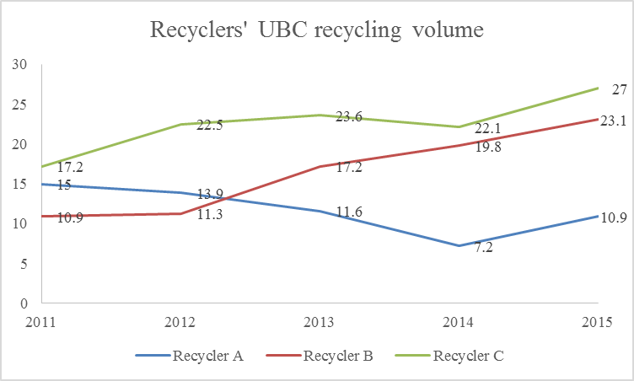Figure 1 The trends of recyclers’ UBC recycling volume
(Note: figures in 1,000 tons)
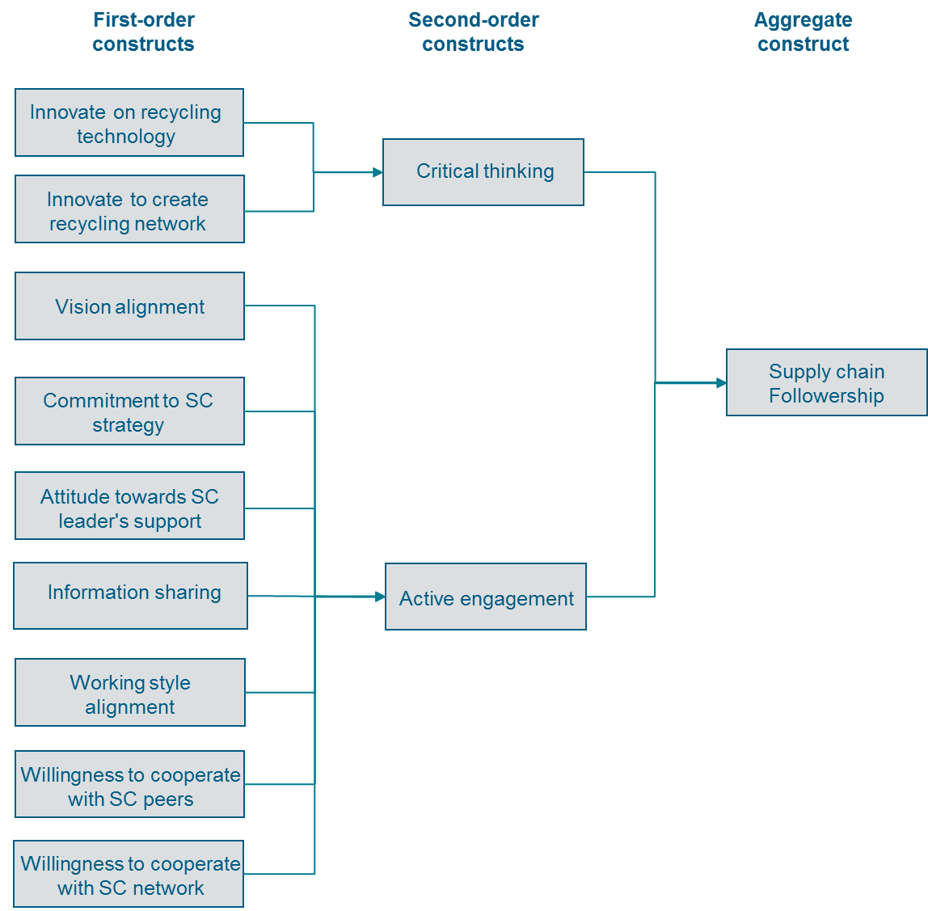

Figure 2 Coding structure of SCF
(Sources: Kelley, 1992; Potter et al., 2001; Defee et al., 2009b, 2010. SC is short for supply chain)

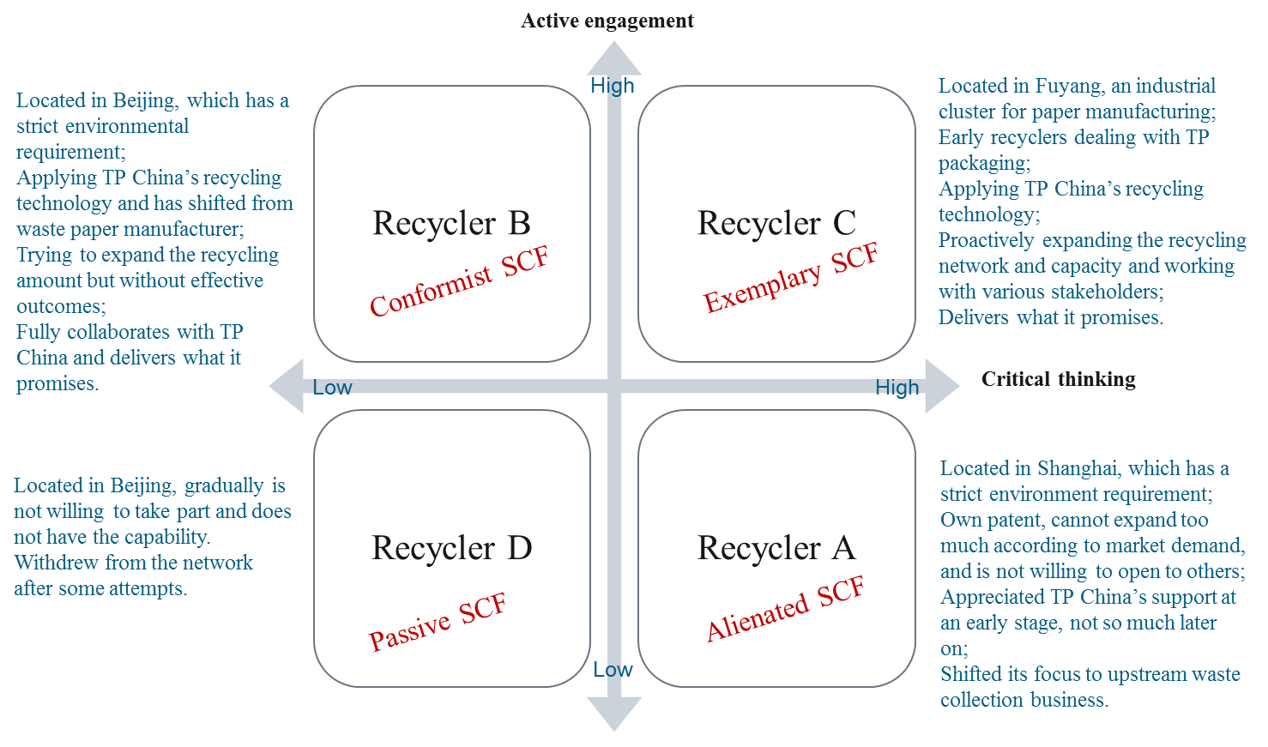

Figure 3 A typology of the recyclers’ followership styles

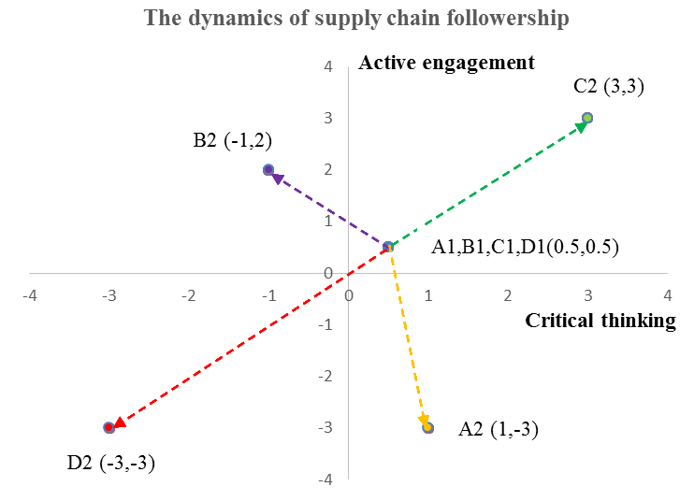
Figure 4 The dynamics of supply chain followership

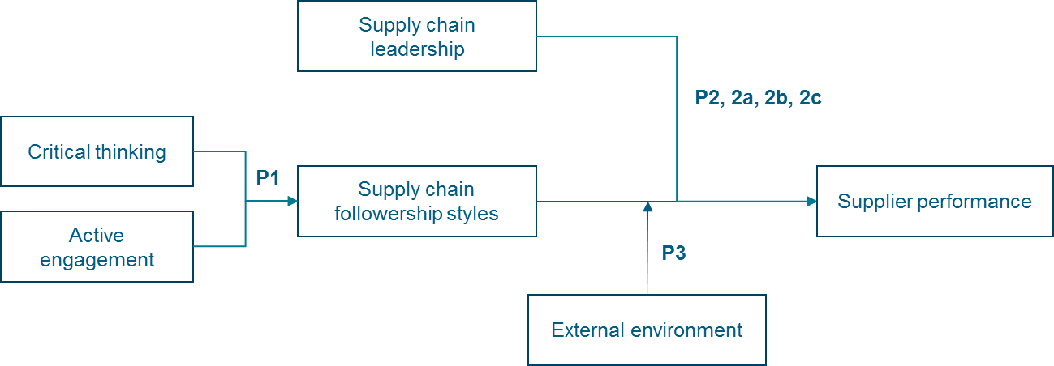

Figure 5 Conceptual framework on supply chain followership

Research on followership | Followership dimensions | Followership types
Kelley (1992) | Critical thinking: critical thinking behaviour through routinely looking for better ways to accomplish a task, or directed thinkers, which maintains the status quo and avoids situations requiring significant change;  Active engagement: take initiative in decision-making, or being told what to do. | Four types at individual level: Exemplary followers; alienated followers; conformist followers;  passive followers.
Potter et al. (2001) | Relationship orientation: identify with the leader’s vision; demonstrate trustworthiness through their behaviours; communicate honestly with the leader;  Performance orientation: hold individual performance standards above those required by the task; cooperate willingly with peers; take on leadership role as needed; embrace change by looking for new ways to accomplish tasks. | Four types at individual level: partners; subordinates; contributor; politician.
Defee et al. (2010) | Style of thinking: critical or directed to accomplish tasks;  Scope of responsibility: carry out expanded responsibilities or maintain more stable responsibilities;  Desire to collaborate: active or passive to develop a network of relationships;  Commitment: group-oriented to align with supply chain leader’s vision or self-oriented to individual goals. | Two types at supply chain level: transformational followership; transactional followership.

Table 1 A summary of different classifications of followership

No | Company | Title | Date
1 | TP China | VP Corporate Communication | 22/09/2014
2 | TP China | Senior Environmental Manager | 08/10/2014
3 | Recycler A | General Manager | 11/10/2014
4 | Recycler B | General Manager | 16/10/2014
5 | TP China | VP Corporate Communication | 08/04/2015
6 | Recycler C | General Manager | 12/04/2015
7 | TP China | Cluster Environmental Director | 20/04/2015
8 | Recycler B | General Manager | 21/01/2016
9 | TP China | Environmental Manager | 07/07/2016
10 | Recycler E | Founder | 07/07/2016
11 | Recycler E | General Manager | 09/07/2016
12 | Recycler A | General Manager | 21/05/2017
13 | TP China | Senior Environmental Manager | 18/08/2017
14 | Recycler F | General Manager | 01/11/2017

Table 2 List of interviewees

Recyclers | Founding Year | Year of collaboration with TP China | No. of employees | Revenue (million RMB) | Technical route
Recycler A | 1998 | 1998 | 30 | 47 | Dealing with the UBC as a whole; environmentally friendly but with high production costs.
Recycler B | 1991 | 2007 | 70 | 75 | Separate the UBC into polymers & aluminium mixture and pulp, then further separate polymers and aluminium; need to apply chemicals and to deal with waste water.
Recycler C | 1994 | 2004 | 200 | 130 | Separate the waste package into polymers & aluminium mixture and pulp, then further separate polymers and aluminium; need to apply chemicals and to deal with waste water.

Table 3 Basic information on the recycling companies
(Note: data as in 2016)

 | Recycler A | Recycler B | Recycler C
Critical thinking | + | - | +++
Recycling technology innovation | It is our technology, which is also why TP China would like to collaborate with us at an early stage. Later, with their support, we got the technology patented. (Recycler A) | TP China provided us the technology solution. As I managed a paper manufacture before, so I also made some further improvement. (Recycler B) | I used to deal with UBC on a small scale. Later on TP China collaborated with us and other technology companies and institutions to invent the polymers and aluminium separation technology. (Recycler C)
Ability to create recycling network | I open my plant to suppliers and can purchase from whoever supplies to me. I am more worried about the market but don't really care about the purchasing channels. We proactively take part in government campaigns, to both gain raw materials and sell our products. (Recycler A) | We receive some factory waste from TP China with a discount. We also develop dealers in Beijing to collect from major channels such as schools, train stations, airports, etc. It is our raw material, so we need to be proactive. (Recycler B) | Recycler C is very proactive to create the recycling network. Now its network covers almost the whole country. Actually, it is quite expensive because of the extra logistics expense; however he continues to do it... He also sets the purchasing price at the highest among his peers to support the collectors... once the collection network has settled down he also sets targets for the collectors and then provides them incentives after they achieve the goal, which is very attractive. (Environmental Manager, TP China)
Active engagement | --- | ++ | +++
Vision alignment | The 2020 goal is unrealistic. (Recycler A) | The goal is not a strict number. 2020 is their target, what can they do if they can't meet it?  In general, developing a green supply chain and circular economy is China's government strategy ... we can't only keep an eye on the current situation, although difficult, the future direction is right. (Recycler B) | 2020 is TP's global target, it will be a challenge. However I believe it can be achieved with efforts. (Recycler C)
Commitment to SC strategy | Some recyclers (such as Recycler A, authors' note) only care about our support. They don't collaborate without our support. ... Now it also moves to waste sorting and puts more efforts to its green account. (Environmental Manager, TP China) | It now faces pressure from the Environment Agent. Recycler B has concerns on whether to continue the business and how to survive in the longer term. (Environmental Manager, TP China) | Recycler C is the one who indeed treats the business as its core business. He put all his wealth in the business, all the external promotion etc. All aspects of the businesses are towards the UBC recycling business.  Now it has started another new project, its capacity will increase to a new level of about 200,000 tons. It is really a big jump and it also means a huge amount of investment. (Environmental Manager, TP China)
Attitude towards SC leader's support | TP China provides us lots of support along our growth; however it also gives us big pressure… increase capacity, I have to maintain the equipment, what if I can't collect enough UBCs, or I can't sell our products, all of which means costs for us? (Recycler A) | Even without TP China's support, without their discount on factory waste, we will still run the plant. Since we are determined to do this, we will then organize all the resources needed. It is our business. (Recycler B) | Recyclers such as Recycler C align with us quite well on our visions. He is also very supportive on environmental protection, so either with or without support, he will carry on the business. (Environmental Manager, TP China)
Information sharing | Without TP China's support, then I am unhappy, I am no longer willing to share the data with them. (Recycler A) | We have signed a contract, so since TP China supports us, we are happy to share our data. (Recycler B) | It is our responsibility. We constantly share our data with TP China. (Recycler C)
Working style alignment | We have conflicts on some processes, so, for example, Recycler A expects to meet our director directly to solve some issues. However, we have complex internal processes. It is not someone who can make a direct decision like small companies, thus there is a big difference on our styles. Then Recycler A thought that we don't trust him. (Environmental Manager, TP China) | We try our best to collaborate with TP China and meet their demands. (Recycler B) | Both companies have a good alignment on the vision. Other multinational companies should learn from TP China's corporate social responsibility. (Recycler C)
Willingness to cooperate with SC peers | The so-called recycler conference is to get us together and communicate with each other. To be frank, no one will share its core advantages. The most we can exchange is the experience on collection. (Recycler A) | We have connections with each other and we know each other well… we also communicate besides the recycler conference, for example on recycling equipment. (Recycler B) | I am considerate towards the other recyclers, about their technologies and operations' conditions. Sometimes I also give them advice. All of us are in a joint cause. (Recycler C)  Recycler C is a leader among the recyclers, it is very proactive and would like the public to know the company. (Environmental Manager, TP China)
Willingness to cooperate with SC network | I can't guarantee that you will be able to interview Recycler A. It has its own patent, so is not willing to open its plant to the public. (Senior Environmental Manager, TP China) | TP China sends visitors to us from time to time. We are willing to host them and we have even built a presenting room for students. (Recycler B) | There is no problem to interview Recycler C, the general manager is very open. (Senior Environmental Manager, TP China)  We are quite open to the public and we have collaborated with various stakeholders such as institutions and NGOs. I am happy to expand our capability with all kinds of external support. (Recycler C)
Table 4 Comparison of recyclers’ followership behaviours

