COVID-19 Emerging Risk Assessment for the Construction Industry of Developing Countries: Evidence from Iraq

M.K.S. Al-Mhdawiª, Mario Brito^{b}, B.S. Onggo^{c}, Abroon Qazi^{d} and Alan O'Connor^{e}
¹
^{a,b} Centre for Risk Research, Southampton Business School, University of Southampton, Southampton, UK; ^{c} Centre for Operational Research, Management Sciences and Information Systems, Southampton Business School, University of Southampton, UK.; ^{d} School of Business Administration, American University of Sharjah, Sharjah, UAE; ^{e} Department of Civil, Structural and Environmental Engineering, Trinity College Dublin, Ireland.

Corresponding author: M.K.S. Al-Mhdawi (M.K.S.Al-Mhdawi@southampton.ac.uk)
Abstract

In developing countries, the construction industry has been one of the hardest hit by the COVID-19 pandemic. The impact of the pandemic has created a whole new set of risks, causing workforce-related issues, supply chain disruptions, and legal and contractual implications. This research aims to identify and quantitatively analyse COVID-19 emerging risks in the construction industry of Iraq. A mixed method approach was used for data collection and analysis, including a focus group session to identify COVID-19 emerging risks, a survey to rate the identified risks, and the development of a fuzzy-based risk assessment model to analyse the level of riskiness of the identified risks. Results indicate that the most critical COVID-19 risks are (1) contract suspension, (2) contractor bankruptcy, (3) materials price escalation, (4) construction contract claims, (5) inappropriate risk allocation, (6) non-compliance with social distancing guidelines, (7) skills shortage, and (8) poor site and virtual communication. This paper contributes to the body of knowledge by providing academics and industry practitioners with a more comprehensive understanding of the risks arising from the COVID-19 pandemic. Moreover, this paper presents a novel model for analysing risks related to extreme conditions, such as the COVID-19 pandemic and future pandemics.
Keywords: COVID-19 pandemic; covid-19 risks; risk assessment; developing countries

- Introduction
The construction industry plays a vital role in the development and growth of economies around the world. It not only generates significant employment and income, but also drives demand for a wide range of goods and services, such as steel, cement, and machinery, which in turn supports other sectors of the economy (Sierra 2021). One of the key characteristics of the construction industry is its size and scale. It is a global industry, with a presence in virtually every country and region of the world. The construction industry employs approximately 7% of the total world's workforce and accounts for 13% of the global GDP (Gross Domestic Product) (Deloitte 2017). These figures are expected to continue growing in the coming years, with estimates suggesting that annual construction-related expenditures could reach $15 trillion worldwide by 2025 (Shahbazi 2019). The construction industry also plays a vital role in meeting the needs of a growing and urbanizing global population. With the world's population expected to reach nearly 10 billion by 2050 (United Nations 2019), there will be a need for significant investment in new housing, commercial, and infrastructure projects to support this growth.
The coronavirus, or COVID-19, is a highly infectious respiratory disease caused by the SARS-COV-2 virus (Pamidimukkala and Kermanshachi 2021). The COVID-19 pandemic has had a profound impact on the global economy, leading to widespread disruptions and declines in various industries. Like many other industries, the construction sector has been affected by the COVID-19 pandemic in a number of ways. The construction industry has experienced a significant reduction in employment opportunities (Alsharef et al. 2021), an increase in material prices (King et al. 2021), delays in contractor payments (Agyekum et al. 2021), disruptions in supply chains (Khalfan and Ismail 2020), a decline in demand for construction-related projects (King et al. 2021), and an increase in construction disputes (Salami et al. 2021). These impacts have had a significant impact on the industry and have presented challenges for construction companies and workers.
In light of the above, the COVID-19 pandemic has had a detrimental effect on the construction industry worldwide. However, the construction markets in developing countries are more susceptible to the effects of the pandemic and its emerging risks due to the following reasons:
- Compared to developed countries, the developing world appears to be facing higher—mortality rates (Gill and Schellekens 2021). The high number of positive COVID-19 cases and deaths that have occurred in developing countries as a result of poor health systems, lack of public health awareness, and non-compliance with global guidelines of wearing facemasks, hand sanitizing, and social distancing have resulted in a significant shortage of skilled construction workers (Amoah and Simpeh 2021; Chigara and Moyo 2021).
- Unlike other 21st century outbreaks (e.g., SARS1, MERS2, or H1N1pdm09), the COVID-19 pandemic is unprecedented in terms of its impact on the construction industry worldwide and in particular on developing countries (Casady and Baxter 2020). In fact, the adverse impact of the COVID-19 pandemic on construction projects in developing countries was reported by several studies to have similar characteristics and behaviors leading to changes in laws, business closures, suspension and termination of construction contracts, and associated challenges experienced by construction stakeholders (Agyekum et al. 2021; Olatunde et al. 2021). Moreover, the effect of the pandemic on developing countries caused significant challenges to the labor market that outweighed the effects of the Great Recession (OECD 2020). Among the challenges workers face are not receiving their due wages from their employers, losing their jobs, being unable to access new employment opportunities, and not having adequate social protection (Walter 2020).
- The construction industry in developing countries may be hindered by a lack of resources and preparedness to operate projects during the COVID-19 pandemic. This lack of readiness may result in increased delays and disruptions within the sector. Furthermore, these countries may be more susceptible to economic consequences of the pandemic, which could potentially result in reduced demand for construction projects and further financial losses for the industry.
To this end, the direct and indirect impact of the pandemic has created a whole new set of risks and uncertainties, causing supply chain disruptions, workforce-related issues, and contractual, legal and operational implications (Assaad and El-adaway 2021). All these factors are interconnected and have created a chain of delays, cost overrun and loss of productivity (Sierra 2021). As a result, it is imperative to assess the level of impact of COVID-19 emerging risks on the construction industry in general and on developing countries in specific. Only a few studies have examined the impact of COVID-19 on the construction industry (see e.g., Khalfan and Ismail 2020; Agyekum et al. 2021; Alsharef et al. 2021; Rehman et al. 2021; Sierra 2021; Amoah and Simpeh 2021; Chigara and Moyo 2021; Olukolajo et al. 2021; Nguyen et al. 2021 ; Kukoyi et al. 2021; Olanrewaju et al. 2022; Elnaggar and Elhegazy 2022 and others). None of the previous efforts have identified and quantitatively analysed the significant risks arising from the COVID-19 pandemic. To this end, this study aims to fill this gap in the literature by providing a comprehensive analysis of the emerging risks faced by the construction industry in developing countries during the pandemic by surveying construction practitioners working in Iraq. The associated objectives are to (1) identify and categorize the risk factors arising from the COVID-19 pandemic, and (2) quantify their level of riskiness using fuzzy sets theory.
This study provides construction practitioners and academic scholars with a comprehensive understanding of the key risks that affect the successful implementation and delivery of construction projects during the COVID-19 pandemic. It is expected that with this understanding, decision-makers will be able to identify and implement appropriate risk response strategies, thereby improving the performance of risk management practices in developing countries.
The reminder of the paper is organized as follows. Section 2 presents an overview of the identified knowledge gap and the Iraqi construction industry. Section 3 describes the research methodology employed. Section 4 presents the results and analysis. Section 5 discusses the key COVID-19 risks identified. Finally, in Section 6, the research conclusions, implications, and limitations are outlined.
- Background

2.1 Previous studies and knowledge gap Identification
In most previous studies, scholars have attempted to understand the impact of COVID-19 pandemic on the construction industry by identifying the industry dimensions that are prone to risks. These dimensions include contractual/legal implications, supply chain operations, construction financial market, and the health and safety of the construction workforce. For instance, Alsharef et al. (2021) identified material delivery delays, shortages of materials, permitting delays, lower productivity rates, cash flow issues, project suspensions, price escalations, and potential conflicts and disputes as major risks facing the U.S. construction industry. Khalfan and Ismail (2020) found that construction companies in Bahrain experienced project delays, salary payment challenges, the need to adopt new modes of work, shortages of supplies and materials, the shift to online platforms, financial difficulties, absent employees, reduced efficiency, restricted site access, and a lack of new projects due to the pandemic. In addition, Sierra (2021) reported that contractors in the UK construction industry faced challenges with the instability of the supply chain and subcontractors, uncertainty surrounding the evolution of the pandemic, and workforce availability and legal exposures. Rehman et al. (2021) found that material and equipment shortages, travel restrictions, delayed permits and work approvals, and health and safety concerns were the main causes of schedule delays and cost overruns in the UAE construction industry. Stiles et al. (2020) emphasized the importance of integrating COVID-19 safety measures into the UK construction industry's risk management system. Agyekum et al. (2021) identified cost increases for construction materials, payment delays, and a decrease in work progression rate as major challenges for the Ghanaian construction industry. Another example is the work of Amoah and Simpeh (2021) who identified non-compliance with social distancing rules, reliance on public transportation, shared tools and equipment, and a lack of personal protective equipment as challenges to implementing COVID-19 safety measures in South Africa's construction sites. A further study, conducted by Chigara and Moyo (2021) who surveyed the Zimbabwean construction professionals to assess the factors affecting optimal health and safety during the pandemic. Olukolajo et al. (2021) surveyed construction site workers in Nigeria to evaluate compliance with COVID-19 protocols. Nguyen et al. (2021) investigated the impact of the pandemic on construction activities in Vietnam. Kukoyi et al. (2021) surveyed construction organizations in Nigeria to assess the risk control systems and challenges of implementing safety measures on construction sites. Furthermore, Olanrewaju et al. (2022) used a questionnaire survey and structural equation modeling to model the environmental, economic, and social impacts of the pandemic on the construction industries in Nigeria, Ghana, and South Africa. Finally, Elnaggar and Elhegazy (2022) evaluated the cost impact of the pandemic on the Egyptian construction industry, considering factors such as manpower, plant and machinery, and materials. While previous research has provided great of knowledge about the impact of the COVID-19 pandemic on the construction industry globally, there remains a gap in the literature regarding the identification and analysis of significant COVID-19 emerging risks for the construction industry in developing countries. Thus, this study addresses the knowledge gap by considering the context of the Iraqi construction industry.

2.2 The construction industry of Iraq
The construction industry in Iraq is a crucial contributor to the country's development, infrastructure, and economy. The construction industry in Iraq plays a critical role in the development and modernization of the country's infrastructure, including the construction of roads, bridges, airports, and other transportation systems, which have been necessary due to the significant damage to infrastructure during the Iraq War and previous sanctions (World Bank 2018). It is also an essential contributor to addressing the housing shortage in Iraq and providing safe and adequate housing for the population. In addition, the construction industry can contribute to the social and cultural development of Iraq by building schools, hospitals, cultural centers, and other facilities that enhance the quality of life for the population.
Furthermore, the construction industry in Iraq is significant in terms of its economic impact. The sector provides employment for a large number of people and generates significant revenue for the country. According to the Iraq Labour Force Survey (ILFS) the construction industry in Iraq employs 16.3% of the Iraqi workforce, making it the main branch of economic activity in Iraq (ILFS 2021). In addition, the construction of new infrastructure and buildings can have a positive impact on the overall economic development of the country by improving connectivity and increasing the efficiency of transportation and communication systems. This can lead to increased economic activity and growth, as businesses and individuals are able to more easily access markets, resources, and opportunities.
In this research, the focus was made on Iraq for the following reasons:
- Iraq is a major economic power in the West Asia and North Africa regions, due to its position as the fifth largest oil producer in the world and the second largest in Organisation of the Petroleum Exporting Countries (OPEC) (Al-Mhdawi et al. 2022);
- Iraq's government is heavily investing in its infrastructure and has taken legislative measures to attract foreign contractors to perform work within the country;
- The Iraqi output value of the construction industry is anticipated to present an annual growth rate at a compound rate of annual growth of 15.75% during (2019-2023) (Market Research Iraq 2021). The industry is consequently expected to rise from a value of US$9.2 billion in 2018 to US$19.2 billion in 2023 (Research and Marker 2021). Between 2003 and 2014, more than US$220 billion was spent on construction and reconstruction efforts following the armed conflict in 2003.
Despite the economic position of the country and the increased number of construction and reconstruction efforts, the construction industry in Iraq has always been plagued with risks and weak outcomes (Al-Mhdawi et al. 2020). This is due to the following:
- Iraqi contracting companies find a big number of challenges to mitigate risks in an environment characterized by poor suppliers, unskilled workforce, logistics difficulties, poor risk management practices (Al-Mhdawi 2020; Al-Mhdawi et al. 2020), and a lack of expertise in using modern technologies for managing construction projects (Bekr 2015). Moreover, the industry suffers from poor safety management practices (Buniya et al. 2020). The accident rate in the Iraqi construction industry in 2018 was 38% of overall industrial accidents (Buniya et al. 2021), which made it one of the most hazardous industries in Iraq.
- The lack of clarity regarding construction regulations and standards, leading to the utilization of substandard materials and poor construction practices
- The absence of a proper legal framework in the construction industry in Iraq has made it difficult to resolve disputes and protect the rights of contractors and other stakeholders in a number of ways. For example, there may be no clear guidelines or regulations in place to govern the construction process, leading to misunderstandings and conflicts between contractors, clients, and other stakeholders. Additionally, the lack of a legal framework may make it difficult to enforce contracts or hold parties accountable for their actions, leading to delays and increased costs. This can also create a level of uncertainty and risk for companies operating in the construction industry, which may discourage investment and hinder the development and growth of the industry.
- The volatile security and political conditions posed an enormous challenge to Iraqi civilians, the Iraqi economy, and construction and reconstruction efforts (Matsunaga 2019). For instance, poor security profile in Iraq, limited private sector engagement, including foreign direct investment, leading to many projects being selected opportunistically.
- Iraq’s current economic context is characterized by extreme dependence on oil production. However, the fluctuation of oil prices in the global market has a direct impact on industries in Iraq. For instance, the collapse of oil prices in 2020 caused significant economic challenges, particularly to the construction industry. In April 2020, the oil prices had fallen by 70% compared to the start of the year, which severely impacted Iraq’s government revenues. As reported in the latest issue of the Iraq Economic Monitor published by the World Bank (World Bank 2020), the Iraqi government revenues fell by 47.5% in the first 8 months of 2020. Declining oil prices in the global market caused a direct effect on the stability of the construction industry in Iraq (Abdulhussein and Shibaani 2016).
In addition to these challenges, the impact of the COVID-19 pandemic on Iraq has increased the level of challenges. In fact, a considerable number of Iraqi construction companies are suffering losses and encountering challenges resulting from both direct and indirect effects of the COVID-19 pandemic, which negatively affects their short-term and long-term sustainable development (OECD 2020). Further, according to preliminary statistics provided by the International Organization for Migration, the COVID-19 impact has resulted in a 52% reduction in employment and a 68% reduction in production in the construction sector in Iraq (IOM 2020).
To this end, Iraq's construction industry represents the unique nature of the impact of the COVID-19 pandemic and its emerging risks on the construction industry across a variety of developing countries experiencing similar challenges and sharing similar characteristics pre and during the COVID-19 pandemic.

- Research methodology
A mixed method approach was adopted in this research for data collection and analysis as presented in Figure 1. This research employs a combination of deductive and inductive reasoning during the investigation process, creating a continuous cycle of reasoning from observations to theories and back to observations. This research depends heavily on the deductive approach, which focuses on the connection between theory and research. The deductive approach involves examining certain theories in order to apply them to specific issues that may result in improved practices (Collis and Hussey 2014). It was used to determine the effects of COVID-19 risks on the construction industry in Iraq. Additionally, the inductive approach, which involves discovering patterns through observations and creating hypotheses (Bernard, 2011), was utilized to comprehend the nature of the issue being studied by providing a concise focus point on the context of the study regarding COVID-19 risks for construction projects in Iraq.
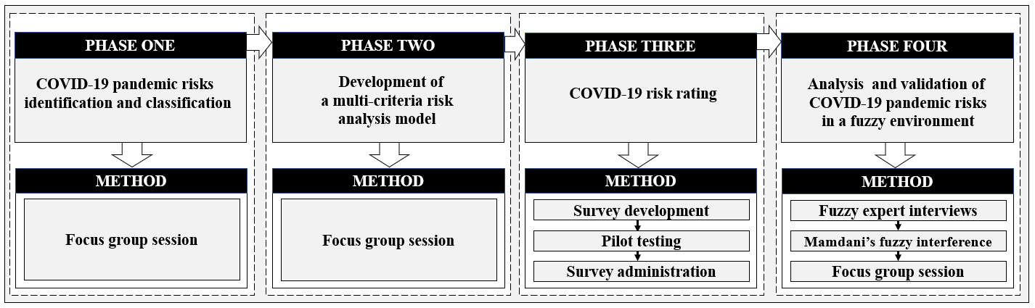
Figure 1. Adopted research methodology
The following subsections provide details regarding each phase.
Phase One: COVID-19 risks identificaon and classificiaon
Risk identificiaon
Few studies have examined the impact of the COVID-19 pandemic and its emerging risks on the construction industry. The current literature, however, is insufficient to identify the significant COVID-19 risks. To this end, a focus group session with several construction experts in Iraq was carried out to identify the COVID-19 emerging risks. Focus groups denote a type of group interview that takes advantage of communication between research participants for data generation. The method aims to seek data from a select few individuals as opposed to a sample that statistically denotes a larger population (Nyumba et al. 2018). Even though group interviews are typically utilized as a fast and efficacious approach to gathering information from many people simultaneously, focus groups incorporate the use of group interaction (Brewer et al. 2012). Notably, the reason behind creating a group involving research participants is that the group must be able to accommodate a reasonable discussion without making it so large that it prevents the participation of certain members (Creswell and Creswell 2017). As such, detailed viewpoints of all informants could be utilized with the appropriate number of participants in a given group. To this end, we selected this method of data collection due to the limited amount of international and local (Iraq context) research on COVID-19 risks in the construction field. In addition, this method can be utilized to explore and uncover a deeper understanding of phenomena or scenarios (Breen 2006). Focus groups usually require small groups of participants, of about 6 to 12 people per group (Harthi 2015). In this research, one focus group session was conducted with 11 experts working in the Iraqi construction industry in order to: (1) identify and classify a list of COVID-19 emerging risks for the construction industry; (2) investigate the need to capture new analysis criteria when analysing construction risks during extreme conditions; (3) identify the decision components for each analysis criterion; and (4) validate the COVID-19 risk assessment model’s outputs and highlight their importance. For the selection of participants, we adopted a judgmental or authoritative sampling method where participants were selected based on their extensive experience with the topic under investigation (Creswell and Creswell 2017). Understanding the impact of the pandemic and its emerging risks on construction projects is a difficult matter. Therefore, it is critical that specialists from various professional levels and backgrounds participate in the focus group session. Thus, we approached project managers, main contractors, and architects. Another criterion for selection is that the participants must have extensive expertise in the construction industry in Iraq. Table 1 presents the profiles of the participants. The focus group participants were contacted and invited to participate through social media, email, and phone. During the focus group session, the authors read the consent form (which had been approved by the University of Southampton) to the participants and obtained their consent to participate. The participants were also asked for their consent to have the session recorded. Following the participants' agreement to have the session recorded, the focus group session took place, lasting for two hours. Upon completion, transcripts were translated from the local language (Arabic) to English. During the session, the key COVID-19 risks were discussed in-depth. Thereafter, a comprehensive and validated list of COVID19 risks and their classification was developed. Ultimately, the focus group outputs were analysed manually using the content assessment method. In content assessment, the main facets and valid inferences from verbal, written or communication messages, are examined either quantitatively or qualitatively are determined (Krippendorff 2013). During this process, key factors were highlighted and sorted in a coherent fashion. The focus group sessions were recorded, those records were reviewed again, and further decisive factors being identified.

Table 1. Profiles of Focus Group Participants
Number  of Group Participants | Construction Role | Range of Experience | Education Level
 |  |  | Dip | BSc | MSc | PhD
3 | Contractors | 17-21 | 0 | 2 | 0 | 0
6 | Project managers | 14-23 | 0 | 2 | 1 | 1
2 | Architects | 9-15 | 1 | 1 | 0 | 0

Risk classification
Risk classification is a crucial aspect of identifying risks in construction projects, as it helps to create a structured and comprehensive process for identifying and combining various risk factors. This can enhance the overall effectiveness and quality of risk identification processes and assist the project team in organizing the many potential risks that may arise during the project. Pre-COVID-19, risks in construction projects were often classified into categories based on factors such as their level of control, technicality, and impact (see e.g., Pejiman 2012; Renuka et al. 2014; El Khalek et al. 2016, and others). The plethora of existing pre-COVID-19 risk classifications indicate that (1) there is no standard method for classification of risk; (2) current classification themes do not cover all types of risk; (3) current classification themes do not take into account the source of risks and their level of exposure. In light of the limitations mentioned above, the lack of previous research on emerging risks associated with COVID-19, and the unique nature of these risks, the authors developed and validated a classification of risks based on their unique source during the focus group meeting with Iraqi construction experts.
It is noteworthy that, while studies on risk classification prior to the COVID-19 pandemic were not directly applicable, they were still useful in understanding the relevance of each risk under a specific theme, which helped to improve the quality of the adopted source-based COVID-19 risk classification.
Phase two: development of a multi-criteria risk assessment model
Risk matrices are described by Cox (2008) as a method for estimating the degree of risk by taking into account the probability of the risk occurrence and its consequences. Risk matrices' popularity is attributed to their visual appearance, simplicity, and ease of use, which are said to facilitate the decision-making process. The use of risk matrices is also recommended by a number of international standards (see, e.g., ISO 31000:2009 and NIST800-30: 2012 and others) and are widely used among scholars in different engineering and construction sectors to analyse project risks (see, e.g., Qazi et al. 2021; Kassem et al. 2019 and others).
To this end, experts who participated in the focus group session were also asked to: (1) evaluate the effectiveness of using the risk matrices; (2) investigate the need to capture new assessment criterion when analysing construction risks during extreme conditions such as COVID-19 pandemic; (3) identify the decision components for each assessment criterion; and (4) establish the conditional statements between the components of each assessment criterion and between the assessment criteria.
Ultimately, a new risk assessment criterion/dimension was added to the probability and impact (PI) matrix. The new criterion is called the organization’s Readiness Level (RL). The new dimension measures the organization RL in terms of the availability of resources and expertise. In this research, the components of the RL assessment criteria are (1) available expertise (AE), this includes assessor's level of technical experience in design, construction and project management, their contractual, legal, and financial experience, and their health and safety; (2) the company’s level of contingencies (CLC). The components of the risk probability of occurrence depend on (1) organization LR; (2) political and security factors (PSF); and (3) out of control factors (OCF) (e.g., adverse weather conditions, pandemics, etc.). Finally, the components of the risk impact are (1) impact on project cost (IPC); (2) impact on project time (IPT); and impact on project quality (IPQ).
In contrast to the PI model, the proposed risk assessment model is called the Risk Probability, Impact, and Readiness (R-PIR) model. Equation 1 defines the relationship between the assessment criteria.
R= RL* LP*LI (1)
Where R=risk; RL= readiness level; PL= probability level; and IL= impact level.
Phase three: COVID-19 risk rating
The identified risks and assessment criteria derived from the focus group session were used to develop the survey. Data collection efforts are discussed in detail in the following subsections:

Survey development
Upon identifying the COVID-19 risks affecting construction projects, we administrated a survey to construction experts in Iraq to quantify the characteristics of each COVID-19 risk. The developed survey allowed the respondents to rate each of the COVID-19 risks in terms of the components of the assessment criteria, i.e., AE and CLC (for the organization level of readiness), PSF and OCF (for the probability of risk occurrence), and IPC, IPT, and IPC (for risk impact on project set objectives)
In this research, we adopted a five-point Likert's quintet scale (1: very low (V.L)) to (5: very high (V.H)) for the assessment of the assessment criteria. Moreover, the survey included questions related to the respondents' (1) construction role, (2) working construction sector, (3) years of construction experience, and (4) educational qualifications.

Survey administration
The developed survey was sent to the targeted Iraqi construction experts, including project managers, architects, contractors, and safety engineers. The respondents targeted in this research were construction professionals (1) working in the Iraqi construction industry; (2) members of various professional bodies in Iraq; (3) have at least five years of experience in the construction industry. To this end, we administrated the survey to 450 construction experts, 213 of whom actually returned the survey. Of the 213 responses, 19 were not completed. As such, the study only considered 194 responses for further analysis, reflecting a response rate of 64.67%. The results and analysis section provides a more detailed discussion on the respondents' profiles.
Phase four: analysis and validation of the COVID-19 pandemic risks
In the construction industry, experts input form an important role in the risk management process, from risk planning, identification, assessment to risk response and monitoring and controlling. Despite automated techniques that aid in the speedy processing of large amounts of data, the entire process is carried out by experts. Their perspectives, engineering expertise, and experience provide a wealth of information for the entire risk management process. However, in many situations, the data on which the decision-making process is based might be incomplete and/or unreliable. The importance of Fuzzy Sets Theory (FST) comes when decision-makers have to make decisions with uncertain, ambiguous, vagueness data. FST is a mathematical approach introduced by Zadeh (1965) to deal with information or data that is too complex or ill-defined to be processed in a conventional algorithm. The key advantage of fuzzy sets in comparison with the classical set theory is its capability to capture the vagueness of concepts (Gunduz et al. 2015) due to uncertainty and human subjectivity (Al-Mhdawi 2020). One of the essential advantages of using fuzzy logic when analysing risks is that the whole process leads to creating a control system that can reduce risks efficiently and effectively. Furthermore, fuzzy logic applications for risk assessment can minimize the subjectivity to an acceptable level. This happens when using qualitative data as an input; subjectivity creates relations and dependencies between inputs data and risk assessment in which it can be better controlled. In the context of this research, the high levels of uncertainties associated with the COVID-19 pandemic impact adversely the effectiveness of the decision-making process. Accordingly, we used FST to analyse COVID-risks due to its ability to provide a robust mathematical framework for capturing uncertainties related to (1) poorly defined data; (2) lack of information; and/or (3) conflicting of experts’ opinions.
In this research, we used four fuzzy controllers. The first controller estimates the organization level of readiness depending on its components i.e., AE and CLC. The second controller estimates the level of COVID-19 risks probability of occurrence depending on RL, PSF and OCF. The third controller estimates the level of impact of COVID-19 risks depending on IPC, IPT and IPQ. Finally, the fourth controller (the main controller) estimates the overall level of riskiness of each COVID-19 risk factor depending on the main assessment criteria i.e., RL, PL, and I.L
In each controller, the risk assessment criteria and their components were fuzzified using a set of membership functions. The fuzzy inputs were evaluated in the fuzzy inference engine to determine the estimated level of each assessment criteria and the overall level of riskiness of each COVID-19 risk, using a well-defined rule base consisting of conditional statements and fuzzy logic operations. After that, the fuzzy conclusion was defuzzified to obtain a fuzzy risk number (F-RN). The Fuzzy Linguistic assessment model was developed using MATLAB® (Version 2019b). The architecture of the proposed COVID-19 risk assessment model depends on three modules i.e., fuzzy system Input/output interference module and knowledge base module. The main processes associated with the model developed are fuzzification, fuzzy inference system, and defuzzification. The authors, given the length limitations of the paper, focused only on highlighting the key aspects of each process as follows:
- For fuzzification, Input and output variables were represented using triangular membership functions. We used triangular membership functions due to its simplicity, effectiveness in capturing subjective and imprecise information, ease of defining the input range, and ease of performing arithmetic calculations.
- For fuzzy inference system, Mamdani’s fuzzy inference system (MFIS) was used to assess the output variable. We used MFIS due to its (1) widespread usage in the literature, (2) intuitive nature, and (3) suitability for subjective inputs.
- For defuzzification process, we used the centroid of area method, which is a widely used method of defuzzification to reflect the viewpoint of the experts.
A five-point Likert scale is used to define the inputs and outputs of the assessment model. (Low (V.L) to Very High (V.H)). To this end, five membership functions were established for the assessment components, criteria, and output variables as presented in Figure 2.
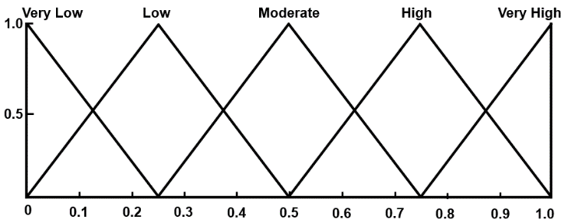
Figure 2. Functions for all linguistic variables (i.e., for inputs and outputs)
To develop IF-THEN rules, interviews were conducted with experts who had experience using fuzzy sets theory in the construction industry and a strong engineering background in managing projects under extreme conditions. The minimum requirement for fuzzy IF-THEN panel sample size to achieve consensus among experts is four, as recommended by Al-Mhdawi et al. (2022). Accordingly, we conducted five interviews with Iraqi construction managers and one risk management professor to develop a list of fuzzy IF-THEN statements for measuring the risk level of emerging COVID-19 risks.
To achieve consensus among experts, four rounds were necessary. Table 2 presents the profiles of the fuzzy panel.
Table 2. Profiles of fuzzy experts
Number of Participants in the Fuzzy Panel | Construction Role | Range of Experience | Education Level
 |  |  | BSc | MSc | PhD
5 | Project managers | 15-24 | 3 | 1 | 0
1 | Risk management academic | 21 | 0 | 0 | 1

At the end, 350 rules were developed for the model. 25 rules for RL estimation, and 125 rules for COVID-19 PL, IL and riskiness level estimation, respectively. Figure 3 present examples of the developed rules for RL, LP, L.I and COVID-19 riskiness level, respectively. Upon completion of the analysis, the results were validated with participants in a follow-up focus group session. We chose this validation method, due to the lack of supporting literature regarding the impact of each COVID-19 emerging risk on construction projects. It is important to mention that the participants in the focus group sessions did not participate in the survey.

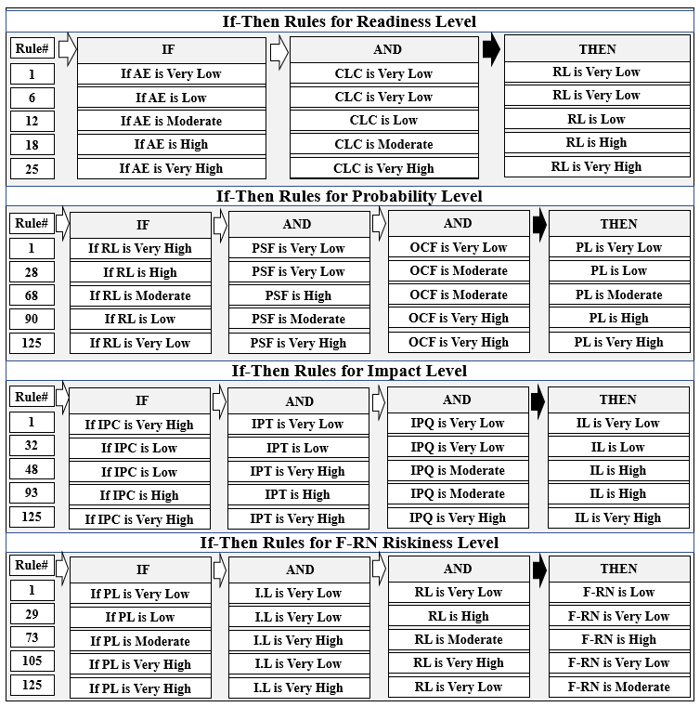
Figure 3. Examples of the developed model's IF-THEN rules
- Results and analysis

4.1 Identified and Classification COVID-19 Risks
Using a focus group session with 11 construction practitioners in Iraq, we identified 46 COVID-19 emerging risks. The identified risks were classified into five themes based on the source of risks, as illustrated in Table 3.

Table 3. Identified COVID-19 risks
Classification | Covid-19 risks
Contractual/Legal Implications | C01. Lack of clarity in the contract language
 | C02. Claims arising under a construction contract
 | C03. Change of law
 | C04. Inappropriate risk allocation
 | C05. Contract suspension
 | C06. Contract termination
Construction Financial Market | C07. Increase in insurance rates
 | C08. Increase in tax rate
 | C09. Fluctuations in exchange rates for currency
 | C10. Escalation in prices of materials
 | C11. Escalation in prices of equipment
 | C12. Reduction in wages for labor
 | C13. Lack of financial flexibility for local government
 | C14. Bankruptcy of contractors
 | C15. Delays in payments
 | C16. Bankruptcy of suppliers
Supply Chain Operations | C17. Scarcity of manpower
 | C18. Lack of construction contractors
 | C19. Skills shortage
 | C20. Machine failure
 | C21. Damage to materials due to prolonged storage and poor storage on construction sites
 | C22. Shortage of construction materials
 | C23. Delays in material delivery
 | C24. Cargo theft
 | C25. Monopolization of construction materials
Health and Safety of the Construction Workforce | C26. Non-compliance with social distancing guidelines
 | C27. Increased subsidy rates
 | C28. Psychological stress
 | C29. Poorly ventilated spaces
 | C30. Delays caused by workforce self-isolating
 | C31. Virus spreading due to poor hygiene and lack of sanitizing stations
 | C32. Virus spreading in the commonly used or high traffic construction area
C33. Lack of cleanliness and sterilization of commonly used surfaces, tools, and workstations by
construction workers
 | C34. Contracting or spreading the virus when traveling to work
 | C35. Contracting or spreading the virus in changing showers, and toilets facilities
 | C36. Contracting or spreading the virus during site meetings and training
 | C37. Lack of face masks or coverings
 | C38. Re-using face masks or covering
Organizational Implications | C39. Delays caused by confusion arising out of the status or effect of government guidance
 | C40. Delayed due to Municipalities' prolonged procedures and routine
 | C41. Delayed work inspection and approval
 | C42. Poor site and virtual communication
 | C43. Restricted site access
 | C44. Delayed contractor mobilization to the site
 | C45. Delay of work progress and reporting
 | C46. Delayed design submission

4.2 Profile of Survey Respondents
Working Sector. As mentioned before, a total of 194 survey responses from construction experts in Iraq were considered for analysis. The latter is equivalent to a response rate of 64.67%, which is considered high compared to previous relevant studies (see e.g., Yates 2014; Tabish and Jha 2018 and others). The distribution of respondents between the public and private sectors was as follows: public (state) sector, 69%; and private sector 31%.
Construction Role. The survey respondents had different construction roles in the Iraqi construction industry, including consultants (13%), contractors (44%), project managers (32%), safety engineers (11%). With such a variety of respondents' construction roles, the views and opinions of experts captured the impact of COVID-19 pandemic risks on the Iraqi construction industry.
Range of Experience. The majority of survey respondents (approximately 69%) had experience in the Iraqi construction industry of more than 15 years. The distribution of the respondents’ range of experience was as follows: 1-5 years, 3%; 6-15 years; 28%; 16-25 years, 38%; and over 25 years; 31%. Ultimately, with such a diverse variety of experience, the collected responses can be considered a good representative of the Iraqi construction industry.
Educational Qualifications. The survey respondents held different educational qualifications, including diplomas (8%), bachelor’s degree (72%), master’s degree (15%), and doctorate degree (5%).
Figures 4 to 7 provide detailed information about the respondents' profile in terms of construction role, experience, and education qualification in the Iraqi construction industry.

Figure 4. Participants’ working sector Figure 5. Participants’ construction role

Figure 6. Participants’ years of experience Figure 7. Participants’ educational
qualifications

4.3 COVID-19 risk assessment under the fuzzy environment
As mentioned in Phase Four of the research methodology, the architecture of the proposed risk assessment model consisted of four fuzzy controllers. The inputs for the first controller were AE, CLC, and RL and the output variable was RL. For the second controller, the input variables were RL, OCF and PSF and the output variable was PL. For the third controller, the input variables were IPC, IPT, and IPQ and the output variable was IL. Lastly, for the fourth controller, the input variables were RL, PL, and IL and the output variable was the riskiness level for COVID-19 risks. The fuzzy controllers were designed using the IF-THEN rules presented in Figure 3. In addition, Figure 8 illustrates the architecture of the proposed risk assessment model. The correlation between fuzzy controllers' inputs and output variables was presented as three-dimensional mapping via Fuzzy logic Surface Viewer. The graphical display of dependencies for each controller included two inputs and one output, as shown in Figures 9 to 12. For instance, Figure 12 illustrates the riskiness surface for the developed model. COVID-19 riskiness on construction projects increases as color intensity increases.
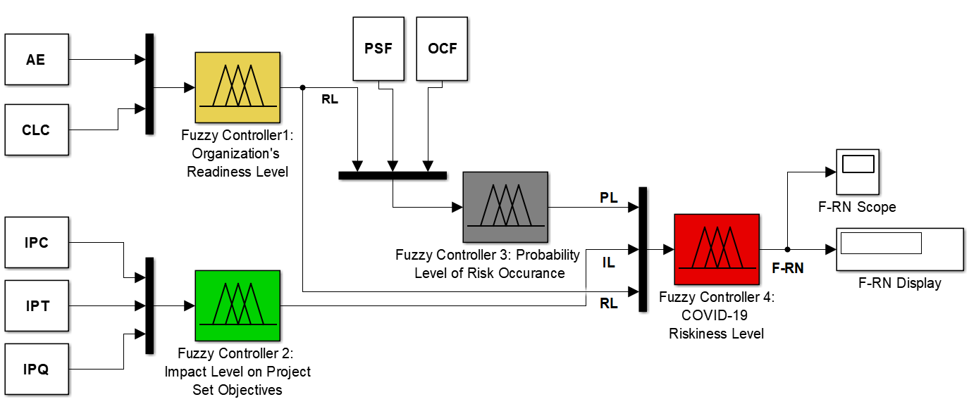
Figure 8. The proposed risk assessment model.
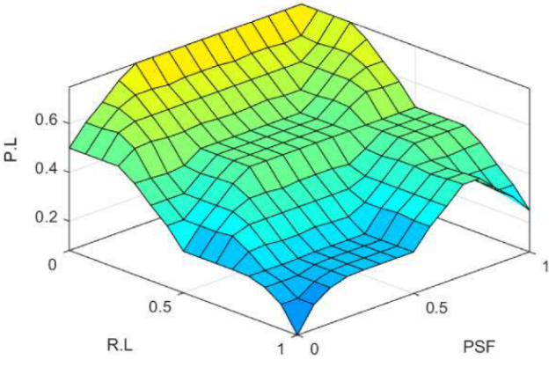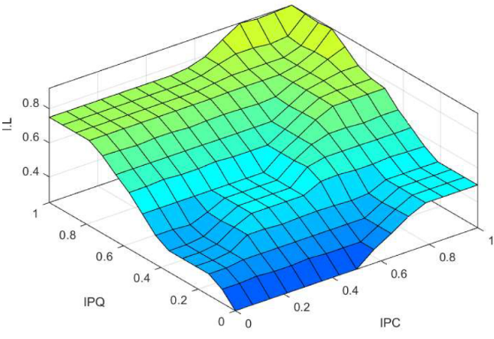
Figure 9. Probability Level Surface Figure 10. Impact level Surface
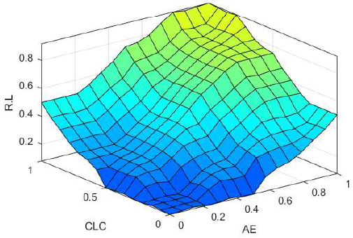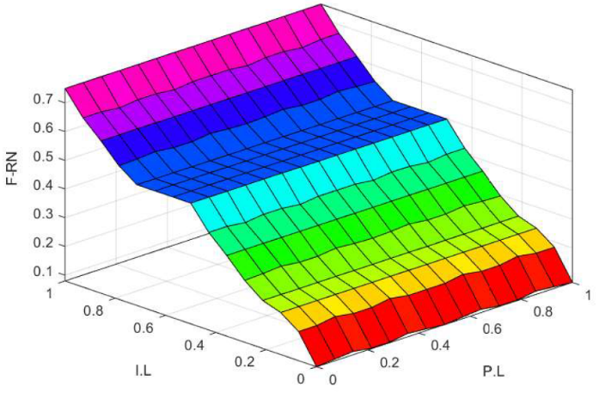
Figure11. Readiness Level Surface Figure 12. COVID-19 risks Riskiness Level Surface

4.4 COVID-19 Risk Assessment
Upon developing the proposed model, we used the mean values of AE, CLC, PSF, OCF, IPC, IPT, and IPQ as inputs (crisp values) to the model as presented in columns 2 to 8 in Table 4 below. The mean values of inputs were (1) fuzzified using triangular membership functions (2) processed conditionally using IF-THEN rules as presented in Figure 3; (3) controlled using a Mamdani-type inference system, and defuzzified using the center of area method. Ultimately, the riskiness level of each COVID-19 risk factor which is represented by F-RN and its rank was generated for all the risk factors as presented in columns 9 and 10 in Table 4.
Table 4. Risk level of each COVID-19 risk factor
Risk ID | Probability Level  (Mean values) |  | Impact Level  (Mean values) |  |  | Readiness Level (Mean values) |  | Fuzzy Risk Number (F-RN) | Rank
 | PSF | OCF | IPC | IPT | IPQ | AE | CLC
C01 | 0.42 | 0.56 | 0.64 | 0.33 | 0.29 | 0.23 | 0.16 | 0.6617 | 9
C02 | 0.85 | 0.65 | 0.53 | 0.41 | 0.74 | 0.30 | 0.26 | 0.7350 | 4
C03 | 0.72 | 0.63 | 0.23 | 0.52 | 0.16 | 0.28 | 0.31 | 0.5302 | 38
C04 | 0.71 | 0.59 | 0.48 | 0.67 | 0.69 | 0.16 | 0.13 | 0.6966 | 5
C05 | 0.62 | 0.81 | 0.78 | 0.94 | 0.63 | 0.22 | 0.25 | 0.8104 | 1
C06 | 0.63 | 0.76 | 0.38 | 0.95 | 0.32 | 0.34 | 0.27 | 0.5983 | 25
C07 | 0.73 | 0.89 | 0.68 | 0.39 | 0.56 | 0.47 | 0.32 | 0.6346 | 16
C08 | 0.46 | 0.69 | 0.72 | 0.41 | 0.62 | 0.26 | 0.32 | 0.6471 | 13
C09 | 0.64 | 0.72 | 0.24 | 0.46 | 0.14 | 0.18 | 0.15 | 0.6353 | 17
C10 | 0.48 | 0.68 | 0.78 | 0.84 | 0.55 | 0.39 | 0.22 | 0.7520 | 3
C11 | 0.74 | 0.48 | 0.35 | 0.69 | 0.26 | 0.20 | 0.25 | 0.6587 | 10
C12 | 0.63 | 0.57 | 0.72 | 0.69 | 0.62 | 0.39 | 0.48 | 0.6165 | 22
C13 | 0.69 | 0.58 | 0.34 | 0.51 | 0.39 | 0.37 | 0.41 | 0.5223 | 40
C14 | 0.58 | 0.73 | 0.69 | 0.78 | 0.53 | 0.21 | 0.23 | 0.8098 | 2
C15 | 0.54 | 0.76 | 0.46 | 0.71 | 0.34 | 0.35 | 0.43 | 0.6020 | 24
C16 | 0.17 | 0.75 | 0.64 | 0.47 | 0.24 | 0.30 | 0.43 | 0.4751 | 42
C17 | 0.47 | 0.63 | 0.18 | 0.75 | 0.53 | 0.32 | 0.54 | 0.5631 | 34
C18 | 0.11 | 0.45 | 0.59 | 0.74 | 0.24 | 0.36 | 0.23 | 0.5507 | 36
C19 | 0.44 | 0.63 | 0.36 | 0.74 | 0.38 | 0.26 | 0.22 | 0.6681 | 7
C20 | 0.12 | 0.74 | 0.15 | 0.58 | 0.40 | 0.54 | 0.36 | 0.3912 | 46
C21 | 0.52 | 0.63 | 0.42 | 0.72 | 0.84 | 0.47 | 0.44 | 0.5938 | 27
C22 | 0.58 | 0.68 | 0.46 | 0.51 | 0.42 | 0.34 | 0.27 | 0.5263 | 39
C23 | 0.61 | 0.74 | 0.38 | 0.85 | 0.28 | 0.23 | 0.30 | 0.6038 | 23
C24 | 0.55 | 0.47 | 0.78 | 0.73 | 0.15 | 0.42 | 0.38 | 0.5651 | 33
C25 | 0.43 | 0.58 | 0.52 | 0.66 | 0.28 | 0.42 | 0.25 | 0.5598 | 35
C26 | 0.49 | 0.68 | 0.37 | 0.63 | 0.51 | 0.14 | 0.21 | 0.6755 | 6
C27 | 0.68 | 0.33 | 0.37 | 0.62 | 0.21 | 0.13 | 0.18 | 0.6504 | 11
C28 | 0.58 | 0.76 | 0.61 | 0.30 | 0.32 | 0.43 | 0.39 | 0.5918 | 29
- C29 | 0.21 | 0.17 | 0.47 | 0.56 | 0.33 | 0.29 | 0.32 | 0.5817 | 31
C30 | 0.18 | 0.39 | 0.33 | 0.78 | 0.15 | 0.32 | 0.28 | 0.5183 | 41
C31 | 0.13 | 0.32 | 0.24 | 0.54 | 0.19 | 0.26 | 0.23 | 0.6439 | 14
C32 | 0.11 | 0.43 | 0.56 | 0.62 | 0.14 | 0.39 | 0.35 | 0.4017 | 45
C33 | 0.15 | 0.24 | 0.43 | 0.58 | 0.16 | 0.27 | 0.21 | 0.6279 | 19
C34 | 0.12 | 0.54 | 0.48 | 0.65 | 0.33 | 0.14 | 0.10 | 0.6433 | 15
C35 | 0.24 | 0.58 | 0.36 | 0.58 | 0.20 | 0.28 | 0.41 | 0.4680 | 43
C36 | 0.22 | 0.47 | 0.59 | 0.64 | 0.24 | 0.33 | 0.26 | 0.5506 | 37
C37 | 0.33 | 0.41 | 0.45 | 0.72 | 0.37 | 0.35 | 0.48 | 0.6218 | 20
C38 | 0.30 | 0.29 | 0.53 | 0.68 | 0.31 | 0.42 | 0.34 | 0.5822 | 30
C39 | 0.34 | 0.81 | 0.38 | 0.58 | 0.14 | 0.22 | 0.19 | 0.6319 | 18
C40 | 0.53 | 0.43 | 0.22 | 0.51 | 0.17 | 0.13 | 0.24 | 0.6489 | 12
C41 | 0.42 | 0.57 | 0.35 | 0.44 | 0.26 | 0.21 | 0.28 | 0.6172 | 21
C42 | 0.13 | 0.84 | 0.67 | 0.64 | 0.44 | 0.24 | 0.29 | 0.6677 | 8
C43 | 0.61 | 0.76 | 0.56 | 0.21 | 0.48 | 0.40 | 0.55 | 0.4561 | 44
C44 | 0.49 | 0.76 | 0.31 | 0.57 | 0.39 | 0.25 | 0.36 | 0.5927 | 28
C45 | 0.56 | 0.49 | 0.41 | 0.53 | 0.20 | 0.34 | 0.18 | 0.5654 | 32
C46 | 0.42 | 0.58 | 0.32 | 0.49 | 0.13 | 0.29 | 0.26 | 0.5951 | 26

- Discussion of research findings
This section discusses the top eight risks arising from the COVID-19 pandemic in the construction industry depending on the findings of the developed assessment model. As mentioned in Phase Four of the research methodology, findings were further discussed with the focus group session’s experts to highlight their significance.
Contract Suspension
Contract suspension (C05) refers to temporary cessation of performance. In the context of Iraq, there are no specific construction regulations regarding health pandemics in the ICC and ICCCEW. In fact, a construction contract may be suspended under certain circumstances such as adverse weather conditions, national holidays, civil wars, military operations, radiation hazards, and revolutions. (ICCCEW 1981).
The following quotes reflect the impression of many of the focus group session participants:
The suspension of contractual obligations by any party affected by the COVID-19 pandemic was treated as an unexpected event that is beyond the parties' reasonable control, which allowed for work stoppages and time extensions [...]. For loss and expense, a contractor who suspends a contract under ICC and ICCCEW is not entitled to financial compensation from the owner, and the contractor must bear the entire cost and risk.
This explains the results of this research, in which C05 was found to be one of the main risks facing the construction industry in Iraq (ranked first).
Contractor Bankruptcy
In the construction industry, there is typically a delay between the time the work is performed and the time that the payment is received. The majority of contracts provide for stage payments in arrears, resulting in the supply chain having substantial work in progress until the payments are received. Businesses may suffer from cash flow issues as a result of a lag in monetary recovery, because they are required to wait up to 90 days or more for their invoices to be paid. To this end, late payments by the client, and supply chain distribution due to extreme conditions and are the most significant causes of contractor’s insolvency, which may ultimately lead to bankruptcy for the contracting company. As a result of the emergency financial crisis resulting from the COVID-19 pandemic, construction companies have been unable to find sufficient workforce, materials, and equipment to continue their progress based on the planned activities and the project finish date (Assaad and El-adaway 2021) which potentially led and continues to lead many contracting companies to file for bankruptcy (Strickland 2020). In the context of Iraq, for example, the Iraqi Contract Conditions for Civil Engineering Works (ICCCEW 1987) stated that during crises contractors are only entitled to time extensions without providing cost reimbursements which may also contribute to contracting companies’ bankruptcy. Further, one of the focus group participants, who is a contractor in the private sector, highlighted the adverse impact of contractor bankruptcy (C14) in Iraq during COVID-19 pandemic on the construction market:
The most bankruptcies during the COVID-19 era in Iraq were recorded for small and new contracting companies. This led to a scarcity of small construction companies, resulting in a void in the market that cannot be filled by large contractors […]. I believe the government should revise their policy and plan during periods of extreme conditions to provide financial support to small and new construction companies.
This explains the results of this research, in which C14 was found to be one of the main risks facing the Iraqi construction industry during the COVID-19 pandemic (ranked second).
Materials Prices Escalation
Materials price escalation (C10) refers to a persistent rise in the prices of the materials used in construction. C10 is caused by a variety of factors, including inflation, supply and demand, politics, macroeconomics, and extreme conditions.
Construction materials typically increase in price each year due to inflation (a problem that contractors faced even prior to the pandemic). Inflation associated with the pandemic, however, has been very different and has played a significant role in the increase of construction costs. Iraq's construction industry heavily relies on foreign construction materials. As COVID-19 is a global pandemic, international factories that manufacture construction materials have experienced production delays. Thus, the supply of construction materials in Iraq dramatically decreased, and what was left became much more expensive.
The following quotes reflect the impression of many of the focus group session participants:
The Iraqi supply chain was disrupted by the volatile global market, creating an increase in material costs largely linked to copper, aluminum, and other products, pushing prices out of reach across most industries.
This explains the results of this research, in which C10 was found to be one of the main risks facing the Iraqi construction industry during the COVID-19 pandemic (ranked third).
Construction Contract Claims
C02 refers to the extent of integration of special construction terms into the contractual conditions to address health-related pandemics. Globally, the COVID-19 pandemic continues to affect construction projects, leading to an increase in construction claims. Compared to developed countries, where vaccine roll-out is faster, contractors in developing countries anticipate that Covid-19 will continue to affect their projects and that the recovery of the industry will take longer than it does in developed countries (Olatunde et al. 2021).
One of the focus group session participants, who is an experienced project manager, had this to say:
Iraq has introduced economic support measures in the majority of its major markets. However, no economic support has been provided to Iraq's construction sector […]. Despite the fact that contracting companies are covered by insurance schemes in most countries, the insurance mechanism for contracting companies in Iraq is inadequate, resulting in many claims […]. Even though some claims arising from delays related to Covid have been settled, we are still lacking clarity from courts and arbitral institutions regarding how these disputes will be resolved.
This explains the results of this research, in which C02 was identified as one of the major risks facing the construction industry in Iraq (ranked fourth).

Non-compliance with Social Distancing Guidelines
Complying with social distancing is one of the best practices to reduce the spread of the virus in the construction industry (Assaad and El-adaway 2021). Due to the rapid spread of COVID-19 virus worldwide and the extremely low vaccination rate in the Iraq, the Iraqi central government has placed a great deal of emphasis on social distancing.
According to the participants in the focus group session, the vast majority of Iraqi construction workers do not adhere to the recommendations of COVID-19 regarding maintaining social distance and wearing personal protective equipment. On the other hand, experts stressed the importance of establishing onsite health and safety management that specializes in COVID-19 testing and implementing social distancing procedures, as well as ensuring that proper construction safety measures are in place to control the spread of the COVID-19 virus.
This explains the findings of this study, in which C26 was found to be one of the main risk factors affecting construction worker health and safety (ranked sixth).
Skills Shortage
Skills shortage (C19) refers to the state of the workforce at the market or project level. In developing countries, the shortage of skilled workers has posed a significant challenge to the construction industry during the COVID-19 pandemic (Olatunde et al. 2021). Most of the participants in the focus group indicated that the severe impact of COVID-19 on industries in general, and construction in particular, has contributed to a shortage of skilled workers in Iraq. Additionally, experts have identified several secondary factors that may contribute to this shortage, including (1) an increased retirement rate, (2) work-related injuries, and (3) unstable wages. This explains the results of this research, in which C19 was found to be one of the main risks facing the construction industry in Iraq (ranked seventh).
Poor Site and Virtual Communication
Several studies have identified poor communication practices as one of the major causes of project delays in the construction industry (Ruqaishi and Bashir 2015; Seddeeq 2019; Abdul Nabi and El-adaway 2021). During COVID-19 era, the shift to video conferencing for regular meetings has been one of the most significant changes in the form of communication for industries (Encinas et al. 2021). However, this shift has been countered by many challenges, particularly in the context of developing countries like Iraq.
One of the focus group session participants, who is an experienced project manager, had this to say:
The inaccessibility of the internet, particularly at remote locations, is one of the primary obstacles to effective communication within project teams.
Furthermore, one of the focus group session’s participants highlighted the following:
Digital channels are less interpersonal and more difficult to engage the project team compared to site meetings.
This explains the results of this study, in which C42 was found to be one of the main risk factors impacting project performance (ranked eighth).
- Conclusion
This research proposes a novel risk assessment model for construction projects under extreme conditions by considering the construction industry of Iraq during the COVID-19 pandemic. We : (1) identified and classification the risk factors arising from the COVID-19 pandemic in the construction industry; and (2) quantified their level of riskiness in terms of their probability of occurrence, impact on project set objectives, and organization's level of readiness. First, a focus group session with 11 construction practitioners in Iraq was carried out to identify a list of COVID-19 risks for the construction industry. Second, a multi-criteria risk assessment model based on FST was established depending on experts’ recommendations. Third, a survey was distributed to and answered by 194 construction professionals to quantify the PL, IL and the RL and their components (i.e., PSF, OCF, IPC, IPT, IPQ, AE, and CLC) for each identified risk factor. Finally, the identified COVID-19 risks were analysed using the developed model and validated by experts in a follow up focus group session. Ultimately, we identified a total of 46 risks classification under five themes as illustrated in Table 3.
The results showed that the following eight risks were common factors affecting construction project objectives during COVID-19 era: (1) contract suspension; (2) contractor bankruptcy; (3) materials prices escalation; (4) construction contract claims; (5) inappropriate risk allocation; (6) non-compliance with social distancing guidelines; (7) skills shortage; and (8) poor site and virtual communication.
6.1 Methodological Implications
Previous research on COVID-19 and the construction industry has employed different tools to capture the negative impact on project objectives like agent-based modeling (Araya 2021), and discrete-event simulation (Afkhamiaghd and Elwakil 2020). This research proposed a new risk assessment model that considered the available expertise, company’s level of contingencies, political and security factors, out of control factors, and the impact on the project, time, cost, and quality. In addition, the proposed model was applied under the fuzzy environment with the aim of formalizing and dealing with human knowledge and uncertainties during decision-making processes (Al-Mhdawi 2020; Muhammad and Madhav 2016).
6.2 Theoretical and Practical Implications
The results of this study will provide construction decision-makers and academics with a better understanding of the key risks associated with the COVID-19 pandemic. In addition, this paper presents a novel model for analysing extreme conditions’ risks related to COVID-19 pandemic and further pandemics. Ultimately, the outcomes of this research would enhance the risk management effectiveness in the construction industry of developing countries and minimize project losses by capturing the role of organization's level of readiness and considering the components of assessment criteria which are much needed when projects are subjected to high levels of uncertainties during extreme conditions.
6.3 Research Limitation
Despite its value, this study has some limitations. First, this research relies on expert judgment through focus group sessions and questionnaire surveys. Other methods, such as project-based case studies, should be considered to complement the results. Second, we identified only 46 risks that were classified under five main construction themes. Other risks emerging from the COVID-19 pandemic should be identified and classified under the study existing themes or under new construction themes. Third, the survey was distributed to construction experts working in three major cities in Iraq: Baghdad, Basra, and Babylon. These cities involve the majority of the construction activities and foreign direct investment. Furthermore, they are considered relatively safe compared to other cities located in the central and southern regions of Iraq. However, cities located in the north of Iraq, such as those in the Kurdistan region, were not included in our survey due to accessibility issues. Finally, not all the stakeholder’s groups were involved in the COVID-19 risk identification and assessment. Other stakeholders such as suppliers and end-users should be invited to conduct follow up studies.
Disclosure statement
No potential conflict of interest was reported by the author(s).
Acknowledgement
This research is part of the first author's Ph.D. thesis conducted at the University of Southampton, UK.

References
Abd El Khalek H, Aziz R F, Kamel H M. 2016. Risk and uncertainty assessment model in international construction projects using fuzzy logic. International Journal of Innovative Research in Engineering & Management. 3(2):134-149.
Abdul Nabi M, El-adaway I H. 2021. Understanding the Key Risks Affecting Cost and Schedule Performance of Modular Construction Projects. Journal of Management in Engineering, 37(4): 04021023.
Abdulhussein H, Shibaani A. 2016. Risk management in construction projects in Iraq: contractors' perspective. Int. Journal of Eng. Research. 4(3):114-130.
Afkhamiaghd A M, Elwakil E. 2020. Preliminary modeling of Coronavirus (COVID-19) spread in construction industry. Journal of emergency management (Weston, Mass.): 18(7), pp.9-17.
Agyekum K, Kukah A S, Amudjie J. 2021. The impact of COVID-19 on the construction industry in Ghana: the case of some selected firms. Journal of Engineering, Design and Technology. 20(1): pp.222-244.
Al-Mhdawi M K S, Motawa I, Rasheed H. 2020. Assessment of risk management practices in construction industry. In the10th Int. Conf. on Eng. Project, and Production Management, Project, and Production Management (pp. 421-433).
Al-Mhdawi M K S, O'Connor A, Brito M P, Qazi A, Rashid H A. 2022. Modeling the effects of construction risks on the performance of oil and gas projects in developing countries: project managers' perspective. Proceedings of Civil Engineering Research in Ireland (CERI 2022).
Al-Mhdawi M K S. 2020. Proposed risk management decision support methodology for oil and gas construction projects. In the10th Int. Conf. on Eng. Project, and Production Management (pp.407-420)
Al-Mhdawi M.K.S. 2022. Risk management of construction projects under extreme conditions: A case study of Iraq. PhD Thesis. The University of Southampton, UK.
Alsharef A, Banerjee S, Uddin S M, Albert A, Jaselskis E. 2021. Early impacts of the COVID-19 pandemic on the United States construction industry. Int. Journal of environmental research and public health. 18(4):1559.
Amoah C, Simpeh F. 2020. Implementation challenges of COVID-19 safety measures at construction sites in South Africa. Journal of Facilities Management. 19(1).
Araya F. 2021. Modeling the spread of COVID-19 on construction workers: An agent-based approach. Safety Science. 133(2021):105022.
Assaad R, El-adaway I H. 2021. Guidelines for Responding to COVID-19 Pandemic: Best Practices, Impacts, and Future Research Directions. Journal of Management in Engineering. 37(3): 06021001.
Bekr G A. 2015. Causes of delay in public construction projects in Iraq. Jordan Journal of Civil Engineering. 9(2).
Bernard H R. 2011. Research Methods in Anthropology: Qualitative and Quantitative Approaches. Rowman and Littlefield.
Bin Seddeeq A, Assaf S, Abdallah A, Hassanain M A. 2019. Time and cost overrun in the Saudi Arabian oil and gas construction industry. Buildings. 9(2): 41.
Breen R L 2006. A Practical Guide to Focus-Group Research. Journal of geography in higher education. 30(3): 463-475.
Brewer G, Gajendran T, Le Goff R. 2012. Building information modelling (BIM): Australian perspectives and adoption trends. Centre for Interdisciplinary Built Environment Research (CIBER), September 2012.
Buniya M K, Othman I, Sunindijo R, Kineber F, Mussi, Ahmad H. 2021. Barriers to safety program implementation in the construction industry. Ain Shams Eng. Journal. 12(1): 65-72.
Buniya M K, Othman I, Durdyev S, Sunindijo R Y, Ismail S, Kineber A F. 2021. Safety Program Elements in the Construction Industry: The Case of Iraq. Int. journal of environmental research and public health. 18(2): 411.
Casady C B, Baxter D. 2020. Pandemics, public-private partnerships (PPPs), and force majeure| COVID-19 expectations and implications. Construction Management and Economics. 38(12):1077-1085.
Chigara B, Moyo T. 2021. Factors affecting the delivery of optimum health and safety on construction projects during the covid-19 pandemic in Zimbabwe. Journal of Eng. Design and Technology. 20 (1): 24-46.
Chigara B, Moyo T. 2021. Factors affecting the delivery of optimum health and safety on construction projects during the covid-19 pandemic in Zimbabwe. Journal of Engineering, Design and Technology. 20(1): 24-46.
Christmann A, Van A S. 2006. Robust estimation of Cronbach's alpha. Journal of Multivariate Analysis. 97(7):1660-1674.
Collis J, Hussey R. 2014. Business research: A practical guide for undergraduate and postgraduate students. London: Palgrave Macmillan.
Cox A. 2008. What's wrong with risk matrices?. Risk Analysis: An International Journal. 28(2): 497-512.
Creswell J W, Creswell J D. 2017. Research design: Qualitative, quantitative, and mixed methods approaches. Sage publications
Deloitte. 2017. Deloitte GCC Powers of Construction 2017, If it’s fundable it’s feasible [online]; [accessed 2022 Aug 23].https://www2.deloitte.com/content/dam/Deloitte/xe/Documents/realestate/construction/gccpowersofconstruction/ me_construction_gccpoc2017.pdf#
Elnaggar S M, Elhegazy H. 2022. Study the impact of the COVID-19 pandemic on the construction industry in Egypt. In Structures. 35: 1270-1277.
Encinas E, Simons A, Sattineni A. 2021. Impact of COVID-19 on Communications within the Construction Industry. EPiC Series in Built Environment. 2: 165-172.
Gill I, Schellekens. 2021. COVID-19 is a Developing Country Pandemic [online]; [accessed 2022 Jun 17].https://www.brookings.edu/blog/future-development/2021/05/27/covid-19-is-a-developing-country-pandemic/
Gunduz M, Nielsen Y, Ozdemir M, 2015. Fuzzy assessment model to estimate the probability of delay in Turkish construction projects. Journal of Management in Engineering. 31(4): 04014055.
IOM (International Organization for Migraiton). 2020. “Impact of COVID19 on small and medium-sized enterprises in Iraq [online]; [accessed 2022 Aug 06].https://www.iom.int/.
Kassem M A, Khoiry M A, Hamzah N. 2019. Using probability impact matrix (PIM) in analyzing risk factors affecting the success of oil and gas construction projects in Yemen. Int. Journal of Energy Sector Management.14(3): 527-546.
Khalfan M, Ismail M. 2020. November. Engineering Projects and Crisis Management: A Descriptive Study on the Impact of COVID-19 on Engineering Projects in Bahrain. In 2020 2nd Int. Sustainability and Resilience Conf. : Technology and Innovation in Building Designs (pp. 1-5).
King S S, Rahman R A, Fauzi M A, Haron A T. 2021. Critical Analysis of Pandemic Impact on AEC Organizations: The COVID-19 Case. Journal of Engineering, Design and Technology. 20 (1): 358-383.
Krippendorff K. 2013. Content analysis: An introduction to its methodology. Sage publications.
Kukoyi P O, Simpeh F, Adebowale O J, Agumba J N. 2021. Managing the risk and challenges of COVID-19 on construction sites in Lagos, Nigeria. Journal of Engineering, Design and Technology. 20(1): 99-144.
Market Research Iraq. 2021. Construction and Infrastructure[online]; [accessed 2022 July 15]. https://www.marketresearchiraq.com/industry/construction-infrastructure.
Matsunaga H. 2019. The Reconstruction of Iraq after 2003: Learning from Its Successes and Failure. World Bank Publications.
McKinsey global institute. 2020. Reinventing Construction. Accessed August 22, 2021. https://www. mckinsey.com
Mohamed M, Tran D Q. 2021. Risk-Based Inspection Model for Hot Mix Asphalt Pavement Construction Projects. Journal of Construction Engineering and Management. 147(6): 04021045.
Muhammad S I, Madhav N. 2016. A Fuzzy- Bayesian model for risk assessment in power plant projects. Proceeding of Conference on ENTERprise Information Systems / Int. Conf. on Project MANagement / Conference on Health and Social Care Information Systems and Technologies, CENTERIS / ProjMAN / HCist 2016, October 5-7, 2016. (pp. 963-970)
Nguyen B N, Nguyen T Q , Dinh H T, Chu A T. 2021. The Impact of the COVID-19 on the Construction Industry in Vietnam. International Journal of Built Environment and Sustainability. 8(3): 47-61.
Nyumba T, Wilson K, Derrick C J, Mukherjee N. 2018. The use of focus group discussion methodology: Insights from two decades of application in conservation. Methods in Ecology and evolution. 9(1): 20-32.
OECD (Organisation for Economic Co-operation and Development). 2020. Coronavirus (COVID-19): SME policy responses[online]; [accessed 2022 July 01]. https://www.oecd.org.
Olanrewaju O I, Chileshe N, Adekunle E O, Salihu C. 2022. Modelling the environmental, economic and social impacts of coronavirus pandemic on the construction industry. International Journal of Construction Management. pp.1-14.
Olatunde N A, Awodele I A, Adebayo B O. 2021. Impact of COVID-19 pandemic on indigenous contractors in a developing economy. Journal of Engineering, Design and Technology. 20(1): 267-280.
Pamidimukkala A. Kermanshachi S. and Jahan Nipa. 2021. Impacts of COVID-19 on Health and Safety of Workforce in Construction Industry. In Int. Conf. on Transportation and Development 2021 (pp. 418-430).
Qazi A, Shamayleh A, El-Sayegh S, Formaneck S. 2021.Prioritizing risks in sustainable construction projects using a risk matrix-based Monte Carlo Simulation approach. Sustainable Cities and Society. 65:102576.
Rehman M S U, Shafiq M T, Afzal M. 2021. Impact of COVID-19 on project performance in the UAE construction industry. Journal of Engineering, Design and Technology. 20 (1): 245-266.
Renuka S M, Umarani C, Kamal S. 2014. A review on critical risk factors in the life cycle of construction projects. Journal of Civil Engineering Research. 4(2A): 31-36.
Research and Markets. 2019. Construction in Iraq key trends and opportunities to 2023. Report ID: 4846333[online]; [accessed 2022 Nov 16]. https://www.researchandmarkets.com/reports/4846333/construction-in-iraq-key-trends-and
Rezakhani P. 2012. Classifying key risk factors in construction projects. Buletinul Institutului Politehnic din lasi. Sectia Constructii, Arhitectura. 58(2): p.27.
Ruqaishi M. Bashir H.A 2015. Causes of Delay in Construction Projects in the Oil and Gas Industry in the Gulf Cooperation Council Countries: a Case Study. Journal. of mgt. in engineering. 31(3): 05014017.
Salami B A, Ajayi S O, Oyegoke A S. 2021. Tackling the impacts of Covid-19 on construction projects: an exploration of contractual dispute avoidance measures adopted by construction firms. International Journal of Construction Management, pp.1-9.
Shahbazi B, Akbarnezhad A, Rey D, Ahmadian F F A, Loosemore M. 2019. Optimization of job allocation in construction organizations to maximize workers’ career development opportunities. Journal of Construction Engineering and Management. 145(6):04019036.
Sierra F. 2021. COVID-19: main challenges during construction stage. Engineering, Construction and Architectural Management. 29(4):1817-1834.
Statista. 2021. Canada – Inflation rate 1986–2026 [online]; [accessed 2021 Feb 23]. https://www.statista.com/statistics/271247/inflation-rate-in-canada/
Stiles S, Golightly D, Ryan B. 2021. Impact of COVID‐19 on health and safety in the construction sector. Human Factors and Ergonomics in Manufacturing and Service Industries. 31: 425–437.
Strickland J T. 2020. Addressing financial impacts of the COVID-19 crisis on construction companies[online]; [accessed 2022 Sep 02]. https://www.natlawreview.com/article/addressing-financial-impacts-covid-19-crisis-construction-companies.
Tabish S Z S, Jha K N. 2018. Beyond the iron triangle in public construction projects. J. Constr. Eng. Manage. 144 (8): 04018067.
United Nations .2019. World population prospects 2019: highlights[online]; [accessed 2022 Dec 05]. https://population.un.org/wpp/Publications/Files/WPP2019_Highlights.pdf
Walter D. 2020. Implications of Covid-19 for labour and employment in India. The Indian Journal of Labour Economics, 63(1), pp.47-51.
World Bank. 2020. Iraq Economic Monitor, fall 2020 : Protecting Vulnerable Iraqis in the Time of a Pandemic, the Case for Urgent Stimulus and Economic Reforms [online]; [accessed 2022 Sep 03].https://openknowledge.worldbank.org/handle/10986/34749 License: CC BY 3.0 IGO.
Yates J K. 2014. Design and construction for sustainable industrial construction. Journal of Construction Engineering and Management. 140 (4): B4014005.
Zadeh L A. 1965. Fuzzy sets . Information and Control. 8: 338-353.

