“Shiny” crypto assets: A systemic look at gold-backed cryptocurrencies during the COVID-19 pandemic

Abstract
In this paper, we empirically analyse the performance of five gold-backed stablecoins during the COVID-19 pandemic and compare them to gold, Bitcoin and Tether. In the digital assets’ ecosystem, gold-backed cryptocurrencies have potential to address the regulatory and policy concerns by decreasing volatility of cryptocurrency prices and facilitating a broader cryptocurrency adoption. We find that during the COVID-19 pandemic, gold-backed cryptocurrencies were susceptible to volatility transmitted from gold markets. Our results indicate that for the selected gold-backed cryptocurrencies, their volatility, and as a consequence, risks, associated with volatility, remained comparable to the Bitcoin. In addition, gold-backed cryptocurrencies did not show safe haven potential comparable to their underlying precious metal, gold.

Key words: stablecoins; cryptocurrencies; gold-backed cryptocurrencies; COVID-19; gold;.

1. Introduction
In this paper, we empirically analyse the performance of five gold-backed stablecoins during the COVID-19 pandemic and compare them to gold and Bitcoin. Stablecoins are one of the most recent innovations in the digital asset ecosystem that have been designed to reduce the volatility inherent in cryptocurrencies in general. In contrast to the leading decentralised digital currencies such as Bitcoin and Ethereum, stablecoins have an in-built price stability mechanism to minimize exchange rate volatility which makes them more attractive for investors. This can be witnessed from their tremendous growth - the market for stablecoins has grown tenfold over the last two years, from $1.4 billion at the start of 2018 to $10.4 billion in May 2020. In addition, the US-dollar backed stablecoin Tether has become the most tradable cryptocurrency with a traded value of $54bn.
Algorithmic and asset-backed stablecoins gained colossal popularity due to their relative ease of convertibility to fiat currencies and links with commonly-used stability benchmarks, such as US dollar and gold. However, gold-backed tokens received attention only in March 2020, which is much later than fiat-backed currencies, when they witnessed a spike in market capitalisation owing to the flight-to-safety behaviour of investors during the COVID-19 crisis. Being associated with both gold and cryptocurrencies, gold-backed tokens offer the potential to become a new safe haven asset offering abnormal returns during uncertain times such as the current pandemic.
Financial regulators have viewed the rapid expansion of decentralised digital assets as a potential threat to financial stability and have since considered different ways of protecting investors and cryptocurrency users against fraud, excess risk, and market crash (e.g., BIS, 2019; FSB, 2020; Arner et al., 2020). Not only has the impressive growth of cryptocurrency markets over the last decade been associated with high speculative activity, cryptocurrency markets have been found to be highly bubble-prone (e.g., Cheah and Fry, 2015; Corbet et al., 2018a).
Corbet et al. (2018b) study the interconnectedness between different cryptocurrencies and highlight the dominant role of Bitcoin as the source of this interconnectedness. Cryptocurrencies, especially Bitcoin, have often been compared to gold and their safe haven properties documented over time (see for instance, Klein et al., 2018; Das et al., 2018, among others). In the context of the COVID-19 pandemic, however, early evidence suggests that in fact cryptocurrency markets did not display the same hedging and safe haven potential as precious metals (e.g., Conlon and McGee, 2020).
Even though cryptocurrency literature is very broad, there exists limited empirical evidence regarding the safe haven properties and interconnectedness of Stablecoins. Griffin and Shamst (2020) analyse whether Tether, a USD-backed stablecoin, inﬂuenced Bitcoin and other cryptocurrency prices during the boom of 2017. They find that Bitcoin prices increased with purchases using Tether. Ante et al. (2020) analyse seven fiat-backed stablecoins and find that stablecoin issuances contribute to price discovery and market efficiency of cryptocurrencies. Wang et al. (2020) analyse three USD-pegged and three gold-pegged stablecoins (DGD, HGT, and XAUR) up to March 2019 and show that even though gold-backed cryptocurrencies are not as effective as gold in their safe haven properties, they can still be used effectively in reducing extreme losses. Aloui et al. (2020) analyse differences between Islamic and non-Islamic gold-backed cryptocurrencies and show that the former are less susceptible to geopolitical risk than non-Islamic tokens. Wasiuzzaman et al. (2021) further investigate the performance of PAX Gold during the COVID-19 pandemic and report time-varying safe haven properties. In a nutshell, existing empirical evidence is available only for very few gold-backed tokens using rather narrow methodological approaches. Our aim in this paper, therefore, is to extend this literature.
To empirically analyse the performance of five gold-backed stablecoins during the Covid-19 pandemic and compare them to gold, Bitcoin and Tether we employ a battery of empirical tests to daily data of five main gold-backed cryptocurrencies, i.e. Digix Gold Token (DGX), Perth Mint Gold Token (PMGT), Tether Gold (XAUT), PAX Gold (PAXG) and the Midas Touch Gold (TMTG), as well as Bitcoin, Tether and gold prices for the period March 2020– August 2021. First, we employ tail copula methodology that allows us to measure dependence between variables at the tails of their distributions. Second, we investigate the potential of gold-backed stablecoins to bounce back to pre-pandemic levels using the Yang and Zhao (2020) unit root test, popular in literature to capture mean-revering behaviour of crypto assets (e.g. Yarovaya et al. 2021). Third, we asses the return and volatility spillover between selected assets using the well-known Diebold and Yilmaz (2012) approach that has been employed widely in cryptocurrency literature (e.g. Corbet, 2018).
Our results indicate that during the COVID-19 pandemic, for the selected gold-backed cryptocurrencies, their volatility, and as a consequence, risks, associated with volatility, remained comparable to the Bitcoin. In addition, gold-backed cryptocurrencies did not show safe haven potential comparable to their underlying precious metal, gold. We uncovered several surprising patterns in our data, which could be interesting for a wide range of practitioners, investors, and financial regulators who are looking for additional empirical evidence on properties and behaviour of stablecoins during periods of increased uncertainty.
This paper is organised as follows. Section 2 explains the main characteristics of gold-backed currencies. While Section 3 discusses technological characteristics of stablecoins, Section 4 focuses on technological aspects of gold-backed stablecoins. Section 5 describes data, the variables of interest and methodology. Section 6 reports empirical results and Section 7 concludes.

2. Technological characteristics of Stablecoins
Financial Technology (Fintech) transforms businesses and affects how financial services are provided. Fintech innovations create opportunities for financial inclusion and help move closer to the UN Sustainable Development Goals (Senyo & Osabutey, 2020). Many financial instruments have been unavailable for most retail investors due to high transaction costs and large denominations, thus being accessible only via investment funds and other large institutional investors. This is why the idea of a decentralised financial system (Nakamoto, 2008) quickly became popular and led to the rapid adoption of blockchain technology for money transfer. At their outset, cryptocurrencies were aimed at decreasing transaction costs, and facilitate free cross-border transfer of funds, thereby providing an alternative to fiat currencies (Shilling and Uhlig, 2019; Easley et al., 2019).
Corbet et al. (2020) distinguish between three main types of digital assets: (i) Currencies: digital assets whose primary use is in monetary transfer and payment; (ii) Blockchains/Protocols: digital assets whose primary function is that of a blockchain platform, or protocol, on which other applications can be built; (iii) Decentralised Applications (dApps): Applications combining user interface and a decentralised back-end, built upon an already existing blockchain. Technologies behind financial payment systems are rapidly evolving, and the most recent innovations in the area aim to address the limitations of the already popular and heavily used Fintech instruments.
Since their creation, cryptocurrencies have been known for their excess volatility, explosivity, market manipulation, and related ethical issues (Gandal et al., 2018). Therefore, at the level of conception, stablecoins have been designed to address some of these challenges and offer a more stable financial instrument to the existing digital payment system. Contrary to Bitcoin, Ethereum, and other well-known cryptocurrencies, whose prices are market-determined which adds to their volatility, stablecoins are backed with commodities or fiats that help check high volatility. They are also designed to enable easier and cheaper access to other markets such as gold silver, and offer more cost-efficient transfer of funds from crypto assets to fiat currencies.
Stablecoins are of mainly two types: First, Collateralized Stablecoins, that include fiat-backed stablecoins whose values are pegged to and backed by reserves of fiat currency, Crypto-backed stablecoins that are backed by cryptocurrencies and asset-backed stablecoins that are underpinned by reserves of assets other than fiat or cryptocurrencies, for instance gold, diamonds, oil etc. Second, non-collateralized Stablecoins, also known as algorithmic stablecoins, or seigniorage supply coins. They do not have any underlying asset and their supply is “regulated” by an algorithm or a decentralized model of governance based on holder votes. Another category is that of hybrid stablecoins that combine the aforementioned features of reserve-backing as well as algorithms or voting to offset volatility. Bullmann et al (2019) provides a comprehensive overview of the stability mechanisms behind different types of stablecoins (i.e., tokenised bunds, off-chain and on-chain collateralised stablecoins, algorithmic stablecoins), and discusses their implications for financial stability.
3. What are gold-backed stablecoins?
Gold-backed stablecoins are asset-backed stablecoins that have physical gold as their underlying asset. Their prices are pegged to gold, making them a less volatile financial instrument. Gold-backed tokens can also be used as collateral for peer-to-peer lending since this information would be safely and securely stored on the Blockchain.
In this study we focus on the five main gold-backed stablecoins: Digix Gold Token (DGX), Perth Mint Gold Token (PMGT), Tether Gold (XAUT), PAX Gold (PAXG) and the Midas Touch Gold (TMTG). The gold-backed cryptocurrencies are compared to gold, Bitcoin and Tether. We included Tether in our analysis to compare the behaviour of selected gold-backed cryptocurrencies with other stablecoins which value is not pegged to gold, but to the USD. Tether is commonly seen as a tool facilitate transactions between fiat currencies and digital assets, and as asset that can affect liquidity of cryptocurrency markets, including Bitcoin (Griffin and Shams, 2020). Tether has the largest market capitalization (i.e. 68.8 billion dollars) among other stablecoins, and has the largest 24-h trading volume among all cryptocurrency traded nowadays. Therefore, we use Tether to account for other stablecoin and digital assets that pegged to a fiat currency.

3.1. Digix Gold Token (DGX)
Digix Gold Token (DGX) is an asset-backed token, backed by the weight of gold (1DGX=1 gram of gold). It uses the Proof of Provenance (PoP) protocol based on Ethereum and the Inter Planetary Files System (IPFS). In addition to Ethereum, Digix uses EOS and Neo blockchains. Digix was established in 2014 in Singapore, and currently has two main cryptocurrencies: Digix Gold (DGX) and Digix DAO (DGD) that provides opportunities to create tokens backed by digital assets. Their value being pegged to physical gold, and DGX claims to provide a safer collateral for borrowing and lending, and act as a convenient instrument for peer-to-peer lending. DGX was the first gold-backed crypto asset of its kind, and is currently traded on some of the largest cryptocurrency exchanges such as Bitfinex, Hotbit, ProBit Exchange and KyberSwap among others. DGX tokens are fully redeemable for gold bullions, which presumably make them more attractive and a safer investment choice in comparison to other cryptocurrencies. They aim to provide a simpler way to invest in traditional gold markets.

3.2. Perth Mint Gold Token (PMGT)
In contrast to DGX and DGD, Perth Mint Gold Token (PMGT) is a gold-backed stablecoin, built on a public blockchain, backed by government-guaranteed gold. Launched in October 2018, PMGT is backed by a GoldPass digital gold certificate issued by The Perth Mint and guaranteed by the Government of Western Australia. Each PMGT equals 1 fine troy ounce of physical gold. It is an ERC20 compliant token on the Ethereum network and has additional smart contract features to enhance its security and regulation. The supply varies constantly, increasing when GoldPass certificates are exchanged for PMGT, and decreasing each time PMGT is redeemed for gold certificates. Like gold-backed cryptocurrencies, PMGT aims to simplify access to gold markets for institutional and retail investors and attract market participants desirous of participating in Fintech and blockchain innovations, but sceptical of the excessive volatility of cryptocurrency markets. PMGT claims to be the most cost-effective gold asset given the absence of any storage/ management fees as well as issuance fee to convert GoldPass certificates to PMGT and vice versa. However, the standard GoldPass fees continues to apply each time investors choose to convert their gold certificates back to fiat currencies or to redeem them for physical gold bullion.

3.3. Tether Gold (XAUT)
Tether Gold is a digital asset offered by TG Commodities Limited, which represents one troy fine ounce of gold on a London Good Delivery gold bar, and currently trading at FTX, Bitfinex, Delta Exchange and Goku Markets. XAUT uses Ethereum blockchain, and have similar characteristics to other gold-backed stablecoins. There are two distinctive features can be mentioned however, individual allocation and redemption conditions. By purchasing 1 unit of XAUT investors will receive ownership rights of one troy fine ounce of physical gold on a specific gold bar, that can be checked using a unique serial number via the look-up website. The investors would be asked to pay one-off using the purchase of XAUT using their TG Commodities Limited accounts, and additional fees on redemption of the tokens, however, investors should hold one full bar of gold worth tokens to request redemption.

3.4. PAX Gold (PAXG)
Like other currencies mentioned above, PAX Gold is also an ERC-20 token on the Ethereum Blockchain, and it is backed by one fine troy ounce (t oz) of a 400 oz London Good Delivery gold bar, that is stored in Brink’s gold vaults. Created in September 2019, PAXG does not have any government guarantee unlike the PMGT, and its underlying physical gold is stored by Paxos Trust Company, regulated by the New York State Department of Financial Services. The top exchanges for PAXG trading are Binance, BitZ, HitBTC, and Kraken. These tokens claim to be converted conveniently into gold through a network of gold retailers in the US and Canada, or into USD at the prevailing market price of gold. In addition to their claim to have one of the lowest on-chain transaction fees in the sector, PAXG also offers their investors the opportunity to confirm their actual ownership of physical gold using a unique serial number.

3.5. The Midas Touch Gold (TMTG)
Finally, we consider TMTG gold-backed token that also operated on the Ethereum. However, in contrast to other stablecoins in our sample, it cannot be directly purchased with fiat currency, and investors have to use Tether first and only after purchase TMTG on the exchanges that offer these tokens, for example, OKEx, MEXC, and Bitglobal. Therefore, we hypothesise that behaviour of TMTG during the COVID-19 would be influenced not only by Bitcoin, but also by Tether, which further justifies our selection of tokens for the analysis. TMTG can be also categorized as utility token used for maintaining the TGXC (Touch Gold Exchange) ecosystem and to purchase other cryptocurrencies on the TGXC DEX platform, while TG tokens are pegged to gold, 1 TG pegged to 1g of gold.

4. Data, variables of interest and methodology
4.1. Data
We collect daily prices for the most tradable gold-backed cryptocurrencies from coinmarketcap.com for Digix Gold Token (DGX), Perth Mint Gold Token (PMGT), Tether Gold (XAUT), PAX Gold (PAXG) and the Midas Touch Gold over the COVID pandemic period from March 2020 to August 2021. Our sample period is chosen due to data availability for the gold-backed stablecoins and trading volume of the gold-backed assets available. Gold and Bitcoin prices have been retrieved from Thomson EIKON, and http://data.bitcoinity.org/, respectively. Here, it is noteworthy that there are significant differences between the well-established Bitcoin and gold markets and the rather contemporary stablecoins. While Bitcoin and gold are traded and analysed at an exchange level, stablecoin data is available at the market level. This difference in scale and scope, makes any direct comparison of data meaningless.
We calculate log returns as:
 | $$r_{t}={In(P}_{t})-{In(P}_{t-1})$$ | (1)
where $r_{t}$ is the daily return on day t and $P_{t}$ and $P_{t-1}$ are the prices at day t and day t-1.
[Figures 1 and 2 here]
Descriptive statistics are presented in Table 1. The univariates above reveal an interesting picture of returns. While the lowest possible return (min) during the sample period (-0.474) is observed for the Digix Gold Token, the highest return for the sample (max) is observed for the Midas Touch Gold (0.940). In terms of median, the Bitcoin offers the highest return compared to all other assets studied (1.806). In terms of mean returns, similar numbers are noted for the studied stablecoins. The highest mean returns are observed, however, for Bitcoin.
[Table 1 here]
In terms of variance, the Midas Touch Gold tops the list (0.013), followed by DGX (0.007) and Bitcoin (0.004). The selected assets have high kurtosis, implying occasional extreme returns. In terms of statistical significance, the Bonett-Seier test for Geary kurtosis yields p-values lower than 0.05 uniformly for all assets, indicating the presence of statistically significant kurtosis.
The highest skewness is noted for the Midas Touch Gold (1.862). In terms of statistical significance, the D'Agostino skewness test reveals significant skewness only for DGX, PMGT and Bitcoin in the sample (p-value equals 0.0198 and 0.0 for PMGT and Bitcoin, respectively, implying that we can reject H0).
To better understand and compare return dynamics across the various assets studied, we investigate asset returns across different quantiles, and the results are also summarised in Table 1.
Here we see that minimum returns range between -47.4% for Digix Gold and -22.4% for Bitcoin. All other stablecoins provide returns that remain below those of gold. In other words, they tend to perform worse than their underlying asset, at their worst.
At the 25th quantile, returns remain negative across all assets but Tether (that is expected given its nature) and vary between -5.9 and -0.4%. At the median, returns range between -1.1 for the Midas Touch Gold and 0.5%, with the highest coming from the DGX and Tether Gold. Gold shows lower values while Bitcoin remains at 0.5%, that is the maximum value at that quantile. Only one stablecoin, namely Midas Touch Gold seems to perform significantly worse than gold having a negative return at that quantile. At the 75th quantile, all returns remain positive, ranging between 0.5% to 3.8%. Here, the Midas Touch Gold tops the list at 3.8% followed by Bitcoin (2.2%) and Digital Gold (2.1%).
The picture however changes when we look at the highest quantile of asset returns. This time we observe a range of 4.9% (Tether) and 94% for the Midas Touch Gold. Digix Gold comes second after Midas, offering 42.6% at the highest quantile. What is remarkable here is the fact that while gold offers good insulation during bad times as witnessed by its comparative lowest value, it fails to generate high returns at its best. Of the eight assets studied, gold ranks 7th, followed by the worst performer in terms of highest returns, Tether. This is not surprising since the Bitcoin is notorious for its extreme downswings. This is also consistent with the hedging and safe haven properties of gold.
While Table 1 offers some clarity on the return dynamics of gold-backed stablecoins and gold, to better understand differences in their risk-return dynamics, we present differences in return values of the five gold backed stable-coins studied in this paper, versus their common underlying asset, gold. Results are presented in the Table 2.
[Table 2 here]
Table 2 clearly indicates that statistically speaking, the key return characteristics of the five gold-backed stablecoins differ significantly from their underlying asset, gold. In terms of minimum and maximum return values, gold-backed stablecoins consistently outperform gold, with DGX offering the highest return advantage compared to gold returns. This seems to suggest promising tail-behaviour on the part of gold-backed stable-coins, vis-à-vis gold. On an average basis, this return advantage is kept.
In terms of risk, we see that all five stablecoins have variance values significantly higher than that exhibited by the underlying gold return series. The highest difference in variance compared to gold is observed for Midas Touch Gold (91%) and DGX (85.2%), while the lowest value is observed for Tether Gold at 14.7%.

4.2 Variables of interest
We focus on three key measurements of the stablecoin market - return, liquidity and volatility.
Liquidity is a traditionally important component to ascertain financial market development. It affects returns, transaction costs, market efficiency, and investment decisions in general (Pastor & Stambaugh, 2003; Acharya & Pederson, 2005; Bekaert, Harvey, & Lundblad, 2007; Chordia, Roll, & Subrahmanyam, 2008; Lee, 2011 etc.). We use several proxies to calculate stable-coin market liquidity (we cannot use the standard measure of liquidity due to limited data availability). First, we use the high-low range (HLR) following Chung and Zhang (2014):
 | $${HLR}_{t}= \frac{H_{t }-L_{t}}{0.5 (H_{t}+ L_{t})}$$ | (2)
where $H_{t }$and $L_{t}$ are the high and low prices.
Second, we estimate volatility over volume index (VoV) of Fong et al. (2017):
 | $${VoV}_{t}=\frac{\ln\left({H_{t}}/{L_{t}}\right)}{\sqrt{volume}}$$ | (3)
Since Eq. (3) requires the use of volumes, we check for potential anomalies in trading volumes using Benford’s law, a well-documented technique in fraud detection. The Benford’s law (Benford, 1938; Varian, 1972; Janvresse and de la Rue, 2004), postulates that numbers in a series follow a consistent pattern in which low digits occur more frequently in initial positions than larger digits. Given its effectiveness in detecting anomalies in almost any series of numbers, this Law has been applied extensively in academic literature (e.g., Durtschi, Hillison & Pacini, 2004; Diekmann, 2007; Tam Cho & Gaines, 2007; Corazza, Ellero & Zorzi, 2010; Druica, Oancea & Vâlsan, 2018) to different settings such as natural sciences (see for instance, Sambridge et al., 2010), auditing (Drake and Nigrini, 2000) and accounting (Papanikolaou and Grammatikos, 2020). Recently, the Benford’s Law has been used in the study of cryptocurrency markets as well (Cong et al., 2019; Peterson, 2020; Jalan et al., 2021).
According to Benford’s Law, for many natural data sequences without anomalies, the probability of observing a first digit of i is approximately equal to log₁₀ (1+1/i) . Thus, to test an empirical distribution against Benford’s Law, we apply the Pearson’s Chi-square test:
$χ^{2}=\sum_{i=1}^{9}{\frac{{{(e}_{i}-b_{i})}^{2}}{Nb_{i}}}$ (4)
where N is our sample size, $e_{i}$ is the observed frequency of digit i appearing as the first digit, and $b_{i}$ is the expected frequency of i according to Benford’s Law.
The Mantissa Arc Test (MAT) will be applied (Alexander 2009). When the mantissae of the volumes are uniformly distributed on the circle, it implies that the mean vector is at (0, 0). In other cases, it will be at the distance of L2 from the centre of the circle. The test value generated $p=1-e^{nL^{2}}$ is then tested for significance using the χ2 distribution.
Realized variance (RV), in any given week t, is defined as the sum of the squared intra-week returns $r_{t,j}$ at a given sampling frequency 1/M:
 | $${RV}_{t,M}=\sum_{j=1}^{M}{r_{t,j}^{2}}$$ | (5)
where M is the number of intervals in the trading week.

4.3. Methodology
4.3.1. Tail dependence
For our study, we use a tail copula methodology that allows us to measure dependence between variables at the tails of their distributions. A tail copula can be defined as a function which explains the dependence structure of joint distributions in upper or lower tails (Schmidt and Stadtmüller, 2006).
In the context of this paper, tail interdependence can be defined as the quantity of concordance among less probable values of the selected gold-backed stable-coins on lower and upper tails of a joint distribution. We apply well established coefficients of tail dependence (as in Frahm at al. 2005; Schmidt & Stadtmüller 2006; Matkovskyy 2019, Matkovskyy, 2020 etc.).
A copula can be expressed empirically as:
$C_{m}\left(u,v\right)=F_{m}\left(G_{m}^{-1}\left(u\right), H_{m}^{-1}\left(v\right)\right), {(u,v)}^{'}∈{[0, 1]}^{2}$ (6)
where $F_{m}$ is the bivariate distribution function, $C_{m}$ is the empirical copula, and $G_{m}$ and $H_{m}$ are the empirical distribution functions corresponding to marginal distribution functions G and H.
Then, following the definition of tail copulae:
$Λ_{L}\left(x,y\right):=\lim_{t→∞}{tC(x/t,y/t)}$ (7)
$Λ_{U}\left(x,y\right):=\lim_{t→∞}{t\overline{C}(x/t,y/t)}$ (8)
the first step of estimators, known as empirical tail copulae, are (Genest et al., 1995; Schmidt and Stadtmüller, 2006):
${\hat{Λ}}_{L,m}\left(x,y\right):=\frac{m}{k}C_{m}\left(\frac{kx}{m},\frac{ky}{m}\right)≈\frac{1}{k}\sum_{j=1}^{m}{1_{\{R_{m1}^{\left(j\right)}≤ks and R_{m2}^{\left(j\right)}≤ky\}}}$ (9)
and
${\hat{Λ}}_{U,m}\left(x,y\right):=\frac{m}{k}{\overline{C}}_{m}\left(\frac{kx}{m},\frac{ky}{m}\right)≈\frac{1}{k}\sum_{j=1}^{m}{1_{\{R_{m1}^{\left(j\right)}≤m-ks and R_{m2}^{\left(j\right)}≤m-ky\}}}$ (10)
where $R_{m1}^{\left(j\right)}$ and $R_{m2}^{\left(j\right)}$ are the rank of independent and identically distributed (i.i.d.) random vectors X^{(j)} and Y^{(j)}, j=1,…, m; $k∈\left\{1,…,m\right\},k=k\left(m\right)→ ∞$and $k/m→ ∞$ as $m→ ∞$.

4.3.2. Quantile unit root
Given the COVID19 pandemic, it is important to investigate the potential of a market to bounce back to recovery after the initial shock. This is called mean-reverting behaviour of asset returns. To determine this property in the context of gold-backed stable-coins in this paper, we apply the unit root tests.
In this study we use $y_{t}=p_{t}-μ$ that is the distance to the stationary mean with $p_{t}$ denoting the logarithm of closing prices of the selected stablecoins, gold and bitcoin at time t, and $μ$ being the equilibrium (mean) level of $p_{t}$. The quantile nonlinear unit root test with covariates is defined as in Galvao (2009) and Yang and Zhao (2020):
$t\left(τ\right)=\frac{f\left(\hat{F^{-1}\left(τ\right)}\right)}{\sqrt{τ\left(1-τ\right)}}{\left(Y_{-1}^{'}M_{Z}Y_{-1}\right)}^{\frac{1}{2}}\hat{δ}(τ)$, (11)
where $f\left(\hat{F^{-1}\left(τ\right)}\right)$ is a consistent estimator of $f\left(F^{-1}\left(τ\right)\right)$, with f and F representing the density and distribution functions of $u_{t}$, $Y_{-1}$ is a vector of lagged dependent variable $y_{t-1}^{}$, $M_{Z}$ is the projection matrix onto the space orthogonal to $z=\left(1,∆y_{t-1},…,∆y_{t-p}, x_{t-q_{1}}^{'}, x_{t+q_{2}}^{'}\right)$.
Under the unit root null hypothesis the limiting distribution of t(𝜏) is defined as (Koenker and Xiao 2004):
$t\left(τ\right)⇒ξ\left(τ\right)=λ\frac{\int_{0}^{1}{\underline{W_{1}}dW_{1}}}{\sqrt{\int_{0}^{1}{{\underline{W}}_{1}^{2}}}dr}+\sqrt{1-λ^{2}}\frac{\int_{0}^{1}{\underline{W_{1}}dW_{2}}}{\sqrt{\int_{0}^{1}{{\underline{W}}_{1}^{2}}}dr}$ , (12)
where $\underline{W_{1}}=W_{1}^{3}-\int_{0}^{1}{W_{1}^{3}dr}$, $W_{1}$ and $W_{2}$ are the standard Brownian motions, $λ=λ\left(τ\right)=\frac{σ_{uψ}(τ)}{σ_{u}σ_{ψ}(τ)}=\frac{σ_{uψ}(τ)}{σ_{u}\sqrt{τ(1-τ)}}$, $ψ_{τ}\left(u\right)=τ-I\left(u<0\right)$, $e_{tτ}=∆y_{t}-z_{t}^{'}β(τ)$, $E\left[\left.ψ_{τ}\left(e_{tτ}\right)\right|F_{t-1}\right]=0$. Following the asymptotic theory for near-integrated processes we utilize the Ornstein-Uhlenbeck process (Chan and Wei 1987; Phillips 1987). Long-run variance and covariance parameters (𝜎2, u and 𝜎_{u𝜓}) are estimated as in Galvao (2009) and Yang and Zhao (2020), by means of the Bartlett, Parzen kernel and Quadratic Spectral windows in the kernel estimators. We calculate bandwidth following Andrews (1991). The BIC is applied to determine the lag orders.
The test statistics for the unit root null hypothesis over quantiles, $τ∈Λ$, are calculated in the following way (Galvao 2009; Yang & Zhao 2020):
$t_{ks}⇒\sup_{τ∈Λ}\left|t(τ)\right|{}$, $t_{cm}=\int_{τ∈Λ}{{t(τ)}^{2}dτ}$ (13)
We compare the results with pre-calculated critical values at different levels of significance.

4.3.3 Spillover and causal relationship
The Diebold & Yilmaz (2012) spillover index is used to measure the respective contribution of volatility shocks in selected assets to the total forecast error variance based on a generalized vector autoregressive framework where forecast-error variance decompositions are invariant to the variable ordering. It is calculated as the ratio of weighted volatilities/covariances based on the transition covariance matrix to show volatility spillovers between the selected gold-backed cryptocurrencies.

5. Results and Interpretation
5.1. Tail dependence
The estimated tail coefficients are presented in Table 3 below.
[Table 3 here]
In general, left tail dependence of gold-backed stable-coins with gold is higher than that in the right tail, that is also common for traditional financial assets. Panel A presents results for lower tail dependence. Here we document the existence of lower-tail dependence between gold and both Tether Gold and Pax Gold (coefficient > 0.5) on the one hand, and Tether Gold and PAX gold on the other (coefficient = 0.53).
An analysis of upper-tail results in panel B reveals dependence between gold with the two the same stable-coins Tether Gold and Pax Gold (coefficient for both approaching 0.5). Interestingly, we once again find a higher return interdependence between Tether Gold and Pax Gold (coefficient = 0.42) than between other pairs.
Thus, it is noteworthy that in their tail behaviour, the gold backed stable-coins are closer to gold than to Bitcoin or Tether. Also, these results indicate that on average, gold-backed cryptocurrencies are more sensitive to downturns in the gold market.
There is a growing literature, such as Ang and Chen (2002), Embrechts et al. (2003), Malevergne and Sornette (2004), Cherubini, Luciano, and Vecchiato (2004), Patton (2006), Danaher and Smith (2011), Nguyen and Bhatti (2012), and Yang and Hamori (2014) Jondeau (2016), Asimit et al. (2016), Matkovskyy (2020) Matkovskyy, et al. (2020) which effectively apply the copula methodology to a wide range of dependencies in asset pricing, asset allocation and risk management. A large number of tail copulae studies, Ang and Chen (2002), Hu (2006) and Hong et al. (2007), and Giacomini et al. (2009) among others, demonstrate that the traditional financial markets are more extreme dependent in downturns. On the other hand, Maghyereh and Abdoh (2020) indicate right-tail dependence between Bitcoin returns and the S&P 500 in the long term. Thus, our results might indicate, that gold-backed stable coin market’s characteristics, in terms of tail interdependence, are closer to the traditional financial markets than to Bitcoin, probably due to its relationship with gold.

5.2. Persistence of gold-backed cryptocurrencies
The test statistics for the unit root null hypothesis over the range of quantiles [0.1,…,0.9] are presented in Table 4 below.
[Table 4 here]
Table 4 helps us identify the persistence/mean reversion properties of the five gold-backed stablecoins, gold, Bitcoin and Tether. Bitcoin displays mean reversion in lower quantiles (0.2-0.3), indicating low potential to auto correct its trajectory after a shock to the return series. This suggests accumulation of the impact of shock over time, without the ability of the series to correct its course over time. The similar results are documented by Yarovaya, Matkovskyy and Jalan (2021). Gold, on the other hand, remains highly persistent across lower quantiles. Tether demonstrates mean reversion in both teils, as well as in the 0.50 quantile.
In the stablecoin sample, general persistence across quantiles is observed for two of five stablecoins – TetherGold and Midas Touch Gold. DGX, on the other hand, demonstrate mean reversion in all quantiles. Perth Mint Gold token displays mean reverting properties in most quantiles except for sporadic persistent behaviour in quantiles 0.1, 0.4 and 0.9. PAX Gold has mean reverting properties only in the higher quantiles (0.6-0.8).
Overall, one gold-backed stablecoin (PAX Gold) studied in this paper exhibit persistence, just like that observed for the underlying asset, gold. This seems also to suggest that just like gold, at higher levels of shocks to the return series, three of the five stablecoins studied in this paper will be able to bounce back to pre-shock values. This, in the context of the uncertainty and financial turmoil caused by the COVID pandemic, shall be taken into account in investment strategies.
One of the important implications of the results is that according with Forbes (1996), the presence of mean reversion is incoherent with equilibrium asset pricing approach and thus contradicts the Efficient Market Hypothesis stating a market is efficient if prices at any point in time fully reflect available information. On the other hand, the Tether Gold and Midas Touch Gold tokens demonstrate absence of mean reversion, meaning higher risk in the long run (Jalan, Matkovskyy and Poti 2021). Overall, the results suggest a presence of asymmetries in the dynamic adjustment of the analysed gold-backed stable-coins.

5.3. Anomalies in Volume
Owing to common belief that cryptocurrency volumes are rigged and manipulated (Ante, 2019; Crypto Integrity 2019), due to the weak regulation, we choose to undertake a robustness test to detect anomalies in stablecoin volumes to ensure validity of our liquidity measures that use these volume estimates. Liquidity is one of the main qualities of the cryptocurrency markets. Due to that importance, manipulation may yield large payoffs to the detriment of investors
The test results are presented in Table 5.
[Table 5 here]
Table 5 presents results for the null hypothesis that volume data follows Benford's Law. Based on near-zero p-vales obtained, we can reject it for DGX, PAXG and Tether, suggesting deviations from Benford's Law. The distributions are presented in appendix.
Prior research has started attracting attention to fake volumes and techniques to inflate an exchange’s liquidity (e.g., Cong et al., 2020; Hougan et al., 2019; Li et al., 2020; Le Pennec et al., 2021). The sources of suspicious volumes vary, i.e., from misreporting, to internal trading to operating desks with zero-fee, etc. This highlights the need for further investigation in suspicious trading volumes, including by regulatory authorities.

5.4. Liquidity
To better understand the behaviour of stablecoin markets during the pandemic, we utilise the High-Low Range (HLR) and the Volatility over Volatility (VoV) measures of liquidity. Fig. 3 below displays dynamics of HLR and VoV liquidity for selected tokens, while Fig. 4 presents average HRL and VoV liquidity. We do not calculate liquidity for bitcoin, gold and Tether since its liquidity varies significantly across exchanges and is not as “universal” across exchanges as volatility.
[Figures 3-4 here]
Liquidity plots of HRL show several individual spikes in liquidity, specifically for PMGT, TMTG and DGX. On the other hand, VoV reveals more conspicuous changes in liquidly for all selected stablecoins, although these fluctuations are more noticeable for PMGT. Measuring average liquidity as HRL, we find that the thre most liquid stablecoins during our estimation period happen to be Midas Touch Gold Token, Digix Gols and Perth Mind Gold. Using VoV, the results are consistent, i.e., the same three stablecoins dominate, however, they differ in ranking, that can be explained by the potential anomalies in volumes.

6.5. Volatility
At the next stage of our analysis, we plot the realised variance of the selected stablecoins, and results are presented in Fig. 5 below. We can see that realized variance for Digix Gold and Midas Touch Gold token substantially exceed that for all selected crypto assets and gold markets.
Considering the average realized variance in Fig. 6, three the most volatile crypto-assets are Midas Touch Gold token, Digix Gold Token and Bitcoin. All gold-backed stablecoins in our sample demonstrate higher average realized variance than the underlying precious metal, gold, and another benchmark – Tether.
This is an important observation, since it clearly shows that despite a relatively steady gold market through the pandemic, gold-backed cryptocurrencies not only match high Bitcoin volatility, but also seem to defeat the original purpose of their creation.
[Figure 5 here]
[Figure 6 here]

6.6. Spillover
Finally, we analyse dynamic spillovers between selected assets using the DY framework. Table 6 shows that while gold is the dominant source of volatility in gold-backed stablecoins, which is by design, Bitcoin does not influence these gold-backed stablecoins, though its highest contribution to volatility is observed for PAXGold and Midas Touch Gold. The PMGT and XAUT shares in each other’s volatilities overshadow volatility contribution from gold. This is in line with our tail coefficients estimates. PAXG contributes to the volatility of PMGT and XAUT. DGX contributes the least to other stablecoins’ volatilities. The most “influential” in affecting other stablecoins’ volatility among the selected stablecoins XAUT and PAXG.
Tether does not contribute to other selected assets. In general, it is in line with other studies, that show no evidence of that Tether boosts the prices of other cryptoassets (Kristoufek 2021).

[Table 6 here]
6. Conclusion
In this paper, we empirically analyse the performance of five gold-backed stablecoins during the Covid-19 pandemic and compare them to gold, Bitcoin and Tether. While gold-backed cryptocurrencies have been designed to add stability to the digital asset ecosystem and address excess volatility, our results suggest that to the contrary, their volatility behaviour during the Covid-19 pandemic remained comparable to the Bitcoin. In addition, gold-backed cryptocurrencies did not show safe haven potential comparable to their underlying precious metal, gold.
Using a tail copula methodology, we show that gold-backed cryptocurrencies are more sensitive to left tail events in the gold market. Application of quantile unit root test to our data reveals that in their tail behaviour, the gold backed stable-coins are closer to gold than to Bitcoin or Tether. However, spillover test reveal that the gold market is the main source of volatility for gold-backed cryptocurrencies and that the Bitcoin has only a marginal impact on the selected stablecoins.
These results are important for current and potential investors in gold and gold-backed instruments in that they facilitate a better understanding of this new class of assets in terms of its risk and return characteristics vis-a-vis the underlying gold market. Our results regarding volatility behaviour of gold-backed stablecoins during the pandemic are useful to policy makers since they provide evidence of the potential pitfalls of this innovation which failed to perform as a safe haven in times of high and unprecedented uncertainty. Our results put to question the role of this new class of assets and call for a rethinking in terms of design if desired objectives of easy access to gold and reduced volatility are to be met. Last but not the least, this paper contributes to the developing cryptocurrency literature and marks one of the first steps in empirically investigating the safe haven properties of stablecoins.

References
Acharya, V. V., & Pederson, L. H. (2005). Asset pricing with liquidity risk. Journal of Financial Economics, 77(2), 375–410.
Alexander J. C. (2009) Remarks on the use of benford’s law. Available at SSRN 1505147
Aloui, C., ben Hamida, H., and Yarovaya, L. (2020). Are Islamic gold-backed cryptocurrencies different? Finance Research Letters, https://doi.org/10.1016/j.frl.2020.101615
Andrews, D.W.K. (1991) Heteroskedasticity and Autocorrelation Consistent Covariance Matrix E
Ang A. and Chen, J. (2002). Asymmetric correlations of equity portfolios. Journal of Financial Economics 63(3), 443–494.
Ante, L., 2019. Market reaction to exchange listings of cryptocurrencies. 10.13140/RG.2.2.19924.76161.
Arner, D., Auer, R., & Frost, J. (2020). Stablecoins: risks, potential and regulation, BIS Working Paper, #905.
Asimit, V. A., Gerrard, R., Hou, Y., and Peng, L. 2016. Tail dependence measure for examining financial extreme co-movements. Journal of Econometrics 194(2), 330–348.
Bekaert, G., & Harvey, C. R. (1997). Emerging equity market volatility. Journal of Financial Economics, 43(1), 29–77.
Benford, F. (1938). The law of anomalous numbers. Proceedings of the American Philosophical Society, 551–572
BIS (2019). Investigating the impact of global stablecoins. Bank for International Settlements.
Bullmann, D., Klemm, J., Pinna, A. (2019). In search for stability in crypto-assets: are stablecoin the solution? European Central Bank, Occasional Paper Series.
Cheah, E.T. & Fry, J. (2018). Speculative bubbles in Bitcoin markets? An empirical investigation into the fundamental value of bitcoin. Economics Letters, 130, pp.32-36. 10.1016/j.econlet.2015.02.029.
Chordia, T., Roll, R., & Subrahmanyam, A. (2008). Liquidity and market efficiency. Journal of Financial Economics, 87(2), 249–268.
Chung, K.H., Zhang, H. (2014). A simple approximation of intraday spreads using daily data. Journal of Financial Markets 17, 94–120.
Cong, Lin and Li, Xi and Tang, Ke and Yang, Yang, Crypto Wash Trading (December 30, 2019). Available at SSRN: https://ssrn.com/abstract=3530220 or http://dx.doi.org/10.2139/ssrn.3530220.
Conlon, T., McGee, R. (2020) Safe Haven or Risky Hazard? Bitcoin during the COVID-19 Bear Market (March 24, 2020). Finance Research Letters, 35. https://doi.org/10.1016/j.frl.2020.101607
Corazza, M., Ellero, A., Zorzi, A. (2010) Checking financial markets via Benford’s law: the S&P 500 case. In: Corazza M., Pizzi C. (eds) Mathematical and Statistical Methods for Actuarial Sciences and Finance. Springer, Milano. https://doi.org/10.1007/978-88-470-1481-7_10
Corbet et al. (2018a). Corbet, S., Lucey, B. & Yarovaya, L. (2018) Datestamping the Bitcoin and Ethereum bubbles, Finance Research Letters, https://doi.org/10.1016/j.frl.2017.12.006
Corbet et al. (2018b). Corbet, S., Meegan, A., Larkin, C., Lucey, B. & Yarovaya, L. (2018). Exploring the dynamic relationships between cryptocurrencies and other financial assets. Economics Letters. https://doi.org/10.1016/j.econlet.2018.01.004
Corbet, S., Lucey, B, Urquhart, A., & Yarovaya, L. (2019). Cryptocurrencies as a financial asset: A systematic analysis. International Review of Financial Analysis, 62, 182-199, https://doi.org/10.1016/j.irfa.2018.09.003.
Crypto Integrity (2019). Fake volumes in cryptocurrency markets — February report. Mechanics of wash trading behind the scenes [www document]. URL https:// medium.com/crypto-integrity/fake-volumes-in-cryptocurrency-markets-february-report-fec9329f1f98.
Danaher, P.J. and Smith, M.S. (2011). Modeling multivariate distributions using copulas: Applications in marketing, Marketing Science 30, 4–21.
Das, D., Roux, C.L., Jana, R.K. and Dutta, A. (2019). Does Bitcoin hedge crude oil implied volatility and structural shocks: a comparison with gold, commodity and the US dollar. Finance Research Letters. 10.1016/j.frl.2019.101386
Diekmann, A. (2007). Note the first digit! Using Benford’s law to detect fraudulent scientific data. Journal of Applied Statistics 34, 321–329.
Drake, P. & Nigrini, M. (2000). Computer assisted analytical procedures using Benford's Law. Journal of Accounting Education. 18. 127-146. 10.1016/S0748-5751(00)00008-7.
Druica, E., Oancea, B., & Vâlsan, C. (2018). Benford’s law and the limits of digit analysis. International Journal of Accounting Information Systems, 31, 75–82.
Durtschi, C., Hillison, W., & Pacini, C. (2004). The effective use of Benford’s law to assist in detecting fraud in accounting data. Journal of Forensic Accounting, 5, 17–34.
Embrechts, P., Lindskog, F. and McNeil, A. (2003). Modelling dependence with copulas and applications to risk management. In Handbook of heavy tailed distributions in finance (ed. S. Rachev), Ch. 8, 329–384. Elsevier, Amsterdam.
Flayyih, H.H., Noorullah, A. S., Jari, D.-A. S. and Hasan, A. M. (2020). Benford Law: A Fraud Detection Tool Under Financial Numbers Game: A Literature Review. sshj 4(5), 1909-1914.
Fong, K.Y.L., Holden, C.W., Tobek, O. (2017). Are volatility over volume liquidity proxies useful for global or US research. Kelley School of Business Research Paper No. 17-49.
Frahm, G., Junker, M., Schmidt, R., (2005). Estimating the tail-dependence coefficient: Properties and pitfalls. Insurance and Mathematical Economics 37(1), 80–100.
FSB (2020). Regulation, Supervision and Oversight of “Global Stablecoin” Arrangements, Financial Stability Board.
Galvao, A.F.Jr. (2009). Unit root quantile autoregression testing using covariates. Journal of Econometrics. 152, 165-178.
Giacomini, E., Härdle, W. and Spokoiny V. (2009). Inhomogeneous dependence modeling with time-varying copulae. Jourmal of Business and Economic Statistics, 27, 224–234.
Griffin, J.M., and Shams, A. (2020). Is Bitcoin Really Untethered? The Journal of Finance, DOI: 10.1111/joﬁ.12903
Han, H., O. Linton, T. Oka, and Y.-J. Whang (2016). The cross-quantilogram: measuring quantile dependence and testing directional predictability between time series. Journal of Econometrics 193(1), 251–270.
Hong, Y., Tu, J., and Zhou, G. (2007). Asymmetries in stock returns: statistical tests and economic evaluation. Review of Financial Studies, 20, 1547–1581.
Hougan, M., Kim, H., Lerner, M. (2019). Economic and non-economic trading in bitcoin: exploring the real spot market for the world’s first digital commodity [www document]. URL https://www.sec.gov/comments/sr-nysearca-2019-01/srnysearca201901-5574233-185408.pdf
Hu, L. (2006). Dependence patterns across financial markets: a mixed copula approach. Applied Financial Economics, 16, 717–729.
Jalan, A., Matkovskyy, R. and Poti, V. (2021). Shall the winning last? A study of recent bubbles and persistence. Finance Research Letters 102162 (in Press)
Jalan, A., Matkovskyy, R. and Urquhart, A. (2021). What effect did the introduction of Bitcoin futures have on the Bitcoin spot market? The European Journal of Finance, 1-31.
Janvresse, É., de la Rue, T. (2004). From uniform distributions to Benford’s law. Journal of Applied Probability 41, 1203–1210
Jondeau, E. 2016. Asymmetry in tail dependence in equity portfolios. Computational Statistics & Data Analysis, 100, 351–368
Koenker, R., & Xiao, Z. (2004). Unit root quantile autoregression inference. Journal of the American Statistical Association 99, 775–787.
Koenker, R., & Xiao, Z. (2006). Quantile autoregression. Journal of the American Statistical Association 101, 980–990.
Klein, T., Thu, H.P. Walter, T. (2018). Bitcoin is not the New Gold – A comparison of volatility, correlation, and portfolio performance. International Review of Financial Analysis, 59, 105-116.
Kristoufek, L. (2021) Tethered, or Untethered? On the interplay between stablecoins and major cryptoassets. Finance Research Letters (In Press).
Le Pennec, G., Fiedler, I., Ante, L. (2021) Wash trading at cryptocurrency exchanges. Finance Research Letters. (in press)
Lee, K. H. (2011). The world price of liquidity risk. Journal of Financial Economics, 99(1), 136–161.
Lee, T.-H. and W. Yang (2014). Granger-causality in quantiles between financial markets: Using copula approach. International Review of Financial Analysis 33, 70–78.
Li, T., Shin, D., Wang, B., 2020. Cryptocurrency pump-and-dump schemes. 10.2139/ssrn.3267041.
Lucey, B.M. (2011) What do academics think they know about gold. Alchemist 62, 12-14.
Maghyereh, A. and Abdoh, H. (2020). Tail dependence between Bitcoin and financial assets: Evidence from a quantile cross-spectral approach. International Review of Financial Analysis 71, 101545.
Malevergne, Y. and Sornette, D. (2004). How to account for extreme co-movements between individual stocks and the market. Journal of Risk 6(3), 71-116.
Matkovskyy, R. (2019). Extremal economic (inter)dependence studies: a case of the Eastern European countries. Journal of Quantitative Economics 17, 667–698.
Matkovskyy, R. (2020) A measurement of affluence and poverty interdependence across countries: Evidence from the application of tail copula. Bulletin of Economic Research 72 (4), 404-416.
Matkovskyy, R. and Jalan, J. (2020) Can Bitcoin be an inflation hedge? Evidence from a quantile-on-quantile model. Economic Review (forthcoming).
Matkovskyy, R., Jalan, A., Dowling, M. (2020). Effects of economic policy uncertainty shocks on the interdependence between Bitcoin and traditional financial markets. The Quarterly Review of Economics and Finance 77, 150-155.
Nguyen, C.C. and Bhatti, M.I. (2012). Copula model dependency between oil prices and stock markets: evidence from China and Vietnam. Journal of International Financial Markets, Institutions and Money, 22, 758–773.
Papanikolaou, N.I. and Grammatikos, T. (2020). Applying Benford’s law to detect accounting data manipulation in the banking industry. Journal of Financial Services Research. (In Press)
Pastor, L., & Stambaugh, R. F. (2003). Liquidity risk and expected stock returns. Journal of Political Economy, 111(3), 642–685.
Patton, A.J. (2006). Modeling asymmetric exchange rate dependence. International Economic Review, 47, 527–556.
Peterson, Timothy, To the Moon: A History of Bitcoin Price Manipulation (June 30, 2020). Available at SSRN: https://ssrn.com/abstract=3639431 or http://dx.doi.org/10.2139/ssrn.3639431.
Sambridge, M., Tkalčić, H., and Jackson, A. (2010), Benford's law in the natural sciences, Geophysical Research Letters, 37, L22301, doi:10.1029/2010GL044830.
Schmidt, R., Stadtmüller, U. (2006). Non-parametric Estimation of Tail Dependence. Scandinavian Journal of Statistics 33(2), 307–335.
Tam Cho, W.K, Gaines, B.J. (2007) Braking the (Benford) law: statistical fraud detection in campaign finance. American statistical assoc. 61(3), 218–223.
Varian, H. (1972) Benford’s law. American statistical assoc. 23, 65–66
Wang, G.-J., Ma, X.-Y., Wu, H-Y. (2020). Are stablecoins truly diversifiers, hedges, or safe havens against traditional cryptocurrencies as their name suggests? Research in International Business and Finance, 54.
Wasiussaman, S., Rahman, H.S.W.H.A. (2021). Performance of Gold-backed Cryptocurrencies during the COVID-19 crisis. Finance Research Letters, https://doi.org/10.1016/j.frl.2021.101958
Yang, L. and Hamori, S. 2014. Dependence structure between CEEC-3 and German government securities markets. Journal of International Financial Markets, Institutions and Money, 29, 109–125.
Yang, Y. and Zhao, Z. (2020) Quantile nonlinear unit root test with covariates and an application to the PPP hypothesis. Economic Modelling. In Press. https://doi.org/10.1016/j.econmod.2020.01.021
Yarovaya, L., Matkovskyy, R., Jalan, A. (2020). The COVID-19 black swan crisis: Reaction and recovery of various financial markets (May 27, 2020). Available at SSRN: https://papers.ssrn.com/sol3/papers.cfm?abstract_id=3611587
Yarovaya, L., Matkovskyy, R., Jalan, A. (2021). The COVID-19 black swan crisis: Reaction and recovery of various financial markets. Research in International Business and Finance (in Press)

All Figures.
Fig. 1. Daily close prices of selected gold-backed cryptocurrencies, gold, Bitcoin and Tether over the COVID-19 pandemic period
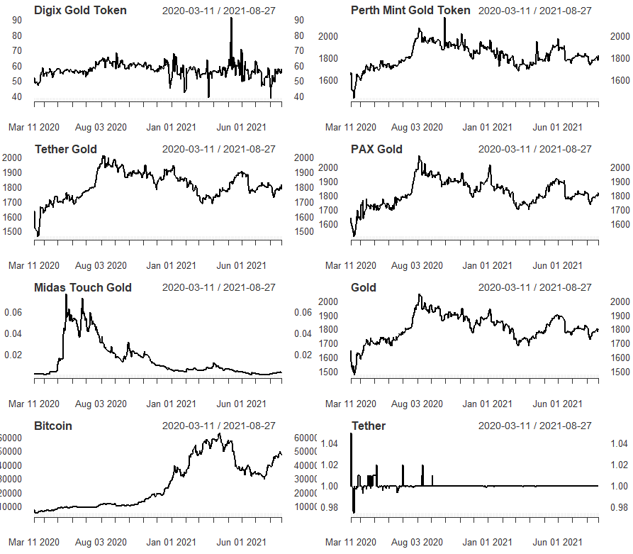
Source: coinmarketcap.com.

Fig.2 Returns over time of Bitcoin, gold, Tether and selected stablecoins (DGX, PMGT, XAUT, PAXG and TMTG)

Figure 3 Liquidity Dynamics.
HLR liquidity of the selected stable coins. | VoV liquidity of the selected stable coins.

Figure 4 Average Liquidity.
Average HLR liquidity | Average VoV liquidity

Figure 5 Realized variance of the selected assets (weekly)

Figure 6 Average realized variance of the selected assets

All tables.
Table 1. Descriptive statistics of asset (Log returns)
 | Digix Gold Token | Perth Mint Gold Token | Tether Gold | PAX Gold | Midas Touch Gold | Gold | Bitcoin | Tether
min | -0.474 | -0.130 | -0.068 | -0.078 | -0.354 | -0.051 | -0.224 | -0.049
max | 0.426 | 0.125 | 0.076 | 0.065 | 0.940 | 0.050 | 0.165 | 0.050
range | 0.900 | 0.255 | 0.144 | 0.142 | 1.293 | 0.100 | 0.389 | 0.099
median | 0.100 | 0.106 | 0.107 | 0.102 | 0.222 | 0.092 | 1.806 | 0.001
mean | 0.001 | 0.000 | 0.001 | 0.000 | -0.011 | 0.000 | 0.005 | 0.000
SE.mean | 0.000 | 0.000 | 0.000 | 0.000 | 0.001 | 0.000 | 0.005 | 0.000
CI.mean.0.95 | 0.004 | 0.001 | 0.001 | 0.001 | 0.006 | 0.001 | 0.002 | 0.000
var | 0.007 | 0.002 | 0.001 | 0.001 | 0.013 | 0.001 | 0.004 | 0.001
std.dev | 0.005 | 0.000 | 0.000 | 0.000 | 0.016 | 0.000 | 0.002 | 0.000
Skewness | -0.553 | -0.461 | -0.164 | -0.241 | 1.862 | -0.688 | -0.742 | 0.175
Kurtosis | 13.073 | 10.042 | 9.495 | 5.780 | 9.987 | 4.142 | 4.839 | 51.554
Return 0.1q | -0.474 | -0.13 | -0.068 | -0.078 | -0.354 | -0.051 | -0.224 | -0.0492
Return 0.25q | -0.019 | -0.007 | -0.005 | -0.006 | -0.059 | -0.004 | -0.013 | 0
Return 0.5q | 0.001 | 0 | 0.001 | 0 | -0.011 | 0 | 0.005 | 0
Return 0.75q | 0.021 | 0.009 | 0.005 | 0.007 | 0.038 | 0.006 | 0.022 | 0
Return 0.99q | 0.426 | 0.125 | 0.076 | 0.065 | 0.94 | 0.05 | 0.165 | 0.04999

Table 2: Differences between selected gold-backed cryptocurrencies and gold, in % difference relative to gold.
 | Digix Gold Token | Perth Mint Gold Token | Tether Gold | DAX Gold | Midas Touch Gold
Min | 89.3 | 60.9 | 25.2 | 34.8 | 85.7
Max | 88.3 | 60.4 | 34.9 | 23.2 | 94.7
Range | 88.9 | 60.7 | 30.3 | 29.5 | 92.2
Median | 70.5 | -84.4 | 41.9 | -10.4 | 103.5
Mean | 8.5 | 13.8 | 14.1 | 10.0 | 58.7
SE (mean) | 84.8 | 45.9 | 1.6 | 15.9 | 91.2
Var | 84.8 | 45.9 | 1.6 | 15.9 | 91.2
SD | 97.7 | 70.7 | 3.2 | 29.2 | 99.2
Coef(var) | 84.8 | 45.9 | 1.6 | 15.9 | 91.2
Note: Negative values indicate a higher corresponding gold value.

Table 3. Tail dependence.
- Lower tail
Gold-backed cryptocurrency | DigixGold Token | Perth Mint Gold Token | Tether Gold | PAX Gold | Midas Touch Gold | Gold | Bitcoin | Tether
Digix Gold Token | 1.00 | 0.21 | 0.16 | 0.11 | 0.11 | 0.11 | 0.11 | 0.05
Perth Mint Gold Token | 0.21 | 1.00 | 0.32 | 0.26 | 0.05 | 0.26 | 0.16 | 0.05
Tether Gold | 0.16 | 0.32 | 1.00 | 0.53 | 0.05 | 0.58 | 0.05 | 0.11
PAX Gold | 0.11 | 0.26 | 0.53 | 1.00 | 0.05 | 0.53 | 0.11 | 0.05
Midas Touch Gold | 0.11 | 0.05 | 0.05 | 0.05 | 1.00 | 0.11 | 0.16 | 0.05
Gold | 0.11 | 0.26 | 0.58 | 0.53 | 0.11 | 1.00 | 0.21 | 0.11
Bitcoin | 0.11 | 0.16 | 0.05 | 0.11 | 0.16 | 0.21 | 1.00 | 0.16
Tether | 0.05 | 0.05 | 0.11 | 0.05 | 0.05 | 0.11 | 0.16 | 1.00
- Upper tail
Gold-backed cryptocurrency | DigixGold Token | Perth Mint Gold Token | Tether Gold | PAX Gold | Midas Touch Gold | Gold | Bitcoin | Tether
Digix Gold Token | 1.00 | 0.00 | 0.00 | 0.05 | 0.00 | 0.05 | 0.05 | 0.00
Perth Mint Gold Token | 0.00 | 1.00 | 0.37 | 0.26 | 0.05 | 0.32 | 0.05 | 0.05
Tether Gold | 0.00 | 0.37 | 1.00 | 0.42 | 0.05 | 0.58 | 0.16 | 0.11
PAX Gold | 0.05 | 0.26 | 0.42 | 1.00 | 0.11 | 0.47 | 0.26 | 0.11
Digital Gold | 0.00 | 0.05 | 0.05 | 0.11 | 1.00 | 0.00 | 0.05 | 0.05
Gold | 0.05 | 0.32 | 0.58 | 0.47 | 0.00 | 1.00 | 0.16 | 0.05
Bitcoin | 0.05 | 0.05 | 0.16 | 0.26 | 0.05 | 0.16 | 1.00 | 0.11
Tether | 0.00 | 0.05 | 0.11 | 0.11 | 0.05 | 0.05 | 0.11 | 1.00
Note: This table shows tail coefficients estimated non-parametrically, as in Schmidt and Stadtmüller (2006). Panel A and B show results for lower and upper tail, respectively. The economic interpretation is straightforward - if values of coefficients are close to 0, it means that extreme values from either lower or upper tail do not correlate with corresponding values of the other asset. However, for coefficients close to 1, tail dependence between the two assets is documented.

Table 4. Tests for quantile unit root
Quantiles | YZt | asymptotic critical values |  |  | Quantiles | Yzt | asymptotic critical values
 |  | 0.01 | 0.05 | 0.10 |  |  | 0.01 | 0.05 | 0.10
 | DigixGoldToken |  |  |  |  | PerthMintGoldToken
0.10 | -2.23 | -2.97 | -2.32 | -1.97 | 0.10 | -1.47 | -3.12 | -2.48 | -2.14
0.20 | -3.85 | -2.96 | -2.31 | -1.96 | 0.20 | -2.58 | -3.16 | -2.54 | -2.20
0.30 | -3.99 | -3.06 | -2.40 | -2.05 | 0.30 | -2.49 | -3.13 | -2.50 | -2.16
0.40 | -5.22 | -2.94 | -2.30 | -1.94 | 0.40 | -2.00 | -3.13 | -2.50 | -2.16
0.50 | -6.61 | -2.92 | -2.28 | -1.92 | 0.50 | -2.22 | -3.12 | -2.49 | -2.15
0.60 | -7.19 | -2.90 | -2.26 | -1.90 | 0.60 | -3.01 | -3.12 | -2.48 | -2.14
0.70 | -6.26 | -2.89 | -2.25 | -1.89 | 0.70 | -2.71 | -3.13 | -2.49 | -2.15
0.80 | -5.54 | -2.83 | -2.17 | -1.81 | 0.80 | -3.93 | -3.11 | -2.46 | -2.12
0.90 | -3.02 | -2.90 | -2.26 | -1.90 | 0.90 | -1.50 | -3.09 | -2.44 | -2.10
TetherGold |  |  |  |  | PAXGold
0.10 | -0.19 | -3.17 | -2.55 | -2.21 | 0.10 | 0.41 | -3.13 | -2.49 | -2.15
0.20 | -0.12 | -3.17 | -2.55 | -2.21 | 0.20 | 0.24 | -3.15 | -2.53 | -2.19
0.30 | -1.28 | -3.11 | -2.47 | -2.13 | 0.30 | -0.62 | -3.15 | -2.52 | -2.19
0.40 | -1.08 | -3.15 | -2.53 | -2.19 | 0.40 | -0.56 | -3.17 | -2.55 | -2.21
0.50 | -2.18 | -3.12 | -2.49 | -2.15 | 0.50 | -1.79 | -3.13 | -2.49 | -2.15
0.60 | -1.05 | -3.11 | -2.47 | -2.13 | 0.60 | -2.49 | -3.13 | -2.49 | -2.15
0.70 | -0.84 | -3.13 | -2.49 | -2.15 | 0.70 | -2.69 | -3.10 | -2.46 | -2.12
0.80 | -1.64 | -3.12 | -2.48 | -2.14 | 0.80 | -2.54 | -3.07 | -2.40 | -2.06
0.90 | -1.89 | -3.04 | -2.38 | -2.04 | 0.90 | -1.24 | -3.06 | -2.39 | -2.05
Midas Touch Gold |  |  |  |  | Bitcoin
0.10 | -0.74 | -2.84 | -2.19 | -1.83 | 0.10 | -2.14 | -3.18 | -2.56 | -2.23
0.20 | -0.45 | -3.07 | -2.40 | -2.06 | 0.20 | -2.55 | -3.21 | -2.60 | -2.27
0.30 | -2.18 | -3.10 | -2.45 | -2.11 | 0.30 | -2.73 | -3.18 | -2.56 | -2.23
0.40 | -1.55 | -3.12 | -2.48 | -2.14 | 0.40 | -0.31 | -3.22 | -2.61 | -2.28
0.50 | -1.48 | -3.14 | -2.51 | -2.17 | 0.50 | 0.63 | -3.23 | -2.63 | -2.30
0.60 | -1.53 | -3.19 | -2.59 | -2.26 | 0.60 | 1.03 | -3.22 | -2.61 | -2.28
0.70 | -1.04 | -3.27 | -2.68 | -2.37 | 0.70 | 0.48 | -3.20 | -2.59 | -2.26
0.80 | -0.07 | -3.27 | -2.68 | -2.36 | 0.80 | 0.64 | -3.18 | -2.57 | -2.24
0.90 | -0.45 | -3.35 | -2.75 | -2.45 | 0.90 | 0.71 | -3.14 | -2.51 | -2.17
Gold |  |  |  |  | Tether
0.10 | 0.39 | -3.17 | -2.56 | -2.23 | 0.10 | -16.91 | -2.81 | -2.15 | -1.79
0.20 | 0.27 | -3.16 | -2.54 | -2.20 | 0.20 | -73.16 | -2.78 | -2.12 | -1.75
0.30 | -0.07 | -3.19 | -2.58 | -2.24 | 0.30 | -401.28 | -2.78 | -2.12 | -1.75
0.40 | -0.56 | -3.18 | -2.57 | -2.24 | 0.40 | 0.00 | -2.78 | -2.12 | -1.75
0.50 | -1.57 | -3.17 | -2.55 | -2.22 | 0.50 | -929059665.82 | -2.78 | -2.12 | -1.75
0.60 | -2.43 | -3.14 | -2.51 | -2.17 | 0.60 | 0.00 | -2.78 | -2.12 | -1.75
0.70 | -2.77 | -3.14 | -2.52 | -2.18 | 0.70 | 0.00 | -2.78 | -2.12 | -1.75
0.80 | -2.75 | -3.12 | -2.48 | -2.14 | 0.80 | 0.00 | -2.78 | -2.12 | -1.75
0.90 | -3.33 | -3.02 | -2.37 | -2.02 | 0.90 | -9.05 | -2.78 | -2.12 | -1.75

Note: The results of the quantile nonlinear unit root tests with covariates are presented in column YZt. The asymptotic critical values are calculated with significance at the 1%, 5% and 10% levels. The null hypothesis of the presence of a unit root is rejected if the calculated test statistic is lower in value than calculated asymptotic critical values at the 1% (***), 5% (**) and 10% (*) levels of significance. Statistically significant coefficients are highlighted in bold.

Table 5. The Pearson's Chi-squared test and Mantissa Arc test results
Tests | Digix Gold Token | Perth Mint Gold Token | Tether Gold | PAX Gold | Midas Touch Gold | Tether
Pearson's Chi-squared test | χ2 =248.17, p=0.000 | χ2 = 87.371, p= 0.529 | χ2 = 63.319, p= 0.982 | χ2 = 147.96, p=0.000 | χ2 = 81.512, p= 0.7011 | χ2 = 203.45, p=0.000
The Mantissa Arc Test and p-value | L=0.099, p=0.000 | L =0.0032, p=0.1823 | L =0.010329, p=0.39 | L =0.0629, p=0.000 | L= 0.014, p= 0.400 | L= 0.07, p= 0.000
Note: we do not analyse the anomalies in volumes for gold and bitcoin, since it is beyond the scope of this research.

Table 6. Diebold & Yilmaz (2012) spillover index
To / From | Digix Gold Token | Perth Mint Gold Token | Tether Gold | PAX Gold | Midas Touch Gold | Gold | Bitcoin | Tether
Digix Gold Token |  | 4.11 | 1.76 | 2.45 | 1.73 | 1.09 | 1.55 | 0.19
Perth Mint Gold Token | 1.53 |  | 25.23 | 19.3 | 1.15 | 25.31 | 0.72 | 1.39
Tether Gold | 1.93 | 29.13 |  | 34.5 | 1.11 | 40.32 | 1.42 | 2.85
PAX Gold | 2.28 | 20.93 | 33.74 |  | 1.84 | 32.13 | 2.35 | 1.36
Midas Touch Gold | 1.64 | 1.06 | 0.55 | 0.78 |  | 1.94 | 4.69 | 0.6

Appendix
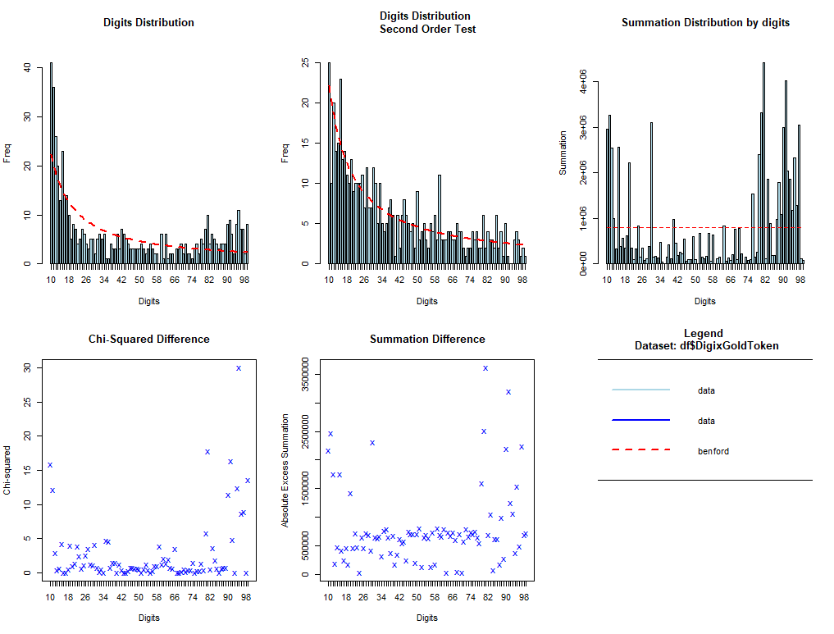
Fig.A1. The Benford’s Law distributions of DigixGoldToken

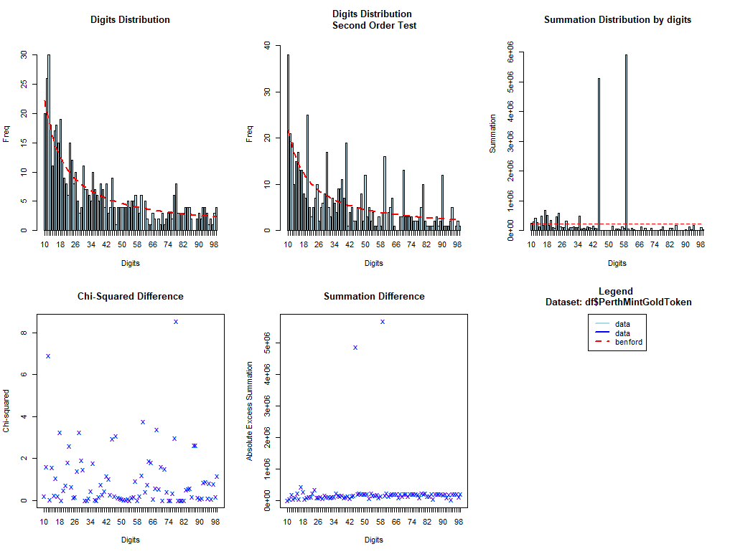
Fig.A2 The Benford’s Law distributions of PerthMintGoldToken

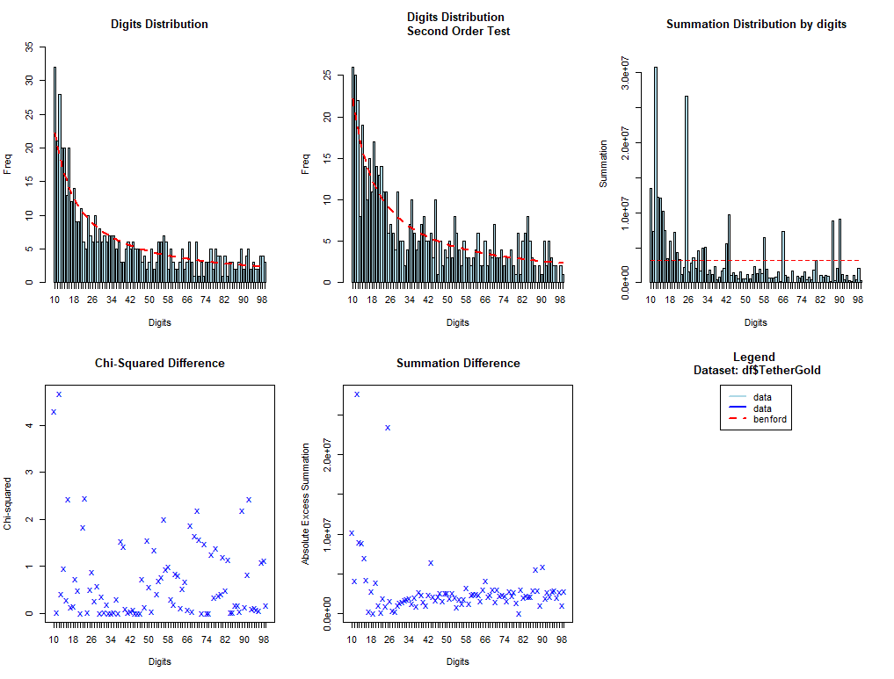
Fig.A3. The Benford’s Law distributions of TetherGold

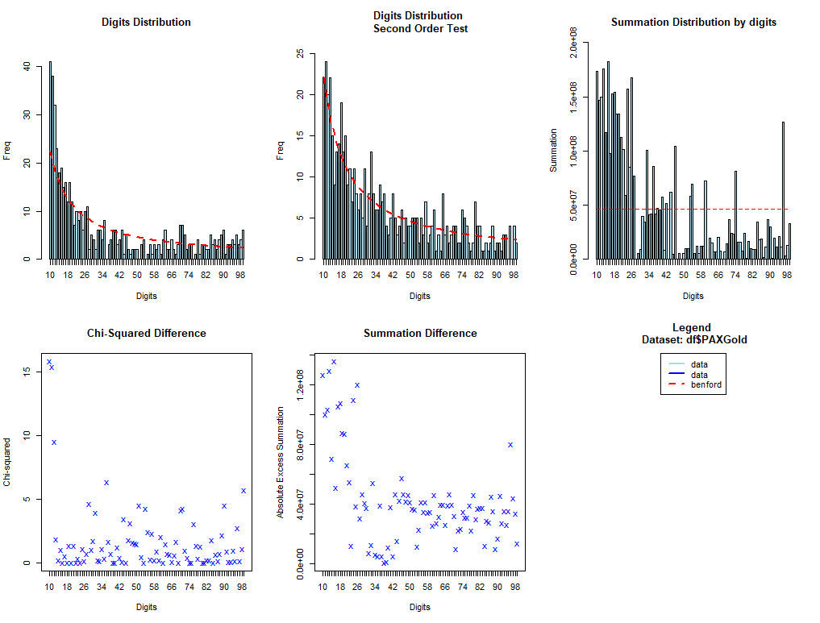
Fig. A4. The Benford’s Law distributions of PAXGold
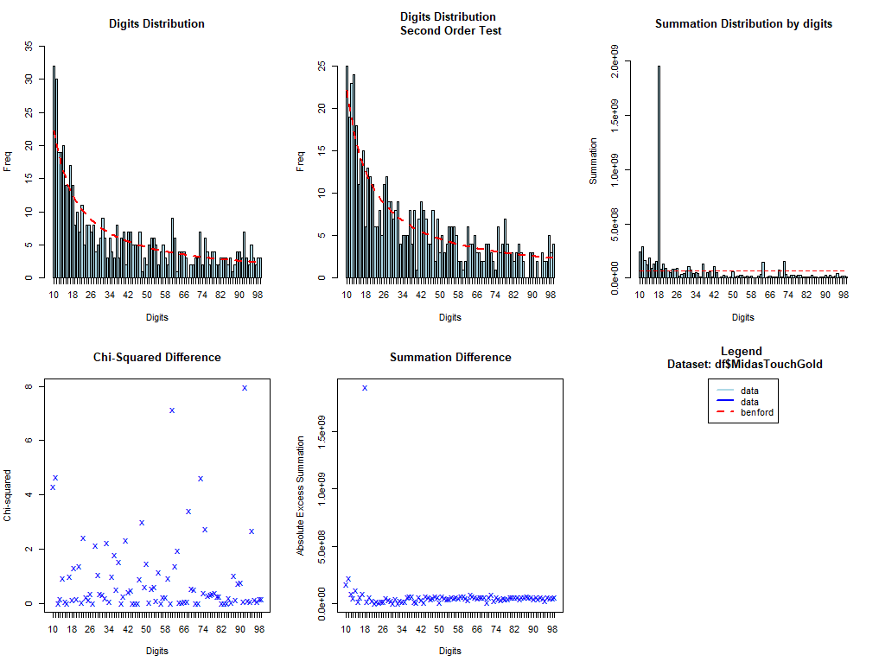
Fig. A5. The Benford’s Law distributions of MidasTouchGold

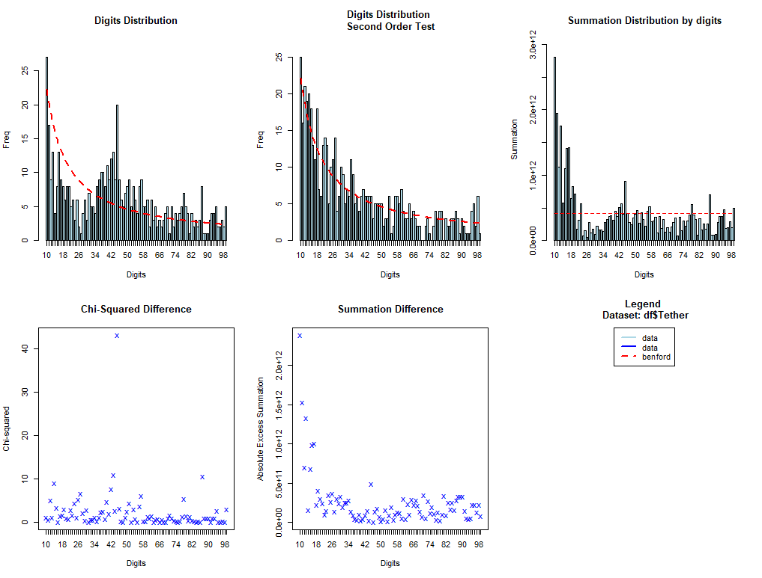
Fig. A5. The Benford’s Law distributions of MidasTouchGold

www.coinmarketcap.com
For a systematic review of cryptocurrency literature, see Corbet et al. (2019) 10.1016/j.irfa.2018.09.003
To see current prices for these assets, see coinmarketcap.com.
To potentially discover if the high/low returns are due to only volatility, we also standardized the returns of the selected assets by standard deviation, so that they all have the same volatility. The results reveal higher maximum and minimum returns for most of the selected assets. The Midas Touch Gold Token is an exception with the relatively similar pattern for both cases.
For a comprehensive review on the use of Benford’s Law in Finance and Accounting, see Flayyih et al. (2020).

