Invertebrate sentience and sustainable seafood

Andrew Crump¹, Heather Browning¹, Alex Schnell², Charlotte Burn³, & Jonathan Birch¹
¹ Centre for Philosophy of Natural and Social Science, London School of Economics and Political Science, UK
² Department of Psychology, University of Cambridge, UK
³ Animal Welfare Science and Ethics, Royal Veterinary College, UK

In a major report for the UK government, we found convincing evidence that octopuses, crabs, and lobsters are sentient. We explore animal welfare implications for the seafood industry.

Every year, humans kill billions of cephalopod molluscs (including octopus, squid, and cuttlefish) and decapod crustaceans (including crabs, lobsters, crayfish, and shrimp) (Figure 1). Far more of these invertebrate animals are slaughtered than the combined total of cows, sheep, pigs, and chickens.

Cephalopods and decapods are frequently slaughtered using methods that would not be allowed for livestock. Caught octopuses may be asphyxiated or clubbed to death; live crabs are dismembered; and lobsters are boiled alive.

In most countries, animal welfare legislation does not protect cephalopods or decapods. The UK’s Animal Welfare Act 2006, for instance, only covers vertebrates. This is because invertebrates have often been viewed as not sentient. Sentience is the capacity to have feelings. It is not simply the capacity to feel pain, although pain and distress raise the most urgent ethical issues.

The UK government commissioned us to evaluate the evidence for sentience in cephalopods and decapods, to determine whether their welfare should be enshrined in legislation. In our resulting report, which reviewed over 300 scientific studies, we found strong and diverse evidence for sentience in both groups (Birch et al. 2021).

The government subsequently amended the Animal Welfare (Sentience) Bill, expanding it to cover cephalopods and decapods. The bill recently became law, and the Animal Welfare (Sentience) Act 2022 now legally recognises these invertebrates as sentient. But what was the evidence for sentience? And what are the wider implications for pathways to sustainable seafood?

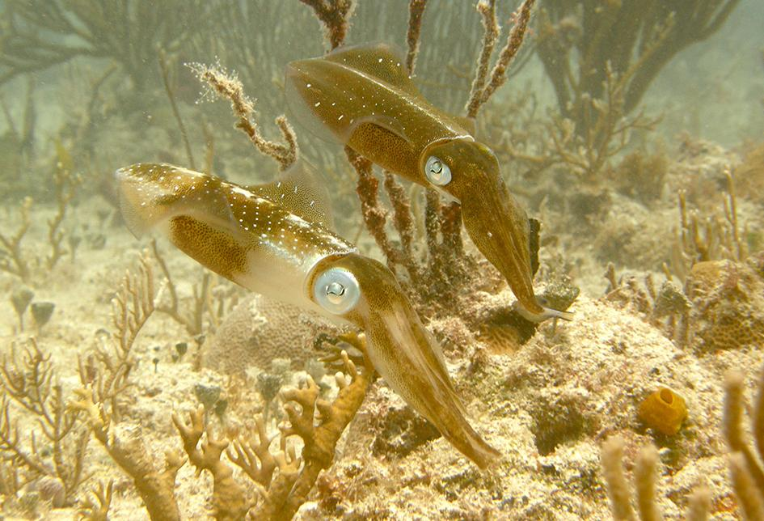
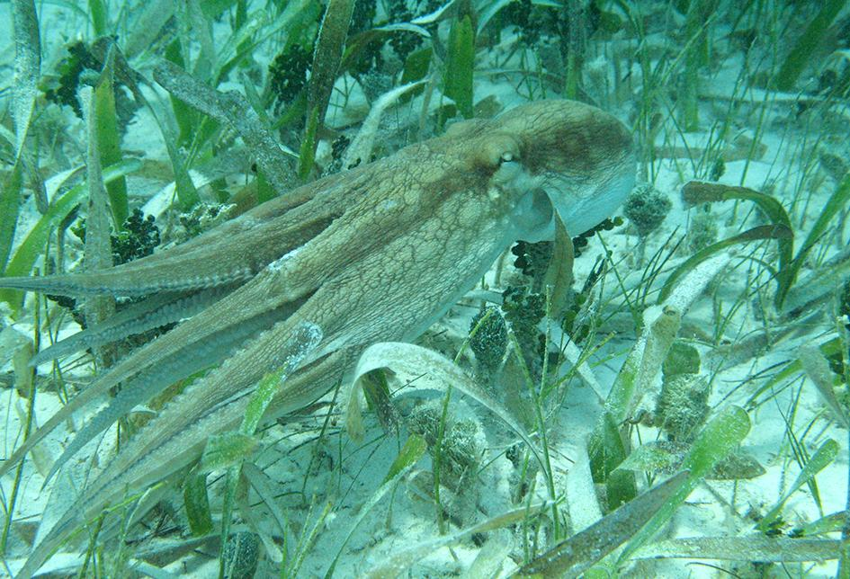
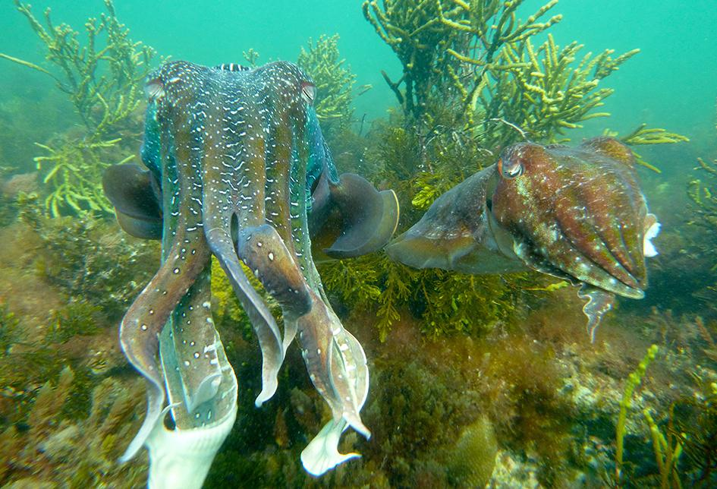
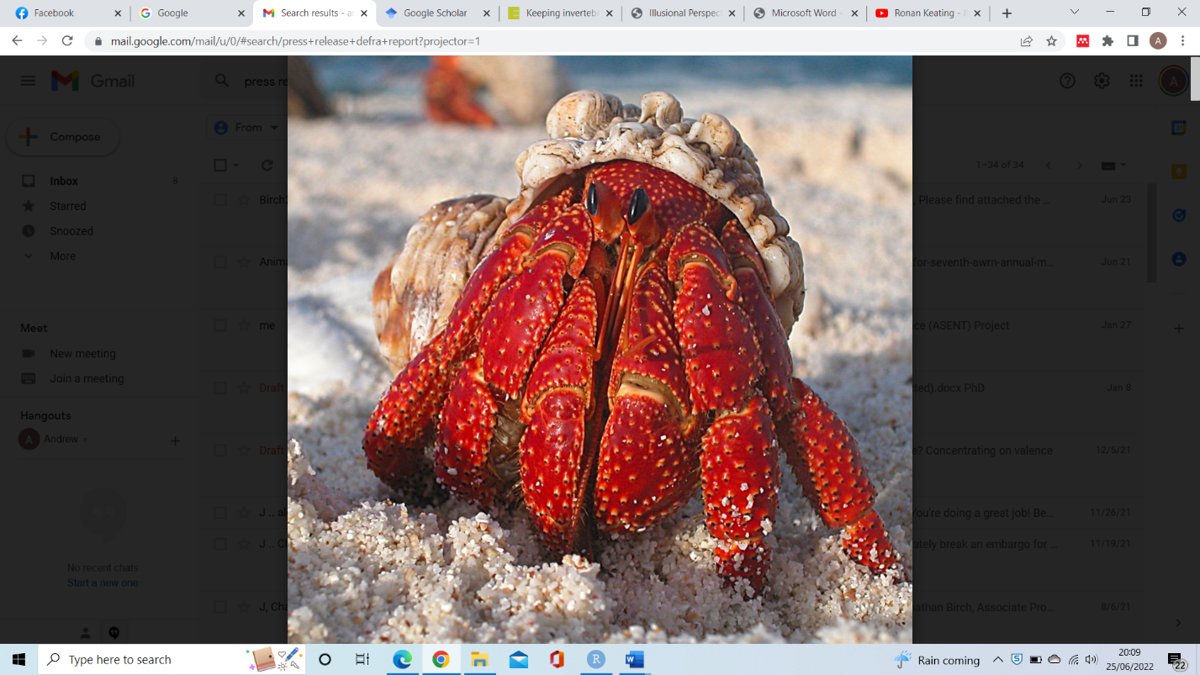
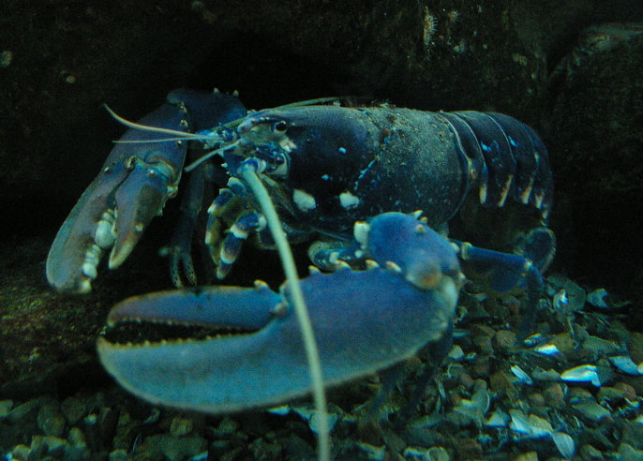

Figure 1. Decapod crustaceans (left) and cephalopod molluscs (right). Top to bottom: lobster (image by Cefaclor at Wikimedia Commons, CC-BY 2.5 licensed), hermit crab, squid, octopus, cuttlefish (cephalopod images by Alexandra Schnell).

Evidence of Sentience

If we want to know how another human feels, we can usually just ask them. But this is obviously not possible for animals, so how do scientists discover whether animals have feelings?

We developed a rigorous framework for evaluating scientific evidence of sentience (Birch et al. 2021, Crump et al. 2022). This determined whether the animals have both the neural mechanisms to generate sentience, and behaviours consistent with the likely adaptive outcomes of sentience. In our framework, candidates for sentience must satisfy various criteria, such as having specialised injury-detecting neurons connected to brain regions that integrate information from various sources.

As well as a complex nervous system, we looked for evidence of flexible behaviours that go beyond simple reflexes. Does the animal flexibly protect the precise site of injury, trade off injury avoidance against finding food, learn to avoid neutral stimuli paired with an aversive stimulus, or learn to select analgesia when injured? Box 1 summarises our full list of criteria.

None of these criteria prove sentience by themselves. None is a “smoking gun”. But they are all relevant to the overall case. The more criteria an animal fulfils, the more likely sentience becomes.

Octopuses meet almost all our criteria – very strong evidence of sentience. When injected with acetic acid, for example, they scrape the injury site with their beak (Crook 2021). They also learn to avoid the location where the injection was given, and selectively access areas where a local anaesthetic is available. These are complex, non-reflexive responses to injury, which indicate the ability to feel pain.

Squid and cuttlefish have been less studied, but there is still substantial evidence of sentience. These cephalopods have large integrative brain regions complex enough to support sentience, and show complex patterns of learning suggesting sentience (Mather 2008).

There is also strong evidence of sentience in true crabs. For instance, applying acetic acid to crabs’ mouths causes them to scratch the area with their claws and attempt escape significantly more often than a control group (Elwood et al. 2017).

Various lines of evidence suggest sentience in other decapods. Many have large, integrative brain regions that facilitate learning and could support sentience. For example, one influential study found evidence of anxiety-like states in crayfish (Fossat et al. 2014). The crayfish were allowed to explore a cross-shaped arena with two light arms and two dark arms. After being stressed, crayfish preferred dark arms – unsurprising since wild crayfish hide from predators in dark shelters.

Preference for dark arms was linked to the brain chemical serotonin, which underpins anxiety in humans. Injecting unstressed crayfish with serotonin caused them to spend longer in the dark arms (Fossat et al. 2014). And an anti-anxiety drug, chlordiazepoxide, reduced the preference for dark arms, suggesting at least a shared basis for anxiety in crayfish and humans.

We found no clear evidence that either cephalopods or decapods fail any criteria. Lack of evidence invariably explained cases where criteria were not satisfied. The amount of scientific attention that animals attract, therefore, limits the strength of evidence for sentience. Octopuses and true crabs have received sustained scientific attention, whereas shrimps (for example) have barely been studied. It is hardly surprising that little evidence has been uncovered in these little-studied groups.

In the report (Birch et al., 2021), we recommended treating all cephalopod molluscs and decapod crustaceans as sentient beings. We advised against restricting the scope of protection to just some cephalopods (e.g., octopuses) or some decapods (e.g., true crabs).
Box 1: Eight lines of evidence that raise the probability of sentience (from Birch et al. 2021)
The animal possesses receptors sensitive to noxious stimuli (nociceptors).
The animal possesses integrative brain regions capable of integrating information from different sensory sources.
The animal possesses neural pathways connecting the nociceptors to the integrative brain regions.
The animal’s behavioural response to a noxious stimulus is modulated by chemical compounds affecting the nervous system in either or both of the following ways:
The animal possesses an endogenous neurotransmitter system that modulates (in a way consistent with the experience of pain, distress or harm) its responses to threatened or actual noxious stimuli.
Putative local anaesthetics, analgesics (such as opioids), anxiolytics or anti-depressants modify an animal's responses to threatened or actual noxious stimuli in a way consistent with the hypothesis that these compounds attenuate the experience of pain, distress or harm.
The animal shows motivational trade-offs, in which the disvalue of a noxious or threatening stimulus is weighed (traded-off) against the value of an opportunity for reward, leading to flexible decision-making. Enough flexibility must be shown to indicate centralized, integrative processing of information involving an evaluative common currency.
The animal shows flexible self-protective behaviour (e.g. wound-tending, guarding, grooming, rubbing) of a type likely to involve representing the bodily location of a noxious stimulus.
The animal shows associative learning in which noxious stimuli become associated with neutral stimuli, and/or in which novel ways of avoiding noxious stimuli are learned through reinforcement. Note: habituation and sensitisation are not sufficient to meet this criterion.
The animal shows that it values a putative analgesic or anaesthetic when injured in one or more of the following ways:
The animal learns to self-administer putative analgesics or anaesthetics when injured.
The animal learns to prefer, when injured, a location at which analgesics or anaesthetics can be accessed.
The animal prioritises obtaining these compounds over other needs (such as food) when injured.
Extending protection to all vertebrates (as existing UK legislation does) involves making evidence-based generalisations from a few intensively studied laboratory species (such as lab rats) to other related species. It is consistent to do the same for invertebrate groups.

Invertebrates already received some legal protection in a handful of countries, including Switzerland, New Zealand, and Norway. Now there is strong evidence that cephalopods and decapods are sentient, other countries must also protect their welfare.

Animal Welfare Implications

Animal welfare is integral to sustainable food production. In 2019, the UN recognised welfare as an omission in its Sustainable Development Goals (Messerli et al. 2019). Cephalopod and decapod welfare nonetheless links to goal 12 (responsible production and consumption) and goal 14 (life below water).

Recognising cephalopods and decapods as sentient does not prohibit their capture, farming, slaughter, or consumption. The Animal Welfare (Sentience) Act 2022, like other UK welfare laws, always included cows, pigs, sheep, chickens, and fishes. Yet all these species are, and will remain, the basis of animal production systems.

Sentience does, however, raise ethical concerns about animal welfare. We, therefore, argue that the welfare of cephalopods and decapods needs consideration.

Key Welfare Risks for Cephalopod Molluscs

In the UK, several fisheries target octopuses, cuttlefishes, and squid. Cephalopods usually die during capture and landing, unlike decapods (which are often transported live before slaughter). Welfare issues are, therefore, like those for wild-caught fish.

Nets and poorly designed tank can injure or cause abrasions to the soft skin of cephalopods, resulting in infection, which are often fatal (Fiorito et al. 2015). Fishing nets can aslo cause cephalopods to suffocate or be crushed under the weight of other animals. Little research has sought to address these risks, although promising intervention measures may exist, including softer netting materials and alternative capture methods, such as traps, are possibilities (Iglesias et al. 2007).

Nevertheless, traps present other problems – such as cannibalism, which has been observed in some commonly studied species of octopus, squid, and cuttlefish (Ibáñez & Keyl 2010; Hernández-Urcera et al. 2015). Cannibalism has been linked to density (Caddy 1983; Aronson 1986; Dawe 1988) and frequency of encounters (Fox 1975), and thus more likely when individuals are trapped together. Fights also increase stress, which can contribute to self-cannibalism (i.e., eating their own arms) (Budelmann 1998).

Cephalopods also have attractive qualities for commercial aquaculture: high economic value, growth rate, protein content, and fecundity. However, current cephalopod aquaculture is incompatible with good welfare (Jacquet et al. 2019).

Conspecific aggression is a problem in commercial aquaculture, alongside several other welfare issues. Live prey is typically needed to avoid poor nutrition, and appropriate hiding places must be provided (shelters for octopus and soft substrate for cuttlefish). Moreover, cephalopods have exacting environmental requirements. Oxygen, pH, CO₂, nitrate, salinity, and temperature must remain constant to prevent poor health and stress (Moltschaniwskyj et al. 2007). Small, barren tanks also fail to offer opportunities for exploration or cognitive stimulation, causing captive cephalopods to display indicators of stress (Jacquet et al. 2019).

Finally, in both fisheries and aquaculture, no commercial cephalopod slaughter methods are humane. Terminal overdose with anaesthetic is the only recommended welfare-friendly approach, but this is inappropriate for cephalopods destined for human consumption (Fiorito et al. 2015). Common slaughter methods include asphyxiation, clubbing, slicing the brain, and reversing the body (mantle), all of which raise welfare concerns.

Key Welfare Risks for Decapod Crustaceans

Decapods represent the fastest growing major fishery worldwide, with hundreds of billions caught and farmed every year (Boenish et al. 2022). In the UK, commercially important examples include brown crab, langoustine, and shrimp. Best-practice guidelines tend to prioritise product quality, rather than animal welfare (Jacklin & Coombes 2005). Welfare concerns are, therefore, prevalent during decapod farming, capture, transport, and slaughter.

A common practice is declawing, the removal of one or both of a decapod’s claws, which prevents injury to humans and aggression between animals. Declawed crabs tend and shield their wound (McCambridge et al. 2016), indicating pain and suffering. If declawed crabs are returned to the ocean, fighting and feeding are compromised, and they can die within days (Duermit et al. 2015). Declawing was banned in the UK from 1986-2000; reinstating this ban would improve decapod welfare.

Nicking, a practice associated with brown crab fisheries, involves cutting the tendons of a decapod’s claw. This makes crabs safer to handle and limits aggression during transport. However, nicking elevates haemolymph glucose and lactate (potential signs of stress), as well as the risk of muscle necrosis and pathology (Welsh et al. 2013). Using individual transport containers or noninvasively immobilising claws are two possible alternatives.

During capture and transport, accidental physical injuries include cracked carapaces, damaged antennae, and limb loss. These are not just welfare issues: intact animals generally command higher prices than injured ones, which can spoil rapidly. Hence, industry best-practice guidelines already emphasise careful handling (Jacklin & Combes 2005). Means of avoiding injury vary between species. With langoustine, for example, creels (baskets) cause lower physiological stress, mortality, and physical damage than trawl nets (Ridgway et al. 2006).

Intact decapods may be transported and kept alive for days or even weeks before slaughter (Barrento et al., 2010). Live crustaceans are also maintained in commercial aquaculture. To prevent both poor welfare and spoilage, their temperature must remain within tolerable limits. Salinity and oxygen levels should also be kept stable for immersed decapods (Barrento et al. 2011), whilst constant humidity is important for “dry-stored” animals (Woll et al. 2010). In addition, best-practice guidelines discourage displaying and transporting live decapods on ice or in icy water (Jacklin & Combes, 2005).

Wherever possible, effective stunning should precede decapod slaughter. Commercial devices can deliver electric shocks that induce a seizure-like state and (apparently) render large crustaceans unconscious (Fregin & Bickmeyer 2016). Stunning devices are available for lobsters, crabs, and crayfish. Otherwise-inhumane slaughter methods can become humane if the animal is effectively stunned beforehand.

Without stunning, most decapod slaughter methods almost certainly entail substantial pain and suffering. Examples include boiling, chilling, tailing (twisting head from body), and any form of dismemberment. Large crustaceans dropped in boiling water routinely take over two minutes to die, likely in extreme suffering (Fregin & Bickmeyer, 2016). Chilling can paralyse and kill decapods, but it is unclear whether loss of consciousness accompanies immobility, and whether chilling is painful.

Lobster and crab nervous systems are relatively decentralised: lobsters have a chain of 13 interconnected nerve clusters (ganglia) running down their bodies, whilst crabs have two main ganglia. Until the neural circuits that underpin sentience are precisely located, we recommend rapidly destroying all these ganglia. This means slicing lobsters down the midline (whole-body splitting) and stabbing crabs through both ganglia (double-spiking). Both methods require precision and training.

Domestic consumers are a particular welfare concern. Live decapods can be ordered from online retailers and various supermarket chains without guidance on storage, handling, or slaughter. These animals are thus highly likely to suffer from poor handling, inhumane slaughter methods, and lack of oversight or accountability. Banning live decapod sales to private individuals would be a low-cost intervention to improve welfare.

Future Directions

Having developed a scientific framework to evaluate evidence of sentience, we hope it is applied to other animal groups harvested for food. Insects and gastropod molluscs should be regarded as serious candidates for sentience, raising potential welfare concerns about farming insects and eating snails. Moreover, we only assessed adult cephalopods and decapods. We hope future studies investigate the development of sentience and determine whether larval phases satisfy our criteria.

To ensure acceptable cephalopod welfare, best-practice guidelines must be developed for their capture, housing, husbandry, and slaughter (see Fiorito et al. 2015). Cephalopod welfare research has, however, been very limited to date. For example, no slaughter methods are both humane and commercially viable. The Association for Cephalopod Research plans to evaluate different stunning methods – a positive step.

Decapods, meanwhile, are often kept alive during transport, storage, and aquaculture, so their long-term welfare needs safeguarding. This requires more research on appropriate stocking densities, environmental conditions, and methods to prevent aggression and injury. Improving health and welfare assessment is also important to allow early identification of suffering, injury, or disease.

Humane slaughter research is another decapod priority. We consider whole-body splitting, double-spiking, and electrocution the best methods, but these can take 10-15 seconds and require specialist training and equipment. The Humane Slaughter Association is, therefore, funding research into crustacean stunning and slaughter, including methods that may be feasible on vessels. Shrimp research is especially urgent, as very little is known about their welfare, or whether they meet the criteria to be considered sentient at all. This is despite 210-530 billion shrimps and prawns being farmed in 2017, plus countless wild-caught individuals (Fishcount 2017).

Including cephalopods and decapods in the Animal Welfare (Sentience) Act 2022 was a huge milestone, but this law only leads to oversight of new legislation. Existing welfare laws must also be extended, including the Animal Welfare Act 2006 (which only protects vertebrates) and the Animals in Scientific Procedures Act 1986 (which only protects vertebrates and cephalopods). To date, the UK government has not amended either piece of legislation. We also hope that other countries recognise cephalopods and decapods as sentient, and take reasonable steps to protect their welfare.

Funding
This research is part of a project that has received funding from the European Research Council (ERC) under the European Union’s Horizon 2020 research and innovation programme, Grant Number 851145. The review of evidence of sentience also received funding from the UK’s Department for Environment, Food and Rural Affairs (Defra), Project Code AW0517.

Conflicts of interest
The authors declare there are no conflicts of interest.

References
Aronson, R.B. (1986). Life history and den ecology of Octopus briareus Robson in a marine lake. Journal of Experimental Marine Biology and Ecology 95, 37-56.
Birch, J., Burn, C., Schnell, A., Browning, H. and Crump, A. (2021). Review of the evidence of sentience in cephalopod molluscs and decapod crustaceans. Defra report.
Boenish, R., Kritzer, J. P., Kleisner, K., Steneck, R. S., Werner, K. M., Zhu, W., ... & Mimikakis, J. (2022). The global rise of crustacean fisheries. Frontiers in Ecology and the Environment, 20(2), 102-110.
Budelmann, B.U. (1998). Autophagy in Octopus. South African Journal of Marine Science 20, 101-108.
Caddy, J.F. (1983). The cephalopods: factors relevant to their population dynamics and to the assessment and management of stocks. In: Caddy JF (ed) Advances in Assessment of World Cephalopod Resources. FAO Fish Tech Pap, 231, 416-449
Crook, R. J. (2021). Behavioural and neurophysiological evidence suggests affective pain experience in octopus. iScience 24, 102229.
Crump, A., Browning, H., Schnell, A., Burn, C., & Birch, J. (2022). Sentience in decapod crustaceans: A general framework and review of the evidence. Animal Sentience, 7(32), 1.
Dawe, E.G. (1988). Length-weight relationships of the short-finned squid in Newfoundland and the effect of the diet on condition and growth. Transactions of the American Fisheries Society 117, 591-599.
Duermit, E., Kingsley-Smith, P. R., & Wilber, D. H. (2015). The consequences of claw removal on stone crabs Menippe spp. and the ecological and fishery implications. North American Journal of Fisheries Management, 35(5), 895-905.
Elwood, R. W., Dalton, N., & Riddell, G. (2017). Aversive responses by shore crabs to acetic acid but not to capsaicin. Behavioural Processes 140, 1-5.
Fiorito, G., Affuso, A., Basil, J., Cole, A., de Girolamo, P., D’angelo, L., ... & Andrews, P. L. (2015). Guidelines for the care and welfare of cephalopods in research–a consensus based on an initiative by CephRes, FELASA and the Boyd Group. Laboratory animals, 49(2_suppl), 1-90.
Fishcount (2017). http://fishcount.org.uk/fish-count-estimates-2/numbers-of-farmed-decapod-crustaceans
Fossat, P., Bacqué-Cazenave, J., De Deurwaerdère, P., Delbecque, J. P., & Cattaert, D. (2014). Anxiety-like behavior in crayfish is controlled by serotonin. Science 344, 1293-1297.
Fox, L.R. (1975). Cannibalism in natural populations. Annual Review of Ecology and Systematics 6, 87-106
Fregin, T., & Bickmeyer, U. (2016). Electrophysiological investigation of different methods of anesthesia in lobster and crayfish. PLoS One, 11(9), e0162894.
Hernández-Urcera, J., Garci, M.E., Roura, Á., González Á.F. Cabanellas-Reboredo, M., Morales-Nin, B., Guerra, Á. (2015). Cannibalistic behaviour of Octopus vulgaris in the wild. Journal of Comparative Psychology,
Ibáñez, C.M., Keyl, F. (2010). Cannibalism in cephalopods. Reviews in Fish Biology and Fisheries, 20, 123-136
Iglesias, J., Sánchez, F. J., Bersano, J. G. F., Carrasco, J. F., Dhont, J., Fuentes, L., ... & Villanueva, R. (2007). Rearing of Octopus vulgaris paralarvae: present status, bottlenecks and trends. Aquaculture, 266(1-4), 1-15.
Jacklin, M., & Combes, J. (2005). The good practice guide to handling and storing live crustacea. Seafish report.
Jacquet, J., Franks, B., Godfrey-Smith, P., & Sanchez-Suarez, W. (2019). The case against octopus farming. Issues in Science and Technology, 35(2), 37-44.
Mather, J. A. (2008). Cephalopod consciousness: behavioural evidence. Consciousness and Cognition, 17(1), 37-48.
McCambridge, C., Dick, J. T., & Elwood, R. W. (2016). Effects of autotomy compared to manual declawing on contests between males for females in the edible crab cancer pagurus: Implications for fishery practice and animal welfare. Journal of Shellfish Research, 35(4), 1037-1044.
Messerli, P., Murniningtyas, E., Eloundou-Enyegue, P., Foli, E. G., Furman, E., Glassman, A., ... & van Ypersele, J. P. (2019). Global sustainable development report 2019: the future is now–science for achieving sustainable development.
Moltschaniwskyj, N. A., Hall, K., Lipinski, M. R., Marian, J. E., Nishiguchi, M., Sakai, M., ... & Warnke, K. (2007). Ethical and welfare considerations when using cephalopods as experimental animals. Reviews in Fish Biology and Fisheries, 17(2), 455-476.
Ridgway, I. D., Taylor, A. C., Atkinson, R. J. A., Chang, E. S., & Neil, D. M. (2006). Impact of capture method and trawl duration on the health status of the Norway lobster, Nephrops norvegicus. Journal of Experimental Marine Biology and Ecology, 339(2), 135-147.
Welsh, J. E., King, P. A., & MacCarthy, E. (2013). Pathological and physiological effects of nicking on brown crab (Cancer pagurus) in the Irish crustacean fishery. Journal of Invertebrate Pathology, 112(1), 49-56.
Woll, A. K., Larssen, W. E., & Fossen, I. (2010). Physiological responses of brown crab (Cancer pagurus Linnaeus 1758) to dry storage under conditions simulating vitality stressors. Journal of Shellfish Research, 29(2), 479-487.

