A new technique to measure shear fracture toughness of adhesives using tensile load
S. Safaei¹, A. Akhavan-Safar^{2*}, M. Jalalvand^{3*}, L.F.M. da Silva⁴

¹ Department of Mechanical Engineering, Politecnico di Milano, Via La Masa 1, Milano 20156, Italy
²Institute of Science and Innovation in Mechanical and Industrial Engineering (INEGI), Rua Dr. Roberto Frias, 4200-465 Porto, Portugal
³Engineering Materials, School of Engineering, University of Southampton, SO17 1BJ Southampton, United Kingdom
⁴ Departamento de Engenharia Mecanica, Faculdade de Engenharia da Universidade do Porto,
Rua Dr. Roberto Frias, s/n, 4200-465 Porto, Portugal

* Corresponding authors: | Meisam Jalalvand, Email: M.Jalalvand@soton.ac.uk
 | Alireza Akhavan-Safar, Email: aAkhavan-Safar@inegi.up.pt

Abstract
The end notched flexure (ENF) test is the most common method for measuring the mode II fracture energy of adhesives which provides reliable results but has some inherent problems. The shear fracture energy calculated using ENF for brittle adhesives is often based on a single data point (corresponding to the fracture load) obtained from the test where the crack grows catastrophically and the results are significantly sensitive to pre-crack tip conditions. The aim of the current study is to introduce a new pure mode II fracture test suitable for measuring the shear fracture energy of adhesives. A new technique for measuring the mode II critical strain energy release rate (SERR) of brittle adhesives is proposed based on the central cut ply (CCP) configuration. Fracture tests were carried out on adhesively bonded steel CCP specimens. It is shown that the crack growth in CCP joints is more stable, and the failure develops in multiple steps that generates more experimental data point during the crack propagation. The mode II fracture energy of a brittle epoxy-based adhesive is extracted using CCP method and is compared with the shear fracture energy obtained from the ENF tests. The effect of adhesive thickness on the obtained fracture energies is also analyzed. The CCP technique can be used to find both the crack initiation and crack propagation toughness values whereas the ENF method only provides the crack initiation fracture energy.

Keywords: ENF test, Crack propagation, Shear fracture energy, CCP specimens, Cohesive Zone Modelling.

- Introduction
Adhesive bonding has become very popular in recent decades since it offers several advantages over classical joining methods. The load transfer through the adhesively bonded interfaces is continuous and does not require fasteners or holes which cause stress concentrations [1, 2]. Adhesively bonded joints also allow for higher joint stiffness [3-5], superior fatigue performance [6-11], and bonding of different materials [12]. This transition has been especially prominent in the aeronautical industry to obtain lightweight designs [13-17].
While there has been a significant research on characterization of bonded adhesives, there is no standard test method for the mode II fracture toughness assessment of adhesives [6]. The ENF test method is widely used for characterization of the mode-II fracture toughness of adhesives [18-27]. The ENF configuration was first used by Chai [28] for adhesive joints. It was found both mode II and mode III fracture micro mechanisms using scanning electron microscopy. Chai and Mall [29] measured the fracture energy of mode II using direct beam theory as a data reduction method. Wang and Williams [30] corrected the crack length in ENF specimens using a correction factor. Also, this method was compared against different finite element simulations. Blackman et al. [31] introduced a corrected beam theory with an effective crack length. The effect of fracture process zone on fracture energy has been considered in this method and it did not need to measure the crack length during the test. de Moura and de Morais [32] modified the corrected beam method and proposed the compliance-based beam method to measure mode II fracture energy. Ayatollahi et al. [22] investigated the effect of notch length (unbonded area) and pre-crack size on mode II fracture energy of a brittle adhesive in ENF fracture tests. Direct beam theory, compliance-based beam method, and J-integral approaches were employed to measure mode II fracture energy of the tested adhesive. It was shown that ENF tests with inaccurate pre-crack size result in a significant mixed-mode condition instead of the pure mode II. Akhavan-Safar et al. [33] calculated the mode II fracture energy of ENF joints using the compliance calibration method (CCM), direct beam theory, and compliance-based beam method. It was realized that these data reduction approaches can lead to a large undesirable scatter for brittle adhesives with unstable crack growth. Also, it was observed that the fracture energies obtained using the CCM method can present a better approximation of the mode II fracture energy in comparison with the other techniques. Ascione et al. [26] developed an experimental program using ENF joints and an epoxy adhesive, to study the hygrothermal durability of the adhesive with respect to the immersion in tap water and sea water for fifteen months at 30 °C. It was found that mode II fracture energy obtained from the compliance-based beam method showed an initial increase followed by a decrease and then reaching a plateau.
The aforementioned studies highlight that the ENF tests along with different data reduction approaches are currently the most common method for obtaining the mode II fracture energy of adhesives. However, when testing a brittle adhesive, due to the quick and unstable crack growth through the adhesive layer, the ENF test provides only a single data point, meaning that for brittle adhesives the obtained fracture energy corresponds to crack initiation and no data is found for crack propagation. Other factors such as friction between the substrate surfaces at the bonding end also influence the experimental results but are not considered when calculating the shear fracture energy in this method.
A different method used to measure the pure mode II interlaminar fracture toughness of fibre reinforced composites is the use of unidirectional composite laminates with Central Cut Plies (CCP) under tensile load. Cui et. al. [34] investigated the delamination of unidirectional glass fiber and carbon fiber epoxy composites by means of CCP specimens. Interlaminar cracks initiate from the cut and delaminate the center cut ply from the outer sandwiching layers, as schematically shown in Figure 1. There is a small transverse stress compressive at the crack tip and therefore the method is deemed as a pure mode II fracture toughness characterization method. Ribeiro et al. [6] studied the mode II debonding of adhesively bonded composites under fatigue loading using a CCP specimen. It was observed that the CCP specimen has the possibility of obtaining a constant debond growth when a constant amplitude tensile fatigue cycle is applied.
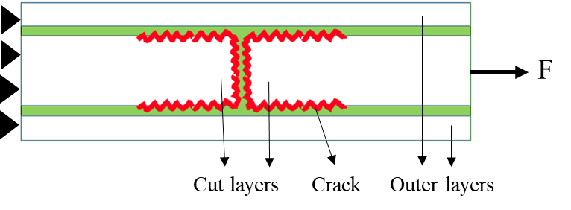
Figure 1- CCP specimen schematic and debonding at the cut.
It is important to measure the fracture energy of adhesive joints corresponding to a stable crack growth, so in the present work, a new technique based on central cut-ply (CCP) laminate configuration previously used for finding the mode II fracture energy of composite materials is used to obtain the fracture energy of adhesives in pure shear mode to bond metallic substrates. Samples with the CCP configuration bonded using brittle adhesives were tested and mode II fracture energy was calculated. The experimentally obtained fracture toughness values from the CCP configuration were compared with the fracture energies obtained experimentally from ENF specimens and commonly used data reduction schemes such as simple beam theory (SBT) and CCM. Three different adhesive thicknesses of CCP and ENF specimens were tested to investigate the effect of adhesive thickness on mode II fracture energy using the proposed methodology. Finally, the cohesive zone modelling (CZM) technique is used to evaluate fracture loads obtained from the fracture tests.
- Data reduction approaches
In this section, SBT and CCM data reduction approaches for ENF samples and central cut-ply method (CCP) equations to measure the mode II fracture energy of adhesively bonded joints are explained.
2.1. Simple beam theory (SBT)
SBT is one of the common approaches used to analyze ENF test results. Presuming that the adhesive layer is stiff, the specimen compliance, C, can be computed using Equation 1 [35]:
$$C=\frac{δ}{P}=\frac{3a^{3}+2L^{3}}{8Bh^{3}E}$$ | (1)
where δ is the applied displacement at the loading point, P is the applied load, a is the crack length, L is half span length, B is the sample width, h is the substrate thickness, and E is the elastic modulus of the substrate. In order to overcome the difficulties regarding the monitoring of the crack length during the ENF test, a is replaced by a_{e}, which is the effective crack length obtained as follows [35]:
$$a_{e}={\left[\frac{8δBh^{3}E}{3P}-\frac{2L^{3}}{3}\right]}^{\frac{1}{3}}$$ |  | (2)
Based on the Irwin-Kiese equation and using linear elastic fracture mechanics (LEFM), the mode II strain energy release rate, G_{II}, is defined with respect to variation of specimen compliance as Equation 3 [36]:
$$G_{II}=\frac{P^{2}}{2B}\frac{dC}{da}$$ | (3)
Finally, the mode II fracture energy can be obtained by substituting Equation 1 into Equation 3 as follows:
$$G_{II}=\frac{9P^{2}a_{e}^{2}}{16B^{2}h^{3}E}$$ | (4)
2.2. Compliance calibration method (CCM)
In this method, the link between the beam compliance and the crack length is specified by calculating the beam compliance for multiple tested pre-crack lengths. The CCM uses Equation 5 for measuring G_{II} based on ASTM D7905/ D7905M-19 standards [37]:
$$G_{II}=\frac{3mP^{2}a^{2}}{2b}$$ | (5)
where P, a, and b are the applied load, corresponding crack length, and sample width, respectively. The coefficient m should be measured by the least square approach as follows:
$$C=A+ma^{3}$$ | (6)
where m is the slope of the regression line and A is the intercept.
2.3. Central cut-plies (CCP)
The study conducted by Cui et. al. [16] highlighted that the mode II critical strain energy release rate of unidirectional composite laminates could be obtained from tensile load at delamination initiation and propagation. Also, fracture energy obtained from CCP technique is independent from the classical equivalent crack length as used for ENF samples. This is because the load at which delamination develops is constant in CCP configuration if the critical fracture energy is assumed to be constant. This method hasn’t been used for characterizing adhesives fracture toughness, but the fundamentals are the same. The CCP specimens in the present study are designed to generate debond between the adhesively bonded substrate layers when the whole sample is loaded under tension. This will allow to obtain the value of mode II critical strain energy release rate of the applied adhesive. To design a suitable specimen configuration, the stress required to cause delamination known as the pull-out stress has to be lower than the stress at which the outer continuous layers fail. Both these stress values are calculated by dividing the pull-out or substrate failure load by the full cross-sectional area of the sample. This condition is defined in Equation 7.
$$σ_{pull-out}<σ_{substrate failure}$$ | (7)
Equation 8 can be used to calculate the mode II energy release rate of adhesively bonded CCP specimens [38].
$$G_{IIC}=\frac{σ_{pull-out}^{2}h^{2}E_{c}t_{c}}{8E_{o}t_{o}(2E_{o}t_{o}+E_{c}t_{c})}$$ | (8)
where h is the full thickness of the specimen, E_{c} is the modulus of the cut layer, t_{c} is the thickness of cut layer and E_{o} and t_{o} are the modulus and thickness of the outer continuous layer, respectively. In this study, since the cut and outer layers are the same material and their thicknesses are also same, Equation 8 is simplified as follows:
$$G_{IIC}=\frac{σ_{pull-out}^{2}h^{2}}{24Et}$$ | (9)
Since the thickness of cut and outer layers are same, the full thickness of specimen is given by h=3t, so the mode II fracture energy is calculated as follows:
$$G_{IIC}=\frac{3tσ_{pull-out}^{2}}{8E}$$ | (10)
Figure 2 shows a quarter of the CCP configuration while the delaminated part of the cut layer is not shown for further clarity. To find the delamination length L₁, the stiffness of the sample, K_{tot}, is used. The total sample stiffness depends on the stiffness of the delaminated and non-delaminated parts, K₁ and K₂ respectively, found from Equation 11 [39] as well as their lengths, L₁, and L₂.
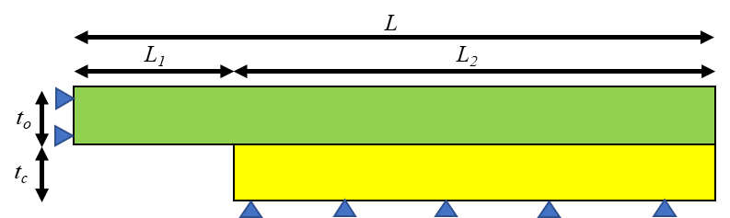
Figure 2- RVE of a CCP specimen to measure delamination
$$\begin{matrix}K_{1}=\frac{E_{o}t_{o}}{L_{1}} & and & K_{2}=\frac{E_{o}t_{o}+E_{c}t_{c}}{L_{2}}\end{matrix}$$ | (11)
The total stiffness can be written as follows [39].
$$\frac{1}{K_{tot}}=\frac{1}{K_{1}}+\frac{1}{K_{2}}⇒K_{tot }=\frac{(E_{o}t_{o})(E_{o}t_{o}+E_{c}t_{c})}{(E_{o}t_{o}L_{2})+(E_{o}t_{o}L_{1}+E_{c}t_{c}L_{1})}$$ | (12)
The non-delaminated length is given by L₂=L-L₁, so the delamination length can be measured using Equation 13.
$$L_{1}=\frac{(E_{o}t_{o})(E_{o}t_{o}+E_{c}t_{c})-(E_{o}t_{o}LK_{tot})}{E_{c}t_{c}K_{tot}}$$ | (13)
This method to measure non-delaminated length is based on a one-dimensional solution for a delaminated sandwich laminate with cracked centre layer and the main condition is that the length of the damage process zone (area of the interface at the tip of the crack where damage parameter is between 0 and 1) is significantly smaller than the crack length. For example, process zone is less than 10% of the total delamination length. In this research, the application of CCP approach is extended to bonded joints with brittle adhesive, where the process zone is small and usually negligible. Based on the limitation discussed above, it is expected that the method is also applicable to semi-brittle materials where a small process zone is formed ahead of the crack tip. CCP technique for more ductile adhesives, especially for joints with a thick bondline, can be applied when crack lengths are well above of the size of the FPZ. Accordingly, Equation 13 should be generally valid for both brittle and ductile adhesives. The application of CCP for ductile adhesives considering the adhesive thickness and crack size requires further research.
- Experimental Procedure
  - Configuration design and materials
The two-part epoxy-based adhesive MEGA-POX 330 (Ghaffari Co., Iran) was used for adhesively bonding the substrates. The weight ratio of hardener to resin was 1:1. The thickness of the adhesive layer was 0.2, 0.4 and 0.8 mm for different joints. The substrates were made from stainless steel. Table 1 presents the mechanical properties of the adhesive and the substrate.

Table 1- Mechanical properties of the adhesive and the substrate [40]
Ultimate tensile stress (MPa) | Poisson’s ratio | Modulus of elasticity (MPa) | Material
20 | 0.41 | 2400 | Adhesive
505 | 0.29 | 197000 | Stainless steel

The details of the geometry and dimensions of the CCP and ENF specimens are shown in Figure 3.
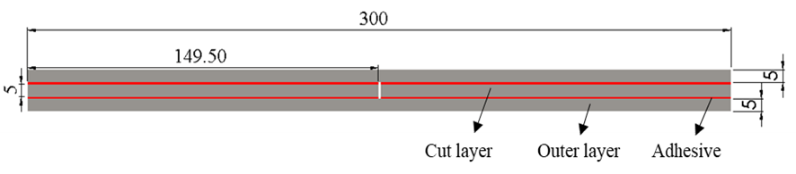
(a)
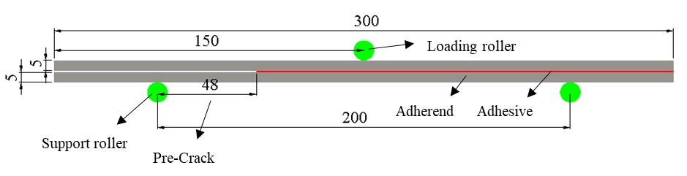
(b)
Figure 3- Side view of the geometry of the a) CCP and b) ENF joints with dimensions in mm
  - Manufacturing and test method
First, stainless steel strips were cut and adherend surfaces were sanded with a 120 Grit sandpaper followed by acetone cleaning and then, they were bonded together using an assembly fixture shown in Figure 4. Metal foils with the thickness of 0.2, 0.4 and 0.8 mm were used at both ends of each sample and in the middle of each joint as spacers to control the adhesive layer thickness precisely. The CCP samples don’t need any pre-crack. To create a pre-crack in the middle of the adhesive layer of ENF specimens, a PTFE Teflon film of 0.05 mm was used. An oven with controlled temperature was used for curing the adhesive. Based on the manufacturer's suggestions, the CCP and ENF joints were both cured in an oven at 160 °C for 2 hours and then were kept at room condition for 7 days before testing. It should be mentioned that in this study, the effect of low relative humidity for the adhesive joints with thin adhesive thickness covered by two substrates was ignored.
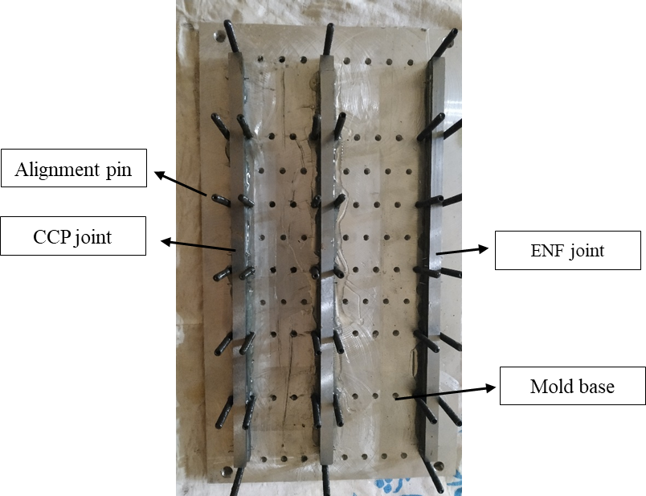
Figure 4- Apparatus used for manufacturing the joints, up view

The CCP joint samples were uniaxially loaded in tension under displacement control condition with the speed of 0.5 mm/min using an Instron 8801 hydraulic universal test machine with the load capacity of 100 kN. Flexure loading were applied to the ENF specimens using a 150 kN universal testing machine. Three joints were tested for each category of samples. Figure 5 shows the setup used for the CCP and ENF experiments.
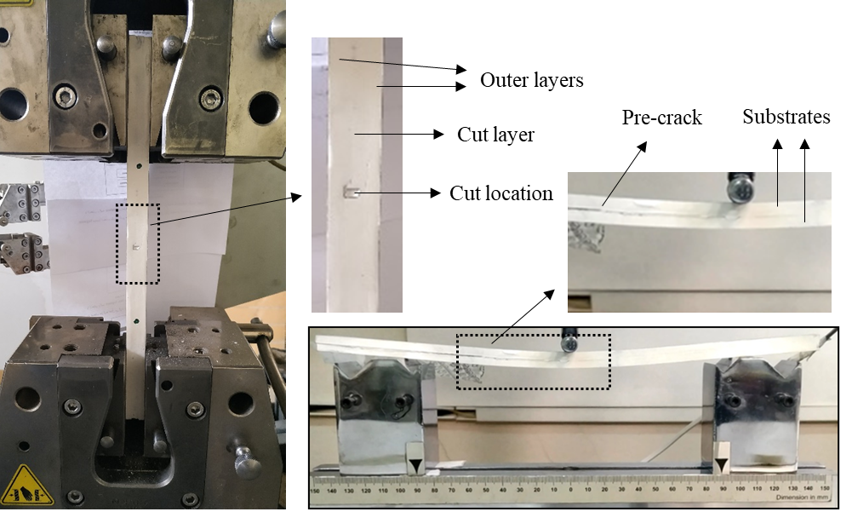
(a) | (b)
Figure 5- Test setup for a) CCP and b) ENF fracture tests.

- Finite element analysis
To study the crack initiation and propagation in CCP and ENF specimens, a 2-D FE analysis was performed using CZM approach. A bilinear constitutive model was considered to model the initiation and development of the debond in the adhesive layer of both CCP and ENF joints. It should be mentioned that in this study, the failure of substrates is not modelled. Figure 3 shows the CCP and ENF FE models schematically. The modulus of elasticity and Poisson’s ratio of the substrates are mentioned in Table 1. To employ a traction-separation law, three parameters including the initial stiffness (K), cohesive strength and the fracture energy must be determined. The initial stiffness can be measured from Equation 14.
$$K=\frac{E}{t}$$ | (14)
E and t are the elasticity modulus and thickness of the adhesive layer. The ultimate tensile and shear stress of the adhesive were considered as 20 MPa and 15 MPa [40], respectively, and the viscosity coefficient was set to 1e-4 s. The values of fracture energies used in the analysis are discussed in Section 5.2. In order to find the best mesh size for an accurate numerical result, a number of analyses were performed and finally, 2250 elements with a mesh size of 0.8×0.8 mm for each substrate of ENF and outer layer of CCP were employed, while the number of elements for each cut layer of CCP was 1122 with a mesh size of 0.8×0.8 mm. It is to be pointed out that four-node 1st order plane strain elements with reduced integration were considered for the steel substrates of CCP and ENF joints. Also, 748 and 238 four-node two-dimensional cohesive elements with one element along the adhesive thickness with the length of 0.8 mm were used to mesh the adhesive layers in the CCP and ENF specimens. The meshed specimens around the debond initiation region are shown in Figure 6.
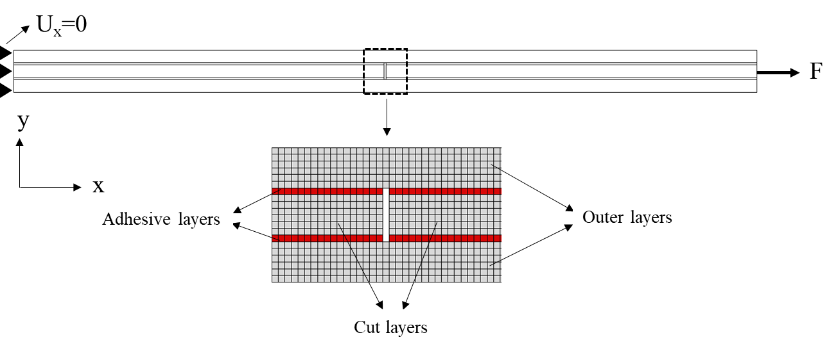
(a)
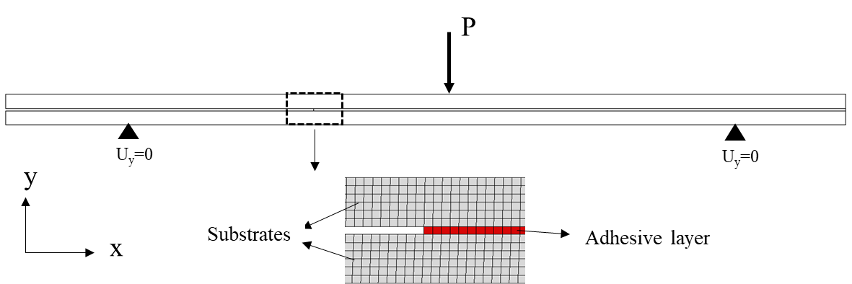
(b)
Figure 6- Boundary conditions, element shape and size of a) CCP and b) ENF joints for the FE analysis.
- Results and discussion
5.1. Experimental results
Fracture tests were performed to compare the fracture energy obtained using SBT, CCM, and CCP methods. Figure 7 shows typical load-displacement graphs of CCP and ENF joints. Basically, the stiffness of the joints should not be affected much by the adhesive thickness, but some differences in initial stiffness of the joints are observed in Figure 7, since the experimental results are based on crosshead displacement which are not accurate. In ENF tests, the crack propagated in adhesive layer catastrophically and the joints failed suddenly in one step when the load reached the maximum value which shows the brittle nature of the adhesive (Figure 7(a)). As shown in Figure 8 for the CCP tests, the cracks propagate in multiple steps. The load drops in the load-displacement curve corresponds to every step that the cracks propagate in the adhesive layers. After full debond of the cut steel layer and the continuous ones, the continuous steel layers fail resulting in the final failure of the CCP joints.
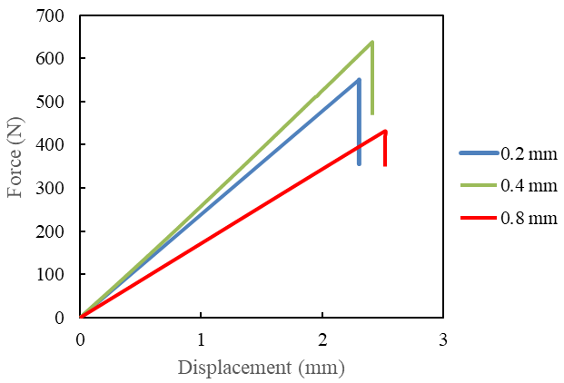 | (a)
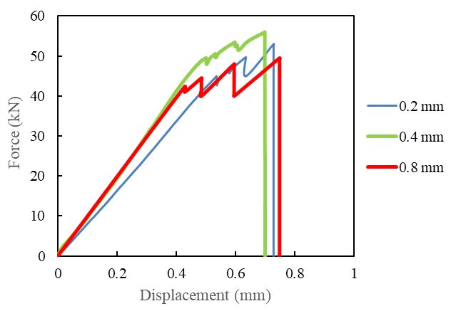 | (b)
Figure 7- Typical load displacement graphs of a) ENF and b) CCP joints for different adhesive thicknesses.
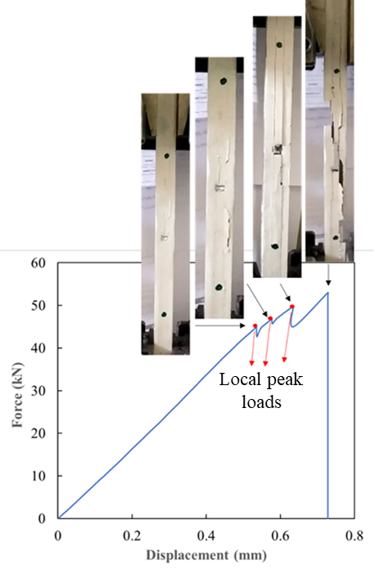
Figure 8- Crack propagation path in CCP specimen.

As shown in Figures 7-b and 8, the total stiffness of the CCP joints decreases once the cracks propagate. The total stiffness of the sample was measured at each loading peak point, just before a local load drop, and the equivalent value of crack length L₁ (see Figure 2) is calculated using Equation 13. Table 2 illustrates the average crack length and the corresponding peak load just before each load drop as highlighted with red points in Figure 8. Also, the experimental fracture loads for the tested ENF joints for three adhesive thicknesses are presented in Table 3. Based on Tables 2 and 3, the fracture load is higher in the CCP and ENF specimens with 0.4 mm adhesive thickness than those samples with adhesives thickness of 0.2 and 0.8 mm.

Table 2- Experimental crack length and fracture loads for the CCP specimens with different adhesive thicknesses
Joint No. | Adhesive thickness (mm) | Crack length (mm)  during the test | Fracture load (N) | G_{IIC} (N/mm)
1 | 0.2 | 0 | 45098 | 0.85
 |  | 19 | 46987 | 0.92
 |  | 27 | 49703 | 1.03
2 |  | 7 | 43987 | 0.8
 |  | 23 | 45671 | 0.87
 |  | 32 | 47609 | 0.94
3 |  | 10 | 43254 | 0.78
 |  | 28 | 44953 | 0.84
 |  | 34 | 48073 | 0.96
4 | 0.4 | 15 | 48860 | 0.99
 |  | 25 | 50112 | 1.05
 |  | 48 | 52451 | 1.15
 |  | 17 | 46980 | 0.92
5 |  | 31 | 49301 | 1.01
 |  | 44 | 53116 | 1.18
 |  | 23 | 45011 | 0.84
6 |  | 35 | 48514 | 0.98
 |  | 53 | 51117 | 1.09
7 | 0.8 | 0 | 42350 | 0.75
 |  | 27 | 44500 | 0.82
 |  | 68 | 47018 | 0.88
8 |  | 12 | 45078 | 0.85
 |  | 39 | 47324 | 0.93
 |  | 55 | 48913 | 1
9 |  | 8 | 42570 | 0.75
 |  | 24 | 45076 | 0.85
 |  | 60 | 47409 | 0.94

Table 3- Experimental fracture loads for the ENF specimens with different adhesive thicknesses
No. of joint | Adhesive thickness (mm) | Pre-crack size (mm) | Fracture load (N) | G_{IIC} (N/mm) -SBT | G_{IIC} (N/mm) -CCM
10 | 0.2 | 48 | 551 | 0.95 | 1.01
11 |  |  | 496 | 0.78 | 0.81
12 |  |  | 530 | 1.06 | 1.16
13 | 0.4 |  | 632 | 1.11 | 1.12
14 |  |  | 615 | 0.98 | 1.19
15 |  |  | 595 | 1.16 | 1.08
16 | 0.8 |  | 462 | 0.93 | 0.96
17 |  |  | 410 | 0.74 | 0.95
18 |  |  | 463 | 0.99 | 0.88

  - Fracture energy
The fracture energy of the CCP and ENF joints was calculated using the CCP, SBT and CCM data reduction methods described in Section 2 and the results are provided in Tables 2 and 3. The mode II fracture energy for CCP joints was calculated using Equation 10. The value of was calculated found dividing the fracture load in Table 2 by the full cross-section area of each sample. Due to stable crack propagation in the CCP samples, it was possible to find the energy release rate values for different average crack length. Figure 9 presents the R-curves of the tested CCP specimens for three different adhesive thicknesses under pure mode II conditions.
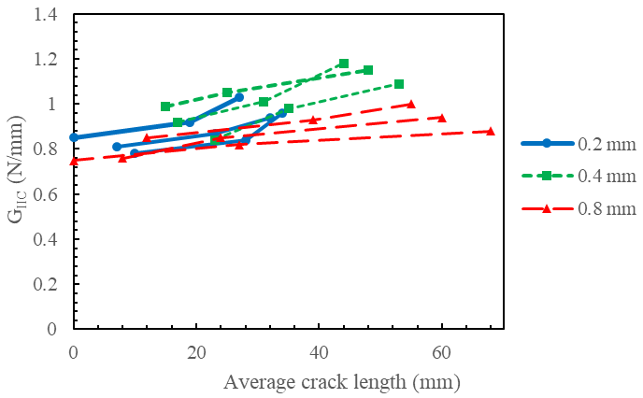
Figure 9- R-curve based on the fracture energy for the CCP joints.
The average mode II fracture energy obtained from the CCP samples and those obtained using the ENF joints using the SBT and CCM data reduction approaches are presented in Figure 10 and Table 4. These results show that both CCP and ENF techniques give relatively similar outcomes with maximum 12.5 % different. The fracture energy values from CCP are more conservative when compared against ENF results. According to both CPP and ENF results, the 0.4 mm adhesive thickness gives maximum fracture energy in both the CCP and ENF specimens among the three tested adhesive thicknesses.
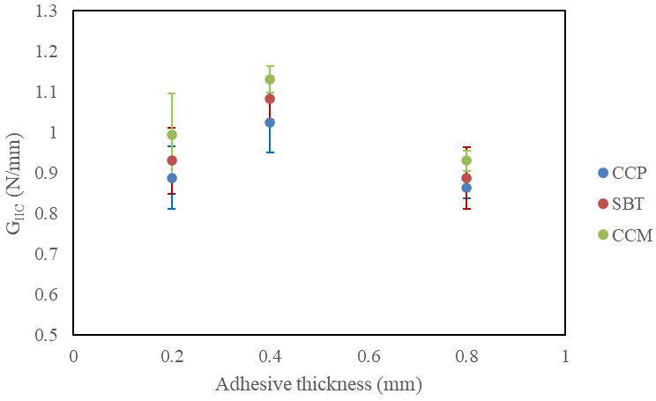
Figure 10- Shear fracture energy, effect of specimen type and adhesive thickness.

Table 4- Differences between fracture energies obtained using CCM, SBT, and CCP methods
Adhesive thickness (mm) | Difference between CCM and CCP  % | Difference between SBT and CCP  %
0.2 | 12.5 | 5.68
0.4 | 10.78 | 5.88
0.8 | 8.14 | 3.49

  - Numerical results
The obtained energies in Figure 10 were used to numerically simulate the crack initiation and crack propagation in both ENF and CCP joints following the methodology explained in Section 4. The average fracture energy from the CPP test was used for CCP simulations and energies obtained from SBT and CCM methods for the simulation of debond in the ENF joints. Damage progression in the CCP and ENF specimens along the adhesive layer for the joints with 0.8 mm adhesive thickness is represented by SDEG damage parameter in Figure 11. The elements of the adhesive layer fully fail when the SDEG reaches 1.
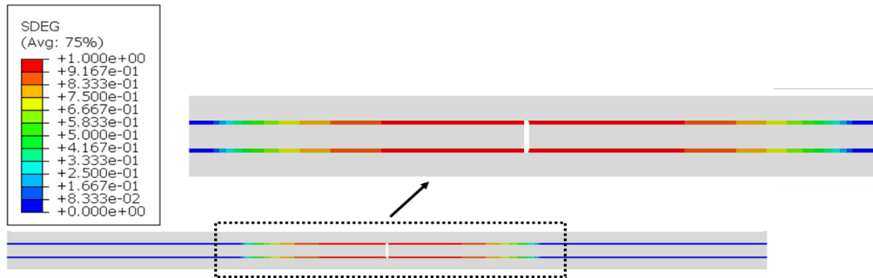
(a)
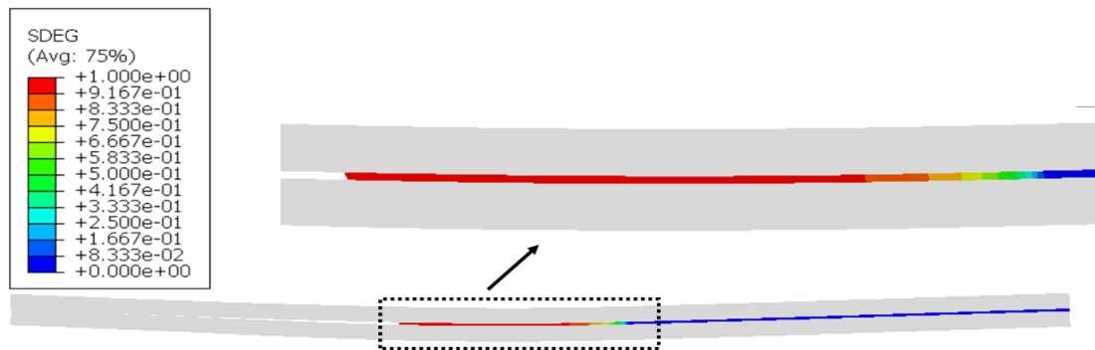
(b)
Figure 11- simulation of the debond process for a) CCP specimen with 0.8 mm adhesive thickness at 43.77 kN load and b) ENF joint with 0.8 mm adhesive thickness at 430 N load using CZM.

Figures 12 and 13 compare the obtained numerical FE load-displacement curves against the typical experimental curves for the CCP and ENF joints with different adhesive thicknesses. As described in Section 4, the last point on the modelling load-displacement graph is not the failure of substrates. The experimental and numerical fracture loads of the CCP and ENF joints are presented in Table 5. It should be noted that the average peak loads (e.g. red points in Figure 8) for CCP specimens have been reported in Table 5. Based on Figures 12 and 13, and Table 5, there is a good agreement between the average fracture loads obtained from the experimental results for the CCP specimens and those obtained by the CZM analysis for all the three tested adhesive thicknesses. Also, the fracture energy found from the SBT data reduction method gives estimations closer to the experimental results when it is used in the FE modeling compared to the CCM data reduction method.

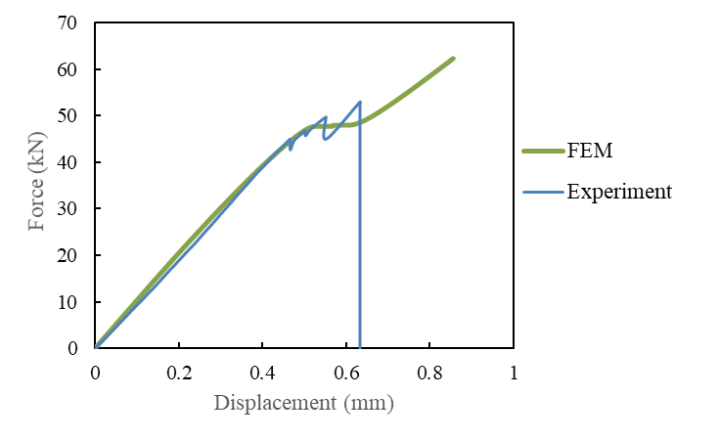 | 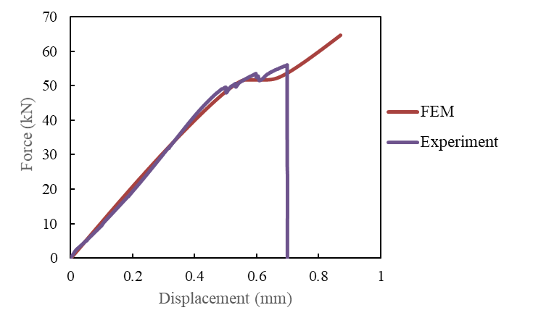
 | (b)
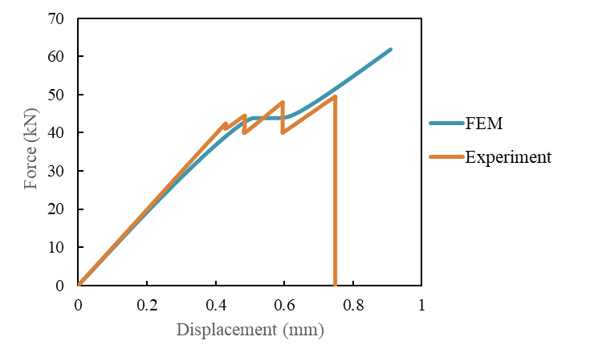
(c)
Figure 12- Load-displacement curves using CZM modelling compared with the experimental results for the CCP joints with a) 0.2 mm, b) 0.4mm and c) 0.8mm adhesive thickness.

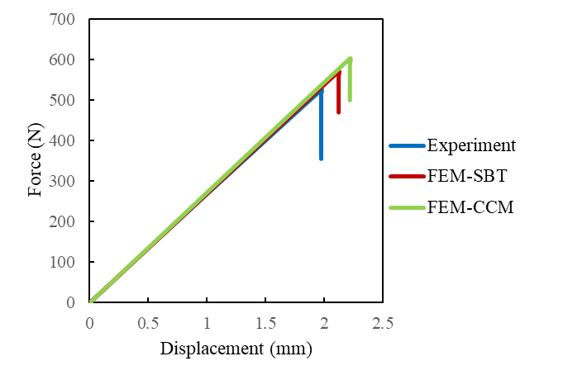 | 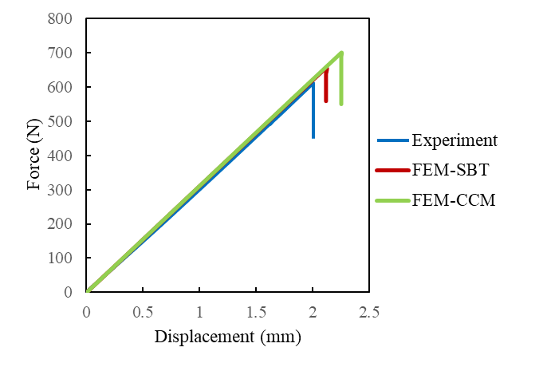
 | (b)
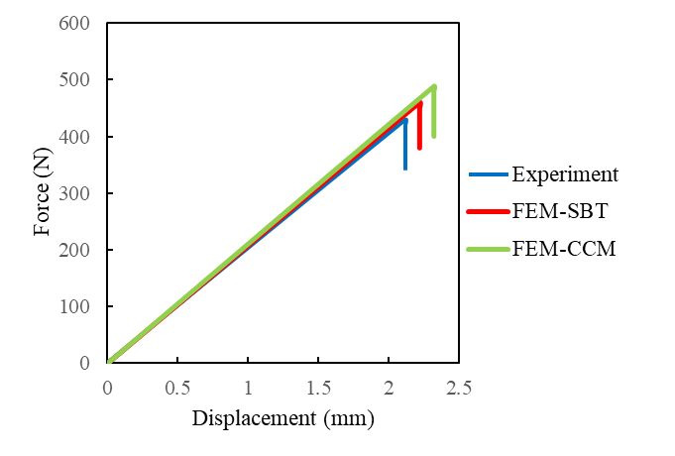
(c)
Figure 13- Load-displacement curves using CZM compared with the experimental results for ENF joints with a) 0.2 mm, b) 0.4mm and c) 0.8mm adhesive thickness.

Table 5- Predicted failure load using CZM compared with the average experimental fracture loads for the CCP and ENF joints and different adhesive thicknesses
CCP |  |  |  | ENF
 |  |  |  |  | SBT |  | CCM
Adhesive thickness (mm) | Experiment (kN) | FEM (kN) | Error  % | Experiment (N) | FEM (N) | Error  % | FEM (N) | Error  %
0.2 | 46.15 | 47.72 | 3.4 | 526 | 551.53 | 4.85 | 602.8 | 14.6
0.4 | 49.5 | 51.81 | 4.67 | 614.45 | 649.01 | 5.62 | 703.61 | 14.51
0.8 | 45.47 | 43.77 | 3.88 | 445.4 | 462.88 | 3.92 | 490.42 | 10.11

To check the accuracy of the fracture energies obtained using the CCP technique, they were employed to predict the fracture load of the ENF samples and the obtained results are shown in Table 6. Comparing the numerically calculated failure loads of the ENF specimens using fracture energies found from the CCP technique and other two techniques in Tables 5 and 6, it can be concluded that the fracture energy found from the CCP experiments estimate the failure load in the ENF joints for brittle adhesives better that those values found from the ENF experiments.

Table 6- Failure load prediction in ENF samples based on CCP fracture energy
Adhesive thickness (mm) | Experiment (N) | FEM (N) | Error %
0.2 | 526 | 545.51 | 3.7
0.4 | 614.45 | 639.19 | 4.03
0.8 | 445.4 | 457.69 | 2.76

- Conclusion
The ENF configuration is one of the most common approaches to measure mode II fracture energy of adhesive joints. SBT and CCM data reduction approaches are widely used to measure the fracture energy from an ENF specimen. Unstable crack propagation is a major problem for ENF joints with brittle adhesive. Since the mode II fracture energy is measured according to crack initiation, the fracture energy obtained from ENF joint can be sensitive to the quality of the pre-crack.
In this paper, a new testing method called Central Cut Ply (CCP) is proposed for fracture energy characterization of adhesives in pure mode II loading conditions. The CCP experimental results were compared with the ENF test data using the SBT and CCM data reduction techniques. Based on the obtained results, following points can be found:
- The crack in CCP joints propagates in multiple steps and failure does not happen suddenly, therefore the fracture energy is measured at more than a single data point.
- CCP method has the feature that fracture energy is independent form the equivalent crack length of ENF test.
- The fracture load and subsequently, the fracture energy is higher in both CCP and ENF joints with 0.4 mm adhesive thickness than 0.2 and 0.8 mm adhesive thickness.
- The fracture energy obtained from ENF was close to the CCP specimens with maximum 12.5% different.
- The average failure loads obtained from the experimental central cut-ply fracture energies are in better agreement with numerical results compared with the CCM technique.
- The difference between numerical and experimental fracture loads for the ENF specimens was decreased when the fracture energies obtained from experimental CCP joints were used in the modelling. This suggests that fracture energies obtained from CCP joint could be a better input for numerical modelling of both CCP and ENF configurations and CCP as a new configuration to measure mode II fracture energy of the adhesive joints provides reliable results.

References
1. Flinn, R.A. and P.K. Trojan, Engineering materials and their applications. 1994.
2. Günther, N., et al., Loading capacity of adhesive joints regarding their manufacturing process. Journal of Advanced Joining Processes, 2020. 1: p. 100020.
3. Naat, N., et al., Effect of surface texture on the mechanical performance of bonded joints: a review. The Journal of Adhesion, 2021: p. 1-93.
4. Ascione, F., L. Granata, and A. Lombardi, The influence of the hygrothermal aging on the strength and stiffness of adhesives used for civil engineering applications with pultruded profiles: an experimental and numerical investigation. The Journal of Adhesion, 2021: p. 1-39.
5. Wang, W. and G. Xian, Effects of steel surface treatment with silanized carbon nanotubes on the bonding properties between steel and epoxy adhesive. The Journal of Adhesion, 2021: p. 1-23.
6. Ribeiro, F.N., M. Martinez, and C. Rans, Evaluation of mode II fatigue disbonding using Central Cut Plies specimen and distributed strain sensing technology. The Journal of Adhesion, 2019. 95(4): p. 259-285.
7. Houjou, K., et al., Effect of test temperature on the shear and fatigue strengths of epoxy adhesive joints. The Journal of Adhesion, 2021: p. 1-19.
8. Manterola, J., et al., Lifetime prediction of bonded structural patch repairs for wind turbine pitch bearing strengthening. The Journal of Adhesion, 2022. 98(6): p. 739-757.
9. Abeln, B., et al., Strengthening of fatigue cracks in steel bridges by means of adhesively bonded steel patches. The Journal of Adhesion, 2022. 98(6): p. 827-853.
10. Feng, W., et al., Fatigue performances and reliability analysis of fatigue life for scarf-repaired composite laminates. The Journal of Adhesion, 2022. 98(4): p. 367-389.
11. Boutar, Y., et al., Cyclic fatigue testing: Assessment of polyurethane adhesive joints' durability for bus structures' aluminium assembly. Journal of Advanced Joining Processes, 2021. 3: p. 100053.
12. Safaei, S., et al., Effect of residual strains on the static strength of dissimilar single lap adhesive joints. The Journal of Adhesion, 2021. 97(11): p. 1052-1071.
13. Hart-Smith, J., 23 - Aerospace industry applications of adhesive bonding, in Adhesive Bonding (Second Edition), R.D. Adams, Editor. 2021, Woodhead Publishing. p. 763-800.
14. SatyanarayanaGupta, M. and K. Veeranjaneyulu, Fabrication and Anayisis of Adhesive joints Used in Aircraft Structures. Materials Today: Proceedings, 2017. 4(8): p. 8279-8286.
15. Budzik, M.K., et al., Testing mechanical performance of adhesively bonded composite joints in engineering applications: an overview. The Journal of Adhesion, 2021: p. 1-77.
16. Brieskorn, L. and M. Vargas, Gap measurement for thermoplastic adhesive joining of aircraft frames. The Journal of Adhesion, 2022. 98(6): p. 647-655.
17. Marchione, F., Effect of hollow adherends on stress peak reduction in single-lap adhesive joints: FE and analytical analysis. The Journal of Adhesion, 2022. 98(6): p. 656-676.
18. Yang, Y., et al., Determination of fracture toughness of an adhesive in civil engineering and interfacial damage analysis of carbon fiber reinforced polymer–steel structure bonded joints. Proceedings of the Institution of Mechanical Engineers, Part L: Journal of Materials: Design and Applications, 2021. 235(11): p. 2423-2440.
19. Delzendehrooy, F., et al., Fracture energy assessment of adhesives Part II: Is GIIc an adhesive material property? (A neural network analysis). Journal of Advanced Joining Processes, 2021. 3: p. 100049.
20. Yan, C.C., et al., The fracture performance of adhesively bonded orthodontic brackets: an experimental-FE modelling study. The Journal of Adhesion, 2022. 98(2): p. 180-206.
21. Chao, Y., et al., Modelling prediction on the degradation in mode II fracture energy of structural adhesive subjected to hygrothermal ageing. The Journal of Adhesion, 2022. 98(5): p. 553-575.
22. Ayatollahi, M.R., et al., Effect of notch length and pre-crack size on mode II fracture energy of brittle adhesives. Engineering Fracture Mechanics, 2019. 212: p. 123-135.
23. Zhang, Y., et al., Mode II interfacial fracture characterization of foam core sandwich materials at elevated temperatures: the effects of frictional stresses between the crack edges. International Journal of Solids and Structures, 2020. 193-194: p. 28-38.
24. Chai, H., Bond thickness effect in mixed-mode fracture and its significance to delamination resistance. International Journal of Solids and Structures, 2021. 219-220: p. 63-80.
25. Bouteiller, P., J. Bleyer, and K. Sab, Continuum damage analysis of delamination in composite laminates using a stress-based layerwise plate model. International Journal of Solids and Structures, 2022. 246-247: p. 111611.
26. Ascione, F., et al., Hygrothermal durability of epoxy adhesives used in civil structural applications. Composite Structures, 2021. 265: p. 113591.
27. Kinuthia, J., Lecture Notes in Civil Engineering (LNCE) - Proceedings of 3rd International Sustainable Buildings Symposium (ISBS 2017) - Volume 1. 2018.
28. Chai, H., Shear fracture. International Journal of Fracture, 1988. 37(2): p. 137-159.
29. Chai, H. and S. Mall, Design aspects of the end-notch adhesive joint specimen. International Journal of Fracture, 1988. 36: p. R3-R8.
30. Wang, Y. and J. Williams, Corrections for mode II fracture toughness specimens of composites materials. Composites Science and Technology, 1992. 43(3): p. 251-256.
31. Blackman, B.R.K., A.J. Kinloch, and M. Paraschi, The determination of the mode II adhesive fracture resistance, GIIC, of structural adhesive joints: an effective crack length approach. Engineering Fracture Mechanics, 2005. 72(6): p. 877-897.
32. De Moura, M. and A. De Morais, Equivalent crack based analyses of ENF and ELS tests. Engineering Fracture Mechanics, 2008. 75(9): p. 2584-2596.
33. Akhavan‐Safar, A., et al., Mode II fracture energy characterization of brittle adhesives using compliance calibration method. Fatigue & Fracture of Engineering Materials & Structures, 2020. 43(9): p. 1928-1937.
34. Cui, W., M.R. Wisnom, and M. Jones, An experimental and analytical study of delamination of unidirectional specimens with cut central plies. Journal of Reinforced Plastics and composites, 1994. 13(8): p. 722-739.
35. Davies, P., et al. COMPARISON OF TEST CONFIGURATIONS FOR THE DETERMINATION OF GIIC : RESULTS FROM AN INTERNATIONAL ROUND ROBIN. 1999.
36. Wagih, A., et al., Improving mode II fracture toughness of secondary bonded joints using laser patterning of adherends. Composites Part A: Applied Science and Manufacturing, 2020. 134: p. 105892.
37. Standard test method for determination of the Mode II interlaminar fracture toughness of unidirectional fiber-reinforced polymer matrix composites. ASTM International, West Conshohocken, PA; 2019.

38. Czél, G., M. Jalalvand, and M.R. Wisnom, Demonstration of pseudo-ductility in unidirectional hybrid composites made of discontinuous carbon/epoxy and continuous glass/epoxy plies. Composites Part A: Applied Science and Manufacturing, 2015. 72: p. 75-84.
39. Jalalvand, M., G. Czél, and M.R. Wisnom, Damage analysis of pseudo-ductile thin-ply UD hybrid composites – A new analytical method. Composites Part A: Applied Science and Manufacturing, 2015. 69: p. 83-93.
40. Jalali, S., et al., Effects of impact fatigue on residual static strength of adhesively bonded joints. Proceedings of the Institution of Mechanical Engineers, Part L: Journal of Materials: Design and Applications, 2021. 235(7): p. 1519-1531.

