Point de Vue

Impacts of the Ukraine–Russia Conflict on the Global Food Supply Chain and Building Future Resilience

Ellen Dyson¹, Rachel Helbig¹, Tessa Avermaete, Kate Halliwell, Philip C. Calder, Lynn R. Brown, John Ingram, Bert Popping, Hans Verhagen, Alan R Boobis, Isabelle Guelinckx, Louise Dye and Neil Boyle

Since Russia’s outrageous invasion of Ukraine in February 2022 food supply chain disruptions have arisen, as both countries are significant net exporters of agricultural commodities. Their combined exports represent a total of 55 per cent of the global market of sunflower oil, 35 per cent of wheat, and 19 per cent of maize, while they are also significant suppliers of fertiliser (FAO, 2022a). The cascading effects of reduced supplies can curtail the production of many other downstream commodities.

Most countries are already facing many stressors along the supply chain in the wake of the financial and labour market crises instigated by the Covid-19 pandemic. The Ukraine–Russia conflict exacerbates the current problems, and the global consequences are disproportionately affecting poorer and vulnerable populations. For example, many North and East African nations are heavily (Egypt: 82 per cent) or wholly (Benin, Somalia) dependent on wheat imports from Ukraine and/or Russia (UNCTAD, 2022). The United Nations World Food Programme (WFP) estimates that 47 million more people could become acutely food insecure in 2022 due to the Ukraine conflict (Husain et al., 2022); hunger and malnutrition are resurging across the world. The progress made towards the Sustainable Development Goals of the United Nations and the European Union’s Green Deal is at risk. Due to global reliance on Russian crude oil and natural gas, energy prices are soaring, cascading downstream effects on transportation and on energy-intensive industries including food manufacturing. Ingredient shortages due to disrupted supplies have led to significant rises in food prices – the effects of which will be most acutely felt by the poorest and most vulnerable households – and amplified the risk of food fraud which creates food safety concerns including the presence of undeclared allergens. In addition, higher energy prices coupled with imposed export bans in Belarus have caused fertiliser shortages, thus increasing agricultural input costs and generating volatility in crop yields, which will likely have profound impacts on food supply into 2023 and beyond.

Due to the urgency of these issues, the European branch of the International Life Sciences Institute convened a meeting of industry, academic and civil society experts to discuss the immediate concerns and potential solutions to the global impact of the Ukraine–Russia conflict on food supply chains. All experts involved contributed to the production of this summary report of the expert discussion.

Affordability
Following the onset of the conflict a strong positive correlation between the world price indices for food, edible oils, and cereals has been evident; this suggests that the Russian invasion of Ukraine instigated a marked increase in global inflation (Ozili, 2022). The Ukraine–Russia conflict and the enduring impacts of the Covid-19 cost of living crisis have led European inflation rates to rise to a 30-year high. Food is becoming less affordable, particularly for lower-income households, who will be disproportionately affected as food constitutes a greater proportion of their household spending (Lall, Henderson and Venables, 2017). As food prices rise, households shift their diets towards staple grains that become more dominant, while consumption of more micronutrient dense animal source foods, fruits and vegetables decline. This is likely to result in child stunting, that can often lead to lifelong costs to the child and the economy, due to poorer cognitive development and educational outcomes, reduced productivity and increased morbidity. In low-income countries, food price increases can have political implications and cause civil unrest, as seen during the 2007/08 financial crises in Cameroon, Burkina Faso, Sri Lanka and Côte d’Ivoire amongst others. Egypt and Yemen may be particularly vulnerable to such impacts due to their heavy reliance on imports of Ukrainian and Russian grain. Prior to the conflict, 6 million tonnes of agricultural commodities per month were exported from Ukrainian Black Sea ports. The UN and Turkey recently negotiated a deal with Russia to reopen the Black Sea trade routes to export wheat and foodstuffs from Ukrainian borders allowing the WFP to resume the purchase, transport and distribution of wheat. As of 5 December 2022, five maritime shipments containing wheat have left Ukrainian ports to aid humanitarian operations in countries such as Ethiopia, Yemen, Somalia and Afghanistan (European Council, 2022; WFP, 2022).

Beyond the increased cost of food felt at the individual level, national budgets are challenged by greater need to deliver social protection programmes, particularly safety nets, and face heightened pressure to enable their citizens to access adequate food. As the Ukraine–Russia conflict will exacerbate existing stress already placed on food systems by the Covid-19 pandemic, this will have long-term impacts on food and nutrition security. As many governments subsidise food products, there is concern that further increases in food prices will constrain their ability to do so. The WFP’s budget has a current shortfall of US$ 10 billion due to the rising cost of fuel, food and shipping, making UN intervention difficult.

From an agricultural production standpoint, with an increase in cereal and edible oil prices, production in less economically developed countries can be expected to increase; however, this will partly be offset by higher input prices. Poorer countries in Africa that rely on imports of Ukrainian/Russian agri-foods may try to incentivise higher production to feed their respective populations, but this would require huge investments that may not be available. Even with more WFP resources directed to parts of the Middle East, Africa and Asia, supply would react with a time lag.

Immediate actions that could mitigate the impacts of the conflict on food affordability include higher government subsidies for vulnerable people to access food, and action to prevent unnecessary product shortages. Disparities between the wealth of countries and their resilience in the face of the Covid-19 pandemic means that many countries’ financial resources are overstretched. In Europe, government and industry have the resources to support the additional costs despite price increases, but most low-income countries do not have any emergency reserves to do this. One solution to maintain global affordability of food could be the creation of a pooled global fund to share wealth between countries. For example, the Food and Agriculture Organization (FAO) has called for a global Food Import Financing Facility to help poorer countries deal with surging prices (FAO, 2022c).

Whilst stockpiling of goods can be employed as a legitimate tool to smooth supply chain pressures, systems need to be established to prevent businesses and traders from speculative stockpiling which can exacerbate or instigate product shortages. Additionally, the panic-buying that was seemingly inspired by the media during the Covid-19 pandemic, should also be mitigated. This will require clear and timely communication from governments and retailers to provide information and reassure consumers. Food retailers should implement limits on quantities of specific products that consumers are permitted to purchase as seen across Europe for vegetable oils. This will help to mitigate unnecessary product shortages and any further price increases that such shortages can generate.

Food safety
Markets will be driven to substitute food products that are in short supply. Most refined vegetable oils do not contain allergens, so common substitutions for vegetable oils, such as sunflower oil are unlikely to pose a high risk of allergenicity. Challenges can be expected where there are rapid and frequent changes to labelling or requirements for labelling flexibility due to the introduction of substitutes. There is concern about toxic residues being present in substitutes due to differences in environmental stewardship and food safety and human health policies around the world, placing an increased need for testing on both companies and governments.

As there are possible public health concerns, it is imperative that any substitutions made are safe for human consumption. Therefore, risk assessors and risk managers need to be consulted when selecting substitutes. The risk from chemical contaminants is extremely low, so small risks of contamination may have to be tolerated in order to feed the population and maintain an adequate food supply. Risk-benefit assessments would be invaluable in supporting such management decisions

Food fraud can pose a high risk to food safety, depending on the type of adulterant. Therefore, meticulous food testing and traceability need to be maintained, and increased where necessary, to enable the detection of food fraud. Further development in traceability and testing facilities is essential to eliminate the risk of contamination because of food fraud. For food manufacturers it is important that they revisit their vulnerability assessments to minimise the heightened food fraud risk caused by price volatility and ingredient shortages.

Temporary derogations to food labelling regulations, or to their enforcement, can facilitate food supply but there must be clear risk assessments and parameters around the substitutions. Uniformity of labelling regulation, and consistent derogation across countries would be useful for streamlining international trade. In addition, to reduce risks of incorrect labelling, packaging will need to be adapted quickly to correctly label any substitutions. There are a multitude of ways in which this can be achieved, for example by using stickers over labels, labelling multiple potential ingredients and signposting in stores. Potential reputational damage as a result of selling contaminated substitutes will serve as a powerful incentive to retailers to ensure appropriate checks are implemented. Education and communication with consumers about substitutes and the associated (absence of) risks is essential for consumer acceptance. The media can play a vital role in minimising stress and anxiety of consumers caused by substitutions.

Nutrition security
Previous economic crises have highlighted that when food prices rise, people maintain their consumption of calories by replacing healthy diets with highly processed foods or cheap staples that have lower micronutrient value. Now, with shortages of certain ingredients, there may be difficulty in identifying other food products that can provide similar intakes of micronutrients. These disruptions to supply chains will result in fewer people having access to adequate nutrition, with the FAO estimating that 8 to 13 million more people would become undernourished in 2022 (FAO, 2022c). In wealthier countries, food price increases will lead some people to turn to more obesogenic diets which are often more affordable, exacerbating diet-related health inequalities. However, low- and middle-income countries will experience the greatest impacts on nutritional security due to their limited economic resources, with malnutrition expected to result in a short-term increase in death rates in these countries. Severe acute malnutrition already kills 1–2 million children each year. Currently an additional 47 million people are at risk of starvation with children the most vulnerable to severe acute malnutrition, which will result in an inevitable spike in child mortality. Hidden hunger and micronutrient malnutrition get less attention than hunger because it is largely invisible; children, women and girls of reproductive age will bear the brunt as they are disproportionately more vulnerable to micronutrient malnutrition than the general population due to their greater need for specific nutrients (Osendarp et al., 2022).

As seen during previous financial crises, many countries have imposed export bans on some food commodities to address growing domestic food insecurity. For example, India has issued an export ban on wheat. This is expected to have a profound impact on neighbouring and vulnerable countries. When financially and/or politically powerful countries impose export bans acting in their own interests, prices are driven higher, exacerbating food insecurity (FAO, 2022b). In terms of ingredients, one of the biggest challenges currently is sourcing sunflower oil, and this is already impacting buyers and food manufacturers who are considering substitutes. Substitute oils will have different technical properties, fatty acid profiles and for some, environmental impacts.

Need to build future resilience
The Ukraine–Russia conflict has highlighted the vulnerability of the global food system, demonstrating the importance of restructuring the food system to improve resilience to future shocks and stresses. In terms of long-term resilience, one proposed solution is to call upon governing bodies to reduce restrictions on global exports: 21 countries (as of October 2022) have already implemented export bans, thus impacting global access to important commodities and food products (Laborde, 2022). Additionally, governments are called upon to scale up coverage of social protection programmes. Strategies and implementation frameworks need to be drawn up to facilitate responses to future potential crises. These can include approaches aimed at enhancing robustness of and/or recovery within the food supply system to ensure that demand can be met. Further, reorientation of expectations of what food systems can deliver can support adjustment to changes in food systems and help manage demand. These 3 ‘Rs’ (Robustness, Resilience, and Reorientation) are strategies that can be employed in isolation or combination to enhance food system resilience levels (Zurek et al., 2022). Solutions must be comprehensive and not limited to global food aid responses, which challenge budgets. A more comprehensive approach needs to be applied including catastrophic bond-type financing, for example facilities such as the Africa Risk Capacity Initiative. What is needed is engagement of all actors, government, non-government, public and private sectors, to ensure a uniform, egalitarian and urgent response.

Notes
1 These two first listed authors made equal contributions and should be regarded as joint first authors.

Acknowledgments

The contribution provided by Dr Avermaete is partly derived from RUSTICA, a project entitled “Demonstration of circular bio-based fertilisers and implementation of optimized fertilizer strategies and value chains in rural communities” that has received funding from the European Union’s Horizon 2020 research and innovation programme under grant agreement No. 101000527.

Further Reading
- European Council (5th December 2022). Ukrainian grain exports explained. https://www.consilium.europa.eu/en/infographics/ukrainian-grain-exports-explained/. (Accessed 6th December 2022).

- Food and Agriculture Organization (FAO) of the United Nations (2022a). Impact of the Ukraine-Russia conflict on global food security and related matters under the mandate of the Food and Agriculture Organization of the United Nations (FAO). FAO Council.

- Food and Agriculture Organisation (FAO) of the United Nations. (2022b). A Global Food Import Financing Facility (FIFF): Responding to soaring food import costs and addressing the needs of the most exposed. Washington, DC: FAO

- Food and Agriculture Organisation (FAO) of the United Nations. (2022c). The importance of Ukraine and the Russian Federation for global agricultural markets and the risks associated with the current conflict. Rome: FAO.

- Husain, A., Greb, F. and Meyer, S. (2022). Projected increase in acute food insecurity due to war in Ukraine. Rome: World Food Programme.

- Lall, S.V., Henderson, J.V. and Venables, A.J. (2017). Africa's cities: Opening doors to the world. Washington, DC: The World Bank.

- Laborde, D. (2022). Food & fertilizer export restrictions tracker. https://public.tableau.com/app/profile/laborde6680/viz/ExportRestrictionsTracker/Foo
- dExportRestrictionsTracker. (Accessed: 6th December, 2022).

- Osendarp, S., Verburg, G., Bhutta, Z., Black, R.E., de Pee, S., Fabrizio, C., Headey, D., Heidkamp, R., Laborde, D. and Ruel, M.T. (2022). Act now before Ukraine war plunges millions into malnutrition. Nature, 604: 620–624.

- Ozili, P.K, Global Economic Consequence of Russian Invasion of Ukraine (2022). Available at SSRN: https://ssrn.com/abstract=4064770 or http://dx.doi.org/10.2139/ssrn.4064770. (Accessed 5th December 2022).

- UNCTAD United Nations Conference on Trade and Development (2022). (16th March 2022). The impact on trade and development of the war in Ukraine. https://unctad.org/system/files/official-document/osginf2022d1_en.pdf

- World Food Programme (WFP) (2022). WFP vessel leaves Ukraine with grain for humanitarian response in Yemen. Available at: https://www.wfp.org/news/wfp-vessel-leaves-ukraine-grain-humanitarian-response-yemen. (Accessed 5th December 2022).
- Zurek, M., Ingram, J., Sanderson, B A., Goold, C., Lyon, C., Alexander, P., Barnes, A., Bebber, D.P., Breeze, T.D., Bruce, A., Collins, L.M., Davies, J., Doherty, B., Ensor, J., Franco, S.C., Gatto, A., Hess, T., Lamprinopoulou, C., Liu, L., Merkle, M., Norton, L., Oliver, T., Ollerton, J., Potts, S., Reed, M.S., Sutcliffe, C., and Withers, P.J.A. (2022). Food system resilience: Concepts, issues and challenges. Annual Review of Environment and Resources, 47:1, 511-534.

Rachel Helbig, MSc in Sustainable Food Systems candidate, School of Earth and Environment, University of Leeds, United Kingdom. Email: bs18eed@leeds.ac.uk

Ellen Dyson, MSc in Sustainable Food Systems candidate, School of Earth and Environment, University of Leeds, United Kingdom. Email: ee21rh@leeds.ac.uk

Louise Dye, Professor of Nutrition and Behaviour. Food Science and Nutrition/School of Psychology, University of Leeds, United Kingdom. Email: l.dye@leeds.ac.uk

Neil Boyle, Research Fellow, School of Psychology, University of Leeds, United Kingdom.
Email : n.b.boyle@leeds.ac.uk.

Tessa Avermaete, Project Manager, Division of Bioeconomics, SFERE team, KU Leuven, Leuven, Belgium.
Email : tessa.avermaete@kuleuven.be

Kate Halliwell, Chief Scientific Officer, Food and Drink Federation, London, United Kingdom.
Email: kate.halliwell@fdf.org.uk

Philip C. Calder, Professor of Nutritional Immunology, Head of School, Faculty of Medicine, University of Southampton, United Kingdom:
Email: p.c.calder@soton.ac.uk

Lynne Brown, Director, Alliances and Policy, HarvestPlus/IFPRI, Washington DC, USA.
Emails: l.brown@cgiar.org

John Ingram, Associate Professor and Senior Research Fellow, Environmental Change Institute, University of Oxford, United Kingdom.
Email: john.ingram@eci.ox.ac.uk

Bert Popping, FOCOS – Food Consulting Strategically, Alzenau, Germany.
Email: bert.popping@focos-food.com

Hans Verhagen, Food Safety & Nutrition Consultancy, Zeist, The Netherlands; University of Ulster, Coleraine, UK; Danish Technical University, Lyngby, Denmark.
Email: hans.verhagen@hotmail.com

Alan R. Boobis, Emeritus Professor of Toxicology, Faculty of Medicine, National Heart & Lung Institute, Imperial College London, United Kingdom.
Email: a.boobis@imperial.ac.uk

Isabelle Guelinckx, Scientific Director, International Life Science Institute Europe (ILSI Europe), Brussels, Belgium.
Email: iguelinckx@ilsieurope.be

Summary
The reverberations of the Ukraine–Russia conflict have been keenly felt in 2022 as the impacts of Russia’s invasion of Ukraine quickly cascaded across the globe, significantly exacerbating existing pressures on global systems. The vulnerabilities of the global food system have been particularly laid bare with significant disruptions to food and fertiliser supply chains instigating profound shocks on global food supply – disproportionately affecting poorer and vulnerable populations of the Global South. The immediate concerns and potential solutions to the global impacts of the Ukraine–Russia conflict were recently discussed by a panel of industry, academic and civil society experts convened by the European branch of the International Life Sciences Institute. All experts are authors of this manuscript. The key concerns: the reduced affordability of food – focussing on those most vulnerable to its effects; the socio-political implications of reduced food security; food safety; and nutrition security are all discussed in this Point de Vue. The authors voice the need for improved resilience to future shocks and stress on the food system.

Pull Quote
“Low and middle-income countries will experience the greatest impacts on nutritional security due to their limited economic resources”.

Photos

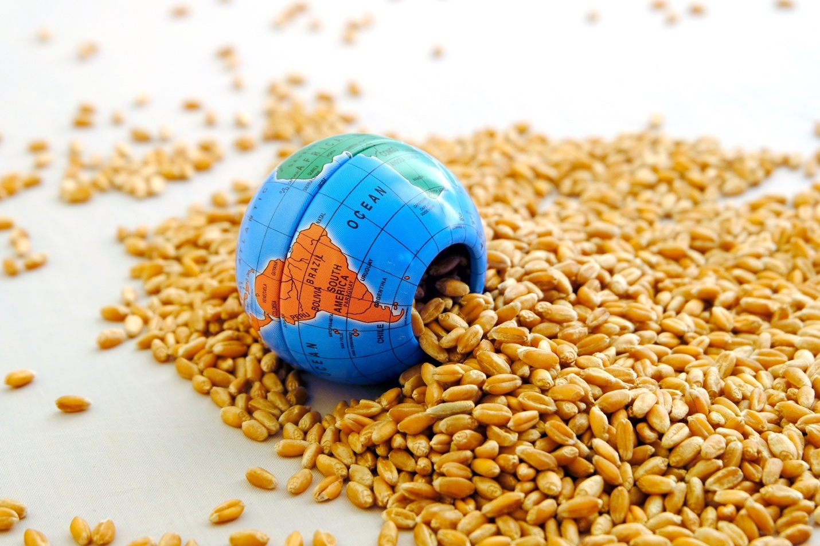
The Ukraine–Russia conflict has instigated significant cascading impacts on global food supply chains © SvetaKost/Shutterstock.com

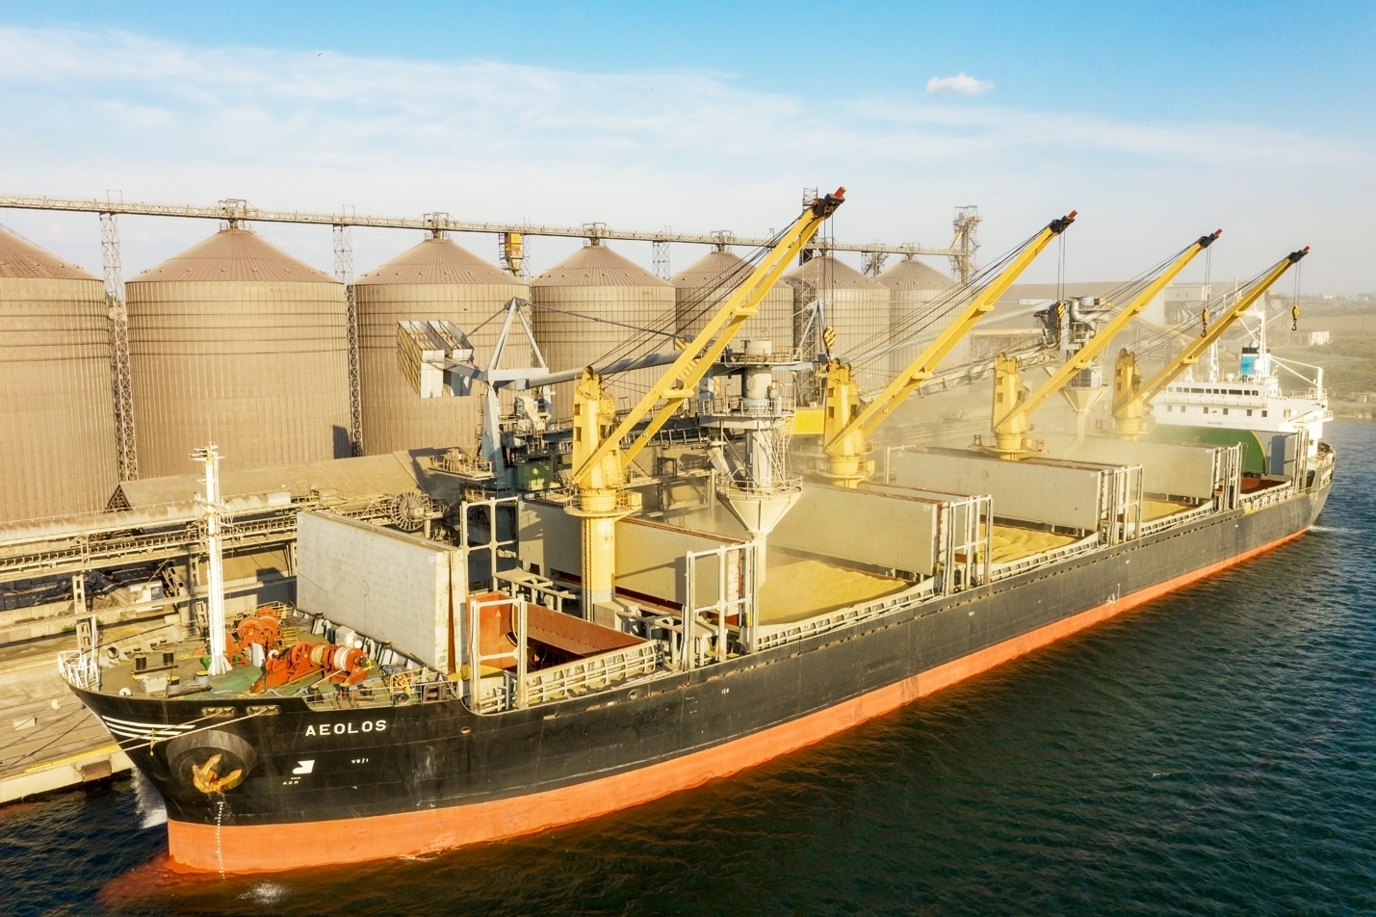
Prior to the conflict, 6 million tonnes of agricultural commodities per month were exported from Ukrainian Black Sea ports, such as Odessa © Elena Larina/Shutterstock.com

The global food supply chain impacts of the Ukraine–Russia conflict will be most acutely felt by the poorest and most vulnerable households © M7Studio/Shutterstock.com

