Susceptibility Weighted Image Analysis Methods in Hypoxic Ischaemic Encephalopathy
Zhen Tang, Sasan Mahmoodi, Angela Darekar, Brigitte Vollmer
Abstract —The purpose of this study is to evaluate venous vascular structure and distribution as prognostic indicators of developmental outcomes for infants with neonatal hypoxic-ischaemic encephalopathy (HIE) by detecting and analyzing ridges representing vessels on susceptibility-weighted magnetic resonance images (SWIs). Forty-two infants with neonatal HIE underwent SWI in the neonatal period and neurodevelopmental assessment at age 24 months. Normalized histograms of the width, intensity, length and Hessian eigenvalues extracted from the ridge analysis of each patient’s SWI are applied as feature vectors to feed into the $kNN$ and random forest classifiers to predict their neurodevelopmental outcomes. The feature vectors extracted from HIEs are further numerically analyzed in this paper to determine the brain regions which have been affected by neonatal HIE. The feature vectors containing width, intensity, length, and eigenvalue show a promising classification accuracy of 78.67% $±$ 2.58%. The features derived from the vascular ridges improve the prognostic value of SWI in HIE. Furthermore, our findings demonstrate that it is possible to predict neurological, motor, and cognitive outcomes by numerical analysis of their neonatal SW images and to identify brain regions on SWI affected by HIE. We also employed the linear regression, polynomial regression, and support vector regression (SVR) model to predict outcomes and the lower mean relative errors (MRE) for motor and cognitive outcomes are 0.088±0.073 and 0.101±0.11 respectively.

Index Terms —Hypoxic-ischaemic encephalopathy, Susceptibility-weighted imaging, ridge detection, neurological, motor, cognitive outcomes.

INTRODUCTION
N
eonatal hypoxic-ischaemic encephalopathy (HIE) is a consequence of perinatal asphyxia and is a significant cause of perinatal death and neurodevelopmental impairments later in life [2]. Approximately 0.2% of infants in high income countries suffer from HIE, resulting in a mortality rate of 15%–25% [1]. HIE carries a high risk for neuro-motor, cognitive, and behavioural difficulties, epilepsy, visual and hearing impairment in survivors. Early diagnosis, assessment of the injury location and extent is important for counselling and identification of those who may benefit from early intervention [3-4].
A range of imaging techniques are used for diagnostic evaluation, including magnetic resonance imaging (MRI) with T1-/T2-weighted imaging (T1WI/T2WI) [6-7], diffusion-weighted imaging (DWI) [9], diffusion tensor imaging (DTI) [8] and SWI[10]. Magnetic Resonance Spectroscopy (MRS) is used in [23] to investigate the extent of damage in some areas of the brain. Compared to other MRI techniques, SWI is more sensitive in detecting and visualising haemorrhagic foci and intravascular deoxygenated blood changes [11]. In [10], the Hessian eigenvalue of the ridge representing vessels in SWI images was used to separate infants with HIE from healthy infants, based on scores obtained by grading the prominence of deep medullary veins [5]. In [13], an extended 3D local binary pattern (LBP) was developed to differentiate the appearance of 3D SWI datasets of infants with HIE, depending on oxygenation status of the infants. The resulting SWI appearance was thought to reflect the corresponding levels of oxygen in the blood. Imbalanced data makes the results in [12] and [13] somewhat biased. In [14], SWI texture parameters such as the skewness of a region of interest (ROI) in SWIs is used to differentiate the infants with HIE from healthy infants. A deep learning technique is also developed in [12] to segment vessels in SWI datasets to help develop further analysis tools for diagnosis.

Using imaging to predict developmental outcomes of infants surviving HIE is an important field of research [16-19]. Most studies have looked at the extent of damage in key areas (including the basal ganglia, thalami, watershed regions and the posterior limb of the internal capsule) using early MRI scans [9]. However, there is limited knowledge on how specific vascular features on MRI relate to outcomes.
The aim of our study is threefold: i) to predict neurological outcome at age 24 months, after HIE. ii) to predict motor and cognitive development at age 24 months. iii) to identify the brain regions mostly affected or damaged by hypoxia-ischaemia.

data acquisition
Ethical approval for this study and use of anonymized routinely collected clinical outcome data was obtained from the Health Research Authority (HRA), Health and Care Research Wales, (HCRW) (IRAS ID 279072; REC reference 20/HRA/0260) and the National Research Ethics Service (NRES) London, City & East (IRAS ID 143392; REC reference 13/LO/1948).

MRI Protocol
MRI was performed on a 1.5 T Siemens Symphony MRI scanner, and included proton density (PD), T1-weighted, T2-weighted, turbo inversion recovery (IR), DWI, and SWI. SWI data was acquired using a, flow-compensated, spoiled gradient echo (FLASH) sequence, with the following pulse sequence parameters: TR/TE/flip angle = 50 ms / 40 ms / 12°, voxel size = 0.9 × 0.9 × 2 mm³, bandwidth = 70 Hz/pixels. Infants were scanned whilst in natural sleep or under general anesthetic.

Clinical Data
Forty-two infants with neonatal HIE born at gestational age >36+6 weeks are included in this research. After undergoing hypothermia treatment, all newborns have MRI in the neonatal period as part of their clinical care. The participants in this study were scanned at a mean age of 7.8 days (min 1 day max 34 days) after birth.
In the context of a follow-up programme all infants had neurodevelopmental assessments at age 24 months including standardised neurological examination and assessment of cognitive, motor, and language development with the Bayley Scales of Infant and Toddler Development 3 (Bayley-3; 31).

Method

Outcome Assessment
The neurological examination consisted of the assessment of cranial nerve function, movements, posture, reflexes, and muscle tone; and neurological status was then considered as either normal or abnormal (Cerebral Palsy). Of the 42 infants neurologically assessed at the age of 2 years, 31 (73.8%) have a normal neurological outcome, and 11 (26.2%) have an abnormal neurological outcome.
Bayley-3 is a standardised tool that assesses developmental function in infants aged between 1 and 42 months [22]. It includes three sections: cognitive, language and motor; scaled scores and composite scores can be calculated from the raw scores. For this study, composite scores were used. Bayley-3 composite scores have a mean of 100 and a standard deviation (SD) of 15. Development is considered age appropriate if Bayley-3 composite scores are less than one SD of the mean (>85). Mild delay is graded according to a composite score greater than 1–1.5 SD below the mean (77.5–85), and a moderate or severe delay is graded if the score is more than 1.5 SD below the mean (<77.5). In our study, we focus on cognitive and motor development as indicated by Bayley-3 composite scores. Outcome data on neurological status were available for 42 children. Since some of the children were unable to complete the Bayley Scales due to neurological impairment (n=11) or compliance with testing, Bayley-3 outcome data were available for 29 children for the cognitive scales, and for 28 children for the motor scales.
 |  | 1 | 1 | 1 |  |  | 0 | 0 | 0
 |  | 1 | 10 | 1 |  |  | 0 | 1 | 0
 |  | 1 | 1 | 1 |  |  | 0 | 0 | 1
- b)
Fig. 1. Bifurcation point template, where convolution with the ridge point is equal to or greater than 13; b) End point template

Image Preprocessing
Before processing SWIs, a brain mask is extracted to remove the background signal from the images to precisely identify vessels in the brain slices. We use an active contour model [21] for each SWI slice to obtain a binary brain mask that eliminates noise, and background from calvarium, as shown in Figure 2(b).

Ridge Detection
In SWI images, blood vessels appear to be ridge-like objects. Zero-crossings of the image derivatives are therefore used to detect the vessels represented by ridges in two-dimensional SWI slices. Generally, using a convolution operator, image $I(x,y;σ)$ can be generated by convolving the image $I(x, y)$ with a Gaussian kernel $G(x, y;σ)$ of variance $σ$, which could also reduce noise existing in SWI images.

$I\left(x,y;σ\right)=I\left(x,y\right)*G(x,y;σ)$ (1)

We denote $I(x,y)$ to be the SWI image in which we extract the brain using the active contour model in section III.B. The change in the gradient of intensity near a pixel is ascertained by the first derivative of the image $I(x,y;σ)$. A ridge point is located where the intensity gradient vanishes. Such a point corresponds to the zero-crossing point. Finally, a connected pixel chain with one-pixel width is obtained for every ridge in the SWI images. Non-vascular ridges (eg due to the appearance of CSF in the images) that divide the brain into two halves in the SWI datasets, are removed using the Hough transform to leave ridges representing only vessels.

Ridge Segmentation
Vessels form ridges in SWI images. To further analyse our SW images, we need to initially detect and then segment each individual ridge. This segmentation later helps us to extract features from each ridge individually. After ridge detection (see [10] for ridge detection), all of the initial SWI images for infants with HIE are transformed into binary images where 1’s (white pixels) represent ridges. A component labelling scheme for connected (ridge) pixels is used here for ridge segmentation. This algorithm is applied to a ridge map (a binary image) to assign a white pixel (ridge pixel) to an individual connected region belonging to a ridge with a certain label. Here, a local 3 x 3 neighbouring window is used to visit each pixel in the ridge map to check eight connectivities surrounding each ridge pixel.
However, before applying this process, it is vital to determine pixels representing the termination and bifurcation points as a part of ridge segmentation. If a central point is a ridge pixel and there is only one neighbour, it becomes a termination point. A bifurcation point has at least two neighbours. The termination and bifurcation points are detected by looking for maxima in an image computed by convolving a ridge image with the template shown in Figure 1(a) and searching for values of unity in an image obtained by convolving a ridge image with all rotated variants of termination template depicted in Figure 1(b). Two termination points in each connected ridge are stored in a list representing a segmented ridge. Bifurcation points are eliminated to separate crossing vessels. As shown in Figure 2(e), each blood vessel (ridge) in the binary ridge map is segmented and for illustration purposes is depicted in a certain color.
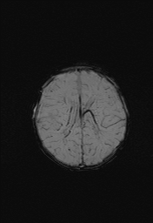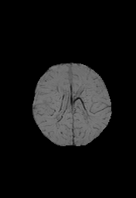
- b) c)
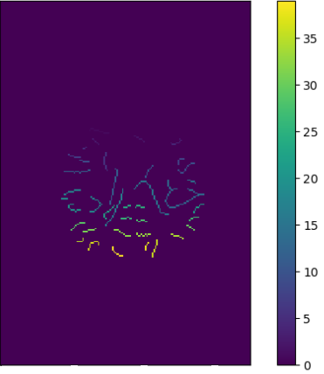
d) e)
Figure 2. a) Original SWI images; b) The result from the active contour model; c) Ridge detection with the grey value threshold = 40, and the threshold of difference between the zero-crossing point and closest point is 270; d) The centreline of the brain removed with pixel = 2; e) Labelled blood vessel

Feature Extraction
Four features, as described below are extracted from the segmented vessels for vessel classification:

Vessel Width Measurement

Vessel width is calculated by measuring the distance between points on the vessel boundaries perpendicular to the ridge orientation as shown in Figure 3(a). For each labelled (segmented) ridge (blood vessel), a Canny edge detector is also applied to find the blood vessel edges. Then, the boundary points on the Canny edges are assigned to two sets in both sides of the ridge, as shown in Figure 3(a). Some junctions are derived from both sides of the ridge along a line normal to $BC$ in Figure 3(a) by connecting three consecutive points on the ridge at point $A$, as shown in Figure 3(a) . The vessel width is defined as the shortest Euclidean distance of the points from boundaries in the both sides of the ridge. Finally, the histogram of all vessel widths is calculated as a feature vector referred to as $Width$ in this paper.

Vessel Intensity Measurement

Depending on varying levels of blood oxygenation, SW images for neonatal HIE will demonstrate veins with varying degrees of lower intensities representing different intensity values of blood vessels in the greyscale image. We utilise the difference between the intensity values of ridge points and those of boundary points of vessels as a marker of hemodynamic or vascular changes in the brain due to HIE. By tracking the ridge pixel coordinates of the vessel and the corresponding edge point pairs of the vessel boundary in the original SW images, the maximum pixel value difference between the ridge point and two shortest edge points in either side of the ridge point (Figure 3(a)) is measured and referred here to vessel intensity as a feature for HIE outcome prognosis. Similar to the Width feature, the histogram of all vessel intensities is computed as a feature vector referred to as $Intensity$ in this paper.
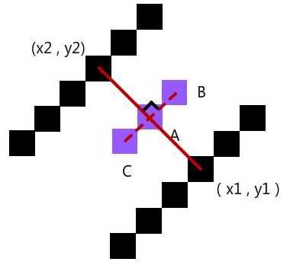
- b)
Figure 3. a) The pixel pairs according to the vertical line; b) Greyscale SWI;

Vessel Length Measurement

We also measure the vessel length as a feature for HIE outcome prognosis. For each segmented ridge, we count the number of pixels from start point to end point as vessel length. Ultimately, a histogram of all vessel lengths within an SWI dataset, constitute a feature vector known as $Length$ here. The coordinates of the start point and the identification number of SWI slice where the vessel is found, as well as the identification number for each patient are stored row by row into a location vector to enable us to find the patient this vessel is associated with as well as to locate the vessel inside the brain (x, y, and slice number).

Ridge Eigenvalue

In SWI images, a ridge point is the local minimum point in the direction of the largest gradient change [10]. The local intensity of the pixel on the ridge is derived from the Hessian matrix consisting of the second-order partial derivative of the SW image. After calculating a $\text{2 × 2}$ Hessian matrix for every pixel on ridges in the two-dimensional SW image, for each ridge point, two eigenvalues ($λ$) of Hessian matrix is computed, where the eigenvalue with the maximal absolute value is treated as a feature for HIE outcome prognosis. A histogram of ridge eigenvalues is also considered as a feature vector known as, $Eigenvalue$ here.

Results
We use the outcomes of neurological, motor development and cognitive development assessments as labels (ground truth) to classify the patients into healthy infants and abnormal patients. Here in this section, we employ traditional machine learning classifiers and regression algorithms with the feature vectors described in the aforementioned section.
TABLE I
Classification accuracy with selected features of vessels
Classifier |  | Normalised Feature | Accuracy result
 | $$kNN$$ | $$\frac{Width}{|Width|}$$ | 69.69$±$4.23%
 |  | $$\frac{Intensity}{|Intensity|}$$ | 71.37$±$4.31%
 |  | $$\frac{Length}{|Length|}$$ | 72.93$±$3.83%
 |  | $$\frac{Eigenvalue}{|Eigenvalue|}$$ | 72.27$±$4.85%
 |  | $$\frac{Width}{|Width|}+\frac{Intensity}{|Intensity|}+\frac{Length}{|Length|}$$ | 70.86$±$3.03%
 |  | $$\frac{Width}{\left|Width\right|}+\frac{Intensity}{\left|Intensity\right|}+\frac{Length}{|Length|}+\frac{Eigenvalue}{|Eigenvalue|}$$ | 75.45$±$5.81%
 | Random forest | $$\frac{Width}{|Width|}$$ | 71.17±7.45%
 |  | $$\frac{Intensity}{|Intensity|}$$ | 72.83±5.67%
 |  | $$\frac{Length}{|Length|}$$ | 74.33±8.68%
 |  | $$\frac{Eigenvalue}{|Eigenvalue|}$$ | 71.17±6.38%
 |  | $$\frac{Width}{|Width|}+\frac{Intensity}{|Intensity|}+\frac{Length}{|Length|}$$ | 78.33±4.43%
 |  | $$\frac{Width}{\left|Width\right|}+\frac{Intensity}{\left|Intensity\right|}+\frac{Length}{|Length|}+\frac{Eigenvalue}{|Eigenvalue|}$$ | 78.67±2.58%

Error of Vessel Segmentation
In some cases, real vessels are not precisely the same as the ridges detected by our algorithm. The performance of the ridge detection method employed here is measured by computing the error in the vessels segmented by our method from the manually segmented vessels (ground truth). Five SWI slices , with a size of 290$×$256 pixels, covering different brain anatomy areas, from five infants are manually annotated as our ground truth for segmented vessels. This sets up five mask images where pixels on vessels are set to one, and non-vessel pixels are considered to be zero. We manually segment 2,455 pixels as vessels in these five slices. Next, ridges of the same five slices are segmented by the segmentation algorithm used here. We compute error pixels $n$ as the difference in the number of pixels between automatically segmented ridges and manually segmented ridges of a vessel. The error is normalised as:
$$p= \frac{n}{m}$$

where $m$ is the total number of ground truth pixel for the vessel. There are 187 error pixels in the five SWI images; these are pixels present in automated vessel segmentation but absent in the manual image or vice versa. The error accuracy in each of the five images is calculated using error pixels. We calculate the mean and standard deviation of the error as $p$ = 7.75% $±$ 1.97% for our vessel segmentation algorithm.

Classification for Neurological Outcomes
Having calculated the histogram of the width, intensity, length and Hessian eigenvalue of the vessels in SWI images, 42 infants with information on neurology outcomes are classified into two groups: 31 with normal neurological outcomes and 11 with abnormal neurological outcomes (cerebral palsy). To balance the data distribution, 11 out of the 31 patients with normal neurology outcomes are randomly selected for the classification process. This selection is performed 10 times in each experiment so that classification accuracies are reported as mean and standard deviation of the classification accuracies over these 10 experiments. Histograms of the four aforementioned features are normalised to the area below each histogram. These normalised histograms merge into a single feature vector by concatenating feature vectors and are then fed into a $kNN$ and a random forest classifier to classify the SW images into normal or abnormal groups.
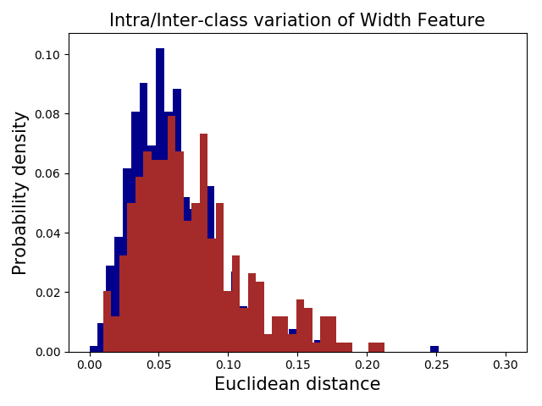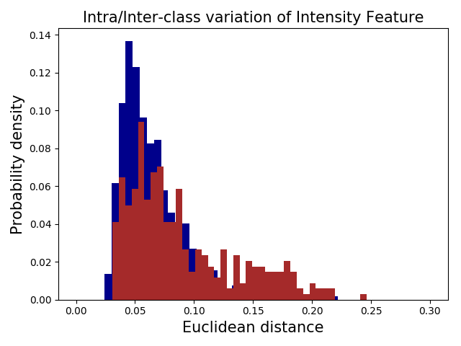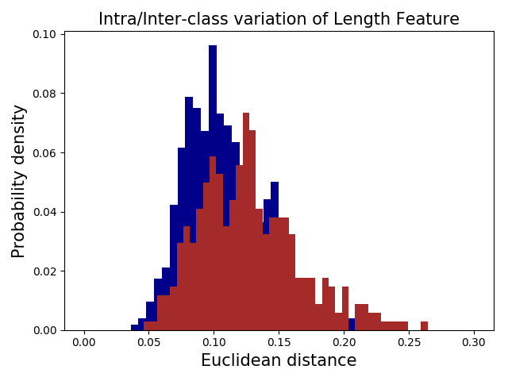
a) b) c)
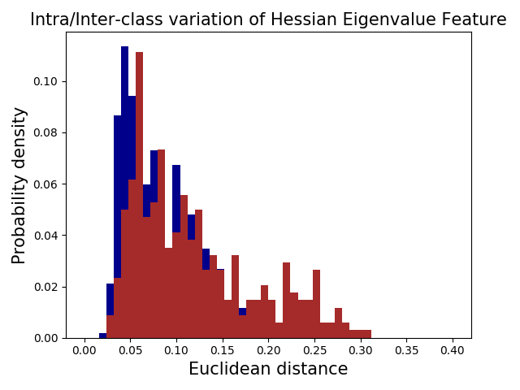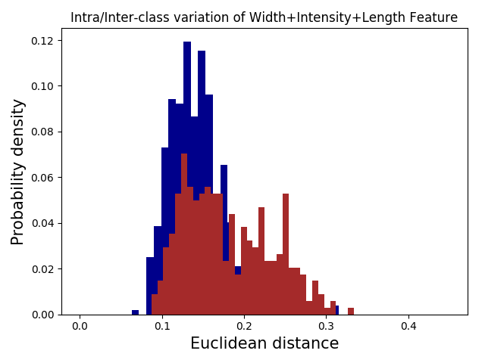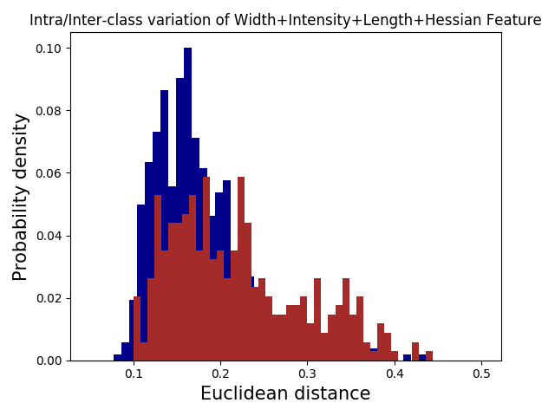
d) e) f)
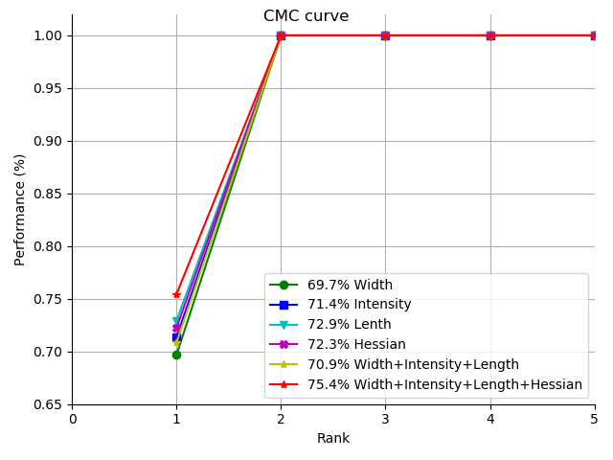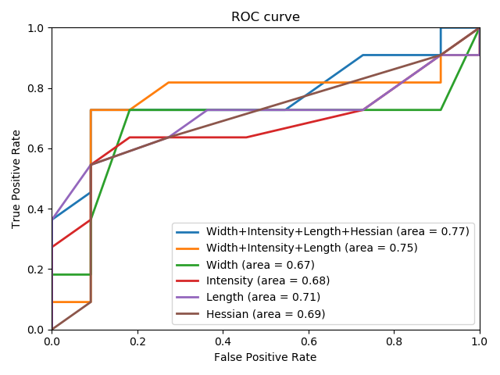
g) h)
Figure 4. Intra/inter-class variations for a)$Width$, b) $Intensity$, c) $Length$, d) $Eigenvalue$, e) $Width+Intensity+Length$, f) $Width+Intensity+Length+Eigenvalue$ ; g) CMC associated with the kNN classifier; h) ROC curve of our method with the random forest classifier

As tabulated in Table I, the highest accuracy 78.67% $±$ 2.58% is achieved by the random forest classifier with four feature vectors (width, intensity, length and Hessian eigenvalue).. However, by using only length as a feature vector, a slightly better classification accuracy than the Hessian eigenvalue feature proposed in [10] is achieved. In Table I, the classification strategy for both classifiers is leave-one-out cross-validation. Figure 4 (a to f) illustrates the inter- and intra-class variation for various combinations of the four aforementioned features for both normal and abnormal groups in our dataset. The blue bars in Figure 4 depict the intra class variations for feature vectors in the same group, and the brown bars represent inter-class variations for feature vectors from different groups. As shown in Figure 4f, the overlap between the two histograms is less than the overlaps of the histograms in Figure 4 (a to d). This is consistent with the results presented in Table I, indicating that the classification accuracy of combined features is higher than that of the single features. Figure 4g also shows the cumulative match characteristic (CMC) curve for the $kNN$ classifier. As shown in figure 4(g), the highest accuracy is a concatenated vector of the four features, with 75.4% in rank 1. It is observed that all of the $kNN$ classifiers achieve 100% accuracy when rank 2. Figure 4(h) displays the receiver operating characteristic (ROC) curves for the various features and their combinations when the KNN classifier is used for classification. As shown in figure 4(h) for each feature or its combination, the area under the ROC curve is also displayed. Figure 4 (g and h) shows the combination of four features mentioned above, i.e. width, intensity, length and Hessian feature vectors (blue curves) have performed the best for this classification task. We also calculate Pearson’s correlation coefficient $r$ for all possible pairs of feature vectors, as demonstrated in Table Ⅱ. The observation in Table Ⅱ is that some features exhibit a certain dependency. This explains why the results of $kNN$ classification for the combination of width, intensity and length are less accurate than the accuracy obtained using only one of the features. To increase the classification accuracy, we apply the random forest revealing a better performance as presented in Table I.
Algorithm 1: Training
TV= total number of vessels in each patient
MD = Mahalanobis Distance
-Extract width, length, intensity and eigenvalue histograms (features) of all vessels
-Calculate the Mean and Covariance Matrix of vessels in feature space for Normal patients
// Finding optimal value
-Set interval ranges $r_{T}$ for threshold $T$, $r_{q}$ for percentage $q$
-FOR each vessel belonging to a patient, $T∈r_{t}$ do
-Count the number of vessels (c) with MD >T
FOR $q∈r_{q}$ do
IF ${ c}/{TV} ≥q\%$
Classify the patient as abnormal
ELSE
Classify the patient as normal
END // for IF
-Calculate the accuracy using the number of correctly Classified patients
-Increase q
END // for q
-Increase T
END // for T
Find T and q with highest classification accuracy.

TABLE Ⅱ
Pearson’s correlation coefficient between the features
 | Width | Intensity | Length | Eigenvalue
Width | 1 | 0.4831 | 0.1667 | -0.1714
Intensity | 0.4831 | 1 | 0.4789 | -0.3122
Length | 0.1667 | 0.4789 | 1 | -0.1973
Eigenvalue | -0.1714 | -0.3122 | -0.1973 | 1

Brain regions affected by hypoxia-ischaemia
Given the correlation of cerebral blood flow with HI injury and the clearly visible borders and morphological features of micro-hemorrhages in SW images after HIE [24], we propose an algorithm to separate vessels damaged by HIE from normal vessels. Such an algorithm would then enable us to find the regions of the brain affected by HI injury and it therefore would help us to assess the associations of the affected brain regions with neurodevelopmental outcomes.

Experimental Design and Approach
Based on our results in sections IV.C and IV.D, our hypothesis is that in SW images, there are some changes in the appearances of some vessels affected by HIE. Therefore we can assume that in a brain affected by hypoxia-ischaemia, there are two groups of vessels: normal and “abnormal” vessels. Here we have used the term “abnormal” for vessels which are affected by HIE and therefore appear differently in SW images from normal vessels. We are therefore aiming to locate the damaged brain regions by detecting these abnormal vessels and to examine if it is possible to predict the outcomes of clinical assessments at birth (24 months before the infants are clinically assessed) by analysing the patients’ SW images. However it is tedious and time consuming for medical experts to annotate such abnormal vessels and in the absence of ground truth data (vessels annotated/labelled by medical experts as abnormal), it is not trivial to separate normal and abnormal vessels in any given SWI. We therefore propose Algorithm 1 to be able to separate normal and abnormal vessels. Algorithm 1 is a supervised classification method to classify vessels into normal and abnormal groups without using any ground truth for normal and abnormal vessels by using the outcomes of clinical assessments as an indirect supervision. In order to supervise the classification process in our algorithm proposed here, the neurological, motor and cognitive outcomes obtained from clinical assessments are used as ground truths to train Algorithm 1.
As can be seen from the pseudo-code of the training of Algorithm 1, we initially consider all vessels in all normal patients. Each vessel is represented by a feature vector which consists of concatenated feature vectors extracted from SW images as described in section III.E. Therefore in our feature space, there are vessels represented by their feature vectors extracted from all slices of all patients with normal outcomes in our dataset. We then compute the centre and covariance matrix for these feature points (vessels) representing normal patients in the feature space. Each vessel is defined as a vector with three concatenated features (Width, Intensity, Eigenvalue histograms) as well as the value of the vessel Length. Next, all vessels for all patients with abnormal outcome, are placed in feature space for the comparison with our original feature points in the feature space. Then every vessel in the feature space is classified into one of two groups: normal or abnormal vessels. The Mahalanobis Distance (MD) of a feature point from the original group of feature points in our feature space is computed. If the MD of this feature point is less than a threshold T, this feature point is considered to be a member of normal vessels. However, if this MD is more than threshold T, then the feature point is considered to be a member of abnormal group of vessels. MD is calculated as:

$$D= \sqrt{{\left(x-μ\right)}^{T}S^{-1}(x-μ)}$$

where $μ$ is the mean vector, $S$ is the covariance matrix for the original group (associated with normal patients) of feature points in our feature space and x is the feature vector associated with a vessel in the feature space. The above operation is performed for all vessels of all SWI slices of a patient. In order to find the most optimal threshold T separating normal and abnormal vessels, we employ the following rule:
If q% or more of vessels of a patient is considered to be abnormal, then the patient is considered to have an abnormal outcome. Otherwise the patient is considered to have normal outcomes

With certain values for q and T, Algorithm 1 predicts some patients with normal outcomes and some other patients with abnormal outcomes. We then measure the accuracy of our algorithm for these values of q and T by comparing the outcome of our algorithm with the outcome of the clinical assessments (ground truth).
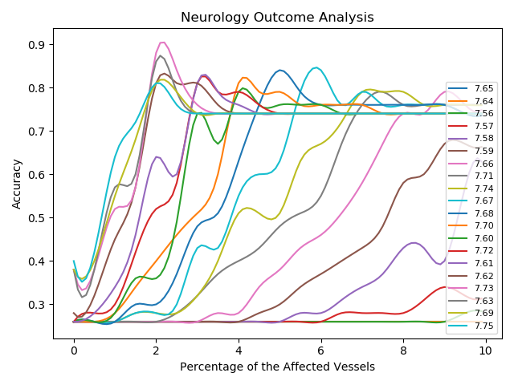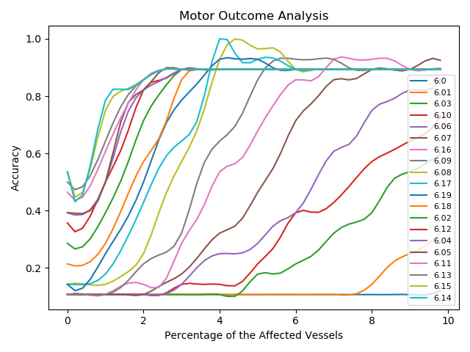
- b)
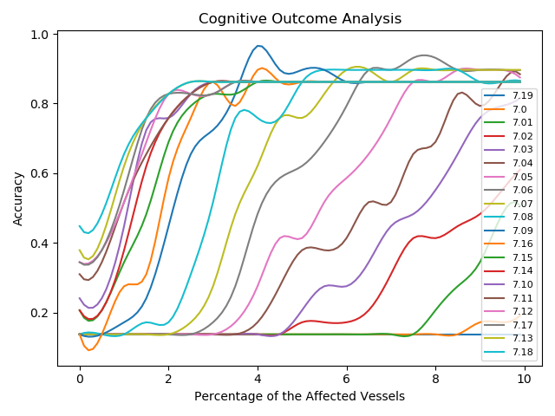
c)
Figure 5. Choosing threshold $T$ and percentage $q$ where the accuracy in the training stage is maximum for a) Neurology outcome analysis; b) Motor outcome analysis; c) Cognitive outcome analysis

By changing q and T, we measure the accuracies of Algorithm 1 for all values of q and T. Finally we choose q and T values that correspond to the maximum accuracy. Figure 5 shows Algorithm 1 accuracies with respect to q and T. Figure 5(a) shows how Algorithm 1 accuracies change with respect to q by changing T. In figure 5(a), different accuracy curves with respect to q for the neurological assessment outcomes are plotted in different colors for different values of T. Ideally the maximum for Algorithm 1 accuracies is desired to be 100%. However due to the distribution of vessel feature vectors in feature space, this may not be achievable. In Such cases, we simply choose the maximum accuracy over all T and q values for an assessment outcome. Figures 5(b) and 5(c) also depict the accuracy curves of our algorithm over various T and q for motor and cognitive developmental outcomes. Having found the optimal values for T and q for each assessment outcome, we have then managed to separate normal and abnormal vessels in our feature space.

Relationship between Brain Regions with Affected Vessels and Neurology Outcome
With 42 infants assessed clinically for neurological outcomes, a threshold of T=7.66 and a percentage of q=1.9% correspond with the best accuracy for our algorithm to enable us to separate normal and abnormal vessels as depicted in figure 5(a). The best total accuracy for Algorithm 1 is 88.1% with 29 out of 31 patients with a normal neurology outcome being truly grouped (93.55%) and eight out of 11 patients with an abnormal neurology outcome being correctly categorised (8/11: 93.75%). The fact that the maximum total accuracy here is less than 100% (i.e. it is 88.1%), implies that some normal vessels are grouped as abnormal and some abnormal vessels are grouped as normal. We therefore propose a fine-tuning method in the following paragraph to find a more accurate boundary separating normal and abnormal vessels by using a KNN classifier.
Fine tuning: The aim of the fine tuning is to find a more accurate boundary between normal and abnormal vessels in the feature space. Such a fine-tuning technique can improve our algorithm performance to up to 100% in the training stage (see Figure 5(a)). To this end, we choose two thresholds:$T_{i}, T_{o}$ in the neighbourhood of the threshold $T_{max}$, corresponding to the maximum accuracy to ensure that $T_{i}<T_{max}<T_{o}$. These thresholds divide the feature space in three regions: the first region is the inner feature subspace considered to contain normal vessels (i.e. MD <$T_{i}$) and the outer feature subspace considered to accommodate abnormal vessels (i.e. MD >$T_{o}$). The third region is the middle subspace between these two above regions (i.e., $T_{i}$<MD<$T_{o}$). By setting these two thresholds, some feature points are placed in the middle subspace between inner and outer subspaces in the feature space. The feature points in the middle subspace are considered as a test set and the rest of feature points inside the inner and outer regions are used as the training set to train a kNN classifier. This kNN classifier then classifies the feature points in the middle subspace (the test set) into the normal group (in the inner subspace) and the abnormal group (in the outer subspace) to determine a more accurate boundary between normal and abnormal groups in the feature space. We keep decreasing $T_{i}$ and increasing $T_{o}$ step by step and measure the classification accuracy in each step. We stop the fine tuning process, if either the classification accuracy reaches 100% or the maximum classification accuracy decreases with respect to the previous iteration. In our experiments, with the first step, we have always reached 100% accuracy and therefore terminate the fine tuning process. It is noted that q and $T_{max}$ are kept constant during the fine-tuning process.
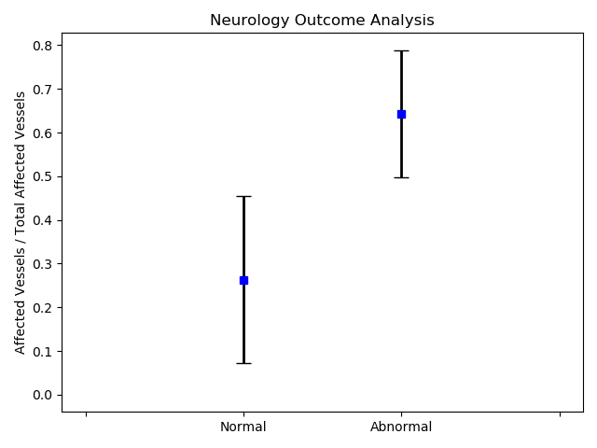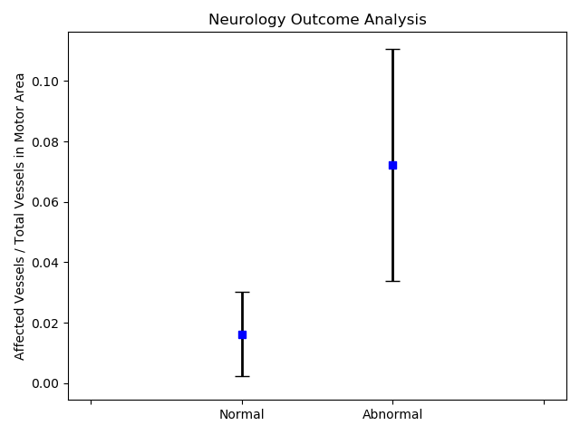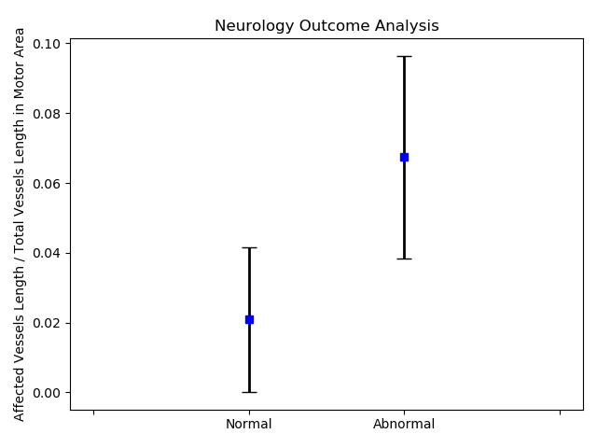
a) b) c)
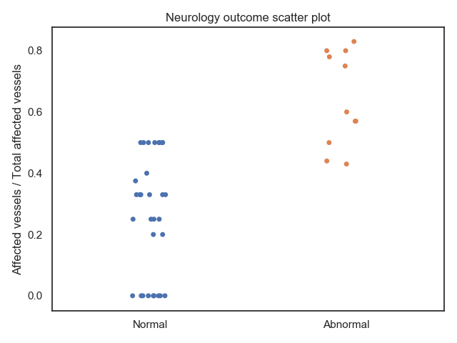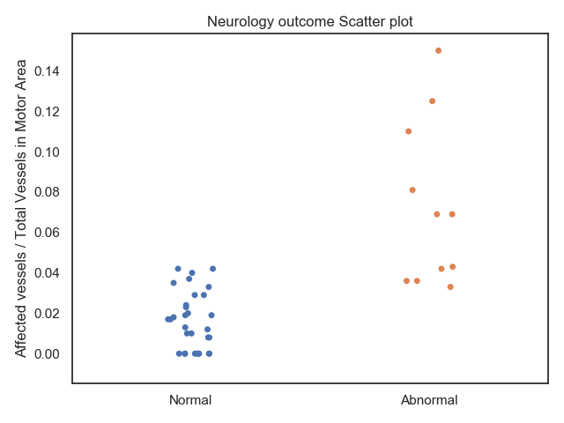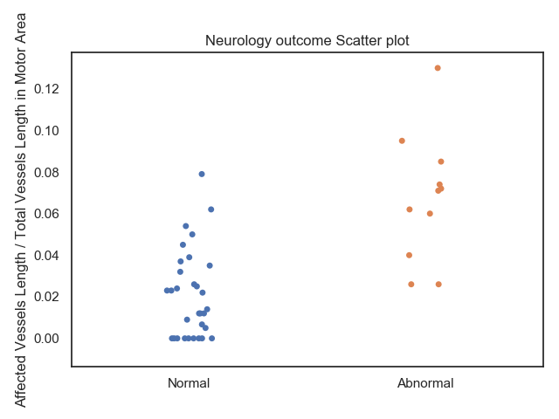
d) e) f)
Figure 6. Ratio of the number of affected vessels in the motor area to the total number of affected vessels: a) Errorbar, d) Scatterplot; Ratio of the number of affected vessels in motor area to the total number of vessels in motor area: b) Errorbar, e) Scatterplot; Ratio of the length of affected vessels in motor area to the total length of vessels in motor area: c) Errorbar, f) Scatterplot

Before analysing the motor regions damaged by the HIE based on neurological outcomes, we perform a validation experiment with a balanced data (11 patients with abnormal neurology and 11 patients with normal neurology randomly opted from 31 patients in the group with normal neurology as the training dataset) to measure the performance of Algorithm 1. Leave-one-out strategy is employed here, which means that Algorithm 1 is trained on all balanced data except for one test patient. Having trained our algorithm by computing T and q, we then measure the number of cases (classification accuracy) where the test patient is classified correctly. The random selection of 11 patients out of 31 patients from the normal group is repeated ten times and the classification accuracy is measured in each time. Final accuracy is calculated as 0.727±0.056 (the mean ± standard deviation over these 10 experiments).
After the fine tuning process, the abnormal vessels percentage for each patient are recalculated. We explore the relationship between percentage of the affected vessels in cortical motor regions of the brain (primary motor area, pre-motor area and supplementary motor area) and the neurology outcomes. In these 42 patients, all of the vessels grouped as abnormal by Algorithm 1 with fine-tuning are counted. Finally, the ratio of the number of abnormal vessels in the motor areas to the total number of abnormal vessels shown in Figure 6(a and d), the ratio of the number of abnormal vessels in motor areas to the total number of vessels in the motor areas shown in Figure 6(b and e), and the ratio of the length of abnormal vessels in motor areas to the total length of vessels in motor areas shown in Figure (c and f) are measured separately for each patient in the normal and abnormal groups to evaluate the relationship between the neurological outcomes and motor cortex damage for neurological outcomes at the age of 24 months. Mean and standard deviation of the ratios in infants with a normal neurology outcome and infants with an abnormal neurology outcome are shown in Figures 6, which shows the individual ratio as blue dots for infants with a normal neurology outcome and red dots for infants with an abnormal neurology outcome in scatterplots.
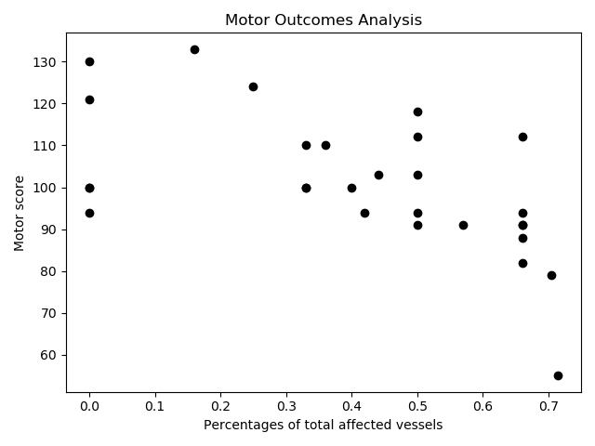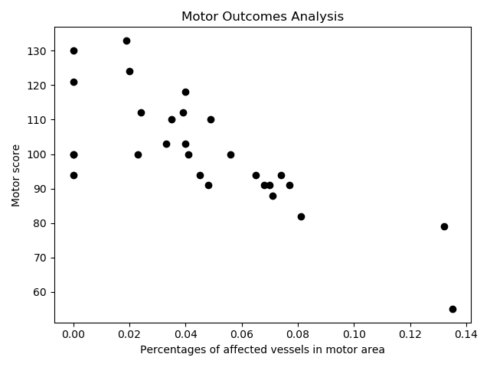
a) b)
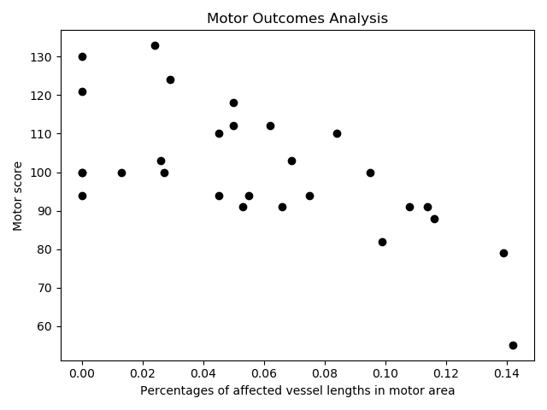
c)
Figure 7. a) the ratio of the number of abnormal vessels in the motor area to the total number of affected; b) the ratio of the number of abnormal vessels in motor area to the total number of vessels in motor area; c) the ratio of the length of abnormal vessels in motor area to the total length of vessels in motor area. All plots in this figure are with T = 6.17 and q=4.1%.

As observed from Figure 6(b and e), there is a significant difference in the ratios between the normal and abnormal groups. Our results indicate that the ratio of affected vessels in motor regions by SWI images to total number of vessels in the motor areas is correlated to neurological outcomes after HIE. Consequently, the neurological outcome at two years old could almost always be predicted by the ratios of the affected vessels described above in the motor areas of cerebral SWI in newborns with HIE. Due to the initial misclassification where two patients with normal neurology are marked as having abnormal motor outcome and three patients with abnormal neurology are classified as patients with normal neurology, even after fine-tuning there is some overlap between the range of ratios for the percentages of affected vessels in patients with normal and abnormal neurology.

Affected Brain Regions Responsible for Delayed Motor Outcomes
TABLE Ⅲ
Correlation of Ratios with Motor Scores
T of 6.17 | Motor score
$$R_{m1}$$ | -0.58
$$R_{m2}$$ | -0.76
$$R_{m3}$$ | -0.65

For the 28 infants with HIE who were assessed with Bayley-III scales, 25 infants have normal motor development (>85), 2 infants have mild motor delay (77.5-85) and one has severe motor delay (<77.5). As observed in figure 5(b), the highest total accuracy of 100% is achieved with a threshold T of 6.17 and a percentage q of 4.1%., These are the ideal values for optimal threshold T and percentage q where patients in both the normal group with normal motor outcome and the abnormal group with mild motor delay and severe motor delay are 100% correctly grouped by Algorithm 1.
Before measuring the number of affected vessels in motor regions of the brain, we perform an experiment to measure the classification accuracy of Algorithm 1 with unseen test data for validation. We use a balanced data (3 patients with delayed motor score and 3 patients with normal motor score randomly selected from 25 normal motor score group). A leave-one-out strategy is then used here to measure the accuracy. The final accuracy of classification using our algorithm to separate patients with delayed motor score from normal motor score is computed by repeating the above process 10 times with random selections from patients’ dataset with normal motor outcomes to achieve an accuracy of 0.75±0.139 (mean ± standard deviation).
We predict that motor scores are related to the percentage of abnormal vessels in the motor areas (i.e. the primary motor area, pre-motor area and supplementary motor area) of the brain. In these 28 patients, all of the vessels grouped as abnormal with the most optimal thresholds T of 6.17 and 6.08 are considered. Having trained our Algorithm 1 with fine tuning, the following terms are measured:
$R_{m1}:$ The ratio of the number of abnormal vessels in the motor area to the total number of abnormal vessels in the brain.
$R_{m2}:$ The ratio of the number of abnormal vessels in the motor area to the total number of vessels in the motor area
$R_{m3}:$ The ratio of the length of abnormal vessels in motor area to the length of total vessels in motor areas.
The scatterplots of these ratios with respect to motor scores are shown in figure 7. As observed from this figure, there are negative correlations between motor scores in one side with $R_{m1}$(figures 7(a and d)), $R_{m2}$ (figures 7(b and e)), and $R_{m3}$(figures 7(c and f)) in the other side. Table Ⅲ respectively show the correlation between the motor score and $R_{m1}$, $R_{m2}$and $R_{m3}$with T of 6.17 and q of 4.1%. It is noted from Table Ⅲ that the correlation between the motor score and the percentage of the abnormal vessels in motor areas to the total number of vessels in the motor area is -0.76 which is the highest among other measurements. As the percentage of abnormal vessels increase in the motor cortex, the motor score decreases. The results presented in Figure 7, demonstrate that the percentage of abnormal vessels in motor areas is correlated with motor development for patients with normal and abnormal neurology. For patients whose motor scores are considered as delayed (<85), these abnormal vessels are clustered in areas associated with the motor function of the brain. The presence of these vessels in the motor cortex of patients with a normal motor score is lower than those in patients with abnormal motor outcome. Therefore, the number of abnormal vessels found in SW images of the motor cortex of the neonatal brain with HIE acquired at birth is related to the clinical motor outcome at the age of two years.

Affected Brain Regions Responsible for Delayed Cognitive Outcomes
The vessels of 29 infants of which 25 infants had normal cognitive outcome (>85), 3 infants with mild cognitive delay (77.5-85) and one severe cognitive delay (<77.5), are optimally partitioned by our aforementioned algorithm proposed in this paper with a threshold T of 7.09 and a percentage q of 3.9%. In the training stage, Algorithm 1 achieves 100% accuracy for patients that have normal cognitive score and 75% accuracy for patients that have mild and severe cognitive delay, and the total accuracy is therefore 96.55%. We also use the kNN classifier for fine-tuning as proposed in section (V-B) and improve the accuracy of 100% in the training stage as observed in Figure 5(c). As observed from this figure, there are two thresholds: 7.06 and 7.13 for which the classification accuracy reaches 100%.
TABLE Ⅳ
Correlation of Ratios with Cognitive Scores
 | Cognitive score
$$R_{c1}$$ | -0.48
$$R_{c2}$$ | -0.36
$$R_{c3}$$ | -0.52

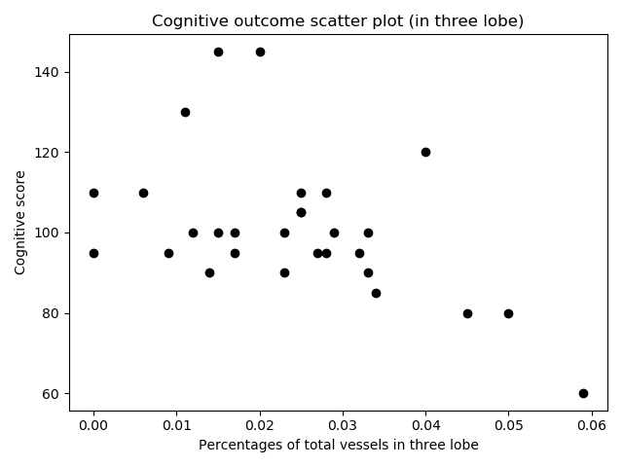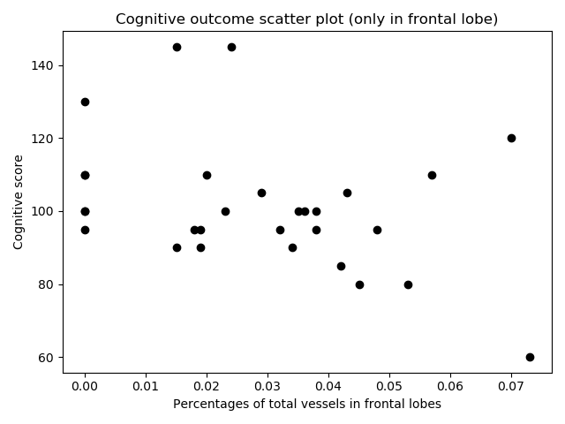
a) b)
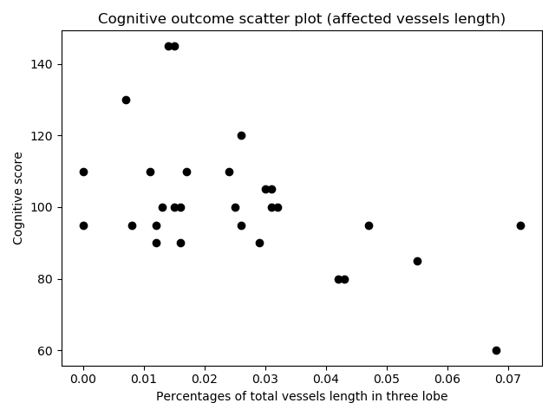
c)
Figure 8. a) the ratio of the number of abnormal vessels in three lobes to total vessels in three lobes; b) the ratio of the number of abnormal vessels in frontal lobes to total vessels in frontal lobes; c) the length of abnormal vessels in three lobes to the length of total vessels in three lobes

Before measuring the correlations between our measurements with cognitive scores, we undertake an experiment to measure the performance of our algorithm using a leave-one-out strategy with unseen test data by balancing our dataset with cognitive outcomes i.e., 4 patients with delayed cognitive scores and 4 patients with normal cognitive score randomly selected from 25 normal cognitive score group. The final accuracy for classifying patients with delayed cognitive score and patients with normal cognitive score is computed as, 0.65 ± 0.098 (mean ± standard deviation) by repeating 10 times the aforementioned experiment in the above paragraph.
Cognitive functions are interrelated, and sometimes they overlap using different brain areas covering attention, memory, language and executive functions. To measure the number of abnormal vessels related to cognitive functions, three areas of the brain are considered in our analysis: the frontal lobe, temporal lobe and parietal lobe. The vessels grouped as abnormal after fine-tuning with a threshold of T=7.09 in each of the three lobes are counted (q=3.9%), and the following terms are calculated:
$R_{c1}:$ The ratio of the number of abnormal vessels in three lobes to total vessels in three lobes.
$R_{c2}:$ The ratio of the number of abnormal vessels in frontal lobe to total vessels in only frontal lobe.
$R_{c3}:$ The ratio of the length of abnormal vessels in three lobes to the length of total vessels in three lobes.
The scatter plots in Figure 8 depict the various relationships between the ratios of abnormal vessels in the three lobes with respect to the cognitive development. The cognitive scores for this group are not strongly correlated with our aforementioned measurements ($R_{c1}$ to $R_{c3}$). The measurement $R_{c2}$ does not show a strong correlation with the cognitive scores at all. However, the measurements $R_{c1}$ and $R_{c3}$ demonstrate stronger correlations with the cognitive scores (as observed from Figure 8(a) and 8(c)), while the correlations between the cognitive scores and the ratios of abnormal vessels in only the frontal is not significant as illustrated in Figures 8(b). The correlation coefficient is -0.52 for abnormal vessels length as tabulated in Table Ⅳ. In summary, the length of abnormal vessels in the frontal, temporal and parietal lobes is the best predictor for cognitive scores assessed at the age of 24 months.
Figure 9 shows the inter- and intra- class variations for two normal and abnormal (vessel) groups for neurology outcome (figure 9(a and b)), motor development (figure 9(c and d)), and cognitive development (figure 9(e and f)). In figure 9, the green histograms illustrate the intra-class variations for vessels within the same group, while the red histograms represent the inter-class variations for vessels from the two different groups. The histograms of feature points are normalised to the area below each histogram. In figures 9(a, c and e), all vessels from patients with normal neurology outcome, normal motor score and normal cognitive score are considered as normal, and all vessels from patients with abnormal neurology outcome, delayed motor cognitive developments are deemed as abnormal respectively. As observed from figures 9(a, c and e), the two histograms are heavily overlapped. The corresponding Receiver Operator Characteristic (ROC) curve for these three cases shown in figure 9(g indicates a low performance (around 50% classification accuracy) for such a vessel classification system. Figure 9(b) depicts inter-class and intra-class variation histograms between abnormal and normal vessels groups after the vessels are classified as normal and abnormal by our Algorithm 1 with fine-tuning proposed in this paper. Figure 9 (d) presents the histograms for inter- and intra- class variations between the abnormal and normal vessel groups after the classification of vessels into normal and abnormal by our Algorithm 1 with thresholds T of 6.17 for motor outcome, while figure 9 (f) represents the abnormal and normal vessel groups classified by Algorithm 1 with fine-tuning for cognitive outcome. As observed from figures 9(b, d, and f), the inter/intra class variation histograms show a better separated features for normal and abnormal vessel groups in the feature space. As observed in figure 9(g), the ROC curve corresponding to the intra/inter class variations of figure 9(f) demonstrates a higher performance in classification (with an AUC higher than 72%). As shown in Figure 9(b, d, and f), the overlap between two histograms and the areas under the ROC curves (orange, red, and brown curves) demonstrate a better performance after Algorithm 1 classifies normal and abnormal vessels in our feature space. It is noted that the abnormal vessel counts and the ratios measurements are achieved by registering [26][27] each SWI containing the detected abnormal vessels with a brain template selected from LPBA40/AIR atlas and containing all brain lobes [28].
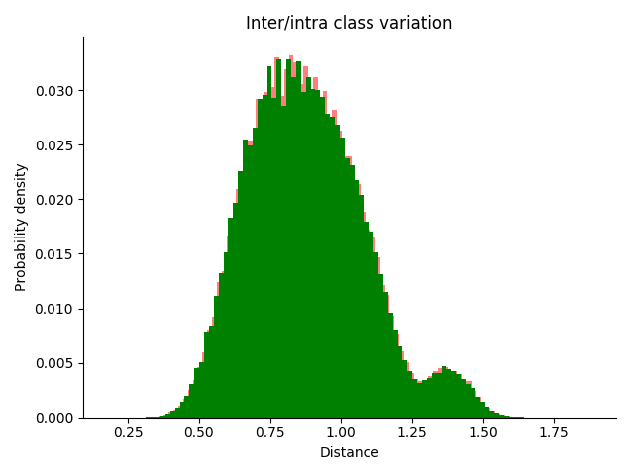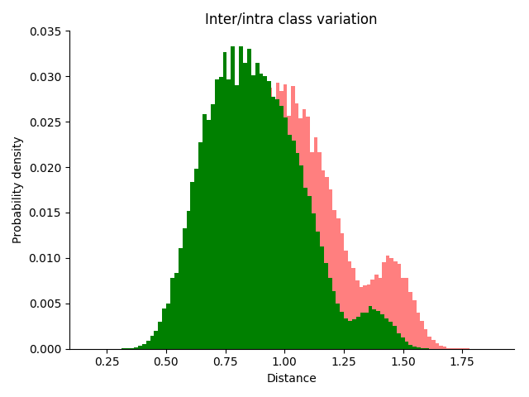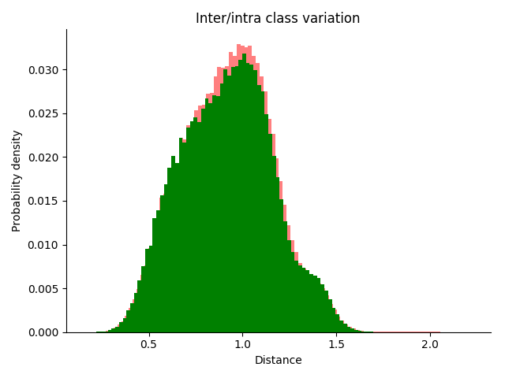
a) b) c)
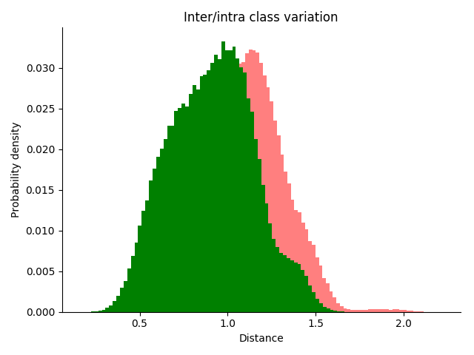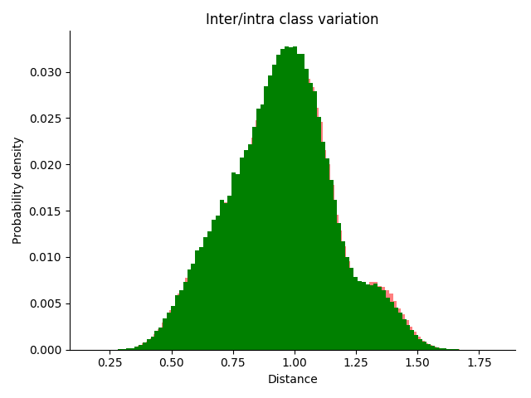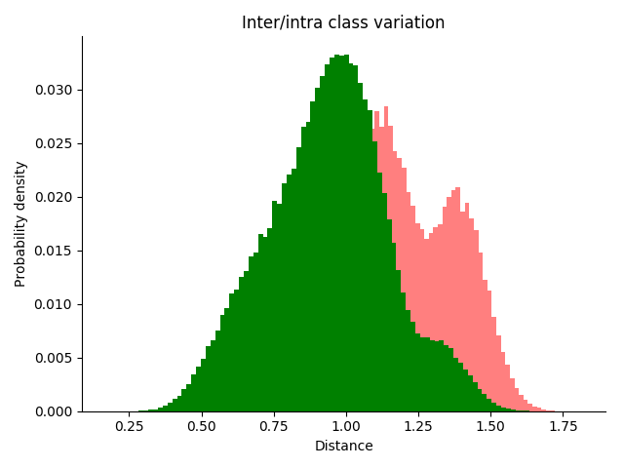
d) e) f)
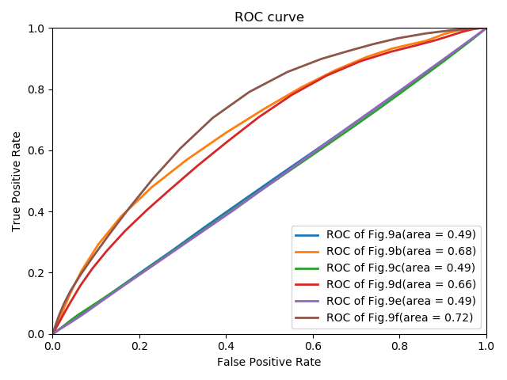
g)
Figure 9. Intra/inter class variations of neurology outcome for: a) original abnormal group and normal group; b) abnormal group and normal group classified by our Algorithm 1 with fine-tuning; Intra/inter class variations of motor outcome for: c) original abnormal group and normal group; d) abnormal group and normal group classified by our Algorithm 1 with T of 6.17; Intra/inter class variation of cognitive outcome for: e) original abnormal group and normal group; f) abnormal group and normal group classified by our Algorithm 1 with fine-tuning; g) ROC curve of above inter- and intra- class variation plots

Regression Analysis for Motor and Cognitive Development
As mentioned in the previous section, for each of 28 patients with motor scores and 29 patients with cognitive scores, three different ratios, $R_{m1}$ to $R_{m3}$, and $R_{c1}$ to $R_{c3}$, respectively are computed as features. These new features can be used as new features to predict motor and cognitive development scores. As our earlier work in [25], we also employ support vector regression (SVR), linear regression (LR) and polynomial regression (PR) to predict the new test. Given a database of $n$ patients with ratios, $x_{n}∈R^{m}$, as input and the corresponding Bayley composite scores $y_{n}$ as output, the motor or cognitive score for a new patient can be predicted by employing different ratios calculated in the previous section through training the LR, PR and SVR model using these ratios (as $x_{n}$) and the associated motor or cognitive scores (as $y_{n}$). The error of regression method is measured by using a leave-one-out strategy.
TABLE Ⅴ
Regression Prediction Errors for Motor and Cognitive Scores
Regression |  | Mean error | Mean relative error
Motor scores with SVR | $$R_{m1}$$ | 12.53±8.26 | 0.124±0.082
 | $$R_{m2}$$ | 9.86±8.73 | 0.097±0.086
 | $$R_{m3}$$ | 9.84±8.41 | 0.097±0.079
Cognitive score with SVRs | $$R_{c1}$$ | 10.25±11.84 | 0.101±0.11
 | $$R_{c2}$$ | 14.74±17.05 | 0.145±0.16
 | $$R_{c3}$$ | 13.35±13.03 | 0.132±0.13
Motor scores with linear regression | $$R_{m2}$$ | 8.94±7.43 | 0.097±0.079
Cognitive scores with Polynomial regression | $$R_{c1}$$ | 11.32±10.42 | 0.111±0.103
Motor scores [25] |  | 10.98±7.67 | 0.109±0.067
Cognitive scores [25] |  | 11.40±13.24 | 0.113±0.13

To measure the performance of these regression models, the error for each test patient is calculated as the absolute difference between the true score for cognitive or motor scores and the corresponding predicted score provided by using trained different regression models with these ratios, and the mean relative error (MRE) as defined below:

MRE = $\frac{1}{n}\sum_{i=1}^{n}{\frac{\left|p_{i}-t_{i}\right|}{t_{i}}}$

where n is the number of patients in our database, $p_{i}$ is the SVR model prediction value, $t_{i}$ is the true value (ground truth). A mean and standard deviation are calculated for both absolute errors and MRE.
Here SVR regression errors calculated using a polynomial kernel with degree = 2 are presented in Table V to compare the results trained with the four vascular features by the same SVR model in [25]. As observed from Table Ⅴ, SVR achieves a better performance in predicting motor scores than in predicting cognitive scores in terms of both mean error value of 9.84±8.41 and MRE value of 0.097±0.079 for patients with motor scores. Both of mean errors and MRE computed by using ratios obtained from Algorithm 1 outperforms the regression results presented in [25]. Also the single variable linear regression model for $R_{m2}$ shows lower mean error value of 8.94±7.43 and MRE value of 0.088±0.073 for motor scores, and the polynomial regression (degree=2) with $R_{c1}$ leads to the mean error value of 11.32±10.42 and MRE value of 0.111±0.103 for cognitive scores. It is noted that the best regression results in Table V is reported in bold.

Conclusion
In this study, the four normalised histograms representing the features for width, intensity, length and eigenvalues of the Hessian matrix are extracted from the vessels (ridges) of neonatal SW images of infants with HIE by using the structure and signal intensity of the venous vessels; these features can be used as predictors of outcomes of neonatal HIE at age 24 months. This study demonstrates the predictive capability of the $kNN$ and random forest classifiers with a leave-one-out cross-validation strategy and SVR models for the outcomes of neonatal HIE. The best accuracy associated with the random forest classifier for concatenated features consisting of width, intensity, length, and Hessian eigenvalues is 78.67 $±$ 2.58%. Our result is better than the classification accuracy reported in [10], which is 72.27 $±$ 4.85%.
This is the first study to classify in the appearance of vessels in SW images into two normal and abnormal groups with indirect supervisions. Such a vessel classification has helped us analyse and identify brain regions responsible for abnormal outcomes based neurological, motor and cognitive assessments. It is interesting to note that our vessel classification is based on clinical assessments rather than the purely image based scoring system proposed by Kitamura [5]. We have measured the performances of our algorithm in various scenarios. By using our algorithm proposed in this paper, in brain regions implemented in the outcomes of interest, we have found some measurements showing strong correlations with outcomes determined by clinical experts who have examined the patients two years after SW images have been taken. The accuracy of early prediction of outcome at the age of two years using SW images in newborns with HIE by Algorithm 1 is approximately 70%. In patients with HIE, abnormalities of blood vessels in the cortical motor areas are closely associated with abnormal neurological outcomes and motor development, with the highest correlation coefficients of -0.76. The detection of damaged blood vessels within this region in early SW images can help determine the type and severity of neurological impairment and motor development in infancy. The correlations of our measurements associated with the abnormal vessels (in the frontal, temporal and parietal lobes) with cognitive outcomes are lower. The length of vessels affected by HIE in the frontal, temporal, and parietal lobes shows the highest correlation of -0.52 with cognitive scores. Due to a lack of data, the lowest relative error of our regression model is related to motor scores, with an MRE of 0.088±0.073. Therefore, our analysis of SW images of patients with HIE provides additional pathological information to support prognostication and identification of those who may benefit from early intervention. One of the areas of future work is to explore the relationship between the ratios of affected vessels, and motor and cognitive development using regression models. Enlarging our dataset would be also another task for our future work. It would also be interesting to perform this analysis on older children (school age children) as another topic for future work. The last but not the least direction for future work would be to compare our vessel classification scheme, based on clinical outcomes, with the vessel scoring system proposed by Kitamura [5].

References
- Martinez-Biarge, M., Diez-Sebastian, J., Rutherford, M. A., & Cowan, F. M. (2010). Outcomes after central grey matter injury in term perinatal hypoxic-ischaemic encephalopathy. Early Human Development, 86(11), 675-682.
- Nadeem, M., Murray, D. M., Boylan, G. B., Dempsey, E. M., & Ryan, C. A. (2011). Early blood glucose profile and neurodevelopmental outcome at two years in neonatal hypoxic-ischaemic encephalopathy. BMC pediatrics, 11(1), 1-6.
- Massaro, A. N., Evangelou, I., Fatemi, A., Vezina, G., Mccarter, R., Glass, P., & Limperopoulos, C. (2015). White matter tract integrity and developmental outcome in newborn infants with hypoxic‐ischemic encephalopathy treated with hypothermia. Developmental Medicine & Child Neurology, 57(5), 441-448.
- Massaro, A. N., Evangelou, I., Brown, J., Fatemi, A., Vezina, G., McCarter, R., ... & Limperopoulos, C. (2015). Neonatal neurobehavior after therapeutic hypothermia for hypoxic ischemic encephalopathy. Early Human Development, 91(10), 593-599.
- Kitamura, G., Kido, D., Wycliffe, N., Jacobson, J. P., Oyoyo, U., & Ashwal, S. (2011). Hypoxic-ischemic injury: utility of susceptibility-weighted imaging. Pediatric Neurology, 45(4), 220-224.
- Trivedi, S. B., Vesoulis, Z. A., Rao, R., Liao, S. M., Shimony, J. S., McKinstry, R. C., & Mathur, A. M. (2017). A validated clinical MRI injury scoring system in neonatal hypoxic-ischemic encephalopathy. Pediatric Radiology, 47(11), 1491-1499.
- Belet, N., Belet, U., ütfi İncesu, L., Uysal, S., Özinal, S., ülay Keskin, T., ... & ̧ükrü Küçüködük, S. (2004). Hypoxic-ischemic encephalopathy: correlation of serial MRI and outcome. Pediatric Neurology, 31(4), 267-274.
- ElBeheiry, A. A., Elgamal, M. A., Ettaby, A. N., Omar, T. E., & Badeib, A. O. (2019). Can diffusion tensor imaging predict cerebral palsy in term neonates with hypoxic ischemic encephalopathy?. Egyptian Journal of Radiology and Nuclear Medicine, 50(1), 1-10.
- Chang, P. D., Chow, D. S., Alber, A., Lin, Y. K., & Youn, Y. A. (2020). Predictive values of location and volumetric MRI injury patterns for neurodevelopmental outcomes in hypoxic-ischemic encephalopathy neonates. Brain Sciences, 10(12), 991.
- Wu, S., Mahmoodi, S., Darekar, A., Vollmer, B., Lewis, E., & Liljeroth, M. (2017, July). Feature extraction and classification to diagnose hypoxic-ischemic encephalopathy patients by using susceptibility-weighted MRI images. In Annual Conference on Medical Image Understanding and Analysis (pp. 527-536). Springer, Cham.
- Ning, N., Li, X., Gao, J., Zhang, Y., Han, J., Luo, X., ... & Yang, J. (2013). Quantitative Measurement of Deep Medullary Venous in Susceptibility Weighted Imaging: Comparison of Hypoxic-ischemic and Normal Neonates. Society of Magnetic Resonance in Medicine Proceedings.
- Zhang, X., Zhang, Y., & Hu, Q. (2019). Deep learning based vein segmentation from susceptibility-weighted images. Computing, 101(6), 637-652.
- Citraro, L., Mahmoodi, S., Darekar, A., & Vollmer, B. (2017). Extended three-dimensional rotation invariant local binary patterns. Image and vision Computing, 62, 8-18.
- Kim, H. G., Choi, J. W., Han, M., Lee, J. H., & Lee, H. S. (2020). Texture analysis of deep medullary veins on susceptibility-weighted imaging in infants: evaluating developmental and ischemic changes. European Radiology, 1-10.
- Wagner, F., Haenggi, M. M., Wagner, B., Weck, A., Weisstanner, C., Grunt, S., ... & Verma, R. K. (2015). The value of susceptibility-weighted imaging (SWI) in patients with non-neonatal hypoxic-ischemic encephalopathy. Resuscitation, 88, 75-80.
- Lee-Kelland, R., Jary, S., Tonks, J., Cowan, F. M., Thoresen, M., & Chakkarapani, E. (2020). School-age outcomes of children without cerebral palsy cooled for neonatal hypoxic–ischaemic encephalopathy in 2008–2010. Archives of Disease in Childhood-Fetal and Neonatal Edition, 105(1), 8-13.
- Schreglmann, M., Ground, A., Vollmer, B., & Johnson, M. J. (2020). Systematic review: long‐term cognitive and behavioural outcomes of neonatal hypoxic–ischaemic encephalopathy in children without cerebral palsy. Acta Paediatrica, 109(1), 20-30.
- Nadeem, M., Murray, D. M., Boylan, G. B., Dempsey, E. M., & Ryan, C. A. (2011). Early blood glucose profile and neurodevelopmental outcome at two years in neonatal hypoxic-ischaemic encephalopathy. BMC Pediatrics, 11(1), 1-6.
- Mitra, S., Kendall, G. S., Bainbridge, A., Sokolska, M., Dinan, M., Uria-Avellanal, C., ... & Robertson, N. J. (2019). Proton magnetic resonance spectroscopy lactate/N-acetylaspartate within 2 weeks of birth accurately predicts 2-year motor, cognitive and language outcomes in neonatal encephalopathy after therapeutic hypothermia. Archives of Disease in Childhood-Fetal and Neonatal Edition, 104(4), F424-F432.
- Volpe, J. J. (2018). Hypoxic-ischemic injury in the term infant: pathophysiology. In Volpe's Neurology of the Newborn (pp. 500-509). Elsevier.
- Kass, M., Witkin, A., & Terzopoulos, D. (1988). Snakes: Active contour models. International Journal of Computer Vision, 1(4), 321-331.
- Edmonds, C. J., Helps, S. K., Hart, D., Zatorska, A., Gupta, N., Cianfaglione, R., & Vollmer, B. (2020). Minor neurological signs and behavioural function at age 2 years in neonatal hypoxic ischaemic encephalopathy (HIE). European Journal of Paediatric Neurology, 27, 78-85.
- Lally, P. J., Pauliah, S., Montaldo, P., Chaban, B., Oliveira, V., Bainbridge, A., ... & Thayyil, S. (2015). Magnetic Resonance Biomarkers in Neonatal Encephalopathy (MARBLE): a prospective multicountry study. BMJ open, 5(9), e008912.
- Li, X., Zhang, W., Liu, D., & Zeng, Y. W. (2019). Effect of 3.0 T Magnetic resonance SWI and MRS on early diagnosis of Neonatal HIE and Regression analysis of related predictive factors. Journal of Hainan Medical University, 25(1), 75-78.
- Tang, Z., Mahmoodi, S., Dasmahapatra, S., Darekar, A., & Vollmer, B. (2020, July). Ridge Detection and Analysis of Susceptibility-Weighted Magnetic Resonance Imaging in Neonatal Hypoxic-Ischaemic Encephalopathy. In Annual Conference on Medical Image Understanding and Analysis (pp. 307-318). Springer, Cham.
- Avants, Brian B., Nick Tustison, and Gang Song. "Advanced normalization tools (ANTS)." nsight j 2.365 (2014): 1-41.
- Avants, B. B., Tustison, N. J., Song, G., Cook, P. A., Klein, A., & Gee, J. C. (2011). A reproducible evaluation of ANTs similarity metric performance in brain image registration. Neuroimage, 54(3), 2033-2044.
- Shattuck, D. W., Mirza, M., Adisetiyo, V., Hojatkashani, C., Salamon, G., Narr, K. L, & Toga, A. W. (2008). Construction of a 3D probabilistic atlas of human cortical structures. Neuroimage, 39(3), 1064-1080.

