Sinusoidal Pulse Width Modulation (SPWM) on Cascaded H-Bridge (CHB) Converter Harmonic Analysis
Saiful Bahri Jaafar^{1,2a)}, Suleiman Sharkh^{2b)}, Dina Shona Laila^{1,2c)}, Ashraf Khalil^{1d)}
¹Faculty of Engineering, Universiti Teknologi Brunei, Gadong, BE1410, Brunei Darussalam
²Faculty of Engineering and Physical Sciences, University of Southampton, Southampton, SO17 1BJ, UK
^{a)}Corresponding email: saiful.jaafar@utb.edu.bn
^{b)}S.M.sharkh@soton.ac.uk
^{c)}dina.laila@utb.edu.bn
^{d)}ashraf.sulayman@utb.edu.bn
ABSTRACT. With the vast range of power electronic applications in modern engineering world, the need for better control of electronic devices is highly important. The control of power electronic converter is necessary in delivering power sourced from either conventional fossil fuel or renewable energy sources. Harmonic analysis in these power electronic converters can improve the necessary power needed, especially in reduction of power losses. The paper analyses the harmonic conditions by looking into total harmonic distortion (THD) in a three-level cascaded H-bridge (CHB) power converter. Fast Fourier Transform (FFT) waveform analysis will be used to observe the output waveforms’ performances. THD analysis and FFT will determine the amount of power that can be transferred. The CHB power converter can be used in devices such as static compensator (STATCOM), unified power factor compensator (UPFC) and other compensating devices in a power system. The THD & FFT analyses will be done using MATLAB/Simulink® software.
Keywords: Sinusoidal Pulse Width Modulation (SPWM); Power electronic; Power converter; Cascaded H-Bridge
INTRODUCTION
Power electronic converter is a powerful device which can be controlled by meticulously switching on and off semiconductor devices built for switching function. One of the most common applications of power electronic converter is its use as a power compensator in a power system. It can control the real power (P) and the reactive power (Q) to provide the best power supply to consumers[1, 2, 3]. Example of a unified power factor compensator (UPFC) using a back-to-back power converter is shown FIGURE 1 [4, 5].

FIGURE 1. Power Converters in Unified Power Factor Compensator (UPFC) of a Power Transmission System.
In FIGURE 1, the two converters are connected back-to-back via a DC link[5, 6, 7, 8]. In this paper, one of the converters will be simulated to observe and analyse how its performance with different switching schemes. The switching functionality of these power converters depends on their ability to properly and automatically switch the semiconductor devices[3, 6]. In this paper, insulated gate bipolar transistors (IGBTs) are used for each of the devices. IGBT provides better power performance, fast switching function and capable of working with less power losses due to heat and other parameters and more advantageous than regular field-effect-transistor (FET) devices[6, 7]. For simplification of analysis, the following specific power converter and controller are used in this paper:
- The power converter used is single phase type, rather than using the three-phase type.
- Controller is applied with using sinusoidal waveform as reference and triangular waveforms for carriers.
- Modulation indices used are 0.8, 1.0 and 1.2 for THD comparison analyses.
- MATLAB/Simulink® is utilized to develop a simulator to determine the output voltage suitability for power system transmission.
CASCADED H-BRIDGE (CHB) POWER CONVERTER
A three-level single phase CHB power converter is shown in FIGURE 2[5, 8, 9]. IGBTs are used to represent the switching devices and two capacitors labelled C₁ and C₂ are connected to DC voltage supplies. The simulation experiment uses equal voltage of 100 V for the each of the DC voltage sources, thus defining this CHB as the symmetrical type, and the output voltage will be a single-phase AC voltage. This completes the DC to AC conversion for this particular converter. The main objective is to obtain a waveform that forms a sinusoidal type signal[8, 9].
The gates of the IGBTs will be connected to the gate drivers, in this case, made out of sinusoidal PWM. The IGBT switching devices labelled as S₁₁, S₂₁, S_{31 and} S₄₁ are to be connected to V_{in1} and S₁₂, S₂₂, S₃₂ and S₄₂ are to be connected to V_{in2}.

FIGURE 2. Cascaded H-Bridge (CHB) Single Phase Power Converter
TOTAL HARMONIC DISTORTION (THD) AND FAST FOURIER TRANSFORM (FFT) ANALYSES
The output voltage THD analysis [8, 9] is done by calculating the following:
$$V_{THD}=\frac{\sqrt{\sum_{h=2}^{N}{V_{h,rms}^{2}}}}{V_{f}}$$
where V_{THD} is the voltage of THD, V_{h} is the voltage at the h^{th} frequency and V_{f} is the voltage at fundamental frequency. V_{THD} is usually represented as the percentage of the overall fundamental frequency voltage. This usually indicates the estimated “power losses” or “switching losses” due to switching sequences.
The FFT waveform analysis usually shows the proportion of how much “small” voltages at different frequency[4, 10]. Most power electronic converters, which are applied for power delivery, will have these voltages at odd harmonics[4, 10]. The FFT will indicate how much or how large these voltages will affect these odd harmonic frequencies that will in turn affect other electromagnetic devices, such as transformers, in the power system. Power electronic converters can use selective harmonic elimination (SHE) switching technique to avoid these effects[10, 11, 12].
SIMULATION OF CASCADED H-BRIDGE (CHB) USING SINUSOIDAL PULSE WIDTH MODULATION (SPWM)
The three-level CHB will be controlled by SPWM. Four types of SPWM are used: level shifted (LS), phase disposition (PD), phase opposition disposition (POD) and alternative phase opposition disposition (APOD). The CHB circuit built using Simulink® is shown in FIGURE 3 [13]. The simulation used FFT built-in block for FFT waveform analysis and built-in THD function inside the block. The analyses are done with different modulation indices to indicate the following conditions: over-modulated (modulation index = 1.2) and under-modulated (modulation index = 0.8) switching sequences.

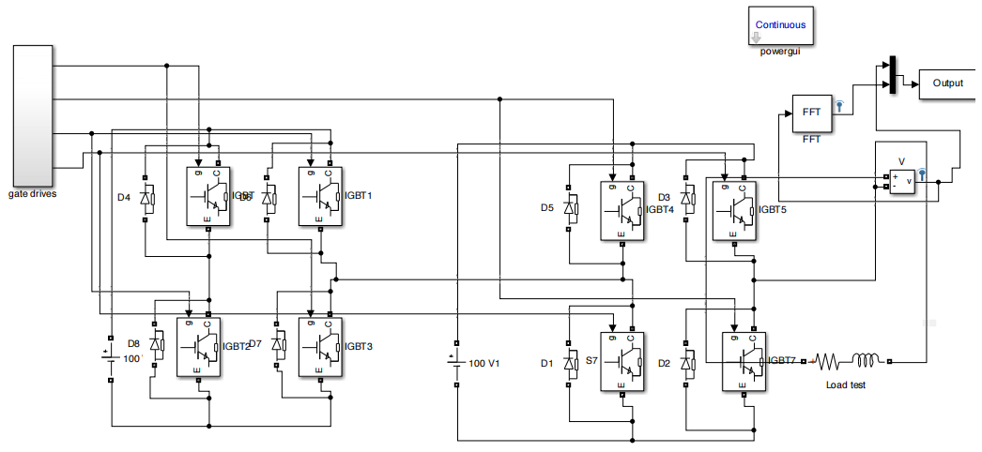FIGURE 3. Simulink® Diagram of a Single Phase CHB.
RESULTS
The results are divided into two parts: 1) using FFT waveforms and 2) THD performance. The SPWM are shown with the sinusoidal reference waveform and triangular carriers. FIGURE 4 shows four waveforms from LSPWM, PDPWM, PODPWM and APODPWM. In this figure, there are four carrier waveforms for the first four switching devices (S₁₁, S₂₁, S₃₁ and S₄₁). The carrier waveforms are then “inverted” to switch the other four switching devices (S₁₂, S₂₂, S₃₂ and S₄₂). This is applied for all the four types of SPWM.
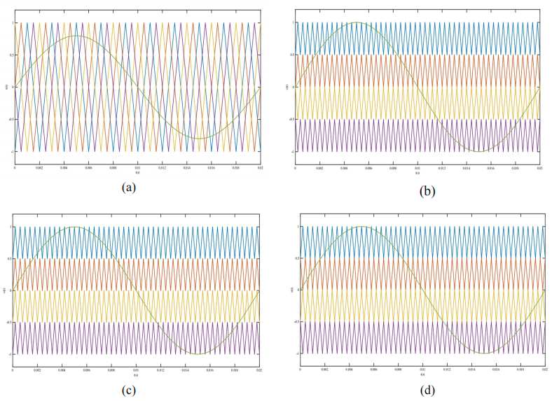
FIGURE 4. Sinusoidal Reference and Triangular Carrier Waveforms for (a) LSPWM, (b) PDPWM, (c) PODPWM, (d) APDPWM
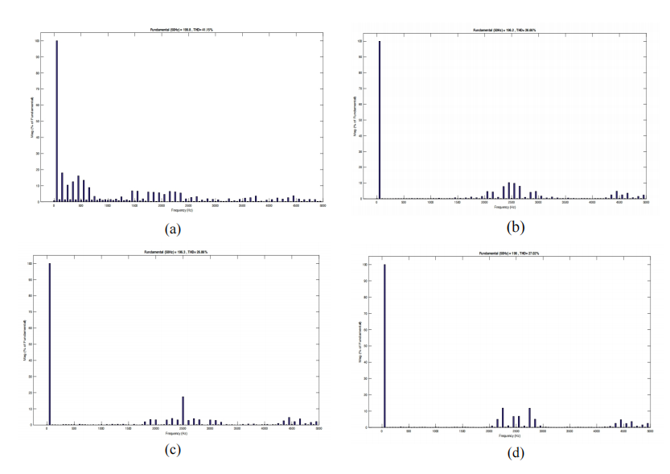
FIGURE 5. Output Voltage of Single Phase CHB for (a) LSPWM, (b) PDPWM, (c)PODPWM and (d) APODPWM.
FIGURE 5 shows the output voltages from CHB using the chosen SPWM and, in this figure, the output voltages follow the sinusoidal reference waveform in terms of frequency (i.e., 50 Hz) and amplitude. As can be observed, the waveforms are not purely sinusoidal. The levels of voltages in the waveforms indicate the multilevel appearance of the devices. FIGURE 6 shows the FFT analysis waveforms using these different SPWM techniques. The FFT waveforms show different indication of voltages at different frequency points. Most of the voltage indications occur at odd harmonic frequencies (i. e 3rd, 5th, 7th etc.). The fundamental frequency is at 50 Hz, as set at the beginning of the experiment. From FIGURES 4, 5 and 6, the THD in % is tabulated in TABLE 1.
As can be observed that the LSPWM produce the largest THD at 0.8 modulation index. The smallest THD is using PODPWM at 1.2 modulation index. It can also be concluded that there are very small differences between the PDPWM, PODPWM and APODPWM. These types of SPWM are usually grouped as “phase-shifted” SPWM. The highest THD is 41.33 % from the LSPWM type.

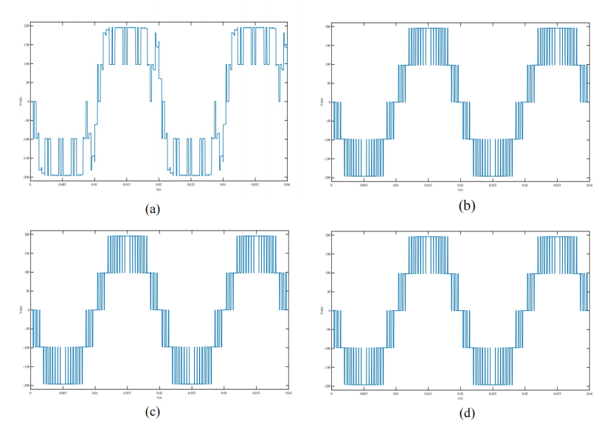
FIGURE 6. FFT Waveform Analysis and THD of (a) LSPWM, (b) PDPWM, (c) PODPWM and (d) APODPWM.

TABLE 1. THD (%) for using SPWM in CHB Converter
Modulation index | 0.8 | 1.0 | 1.2
LSPWM | 41.33 | 41.15 | 32.89
PDPWM | 38.19 | 26.66 | 21.74
PODPWM | 38.41 | 26.86 | 21.67
APODPWM | 38.69 | 27.02 | 22.27

CONCLUSIONS
This paper presented MATLAB/Simulink® simulation of a single phase CHB using different types of SPWM as switching sequence application. It can be observed that the phase shifted type of SPWM will produce the best result for this type of converters. The level shifted type has a larger THD than the phase shifted type. Overall, the results showed that phase shifted type is more usable than the level shifted one, but improvements can still be made. This could be used for a UPFC or STATCOM applications. A more powerful switching scheme tool is the space vector type, which will give smaller THD and good FFT waveforms.
REFERENCES
- A. Nabae, I. Takahashi, H. Akagi, “A New Neutral-Point-Clamped PWM Inverter”, IEEE Transactions on Industry Applications, vol. 1A-17, no. 5, September/October 1981.
- L. G. Franquelo, J. Rodriguez, J. I. Leon, S. Kouro, R. Portillo, M. A. M. Prats, “The Age of Multilevel Converters Arrives”, IEEE Industrial Electronics Magazine, vol. 2, no. 2, pp. 28-39, June 2008.
- J. Rodriguez, J-S. Lai & F. Z. Peng, “Multilevel Inverters: A Survey of Topologies, Control and Applications”, IEEE Transactions on Industrial Electronics, vol. 49, no. 4, pp. 724-738, August 2002.
- W. Zhu, K. Zhou, “A High-Frequency-Link Single-Phase PWM Rectifier”, IEEE Transactions on Industrial Electronics, vol. 62, no. 1, pp. 289-298, January 2015.
- R. Darus, G. Konstantinou, J. Pou, S. Ceballos, V. G. Agelidis, “Comparison of Phase-Shifted and Level-Shifted PWM in Modular Multilevel Converters”, Proceedings International Power Electronic Conference, pp. 3764 – 3770, May 2014.
- M. H. Rashid, “Power Electronics Handbook”, Academic Press, 2001.
- D. G. Holmes, T. A. Lipo, “Pulse Width Modulation for Power Converters: Principles and Practice”, Wiley-Blackwell, 2003.
- C. D. Townsend, Y. Yu, G. Konstantinou & V. G. Agelidis, “Cascaded H-Bridge Multilevel PV Topology for Alleviation of Per-Phase Power Imbalances and Reduction of Second Harmonic Voltage Ripple”, IEEE Transactions on Power Electronics, August 2016.
- S. Rathore, M. K. Kirar, S. K. Bhardwaj, “Simulation of Cascaded H-Bridge Multilevel Inverter using PD, POD, APOD Techniques”, An Electrical & Computer Engineering: An International Journal (ECIJ), vol. 4, no. 3, September 2015.
- J. Pereda, J. Dixon, “High-Frequency Link: A Solution for using Only One DC Source in Asymmetric Cascaded Multilevel Inverters”, IEEE Transactions on Industrial Electronics, vol. 58, no. 9, pp. 3884 – 3892, September 2011.
- S. R. Gupta, G. S. Anitha, “PD-PWM Based Cascaded H-Bridge Multilevel Inverter for Photovoltaic Systems”, International Journal of Advanced Research in Electrical, Electronics and Instrumentation Engineering (IJAREEIE), vol. 4, no. 7, pp. 6072 – 6078, July 2015.
- G. I. Orfanoudakis, S. M. Sharkh, M. A. Yuratich and M. A. Abu – Sara, “Loss Comparison of Two and Three-Level Inverter Topologies,” Proceedings of 5th International Conference on Power Electronics, Machines and Drives (PEMD), 2010.
- G. I. Orfanoudakis, S. M. Sharkh and M. A. Yuratich, “Analysis of DC-link Capacitor Losses in Three-Level Neutral-Point-Clamped and Cascaded H-Bridge Voltage Source Inverters,” IEEE International Symposium on Industrial Electronics (ISIE), Bari, Italy, 2010.

