Basede cohort vOSIN/R1

An assessment of intervention thresholds for high fracture risk in Chile

Enrique Lopez Gavilanez^{1,2} ∙ Imaicela N Luis¹ ∙ Navarro G Mario¹ ∙ Helena Johansson^{3,4,5} ∙ Nicholas C Harvey^{6,7} ∙ Mattias Lorentzon^{3,5} ∙ Enwu Liu³ ∙ Liesbeth Vandenput^{3,5} ∙ Eugene V McCloskey^{4, 8} ∙ John A Kanis^{3,4}

¹ AECE Research Group. The Association of Clinical Endocrinologists of Ecuador. Guayaquil, Ecuador.

² Hospital Docente de la Policía Nacional Guayaquil #2. Guayaquil, Ecuador
³ Mary McKillop Institute for Health Research, Australian Catholic University, Melbourne, Australia
⁴ Centre for Metabolic Bone Diseases, University of Sheffield, Sheffield, UK
⁵ Sahlgrenska Osteoporosis Centre, Institute of Medicine, University of Gothenburg, Gothenburg, Sweden
⁶ MRC Lifecourse Epidemiology Centre, University of Southampton, Southampton, UK
⁷ NIHR Southampton Biomedical Research Centre, University of Southampton and University Hospital Southampton NHS Foundation Trust, Southampton, UK
⁸ Mellanby Centre for Musculoskeletal Research, Department of Oncology and Metabolism, University of Sheffield, Sheffield, UK

Correspondence to: Prof John A Kanis, Centre for Metabolic Bone Diseases, University of Sheffield Medical School, Beech Hill Road, Sheffield S10 2RX, UK; Tel: +44 114 285 1109; Fax: +44 114 285 1813; w.j.pontefract@shef.ac.uk

Summary
Assessment and treatment pathways using FRAX-based intervention thresholds in Chile can be used to identify patients at high risk of fracture and avoid unnecessary treatment in those at low fracture risk.
Abstract
Purpose
The aim of the present study was to explore treatment paths and characteristics of women eligible for treatment in Chile based on major osteoporotic fracture (MOF) probabilities derived from FRAX®.
Methods
Intervention and assessment thresholds were derived using methods adopted by the National Osteoporosis Guideline Group for FRAX-based guidelines in the UK but based on the epidemiology of fracture and death in Chile. Age-dependent and hybrid assessment and intervention thresholds were applied to 1998 women and 1122 men age 50 years or more drawn from participants in the National Health Survey 2016 - 2017.
Results
Approximately 12% of men and women had a prior fragility fracture and would be eligible for treatment for this reason. Using age-dependent thresholds, an additional 2.6% of women (0.3% of men) were eligible for treatment in that MOF probabilities lay above the upper assessment threshold. A BMD test would be recommended in 5% of men and 38% of women. With hybrid thresholds, an additional 13% of women (3.6% of men) were eligible for treatment and BMD recommended in 11% of men and 42% of women.
Conclusion
The application of hybrid intervention thresholds ameliorates the disparity in fracture probabilities seen with age-dependent thresholds. Probability based assessment of fracture risk, including the use of the hybrid intervention thresholds for Chile are expected to help guide decisions about treatment.
Keywords: osteoporosis; fracture risk assessment; FRAX; intervention threshold

Introduction

The primary goal of osteoporosis treatment is to prevent the occurrence of fractures. For this reason, the management of the disorder by health care practitioners is assisted by instruments that assess patients’ fracture risk to optimise clinical decisions about prevention and treatment. Available online risk engines include the Garvan fracture risk calculator [1], QFracture® [2] and FRAX® [3, 4, 5]. An important difference between FRAX and other risk models is that the parameters of risk differ (incidence for Garvan and QFracture vs. probabilities for FRAX) so that comparative data are not readily interpreted [6]. FRAX is the most widely used globally [7] and computes the 10-year probability of fragility fractures based on several common clinical risk factors and, optionally, a bone densitometry result obtained from dual-energy x-ray absorptiometry (DXA) [8, 9]. FRAX models are available for 80 countries covering more than 80% of the world population at risk [10] and have been incorporated into more than 100 guidelines worldwide [7] including those from Latin America [11, 12, 13, 14, 15, 16].
The use of FRAX demands a consideration of intervention thresholds, namely the fracture probability at which treatment is recommended. Several approaches have been adopted including a fixed probability thresholds, age-dependent thresholds and hybrid approaches [7]. The aim of the present study was to explore a potential assessment pathway for fracture risk in men and women from Chile based on two different FRAX probability derived intervention thresholds.

Methods

Population studied
The present study comprised data from participants in the National Health Survey 2016 - 2017, third version. The survey was a national cross-sectional study that collected information between August 2016 and January 2017 from 6027 men and women age 15 years and over from urban and rural areas of the 15 regions of Chile. The population sample was probabilistic and geographically stratified. The full sample design and methodological details have been described elsewhere [17]. The survey mostly used internationally validated instruments and was designed to estimate the prevalence of priority health problems and associated risk factors. The forms, database, manuals, and codebooks are publicly available and can be downloaded from the web [18]. For the purposes of this report, all men and women aged 50 years or older were selected (n=1122 and n=1998 for men and women, respectively). The study was approved by the ethics committee of the Hospital Docente Policía Nacional Guayaquil No.2, Ecuador.

FRAX variables
A structured questionnaire was used to collect information from all participants. No data on bone mineral density (BMD) were available. Age and sex were self-reported. Height was measured in centimetres and weight in kilograms, and body mass index (BMI) was calculated as weight in kilograms divided by height in meters squared. Data on BMI were available in 89% of men and 90% in women (n=129 and 208 missing, respectively). With regard to the dichotomous FRAX variables, information on current smoking was available in all men and women, and for causes of secondary osteoporosis was available in all except for one man. Information was available for prior fragility fracture in all except 3 men and 13 women. Parental history of hip fracture information was present in 94% of men and 96% of women (n=71 and 86 missing, respectively); information on alcohol intake was available in 89% of men and 91% of women (n=121 and 188 missing, respectively). We did not use the questions and answers related to arthritis because the survey indicated that they have not been validated, nor those related to glucocorticoids, which also lacked sufficient detail. For the purposes of this analysis, rheumatoid arthritis, exposure to glucocorticoids and other missing variables were simulated.

Simulation of risk variables
Data from the cohort itself were used to simulate missing values, except for exposure to glucocorticoids and rheumatoid arthritis. Appropriate logistic regression equations were identified to generate data for the dichotomous FRAX variables as described previously [19, 20, 21]. The equations were applied to the data in the cohort to predict the probability of having a positive value for the missing risk factor for each individual. Next, a random number between 0 and 1 was generated using a computer program, which was then compared with the predicted probability for that variable for that individual. If the random number was less than or equal to the predicted probability, the individual was assigned a positive response for the risk factor. If the random number was larger than the predicted probability, the person was assigned a negative response for the risk factor. Missing BMI was simulated using linear regression and the SD, from the cohort itself. An expected value was calculated from the model for each individual. The expected value and SD were used together with a random number (0-1) to simulate the missing value.
Measured data on exposure to glucocorticoids and rheumatoid arthritis were missing from the data set. For these variables, data were available in the WHO cohorts from North America and Europe used to develop the FRAX model. Thus, data from the WHO cohorts were used to identify appropriate logistic regression equations needed to generate data for the missing risk factors.

Fracture probabilities
The 10-year probabilities of hip fracture and a major osteoporotic fracture (clinical spine, hip, humerus or distal forearm fracture) were calculated using the FRAX model for Chile (https://www.sheffield.ac.uk/FRAX/tool.aspx?country=50) [22, 23. Calculations were undertaken without the inclusion of femoral neck BMD. The upper age for the calculation of FRAX is 90 years. In 33 individuals with an age >90 years, the age for computation was set at 90 years. A small proportion of the cohort had information on osteoporosis treatment (n=233: 16 men and 217 women) of whom 63% (146: 6 men and 140 women) were taking osteoporosis treatment. Fracture probabilities in this subset were compared with those of the whole cohort.

Intervention thresholds based on FRAX
The approach to the setting of intervention and assessment thresholds used the methodologies adopted by the National Osteoporosis Guideline Group for FRAX-based guidelines in the UK [24, 25, 26]. In the first approach, the intervention threshold for men and women is set at a 10-year probability of a major osteoporotic fracture (MOF) equivalent to that of a woman of the same age with a prior fracture and therefore rises progressively with age up to the age of 85 years. Thereafter, fracture probability decreases slightly due to the competing effect of mortality (Figure 1). For the purpose of this report the threshold is termed age-dependent.
More recently, NOGG modified the threshold. The intervention threshold up to the age of 70 years was set at a 10-year probability of a major osteoporotic fracture (MOF) equivalent to that of a woman of the same age with a prior fracture. At age 70 years and above, a fixed threshold was applied that equalled the probability at the age of 70 years [27]. The second option is termed a hybrid threshold (see Figure 1).
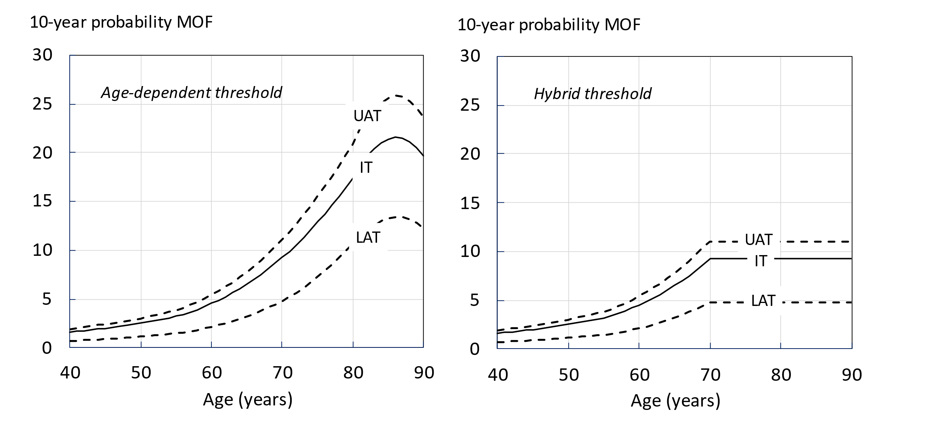
Figure 1: Assessment and intervention thresholds for major osteoporotic fracture probability (MOF) in Chile with the use of FRAX. Individuals with probabilities below the lower assessment threshold (LAT) are considered for lifestyle advice. Those at intermediate risk (probabilities between the upper assessment threshold (UAT) and lower assessment threshold (LAT) are further assessed with BMD measurement. Where probabilities calculated using BMD lie above or below the intervention threshold (IT), treatment or lifestyle advice, respectively, is recommended. Patients with probabilities above the upper assessment threshold (UAT) are considered for treatment. Where BMD measurement is not practical, patients with probabilities above the IT are considered for treatment.

Assessment thresholds for BMD testing
Two assessment thresholds for making recommendations for the measurement of BMD were considered [9, 24, 25]:
A threshold probability below which neither treatment nor a BMD test should be considered (lower assessment threshold).
A threshold probability above which treatment may be recommended irrespective of BMD (upper assessment threshold).
The lower assessment threshold was set to exclude a requirement for BMD testing in men and women without clinical risk factors, as given in current European guidelines [26, 28, 29]. It was therefore set to the age-specific 10-year probability of a major fracture equivalent to women with no clinical risk factors. The upper threshold was chosen to minimize the probability that a patient, classified as being at high risk using clinical risk factors alone, would be reclassified to be at low risk with additional information on BMD and vice versa [30]. The upper assessment threshold was set at 1.2 times the intervention threshold as used in the UK [25]. Their application to the two intervention thresholds is given in Figure 1 and numerical values in Table 1
Table 1 Numerical values for thresholds for major osteoporotic fracture probabilities for age-dependent and hybrid models based on the Chilean version of FRAX. LAT and UAT refer to the lower and upper assessment thresholds, respectively, between which a BMD is indicated. The intervention threshold (IT) denotes the thresholds for high risk.
 | Age-dependent thresholds |  |  |  | Hybrid thresholds
Age (years) | LAT | UAT | IT |  | LAT | UAT | IT
40 | 0.7 | 1.9 | 1.6 |  | 0.7 | 1.9 | 1.6
45 | 0.9 | 2.4 | 2.0 |  | 0.9 | 2.4 | 2.0
50 | 1.1 | 3.0 | 2.5 |  | 1.1 | 3.0 | 2.5
55 | 1.5 | 3.9 | 3.2 |  | 1.5 | 3.9 | 3.2
60 | 2.2 | 5.5 | 4.5 |  | 2.2 | 5.5 | 4.5
65 | 3.2 | 7.8 | 6.5 |  | 3.2 | 7.8 | 6.5
70 | 4.8 | 11 | 9.2 |  | 4.8 | 11 | 9.2
75 | 7.3 | 16 | 13 |  | 4.8 | 11 | 9.2
80 | 11 | 21 | 17 |  | 4.8 | 11 | 9.2
85 | 13 | 26 | 21 |  | 4.8 | 11 | 9.2
90 | 12 | 25 | 20 |  | 4.8 | 11 | 9.2

Management pathway
The risk of fracture is first assessed on clinical risk factors alone which in turn provides guidance whether a femoral neck BMD measurement or treatment is indicated, an approach that has been endorsed by the UK National Institute for Health and Care Excellence [31]. An exception is in the presence of a prior fragility fracture, in which case treatment is to be considered in such patients without necessarily undertaking a BMD measurement. For the present report, we assumed that treatment would be considered in all men and women with prior fracture. In other patients with no prior fracture, the decision is based on the 10-year probability of major osteoporotic fracture with some individuals deemed at high risk (treatment without BMD), some at or near the intervention threshold (intermediate risk; BMD indicated to finalise risk evaluation and stratification) and some at low risk (lifestyle advice, reassurance and re-evaluation in the future). Since BMD is not collected in the cohort, the decision to treat or not is based on a comparison to age-specific thresholds for major osteoporotic fracture only when BMD is not entered in the probability calculation; a probability at or above the threshold indicates eligibility for treatment.

Results
The baseline characteristics of the cohort are given in Table 2. Prevalence and mean of clinical risk factors in the cohort with simulation did not differ from the subset that had all variables (see Appendix). Approximately 12% of men and women had a prior fracture. MOF probabilities were higher in women than in men. Fracture probabilities for both hip fracture and MOF were skewed to the left as shown for MOF in women (Figure 2). As would be expected, MOF probabilities were higher in individuals with a prior fracture than in those with a negative fracture history.

Table 2 Summary description of the baseline variables (N = 3120).
 | Men |  |  |  | Women
 | N | Mean | SD | (%) | N | Mean | SD | (%)
Age (years) | 1122 | 65.2 | 10.1 |  | 1998 | 65.4 | 10.4
BMI (kg/m²) | 1122 | 28.6 | 4.6 |  | 1998 | 29.9 | 5.7
Previous fracture | 137 |  |  | 12.2 | 242 |  |  | 12.1
Current smoking | 265 |  |  | 23.6 | 408 |  |  | 20.4
Secondary osteoporosis | 75 |  |  | 6.7 | 386 |  |  | 19.3
Alcohol (>3 units per day) | 39 |  |  | 3.5 | 4 |  |  | 0.2
Parental history of hip fracture | 76 |  |  | 6.8 | 141 |  |  | 7.1
Glucocorticoid exposure | 36 |  |  | 3.2 | 98 |  |  | 4.9
Rheumatoid arthritis | 44 |  |  | 3.9 | 96 |  |  | 4.8
Ten-year probability (%)*
Hip | 1122 | 0.96 | 1.35 |  | 1998 | 2.10 | 3.37
MOF | 1122 | 2.52 | 1.40 |  | 1998 | 5.37 | 5.37
 |  | Median | IQR |  |  | Median | IQR
Hip fracture | 1122 | 0.5 | 0.2-1.3 |  | 1998 | 0.8 | 0.3-2.6
MOF | 1122 | 1.9 | 1.2-3.3 |  | 1998 | 3.3 | 1.7-7.2
*Calculated without BMD;
IQR interquartile range

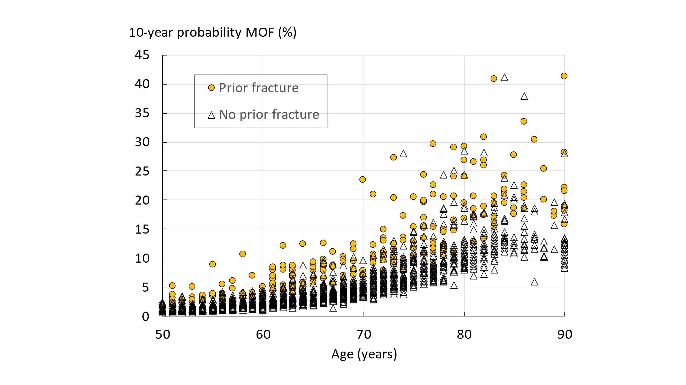

Fig. 2 10-year probability of a major osteoporotic fracture calculated without BMD in women according to age. Circular symbols denote women with a prior fracture.

Management pathway
In total, 242 of 1998 women 50 years of age or above (12.1% of the female cohort) had a prior fragility fracture and would be eligible for treatment on this basis. In the case of men, 137 (12.2%) had a prior fracture. The categorisation of the cohort according to threshold strategy (age-specific or hybrid) is shown in table 3.
Age-dependent threshold
For those without a prior fracture (n=1756), 51 additional women (2.6% of all women) would be eligible for treatment in that their fracture probability without BMD exceeded the intervention threshold for Chile. Overall (including women with a prior fracture) 14.7% of women would be eligible for treatment. The population eligible for treatment had an average MOF probability of 12.0% compared with 5.4% in all women (ratio 2.22). For men without a prior fracture (n=985), only 2 additional men would be eligible for treatment in that their fracture probability without BMD exceeded the age-specific intervention threshold. The men eligible for treatment had an average MOF probability of 4.5% compared with 2.5% in all men (ratio 1.80). If BMD tests were not to be undertaken, then an additional 35 patients who lay above the intervention threshold would be eligible for treatment with the age dependent thresholds (average probability 11.7%).
Hybrid threshold
For those without a prior fracture (n=1756), 258 additional women (12.9% of all women) would be eligible for treatment in that their fracture probability without BMD exceeded the intervention threshold. Overall (including women with a prior fracture) 25.0% of women would be eligible for treatment. The population eligible for treatment had an average MOF probability of 12.2% compared with 5.4% in all women (ratio 2.26). For men without a prior fracture (n=985), 4 additional men would be eligible for treatment in that their fracture probability without BMD exceeded the age-specific intervention threshold. The men eligible for treatment had an average MOF probability of 4.6% compared with 2.5% in all men (ratio 1.84). If BMD tests were not to be undertaken, then an additional 92 patients who lay above the intervention threshold would be eligible for treatment with the hybrid thresholds (average probability 9.5%).
BMD tests
Using the age-specific assessment thresholds, 5.1% of men and 38.4% of women had fracture probabilities that lay between the upper and lower assessment threshold and would thus be eligible for testing with BMD to reassess fracture probability. With the hybrid thresholds, 10.6% of men and 47.1% of women would be eligible (see table 3).
Table 3. Categorisation of cohort and corresponding fracture probabilities (10- year probabilities of a major osteoporotic fracture) when using age dependent or hybrid thresholds. The last column of each threshold ‘MOFs expected’ gives the number of fractures expected in 10 years in each category for a total population of 100,000 (%Population X Probability X 100)
 | Age-dependent thresholds |  |  |  | Hybrid thresholds
 | % Population | Probability (%) | MOFs expected |  | % Population | Probability (%) | MOFs expected
Men
All men | 100 | 2.5 | 25,000 |  | 100 | 2.5 | 25,000
Prior fracture | 12.2 | 4.4 | 5368 |  | 12.2 | 4.4 | 5368
Others treated | 0.2 | 11.3 | 339 |  | 0.4 | 12.4 | 496
BMD tests | 5.1 | 2.9 | 1479 |  | 10.6 | 4.2 | 4452
Low risk (< LAT) | 82.6 | 2.2 | 18,172 |  | 76.8 | 1.9 | 14,592
Low risk (<IT) | 87.6 | 2.2 | 19,272 |  | 87.4 | 2.2 | 19,228
Women
All women | 100 | 5.4 | 54,000 |  | 100 | 5.4 | 54,000
Prior fracture | 12.1 | 11.5 | 13,915 |  | 12.1 | 11.5 | 13915
Others treated | 2.6 | 14.4 | 3744 |  | 12.9 | 12.8 | 16,512
BMD tests | 38.4 | 5.6 | 21,504 |  | 41.7 | 4.8 | 20,016
Low risk (< LAT) | 48.7 | 3.4 | 16,558 |  | 37.9 | 2.1 | 7959
Low risk (<IT) | 85.3 | 4.2 | 35,826 |  | 75.0 | 3.1 | 23,250

Age dependency
Categorisation of the female cohort by age is shown in Figure 3 for the two threshold
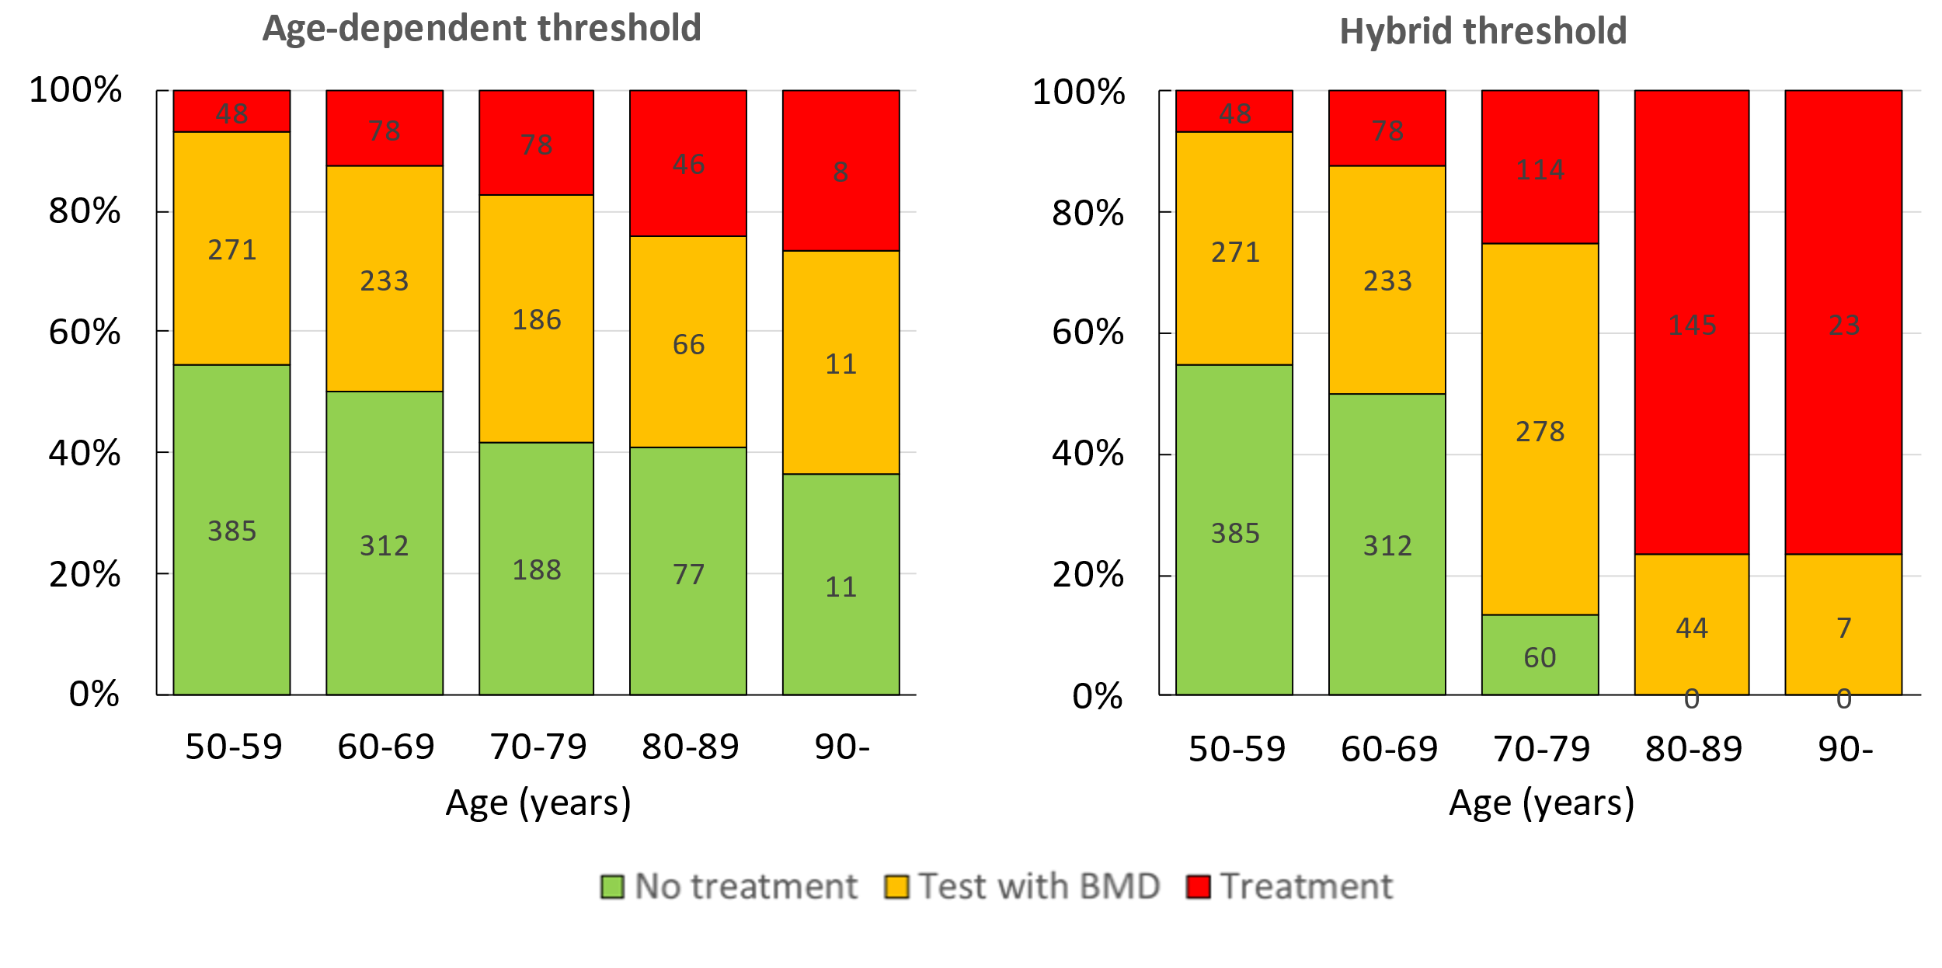
models. As expected, the proportion of women treated rose with age. By definition, there were no differences between threshold models in the proportion of women eligible for treatment up to the age of 70 years. With the age-dependent thresholds, the proportion of women treated was 18%,24% and 27% for each decade from the age of 70 years. For the hybrid model the corresponding proportions were 27%, 77% and 77%, respectively.

Fig. 3 The proportion of women categorised as requiring no treatment, testing with BMD or eligible for treatment with age-specific thresholds (left hand panel) or hybrid thresholds (right). The numbers refer to the number of women in each category.

Prior treatment
Patients identified as having prior treatment for osteoporosis had a higher hip fracture probability than the total cohort (3.2 vs. 1.7%, respectively). Similarly, prior treatment for osteoporosis had a higher MOF probability than the total cohort (7.6 vs. 4.3%, respectively).

Discussion
In this report, we present two methods of categorising men and women on the basis of fracture probabilities derived from FRAX. The categories identified comprised those at low risk, those at intermediate risk in whom a BMD test might be recommended, and those eligible for treatment. The age-dependent triage used was similar to that originally adopted by the National Osteoporosis Guideline Group (NOGG) in the UK and more recently in European guidelines [24, 25, 28, 29] but applied to the FRAX model for Chile. As noted above, in this approach the intervention threshold is set at a fracture probability equivalent to a woman of the same age with a prior fragility fracture. The rationale is that if women with a prior fragility fracture are considered eligible for treatment, as commonly considered, then women without fracture but with equivalent probabilities are also eligible for treatment. The second triage system examined was the hybrid model where intervention threshold in individuals age 70 years or more were fixed to the age-dependent thresholds at the age of 70 years.
The proportion of the female population potentially eligible for treatment was 14.7% or 25.0%, depending on the intervention threshold applied (age-specific or hybrid). As expected, the proportion of women eligible for treatment was higher with the application of the hybrid thresholds. Since both management pathways recommend treatment in women with a prior facture, the appropriate comparison is the number of women without prior fracture using the two threshold approaches. The proportion of women potentially eligible for treatment was 2.6% for the age-specific threshold or 12.9%, for the hybrid threshold. Although the fracture probability was marginally lower with the hybrid thresholds, the number of MOFs expected over 10 years was more than 4-fold higher than with the age-dependent thresholds (see Table 3). Thus, a treatment strategy would save many more fractures using the hybrid approach. Moreover, as noted for the UK [27], the fracture probability of those identified for treatment (12.8%) more closely matched those women with a prior fracture (11.5%) than those identified using the age-dependent thresholds (14.4%). Also, the requirement for BMD tests was only marginally higher with the hybrid threshold. In the case of men, individuals with no prior fracture had fracture probabilities that were similar to those in women. The major difference between men and women lay in the relatively low fracture probability in those with a prior fracture compared with women.
The goal of setting intervention thresholds is to maximise the benefit on outcomes while limiting the risks and costs that accompany the intervention. This is a complex process that includes consideration of country-specific factors such as reimbursement, cost-effectiveness and society’s willingness to pay [28]. Within a country, it would seem desirable that at any given age, the selection criteria for intervention results in equitable access to therapy for patients with the same age-specific absolute probability of fracture. We conclude that the hybrid thresholds examined here achieve this objective, at least for women.
There are a number of limitations to consider in this study. First, although the survey was aimed at generating a cohort representative of the Chilean population, the relatively small sample size might impair the accuracy of our estimates and thus the number of individuals eligible for treatment. Independent verification of this analysis in other cohorts would be appropriate. Second, the present study was confined to threshold probabilities for a major osteoporotic fracture whereas hip fracture probability is the other output of FRAX used in the NOGG guidance [26]. Indeed, treatment is recommended if the hip fracture probability or the major osteoporotic fracture probability exceeds the intervention threshold. The consideration of the two fracture probabilities is likely also to increase the number of men and women identified at high risk. Additionally, the probability thresholds for major osteoporotic fracture rest on more assumptions than those for hip fracture [32]. Third, BMD was not measured in this population sample, so that the proportion of individuals exceeding the intervention threshold and thus be eligible for treatment is not known. Notwithstanding, treatment can be directed using FRAX without BMD, albeit with lower sensitivity [33, 34]. The strategy implies, however, that patients at high risk, but identified without BMD, would respond to pharmacological intervention. The evidence that such patients respond to treatment is strong [35, 36, 37, 38, 39]. The principal reason is that BMD values are low in patients identified with FRAX but without a BMD test [34, 35]. A potential consideration is that some of the risk factor information needed was missing in the cohorts and had to be simulated. The weakness of simulation is that there is a loss of accuracy for those individuals in whom missing variables were simulated. However, this is less relevant for populations, and summary data more closely reflect the sample from which data were drawn with a benefit of optimising sample size. Lastly, a proportion of the population sample were exposed to treatments for osteoporosis which might in turn affect fracture probabilities, though the effect is likely to be very small [40].
The present study has shown the impact of strategies for fracture risk assessment following the methodologies proposed by NOGG but based on Chilean FRAX. Of these methodologies, the use of hybrid thresholds identifies more individuals at high fracture risk and therefore eligible for treatment than the use of age-specific thresholds. The implementation of these thresholds is expected to avoid unnecessary treatment of women at low fracture risk and direct treatments to those at high risk. The incorporation of country-specific intervention thresholds and the refinement of risk categorization in national osteoporosis guidelines will positively influence the choice of treatment by physicians in the countries of the region.
Acknowledgements.
This research used information from the Health Surveys for epidemiological surveillance of the Subsecretaría de Salud Pública. The authors are grateful to the Ministry of Health of Chile for having made the database available to us. All the results obtained from the study or research are the responsibility of the authors and in no way compromise the said institution [http://epi.minsal.cl/encuesta-nacional-de-salud-2015-2016/].
Conflicts of interest.
JAK, HJ, NCH, ML, EL LV and EVM comprise the team that develops and maintains FRAX. JAK, EVM and NH are members of the National Osteoporosis Guideline Group (UK). ELG, INL and NGM report no competing interests.
Funding statement. No sponsors funded nor had any decision in the development, review or submission of this article.

References

1. | Nguyen ND, Frost SA, Center JR, Eisman JA, Nguyen TV (2008) Development of prognostic nomograms for individualizing 5-year and 10-year fracture risks. Osteoporos Int 19:1431–1444
2. | Hippisley-Cox J, Coupland C (2009) Predicting risk of osteoporotic fracture in men and women in England and Wales: prospective derivation and validation of QFractureScores. BMJ 339:b4229
3. | Kanis JA, McCloskey E, Branco J, Brandi ML, Dennison E, Devogelaer JP, Ferrari S, Kaufman JM, Papapoulos S, Reginster JY, Rizzoli R (2014) Goal-directed treatment of osteoporosis in Europe. Osteoporos Int 25: 2533-43.
4. | Kanis JA, Johansson H, Harvey NC and McCloskey EV (2018) A brief history of FRAX. Arch Osteoporos 13: 118. DOI: 10.1007/s11657-018-0510-0.
5. | Kanis JA, Harvey NC, Johansson H, Liu E, Lorentzon M, Leslie WD, Eugene V McCloskey E (2020) A decade of FRAX: How has it changed the management of osteoporosis? Aging Clin Exp Res 33:187-196
6. | Kanis JA, Oden A, Johansson H, McCloskey E (2012) Pitfalls in the external validation of FRAX. Osteoporosis International 23: 423-31
7. | Kanis JA, Harvey NC, Cyrus Cooper C, Johansson H, Odén A, McCloskey EV, the Advisory Board of the National Osteoporosis Guideline Group (2016) A systematic review of intervention thresholds based on FRAX. A report prepared for the National Osteoporosis Guideline Group and the International Osteoporosis Foundation. Arch Osteoporos 11:25. doi: 10.1007/s11657-016-0278-z.
8. | Kanis JA on behalf of the World Health Organization Scientific Group (2007) Assessment of osteoporosis at the primary healthcare level. Technical Report. WHO Collaborating Centre, University of Sheffield, UK. Available at . http://www.shef.ac.uk/FRAX/pdfs/WHO_Technical_Report.pdf. Accessed 26 June 2021
9. | Kanis JA, Johnell O, Oden A, Johansson H, McCloskey E (2008) FRAX™ and the assessment of fracture probability in men and women from the UK. Osteoporos Int 19: 385-397
10. | Odén A, McCloskey EV, Kanis JA, Harvey NC, Johansson H (2015) Burden of high fracture probability worldwide: secular increases 2010-2040. Osteoporos Int 26:2243–2248
11. | Schurman L, Galich AM, González C, González D, Messina OD, Sedlinsky C, Uñas CR, Sánchez A (2017) Guías argentinas para el diagnóstico, la prevención y el tratamiento de la osteoporosis 2015 [Argentine guidelines for the diagnosis, prevention and treatment of osteoporosis, 2015]. Medicina (B Aires). 2017;77(1):46-60. Spanish.
12. | Radominski SC, Bernardo W, Paula AP, Albergaria BH, Moreira C, Fernandes CE, Castro CHM, Zerbini CAF, Domiciano DS, Mendonça LMC, Pompei LM, Bezerra MC, Loures MAR, Wender MCO, Lazaretti-Castro M, Pereira RMR, Maeda SS, Szejnfeld VL, Borba VZC (2017) Brazilian guidelines for the diagnosis and treatment of postmenopausal osteoporosis. Rev Bras Reumatol Engl Ed. 2017;57 Suppl 2:452-466. English, Portuguese. doi: 10.1016/j.rbre.2017.07.001.
13. | Medina Orjuela A, Rosero Olarte O, Rueda Plata PN, Sánchez Escobar F, Chalem Chouekae M, González Reyes MA et al (2018) II Consenso Colombiano para el manejo de la osteoporosis posmenopáusica. Rev Colomb Reumatol. 25(3):184–210
14. | Instituto Mexicano del Seguro Social (2018) Diagnóstico y tratamiento de osteoporosis en mujeres posmenopáusicas. Guía de Evidencias y Recomendaciones: Guía de Práctica Clínica. México, CENETEC. Accessed: http://www.cenetec-difusion.com/CMGPC/GPC-IMSS-673-18/ER.pdf Accessed 29 August 2022
15. | Secretaria de Salud sde Mexico (2019) Prevención, diagnóstico y tratamiento de la osteoporosis [2019]. Guía de Consulta Para el Médico de Primer Nivel de Atención.. cenetec-difusion.com/gpc-sns/wp-content/uploads/2019/06/GuiaConsulta_Osteoporosis.pdf
16. | Clark P, Denova-Gutiérrez E, Zerbini C, Sanchez A, Messina O, Jaller JJ, Campusano C, Orces CH, Riera G, Johansson H, Kanis JA (2018) FRAX-based intervention and assessment thresholds in seven Latin American countries. Osteoporos Int. 29(3):707-715.
17. | Department of Epidemiology of the Ministry of Health of Chile (2018) National Health Survey 2016-2017. Available from: http://epi.minsal.cl/encuesta-ens-descargable/.
18. | Department of Epidemiology of the Ministry of Health of Chile (2018) National Health Survey 2016-2017. http://epi.minsal.cl/encuesta-nacional-de-salud-2015-2016/, accessed 29th August 2022.
19. | Dawson-Hughes B, Looker AC, Tosteson ANA, Johansson H, Kanis JA, Melton III LJ (2010) The potential impact of new National Osteoporosis Foundation guidance on treatment patterns. Osteoporos International 21: 41-52.
20. | Kanis JA, Chandran M, Chionh SB, Ganeson G, Harvey NC, Koh WP, Kwok T, Lau TC, Liu E, Lorentzon M, McCloskey EV, Tan KB, Vandenput L, Johansson H (2020) Use of age-dependent FRAX-based intervention thresholds for Singapore. Arch Osteoporos 15: 104. doi: 10.1007/s11657-020-00782-9.
21. | Johansson H, Kanis JA,Oden A, Johnell O, Compston J, McCloskey EV (2012) A comparison of case finding strategies in the UK for the management of hip fractures. Osteoporos Int 23:907–915.
22. | Kanis JA, Odén A, McCloskey EV, Johansson H, Wahl DA, Cooper C.(2012) A systematic review of hip fracture incidence and probability of fracture worldwide. Osteoporos Int. 23(9):2239-56.
23. | Riedermann P, Bustos L, Neira O, McCloskey E, Johansson H, Riedermann D, Kanis J (2016) The effect of latitude in on the risk of hip fractures in Chile. J Bone Miner Res 31 (Suppl s1): S36
24. | Compston J, Bowring C, Cooper A, Cooper C, Davies C, Francis R, Kanis JA, Marsh D, McCloskey EV, Reid DM, Selby P, Wilkins M, National Osteoporosis Guideline Group (NOGG) (2009) Guidelines for the diagnosis and management of osteoporosis in postmenopausal women and men from the age of 50 years in the UK. Maturitas 62:105–108
25. | Kanis JA, McCloskey EV, Johansson H, Strom O, Borgstrom F, Oden A, the National Osteoporosis Guideline Group (2008) Case finding for the management of osteoporosis with FRAX®—assessment and intervention thresholds for the UK. Osteoporos Int 19: 1395–1408 Erratum 2009 Osteoporos Int 20, 499–502
26. | Gregson CL, Armstrong DJ, Bowden J, Cooper C, Edwards J, Gittoes NJL, Harvey N, Kanis J, Leyland S, Low R, McCloskey E, Moss K, Parker J, Paskins Z, Poole K, Reid DM, Stone M, Thomson J, Vine N, Compston J. Correction: UK clinical guideline for the prevention and treatment of osteoporosis. Arch Osteoporos. 2022 May 19;17(1):80. doi: 10.1007/s11657-022-01115-8. Erratum for: Arch Osteoporos. 2022 Apr 5;17(1):58.
27. | McCloskey E, Kanis JA, Johansson Harvey N Odén A, Cooper A, Cooper C, Francis R, Reid D, Selby P, Davies C, Bowring C, Compston (2015) FRAX-based assessment and intervention thresholds-an exploration of thresholds in women aged 50 years and older in the UK. Osteoporos Int 26: 2091-9.
28. | Kanis JA, Cooper C, Rizzoli R, Reginster J-Y; Scientific Advisory Board of the European Society for Clinical and Economic Aspects of Osteoporosis (ESCEO) and the Committees of Scientific Advisors and National Societies of the International Osteoporosis Foundation (IOF) (2019) European guidance for the diagnosis and management of osteoporosis in postmenopausal women. Osteoporos Int 30: 3-44.
29. | Lekamwasam S, Adachi JD, Agnusdei D, Bilezikian J, Boonen S, Borgström F, Cooper C, Diez Perez A, Eastell R, Hofbauer L, Kanis JA, Langdahl BL, Lesnyak O, Lorenc R, McCloskey E, Messina OD, Napoli N, Obermayer-Pietsch B, Ralston SH, Sambrook PN, Silverman S, Sosa M, Stepan J, Suppan G, Wahl DA, Compston JE for the Joint IOF-ECTS GIO Guidelines Working Group (2012) A framework for the development of guidelines for the management of glucocorticoid-induced osteoporosis. Osteoporos Int 23: 2257-76.
30. | Johansson H, Oden A, Johnell O, Jonsson B, de Laet C, Oglesby A, McCloskey EV, Kayan K, Jalava T, Kanis JA (2004) Optimization of BMD measurements to identify high risk groups for treatment--a test analysis. J Bone Miner Res. 19(6):906-913.
31. | National Institute for Health and Care Excellence (2012) NICE clinical guideline 146. Osteoporosis: assessing the risk of fragility fracture. London, UK.
32. | Leslie WD, Kanis JA (2021) Calibration of FRAX: A journey, not a destination. Calcif Tissue Int 109(6): 597-599 doi:10.1007/s00223-021-00891-8
33. | Kanis JA, Oden A, Johnell O, Johansson H, De Laet C, Brown J, Burckhardt P, Cooper C, Christiansen C, Cummings S, Eisman JA, Fujiwara S, Glüer C, Goltzman D, Hans D, Krieg MA, La Croix A, McCloskey E, Mellstrom D, Melton LJ 3rd, Pols H, Reeve J, Sanders K, Schott AM, Silman A, Torgerson D, van Staa T, Watts NB, Yoshimura N (2007) The use of clinical risk factors enhances the performance of BMD in the prediction of hip and osteoporotic fractures in men and women. Osteoporos Int 18: 1033–46.
34. | Leslie WD, Majumdar SR, Lix L, Johansson H, McCloskey EV Kanis JA (2012) High fracture probability with FRAX® usually indicates densitometric osteoporosis: Implications for clinical practice. Osteoporos Int 23: 391-397.
35. | Kanis JA, McCloskey E, Johansson H, Oden A, Leslie WD (2012) FRAX® with and without BMD. Calcif Tiss Int 90:1–13.
36. | Torgerson DJ, Bell-Syer SE (2001) Hormone replacement therapy and prevention of nonvertebral fractures: a meta-analysis of randomized trials. JAMA 285: 2891–2897.
37. | Cauley JA, Robbins J, Chen Z, Cummings SR, Jackson RD, LaCroix AZ, LeBoff M, Lewis CE, McGowan J, Neuner J, Pettinger M, Stefanick ML, Wactawski-Wende J, Watts NB (2003) Effects of estrogen plus progestin on risk of fracture and bone mineral density: the Women’s Health Initiative randomized trial. JAMA 290:1729–1738.
38. | McCloskey EV, Beneton M, Charlesworth D, Kayan K, deTakats D, Dey A, Orgee J, Ashford R, Forster M, Cliffe J, Kersh L, Brazier J, Nichol J, Aropuu S, Jalava T, Kanis JA (2007) Clodronate reduces the incidence of fractures in community-dwelling elderly women unselected for osteoporosis: results of a double-blind, placebo-controlled randomized study. J Bone Miner Res 22: 135-141.
39. | Reid IR, Horne AM, Mihov B, Stewart A, Garratt E, Wong S, Wiessing KR, Bolland MJ, Bastin S, Gamble GD 2018) Fracture prevention with zoledronate in older women with osteopenia. N Engl J Med 379(25):2407-2416.
40. | Leslie WD, Lix LM, Johansson H, Oden A, McCloskey E, Kanis JA, for the Manitoba Bone Density Program (2012) Does osteoporosis therapy invalidate FRAX for fracture prediction? J Bone Miner Res 27: 1243-1251.

Appendix

Table A Summary description of the baseline variables in the cohort.
 | Original cohort |  |  |  | Original cohort plus simulated variables
 | N | Mean | SD | (%) | N | Mean | SD | (%)
Age (years) | 3120 | 65.3 | 10.3 |  | 3120 | 65.3 | 10.3
BMI (kg/m²) | 2783 | 29.4 | 5.4 |  | 3120 | 29.4 | 5.3
Female | 3120 |  |  | 64.0 | 3120 |  |  | 64.0
Previous fracture | 3104 |  |  | 12.1 | 3120 |  |  | 12.1
Current smoking | 3120 |  |  | 21.5 | 3120 |  |  | 21.5
Secondary osteoporosis | 3119 |  |  | 14.8 | 3120 |  |  | 14.8
Alcohol 3 or more units per day | 2811 |  |  | 1.4 | 3120 |  |  | 1.4
Parental history of hip fracture | 2963 |  |  | 7.0 | 3120 |  |  | 6.9
Glucocorticoid exposure | 0 |  |  | - | 3120 |  |  | 4.3
Rheumatoid arthritis | 2793 |  |  | 6.9 | 3120 |  |  | 4.5

