Mid-term Results of the Prospective LUMI-PAE Study: Propensity-matched Analysis of 1-year Follow-up Data
Ganesh Vigneswaran^{1,2} ganesh.vigneswaran@uhs.nhs.uk (corresponding author)
Neel Doshi^{1,2} neel.doshi@uhs.nhs.uk
Drew Maclean¹ drew.maclean@uhs.nhs.uk
Santosh Mathew¹ santosh.mathew@uhs.nhs.uk
Sachin Modi¹ sachin.modi@uhs.nhs.uk
Mark Harris³ mark.harris@uhs.nhs.uk
Nigel Hacking¹ nigel.hacking@uhs.nhs.uk
Timothy Bryant¹ timothy.bryant@uhs.nhs.uk
1- Department of Interventional Radiology, University Hospital Southampton, Tremona Road
Southampton, SO16 6YD
2 - Cancer Sciences, University of Southampton, Southampton General Hospital, Tremona Road, Southampton, SO16 6YD
3- Department of Urology, University Hospital Southampton, Tremona Road, Southampton, UK, SO16 6YD
Compliance with Ethical Standards
Funding
This study was funded by Boston Scientific. Where data pertains to the UK-ROPE study – this was collected as part of the UK-ROPE study and was funded through multiple streams. The involvement of an independent academic evaluation centre ‘Cedar’ was funded through the National Institute for Health and Care Excellence (NICE). Procedure costs were covered either through local commissioning streams, or through a grant from Cook Medical (Europe), where this was not possible.
Conflict of Interest
Nigel Hacking was in receipt of a research grant to run the UK-ROPE study from Cook Medical, has received honoraria from Boston Scientific and Celonova as a speaker and has been on Advisory boards for BTG. Tim Bryant has proctored for Boston Scientific and Terumo and has received speaker honorariums from Boston Scientific. Sachin Modi has received a speaker honorarium from Boston Scientific. The other authors declare no conflict of interest.
Ethical Approval
All procedures performed were in accordance with the ethical standards of the institutional and HRA (IRAS 217945) and with the 1964 Helsinki declaration and its later amendments or comparable ethical standards.
Patient Consent
Informed consent was obtained from all individual participants included in the study. Consent for publication was obtained for every individual person’s data included in the study.

Introduction

Benign prostatic hyperplasia (BPH) is the main cause of lower urinary tract symptoms (LUTS). Prostatic artery embolization (PAE) is now a therapeutic alternative to transurethral resection of the prostate (TURP) and is gaining popularity as a minimally invasive alternative, with shorter hospital stays, lower costs, and fewer complications [1-2].

Many established embolic agents used in PAE are radiolucent e.g. polyvinyl alcohol (PVA), spherical PVA, trisacryl gelatin microspheres (TGM), polyzene coated hydrogel microspheres and polyethylene glycol microspheres. DC Bead LUMI (Boston Scientific, Marlborough, USA) are calibrated, biocompatible, non-resorbable hydrogel beads made from polyvinyl alcohol and 2,3,5 triiodo benzaldehyde and are radiopaque [3].

Radiopacity offers real-time bead localization and can help distinguish between target and non-target embolization. Visualisation of non-target embolization to penile, vesical, rectal branches could allow early identification and limit morbidity and visualization of target tissue may highlight missed or collateral supply. Radiopaque beads are now used in clinical practice, especially for hepatic embolization [3] but there are limited reports of use in PAE [4-5].

Materials and Methods
27 patients were enrolled in this prospective single-centre cohort study and had PAE with DC Bead LUMI between July 2018-August 2020. The primary outcome was a reduction in symptoms as measured by IPSS at 12 months post-procedure. The secondary outcome measures included (a) embolic agent safety and (b) comparison of IPSS outcomes with matched data from the UK-ROPE cohort study [2].

Inclusion criteria were (i) male patients between (ii) 50 to 80 years of age with (iii) moderate to severe lower urinary tract symptoms secondary to benign prostatic enlargement (BPE) as calculated by IPSS greater than 14, (iv) QOL ≥ 4, (v) prostate volume ≥ 40 cc, maximum urinary flow rate < 12 ml/s, (vi) medically refractory BPE as defined by symptoms after 6 months of medical therapy or an inability to tolerate medical treatment due to side-effects.

Exclusion criteria for the LUMI-PAE study were atherosclerosis of the prostatic arteries, surgical indications (chronic retention, bladder diverticulae, urethral stenosis), detrusor instability, neurogenic bladder, malignancy (TRUS/MRI/Biopsy proven), PSA > 4, high SWOP risk needing prostate biopsy, non-obstructed on urodynamics and eGFR ≤ 45ml/min/m². All procedures were performed within local hospital standards of practice and have been previously described [5]. Embolization was performed with DC Bead LUMI (Boston Scientific, Marlborough, Massachusetts, USA) sized 75-150μm until stasis was achieved.

Baseline IPSS (International Prostate Symptom Score) was recorded during an in-person clinical visit questioning. Patients were followed up by postal questionnaire for 12 months post-procedure IPSS. CT/MRI imaging was performed 3 months post-PAE.

A logistic regression and nearest neighbour propensity-matched analysis (matched for age, baseline IPSS, baseline prostate volume and baseline flow rate (Qmax)) were used to compare the prospective DC Bead LUMI cohort against a matched control group from the UK-ROPE (UK-Registry of Prostate Embolization) study (see supplementary methods).

Results

At the current point of mid-term analysis, 11 of the 27 patients had undergone PAE and completed 12-month follow-up. A matched group of 11 patients were identified from the UK-ROPE study through propensity matching. There were no significant differences in any of the baseline characteristics between LUMI and matched UK-ROPE cohorts (see Table 1). There was adequate propensity matching (p=0.33, see Supp. Fig 1).

[Table 1]

We evaluated outcomes using IPSS and compared pre-procedure IPSS with 12-month IPSS post-PAE. The prospective LUMI cohort demonstrated a significant improvement in IPSS at 12 months post-embolization vs baseline (13.5 ± 9.1 vs 25.3 ± 4.5, respectively, p < 0.001, Figure 1). The matched UK-ROPE cohort also demonstrated improvement at 12 months vs baseline (11.5 ± 5.9 vs 24.9 ± 4.9, respectively, p<0.001). We found no significant difference in the change in IPSS between the LUMI and matched UK-ROPE cohorts (11.7 ± 7.9 vs 12.5 ± 7.5, respectively, p=0.82, Figure 2).

There were two minor treatment related adverse events (modified clavien dindo = II); one patient developed post procedure prostate related pain requiring hospitalisation for analgesia (2 days, modified clavien dindo = II) and the other patient required a short hospitalisation (<5 days) for dysuria and difficulty passing urine requiring a temporary short-term urinary catheter (modified clavien dindo=II).

[Figure 2]
[Figure 3]

Discussion

Mid-term analysis has suggested that there is a significant improvement in symptoms (IPSS) at 12-months following PAE with the use of radiopaque DC LUMI beads. The magnitude of symptom improvement was similar to established radiolucent beads used in the UK-ROPE study [1-2].

The systematic use of radiopaque beads in PAE is limited but may improve intra- and post-procedural monitoring by highlighting non-target embolization, and complications [5]. We provide evidence in support of both the safety and efficacy of radiopaque DC LUMI beads in PAE, but it is unclear whether these benefits will enhance patient outcomes.

Conclusion
Mid-term results suggest that DC Bead LUMI is an effective embolic agent for PAE and achieves a comparable overall symptom score reduction to established agents. Final study data will be required to further validate these preliminary findings as well as confirm the safety profile.

References

- Hacking, N., Vigneswaran, G., Maclean, D., Modi, S., Dyer, J., Harris, M. and Bryant, T. (2019). Technical and Imaging Outcomes from the UK Registry of Prostate Artery Embolization (UK-ROPE) Study: Focusing on Predictors of Clinical Success. CardioVascular and Interventional Radiology, 42(5), pp.666–676. doi:10.1007/s00270-018-02156-8
- Ray, A.F., Powell, J., Speakman, M.J., Longford, N.T., DasGupta, R., Bryant, T., Modi, S., Dyer, J., Harris, M., Carolan-Rees, G. and Hacking, N. (2018). Efficacy and safety of prostate artery embolization for benign prostatic hyperplasia: an observational study and propensity-matched comparison with transurethral resection of the prostate (the UK-ROPE study). BJU International, 122(2), pp.270–282. doi:10.1111/bju.14249
- Duran, R., Sharma, K., Dreher, M.R., Ashrafi, K., Mirpour, S., Lin, M., Schernthaner, R.E., Schlachter, T.R., Tacher, V., Lewis, A.L., Willis, S., Hartog, M. den, Radaelli, A., Negussie, A.H., Wood, B.J. and Geschwind, J.-F.H. (2016). A Novel Inherently Radiopaque Bead for Transarterial Embolization to Treat Liver Cancer - A Pre-clinical Study. Theranostics, 6(1), pp.28–39. doi:10.7150/thno.13137.
- Brown B, Yu H, Bagla S, Isaacson A. Nontarget radiopaque embolic deposition during prostatic artery embolization. J Vasc Interv Radiol. Elsevier BV; 2022;33:558-563.e1.
- Brown B, Brader R, Bagla S, Isaacson A. Comparison of postprostatic artery embolization cone-beam CT and estimated radiopaque particle distribution on follow-up imaging: A case report. J Vasc Interv Radiol. Elsevier BV; 2020;31:864-867.e1.

 | LUMI | UK-ROPE | p
Age | 70.1 ± 5.4 | 70.1 ± 7.3 | 1
Baseline IPSS | 25.3 ± 4.5 | 24 ± 4.9 | 0.52
Baseline Prostate Volume | 105.3 ± 42.1 | 120.2 ± 58.5 | 0.33
Baseline Flow Rate | 12.0 ± 3.5 | 10 ± 3.2 | 0.1
Table 1: Demographic and baseline data (LUMI vs UK-ROPE matched cohort).

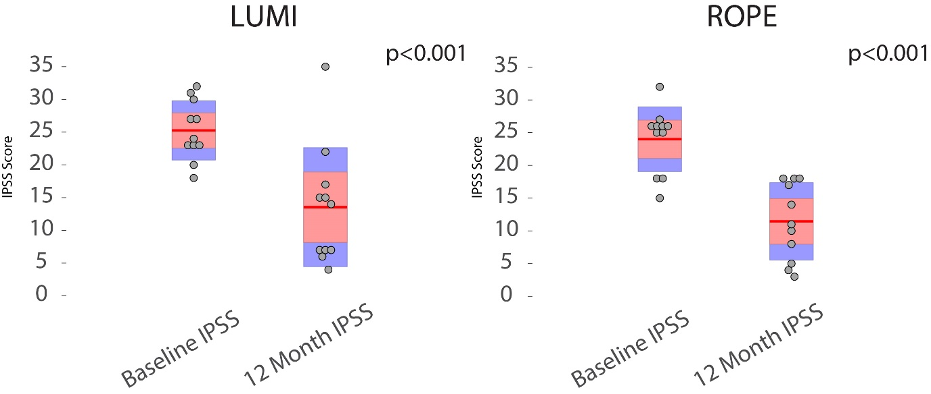
Figure 1: Improvement in IPSS pre- and 12-month post procedure (LUMI vs matched UK- ROPE cohort). Means displayed in solid red line. 1.96 x standard error of the mean (95% confidence intervals) and 1 standard deviation displayed in light red and blue shading respectively. Raw data, where displayed, has been indicated in the form of grey circles with jitter.

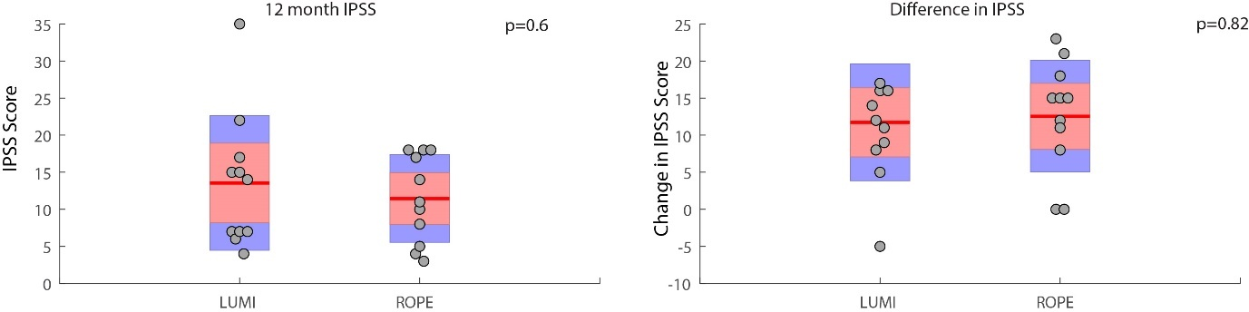
Figure 2: Comparison of raw 12-month post-procedural IPSS in LUMI vs matched UK-ROPE cohort (left) and decrease in IPSS as measured from baseline against 12-month scores in LUMI vs matched ROPE cohort (right). Means displayed in solid red line. 1.96 x standard error of the mean (95% confidence intervals) and 1 standard deviation displayed in light red and blue shading respectively. Raw data, where displayed, has been indicated in the form of grey circles with jitter.

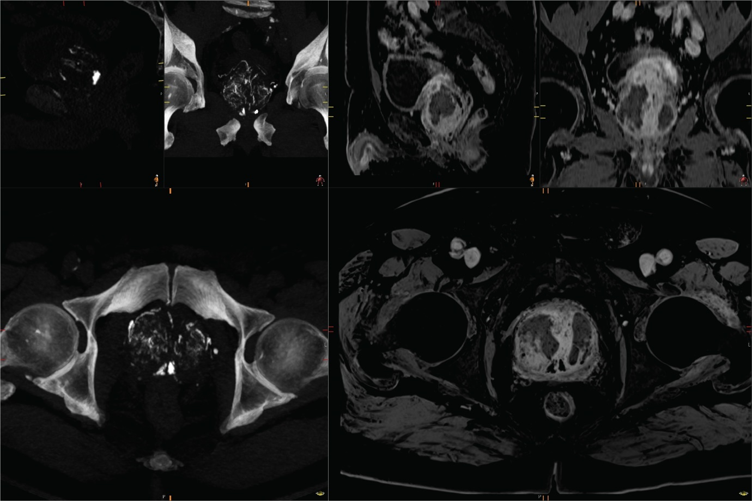
Figure 3: CT(Left) and MRI (right) 3-months post PAE with DC LUMI. The distribution of the DC LUMI bead that can be visualised owing to non-resorbable spherical radio-opaque embolic agent and the corresponding infarction of the prostate.

Supplementary material:

Embolization technique:

All procedures were performed within local hospital standards of practice. Percutaneous right common femoral artery access was performed under US guidance with injection of local anaesthetic before typically siting a 5Fr sheath. A catheter and hydrophilic wire were used for cannulation of the contralateral internal iliac artery and 2.4 Fr microcatheter (typically Bern Direxion microcatheter, Boston Scientific, Marlborough, USA) was used for contralateral prostatic artery catheterisation. A contrast enhanced Cone-beam CT was performed to confirm glandular enhancement and identification of clinically significant collateral vessels. Embolization was performed with DC Bead LUMI (Boston Scientific, Marlborough, Massachusetts, USA) sized 75-150μm until stasis was achieved. Typically, a Waltman loop was formed for access to the ipsilateral prostatic artery via the internal iliac artery and embolization as described above is repeated. Arterial access site was closed using a closure device or manual pressure with monitoring on the day unit for early complications. With all cases performed as a day case procedure. Duration of the total procedure, fluoroscopy time and received dose were recorded. If a urinary catheter was inserted on the day of the procedure, this is removed post procedure.

Statistical analysis:

The prospective DC Bead LUMI cohort was matched against a group from the UK-ROPE study. The authors have collated data and reported findings from the UK-ROPE study previously and this database has been used for propensity matching [1]. The matched group was identified using a logistic regression and nearest neighbour propensity-matched analysis, consistent with accepted standards of comparison.

This statistical method was chosen to reduce bias from significant variation in group sizes and reduce differences in baseline variability through propensity matching of key variables to reduce selection bias. Patients were matched on the following variables; (a) Age, (b) Baseline IPSS, (c) baseline prostate volume and (d) baseline flow rate (Qmax). IPSS at baseline and 12 months post procedure was used for evaluation.

Paired student t-tests were used to evaluate differences between the matched cohorts as per accepted practice. A probability of less than 0.05 was used to determine statistical significance. Figures include means displayed in solid red line. 1.96 x standard error of the mean (95% confidence intervals) and 1 standard deviation displayed in light red and blue shading respectively. Raw data, where displayed, has been indicated in the form of grey circles with jitter. All statistical tests were performed using Matlab 2021a.

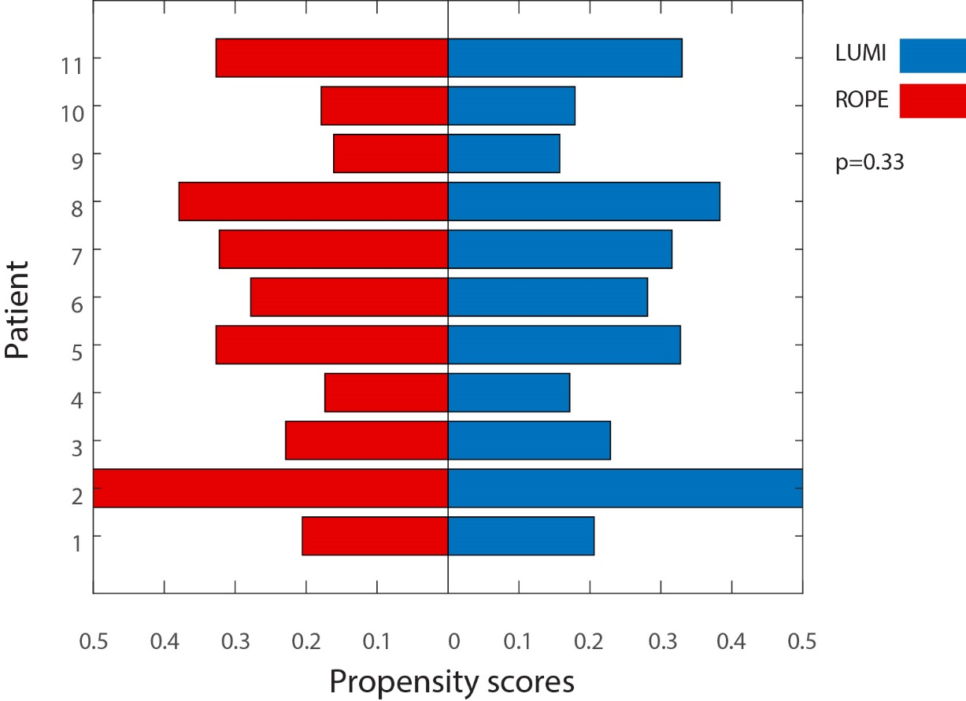

Supplementary Figure 1: 11 patient comparison of propensity matched scores (LUMI vs ROPE matched cohort).

- Ray, A.F., Powell, J., Speakman, M.J., Longford, N.T., DasGupta, R., Bryant, T., Modi, S., Dyer, J., Harris, M., Carolan-Rees, G. and Hacking, N. (2018). Efficacy and safety of prostate artery embolization for benign prostatic hyperplasia: an observational study and propensity-matched comparison with transurethral resection of the prostate (the UK-ROPE study). BJU International, 122(2), pp.270–282. doi:10.1111/bju.14249

