Political trust in the first year of the COVID-19 pandemic: a meta-analysis of 67 studies

Daniel Devine, Viktor Valgarðsson, Jessica Smith, Will Jennings, Michele Scotto di Vettimo, Hannah Bunting, and Lawrence McKay

Abstract

Trust in political actors and institutions has long been seen as essential for effective democratic governance. During the COVID-19 pandemic, trust was widely identified as key for mitigation of the crisis through its influence on compliance with public policy, vaccination and many other social attitudes and behaviours. We study whether trust did indeed predict these outcomes through a meta-analysis of 67 studies and 426 individual effect sizes derived from nearly 1.5 million observations worldwide. Political trust as an explanatory variable has small to moderate correlations with outcomes such as vaccine uptake, belief in conspiracy theories, and compliance. These correlations are heterogenous, and we show that trust in health authorities is more strongly related to vaccination than trust in government; but compliance is more strongly related to government than other institutions. Moreover, the unique case of the United States indicates that trust in President Trump had negative effects across all observed outcomes, except in increasing conspiracy beliefs. Our analysis also shows that research design features (such as response scales) and publication bias do not importantly change the results. These results indicate that trust was important for the management of the pandemic and supports existing work highlighting the importance of political trust.

Keywords: political trust; COVID-19; meta-analysis

Forthcoming at the Journal of European Public Policy

Introduction

Trust in political actors and institutions is seen as a fundamental resource for democratic governance and social cooperation. In the foundational political science literature, it was argued that ‘no set of incumbent authorities in modern mass societies’ could make decisions or implement policy without trust – and ‘few systems [were] able to survive long’ without it (Easton, 1975). Social trust, a distinct but related concept which refers to trust in other people rather than in political actors in particular, has long been studied as a core ingredient for social cooperation, democratic development and economic growth (Putnam, 2000). Empirical research since has argued that political trust is related to important outcomes such as policy preferences, vote choice, and social compliance (for reviews, see: Citrin and Stoker 2018; Zmerli and Van der Meer 2017), and trust-building has been a core component of governance within the OECD (Bouckaert, 2012; Brezzi et al., 2021; OECD, 2017).

The COVID-19 pandemic led many governments to rapidly implement stringent policies, mostly with limited scrutiny from the public or legislatures; these policies placed unprecedent restrictions on individuals’ lives and relied fundamentally on collective action and broad compliance. It has been commonplace to assert that political trust is a key variable in explaining governments’ variable success in fighting the pandemic. In a highly cited paper published early in the pandemic, Bavel et al (2020) highlighted the role of political trust in relation to outcomes as diverse as vaccine uptake, compliance and behaviour change, risk assessment, belief in conspiracy theories, and much else. Two years into the pandemic, Bollyky et al. (2022) argued in The Lancet that political trust was the only social factor correlated with (lower) infection rates, leading to the Wall Street Journal headline that ‘COVID is less deadly where there is trust’ (Bollyky, Dieleman, and Hulland, 2022). And this has political consequences; in the UK House of Commons, then-Prime Minister Boris Johnson stated in defence of his government’s policies that ‘the single biggest index of that trust [in government] has been [the public’s] willingness to come forward voluntarily […] to get vaccinated’ (HC Deb, 2022).

Despite an enormous amount of research produced on the relationship between political trust and COVID-related outcomes, there has been no systematic accumulation of this research. It is not clear that trust matters in ways we expect, nor the magnitude of any potential effect, and this is likely to have importance consequences for policy framing and academic research. Whilst it is commonplace to assert that political trust is important in driving outcomes such as vaccine uptake, the extant political trust literature and evidence from other epidemics provide a more complex account. Whilst trust can reduce outcomes like vaccine hesitancy and drive compliance in some contexts, it can also reduce the perceived risk COVID poses, reducing compliance and vaccine uptake (Devine et al., 2021; Jennings et al., 2021; Wong & Jensen, 2020; Yue et al., 2022). Moreover, trust can lead governments to act more slowly in imposing hard restrictions, instead relying on recommendations or soft law, leading to higher overall deaths (Toshkov et al., 2021). Trust seemingly matters for public policy during crises like the pandemic, but more systematic analysis is required to inform decision-makers and researchers alike.

To understand how, where and whether trust was important during the pandemic, we report the first systematic review and meta-analysis on the consequences of trust for COVID-related outcomes. Our analysis is based on 67 studies that use trust as an explanatory variable, leading to 426 coefficients encompassing nearly one and a half million observations from across the world in the first year of the pandemic. Our results indicate that trust had a small to moderate correlation with outcomes such as belief in conspiracy theories, vaccine hesitancy and compliance with public health measures. The only outcome studied which trust was not consistently related to was risk perceptions of COVID, for which effect sizes were heterogenous but centred over zero. Yet, we also show that correlations are to a degree dependent on the object of trust (e.g., parliament or government) and its outcome (e.g., vaccine uptake or conspiracy beliefs). For instance, trust in public health authorities has a large effect on vaccine hesitancy but not compliance, and the reverse is true for trust in government. Meanwhile, trust in President Trump had a negative correlation across all included outcomes, except for conspiracy beliefs, which had a positive correlation. We also show that the effect sizes are not substantively moderated by research design considerations such as region, question response scales or length of time since the pandemic began.

Our paper has four important contributions. First, we provide the first systematic overview of the consequences of political trust during the COVID-19 pandemic. This is a topic that has inspired a vast amount of research and has had important public and political consequences. We believe rigorously summarising existing knowledge is an important contribution to understanding societal responses to the pandemic. This also contributes to the wider study of political trust. Work on the consequences of political trust is relatively sparce; indeed, it is the ‘biggest deficiency’ in the trust literature (T. van der Meer & Zmerli, 2017) in which there is relatively little ‘reliable knowledge’ (Marien & Hooghe, 2011), despite being of fundamental and long-standing interest in political science. The number of relevant studies of the importance of trust during the pandemic is already so vast that this context offers a unique case for assessing the consequences of trust and its moderators. Thirdly, our analysis provides some theoretical nuance to existing studies on the consequences of trust, insofar as it shows that (i) the consequences of trust are dependent on both the object of trust and its outcome and (ii) trust’s consequences depend at least in part on the message of the trusted, such that President Trump undermined vaccine uptake, compliance, and increased conspiracy beliefs. Finally, our empirical contribution also lies in our method; meta-analyses are rarely used in political or social science more generally yet are important for knowledge accumulation. We provide a transparent, robust and scholarly useful example of meta-analysis that can be built on for future work.

In the next section, we briefly outline the dominant theoretical mechanism that links political trust to a variety of outcomes, including those related to the COVID pandemic. We do so to outline the expected direction of the relationship between trust and our studied outcomes, but also to problematise the narrative that political trust has been a universal good in fighting the pandemic. We next turn to our methods and data, describing our data collection process. We then describe our results, before concluding with a discussion of their academic and policy implications.

Political trust and the COVID pandemic

Before we can resolve the question of how trust mattered for fundamental outcomes during the pandemic, we need to consider how trust is theorised – why would trust be relevant in the first place? Conceptually, we consider trust to be the belief that an object of trust (a person or institution) would produce positive outcomes even if you cannot ensure it (Easton, 1975). It is, more precisely, the willingness to make oneself vulnerable in the expectation that an action will be performed without monitoring or control; it is making oneself vulnerable to an object (person or institution) that could do you some harm. Whilst there is no clearly established definition of trust, most current accounts consider acceptance of risk when faced with uncertain outcomes as central to trust (Citrin & Stoker, 2018; Hardin, 2002; Robbins, 2016; T. W. G. van der Meer, 2017). We also consider trust to be relational, that “A trusts B to do X” (Hardin, 2002); there is both an object (B) and action (X). We do believe that trust doesn’t have to involve an action: people can trust in general, which may be a weighted average of all relevant actions. It is conceptually possible, then, to state: “A trusts B” as well as “A trusts B to do X” (Faulkner & Simpson, 2017). The ‘political’ aspect of political trust enters primarily at the ‘B’, by which we mean political institutions, such as government, parties, political leaders, legislatures, and so on. In our analysis, we include the object of trust and outcome to understand whether trust varies across these two dimensions.

In this section, we briefly review the literature on trust as an outcome variable during the pandemic. We then turn to our primary focus, trust as an explanatory variable. We provide a narrative review of the theory linking political trust with various outcomes present in the literature.

Trust as an outcome variable

In the early stages of the pandemic, studies argued that the crisis caused a ‘rally-round-the-flag’ effect, as defined by (Mueller, 1970): a surge in support for the governing institutions and leaders in response to an event which is international, involves the country and particularly the leader directly, and is ‘specific, dramatic, and sharply focused’. The outbreak of COVID is a good match for such a rallying effect. As such, various authors documented these rallies in trust (Bol et al., 2021; De Vries et al., 2021; Esaiasson et al., 2021; Groeniger et al., 2021; Kritzinger et al., 2021; Sibley et al., 2020), even in the UK, whose response was contested and trust at a record low (Davies et al., 2021). However the determinants of this rally were not clear; whilst it may have been the implementation of lockdown, it may also have been increasing death rates (Schraff, 2021). Increases in trust were also heterogenous across the public, with some people changing trust judgements more than others, if they changed at all (Hegewald & Schraff, 2022). Indeed, some authors have also argued that the pandemic led to lower trust in government. (Bernardi & Gotlib, 2023) for instance argue that higher reported stress leads to lower evaluations of government performance and trust.

This and other ‘rallies’ are seen as beneficial in a crisis: it allows government to get on with the job of dealing with the crisis and increases compliance with the measures required to do so. Put in the nomenclature of our conceptual definition of trust, in the face of very uncertain and possibly very risky outcomes, a ‘rally’ allows governments considerable capital to achieve otherwise unworkable policy outcomes. Our focus is on whether this is indeed the case.

Trust as an explanatory variable

Why would we expect trust to matter for other important outcomes? The now-dominant theoretical mechanism linking trust and various outcomes is that trust is a heuristic citizens use to make judgements about politics (Hetherington, 2005; Rudolph et al., 2017). In an absence of perfect information or the desire to obtain it, citizens rely on information and cues from political actors to make their judgements. This leads to the basic and intuitive hypothesis that trust is positively related to state-organised policy generally: if one trusts the government (or another actor), and they are advocating a policy, one is more likely to support that policy. Scholars have extended this logic on the basis that trust is primarily about uncertainty, as noted above: trust is not necessary if an outcome is guaranteed. Trust, it is argued, explains policy preferences and compliance to a greater degree if there is greater risk and uncertainty, such as when the time-horizon of the policy is very long (like climate change or social investment policy) or comes with high costs (such as tax increases or significant behaviour change) (Hetherington, 2005; Jacobs & Matthews, 2017; Rudolph et al., 2017).

During the pandemic, citizens in almost all democracies faced a situation with high uncertainty and potentially high costs for themselves, family, friends, and society. There was also low information due to the rarity of severe health crises and the rapidly changing circumstances. In this context, citizens were asked to modify their behaviour in response to government policies, including isolating to varying degrees (meaning full stay-at-home orders in most countries), mask-wearing, social distancing, and rigorous hygiene. Further into the pandemic, citizens were also required to go back to work or similar when they may not have felt it safe to do so. These abrupt changes under conditions of uncertainty necessitate a rare application of trust in policymaking government and its institutions. Those who believe that the government can be trusted to serve them well should be more willing to follow their rules and guidance, and less likely to believe that they are out to (for example) enslave the population through manufacturing a pandemic or willingly administering dangerous vaccines.

As the pandemic progressed, citizens were also asked to trust in vaccinations that were developed with historic speed, and in their roll-out through government (or government-adjacent) institutions. All the while, conspiracy theories circulated about the true source of the virus, and whether governments had nefarious intentions in keeping people at home and through vaccination programs. This arguably counter-acted the perhaps positive impact of increased information due to parallel increases in misinformation. The trust-as-heuristic mechanism provides straightforward predictions for these outcomes: trust is positively related to vaccination (intent and uptake) and compliance, but negatively related to beliefs in conspiracy theories.

Whilst this perspective is intuitive, the relationship between trust and the perceived seriousness and risk of COVID is less clear. It is plausible that trust in institutions reduces anxiety and risk: if we expect that institutions have the capacity to address the pandemic, we may feel less concerned about it. However, it is also possible that trust drives information-seeking and since most governments were highlighting the serious societal and public health risk of COVID, may lead to perceptions of greater anxiety and risk (Srol et al., 2021; Surina et al., 2021). Still others expect that trust plays a minimal role in risk perceptions, given the relevance of other predictors (such as having experienced COVID) (Dryhurst et al., 2020). The expectations for risk and seriousness are mixed.

In addition, if the trust as heuristic argument is correct, then it follows that the consequences of trust depend on the messaging or policy position of the object of trust. If, for instance, trust in government is high but that government is explicitly anti-vaccination or espousing conspiracy theories, one would expect that trust to be detrimental rather than helpful for driving vaccination. This becomes more complicated once we consider that different objects of trust may take conflicting positions within the same country; for instance, government may not encourage behaviour change like social distancing, but public health authorities may do, and parties may cue their supporters differently. More broadly, different countries and governments met the challenge of the pandemic in different ways, with different measures and messaging adopted, meaning that the effects of trust may well vary between countries and regions. It is not at all clear how these tensions play out, and something the present study aims to shed light on.

Finally, there are a vast range of methodological decisions which may influence results, such as the measurement of trust, the region of study, time period of the study, and much else – such as apparently random variation in approaches (Breznau et al., 2022). As such, the proposed direction and consequences of trust seem far less clear than currently presented in the literature and policy debate.

In what follows, we provide a broad analysis of the relationship between political trust and COVID-related outcomes, synthesising the existing quantitative literature. Our intention is not to test every possible permutation of the relationship between trust and these outcomes but to test the broader claim that trust is helpful in mitigating the pandemic or in supporting public health measures.

Methods and Data

To test this, we use meta-analysis, which is a ‘systematic literature review supported by statistical methods where the goal is to aggregate and contrast the findings from several related studies’ (Viechtbauer, 2010). A meta-analysis requires three core steps. First, the data collection and coding of existing literature; second, the standardisation of quantities of interest across these studies; third, the modelling of these derived effect sizes. In this section, we describe each of these steps.

Data collection and coding

To collect studies on the relationship between trust and COVID-related outcomes, we searched ProQuest and Web of Science, limiting the search to ‘Title, Abstract and Key Words’, and date of publication between January 2020 and the date of the search (20th August 2021), with the following search terms:

(trust OR "political trust" OR "trust in politics" OR "political distrust" OR distrust) AND
(policy OR "policy preferences" OR "turnout" OR "voting" OR "voter turnout" OR participation OR "political participation" OR "political behavio$r" OR behavio$r OR compliance OR "public opinion" OR opinion OR consequence* OR conspiracy OR "vaccin*") AND (COVID” OR "COVID-19" OR "coronavirus" OR pandemic).

Our search terms were intentionally broad to obtain results for numerous outcomes that are prevalent within the early literature on political trust during COVID, such as compliance and vaccination. We were also motivated by the existing trust literature; these are core outcomes identified by existing reviews (Citrin & Stoker, 2018; Uslaner, 2018; T. van der Meer & Zmerli, 2017) and therefore maximise our ability to contribute beyond the context of COVID. We could not plausibly address all potential outcomes, and indeed our search did not return substantial numbers of important outcomes, such as excess deaths. However, we do believe that our search returned many outcomes of interest at the time (such as conspiracy beliefs and vaccination) and those of relevance to the broader literature on political trust.

The initial search returned 1,823 texts. One author screened the titles and abstracts, leading to 1,611 excluded, with 113 duplicates and 1,498 deemed irrelevant. These were only excluded at this stage if they were fundamentally incompatible with the meta-analysis, such as not studying the link between trust and some COVID-related outcome, not conducted during the pandemic, or similar. We then searched 212 returns for full texts, and 3 were not possible to locate. We screened the full texts of 209 returns, excluding 142. Reasons for these exclusions are available in Figure 1 (‘Reports excluded’), and broadly include issues such as the independent variable not being political trust and it not being possible to extract the effect size. At this stage, the final papers were distributed to seven coders, with 12 (18%) double coded. We then harmonised and coded the final dataset. We coded and therefore included a total of 67 texts. We describe our search process in Figure 1.

Identification of studies

Records identified from:
Web of Science (n = 995)
ProQuest (n = 828)

Identification

Ineligible (n = 1498)
Duplicates* (n = 113)
Total excluded (n = 1611)

Records screened based on title and abstract (n = 1823)

Unable to access (n = 3)

Reports sought for retrieval
(n = 212)

Screening

Reports excluded (total n = 142):
Ineligible construct (n = 70)
Ineligible analysis (n = 48)
Ineligible design (n = 15)
Ineligible units (n = 5)
Ineligible language (n = 3)
Other (n = 1)
Reports assessed for eligibility
(n = 209)

Studies included in review
(n = 67)
Included

* Duplicates assessed after first screening of abstract and title.

Figure 1: PRISMA diagram of data collection

Effect size calculation

We took all relevant estimates directly from the texts; for instance, if a text reported an association between trust and some COVID-related outcome and fulfilled our inclusion/exclusion criteria, it was included. Standard errors and coefficients were calculated for all outcomes. For instance, papers which reported odds ratios or confidence intervals were converted to standard error and log odds. In most instances, these were obtained through replication data or author contact (N = 326) but where this was not possible they were calculated by hand (N = 65). From these, a t-statistic was calculated and standardised into z-transformed (partial) correlation coefficients (Aloe, 2014; Dinesen et al., 2020). Whilst some coefficients (N = 92) are raw bivariate correlations, all others are the outcomes of models controlling for other factors. These observations are transformed into partial correlations which take into account the sample size and degrees of freedom of the model. We report these together in the main text but separately in Appendix Figure A1. The interpretation of the Fisher’s Z is identical to that of the more familiar correlation coefficient.

Modelling approach

Our primary modelling strategy is a random effects model. For most outcomes, this includes a level for the study (such that estimates from the same study will be correlated) and, where relevant, we also include a level for the data source (such that observations from the same data source will be correlated). The observations are weighted by their precision (standard error) and the amount of residual model heterogeneity, as is standard in meta-analysis (Viechtbauer, 2010). The primary alternative is the fixed effects model. This assumes that the true effect is the same across all countries and time periods which is not a credible assumption here; instead, the random effects model assumes there is a common distribution of effects but allows the effect to vary. We report study-pooled analyses in Appendix Figure A1.

Results

Descriptive statistics

Beginning with descriptive statistics, Figure 2 reports four research design features of the data: country of study, region of study, dependent variable (i.e., outcome), and the object of trust. Most of the studies are cross-national (three or more countries within the sample) and most single-country studies are from the US, Germany and the UK. There is a relatively even distribution over other countries including Japan, Greece and Australia. Whilst there appears to be reasonable country coverage, approximately half of the observations are from European countries; in terms of regions, a clear omission in the literature is Africa, for which we have no observations. The object of trust – what the respondent is asked whether they trust – is most often the government in general, followed by ‘Other’, which typically means an index of different institutions, and then politicians/parties and public health authorities (which we restricted to explicitly political authorities, such as the Department of Health). 14 observations refer to a specific incumbent, that is, a particular political actor such as the President.

The figure also shows our nine different outcomes. A plurality of papers concerned vaccine-related outcomes (such as hesitancy or willingness), followed by compliance; the next most common are seriousness/risk and conspiracy beliefs. In our main analyses, we use only those outcomes that have more than 10 separate papers: vaccination, compliance, risk and seriousness, and conspiracy beliefs. All but one of these outcomes are at the individual-level (i.e., are not country or region aggregates); aggregate studies looking at death rates for instance were collected but are so few in our final data (indeed, our least populated category) that meta-analysis was not suitable.

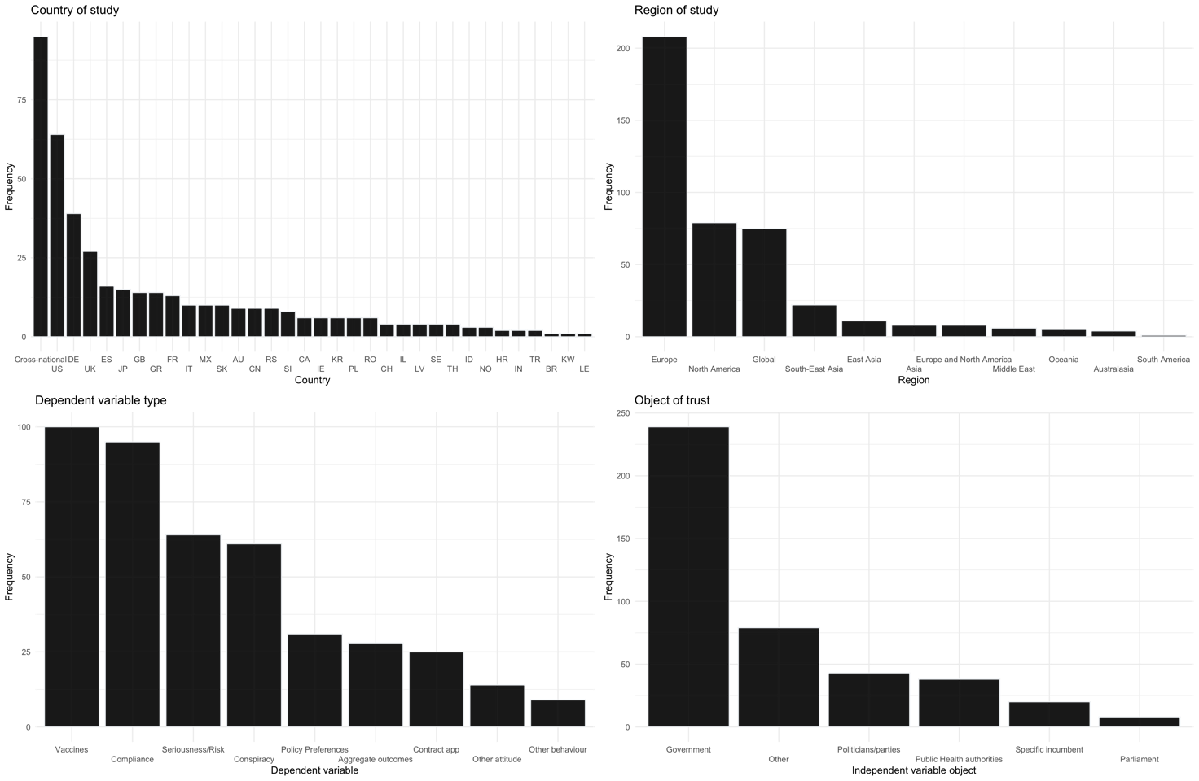
Figure 2: Descriptive statistics of the data

Main finding: small-to-moderate correlations

Turning to the primary results of the meta-analytic results of the relationship between trust and COVID-related outcomes, Figure 3 reports the results from our random-effects meta-analysis (full table in Appendix 9). The point estimate and 95% confidence intervals represent the average estimate; the underlying points represent individual coefficients with their size the overall weight they contribute to the final estimate. Our results indicate that trust has a significant effect size across all outcomes except for risk and seriousness attitudes. The correlation of trust with compliance is, in Z-transformed Pearson correlations, r_{z} = 0.11 (95% CI = [0.03, 0.19]) for vaccination it is r_{z} = 0.10 (95% CI = [0.064, 0.14]) and for conspiracy beliefs r_{z} = -0.23 (95% CI = [-0.32, -0.12]) (i.e. negatively related to conspiracy beliefs). Trust has a small and non-significant relationship with risk and seriousness attitudes (r_{z} = 0.04, 95% CI = [-0.033, 0.12]). We also provide the absolute effect size for all outcomes which shows that trust has an overall correlation of r_{z} = 0.14 (95% CI = [0.12, 0.17]). To be clear, this ‘overall’ correlation is the absolute correlation so cannot be interpreted directionally; it is the average correlation to indicate the overall importance of trust. To be explicit, these estimates therefore indicate that trust is importantly related to a variety of fundamental outcomes during the COVID pandemic.

Putting these estimates in context, they are consistent with other meta-analyses in political science on topics such as terrorism, ethnic diversity, and globalisation (Devine, 2022; Dinesen et al., 2020; Godefroidt, 2023; Heimberger, 2021). For instance, Godefroidt (2021) estimates that terror attacks have an overall effect on a conservative ideological shift amongst the public of 0.132; our estimates suggest that political trust has a similar correlation with compliance, vaccination, and a larger, negative correlation with conspiracy beliefs.

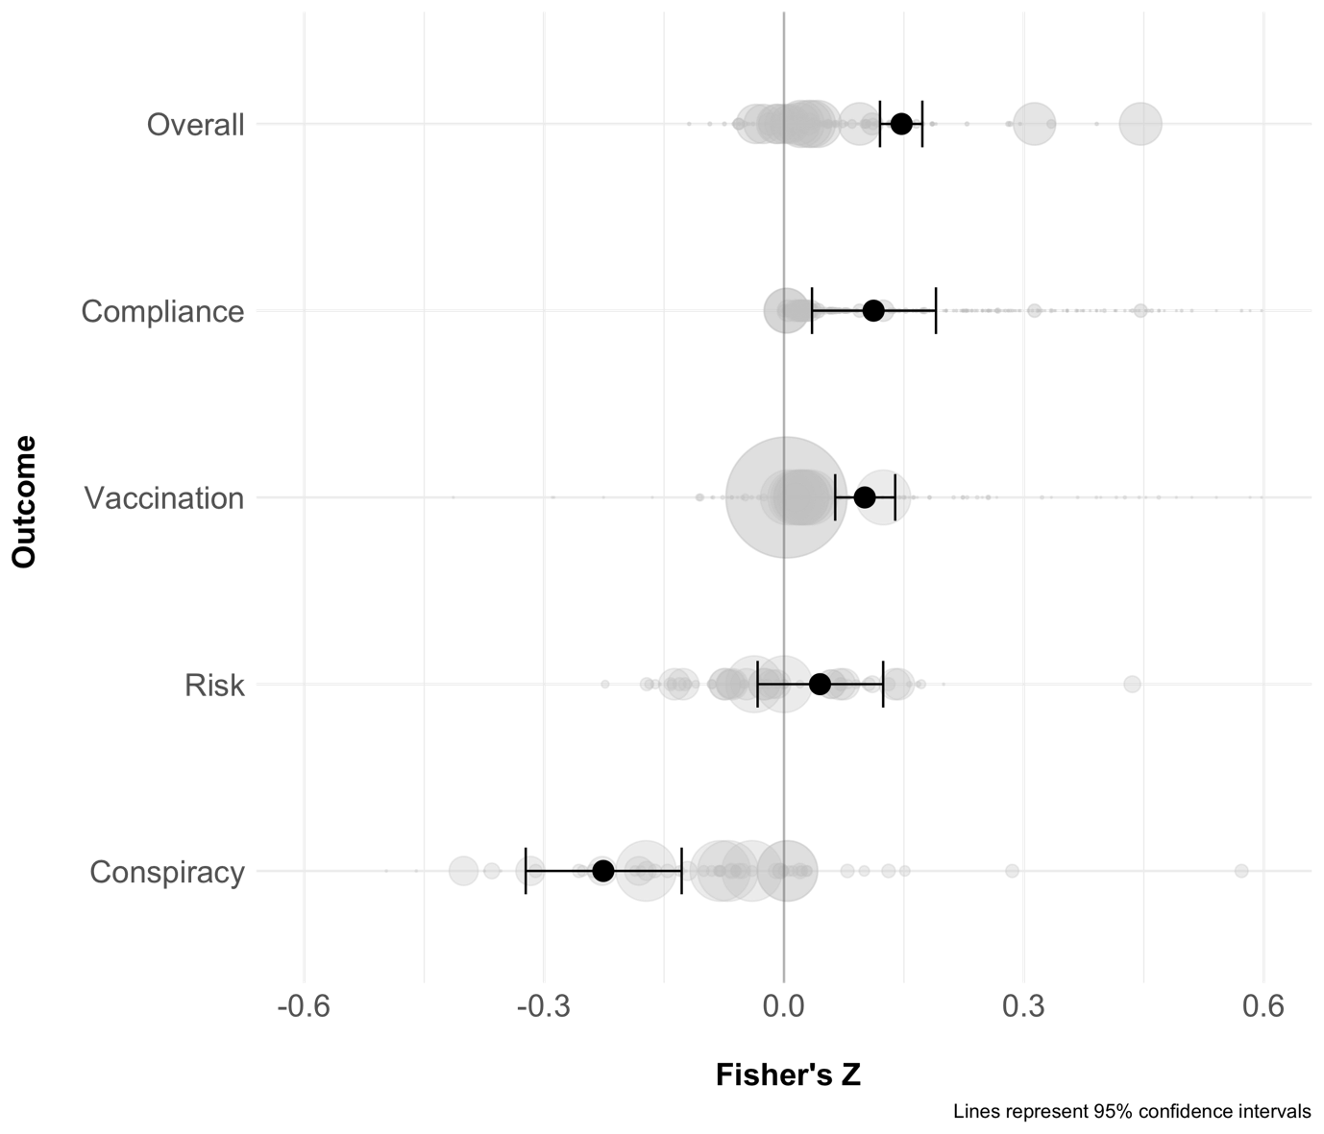
Figure 3: Meta-analytic estimates

In Appendix Figure A1, we provide separate estimates for study pooled and partial or raw correlations. These show slightly larger correlations for non-partial correlations (i.e. those without any controls) and wider confidence intervals for study-pooled estimates. We also remove outliers from each of the models and show that the results do not change; the overall correlation is weaker (r_{z} = 0.07 (95% CI = [0.04, 0.10]) but this does not change estimates for the core outcomes. For presentational purposes, we also provide forest plots for the study-pooled estimates (A2-A5) to show results for different studies and how much they contribute to the overall estimate.

Meta-regression analysis

The models indicate that almost all the variance is due to genuine heterogeneity in effect sizes rather than chance. It is therefore possible that this heterogeneity can be explained, and so we turn to exploratory (non-registered) meta-regression analyses to identify possible sources of heterogeneity. Meta-regression analyses assume that effect sizes are influenced by variables other than the sampling error generated by the underlying studies. As we discuss in the literature review, there are also good theoretical reasons to believe trust may vary, such as due to the object of trust and region. There are also a variety of research design decisions that may influence the results (Breznau et al., 2022). To test for this, we use random-effects meta-regression, which includes explanatory variables when predicting the effect sizes. Our formula is:

$$Y_{ij} = β_{x}X_{ij} + b_{j} +b_{k}+ϵ_{ij}$$

This is very similar to the familiar regression equation, in which $Y_{ij}$ is the effect size i in study j; $β_{x}X_{ij}$ is the vector of ‘moderator’ variables (the variables we expect to influence, or moderate, the effect sizes $Y_{ij}$); $b_{j}$ is our intercept for the individual studies; $b_{k}$ is the intercept for the data source of the estimate; and $ϵ_{ij}$ is the residual error. An important point for interpretation here is that we have removed the fixed intercept ($β_{0})$ so all the categories of the moderating variable can be used (i.e., we do not have to remove one category to avoid collinearity); the interpretation of the coefficient ($β_{x})$ is the estimated coefficient for a particular level ($X_{ij})$. We tested for five variables: the object of trust, region, the response scales of predictor and outcome variables, and time since the pandemic began. We tested these for each of the primary outcomes (vaccines, conspiracy, compliance and risk) separately.

For theoretical reasons outlined, we focus on the object of trust, which is a significant moderator in all cases (an omnibus F test of moderators ranging from p = 0.01 to p < 0.0001). The tensions and differences in effects of trust identified in an early review of the literature are evident in the extant body of work (Devine et al., 2021). For instance, the correlation of trust in public health authorities with compliance is insignificant and relatively small (r_{z} = 0.06) but significant and substantial for vaccination (r_{z} = 0.18); on the other hand, trust in government is r_{z} = 0.12 for compliance, but only r_{z} = 0.07 for vaccination. Interestingly, trust in the incumbent has a non-significant correlation across all outcomes. Trust in any political authority, with the exception of a specific incumbent, has a negative and sizeable correlation with conspiracy beliefs. These results are presented in Figure 4. What these indicate most pertinently is that trust in public health authorities (which means a health department, rather than ‘doctors’) is a powerful predictor of a positive stance towards vaccinations, above and beyond explicitly political institutions. Compliance, meanwhile, is more likely to be achieved through trust in government.
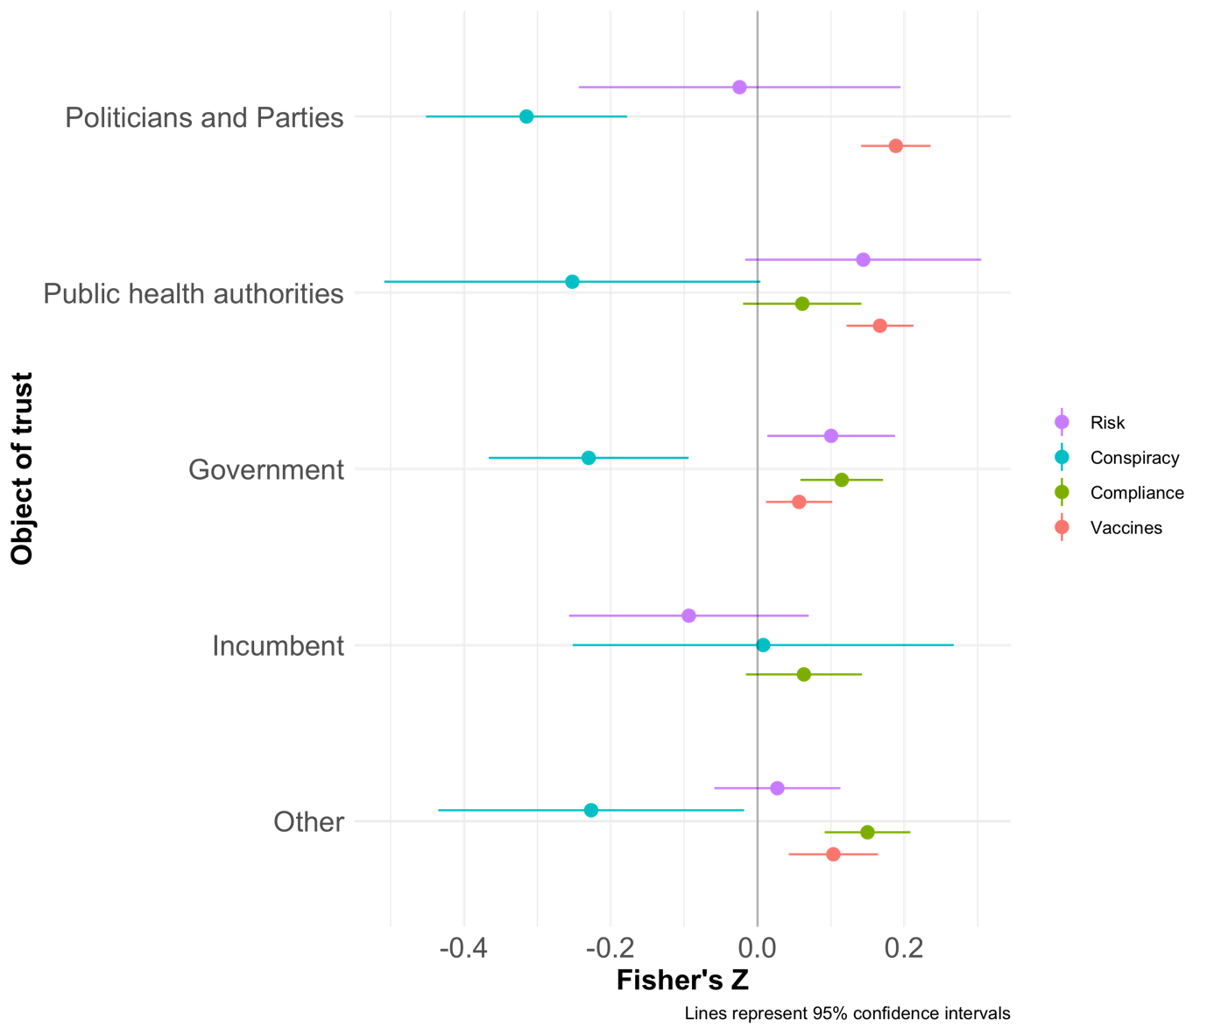
Figure 4: Meta-regressions with object of trust as a predictor

In terms of research design features, we find that the effect of region was a significant moderator for conspiracy beliefs (p = 0.03), compliance (p = 0.001) and vaccines (p < 0.0001), but not risk (p = 0.24), with a notable difference that the correlation of trust and compliance is twice the size in North America (r_{z} = 0.34) as in Europe (r_{z} = 0.15). Moreover, trust is only related to compliance in Europe and North America, with all other regions insignificant and centred over zero; trust and vaccination are related similarly in all regions. It is unclear from our data why this is the case, but these variations may be indicative of different cultural settings, the politicisation of public health guidelines in different countries, or more prosaically the fewer number of studies.

Finally, whilst the moderation effect of the response scales of the dependent and independent variables are significant, the substantive differences are small. Importantly, the time since the pandemic began is a significant moderator for the vaccine outcomes only (p = 0.02) but the substantive difference is negligible, indicating that the correlation of trust did not change over the pandemic, at least up to 17 months after the pandemic began.

Collectively, these results indicate interesting and substantively important variation in the correlation of trust across regions and objects of trust, and that these differences are unlikely to be driven by prosaic design features such as response scales.

A major obstacle for meta-analyses is reporting bias, in which our data only includes studies with large effects or that are statistically significant. This can arise for a range of reasons: because studies are not published (publication bias), authors do not report them (selective outcome reporting), or authors only report the largest effect or most significant result (selective analysis reporting) (Sterne et al., 2011). Whatever the cause, the presence of reporting bias can attenuate our conclusions. In Appendix section 4, we present results from essentially all common tests of publication bias (Citkowicz & Vevea, 2017; Mavridis & Salanti, 2014). We start with funnel plots supplemented with trim-and-fill analyses and Eggers’ regression; these graph and quantify the relationship between effect sizes and the precision estimate (standard error) and provide an estimate of publication bias. Typically, publication bias is presumed to exist if the funnel is asymmetric (where less precise studies have large point estimates). These indicate no reporting bias in our data. We then move to selection models, which essentially weights studies by their significance values on the assumption that non-significant values are under-represented in the data, and provides an estimate adjusted for this over-representation. Our results from these tests show (i) overall, minimal evidence of reporting bias across our core outcomes; (ii) if there is reporting bias, this is only for compliance outcomes; and (iii) our estimates are robust to moderate but not severe reporting bias. As such, we are confident our results are robust under most realistic scenarios.

We also provide a small case-study of the United States in Appendix Section 7, which is in the unique situation of trust in President Trump having a negative relationship to desirable outcomes like compliance, but trust in other institutions has a generally positive relationship with all outcomes. As we note in the following section, this underlines the importance of the object of trust for the relationship between trust and COVID-related outcomes.

Discussion

Throughout the pandemic, scholarly and public debate argued that political trust is a key resource for combating COVID-19. Whilst this generated a large amount of academic research, there have been no systematic efforts to summarise current quantitative evidence, and it has remained unclear whether this interest in political trust is warranted, or how trust’s effect varies. Despite the rather unique context of the pandemic, this debate speaks directly to the concern in the foundational political science literature that regards trust in politics as fundamental for the sound, legitimate working and, indeed, survival of (democratic) societies (Cole, 1973; Easton, 1975; Miller, 1974).

This paper has reported a systematic review and meta-analysis of effect sizes from 67 texts, 426 coefficients, and 1,479,154 observations from studies conducted around the world. Trust has had an important and heterogenous correlation with important outcomes during the COVID-19 pandemic. Notwithstanding concerns of causality, political trust may have been particularly important for combating conspiracy beliefs and a lesser extent in encouraging compliance with public health measures and vaccine uptake. Our analysis revealed two important nuances. The object of trust – such as government, public health authority, or incumbent – is important in moderating the correlation with different outcomes; whilst government and similar institutions are important for maintaining compliance, public health authorities are equally as fundamental for supporting vaccination. We also show important regional differences: region is a significant moderator for all outcomes except risk, and is most important for compliance, which is only significant in North America and Europe and is twice the size in the former than latter. Descriptively however, our data show a strong regional skew towards Europe and North America in terms of the prevalence of studies, with a complete absence of studies from Africa. Our core results are robust to outlier removal, whether they are raw or partial correlations, and study pooling.

Our results have important implications for the academic literature on the consequences of trust. Further, they are consistent with the general hypotheses advanced by existing literature. The foundational work characterised trust as essential to the sound working of democracy, and the empirical literature since has suggested trust is important for outcomes such as compliance with tax law, policy preferences, and voter turnout (Hetherington, 2005; Hooghe & Marien, 2013; Letki, 2006; Scholz & Lubell, 1998), though there is a relative dearth of evidence given the importance and popularity of the topic (T. van der Meer & Zmerli, 2017). Our results help address this, systematising existing studies concerning a specific event, and are consistent with existing conclusions: trust is related to important societal outcomes.

At the same time, our results indicate important variation. There is substantial variation in our results depending on the object and area of trust – the B and X of the ‘A trusts B to do X’ statement – which is rarely addressed, to our knowledge, in the political science literature. At least with respect to compliance and vaccination during the pandemic, the effect of trust varies depending on who is trusted. Moreover, this suggests that citizens do indeed differentiate meaningfully between trust objects, at least as far as the consequences of trust are concerned (Fisher et al., 2010). If this finding extends beyond COVID-related outcomes, that may lead to more accurate conclusions regarding the relationship between trust and outcomes such as policy preferences and compliance. This has theoretical consequences for the dominant trust-as-heuristic approach. Whilst trust is expected to have general consequences (such as increasing compliance and vaccination uptake in the case of COVID, or support for redistribution policy and other government-expanding policies in the wider literature), these results suggest the effect is at least in part conditional on the position of the trusted. Testing that proposition outside the context of the pandemic would be a fruitful avenue for future stu``` dies to expand upon our findings. It would also contribute to a more nuanced – and accurate - approach to integrating consideration of trust in public policy.

One of our more surprising conclusions is that trust is, on average, unrelated to risk and seriousness attitudes, despite competing expectations outlined in the theoretical section. It is possible trust in government (as opposed to other objects) is related to perceptions of greater risk/seriousness. As Figure 3 indicates, there are both positive and negative estimates, but this would likely be the case if the ‘true effect’ was zero. As such, we suggest that the mixed findings with respect to this outcome is because the value is zero, a conclusion reached by Dryhurst et al. (2020). We cannot say whether this generalises to other contexts, but we have no reason to expect that the pandemic is sufficiently different to other crises or epidemics to change our hypothesis of a null effect.

This being said, we show that the consequences of trust vary meaningfully across regions, with compliance only significantly related to trust in Europe and North America, though trust is important for vaccination around the world. We are not able to answer why this is the case, and it could be due to a range of factors such as the differential politicisation of aspects of the pandemic, cultural contexts, role of government, varying approaches to the pandemic and much else; what we can say with confidence is that these differences exist, are worth exploring, and provide some nuance to our results.

Perhaps more importantly, our results are directly relevant for public policy: trust and trust-building have been a core strategy of world governments, especially within the OECD, for over a decade (Bouckaert, 2012; Brezzi et al., 2021; OECD, 2017). Specifically during the pandemic, trust has been cited as one of the core determinants of compliance, vaccination, and rejection of conspiracy theories (Bollyky, Hulland, et al., 2022). Our results support these claims and should encourage governments and international organizations to continue their efforts to rebuild political trust around the world. More specifically in the context of pandemic management, our findings suggest that vaccination policies may be better driven by public health authorities than governments, whilst compliance should be driven by (trusted) governments. The obvious policy implication is that messaging on vaccination should be delivered – at least publicly – by health authorities, with compliance and related measures delivered by governments.

Of course, our study is not without limitations. First, like all empirical analyses, our data is limited to the collection period and the coverage of the underlying studies covered here. This means that some regions are under-represented and we only cover the first year-and-a-half of the pandemic. Second, we note some important qualifications to the data of the underlying studies. Most obviously, as mentioned previously, almost all of the included studies are observational, and we cannot rule out reverse causality or some other confounding variable. We nonetheless strongly believe that summarising the existing literature – observational or otherwise – is an important, worthwhile and informative exercise that considerably advances our knowledge of this important topic. In addition, given the quite robust associations we and other studies have observed and the meaningful and expected differences, we would be surprised if the entirety of the relationship was explained by other factors; at least in the cases of vaccination and compliance, it seems less plausible that these would cause higher trust levels than the other way around. Similarly, almost all our data is self-reported (i.e., survey based), rather than based on ‘objective’ measures, which might provide more reliable results. Further systematic reviews and analyses filling in these gaps would be valuable.

Nonetheless, by providing a rigorous, systematic analysis of the existing empirical literature, we show that trust is relevant for policy success, adding evidence to a fundamental proposition in the academic literature, about the role of political trust in democratic governance.
Acknowledgements

We’d like to thank all the authors we contacted for responding helpfully and providing any data or clarifications we required. We would also like to thank the four reviewers for extensive comments which changed the paper enormously and for the better.

Disclosure statement

No potential conflict of interest was reported by the author(s).

Notes on contributors

Daniel Devine is a Fellow in Political Sociology at St Hilda’s College, University of Oxford
Viktor Valgarðsson is a Leverhulme Early Career Research Fellow at the University of Southampton
Jessica Smith is a Lecturer in Politics at the University of Edinburgh
Will Jennings is a Professor of Political Science and Public Policy at the University of Southampton
Michele Scotto di Vettimo is a Postdoctoral Research Fellow at the University of Exeter
Hannah Bunting is a Lecturer in Quantitative British Politics at the University of Exeter
Lawrence McKay is a British Academy Postdoctoral Research Fellow at the University of Southampton

Funding

This work was partially supported by the UK Economic and Social Research Council under Grant number ES/S009809/1 (TrustGov project, University of Southampton)

ORCID

Daniel Devine: 0000-0002-0335-1776
Viktor Valgarðsson: 0000-0003-2891-7489
Jessica Smith: 0000-0002-4909-8884
Will Jennings: 0000-0001-9007-8896
Michele Scotto di Vettimo: 0000-0002-7627-3975
Hannah Bunting: 0000-0002-9701-3064
Lawrence McKay: 0000-0002-2071-3943

References

Aloe, A. M. (2014). An Empirical Investigation of Partial Effect Sizes in Meta-Analysis of Correlational Data. The Journal of General Psychology, 141(1), 47–64. https://doi.org/10.1080/00221309.2013.853021
Bernardi, L., & Gotlib, I. H. (2023). COVID-19 stressors, mental/emotional distress and political support. West European Politics, 46(2), 425–436. https://doi.org/10.1080/01402382.2022.2055372
Blair, G., Christensen, D., & Rudkin, A. (2021). Do Commodity Price Shocks Cause Armed Conflict? A Meta-Analysis of Natural Experiments. American Political Science Review, 115(2), 709–716. https://doi.org/10.1017/S0003055420000957
Bol, D., Giani, M., Blais, A., & Loewen, P. J. (2021). The effect of COVID‐19 lockdowns on political support: Some good news for democracy? European Journal of Political Research, 60(2), 497–505. https://doi.org/10.1111/1475-6765.12401
Bollyky, T. J., Dieleman, J. L., & Hulland, E. N. (2022). Covid Is Less Deadly Where There Is Trust. Wall Street Journal. https://www.wsj.com/articles/covid-is-less-deadly-where-there-is-trust-11643906663
Bollyky, T. J., Hulland, E. N., Barber, R. M., Collins, J. K., Kiernan, S., Moses, M., Pigott, D. M., Reiner Jr, R. C., Sorensen, R. J. D., Abbafati, C., Adolph, C., Allorant, A., Amlag, J. O., Aravkin, A. Y., Bang-Jensen, B., Carter, A., Castellano, R., Castro, E., Chakrabarti, S., … Dieleman, J. L. (2022). Pandemic preparedness and COVID-19: An exploratory analysis of infection and fatality rates, and contextual factors associated with preparedness in 177 countries, from Jan 1, 2020, to Sept 30, 2021. The Lancet, 399(10334), 1489–1512. https://doi.org/10.1016/S0140-6736(22)00172-6
Bouckaert, G. (2012). Trust and public administration. Administration, 60(1), 91–115.
Breznau, N., Rinke, E. M., Wuttke, A., Nguyen, H. H. V., Adem, M., Adriaans, J., Alvarez-Benjumea, A., Andersen, H. K., Azevedo, F., Bahnsen, O., Balzer, D., Bauer, G., Bauer, P. C., Baumann, M., Baute, S., Benoit, V., Bernauer, J., Berning, C., Bethke, F. S., … Żółtak, T. (2022). Observing Many Researchers Using the Same Data and Hypothesis Reveals a Hidden Universe of Uncertainty. Proceedings of the National Academy of Sciences, 119(44), 1–8. https://doi.org/10.31222/osf.io/cd5j9
Brezzi, M., Gonzalez, S., Nguyen, D., & Prats, M. (2021). An updated OECD framework on drivers of trust in public institutions to meet current and future challenges. OECD Working Papers on Public Governance, 48.
Citkowicz, M., & Vevea, J. L. (2017). A parsimonious weight function for modeling publication bias. Psychological Methods, 22(1), 28–41. https://doi.org/10.1037/met0000119
Citrin, J., & Stoker, L. (2018). Political Trust in a Cynical Age. Annual Review of Political Science, 21(1), 49–70. https://doi.org/10.1146/annurev-polisci-050316-092550
Cole, R. L. (1973). Toward as Model of Political Trust: A Causal Analysis. American Journal of Political Science, 17(4), 809. https://doi.org/10.2307/2110610
Davies, B., Lalot, F., Peitz, L., Heering, M. S., Ozkececi, H., Babaian, J., Davies Hayon, K., Broadwood, J., & Abrams, D. (2021). Changes in political trust in Britain during the COVID-19 pandemic in 2020: Integrated public opinion evidence and implications. Humanities & Social Sciences Communications, 8(1), 166. https://doi.org/10.1057/s41599-021-00850-6
De Vries, C. E., Bakker, B. N., Hobolt, S., & Arceneaux, K. (2021). Crisis Signaling: How Italy’s Coronavirus Lockdown Affected Incumbent Support in Other European Countries. Political Science Research and Methods, 9(3), 451–467. https://doi.org/10.2139/ssrn.3606149
Devine, D. (2022). Trust Matters: A meta-analysis on the consequences of trust. OSF Preprints. https://osf.io/qtdwj
Devine, D., Gaskell, J., Jennings, W., & Stoker, G. (2021). Trust and the Coronavirus Pandemic: What are the Consequences of and for Trust? An Early Review of the Literature. Political Studies Review, 19(2), 274–285. https://doi.org/10.1177/1478929920948684
Dinesen, P. T., Schaeffer, M., & Sønderskov, K. M. (2020). Ethnic Diversity and Social Trust: A Narrative and Meta-Analytical Review. Annual Review of Political Science, 23(1), 441–465. https://doi.org/10.1146/annurev-polisci-052918-020708
Dryhurst, S., Schneider, C. R., Kerr, J., Freeman, A. L. J., Recchia, G., van der Bles, A. M., Spiegelhalter, D., & van der Linden, S. (2020). Risk perceptions of COVID-19 around the world. Journal of Risk Research, 23(7–8), 994–1006. https://doi.org/10.1080/13669877.2020.1758193
Easton, D. (1975). A Re-Assessment of the Concept of Political Support. British Journal of Political Science, 5(4), 435–457.
Esaiasson, P., Sohlberg, J., Ghersetti, M., & Johansson, B. (2021). How the coronavirus crisis affects citizen trust in institutions and in unknown others: Evidence from ‘the Swedish experiment’. European Journal of Political Research, 60(3), 748–760. https://doi.org/10.1111/1475-6765.12419
Faulkner, P., & Simpson, T. (2017). The Philosophy of Trust. Oxford University Press.
Fisher, J., Van Heerde, J., & Tucker, A. (2010). Does One Trust Judgement Fit All? Linking Theory and Empirics. British Journal of Politics and International Relations, 12(2), 161–188.
Godefroidt, A. (2023). How Terrorism Does (and Does Not) Affect Citizens’ Political Attitudes: A Meta-Analysis. American Journal of Political Science, 67(1), 22–38.
Groeniger, J. O., Noordzij, K., van der Waal, J., & de Koster, W. (2021). Dutch COVID-19 lockdown measures increased trust in government and trust in science: A difference-in-differences analysis. Social Science & Medicine, 275, 1–8. https://doi.org/10.1016/j.socscimed.2021.113819
Hardin, R. (2002). Trust and Trustworthiness. Russell Sage.
HC Deb. (2022). House of Commons Vol 707. https://hansard.parliament.uk/Commons/2022-01-19/debates/9E134503-624C-465D-870C-DFBCC1A0E4D2/Engagements?highlight=trust%20vaccine#contribution-2186D8CD-FFD7-4244-9E8B-9DA500D34C24
Hegewald, S., & Schraff, D. (2022). Who rallies around the flag? Evidence from panel data during the Covid-19 pandemic. Journal of Elections, Public Opinion and Parties, 1–22. https://doi.org/10.1080/17457289.2022.2120886
Heimberger, P. (2021). Does economic globalization affect government spending? A meta-analysis. Public Choice, 187, 349–374. https://doi.org/10.1007/s11127-020-00784-8
Hetherington, M. J. (2005). Why trust matters. Princeton University Press.
Hooghe, M., & Marien, S. (2013). A Comparative Analysis of the Relation Between Political Trust and Forms of Political Participation in Europe. European Societies, 15(1), 131–152. https://doi.org/10.1080/14616696.2012.692807
Jacobs, A. M., & Matthews, J. S. (2017). Policy Attitudes in Institutional Context: Rules, Uncertainty, and the Mass Politics of Public Investment. American Journal of Political Science, 61(1), 194–207. https://doi.org/10.1111/ajps.12209
Jennings, W., Stoker, G., Valgarðsson, V., Devine, D., & Gaskell, J. (2021). How trust, mistrust and distrust shape the governance of the COVID-19 crisis. Journal of European Public Policy, 28(8), 1174–1196. http://dx.doi.org/10.1080/13501763.2021.1942151
Kritzinger, S., Foucault, M., Lachat, R., Partheymüller, J., Plescia, C., & Brouard, S. (2021). ‘Rally round the flag’: The COVID-19 crisis and trust in the national government. West European Politics, 44(5–6), 1205–1231. http://dx.doi.org/10.1080/01402382.2021.1925017
Letki, N. (2006). Investigating the Roots of Civic Morality: Trust, Social Capital, and Institutional Performance. Political Behavior, 28(4), 305–325. https://doi.org/10.1007/s11109-006-9013-6
Marien, S., & Hooghe, M. (2011). Does political trust matter? An empirical investigation into the relation between political trust and support for law compliance. European Journal of Political Research, 50(2), 267–291. https://doi.org/10.1111/j.1475-6765.2010.01930.x
Mavridis, D., & Salanti, G. (2014). How to assess publication bias: Funnel plot, trim-and-fill method and selection models. Evidence Based Mental Health, 17(1), 30–30. https://doi.org/10.1136/eb-2013-101699
Miller, A. H. (1974). Political Issues and Trust in Government: 1964-1970. The American Political Science Review, 68(3), 951–972. https://doi.org/10.2307/1959140
Mueller, J. E. (1970). Presidential Popularity from Truman to Johnson. American Political Science Review, 64(1), 18–34. https://doi.org/10.2307/1955610
OECD. (2017). Trust and Public Policy: How Better Governance Can Help Rebuild Public Trust. Paris.
Putnam, R. D. (2000). Bowling Alone: The Collapse and Revival of American Community. Simon and Schuster.
Robbins, B. G. (2016). What is Trust? A Multidisciplinary Review, Critique, and Synthesis. Sociology Compass, 10(10), 972–986. https://doi.org/10.1111/soc4.12391
Rudolph, T. J., Zmerli, S., & Van Der Meer, T. W. G. (2017). Political trust as a heuristic. In Handbook on Political Trust. Edward Elgar Publishing.
Scholz, J. T., & Lubell, M. (1998). Trust and Taxpaying: Testing the Heuristic Approach to Collective Action. American Journal of Political Science, 42(2), 398–417. https://doi.org/10.2307/2991764
Schraff, D. (2021). Political trust during the Covid‐19 pandemic: Rally around the flag or lockdown effects? European Journal of Political Research, 60(4), 1007–1017. https://doi.org/10.1111/1475-6765.12425
Sibley, C. G., Greaves, L. M., Satherley, N., Wilson, M. S., Overall, N. C., Lee, C. H. J., Milojev, P., Bulbulia, J., Osborne, D., Milfont, T. L., Houkamau, C. A., Duck, I. M., Vickers-Jones, R., & Barlow, F. K. (2020). Effects of the COVID-19 pandemic and nationwide lockdown on trust, attitudes toward government, and well-being. American Psychologist, 75(5), 618–630. https://doi.org/10.1037/amp0000662
Srol, J., Mikuskova, E. B., & Cavojova, V. (2021). When we are worried, what are we thinking? Anxiety, lack of control, and conspiracy beliefs amidst the COVID-19 pandemic. Applied Cognitive Psychology, 35(3), 720–729. https://doi.org/10.1002/acp.3798
Sterne, J. A. C., Sutton, A. J., Ioannidis, J. P. A., Terrin, N., Jones, D. R., Lau, J., Carpenter, J., Rucker, G., Harbord, R. M., Schmid, C. H., Tetzlaff, J., Deeks, J. J., Peters, J., Macaskill, P., Schwarzer, G., Duval, S., Altman, D. G., Moher, D., & Higgins, J. P. T. (2011). Recommendations for examining and interpreting funnel plot asymmetry in meta-analyses of randomised controlled trials. BMJ, 343(1), 1–8. https://doi.org/10.1136/bmj.d4002
Surina, S., Martinsone, K., Perepjolkina, V., Kolesnikova, J., Vainik, U., Ruza, A., Vrublevska, J., Smirnova, D., Fountoulakis, K. N., & Rancans, E. (2021). Factors related to COVID-19 preventive behaviors: A structural equation model. Frontiers in Psychology, 12. https://doi.org/10.3389/fpsyg.2021.676521
Toshkov, D., Carroll, B., & Yesilkagit, K. (2021). Government capacity, societal trust or party preferences: What accounts for the variety of national policy responses to the COVID-19 pandemic in Europe? Journal of European Public Policy, 29(7), 1009–1028. https://doi.org/10.1080/13501763.2021.1928270
Uslaner, E. M. (2018). The Study of Trust. In E. M. Uslaner (Ed.), The Oxford Handbook of Social and Political Trust (pp. 1–12). Oxford University Press.
van der Meer, T. W. G. (2017). Political Trust and the “Crisis of Democracy”. In T. W. G. van der Meer, Oxford Research Encyclopedia of Politics. Oxford University Press. https://doi.org/10.1093/acrefore/9780190228637.013.77
van der Meer, T., & Zmerli, S. (2017). The deeply rooted concern with political trust. In S. Zmerli & T. van der Meer (Eds.), The Handbook on Political Trust. Edward Elgar Publishing.
Viechtbauer, W. (2010). Conducting Meta-Analyses in R with the metafor Package. Journal of Statistical Software, 36(3). https://doi.org/10.18637/jss.v036.i03
Wong, C. M. L., & Jensen, O. (2020). The paradox of trust: Perceived risk and public compliance during the COVID-19 pandemic in Singapore. Journal of Risk Research, 23(7–8), 1021–1030. https://doi.org/10.1080/13669877.2020.1756386
Yue, R. P. H., Lau, B. H. P., Chan, C. L. W., & Ng, S.-M. (2022). Risk perception as a double-edged sword in policy compliance in COVID-19 pandemic? A two-phase evaluation from Hong Kong. Journal of Risk Research, 25(9), 1131–1145. https://doi.org/10.1080/13669877.2021.1936612
Zmerli, S., & van der Meer, T. (Eds.). (2017). Handbook on political trust. Edward Elgar Publishing.

St Hilda’s College, University of Oxford. Corresponding author (Daniel.devine@st-hildas.ox.ac.uk).
University of Southampton
University of Edinburgh
University of Southampton
University of Exeter
University of Exeter
University of Southampton
Notes The anonymised pre-registration can be found on the OSF: https://osf.io/wgy5s/?view_only=3059eb2fe2764dcba1d4b9f130bae7a0. Deviations from registration are described in Appendix Section 8.
A previous meta-analysis found just five in five leading political science journals between 1999 and 2018 (Blair et al., 2021)
It is also of course possible that the relationship is reversed, such that high anxiety and risk may have heterogeneous effects on political trust. We address this general concern in the concluding discussion.
The asterisk (*) stands in for any characters, including no characters, so that ‘vaccin*’ can be ‘vaccines’, ‘vaccine’, or ‘vaccination’. The dollar sign ($) represents zero or one character such that ‘behavio$r’ can be ‘behavior’ or ‘behaviour’.
We did not specify whether the returns had to be ‘objective’ (such as recorded deaths) or ‘subjective’ (such as reported compliance). The vast majority of our included studies are the latter; just 14 were the former.
Please see Appendix Section 8 for a description of what this harmonisation involved.
‘Preferred Reporting Items for Systematic Reviews and Meta-Analyses’ (PRISMA), see http://www. prisma-statement.org.
The partial correlation is given by $r_{p1}=\frac{t_{f}}{\sqrt{t_{f}^{2}+\left(n-p-1\right)}}$ where t_{f} is the t-test of the regression coefficient, n – p – 1 is the degrees of freedom in which p is the number of predictors and n number of cases (sample size). The product of this, r, is then z-transformed by $z=\frac{1}{2}\log{\frac{1+r}{1-r} }$. The Z transformation means the effect sizes are more normally distributed (without the transformation, the distribution would be negatively skewed), and the coefficients from different samples can be compared.
The I² statistics, which indicate the percentage of variability in effects due to heterogeneity rather than chance, range from 96% to 99% and the Q test for heterogeneity is significant at the p < 0.0001 level for all models.
We keep to the simplest case of time since the global onset of the pandemic, as waves and other measures vary substantially by country.

