River flow induced nonlinear modulation of M₄ overtide in large estuaries

Leicheng Guo^{1, *}, Chunyan Zhu¹, Huayang Cai ²,
Zheng Bing Wang ^{3, 4}, Ian Townend ⁵, Qing He ¹

¹ State Key Lab of Estuarine and Coastal Research, East China Normal University, Shanghai 200241, China
² School of Ocean Engineering and Technology, Sun Yat-Sen University, Guangzhou 510275, China
³ Department of Hydraulic Engineering, Faculty of Civil Engineering and Geosciences, Delft University of Technology, Delft 2600GA, the Netherlands
⁴ Marine and Coastal Systems Department, Deltares, Delft 2629 HV, the Netherlands
⁵ School of Ocean and Earth Sciences, University of Southampton, Southampton, UK

* Corresponding author, E-mail: lcguo@sklec.ecnu.edu.cn
Key points
1. River discharge enhances tidal wave deformation and induces larger overtides in estuaries.

2. Overtide generation is maximal when the river discharge to tidal mean discharge ratio is close to unity.

3. The quadratic bottom stress plays a dominant role in controlling the space-dependent overtide variations.
Abstract
River discharge is known to enhance tidal damping and tidal wave deformation in estuaries. While the damping effect on astronomical tides has been well documented, river impact on tidal wave deformation and associated overtide generation (shallow water harmonics of one or more astronomical constituents, such as M₄) remains insufficiently understood. Overtides affect tidal asymmetry, extreme water levels and subsequent sediment transport and flooding management, thus meriting in-depth examination. Being inspired by unusual overtide changes in the landward and seaward parts of the Changjiang Estuary under low and high river discharges, in this work, we use a schematized tidal estuary model to systematically explore overtide variations under different river discharges. Model results show enhanced overtide generation in the case with river discharge compared with that without river impact. The M₄ amplitude decreases in the landward parts of the estuary, but increases in the seaward parts under increasing river discharges. The potential energy of M₄ integrated throughout the estuary shows nonlinear variations and reaches a transitional maximum when the river discharge to tidal mean discharge (R2T) ratio at the mouth is close to unity. Similar nonlinear behaviors are observed for compound tides like MS₄ when more astronomical constituents are prescribed and triad tidal interactions are enabled. The space-dependent overtide variability is more profound in large estuaries with high river discharges like the Amazon and Changjiang estuaries. It is ascribed to the inherently nonlinear river-tide interactions, specifically the two-fold effects of river discharge in enhancing bottom stress, which simultaneously enhances dissipation of astronomical constituents and reinforces the energy transfer to overtides. These findings highlight the profound nonlinear impact of river discharge on overtides, and inform the study of tidal asymmetry and compound flood risk in large estuaries and deltas.
Key words: Estuary; Overtide; Bottom stress; River discharge

1. Introduction

1.1 Tidal propagation
Tides are a primary force driving water level oscillations, horizontal water motion and transport of sediment and contaminant in estuarine and coastal environments. Examination of tidal wave dynamics supports many aspects of coastal management, including flooding risk mitigation, coastal erosion defense, and wetland conservation.
Tidal dynamics in oceanic and coastal waters have been extensively studied for centuries (Green, 1837; Talke and Jay, 2020). It is well established that tidal waves traveling into estuaries are altered in amplitude and wave shape due to water depth changes, channel convergence (Jay, 1991; Friedrichs and Aubrey, 1994; Lanzoni and Seminara, 1998; Talke and Jay, 2020), and river discharge (Godin, 1985; Horrevoets et al., 2004; Cai et al., 2014). It is also well known that river flow enhances tidal energy dissipation and tidal damping by enhancing the bottom friction (Jay and Flinchem, 1997; Godin, 1999; Horrevoets et a., 2004; Toffolon and Savenije, 2011).
Tides are also distorted inside estuaries. Tidal distortion is ascribed to the fact that high water travels faster than low water, owing to larger water depth and tidal wave celerity during high water. This results in shorter rising tide and longer falling tide, i.e., tidal wave deformation, which is a result of interactions between M₂ and its overtide M₄ (Pugh, 1987). The amplitude of M₄ overtide is small and insignificant in relatively deep and open coastal seas, but can become profound inside shallow-water environments. Generation of M₄ tide has been examined in tide-dominant estuaries and inlets given that the resultant tidal asymmetry controls tide-averaged sediment transport and morphological changes (Parker, 1984; Speer and Aubrey, 1985; Friedrichs and Aubrey, 1988; Le Provost, 1991 etc.). Furthermore, river flow reinforces tidal wave deformation by prolonging falling tides and shortening rising tides (Stronach and Murty, 1989; Gallo and Vinzon, 2005). This increased wave distortion is apparent from larger M₄ to M₂ amplitude ratios.
A small number of studies, however, suggest that the impact of river flow on tidal wave deformation and overtide generation exhibits more variability. Godin (1985, 1999) reported accelerated low water and retarded high water in the upper Saint Lawrence Estuary under larger river discharge, whereas the high water was hastened and the low water was delayed in the seaward parts of the estuary. In the Changjiang Estuary, the amplitude of the quarter-diurnal tidal specie (the tidal constituents with four cycles a day, including M₄, MS₄, and MN₄ etc.), resolved by continuous wavelet transform method, becomes larger in the seaward parts of the estuary, but smaller in the landward parts under higher river discharges (Guo et al., 2015, 2019). These studies imply that the M₄ overtide is sensitive to river discharge magnitude and it displays space-dependent variations under different river discharges.
The locally generated overtide is related to the nonlinear dynamics in shallow waters, which stimulate energy transfer from astronomical constituents to overtides (Parker, 1984; Talke and Jay, 2020). Non-linearity enters the mathematical representation of a tidal system through the divergence of excess volume in the continuity equation and the advection and bottom friction terms in the momentum equation (Speer and Aubrey, 1985; Parker, 1984, 1991; Wang et al. 1999, 2002; Losada et al., 2017). Pioneering studies with scaling analysis suggested that the advection term is insignificant when scaled with estuarine length or wavelength in short and tide-dominated estuaries, thus was ignored in analytical solutions (Speer and Aubrey, 1985; Friedrichs and Aubrey, 1994).
In the presence of a river flow, the advection term may play a role in slowing down incident tidal waves and speeding up the reflected waves (Godin, 1985, 1991; van Rijn, 2011; Kästner et al., 2019). This is because river flow enlarges the mean current velocities; therefore the advection term becomes significant (Talke and Jay, 2020). Gallo and Vinzon (2005) and Losada et al. (2017) evaluated the relative importance of the nonlinear terms on overtide generation in the case of the Amazon and Guadalquiver Estuaries, respectively. The quadratic bottom stress was found to play a dominant role in reducing tidal amplitudes and decreasing wave celerity (Proudman, 1953; Godin, 1985; Le Provost, 1991; Horrevoets et al., 2004), and stimulating the generation of new harmonics (Proudman, 1953; Pingree and Maddock, 1978; Parker, 1984; Wang et al., 1999; Gallo and Vinzon, 2005).

1.2 Inspirations from the Changjiang Estuary
In the case of the Changjiang Estuary, preliminary analysis of tidal water level data suggests peculiar overtide changes under low and high river discharges. The Changjiang Estuary is the second longest estuary in the world, with a tide-influenced river reach as along as 650 km (Figure 1a), only after the ~1,100 km tidal penetration in the Amazon Estuary (Gallo and Vinzon, 2005). River discharge at the limit of tidal wave propagation, Datong gauge, varies seasonally in the range of 10,000-60,000 m³/s (Figure 1b; Guo et al., 2018). The incident astronomical tides are semi-diurnal with a maximum tidal range of 5.9 m, and the M₂ is the most significant constituent, followed by S₂, O₁, and K₁. The incoming tidal waves are firstly amplified before travelling into the estuary, owing to a landward decrease in water depth (Figure 1c). Tidal waves are then predominantly dissipated inside the estuary despite width convergence in the seaward parts of the estuary, because of stronger influence of bottom friction and river discharge. Tidal damping is more significant in the wet seasons when river discharge is higher, particularly in the landward parts of the estuary upstream of Jiangyin.
Significant M₄ overtide is detected inside the Changjiang Estuary, while it is insignificant in the coastal waters (Figure 1d). In addition, the M₄ amplitude is overall larger in the seaward parts of the estuary in the wet seasons when the river discharge is higher (Figure 1d). The amplitude ratios of the quarter- to semi-diurnal tidal species (resolved by continuous wavelet transform) decrease with increasing river discharge in the landward parts of the estuary, but increase in the seaward parts (Figure 1e; Guo et al., 2015). Furthermore, the skewness of the time derivative of tidal water levels, which indicates the duration asymmetry between rising tide and falling tides (Nidzieko, 2010), is predominantly positive, suggesting shorter rising tide. The positive skewness is larger under higher river discharge at the seaward gauge, but reduces at the landward gauge. It suggests increased falling tide duration (compared with rising tide duration) in the seaward parts of the estuary but decreased in the landward parts when river discharge increases (Figure 1f; Guo et al., 2019).
These preliminary results (Figures 1d-f) consistently demonstrate that the overtides display distinctive variations between the landward and seaward parts of the estuary in response to low and high river discharges. This provides a clear indication of the spatial variability in large estuaries. However, understanding of the spatial overtide variations under a wider range of river discharges and the physical controls is incomplete.
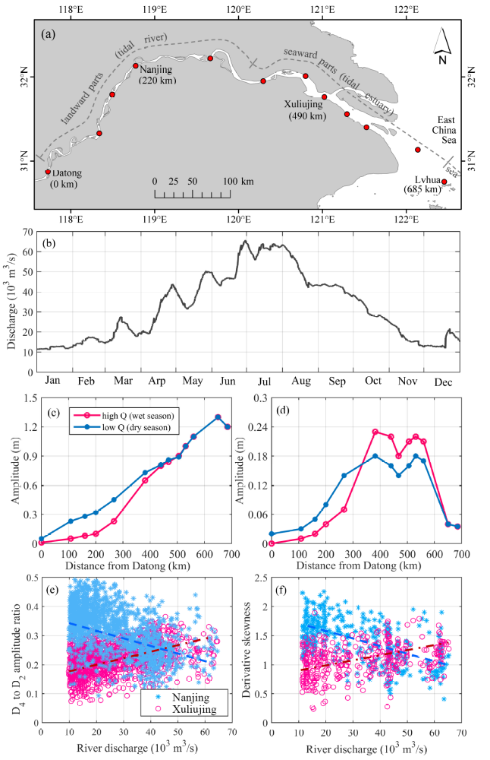

Figure 1. (a) The geometry and tidal gauges in the Changjiang Estuary, (b) river discharge variations within a year course, along-river (c) M₂, and (d) M₄ amplitude variations in the dry and wet seasons, (e) amplitude ratios of the quarter-diurnal to semi-diurnal tides, and (f) skewness of the time derivative of tidal water levels at Nanjing and Xuliujing. Details of the Changjiang Estuary and the tidal data are given in Guo et al. (2015). The numbers in the brackets in panel (a) indicate the seaward distance from Datong. The data in panels (c)-(e) is from Guo et al. (2016) and that in panel (f) is from Guo et al. (2019).

1.3 Rationale and objective
Examination of tidal data has provided a basic framework for our understanding of tidal dynamics in estuaries (Dronkers, 1964; Godin, 1985). One challenge in tidal data analysis lies in that river discharges can vary in a large range in short periods, thus inducing strong non-stationary variations in tidal dynamics. Conventional harmonic analysis, adopting a stationary assumption, may not accurately resolve the non-stationary river tides (Jay and Flinchem, 1997), although there have been attempts to use continuous wavelet transform (Jay et al., 2014; Guo et al., 2015) and a complex demodulation method (Bloomfield, 2013) as complementary approaches.
In addition, analytical solutions of tidal dynamic equations, which drop the advection term or adopt a linear assumption or a simplified expansion of the friction term (Green, 1837; Kreiss, 1957; Jay, 1991; Parker, 1991; Friedrichs and Aubrey, 1994; van Rijn, 2011), have facilitated exanimation of leading-order wave propagation such as landward damping and amplification of astronomical tides (Jay, 1991; Friedrichs and Aubrey, 1994; Lanzoni and Seminara, 1998; Savenije, 2005). More recent improvements to these analytical methods take into account more than one tidal component, use a robust approximation of the nonlinear friction term, and include their impact on morphodynamic changes (Lanzoni and Seminara, 1998; Ridderinkhof et al., 2014; Alebregtse and de Swart, 2016; Chernetsky et al., 2010; Dijkstra et al., 2017).
Numerical simulations of tidal dynamics provide an alternative approach that can fully capture the non-linear dynamics without simplification. They include the detailed changes in estuarine geometry and are widely employed to examine tides in estuaries with more complexity in morphology and dynamics (Lu et al., 2015; Elahi et al., 2020). To cope with the strong nonlinearity in tidal dynamics in long estuaries with highly varying river discharges, in this work, we aim to combine the advantages of these methods by using a numerical model of a schematized estuary. The objectives of this study are to explore (1) how overtides change under different river discharges and nonlinear river-tide interactions, and (2) what is the controlling impact of river flow and nonlinear processes on the spatial variability of overtide.

2. Methodology

2.1 Theoretical analysis of overtide generation
Tidal wave propagation in a 1D model is governed by the width-averaged shallow water equations, i.e., the continuity and momentum conservation equations, when the effect of Coriolis force and density variations are neglected (Dronkers, 1964), as follows,
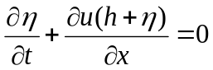 (1)
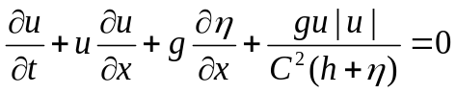 (2)
where u is velocity, η is water height above mean sea level, h is water depth below mean sea level, g is gravitational acceleration (9.8 m²/s), and C is a Cheźy friction coefficient prescribed as 65 m^{1/2}/s uniformly, which leads to predominantly landward tidal damping within the schematized estuary, as that observed in reality (see Figures 1 and 3).
In the presence of a river discharge, the water level height is composed of a mean water height related to river flow η₀, and a tide-induced water level oscillation,
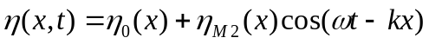 (3)
in case of the presence of M₂ tide only, in which η_{M2} is the surface amplitude of M₂, and ω is the frequency of M₂, and k is tidal wave number. Similarly, the current is composed of a mean current and a tidal component,
(4)
in which u₀ is the mean current velocity while the minus sign indicates the seaward direction, u_{M2} is the velocity amplitude of M₂, θ is the phase difference between tidal surface wave and tidal currents. Overtide components are not included in Eqs. (3) and (4) as a simplification, which will not fundamentally change the following analytical description in identifying their internal generation.
Three nonlinear terms are identified in the tidal wave equations, namely the discharge gradient term in the continuity equation, and the advection and quadratic friction terms in the momentum equation:
- discharge gradient: 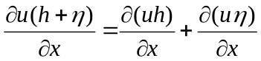 (5)
- advection: 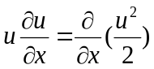 (6)
- bottom friction: 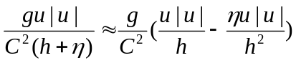 (7)
The bottom friction term is approximately expanded into a bottom shear stress term and a term considering depth variations, as the two terms on the right hand of Eq. (7), respectively, according to Godin and Martinez (1994), given the tidal amplitude to water depth ratio (|η|/h) is generally smaller than one. Note that the bottom friction term can be calculated accurately with resolved water depths and velocities in the numerical model, while the approximation of Eq. (7) is just used to analytically demonstrate how the friction would lead to local generation of compound tides and overtides. Firstly, considering a situation when river discharge is small and the associated mean current (u₀) is insignificant, the quadratic bottom stress can be further expressed by Fourier decomposition according to Le Provost (1991) and Wang et al. (1999):
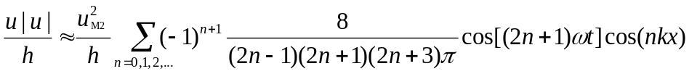 (8)
Eq. (8) suggests that the self-interaction of M₂ tide through the quadratic bottom stress produces a series of overtide harmonics with odd-multiple frequencies, e.g., M₆ and M₁₀ (Parker, 1984). In addition, Eq. (8) also yields a contribution to the same frequency as M₂ (when n=0), which suggests tidal energy dissipation via the quadratic shear stress term (Wang et al., 1999). Similarly, the depth variation term in Eq. 7 can be expressed as:
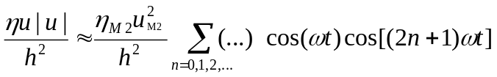
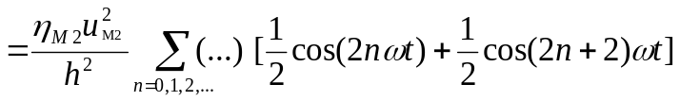 (9)
Eq. (9) suggests that self-interaction of M₂ tide through the depth variation term generates even-multiple frequency harmonics, e.g., M₄ and M₈. Similar decomposition analysis for the advection and discharge gradient term suggests the generation of even-frequency overtide as well (Parker, 1984; Wang et al., 1999). Following similar logic, when two components such as M₂ and S₂ tides are prescribed, compound tides with frequencies the sums (e.g., MS₄) or differences (e.g., MSf) of the prescribed constituents are generated. The focus of this study is devoted to M₄ overtide, given it is the first overtide of M₂ and of profound importance for study of tidal asymmetry.
To further explore the controlling mechanisms of overtide generation, we adopt the approximation of the quadratic bottom stress according to Godin and Martinez (1994) and Godin (1999), as follows,
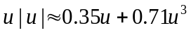 (10)
Replacing the Eqs. (3) and (4) with Eq. (10) and using the sine and cosine summation rules, the harmonic decomposition approach of the nonlinear terms is used to identify their relative importance on the M₄ overtide. Following the methods in Gallo and Vinzon (2005) and Leberthal et al. (2019) but considering both quadratic bed shear and depth variation terms, we can identify the contribution of the three nonlinear terms on M₄ overtide generation, i.e., discharge gradient, advection, and bottom friction, based on the modeled mean water height, mean current, and surface wave amplitudes and velocity amplitudes of M₂ and M₄ tides,
- discharge gradient: (11)
- advection: 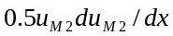 (12)
- friction: 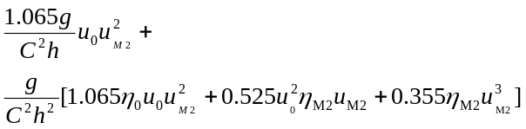 (13)
The first term in Eq. (13) is ascribed to the quadratic bottom shear while the other terms are attributed to the depth variations. The advection and friction terms are normalized by squared maximum velocity and the discharge gradient term is normalized by the product of maximum velocity and maximum water level range. The Eqs. (11) to (13) indicate that the interaction between the mean current and M₂ velocity would generate even-frequency harmonics like M₄ via both the quadratic bed shear stress and depth variation terms, which suggests river-enhanced M₄ overtide generation.
Given strong spatial variations in M₄ amplitude, we further integrate the total potential M₄ energy along the estuary (van Rijn, 2011), as follows:
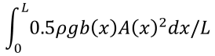 (14)
where: L is the channel length, ρ is the water density, b is channel width, and A is the amplitude of M₄ tide which varies along the estuary. The integrated energy hence indicates the overall strength of overtide throughout the estuary under different river discharges.

2.2 Numerical model setup
In this study, we seek to capture the nonlinear tidal dynamics by using a numerical model, i.e., the open-source Delft3D codes, which have been widely validated and used in varying estuarine and coastal environments (Lesser et al., 2004). We construct a schematized 1D estuary model, which is 650 km long and is composed of a weakly convergent upstream segment (km-0 to km-400, width varying from 2 to 5 km) and a strongly convergent downstream segment (km-400 to km-650, width varying from 5 to 32 km (Figure 2a). This convergent planform mimics the Changjiang Estuary, although excluding the regional width changes, and the geometry is used as a reference case.

Table 1. Model setting and sensitivity simulations. A indicates the tidal amplitude and L_{b} is the convergence length. Q indicates river discharge, and R2T is the river discharge to tidal discharge ratio at the mouth section under a M₂ tide with 1.0 m amplitude. L_{b} is the width convergence length in the depiction of width variations B=B₀exp(-x/L_{b}).
Geometry | Boundary conditions |  |  | Name
Geometry | Tidal forcing | Q (m³/s) | R2T | Name
width variations mimicking the Changjiang Estuary | M₂ tide (A=1.0 m) | 0 | 0 | cQ0
width variations mimicking the Changjiang Estuary | M₂ tide (A=1.0 m) | 10,000 | 0.2 | cQ1
width variations mimicking the Changjiang Estuary | M₂ tide (A=1.0 m) | 30,000 | 0.75 | cQ3
width variations mimicking the Changjiang Estuary | M₂ tide (A=1.0 m) | 60,000 | 2.1 | cQ6
prismatic channel | M₂ tide (A=1.0 m) | 0 | 0 | pQ0
prismatic channel | M₂ tide (A=1.0 m) | 10,000 | 0.5 | pQ1
prismatic channel | M₂ tide (A=0.5, 2.0 m) | 10,000 | 0.5 | pQ1
prismatic channel | M₂ tide (A=0.5, 2.0 m) | 30,000 | 2.6 | pQ3
prismatic channel | M₂ tide (A=1.0 m) + S₂ tide (A=0.5 m) | 30,000 | 2.6 | pQ3
prismatic channel | M₂ tide (A=1.0 m) + S₂ tide (A=0.5 m) | 60,000 | 42 | pQ6
smaller convergence rate, L_{b}=600 km | M₂ tide (A=1.0 m) | 0-60,000* | 0-2.5 | SCs
medium convergence rate, L_{b}=300 km | M₂ tide (A=1.0 m) | 0-60,000* | 0-1.63 | MCs
large convergence rate, L_{b}=150 km | M₂ tide (A=1.0 m) | 0-60,000* | 0-1.54 | LCs
* indicates that river discharge are prescribed by values in the range of 0-60000 m³/s with an increment of 5000 m³/s.

Channel convergence is expected to affect tidal wave propagation and wave deformation (Jay, 1991; van Rijn, 2011; Talke and Jay, 2020). To further explore the impact of basin geometry, we setup a prismatic channel model with similar settings as the convergent estuary (i.e., 2 km width and similar length; Figure 2b). Moreover, we configure similar estuaries with varying convergence rates, i.e., with a convergence length of 600 km, 300 km, and 150 km (Figure S1 and Table 1). The width convergence rate, defined as the ratio of the convergence length to the physical estuary length, varies in the range of 0.23-0.92, which is representative of the convergence rate of the estuaries in the real world (Lanzoni and D'Alpaos, 2015).
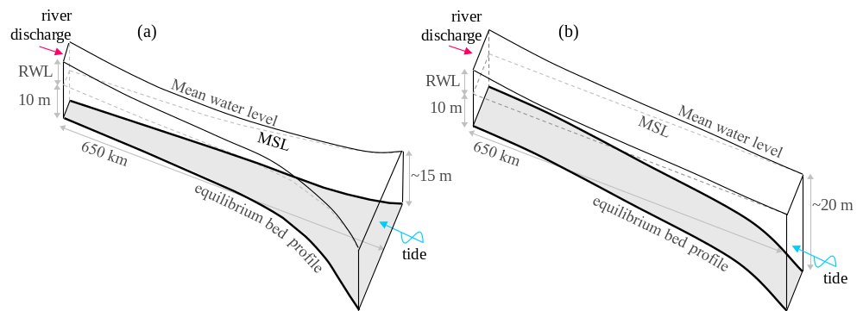

Figure 2. Sketches of the schematized estuary model outline and settings considering (a) a convergent and (b) a prismatic planform. The shade face indicates the equilibrium bed profile. The RWL and MSL indicate residual water level and mean sea level, respectively.

The model is forced by river discharge and tides. For simplicity we mainly consider a semi-diurnal M₂ constituent with an amplitude of 1.0 m at first, and then run extra sensitivity simulations considering different M₂ amplitudes (2.0 m and 0.5 m) and the situation with both M₂ (an amplitude 1.0 m) and S₂ (0.5 m) to facilitate more tidal interactions and generation of compound tide like MS₄ (Table 1). Other astronomical constituents like O₁ and K₁ are excluded because they would not affect the M₂ propagation very much.
River discharge is prescribed by constant values of 0, 10,000, 30,000, 60,000 m³/s, symbolized as Q0, Q1, Q3, and Q6 scenarios, respectively, to facilitate harmonic analysis with a stationary assumption. A dimensionless parameter, defined as the ratio of river discharge to tide-averaged mean discharge (i.e., tidal prism divided by tidal period) at the mouth section (R2T ratio), is estimated to be 0, 0.5, 2.6, and 42, respectively, in the prismatic channel forced by a M₂ tide 1.0 m in amplitude. The four situations thus can be classified into tide-dominant, low, medium, and very high river discharge circumstances, respectively (see section 3.4). As the river discharge is prescribed constant, harmonic analyses is applicable to the modeled time series of water levels and currents (Pawlowicz et al., 2002), which outputs mean water height, mean current, and the amplitudes and phases of surface wave and velocity of M₂ and M₄ constituents for further analysis.
To obtain a suitable bottom profile for the tidal model, we first run a morphodynamic simulation based on the above-mentioned model outline, with an M₂ tide and a river discharge seasonally varying between 10,000 and 60,000 m³/s as the boundary forcing conditions, as presented in Guo et al. (2016). The long-term morphodynamic simulation starts from an initial sloping bed with depth varying from 5 m to 15 m seaward, considers sediment transport and bed level changes, which leads to a dynamic morphological equilibrium when bed level change rates have significantly slowed down at the centennial time scales (Guo et al., 2016). The eventual equilibrium bed profile is then used as the bottom level condition in the tidal simulations. Similar morphodynamic simulations are conducted to obtain close-to-equilibrium bed profiles used in the sensitivity scenarios. An equilibrium bed profile is used in the tidal simulations to maintain consistency between the boundary forcing conditions (river discharge and tides) and the morphology (width and depth). Based on this equilibrium bed profile and given high river discharge imposed, the incoming tides are largely dissipated in the landward parts of the estuary, thus the influence of wave reflection is minimized.
Past studies using similar 1D representation of tidal estuaries confirm the capture of leading-order dynamic processes (Friedrichs and Aubrey, 1994; Lanzoni and Seminara, 1998). Nevertheless, it is noteworthy that the 1D model excludes tidal flats and assumes uniform water density. These excluded processes may lead to additional momentum loss, reduction in bottom drag, and then influence tidal asymmetry (Friedrichs and Aubrey, 1988; Talke and Jay, 2020). Although simplified, the model provides a virtual lab where tidal wave propagation, deformation and associated overtide dynamics under varying river discharges can be straightforwardly isolated from the influences of basin geometry and irregular shoreline, which enables exploration of river-tide interactions and overtides.

3. Model results

3.1 Tidal variations under varying river discharges
The streamwise variations of tidal amplitudes for both astronomical constituent and overtide in the reference case are shown in Figure 3. The M₂ tide is slightly amplified in the seaward regions close to the mouth, owing to channel convergence (Figure 3a). Landward of that, the M₂ tide is predominantly dissipated, and river discharge enhances the damping in the landward direction.
In addition, a considerable M₄ tide is detected in the cQ0 scenario (no river discharge) with a local amplitude maximum around km-450 (Figure 3b). The M₄ amplitude becomes larger throughout the estuary in the cQ1 scenario compared with that in cQ0 (Figure 3b). However, under further higher river discharges, the M₄ amplitude reduces in the landward parts of the estuary, e.g., landward km-300, but continues to increase in the seaward parts, e.g., seaward km-500 (Figure 3b). The location with maximal M₄ amplitude moves slightly landward as the river discharge increases from zero (i.e., from km-450 in the cQ0 scenario to km-400 in the cQ1 scenario), but seaward as the river discharge further increases (i.e., from km-420 in the cQ3 scenario to km-500 in the cQ6 scenario).
The M₄ to M₂ amplitude ratio exhibits similar variations as the M₄ amplitude, but the ratio is overall larger in the landward parts of the estuary where the amplitudes of both M₂ and M₄ tides are small (Figure 3d). The increasingly damped and distorted tidal waves further illustrate the river impact on the incoming tides (see Figure S2 in the SI).
A compound constituent MS₄ is generated and detected inside the estuary when both M₂ and S₂ tides are imposed at the seaward boundary of the model. The MS₄ tide exhibits similar spatial variations as M₄ tide in response to increased river discharges (Figure 3c). Similar results can be obtained for other overtides (e.g., M₆, MN₄ and S₄) if more astronomical constituents are prescribed and associated tidal interactions activated. We therefore focus on the M₄ overtide for the presentation of other results.
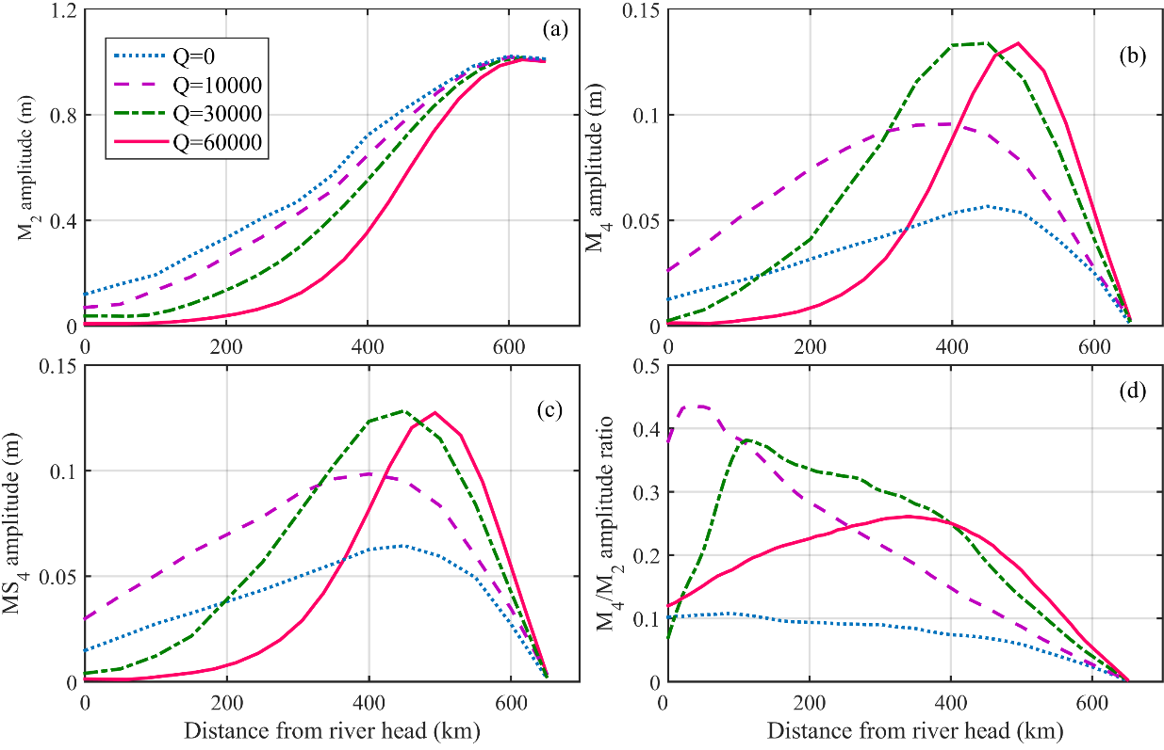

Figure 3. The model-reproduced longitudinal variations of (a) M₂ amplitude, (b) M₄ amplitude, (c) MS₄ amplitude (in the scenario when both M₂ and S₂ are imposed at the boundary), and (d) the M₄ to M₂ amplitude ratios in the reference convergent estuary.

3.2 Sensitivity to channel convergence
In the prismatic estuary, river discharge substantially elevates the mean water levels (Figure 4a). The incoming M₂ tide is persistently damped inside the estuary, without any amplification (Figure 4b). Larger river discharges elevate the mean water level more and increase the streamwise water level gradients, leading to more dissipation of the astronomical tides.
Significant M₄ overtide is detected inside the estuary, although its amplitude is overall smaller compared with that in the reference convergent estuary (Figure 4c). Apart from the differences in amplitudes, the longitudinal variations of both the astronomical constituent and the overtide and their spatial dependence on river discharge exhibit identical patterns as the reference convergent estuary (Figures 3 and 4). These consistent results imply that channel convergence does not fundamentally change the spatial dependence of overtide behavior on river discharge; hence, model results on the prismatic channel are examined in depth in this work for simplicity.
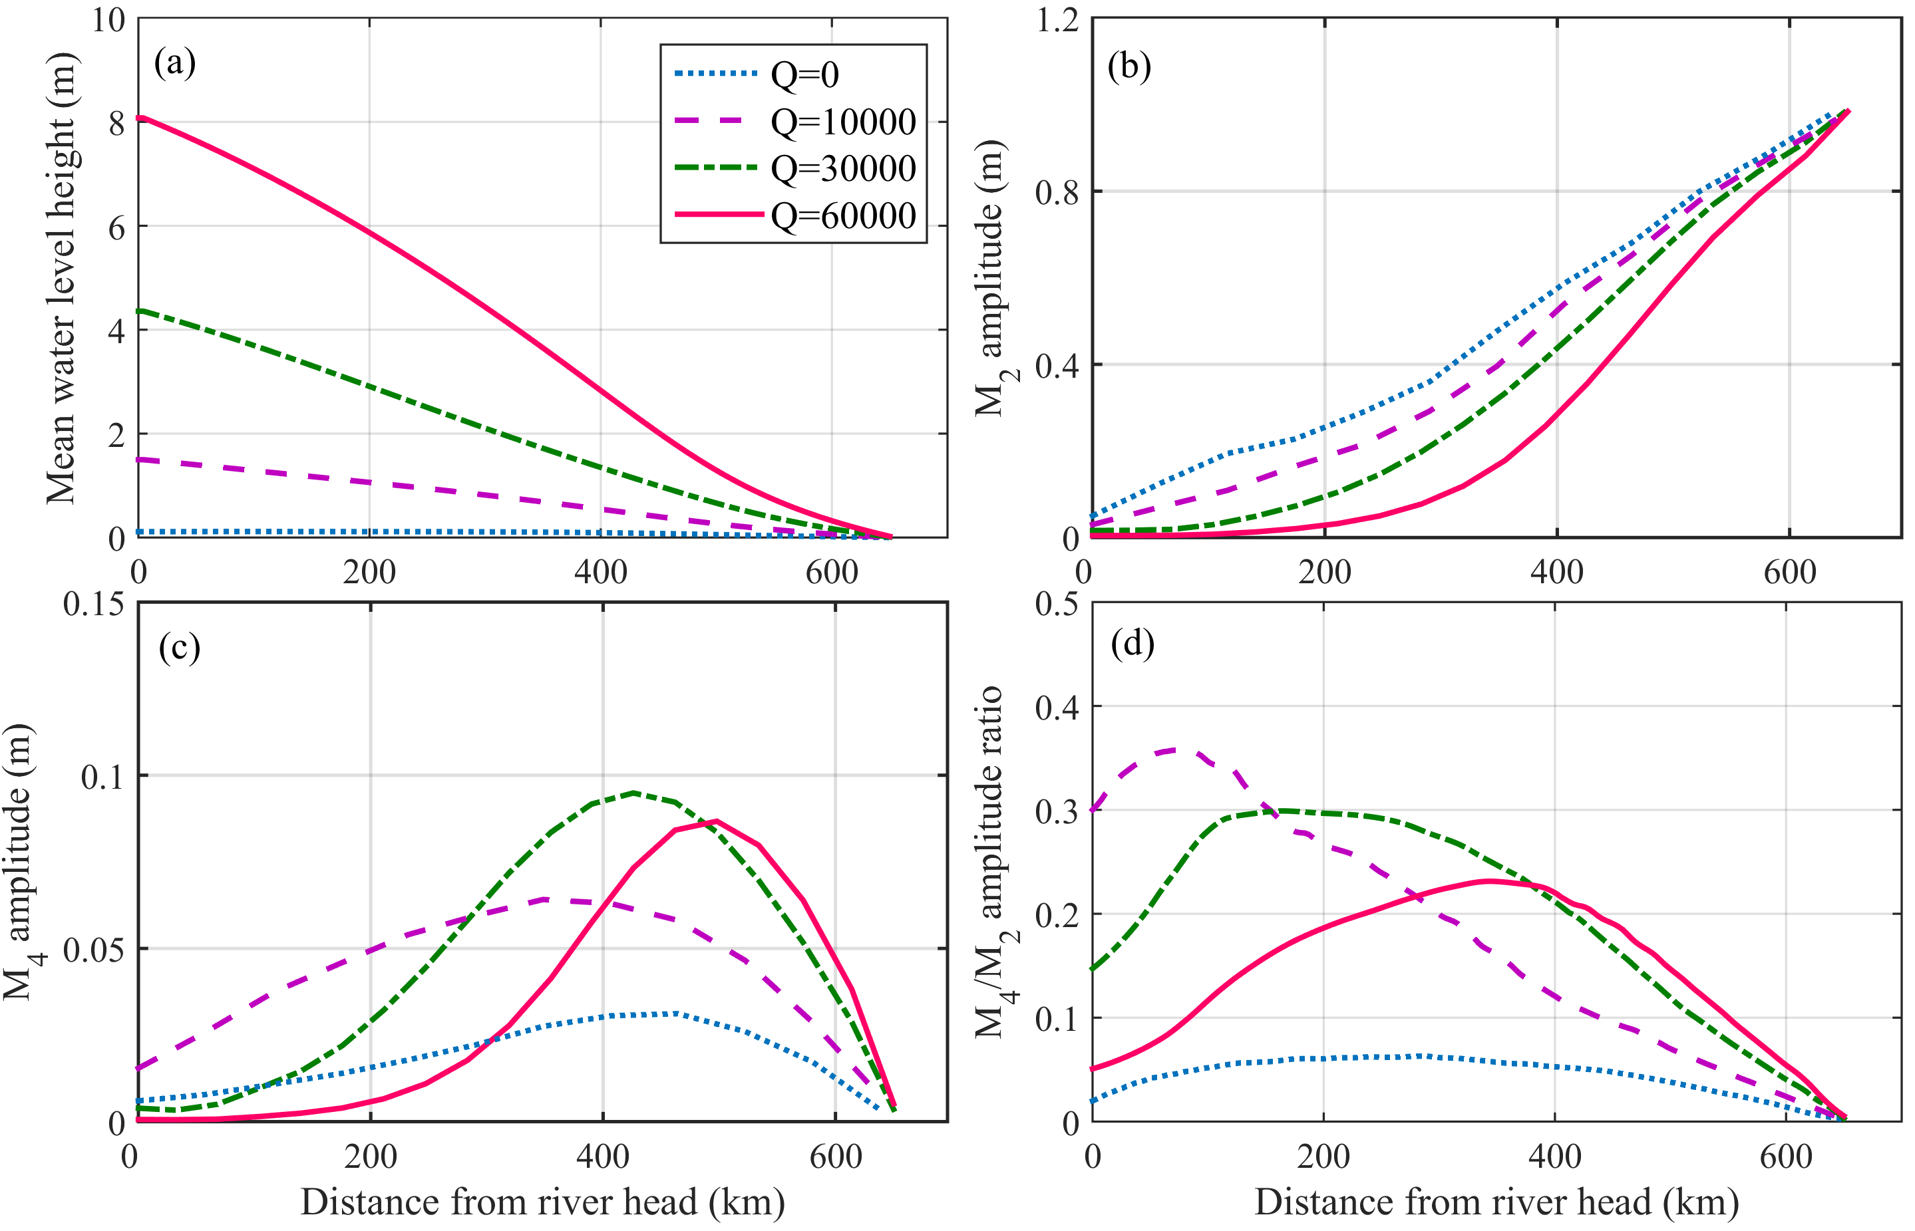

Figure 4. Model-reproduced longitudinal variations of (a) mean water level height, (b) M₂ tidal amplitude, (d) M₄ tidal amplitude, and (d) the M₄ to M₂ amplitude ratio under different river discharge in the prismatic estuary.

3.3 Contribution of the nonlinear processes
We quantify the individual contribution of different nonlinear terms on M₄ and their variations along the estuary based on the method proposed in section 2.1 and model-produced mean water level height, mean current, and tidal amplitudes. In the absence of river discharge (scenario pQ0), the discharge gradient term is the largest contribution to M₄ overtide generation owing to strong landward damping of M₂ and subsequent longitudinal flux gradients, followed by bottom friction and advection (Figure 5a). Bottom friction is shown to be more significant than the other terms, when there is a river discharge (Figures 5b-d). The impact of quadratic bottom stress is much more important than that of depth variations. The advection term is of minor importance compared with the other two nonlinear terms.
Spatially, the impact of bottom friction is more profound in the landward regions, whereas the impact of discharge gradient and advection terms is more apparent in the seaward regions close the estuary mouth. The location of maximum M₄ amplitude is close to the peak under the combined contribution of discharge gradient and advection in the pQ0 scenario and to the peak in bottom friction in the other three scenarios. Overall, these results suggest that the bottom friction, or more precisely the quadratic bottom stress, is the dominant forcing in generating M₄ overtide in the circumstances with significant river discharge. Note that the contribution of the bottom friction term is non-negligible in the pQ0 scenario (no river discharge). This is because there is a seaward mean current, i.e., Stokes return flow, which plays a similar a role on the tides as does a river discharge induced mean current; although the magnitude of the Stokes return flow is comparatively small.
The significance of the quadratic bottom stress can be further inferred when comparing model results under quadratic and linear bottom stress. The quadratic bottom stress can be linearized using the first order of the method based on the energy dissipation condition of Lorentz (1926), as that in Zimmerman (1992) and Hibma et al. (2003) (see section II in SI). When similar simulations are run using linear bottom stress, damping of the principal M₂ tide is smaller (see Figure S5). Measurable M₄ tide is still detected inside the estuary under a linear bottom stress, which is ascribed to the effects of the nonlinear advection and depth variation terms, but its amplitude is smaller compared to those under a quadratic bottom stress (Figure S5). Moreover, increasing river discharge neither induces more damping of principal M₂ tide, nor more overtide generation under a linear bottom stress. These results and comparison confirm the role of quadratic bottom stress on overtide generation, particularly when river discharge is large.
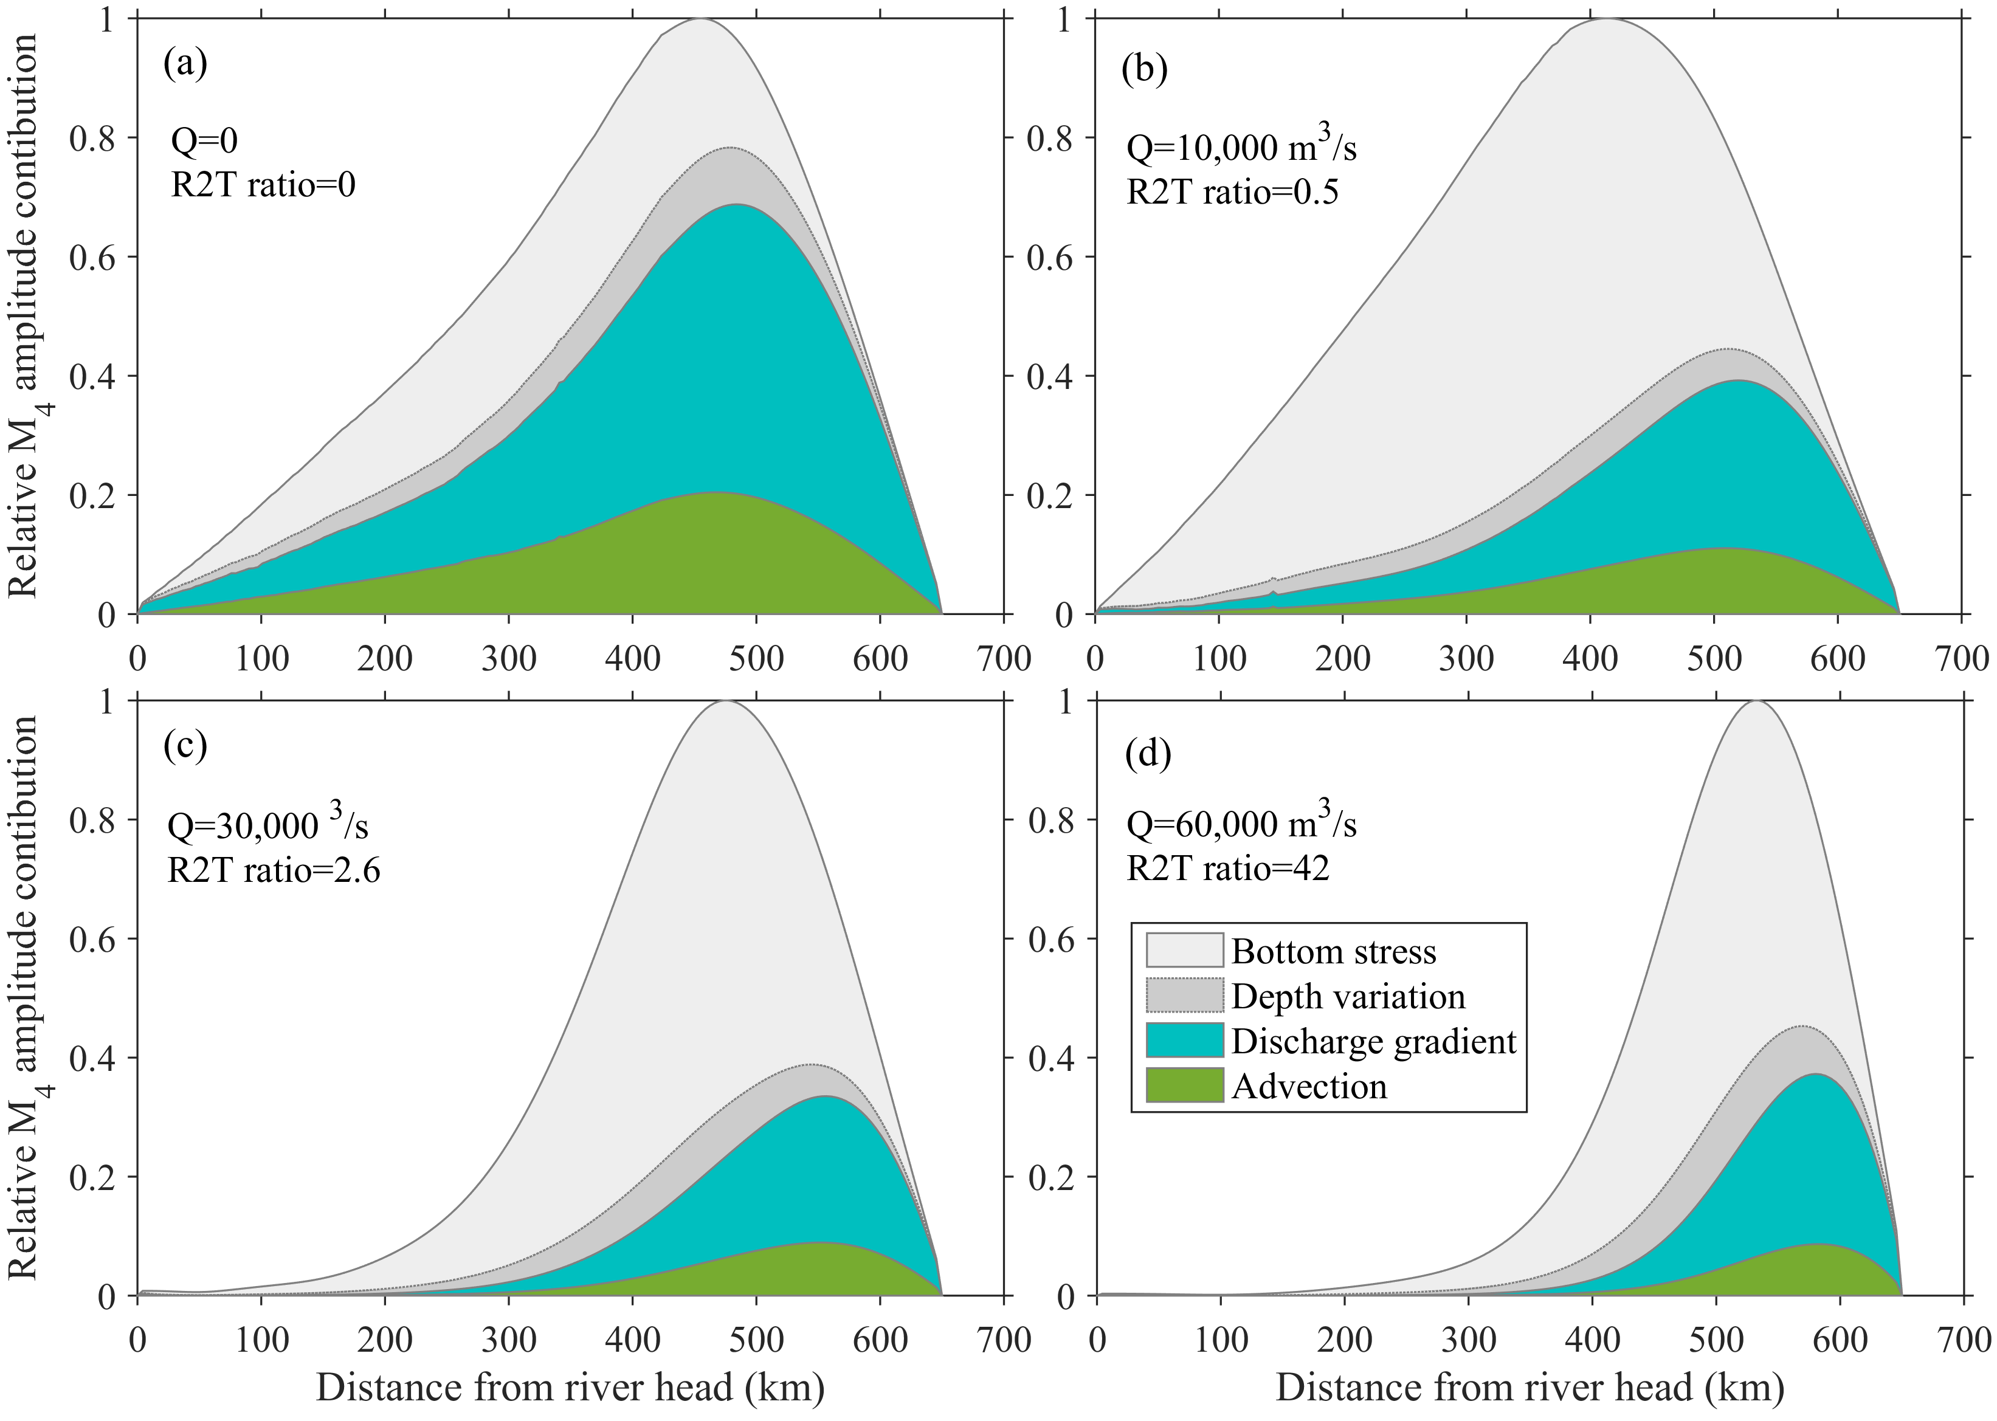

Figure 5. Quantification of the relative importance of three nonlinear terms (the patch area) on M₄ overtide amplitude in the (a) pQ0, (b) pQ1, (c) pQ3, and (d) pQ6 scenarios in the prismatic channel. The contribution of bottom friction is divided into the components of bottom stress and depth variation. The relative M₄ amplitude is normalized by the maximal value in each scenario.

3.4 Quantification of the river discharge threshold
The model results imply that the M₄ amplitude first increases and then decreases as the astronomical M₂ tide is increasingly dissipated by larger river discharges. It implies the presence of an intermediate condition under which the M₄ tide may reach maximum. To better capture and reveal the intermediate threshold, we run extra simulations considering constant river discharges in the range of 0 to 60,000 m³/s at an increment of 5,000 m³/s. We then integrate the total (tide-averaged) energy of the M₂ and M₄ tides (kg·m²/s²) throughout the estuary, according to Eq. 14, to represent accumulated tidal strength. We see that the total energy of the M₂ tide decreases approximately exponentially with increasing R2T ratios (Figure 6a). The decrease is more significant for R2T<5 (see Figure S3a). When taking the pQ0 scenario as the reference, the ratios of the total energy of M₄ in the scenarios with river discharge to that in the pQ0 scenario, however, first increase with increasing R2T ratio from zero and reach a peak when the R2T ratio is close to unity, followed by a decrease as the R2T ratio further increases (Figure 6a). The maximal total energy of M₄ is 3.7 times larger than the case with no river discharge in the prismatic estuary (when M₂ is 1.0 m). Similarly, the energy ratios of M₄ to M₂ tides display similar variations as the total energy variation of the M₄ tide, with a peak reached when the R2T ratio is around 1-2 (Figure 6b).
The results of the sensitivity scenarios under varying degrees of width convergence show similar variations of the total energy ratio of M₄ to M₂ tides with increasing R2T ratios, i.e., increase first, maximum reached, and followed by a decrease (Figure 6). River-enhanced generation of M₄ increases at a smaller rate under larger M₂ tide, when compared with the pQ0 scenario (Figure 6a), because tidal dissipation rates are larger under larger tides, thus smaller overtide generation in the scenarios which include river discharge. However, the energy ratios of M₄ to M₂ increase with tidal amplitude (Figure 6b), suggesting an increasing percentage of M₂ energy is transferred to the overtide. This is because stronger tides benefit river-tide interactions and the consequent generation of overtides. Other than these differences, the change behaviors of the energy ratios with increasing R2T are consistent. Overall, these results consistently imply that a river discharge smaller than an intermediate threshold favors more M₄ tide generation, whereas a larger river discharge above the threshold constrains M₄ tide.
The model results consistently suggest that an intermediate river discharge with a R2T ratio around unity benefits maximal M₄ overtide generation (Figure 6). While a prismatic estuary is characterized by R2T=1 as an optimum threshold for maximal M₄ generation, convergent estuaries show some variations around unity, i.e., R2T>1 in mildly convergent systems and R2T<1 in strongly convergent systems. The R2T threshold, however, varies in a narrow range in all scenarios in this study, i.e., 0.7-1.2. It confirms the presence of an intermediate threshold in nonlinear overtide changes in response to increasing river discharges.
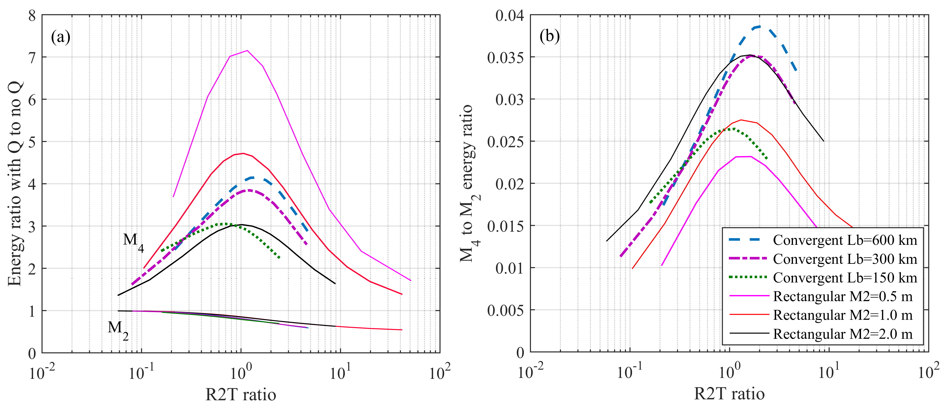

Figure 6. (a) The ratio of the integrated total energy (TE) in the scenarios with river discharge to the case without river discharge (Q0 scenarios) for both M₂ (thin lines) and M₄ (thick lines) tides, and (b) the ratio of total M₄ tide energy to M₂ tide, as a function of the ratio of river discharge to tide-mean discharge at the estuary mouth (R2T ratio). Also see Figure S3 in the SI.

4. Discussion

4.1 Comparison with actual estuaries
The modeled overtide variability is consistent with findings in real-world estuaries. The modeled results between the cQ1 and cQ3 scenarios agree with the streamwise variations in the astronomical tides and overtides under low and high river discharges in the Changjiang Estuary. The modeled variation trend of the M₄ to M₂ amplitude ratios in response to increasing river discharge also agrees well with that in the Changjiang Estuary (see Figure S4). In the Amazon Estuary where the river discharge is similarly high and varies over a large range, the M₄ amplitude was larger under a mean river discharge compared to an idealized situation with zero discharge (Figure 7c; Gallo and Vinzon, 2005). This is again consistent with the modeled differences between the cQ0 and cQ1 scenarios in this study. In the Columbia Estuary, a maximum in M₄ amplitude is approached in the seaward parts of the estuary, followed by a subsequent decrease upriver under a yearly-mean river discharge (Figure 7d; Jay et al., 2014). The model results also explain why a higher river discharge hastens the high water and delays the low water in the seaward parts of the Saint Lawrence Estuary (Godin, 1985, 1999). In the Ganges-Brahmaputra-Meghna Delta, model results suggested enhanced quarter-diurnal tides in the seaward regions of the delta and a transition from increase to decrease in the landward regions with increasing river discharge (Elahi et al., 2020). These field data and model results confirm that the findings regarding the spatial dependence of overtide on river discharge are ubiquitous for estuaries with large river discharges.
The above-mentioned nonlinear overtide changes were predominantly reported in large estuaries and deltas where both river and tidal influences are profound, e.g., the Amazon (Gallo and Vinzon, 2005), Changjiang (Guo et al., 2015), and Ganges (Elahi et al., 2020). However, similar phenomenon have not been documented in other tide-dominated estuaries with relatively smaller river discharge, although the importance of overtide in controlling tidal asymmetry and residual transport has been widely reported, e.g., in the Humber Estuary in the UK (Winterwerp, 2004) and the Scheldt Estuary in the Netherlands (Wang et al., 2002). This is because river discharge in tide-dominated estuaries is overall small and rarely reaches a magnitude that exceeds R2T=1. For instance, the R2T is <0.01 in the Scheldt Estuary (van Rijn, 2011; Wang et al., 2019), and it is ~0.012 in the Humber Estuary (Winterwerp, 2004; Townend et al., 2007). Therefore, the role of river discharge in stimulating tidal wave deformation and overtide generation (when R2T<1) has been widely reported in these tide-dominated estuaries, whereas the situation with R2T>1 is far less prevalent and hence less documented.
Moreover, most tide-dominated estuaries are relatively shorter in physical length compared with tidal wavelength, hence the space-dependent overtide variations are less apparent compared with that in large estuaries. Large estuaries with high river discharge are comparatively much longer, in terms of the inland extent of tidal propagation, despite the enhanced tidal damping due to the river discharge. For instance, tidal waves propagate inland ~1,100 km in the Amazon Estuary and ~650 km in the Changjiang Estuary. This long distance tidal wave propagation is possible because of the smaller bed level gradients in the low-lying delta plains formed under high river discharge and sediment supply. The large estuaries thus provide space for slower tidal wave damping and facilitate wave deformation to accommodate the large variations of river discharges and friction at different time scales (Zhang et al., 2015).
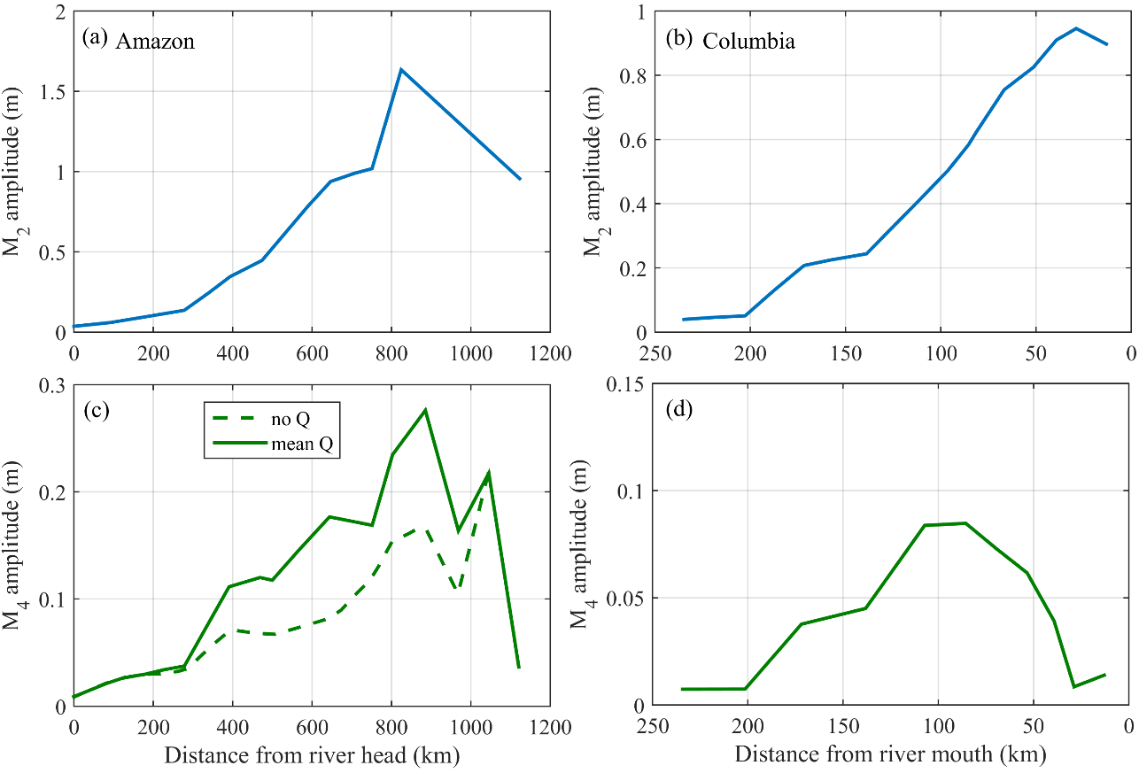

Figure 7. Amplitude variations of M₂ and M₄ overtide in the (a, c) Amazon Estuary and (b, d) Columbia Estuary, from Gallo and Vinzon (2005) and Jay et al. (2014), respectively.

4.2 Role of river discharge
River discharge has two-fold effects on tidal propagation and deformation (Figure 8). River discharge enlarges the mean currents and the effective friction on the moving flow. On the one hand, this induces more damping of the incoming astronomical tides, i.e., more energy dissipation. On the other hand, the river-enhanced bottom friction reinforces the energy transfer from astronomical tides to overtides, i.e., stimulating overtide generation. As more astronomical tidal energy is dissipated by larger river discharges, which is more profound in the landward parts of estuaries, the energy available for transferring to overtides is also constrained. In addition, the overtides generated in the seaward parts of estuaries propagate landward and are damped by higher discharge in the landward regions. As a result, an intermediate river discharge (when the R2T ratio is close to unity) provides an effective bottom stress that will not dissipate the astronomical tides too much, and at the same time stimulates considerable energy transfer to overtides. The intermediate threshold balance leads to the occurrence of a maximum in overtide energy when integrated over the length of the estuary.
River impact on tidal wave propagation and deformation is spatially variable. River discharge substantially elevates the mean water level in the landward parts of estuaries. The consequent larger water level gradient restricts landward wave propagation (Godin, 1985; Cai et al., 2019). In the seaward parts of an estuary where the incident tidal waves are less dissipated, the role of river discharge in reinforcing the effective bottom friction and enhancing overtide generation is more pronounced. In contrast, in the landward parts of an estuary, the role of river discharge in dissipation of astronomical tide is more prominent. These spatially variable dynamics explain the contrasting overtide changes in response to increasing river discharge between the landward and seaward parts (Figure 8). It confirms that tidal wave deformation maybe one of the degrees-of-freedom of estuaries to maintain a state of minimum work by adjusting tidal wave shapes in response to different river discharges (Zhang et al., 2015).
The two-fold river effects on tidal propagation and deformation are coherently related to the nonlinear bottom friction. Past studies have indicated that the effects of river discharge on tidal damping are exerted by a mechanism identical to bottom stress (Horrevoets et al., 2004; Cai et al., 2014). River-tide interaction enhances ebb current velocities and the bottom stress on the flow, which subsequently induces larger tidal damping (Alebregtse and de Swart, 2016). Past studies have also suggested that the nonlinear advection term is the main cause of M₄ generation in tide-dominant estuaries, whilst the nonlinear bottom stress term leads to generation of M₆ (Pingree and Maddock, 1978; Parker, 1984, 1991; Wang et al., 1999; Elahi et al., 2020). Additionally, the quadratic bottom stress term leads to significant M₄, through river-tide interaction, i.e., between a river-enhanced mean current and M₂ current (Wang et al., 1999). This explains why the M₄ amplitude is larger in the presence of a river discharge and a quadratic bottom stress, compared with the situation with no river discharge and/or a linear bottom stress.
Although the model results are obtained under different but constant river discharges, the findings in this work still hold true when considering time-varying river discharges (see Figures S6-S8 in the SI). One slight difference is that the damping rate of the astronomical tides would be slightly different during the rising and falling limb of a river discharge hydrograph (Sassi and Hoitink, 2013), which may be due to a time lag in the influence of river discharge along the length of an estuary.
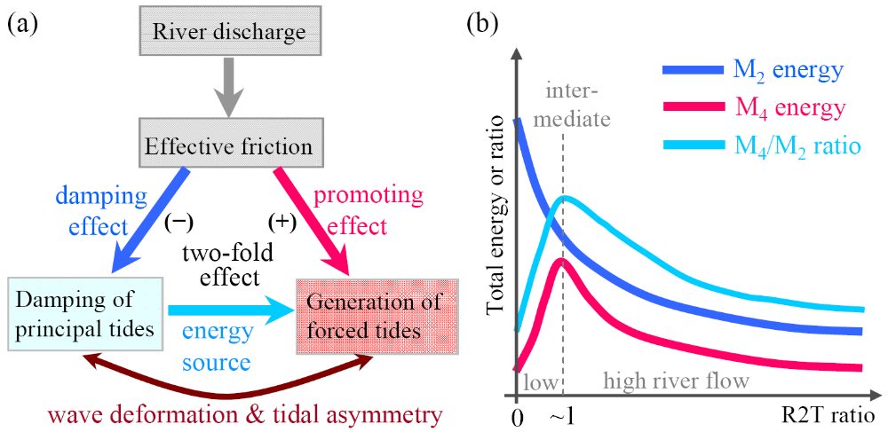

Figure 8. Sketches showing (a) the two-fold effects of river discharge on tidal propagation and deformation through the bottom friction, and (b) the intermediate river discharge threshold that maximizes overtide generation.

4.3 Implications and limitations
Better understanding of the overtide changes has broad implications for study of tidal bores, interpretation of extreme high-water levels and associated flood risk, tidal asymmetry and tide-averaged sediment transport. Tidal wave deformation changes the height of high-water and low-water, which then influence flooding risk management, particularly the compound flood risk induced by high river discharge and high tide within estuaries and deltas (Moftakhari et al., 2017). The water level height also affects the water depth for navigational channels. In the extreme situation, tidal wave deformation leads to tidal bores when tides are concurrently amplified and distorted to an extreme degree (Bonneton et al., 2015). Other than the amplification by channel convergence, river discharge is expected to play a role in enhancing wave deformation and tidal bore formations given its dual impacts on tides.
The longitudinally distinct overtide behaviors have implications for spatial division of estuaries (Figure 9). Traditionally two regions can be identified in the river-to-ocean transition zones, i.e., an inland part dominated by river forcing, with some damped tidal wave influence, unidirectional currents, no salinity, and a seaward part predominantly controlled by tidal forcing, bidirectional currents, and of profound salinity due to saltwater intrusion influence (Jay and Flinchem, 1997; Guo et al., 2015, 2020; Figure 9). Moreover, a larger estuary may be divided into a landward tidal river segment and a seaward tidal estuary segment, based on the relative strength of subtidal signals (Hoitink and Jay, 2016) and streamwise hydro-morphological variability (Gugliotta and Saito, 2019). Inland tidal river is characterized with lower low water at neap tide than spring tide, sinuous channels with a uniform width, and a seaward increasing water depth, whereas tidal estuary is likely more convergent with a decrease in water depth in the seaward direction and affected by saltwater intrusion (Guo et al., 2015; Hoitink and Jay, 2016; Gugliotta and Saito, 2019). In this work focusing on overtide, the seaward part of an estuary is identified as the region with a landward increase in overtide amplitude, while the landward part is featured by a landward decrease in overtide amplitude (Figure 9). The location of the division is at the point of maximal overtide amplitude, and its position moves with river discharge. Note that this division tends to be more seaward compared with the transition between tidal river and tidal estuary.

Figure 9. A conceptual sketch of the river-to-ocean transitional zone with distinctive tidal and hydro-morphological features between a landward tidal river and a seaward tidal estuary segments.

Knowledge of the nonlinear overtide changes informs study of the overtide components of tidal currents and associated sediment transport processes. The interactions between mean currents and the quarter-diurnal overtide currents contribute to net water transport (Alebregtse and de Swart, 2016). The current interactions between M₂ and M₄ tides play a profound role in controlling tidally-averaged sediment transport, e.g., sediment import or export and resultant infilling or empty of estuaries, particularly when river discharge is small (Postma, 1961; Guo et al., 2014). Largest seaward sediment flushing and development of deepest estuarine equilibrium bed profile occurs when the river-controlled mean current velocity is equal to tide-induced current velocity (Guo et al., 2014). It is because river-tide interactions enhance seaward residual sediment transport, while a much larger river discharge would dampen the effect of river-tide interaction and tidal asymmetry.
Although channel convergence is not modeled to fundamentally change the overtide variations in response to varying river discharges, the potential impact of the simplified model setting in this study still mandates careful evaluation. For instance, regional narrowing and shallowness in geometry and morphology will induce variations in tidal damping rates and distribution of amplitudes. The bed profile condition used in the model affects tidal propagation and hence the location of maximal M₄ amplitude. River estuaries can be partially or highly stratified, and a density difference and associated stratification affect tides by reducing the effective drag coefficient and changing the pressure-gradient term (Talke and Jay, 2020). This impact maybe further manifested in surface amplitude of overtide given the role of river-tide current interactions in the nonlinear terms (Dijkstra et al. 2017). Intertidal flats are known as a sink of momentum and would exert additional impact on tidal wave propagation (Hepkema et al., 2018). Exclusion of intertidal flats in this work thus may lead to overestimation of the overtide amplitude. Furthermore, the intermediate river discharge threshold is expected to vary with estuarine size and shape, given that tidal mean discharge is strongly affected by estuarine morphology. Barrier dams within tidal wave propagation limit, e.g., the Bonneville Dam in the lower Columbia River (Jay et al., 2014), may induce wave reflection that affects tidal wave dynamics, in contrasts to the unconstrained estuaries. These dynamic complexities merit site-specific examination.

5. Conclusions
This work is devoted to examining overtide behavior under varying river discharges in long and friction-dominated estuaries. Inspired by preliminary findings in the Changjiang Estuary, we use a numerical model for a schematized estuary to capture the nonlinear tidal dynamics under varying river discharges. Model results reveal significant overtide M₄ generated inside the estuary and its amplitude exhibits strong spatial dependence and nonlinear changes. While the astronomical M₂ tide is increasingly dissipated as the R2T ratio increases from zero, the M₄ amplitude decreases in the landward parts of the estuary but increases in the seaward parts. With increasing R2T ratio, the total energy of M₄ overtide integrated throughout the estuary first increases and reaches a peak when the R2T ratio is close to unity, followed by a decrease when river discharge further increases. The modeled nonlinear overtide changes are quantitatively validated by data in the Changjiang and Amazon Estuaries etc.
Sensitivity simulations confirm the dominant role of river-enhanced bottom friction in controlling the overtide behavior. The enhanced bottom friction has two-fold effects on tidal wave propagation and deformation, namely dissipation of astronomical tidal energy and stimulation of energy transfer to overtides. As a result, an intermediate river discharge threshold benefits maximal overtide generation. This study demonstrates the need to look at both tidal wave propagation and deformation at the same time in examination of tidal wave dynamics, as well as their nonlinear spatial variations in large river estuaries. The findings have implications for studies of tidal bores and tidal asymmetry and associated morphological changes in large estuaries.

Acknowledgements
This work is supported by National Natural Science Foundation of China (Nos. U2040216; 41876091), and partially sponsored by the project 'Coping with deltas in transition' within the Programme of Strategic Scientific Alliance between China and The Netherlands (PSA), financed by the Ministry of Science and Technology, P.R. China (MOST) (No. 2016YFE0133700) and Royal Netherlands Academy of Arts and Sciences (KNAW) (No. PSA-SA-E-02).

References
Alebregtse N.C., de Swart H.E., 2016. Effect of river discharge and geometry on tides and net water transport in an estuarine network, an idealized model applied to the Yangtze Estuary. Continental Shelf Research 123, 29-49.
Bonneton P., Bonneton N., Parisot J.-P., Castelle B., 2015. Tidal bore dynamics in funnel-shaped estuaries. Journal of Geophysical Research: Oceans 120, 923-941.
Bloomfield P., 2013. Fourier analysis of time series: An introduction (2nd), Wiley Series in Probability and Statistics, John Wiley & Sons, New York.
Buschman F.A., Hoitink A.J.F., van der Vegt M., Hoekstra P., 2009. Subtidal water level variation controlled by river flow and tides. Water Resources Research 45, W10420, doi:10.1029/2009WR008167.
Cai H.Y., Savenije H.H.G., Toffolon M., 2014. Linking the river to the estuary: influence of river discharge on tidal damping. Hydrology and Earth System Science 18, 287–304.
Cai H.Y., Savenije H.H.G., Garel E., Zhang X.Y., Guo L.C., Zhang M., Liu F.., Yang Q.S., 2019. Seasonal behaviors of tidal damping and residual water level slope in the Yangtze River estuary: identifying the critical position and river discharge for maximum tidal damping. Hydrology Earth System Science 23, 2779–2794.
Chernetsky A.S., Schuttelaars H.M., Talke S.A., 2010. The effect of tidal asymmetry and temporal settling lag on sediment trapping in tidal estuaries. Ocean Dynamics 60, 1219-1241.
Dijkstra Y.M., Brouwer R.L., Schuttelaars H.M., Schramkowski G.P., 2017. The iFlow modelling framework v2.4: a modular idealized process-based model for flow and transport in estuaries. Geoscientific Model Development 10, 2691-2731.
Dronkers J.J., 1964. Tidal computations in rivers and coastal waters. North-Holland, Amsterdam, pp.219–304.
Elahi M.W.E., Jalón-Rojas I., Wang X.H., Ritchie E.A., 2020. Influence of seasonal river discharge on tidal propagation in the Ganges-Brahmaputra-Meghna Delta, Bangladesh. Journal of Geophysical Research: Oceans 125, 1–19.
Friedrichs C.T., Aubrey D.G., 1988. Non-linear tidal distortion in shallow well-mixed estuaries: a synthesis. Estuarine, Coastal and Shelf Science 27, 521-545.
Friedrichs C.T., Aubrey D.G., 1994. Tidal propagation in strongly convergent channels. Journal of Geophysical Research 99, 3321–3336.
Gallo M.N., Vinzon S.B., 2005. Generation of overtides and compound tides in the Amazon Estuary. Ocean Dynamics 55, 441-448.
Godin G., 1985. Modification of river tides by the discharge. Journal of Waterway, Port, Coastal and Ocean Engineering 111(2), 257–274.
Godin G. 1991. Frictional effects in river tides. In: B.B. Parker (ed.), Tidal hydrodynamics, John Wiley, Toronto, pp.379–402.
Godin G., 1999, The propagation of tides up rivers with special consideration of the upper Saint Lawrence River. Estuarine, Coastal and Shelf Science, 48, 307–324.
Godin G., Martinez A., 1994. Numerical experiment to investigate the effect of quadratic friction on the propagation of tides in a channel. Continental Shelf Research 14, 723-748.
Gugliotta M., Saito Y., 2019. Matching trends in channel width, sinuosity, and depth along the fluvial to marine transition zone of tide-dominated river deltas: The needs for a revision of depositional and hydraulic models. Earth-Science Reviews 191, 93-113.
Guo L.C., Su N., Zhu C.Y., He Q., 2018. How have the river discharges and sediment loads changed in the Changjiang River basin downstream of the Three Gorges Dam? Journal of Hydrology 560, 259-274.
Guo L.C., van der Wegen M., Jay D.A., Matte P., Wang Z.B., Roelvink J.A., He Q., 2015. River-tide dynamics: exploration of nonstationary and nonlinear tidal behavior in the Yangtze River estuary. Journal of Geophysical Research: Oceans 120, doi:10.1002/2014JC010491.
Guo L.C., van der Wegen M., Wang Z.B., Roelvink J.A., He Q., 2016. Exploring the impacts of multiple tidal constituents and varying river flow on long-term, large scale estuarine morphodynamics by means of a 1D model. Journal of Geophysical Research: Earth Surface 120, doi:10.1002/2016JF003821.
Guo L.C., Wang Z.B., Townend I., He Q., 2019. Quantification of tidal asymmetry in varying tidal environments. Journal of Geophysical Research: Oceans 124, 773-787.
Guo L.C., Zhu C.Y., Wu X.F., Wang Y.Y., Jay D.A., Townend I., Wang Z.B., He Q., 2020. Strong inland propagation of low-frequency long waves in river estuaries. Geophysical Research Letters 47, e2020GL089112. http://doi.org/10.1029/2020GL089112.
Hepkema T.M., de Swart H.E., Zagaris A., Duran-Matute M., 2018. Sensitivity of tidal characteristics in double inlet systems to momentum dissipation on tidal flats: a perturbation analysis. Ocean Dynamics 68, 439-455.
Hibma A., H.M. Schuttelaars, Z.B. Wang. 2003. Comparison of longitudinal equilibrium proﬁles of estuaries in idealized and process-based models. Ocean dynamics, 53, 252–269.
Hoitink A.J.F., Jay D.A., 2016. Tidal river dynamics: implications for deltas. Reviews of Geophysics 54, 240–272.
Horrevoets A.C., Savenije H.H.G., Schuurman J.N., Graas S., 2004. The influence of river discharge on tidal damping in alluvial estuaries. Journal of Hydrology, 294, 213–228.
Jay D.A., 1991. Green’s law revisited: tidal long-wave propagation in channels with strong topography, Journal of Geophysical Research 96, 20585–20598.
Jay D.A., Leffler K., Diefenderfer H.L., Borde A.B., 2014. Tidal-fluvial and estuarine processes in the lower Columbia River: I. along-channel water level variations, Pacific Ocean to Bonneville Dam. Estuaries and Coasts, doi: 10.1007/s12237-014-9819-0.
Kästner K., Hoitink A.J.F., Torfs P.J.J.F.,, Deleersnijder E., Ningsih N.S., 2019. Propgation of tides along a river with a sloping bed. Journal of Fluid Mechanics 872, 39-73.
Kreiss H., 1957. Some remarks about nonlinear oscillations in tidal channels. Tellus 9, 53–68.
Lanzoni S., Seminara G., 1998. On tide propagation in convergent estuaries. Journal of Geophysical Research 103(C13), 30793–30812.
Lanzoni S., D'Alpaos A., 2015. On funneling of tidal channels. Journal of Geophysical Research: Earth Surface 120, 433–452.
Le Provost C., 1991. Generation of overtides and compound tides (review). In: B.B. Parker (ed.), Tidal Hydrodynamics, John Wiley, Toronto, pp.269–295.
Lieberthal B., Huguenard K., Ross L., Bears K., 2019. The generation of overtides in flow around a headland in a low inflow estuary. Journal of Geophysical Research: Oceans 124, 955-980.
Losada M.A., Diez-Minguito M., Reyes-Merlo M.A., 2017. Tidal-fluvial interaction in the Guadalquivir River Estuary: Spatial and frequency-dependent response of currents and water levels. Journal of Geophysical Research: Oceans 122, 847-865.
Lu S., Tong C.F., Lee D.-Y., Zheng J.H., Shen J., Zhang W., Yan Y.X., 2015. Propagation of tidal waves up in the Yangtze Estuary during the dry season. Journal of Geophysical Research: Oceans 120, 6445-6473.
Matte P., Jay D.A., Zaron E.D., 2013. Adaptation of classical tidal harmonic analysis to nonstationary tides, with application to river tides. Journal of Atmosphere and Oceanic Technology 30(3), 569-589.
Moftakhari H., Salvadori G., AghaKouchak A., Sanders B., Matthew R., 2017. Compounding effects of sea level rise and fluvial flooding. Proceedings of the National Academy of Sciences 114(37), 9785–9790.
Nidzieko N.J., 2010. Tidal asymmetry in estuaries with mixed sedmidiurnal/diurnal tides. Journal of Geophysical Research: Oceans 115, C08006, doi:10.1029/2009JC005864.
Parker B.B., 1984. Frictional effects on tidal dynamics of shallow estuary. PhD. Dissertation, The Johns Hopkins University, 291 pp.
Parker B.B., 1991. The relative importance of the various nonlinear mechanisms in a wide range of tidal interactions. In: B.B. Parker (ed.), Tidal Hydrodynamics, John Wiley, New York, pp.237–268.
Pawlowicz R., Beardsley, B., Lentz, S., 2002. Classical tidal harmonic analysis including error estimates in MATLAB using T_TIDE. Computers & Geosciences 28, 929–937.
Pingree R.D., Maddock L., 1978. The M₄ tide in the English Channel derived from a non-linear numerical model of the M₂ tide. Deep-Sea Research 25, 52-63.
Postma H., 1961. Transport and accumulation of suspended matter in the Dutch Wadden Sea. Netherlands Journal of Sea Research 1, 148–190.
Pugh D.T., 1987. Tides, surges and mean sea-level, 472 pp., John Wiley, Hoboken, N.J.
Ridderinkhof W., de Swart H.E., van der Vegt M., Alebregtse N.C., Hoekstra P., 2014. Geometry of tidal inlet systems: A key factor for the net sediment transport in tidal inlets. Journal of Geophysical Research: Oceans 119 (10), 6988-7006, doi: 10.1002/2014jc010226.
Sassi M.G., Hoitink A.J.F., 2013. River flow controls on tides and tide-mean water level profiles in a tidal freshwater river. Journal of Geophysical Research 118, 1–3, doi:10.1002/jgrc.20297.
Savenije H.H.G., Toffolon M., Haas J., Veling E.J.M., 2008. Analytical description of tidal dynamics in convergent estuaries. Journal of Geophysical Research 113, C10025, 1–18, doi:10.1029/2007JC004408.
Stronach J.A., Murty T.S., 1989. Nonlinear river-tidal interactions in the Fraser River, Canada. Marine Geodesy 13(4), 313–339.
Talke S.A., Jay D.A., 2020. Changing tides: the role of natural and anthropogenic factors. Annual Review of Marine Sciences 12, 14.1-14.31.
Townend I.H., Wang Z.B., Rees J.G., 2007. Millennial to annual volume changes in the Humber Estuary. Proceedings of the Royal Society A, https://doi.org/10.1098/rspa.2006.1798.
van Rijn L.C., 2011. Analytical and numerical analysis of tides and salinities in estuaries, part I: tidal wave propagation in convergent estuaries. Ocean Dynamics 61, 1719–1741.
Walters R.A., Werner, R.E., 1991. Nonlinear generation of overtide, compound tides, and residuals. In: B.B. Parker (ed.), Tidal Hydrodynamics, John Wiley, Toronto, pp.297–320.
Wang Z.B., Juken H., de Vriend H.J., 1999. Tidal asymmetry and residual sediment transport in estuaries. WL|Hydraulic, report No. Z2749, 66 pp.
Wang Z.B., Jeuken M., Gerritsen H., de Vriend H.J., Kornman B.A., 2002. Morphology and asymmetry of vertical tides in the Westerschelde estuary. Continental Shelf Research 22, 2599-2609.
Wang Z.B., Vandenbruwaene W., Taal M., Winterwerp H., 2019. Amplification and deformation of tidal wave in the Upper Scheldt Estuary. Ocean Dynamics, http://doi.org/10.1007/s10236-019-01281-3.
Winterwerp J.C., 2004. The transport of fine sediment in shallow basins: Humber case study. Delft Hydraulics Report No. Z3506, 76pp.

Zimmerman J.T.F., 1992. On the Lorentz linearization of a nonlinearly damped tidal Helmholtz oscillator. Proceeding KNAW 95 (1), 127–145.

Zhang E.F., Savenije H.H.G., Chen S.L., Mao X.H., 2012. An analytical solution for tidal propagation in the Yangtze Estuary, China. Hydrology and Earth System Sciences 16, 3327-3339.

Zhang M., Townend I., Cai H.Y., Zhou Y.X., 2015. Seasonal variation of tidal prism and energy in the Changjiang River estuary: A numerical study. Chinese Journal of Oceanology and Limnology 33(5), 1–12.

