Supplementary Materials

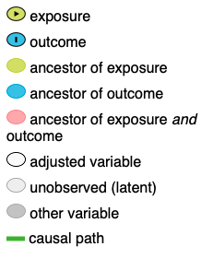
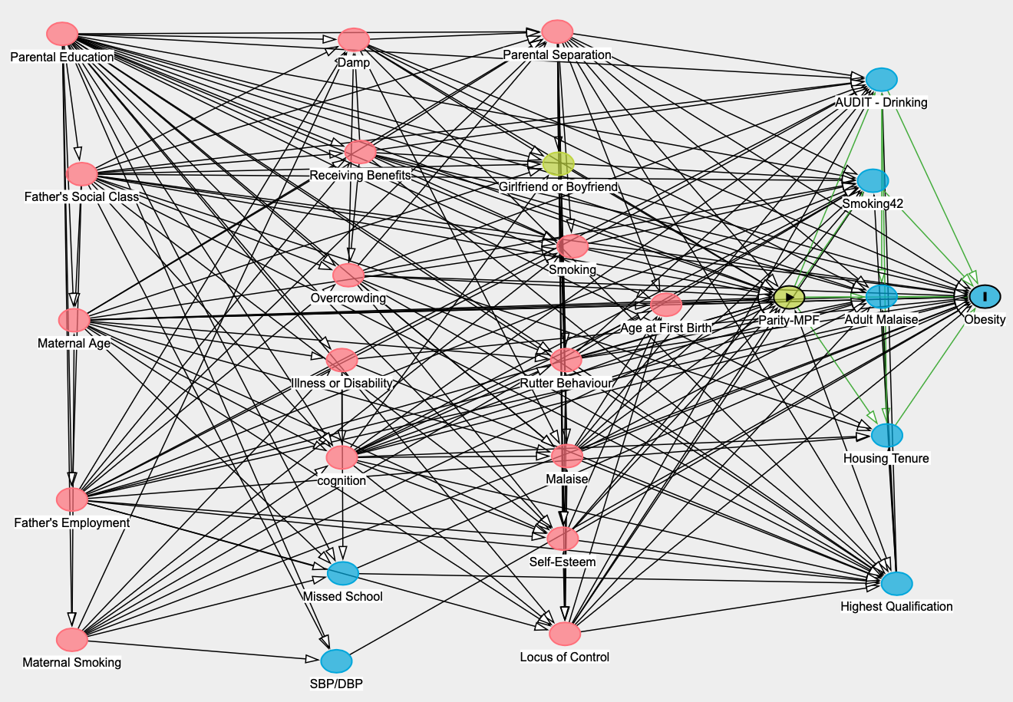
Supplementary Materials 1. A directed acyclic graph illustrating the relationship between MPF at age 42 and obesity at age 46.

DAGs are a graphical model that depict a set of hypotheses about the causal processes that generate a set of variables of interest. An arrow X → Y is drawn if there is a hypothesised direct causal effect of X on Y. An arrow X → Y only represents that part of the causal effect which is not mediated by any of the other variables in the diagram. For pathways where there is certainty that X does not have a direct causal influence on Y, then the arrow is omitted. A hypothesised causal pathway can also operate through mediators (X→M →Y) if these causal paths start at the exposure, contain only arrows pointing away from the exposure (i.e., to mediators recorded after the exposure), and end at the outcome
 | Fathers (n=3088) |  |  | Mothers (n=3532)
 | Obesity |  |  | Obesity
MPF | OR | Sig. | 95% CI | OR | Sig. | 95% CI
Unadjusted association | 1.12 |  | (0.91, 1.38) | 1.31 | ** | (1.10, 1.56)
(+) Parental controls¹ | 1.00 |  | (0.81, 1.25) | 1.17 |  | (0.98, 1.41)
(+) Child controls age 10 – including child BMI² | 1.04 |  | (0.83, 1.31) | 1.10 |  | (0.91, 1.32)
(+) Child controls age 16³ | 1.06 |  | (0.84, 1.33) | 1.12 |  | (0.92, 1.36)
(+) Adult controls age 42⁴ | 1.07 |  | (0.85, 1.35) | 1.04 |  | (0.86, 1.27)
Supplementary materials 2. Odds ratios of obesity according to whether or not the cohort member had experienced multi-partner fertility, where childhood BMI is included in analysis. Baseline outcome: no multi-partner fertility.

* P ≤ 0.05, ** P ≤ 0.01, *** P ≤ 0.001
¹Parental education, parental social class, maternal age, maternal smoking; ²child cognitive ability, illness or disability, overcrowding, benefits; ³self-esteem, locus of control, malaise, Rutter behaviour, parental separation, smoking status; ⁴age at first birth, education, smoking, AUDIT, housing tenure, malaise.

 | Fathers (n=3088) |  |  | Mothers (n=3532)
 | Obesity |  |  | Obesity
MPF | OR | Sig. | 95% CI | OR | Sig. | 95% CI
Unadjusted association | 1.12 |  | (0.91, 1.38) | 1.31 | ** | (1.10, 1.56)
(+) Parental controls¹ | 1.00 |  | (0.81, 1.25) | 1.17 |  | (0.98, 1.41)
(+) Child controls age 10 – excluding child BMI² | 0.95 |  | (0.76, 1.18) | 1.10 |  | (0.92, 1.33)
(+) Child controls age 16³ | 0.96 |  | (0.77, 1.20) | 1.11 |  | (0.93, 1.34)
(+) Adult controls age 42⁴ | 0.98 |  | (0.78, 1.22) | 1.03 |  | (0.85, 1.24)

Supplementary materials 3. Odds ratios of obesity according to whether or not the cohort member had experienced multi-partner fertility and excluding childhood BMI. Baseline outcome: no multi-partner fertility.

* P ≤ 0.05, ** P ≤ 0.01, *** P ≤ 0.001
¹Parental education, parental social class, maternal age, maternal smoking; ²child cognitive ability, illness or disability, overcrowding, benefits; ³self-esteem, locus of control, malaise, Rutter behaviour, parental separation, smoking status; ⁴age at first birth, education, smoking, AUDIT, housing tenure, malaise.

