Purple text is content that I kept in but may not be required
Red text has not been checked by supervisors
Black text ready for submission
Highlighted text needs to be done

Title
Fatigue crack growth behaviour and life prediction following a lifetime extension strategy in the low-cycle fatigue regime for FV566 turbine blade steel.

DOI
To be confirmed by the journal

Authors
Benjamin M.D. Cunningham¹, Philippa A.S. Reed¹, Andrew R. Hamilton¹, Andrew Morris²
¹ Department of Mechanical Engineering, University of Southampton, UK, SO17 1BJ
² EDF, Coal & Gas Operations, Central Technical Organisation, Barnwood, Gloucester, UK

Corresponding author information
B.M.D.Cunningham
Department of Mechanical engineering, University of Southampton, UK, SO17 1BJ
B.Cunningham@soton.ac.uk

Author contribution statement
B.M.D. Cunningham performed the testing and drafted the manuscript. A. Morris provided funding, material and study conception. P.A.S. Reed and A.R. Hamilton provided supervision for the project and were involved in the drafting and editing of the final manuscript. James wise and

Abstract
Bend bars made from FV566 martensitic stainless steel were extracted from the root of ex-service power plant turbine blades and representative notches introduced. Constant amplitude cyclic loading, and with overload cycles with an overload ratio (OLR) of 1.56 applied every 150 baseload cycles, were applied to the samples until a crack of 1 mm was observed. A ‘lifetime extension strategy’ was applied, involving grinding away existing short cracks, followed by T0 shot peening on the top surface of the sample. Fatigue cyclic loading was recommenced with initial strain range loading conditions until failure. A lifetime prediction method combining the Coffin-Manson and Paris Law relationships were used to investigate the efficacy of the ‘lifetime extension strategy’ for industrial use. The ‘lifetime extension strategy’ increased the life of U-notched samples tested and a minimum increase in strain range following the application of the ‘lifetime extension strategy’ was estimated. It is expected that the application of a’ lifetime extension strategy’ such as the one tested may provide some additional service life to existing in-service turbine blades.
170 words

Keywords
Constant Amplitude, Overloads, Fatigue Crack Growth, Low Cycle Fatigue, Notches, Short Cracks, Stainless Steel, Life Prediction.

Highlights
The application of a ‘lifetime extension strategy’ increased fatigue lifetimes of samples.
The lifetime extension strategy’ may have quantifiable limitations.
The lifetime extension strategy could have industrial applications.
Overloads with OLR of 1.56 applied every 150 baseload cycles had no effect on the short crack growth rates of shot peened samples.

Introduction
Low pressure steam turbine blades typically made from martensitic stainless steels are being increasingly exposed to cyclic fatigue conditions. Steam turbines are being used intermittently to meet demand with a frequency of 150 start/stop cycles per year due to increased use of less predictable renewable energy sources, along with annual overspeed testing at 10 % above maximum load. During routine inspection, cracking has been observed in the fir tree root fillets of the last stage low pressure steam turbine blades. The current industry recommendation is to replace cracked turbine blades at considerable cost due to a lack of applicable knowledge of short crack growth behaviour in the notch field (personal communication, EDF, 5th January 2018) {Cunningham, 2022 #256}.
An alternative repair approach, known as the ‘lifetime extension strategy’, has been investigated on FV448 material by He {He, 2015 #19} to extend service life. A U-notch sample was cyclically loaded with an R-ratio of 0.1 under constant amplitude loading conditions with a strain range of 0.68 % at the notch surface until surface cracks between 1.2 – 1.5 mm were observed. The existing cracks were ground away, regressing the fatigue process, followed by T0 shot peening to induce further resistance to fatigue {He, 2016 #87}. The sample was subjected to constant amplitude cyclic loading under the same strain range loading conditions of 0.68 % at the notch surface until failure and the fatigue life recorded. This lifetime extension strategy did not significantly extend fatigue life. One reason for this result was the presence of residual cracks on the notch surface after the grinding process, encouraging very early crack initiation and short crack growth behaviour. It is anticipated that removing all the cracks following the lifetime extension strategy may therefore offer some lifetime benefit.
The effect of shot peening on fatigue behaviour and lifetime, including turbine blades, has been well documented {He, 2013 #198;Soady, 2013 #172;Xiang, 2010 #101;Soady, 2011 #88;He, 2016 #87;You, 2017 #22;He, 2015 #19;Soady, 2013 #1} #332. T0 shot peening induced relatively early crack initiation behaviour in FV448 due to surface damage {He, 2013 #198} and #332 and an increase in surface roughness considered detrimental to fatigue life {Maiya, 1975 #168}with {Soady, 2013 #172}. However, the compressive residual stress up to 350 µm beneath the notch surface and strain hardening induced by the shot peening process acts as a significant barrier to short crack initiation and growth {He, 2016 #87}. For FV566 U-notch samples, short crack growth rate was reduced by a factor of ten over non-peened samples and a period of inactivity was observed between 40 % and 80 % lifetime ref~332, extending fatigue life of shot peened samples overall. Beneficial lifetime extension from shot peening diminishes with increasing strain range, especially in the low cycle fatigue regime, where large plastic deformation causes residual stress relaxation {Achintha, 2014 #159;You, 2017 #73;You, 2017 #40;Soady, 2011 #88;Soady, 2013 #1} #332.
An overload with overload ratio (OLR) of 1.11 did not induce a measurable effect on the fatigue behaviour or lifetimes of FV566 U-notched samples {Cunningham, 2022 #256}and as such are not expected to affect lifetimes in this study. An expected result since an overload threshold of 1.44 and 1.55 has been observed in similar materials {Bernard, 1977 #17;Jones, 1973 #163}. Nonetheless, an overload with OLR of 1.56 applied every 150 baseload cycles resulted in a retardation in short crack growth rates and an extension in fatigue life due to compressive residual stress and possible closure effects {Cunningham, 2022 #256}, a result shared by many authors {Zhou, 2016 #61;Ward-Close, 1989 #54;Topper, 1985 #133;Taheri, 2003 #131;Skorupa, 1999 #219;Shuter, 1996 #29;Shin, 1993 #34;Romeiro, 2009 #36;Robin, 1983 #119;Pommier, 2002 #32;Bernard, 1977 #17;MacDougall, 1997 #38;Jones, 1973 #163;Hammouda, 2004 #49;Fleck, 1985 #121;DuQuesnay, 1995 #35;Damri, 1991 #55}. While the effects of overloads are known for non-peened U-notched martensitic stainless steel, the effects of overloads on shot peened U-notch samples in three-point bending loading conditions need further investigation.
Dalaei et al {Dalaei, 2011 #279} investigated the effects of single overload and underload cycles on the lifetimes of non-peened and shot peened cylindrical samples made from normalized steel under fully reversed cyclic loading conditions. A fully reversed baseline strain range of 0.6 % produced a lifetime of 120,000 cycles for a peened specimen and 30,000 cycles for a non-peened equivalent. Combinations of overloads and underloads were applied with the following effects. Applying a single compressive overload immediately followed by a tensile overload at strain fully reversed range of 1.2% (with the equaivaent OLR oif?) after 1000 baseload cycles (C1000) resulted in a lifetime 92,000 cycles. Applying a single compressive overload immediately followed by a tensile overload on the first cycle (C1) resulted in a lifetime of 88,000 cycles. Applying a single tensile overload immediately followed by a compressive overload on the first cycle (T1) resulted in a lifetime of 70,000 cycles. Applying a single tensile overload immediately followed by a compressive overload after 1000 baseload cycles (T1000) resulted in a lifetime of 42,000 cycles (Error! Reference source not found.). These results suggest a combination of residual stress relaxation and reintroduction of residual stress from the underload/overload cycles are responsible for the difference in the lifetimes. It is anticipated that some residual stress relaxation may be expected from single periodic tensile overloads with OLR of 1.56 every 150 baseload cycles applied to U-notch samples that may affect the total life.
Grinding notch surface material will affect the notch geometry and ultimately the fatigue behaviour. A study was carried out on FV566 with various U-notch geometries to explore these effects ref. Finite Element (FE) modelling of various notch geometries with identical strain range loading conditions showed that changing the notch geometry had a small effect on the stress and stain range distribution within the notch field during cyclic loading. Despite this, experimental testing showed that the fatigue behaviour such as short crack growth rates (based upon linear-elastic-fracture-mechanics) and lifetimes remained unchanged when subjected to identical strain range loading conditions. The strain range was found to have the largest impact on fatigue life of U-notched samples. The change in the cyclic strain range at the notch surface is geometry dependant and required FE modelling to investigate this change for individual applications.
It is necessary to consider an expected increase in the strain range at the notch surface for appropriate industrial application of the lifetime extension strategy. Life prediction approaches can be used to obtain a relationship between lifetime and cyclic stress/strain range. For low cyclic fatigue (LCF) conditions, Basquin’s {Basquin, 1910 #302} relationship between stress amplitude and number of cycles to failure is typically combined with the Coffin and Manson {Coffin Jr, 1954 #303;Manson, 1953 #304} relationship (Equation 1) to predict strain amplitude and number of cycles to failure, which reasonably accounts for the effects of material plasticity {Nip, 2010 #325}.
$$\frac{∆ε}{2}=\frac{{σ^{'}}_{f}}{E}{\left({2N}_{f}\right)}^{b}+{ϵ^{'}}_{f}{\left({2N}_{f}\right)}^{c}$$ | Equation 1
While this total life approach can account for changes in applied strain range, it is unable to predict the number of cycles to a specific period during the fatigue lifecycle, such as when a short crack has grown a specific length. To predict this, damage tolerant lifing approaches must be utilized such as the well-known Paris Law {Paris, 1963 #102}. The Paris-law (Equation 2) is typically used to define the relationship between long crack growth rate and stress intensity factor ΔK or ΔK_{Surface}:
$$\frac{da}{dN}=C∆K^{m}$$ | Equation 2
This damage tolerant approach can be adopted for short crack growth rate and allows for a prediction in the number of cycles to a specific short crack length. The total number of cycles to grow a crack from some initial crack length a₁ to some final crack length a₂ can be achieved by integrating the Paris-law {Pugno, 2006 #309} (Equation 3) or using iterative methods:
$$N=\frac{1}{C}\int_{a_{2}}^{a_{1}}{\frac{1}{∆K{\left(a\right)}^{m}}}da$$ | Equation 3
A damage accumulation rule (Equation 4), proposed by Palmgren {Palmgren, 1924 #306} and later developed by Miner {Miner, 1945 #116} is a popular approach to fatigue life prediction accounting for variable amplitude loading conditions, such as periodic overload cycles.
$$D=\sum_{i=1}^{i=m}{\frac{n_{i}}{N_{i}}=1}$$ | Equation 4
It is well known that the Palmgren-Miner damage accumulation rule is not accurate with some D values being calculated as low as 0.03 and as high as 22.8 {Sun, 1994 #6}. The Palmgren-Miner rule does not consider strain hardening and residual stresses induced from the overload cycles that are known to increase fatigue life. Many authors have attempted to develop the Palmgren-Miner approach {Sun, 1994 #6} cited in {Collins, 1981 #307}. Others have attempted to apply statistical probability modelling to offer some confidence level to lifetime predictions {Sun, 2014 #66;Birnbaum, 1968 #139;Shimokawa, 1980 #140}. However, the increasing complexity from recent developments does not currently outweigh the reduction in prediction error, which is typically a conservative estimate.
This study is driven by the need to safely extend the operational lifetime of these last low pressure steam stage turbine blades, which present a serious safety risk in the event of catastrophic failure. The efficacy of the ‘lifetime extension strategy’ (involving fully grinding away existing cracks followed by T0 shot peening on the notch surface) as a maintenance procedure for in-service turbine blades will be investigated via development of a lifetime prediction model combining total life and damage tolerant approaches and compared with experimental testing of U-notched samples. The effect of periodic tensile overloads with OLR of 1.56 every 150 baseload cycles on the fatigue behaviour of shot peened U-notched samples will also be investigated.
A | 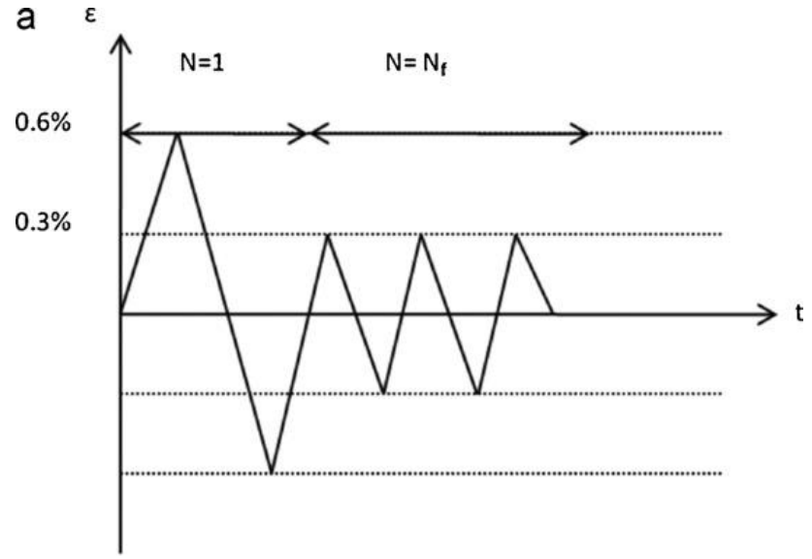 | B | 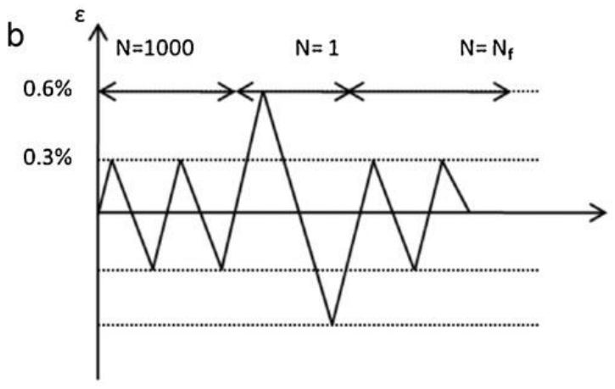
C | 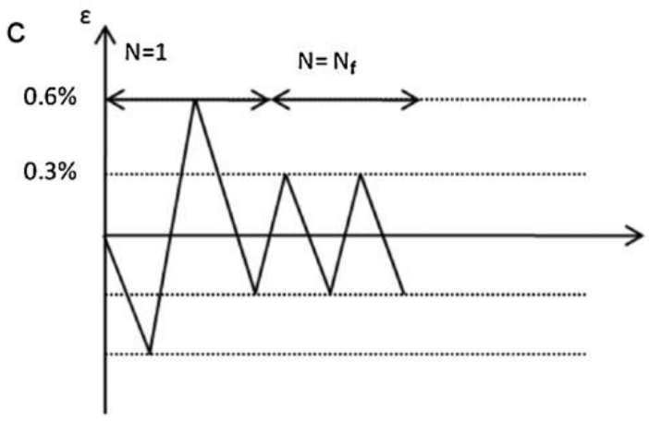 | D | 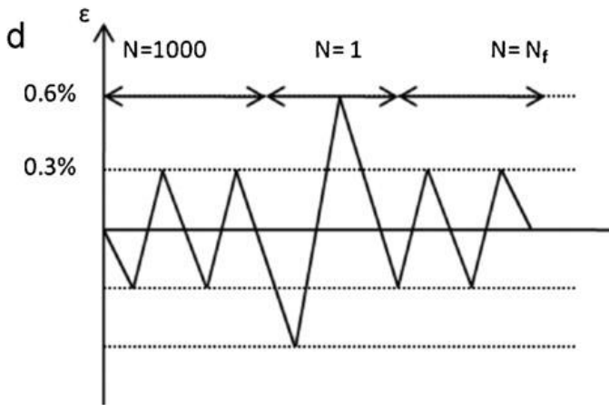
E | 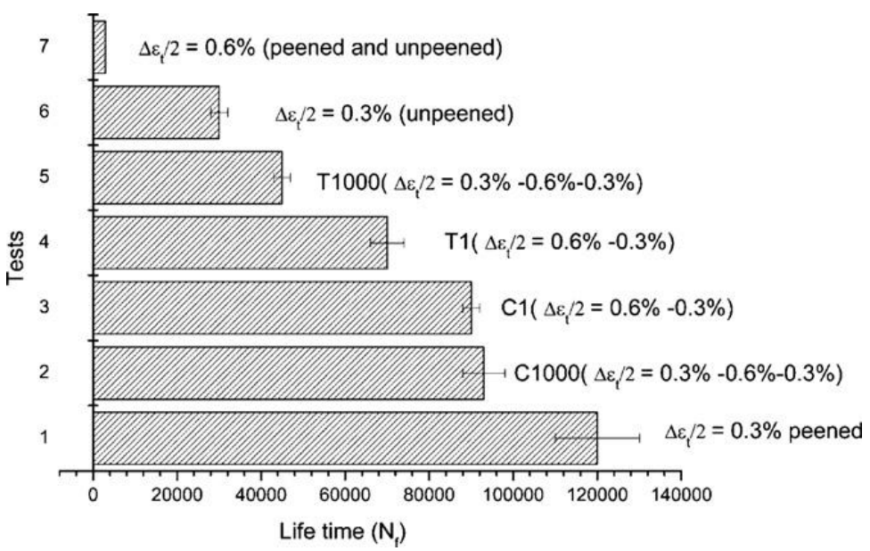
Figure 1 Strain % versus time for A) a tensile overload followed immediately by a compressive overload during the first cycle, followed by constant amplitude loading for the remainder of the test (T1), B) a tensile overload followed immediately by a compressive overload during the 1000th cycle followed by constant amplitude loading for the remainder of test (T1000), C) a compressive overload followed by a tensile overload cycle during the first cycle followed by constant amplitude loading for the remainder of the test (C1), and D) a compressive overload followed by a tensile overload followed during the 1000th cycle followed by constant amplitude loading (C1000) for the remainder of test {Dalaei, 2011 #279}. E) Test conditions versus lifetime in number of cycles {Dalaei, 2011 #279}.
1537 words excl caption

Materials and experimental method
Plain bend bars made from FV566 martensitic stainless steel were extracted from the root of an ex-service low-pressure steam turbine blades {Cunningham, 2022 #330}. It is understood this material has been austenitised at 1050 °C and oil quenched, with tempering at 650 °C {Turnbull, 2012 #239}. The heat treatment, microstructure, material properties and baseline fatigue behaviour for this material are reported in our previous work {Cunningham, 2022 #256} and #330.
The plain bend bars were U-notched with industry relevant dimensions (2.25 mm radius and 1.25 mm deep) machined into the centre of the samples (Figure 2-A). The U-notch surface was polished using 9 µm diamond suspension and a rotary power tool to remove machining marks. Surface roughness R_{a} measurements of 0.039 μm ± 0.015 μm were found using a contact profilometer (Infratouch) with a 2 µm diameter stylus.
Interrupted partial lifetime fatigue testing was carried out under 3-point bend constant amplitude cyclic loading conditions on all U-notched samples using an Instron TM ElectroPulse E10000 electromechanical fatigue testing machine. A 3D non-linear finite element quarter model was developed using ABAQUS to determine the test loading conditions and provide strain range estimations in the centre of the notch {Cunningham, 2022 #256}. A mesh convergence study using C3D20 full integration quadratic hexahedral elements was carried out to determine an adequate mesh {Cunningham, 2022 #330}. Elastic–plastic material data from monotonic tensile testing performed by Frazer-Nash Consultancy (FNC) {Cunningham, 2022 #256} was used to describe the plastic behaviour of the material.
Interrupted fatigue testing was carried out on U-notch samples with regular surface replication of the notch surface using Repliset-F5 (Struers Ltd) silicone with a resolution of 10 μm. This method allowed the recording of crack initiation and growth mechanisms in the surface of the U-notch at regular intervals during fatigue cycling. A fuller description of the method is described in our previous paper {Cunningham, 2022 #256}. All tests were carried out at room temperature using a sinusoidal waveform at a frequency of 10 Hz and with R-ratio of 0.1. Single tensile periodic overloads with OLR of 1.56 (Equation 5) {Shin, 1993 #34} were applied every 150 baseload cycles with a slower frequency of 1 Hz for one test.
$$OLR=\frac{P_{OL}-P_{min}}{P_{max}-P_{min}}$$ | Equation 5
The test was paused once a short crack with a projected surface length of 1 mm was observed and the lifetime extension strategy applied as detailed. The cracks formed during the initial lifetime testing were ground away using a rotary power tool and carbide mounted tip, with a diameter of 3 mm (available from PTEFD), and lubricant (WD 40). Care was taken to ensure a consistent symmetrical notch was formed. A second notch was formed inside the original notch with total notch depth of 2 mm (Figure 2-B) or 3 mm (Figure 2-C). The top surface including the notch surface was subjected to a T0 industrial standard shot peen (MI230R 200% 13A) by Sandwell UK Ltd, The shot diameter was 0.58 mm, shot hardness (Hardness Rockwell C) 45 – 52 HRC and shot velocity was 57 ms⁻¹. The surface roughness of the shot peened surface had a measured R_{a} of 2.7 μm ± 0.4 μm via a contact profilometer. The depth and radius of the notch geometries were measured via optical microscopy and image processing software (Image J). The ‘repaired’ samples were subjected to further interrupted lifetime testing with the same initial nominal strain range by reducing the minimum and maximum loads accordingly, found using the FE model.
A record of crack length, cproj, versus number of cycles, N, was constructed for short crack growth rate determination both before and after the lifetime extension strategy was applied using a “best estimation” method. A visual representation of the crack evolution during fatigue was created from the replicas and animated in Microsoft PowerPoint. Crack growth rates dcproj/dN were calculated using the secant method and compared for the U-notch specimens tested. The ΔK values of the short cracks were calculated using the methodology described in {Scott, 1981 #56;Holdbrook, 1979 #57}.
An optometry surface profiling microscope (Alicona) was used to observe and analyse the fracture surfaces of FV566 U-notch samples with two notch radii (2.25 mm and 1.5 mm) from this study and including samples from previous studies ref. The surface topology of the fracture surface close to the notch surface was recorded as height (a distance perpendicular to the fracture surface plane and parallel with the longitudinal/tensile axis) using the Alicona’s post analysis software (Figure 3A). Twenty locations were chosen at random along the width of the sample to represent initiation events. The difference in height between each successive initiation location (known as the out-of-plane distance) were found (Figure 3B,C) and the average out-of-plane distance ($\overline{d}$) calculated using (Equation 6) for each sample.
A | 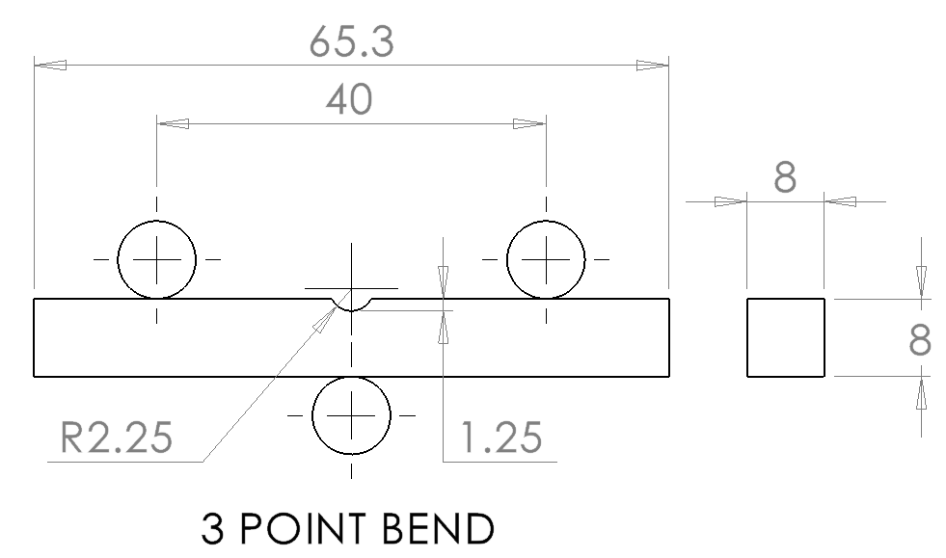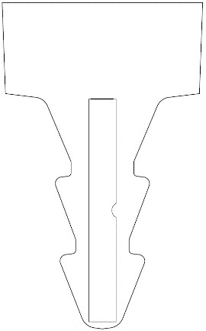
B | 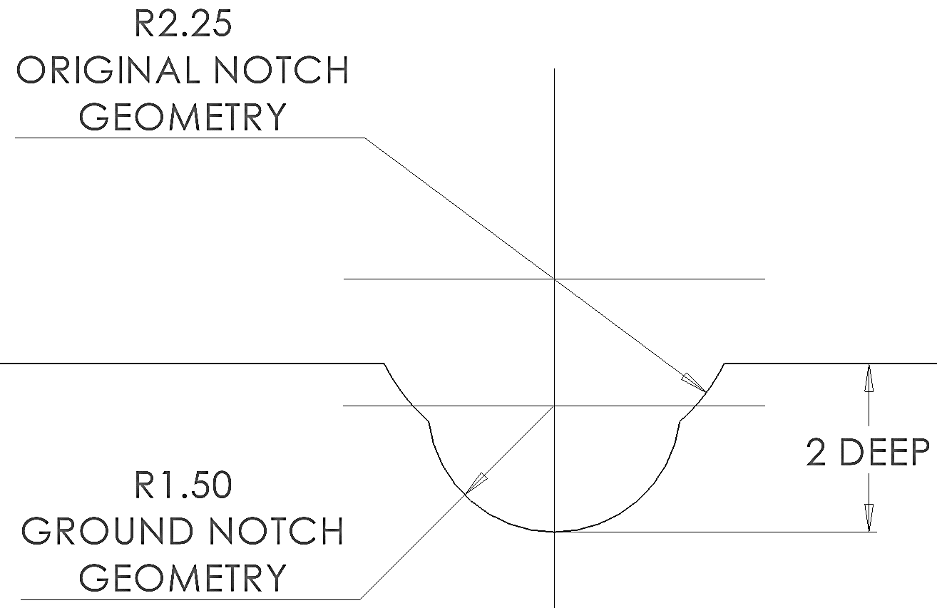 | C | 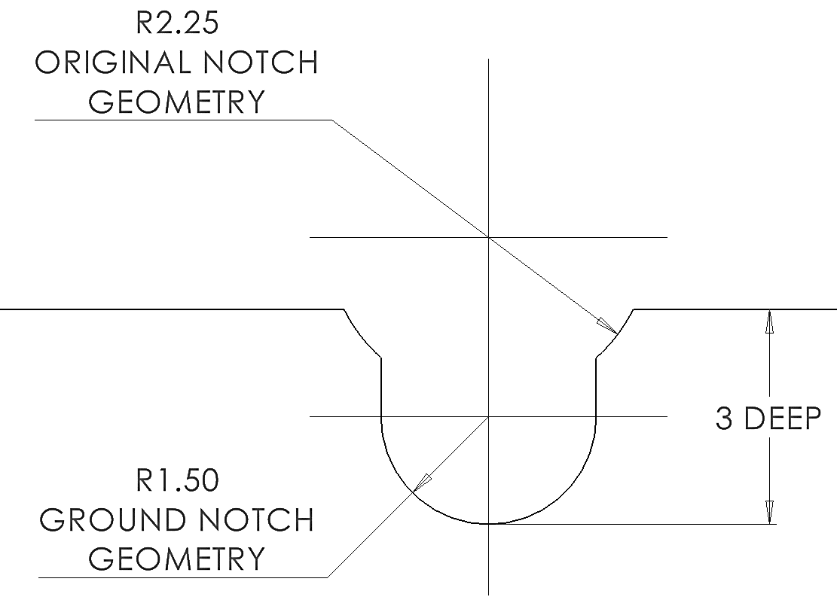
Figure 2 A) U-notch sample geometry as set up for 3-point cyclic fatigue testing ref. Schematic showing the profile of a ‘repaired’ notch after the lifetime extension strategy has been applied with radius (R) of 2.25 total depths of B) 2 mm and C) 3 mm.

A | 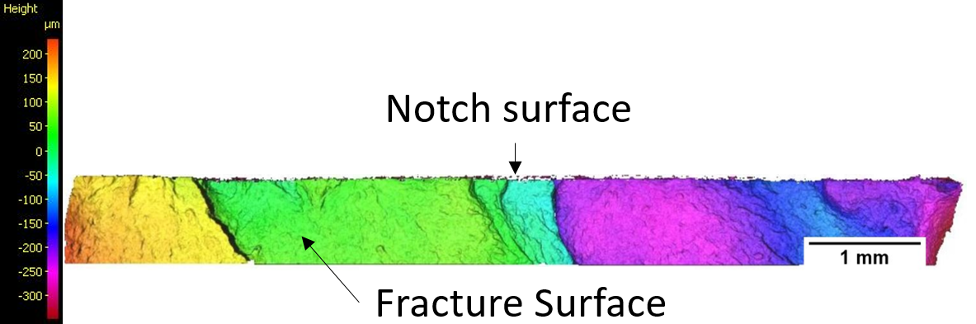
B | 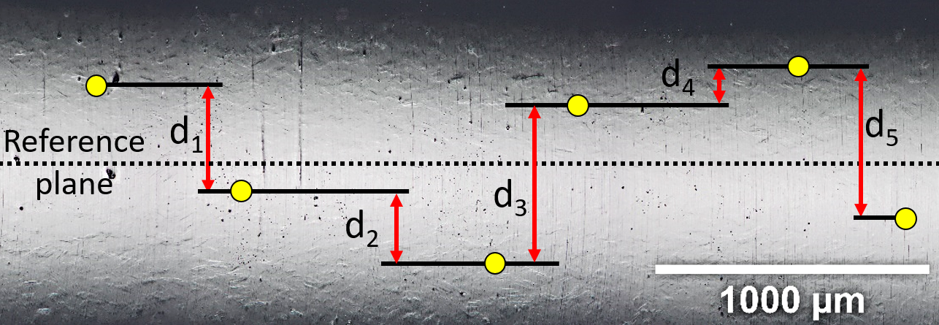
C
Figure 3 A) The colour coded topology of the fracture surface (close to the notch surface) of a failed FV566 U-notch sample showing the height as distance from a reference plane (parallel to the fracture surface). B) Typical notch surface section with random initiation locations (as yellow dots). The out-of-plane distance d_{x} is calculated by measuring the difference in height between two neighbouring initiation locations. C) Schematic side view of a typical U-notch sample. Note how the ‘Out-of-plane distance’ is a projected distance.
$$\overline{d}=\frac{1}{n}\sum_{1}^{n}{d_{n}}$$ | Equation 6

Results
The short crack growth rate versus ΔK_{Surface} for polished and shot peened U-notch samples with constant amplitude loading and overloads with OLR of 1.56 applied every 150 baseload cycles were compared under linear elastic fracture mechanics (LEFM) assumptions. The author acknowledges that LEFM does not capture effects of plasticity, especially at lower ΔK values for LCF conditions. However, for the purposes of comparison between surface and loading conditions and prediction of lifetime based upon the Paris-law, LEFM can be sufficient in this regard.
Single periodic tensile overloads with OLR of 1.56 applied every 150 baseload cycles were found to retard short crack growth rates for polished U-notch samples {Cunningham, 2022 #256}. The addition of T0 shot peening produced more profound retardation in short crack growth (Figure 4A). The characteristic retardation in crack growth rates from shot peened samples due to the compressive residual stress was minimally impacted by the presence of single periodic tensile overload cycles. No residual stress relaxation was observed from the overload cycles, which may reintroduce some compressive residual stress at higher ΔK values. A greater range in the crack growth rate of short cracks was observed between ΔK_{Surface} of 10 and 25 MPam^{0.5} (represented as the shaded green area).
A | 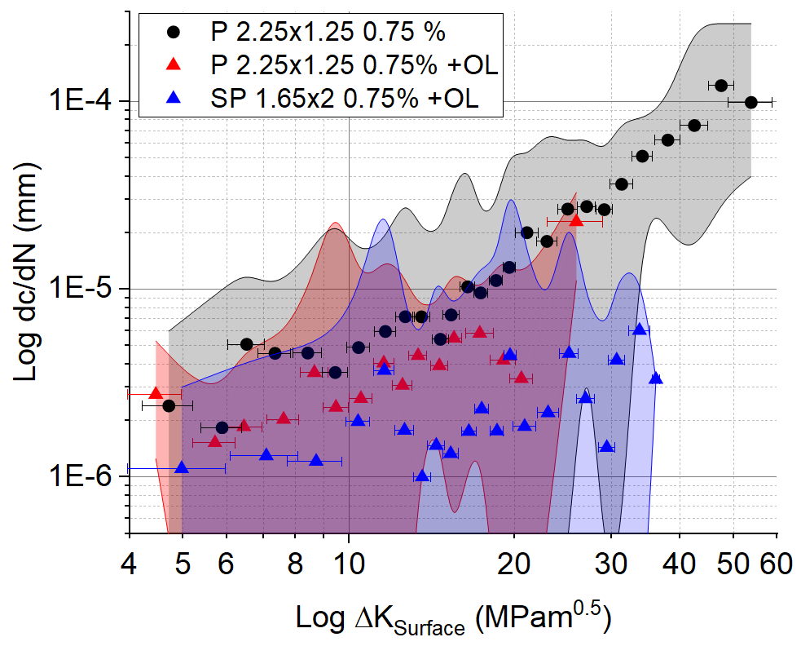 | B | 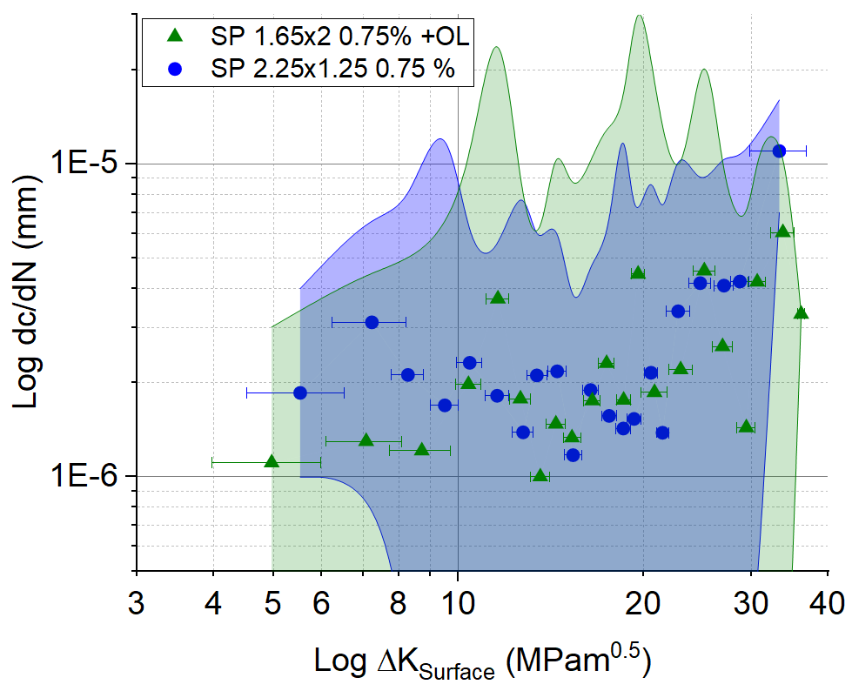
Figure 4 Short crack growth rate versus ΔK_{Surface} for U-notch samples under a baseload strain range of 0.75 % for A) shot peened (SP) notch surface under constant amplitude from Cunningham et al {Cunningham, 2022 #256} and with single periodic overloads (OL) with OLR of 1.56 every 150 baseload cycles, B) polished (P) notch surface under constant amplitude loading and polished notch surface with single periodic overloads every 150 baseload cycles from Cunningham et al {Cunningham, 2022 #256}, compared with shot peened notch surface with a different notch geometry and single periodic overloads every 150 baseload cycles.
A detailed study of the short crack growth behaviour for the primary crack using methods detailed in {Cunningham, 2022 #256} was carried out for U-notch specimens subjected to the lifetime extension strategy. The number of crack initiation events (adding to the total number of cracks that made up the primary crack) and coalescence events (subtracting from the total number of cracks that made up the primary crack) for two samples, with constant amplitude loading and with overloads of OLR 1.56 every 150 baseload cycles, are presented in (Figure 5A,B). To gain further understanding and visualization of the crack initiation, coalescence, and growth stages, a PowerPoint animation approach was adopted to reconstruct the evolution of the short cracks from the silicone replicas to scale Figure 5D,E) ref.
A polished typical notch geometry (notch radius of 2.25 mm and a notch depth of 1.25 mm) was subjected to constant amplitude cyclic loading with a strain range of 0.75 % at the notch surface. Crack initiation on the polished notch surface began around 20 % lifetime, after which crack initiation activity was low with 1 or 2 cracks initiating in between each replica. A surface crack with a projected length of approximately 1 mm was observed at 35 % lifetime. A lifetime extension strategy was applied, removing all surface cracks, followed by T0 shot peening on the notch surface and corresponding top surface of the sample. The U-notch had a notch radius of 1.65 mm and a notch depth of 2 mm. Crack initiation activity on the shot peened notch surface was first observed around 50 % lifetime (the first replica record available). The first crack coalescence event was observed around 55 % lifetime. Crack initiation activity reduced in intensity followed by three crack coalescence events until 60 % lifetime. Low initiation activity was seen with 4 initiation events occurring between 60 % and 90 % lifetime. Short crack growth was particularly slow during this period. The maximum number of cracks that made up the primary crack was 15 between 68 % and 82 % lifetime. Crack coalescence activity increased at 82 % lifetime and took over short crack behaviour until a full width crack was observed (Figure 5A,C,D). The video can be viewed here https://www.youtube.com/watch?v=W1DT7y4YVPA and also at https://eprints.soton. ac.uk/XXXXXX/.
A polished typical notch geometry (notch radius of 2.25 mm and a notch depth of 1.25 mm) was subjected to single tensile periodic overloads with OLR of 1.56 every 150 baseload cycles with a strain range of 0.75 % at the notch surface. Six crack initiations on the polished notch surface were observed around 13 % lifetime (first available replica). Crack coalescence was first seen approximately 22 % lifetime. Crack initiation activity increased substantially around 30 % lifetime. Crack coalescence activity subsequently increased between 35 % and 38 % lifetime. A surface crack with projected length of 1 mm was observed around 38 % lifetime. A lifetime extension strategy was applied, removing all surface cracks, followed by T0 shot peening on the notch surface and corresponding top surface of the sample. The second phase of testing was carried out on a shot peened notch surface with notch radius of 1.65 mm and notch depth of 2 mm. Crack initiation activity on the shot peened notch surface was first observed around 49 % lifetime. Crack initiation activity increased with a similar intensity observed on the polished notch surface between 55 % and 60 % lifetime. Crack initiation activity reduced in intensity from 60 % to 75 % lifetime. Crack coalescence activity was high between 70 % and 75 % lifetime. A period of low activity dominated by coalescence behaviour was seen between 75 % and 85 % lifetime. Low initiation activity with increased coalescence activity was seen between 85 % and 95 % lifetime. Coalescence activity substantially increased around 95 % to 98 % where the primary crack grew the full width of the sample. (Figure 5B,C,E) The video can be viewed here https://www.youtube.com/watch?v=71VQmezhdHg and also at https://eprints.soton. ac.uk/XXXXXX/.
A | 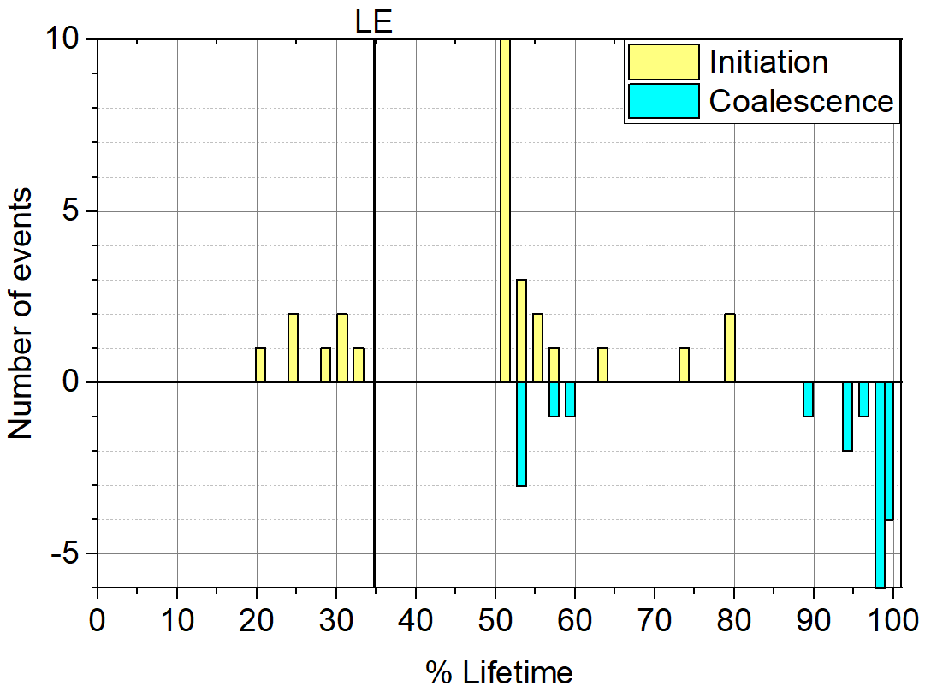 |  | B | 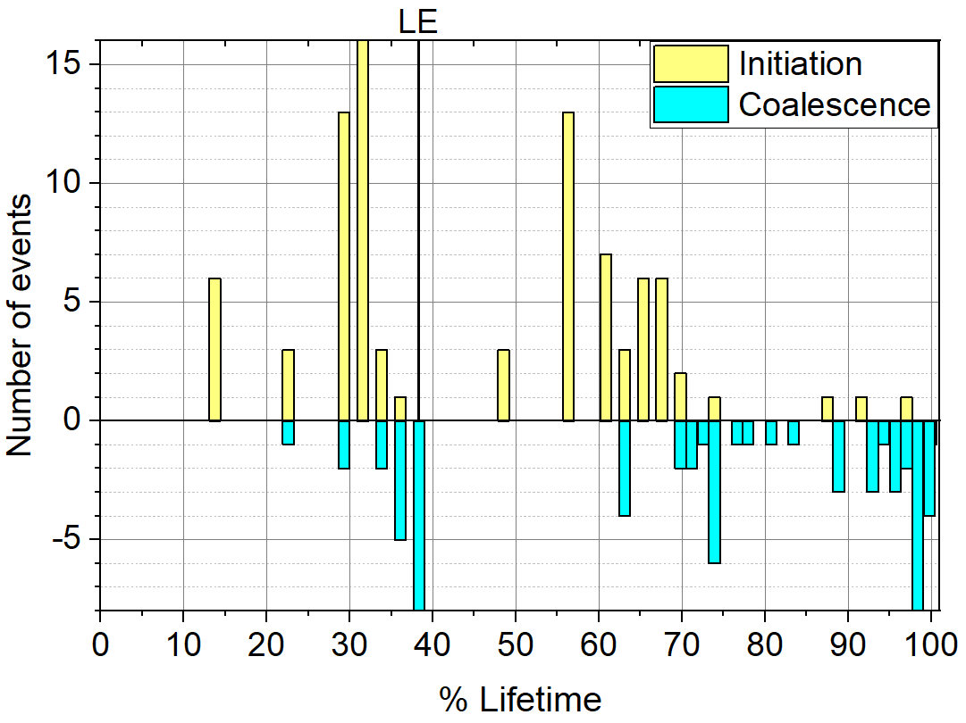
C | 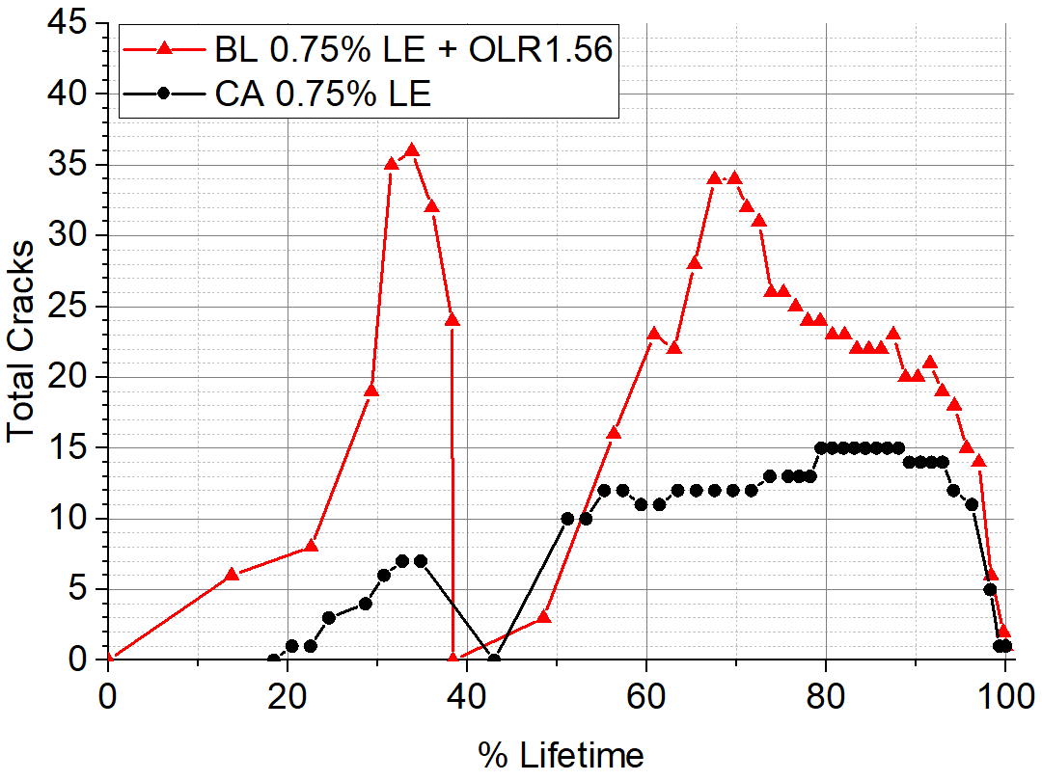
D |  | 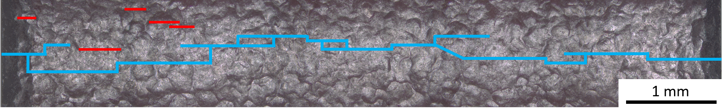
E |  | 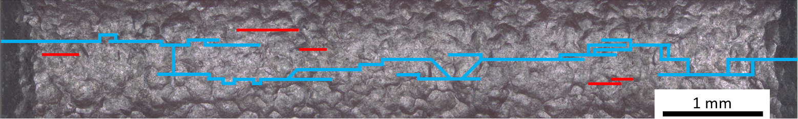
Figure 5 The number of initiation events in yellow (adding to the number of primary cracks) and coalescence events in blue (subtracting from the number of primary cracks) formed in between each replica for A) a sample subjected to the lifetime extension strategy (LE) under constant amplitude loading with a strain range of 0.75 %, and B) a sample subjected to the same lifetime extension strategy with single periodic tensile overloads (OL) with OLR of 1.56 applied every 150 baseload (BL) cycles. C) The total number of cracks that made up the primary crack versus percentage lifetime for both samples subjected to the lifetime extension strategy. D) The final notch surface replica record from the crack evolution diagrams for a sample subjected to the lifetime extension strategy under constant amplitude loading at a constant amplitude strain range of 0.75 % and E) A sample subjected to the same lifetime extension strategy with single periodic tensile overloads with OLR of 1.56 applied every 150 baseload cycles with a constant amplitude.
The fatigue life of the U-notch samples subjected to a lifetime extension strategy was recorded and is compared with results using similar materials and U-notch geometry ref. FV566 samples with U-notch geometry 2.25 mm radius and 1.25 mm depth were subjected to either a polished, or T0 shot peened surface condition. Shot peening increased the lifetime of samples at lower strain ranges with one sample subjected to 2,240,000 cycles before the test was stopped due to no activity ref. The application of the lifetime extension strategy extended the lifetimes of U-notched samples when the initial strain range applied at the notch surface at the beginning of the test was kept constant throughout testing. An improvement of approximately 93 % over polished U-notch and 57 % over shot-peened U-notch surface condition was observed for both constant amplitude loading conditions and periodic tensile overloads with OLR of 1.56 applied every 150 baseload cycles. The overload cycles did not appear to provide any additional lifetime extension to the samples.
The out-of-plane variance (average perpendicular distance between neighbouring cracks) for U-notch radius of 2.25 mm was 64.5 µm ± 20.8 µm (one standard deviation), while for a 1.5 mm radius the out-of-plane variance was 60.9 µm ± 15.1 µm fig. Increasing the strain range tended to increase the out-of-plane variance. At isolated strain ranges of 1.65 % and 1.18 %, the out-of-plane variance slightly decreased with a sharper notch radius. Overall, the notch radius did not significantly decrease the out-of-plane variance.
A | 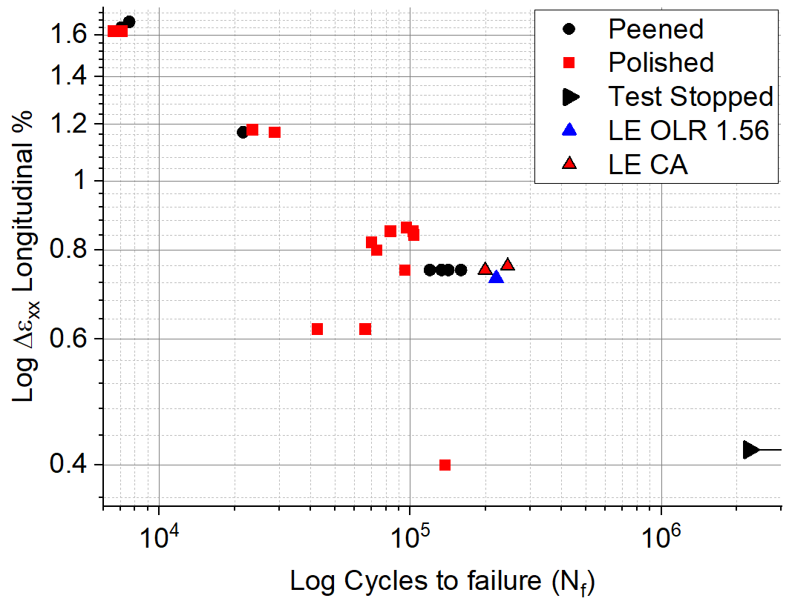 | B | 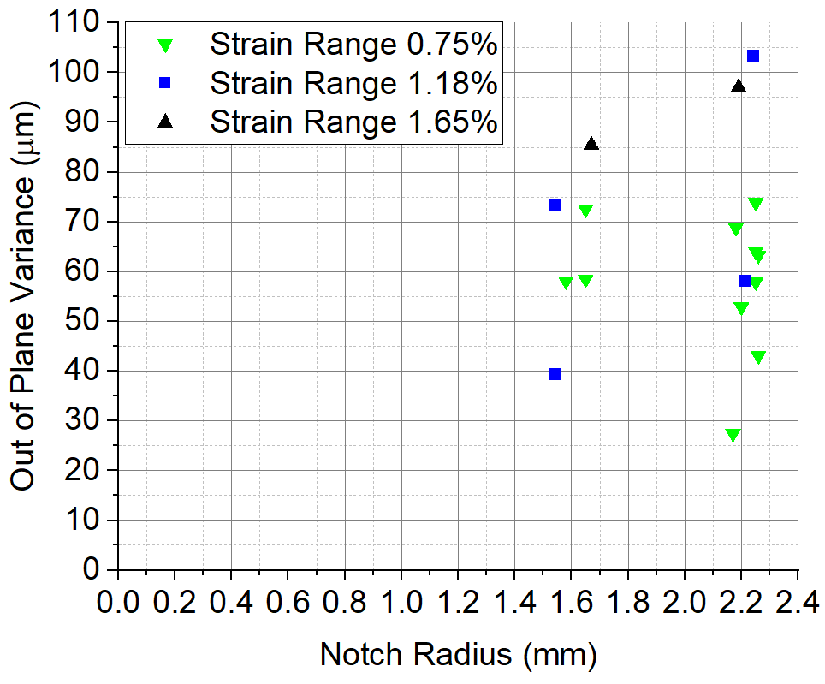
Figure 6 A) Longitudinal strain range % at the notch surface versus number of cycles to failure for U-notched samples with polished and shot peened (Peened) notch surface conditions from ref with three samples subjected to the lifetime extension strategy (LE), two samples under constant amplitude loading and one sample with single periodic overloads with OLR of 1.56 every 150 baseload cycles. The peened U-notch sample with strain range of 0.4% was stopped (not run to failure) as no cracks were found to have initiated within 2 250 000 cycles. B) Out-of-plane variance versus notch radius for three strain ranges of 0.75 %, 1.18 % and 1.65 %.

Discussions
Shot peening had more profound retardation effect on short crack growth than single periodic overload cycles with an OLR of 1.56 applied every 150 baseload cycles alone ref, especially between ΔK_{Surface} values of 15 and 20 MPam^{0.5}. The presence of the overload cycles did not appear to impact short crack growth rates of shot peened samples with minimal residual stress relaxation effects observed. It is possible that the additional strain hardening effect from shot peening acts as a further barrier to residual stress relaxation from the overload cycles, helping maintain the fatigue resistant properties from the shot peening process.
Compressive residual stress in the notch field from single periodic overloads of 1.56 applied every 150 baseload cycles led to a significant delay in the number of cycles to crack initiation paper 1. Shot peening was found to nullify this effect despite the presence of compressive residual stress due to presence of pre-existing cracks induced by the shot peening process, a feature observed in several papers. The increase in strain range during the overload cycles resulted in an increase in the total number of cracks that formed the primary crack both for a polished notch surface condition (Figure 7) ref and shot peened condition, which led to an increase in the coalescence activity compared with constant amplitude loading ref #332.
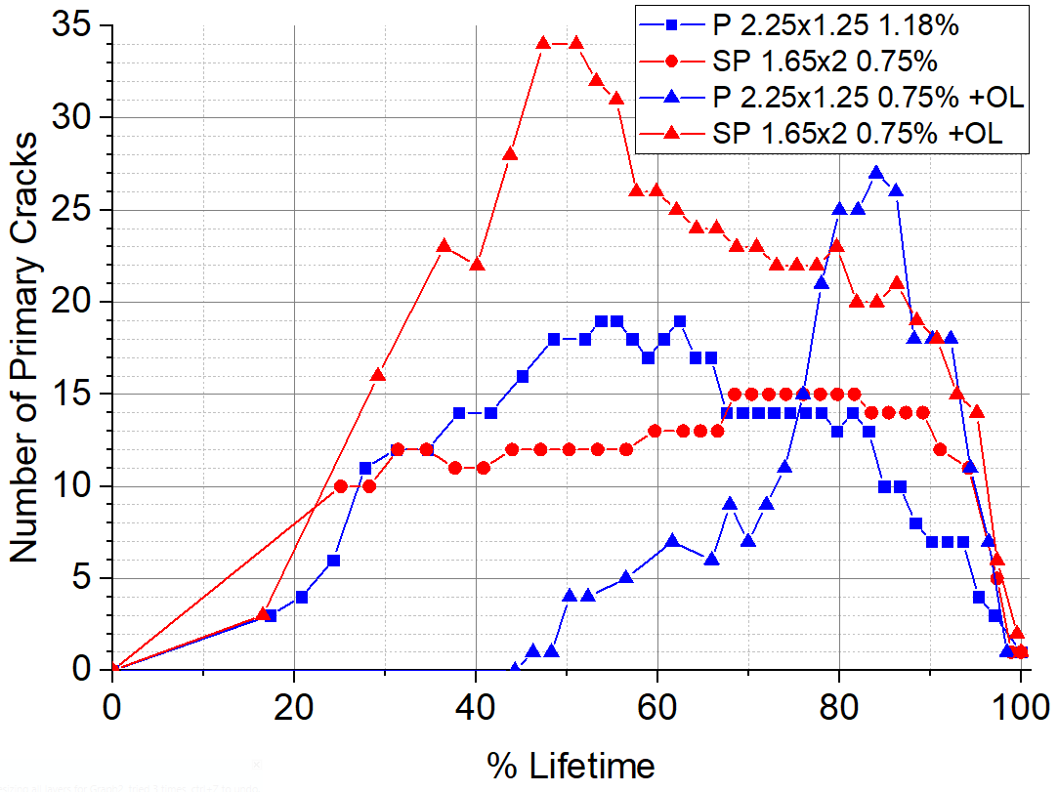
Figure 7 The total number of cracks that formed the primary crack versus lifetime percentage for polished and shot peened notch surface conditions under constant amplitude loading, and single periodic tensile overloads with OLR of 1.56 every 150 baseload cycles loading. Ref and put refs on graph

Lifetime prediction
The Coffin-Manson relationship (Equation 1) ref re-written into a simpler form shown in (Equation 7) was used to characterise the relationship between strain range at the notch surface versus the number of cycles to total failure for both polished and shot peened U-notched samples including results from ref.
$$∆ε={A\left(N_{f}\right)}^{b}+{ϵ^{'}}_{f}{\left(N_{f}\right)}^{c}$$ | Equation 7
The Coffin-Manson constants Table 1 resulting curves for the polished (orange) and shot peened (blue) U-notch surface conditions are presented in Figure 8. A result below a strain range of 0.6 % on the notch surface was omitted from the fitting process since the result was not from a completed test.
Surface Condition | Coffin-Manson Constants
 | A | b | $${ϵ^{'}}_{f}$$ | c
Polished | 0.00365 | 0 | 0.539 | -0.424
Shot Peened | 0.00365 | 0 | 0.501 | -0.411
Table 1 Coffin-Manson constants obtained by empirical fitting to experimental data for polished and shot peened U-notch surface conditions.
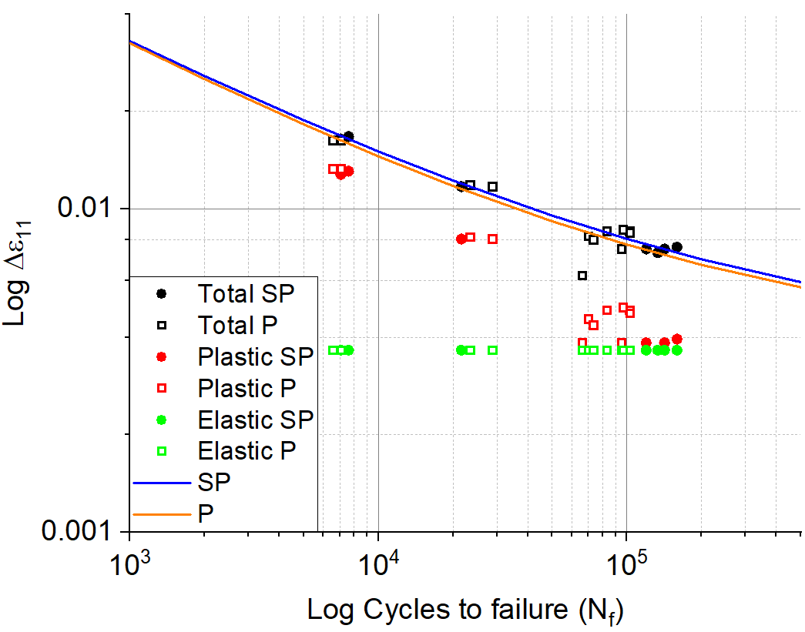
Figure 8 Longitudinal strain at the notch surface versus lifetime for polished (hollow squares) and shot peened (filled circles) U-notch samples. The total strain applied to the notch surface during testing (black data points) were split into their plastic strain (red data points) and elastic strain (green data points) counterparts. The resulting Coffin-Manson curves for the polished notch surface condition (orange line) and the shot peened notch surface condition (blue line) are presented. This figure includes results from ref.
The difference between the two derived Coffin-Manson curves shows the predicted life extension from shot peening (Figure 9 A). The percentage increase in lifetime from shot peening decreases with a near power-law relationship with increasing strain range (Figure 9 B), showing the fatigue resisting properties of shot peening diminish with increasing strain range. A result commonly observed {Soady, 2011 #88;Dalaei, 2011 #279}#332 due to compressive residual stress relaxation due to high plastic deformation during cyclic loading in the low cycle fatigue regime.
A | 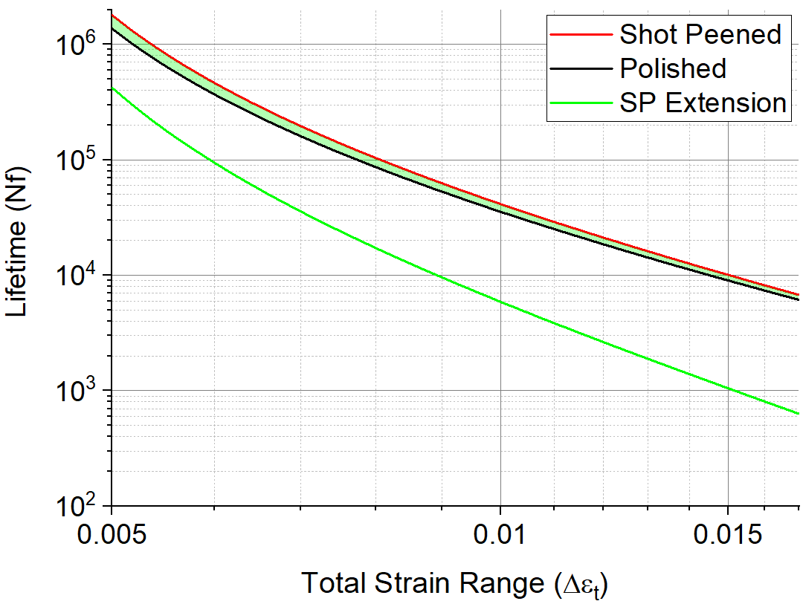 | B | 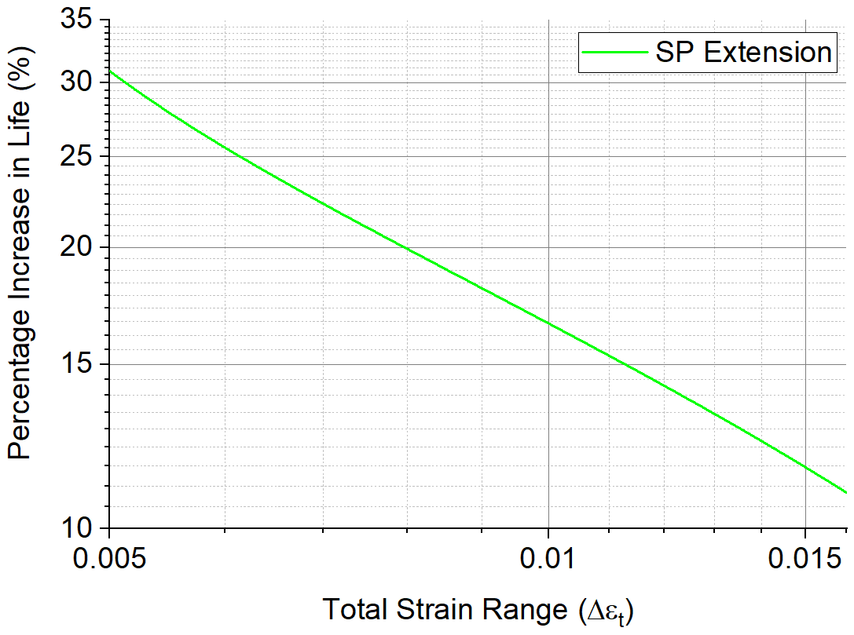
Figure 9 Predicted total lifetimes (using the Coffin-Manson relationship) with increasing total longitudinal strain range for shot peened (red line) and polished (black line) notch surface conditions. The difference between the Coffin-Manson relationships for shot peened and polished surface condition is indicative of the expected lifetime extension from the application of shot peening (green shaded area and green line ‘SP Extension’). B) The lifetime extension from shot peening presented as a percentage increase in life compared with the polished surface condition.
Crack initiation phase and prediction method
Several interrupted fatigue tests on U-notch samples with various surface and loading conditions were carried out refs, the number of cycles to crack initiation for these samples are shown in (Table 2). Crack initiation was recorded as a percentage of lifetime so that samples with various strain ranges could be compared. The number of cycles to crack initiation for various strain ranges can be predicted using the Coffin-Manson relationship and the percentage lifetime to crack initiation from replica records. This prediction method assumes that strain range has no effect on lifetime percentage to crack initiation. The number of cycles to crack initiation for a strain range of 0.75 % are known directly from replica records obtained during testing ref.
Single periodic tensile overloads with OLR of 1.56 increased the number of cycles to crack initiation, due to the compressive residual stress within the notch field ref paper 1. The number of cycles to crack initiation was similar for a shot peened sample and a polished sample.
However, shot peening the notch surface reduced the percentage lifetime to crack initiation by approximately 10%. The presence of pre-existing cracks a feature seen in similar shot peened steels {Saklakoglu, 2021 #266;He, 2013 #198;Sakamoto, 2015 #277} can include paper 2 #332. and increased surface roughness from shot peening considered detrimental to fatigue {Maiya, 1975 #168;Suresh, 1998 #3} was found to outweigh the crack initiation inhibiting quality from compressive residual stress and strain hardening ref. The presence of single periodic tensile overloads with OLR of 1.56 every 150 baseload cycles increased the number of cycles to crack initiation for a polished sample ref paper 1. However, identical overload cycles did not have this effect on the shot peened notch surface, also attributed to the presence of pre-existing cracks on the notch surface.
Surface/Loading condition | Lifetime (%) | Number of cycles to Initiation | Error (Cycles)
Polished | 11.2 < 29.1 < 56 ª | 26 000 ª | + 24 000 ª  -16 000 ª
Polished + OL | 31.3 < 38.7 < 46.1 ª | 37 800 ª | + 7 200 ^{b}  - 7 200 ^{b}
Shot Peened | 7.2 < 17.3 < 36 ª | 24 000 ª | + 26 000 ^{b}  - 14 000 ^{b}
Shot Peened + OL | 0 < 16.5 < 29.2 ^{c} | 22 650 ^{c} | + 17 400 ^{d}  - 22 650 ^{d}
Table 2 The lifetime percentage range and the corresponding number of cycles when crack initiation was first observed on U-notch samples for various surface and loading conditions. ª The number of cycles was based upon an average percentage lifetime for all available samples. ^{b} The error was based upon the average percentage lifetime of the preceding and succeeding replica. ^{c} The results are based upon a single test. ^{d} The error is based upon the number of cycles from the preceding and succeeding replica records. The table includes data from ref
Short crack growth stage and method
Total life approaches such as Coffin-Manson cannot be used to estimate the fatigue life at some arbitrary point during the fatigue life (such as when a short crack of 1 mm is observed). Short crack growth rate versus ΔK_{Surface} information was obtained from interrupted testing of multiple U-notch samples presented available in paper 1 and 2. The Paris-law constants C and m (Equation 2) were found by empirical regression fitting the data from the replica records (Table 3). The number of cycles for the short crack phase was found for each surface and loading condition using an iterative feedback loop (Figure 10).
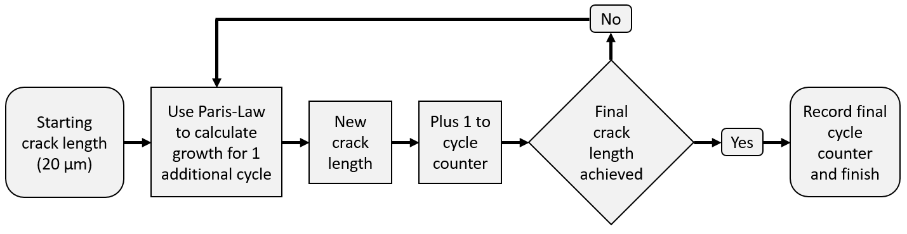
Figure 10 A schematic flow diagram showing the iterative feedback loop process used to calculate the number of cycles to grow a crack from a pre-defined initial crack length to a target crack length.
An average initial starting projected surface short crack length of 20 µm was chosen to represent the crack length immediately following initiation (typically observed on replica records). The number of initiation events forming the main crack was found using a method involving counting ratchet marks from the fracture surface using optometry microscopy described in paper 1. The final (or target) crack length (Table 3) was calculated based upon the average primary crack length required to span the entire sample width (Equation 8).
$$Target final crack length= \frac{Number of initiation events}{Width of sample}$$ | Equation 8
This final crack length (Table 3) assumes the crack initiation events occur at the same time and are equidistant and in plane of one another. An initial crack length error of ± 5 µm was chosen to represent measurement error and small variations in crack length. An error of ± 20 % in the number of crack initiation events that formed the main crack was chosen to represent variations in number of crack initiations events and data processing error (Table 3). The error in the number of cycles for short crack phase does not include possible material blade variations. Due to a non-linear crack growth rate versus ΔK_{Surface} relationship due to the compressive residual stress field for shot peened surface conditions, two Paris-law constants were found for ΔK_{Surface} below and above 20 MPam^{0.5}.
The variation in the final crack length from was the most significant source of error. It was most significant for a shot peened notch surface (90 % of total error) than for the polished notch surface (60 % of total error) due to the substantial retardation of the short crack growth rate.
Constant amplitude loading resulted in the least number of cycles for the short crack phase. Single periodic tensile overloads with OLR of 1.56 every 150 baseload cycles increased the number of cracks making up the primary crack, reducing the final average crack length. However, the compressive residual stress in the notch field induced from the overload cycles retarded the short crack growth rate sufficiently to increase number of cycles during short compared to constant amplitude. The combination of the pre-existing cracks and the higher strain from overload cycles on the shot peened notch surface resulted in the highest number of cracks forming the primary crack and therefore the shortest final average crack length. The overload cycles appear to induce a very small residual relaxation effect at higher ΔK_{Surface} values, slightly reducing the number of cycles in the short crack phase compared with constant amplitude loading.
Surface/Loading condition | Paris-law Constants |  | Final Crack Length (µm) | Number of cycles for short crack phase | Error (Cycles)
 | C | m
Polished | 3.6 x 10⁻⁸ | 2.05 | 1000 | 43 800 | + 9 100  - 5 200
Overload | 1.2 x 10⁻⁸ | 2.3 | 350 | 54 300 | + 8 900  - 7 100
Shot Peened | 1.6 x 10⁻⁶  2.2 x 10⁻¹² | 0  4.5ª | 315 | 92 200 | ± 28 900
Shot Peened + Overload | 3.5 x 10⁻⁷  1.4 x 10⁻¹¹ | 0.65  4.04ª | 229 | 64 500 | + 12 000  - 9 500
Table 3 The Paris-law constants by empirical fitting of experimental short crack growth rate versus ΔK_{Surface} data for various surface/loading conditions including from ref. The estimated number of cycles for the short crack phase is calculated based upon an initial starting crack (20 µm) and the final crack length. The associated error is based upon a variation in starting crack length and final crack length. ª The Paris-law constants for ΔK_{Surface} values greater than 20 MPam^{0.5}. The overload cycles were applied with OLR of 1.56 every 150 baseload cycles.
Combined phases compared with actual values
The average lifetimes of U-notch samples were split into the initation ans short crack pahses with the remaining lifetime comprised of colelescence Figure 11

However, the addition of larger overloads with OLR of 1.56 applied every 150 baseload cycles were found to increase the total life of U-notched samples overall.
Additionally, the number of cycles for the short crack phase were slightly increased due to compressive residual stress ahead of the crack tip induced by the overload cycles.
This result is expected for stainless steel material and is in agreement with several authors {Bernard, 1977 #17;Damri, 1991 #55;Darvish, 1995 #50;Hammouda, 2004 #49;Pommier, 2002 #32;Romeiro, 2009 #36;Salvati, 2017 #84;Shin, 1993 #34;Shuter, 1996 #29;Suresh, 1983 #43;Ward-Close, 1989 #54}.

The lifetime extension is attributed to residual compressive stress and strain hardening beneath the notch surface due to shot peening, hindering short crack growth and increasing the number of cycles for the short crack phase.
The significantly retarded short crack growth rate is responsible for the relatively large approximated error in the total life.
Stacking phases on top of each other incorrectly assumes that phases happen one after another, in reality, phases can occur simultaneously over a transitional period.
The results show short crack growth phase to represent the majority of fatigue life for indicating LCF conditions. Whereas in the HCF the major phase affecting overall life is the initiation phase.
What si remaining life
Why is the remaining life fro polished so small and sp=ol so large
Statement in here about how changing the notch radius did not alter the out of plane distance and therefore it is not expected that a reduction in the radius would affect the number of cycles for the coalescence phase

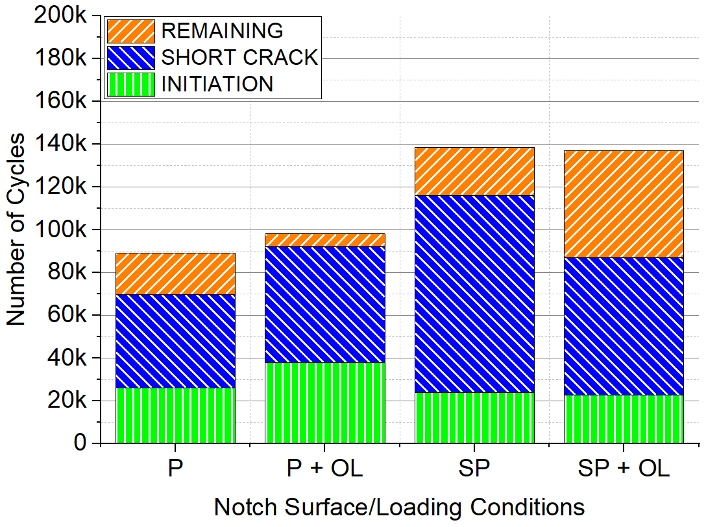
Figure 11 The average total lifetime separated into the initiation, short crack and remaining life stages for U-notched samples with the following surface and loading conditions. Polished (P), Polished with single periodic tensile overloads with OLR of 1.56 every 150 baseload cycles (P+OL), Shot Peened (SP) and Shot Peened with single periodic tensile overloads with OLR of 1.56 every 150 baseload cycles (SP+OL).
The lifetime prediction method was applied and compared with experimental testing of samples subjected to the lifetime extension strategy (LES) (Table). The longitudinal strain range at the notch surface was found using FE modelling developed using the method from ref. The Coffin-Manson relationship for a polished U-notch surface condition table was used to predict the number of cycles to failure for the polished sample. The average percentage life to crack initiation table was used with the Coffin-Manson prediction to predict the number of cycles to crack initiation for a polished U-notch surface. The Paris-law relationship for constant amplitude or single periodic tensile overloads with OLR of 1.56 every 150 baseload cycles was used to predict the number of cycles for a short crack to grow a projected distance of 1 mm from an initial projected crack length of 20 µm. The lifetime extension strategy involving fully grinding away existing cracks followed by T0 shot peening on the top surface of the sample. The load required to maintain the initial strain range of 0.75 % after the lifetime extension strategy was applied was determined using the FE model. The Coffin-Manson relationship for a shot peened U-notch surface condition (table) was used to predict the number of cycles to failure for the shot peened sample. The estimated lifetimes for pre and post lifetime extension strategy are combined to find the total estimated lifetime of the sample and compared with experimental data.
Process / Sample | LE CA 1 | LE CA 2 | LE + OL
Pre-LES strain range from FE modelling | 0.0075 | 0.0075 | 0.0075
Coffin-Manson prediction for polished U-notch | 115 245 | 115 245 | 115 245
Percentage life to crack initiation (polished sample) | 29.1 % | 29.1 % | 38.7 %
Coffin-Manson prediction for crack initiation | 33 536 | 33 536 | 44 599
Paris-Law prediction to 1 mm crack growth | 43 800 | 43 800 | 54 300
Pre-LES strategy prediction | 77 336 | 77 336 | 98 899
Pre-LES cycles found from experimentation | 85 000 | 79 000 | 83 000
Lifetime extension strategy (LES) applied | - | - | -
Modified notch geometry (radius x depth mm) | 1.65 x 2.2 | 1.58 x 3 | 1.65 x 2
Post-LE strain range from FE modelling | 0.0076 | 0.0075 | 0.0074
Coffin-Manson prediction for shot-peened U-notch | 131 030 | 139 466 | 148 688
Actual cycles for shot-peened from experimentation | 159 189 | 119 670 | 136 960
Total predicted number of cycles (subjected to LES) | 208 366 | 216 802 | 247 587
Actual total cycles from experimentation | 244 189 | 198 670 | 219 960
Table 4 The lifetime prediction method is broken out into its constituent processes and applied and compared to three test samples subjected to the lifetime extension strategy (LE).
How the prediction method compares with experimental values
The that account for the total lifetime of an average U-notch sample subjected to the lifetime extension strategy with constant strain range of 0.75% was compared with polished and U-notch surface conditions for constant amplitude loading (Figure 12 A) and with single periodic tensile overloads of 1.56 every 150 baseload cycles (Figure 12 B).

The fatigue lifetime prediction method based upon the total life (Coffin-Manson) and damage tolerant (Paris-law) approaches (Table 4) was used to predict the lifetime for a U-notched sample subjected to the lifetime extension strategy at a strain range of 0.75 % throughout the test.
The same method was used to estimate the number of cycles for samples subjected to overloads with single periodic tensile overloads with OLR of 1.56.

The total fatigue life found from experimentation of two samples subjected to the lifetime extension strategy with constant amplitude loading were averaged and compared with the prediction approach.
The error for the actual lifetime is the range of the two lifetime results obtained.
The total fatigue life from an experiment of a sample subjected to the lifetime extension strategy with overloads with OLR of 1.56 every 150 baseload cycles was compared with the prediction approach and the error based on the range of values from the two constant amplitude tests.

The lifetime prediction closely represents the average lifetime of experimentally tested U-notch samples.
The predicted lifetime of the sample with additional overloads was higher than experimental results, it appears that the number of cracks to initiation may have been initially overestimated, further suggesting that the number of cycles to crack initiation for a polished sample with overload cycles may require more investigation.
A | 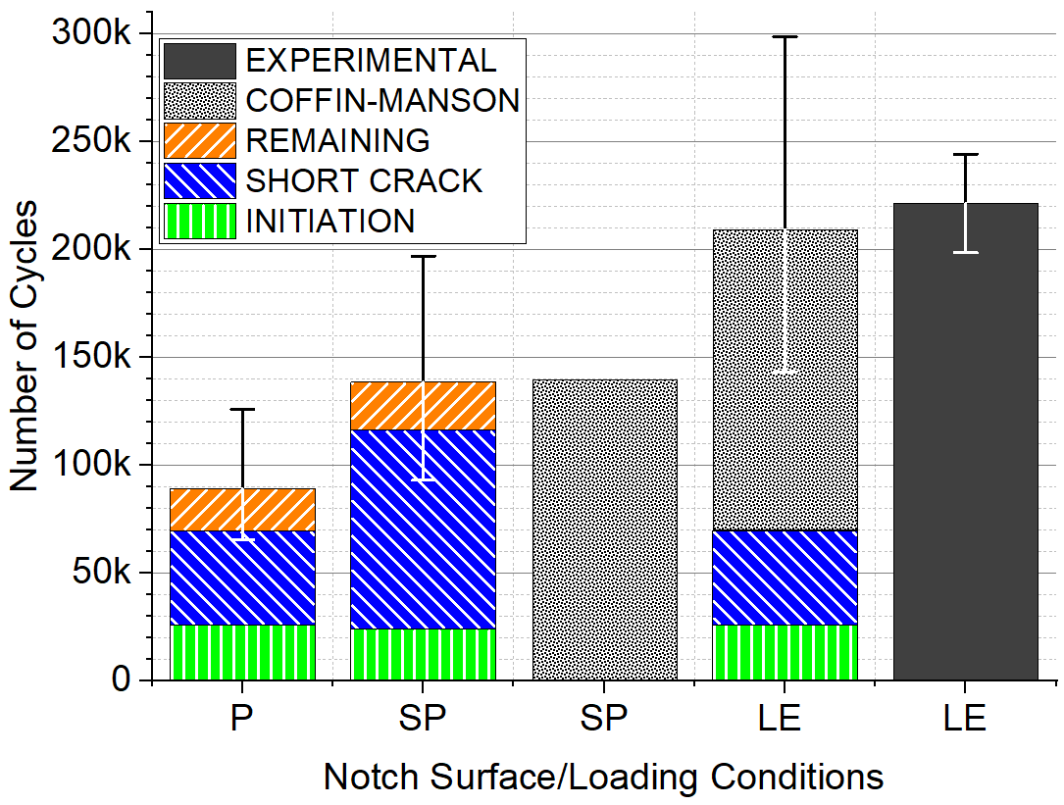 | B | 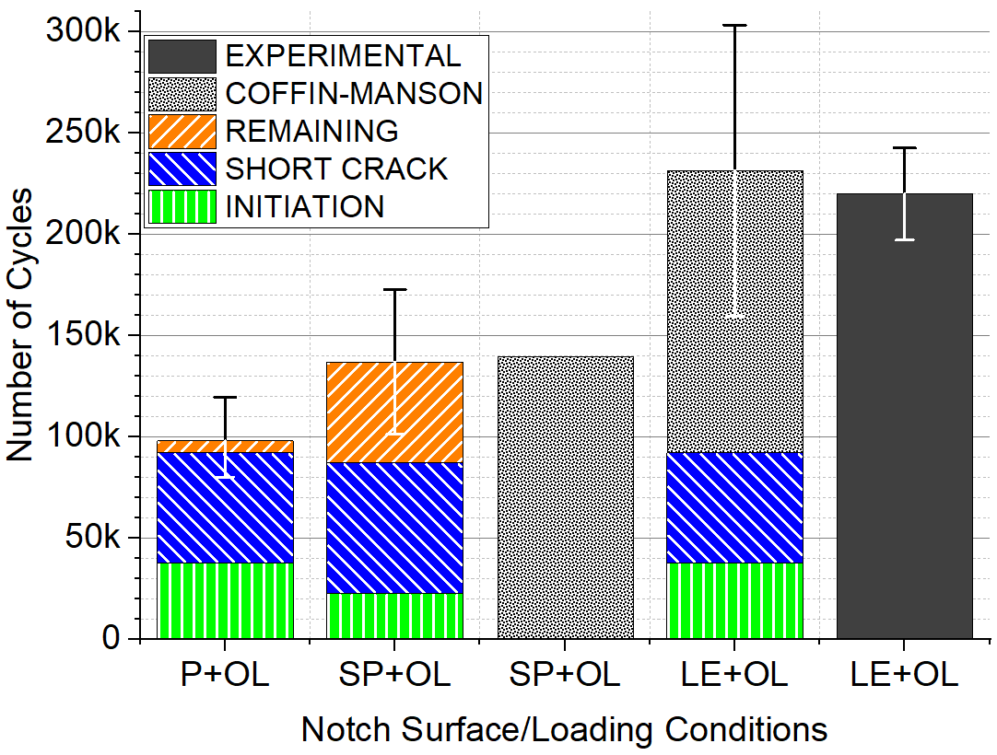
Figure 12 A) The total average lifetime for Polished (P) and Shot Peened (SP) U-notched samples under constant amplitude loading at a strain range of 0.75 % and B) with single periodic overloads with OLR of 1.56 every 150 baseload cycles. The individual phases were used to estimate the number of cycles for samples subjected to the lifetime extension strategy (LE) and compared with a method which uses the Coffin-Manson (CM) relationship for shot peened notch surface conditions to predict total life. Both prediction methods are compared with the average lifetime found experimentally (EXP) for the two samples subjected to the lifetime extension strategy. Maybe ned to look at the error range for the apper as well
The predicted lifetimes using the Coffin-Manson relationship for polished and shot peened samples and using the prediction method described above for samples subjected to the lifetime extension strategy are shown in Figure 13. Results that fall in the red shaded area represent under-conservative predictions, while the blue shaded area represents over-conservative predictions (within a factor of two). It is not surprising that predictions are both over-conservative and under-conservative due to regression fitting of the experimental lifetime data to obtain the Coffin-Manson constants.
The prediction methods for the lifetime extension strategy appear to be relatively accurate and within 15 % of lifetime found experimentally. However, it is more useful from an industrial perspective to offer a conservative approach based upon worst case scenarios. A conservative lifetime prediction for samples subjected to the lifetime extension strategy was made that accounted for a possible worst-case scenario based upon the accumulated error from each lifecycle phase. The predictions were consistently over-conservative, with one prediction less than half the number of cycles found experimentally.
Miners rule
Do not know what to do here, I could go to town and use the miners rule to predict the lifetime extension strategy with overloads by combining the crack initiation percentage and paris law for short crack growth and then use the coffin-manson to predict the lifetimes ofr the strain ranges and use the miners rule to predict the lifetime with overloads. Effectively combining all three coffin manson. Paris law, and miners rule all together in one go. But I am afraid that the paper will have too much content.
The Palmgren-Miner rule cumulative damage approach (Equation 9) was used to predict the lifetime of fatigue samples with single periodic tensile overloads with OLR of 1.56 every 150 base load cycles from ref.
$$N_{fOL}= \frac{n_{BL}}{{n_{BL}+n}_{OL}}N_{f∆εBL}+\frac{n_{OL}}{{n_{BL}+n}_{OL}}N_{f∆εOL}$$ | Equation 9
A polished U-notch sample with notch radius of 2.25 mm and notch depth of 1.25 mm was subjected to constant amplitude loading at the baseload level with a longitudinal strain range of 0.75 % at the notch surface, which failed at 46 654 cycles. A second polished U-notch sample was subjected to constant amplitude loading at the overload level strain range of 1.69 % at the notch surface which failed at 6576 cycles. A lifetime prediction of 46 389 cycles for a polished U-notch sample and with periodic tensile overloads with OLR of 1.56 was made using the Palmgren-Miner rule (Equation 9). A third polished U-notch sample was subjected to single periodic tensile overloads with OLR of 1.56 (strain range of 1.69 % at the notch centre) applied every 150 baseload cycles (0.75 % strain range at the notch centre) to test the prediction which failed at 57 228 cycles. The Palmgren Miner rule was found to be over-conservative by 23 % (Table 5).

Cyclic loading | Miners rule prediction | Number of cycles to failure | Miners rule error
CA Δε = 0.75 % | N/A | 46 654 | N/A
CA Δε = 1.69 % | N/A | 6 576 | N/A
OLR of 1.56 applied every 150 baseload (Δε = 0.75 %) cycles | 46 389 | 57 228 | 23 %
Table 5 The lifetime of two constant amplitude tests at the base load level (0.75 %) and overload level (1.69 %) were used to predict the lifetime for a sample with single tensile periodic overloads with OLR of 1.56 applied every 150 baseload cycles using the Palmgren-Miner rule.
The Palmgren-Miner rule is a damage accumulation rule that always predicts a lower fatigue lifetime for occasional overloads when compared with constant amplitude loading conditions. The Palmgren-Miner rule does not take into account the effects of plasticity and therefore residual stress and strain hardening effects of localised material during low cycle fatigue {Miner, 1945 #116;Sun, 1994 #6}. Therefore, the Palmgren-Miner rule is typically considered to be a conservative prediction.
The Palmgren-Miner rule is typically an over-conservative prediction method and is considered an industrially appropriate for lifetime prediction of samples with single periodic tensile overloads. The Palmgren-Miner rule always predicts a lower lifetime than constant amplitude cyclic loading conditions at the baseload strain range. U-notch samples with overload cycles with OLR of 1.56 every 150 baseload cycles are expected to increase the total number of cycles to fatigue failure. Therefore, it may be more appropriate to use a lifetime prediction method based upon constant amplitude loading at the baseload strain range, where over-conservative lifetime predictions would typically be expected.
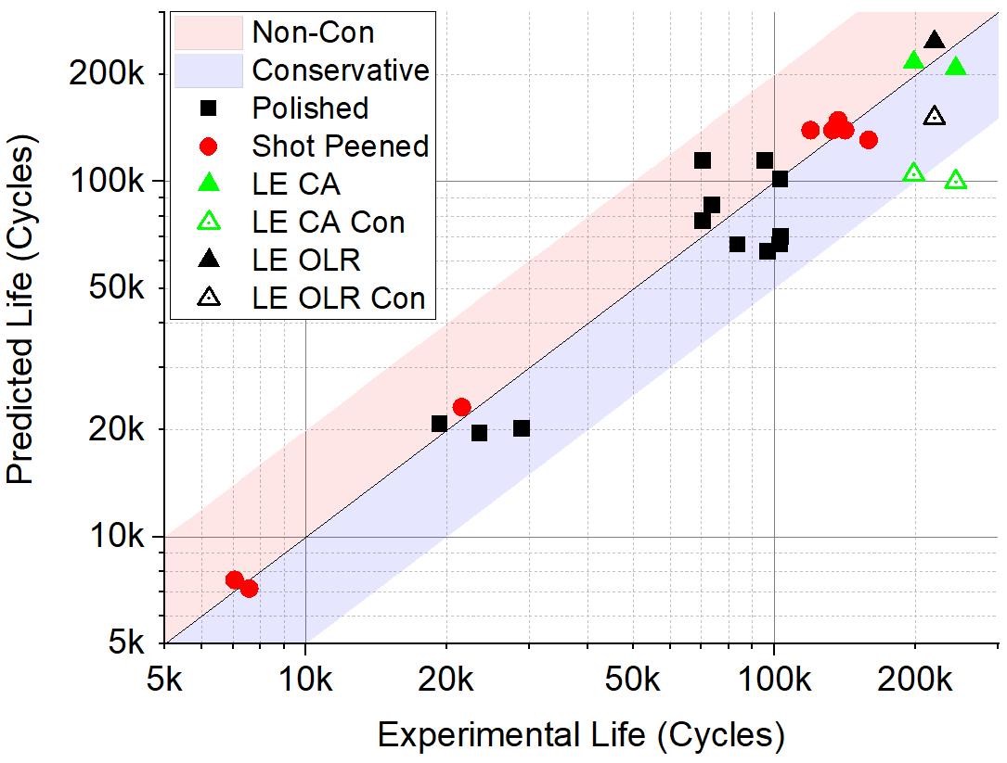
Figure 13 Predicted lifetime versus actual lifetime in number of cycles for the polished (P) and shot peened (SP) notch surface conditions as well as samples subjected to the lifetime extension strategy (LE) using conservative (Con) and non-conservative lifetime predictions methods. Results within the red area indicate under-conservative predictions and results within the blue area indicate over-conservative prediction within a factor of two.
The application of the lifetime extension strategy in an industrial environment is more likely to change the strain range at the U-notch. The prediction method developed in this work can account for strain range changes after such a U-notch geometry modification. The maximum longitudinal strain range at the notch surface that still provides a lifetime extension can be predicted using the Coffin-Manson relationship table. A more conservative (and therefore industrially relevant) maximum strain range prediction was carried out by considering the worst-case accumulated error found from the initiation and short crack phases table.
Sample | LE CA
Pre-LE strain range from FE modelling | 0.0075
Coffin-Manson prediction for the polished U-notch | 115 245
Percentage life for crack initiation (polished sample) | 29.1
Coffin-Manson prediction for crack initiation | 33 536
Paris-law Cycles to 1 mm crack growth (Paris-law) | 43 800
Cycles for pre-LE strategy (prediction) | 77 336
Lifetime extension strategy (LE) applied | -
Minimum cycles needed for overall lifetime extension | (115 245 – 77 336) = 37 909
Maximum strain range from reverse Coffin-Manson | 0.0102
Conservative maximum strain range | 0.0086
Table 6 The lifetime prediction method was modified to obtain a maximum strain range which still provides a positive overall lifetime extension over a polished sample not subjected to the lifetime extension strategy. The conservative maximum strain range assumes the worst possible case considering the maximum applied error.
All cracks were fully ground away with no residual cracks present on the notch surface for all FV566 samples subjected to the lifetime extension strategy. The presence of the residual cracks resulted in early crack initiation and the total lifetimes were similar between samples with or without the lifetime extension strategy applied {He, 2015 #19} highlighting the importance of this consideration as a maintenance procedure for industry. Residual cracks after a grinding process may be representative of a possible outcome in an industrial environment, complete removal of residual cracks must be consistently achieved via inspection methods.
FE modelling can be applied in conjunction with the lifetime extension prediction method developed in this work to complex geometries such as the fir-tree-root-fillets of low-pressure turbine blades. Both tools together can help explore the feasibility of a lifetime extension strategy including grinding out existing cracks followed by shot peening as a maintenance procedure for applicable industrial components.

Conclusions
The additional overload cycles with OLR of 1.56 applied every 150 baseload cycles increased the number of crack initiation events and crack coalescence activity observed on shot peened U-notch samples.
The reduction in short crack growth rates from shot peening was maintained despite the presence of overloads with OLR of 1.56 every 150 baseload cycles due to minimal relaxation of compressive residual stress and strain hardening from the shot peening process.
The application of the lifetime extension strategy increased lifetimes overall over samples with similar U-notch surface, geometry, and loading conditions. This increase in lifetime is attributed to the reversal of the fatigue process, followed by shot peening.
A lifetime prediction model based upon a total life approach (Coffin-Manson) and a damage tolerant approach (Paris-law) successfully predicted the lifetime of samples subjected to the lifetime extension strategy with both conservative and non-conservative estimates.
The model was also used to predict the maximum permissible increase in applied strain range at the notch for continued lifetime extension benefit.
The model could be adopted alongside FE modelling of in-service turbine blade root-fillets to determine the efficacy of the lifetime extension strategy as a maintenance procedure for in-service life extension.

Nomenclature
Include miners rule stuff
FE / FEA | Finite Element / Finite Element Analysis
HRC | Rockwell Hardness
LCF | Low Cycle Fatigue
LE | Lifetime extension strategy
LEFM | Linear Elastic Fracture Mechanics
a | The depth of a long crack or semi-elliptical surface crack
a₁ | Initial starting crack length
a₂ | Final crack length
cproj | Half projected length of a semi-elliptical surface crack length
$$\overline{d}$$ | Average out-of-plane distance between neighbouring cracks
$$E$$ | Youngs Modulus
$$m$$ | Total number of load states
$$N$$ | Number of cycles
$$n$$ | Number of cracks
$$n_{i}$$ | Number of cycles carried out at load state i
$$N_{i}$$ | Number of cycles to failure for load state i
$$N_{f}$$ | Number of cycles to failure
OLR | Overload ratio
$$P_{max}$$ | Maximum load during baseload cycle
$$P_{min}$$ | Minimum load during baseload cycle
$$P_{OL}$$ | Maximum load during overload cycle
R_{a} | Average surface height from the mean reference plane
$$∆ε$$ | Strain range
$$∆ε_{xx}$$ | Strain range in the longitudinal direction
ΔK | Stress intensity factor range
ΔK_{Surface} | Stress intensity factor of semi-elliptical surface cracks
$${ϵ^{'}}_{f}$$ | Fatigue ductility coefficient
$${σ^{'}}_{f}$$ | Fatigue strength coefficient

Acknowledgments
This study is financially supported by the Engineering and Physical Sciences Research Council (EPSRC), UK (Grant EP/N509747/1). The authors would like to acknowledge the funding and support of the University of Southampton. We would also like to thank EDF energy for providing ex-service blade material and industrial co-funding for this project. And lastly James Wise at Frazer-Nash Consultancy (FNC) for providing tensile data for FV566. For the purpose of open access, the author has applied a CC BY public copyright licence to any Author Accepted Manuscript version arising from this submission.

Data statement
All data supporting this study are openly available from the University of Southampton repository at DOI to be established.

Source of funding
This study is financially supported by EDF Energy through the Engineering and Physical Sciences Research Council (EPSRC), UK (Grant EP/N509747/1).

References

