Electrical broth micro-dilution for rapid antibiotic resistance testing

Daniel Spencera, Yuetao Lia, Yiling Zhub, J. Mark Suttonb,c, Hywel Morgana,*

a School of Electronics and Computer Science, and Institute for Life Sciences, University of Southampton, Hants, SO17 1BJ UK

b Technology Development Group, Research and Evaluation, UK Health Security Agency (UKHSA), Porton, Salisbury, SP4 0JG UK

cInstitute of Pharmaceutical Science, School of Cancer & Pharmaceutical Sciences, King’s College London, Franklin-Wilkins Building, 150 Stamford Street, London, SE1 9NH, United Kingdom

*hm@ecs.soton.ac.uk

**Abstract**

Rapid tests to assess the susceptibility of bacteria to antibiotics are required to inform antibiotic stewardship. We have developed a novel test, which measures changes in the impedance of a nanolitre volume of bacterial suspension to determine an “electrical” minimum inhibitory concentration (eMIC). Two representative strains of *Klebsiella pneumoniae, Acinetobacter baumannii, Escherichia coli, Pseudomonas aeruginosa* and *Staphylococcus aureus*, were tested against a panel of frontline antibiotics with different modes of action (ciprofloxacin, doxycycline, colistin and imipenem, gentamicin and ceftazidime). The eMIC measured at 1 hour correlated strongly with a standard 24hr microbroth dilution MIC, for all combinations of antibiotic and bacteria, allowing strains to be correctly assigned as sensitive or resistant measured in a fraction of the time.

Key Words: Antimicrobial Susceptibility Test (AST); Antimicrobial Resistance; Impedance Sensing; Broth Microdilution. Minimum Inhibitory Concentration (MIC)

In 2016, a report chaired by Jim O'Neill predicted that by 2050 anti-microbial resistance (AMR) will be the largest cause of death, killing 10 million worldwide annually [1]. Three years later, in 2019 it has been estimated that, 4.95 million people died from illnesses in which bacterial AMR played a part, with >1 million deaths as a direct result of AMR [2]. Drug-resistant infections kill more people than HIV/AIDS (864,000 deaths) or malaria (643,000 deaths).

One of the recommendations from the O’Neill report was the need for faster and simpler diagnostics, including tests to determine the susceptibility profile of antibiotics [3]. A rapid test would enable informed prescribing of therapy and reduce the ineffective treatment time window. The absence of a simple rapid diagnostic tests drives misuse of antibiotics, accelerating the emergence of antibiotic resistant bacteria. Therefore, tests that can identify the most appropriate antibiotic are required to prevent inappropriate treatment and protect human health.

An Antimicrobial Susceptibility Test (AST) determines the sensitivity of a bacterial pathogen to an antibiotic or panel of antibiotics. The classical AST is performed using either broth micro-dilution (BMD) or disk diffusion, where bacterial growth is measured in the presence of a range of concentrations of antibiotics. An AST is also used to determine the Minimum Inhibitory Concentration (MIC) of an antibiotic. In BMD, this is defined as the lowest concentration of antibiotic that inhibits the growth of an organism measured *in-vitro*. This is measured by eye after an incubation time of typically 24 hours. An AST is the “gold standard” but can take upwards of 48 hours to complete. Although widely used, they are time-consuming principally because the number of bacteria does not reach the minimum detectable level, as defined by the standard protocols, for typically 24 hours in rapidly growing bacteria.

Many rapid AMR tests have been reported in the literature, broadly categorised as either genotypic or phenotypic assays. Genotypic methods detect genes that confer resistance, whilst phenotypic assays monitor changes in the response or behaviour of bacteria when exposed to antibiotics. Because the presence of a gene does not necessarily confer resistance, phenotypic tests are preferred to genotypic and are the most widely used in most settings. Several new tests are in development and some have FDA approval and are commercially available [4,5], but the majority of tests still take many hours.

Microfluidic AMR tests have also been developed [6]. Choi *et al.* described an optical system that could detect antibiotic susceptibility within 4 hours [7]. The system automatically counts bacteria by imaging morphological changes that occur after antibiotic exposure, such as division, swelling formation and filamentary formation. Baltekin *et al.* designed a chip with 2000 parallel micrometre channels to trap and image single bacteria [8]. The bacterium length was measured in the presence of an antibiotic and used to determine susceptibility within 30 minutes. Redox reporters such as resazurin have also been used to measure bacterial metabolism. Besant *et al.* designed an electrochemical device that captures bacteria in miniature wells and delivers a resistance profile after a one hour incubation period [9]. Droplets have been used as nL containers to trap single or small numbers of bacteria, with metabolism monitored by fluorescence [10]. Other approaches measure use flow cytometry and metabolic probes to measure viability after exposure to antibiotics [11]. However, all these methods require either the use of specific electrochemical or fluorescent labels, coupled with complex optical systems.

Electrical or electrochemical methods provide alternative methods of monitoring bacteria growth and behaviour. They are relatively simple and do not require specific probes. Chotinantakul *et al* [12] described a method for detecting susceptibility to antibiotics using an electrochemical respiration assay following a 3 hour incubation period. The growth of bacteria has also been measured directly using electrochemical impedance spectroscopy [13,14]. Bacteria were cultured on antibiotic-seeded hydrogels and the susceptibility determined in a timeframe of around 2 hours. Yang *et al* [15] demonstrated that bacteria trapped in a narrow channel can modify an electrical current flowing through the channel. As bacteria grow or die the resistance changes and the authors measured the response to ampicillin and nalidixic in a 2 hours window. We have also shown that morphological changes in single bacteria induced by antibiotic exposure can be measured directly using single cell impedance spectroscopy [16].

Rather than directly measuring the properties of the microorganisms, it is also possible to infer changes in properties from measurements of the suspending media. It has been known for nearly 100 years that as bacteria divide and grow, they produce a change in the electrical resistance of the suspending medium [17]. The increase in biomass can also be directly measured by capacitance [18-19].

Bacterial growth as determined from conductivity changes in the medium is due to the production of organic acids during metabolism, as illustrated in Fig 1(a). Ur and Brown demonstrated concordance between measured growth and the electrical impedance of the suspending medium [20,21]. The specific bacterial species and presence of antibiotics all influenced the impedance. Cady *et al.* mixed bacterial samples with antibiotics and monitored the impedance over 20 hours [22,23]. They reported that an MIC could be determined by impedance at 5 hours and that this was within a 2-fold difference to an MIC determined by BMD at 20 hours. Richards *et al.* noted that conductivity changes dominate [24]; Colvin and Sherris described a system to determine the MIC of antibiotic using impedance [25]. After overnight incubation there was 93% correlation with visual readings. When the time window was reduced to 6 hours the correlation dropped to only 34% but this was improved by increasing the inoculum concentration.

Miniature interdigitated electrode arrays have been used to improve the sensitivity and simultaneously capture and concentrate bacteria from solution using electrophoresis or dielectrophoresis [26]. Sengupta *et al* showed that the concentration of bacteria could be measured by capacitance and that growth in the presence of antibiotics could be used to determine resistance and an MIC [27]. They showed different changes in capacitance over time and attributed these to differences in the mode of action of the antibiotic, either bacteriostatic or bactericidal.

Safavieh *et al.* developed a simple AMR test by measuring the impedance of bacteria captured using antibodies onto an interdigitated electrode array. They demonstrated that the medium resistance of an *E. coli* suspension or a methicillin-resistant *S. aureus* (MRSA) suspension reduced by >50% within 1 hour, when the initial bacterial concentrations was 106 CFU/mL [28]. Mixing antibiotics with the bacterial samples significantly slowed the resistance change in susceptible bacteria. Their device could detect antibiotic susceptibility of *E. coli* and *S. aureus* based on an end-point impedance after 90 minutes. Scherer *et al* developed a multiplexer circuit to measure many nanolitre chambers in parallel [29]. In contrast to an increasing medium conductivity during growth, *Swami et al* used a low conductivity suspending medium to measure the release of ions following cell death on a miniature interdigitated electrode array [30].

In this paper we describe a simple test that provides an “electrical” minimum inhibitory concentration (eMIC) by measuring the change in the electrical impedance of a bacterial suspension after a short 1 hour exposure to a range of antibiotic concentrations. The protocol was designed to mirror the classical BMD used in diagnostic microbiology laboratories and described by standard ISO 20776-1:2019 [31]. During growth bacteria metabolise sugars to lactic acid or other organic acids and other compounds that decrease the pH and increase the conductivity of the suspending media (Figure 1a). However, for slowly dividing or non-viable bacteria that are susceptible to have been exposed to antibiotics this change in conductivity is small or non-existent. Both the resistance and capacitance of a suspension of bacteria can be influenced by many factors other than the antibiotics, including temperature. In order to obviate these issues, we developed a simple difference measurement technique that cancels out any non-biological trends. Two samples of identical bacteria are measured together. One is exposed to antibiotic, whilst the other (control) sample is not. The difference between the two impedance signals after 1 hour incubation indicates the degree of susceptibility or resistance.

RESULTS AND DISCUSSIONS

The conductivity of a suspension of bacteria in standard growth medium was measured with a miniature sample cell, shown conceptually in Fig 1b. The “sensor chip” consists of sets of platinum micro-electrodes fabricated onto a glass substrate. Each sample well contains one set of four electrodes that measures the electric impedance of the sample at low AC frequencies. Two outer electrodes inject an AC current, whilst a pair of inner electrodes is used to measure the voltage drop. Two sensors are used simultaneously, one containing the antibiotic exposed sample and the other the control (non-exposed) sample. The sensing chip is fabricated so that a narrow channel runs over the electrodes (see Methods). The total volume of the channel is 2L, but the sample volume above the sensing electrodes is approximately 100nL. Samples of bacteria are injected into the device with a pipette, and the entry and exit ports covered with a thin layer of mineral oil to prevent evaporation. The impedance is measured at time zero and again after 1 hour. Chips can be washed and reused. For further details see Methods

In a typical test, a colony of bacteria from an overnight culture is resuspended in MH1 broth to an optical density (OD) equivalent to approximately 106 CFU/mL. Aliquots are mixed with specific antibiotics at different concentrations including a control sample with no antibiotics, and samples introduced into the chip. The chips are incubated for 1 hour at 37 °C on a heated plate, which is part of the reader (see Methods). This protocol is shown in Fig 1(c). The change in impedance of the antibiotic-exposed samples is measured (100mV at 100Hz), and referenced against an identical control sample with no antibiotics. The magnitude of the impedance at the start of the test ( $\left|Z_{t=0}\right|)$ and at the end ( $\left|Z_{t=60}\right|)$ was normalised to the control (0mg/L) according to the following equation (the phase angle is always close to zero).

$Normalised conductivity change (∆κ)=\frac{{\left[\left|Z_{60}\right|-\left|Z_{0}\right|\right]}_{Antibiotic}}{{\left[\left|Z_{60}\right|-\left|Z_{0}\right|\right]}_{No antibiotic}}$ (1)

Bacteria that are resistant to antibiotics continue to grow and metabolise, and the change in impedance in both control and antibiotic exposed is almost the same, so that $∆κ$ is close to 100%. Any change in growth due to the presence of antibiotic reduces $∆κ$, and for fully susceptible bacteria this is close to 0%.

Fig 1d shows an example dataset for *K. pneumoniae* strain NCTC 13368 exposed to ceftazidime at a range of different concentrations. The x-axis shows the normalised conductivity change (equation (1) and the y-axis is the log2 fold concentration range of antibiotics, as per a standard BMD. The error bars show the standard deviation for n=3 biological repeats. By definition the first bar (antibiotic concentration = 0 mg/ml) is set to 100%. The graph shows that for low antibiotic concentrations, the change in conductivity is similar to the control. At higher antibiotic concentrations, the change after 60 minutes is much lower. In other words, the antibiotic exposed cells do not grow (or die) whilst the control cells continue to grow leading to a large (differential) change in the conductivity of the suspending medium. Overlaid on the image is the MIC determined by a classical broth microdilution (after 24 hours) for the same sample (16mg/L) demonstrating excellent concordance with the electrical MIC (or eMIC). Having demonstrated the principle of the system, the *Klebsiella* response was measured for six different antibiotics representing a wide range of modes of action. The antibiotics were *ceftazidime, colistin, ciprofloxacin, gentamicin, imipenem* and *doxycycline*, and their modes of action summarised in Table 1.

|  |  |
| --- | --- |
| Ceftazidime | Inhibition of cell wall synthesis by binding to penicillin-binding proteins. |
| Ciprofloxacin | Fluoroquinolone that acts on topoisomerases (DNA gyrase) preventing supercoiling of the DNA and DNA replication. |
| Colistin | Targets cell membrane binding to LPS and phospholipids displacing divalent cations leading to disruption of the outer cell membrane and death |
| Doxycycline | Bacteriostatic (rather than bactericidal). Stops bacteria growth by binding to the 30S ribosome. Lipophilic so easily crosses multiple membranes. |
| Gentamicin | Inhibits protein synthesis by binding 30S ribosomes. |
| Imipenem | Inhibition of cell wall synthesis by binding to penicillin-binding proteins. |

Table 1. Summary of mode of action for the different antibiotics used

Figure 2 shows the conductivity data for *K. pneumoniae*; NCTC 13368 exposed for one hour to each of these different antibiotics. The height of the bars indicates the response of the bacteria as measured by changes in conductivity, normalised to 100% according to equation (1). The bars are the mean of three repeats with one S.D. Also shown is the MIC for each sample as determined by BMD (after 24 hours) - shaded dark-blue regions in the figure. The light blue regions either side highlight the ±1 dilution band corresponding to the accepted tolerance of the broth MIC method, where a 2-fold differences in MIC not generally regarded as significant (see ISO 20776-1:2019 [31]). The conductivity change across the dilution range follows a sigmoidal shape, where the drop in conductivity mirrors observations made with classical broth microdilution. For all antibiotics the conductivity change starts to drop at sub-MIC concentration and falls below 50% at the MIC; little or no change in conductivity is observed at antibiotic concentrations above the MIC. It is noteworthy that despite the wide range of different antibiotics used, the general method of measuring the impedance change provides an eMIC that is consistent (within one dilution) with the BMD. Of note is the response to imipenem, a carbapenem that inhibits growth at even the lowest antibiotic concentration used in this study (0.125mg/mL corresponding to the broth MIC), the relative conductivity change during one hour is almost zero. All six antibiotics lead to observable differences in suspending media conductivity relative to the control but there does not appear to be anything to link the changes to the mode of action of the antibiotic apart from doxycycline. This is a bacteriostatic antibiotic which does not kill the cells but inhibits. division. Even in this case there is a significant change in the impedance after the 1 hour incubation window. The observed changes in impedance are a function of the metabolic state and growth of the bacteria, so should be similar for most bacteria irrespective of resistance mechanism. The only exception might be resistance mechanisms which are switched on more slowly by bacteria, such as vanA expression in Enterococcus

To determine the equivalence between our rapid readout (electrical metabolism) and classical methods, a range of different bacterial species was measured consisting of five different species (two strains of each) using the same six antibiotics. The panel was *K. pneumoniae* (NCTC 13368 and M6), *E. coli* (NCTC 12923 and LEC001), *S. aureus* (EMRSA-15 and ATCC 9144), *A. baumannii* (AYE and ATCC 17978), *P. aeruginosa* (PAO1 and NCTC 13437). The original data (impedance before normalisation) for all 10 bacteria and 6 antibiotics is in the ESI, Figure S1, where the y-axis is the absolute change in impedance (not normalised). This entire data set can be consolidated into a set of 6 plots as shown in Figure 3 where the normalised electrical impedance change is plotted against antibiotic concentration for all the different microorganisms. For each of the six antibiotics (a) to (f). there are two plots. For each plot, the left hand side panel is the normalised electrical impedance vs absolute antibiotic concentration. For clarity of presentation these lines have not been labelled with the name of organism (refer to ESI for individual plots) but are colour coded as per the MIC determined from a standard broth microdilution [32]. The blue colour indicates highly sensitive MIC ≤0.125mg/l; red highly resistant MIC >64mg/L and yellow intermediate 0.125mg/L<MIC≤64mg/L. The rhs panel shows the data scaled to the MIC for the case where this is explicit (i.e. the yellow lines), as the blue or red lines as the MIC for these very sensitive or resistant strains are not exact (i.e. <= minimum or > maximum test concentration). The graph shows that the data collapse onto a single set of sigmoidal curves demonstrating the effectiveness of the rapid e-MIC method for strains with intermediate MICs.

For ciprofloxacin, doxycycline, colistin and imipenem, the curves overlap within a very tight band, whereas for gentamicin and ceftazidime the band is slightly wider. The reasons for this are not clear but one possible explanation could be the presence or relative timing of expression of different resistance mechanisms which affect the conductivity measurement for specific isolates. For doxycycline, a bacteriostatic antibiotic, the mean change occurs at around MIC/4, whilst at the MIC there is close to 0% growth. The MIC is an end-point measurement after typically 24 hours and considers any growth up to that time point. Therefore our observation of partial growth (at sub-MIC concentrations) is not unexpected. For ciprofloxacin at the MIC the conductivity change is in the range 30% to 10%, falling to 0% at 2X MIC. This difference may reflect the different modes of action of the antibiotics, and could be compensated for in any future clinical test. Despite this, the data demonstrates the utility of a fast electrical-MIC test where setting the threshold for conductivity to e.g. 10% would correctly identify the MIC within +/- 2-fold dilution.

From data in Figure 3 it is not possible to determine an exact value for the electrical MIC; this requires defining a threshold in the impedance data (). In classical broth microdilution the threshold is defined as the point at which growth is no longer observable by eye. To set a similar threshold we calculated the average value of  for the set of yellow impedance curves using the MIC determined by BMD – see Fig S2 for further details. Figure 3 shows that the impedance sensitivity depends on the antibiotic, i.e. the impedance reduces earlier for some antibiotics compared with others. Therefore the same calculation was done separately for each antibiotic. We then defined the eMIC as the lowest antibiotic concentration at which  is below this threshold (see Fig S2). Finally the correlation between the eMIC and MIC is plotted in Figure 4 for all antibiotic/strain combinations. The figure shows that the eMIC matches the classical MIC within one dilution for all cases. This is termed essential agreement by ISO 20776-1:2019. Note that this data has been collected for a very small panel of antibiotics and strains but it demonstrates the principle of the technique. The threshold for other organisms/antibiotic combinations would need to be determined explicitly by measuring an extensive panel, and is likely to be different for each combination.

The test is designed to integrate into a conventional clinical workflow, typical of any microbiology diagnostic lab in a large hospital. A patient sample such as urine is first pre-processed with the causative organisms grown on agar plates to produce pure cultures. Typically this may be a low electrolyte agar, for example a CLED plate (cystine–lactose–electrolyte-deficient agar) that is a non-inhibitory growth medium for the isolation and differentiation of urinary *Enterobacteriaceae* and *Pseudomonas*. After 24 hours, colonies are then re-streaked onto conventional agar plates for disk diffusion experiments, or alternatively suspended in media for a BMD assay which takes another 18 – 24 hours. For blood, a 10mL blood bottle (containing growth medium) is kept at 37oC until bacterial growth is detected (from a pH change due to CO2) which can be many days. A classical AST is performed when sufficient organisms are present. Because our assay requires fewer total organisms it does not require the full 24 hour incubation on a purity plate and could be integrated into a standard clinical workflow. For example a rapid AST would be performed on organisms taken from a CLED plate after a short growth period (a few hours), thus significantly shortening the time of the AST, potentially from nearly 2 days to a few hours (within a clinical shift).

CONCLUSION

This paper has demonstrated a very simple, inexpensive and rapid method of determining the Minimum Inhibitory Concentration (MIC) of bacteria by measuring the change in the electrical conductivity of the suspending medium containing a few hundred organisms. The test was evaluated with a panel of 10 different bacterial strains and 6 antibiotics demonstrating excellent equivalence with the classical broth microdilution assay. The measurement chamber volumes are small (100nL) and uses standard concentrations of bacteria (106 cfu/mL), making the technology suitable for applications where few bacteria are available, for example susceptibility testing of bacteria in blood [33]. The electrical measurements can be easily scaled and multiplexed to monitoring large number of chambers simultaneously, ideal for the high throughput requirements for clinical microbiology laboratories. The current system is designed to fit into a standard clinical workflow, where colonies are picked from overnight purity plates. Development of a rapid test that is direct from sample would require additional methods of extracting and purifying bacteria prior to incubation in media. ~~Finally, the compact format is suited to rapid testing in primary care where the majority of antibiotics are prescribed.~~

**METHODS**

**Chip sensor design**

The measurement chip shown in Figure 1 (b) has two chambers side by side, one for the control (no antibiotic) and one for the exposed (with antibiotic) bacterial sample. The base of chip comprises a glass substrate onto which pairs of platinum microelectrodes are fabricated by photolithography. Each electrode is 200µm wide; the distance between the measurement electrode pair is 1.2mm and the outer (drive) electrode pair centre-to-centre spacing is 2mm. A measurement chamber is made from PMMA bonded to the glass substrate using double sided medical grade adhesive tape (3M). The PMMA chamber is designed to be filled with approximately 2μL of sample, but the measurement chamber volume (covering the electrodes) is only approximately 200nL (125-µm deep, 4-mm long and 400-µm wide). The detection volume (above the two sensing electrodes) is approximately half of the culture chamber volume (around 100nL). Bacteria are loaded into the chamber at a concentration of approximately 106 cfu/mL in MH1 media using a pipette. A minimum of two samples is required, one without antibiotic (control) and one (or more) with fixed concentrations. After filling the inlet and outlet chambers are covered with a thin layer of mineral oil to prevent evaporation. Each chip measures a single antibiotic at a single concentration; multiple chips are connected in parallel and signals processed through a multiplexer. A simple electronic circuit provides a constant current drive signal of 100mV at 10Hz to the outer electrode pair, with the impedance magnitude determined from the voltage measured across the inner electrode pair. The real part of the impedance is the sample conductivity (phase angle is zero). The measurement chips sit on a heated pad (Kapton Polyimide Flexible Heater, Omega USA) to maintain a temperature of 37 °C, via a PID controller (Red Lion PXU30020 USA). A type K thermocouple (TENMA) was placed directly on the chip (with thermal paste) and used to control the PID. A photograph of the final assembly is shown in ESI, Fig S3.

**Chip calibration**

The sensor performance was evaluated using conductivity calibration solutions. The impedance magnitude vs frequency is show in ESI Fig S4 demonstrating that the signal is independent of frequency below 100kHz and that the measured signal is dominated by the real part of the impedance. The accuracy of the system was evaluated by plotting the difference in impedance signal compared to a commercial conductivity meter (RS PRO 123-8777) with calibration solutions (Hannah Instruments). For values of conductivity around 0.5 S/m, the error was less than 1% (see ESI). Note that for measurement of bacteria, only the relative change in conductivity with time is required (not the absolute value) so that the accuracy is less important.

**Broth micro dilution**

*K. pneumoniae* (NCTC 13368 and M6), *E. coli* (NCTC 12923 and LEC001), *S. aureus* (EMRSA-15 and ATCC 9144), *A. baumannii* (AYE and ATCC 17978), *P. aeruginosa* (PAO1 and NCTC 13437) (as described previously [34]) were used for resistance/susceptibility testing using a modified version of the CLSI standard method, with MH1 media replacing MH2, to facilitate comparison with the conductance measurements. The strains were cultured in a shaking incubator at 200 rpm, overnight at 37°C in 3 mL MH1 broth. The OD of overnight culture was determined at 600 nm. In a 96-well plate, 200 µL bacterial suspension in MH1 broth, with a final OD equivalent to 5x105 cfu/ml, were incubated with antibiotics at 64 μg/mL to 0 µg/mL. The endpoint OD600 of each well was recorded after the 96-well plate was incubated at 37°C for >20 hours.

DATA AVAILABILITY STATEMENT

The data that support the findings of this study are openly available in University of Southampton repository at http://doi.org/[doi].

**References**

[1] O’Neill, J. (ed.) The Review on Antimicrobial Resistance. Tackling drug-resistant infections globally: final report and recommendations. 1–72 (amr-review.org, HM Government, 2016).

[2] Murray, CJL *et al*., Global burden of bacterial antimicrobial resistance in 2019: a systematic analysis, The Lancet, **399**, 629 – 655 (2022).

[3] O’Neil, J. (ed) Rapid diagnostics: Stopping Unnecessary use of Antibiotics. (amr-review.org, HM Government, 2015)

[4] Puttaswamy S, Gupta S.K., Regunath H., Smith L.M. and Sengupta S., A Comprehensive Review of the Present and Future Antibiotic Susceptibility Testing (AST) Systems. Archives of Clinical Microbiology **9** 83 2018

[5] Alex van Belkum, Carey-Ann D. Burnham, John W. A. Rossen, Frederic Mallard, Olivier Rochas & William Michael Dunne Jr. Innovative and rapid antimicrobial susceptibility testing systems. Nature Reviews Microbiology 18, 299–311 (2020)

[6] Ning Qin, Pei Zhao, Emmanuel A. Ho, Gongming Xin, and Carolyn L. Ren. Microfluidic Technology for Antibacterial Resistance Study and Antibiotic Susceptibility Testing: Review and Perspective. ACS Sens., 6, 3–21 (2021)

[7] Choi, J. et al. A rapid antimicrobial susceptibility test based on single-cell morphological analysis. Sci. Transl. Med. 6, 267ra174 (2014)

[8] Baltekin, Ö., Boucharin, A., Tano, E., Andersson, D. I. and Elf, J. Antibiotic susceptibility testing in less than 30 min using direct single-cell imaging. PNAS 114, 9170–9175 (2017).

[9] Besant, J. D., Sargent, E. H. and Kelley, S. O. Rapid electrochemical phenotypic

profiling of antibiotic- resistant bacteria. Lab. Chip 15, 2799–2807 (2015).

[10] Postek W and Garstecki P., Droplet Microfluidics for High-Throughput Analysis of Antibiotic Susceptibility in Bacterial Cells and Populations. Acc. Chem. Res., 55, 605−615 (2022)

[11] Mulroney, K. T. et al. Rapid susceptibility profiling of carbapenem-resistant

Klebsiella pneumoniae. Sci. Rep. 7, 903 (2017).

[12] Chotinantakul K., Suginta W., and Schulte A. Advanced Amperometric Respiration Assay for Antimicrobial Susceptibility Anal. Chem., 86 10315–10322 2014

[13] Hannah S., Addington E., Alcorn D., Shu W., Hoskisson P.A. and Corrigan D.K, Rapid antibiotic susceptibility testing using low-cost, commercially available screen-printed electrodes. Biosensors and Bioelectronics 145 111696 2019

[14] Hannah S., Dobrea S., Lasserre P., Blair E. O. Alcorn D., Hoskisson P.A. and Corrigan D.K. Development of a Rapid, Antimicrobial Susceptibility Test for E. coli Based on Low-Cost, Screen-Printed Electrodes Biosensors 2020, 10 153

[15] Yang Y., Gupta K., Ekinci K.L. All-electrical monitoring of bacterial antibiotic susceptibility in a microfluidic device PNAS 117 10639-10644 2020

[16] Spencer D.C., Paton T.F., Mulroney K.T., Inglis T.J.J., Sutton J.M., Morgan H. A fast impedance-based antimicrobial susceptibility test Nat Comm. 11(1): 5328, (2020)

[17] Parsons. L.B and Sturges W.S. The possibility of the conductivity method as applied to studies of bacterial metabolism. Journal of Bacteriology, 11 177, (1926)

[18] Kell D.B. and Todd R.W. Determination of biomass WO 88/02114

[19] Sengupta S, Battigelli D.A. and Chang H-C. A micro-scale multi-frequency reactance measurement technique to detect bacterial growth at low bio-particle concentrations Lab Chip, 6, 682–692 (2006)

[20] Ur, A., and Brown DFJ. 1974. Rapid detection of bacterial activity using impedance measurements. Biomed. Eng. 9:18-20.

[21] Ur, A., and Brown DFJ. 1975. Impedance monitoring of bacterial activity. J. Med. Microbiol. 8:19-28.

[22] Cady, P. 1975. Rapid automated bacterial identification by impedance measurement, p. 73-99. In C. G. Heden and T. Illeni (ed.), New approaches to the identification of microorganisms. John Wiley and Sons, Inc., New York.

[23] Cady P, Dufour SW, Shaw J, Kraeger SJ, Electrical Impedance Measurements: Rapid Method for Detecting and Monitoring Microorganisms. J. Clinical Microbiology **7** 265 (1978)

[24] Richards JCS., Jason AC, Hobbs G, Gibson DM and Christie RH Electronic measurements of bacterial growth Journal of Physics E: Scientific Instruments, 11. 560-580. (1978)

[25] Colvin H.J. and Sherris J.C. Electrical Impedance Measurements in the Reading and Monitoring of Broth Dilution Susceptibility Tests. Antimicrob Agents Chemother. **12** 61–66. (1977)

[26] R. Gomez-Sjoberg, D. T. Morisette and R. Bashir, "Impedance microbiology-on-a-chip: microfluidic bioprocessor for rapid detection of bacterial metabolism," J Microelectromech Syst, **14** 829-838 2005

[27] Puttaswamy S, Lee BD, Amighi B, Chakraborty S, Sengupta S Novel Electrical Method for the Rapid Determination of Minimum Inhibitory Concentration (MIC) and Assay of Bactericidal/Bacteriostatic Activity. J Biosens Bioelectron S2:003. (2011)

[28] Safavieh M,  Pandya H.J., Venkataraman M., Thirumalaraju P., Kanakasabapathy M.K., Singh A., Prabhakar D., Chug M.K. Shafiee H., , Rapid Real-Time Antimicrobial Susceptibility Testing with Electrical Sensing on Plastic Microchips with Printed Electrodes ACS Appl Mater Interfaces. **14** 12832-12840 (2017)

[29] Scherer B *et al*, Digital electrical impedance analysis for single bacterium sensing and antimicrobial susceptibility testing. Lab Chip, 21, 1073 (2021)

[30] Swami P ., Verma G., Holani A., Kamaraju S., Manchanda V., Sritharan V. and Gupta S. Rapid antimicrobial susceptibility profiling using impedance spectroscopy. Biosensors and Bioelectronics **200** (2022) 113876

[31] <https://www.iso.org/standard/70464.html>

[32][www.eucast.org/fileadmin/src/media/PDFs/EUCAST_files/Disk_test_documents/2022_manuals/Reading_guide_BMD_v_4.0_2022.pdf](http://www.eucast.org/fileadmin/src/media/PDFs/EUCAST_files/Disk_test_documents/2022_manuals/Reading_guide_BMD_v_4.0_2022.pdf)

[33] Pitt WG *et al*, Rapid Separation of Bacteria from Blood—Review and Outlook, Biotechnol Prog. July 08; 32(4): 823–839 (2016)

[34] Picconi P *et al*. New Broad-Spectrum Antibiotics Containing a Pyrrolobenzodiazepine Ring with Activity against Multidrug-Resistant Gram-Negative Bacteria J. Med. Chem., 63, 13, 6941–6958 (2020)

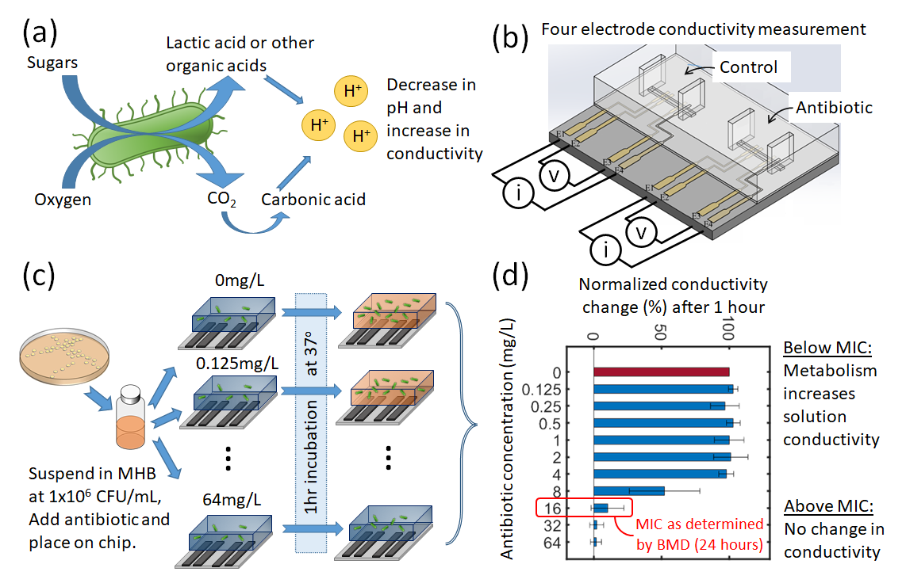

Figure 1. Principle of the rapid eMIC. (a) Actively dividing bacteria metabolise carbohydrates and other compounds leading to a change in the pH of the conductivity of the suspending medium. This is measured with 4-electrode conductivity cell with a 200nL measurement volume in a microfabricated glass chip as shown in (b). (c) is a graphical representation of the protocol: colonies from a plate are resuspended in Muller-Hinton Broth (MHB) to a concentration of 106 CFU/mL, mixed with different concentrations of an antibiotic (diluted a log 2 scale from 0.125 to 64mg/L) plus a control. (d) shows a typical results profile. At antibiotic concentrations below the MIC, the conductivity change after 1 hour is similar for the antibiotic & control samples, reflecting active cell metabolism and growth. At higher concentrations, the antibiotic halts metabolism and there is no change in the suspension conductivity (0%).

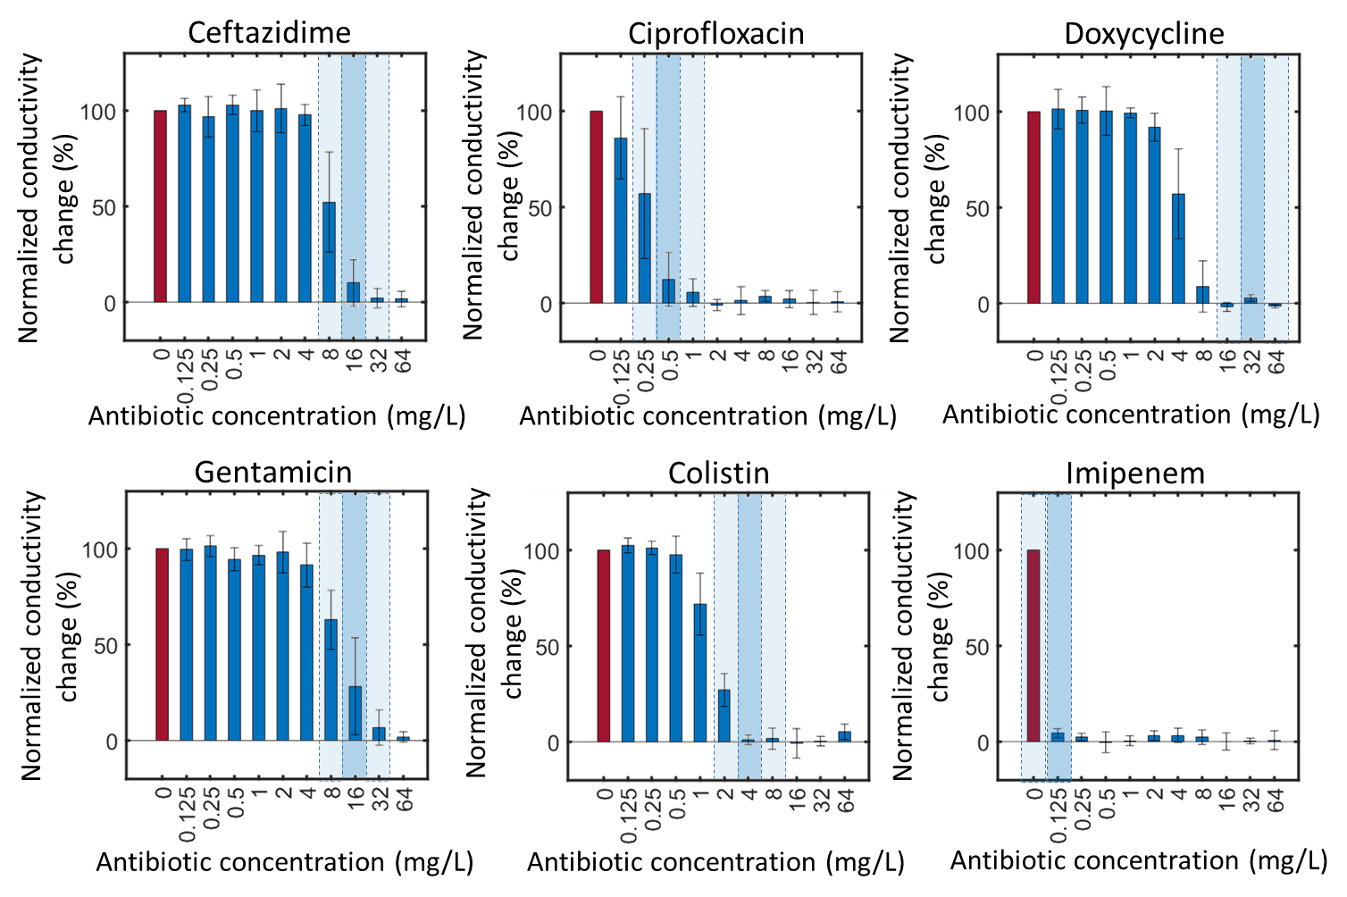

Figure 2. Bar chart showing the relative growth of *Klebsiella pneumonia* strain 13368 after a 1 hour exposure to 6 different antibiotics at 10 different concentrations (and a control of 0mg/L). The y-axis represents the normalised conductivity change at 60 minutes, which is 100% for the unexposed sample and is shown as the red bar for clarity. The height of the bar is the mean for n=3 biological repeats and the error bar shows the standard deviation. The MIC for each sample as determined by BMD (after 24 hours) is shown by the shaded dark-blue regions. The light blue regions either side highlight the ±1 dilution band corresponding to the accepted tolerance of the BMD.

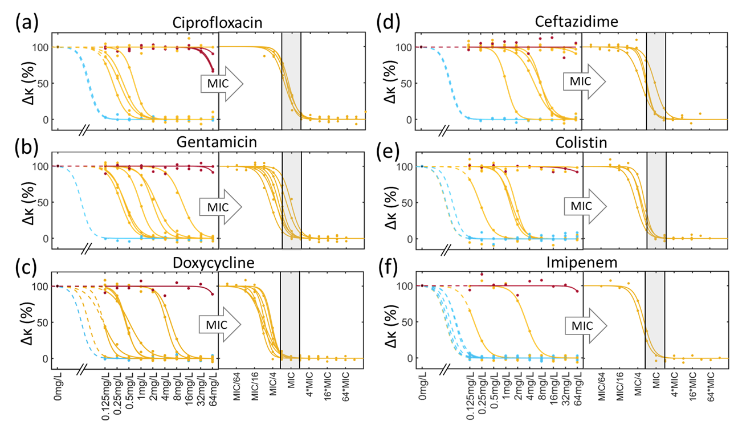

Figure 3. The normalised impedance change for 10 different bacteria (5 species, 2 strain of each), exposed to 6 different antibiotics. Each line is for a different organism (not labelled for clarity, see ESI for the complete dataset). The lines are colour coded as per the MIC determined by a standard broth microdilution (BMD), where blue is highly sensitive ≤0.125mg/l, red is highly resistant >64mg/L and 0.125mg/L<MIC≤64mg/L in yellow. For each of (a) to (f) the normalised conductivity change is plotted against the absolute antibiotic concentration (lhs) and also against the MIC (rhs) determined from the BMD.

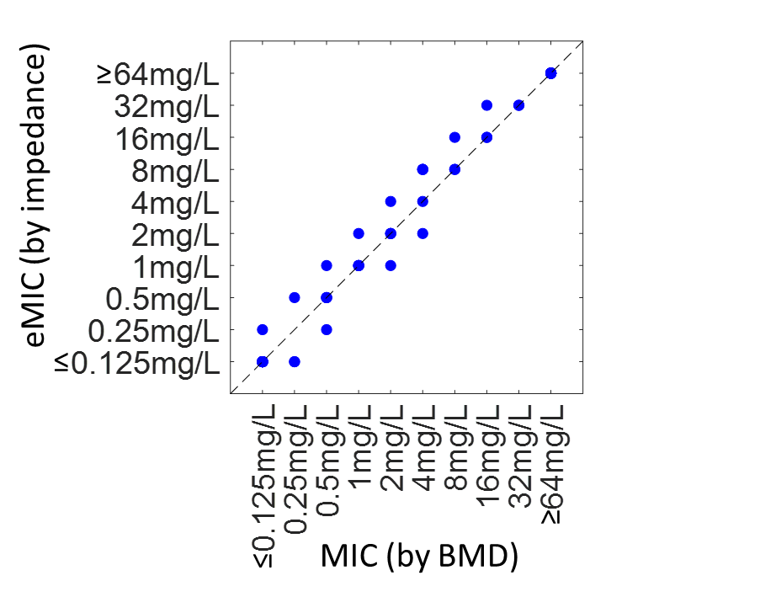

Figure 4. Correlation between the classical MIC determined by broth microdilution (BMD) at 24 hours and the eMIC determined after 1 hour incubation by impedance. The eMIC is defined (from Figure 3) as the antibiotic concentration for which the normalised impedance () falls below a threshold (see text for details). Note that many data points overlap.

For TOC only

