Abstract

Advances in automotive engineering have brought about a range of new vehicle technologies, such as automation, connectivity and electrification, which are expected to have multiple effects on different aspects of people’s lives and have the potential of radically transforming the transportation status quo. This paper explores the effects that such new technologies can have on land use by employing a Land Use and Transportation Interaction (LUTI) modelling approach. A new methodology is developed to simulate the effects of automation, connectivity and electrification on accessibility and to conduct a sensitivity analysis. The analysis is carried out on a regional scale to determine the effects of the new technologies on multiple cities that form a region. The case study for this application is the region of the West Midlands (UK). The results suggest that new vehicle technologies can affect accessibility, population and employment in the cities of the region, the region itself, as well as the peripheral zones beyond the boundary of the region in a 15-year modelling period. Most notably, the two main urban cores of the region are found to not lose their financial power, despite increases in employment opportunities and population density in more rural outskirts. The increased accessibility also results in the relocation of lower-income households to places with lower housing rent. The sensitivity analysis shows that these findings are mostly impacted by changes in road capacity (which is expected to be generally higher as a result of these new technologies), as well as different penetration levels in the fleet.

Keywords: automation, connectivity, electrification. LUTI, West Midlands

INTRODUCTION

Transportation changes rapidly due the new opportunities created by advances in various related sectors. Recent advances in automotive engineering have led to new vehicle technologies, such as automation, connectivity and electrification, which have culminated to the creation of Connected and Autonomous Vehicles (CAVs) and Electric Vehicles (EVs). The examination of the effects of these new technologies on the spatial distribution of activities is important for professionals in the field, as the last time that such a transformative and disruptive intervention in transportation occurred was when the private car was introduced, which suddenly resulted in higher accessibilities in the outskirts of the cities and in an almost “explosive” expansion of the urban cores’ peripheries.

The aim of this study is to investigate the effects of new transportation technologies on land use at a regional level of analysis. The importance of the examination of the land use effects from new vehicle technologies has been mentioned in various sources the literature, such as Emberger & Pfaffenbichler (2020), Meyer et al. (2017) and Soteropoulos et al. (2018). Moreover, many studies on the subject have focused on urban scales of analysis (e.g. Emberger & Pfaffenbichler, 2020). However, the examination of the distribution of activities at regional levels is equally important, as also stated in the analysis of Luo et al. (2019), as the effects on the major urban cores will affect whole regions, including not just the major cities, but also rural areas, villages and smaller cities.

Using the well-established framework of Land Use and Transportation Interaction (LUTI) modelling (Geurs and van Wee, 2004), a new approach is developed to reflect projected changes in road capacity and total cost of ownership as a result of the new vehicle technologies. This methodology includes modifications to a number of parameters, such as generalised cost of travel, trip generation rates and Passenger Car Unit (PCU) values. A number of relevant simulation scenarios are developed and applied, utilising the DELTA LUTI model (Simmonds, 2019a), to the example case study of the West Midlands region (UK) in order to explore changes in accessibility and to conduct a sensitivity analysis.

The rest of the paper is structured as follows. Section 2 presents the background of the study by reviewing the literature to establish the research gap. Section 3 describes the study’s methodological approach and, starting from a brief description of the simulation framework for this analysis, application case study and also explains how LUTI models are adapted to consider the effects of new vehicle technologies on land use and to define the scenarios tested. Section 4 reports and discusses the results of the simulation process and sensitivity analysis. Finally, Section 5 concludes the paper and identifies areas of future work.

Literature Review
A critical point for implementing this analysis is the literature review, as it provides a foundation of knowledge for the topic. This review includes an investigation of related analyses in order to explore the main characteristics of new transportation technologies and their effects based on the literature and as a result identify a research gap.

New transport technologies and their effects
The necessity to predict land use effects from new transportation technologies has been repeatedly identified in the literature, and this paper aims to shed further light on this research question. For instance, Milakis et al. (2017) explicitly mention that it is necessary to evaluate the effects of automation utilising LUTI models and accessibility measures in the long-term. The technologies, which are most influential in transportation today are connectivity, automation and electrification, which are reflected in different innovations, such as Connected and Autonomous Vehicles (CAVs), Electric Vehicles (EVs), as well as Shared Mobility (Sperling, 2018). This paper focuses on private vehicle ownership of new technologies; thus, the background examination explores CAVs and EVs. A definition for these two technologies is provided next.

- Connected and Autonomous Vehicles:
Vehicles that are driven without human control are called autonomous vehicles. They have the ability to drive with shorter headways and have therefore the potential to increase road capacity (van den Berg and Verhoef, 2016). There are different levels of automation in vehicles, ranging from Level 0, which indicates no autonomy, to Level 5, which represents full automation (Sperling, 2018). The development of ICT has furthermore introduced communication abilities to vehicles. Connected vehicles, hence, are able to utilise wireless communication and support many types of interactions, such as vehicle-to-sensor, vehicle-to-vehicle, vehicle–to-infrastructure, vehicle–to-Internet and vehicle-to-everything (Lu et al., 2014). The two technologies are not mutually exclusive, meaning that a vehicle can be automated, connected or both. The combination of the two technological streams in vehicle technologies lead to CAVs, which have the ability to transmit and receive data and to self-drive, partially or completely (Jadaan et al., 2017).

- Electric Vehicles:
Transport electrification is a rapidly evolving field and comprises a variety of applications, including EVs, but also charging points and wireless continuous electricity supply. The present study focuses on EVs, which, based on their characteristics, can be separated into three main technological categories: Battery Electric Vehicles, Hybrid Electric Vehicles and Plug-in Hybrid Electric Vehicles (Clement-Nyns et al., 2010).

These new vehicle technologies are expected to change the current transportation systems and bring new opportunities to people (May et al., 2020; van Wee et al., 2020). The effects of automation on land use based on the literature are mixed, with urban rural areas becoming attractive due to the lower cost of trips on one hand (Soteropoulos et al., 2018), but with densification of the main urban cores also taking place on the other hand, as trips with shared autonomous vehicles create an inexpensive alternative to public transport (Gelauff et al., 2019). This conclusion is also mentioned in the research of Coppola and Silvestri (2019), as based on their modelling results, if public transport infrastructure is improved and also vehicle automation is incorporated in the system, population and employment are increased within the limits of the CBD and reduced outside of these limits, compared with the business as usual scenario developed for Rome (Coppola and Silvestri, 2019). Cordera et al. (2021) mention that based on their results, vehicle automation does not necessarily cause urban sprawl, if increased road capacity does not increase congestion and if trip rates also do not increase. Based on the results of Bridgelall and Stubbing (2021), if population and employment are increased based on current statistical analyses and predictions, CAVs can possibly increase demand for different land uses, thus leading to changes in the spatial distribution of activities of an urban or regional system. Moreover, Zhang et al. (2021) developed a LUTI framework to incorporate vehicle electrification, and based on their results activity, both residential and employment, is increased in balanced rates across the city of Changzhou in China, but activity is reduced in its peripheral zones.

Automation is, therefore, expected to change various factors that are important in LUTI modelling. Firstly, autonomous vehicles will likely reduce values of time in comparison with non-automated vehicles (Perrine et al., 2020), due to the fact that the burden of driving will be fully or partially removed (Davidson and Spinoulas, 2015; de Looff et al., 2018; Emberger and Pfaffenbichler, 2020; Kolarova et al., 2018; May et al., 2020; Wadud, 2017). Moreover, the existence of electrification is also expected to change the generalised costs of travelling, because the vehicle operating costs will be reduced (UK Department for Transport, 2021a), assuming of course that the current prices and taxes will be maintained.

Another important aspect that will be affected is trip generation. For example, Dias et al. (2020) attempt to incorporate autonomous vehicles in the classical four-stage model. In the trip generation stage, it is suggested that because of less inconvenience related to driving and latent demand, autonomous vehicles become more desirable and this leads to potentially more vehicle trips. This assumption is also in line with the paper of Truong et al. (2017), where the trip generation impacts of autonomous vehicles are analysed in Victoria, Australia by introducing a new model to estimate trip rates, considering also vehicle autonomy (Truong et al., 2017). Trip rates will also increase for Zero Occupancy Vehicle (ZOV) trips due to trips of seniors and students that will, in the future, have access to automation (Bernardin et al., 2019).

Changes are also to be expected in road capacity as a result of shorter headways between vehicles in traffic, enabled by the improved reliability of the vehicles’ connectivity features (Dias et al., 2020; Luo et al., 2019; May et al., 2020). Moreover, using the LUTI model of MARS, at the national spatial scale for Austria, Emberger and Pfaffenbichler (2020) concluded that for different scenarios related to vehicle automation incorporated in the transportation system vehicle-kms are increased up to 22%, with the most pronounced results in the capital city of Vienna and following the other large cities of Austria. In their analysis only if road capacity is reduced, are vehicle-kms reduced, but only by 2% (Emberger and Pfaffenbichler, 2020).

The literature further shows that vehicle ownership costs are expected to change with the existence of new vehicle technologies, due to, for example, different purchase prices and subsidies for electrification (UK Government, 2020b; Palmer et al., 2018) and due to the higher costs of equipment required for automation (Bansal and Kockelman, 2017; Wadud, 2017).

Finally, accessibility, which is a key factor for the LUTI models, has been mentioned to be affected by new vehicle technologies by various sources. For example, according to Luo et al. (2019) accessibility is expected to be increased because of the co-existence of privately owned CAVs and Shared Autonomous Vehicles (SAVs), causing further suburbanisation and urban sprawl (Luo et al., 2019). Similar conclusions have been reached by Nahmias-Biran et al. (2020), Papa and Ferreira (2018) and Cohen and Cavoli (2019). Moreover, based on the results of May et al. (2020), who have implemented scenarios in the LUTI model of MARS for Leeds in the UK to incorporate vehicle automation, accessibility is especially reduced for people that use public transport for every day travel, because public transport demand is reduced. The accessibility impacts of electric vehicles are highly related in the literature with the location of charging infrastructure. He et al. (2020) investigates the interrelation between accessibility and the adoption of EVs and concludes that the density of charging points and their accessibility play a major role for EV adoption. This conclusion is consistent with the works of Sweda & Klabjan (2012), Brost et al. (2018) and Guler & Yomralioglu (2020).

Consequently, the available literature points to a broad consensus that new transport technologies are likely to have substantial impacts on land use and transport patterns. Moreover, based on the report of the US National Cooperative Highway Research Program (2019) and on US Governor’s Office of Planning and Research (2022), these impacts are also investigated not only in the academic community, but also in different sectors among transport and planning professionals, as plans for dealing with vehicle automation have been developed for example among different states in the United States, such as Missouri, Delaware, Iowa, and Texas as well as for a number of cities such as, Los Angeles, San Francisco, Austin and Seattle. An important example of practice in the US is the California Transportation Plan 2050, in which three models (CSF2TDM, TREDIS and CARB’s Vision model) were used complementarily to forecast transportation and land use impacts from a variety of transport innovations including CAVs and electrification. The modelling results from this analysis, which are related to modal split, VMT, delays and emissions, indicated that new vehicle technologies may reduce trip lengths resulting in higher accessibility and increased employment and income (California State Transportation Agency, 2021).

It is, therefore, essential that these impacts are examined holistically, and indeed, this is already highlighted by a number of studies, such as Harney (2019), who suggest that the co-existence of all three technological elements (electrification, automation and connectivity) is likely to bring about more significant changes that may be currently largely unaccounted for. Moreover, an important aspect is that the current literature explores the impact that new vehicle technologies might have on the urban structure, however, exploring the effect at a regional scale is an integral part of urban and regional planning. It is the aim of the present study to address precisely these research questions, namely to determine the land use effects from the co-existence of new vehicle technologies at a regional scale.

Methodology
This section refers to the methodology followed that leads to the results and conclusions. It consists of four parts, namely the procedure for the identification of an appropriate LUTI model, a presentation of the characteristics of the selected case study, the scenario formulation for the sensitivity analysis and the general methodological principles followed to implement the scenarios.

Identifying an appropriate LUTI model
LUTI models can predict the spatial evolution and distribution of activities based on transportation interventions and vice versa. Based on their underlying methodology, they can be classified into three main categories (Timmermans, 2003):
- Aggregate spatial interaction-based models
- Utility-maximising multinomial logit-based models
- Activity-Based, microsimulation models

Models of the first category have been criticised in the literature for lacking a solid mathematical and theoretical base (Fotheringham, 2001). As such, the selected LUTI model for this application needs to be either from the second or the third category. Consequently, LUTI models that could potentially be appropriate for this research include: METROSIM, MEPLAN, TRANUS, MUSSA, URBANSIM, DELTA and PECAS (Jones, 2016; Solignac, 2018; Timmermans, 2003; Wegener, 2014).

Among these models, DELTA has been chosen for this analysis as it has a number of advantages that make it appropriate. First of all it should be mentioned that it is dynamic, as it considers time by iterating in discrete time periods, (Bates & Oosterhaven, 1999; Hunt & Abraham, 2003). Moreover, it works on multi-level scales of analysis (Jones, 2016; Scottish-Executive, n.d.), the number of the modelled employment sectors is this LUTI model is not limited (Simmonds, 1999; Bates et al., 1999). Another important aspect is that DELTA can simulate different household employment compositions, as operate in a micro-level household formation (Wegener, 2006; Acheampong et al., 2015). Today households with one employee only are rare and not representative, especially in high-income countries. For example in the UK 72.8% of households have both parents employed and only 23.5% are one employee households (UK Office for National Statistics, 2022). Furthermore, using a LUTI model with many land use components that represent something different in the urban economic system, is more suitable for this research. DELTA has sub-models in the land use part and is highly analytic (Hunt and Abraham, 2003). Finally, it should be mentioned that it can also be complemented by microsimulation, thus combining procedures from both methodological categories, which provides flexibility (Feldman et al., 2007).

The land use module of DELTA consists of several interacting models as follows:

- Transition model: Determines the amount of residential moving and the establishment of new households.
- Car ownership model: Predicts the number of households owning 0,1 or 2+ cars.
- Location model: Specifies the location and relocation of employment opportunities and of households.
- Employment status model: Updates the employment status and the number and type of home-to-work trips based on the results of the location model.
- Migration model: Simulates the relocation of households to different areas in a region.
- Investment model: Allocates investments to different districts and/or regions.
- Production trade model: Estimates the production of all the employment sectors in all areas of a region (Simmonds et al., 2010).

There are numerous UK transportation models, which are compatible with DELTA, including the Highly Strategic Transport Model (HSTM) (DSC, 2019), London Transportation Studies (LTS), TRAM (Simmonds and Feldman, 2005) and START (Feldman et al., 2007). The transportation model used here is the HSTM, which is implemented to produce the broad results of the Policy Responsive Integrated Strategy Model (PRISM) (Simmonds, 2019b).

Case Study
The selected case study is the West Midlands region in the UK, which borders the East Midlands, North West, South West and South East regions of England, as well as Wales. The most important urban areas in the region are Birmingham and Coventry (Medland, 2012). The region and its metropolitan and urban areas are financially fast-growing areas in England excluding London (West Midlands Combined Authority, 2017). The locations of the West Midlands region and its two major cities, Birmingham and Coventry, are illustrated in Figure 1.
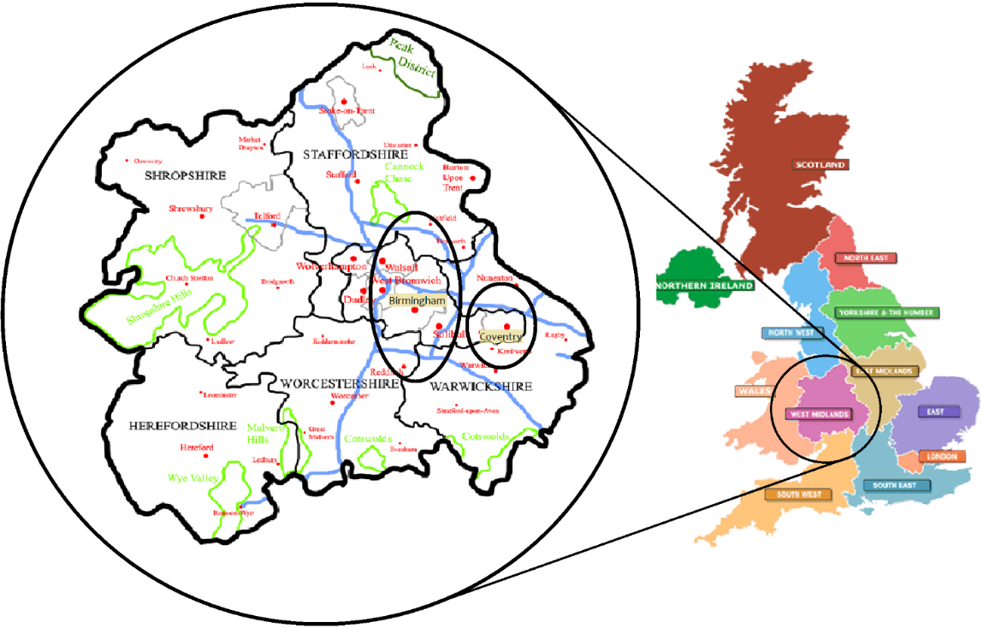
Figure 1: West Midlands, Birmingham and Coventry, adapted from (wikiwand.com, 2021).
The total population of the region exceeds 5 million and the specific distribution of population per county in the region is presented in Table 1. The Gross Disposable Household Income (GDHI) per person in the region is just over £15,000/year, as presented in Figure 2, and since 2002 the size of the labour market has consistently increased (Figure 3) based on the latest UK census (UK Office for National Statistics, 2021)
Table 1: Population in West Midlands (UK Office for National Statistics, 2021)
West Midlands Region | Population
Herefordshire | 187,100
Shropshire | 509,200
Staffordshire | 1,134,500
Warwickshire | 596,800
West Midlands (Metropolitan County) | 2,919,600
Worcestershire | 603,600

Figure 2: GDHI per person in the UK (£) (UK Office for National Statistics, 2021)

Figure 3: Employment in West Midlands (UK Office for National Statistics, 2021)

In terms of transport, the region is served by an advanced roadway network comprising the M5 motorway, which connects the region with the South West England, the M6 motorway, which connects the region with North West England and Scotland, and the A5 expressway, which transverses the region southeast to northwest (UK National Highways, 2022). Moreover, the region is served by a number of railway lines linking it with the rest of the UK (Network Rail, 2022), and there are plans for implementation of high speed rail, under the HS2 project which will connect London to Birmingham (UK Department for Transport, 2016). It is essential to mention that both the road and railway networks are not as dense in the western parts of the region in comparison with the northern and eastern ones (Network Rail, 2022; UK National Highways, 2022), which highly affects accessibility and connectivity with other regions. In terms of urban public transport, the West Midlands County has bus services and light rail, whilst the rest of the counties comprise primarily bus services (PLUSBUS, 2022; Transport for West Midlands Combined Authority, 2021).

According to Transport for West Midlands Combined Authority (2021), the modal split in Birmingham for AM peak trips is 51.7% public transport, 41.2% car, 4.6% light vehicles, 1.7% heavy vehicles and 0.8% cycle. In Coventry the split differs from Birmingham as it is 16.6% for public transport, 71.2% car, 9.5% light vehicle trips, 1.9% heavy vehicles and 0.8% cycle. As a result, depending on the transportation system characteristics the modal split is different across the urban and rural areas of the region. Finally it should be mentioned that the average vehicle age in the fleet does not exceed 8 to 9 years (UK Department for Transport, 2015).

The West Midlands region is a suitable case study, as the conclusions drawn from it can be transferrable to other case studies, as mentioned in Morris et al. (2013). The area consists of a number of different land uses with different spatial and geographical characteristics. According to Owen et al. (2006), who conducted a land classification using principal component and cluster analysis, the West Midlands metropolitan area comprises eight urban land-cover classes, namely: villages and farms, light suburban, suburban, dense suburban, urban with transport, urban, light urban and woodland. Results from this analysis would of interest to other regions in the UK, but also, they would also be important to regions of similar structure around the world. One example is the Ruhr conurbation (Germany), which is comprised of a number of urban cores and has similar rates of population and employment with West Midlands, while also including an advanced road and railway network (De Ridder et al., 2008).

The wider region of the West Midlands comprises further important urban areas, other than Birmingham and Coventry, such as Stoke-on-Trent and Wolverhampton, making it rich in terms of spatial information. This region can provide conclusions comparable to other regions, not only due to its geography, but due to the interest of investors as well (Brand et al., 2000). Thus, by introducing new transport technologies in this case study, it possible to evaluate land use effects in multiple areas and draw conclusions for a variety of spatial cores. These conclusions could be essential for developing sustainable policies of urban mobility in this new era of transportation.

Scenario formulation
Scenario-based analysis is carried out in this paper, because, currently there is uncertainty in terms of the land use effects of new vehicle technologies and this needs to be further examined for conclusions to be drawn, based on the differences that modelling scenarios may provide. Such scenario-based analysis is important because it can improve the prediction power of the modelling process and assist in addressing the research question in more depth (Pichery, 2014). Evaluating the outcomes of different possible future contexts is an integral part of transportation planning and can assist in understanding the future further, in improving policy making, and in assessing the robustness of new data and scenarios (Lyons et al., 2021).

According to Hines and Bishop (2013), the plausibility of future scenarios in transportation planning decreases when the simulated time period becomes longer. As a result, the sensitivity analysis scenarios are modelled for a 15-year simulation period, which can provide an insight into the main research question and is in accordance with current UK government future goals. Moreover, there are different scales of analysis that scenarios could be defined, tested and evaluated in, such as national, regional and urban (de la Barra, 1989). Regional analysis is selected to be the spatial scale here, as analysis in relation to either connectivity, automation or electrification has already been explored at the urban (e.g. Heinrichs, 2016; Medina-Tapia & Robusté, 2019; Thakur et al., 2016; Zhang, 2017) and the national scales (e.g. Gelauff et al., 2019; Nahmias-Biran et al., 2020). Only few studies have addressed new vehicle technologies using a regional analysis, such as Luo et al. (2019), who focused only on automation, and Muto et al. (2022), who concentrated only on electrification.

In total, nine scenarios are formulated to examine the sensitivity of the results based on the uncertainty regarding the proportions of new vehicle technologies in the fleet, which is evident from the large number of different available projections for the same technologies (e.g.. Atkins, 2016; DfT, 2019; KPMG, 2019; Litman, 2016; National Atmospheric Emissions Inventory, 2019), but also based on the effect that connectivity will have on road capacity. Four different groups of proportions of vehicle technologies in the fleet have been deemed as essential for this sensitivity analysis and details for these will be analysed in the following sections. Even though road capacity is generally expected to increase with connectivity, this has not been distinctively specified by current research (Williams, 2019), and so testing the sensitivity of different vehicle penetration scenarios with and without their effect on road capacity can contribute further to understanding the effects of connectivity on land use. The first scenario of the analysis is the Business As Usual (BAU) scenario and eight test scenarios. The BAU scenario is developed not only for the region of the West Midlands, but also a number of larger zones in the periphery of the region are included in the model to include the effect of migration from external zones. Each test scenario formulated has a name, consisting of a number and a letter: the number represents the Proportion Group, while the letter denotes whether changes in road capacity are considered (with ‘P’ corresponding to a PCU value change, and ‘N’ meaning that no change to the PCU value). The following scenarios are, therefore, defined:

- Scenario BAU
- Scenarios 1N, 1P, 2N, 2P, 3N, 3P, 4N and 4P

Inputs
To implement these test scenarios a methodological framework has been developed, which includes a number of different modelling procedures and assumptions consistent with the current literature. More specifically, the assumptions that are made are related to changes in trip rates in order to affect trip generation. Moreover, accessibility and modal split are modelled by considering assumptions of changes in generalised costs estimation parameters and vehicle technologies penetration rates in the fleet. Accessibility in DELTA connects the transportation model of DELTA with its land use models and it affects spatial distribution of activities in the system. Two elements that are also modelled are car ownership levels after estimating the total cost of ownership by using a number of cost related assumptions and network effects by considering changes in the PCU value. The core procedure of implementing the test scenarios is presented in depth in this section.

3.2.1 Trip rates
Innovations in transport change people’s travel and can result in different trip generation rates. According to Dias et al. (2020), because of the convenience related to driving and latent demand, travel by CAVs becomes more desirable, which leads potentially to more vehicle trips; an increase of 5% is assumed here, which is in line with other related literature, such as Bernardin et al. (2019), where zero occupancy vehicle trips are also considered. It is further suggested that trip rates should be increased after the incorporation of new technologies, as barriers to mobility will be reduced, particularly for people with disabilities, children and seniors (Bernardin et al., 2019). Consequently, a 5% increase for work trips, and for trips of students and of the elderly is adopted.

3.2.2. Penetration rates of different vehicle technologies
Knowledge regarding penetration rates of CAVs and EVs in the fleet is necessary to estimate their land use impacts by formulating relevant scenarios, but in the absence of actual data, this can only be obtained from projections available in the literature. For CAVs, two scenarios are considered based on Atkins (2016). The first scenario assumes a 25% penetration of CAVs, with 20% being Level 2 CAVs, 5% Level 3 CAVs and the remaining 75% being a mixture of Level 1 CAVs and conventional cars. The second scenario assumes 50% penetration of CAVs and this case the breakdown is: 50% Level 1 CAVs and conventional cars, 35% Level 2 CAVs, 10% Level 3 CAVs and the remaining 5% Level 4 and Level 5 CAVs (Atkins, 2016). The main difference of the two scenarios is that full automation (Level 5) is only included in the latter. For EVs, on the other hand, following two independent sources, the following penetration rates are considered:

- A 24.2% rate (UK Department for Transport, 2021a), which is based on the goals of the UK Transportation Decarbonation Plan for banning the sale of EVs in 2030, as mentioned by the UK Department of Transport (2020a)
- A 14.1% rate (National Atmospheric Emissions Inventory, 2019) until 2035, which was published in 2019 and could be an important indicator for the transferability of the results for case studies, for which such decarbonisation plans do not apply and thus the penetration of EVs in the fleet will be lower.
The percentages for EVs used for each simulation year are presented in Table 2.
Table 2: Penetration rates of EVs in the fleet
Year | UK Department for Transport, 2021 | National Atmospheric Emissions Inventory, 2019
2021 | 1.71% | 0.6%
2022 | 2.35% | 0.8%
2023 | 3.13% | 1.1%
2024 | 4.08% | 1.5%
2025 | 5.28% | 2.1%
2026 | 6.76% | 2.9%
2027 | 8.47% | 3.9%
2028 | 10.28% | 4.9%
2029 | 12.19% | 6.1%
2030 | 14.29% | 7.5%
2031 | 16.36% | 8.8%
2032 | 18.39% | 10.1%
2033 | 20.38% | 11.4%
2034 | 22.34% | 12.8%
2035 | 24.24% | 14.1%

Since, the sensitivity of the results is based on projections, the figures from all four scenarios are combined to form four groups of projections of proportions. More specifically the groups are:

- Proportions Group 1: The combination of the 25% penetration scenarios of CAVs from (Atkins, 2016) with the 14.1% penetration scenario for EVs from the (National Atmospheric Emissions Inventory, 2019).
- Proportions Group 2: 25% penetration of CAVs (Atkins, 2016) with the 24.2% penetration for EVs (UK Department for Transport, 2021a).
- Proportions Group 3: 50% penetration of CAVs (Atkins, 2016) with the 14.1% penetration for EVs (National Atmospheric Emissions Inventory, 2019).
- Proportions Group 4: 50% penetration of CAVs (Atkins, 2016) with the 24.2% penetration for EVs (UK Department for Transport, 2021a).

These sources are combined because the technologies are not mutually exclusive. Thus, all the costs are affected due to changes in fuel costs, values of time and initial purchase prices from subsidies for EVs.

3.2.3. Generalised costs
New vehicle technologies will change vehicle operating costs and values of time (Litman, 2019), thus changing generalised costs of travelling. The calculation of generalised cost (GC) is conducted according to the UK Transport Analysis Guidance (WebTAG) (UK Department for Transport, 2021a). The parameters need for the calculation of the generalised cost are:

- Non-Fuel Costs (NFC) in (£/km)
- Fuel Costs (FC) in (£/km)
- Value of Time (VoT) in (£/h)
- Distance (D) in (km)
- Journey time (JT) in (h)

The generalised cost per trip for every vehicle type is, hence, estimated as:

$$GC=\left(NFC+FC\right)*D+VoT*JT$$ | (1)
Based on the UK Department for Transport (2021a), non-fuel costs which are relevant to oil, tyres, maintenance, depreciation and vehicle capital saving are estimated using equation (2).
$$C=a_{1}+b_{1 }/ V$$ | (2)

where:
C: Cost in pence per km
V: the average speed in km/hr
$a_{1}$: a parameter for distance related costs defined by vehicle category and purpose (pence/km)
$b_{1}$: a parameter for vehicle capital saving defined by vehicle category and purpose (pence/hr)
The values for $a_{1}$ and $b_{1}$ for the base year 2021 for work trips in 2011 prices are presented in Table 3. It should be noted that based on the UK Department for Transport (2021a) the value of parameter $b_{1}$ is equal to zero for non-work trips, as it is only relevant to working vehicles. Finally, these parameters may vary through time, as the proportions of electric vehicles in the fleet changes in the future years (UK Department for Transport, 2021a).
Table 3: $a_{1}$ and $b_{1}$ values for 2021 for work trips
Year | $a_{1}$ | $b_{1}$
2021 | 4.013 | 16.729
Regarding the fuel costs, the formula related to fuel consumption as provided from the UK Department for Transport (2021a), (equation (3)) is calculated. Data for this formula are available in A.1.3.12 for work purposes and in A.1.3.13 for non-work purposes. Moreover, the estimated results were uplifted using the Value Added Tax (VAT) for each propulsion type, available in A.1.3.7 of the UK Department for Transport (2021a).
$$L=a/V+b+c×V+d×V^{2}$$ | (3)
where:
L: Fuel consumption expressed in pence/km
V: the average speed in km/hr
a, b, c, d: the parameters defined by each vehicle category and purpose
The values for the parameters of a, b, c, d for the base year 2021 are presented in.
Table 4: a, b, c, d values for 2021
 | Petrol Car |  |  |  | Diesel Car |  |  |  | Electric Car
Year | a | b | c | d | a | B | c | d | b
2021 | 35.941 | 7.638 | -0.087 | 0.0006 | 41.163 | 5.902 | -0.057 | 0.0004 | 2.279

The values for estimating the parameters of non-fuel and fuel costs for future simulation years are also obtained from the projections provided by the UK Department for Transport (2021a).

The generalised time in DELTA (GC_{D}) (equation (2)) is the GC expressed in minutes to match the data needed for the accessibility measures (David Simmonds Consultancy Ltd, 2017). To achieve this, the GC is divided by the value of time per purpose (VoT_{purpose}). The values inserted for the conversion for VoT_{purpose} come from the UK Department for Transport (2021b). GC_{D} is estimated for all trip purposes, for every zone pair and for each year of the simulation period.
$${GC}_{D}=GC/{VoT}_{purpose}$$ | (4)
The proportions of new technologies in the fleet are multiplied by the GC_{D} of each technology and are then added up to calculate the total generalised time of the private car (equation (5)). Hence:

$${GC}_{Y}=\sum_{Y}^{Tech}{\left(P_{Y}^{Tech}*{GC}_{Y}^{Tech}\right)}$$ | (5)
where:
${GC}_{Y}$: Total generalised time of private car for each transportation simulation year _{(Y)}
$P_{Y}^{Tech}$: Proportion of each vehicle technology ^{(Tech)} in the national passenger car fleet for each transportation simulation year _{(Y)}
${GC}_{Y}^{Tech}$: Generalised time for each vehicle technology ^{(Tech)} for the specific simulation year _{(Y)}.

Values of time are estimated based on WebTAG’s data (Table 5) (UK Department for Transport, 2021a).
Table 5: Values of time based on WebTAG (2011 prices)
Values of Working (Employers' Business) Time by Mode
(£ per hour)
 | Cost
Car driver | 15.27
Car passenger | 15.27
LGV (driver or passenger) | 10.81
OGV (driver or passenger) | 12.46
PSV driver | 12.27
PSV passenger | 8.66
Taxi driver | 11.81
Taxi / Minicab passenger | 15.27
Rail passenger | 25.19
Underground passenger | 8.66
Walker | 8.66
Cyclist | 8.66
Motorcyclist | 15.27
Average of all working persons | 16.64
Values of Non-Working Time by Trip Purpose
Trip Purpose | Cost
Commuting | 8.59
Other | 3.92

Regarding vehicle operation costs, initially fuel consumption should be calculated and the formula of fuel consumption which depends on average speed in km/hr as well as parameters defined by each vehicle category and purpose and also non-fuel costs, which are relevant to tyres, maintenance, vehicle capital saving etc. The formula for non-fuel costs depends on the average speed in km/hr and a parameter for distance related costs defined by vehicle category and purpose and also a parameter for vehicle capital saving defined by vehicle category purpose. Both the fuel and the non-fuel costs were converted to 2011 prices, using the GDP deflator, as 2011 is the base year of the model.

To express the journey time in monetary values for the generalised cost for all trip purposes and for each zone pair, the value of time is multiplied by the journey time. The literature suggests that the value of time reduces with automation (Litman, 2019), as the travel time of a journey can be used for different activities (Kolarova et al., 2018) and the burden of driving is removed (Becker & Axhausen, 2018). To incorporate this, it is assumed that the value of time of Level 2 and Level 3 CAVs is 5% lower than that of conventional vehicles as a result of being able to spend part of the travel time more productively. Moreover, the value of time of CAVs of the two higher levels of automation, namely Levels 4 and 5, is assumed to be 50% less than for conventional cars for work trips and 80% less for non-work trips (Milakis et al., 2017).

3.2.4. Passenger Car Units (PCU)
Vehicle connectivity has been found to bring changes in highway capacity. The ratio of the capacity consumed by CAVs and by manually driven vehicles was estimated in the study of Dias et al. (2020) as:

$$F_{AV_PCU}=(l_{AV}+ D_{AV})/(l_{s}+ D_{s})$$ | (4)

where:

$F_{AV_PCU}$: the ratio of capacity of a CAV compared to a standard PCU
$l_{AV}$: length of a CAV
$D_{AV}$: headway maintained by CAV
$l_{s}$: length of vehicle that consumes 1 PCU
$D_{s}$: headway maintained by vehicle that consumes 1 PCU

From a range of 20 mph to 82 mph the PCU values were found to vary between 0.56 and 0.76. Since an aggregate transport model does not allow for speed-dependent PCU, a more conservative value of 0.7 was adopted (Dias et al., 2020). A similar factor was also applied in the analysis of CAVs of Luo et al. (2019). Thus, the PCU value used here is 0.7 and it is important to note that this value does not refer to freight vehicles or buses, as this analysis focuses on passenger car trips. The literature sometimes includes this step (i.e. Luo et al., 2019) and sometimes it omits it (i.e. Thakur et al., 2016), thus both are tested here (resulting in the ‘P’ and ‘N’ scenarios respectively). It is reasonable to expect that since only a proportion of vehicles in the fleet across all scenarios will be connected, PCU values may not be reduced, until all or most of the users operate a connected vehicle. However, according to Craig Benjamin Rafter (2020) capacity could increase with better traffic control with CAVs and this is possible even with penetration rates as low as 10%. As a result, incorporating this effect to the analysis might provide important results related to accessibility and thus both cases are tested, in order to understand further the impacts of connectivity.

3.2.5. Total Cost of Ownership
The analysis of car ownership costs includes an estimation of the TCO and the method used is an adaptation of the one developed by Palmer et al. (2018) and Baek et al. (2021) (equation (5)). This formula is selected because it was developed by comparing international examples, which makes it applicable in multiple cases and different vehicle technologies. The value calculated is the TCO present value after t years of ownership. Hence, the TCO is calculated as:

$${TCO}_{Tech}=\sum_{t=1}^{3}{({(D}_{t}+E_{t}+T_{t}+F_{t}+M_{t}+I_{t})/{\left(1+r\right)}^{t})}$$ | (5)
where:
${TCO}_{Tech}$: TCO for a specific vehicle technology type
$D_{t}$: Annual depreciation costs
$E_{t}$: Annual fuel costs
$T_{t}$: Annual Tax
$F_{t}$: Annual financing costs
$M_{t}$: Annual maintenance costs
$I_{t}$: Annual insurance costs
$r$: Discount rate
$t$: Year of ownership

Since different technologies are examined in each simulation year and both used and new cars (which have different initial purchase costs) co-exist in the fleet, the proportions of new and used vehicles of each technology in the car fleet, ${P_{N,Y}}^{Tech}$ and ${P_{U,Y}}^{Tech}$ respectively, are multiplied with the estimated TCOs for each technology and finally added up to find the total TCO of owning a car in the simulation year. This procedure is presented in equations (6), (7) and (8). Consequently, for new vehicles:
$${TCO}_{N,Y}=\sum_{Y}^{Tech}{\left({P_{N,Y}}^{Tech}*{TCO}_{N,Y}^{Tech}\right)}$$ | (6)
where:
${TCO}_{N,Y}$: TCO of new vehicles for each simulation year Y
${P_{N,Y}}^{Tech}$: proportion of new vehicles of each technology in the fleet and for each simulation year Y
${TCO}_{N,Y}^{Tech}$: TCO of new vehicles for each vehicle technology for the specific simulation year Y

As concerns used vehicles:
$${TCO}_{U,Y}=\sum_{Y}^{Tech}{\left({P_{U,Y}}^{Tech}*{TCO}_{U,Y}^{Tech}\right)}$$ | (7)
where:
${TCO}_{U,Y}$: TCO of used vehicles for each simulation year Y
${P_{U,Y}}^{Tech}$: Proportion of used vehicles of each technology in the fleet and for each simulation year Y
${TCO}_{U,Y}^{Tech}$: TCO of used vehicles for each vehicle technology for the specific simulation year Y

The final TCO of owning a car for the simulation year Y (${TCO}_{Y}$) can, hence, be found by adding the two TCOs of new and used vehicles:

$${TCO}_{Y}={TCO}_{N,Y}+{TCO}_{\begin{aligned}U,Y \\ \end{aligned}}$$ | (8)
The sources and values for the calculation of equation (5) are as follows:
- Depreciation rate: -0.215 (Storchmann, 2004).
- Discount rate: 3.5% (Palmer et al., 2018).
- Subsidies: £3,000 for purchasing an EV (data.gov.uk, 2020a).
- Annual Mileage: Table nts0901 in (data.gov.uk, 2020c), which based on the included data, indicates an average of 8,090 annual mileage for vehicles in the UK.
- Annual Fuel/ Electricity Costs: Table 4.1.2 of the “Monthly and annual prices of road fuels and petroleum products - Statistical data sets” (UK Department for Business Energy & Industrial Strategy, 2020). Based on this analysis, the average price of fuel in the UK until 2021 is 1.30 pence/litre and for electricity is 15.63 pence/kWh, in 2011 prices.
- Maintenance Data: £54.85/ year (data.gov.uk, 2020c). This price changes depending on the type of vehicle, ranging from £29.65 for a Motorcycle (engine size up to 200cc) to £124.50 Class 5 vehicles (more than 16 passenger seats) with a seatbelt installation check in 2021 prices. However, for this analysis the GDP deflator is used to express these prices to in 2011 prices.
- Insurance Data: The median expenditure of UK households on motor insurance is approximately £450/year (Association of British Insurers, 2019).
- Vehicle tax Data: Vehicle tax is changing depending on the CO₂ emissions, thus for example a diesel vehicle that emits 91 to 100g/km of CO₂ will be taxed £150/year and an alternative fuel vehicle that does not emit CO₂ will not be taxed (data.gov.uk, 2020d).

The two highest costs of vehicle ownership are the purchase price and fuel consumption. To estimate representative costs, example models are selected, which include different technical characteristics and are selected on the basis of their high popularity (number of sales). For the initial purchase price of used cars, the information from the manufacturers is used. The only exception concerns the Mercedes models, which are not sold as used and therefore the initial price is reduced by 48% (same reduction rate as Nissan) (Nissan UK, 2020). These costs are presented in Table 6.
Table 6: Initial price and vehicle efficiency for different car models
Models | Initial Price (New) | Initial Price (Used) | Vehicle Efficiency
Nissan Leaf | £26,845 | £13,995 | 0.238095 | kWh/mile
Nissan Tekna | £29,845 | £15,559 | 0.238095 | kWh/mile
Mercedes A250e | £32,980 | £17,193 | 0.234964 | kWh/mile
Ford Fiesta | £16,640 | £9,474 | 53.3 | Mpg
Toyota Corolla | £27,455 | £14,995 | 57.6 | Mpg
Mercedes A250 | £31,135 | £16,231 | 41.5 | Mpg
Adapted from Ford, 2020; Mercedes-Benz, 2020; Nissan UK, 2020; Toyota UK, 2020.

Full automation requires technological equipment (such as GPS, LiDAR and cameras), which makes the initial price higher. Varying estimates of the additional cost are recommended in the literature, ranging from £5,000 (Lee, 2013) to as much as £16,400 ($23,950) (Bansal and Kockelman, 2017). In the case of Lee (2013) the estimate is rather optimistic, whereas in the Bansal & Kockelman (2017) the cost is unrealistically high to allow CAVs to have sufficient commercial success if privately owned. Wadud (2017) provides an estimate based on the data of the study of Mosquet et al. (2015) at an intermediate value of £9400, and this is the one used here in addition to the initial purchase price of the Mercedes models to estimate costs from Level 4 and Level 5 CAVs. Finally, it should be mentioned that the GDP deflator is used to express all costs in 2011 prices (UK Department for Transport, 2021a), which is the base year in the model.

Figure 4 is a bar chart of the results from the calculation of the TCO for each vehicle category. Some important elements that should be noted include:

  - The TCO results indicate that as the level of automation increases, the TCO also increases due to the additional costs of full automation.
  - The TCO results of the electric categories are lower than those of the non-electric categories due to the subsidies provided for EVs. Here it should also be noted that the results were compared without the subsidies as well, and the electric vehicles were more expensive, but with the electrification grant this result changed.
  - The TCO results of the used vehicles are lower than those of new vehicles due to the lower initial purchase price.

Figure 4: Total Cost of Ownership Results

3.2.5. Summary of inputs and assumptions
Table 7 is a summary table related to the assumptions used for the definition of the test scenarios that differentiates them from the BAU scenario, as the BAU scenario does not include these modelling assumptions.
Table 7: Summary table of assumptions in each scenario
Scenario name | Trip rates | Proportions of new vehicle technologies in the fleet | Generalised costs | Road Capacity  (PCU value) | Total Cost of Ownership
1N | 5% increase (work trips, student trips and trips of the elderly) | Proportions Group 1 | Reduction of value of time for CAVs and reduction of vehicle operation costs for EVs | 1 | Increased TCO for Level 2 and 3 of CAVs
1P |  | Proportions Group 1 |  | 0.7
2N |  | Proportions Group 2 |  | 1
2P |  | Proportions Group 2 |  | 0.7
3N |  | Proportions Group 3 |  | 1 | Increased TCO for Level 2 and 3 of CAVs  & Increased TCO for Level 4 and 5 of CAVs due to additional technological equipment
3P |  | Proportions Group 3 |  | 0.7
4N |  | Proportions Group 4 |  | 1
4P |  | Proportions Group 4 |  | 0.7

Results and Disscusion

To analyse the effects of the scenarios formulated on the regional structure of land uses and urban cores, two factors need to be examined in depth: population and employment. Graphs for population and employment changes over the modelling period are provided for all test scenarios, and cartographical representations are created in order to visualise the spatial distribution of activities and accessibilities after the end of the simulation period, i.e. in 2036.

Graphical representations

4.1.1 Population and employment results in the region

As can be seen in Figures 7-10, both population and employment in the region increase in all scenarios, but at different rates. It is essential to note that population and employment increase even if none of the transportation changes are implemented, due to migration and competition with other regions based on the results of the BAU scenario, which can also be validated based on estimated data from Birmingham City Council (2018). Based on the produced results from this analysis, the total population of the region is expected to increase to more than 6,560,000 by 2033 (Birmingham City Council, 2018). However, with the existence of new transportation interventions these rates are different based on the alterations in each scenario.

The trends in both variables are similar, with employment changing slightly more rapidly and resulting in higher percentage changes. It is clear in all scenarios that each year exhibits an upward trend, which means that increasing proportions of new vehicle technologies lead to higher percentage changes. The reduced generalised costs result in areas of the region becoming more accessible, and as a consequence, financial and residential opportunities increase overall in the region (Volpati & Barthelemy, 2020). These results are in line with the regional analysis presented in the study of Gelauff et al. (2019), where automated vehicles were modelled to conduct regional analysis.

It is evident, however, from the time series presented, that scenarios for which the PCU value is 0.7 (i.e., the ‘P’ scenarios) have higher percentage differences in comparison to the scenarios where the PCU value was set to 1 (i.e., the ‘N’ scenarios). More specifically, both population and employment are sensitive to the increase in road capacity as a result of increased connectivity. Considering the literature, these results are not surprising, as increased road capacity typically results in higher employment and population densities (Hymel, 2009; Tennøy et al., 2019), whereas on the other hand reduced road capacities have the opposite effects (Jin & Rafferty, 2017; Lomax & Smith, 2018). As a result, the combined effect of the increased road capacity from the shorter headways and the incorporation of new vehicle technologies leads to more pronounced changes in the area for the respective scenarios.

At first glance the results do not appear to be sensitive to the different proportions of new vehicle technologies in the fleet, as the increases for both variables are values of the same scale. In scenarios of groups 1 and 2, namely 1P, 1N, 2P and 2N, full automation is not assumed, whereas as in scenarios of group 3 and 4, it is assumed that 5% of CAVs will be fully autonomous by the end of the simulation period. Even though the percentages are at similar scales, it should be noted that the results of scenarios of groups 3 and 4 are slightly higher in comparison with results from scenarios of groups 1 and 2. This indicates that since the burden of driving, or partially driving, exists until the end of the simulation for most vehicles, in all scenarios the percentage changes remain at similar levels. However, it would have been possible to see more pronounced results in the years after the simulation period, as the existence of full automation would have been reflected by higher proportions in the fleet.

Interestingly after 2030, it is evident that there is a higher slope in the presented time series and this is because the sales of new diesel and petrol cars will be banned in the UK after 2030. As a result the proportions of electric vehicles in the fleet will increase significantly, which results in higher rates of lower generalised costs.

However, the spatial distribution of these results is important to be examined in order to draw more generic conclusions, and so the examination of the results continues with the cartographical representations.

Figure 5: Impact of test scenarios on population

Figure 6: Impact of test scenarios on population

Figure 7: Impact of test scenarios on employment

Figure 8: Impact of test scenarios on employment

4.1.2 Population and employment results in the main regional CBDs

An important element of this analysis is to examine the effects of the test scenarios to the BAU scenario for the main CBDs of the region, namely for Birmingham, Coventry and Stoke-on-Trent. This investigation is conducted by examining the population and employment densities from these three CBDs, as conducted in classical urban studies (Small and Song, 1994).

Figure 9: Employment Density in Birmingham

Figure 10: Population Density in Birmingham

Figure 11: Employment Density in Coventry

Figure 12: Population Density in Coventry

Figure 13: Employment Density in Stoke-on-Trent

Figure 14: Population Density in Stoke-on-Trent
In all three urban areas it is evident from the figures that population and employment have similar trends, as the densities initially decrease for population and increase after 2031 and the opposite phenomenon can be observed for employment. Even though population increases across the whole region, as already mentioned, the population density decreases for the main CBDs at relatively small rates, which indicates that even though population might remain the same in terms of density of the CBDs, this regional increase in population will be located in areas outside of the CBDs. Employment on the other hand does not significantly change across scenarios for the CBDs, except for a notable reduction of employment density for Stoke-on-Trent for the simulation years after 2031. As in the previous results for the region in respect to population, the results for the 'P' scenarios are more pronounced in comparison with the results for the 'N' scenarios, whereas this is not the case for employment. All the above show that the conclusions for the whole region are different in respect to the conclusions for the CBDs, which is a main point for an analysis at a regional scale. This highlights the importance of a spatial analysis of the redistribution of activities in the region, in order to understand the results further through an examination with cartographical representations.

Cartographical representations
The cartographical representations of activity and the region and accessibilities are presented in Figure 9 – Figure 12. All the maps use the projection system of OSGB 1936 / British National Grid, with Airy 1830 ellipsoid and Greenwich as prime median (Olliver, 2012).
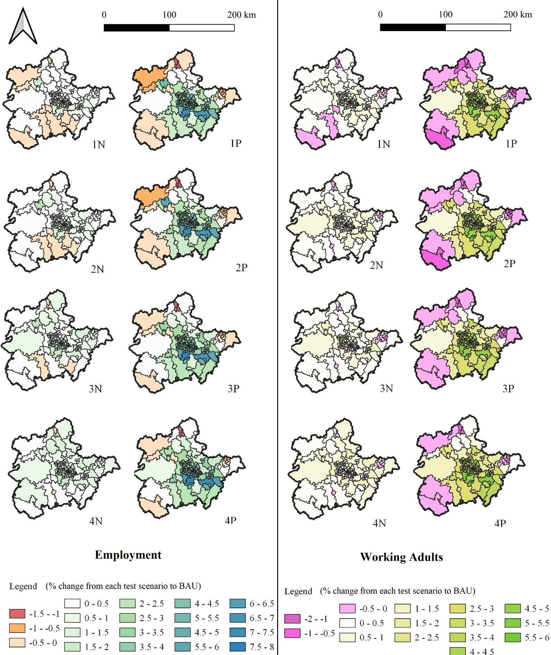
Figure 15: Spatial distribution of employment and working adults one year after the simulation period (2036)
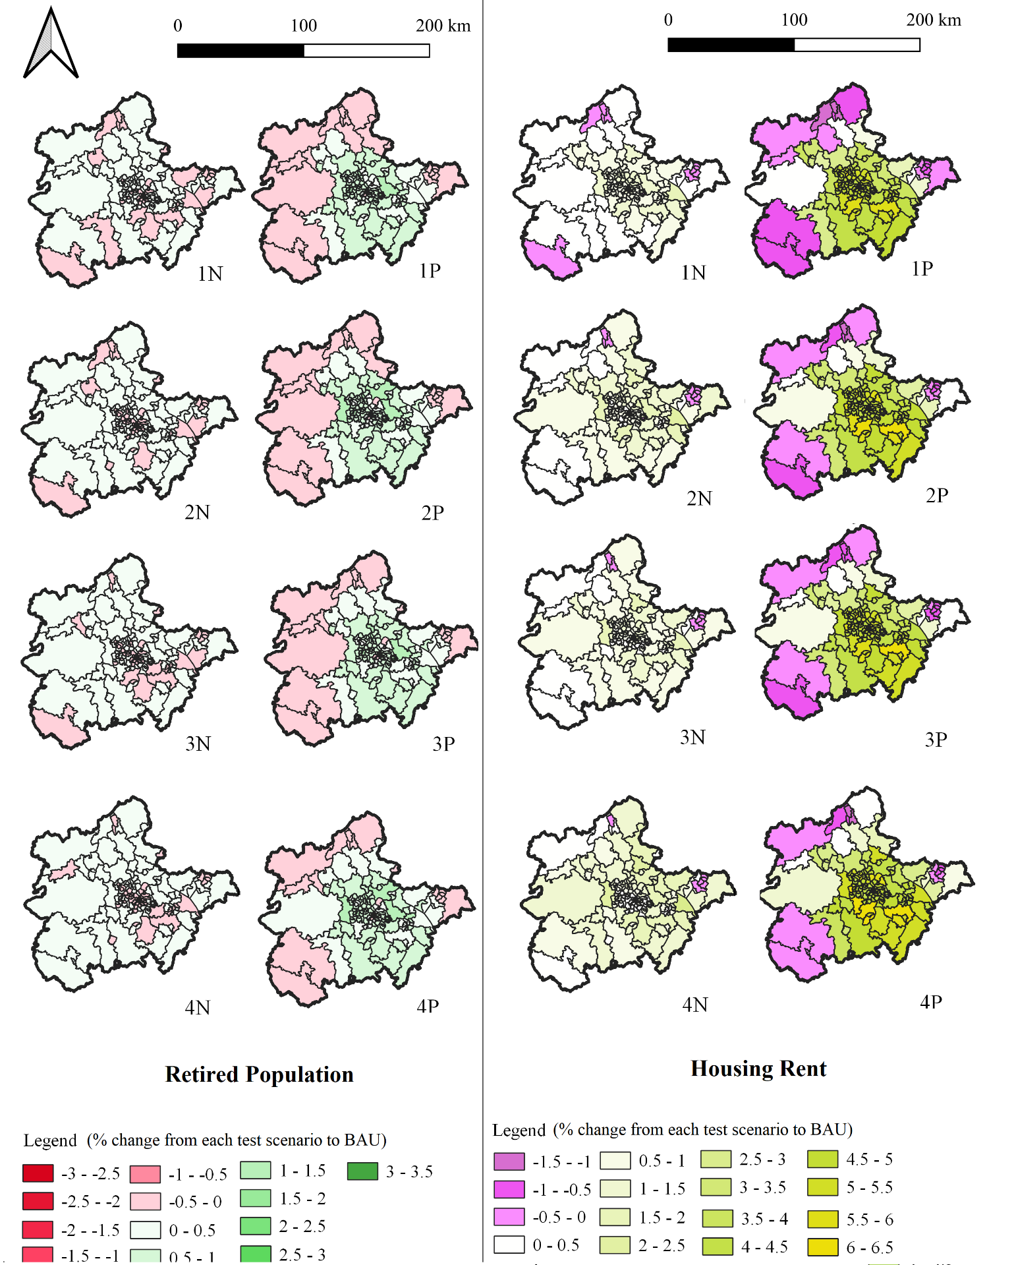Figure 16: Spatial distribution of retired population and housing rent one year after the simulation period (2036)
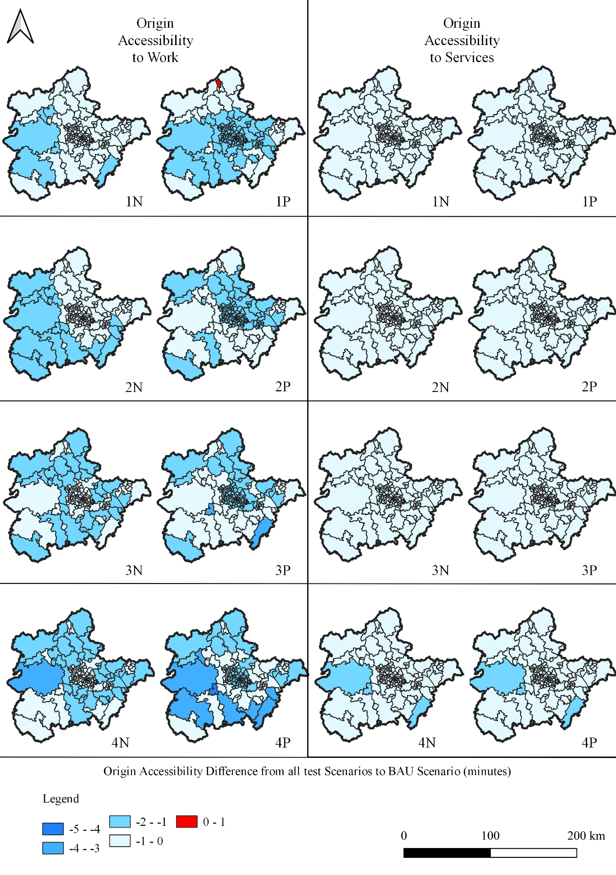Figure 17: Spatial distribution of origin accessibilities one year after the simulation period (2036)
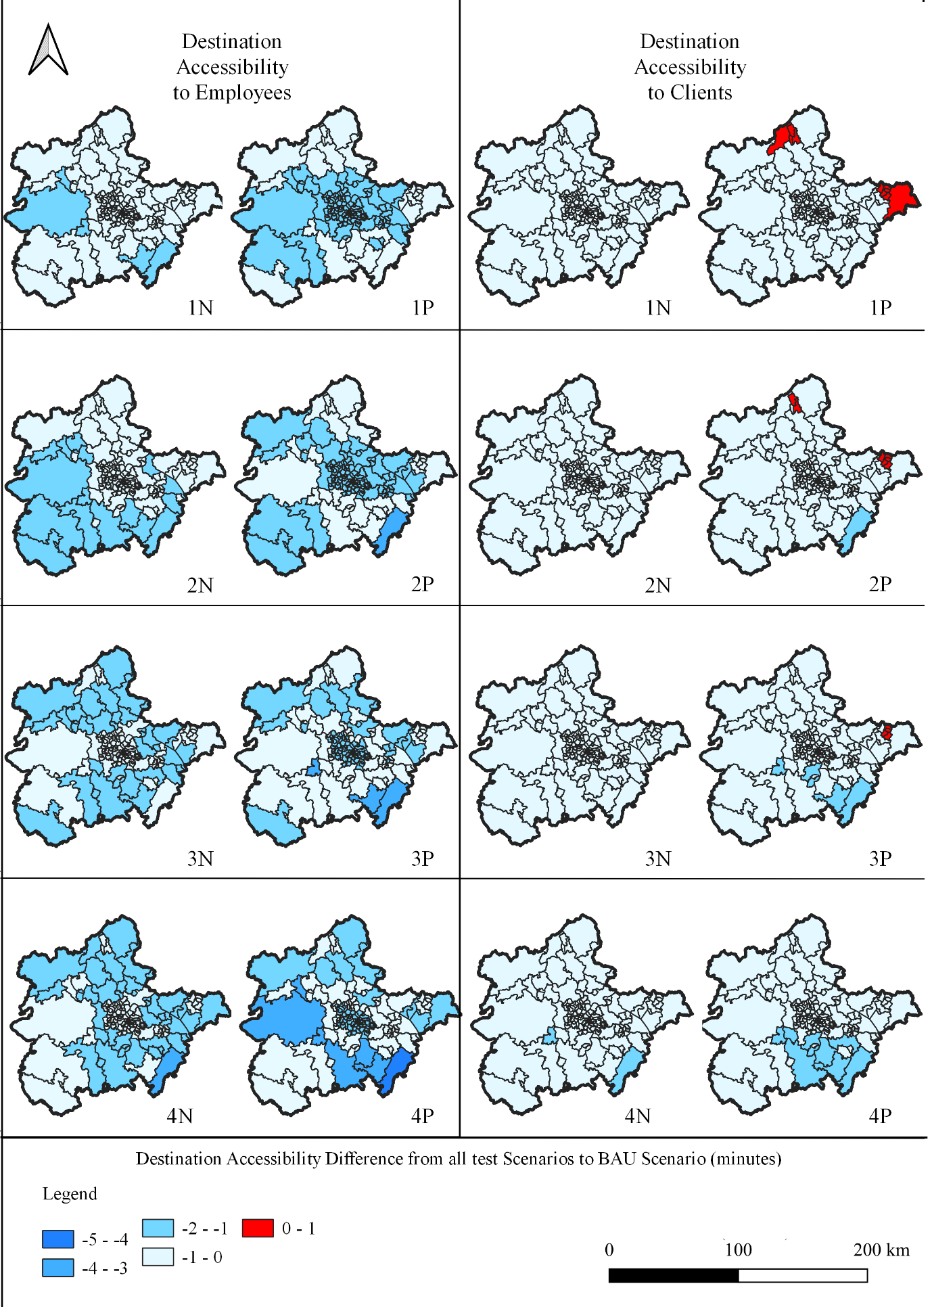Figure 18: Spatial distribution of destination accessibilities one year after the simulation period (2036)
From all the maps it is evident that the scenarios comprising a road capacity increase have more pronounced impacts than those where the PCU value remained 1, as was also concluded from the time series analysed in the previous section.

For the three variables of employment, working adults and housing rent, it can be observed from the maps that in the ‘N’ scenarios, in which the PCU remained 1, the development was more balanced across the urban cores of the region and rural areas, because the percentage changes in the respective zones were between 0 to 1%. However, in comparison with the ‘P’ scenarios, in which the PCU value was reduced, employment, working adults and housing rent did not follow the same patterns. More specifically, regarding employment, in ‘N’ scenarios it appears that higher penetration of new vehicle technologies in the fleet results in fewer zones with low employment levels. Specifically, 16 zones exhibit a -0.5% to 0% change in employment in scenario 1N and these are mostly concentrated in the South and North-West, but as penetration increases in scenarios 2N, 3N, and 4N, this pattern is observed in considerably fewer such zones (nine, six and three, respectively) that are predominantly located only in the South. This is expected, as current road and rail connectivity in these zones, which are neighbouring with Wales, is lower in comparison with the rest of the region, and so lowering transportation costs makes these areas more attractive for employers due to currently lower rents. Vehicle automation reduces transport costs but actual in vehicle time is of high importance to accessibility to employment. Regarding working adults and housing rent, the results are not so sensitive to varying proportions of vehicle technologies in the fleet, as scenarios 2N, 3N and 4N appear to have similar spatial distribution of working adults; with increases of up to 2% for both variables in scenario 1N, however, some zones in the periphery and especially in the South experience reductions of 1% in working adults and 2% in housing rents.

In the case of increased road capacity and lower PCU values (‘P’ scenarios), however, the outskirts of the region see a decrease of up to 2% in all three variables, but the two main cities in the region, namely Birmingham and Coventry, and the areas surrounding them, develop economically, because the increase in these zones reaches 8% for employment, 6% for working adults and 6.5% for housing rent. The reason for this difference between ‘P’ and ‘N’ scenarios is that urban cores in the region are already attractive due to the higher employment rates in comparison with other areas, and by reducing congestion with shorter headways, these areas become even more attractive. At the same time, the reduced generalised costs provide higher freedom in mobility, and thus possible expansions of the existing cities are evident. If these trends continue, this phenomenon could result in new urban areas forming in the surrounding areas of the cities, as also supported by Kim et al. (2015), which will of course form their boundaries based on the existing planning restrictions.

Moreover, in ‘P’ scenarios the zones in the two cities and in the ones surrounding them see increased employment with percentage changes of the same scale; at the same time, fewer zones in scenario 1P appear to have reduced employment similarly to the ‘N’ scenarios as the penetration of new vehicle technologies increases. This is also a pattern that is similar for housing rent and working adults. This effect of increasing penetration that results in more zones in the region benefiting financially is also shown in other papers in the literature, such as Gelauff et al. (2019). As a result, it appears that if the mixture of conventional vehicles and CAVs does not result in higher network capacities, and with higher penetrations of new vehicles in the fleet occurring in the future, a more balanced development in terms of employment, residential location of working adults and housing rent will likely occur across the region. On the other hand, increased road capacities could lead to the geographical expansion of the cities, while at the same time city centres will not lose their financial power.

Retired population is a variable that appears to have some similarities with the previous three, but there are also some key differences. From the maps it can be, again, observed that a more balanced development is achieved if network capacity does not increase, as in the ‘N’ scenarios, with most of the zones increasing by up to 1% and a small number of zones decreasing by 1%. In the ‘P’ scenarios the outskirts of the region see retired population declines of up to 1% accompanied by an increase of up to 3.5% in the peripheral zones of Birmingham and Coventry. It is important to mention that in all scenarios the cores of Birmingham and Coventry have zones with 1% lower retired population, which is a difference from the patterns observed in the previous three variables. Moreover, in both groups of scenarios, namely ‘N’ and ‘P’, as the penetration of new vehicle technologies increases, the number of zones with reductions in residential location of retired population also decreases. This is happening because according to the UK Office for National Statistics (2019), housing rent in the cities is the highest in the whole region. Knowing that people are willing to make longer journeys with lower generalised cost as a result of the introduction of new vehicle technologies, it is possible that retired people relocate out of the cities of Birmingham and Coventry to other areas of the region, where housing rent was lower. Thus, in terms of this section of population, urban sprawl is evident, in contrast with working adults. The fact that housing rent increases in the urban areas, having been already higher than in the rural ones, also means that working adults of higher income move to the economic centres and the retired population relocates to the outskirts as a result of higher accessibility from automation.

The evaluation of accessibility is also an important factor of this process (Zhong et al., 2020). Four types of accessibility are considered: origin accessibility to work and to services, and destination accessibility to employees and to clients. Origin accessibility is the measure of how easily people can reach a destination based on the characteristics of their origin, and destination accessibility is the measure that describes how easily destinations can be reached. Accessibility is measured in ‘generalised minutes’, which means that negative differences from the base scenario represent benefits in accessibility and vice versa (Simmonds et al., 2010); as such, in Figures 8 and 9 negative values are represented with blue, which indicates that generalised travel time has been reduced, and thus that locations have become more accessible.

From the results presented in Figures 17 and 18 it is evident that all types of accessibility have increased in the region, especially for work, because there is a generalised time reduction of up to 5 minutes in the region, which enables the population to travel quickly to different parts of the region. Similar results in both origin and destination accessibilities have occurred, because the spatial distribution of the adoption of new vehicle technologies in the fleet was considered uniform in the study area. Thus, the changes have been modelled evenly in the region and as a result the entire region has become more accessible. The scenario with the highest accessibilities is 4P, exhibiting a reduction of 3 to 5 generalised minutes in all the zones of Birmingham and seven zones outside of the West Midlands County. These results are in line with various sources from the literature that suggest that automation increases accessibility (e.g. Luo et al., 2019; Nahmias-Biran et al., 2020; Soteropoulos et al., 2018; Thakur et al., 2016).

Also, the results of the accessibility are more sensitive to different vehicle penetration rates in the fleet in comparison to the results presented in Figures 15 and 16. Work accessibility in the literature has more pronounced effects in comparison to other types of accessibilities, such as residential (e.g. Cordera et al., 2021). As can be observed, most zones in origin accessibility to services and destination accessibility to clients have 1-minute decreases in generalised time. However, for the other two types of accessibilities, which are related to work, a larger number of zones exhibit generalised time decreases of 4 to 5 minutes. The reason why in this case origin and destination accessibilities to services are lower than the ones to work, is because non-work trips have increased trip rates, which increases the number of trips and as a result congestion for non-work purposes. As a result, the benefit for accessibility to services is lower than the benefit for accessibility to work.

Moreover, it should be noted that work accessibility has increased more in rural areas of the region, indicating that accessibility benefits are higher for residents of lower density areas, rather than higher density ones, such as Birmingham and Coventry, due to the increase of financial activity in these zones. Similar findings regarding accessibilities in rural areas were also obtained by Ahmed et al. (2020).

Overall, this increase in accessibility explains why there is a general increase in population and employment in the region, but it should also be mentioned that, again, the combined effect with the increase in road capacity in the ‘P’ scenarios results to more pronounced effects because the reduced travel times from shorted headways, increase accessibility even more.

Finally, until the end of the simulation period, the percentages do not indicate a change of form. However, considering the increase of employment accessibility in rural areas and supposing that these trends of population and employment continue unchanged in the following years, a polycentric regional form with possible expansions may occur, similar, theoretically, to the polycentric urban model of Harris and Ullman (Rodrigue et al., 2016), at a larger spatial scale of analysis.

Analysing the peripheral zones of Birmingham and Coventry assisted the understanding of the effects of new vehicle technologies in both urban cores. Thus, it was deemed appropriate to follow the same procedure in the more macroscopic scale of analysis for the region by investigating the adjoining zones of the peripheral zones of the West Midlands. The cartographical representations are presented in Figure 19 and Figure 20, showing the percentage changes of the peripheral adjoining zones of the region in terms of employment and working adults, respectively, one year after the end of the simulation period.
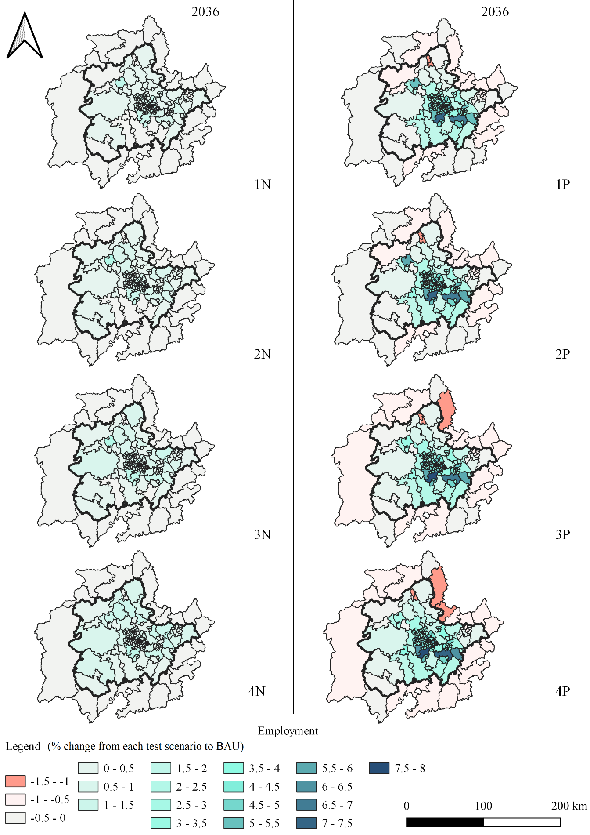
Figure 19: Buffer Zone Examination- Employment
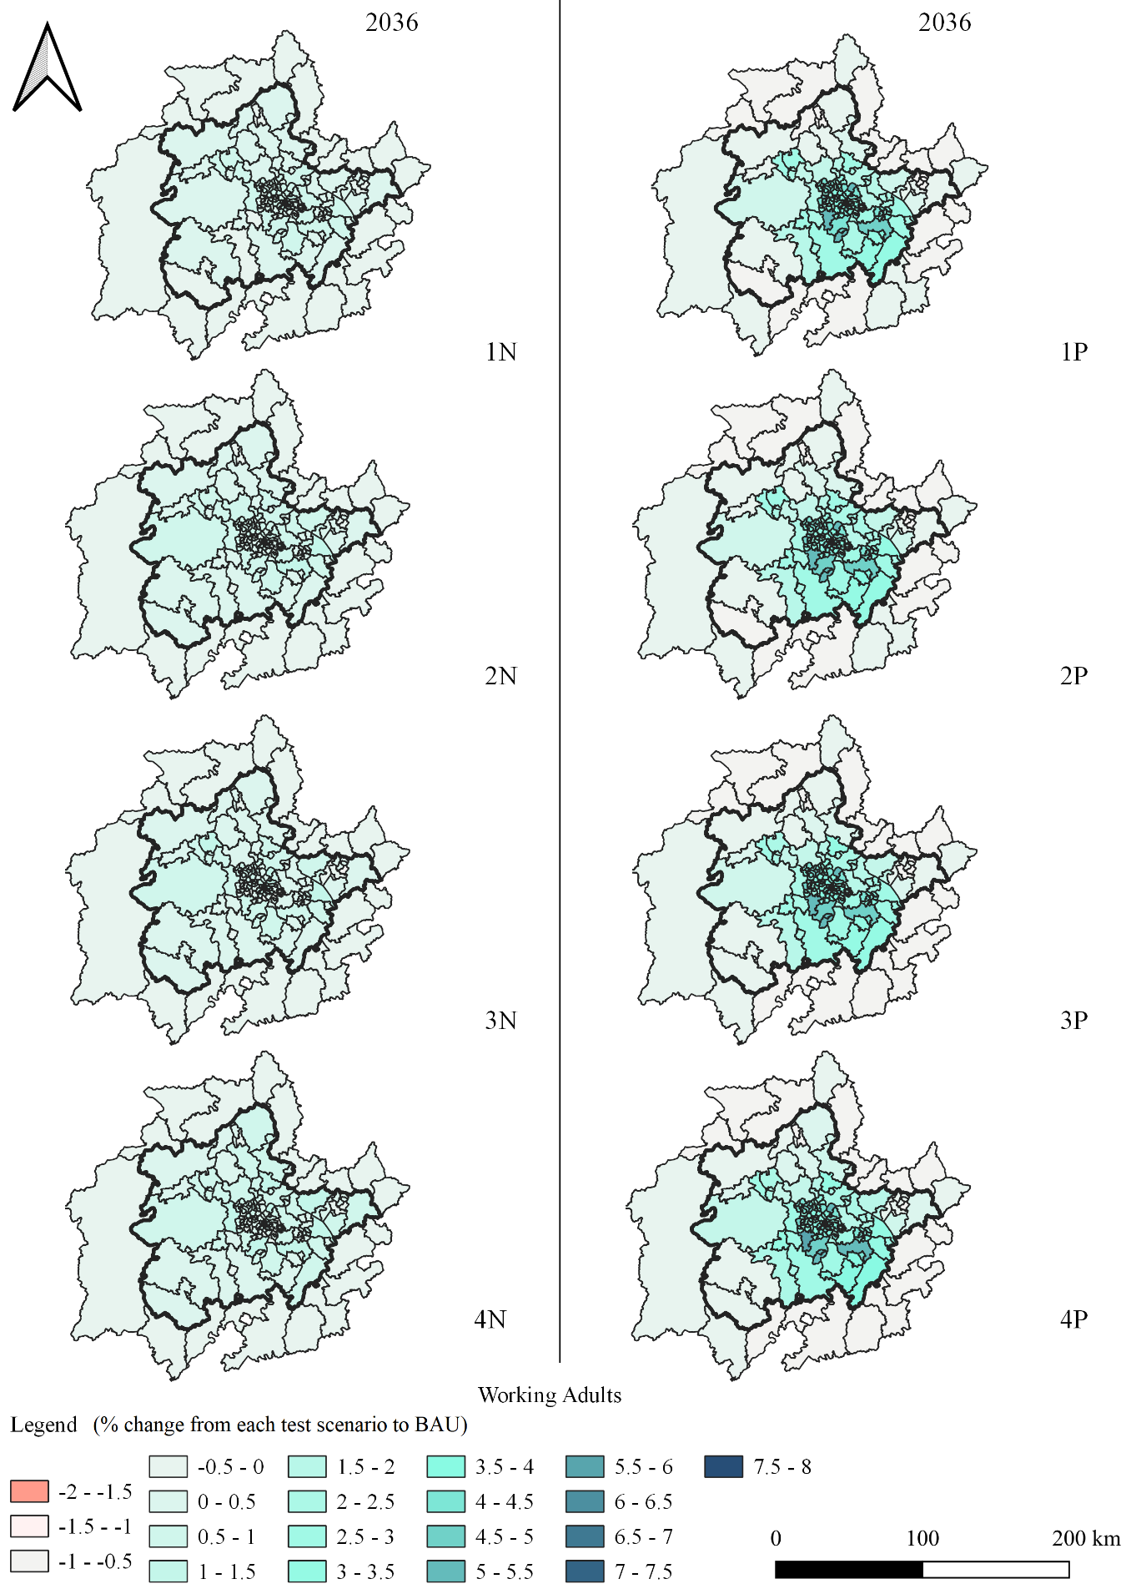
Figure 20: Buffer Zone Examination- Working Adults
The adjoining spatial units of analysis in the two maps have been also affected by the incorporation of new vehicle technologies in the region. More specifically, minor percentage changes are evident in most zones of all scenarios for both variables ranging from -1.5% to 0.5%. Regarding this analysis, the results of employment and working adults are sensitive to the increased capacity from connectivity, but not to the different scenarios of proportion of new vehicle technologies in the fleet. More Specifically, in the ‘N’ scenarios the increase of the two variables is evenly distributed, but in the ‘P’ scenarios the adjoining zones lose their financial power as people are attracted to work and reside in the West Midlands. In other words, the incorporation of electrification and automation, leads to the redistribution of activities in the adjoining regions as well, with increased population and employment in the ‘N’ scenarios and the opposite effects in the ‘P’ scenarios.

Key Findings
Table 8 summarises the key findings as discussed from the analysis of this section.
Table 8: Summary table of Key Findings
 | Key Findings
1 | Regional population and employment increased in all test scenarios compared to BAU scenario.
2 | Regional employment results in higher percentage changes compared to population.
3 | Scenarios 1P, 2P, 3P, and 4P have more pronounced results of population and employment compared to 1N, 2N,3N, and 4N.
4 | All three urban areas have similar trends in urban population and employment.
5 | Total regional results have different trends from urban results of population and employment.
6 | Scenarios 1N, 2N, 3N, and 4N have a more balanced development of employment, working adults and housing rents across the urban cores of the region and rural areas compared to 1P, 2P,3P, and 4P.
7 | In scenarios 1P, 2P, 3P, and 4P, the two main cities in the region and the areas surrounding them have the highest increases in percentages in employment, working adults and housing rent.
8 | Regionally, the percentage changes in retired population in scenarios 1N, 2N, 3N, and 4N are between -1% and 1%.
9 | In scenarios 1P, 2P, 3P, and 4P, the retired population was reduced by 1%, but in the peripheral zones of Birmingham and Coventry there was an increase of up to 3.5%.
10 | As the penetration of new vehicle technologies increased, the reduction of retired population decreased in all test scenarios.
11 | All types of accessibility improved in all scenarios.
12 | Work accessibility had more pronounced results as the penetration rates in the fleet increased, especially in the rural areas of the region.
13 | Zones outside of the modelling area were also slightly affected from the incorporation of new vehicle technologies in the fleet in all test scenarios.

Conclusions

In conclusion, modelling new vehicle technologies using LUTI models can provide very useful results for transportation and urban planners and decision makers. The methodology developed to incorporate new vehicle technologies is a multidimensional approach that can be adopted by a number of LUTI models, considering, of course, modifications that are important to be included based on the mathematical structure of the model used.

Considering the results, the incorporation of new vehicle technologies could lead to increased accessibility, population and employment in the region, as a result of higher mobility freedom. The influence, however, of the effective increase of road capacity is high, as the effects are more pronounced in the respective scenarios. Moreover, the level of penetration of new vehicle technologies in the fleet affects the spatial distribution of activities, which is important especially for the rural areas, as in all scenarios the two main urban cores of the region, namely Birmingham and Coventry, do not lose their economic power. It is essential to mention that the increase of population and employment was mainly concentrated in the peripheral zones of the two cities, which was found in the analysis of employment and population densities, as well as the examination of the cartographical representations. As a result, this indicates urban sprawl for both of the cities. Moreover, the reduced percentages for employment, working adults, retired population and housing rent are mainly concentrated across all scenarios in the west of the region, where transportation infrastructure is not as advanced and population and employment rates are naturally lower, which shows how these areas might even lose more financial power in the future with the existence of new transportation technologies. Additionally, work accessibility in the tested scenarios has increased further, especially in lower density areas, indicating their potential development after the end of the simulation period. Finally, the analysis of the peripheral zones of the region indicates that the areas surrounding the region will also be affected by new vehicle technologies, by benefiting if road capacity is not increased and by losing financial power if road capacity does increase; this is because this phenomenon makes high density areas in the West Midlands more attractive to population groups in the adjoining zones as well. The co-existence of new transportation technologies in the study area also leads to the acceptance of longer trips and more mobility freedom, which ultimately affects cities and regions spatially and financially.

These conclusions could be useful for policy-makers formulating sustainable transport and land use policies and plans for different scales of analysis, as well as for regions and cities that have similar spatial and financial characteristics. The analysis indicates that a change in the current legal framework is of high importance to enable a gradual, controlled and sustainable introduction of new vehicle technologies in order to avoid the negative consequences like urban sprawl. Policies could include road pricing, incorporation of traffic calming measures , improvement of public transport services and frequencies as well as combinations of such measures (Sarri et al., 2022). Urban and regional planners could also conduct proposals that promote incentives to reduce urban sprawl, such as relaxing density restrictions or reform property taxation

Limitations regarding the technical aspects of this research work are related to data availability. For example, informed assumptions based on the literature had to be made with respect to values for the proportions of new vehicle technologies in the fleet and reductions in values of time for automated vehicles. The accuracy of the study would increase greatly if such parameters can be obtained from official sources, such as the UK Government. Moreover, the scenarios have assumed uniform distribution of adoption of CAVs and EVs in the fleet, which is another limitation. Finally, it should be mentioned that the performance of EVs, the allocation of new charging points in the network and the technological advancements of batteries and charging points are important for the rollout of EVs in the UK (Calvillo and Turner, 2020), which are indeed factors that need to be considered in future analyses and may also affect land use.

In general, it would be important for simulation scenarios of future research to be created in order to provide answers to the main research questions and become a tool for policy makers, in order to overcome technological obstacles. Important future research questions include the GHG emissions of new vehicle transportation technologies as well as the environmental impacts of required infrastructure related to vehicle autonomy and electrification (Gouge et al., 2022). Moreover, scenarios could be created to examine the affordability of these new technologies to social groups of different income levels, in order to examine impacts on social equity. Questions could also arise regarding the data security of the people that use these technologies, as well as the possible impact that these technologies might have on cases in low- and medium-income countries where the case studies have different spatial and financial characteristics. More specifically, for this analysis future work could include additional scenarios, in which the reduction of the PCU value could vary with the proportion of connected vehicles in the fleet. Moreover, the incorporation of new transportation business models, that include new vehicle technologies, could be explored so as to enable a more comprehensive examination of the holistic effects of new options in the future. For example, the effects that Mobility as a Service, on-demand transport and car sharing may have on land use, if they are combined with the examined vehicle technologies, could be examined. Another important element regarding future work is the examination of freight transportation scenarios that include new transportation technologies, which was not tested in this analysis. Finally, it would be important that the developed methodology is applied and expanded with other modelling frameworks, such as UrbanSim or TRANUS, in order to be able to examine multi-dimensional research questions regarding new vehicle technologies.

REFERENCES
Acheampong, R.A., Silva, E., 2015. Land use–transport interaction modeling: A review of the literature and future research directions. J. Transp. Land Use. https://doi.org/10.5198/jtlu.2015.806
Ahmed, T., Hyland, M., Sarma, N.J.S., Mitra, S., Ghaffar, A., 2020. Quantifying the employment accessibility benefits of shared automated vehicle mobility services: Consumer welfare approach using logsums. Transp. Res. Part A Policy Pract. 141. https://doi.org/10.1016/j.tra.2020.09.002
Association of British Insurers, 2019. UK Insurance and Long-Term Savings: The state of the market 15p.
Atkins, 2016. Research on the Impacts of Connected and Autonomouse Vehicles (CAVs) on Traffic Flow 58.
Baek, K.H., Kim, G.P., Nam, D.H., Kim, J.S., Jang, C.H., Suh, M.W., 2021. Analysis of Regional Characteristics of Total Cost of Ownership in California, the UK, and Republic of Korea. Int. J. Automot. Technol. https://doi.org/10.1007/s12239-021-0118-z
Bansal, P., Kockelman, K.M., 2017. Forecasting Americans’ long-term adoption of connected and autonomous vehicle technologies. Transp. Res. Part A Policy Pract. 95, 49–63. https://doi.org/10.1016/j.tra.2016.10.013
Bates, J., Oosterhaven, J., 1999. Review of Land-Use / Transport Interaction Models, Department of the Environment, Transport and the Regions.
Becker, Axhausen, K.W., 2018. Predicting the use of automated vehicles for Zurich, Switzerland.
Bernardin, V.L., Mansfield, T., Swanson, B., Sadrsadat, H., Bindra, S., 2019. Scenario Modeling of Autonomous Vehicles with Trip-Based Models. Transp. Res. Rec. https://doi.org/10.1177/0361198119846478
Birmingham City Council, 2018. Birmingham Demographic Brief /2018 Projection 1–11.
Brand, S., Hill, S., Munday, M., 2000. Assessing the impacts of foreign manufacturing on regional economies: The cases of Wales, Scotland and the West Midlands. Reg. Stud. https://doi.org/10.1080/00343400050078123
Bridgelall, R., Stubbing, E., 2021. Forecasting the effects of autonomous vehicles on land use. Technol. Forecast. Soc. Change 163. https://doi.org/10.1016/j.techfore.2020.120444
Brost, W., Funke, T., Lembach, M., 2018. Spatial analysis of the public transport accessibility for modelling the modal split in the context of site identification for charging infrastructure. Infrastructures. https://doi.org/10.3390/infrastructures3030021
California State Transportation Agency, 2021. California Transportation Plan (CTP) 2050. Sacramento,ΨΑ.
Calvillo, C.F., Turner, K., 2020. Analysing the impacts of a large-scale EV rollout in the UK – How can we better inform environmental and climate policy? Energy Strateg. Rev. 30. https://doi.org/10.1016/j.esr.2020.100497
Clement-Nyns, K., Haesen, E., Driesen, J., 2010. The impact of Charging plug-in hybrid electric vehicles on a residential distribution grid. IEEE Trans. Power Syst. 25, 371–380. https://doi.org/10.1109/TPWRS.2009.2036481
Cohen, T., Cavoli, C., 2019. Automated vehicles: exploring possible consequences of government (non)intervention for congestion and accessibility. Transp. Rev. 39, 129–151. https://doi.org/10.1080/01441647.2018.1524401
Coppola, P., Silvestri, F., 2019. Future mobility and land use scenarios: Impact assessment with an urban case study. https://doi.org/10.1016/j.trpro.2019.12.006
Cordera, R., Nogués, S., González-González, E., Moura, J.L., 2021. Modeling the impacts of autonomous vehicles on land use using a luti model. Sustain. 13. https://doi.org/10.3390/su13041608
Craig Benjamin Rafter, 2020. Integrating Connected Vehicles into Urban Traffic Management Systems. UNIVERSITY OF SOUTHAMPTON.
data.gov.uk, 2020a. Low-emission vehicles eligible for a plug-in grant.
data.gov.uk, 2020b. New registrations [WWW Document]. URL https://www.gov.uk/vehicle-registration/new-registrations (accessed 11.22.20).
data.gov.uk, 2020c. Getting an MOT 1–10.
data.gov.uk, 2020d. Vehicle tax rates 1–8.
David Simmonds Consultancy Ltd, 2017. DELTA User Reference Manual.
Davidson, P., Spinoulas, A., 2015. AUTONOMOUS VEHICLES-WHAT COULD THIS MEAN FOR THE FUTURE OF TRANSPORT?, in: Australian Institute of Traffic Planning and Management (AITPM) National Conference.
de la Barra, T., 1989. Integrated Land Use and Transport Modelling: Decision chains and hierarchies. Cambridge Univ. Press 194. https://doi.org/doi.org/10.1017/CBO9780511552359
de Looff, E., Correia Homem de Almeida, G., van Cranenburgh, S., Snelder, M., van Arem, B., 2018. Potential changes in value of travel time as a result of vehicle automation: a casestudy in the Netherlands. TRB 97th Annu. Meet. Compend. Pap.
De Ridder, K., Lefebre, F., Adriaensen, S., Arnold, U., Beckroege, W., Bronner, C., Damsgaard, O., Dostal, I., Dufek, J., Hirsch, J., IntPanis, L., Kotek, Z., Ramadier, T., Thierry, A., Vermoote, S., Wania, A., Weber, C., 2008. Simulating the impact of urban sprawl on air quality and population exposure in the German Ruhr area. Part I: Reproducing the base state. Atmos. Environ. 42. https://doi.org/10.1016/j.atmosenv.2008.06.045
DfT, 2019. WebTAG: TAG data book, November 2019 [WWW Document]. Transp. Model. Apprais.
Dias, F.F., Nair, G.S., Ruíz-Juri, N., Bhat, C.R., Mirzaei, A., 2020. Incorporating Autonomous Vehicles in the Traditional Four-Step Model. Transp. Res. Rec. J. Transp. Res. Board. https://doi.org/10.1177/0361198120922544
DSC, 2019. West Midlands Dynamic Economic Impact Model WMDEIM. Cambridge, UK.
Emberger, G., Pfaffenbichler, P., 2020. A quantitative analysis of potential impacts of automated vehicles in Austria using a dynamic integrated land use and transport interaction model. Transp. Policy. https://doi.org/10.1016/j.tranpol.2020.06.014
Feldman, O., Simmonds, D., Zachariadis, V., Mackett, R., Bosredon, M., Richmond, E., Nicoll, J., 2007. SIMDELTA -A MICROSIMULATION APPROACH TO HOUSEHOLD LOCATION MODELLING. Pap. Present. to World Conf. Transp. Res. 2007, June 24-28, Univ. California, Berkeley. 1–22.
Ford, 2020. Ford Fiesta - Customer Ordering Guide and Price List 1–18.
Fotheringham, A.S., 2001. Spatial Interaction Models. Int. Encycl. Soc. Behav. Sci. 14794–14800. https://doi.org/10.1016/b0-08-043076-7/02519-5
Gelauff, G., Ossokina, I., Teulings, C., 2019. Spatial and welfare effects of automated driving: Will cities grow, decline or both? Transp. Res. Part A Policy Pract. https://doi.org/10.1016/j.tra.2019.01.013
Geurs, K.T., van Wee, B., 2004. Land-use/transport Interaction Models as Tools for Sustainability Impact Assessment of Transport Investments: Review and Research Perspectives. Eur. J. Transp. Infrastruct. Res.
Gouge, V., Sarri, P., Kaparias, I., 2022. The uptake of electrification and its transport and land use impacts; The case of Southampton (UK), in: HEART | European Association for Research in Transportation 2022.
Guler, D., Yomralioglu, T., 2020. Suitable location selection for the electric vehicle fast charging station with AHP and fuzzy AHP methods using GIS. Ann. GIS. https://doi.org/10.1080/19475683.2020.1737226
Harney, D., 2019. Potential impacts of electric vehicles, maas and automated vehicles in australia. EUROPEAN TRANSPORT CONFERENCE, pp. 1–35.
He, S.Y., Luo, S., Sun, K.K., 2020. Factors Affecting the Adoption Intention of Electric Vehicles: The Roles of Objective, Perceived and Prospective Accessibility. SSRN Electron. J. https://doi.org/10.2139/ssrn.3660754
Heinrichs, D., 2016. Autonomous driving and urban land use, in: Autonomous Driving: Technical, Legal and Social Aspects. https://doi.org/10.1007/978-3-662-48847-8_11
Hines, A., Bishop, P.C., 2013. Framework foresight: Exploring futures the Houston way. Futures 51. https://doi.org/10.1016/j.futures.2013.05.002
Hunt, J.D., Abraham, J.E., 2003. Design and Application of the PECAS Land Use Modeling System. 8th Comput. Urban Plan. Urban Manag. Conf. 1–16.
Hymel, K., 2009. Does traffic congestion reduce employment growth? J. Urban Econ. 65. https://doi.org/10.1016/j.jue.2008.11.002
Jadaan, K., Zeater, S., Abukhalil, Y., 2017. Connected Vehicles: An Innovative Transport Technology, in: Procedia Engineering. https://doi.org/10.1016/j.proeng.2017.04.425
Jin, J., Rafferty, P., 2017. Does congestion negatively affect income growth and employment growth? Empirical evidence from US metropolitan regions. Transp. Policy 55. https://doi.org/10.1016/j.tranpol.2016.12.003
Jones, J., 2016. Spatial bias in LUTI models. Université catholique de Louvain, Louvain.
Kim, K., Yook, D., Ko, Y., Kim, D., 2015. An Analysis of Expected Effects of The Autonomous Vehicles on Transport and Land Use in Korea. Work. Pap.
Kolarova, V., Steck, F., Cyganski, R., Trommer, S., 2018. Estimation of the value of time for automated driving using revealed and stated preference methods, in: Transportation Research Procedia. https://doi.org/10.1016/j.trpro.2018.09.044
KPMG, 2019. The rise of electric, shared and autonomous fleets 1–20.
Lee, 2013. Self-driving car given UK test run at Oxford University [WWW Document]. BBC. URL https://www.bbc.co.uk/news/technology-21462360 (accessed 11.21.20).
Litman, T., 2016. Autonomous Vehicle Implementation Predictions. Victoria Transp. Policy Inst. 28.
Litman, T.A., 2019. Autonomous Vehicle Implementation Predictions Implications for Transport Planning. Traffic Technol. Int. 36–42.
Lomax, N., Smith, A., 2018. Effect of capacity constraints on population and employment distribution 1–15.
Lu, N., Cheng, N., Zhang, N., Shen, X., Mark, J.W., 2014. Connected vehicles: Solutions and challenges. IEEE Internet Things J. https://doi.org/10.1109/JIOT.2014.2327587
Luo, L., Troncoso Parady, G., Takami, K., Harata, N., 2019. Evaluating the Impact of Autonomous Vehicles on Accessibility Using Agent-Based Simulation —A Case Study of Gunma Prefecture. J. JSCE. https://doi.org/10.2208/journalofjsce.7.1_100
Lyons, G., Rohr, C., Smith, A., Rothnie, A., Curry, A., 2021. Scenario planning for transport practitioners. Transp. Res. Interdiscip. Perspect. 11. https://doi.org/10.1016/j.trip.2021.100438
May, A.D., Shepherd, S., Pfaffenbichler, P., Emberger, G., 2020. The potential impacts of automated cars on urban transport: An exploratory analysis. Transp. Policy 98. https://doi.org/10.1016/j.tranpol.2020.05.007
Medina-Tapia, M., Robusté, F., 2019. Implementation of connected and autonomous vehicles in cities could have neutral effects on the total travel time costs: Modeling and analysis for a circular city. Sustain. 11. https://doi.org/10.3390/su11020482
Medland, A., 2012. Portrait of the West Midlands. Off. Natl. Stat. URL www. ons. gov. uk. … 1–36.
Mercedes-Benz, 2020. A ‑ Class Hatchback and Saloon.
Meyer, J., Becker, H., Bösch, P.M., Axhausen, K.W., 2017. Autonomous vehicles: The next jump in accessibilities? Res. Transp. Econ. https://doi.org/10.1016/j.retrec.2017.03.005
Milakis, D., Van Arem, B., Van Wee, B., 2017. Policy and society related implications of automated driving: A review of literature and directions for future research. J. Intell. Transp. Syst. Technol. Planning, Oper. https://doi.org/10.1080/15472450.2017.1291351
Morris, J., Cobbing, P., Leach, K., Conaty, 2013. Mainstreaming community economic development in Manitoba. Localise West Midlands Barrow Cadbury Trust 229–259.
Mosquet, X., Dauner, T., Lang, N., Rübmann, M., Mei-Pochtler, A., Agrawal, R., Schmieg, F., 2015. Revolution in the driver’s seat: The Road to autonomous vehicles. Bost. Consult. Gr.
Muto, S., Toyama, H., Takai, A., 2022. Evaluation of Transport and Location Policies to Realize the Carbon-Free Urban Society. Sustainability. https://doi.org/https://doi.org/10.3390/su14010014
Nahmias-Biran, B. hen, Oke, J.B., Kumar, N., Lima Azevedo, C., Ben-Akiva, M., 2020. Evaluating the impacts of shared automated mobility on-demand services: an activity-based accessibility approach. Transportation (Amst). https://doi.org/10.1007/s11116-020-10106-y
National Atmospheric Emissions Inventory, 2019. UK Fleet Composition Projections (Base 2019r/2017 NAEI). For the UK outside London.
NetworkRail, 2022. West Coast South route [WWW Document]. URL https://www.networkrail.co.uk/running-the-railway/our-routes/west-coast-mainline-south/ (accessed 1.3.22).
Nissan UK, 2020. Nissan Leaf. The Tech Advanced, 100% Electric Car.
Olliver, J.G., 2012. Datums and Map Projections for remote sensing, GIS and surveying. Surv. Rev. 36. https://doi.org/10.1179/003962601791521738
Owen, S.M., MacKenzie, A.R., Bunce, R.G.H., Stewart, H.E., Donovan, R.G., Stark, G., Hewitt, C.N., 2006. Urban land classification and its uncertainties using principal component and cluster analyses: A case study for the UK West Midlands. Landsc. Urban Plan. https://doi.org/10.1016/j.landurbplan.2005.11.002
Palmer, K., Tate, J.E., Wadud, Z., Nellthorp, J., 2018. Total cost of ownership and market share for hybrid and electric vehicles in the UK , US and Japan. Appl. Energy 209, 108–119. https://doi.org/10.1016/j.apenergy.2017.10.089
Papa, E., Ferreira, A., 2018. Sustainable Accessibility and the Implementation of Automated Vehicles: Identifying Critical Decisions. Urban Sci. https://doi.org/10.3390/urbansci2010005
Perrine, K.A., Kockelman, K.M., Huang, Y., 2020. Anticipating long-distance travel shifts due to self-driving vehicles. J. Transp. Geogr. https://doi.org/10.1016/j.jtrangeo.2019.102547
Pichery, C., 2014. Sensitivity Analysis. Encycl. Toxicol. Third Ed. 236–237. https://doi.org/10.1016/B978-0-12-386454-3.00431-0
PLUSBUS, 2022. PLUSBUS | HOME [WWW Document]. URL https://plusbus.info/ (accessed 6.26.22).
Rodrigue, J.P., Comtois, C., Slack, B., 2016. The geography of transport systems, The Geography of Transport Systems. https://doi.org/10.4324/9781315618159
Sarri, P., Tzouras, P., Tsigdinos, S., Kaparias, I., Kepaptsoglou, K.L., 2022. Exploring The Land Use And Transport Interaction Effects Of City-Wide Active Travel Schemes. TRB Annu. Meet.
Scottish-Executive, n.d. Scoping Study Investigating the Development of a Land Use and Transport Model for Scotland REVIEW OF MODELS. Rev. Lit. Arts Am.
Simmonds, D., 2019a. The DELTA models and their applications. M Echenique, M Batty, M Wegener Y Jin Appl. Urban Model. Br. Acad. Proceedings. (Preprint available from author; Provid. an Updat. previous Pap. Publ. from 1999 onwards.).
Simmonds, D., 2019b. Integrated modeling in the UK : Practical usability of integrated models. J. Transp. Land Use 327–334.
Simmonds, D., 1999. The design of the DELTA land-use modelling package. Environ. Plan. B Plan. Des. 26, 665–684. https://doi.org/10.1068/b260665
Simmonds, D., Feldman, O., 2005. Land-use modelling with DELTA: update and experience. Proc. Ninth Int. Conf. Comput. Urban Plan. Urban Manag. 1–16.
Simmonds, D., Preston, J., Pagliara, F., 2010. Residential Location Choice : Models and Applications, Advances in Spatial Science.
Small, K.A., Song, S., 1994. Population and Employment Densities: Structure and Change. J. Urban Econ. 36. https://doi.org/0094-1190/94
Solignac, M., 2018. Véhicule électrique et forme urbaine : une évaluation prospective To cite this version : HAL Id : tel-01882700. Université Paris-Est.
Soteropoulos, A., Berger, M., Ciari, F., 2018. Impacts of automated vehicles on travel behaviour and land use: an international review of modelling studies. Transp. Rev. 39, 29–49. https://doi.org/10.1080/01441647.2018.1523253
Sperling, D., 2018. Three revolutions: Steering automated, shared, and electric vehicles to a better future, Three Revolutions: Steering Automated, Shared, and Electric Vehicles to a Better Future. https://doi.org/10.5822/978-1-61091-906-7
Storchmann, K., 2004. On the depreciation of automobiles: An international comparison. Transportation (Amst). https://doi.org/10.1023/B:PORT.0000037087.10954.72
Sweda, T.M., Klabjan, D., 2012. Finding minimum-cost paths for electric vehicles, in: 2012 IEEE International Electric Vehicle Conference, IEVC 2012. https://doi.org/10.1109/IEVC.2012.6183286
Tennøy, A., Tønnesen, A., Gundersen, F., 2019. Effects of urban road capacity expansion – Experiences from two Norwegian cases. Transp. Res. Part D Transp. Environ. 69. https://doi.org/10.1016/j.trd.2019.01.024
Thakur, P., Kinghorn, R., Grace, R., 2016. Urban form and function in the autonomous era, in: ATRF 2016 - Australasian Transport Research Forum 2016, Proceedings.
Timmermans, H., 2003. The Saga of Integrated Land Use-Transport Modeling: How Many More Dreams Before We Wake Up? Moving through nets: The physical and social dimensions of travel. Pap. Present. 10th Int. Conf. Travel Behav. Res. Aug. 10-15 10–15.
Toyota UK, 2020. Toyota Corolla Hatchback Prices & Costs 1–3.
Transport for West Midlands Combined Authority, 2021. Modal Share [WWW Document]. URL https://community-engagement-tfwm.hub.arcgis.com/pages/modal-split (accessed 10.3.22).
Truong, L.T., De Gruyter, C., Currie, G., Delbosc, A., 2017. Estimating the trip generation impacts of autonomous vehicles on car travel in Victoria, Australia. Transportation (Amst). 44, 1279–1292. https://doi.org/10.1007/s11116-017-9802-2
UK Department for Business Energy & Industrial Strategy, 2020. Monthly and annual prices of road fuels and petroleum products - Statistical data sets 24–29.
UK Department for Transport, 2021a. WebTAG: TAG data book, 2021 [WWW Document]. Transp. Model. Apprais.
UK Department for Transport, 2021b. Appraisal and Modelling Strategy A route map for updating TAG during uncertain times.
UK Department for Transport, 2016. High Speed Rail (London - West Midlands).
UK Department for Transport, 2015. Taxi and Private Hire Vehicle Statistics : 2015 4.
UK National Highways, 2022. West Midlands [WWW Document]. URL https://nationalhighways.co.uk/our-roads/west-midlands/ (accessed 10.3.22).
UK Office for National Statistics, 2022. Families and the Labour Market: main reference tables, England: 8 March 2021.
UK Office for National Statistics, 2021. UK Census [WWW Document]. URL https://www.ons.gov.uk/ (accessed 9.29.22).
UK Office for National Statistics, 2019. Private Rental Market Summary Statistics – April 2018 to March 2019 44, 1–7.
US Governor’s Office of Planning and Research, 2022. Automated Vehicle Principles for Healthy and Sustainable Communities [WWW Document]. URL https://opr.ca.gov/planning/transportation/automated-vehicles.html (accessed 11.25.22).
US National Cooperative Highway Research Program, 2019. Foreseeing the Impact of Transformational Technologies on Land Use and Transportation, Foreseeing the Impact of Transformational Technologies on Land Use and Transportation. https://doi.org/10.17226/25580
van den Berg, V.A.C., Verhoef, E.T., 2016. Autonomous cars and dynamic bottleneck congestion: The effects on capacity, value of time and preference heterogeneity. Transp. Res. Part B Methodol. 94, 43–60. https://doi.org/10.1016/j.trb.2016.08.018
van Wee, B., Milakis, D., Thomopoulos, N., 2020. Overall synthesis and conclusions, in: Advances in Transport Policy and Planning. https://doi.org/10.1016/bs.atpp.2020.06.001
Volpati, V., Barthelemy, M., 2020. Revisiting the coupling between accessibility and population growth. JPhys Complex. 1. https://doi.org/10.1088/2632-072X/ab97a7
Wadud, Z., 2017. Fully automated vehicles: A cost of ownership analysis to inform early adoption. Transp. Res. Part A Policy Pract. https://doi.org/10.1016/j.tra.2017.05.005
Wegener, M., 2014. Land-use transport interactions models, in: Handbook of Regional Science. pp. 1–1732. https://doi.org/10.1007/978-3-642-23430-9
Wegener, M., 2006. Overview of Land Use Transport Models. pp. 127–146. https://doi.org/10.1108/9781615832538-009
West Midlands Combined Authority, 2017. The West Midlands Strategic Transport Plan.
wikiwand.com, 2021. West Midlands (region) [WWW Document]. URL https://www.wikiwand.com/en/West_Midlands_(region) (accessed 7.29.21).
Williams, N., 2019. Integrating Position Uncertainty in Connected and Automated Vehicle Applications. UNIVERSITY OF CALIFORNIA.
Zhang, R., Zhang, J., Long, Y., Wu, W., Liu, J., Jiang, Y., 2021. Long-term implications of electric vehicle penetration in urban decarbonization scenarios: An integrated land use–transport–energy model. Sustain. Cities Soc. https://doi.org/10.1016/j.scs.2021.102800
Zhang, W., 2017. The interaction between land use and transportation in the era of shared autonomous vehicles: A simulation model. Georgia Institute of Technology.
Zhong, S., Li, X., Jiang, Y., Cheng, R., Wang, Z., 2020. Identifying the combined effect of shared autonomous vehicles and congestion pricing on regional job accessibility. J. Transp. Land Use 13. https://doi.org/10.5198/jtlu.2020.1692

