All Things Must Pass? Recent Changes to Competition and Ownership in Public Transport in Great Britain.

Keywords
Bus, Competition, Ownership, Rail, Regulation

Classification codes
L51 Economics of regulation, L92 Railroads and other surface transportation

John Prestonª
ªSchool of Engineering, Boldrewood, University of Southampton, SO16 7QF, UK. Tel: +44 23 8059 4660

Abstract
The publication of the National Bus Strategy in March and the Williams-Shapps Plan for Rail in May 2021 suggests an end to the period of deregulation and privatisation that has dominated local buses in Great Britain since the mid-1980s and national rail since the mid-1990s.
This paper reviews the recent trends in the local bus and national rail industries in Great Britain, both pre- and post-Covid. The policy response in the two sectors seems to be searching for solutions that do not involve full blooded public control and ownership, at least in England. For local buses, emphasis is being placed on the development of Enhanced Partnerships between operators and Local Authorities. For national rail, the key organisational change is the establishment of Great British Railways to vertically integrate the planning of infrastructure and train services. Operations will remain vertically and horizontally separated but with franchising replaced by Passenger Service Contracts.
For both sectors, post-Covid, there will be an emphasis on demand and service recovery, with funding likely to be problematic. Future prospects will be considered, alongside the potential for further turns of the regulatory cycle, with respect to both competition and ownership.
1. Introduction
The origins of the International Conference on Competition and Ownership in Land Passenger Transport can be traced back to the deregulation of local buses in Great Britain outside London as a result of the 1985 Transport Act (Preston, 2005 ). This built on the earlier 1980 Transport Act which, amongst other things, deregulated express coaches in Great Britain. These reforms contributed to the global interest in the privatisation and deregulation of transport (see, for example, Gomez-Ibanez and Meyer, 1993). This interest was further stimulated by the 1993 Railways Act that led to the ‘privatisation’ of national railways in Great Britain. This, in turn, led to the focus of this conference series to be extended from bus and coach to land passenger transport. It also established Great Britain as something of a living laboratory for public transport reform given these natural experiments in industrial reorganisation (Preston, 2001a). This was against the background of an international movement of neoliberal reforms in a range of economic sectors (Saal and Parker, 2003, and Crew and Parker, 2006). A remarkable feature of the public transport reforms in Great Britain has been their longevity. The regimes established for local buses in the mid-1980s and for national rail in the mid-1990 were largely intact in 2020, although there had been some changes in emphasis in the intervening period. This stability is particularly remarkable as the reforms have spanned three changes in political control at the national level: in 1997 (Labour), 2010 (Conservative – Liberal Democrat Coalition) and 2015 (Conservative).
The possibility of a new regime was indicated by two policy documents published in 2021. A National Bus Strategy for England (local buses being a devolved responsibility) was produced in March (DfT, 2021), whilst the Williams-Shapps Plan for rail was published in May (CP 423, 2021). These policy documents will be discussed in turn and then related to recent trends in the two industries. Some likely future directions will be discussed and then some conclusions drawn. The objective of this paper is to provide a critical review of these two policy documents, with reference to their historical and contemporary contexts, including data on key trends in the two industries, and to the literature on regulatory cycles in transport. It is not the intention to provide a review of the international experience of reforms in bus and rail markets – such reviews are provided, for example, by Sheng and Meng (2020) and Ait Ali and Eliasson (2021) respectively
2. The Bus Industry and the National Bus Strategy
The 1985 Transport Act was a package of reforms. In addition, to the quantity deregulation of local buses outside London (fares having been deregulated by the 1980 Act), it also introduced competitive tendering of socially necessary services, the commercialisation and privatisation of nationally and municipally owned bus fleets and the tightening of regulations concerning safety (enforced by the Traffic Commissioners) and competitive behaviour (enforced by the Office of Fair Trading). The rationale behind the reforms was articulated by Beesley and Glaister (1985). It was believed that the reforms would reverse the long-run decline of the local bus industry by introducing competition, reducing costs and achieving a better mix of services and fares, whilst not having any undesirable spin-offs. Some counterarguments were provided by Gwilliam et al. (1985). The long-term impacts of this package of reforms were assessed by Preston and Almutairi (2013, 2014) who argued that the main effects had worked their way through the system by around 2000, a period of some 15 years and the reforms had not, in the main, reversed the long-run decline of local buses in Great Britain outside London, although there has been some success in London with a regulatory regime of comprehensive tendering.
Given concerns that bus deregulation has not worked out in the manner intended, there has been a raft of subsequent legislation and policy documents affecting buses. New Labour developed an Integrated Transport White Paper (that led to the 2000 Transport Act) and this was accompanied by a series of daughter documents, including one on bus entitled From Workhorse to Thoroughbred (DETR, 1999). This was modest in both ambition and outcome. As was noted around that time “policy makers need to work towards re-establishing the bus as a workhorse before they can think of it becoming a thoroughbred. By the 1990s, it had become something of a semi-retired pit pony in large parts of the country” (Preston, 2003, 173). The 2000 Transport Act made provision for Statutory Quality Partnerships (SQPs) and for Quality Contracts (QCs), with the latter being based on the comprehensive competitive tendering model in existence in London, but in the event no QCs were established, whilst there were only two SQPs. Voluntary Quality Partnerships between bus operators and authorities emerged in the 1990s and were seen as a form of light touch regulation (Carr, 1997). By the beginning of the next decade, Preston et al. (2005) were reporting on 30 Voluntary Quality Partnerships. The 2008 Local Transport Act introduced some measure to overcome the barriers to the establishment of SQPs and QCs, including the development of Integrated Transport Authorities (ITAs). This had some limited success, with Rye and Wretstrand (2014) reporting six more SQPs and Villa i Aguilar et al. (2022) reporting around 14 in total in England and Scotland. However, the only QC scheme that was progressed (in Tyne and Wear) ultimately failed to gain approval (McTigue et al., 2020). With the onset of the Coalition Government the focus was on competition for discretionary funds with the 2012 Green Light for Better Buses policy document launching the Better Bus Area and Greener Bus Funds (Preston et al., 2014). Subsequently, the Conservative administration implemented the 2017 Bus Services Act, the third attempt to enact Quality Partnerships. SQPs became Advanced Quality Partnerships and QCs became franchising, whilst there were provisions for Enhanced Partnerships that permitted shared ticketing and coordinated services as had been successfully developed in Oxford but had been previously prohibited on pro-competition grounds (White, 2017). The Department for Transport (DfT) reported that 20% of bus operators in England were involved in at least one partnership scheme in 2017/18, although Preston and Darivakis (2019) were only able to identify 15 quality partnerships in England, of which 11 were voluntary (73%). If this is representative, then only around 5% of bus operators were involved in statutory schemes.
Bus policy reform gained impetus with the premiership of Boris Johnson. As Mayor of London (2008 to 2016), he used bus services as a key policy instrument and at a conference in Manchester in July 2019, in one of his first speeches after taking office as Prime Minister he was quoted as saying: “I know a lot about buses, believe me. I love buses, I helped to invent a new type of bus. I will begin in urgency, the transformation of local bus services here today in Manchester”. It was perhaps no coincidence that Transport for Greater Manchester was the authority that was pushing most for London style bus franchising. It is fair to say that the subsequent bus strategy had the then Prime Minister’s imprint, with the strap line Bus Back Better alluding to both the post-Covid 19 recovery and the levelling-up agenda. The key provision was that by July 2021, all Local Transport Authorities (LTAs) should establish Enhanced Partnerships, except Combined Mayoral Authorities (CMAs), such as Greater Manchester, that are planning franchising. Quality partnerships in their initial incarnation were often light touch in nature. A typical agreement would be at a route or network level and involve private operators increasing the quality of vehicles (newer vehicles with low-floor access and low emissions) and in return Local Authorities would improve the provision of infrastructure, such as at bus stops and stations. Where Local Authorities provided bus priority measures (dedicated bus lanes, priority at traffic signals etc.), the private operators might agree to minimum service levels and joint marketing. Enhanced Partnerships provide local authorities with the potential to specify requirements with regards to a wider range of service options, including timetabling requirements, bus frequencies, ticketing and marketing arrangements, appearance of vehicles and public transport information provision.
By October 2021, it was decreed that all LTAs should publish Bus Service Improvement Plans (BSIPs). The reforms will involve common routing and numbering, low flat fares and daily caps, the promotion of bus priority and on demand service and investment in 4,000 zero emission vehicles. At the time of writing, the DfT was consulting on ending the sale of non-zero emission buses sometime between 2025 and 2032. Initial investment of £170 million in the All-Electric Bus Town or City and the Zero Emission Bus Regional Area (ZEBRA) scheme will result in 1,278 zero emission buses in 17 LTAs. In April 2022, the DfT announced that 31 LTAs (out of a total of 79) were successful in their BSIP investment bids, whilst a low fare experiment would commence in Cornwall. Including earlier awards, just under two-thirds of England’s population will benefit from the commitment to invest £3 billion to transform bus services announced in 2020. This does beg the question of what will happen to buses serving the other third of the population, particularly given concerns over the clarity of the assessment criteria.
3. The Rail Industry and the Williams-Shapps Plan
Just as the 1985 Transport Act was not solely about bus deregulation, the 1993 Railway Act was not solely about rail privatisation. It was also a policy package that included a range of measures. Firstly, it involved horizontal separation of the industry and introduced off track competition through a series of franchise competitions. The passenger business was split into 25 geographically based Train Operating Companies (TOCs), with franchising administered by the Office of Passenger Rail Franchising (OPRAF). For the freight business, seven TOCs were created and privatised by direct sale – with six being sold to one bidder (EWS). Secondly, open access competition was permitted but for the passenger sector this competition was moderated by the Office of the Rail Regulator (ORR) in three phases (to 1999, 1999 to 2002, 2002 onwards). Thirdly, vertical separation involved the infrastructure authority (Railtrack) being floated on the stock exchange and three rolling stock leasing companies (ROSCOs) being set up and sold by direct sale. Similarly, some 80 ancillary businesses (including infrastructure and rolling stock maintenance) were set-up and privatised by direct sales. Lastly, regulations were strengthened in a number of areas, including with respect to track access charges, fares and health and safety. These detailed changes and the events that led up them are well documented by Gourvish (2002, 2008) and Parker (2012). The rationale for the reforms was similar to that for buses, albeit for an industry that was perceived as stagnating rather than declining, and that required greater structural reform in order to permit competition (Preston, 1996).
The impacts of these reforms, particularly with respect to passenger rail franchising, have been presented at previous conferences in this series and subsequently published in Research in Transportation Economics (Preston, 2008, 2017, 2018a, Preston and Robins, 2013, Preston and Bickel, 2020). The initial impacts seemed to take around 10 years to work through the system. The key finding was that the benefits from increased passenger use was more than offset by increases in costs. However, these reforms may be seen to have had a number of phases related particularly to the evolution of passenger rail franchising that in turn can be associated with further impacts (see also Table 3). In essence, this evolution was responding to both the success of the reforms (such as the growth in passenger demand and the resultant need for investment in capacity) and the failures (such as escalating costs, periodically poor punctuality and reliability, accidents and financial failures). The second phase was associated with the new Labour administration, the 2000 Transport Act and the Ten-Year Plan for Transport. This led to the creation of the Strategic Rail Authority (SRA) to replace OPRAF and provide greater overall direction of the industry. However, these changes were overtaken by events triggered by the Hatfield accident in October 2000. This led to Railtrack going into receivership a year later (October 2001) and its replacement by Network Rail the following year. Network Rail was a hybrid organisation set up as a company limited by guarantee but re-classified by the Office for National Statistics as a public body in 2014. The failure of Railtrack led to the Future of Rail White Paper in 2004 (Cm 6233, 2004) and the 2005 Railways Act which ushered in a third phase of the reforms in which the SRA’s role was taken over by the DfT to ensure more direct governmental control of funding. These reforms were consolidated by a further White Paper in 2007 (Cm 7176, 2007). However, the election of the Coalition government stimulated further reforms, designed to increase financial sustainability in an era of austerity (Cm 8313, 2012). In particular, a series of measures were designed to reduce overoptimistic bidding by replacing the cap and collar incentive regime with a Subordinated Loan Facility (SLF). However, this reform failed in its first application to the West Coast Main Line franchise and this fourth phase of reforms was in essence stillborn. This led to the instigation of the Laidlaw Enquiry (HC 809, 2012) and the Brown Review (Cm8526, 2013). The recommendations of these reports led to the fifth phase of reforms. The Conservative administration produced a strategic vision paper in 2017 (Cm 9719, 2017) and commissioned a review led by Keith Williams in September 2018, in the aftermath of the failed introduction of new cross city timetables in London and Manchester that led to an independent inquiry chaired by Stephen Glaister (ORR, 2018). A White Paper was scheduled for autumn 2019 but this was delayed by the General Election (December 2019) and then by Covid. As a result of the pandemic, franchising was suspended on 23 March 2020, being replaced for six-months by Emergency Measure Agreements (EMAs) and subsequently Emergency Measure Recovery Agreements (EMRAs) and direct awards. This constituted a sixth phase of reforms.
In May 2021 the much-awaited William Reviews was finally published, although now rebranded the Williams-Shapps Plan for Rail to acknowledge the role of the Secretary of State for Transport at the time, Grant Shapps (CP 423, 2021). The Plan involves a series of promises, outcomes and commitments that will constitute a seventh phase of reforms. Seven promises consist of: bringing the railways back together, delivering more punctual and reliable services; making the railways easier to use; rebuilding public transport use after the pandemic; maintaining safe and secure railways for all; keeping the best elements of the private sector that have helped to drive growth; making the railways more efficient; and growing, not shrinking, the network. The 10 outcomes consist of: modern passenger experience; retail revolution; new ways of working with the private sector; financial sustainability; greater control for local people and places; cleaner, greener railway; new offers for freight; increased speed of delivery and efficient enhancements; skilled, innovative workforce; and simpler industry structure.
As shown by Figure 1, the main change is the vertical integration of the planning of infrastructure and train services by the creation of Great British Railways which brings together the planning functions of the DfT and Network Rail, as well as the Rail Delivery Group (RDG – previously the Association of Train Operating Companies, ATOC). However, operations would remain horizontally and vertically separated, with the likelihood of a residuary RDG representing private sector interests. These reforms are, at least in England, a simplification rather than nationalisation, although in Scotland and Wales the respective TOCs have been taken into governmental control. Railways in Northern Ireland have always been under public control and ownership.
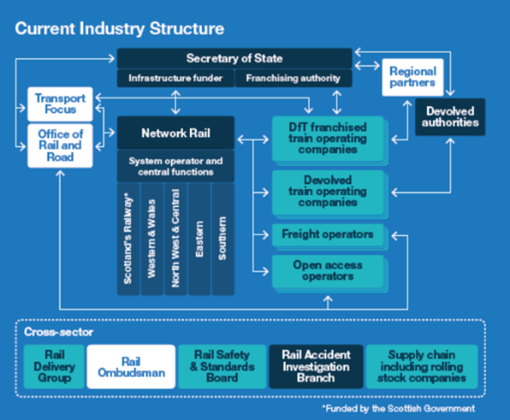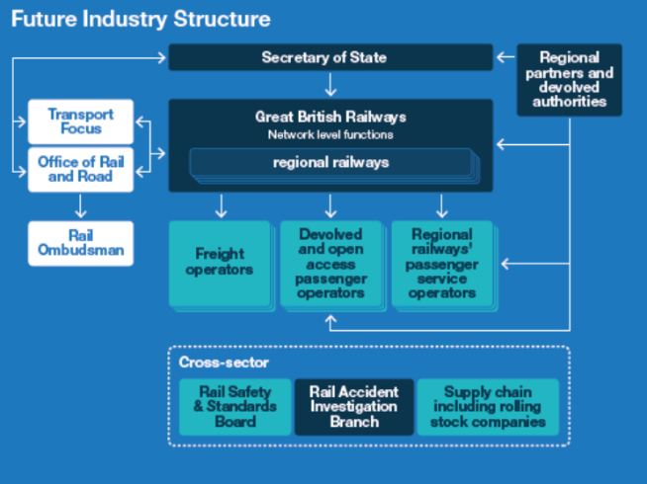
Figure 1: National Rail Industry Structure Before (Left) and After (Right) the Williams-Shapps Plan for Rail.
The Plan includes some 62 commitments. These cover the integrated organisation (1-20), replacing franchising (21-29), passenger experience (30-44), the role of the private sector (45-51), innovation (52-58) and people (59-62). As an example, those relevant to passenger rail franchising are:
21. Franchising will be replaced by Passenger Service Contracts (PSCs);
22. PSCs will focus operators on meeting passengers’ priorities and will incentivise them to grow usage;
23. Each PSC will be designed to support the needs of passengers and the whole network as part of an integrated system;
24. PSCs will be different across the network and will not take a one-size-fits-all approach;
25. Operators will have greater commercial freedom on some parts of the network with revenue sharing arrangements where appropriate. New open access services will be explored where spare capacity exists;
26. The geographic and financial size of PSCs will reflect local markets and needs;
27. Competition for PSCs will be greater than for franchises and Great British Railways will aim to complete all contracts;
28. If operators fail, the government will be ready to step in and take control where needed; and
29. The government will work with the private sector and potential new market entrants to develop and implement these changes.

Exemplars for PSCs given in the Plan and supporting documents include London Overground plus contracting-out in Germany, Sweden, Massachusetts Bay Transit Authority (MBTA – Boston), Sydney and Melbourne. The focus is likely to be on gross cost, smallish contracts, of medium length with extension options and with punctuality penalties. Other incentives are being considered with respect to quality of services, passenger experience, revenue protection and train capacity, whilst there would be scorecard linked incentives related to collaboration and innovation. For some contracts, revenue incentives and risk sharing would be considered. Simpler contracts are believed to be desirable given that the Franchise Agreements they would replace were typically over 1,000 pages long. It is also believed PSCs would encourage more competition. Over 5 bids per franchise were received in Phase 1 (Preston, 2001b), but this was down to around 2 by Phase 5 (Preston and Bickel, 2020). The Plan notes that “Since 2012, around two-thirds of contracts have been awarded without a competition” (CP 423, 2021, 59). However, it is not yet clear to what extent these PSCs will be different from the franchises they replace.
Another important feature of the Plan is to reduce costs. There are aspirations for cost reductions of around 15% of pre-COVID revenue (£1.5 billion pa) by 2027 over and above those already planned whilst continuing to grow the rail network. In 2019/20, UK rail income was £20.2 billion and expenditure of a similar magnitude (ORR, 2020), so a cost reduction of around 7% is planned. This could be achieved through reductions in transaction costs and exploitation of economies of scale and scope. In addition, Network Rail aims to save £0.7 billion per annum in Control Period 6 (2019-24) – so total cost reductions are of the order of 11%. However, the McNulty Review saw scope for 30% reductions in costs through adopting European best practice, so these reductions should be achievable (DfT and ORR, 2011). Similarly, Preston and Bickel (2020) estimated total industry costs in 2017/18 as £18.2 billion and a counterfactual as 26% lower, which again suggests a cost reduction of 11% could be achievable. The expected cost reductions are similar to those postulated as a result of nationalisation by Taylor and Sloman (2013). Reductions in transaction costs are also possible but empirical evidence suggests that, where these can be measured, they are a small percentage of costs (Merkert, 2010), whilst any economies of scale and scope in planning may be offset by diseconomies in operations.
The Government announced a Transport Bill in the Queen’s Speech to Parliament in May 2022, although the precise timings and content remain unclear. The main elements of the Bill with respect to rail involve providing the new body, Great British Railways, with the powers it needs to act as the single national leader of the railways, with clear lines of accountability for decision-making and joined-up leadership to deliver a customer-focused railway, including improving accessibility and promoting open data. Great British Railways will work within a clear mandate, goals and budgets set by the Government, who will reserve powers of direction. It will also involve the transfer of contracting powers for passenger services to Great British Railways and will ensure the best of the private sector is retained by expanding its role under the new model, introducing new passenger service contracts focussed on getting the trains running punctually and reliably. In the meantime, a Great British Railways Transition Team has been developed that has consulted on a 30-year Whole Industry Strategic Plan linked to five key strategic objective of meeting customer needs, financial sustainability, contributing to economic growth, supporting levelling up and connectivity; and delivering environmental sustainability.
4. Some Key Trends in the Bus Industry
The key trends in the British bus industry are well documented (see, for example, Preston, 2018b). Some estimates of broad indicators are given in Table 1.

Table 1: Trends in the British Bus Industry 1985/6 to 2019/20 (to 2008/9 in brackets) (% change)
 | Passenger  Journeys | Real Receipts per Passenger | Vehicle Kms | Real Costs per Vehicle Km | Real Subsidy **  (to 2018/19)
London | +76% (+87%) | +32% (+15%) | +79% (+78%) | NA  (-28%) | +37% (+84%)
Great Britain outside London | -44%  (-31%) | +65% (+55%) | -3% (+20%) | +4%  (-20%) | -18% *** (+5%)
Based on Transport Statistics Great Britain
* Fare Index from 2009
** Excluding Fuel Duty Rebate (FDR)/Bus Service Operator Grant (BSOG)
*** Based on trends in England, outside London. Data for Scotland and Wales not readily available.
NA Not Available
On the face of it, the differences between London and Great Britain outside London are stark. Between 1985/6 and 2019/20, passenger journeys grew by 76% in London, whilst they declined by 44% elsewhere, although both markets have exhibited similar declining trends since around 2012 (DfT, 2021, 21). London has also seen a sustained increase in bus services and, since 2000, increases in subsidy (although around the turn of the millennium the system was close to break-even). It has also had lower real fare increases than the rest of Great Britain. Where real costs can be compared, the unit costs reductions in London were even greater than those outside London, although outside London these costs have subsequently increased. It is therefore little surprise that the National Bus Strategy, in essence, attempts to replicate features of the London model elsewhere in England. However, as White (2010), amongst others, has pointed out, the market in London is different from elsewhere in Great Britain, in terms of demographic and economic change, as well as in terms of the presence of congestion charging as well as ultra-low emission zones and higher levels of funding. The institutional capacity for (and maturity of) public transport planning is also greater in London than elsewhere, which is why Enhanced Partnerships are favoured over franchising in most areas.
These broad trends have been disrupted by Covid which as Figure 2 illustrates has had a similar impact on bus use in London and outside London. The initial lock-down in the spring of 2020 led to reductions in excess of 80% whilst the subsequent lock down in early 2021 led to reductions of between 70% and 80% (although there may also be seasonal factors at play). The new normal appears to be a demand reduction of around 20%, with work and shopping trips, and concessionary travel, particularly reduced (White, 2022).
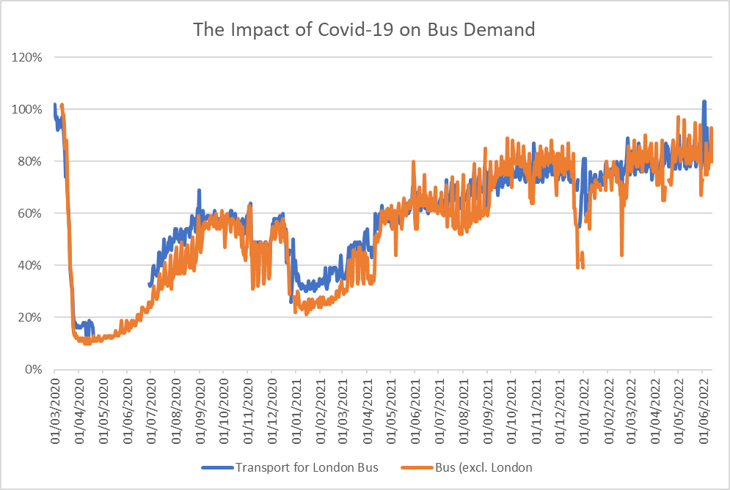
Figure 2: The Impact of Covid-19 on Bus Demand
Source: https://www.gov.uk/government/statistics/transport-use-during-the-coronavirus-covid-19-pandemic

The immediate implication is financial. In 2019/20, for bus in England almost 40% of operating revenue came from Government Support, in the form of gross Public Transport (PT) support (for socially necessary tendered services), reimbursement for concessionary travel (particularly for the elderly who have free travel outside the morning peak) and BSOG (Bus Service Operators Grant, a discretionary grant that helps operators recover some of their fuel costs and previously known as Fuel Duty Rebate). It is increasingly a misnomer to think of local bus services in England as being purely commercial. In 1999/00, the corresponding figure was 32% (for Great Britain) (Preston, 2003, 167). This increase may be partly explained by the roll out of national concessionary fare schemes in Wales in 2002, Scotland in 2006 and England in 2008. For 2020/21, given that Covid-19 Bus Services Support Grant (CBSSG) was reported in the National Bus Strategy as over £1 billion in 2020 (DfT, 2021, 78) and that concessionary travel reimbursement was temporarily uncoupled from ridership, the percentage of operating revenue that came from Government support ballooned to 77%, falling back to 57% in 2021/22.

Table 2: Fare Receipts and Government Support: England
£ million current prices
Year | Fare Receipts | Gross  PT Support | Concess-ionary  Travel | BSOG | CBSSG/  BRG | Total Operating Revenue
2019/20 | 3,168 | 839 | 982 | 246 |  | 5,235
2020/21 | 1,261 | 1,975 | 971 | 227 | 1,118 | 5,522
2021/22 | 2,320 | 1,487 | 915 | 245 | 453 | 5,420

Source: DfT (2023) Bus Statistics Data Tables. Table BUS05ai

Figure 3 indicates further trends that may impact on financial sustainability. As Table 2 showed, fares have grown in real terms. The left graph of Figure 3 shows that since 2005, for England as a whole this growth has been around 1% per annum, although in London this is impacted by Mayor Khan’s fare freeze from 2016. As a result, over the period 2005 to 2020, the greatest increases in real fares in England have been in the metropolitan areas, whilst the lowest increases have been in London. Moreover, these increases have been over a period of historically low inflation (around 2% per annum). Real fare increases may be more challenging in a period when inflation (measured by the Consumer Price Index) peaked at over 11% late in 2022. Figure 3 also indicates that operating costs (excluding administration and depreciation) have been increasing relatively uniformly since 2004/5, albeit with a spike in the most recent year. Over the whole period, the right graph of Figure 3 shows that there has been a 2% per annum real increase, although data for London is no longer available. The largest increases are in the English metropolitan areas and the lowest are in Wales and Scotland. Given rising input prices, especially for labour and fuel, and the associated cost of living crisis, and that around 80% of bus costs are related to labour and fuel (see Cowie, 2010, 106), it seems likely that the industry will face intense cost pressures in the short- to medium-run.

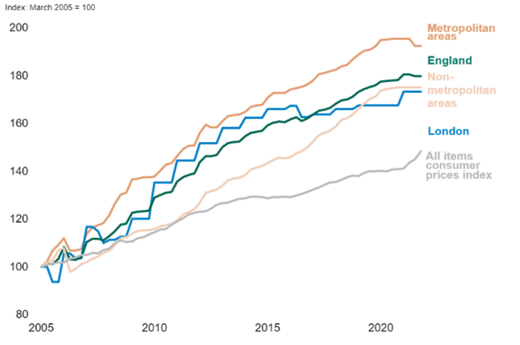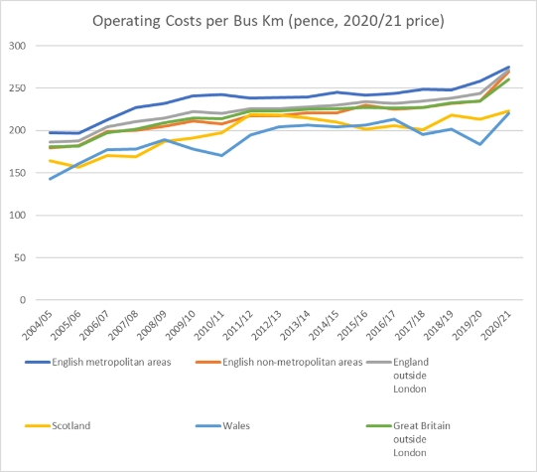

Figure 3: Fare (left) and Operating Cost (right) Trends
Horizontal axes (both): year. Vertical axis (left) Nominal Price Indices. Vertical axis (right): Real Operating costs per bus kilometre.
Sources: DfT Quarterly Bus Statistics October-December 2021 (Fares) Transport Statistics Great Britain, Table Bus 0408(Operating Costs)

A key question is whether the National Bus Strategy will be able to overcome these financial pressures. Without bus priority, Preston et al. (2003) estimated that at most quality partnerships would increase demand by 25%. Preston and Darivakis (2019) estimated that quality partnerships are associated with uplifts in demand of between 20% and 61% (although the high end would include some priority). The best that partnerships without priority might hope is that interventions may return demand to pre-Covid levels. Currie and Wallis (2008) estimated that bus priority increases demand on affected bus routes by 50-100% over 3 to 5 years. This figure has been broadly confirmed by individual case studies, for example Brett and Menzies (2014) found the Cambridgeshire Busway doubled demand, and by reviews of the state of the art (Deng and Nelson, 2011, Ingvardson and Nielson, 2017). KPMG (2016, 38) found that cities with long standing bus partnerships such as Brighton and Nottingham had bus usage per capita up to double that which would have been forecast by population density alone. However, the problem here may be one of financial incentives. In providing bus priority, LTAs have to use up a lot of financial capital in providing new rights of way and/or use up lots of political capital in reallocating road space and adjusting traffic control to favour buses at the expense of private motorists. In return, operators may provide better services but there is a perceived danger that the investments will leak out of the area in the form of increased operating profits and hence dividends for the operating groups’ shareholders. In such cases, franchising might be seen as providing better public control, although a possible quid pro quo for partnerships could be the provision of zero emission vehicles by the operators, particularly if authorities contribute to depot costs and/or the costs of fuelling facilities. Hensher (2021) believes that the need to have greener bus fleets will give an impetus to negotiated contracts and the development of trusting partnerships (after Stanley and Hensher, 2008). It is conceivable that these partnerships could be extended along the supply chain to include vehicle manufacturers, energy suppliers and specialists in battery and/or fuel cell technology.

5. Some Key Trends in the Rail Industry
Building on Preston and Bickel (2020) (as above) and taking into account the Williams-Shapps Plan, seven phases of rail reform in Britain can be identified, as shown by Table 3.
Table 3: The Seven Phases of Passenger Rail Reform, with particular reference to franchising.
Phase | Dates | Responsible  Authority | Achievements | Assessment
1 | 1996 – 2000 | OPRAF | 25 franchises let | Initial success.
2 | 2001 – 2004 | SRA | 9 franchises re-let, 1 failure, 13 renegotiated. | Cost over-runs post Hatfield.
3 | 2005 – 2012 | DfT  – Cap and Collar | 12 franchises re-let. 2 failures | Revenue shortfalls.
4 | 2012 – 2013 | DfT  – SLF | 1 cancellation | Shortcomings in evaluation
5 | 2014 – 2020 | DfT  – Horses for courses | 11 franchises re-let by mid-2019. 2 failures. | Limited competition reflected by 13 Direct awards.
6 | 2020 – 2023 | DfT  – Suspension of Franchising | Emergency Management Agreements/Emergency Recovery Measures Agreements/National Rail Contracts. At least 4 Direct Awards. 2 failures | Wide use of Management Contracts.
7 | 2023 - | GBR (Great British Railways) | Passenger Service Contracts | To be determined.

As with bus, the key trends in rail are well documented (Preston, 2018b). Table 4 shows that up to 2017/18, demand for passenger rail services had more than doubled and supply had increased by almost 50%, whilst fares remained broadly stable in real terms since the commencement of the reforms in the mid-1990s. However, Covid 19 wiped out many of these gains. Although the reforms had clearly had some success on the demand side, there were sustained increases in unit costs and in Government support. The increases in unit costs and Government support (including enhancements) are particularly marked in 2020/21, with unit costs (per train km) over double the levels in the mid-1990s and Government support almost quadruple. The large recent increases in unit costs reflect the loss of economies of density as a result of reductions in train kilometres.
One area of improvement as a result of Covid was punctuality and reliability. For example, on-time arrivals at stations between April and June 2020 increased by 17.1 percentage points relative to the year before to 86.4%. Similarly, the Public Performance Measure (PPM) increased by 6.2 percentage points to 96.2%. These were the best results since the time series began, in 2014-15 and 1997-98 respectively. Cancellations were halved to 1.2% of scheduled services, again the best since the time series began in 2014-15. Total passenger train km between April and June 2020 were 84.2 million, 39.6% less than for the equivalent quarterly period in 2019 (Armstrong et al., 2021).
Table 4: Key Trends in the Passenger Railway in Britain since 1995/6 (% change)
Phase | Dates | Demand  (Pass Km) | Real receipts per pass km | Supply (Train Km) | Real Unit Costs (per Train Km) | Real support
1 | 95/96-00/01 | +31 | -5 | +21 | +20 | -38
2 | 01/02-  04/05 | +7 | +4 | +7 | +18 | +185
3 | 05/06-11/12 | +34 | +3 | +11 | +2 | 0
4/5 | 12/13-17/18 | +16 | -3 | +2 | +5 | +3
TOTAL |  | +118 | -1 | +47 | +52 | +81
5/6 | 17/18 –  20/21 | -81 | -6 | -20 | +52 * | +112 *
TOTAL |  | -59 | -7 | +18 | +130 | +284
* Based on ORR Rail industry finance (UK) 2020-21.
Figure 4 gives more detail on the impact of Covid-19 on rail demand. It can be seen that National Rail and London Underground have very similar trends, with the first lockdown reducing demand by over 90% and the subsequent lockdowns by around 80%. The impact of Covid-19 seems to have been greater than for bus and the recovery somewhat slower but again demand seems to be levelling off at around 80% of pre-Covid levels. Recovery has been strongest in leisure markets and weakest in the commuter and business travel markets, resulting in a reduction in revenue yields. The usage figures for London Underground have been affected by industrial disputes, a feature that spread to the national rail system in June 2022.

Figure 4: The Impact of Covid-19 on Rail Demand
Source: https://www.gov.uk/government/statistics/transport-use-during-the-coronavirus-covid-19-pandemic

The impact of Covid on railway finances is illustrated by Table 5. In 2019/20, 32% of the rail industry’s income came from Government operating support (excluding support for enhancements, including HS2, and miscellaneous support, such as for the British Transport Police). This is less than for the bus industry. In 2020/21, operating support increased by over £10 billion and accounted for 82% of income before reducing to 62.5% in 2021/2, both of which are greater than for buses. If enhancements and miscellaneous support are included, Government support in 2019/20 was £11,632 million, in 2020/21 it was £22,905 million and in 2021/22 was £20,346 million (ORR, Table 7270). If enhancements and miscellaneous funding are included, Government support increases from 45% to 85% of total income and then down to 72% for each of the respective years, all substantially in excess of bus.

Table 5: Rail Industry Income (£ million 2021/22 prices)
 | Fares and Passenger Income | Other Sources | Government | Total
2019/20 | 11,939 | 2,323 | 6,761 | 21,023
2020/21 | 2,558 | 1,328 | 17,590 | 21,476
2021/22 | 6,430 | 1,550 | 13,300 | 21,280
Note other sources include HS1 and Northern Ireland Railways.
Source: ORR, Table 7210.

6. Future Directions
Regulatory cycles are relatively well-known phenomena that can be traced back to Needham (1983), have been popularised in bus transport by Gwilliam (2008) and developed by Dementiev and Han (2020). Prior to the reforms of the 1980s and 1990s, both the bus and rail industries were regulated public monopolies, as per Figure 5. The reforms sought to inject competitive private supply (Figure 5 top) but took different paths in that the bus industry outside London pursued the competition in the market route that resulted in the emergence of private oligopolies (Figure 5, bottom). Villa i Aguiler et al. (2022) note that although bus deregulation does not entirely break the regulatory cycle, it has certain elements baked-in (such as private ownership rights to routes) thus making it difficult to ‘re-connect’ to the cycle and hence restricting policy options. By contrast, for buses in London and for the vast majority of national passenger rail services, competition for the market was pursued, based on tendering/franchising (also Figure 5 bottom). Here, re-connection may be more feasible.
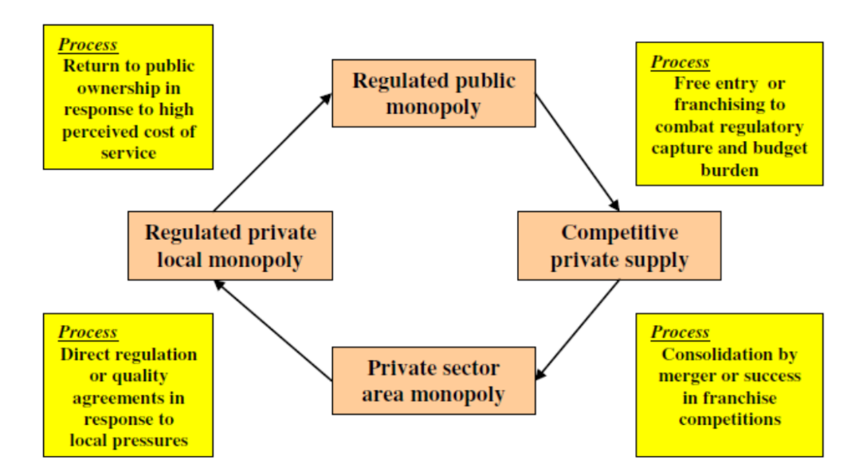
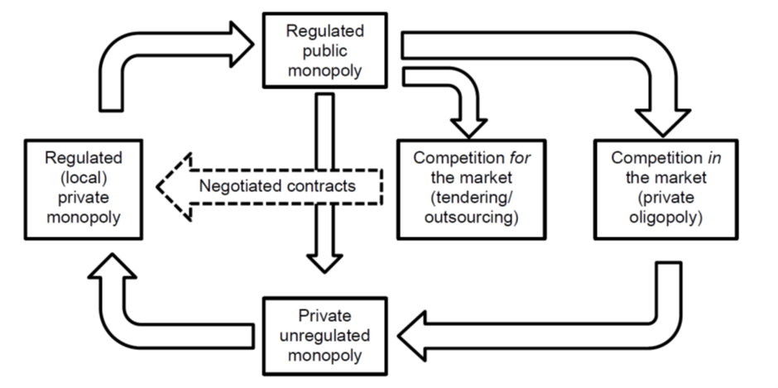
Figure 5: Regulatory Cycles
Sources: Gwilliam (2008) top, Dementiev and Han (2020).

The broad approach might be seen as being one of regulated deregulation (van de Velde and Wallis, 2013). One possible interpretation of the National Bus Strategy and the Williams-Shapps Plan is that greater emphasis will be placed on negotiations and agreements, particularly with respect to Enhanced Partnerships for buses but also with respect to some aspects of Passenger Service Contracts for rail, such as contract extensions. Planning of services will be largely a public sector activity (with some input from the private sector) but operations will be a regulated, local, private monopoly (or oligopoly). Another important contribution of Dementiev and Han (op cit.) is to highlight the role of three exogenous variables in the regulatory cycle: technology, fiscal constraints and institutional capacity. In the short-run, fiscal constraints will be important with the bus and rail industries fighting for their very survival, given patronage reductions of 20%, the eventual withdrawal of Covid-related funding and rapidly increasing costs, exacerbated by labour shortages and unrest. In the medium-run, the emphasis may be on building institutional capacity to progress Enhanced Partnerships and establish Great British Railways. In the longer-run, technology in terms of digitisation and automation may be crucial, in terms of both reducing costs and increasing service quality.
7. Conclusions
Overall, it is evident that the two reports discussed in this paper represent a further turn in the regulatory cycle of the two industries. All things must pass, in that the previous regulatory regimes appear to have run their course. However, this regulatory turn occurred for different reasons, being related to perceived demand-side failures for buses outside London (particularly when contrasted with buses within London) and largely supply-side failures for national rail, albeit exposed by some demand-side successes. It also seems likely that the next phase of reforms will continue on slightly different paths. For both industries, there is likely to be more public control of planning at both strategic and tactical levels (see also van de Velde, 1999), although for buses this will be largely through partnerships. However, there will be continued involvement of the private sector in terms of operations largely through competition for the market for national rail and buses in London (and possibly a few other big cities such as Manchester) and largely through competition in the market for local buses elsewhere. Although difficult to summarise concisely, the likely key changes to the regimes are highlighted by Table 6 in terms of the degree of public control.
Table 6: Summary of Key Changes in the Control of Functions as a Result of the 2021 Reforms
 |  | Strategic | Tactical | Operational
Bus outside London | Before | Private | Private | Private
 | After | Partnership | Partnership | Private
National  Rail | Before | Public/Private* | Private | Private
 | After | Public | Public | Private
* For passenger operations, strategic functions have largely been carried out by public bodies such as, over time, OPRAF, SRA and DfT. However, private operators have had some input in to the franchising process and have control of open-access passenger and freight operations.
Greater public ownership in operations seem unlikely, at least outside the devolved administrations and a few local authorties. Perhaps the most obvious lacuna is the lack of integration between bus and rail and the limited consideration of multimodal contracting that is more advanced elsewhere, most notably the Netherlands (Hoekstra et al., 2019). Similarly, the scope for digital tools such as Mobility as a Service (MaaS) to integrate public transport offerings is underplayed, whilst MaaS may also have implications for the contracting-out of public transport (Hensher, 2017).

Postscript
Since this paper was submitted (end of June 2022) and presented to conference (5th September 2022), it has been somewhat overtaken by events. Boris Johnson’s position as the UK’s Prime Minister formally came to an end on 6th September 2022, being replaced by Liz Truss who only lasted 50 days and was replaced by Rishi Sunak on 25th October 2022. This inevitably led to changes in the Secretary of State for Transport with Grant Shapps being replaced by Anne-Marie Trevelyan on 6th September who was in turn replaced by Mark Harper on 25th October. The implications of this period of political and economic uncertainty for public transport policy are not yet clear but it is evident that there will not be parliamentary time for primary legislation for the creation of Great British Railways until the next parliament, which in practice means 2025 at the very earliest (as of March 2023 a timetable for this has still not been produced). Demand continues to recover for both bus and rail (and is currently around 90% of pre-Covid levels), but it is also evident that the cost-of-living crisis, exacerbated by political and economic uncertainty, has increased the cost pressures on the bus and rail industries, whilst also limiting the scope for Government funding for capital and operating expenditure. It seems likely that the ambitions of both the National Bus Strategy and the Williams-Shapps Plan will need to be curtailed
Acknowledgement
The author is grateful for the comments from two anonymous referees. The usual caveat applies, all remaining mistakes are the responsibility of the author.

References
Ait Ali, A. and Eliasson, J. (2021). European railway deregulation: an overview of market organization and capacity allocation. Transportmetrica A: Transport Science, 1-25.
Armstrong, J., Preston, J., Zieger, S., and Niessen, N. (2021) Sub-threshold delays and GB timetable quality. Paper presented at RailBeijing 2021, Beijing, China.
Beesley, M and Glaister, S. (1985) Deregulating the Bus Industry in Britain – (C) Response. Transport Reviews, 5, 133-142.
Brett, A. and Menzies, B. (2014) Cambridgeshire Guided Busway, UK: an analysis of usage. Proceedings of the Institution of Civil Engineers – Transport, 176, 3, 124-133.
Carr, J.D. (1997) Light Touch Regulation for the Privatised Bus Industry. 5th International Conference on Competition and Ownership in Land Passenger Transport. Leeds.
Cm 6233 (2004) The Future of Rail. London: DfT. July.
Cm 7176 (2007) Delivering a Sustainable Railway. London: DfT. July.
Cm 8313 (2012) Reforming Our Railways. London: HMSO. March
Cm 8526 (2013) Brown Review of the Rail Franchising Programme. London: HMSO. January.
Cm 9719 (2017) Connecting People: A Strategic Vision for Rail. London: DfT. November.
Cowie, J. (2010) The Economics of Transport: A theoretical and applied perspective. Abingdon: Routledge.
CP 423 (2021) Great British Railways. The Williams-Shapps Plan for Rail. May. London: HMSO. https://www.gov.uk/government/publications/great-british-railways-williams-shapps-plan-for-rai
Crew, M and Parker, D. (2006) International Handbook on Economic Regulation. Cheltenham: Edward Elgar.
Currie, G. and Wallis, I. (2008) Effective ways to grow urban bus markets – a synthesis of evidence. Journal of Transport Geography, 16, 6, 419-429.
Dementiev, A. and Han, H. J. (2020) A theory of deregulation in public transport. Research in Transportation Economics, 83, 100953.
Deng, T. and Nelson, J. (2011) Recent Developments in Bus Rapid Transit: A Review of the Literature. Transport Reviews, 31, 1, 69-96.
DETR (Department of Environment, Transport and the Regions) (1999) From workhorse to thoroughbred: a better role for bus travel. London: DETR.
DfT and ORR (2011) Realising the Potential of GB Rail. Final Independent Report of the Rail Value for Money Study. May. London: DfT.
DfT (2021) Bus Back Better. National Bus Strategy for England. March. London: HMSO. https://www.gov.uk/government/publications/bus-back-better
Gomez-Ibanez, J. A. and Meyer, J. R. (1993) Going Private. The International Experience with Transport Privatization. Washington DC: Brookings Institution.
Gourvish, T. (2002) British Rail 1974-97: From Integration to Privatisation. Oxford: Oxford University Press.
Gourvish, T. (2008) Britain’s Railways 1997-2005 Labour’s Strategic Experiment. Oxford: Oxford University Press.
Gwilliam, K.M., Nash, C.A. and Mackie, P.J. (1985) Deregulating the Bus Industry in Britain – (B) The Case Against. Transport Reviews, 5, 105-132.
Gwilliam, K. (2008) Bus transport: Is there a regulatory cycle? Transportation Research A, 42, 9, 1183-1194.
HC 809 (2012) Report of the Laidlaw Inquiry. Inquiry into the lessons learned for the Department for Transport from the InterCity West Coast Competition. London: House of Commons. December.
Hensher, D.A. (2017) Future bus transport contracts under a mobility as a service (MaaS) regime in the digital age: are they likely to change? Transportation Research A, 98, 86-96.
Hensher, D.A. (2021) The case for negotiated contracts under the transition to a green bus fleet, Transportation Research A, 154, 255-269.
Hoekstra, G., Veeneman, W., van Oort, N. and Goverde, R, (2019) The potential of multimodal concessions for service improvements; three cases from the Netherlands. 16th International Conference on Competition and Ownership in Land Passenger Transport. Singapore.
Ingvardson, J. and Nielsen, O. (2017) Effect of New Bus and Rail Rapid Transit systems: An International Review. Transport Reviews, 38, 1, 96-116.
KPMG (2016) Local Bus Market Study. London: Department for Transport.
McTigue, C., Rye, T. and Monios, J. (2020) Identifying barriers to implementation of local transport policy – Lessons learned from case studies on bus policy implementation in Great Britain. Transport Policy, 91, 16-25.
Merkert, R. (2010) Changes in Transaction Costs over Time – the case of franchised train operating companies in Britain. Research in Transportation Economics, 29, 1, 52-59.
Needham, R. (1983) The Economics and Politics of Regulation: A Behavioural Approach. Boston: Little, Brown and Company.
ORR (Office of Rail and Road) (2018) Independent Inquiry into the Timetable Disruption in May 2018. London: ORR. December.
ORR (2020) Rail Industry Finance (UK) 2019-20. London: ORR. November.
Parker, D. (2012) The Official History of Privatisation. Volume II Popular Capitalism 1987-1997. Chapters 16 and 17. Abingdon: Routledge.
Preston, J., Huang, B. and Whelan, G. (2005) Determining Optimal Bus Service Provision: The Role of Quality in the Service Mix. In Hensher, D. (Ed.) Competition and Ownership in Land Passenger Transport. Selected Refereed Papers from the 8th International Conference. Elsevier, Oxford. 177-194.
Preston, J.M. and Almutairi, T. (2013). Evaluating the Long Term Impacts of Transport Policy: An Initial Assessment of Bus Deregulation. Research in Transportation Economics, 39, 208-214.
Preston, J.M. and Almutairi, T. (2014) Evaluating the Long Term Impacts of Transport Policy: The Case of Bus Deregulation Revisited. Research in Transportation Economics, 48, 263-269.
Preston, J., Song., Y. and Hickford, A. (2014) Delivering Sustainable Public Transport: The Case of the Better Bus Area Fund. Research in Transportation Economics. 48, 373-380.
Preston, J and Darivakis, E. (2019) Can Bus Quality Partnerships or Contracts Make a Difference? 16th International Conference on Competition and Ownership in Land Passenger Transport. Singapore.
Preston, J. and Bickel, C. (2020) And the Beat Goes On. The continued trials and tribulations of passenger rail franchising in Great Britain. Research in Transportation Economics. 83, 100846.
Preston, J. (2001a) An Overview of Public Transport Reforms in Great Britain and Forecasts for the Future. International Journal of Transport Economics, 26,1, 23-48.
Preston, J. (2001b) Franchising and Re-franchising of Passenger Rail Services in Britain. Transportation Research Record, 1742, 1-9.
Preston, J. (2003) A Thoroughbred in the Making? The Bus Industry under Labour. In Docherty, I. and Shaw, J. (Eds) A New Deal for Transport? Oxford: Blackwell. 158-177.
Preston, J. (2005) The Road to Rio: A Brief History of the International Conferences on Competition and Ownership in Land Passenger Transport. In Hensher, D. (Ed.) Competition and Ownership in Land Passenger Transport. Selected Refereed Papers from the 8th International Conference. Elsevier, Oxford. 7-20.
Preston, J. (2008) A Review of Passenger Rail Franchising in Britain: 1996/7 – 2006/7. Research in Transportation Economics. 22, 71-77.
Preston, J. (2017) Deja Vu All Over Again? Rail Franchising in Britain. Research in Transportation Economics. 59, 107-115.
Preston, J. (2018a) The Wheels Keep on Turning: Is the end of rail franchising in Britain in sight? Research in Transportation Economics. 69, 187-196.
Preston, J. (2018b) The Impact of Reform on Public Transport Markets. In Cowie, J. and Ison, S. (Eds) Routledge Handbook of Transport Economics. Chapter 9
Rye, T. and Wretstrand, A. (2014). Converging structures? Recent regulatory change in bus-based local public transport in Sweden and England. Research in Transportation Economics, 48, 24-32.
Saal, D. and Parker, D. (2003) International Handbook on Privatization. (Cheltenham: Edward Elgar).
Sheng, D. and Meng, Q. (2020) Public bus service contracting: A critical review and future research opportunities. Research in Transportation Economics, 83, 100938.
Stanley, J. and Hensher, D. A. (2008). Delivering trusting partnerships for route bus services: a Melbourne case study. Transportation Research A, 42, 10, 1295–1301.
Taylor, I. and Sloman, L. (2013) Reunifying Britain’s railways: obstacles and opportunities. Public Money and Management, 33, 5, 329-336.
Van de Velde, D. and Wallis, I. (2012). ‘Regulated deregulation’ of local bus services—An appraisal of international developments. Research in Transportation Economics, 13, 21-33.
van de Velde, D. (1999) Organisational forms and entrepreneurship in public transport. Transport Policy, 6, 147-158.
Villa i Aguilar, X., Rye, T., McTigue, C., & Cowie, J. (2022). Bus Franchising in English and Scottish regions – viable solution or unfeasible instrument? Transport Policy, 120, 1-10.
White, P. R. (2010). Factors behind recent bus patronage trends in Britain and their implications for future policy. International Journal of Transport Economics, 36, 13-31.
White, P.R. (2017) Prospects in Britain in the Light of the Bus Services Act 2017. 15th International Conference on Competition and Ownership in Passenger Transport. Stockholm.
White, P.R. (2022) The Future of the Bus. Where are we now? Presentation to Expert Round Table. Leeds: DfT North. June

https://www.gov.uk/government/statistical-data-sets/bus-partnership-schemes-bus11 <Accessed 21 June 2022>
http://www.passengertransport.co.uk/2019/08/pm-i-will-transform-bus-services/ <Accessed 29 June 2022>
https://www.gov.uk/government/news/cheaper-and-better-buses-in-7-billion-package-to-level-up-transport-outside-london <Accessed 26 June 2022>
https://www.route-one.net/opinion/a-funding-fault-line-runs-through-the-national-bus-strategy/ <Accessed 29 June 2022>
In May 2022, Rail Partners was formed to continue advocacy and policy activities previously undertaken by RDG on behalf of members, in advance of RDG’s transfer to Great British Railways in 2024.
See https://www.gov.uk/government/publications/queens-speech-2022-background-briefing-notes <Accessed 27 June 2022>
See https://gbrtt.co.uk/wisp/ <Accessed 27 June 2022>
CBSSG was replace by Bus Recovery Grant (BRG) in September 2021 and was initially planned to operate up to October 2022 (subsequently extended to the end of March 2023 and then to the end of June 2023). Reviews of the national concessionary fare scheme and of BSOG are also underway at the time of writing.
The conurbations centred on Birmingham, Leeds, Liverpool, Manchester, Newcastle and Sheffield.

