Global Supply Chain Pressure and Commodity Markets:
Evidence from Multiple Wavelet and Quantile Connectedness Analyses

Abstract

This paper examines the time-scale impacts of global supply chain pressure on commodity markets under extreme market conditions from January 2000 to July 2022. The paper uses a novel quantile-based connectedness approach and vector wavelet coherence. It shows that the supply chain pressure transmits shocks to commodities at all time horizons. The findings also report that the joined effect of the global supply chain pressure and real global economic activity is more pronounced in the long-run horizon.

Keywords: commodity markets; global supply chain pressure; global real economic activity; climate policy uncertainty; quantile-based connectedness; vector wavelet coherence

1. Introduction

Since the begging of the Covid-19 pandemic in early 2020, disruptions in the global supply chain have negatively affected the economy. In early February 2022, Russia's invasion of Ukraine created another shock, amplifying the existing supply chain problems. Since both countries are among the leading agriculture and energy exporters, this conflict has negatively affected the supply of primary commodities. Costs of living, prices for food and energy, and a surge in inflation and interest rates have been the highest since the Global Financial Crisis of 2008 (Word Bank, 2023). Notably, the supply chain constraints increased energy and food security concerns since households have been forced to adjust their consumption patterns altering the global demand for goods and services beyond fossil fuels and agriculture. While the COP27 set stricter targets to cut carbon emissions and combat climate change faster, the global supply chain pressure makes it harder to achieve these goals. The increased climate policy uncertainties put pressure on the commodity markets, making the nexus between the global supply chain and commodity markets even more complex. The global supply chain is more complex and vulnerable, and its key disruptor is extreme climate (Qin et al., 2023). It is expected that climate uncertainty and supply chain pressure may affect the global economy. Nam (2021) examined the impact of climate extremes on global commodities and documented that climate uncertainty yields an inflationary pressure on food, energy, and non-energy commodities. Further, the interaction among global economic activity measures and commodity markets changes is investigated in some recent research work by Mont’Alverne Duarte et al. (2021), Alquist et al. (2020), Lv and Wu (2022), to name but a few.

The impact of global supply chain pressure on commodity markets has also been significant in recent years. Recently, the Covid-19 pandemic and the war in Ukraine disrupted global supply chains with demand and supply disruptions in logistics and transportation (Xu et al., 2020). These issues increased the price volatility in commodity markets during the Covid-19 pandemic (Rajput et al., 2021). As global supply chains shift, the demand for certain commodities has changed. For example, the Covid-19 pandemic has increased demand for some food commodities while reducing demand for others (Aday and Aday, 2020).

Given this backdrop, this paper examines the effects of global supply chain constraints, global real economic activity, and climate policy uncertainty on the returns of several commodity markets (energy, non-energy, agriculture, food, raw materials, and precious metals) from January 2000 to July 2022. We assume that climate policy uncertainty and supply and demand disruptions related to the Russia-Ukraine military conflict and the Covid-19 pandemic are critical determinants of commodity market returns. Therefore, we control the demand side of the commodity market using the index of global real economic activity (IGREA) and policy uncertainty using the Climate Policy Uncertainty Index (CPUI). This paper contributes to prior studies by controlling commodity markets' supply side using the Global Supply Chain Pressure Index (GSCPI).

According to our knowledge, this is the first empirical paper in the literature to analyse the effects of global supply chain pressures on different commodity markets. The findings show more vital connectedness between markets under concern. Furthermore, according to the wavelet coherence analysis, commodities are more sensitive to real economic activity, particularly at medium and long-term horizons.

The remainder of the paper is organised as follows. Section 2 explains the data and the methodology. Section 3 also provides the main findings. Section 4 concludes.

2. Data, Model, and Methodology

2.1 Data and Model
We focus on the determinants of the leading commodity returns, i.e.energy, non-energy, agriculture, food, raw materials, and precious metals, from January 2000 to July 2022. The commodity market data are the indices based on the nominal USD (2010=100). They are downloaded from the World Bank (2023). The sample's starting date and monthly frequency have been selected due to data availability.

Our model assumes that there are three pillars of commodity markets. The first is the supply side of the model, which is measured by the GSPCI, developed by The Federal Reserve Bank of New York. The GSCPI integrates the Baltic Dry, Harpex, and airfreight cost indices to measure potential supply chain disruptions. The GSCPI also uses several supply chain-related components from Purchasing Managers' Index surveys, focusing on manufacturing firms across seven economies: China, Eurozone, Japan, Korean Republic, Taiwan, the United Kingdom, and the United States. Therefore, the GSCPI is limited to seven developed economies.

The second pillar is the demand side of the model, which the IGREA in industrial commodity markets measures. This measure is provided by Kilian (2009, 2019).

The final pillar is climate uncertainty, measured by the CPUI. The CPUI index was introduced by Gavriilidis (2021) following Baker et al. (2016)'s methodology. At this stage, Gavriilidis (2021) implements text mining on specific words related to"uncertainty" or words of "climate policy" in eight leading United States newspapers.

Our model assumes that demand-side, supply-side and climate policy uncertainty determine commodity market returns. We hypothesise that GSCPI, IGREA, and CPUI positively affect the returns of the selected commodities. Table 1 presents the descriptive statistics of the return series.

[Insert Table 1 around here]

2.2 Quantile Connectedness
We follow Ando et al. (2022) to examine the dynamic transfer mechanism of market spillovers. Nevertheless, Ando et al. (2022) extend the connectedness approach introduced by Diebold and Yilmaz (2012, 2014). This framework is specifically based on the quantile regression technique of Koenker and Xiao (2006). An N-vector quantile VAR process of order q gives the spillover connectedness mechanism. According to Ando et al. (2022):
$$Z_{t}=a\left(τ\right)+\sum_{j=1}^{q}{A_{j}(τ)Z_{t-j}}+ϵ_{t}\left(τ\right), t=1,…T$$ | (1)
$Z_{t}$defines n-dimensional dependent vectors of conditional volatility. The n-constants and residuals vectors at quantile $τ$ are expressed by $a\left(τ\right)$ and $ϵ_{t}\left(τ\right)$, respectively.
The $τ$th quantile of response Z is defined as:
$$Q_{t}\left(Z_{t}|Z_{t-1},…,Z_{t-q}\right)=a\left(τ\right)+\sum_{j=1}^{q}{{\hat{A}}_{j}(τ)}Z_{t-j}$$ | (2)
After some constraints are applied to the matrix of coefficients denoted by $B_{j}(τ)$, based on some tools of Koop et al. (1996) and Pesaran and Shin (1998), the generalised forecast error variance decomposition (GFEVD) of a market assigned to spillovers of several markets for a predictive horizon H is:
$$π_{ij}^{g}=\frac{ω_{jj}^{-1}{\sum_{h=0}^{H-1}{\left(ε_{i}^{'}B_{h}Ωε_{j}\right)}}^{2}}{\sum_{h=0}^{H-1}{\left(ε_{i}^{'}B_{h}Ωε_{j}\right)}}$$ | (3)
Where $ε_{i}$ defines the chosen vector with one as the ith component and zeros otherwise. $Ω$ is the covariance matrix of $ε_{i}$ and $ω_{jj}$ defines the jth diagonal components of $Ω$. Then, after the normalisation procedure in the variance decomposition matrix, we obtain the following:
$${\tilde{π}}_{ij}^{g}(H)=\frac{π_{ij}^{g}(H)}{\sum_{j=1}^{N}{π_{ij}^{g}(H)}}$$ | (4)
According to Ando et al. (2022), the following measures are used.
Total spillover index at quantile $τ$:
$$TSI(τ)=\frac{\sum_{i=1}^{N}{\sum_{j=1,i≠j}^{N}{{\tilde{π}}_{ij}^{g}(τ)}}}{\sum_{i=1}^{N}{\sum_{j=1}^{N}{{\tilde{π}}_{ij}^{g}(τ)}}}×100$$ | (5)
The directed spillover index at $τ$ from market j to market i (referred to as FROM) is:
$${SI}_{i←j}(τ)=\frac{\sum_{j=1,i≠j}^{N}{{\tilde{π}}_{ji}^{g}(τ)}}{\sum_{j=1}^{N}{{\tilde{π}}_{ji}^{g}(τ)}}×100$$ | (6)
The directed spillover index at $τ$ from market i to j (referred to as TO) is:
$${SI}_{i→j}(τ)=\frac{\sum_{j=1,i≠j}^{N}{{\tilde{π}}_{ij}^{g}(τ)}}{\sum_{j=1}^{N}{{\tilde{π}}_{ij}^{g}(τ)}}×100$$ | (7)
The net directed spillover index at $τ$ is:
$${NSI}_{i}\left(τ\right)={SI}_{i→j}\left(τ\right)-{SI}_{i←j}(τ)$$ | (8)
2.3. Vector Wavelet Coherence
Oygur and Unal (2021) introduced vector wavelet coherence (VWC). According to Oygur and Unal (2021), the VWC is a generalisation of the multiple wavelet coherence developed by Mihanovic et al. (2009). We employed this technique to investigate the time-frequency dynamics and strength of causal effects between selected markets. To do so, our model is:
$$Y_{com}←\left(X_{IGREA},X_{GSCPI},X_{CPU}\right)$$ | (9)
Where $Y_{com}$ refers to the specific commodity market.

Assume $Y_{com}$ be the commodity market (dependent variable) and $X_{IGREA},X_{GSCPI},X_{CPU}$ (independent variables), the squared n-dimensional VWC between $Y_{com}$. And other regressors are:

$${{VR}_{Y_{com}(X_{IGREA}X_{GSCPI}X_{CPU})}^{2}}_{}={VR}_{Y_{com(q)}}^{2}=1-\frac{M^{d}}{S_{YY}M_{YY}^{d}}$$ | (10)
Where M is a $3×3$ matrix of all smoothed cross-wavelet spectra $S_{ij}=S(W_{ij})$. After some reformulation, the squared VWC is defined as:
$${VR}_{Y(q)}^{2}=1-\frac{C^{d}}{C_{YY}^{d}}$$ | (11)
Where C is a $3×3$ matrix of all smoothed wavelet coherencies.

3. Main Findings

3.1 Extreme Spillovers Connectedness
The quantile connectedness among the studied markets is performed using the quantile VAR approach under the joint distribution's extreme lower and upper quantiles. The return spillovers of market indices are carried out for quantile VAR(1) with a 10-period predicting horizon and a 100-month rolling window.

The results reported in Table 2 show that markets recorded almost similar gross directional spillovers from others, i.e., the contribution to the forecast error variance lies between 84.32% and 87.84%, with the GSCPI and agriculture receiving the highest contributions from others, followed by the food market. Accordingly, under extreme market conditions, spillovers to global supply chain pressure and agriculture have the highest intensity. On the other hand, the CPUI and IGREA indices, their contributions TO others, are the lowest, with 67.68% and 79.77%, respectively. The intensity of the net spillovers, IGREA, GSCPI, and CPUI transmit fewer shocks than they receive. Thus they are net receivers of return spillovers.

[Insert Table 2 around here]

The results for favourable market conditions are presented in Table 3. Overall, the total return spillovers FROM others (ranging from 80.98% to 85.58%) and TO others (ranging from 72.12% to 94.60%) are high, suggesting a substantial spillover effect among the selected markets. In addition, the results show a switching behaviour of energy and raw materials from net transmitters (at the 5th quantile) to net receivers (at the 95th quantile) of the return shocks.

[Insert Table 3 around here]

To summarise, our findings suggest the presence of strong tail spillovers in the upside and downside quantile distribution, which infers a relatively high connectedness between markets. Furthermore, the net spillovers, i.e.non-energy at the 5th and 95th quantiles, precious metals at the 5th quantile, and food at the 95th quantile) played a leading role in the information transmission mechanism in the selected variable system. This evidence may indicate the dominance of non-energy and food commodities under boom market conditions. Further, precious metals diplay influential power during the bearish markets. However, investors will likely be aware of the market events and the time-scale nature of the relationship between commodity markets and supply chain, controlling for climate risk and economic condition.

The total dynamic connectedness is displayed in Figure 1. It is found that a high connectedness for significant negative (underneath the 20th quantile) and large positive (overhead the 80th quantile) shocks indicates a symmetric effect of dynamic spillovers. Energy, precious metals, and raw materials exhibit heterogeneous patterns, i.e., the net spillovers from these markets vary over periods and through market conditions. The findings for directional spillovers are reported in heat maps, as shown in Figures 2-10. It is observed that agriculture, food, and non-energy markets are the net transmitting of spillovers. In contrast, the net receiving markets are IGREA, GSCPI, and CPUI. Warmer shadow episodes indicate the net transmitter market.

[Insert Figures 1 to 10 around here]

3.2 Time-scale and Causality Analysis
We also used the bivariate and multiple coherence analyses and phase differences to explore the co-movement and causal effects of IGREA, GSCPI, and CPUI on the commodity markets. Figure A1 depicts a significantly high joined effect of IGREA and GSCPI uncovered at all periods and frequency bands, as shown by plenty of red-zoned episodes in the heatmaps. Figure A2 shows that the combined impact of IGREA and GSCPI seems more pronounced than the simultaneous effect of CPUI and GSPCI; i.e., commodity markets depend more on global economic activity than climate policy uncertainty. The findings are reported in the supplementary materials (appendices A, B, C).

The joined effect of IGREA, GSCPI, and CPUI on the selected commodities is displayed in Figure B1. It is observed that the related variables are a powerful predictor of commodity returns. Interestingly, supply chain pressures and real economic activity predict more robust commodity returns over time than the climate policy uncertainty when joined to supply chain pressures.

Finally, the results report the time-varying co-movements and lead-lag nexus for the pairs: IGREA-commodity, GSCPI-commodity, and CPUI-commodity, as shown in Figures C1-C3. There are several subsample phases seen with significant solid islands. For instance, non-energy-GSCPI (32- to 64-month frequency bands), raw materials-GSCPI (20- to 36-month frequency bands), and agriculture-GSCPI (32- to 64-month frequency bands) demonstrate large coherency islands, with GSCPI leading. In addition, the nexus between IGREA, GSCPI, and CPUI with commodities is time-varying and frequency changeable. Finally, concerning phase relation, in most frequency bands, global supply chain pressures usually led the commodity markets (down-right arrows). This evidence suggests that an increase in supply chain pressures leads to weaker returns of commodities.

4. Conclusion

Using the vector wavelet coherence and quantile connectedness approach, this paper investigated the dynamic connectedness and lead-lag relationships between the global supply chain pressures, real economic activity, climate policy uncertainty, and the global commodity markets. This study contributes to the literature by examining how supply chain pressure and climate uncertainty affect commodity returns. Further, we explore the combined effect of global economic activity, supply chain pressure and climate risk on commodity markets. Furthermore, investigating such effects over extreme market states and several time horizons. The paper observed that agriculture, food, and non-energy markets appeared as net transmitters of shocks. The vector wavelet coherence analyses also revealed the combined solid effect of global supply chain pressures and real economic activity on commodity markets. This effect varies over time and frequency. Concerning phase difference analysis, global supply chain pressures are leading. However, our results are limited to commodity markets.

Our study has vital implications for market participants who intend to decarbonise their portfolios and incorporate commodity assets to diversify their interest in climate uncertainty and supply chain-related sentiment. The results enhance investor’s understanding of the direction and scale of shock spillovers among commodity markets, climate uncertainty, and supply chain pressure under positive and negative market conditions. These insighted can further help to reduce extreme risks and improve their trading decision. Policymakers should pay further attention to climate uncertainty, supply chain-related pressure and commodity assets nexus, since significant negative impacts have been identified. The findings of our paper are limited to commodity markets. Future papers can focus on other markets, such as exchange rates and stock markets, to investigate the role of global supply chain pressures.

References
Aday, S., & Aday, M. S. (2020). Impact of COVID-19 on the food supply chain. Food Quality and Safety, 4(4), 167-180.
Alquist, R., Bhattarai, S., Coibion, O., (2020). Commodity-price comovement and global economic activity. Journal of Monetary Economics 112, 41–56.
Ando, T., Greenwood-Nimmo, M. & Shin, Y. (2022). Quantile Connectedness: Modeling Tail Behavior in the Topology of Financial Networks. Management Science, 68(4), 2377-3174.
Baker, S.R., Bloom, N. & Davis, S.J. (2016). Measuring Economic Policy Uncertainty. Quarterly Journal of Economics, 131(4), 1593-1636.
Diebold, F. X., & Yilmaz, K. (2012). Better to give than to receive: Predictive directional measurement of volatility spillovers. International Journal of Forecasting, 28(1), 57-66.
Diebold, F. X., & Yılmaz, K. (2014). On the network topology of variance decompositions: Measuring the connectedness of financial firms. Journal of Econometrics, 182(1), 119–134.
Gavriilidis, K. (2021). Measuring Climate Policy Uncertainty. Available at SSRN, No. 3847388.
Kilian, L. (2009). Not All Oil Price Shocks are Alike: Disentangling Demand and Supply Shocks in the Crude Oil Market. American Economic Review, 99(3), 1053-1069.
Kilian, L. (2019). Measuring Global Real Economic Activity: Do Recent Critiques Hold Up to Scrutiny? Economics Letters, 178, 106-110.
Koenker, R., & Xiao, Z. (2006). Quantile autoregression. Journal of the American Statistical Association, 101(475), 980–990.
Koop, G., Pesaran, M. H., & Potter, S. M. (1996). Impulse response analysis in nonlinear multivariate models. Journal of Econometrics, 74(1), 119–147.
Lv, W., Wu, Q., (2022). Global economic conditions index and oil price predictability. Finance Research Letters, 48, 102919. https://doi.org/10.1016/j.frl.2022.102919
Mihanović, H., Orlić, M., & Pasarić, Z. (2009). Diurnal thermocline oscillations driven by tidal flow around an island in the Middle Adriatic. Journal of Marine Systems, 78, S157-S168.
Mont’Alverne Duarte, A., Gaglianone, W.P., de Carvalho Guillén, O.T., Issler, J.V., (2021). Commodity prices and global economic activity: A derived-demand approach. Energy Economics, 96, 105120. https://doi.org/10.1016/j.eneco.2021.105120
Nam, K., (2021). Investigating the effect of climate uncertainty on global commodity markets. Energy Economics, 96, 105123. https://doi.org/10.1016/j.eneco.2021.105123
Oygur, T., & Unal, G. (2021). Vector Wavelet Coherence for Multiple Time Series. International Journal of Dynamics and Control, 9(2), 403-409.
Pesaran, H. H., & Shin, Y. (1998). Generalised impulse response analysis in linear multivariate models. Economics Letters, 58(1), 17–29.
Qin, M., Su, C.-W., Umar, M., Lobonţ, O.-R., Manta, A.G., (2023). Are climate and geopolitics the challenges to sustainable development? Novel evidence from the global supply chain. Economic Analysis and Policy, 77, 748–763. https://doi.org/10.1016/j.eap.2023.01.002
Rajput, H., Changotra, R., Rajput, P., Gautam, S., Gollakota, A. R., & Arora, A. S. (2021). A shock like no other: coronavirus rattles commodity markets. Environment, Development and Sustainability, 23, 6564-6575.
Urom, C., Ndubuisi, G., Guesmi, K., (2022). How do financial and commodity markets volatility react to real economic activity? Finance Research Letters, 47, 102733. https://doi.org/10.1016/j.frl.2022.102733
Xu, Z., Elomri, A., Kerbache, L., & El Omri, A. (2020). Impacts of COVID-19 on global supply chains: Facts and perspectives. IEEE Engineering Management Review, 48(3), 153-166.
World Bank (2023). Commodity Markets. Washington, DC: World Bank.

Appendices A, B, C. Supplementary Materials

Table 1. Summary Statistics
 | Energy | Non_Energy | Agriculture | Food | Raw_Materials | Precious_Metals | IGREA | GSCPI | CPU
Mean | -0.301 | -0.273 | -0.242 | -0.304 | -0.100 | -0.430 | -0.246 | -0.018 | -0.633
Variance | 42.882 | 6.762 | 5.577 | 9.065 | 3.906 | 13.614 | 463.8 | 0.132 | 4903.634
Skewness | 1.152*** | 1.315*** | 0.611*** | 0.518*** | 0.209 | -0.256* | 0.465*** | 0.089 | -0.138
Kurtosis | 3.172*** | 8.920*** | 6.072*** | 5.871*** | 5.873*** | 2.013*** | 3.109*** | 1.488*** | 15.879***
JB | 168.382*** | 947.783*** | 420.321*** | 389.443*** | 379.828*** | 47.278*** | 115.390*** | 24.620*** | 2763.839***
ERS | -5.952*** | -5.724*** | -6.206*** | -6.534*** | -5.511*** | -5.831*** | -8.492*** | -7.378*** | -8.467***
Q(10) | 46.459*** | 96.389*** | 84.867*** | 78.233*** | 58.902*** | 18.015*** | 30.685*** | 10.791** | 54.792***
Q2(10) | 110.614*** | 72.039*** | 53.678*** | 53.956*** | 83.583*** | 54.975*** | 33.326*** | 61.528*** | 56.071***
Note: ***, **, and * refers to 1%, 5%, and 10% significance levels, respectively.

Table 2. Total Spillover Connectedness at Extreme Lower Quantile (5th quantile)
 | Energy | Non_Energy | Agriculture | Food | Raw_Materials | Precious_Metals | IGREA | GSCPI | CPU | FROM
Energy | 13.25 | 11.76 | 10.98 | 11.68 | 11.39 | 11.74 | 10.31 | 10.8 | 8.1 | 86.75
Non_Energy | 11.57 | 13.41 | 12.2 | 12.38 | 11.25 | 11.82 | 9.57 | 9.82 | 7.99 | 86.59
Agriculture | 11.04 | 11.85 | 12.16 | 12.7 | 11.46 | 11.9 | 10.06 | 10.61 | 8.23 | 87.84
Food | 10.95 | 11.34 | 11.08 | 12.18 | 11.62 | 12.78 | 10.63 | 11.21 | 8.2 | 87.82
Raw_Materials | 10.85 | 13.1 | 12 | 11.51 | 13.54 | 11.27 | 8.88 | 9.95 | 8.89 | 86.46
Precious_Metals | 11.1 | 12.17 | 10.82 | 11.01 | 10.37 | 15.68 | 9.37 | 10.46 | 9.02 | 84.32
IGREA | 11.74 | 11.61 | 10.5 | 11 | 10.07 | 11.87 | 13.85 | 10.75 | 8.61 | 86.15
GSCPI | 10.98 | 10.97 | 10.41 | 11.34 | 11.7 | 13.04 | 10.76 | 12.16 | 8.64 | 87.84
CPU | 10.57 | 10.83 | 10.2 | 10.77 | 10.65 | 12.38 | 10.19 | 11.24 | 13.17 | 86.83
TO | 88.8 | 93.62 | 88.2 | 92.4 | 88.51 | 96.79 | 79.77 | 84.83 | 67.68 | TCI=86.73%
NET | 2.04 | 7.04 | 0.35 | 4.59 | 2.05 | 12.47 | -6.38 | -3.01 | -19.15
Notes: The Table shows the results of volatility spillover connectedness. The directional spillover between market i and market j is shown in the off-diagonal components of the 9×9 matrix. "FROM": off-diagonal row sums define the spillovers transmitted to market i from the rest of the markets. "TO": off-diagonal column sums the overall spillovers from market i to all remaining markets. "NET": "TO" minus "FROM". Under the quantile VAR connectedness specification of lag length 1 (based on AIC), we set the forecast period to 10 days and a rolling window length of 200.

Table 3. Total Spillover Connectedness at Extreme Upper Quantile (95th Quantile)
 | Energy | Non_Energy | Agriculture | Food | Raw_Materials | Precious_Metals | IGREA | GSCPI | CPU | FROM
Energy | 16.16 | 12.58 | 11.2 | 11.03 | 10.75 | 10.25 | 8.86 | 9.81 | 9.36 | 83.84
Non_Energy | 11.42 | 15.1 | 13.41 | 12.86 | 11.89 | 10.39 | 7.32 | 9.86 | 7.75 | 84.9
Agriculture | 10.09 | 13.24 | 14.6 | 14.37 | 11.69 | 9.49 | 8.62 | 9.33 | 8.56 | 85.4
Food | 9.92 | 12.76 | 13.64 | 14.42 | 10.94 | 9.51 | 9.81 | 9.58 | 9.43 | 85.58
Raw_Materials | 10.83 | 13.08 | 10.92 | 9.85 | 16.57 | 10.34 | 7.57 | 10.37 | 10.47 | 83.43
Precious_Metals | 10.97 | 11.34 | 9.92 | 9.9 | 10.9 | 16.11 | 9.27 | 11.6 | 9.98 | 83.89
IGREA | 10.1 | 11.02 | 11.89 | 11.94 | 9.2 | 9.86 | 17.27 | 9.77 | 8.95 | 82.73
GSCPI | 10.44 | 10.77 | 9.93 | 9.82 | 9.99 | 11.39 | 9.63 | 17.57 | 10.45 | 82.43
CPU | 9.7 | 9.83 | 9.43 | 9.57 | 9.56 | 10.53 | 11.04 | 11.33 | 19.02 | 80.98
TO | 83.49 | 94.6 | 90.34 | 89.33 | 84.93 | 81.76 | 72.12 | 81.65 | 74.95 | TCI=83.69%
NET | -0.34 | 9.7 | 4.95 | 3.75 | 1.49 | -2.13 | -10.61 | -0.78 | -6.03
Note: See notes in Table 2.

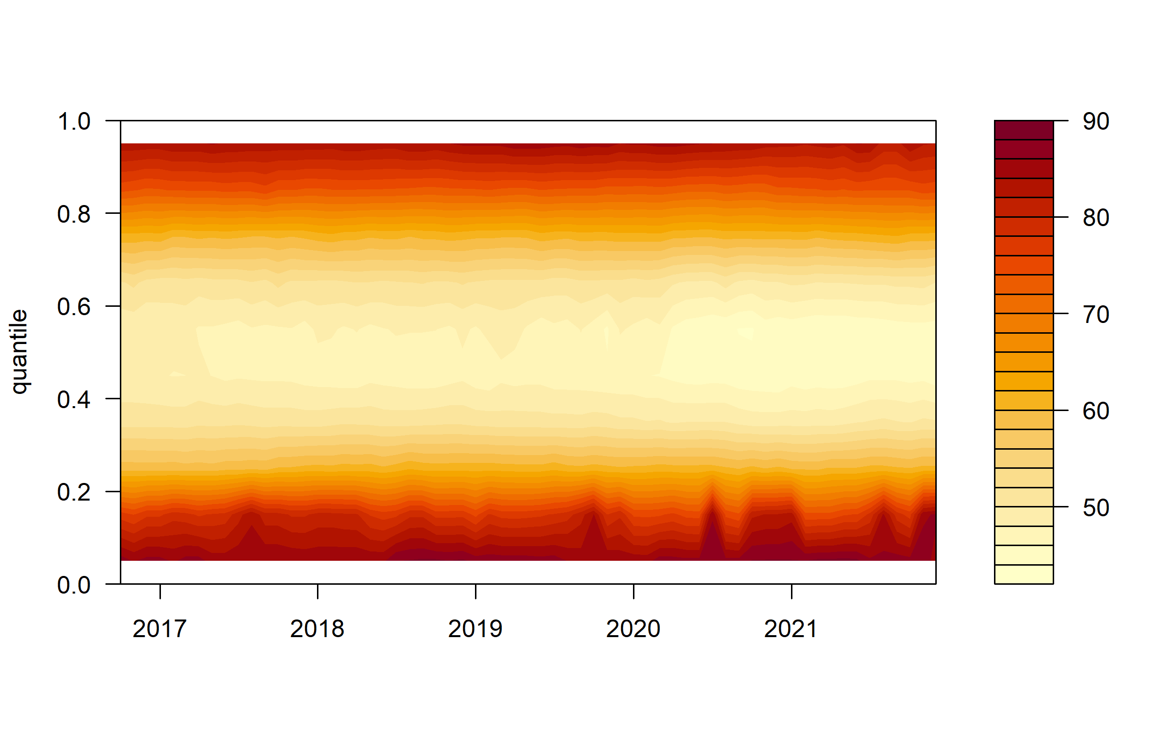
Figure 1. Overall Dynamic Connectedness

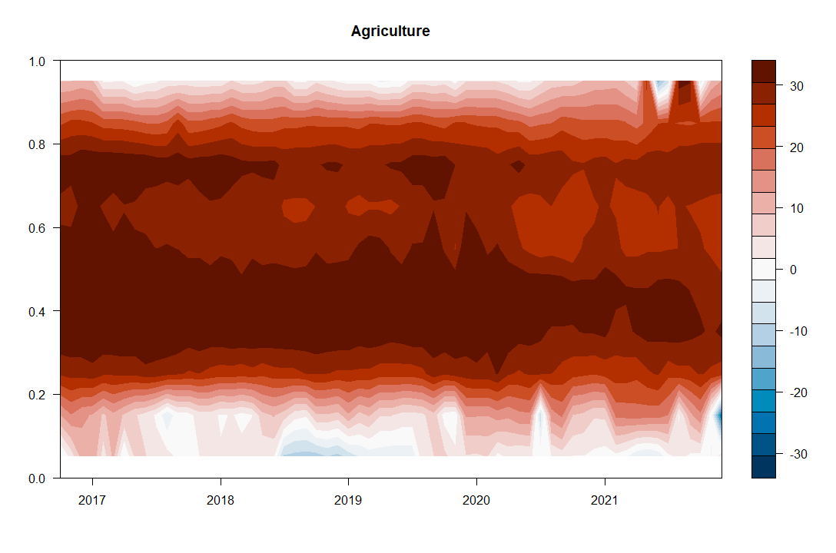
Figure 2. Net Total Directional Connectedness for Agriculture

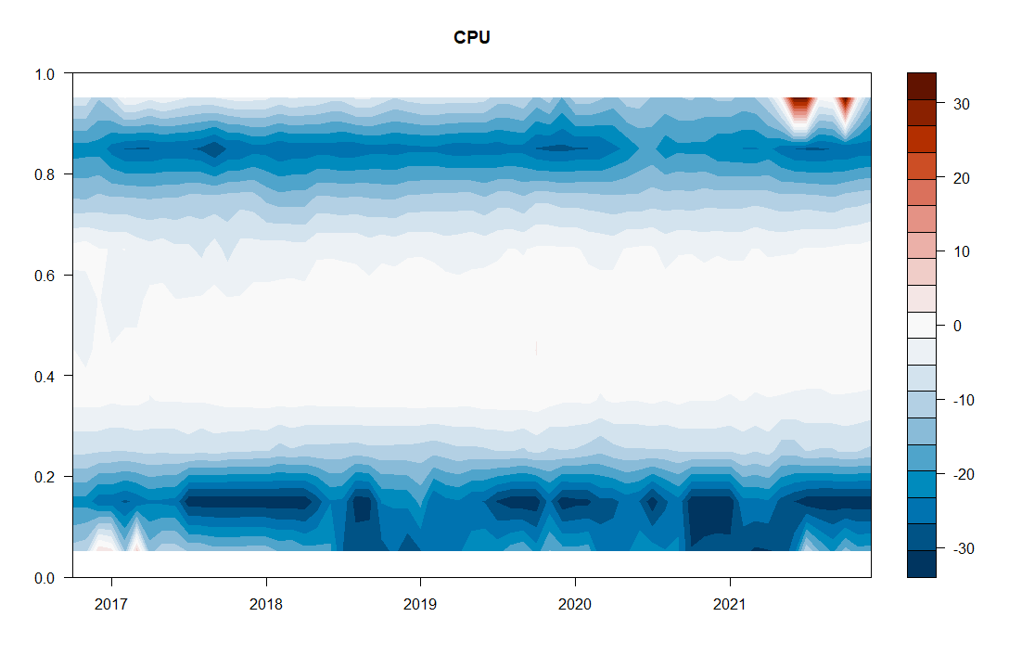
Figure 3. Net Total Directional Connectedness for the CPU
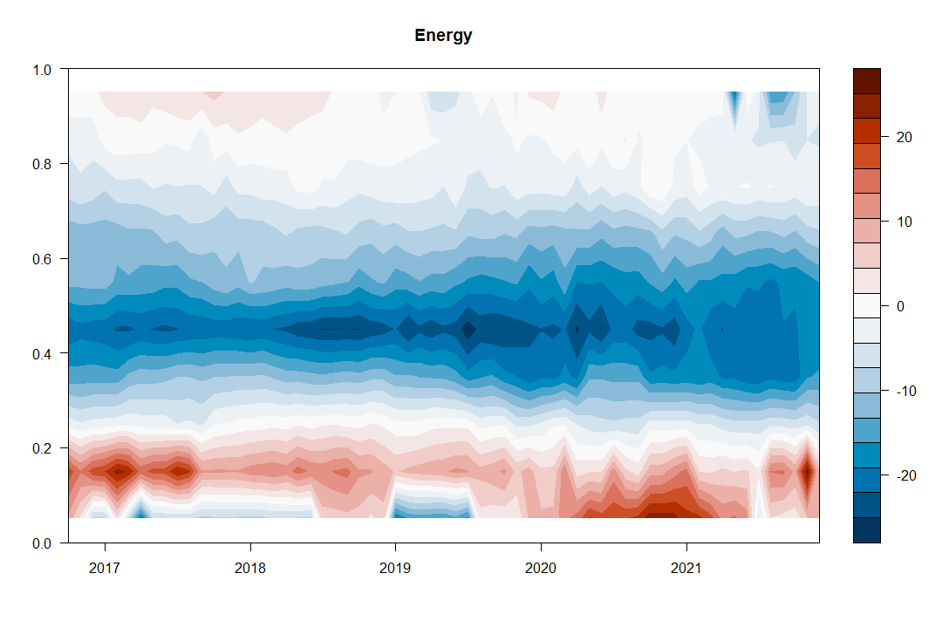
Figure 4. Net Total Directional Connectedness for Energy

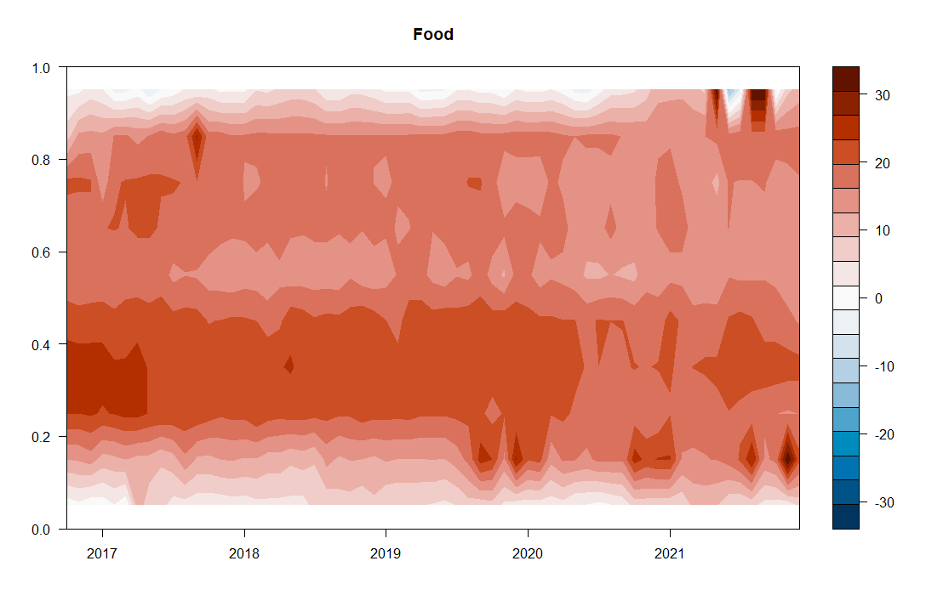
Figure 5. Net Total Directional Connectedness for Food

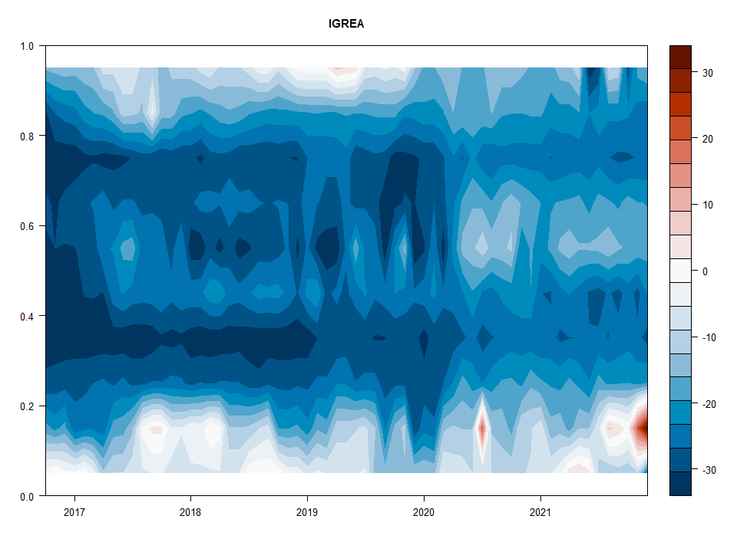
Figure 6. Net Total Directional Connectedness for IGREA

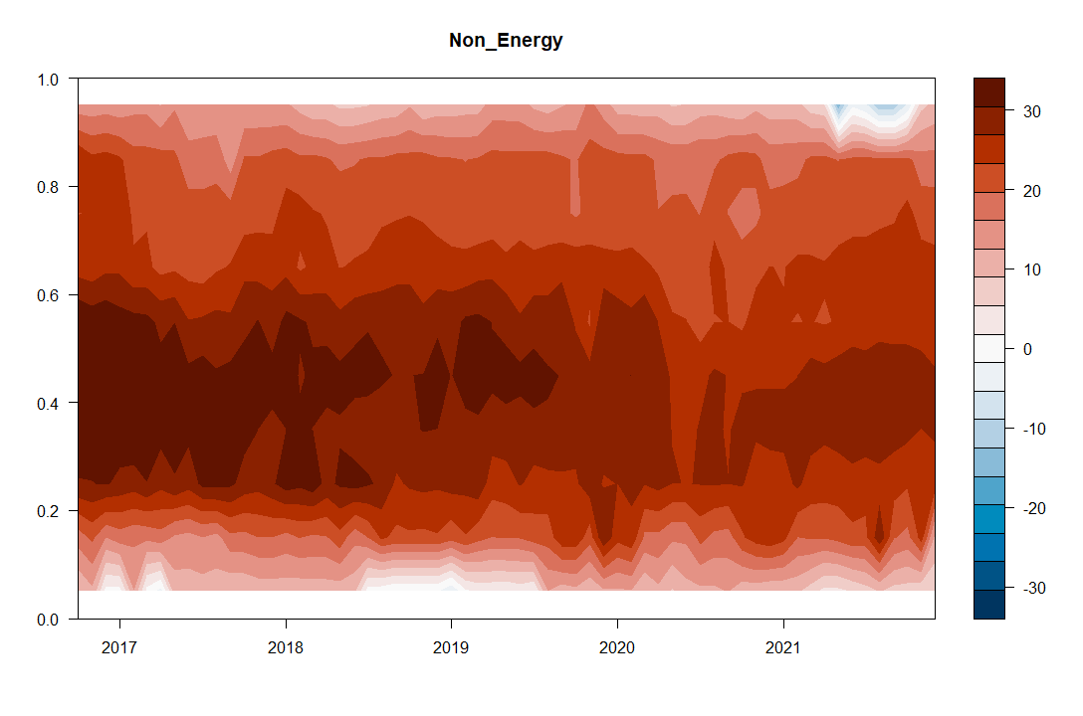
Figure 7. Net Total Directional Connectedness for Non-energy
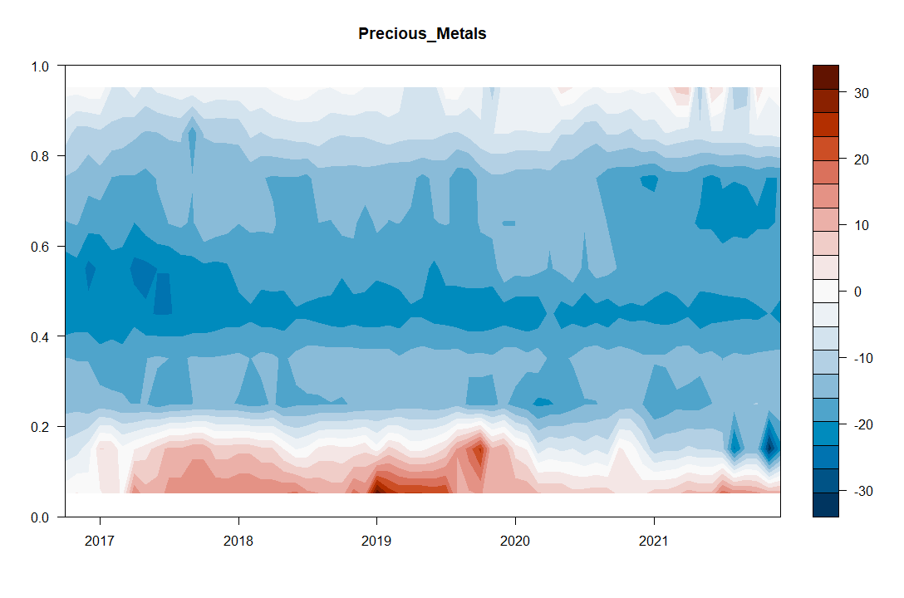
Figure 8. Net Total Directional Connectedness for Precious Metals

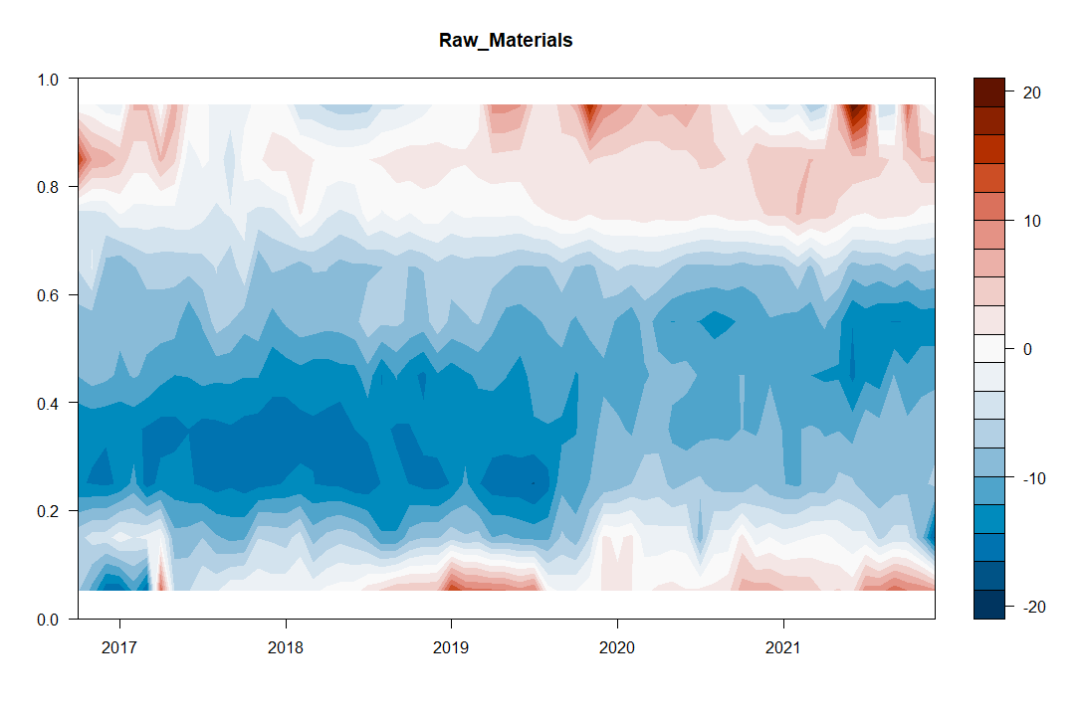
Figure 9. Net Total Directional Connectedness for Raw Materials

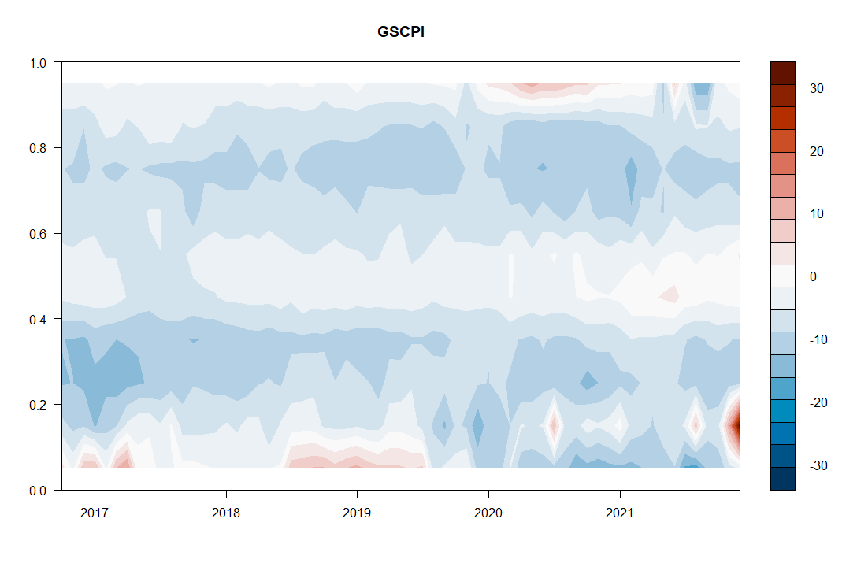
Figure 10. Net Total Directional Connectedness for the GSCPI

Visit https://www.worldbank.org/en/research/commodity-markets for details.
Refer https://www.newyorkfed.org/research/policy/gscpi#/overview for details.
Visit https://www.dallasfed.org/research/igrea.aspx for details.
Refer https://www.policyuncertainty.com/climate_uncertainty.html for details.
More details of the method are presented in Oygur and Unal (2021).

