Guenther, C. L., Zhang, Y., & Sedikides, C. (2023). The authentic self is the self-enhancing self: A self-enhancement framework of authenticity. Personality and Social Psychology Bulletin. Advance online publication. https://10.1177/01461672231160653

The Authentic Self Is the Self-Enhancing Self:
A Self-Enhancement Framework of Authenticity

Corey L. Guenther¹, Yiyue Zhang², and Constantine Sedikides³

¹Department of Psychological Science, Creighton University
²Department of Psychology, Ohio University
³School of Psychology, University of Southampton

Author Note
Corey L. Guenther https://orcid.org/0000-0002-3585-9734
Yiyue Zhang https://orcid.org/0000-0002-4594-6751
Constantine Sedikides https://orcid.org/0000-0002-7563-306X
This work was partially supported by a Graduate Student Research Fund from Ohio University to the second author. The authors have no known conflict of interest to disclose. All studies reported in this work have been conducted according to APA ethical standards for the treatment of human subjects. All study data and materials can be found on Open Science Framework (https://osf.io/ep3xn/?view_only=a8c57d2f3b744e8ca7e5c1208f71ff19). Preregistrations can be found on AsPredicted.org (https://aspredicted.org/WXB_SRK and https://aspredicted.org/VKP_N3J). Corresponding author: Corey L. Guenther, Department of Psychological Science, Creighton University, Omaha, NE 68178, USA; Email: coreyguenther@creighton.edu.
Abstract
Authenticity refers to behaving in a manner that aligns with one’s true self. The true self,
though, is positive. From a self-enhancement standpoint, people exaggerate their strengths and overlook their shortcomings, forming positively-distorted views of themselves. We propose a self-enhancement framework of authenticity, advocating a reciprocal relation between the two constructs. Trait self-enhancement was associated with higher trait authenticity (Study 1), and day-to-day fluctuations in self-enhancement predicted corresponding variations in state authenticity (Study 2). Further, manipulating self-enhancement elevated state authenticity (Studies 3–4) which was associated with meaning in life (Study 4), and manipulating authenticity augmented self-enhancement which was associated with meaning in life and thriving (Study 5). The authentic self is largely the self-enhancing self.
Keywords: authenticity, self-enhancement, better-than-average effect, well-being, meaning
From Aristotle (1985) through humanistic inquiry (Maslow, 1962; Rogers, 1961) and the positive psychology movement (Gable & Haidt, 2005; Seligman, 2002) to popular culture (Dillard, 2016; Nadrich, 2019), authenticity has been depicted as central to human experience and life fulfillment. We take a critical look at the construct and interrogate its relation to self-enhancement. In doing so we propose a bidirectional self-enhancement framework of authenticity, such that self-enhancement elicits authenticity and authenticity strengthens self-enhancement.
Conceptualizations of Authenticity
Authenticity is defined as being true to oneself (Jongman-Sereno & Leary, 2018; Sedikides et al., 2019). To be authentic one must allow their behavior to reflect a spontaneous expression of the self and must live in a way that conveys their actual characteristics and desires (Maslow, 1971). Inauthenticity, by contrast, implies “acting in ways that are not the real me or my true self” (Harter et al., 1996, p. 360).
Authenticity is further differentiated as trait and state (Sedikides et al., 2017). According to a multicomponent framework of trait authenticity (Kernis & Goldman, 2006), living authentically involves: (1) awareness of one’s strengths, weaknesses, goals, and aspirations; (2) engaging in unbiased processing of self-relevant information (i.e., accepting both positive and negative feedback); (3) behaving consistently with one’s values, standards, and preferences (i.e., not behaving falsely in the service of appeasing external influence); and (4) striving for relational openness, genuineness, and truthfulness in one’s close relationships. Other conceptualizations similarly emphasize authentic living as acting in accordance with one’s true self, and as exhibiting awareness and acceptance of one’s attributes (Knoll et al., 2015; Wood et al., 2008).
State authenticity is the transient sense of being true to one’s self (Sedikides et al., 2017). States are associated with cognitions, emotions, or actions in a particular situation (Fleeson, 2001), and are construed as relatively short-lived (Fridhandler, 1986). For example, individuals may experience state authenticity when they uphold their personal values in ambiguous situations (Erickson, 1995), engage in familiar activities (Lenton, Bruder et al., 2013), or perceive their goal strivings are congruent with their values (Sheldon & Elliot, 1998).
State authenticity is positively related to trait authenticity (Lenton, Bruder et al., 2013), and trait authenticity can be conceptualized as an accumulation of discernible state authenticity episodes (Nezlek, 2007). However, the two constructs correlate only modestly, as trait authenticity does not necessarily predict state authenticity in a given situation (Lenton, Bruder et al., 2013). For example, people feel more authentic when behaving agreeably and conscientiously even when they are not dispositionally agreeable or conscientious (Fleeson & Wilt, 2010).
Eliciting Authenticity: Self-Awareness or Self-Enhancement?
To infer they are authentic, it has been argued (Kernis & Goldman, 2006), people must know who they really are. However, people are often unaware of their psychological states (Nisbett & Wilson, 1977), and introspection or self-awareness is not necessarily the optimal path to self-knowledge (Wilson & Dunn, 2004). Relatedly, self-evaluation—especially on personally-important (or central) attributes—is marked by considerable, if not excessive, self-positivity (i.e., self-enhancement effect; Alicke et al., 2013; Sedikides & Gregg, 2008), typically the result of “striving to preserve or augment the favorability of one’s self-views” (i.e., self-enhancement motive; Sedikides, 2020, p. 251). For example, people prefer feedback that informs their strengths rather than weaknesses (Kunda, 1990), even when the feedback source is identical (Sedikides et al., 2016). They also believe they are better-than-average on important dimensions (Zell et al., 2020), and evaluate their abilities based on peak performances rather than objective base-rate averages (Guenther et al., 2015). Moreover, people are often unaware of their biased self-evaluations (Gregg et al., 2011): They are willing to bet money that their better-than-average views are correct (Williams & Gilovich, 2008), and opine that others are more likely to fall victims to self-enhancement than themselves (Pronin et al., 2002). Self-enhancement has been documented in both Western and Eastern cultures (Sedikides et al., 2015), and predicts well-being (Dufner et al., 2019).
Given the robustness with which self-evaluation is marked by self-enhancement, we advance a bidirectional self-enhancement framework of authenticity. We propose that people feel authentic when they self-enhance, and people self-enhance when they feel authentic. Proclivities toward authentic living and heightened authenticity, then, will be evident when self-views are marked by self-enhancement, and self-enhancement will be evident when people feel like their true selves.
We focus on self-enhancement as an antecedent to and consequence of subjective rather than objective authenticity (Rivera et al., 2019). Subjective authenticity refers to whether one feels as though they act in accordance with their true self (Kelley et al., 2022; Lenton, Bruder et al., 2013; Kernis & Goldman, 2006; Wood et al., 2008). Objective authenticity refers to whether the true self guides one’s behaviors, goals, and decision-making (Maslow, 1962; Rogers, 1961). Subjective authenticity and its implications for well-being have been gaining momentum in the personality and social psychological literature (Chen, 2019; Rivera et al., 2019; Sedikides et al., 2019; Sutton, 2020).
Authenticity and Self-Enhancement: Suggestive Evidence
There is suggestive evidence for the self-enhancement framework of authenticity. Authenticity is often associated with positive personality characteristics and behaviors instead of accurate self-reflections. For example, trait authenticity has been linked to higher self-esteem (Goldman & Kernis, 2002; Lenton et al., 2016; Lenton, Bruder et al., 2013; Wood et al., 2008) across several cultures (China, India, Singapore, U.S.; Slabu et al., 2014). Also, trait authenticity is positively associated with social desirability (Toper et al., 2022), an index of self-enhancement (Dufner et al., 2019). Moreover, trait authenticity arises in positive or socially desirable situations. In one study (Sheldon et al., 1997), genuineness and self-expressiveness were linked with positive ratings on Big Five personality traits: Participants reported feeling most authentic in social roles in which they perceived themselves as more extroverted, agreeable, conscientious, open to experience, and non-neurotic.
Likewise, state authenticity is positively associated with self-esteem in daily reports (Heppner et al., 2008), and is tethered to the positive self. In one study (Jongman-Sereno & Leary, 2016), participants imagined themselves resolving moral dilemmas in ways that were congruent with their personal desires, goals, and characteristics. Participants viewed their hypothetical behaviors as more authentic when these behaviors represented morally superior (rather than inferior) options, despite all behaviors being consistent with participants’ self-reported characteristics. A similar finding emerged when participants recalled actual behaviors: positive behaviors were perceived as more authentic than negative ones, even when all behaviors were congruent with participants’ self-reported characteristics. Other studies have documented parallel effects. For example, self-compassion, a positive personality trait, increases state authenticity regardless of dispositional self-compassion (Zhang et al., 2019), and state authenticity is induced by favorable acts such as upholding personal values (Smallenbroek et al., 2017) or behaving morally (Christy et al., 2016).
Finally, individuals construe their true selves as essentially good and moral (Newman et al., 2014). They believe their true selves guide them to behave virtuously (Newman et al., 2015), and perceive their own authentic selves as more positive and moral than others’ (Zhang & Alicke, 2021). Likewise, children believe their positive (vs. negative) traits reflect more of their authentic selves (Harter, 2002). The relation between perceptions of moral goodness and true self-knowledge is reciprocal: Individuals report reduced self-knowledge when they are reminded of their immoral behaviors, and feel they know more about the true selves of highly moral targets (Christy et al., 2016). Taken together, there is preliminary evidence for a link between self-enhancement and authenticity at trait and state levels. The search for true-self knowledge appears to be guided by positivity more than accuracy.
Overview
We report five studies testing the self-enhancement framework of authenticity. We hypothesize that trait self-enhancement is positively associated with trait authenticity (Study 1), and that day-to-day fluctuations in self-enhancement predict corresponding variations in state authenticity (Study 2). Further, we hypothesize a causal link between self-enhancement and authenticity, such that self-enhancement elevates state authenticity (Studies 3–4), which in turn is associated with higher well-being (meaning in life [MIL]; Study 4). Lastly, we hypothesize a causal relation between authenticity and self-enhancement, such that authenticity increases self-enhancement, which in turn is related to higher well-being (MIL and thriving; Study 5).
All studies were approved by the Institutional Review Board of the pertinent university. We report all measures, and preregistered Studies 4–5. Data, codes, and stimulus materials are on OSF (https://osf.io/ep3xn/?view_only=a8c57d2f3b744e8ca7e5c1208f71ff19).
Study 1
In Study 1, we tested the hypothesis that self-enhancement and authenticity are positively related at the trait level. We made no hypotheses regarding variation in correlation strength across authenticity subscales.
Method
Participants
We recruited an opportunistic sample of 185 Creighton University undergraduates (80 women, 65 men, 40 unknown due to a recording error; no age information). A sensitivity analysis (G*Power 3.1; Faul et al., 2009) indicated that 185 participants would yield 80% power to detect a small-to-medium effect (ρ = .20, assuming α = .05). We did not collect racial/ethnic data in Studies 1-3; however, in the relevant institution 70% of undergraduates are White, 8% Asian, 10% Hispanic/Latino, 2% Black, 6% multiple races, 2% Nonresidents, and 1% race-unspecified.
Procedure
Participants responded—in individual cubicles—to three questionnaires. They completed a dispositional authenticity measure and two (blocked) self-enhancement measures in random order, with the order of the self-enhancement measures counterbalanced.
Self-Enhancement. The first measure pertained to the better-than-average effect, a key indicator of self-enhancement (Sedikides & Alicke, 2019; Zell et al., 2020) that has been employed in research on individual differences in self-enhancement and correlates with other indicators of it (Taylor et al., 2003). Specifically, we used the How I See Myself Questionnaire (HSM; Taylor & Gollwitzer, 1995) to assess whether participants perceived themselves as superior to their peers. Participants evaluated themselves relative to a same-gender/age peer at their university on 22 items reflecting traits and skills, 11 of which were positive (e.g., “sensitive to others,” “academically able”) and 11 negative (e.g., “anxious,” “manipulative”). Responses ranged from 1 (much worse than the average college student of my age and gender) to 7 (much better than). We computed the BTAE by averaging ratings across items (α = .76).
The second measure was narcissism, also a key indicator of self-enhancement (Gebauer et al., 2017; Grijalva & Zhang, 2016), with individual differences in narcissism correlating positively with other self-enhancement indicators (Dufner et al., 2019). Specifically, we used the Narcissistic Personality Inventory-16 (NPI-16; Ames et al., 2006). Each of its 16 items constituted a pair of statements. For each pair, one statement exemplified the narcissistic response (e.g., “I am an extraordinary person”) and the other the non-narcissistic response (e.g., “I am much like everybody else”). Participants chose between the two statements. We added the number of narcissistic statements chosen (α = .69) to yield a narcissism index. Given that narcissism is marked by excessive self-positivity that is objectively unwarranted (Sedikides, 2021a), examining the relation between narcissism and authenticity offers a stringent test of whether authenticity reflects veridical self-perception or self-enhancement.
Authenticity. Participants completed the Trait Authenticity Inventory (AI-3; Kernis & Goldman, 2006). It comprises 45-items referring to the abovementioned four authenticity components. The relevant subscales are: awareness (12 items; e.g., “I actively attempt to understand myself as best as possible”), unbiased processing (10 items; e.g., “I am very uncomfortable objectively considering my limitations and shortcomings” [reverse-scored]), behaving consistently (11 items; e.g., “I rarely if ever, put on a “false face” for others to see”), and relational orientation (12 items; e.g., “If asked, people I am close to can accurately describe what kind of person I am”; 1 = strongly disagree, 5 = strongly agree). We computed indices for each component by averaging responses to items within the relevant subscale (awareness α = .82; unbiased processing α = .66; behavior consistency α = .63; relational orientation α = .62), and computed the trait authenticity index by averaging responses across all items (α = .86).
Results and Discussion
We hypothesized a positive link between self-enhancement and authenticity. We correlated scores on each self-enhancement measure—the HSM and NPI-16—with overall scores on the AI-3 and scores on each of the AI-3 subscales1 (Table 1).
The BTAE was positively related to authenticity, r(173) = .45, p < .001, and each sub-component of it. Perceiving oneself as better-than-average was linked to a greater proclivity to regard oneself as more aware of one’s strengths and weaknesses, r(180) = .47, p < .001, unbiased in self-evaluation, r(180) = .28, p < .001, behaving consistently with one’s internal world, r(177) = .32, p < .001, and having a genuine relational orientation, r(178) = .29, p < .001. Also, narcissism was positively associated with trait authenticity, r(175) = .23, p = .002, and with three authenticity sub-components: awareness, r(182) =.20, p = .006, unbiased processing, r(182) = .26, p < .001, and behaving consistently, r(179) = .21, p = .004. These results support the self-enhancement/authenticity framework.
Study 2
In Study 2, we sought an ecologically valid test of the association between self-enhancement and authenticity. Participants completed measures of self-enhancement and authenticity for seven consecutive days. We hypothesized that participants would experience greater authenticity on days when they self-enhanced more.
Method
Participants
We followed the sampling plan of studies that used a similar daily-diary design (Evans et al., 2022; Lenton et al., 2016; Zhang et al., 2019) aiming to test at least 100 participants, a typical sample size in daily-diary research (Ohly et al., 2010). We tested 123 Creighton University undergraduates. We excluded two for completing only one survey, leaving an N = 121 (77 women, 43 men, 1 non-binary). Their age ranged from 18–25 years (M = 18.93, SD = 1.04). Of them, 96.7% completed at least five surveys totaling 799 responses.
Procedure
In a pre-session, we invited participants to the laboratory (in groups of up to 14) explaining the study requirements. We collected the data on Qualtrics. For seven consecutive days, participants received a link (via email) to a survey that contained measures of state self-enhancement and authenticity (in random order). We distributed the surveys at late afternoon with instructions to be returned before midnight.
Self-Enhancement. Participants completed a BTAE measure wherein they made in-the-moment comparative ratings on five high-importance traits (Brown, 2012). Specifically, they rated themselves in comparison to the average same gender/age peer at their institution on honesty, kindness, responsibility, intelligence, and competence (1 = considerably below average, 5 = average, 9 = considerably above average). Each item was preceded by the stem “Right now” (e.g., “Right now, how would you rate your competence compared to the average student”). All ratings were made on a slider scale that recorded evaluations to two decimal points: The slide bar defaulted to the scale midpoint (“average”) to begin each rating, and participants adjusted the bar as needed to reflect their comparative self-judgments that day. We computed a daily self-enhancement index by averaging comparative ratings across items each day.
Authenticity. Participants completed the 4-item Southampton Authenticity Scale (Kelley et al., 2022; e.g., Right now, “I feel like the real me”; 1 = strongly disagree, 6 = strongly agree). We computed a daily authenticity index by averaging ratings across items each day.
Results and Discussion
To account for the nested nature of the data (days within people), we used linear mixed-modeling examining whether self-enhancement predicted authenticity across days. We centered daily self-enhancement on each participant’s mean state self-enhancement score across the entirety of the study. This within-subjects approach allowed us to test whether day-to-day deviations above or below each participant’s typical level of self-enhancement predicted systematic changes in felt authenticity. Intercepts varied, whereas slopes were fixed.
Daily self-enhancement predicted daily authenticity: On days when participants self-enhanced more, they reported higher authenticity, b = .38, SE = .04, t = 9.80, p < .001, 95% CI [.31, .46]. This finding replicates and extends Study 1 by providing ecologically valid evidence for the hypothesis that self-enhancement is associated with heightened authenticity.
Further, in a lagged analysis, we found that yesterday’s self-enhancement predicted today’s authenticity, b = .72, SE = .01, t = 70.23, p < .001, 95% CI [.70, .74], even after controlling for yesterday’s authenticity, b = .22, SE = .02, t = 9.44, p < .001, 95% CI [.18, .27]. Interestingly, yesterday’s authenticity also predicted today’s self-enhancement, b = .19, SE = .04, t = 5.16, p < .001, 95% CI [.12, .26], and continued to do so after controlling for yesterday’s self-enhancement, b = .11, SE = .03, t = 3.54, p < .001, 95% CI [.05, .17], although the strength of this relation was weaker. These findings offer preliminary evidence for the bidirectional relation between self-enhancement and authenticity.
Study 3
In Studies 1-2, we obtained a positive relation between self-enhancement and authenticity. In Study 3, we tested this relation causally. Participants completed a personality assessment and received favorable or unfavorable feedback along dimensions that differed on personal importance. Self-enhancement concerns most prominently influence self-evaluations on personally-important domains (Gebauer at al., 2013; Sedikides et al., 2016), and so we expected that authenticity would be most influenced by feedback favorability on high-importance trait dimensions. We hypothesized that participants who received favorable (vs. unfavorable) feedback on important (vs. unimportant) traits would report greater authenticity.
Method
Participants
A power analysis (G*Power 3.1; Faul et al., 2009) indicated that 274 participants would yield 80% power to detect a small to medium effect (f = .17, assuming α = .05). We recruited 275 Creighton University undergraduates (184 women, 90 men, 1 prefer-not-to-answer), aged from 17–24 years (M = 18.81, SD = .88).
Procedure
Participants completed the study—ostensibly their university’s effort to understand student personality profiles—in individual cubicles. First, they filled out the 44-item Big Five Inventory (BFI; John & Srivastava, 1999), advertised as one of the most accurate and widely used personality inventories. Next, participants were randomly assigned to receive (bogus) favorable or unfavorable feedback regarding their standing relative to same-university peers on six traits, three of which were of high importance (e.g., honest, kind, responsible) and three of low importance (outgoing, imaginative, agreeable; Brown, 2012), controlling for the favorability of feedback within a given category (high vs. low importance). Hence, the design comprised a 2 (high importance traits: favorable vs. unfavorable feedback) × 2 (low importance traits: favorable vs. unfavorable feedback) design yielding four conditions: favorable feedback on high-importance traits/favorable feedback on low-importance traits (n = 71); favorable feedback on high-importance traits/unfavorable feedback on low-importance traits (n = 67); unfavorable feedback on high-importance traits/favorable feedback on low-importance traits (n = 61); unfavorable feedback on high-importance traits/unfavorable feedback on low-importance traits (n = 76).
When assigned to receive favorable feedback, participants learned that they scored between the 92nd and 97th percentile on each of the three traits in the relevant category (high- vs. low-importance). When assigned to receive unfavorable feedback, participants learned that they scored between the 27th and 32nd percentile on each of the three traits in the relevant category. We displayed feedback on screen one trait dimension at a time, in random order for each participant, for a minimum of 12 seconds (see Appendix for an example), after which participants elected when to advance to additional feedback. Finally, participants completed the same state authenticity measure as in Study 2 (α = .89).
Results and Discussion
We present descriptive statistics in Table 2. A 2×2 Analysis of Variance (ANOVA) yielded a significant main effect of high-importance feedback on authenticity, F(1, 271) = 7.89, p = .005, η_{p}² = .028. Participants receiving favorable feedback on high-importance traits (M = 4.92, SD = .85) evinced greater authenticity than those receiving unfavorable feedback on high-importance traits (M = 4.57, SD = 1.14). Neither the main effect of low-importance feedback, F(1, 271) = .25, p = .621, η_{p}² = .001, nor the high- versus low-importance feedback interaction, F(1, 271) = .30, p = .585, η_{p}² = .001, were significant. Consistent with our theoretical framework, receipt of favorable (vs. unfavorable) feedback—particularly in personally-important trait domains—increased authenticity, even though both types of feedback purportedly offered objective insight into one’s strengths and weaknesses2. Self-enhancing accuracy, not simply accuracy per se, is more paramount to the emergence of authenticity.
Study 4
In pre-registered Study 4 (https://aspredicted.org/VKP_N3J), we tested the replicability of Study 3’s finding that self-enhancement augments authenticity. More importantly, we extended Study 3 in four ways. First, we used a different self-enhancement manipulation and measure of authenticity. Second, we evaluated an alternative explanation for the Study 3 results. It is possible that providing self-enhancing feedback on high-importance traits elevated positive affect (Sedikides & Strube, 1997), which may have increased authenticity (Lenton, Slabu et al., 2013). Third, we examined exploratorily whether temporal orientation moderates the relation between self-enhancement and authenticity. People construe their future self more favorably than their past or current self (Guenther & Zhang, 2022; Preuss & Alicke, 2017). Also, they may regard their future self as more authentic than their current self (Lenton, Bruder et al., 2013; Seto & Schlegel, 2018). Thus, we examined whether self-enhancing with a future-orientation (vs. past-orientation) would more strongly impact authenticity. Lastly, we tested whether augmenting authenticity via self-enhancement has downstream consequences on a well-being indicator, MIL. Prior research has linked both self-enhancement (Abeyta et al., 2017; Lilgendahl & McAdams, 2011) and authenticity (Sedikides et al., 2019; Wood et al., 2008) to higher MIL. We tested, then, whether elevated authenticity is one mechanism by which self-enhancement improves well-being.
Method
Participants
A power analysis (G*Power 3.1; Faul et al., 2009) indicated that 351 participants would yield 80% power to detect a small to medium effect (f = .15, assuming α = .05). We recruited 361 U.S.-based Prolific workers for $.85. After excluding one participant whose responses to two attention check items were below the scale median, the final sample comprised 360 participants (159 women, 181 men, 9 non-binary individuals, 2 transgender women, 9 unspecified) aged from 18–79 years (M = 37.35, SD = 14.38). Of them, 77.78% were White, 5.00% Black, 11.67% Asian, 0.56% Hawaiian, 0.56% Middle Eastern, 2.50% mixed-race, and 1.93% race-unspecified. We used a 2 (self-reflection: enhanced vs. diminished) × 2 (time orientation: past vs. future self) between-subjects design, randomly assigning participants to conditions.
Procedure and Measures
We adapted the manipulation after O’Mara et al. (2012). In the enhanced-future condition, participants wrote about an imagined future occasion where they would show a much higher level of caring, understanding, or kindness than they had now. The instructions for the diminished-future condition were similar, except participants wrote about an imagined occasion where they would show a much lower level of caring, understanding, or kindness than they had now. The protocol for the enhanced-past and diminished-past conditions was similar, except that participants recalled past occasions. Next, all participants completed a manipulation check and the measures.
Self-Enhancement Manipulation Check. Participants provided self-evaluations on 15 high-importance traits (Brown, 2012; e.g., competent, honest, trustworthy; 1 = lowest level, 7 = highest level). Past-oriented participants rated their past selves, whereas future-oriented participants rated their future selves (“rate the amount of each trait you believe you have [had] when imagining [recalling] this situation”). We averaged ratings across items to form a self-enhancement index (α = .94).
Authenticity. Participants completed a 3-item state authenticity measure (“Thinking about this situation makes me feel that…” “I am authentic;” Kifer et al., 2013; 1 = strongly disagree, 7 = strongly agree). We averaged responses across items to create an authenticity index (α = .97).
Meaning in Life. Participants completed a state version of the 5-item Presence of Meaning Subscale of the Meaning in Life Questionnaire (PMIL; Steger et al., 2006). A sample item is: “Thinking about this situation makes me feel that I understand my life’s meaning right now” (1 = strongly disagree, 7 = strongly agree). We averaged ratings across items to create a MIL index (α = .95).
Positive Affect. Participants completed a 4-adjective mood scale (Hepper et al., 2012) that assessed positive affect (e.g., “happy”) and negative affect (e.g., “sad”; 1 = not at all, 7 = very much). After reverse-scoring, we averaged responses to create a positive affect index (α = .93).
Results
First, we conducted a series of 2 (self-reflection: enhanced vs. diminished) × 2 (time orientation: past vs. future self) ANOVAs on self-enhancement, state authenticity, meaning in life, and affect. We present descriptive statistics in Table 3.
Self-Enhancement Manipulation Check
A self-reflection main effect showed that participants in the enhanced condition self-enhanced more than those in the diminished condition, F(1, 356) = 190.38, p < .001, η_{p}² = .348, 95% CI [1.34, 1.78]. Neither the time orientation main effect, F(1, 356) = 2.41, p = .121, η_{p}² = .007, nor the Self-Reflection × Time Orientation interaction, F(1, 356) = .31, p = .580, η_{p}² = .001, was significant. The manipulation was effective.
State Authenticity
A self-reflection main effect indicated that participants in the enhanced condition reported higher authenticity than those in the diminished condition, F(1, 356) = 96.48, p < .001, η_{p}² = .213, 95% CI [1.35, 2.02]. Neither the time orientation main effect, F(1, 356) = 1.17, p = .280, η_{p}² = .003, nor the Self-Reflection × Time Orientation interaction, F(1, 356) = .63, p = .427, η_{p}² = .002, was significant.
Meaning in Life
Participants in the enhanced condition reported more MIL than those in the diminished condition, F(1, 356) = 19.58, p < .001, η_{p}² = .052, 95% CI [.41, 1.07]. Neither the time orientation main effect, F(1, 356) = .001, p = .978, η_{p}² = .000, nor the Self-Reflection × Time Orientation interaction, F(1, 356) = 1.13, p = .288, η_{p}² = .003, was significant.
Positive Affect
Participants in the enhanced condition reported more positive affect than those in the diminished condition, F(1, 356) = 16.93, p < .001, η_{p}² = .045, 95% CI [.34, .96]. Neither the time orientation main effect, F(1, 356) = .30, p = .587, η_{p}² = .001, nor the Self-Reflection × Time Orientation interaction, F(1, 356) = .03, p = .868, η_{p}² = .000, was significant. Entering affect as a covariate in the preceding analyses did not alter the results3.
Mediation Analysis
The Self-Reflection × Time Orientation interactions were not significant. So, instead of a moderated mediation analysis, we conducted a mediation analysis using PROCESS model 4 (Hayes, 2018) with 10,000 bootstrapping estimates. We entered self-reflection (enhanced vs. diminished) as the predictor, authenticity as the mediator, and MIL as the outcome.
The overall indirect effect was significant, estimate = .66, 95% CI [.46, .87], SE = .10. Participants who enhanced experienced higher authenticity, which in turn positively predicted MIL (Figure 1). Furthermore, the mediation model remained significant after controlling for positive affect, estimate = .43, 95% CI [.26, .61], SE = .09.
Discussion
The Study 4 results converged with those of Study 3 to support the hypothesis that self-enhancement augments authenticity. We obtained these results using an alternative self-enhancement manipulation and state authenticity measure to those of Study 3. Additionally, Study 4 demonstrated that authenticity mediates the effect of self-enhancement on MIL independently of positive affect and time orientation.
Study 5
Studies 1–2 showed an association between self-enhancement and authenticity, whereas Studies 3–4 indicated that self-enhancement increases authenticity. These findings are consistent with the self-enhancement framework of authenticity. As a reminder, though, this framework anticipates a reciprocal relation between the two constructs. We tested in preregistered Study 5 (https://aspredicted.org/WXB_SRK) the causal effect of authenticity on self-enhancement. We manipulated authenticity (compared to inauthenticity and control) and assessed its effect on self-enhancement.
Authenticity is associated with higher MIL (Sedikides et al., 2019; Wood et al., 2008). It is also positively associated with other indices of psychological well-being, such as thriving (Kelley et al., 2022), which reflects a holistic view of healthy functioning that encompasses assorted constructs (e.g., belonging, optimism, purpose, self-efficacy, vitality). Likewise, self-enhancement is positively associated both with MIL (Abeyta et al., 2017; Lilgendahl & McAdams, 2011) and thriving (Dufner et al., 2019; Taylor et al., 2013). We therefore proceeded to test whether self-enhancement mediates the effect of authenticity on MIL and thriving.

Method

Participants
A power analysis (G*Power 3.1; Faul et al., 2009) indicated that 432 participants would yield 80% power to detect a small to medium effect in a one-way ANOVA (f = .15, assuming α = .05). We recruited 443 U.S.-based Prolific workers for $.85. After excluding one participant whose responses to two attention check items were below the scale median, the final sample comprised 442 participants4 (223 women, 206 men, 7 non-binary individuals, 1 transgender woman, 1 transgender man, 4 unspecified) aged from 18–79 years (M = 35.70, SD = 13.80). Of them, 77.83% were White, 6.11% Black, 0.90% Native American, 7.47% Asian, 0.45% Hawaiian, 4.52% mixed-race, and 2.71% race-unspecified. We randomly assigned participants to conditions (authenticity vs. inauthenticity vs. control).

Procedure and Measures
We ran the study on Qualtrics. We modeled our manipulation after Gino et al. (2015). Participants in the authenticity condition recalled and described (for a maximum of 5 min) a time in their personal or professional life when they behaved in a way that “made you feel true to yourself, that made you feel authentic.” Participants in the inauthenticity condition recalled and described a time that made them feel untrue to themselves and inauthentic. Finally, participants in the control condition recalled and described a neutral experience (e.g., what happened yesterday throughout the day). Next, all participants completed a state authenticity manipulation check using the same 3-item measure as in Study 4 (α = .98).
Self-Enhancement. Participants completed the same self-enhancement measure as in Study 4 (α = .95).
Well-Being: Meaning in Life and Thriving. We assessed MIL with the PMIL (α = .94), as in Study 4. We assessed thriving with the 10-item Brief Inventory of Thriving (Su et al., 2014). A sample item is: “Thinking about this situation makes me feel I am achieving most of my goals” (1 = strongly disagree, 7 = strongly agree; α = 0.96).
Positive Affect. Participants completed the positive affect measure of Study 4 (α = 0.93).
Data-Analytic Strategy
Following Kelley et al.’s (2022) approach, we first conducted a series of one-way ANOVAs to assess the influence of the manipulation on the manipulation check, self-enhancement, MIL, thriving, and positive affect. If statistically significant, we followed with a planned orthogonal (linear) contrast to assess whether the value of each variable would be—as anticipated—highest in the authenticity condition (= +1), intermediate in the control condition (= 0), and lowest in the inauthenticity condition (= -1).
Results
The Levene’s test for homogeneity of variances was significant for all measures, Fs ≥ 3.01, ps ≤ .05. Thus, we report Welch’s Fs for all omnibus tests. We provide descriptive statistics in Table 4.

Manipulation Check
The omnibus effect on level of authenticity was significant, F(2, 272.62) = 176.80, p < .001, η² = .54. The planned linear contrast was also significant, t(201.55) = 18.64, p < .001, d = 2.40. Level of authenticity was highest in the authenticity condition (M = 6.22, SD = .89), intermediate in the control condition (M = 5.92, SD = 1.10), and lowest in the inauthenticity condition (M = 3.04, SD = 1.83). The manipulation was effective.

Self-Enhancement
The omnibus effect on self-enhancement was significant, F(2, 277.32) = 36.00, p < .001, η² = .16, as was the linear contrast, t(220.13) = 8.50, p < .001, d = 1.04. Self-enhancement was strongest in the authenticity condition (M = 5.45, SD = .83), intermediate in the control condition (M = 5.16, SD = 1.07), and weakest in the inauthenticity condition (M = 4.25, SD = 1.46).

Meaning in Life
The omnibus effect on MIL was significant, F(2, 290.75) = 15.77, p < .001, η² = .07. The linear contrast was also significant, t(276.86) = 5.62, p < .001, d = .65. MIL was highest in the authenticity condition (M = 4.99, SD = 1.36), intermediate in the control condition (M = 4.61, SD = 1.59), and lowest in the inauthenticity condition (M = 4.01, SD = 1.56).

Thriving
The omnibus effect on thriving was significant, F(2, 289.79) = 15.94, p < .001, η² = .07, as was the linear contrast, t(274.27) = 5.65, p < .001, d = .67. Thriving was highest in the authenticity condition (M = 5.25, SD = 1.17), intermediate in the control condition (M = 4.91, SD = 1.28), and lowest in the inauthenticity condition (M = 4.39, SD = 1.38).

Positive Affect
The omnibus effect on positive affect was significant, F(2, 287.00) = 11.80, p < .001, η² = .04, as was the linear contrast, t(264.15) = 4.70, p < .001, d = .52. Positive affect was highest in the authenticity condition (M = 5.54, SD = 1.11), intermediate in the control condition (M = 5.10, SD = 1.53), and lowest in the inauthenticity condition (M = 4.83, SD = 1.43). Importantly, entering positive affect as a covariate in the above-reported analyses on self-enhancement, MIL, and thriving did not alter the results5.

Mediation Analysis
To assess whether self-enhancement mediated the effect of authenticity on well-being, we conducted mediation analyses via PROCESS model 4 (Hayes, 2018) with 10,000 bootstrapping estimates. We entered the authenticity manipulation as predictor, self-enhancement as mediator, and MIL and thriving as outcomes.
When MIL was the outcome, the overall indirect effect for the contrast between the authenticity and inauthenticity conditions was significant, estimate = .68, 95% CI [.49, .88], SE = .10. Participants in the authenticity (vs. inauthenticity) condition reported higher self-enhancement, which positively predicted MIL (Figure 2). Moreover, the model remained significant after controlling for positive affect, estimate = .41, 95% CI [.25, .57], SE = .08. Additionally, the overall indirect effect for the contrast between the authenticity and control conditions was significant, estimate = .16, 95% CI [.04, .30], SE = .06. Participants in the authenticity (vs. control) condition reported higher self-enhancement, which positively predicted MIL. The overall indirect effect for the contrast between the inauthenticity and control conditions was likewise significant, estimate = .51, 95% CI [.34, .71], SE = 0.09. Participants in the inauthenticity (vs. control) condition reported lower self-enhancement, which negatively predicted MIL.
When thriving was the outcome, the overall indirect effect for the contrast between the authenticity and inauthenticity conditions was significant, estimate = .63, 95% CI [.46, .82], SE = .10. Participants who were in the authenticity (vs. inauthenticity) condition reported more self-enhancement, which positively predicted thriving (Figure 3). Additionally, the model remained significant after controlling for positive affect, estimate = .33, 95% CI [.21, .48], SE = .07. Furthermore, the overall indirect effect for the contrast between the authenticity and control conditions was significant, estimate = .15, 95% CI [.04, .28], SE = .06. Participants in the authenticity (vs. control) condition reported higher self-enhancement, which positively predicted thriving. Lastly, the overall indirect effect for the contrast between the inauthenticity and control conditions was significant, estimate = .48, 95% CI [.31, .67], SE = .09. Participants in the inauthenticity (vs. control) condition reported lower self-enhancement, which negatively predicted thriving.
Discussion
When participants felt authentic (vs. inauthentic and control), they engaged in self-enhancement, and doing so predicted increases in MIL and thriving. As in Study 4, controlling for positive affect did not alter the results, consistent with findings that felt authenticity overlaps only partially with positive affect (Rivera et al., 2019; Lenton, Bruder et al., 2013a; Slabu et al., 2014).
General Discussion
Authenticity has a rich tradition in philosophy and psychology, and is appealing to popular culture: A Google search of “authenticity” (February 4, 2022) generated 1,900,000,000 results. To live authentically, scholars proposed, is to escape self-delusion and have one’s judgments, decisions, and behaviors guided by self-insight and veridical self-perception (Knoll et al., 2015; Wood et al., 2008). Authentic living, then, is best achieved when one’s actions are aligned with their values and sentiments (Kernis & Goldman, 2006; Maslow, 1971). However, people are often unaware of their psychological states and immune to the vagaries of introspection (Nisbett & Wilson, 1977; Wilson & Dunn, 2004). Further, self-evaluations are frequently positively skewed (Vazire & Carlson, 2011; Wilson & Dunn, 2004). Indeed, people tend to form positively-distorted views of themselves (Alicke et al., 2013; Sedikides et al., 2015). The literature has offered suggestive evidence of a link between authenticity and self-enhancement (Christy et al., 2016; Jongman-Sereno & Leary, 2016). Here, we formulated a self-enhancement framework of authenticity. We advocated that authenticity—both as trait and state—is characterized by self-enhancement rather than self-insight. Specifically, we postulated a bidirectional relation between the two constructs. Authenticity is largely based on self-enhancement, and when people feel authentic they self-enhance—both of which have downstream consequences for well-being.
Summary of Findings and Implications
In Study 1, authenticity was positively associated with self-enhancement, operationalized as the better-than-average effect and grandiose narcissism. In Study 2, participants experienced more authenticity on days in which they self-enhanced more; also yesterday’s self-enhancement predicted today’s authenticity, and yesterday’s authenticity predicted today’s self-enhancement. In Study 3, self-enhancement (receiving favorable than unfavorable feedback) augmented authenticity, despite the feedback ostensibly deriving from the same diagnostic assessment. In Study 4, self-enhancement (engaging in enhanced vs. diminished reflection about one’s past or future) elevated authenticity, which augmented MIL independently of positive affect. Finally, in Study 5, authenticity (vs. inauthenticity and control) increased self-enhancement, with the latter transmitting the effect of authenticity on MIL and thriving, controlling for positive affect. Taken together, authenticity and self-enhancement are not discordant; rather, they are fundamentally intertwined.
Although our research represents the first direct test of the relation between self-enhancement and authenticity, the results are consistent with several literature streams. For instance, authenticity is linked more with moral than immoral behavior (Newman et al., 2014), and socially desirable than undesirable behavior (Jongman-Sereno & Leary, 2016). Likewise, people believe their authentic selves to be positive and morally good, and to be more positive than the authentic selves of others (Zhang & Alicke, 2021). Despite popular belief and previous conceptualizations, self-enhancement is an essential ingredient for eliciting perceptions that one is living life authentically.
Limitations and Future Directions

Future research can expand understanding of the self-enhancement-authenticity link in several ways. We tested exclusively U.S. participants in Studies 1–3, and mostly U.S. participants in Studies 4–5. Considerable evidence points to the panculturality of both self-enhancement (Chiu et al., 2011; Chung et al., 2016; Sedikides et al., 2015) and authenticity (Ito & Kodama, 2007; Kim et al., 2022; Slabu et al., 2014), and so to the likelihood that their association is pancultural. Regardless, follow-up research would do well to test for cross-cultural specificity.

Our results indicated that self-enhancement elicits greater authenticity than self-diminishment, and literature shows that people across cultures are averse to self-diminishing feedback (Gaertner et al., 2012; Sedikides, 2012). Nevertheless, given that the acceptance of personal faults has traditionally been considered a trademark of objective authenticity—which we do not address here—future research should examine whether willing (i.e., internalized) self-diminishment fosters authenticity. This may be more likely to occur in reference to contextualized self-aspects (perceptions of the self in specific relationships or situations) rather than global self-views (Chen et al., 2006). Nevertheless, given that both domain-specific and global self-views are predominantly positive (Gaertner et al., 1999; Kendall et al., 1989; Thomaes et al., 2017) and given the potency of the self-enhancement motive especially on personally-important attributes (Anseel & Martinescu, 2020; Sedikides, 2021b; Sedikides et al., 2021), we expect that, at least among healthy or typical individuals, willing internalization of negative self-views would be rather rare.

Future work may also explore additional implications of the self-enhancement-authenticity link besides well-being. The social domain is of relevance. According to our theoretical framework, self-enhancement is intrinsic to authenticity. However, persistent and blatant self-enhancement may be viewed negatively by others (Hoorens et al., 2012; Van Damme et al., 2016). By extension, the persistent and blatant pursuit of authenticity may entail unfavorable social consequences. Relatedly, felt authenticity is not necessarily equivalent to perceived authenticity: Self-perceived authentic individuals are not necessarily seen as authentic by others. Moreover, inauthentic persons may be seen as authentic (Hart et al., 2020; Rosenblum et al., 2020). This discrepancy between felt and perceived authenticity is partially due to observers not having access to inner states of actors or actors’ authentic selves. Consequently, judgments of authenticity commonly rely on actors’ observable behaviors (Gershon & Smith, 2020; Johnson et al., 2004).
Observers may attempt to infer a target’s authenticity by scrutinizing the target’s behavior for ulterior motives. Attributions of external motives (e.g., to gain financial rewards or ingratiate) may culminate in perceptions of insincerity and inauthenticity (Gershon & Smith, 2020; Lafrenière et al., 2016). For example, observers rate donors’ prosocial actions as less authentic when informed of donors’ financial interests (Berman et al., 2015). Also, self-presentation strategies such as humblebragging and self-handicapping that aim to increase one’s likability and perceived competence often backfire, as they raise questions about a person’s earnestness and authenticity (Luginbuhl & Palmer, 1991; Sezer et al., 2018). Hence, if authenticity-driven self-enhancers raise suspicions about ulterior motives, they might be viewed unfavorably.
Coda
Contrary to historical conceptualizations and lay intuition, veridical self-insight may not light the path toward living life authentically. Instead, authenticity and self-enhancement go hand-in-hand. Authentic people think highly of themselves, and people who think highly of themselves feel authentic.

References
Abeyta, A.A., Routledge, C., & Sedikides, C. (2017). Material meaning: Narcissists gain existential benefits from extrinsic goals. Social Psychological and Personality Science, 8(2), 219–228. http://dx.doi.org/10.1177/1948550616667618
Alicke, M.D., Zell, E., & Guenther, C.L. (2013). Social self-analysis: Constructing, protecting, and enhancing the self. Advances in Experimental Social Psychology, 48, 173–234. https://doi.org/10.1016/B978-0-12-407188-9.00004-1
Ames, D.R., Rose, P., & Anderson, C.P. (2006). The NPI-16 as a short measure of narcissism. Journal of Research in Personality, 40, 440–450. http://dx.doi.org/10.1016/j.jrp.2005.03.002
Anseel, F., & Martinescu, E. (2020). Praise from a self-enhancement perspective: More, I want more? In E. Brummelman (Ed.), Psychological perspectives on praise (pp. 3-10). Routledge. https://doi.org/10.31234/osf.io/9bjgn
Aristotle. (1985). Nicomachean ethics (T. Irwin, Trans.). Hackett. (Original work published 350 B.C.)
Berman, J.Z., Levine, E.E., Barasch, A., & Small, D.A. (2015). The braggart’s dilemma: On the social rewards and penalties of advertising prosocial behavior. Journal of Marketing Research, 52(1), 90–104. https://doi.org/10.1509/jmr.14.0002
Brown, J.D. (2012). Understanding the better than average effect: Motives (still) matter. Personality and Social Psychology Bulletin, 38(2), 209–219. https://doi.org/10.1177/0146167211432763
Chen, S. (2019). Authenticity in context: Being true to working selves. Review of General Psychology, 23(1), 60–72. https://doi.org/10.1037/gpr0000160
Chen, S., English, T., & Peng, K. (2006). Self-verification and contextualized self-views. Personality and Social Psychology Bulletin, 32(7), 930–942. https://doi.org/10.1177/0146167206287539
Chung, J., Schriber, R.A., & Robins, R.W. (2016). Positive illusions in the academic context: A longitudinal study of academic self-enhancement in college. Personality and Social Psychology Bulletin, 42(10), 1384–1401. https://doi.org/10.1177/0146167216662866
Chiu, C.-y., Wan, C., Cheng, S.Y.Y., Kim, Y.-H., & Yang, Y.-J. (2011). Cultural perspectives on self-enhancement and self-protection. In M.D. Alicke & C. Sedikides (Eds.), Handbook of self-enhancement and self-protection (pp. 425–451). Guilford Press.
Christy, A.G., Seto, E., Schlegel, R.J., Vess, M., & Hicks, J.A. (2016). Straying from the righteous path and from ourselves: The interplay between perceptions of morality and self-knowledge. Personality and Social Psychology Bulletin, 42(11), 1538–1550. https://doi.org/10.1177/0146167216665095
Dillard, S. (2016). Discover your authentic self: Be you, be free, be happy. Llewellyn Publications.
Dufner, M., Gebauer, J.E., Sedikides, C., & Denissen, J.J.A. (2019). Self-enhancement and psychological adjustment: A meta-analytic review. Personality and Social Psychology Review, 23(1), 48–72. https://doi.org/10.1177/1088868318756467
Erickson, R.J. (1995). The importance of authenticity for self and society. Symbolic Interaction, 18(2), 121–144. https://doi.org/10.1525/si.1995.18.2.121
Evans, N.D., Juhl, J., Hepper, E.G., Wildschut, T., Sedikides, C., & Fetterman, A.K. (2022). Romantic nostalgia as a resource for healthy relationship functioning. Journal of Social and Personal Relationships, 39(7), 2181–2206. https://doi.org/10.1177/02654075221075773
Faul, F., Erdfelder, E., Buchner, A., & Lang, A.-G. (2009). Statistical power analyses using G*Power 3.1: Tests for correlation and regression analyses. Behavior Research Methods, 41, 1149–1160.
Fleeson, W. (2001). Toward a structure- and process-integrated view of personality: Traits as density distributions of states. Journal of Personality and Social Psychology, 80(6), 1011–1027. https://doi.org/10.1037/0022-3514.80.6.1011
Fleeson, W., & Wilt, J. (2010). The relevance of Big Five trait content in behavior to subjective authenticity: Do high levels of within-person behavioral variability undermine or enable authenticity achievement? Journal of Personality, 78(4), 1353–1382. http://doi.org/10.1111/j.1467-6494.2010.00653.x
Fridhandler, B.M. (1986). Conceptual note on state, trait, and the state–trait distinction. Journal of Personality and Social Psychology, 50(1), 169–174. https://doi.org/10.1037/0022-3514.50.1.169
Gable, S.L., & Haidt, J. (2005). What (and why) is positive psychology? Review of General Psychology, 9(2), 103–110. https://doi.org/10.1037/1089-2680.9.2.103
Gaertner, L., Sedikides, C., & Cai, H. (2012). Wanting to be great and better but not average: On the pancultural desire for self-enhancing and self-improving feedback. Journal of Cross-Cultural Psychology, 43(4), 521–526. https://doi.org/10.1177/0022022112438399
Gaertner, L., Sedikides, C., & Graetz, K. (1999). In search of self-definition: Motivational primacy of the individual self, motivational primacy of the collective self, or contextual primacy? Journal of Personality and Social Psychology, 76(1), 5–18. https://doi.org/10.1037/0022-3514.76.1.5
Gebauer, J.E., Sedikides, C., & Schrade, A. (2017). Christian self-enhancement. Journal of Personality and Social Psychology, 113(5), 786–809. https://doi.org/10.1037/pspp0000140
Gebauer, J.E., Wagner, J., Sedikides, C., & Neberich, W. (2013). The relation between agency-communion and self-esteem is moderated by culture, religiosity, age, and sex: Evidence for the self-centrality breeds self-enhancement principle. Journal of Personality, 81(3), 261–275. https://doi.org/10.1111/j.1467-6494.2012.00807.x
Gershon, R., & Smith, R.K. (2020). Twice-told tales: Self-repetition decreases observer assessments of performer authenticity. Journal of Personality and Social Psychology, 118, 307–324. https://doi.org/10.1037/pspi0000183
Gino, F., Kouchaki, M., & Galinsky, A.D. (2015). The moral virtue of authenticity: How inauthenticity produces feelings of immorality and impurity. Psychological Science, 26(7), 983-996. http://dx.doi.org/10.1177/0956797615575277
Goldman, B.M., & Kernis, M.Y. (2002). The role of authenticity in healthy psychological functioning and subjective well-being. Annals of American Psychotherapy Association, 5(6), 18-20.
Gregg, A.P., Sedikides, C., & Gebauer, J.E. (2011). Dynamics of identity: Between self-enhancement and self-assessment. In S.J. Schwartz, K. Luyckx, & V.L. Vignoles (Eds.), Handbook of identity theory and research (Vol. 1, pp. 305–327). Springer.
Grijalva, E., & Zhang, L. (2016). Narcissism and self-insight: A review and meta-analysis of narcissists’ self-enhancement tendencies. Personality and Social Psychology Bulletin, 42(1), 3–24. https://doi.org/10.1177/0146167215611636
Guenther, C.L., Taylor, S.G., & Alicke, M.D. (2015). Differential reliance on performance outliers in athletic self-assessment. Journal of Applied Social Psychology, 45(7), 374–382. https://doi.org/10.1111/jasp.12303
Guenther, C.L., & Zhang, Y. (2022). Home alone yet optimistic: Social identity management amidst comparative pessimism. Journal of Social Psychology. https://doi.org/10.1080/00224545.2022.2077688
Hart, W., Richardson, K., Breeden, C.J., & Kinrade, C. (2020). To be or to appear to be: Evidence that authentic people seek to appear authentic rather than be authentic. Personality and Individual Differences, 166, 110–165. https://doi.org/10.1016/j.paid.2020.110165
Harter, S. (2002). Authenticity. In C.R. Snyder & S.J. Lopez (Eds.), Handbook of positive psychology (pp. 382–394). Oxford University Press.
Harter, S., Marold, D.B., Whitesell, N.R., & Cobbs, G. (1996). A model of the effects of perceived parent and peer support on adolescent false self behavior. Child Development, 67(2), 360–374. https://doi.org/10.2307/1131819
Hayes, A.F. (2018). Introduction to mediation, moderation, and conditional process analysis: A regression-based approach (2nd Ed.). Guilford Press.
Hepper, E.G., Ritchie, T.D., Sedikides, C., & Wildschut, T. (2012). Odyssey’s end: Lay conceptions of nostalgia reflect its original Homeric meaning. Emotion, 12(1), 102–119. https://doi.org/10.1037/a0025167
Heppner, W.L., Kernis, M.H., Nezlek, J.B., Foster, J., Lakey, C.E., & Goldman, B.M. (2008). Within-person relationships among daily self-esteem, need satisfaction, and authenticity. Psychological Science, 19(11), 1140-1145. http://dx.doi.org/10.1111/j.1467-9280.2008.02215.x
Hoorens, V., Pandelaere, M., Oldersma, F., & Sedikides, C. (2012). The hubris hypothesis: You can self-enhance, but you’d better not show it. Journal of Personality, 80(5), 1237–1274. https://doi.org/10.1111/j.1467-6494.2011.00759
Ito, M., & Kodama, M. (2007). Sense of authenticity, affectivity, and cultural construal of the self among Japanese university students. Psychological Reports, 100(1), 83–86. https://doi.org/10.2466/pr0.100.1.83-86
John, O.P., & Srivastava, S. (1999). The Big Five Trait taxonomy: History, measurement, and theoretical perspectives. In L.A. Pervin & O.P. John (Eds.), Handbook of personality: Theory and research (pp. 102–138). Guilford Press.
Johnson, J.T., Robinson, M.D., & Mitchell, E.B. (2004). Inferences about the authentic self: when do actions say more than mental states? Journal of Personality and Social Psychology, 87(5), 615–630. https://doi.org/10.1037/0022-3514.87.5.615
Jongman-Sereno, K.P., & Leary, M.R. (2016). Self-perceived authenticity is contaminated by the valence of one’s behavior. Self and Identity, 15(3), 283–301. https://doi.org/10.1080/15298868.2015.1128964
Jongman-Sereno, K.P., & Leary, M.R. (2018). Self-judgments of authenticity. Self and Identity, 19(1), 32–63. https://doi.org/10.1080/15298868.2018.1526109
Kelley, N.J., Davis, W.E., Dang, J., Liu, L., Wildschut, T., & Sedikides, C. (2022). Nostalgia confers psychological wellbeing by increasing authenticity. Journal of Experimental Social Psychology, 102, 104379. https://doi.org/10.1016/j.jesp.2022.104379
Kendall, P.C., Howard, B.L., & Hays, R.C. (1989). Self-referent speech and psychopathology: The balance of positive and negative thinking. Cognitive Therapy and Research, 13(6), 583-598. https://doi.org/10.1007/BF01176069
Kernis, M.H., & Goldman, B.M. (2006). A multicomponent conceptualization of authenticity: Theory and research. Advances in Experimental Social Psychology, 38, 283-357. http://dx.doi.org/10.1016/S0065-2601(06)38006-9
Kifer, Y., Heller, D., Perunovic, W.Q.E., & Galinsky, A.D. (2013). The good life of the powerful: the experience of power and authenticity enhances subjective well-being. Psychological Science, 24(3), 280–288. https://doi.org/10.1177/0956797612450891
Kim, J., Chen, K., Rivera, G.N., Hong, E.K., Kamble, S., Scollon, C.N., Sheldon, K.M., Zhang, H., & Schlegel, R.J. (2022). True-self-as-guide lay theory endorsement across five countries. Self and Identity. https://doi.org/10.1080/15298868.2022.2028670
Knoll, M., Meyer, B., Kroemer, N.B., & Schröder-Abé, M. (2015). It takes two to be yourself. Journal of Individual Differences, 36(11), 38–53. https://doi.org/10.1027/1614-0001/a000153
Kunda, Z. (1990). The case for motivated reasoning. Psychological Bulletin, 108(3), 480–498. https://doi.org/10.1037/0033-2909.108.3.480
Lafrenière, M.-A., K., Sedikides, C., Van Tongeren, D.R., & Davis, J.L. (2016). On the perceived intentionality of self-enhancement. The Journal of Social Psychology, 156(1), 28–42. https://doi.org/10.1080/00224545.2015.1041447
Lenton, A.P., Bruder, M., Slabu, L., & Sedikides, C. (2013). How does “being real” feel? The experience of state authenticity. Journal of Personality, 81(3), 276–289. https://doi.org/10.1111/j.1467-6494.2012.00805.x
Lenton, A.P., Slabu, L., Sedikides, C., & Power, K. (2013). I feel good, therefore I am real: Testing the causal influence of mood on state authenticity. Cognition and Emotion, 27(7), 1202–1224. https://doi.org/10.1080/02699931.2013.778818
Lenton, A.P., Slabu, L., & Sedikides, C. (2016). State authenticity in everyday life. European Journal of Personality, 30(1), 64–82. https://doi.org/10.1002/per.2033
Lilgendahl, J.P., & McAdams, D.P. (2011). Constructing stories of self-growth: How individual differences in patterns of autobiographical reasoning relate to well-being in midlife. Journal of Personality, 79(2), 391–428. http://dx.doi.org/10.1111/j.1467-6494.2010.00688.x
Luginbuhl, J., & Palmer, R. (1991). Impression management aspects of self-handicapping: Positive and negative effects. Personality and Social Psychology Bulletin, 17(6), 655–662. https://doi.org/10.1177/0146167291176008
Maslow, A. (1962). Toward a psychology of being. D Van Nostrand.
Maslow, A.H. (1971). The farther reaches of human nature. Arkana/Penguin Books.
Nadrich, O. (2019). Live true: A mindfulness guide to authenticity. The BookFest.
Newman, G.E., Bloom, P., & Knobe, J. (2014). Value judgments and the true self. Personality and Social Psychology Bulletin, 40(2), 203–216. https://doi.org/10.1177/0146167213508791
Newman, G.E., De Freitas, J., & Knobe, J. (2015). Beliefs about the true self explain asymmetries based on moral judgment. Cognitive Science, 39(1), 96–125. https://doi.org/10.1111/cogs.12134
Nezlek, J.B. (2007). A multilevel framework for understanding relationships among traits, states, situations and behaviours. European Journal of Personality, 21(6), 789–810. https://doi.org/10.1002/per.640
Nisbett, R.E., & Wilson, T.D. (1977). Telling more than we can know: Verbal reports on mental processes. Psychological Review, 84(3), 231–259. https://doi.org/10.1037/0033-295X.84.3.231
O’Mara, E.M., Gaertner, L., Sedikides, C., Zhou, X., & Liu, Y. (2012). A longitudinal-experimental test of the panculturality of self-enhancement: Self-enhancement promotes psychological well-being both in the West and the East. Journal of Research in Personality, 46, 157–163. https://doi.org/10.1016/j.jrp.2012.01.001
Ohly, S., Sonnentag, S., Niessen, C., & Zapf, D. (2010). Diary studies in organizational research: An introduction and some practical recommendations. Journal of Personnel Psychology, 9(2), 79–93. https://doi.org/10.1027/1866-5888/a000009
Preuss, G.S., & Alicke, M.D. (2017). My worst faults and misdeeds: Self-criticism and self-enhancement can co-exist. Self and Identity, 16(6), 645–663. https://doi.org/10.1080/15298868.2017.1296019
Pronin, E., Lin, D.Y., & Ross, L. (2002). The bias blind spot: Perceptions of bias in self versus others. Personality and Social Psychology Bulletin, 28(3), 369–381. https://doi.org/10.1177/0146167202286008
Rivera, G.N., Christy, A.G., Kim, J., Vess, M., Hicks, J.A., & Schlegel, R.J. (2019). Understanding the relationship between perceived authenticity and well-being. Review of General Psychology, 23(1), 113–126. https://doi.org/10.1037/gpr0000161
Rogers, C.R. (1961). On becoming a person. Houghton Mifflin.
Rosenblum, M., Schroeder, J., & Gino, F. (2020). Tell it like it is: When politically incorrect language promotes authenticity. Journal of Personality and Social Psychology, 119(1), 75–103. https://doi.org/10.1037/pspi0000206
Sedikides, C. (2012). Self-protection. In M.R. Leary & J.P. Tangney (Eds.), Handbook of self and identity (2nd ed., pp. 327–353). Guilford Press.
Sedikides, C. (2020). On the doggedness of self-enhancement and self-protection: How constraining are reality constraints? Self and Identity, 19(3), 251–271. https://doi.org/10.1080/15298868.2018.1562961
Sedikides, C. (2021a). In search of narcissus. Trends in Cognitive Sciences, 25(1), 67–80. https://doi.org/10.1016/j.tics.2020.10.010
Sedikides, C. (2021b). Self-construction, self-protection, and self-enhancement: A homeostatic model of identity protection. Psychological Inquiry, 32(4), 197–221. https://doi.org/10.1080/1047840X.2021.2004812
Sedikides, C., & Alicke, M.D. (2019). The five pillars of self-enhancement and self-protection. In R.M. Ryan (Ed.), The Oxford handbook of human motivation (2nd ed., pp. 307–319). Oxford University Press.
Sedikides, C., Alicke, M. D., & Skowronski, J. J. (2021). On the utility of the self in social perception: An Egocentric Tactician Model. Advances in Experimental Social Psychology, 63(1), 247–298. https://doi.org/10.1016/bs.aesp.2020.11.005
Sedikides, C., Gaertner, L., & Cai, H. (2015). On the panculturality of self-enhancement and self-protection motivation: The case for the universality of self-esteem. Advances in Motivation Science, 2, 185–241. https://doi.org/10.1016/bs.adms.2015.04.002
Sedikides, C., Green, J.D., Saunders, J., Skowronski, J.J., & Zengel, B. (2016). Mnemic neglect: Selective amnesia of one’s faults. European Review of Social Psychology, 27(1), 1–62. https://doi.org/10.1080/10463283.2016.1183913
Sedikides, C., & Gregg, A.P. (2008). Self-enhancement: Food for thought. Perspectives on Psychological Science, 3(2), 102–116. https://doi.org/10.1111/j.1745-6916.2008.00068.x
Sedikides, C., Lenton, A.P., Slabu, L., & Thomaes, S. (2019). Sketching the contours of state authenticity. Review of General Psychology, 23(1), 73–88. https://doi.org/10.1037/gpr0000156
Sedikides, C., Slabu, L., Lenton, A., & Thomaes, S. (2017). State authenticity. Current Directions in Psychological Science, 26(1), 515–520. https://doi.org/10.1177/0963721417713296
Sedikides, C., & Strube, M.J. (1997). Self-evaluation: To thine own self be good, to thine own self be sure, to thine own self be true, and to thine own self be better. Advances in Experimental Social Psychology, 29, 209–269. https://doi.org/10.1016/S0065-2601(08)60018-0
Seligman, M.E.P. (2002). Authentic happiness: Using the new positive psychology to realize your potential for lasting fulfillment. Free Press.
Seto, E., & Schlegel, R.J. (2018). Becoming your true self: Perceptions of authenticity across the lifespan. Self and Identity, 17(3), 310–326. https://doi.org/10.1080/15298868.2017.1322530
Sezer, O., Gino, F., & Norton, M.I. (2018). Humblebragging: A distinct—and ineffective—self-presentation strategy. Journal of Personality and Social Psychology, 114(1), 52–74. https://doi.org/10.1037/pspi0000108
Sheldon, K.M., & Elliot, A.J. (1998). Not all personal goals are personal: Comparing autonomous and controlled reasons for goals as predictors of effort and attainment. Personality and Social Psychology Bulletin, 24(5), 546–557. https://doi.org/10.1177/0146167298245010
Sheldon, K.M., Ryan, R.M., Rawsthorne, L.J., & Ilardi, B. (1997). Trait self and true self: Cross-role variation in the Big-Five personality traits and its relations with psychological authenticity and subjective well-being. Journal of Personality and Social Psychology, 73(6), 1380–1393. https://doi.org/10.1037/0022-3514.73.6.1380
Slabu, L., Lenton, A.P., Sedikides, C., & Bruder, M. (2014). Trait and state authenticity across cultures. Journal of Cross-Cultural Psychology, 45(9), 1347–1373. https://doi.org/10.1177/0022022114543520
Smallenbroek, O., Zelenski, J.M., & Whelan, D.C. (2017). Authenticity as a eudaimonic construct: The relationships among authenticity, values, and valence. The Journal of Positive Psychology, 12(2), 197–209. https://doi.org/10.1080/17439760.2016.1187198
Steger, M.F., Frazier, P., Oishi, S., & Kaler, M. (2006). The meaning in life questionnaire: Assessing the presence of and search for meaning in life. Journal of Counseling Psychology, 53(1), 80–93. https://doi.org/10.1037/0022-0167.53.1.80
Su, R., Tay, L., & Diener, E. (2014). The development and validation of the Comprehensive Inventory of Thriving (CIT) and the Brief Inventory of Thriving (BIT). Applied Psychology: Health and Well-being, 6(3), 251–279. https://doi.org/10.1111/aphw.12027
Sutton, A. (2020). Living the good life: A meta-analysis of authenticity, well-being and engagement. Personality and Individual Differences, 153, 109645. https://doi.org/10.1016/j.paid.2019.109645
Taylor, S.E., & Gollwitzer, P.M. (1995). The effects of mindset on positive illusions. Journal of Personality and Social Psychology, 69(2), 213–226. http://dx.doi.org/10.1037/0022-3514.69.2.213
Taylor, S.E., Lerner, J.S., Sherman, D.K., Sage, R.M., & McDowell, N.K. (2003). Portrait of the self-enhancer: Well adjusted and well liked or maladjusted and friendless? Journal of Personality and Social Psychology, 84(1), 165–176. https://doi.org/10.1037/0022-3514.84.1.165
Thomaes, S., Brummelman, E., & Sedikides, C. (2017). Why most children think highly of themselves. Child Development, 88(6), 1873–1884. https://doi.org/10.1111/cdev.12937
Toper, A., Sellman, E., & Joseph, S. (2022). Examining the structure of authenticity: A factor analytic study of the Authenticity Scale and Authenticity Inventory Subscales. The Humanistic Psychologist, 50(2), 304–319. https://doi.org/10.1037/hum0000223
Van Damme, C., Hoorens, V., & Sedikides, C. (2016). Why self-enhancement provokes dislike: The hubris hypothesis and the aversiveness of explicit self-superiority claims. Self and Identity, 15(2), 173–190. https://doi.org/10.1080/15298868.2015.1095232
Vazire, S., & Carlson, E.N. (2011). Others sometimes know us better than we know ourselves. Current Directions in Psychological Science, 20(2), 104–108. https://doi.org/10.1177/0963721411402478
Wilson, T.D., & Dunn, E.W. (2004). Self-knowledge: it’s limits, value, and potential for improvement. Annual Review of Psychology, 55, 493–518. http://dx.doi.org/10.1146/annurev.psych.55.090902.141954
Williams, E.F., & Gilovich, T. (2008). Do people really believe they are above average? Journal of Experimental Social Psychology, 44(4), 1121–1128. http://dx.doi.org/10.1016/j.jesp.2008.01.002
Wood, A.M., Linley, P.A., Maltby, J., Baliousis, M., & Joseph, S. (2008). The authentic personality: A theoretical and empirical conceptualization and the development of the Authenticity Scale. Journal of Counseling Psychology, 55(3), 385–399. https://doi.org/10.1037/0022-0167.55.3.385
Zell, E., Strickhouser, J.E., Sedikides, C., & Alicke, M.D. (2020). The better-than-average effect in comparative self-evaluation: A comprehensive review and meta-analysis. Psychological Bulletin, 146(2), 118–149. https://doi.org/10.1037/bul0000218
Zhang, Y., & Alicke, M. (2021). My true self is better than yours: Comparative bias in true self judgments. Personality and Social Psychology Bulletin, 47(2), 216–231. https://doi.org/10.1177/0146167220919213
Zhang, J.W., Chen, S., Shakur, T.K.T., Bilgin, B., Wen, J.C., Ramis, T., Shaban-Azad, H., Razavi, P., Nutankumara, T., & Manukyan, A. (2019). A compassionate self is a true self? Self-compassion promotes subjective authenticity. Personality and Social Psychology Bulletin, 45(9), 1323–1337.
http://dx.doi.org/10.1177/0146167218820914

Table 1
Correlations Between Better-than-Average Beliefs (HSM), Narcissism (NPI-16), and Trait Authenticity (AI-3 Plus Subscales) in Study 1

Measure HSM NPI-16 AI-3 Unbiased Awareness Behavioral Relational
Processing Consistency Orientation
1. HSM --
2. NPI-16 .32** --
3. AI-3 .45** .23* --
4. Unbiased .28** .26** .65** --
Processing
5. Awareness .47** .20* .85** .40** --
6. Behavioral .32** .21* .82** .43** .61** --
Consistency
7. Relational .29** .003 .71** .23* .51** .51** --
Orientation
Note. * p < .01, ** p < .001.

Table 2
Means and Standard Deviations for State Authenticity as a Function of Feedback and Importance in Study 3

High-Importance Traits
Favorable Feedback Unfavorable Feedback
Low-Importance Traits
Favorable Feedback 4.92 (.80) 4.64 (.96)
Unfavorable Feedback 4.93 (.90) 4.52 (1.27)
Note. N = 275. Standard deviations are in the parentheses.

Table 3
Mean and Standard Deviations for All Measures by Condition in Study 4
 | Scenario | Past |  |  | Future |  |  | Total
 | Self | Diminished | Enhanced | Total | Diminished | Enhanced | Total | Diminished | Enhanced | Total
 | N | 87 | 85 | 172 | 98 | 90 | 188 | 185 | 175 | 360
Self-Enhancement | M | 3.74 | 5.24 | 4.48 | 3.85 | 5.47 | 4.63 | 3.80 | 5.36 | 4.56
 | SD | 1.32 | 0.83 | 1.33 | 1.24 | 0.75 | 1.32 | 1.28 | 0.80 | 1.32
State Authenticity | M | 3.83 | 5.65 | 4.73 | 4.15 | 5.70 | 4.89 | 4.00 | 5.68 | 4.82
 | SD | 1.90 | 1.26 | 1.85 | 2.00 | 1.08 | 1.80 | 1.96 | 1.17 | 1.82
Meaning in Life | M | 4.24 | 4.81 | 4.52 | 4.06 | 4.98 | 4.50 | 4.15 | 4.89 | 4.51
 | SD | 1.53 | 1.52 | 1.55 | 1.73 | 1.51 | 1.69 | 1.64 | 1.51 | 1.62
Positive Affect | M | 4.64 | 5.32 | 4.98 | 4.58 | 5.21 | 4.88 | 4.61 | 5.26 | 4.93
 | SD | 1.68 | 1.49 | 1.62 | 1.47 | 1.34 | 1.44 | 1.57 | 1.41 | 1.53
Note. N = 360.

Table 4
Mean and Standard Deviations for All Measures by Condition in Study 5
 | Scenario | Authenticity | Inauthenticity | Control | Total
 | N | 146 | 142 | 155 | 442
State Authenticity | M | 6.22 | 3.04 | 5.92 | 5.10
 | SD | 0.89 | 1.83 | 1.10 | 1.94
Self-Enhancement | M | 5.45 | 4.25 | 5.16 | 4.96
 | SD | 0.83 | 1.46 | 1.07 | 1.25
Meaning in Life | M | 4.99 | 4.01 | 4.61 | 4.54
 | SD | 1.36 | 1.56 | 1.59 | 1.56
Thriving | M | 5.25 | 4.39 | 4.91 | 4.86
 | SD | 1.17 | 1.38 | 1.28 | 1.32
Affect | M | 5.54 | 4.83 | 5.10 | 5.16
 | SD | 1.11 | 1.43 | 1.53 | 1.40
Note. N = 442.

Figure 1
Regression Coefficients for the Relation Between Self and Meaning in Life, Mediated by State Authenticity in Study 4
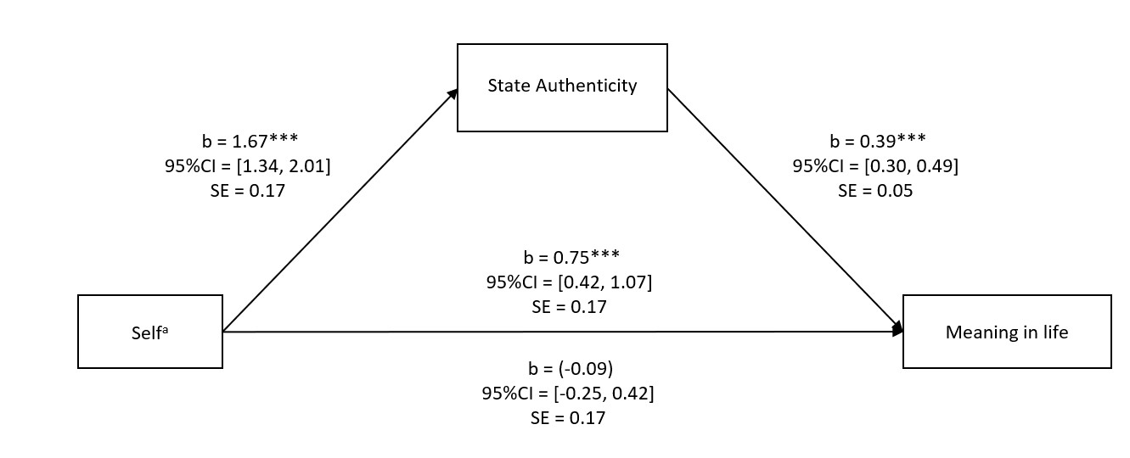
Note. The regression coefficients between self and meaning in life, controlling for state authenticity, are in parentheses. ªThe enhanced condition was coded as 1 and the diminished condition was coded as 0. ***p < .001.

Figure 2
Regression Coefficients for the Relation Between Scenario and Meaning in Life, Mediated by Self-Enhancement, in Study 5
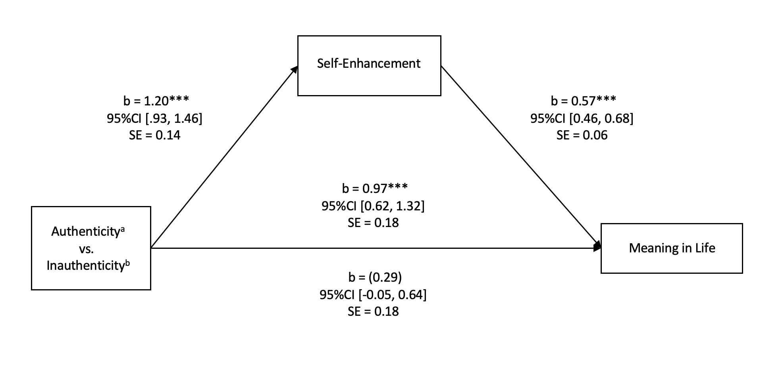Note. The regression coefficients between scenario and meaning in life, controlling for self-enhancement, are in parentheses. ªCoded as 1. ^{b}Coded as 0. ***p < .001.

Figure 3
Regression Coefficients for the Relation Between Scenario and Thriving, Mediated by Self-Enhancement, in Study 5
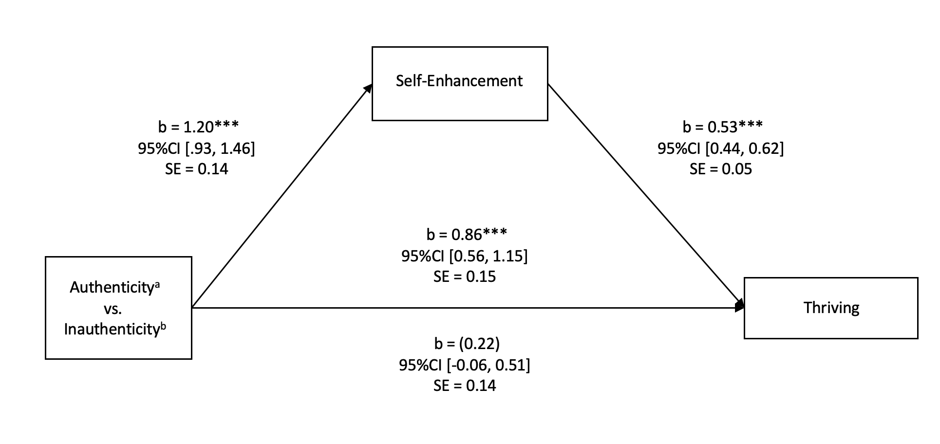
Note. The regression coefficients between scenario and thriving, controlling for self-enhancement, are in parentheses. ªCoded as 1. ^{b}Coded as 0. ***p < .001.

Appendix
Sample Personality Trait Feedback in Study 3

Favorable Feedback, High-Importance Trait:
Honesty:
Your Score: 94th percentile. This indicates that your honesty is higher than 94% of the students at MASKED University

Extremely ------------------------------------------------------------------------- X --------------Extremely
Low High

Unfavorable Feedback, Low-Importance Trait:
Outgoing:
Your Score: 27th percentile. This indicates that 73% of the students at MASKED University are more outgoing than you are.

Extremely ---------------X--------------------------------------------------------------------------Extremely
Low High

SUPPLEMENTARY MATERIALS

for

The Authentic Self Is the Self-Enhancing Self:
A Self-Enhancement Framework of Authenticity

Study 1 Stimulus Materials

How I See Myself Questionnaire (Better-Than-Average Measure; Taylor & Gollwitzer, 1995)

For each of the qualities or skills below, we would like you to rate yourself in comparison to your peers. Specifically, we want you to think about how the average Creighton college student of your age and gender rates on each of these qualities or skills, and then rate yourself in comparison. Please use the following scale to rate yourself:

1 = Much worse than the average college student of my age and gender
2 = Somewhat worse than the average college student of my age and gender
3 = Slightly worse than the average college student of my age and gender
4 = About the same than the average college student of my age and gender
5 = Slightly better than the average college student of my age and gender
6 = Somewhat better than the average college student of my age and gender
7 = Much better than the average college student of my age and gender

Please read each item and fill in with the number that corresponds to your self-perception.

_____ Cheerful

_____ Socially self-confident

_____ Moody

_____ Intellectually self-confident

_____ Creative

_____ Selfish

_____ Academically able

_____ Self-respecting

_____ Impatient

_____ Difficulty making friends

_____ Lacking motivation

_____ Anxious

_____ Self-defeating

_____ Original

_____ Cranky

_____ Understanding of others

_____ Manipulative

_____ Shy

_____ Sensitive to others

_____ Desire to achieve

_____ Lazy

_____ Confident in ability to obtain personal goals

NPI-16 (Ames et al., 2006)

Read each pair of statements below and place an “X” by the one that comes closest to describing your feelings and beliefs about yourself. You may feel that neither statement describes you well, but pick the one that comes closest. Please complete all pairs.

1. | ___ | I really like to be the center of attention
 | ___ | It makes me uncomfortable to be the center of attention
2. | ___ | I am no better or no worse than most people
 | ___ | I think I am a special person
3. | ___ | Everybody likes to hear my stories
 | ___ | Sometimes I tell good stories
4. | ___ | I usually get the respect that I deserve
 | ___ | I insist upon getting the respect that is due me
5. | ___ | I don't mind following orders
 | ___ | I like having authority over people
6. | ___ | I am going to be a great person
 | ___ | I hope I am going to be successful
7. | ___ | People sometimes believe what I tell them
 | ___ | I can make anybody believe anything I want them to
8. | ___ | I expect a great deal from other people
 | ___ | I like to do things for other people
9. | ___ | I like to be the center of attention
 | ___ | I prefer to blend in with the crowd
10. | ___ | I am much like everybody else
 | ___ | I am an extraordinary person
11. | ___ | I always know what I am doing
 | ___ | Sometimes I am not sure of what I am doing
12. | ___ | I don't like it when I find myself manipulating people
 | ___ | I find it easy to manipulate people
13. | ___ | Being an authority doesn't mean that much to me
 | ___ | People always seem to recognize my authority
14. | ___ | I know that I am good because everybody keeps telling me so
 | ___ | When people compliment me I sometimes get embarrassed
15. | ___ | I try not to be a show off
 | ___ | I am apt to show off if I get the chance
16. | ___ | I am more capable than other people
 | ___ | There is a lot that I can learn from other people

AI-3 (Kernis & Goldman, 2006)

The following measure has a series of statements that involve people’s perceptions about themselves. There are not right or wrong responses, so please answer honestly. Respond to each statement by writing the number from the scale below, which you feel most accurately characterizes your response to the statement.

1 2 3 4 5
Strongly Disagree Neither Agree Agree Strongly
Disagree Nor Disagree Agree

- I am often confused about my feelings. _____
- I frequently pretend to enjoy something when in actuality I really don’t. _____
- For better or for worse I am aware of who I truly am. _____
- I understand why I believe the things I do about myself. _____
- I want people with whom I am close to understand my strengths. _____
- I actively try to understand which of my self-aspects fit together to form my core- or true-self. _____
- I am very uncomfortable objectively considering my limitations and shortcomings. _____
- I’ve often used my silence or head-nodding to convey agreement with someone else’s statement or position even though I really disagree. _____
- I have a very good understanding of why I do the things I do. _____
- I am willing to change myself for others if the reward is desirable enough. _____
- I find it easy to pretend to be something other than my true-self. _____
- I want people with whom I am close to understand my weaknesses. _____
- I find it very difficult to critically assess myself. _____
- I am not in touch with my deepest thoughts and feelings. _____
- I make it a point to express to close others how much I truly care for them. _____
- I tend to have difficulty accepting my personal faults, so I try to cast them in a more positive way. _____
- I tend to idealize close others rather than objectively see them as they truly are. _____
- If asked, people I am close to can accurately describe what kind of person I am. _____
- I prefer to ignore my darkest thoughts and feelings. _____
- I am aware of when I am not being my true-self. _____
- I am able to distinguish those self-aspects that are important to my core- or true-self from those that are unimportant. _____
- People close to me would be shocked or surprised if they discovered what I keep inside me. _____
- It is important for me to understand my close others’ needs and desires. _____
- I want close others to understand the real me rather than just my public persona or “image.” _____
- I try to act in a manner that is consistent with my personally held values, even if others criticize or reject me for doing so. _____
- If a close other and I are in disagreement I would rather ignore the issue than constructively work it out. _____
- I’ve often done things that I don’t want to do merely not to disappoint people. _____
- I find that my behavior typically expresses my values. _____
- I actively attempt to understand myself as best as possible. _____
- I’d rather feel good about myself than objectively assess my personal limitations and shortcomings. _____
- I find that my behavior typically expresses my personal needs and desires. _____
- I rarely if ever, put on a “false face” for others to see. _____
- I spend a lot of energy pursuing goals that are very important to other people even though they are unimportant to me. _____
- I frequently am not in touch with what’s important to me. _____
- I try to block out any unpleasant feelings I might have about myself. _____
- I often question whether I really know what I want to accomplish in my lifetime. _____
- I often find that I am overly critical about myself. _____
- I am in touch with my motives and desires. _____
- I often deny the validity of any compliments that I receive. _____
- In general, I place a good deal of importance on people I am close to understanding who I truly am. _____
- I find it difficult to embrace and feel good about the things I have accomplished. _____
- If someone points out or focuses on one of my shortcomings, I quickly try to block it out of my mind and forget it. _____
- The people I am close to can count on me being who I am regardless of what setting we are in. _____
- My openness and honesty in close relationships are extremely important to me. _____
- I am willing to endure negative consequences by expressing my true beliefs about things. _____
Study 2 Stimulus Materials

Self-Enhancement (honesty, kindness, responsibility, intelligence, competence)

Ratings for the next 5 traits should pertain to how you feel RIGHT NOW. For each trait we would like you to rate yourself in comparison to the average Creighton University student of your same age and gender. For each dimension, indicate how you believe you rate on a scale from 1 (Considerably below average) to 9 (Considerably above average) by dragging the slider to best reflect your comparative rating. Again, please make your ratings according to how you feel RIGHT NOW.

Example response scale employed in Qualtrics:

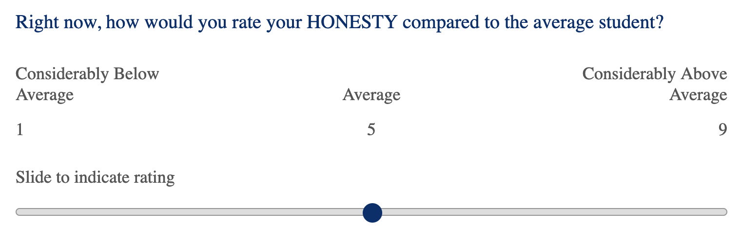

Southampton State Authenticity Scale (Kelley et al., 2022)

The following statements refer to how you feel RIGHT NOW. Please indicate your agreement or disagreement with each statement by selecting the number that best corresponds to your level of agreement. The number should be anywhere from 1 to 6, according to the following scale.

1 | 2 | 3 | 4 | 5 | 6
Strongly disagree | Moderately disagree | Slightly disagree | Slightly  agree | Moderately agree | Strongly  agree

- _____ Right now, I am feeling authentic.
- _____ Right now, I feel true to myself.
- _____ Right now, I feel like the real me.
- _____ Right now, I feel genuine.

Study 3 Stimulus Materials

Cover Story - Big Five Inventory Instructions (MediaLab; John & Srivastava, 1999)

The task you are about to complete is part of an effort by the Creighton University Office of Institutional Research to better understand the personality profiles of its students. All participants will complete the 44-item Multiphasic Personality Inventory (John & Srivastava, 1999), which is one of the most accurate and widely used personality inventories on the market. Following your completion of the inventory, your scores for six different trait dimensions will be calculated, and you will receive your personality profile results within moments of completing the assessment.

Click “continue” to begin.

(Scale on next page)
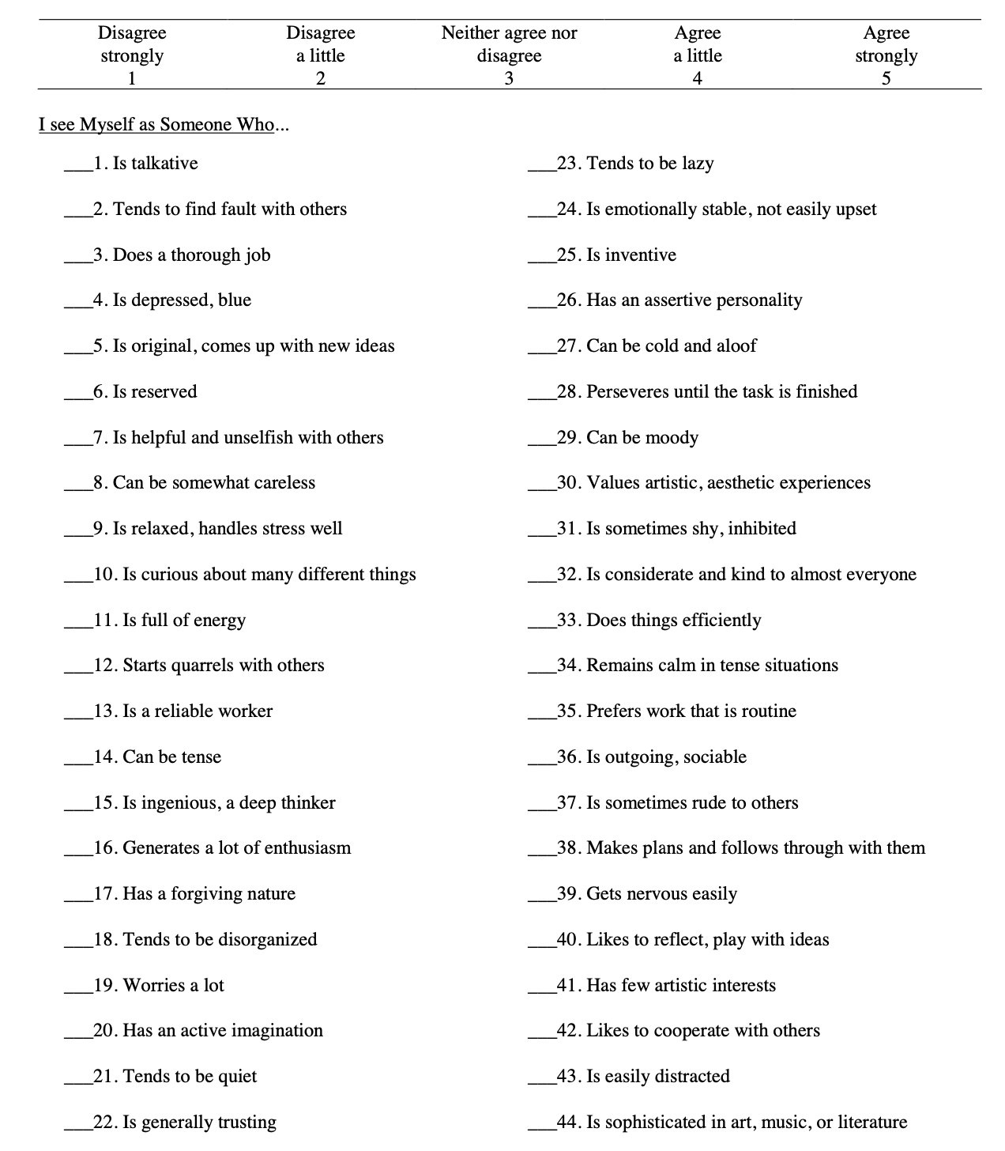

Southampton State Authenticity Scale (Kelley et al., 2022)

The following statements refer to how you feel RIGHT NOW. Please indicate your agreement or disagreement with each statement by selecting the number that best corresponds to your level of agreement. The number should be anywhere from 1 to 6, according to the following scale.

1 | 2 | 3 | 4 | 5 | 6
Strongly disagree | Moderately disagree | Slightly disagree | Slightly  agree | Moderately agree | Strongly  agree

- _____ Right now, I am feeling authentic.
- _____ Right now, I feel true to myself.
- _____ Right now, I feel like the real me.
- _____ Right now, I feel genuine.

Real-Self Overlap Scale (Lenton, Slabu et al., 2013)

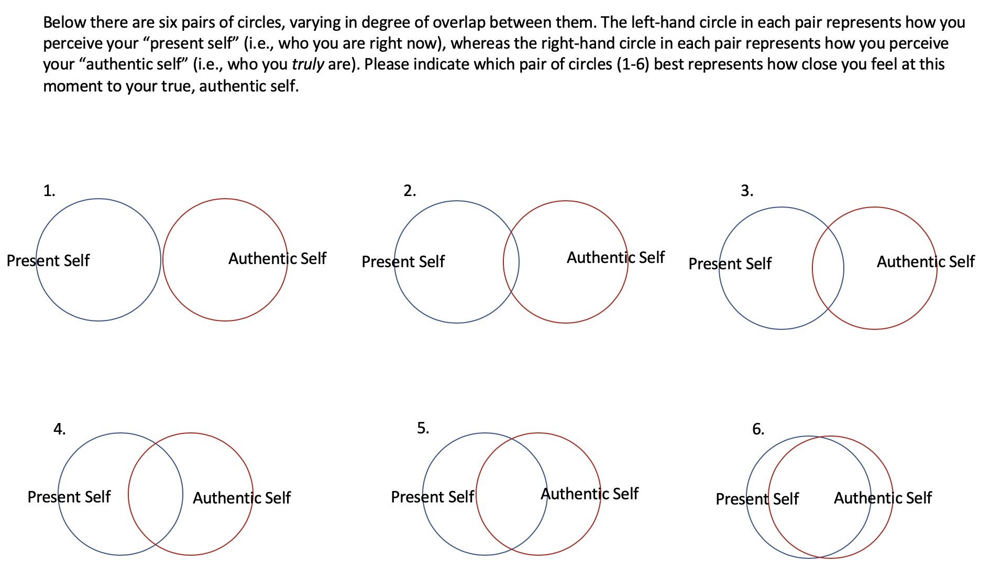

Study 4 Stimulus Materials

Manipulation of Self-Enhancement (after O’Mara et al., 2012)

Future Enhance Condition
Please imagine a future time in your personal or professional life when you behave in a way that showed a much higher level of caring, understanding, or kindness than you have now.

Please spend the next five minutes describing the details about this situation that made you more caring, understanding, or kind. What was it like to be in this situation? What thoughts and feelings did you experience? [3 minutes timer]
_______

Please note that it may take a few moments for the “next page” button to appear at the bottom of this page.

Future Diminish Condition
Please imagine a future time in your personal or professional life when you behave in a way that showed a much lower level of caring, understanding, or kindness than you have now.

Please spend the next five minutes describing the details about this situation that made you less caring, understanding, or kind. What was it like to be in this situation? What thoughts and feelings did you experience? [3 minutes timer]
_______

Please note that it may take a few moments for the “next page” button to appear at the bottom of this page.

Past Enhance Condition
Please recall a time in your personal or professional life when you behaved in a way that showed a much higher level of caring, understanding, or kindness than you have now.

Please spend the next five minutes describing the details about this situation that made you more caring, understanding, or kind. What was it like to be in this situation? What thoughts and feelings did you experience? [3 minutes timer]
_______

Please note that it may take a few moments for the “next page” button to appear at the bottom of this page.

Past Diminish Condition
Please recall a time in your personal or professional life when you behaved in a way that showed a much lower level of caring, understanding, or kindness than you have now.

Please spend the next five minutes describing the details about this situation that made you less caring, understanding, or kind. What was it like to be in this situation? What thoughts and feelings did you experience? [3 minutes timer]
_______

Please note that it may take a few moments for the “next page” button to appear at the bottom of this page.

Manipulation Check
We would like you to rate the amount of the following 15 traits of you believe you have (had) when imagining (recalling) this situation. There is no right or wrong answer. Please be as honest and open as you can.

Thinking about this situation makes feel that I am (was)…

1. Honest
2. Trustworthy
3. Respectful
4. Just
5. Forgiving
6. Fair
7. Principled
8. Caring
9. Selfless
10. Compassionate
11. Competent
12. Confident
13. Intelligent
14. Independent
15. Competitive

Response Scale: 1 = lowest level, 7 = highest level

State Authenticity Scale (Kifer et al., 2013)
The following questions relate to the situation that you just imagined (recalled). How does imagining (recalling) this situation make you feel?

Thinking about this situation makes feel that …
1. I am really being me.
2. I am my true self.
3. I am authentic.

Response Scale: 1 = strongly disagree, 7 = strongly agree

Meaning in Life (Steger et al., 2006)
The following questions relate to the situation that you just imagined (recalled). How does recalling this situation make you feel?

Right now, thinking about this situation makes feel that …
1. I understand my life’s meaning.
2. My life has a clear sense of purpose.
3. I have a good sense of what makes my life meaningful.
4. I have discovered a satisfying life purpose.
5. My life has no clear purpose. [reverse-coded]

Response Scale: 1 = strongly disagree, 7 = strongly agree

Affect (Hepper et al., 2012)
Please indicate how you feel now.

Right now, I feel…
1. Happy
2. In a good mood
3. Unhappy
4. Sad

Response Scale: 1 = not at all, 7 = very much

Attention Checks
1. How honest were you in your responses?
2. How seriously did you take the survey?

Response Scale: 1 = not at all, 5 = very much

Demographics
1. What is your gender?
a) Man
b) Woman
c) Non-binary
d) Transgender woman
e) Transgender man
f) Prefer not to answer
g) Other _______

2. What is your age (Text entry)
_______

3. What is your race (multiple choices available)
a) White
b) Black or African American
c) American Indian or Alaska Native
d) Asian/Asian American
e) Native Hawaiian or Pacific Islander
f) Middle Eastern/Arab American
g) Other_______

4. What is your ethnicity?
a) Hispanic
b) Non-Hispanic

Study 5 Stimulus Materials

Manipulation of Authenticity (after Gino et al., 2015)

Authenticity Condition
Please recall a time in your personal or professional life when you behaved in a way that made you feel true to yourself, that made you feel authentic. It should just be a situation in which you felt authentic with your core self.

Please spend the next five minutes describing the details about this situation that made you feel authentic. What was it like to be in this situation? What thoughts and feelings did you experience? [3 minutes timer] _______

Please note that it may take a few moments for the “next page” button to appear at the bottom of this page.

Inauthenticity Condition
Please recall a time in your personal or professional life when you behaved in a way that made you feel untrue to yourself, that made you feel inauthentic. It should just be a situation in which you felt inauthentic with your core self.

Please spend the next five minutes describing the details about this situation that made you feel inauthentic. What was it like to be in this situation? What thoughts and feelings did you experience? [3 minutes timer] _______

Please note that it may take a few moments for the “next page” button to appear at the bottom of this page.

Control Condition
Please recall what happened yesterday, throughout the day.

Please spend the next five minutes describing the details about this situation. What was it like to be in this situation? What thoughts and feelings did you experience? [3 minutes timer] _______

Please note that it may take a few moments for the “next page” button to proceed to appear at the bottom of this page.

Manipulation Check
The following questions relate to the situation that you just recalled. How does recalling this situation make you feel?

Thinking about this situation makes feel that …
1. I am really being me.
2. I am my true self.
3. I am authentic.

Response Scale: 1 = strongly disagree, 7 = strongly agree

Self-Enhancement (as in Study 4)
We would like you to rate the amount of the following 15 traits of you believe you have right now. There is no right or wrong answer. Please be as honest and open as you can.

Thinking about this situation makes feel that I am …

1. Honest
2. Trustworthy
3. Respectful
4. Just
5. Forgiving
6. Fair
7. Principled
8. Caring
9. Selfless
10. Compassionate
11. Competent
12. Confident
13. Intelligent
14. Independent
15. Competitive

Response Scale: 1 = lowest level, 7 = highest level

Meaning in Life (Steger et al., 2006)
The following questions relate to the situation that you just recalled. How does recalling this situation make you feel?

Right now, thinking about this situation makes feel that …

1. I understand my life’s meaning.
2. My life has a clear sense of purpose.
3. I have a good sense of what makes my life meaningful.
4. I have discovered a satisfying life purpose.
5. My life has no clear purpose. [reverse-coded]

Response Scale: 1 = strongly disagree, 7 = strongly agree

Thriving (Su et al., 2014)
The following questions relate to the situation that you just recalled. How does recalling this situation make you feel? Please indicate your agreement or disagreement with each of the following statements using the scale below.

Right now, thinking about this situation makes feel that …

1. My life has a clear sense of purpose
2. I am optimistic about my future
3. My life is going well
4. I feel good most of the time
5. What I do in life is valuable and worthwhile
6. I can succeed if I put my mind to it
7. I am achieving most of my goals
8. In most activities I do, I feel energized
9. There are people who appreciate me as a person
10. I feel a sense of belonging in my community

Response Scale: 1 = strongly disagree, 7 = strongly agree

Affect (Hepper et al., 2012)
Please indicate how you feel now.

Right now, I feel…
1. Happy
2. In a good mood
3. Unhappy
4. Sad

Response Scale: 1 = not at all, 7 = very much

Attention Checks
1. How honest were you in your responses?
2. How seriously did you take the survey?

Response Scale: 1 = not at all, 5 = very much

Demographics

1. What is your gender?
a) Man
b) Woman
c) Non-binary
d) Transgender woman
e) Transgender man
f) Prefer not to answer
g) Other _______

2. What is your age (Text entry)
_______

3. What is your race (multiple choices available)
a) White
b) Black or African American
c) American Indian or Alaska Native
d) Asian/Asian American
e) Native Hawaiian or Pacific Islander
f) Middle Eastern/Arab American
g) Other_______

4. What is your ethnicity?
a) Hispanic
b) Non-Hispanic

1 Degrees of freedom vary across coefficients due to missing data.
2 After the Southampton Authenticity Scale, participants completed the Real-Self Overlap Scale (Lenton, Slabu et al., 2013). They viewed six diagrams of two separate circles overlapping to varying degrees, where one represented the “present self” and the other the “authentic self.” Participants indicated “which pair of circles (1–6) best represents how close you feel at this moment to your true, authentic self.” An ANOVA produced no main effects or interactions, all Fs ≤ .708, all ps ≥ .401. The Real-Self Overlap Scale is a rarely used measure, perhaps due to is narrow focus on comparing the “right now” self with the “real self.” We abandoned its use.
3 A 2×2 Analysis of Covariance (ANCOVA) controlling for positive affect yielded a main effect of self-reflection on the manipulation check, F(1, 355) = 165.22, p < .001, η_{p}² = .318, authenticity, F(1, 355) = 78.53, p < .001, η_{p}² = .181, and MIL, F(1, 355) = 6.75, p = .010, η_{p}² = .019. No other effect was significant, Fs ≤ 3.32, ps ≥ .07.
4 We detected eight outliers as per preregistration criteria. However, excluding outliers did not impact results; thus, we reported all data.
5 An ANCOVA controlling for positive affect yielded an effect on the manipulation check, F(2, 438) = 237.96, p < .001, η_{p}² = .521, self-enhancement, F(2, 438) = 34.12, p < .001, η_{p}² = .135, MIL, F(2, 438) = 7.56, p < .001, η_{p}² = .033, and thriving, F(2, 438) = 7.61, p < .001, η_{p}² = .034.

