A systematic literature review on port competitiveness

Hang Yu¹, Yu Gong¹, Jun Liu²
¹ Southampton Business School, University of Southampton, SO17 1BJ, UK
² College of Economics and Social Development, Nankai University, Tianjin, 300071, China
Abstract
The continuous investment and expansion of ports has introduced new requirements for the sustainable development of seaports. Port competitiveness is an increasingly relevant subject due to the value that ports create for enterprises in the maritime supply chain. As the functions and requirements of ports evolve, this article aims to present an up-to-date review of the research trends and future directions of port competitiveness. A systematic literature review was performed to comprehensively gather and review 81 journal papers on port competitiveness published in the past two decades. The result shows a hierarchy of the top ten port competitiveness drivers based on their research frequency in the literature, categorized into four aspects. The frequency ranking of port competitiveness strategies is further summarized based on the reviewed papers. This paper also provides a critical analysis of port competitiveness content mechanism in order to identify research trends, gaps, and future research directions.

- Introduction
Ports have long played a vital role in the global logistics supply chain by serving as interchange points between maritime and inland transport. More than 90% of international trade is achieved through maritime transport (UNCTAD, 2022). With the rapid spread of the COVID-19 pandemic around the world, global economic and trade development has suffered a huge impact. Shipping prices have been soaring and port production activities have also been affected by regional policies (Narasimha et al., 2021). Global port congestion, port labour shortages, and other difficulties highlight the port's critical role in the marine supply chain. Similarly, trade conflict between China and the United States poses difficulties to the port industry's normal operations (Guo et al., 2021), emphasizing the significance of ports in the maritime network.
The environment of port competition had also shifted, changing how port competitiveness is understood. Port competition has evolved from attracting port users to providing value to supply chain consumers. Ports must improve their supply chain coordination and cooperation ability to remain competitive and integrate into the global supply chain (Song and Panayides, 2008). Under higher standards sustainable management, port companies aims for long-term sustainable development by balancing economic growth, environmental protection, and social progress (Taljaard et al., 2021). Internationally competitive ports must implement environmental management and be socially responsible (Hossain et al., 2021). Meanwhile, regional development is seeing a trend of global economic transfer to port cities due to the huge economic benefits brought by ports (Ferrari et al., 2010). Competition between public-owned ports is a field of urban development strategy as public policy influencing port strategies (Fransoo and Lee, 2013). As a result, port competitiveness has received great attention from governments and business sectors alike.

  - Defining port competitiveness
The definition of port competitiveness is generally based on the function of a port in the context of maritime logistics and supply chain management. The definition of port competitiveness in research has different expressions according to different perspectives. From a comparative perspective, Chang and Talley (2019) defined port competitiveness as the degree to which a port competes with other ports. A similar definition from Heaver (1995) shows that port competitiveness refers to the ability of ports to gain comparative advantages in terms of products, infrastructure, service, etc. From the perspective of port performance, Huang et al. (2003) defined port competitiveness as the ability to create value in the port and its vicinity. An extended view of this definition was provided by Nalebuff et al. (1996), who defined port competitiveness as a reflection of a port’s ability to grow resources, competencies and capabilities from a cooperative perspective. From a port choice perspective, a competitive port is understood as one that is easier to select than other ports, thus promoting its market share growth (Merk, 2013).

For the port industry, meeting customers' demands faster and better has become the main goal to enhance the competitiveness of ports. Ports with competitive advantages are able to improve customer satisfaction as well as create profits through low-cost and high-quality services (Notteboom and Yap, 2012). By integrating their own factors and interacting with the external environment, ports have comparative advantages over other ports, improving market share, generating value and maintaining sustainable development (Bichou and Gray, 2005). This paper understands port competitiveness as the port's effective attraction to the source of goods and investment by virtue of a series of conditions conducive to production and operation, such as its container turnover capacity, natural characteristics, policy, and technology.

  - Existing related review and motivation
Academic research on port competitiveness has been extensively conducted since the 1990s., with a large proportion of articles published in recent years (Chang et al., 2018). There are four existing review papers on or partly on competitiveness as summarized in table 1. Parola et al. (2017) reviewed 170 papers from 1983 to 2014 to explore port competitiveness drivers and to discuss cutting-edge industry trends. Munim and Saeed (2019) identified the most influential universities, journals, and articles in port competitiveness research based on a citation analysis of 267 research papers. These two reviews, however, remain limited in their understanding of port competitiveness in terms of the factors that influence it. Motivated by their research, this article adjusts the frequency ranking of port competitiveness factors in high-quality journals over the past two decades, classifies these factors further, and analyses the mechanism by which they affect port competitiveness.

Chang and Talley (2019) reviewed 644 articles on port competitiveness from the perspective of port productivity and efficiency, dividing them into traditional port-only studies and chain studies and summarising the paucity of literature on port competitiveness from the supply chain viewpoint. Luo et al. (2022) determined the relationships between port competition, cooperation, and competitiveness based on a literature review on these areas of study. However, these two reviews are much broader in scope and stay on descriptive analysis and straightforward summaries of port competitiveness. This review therefore aims to add a comprehensive analysis of the content of port competitiveness including influencing factors, strategies, underlying mechanisms, etc.

Table 1. Existing literature review on port competitiveness
Reference | Journal | Period covered by the study | Number of reviewed articles | Methodology | Scope of research | Focused aspect of port competitiveness
Parola et al. (2017) | Transport reviews | 1983-2014 | 170 | Systematic literature review (SLR) | Drivers of port competitiveness | Economies of scale in shipping; Governance changes; Coopetition between ports in proximity; Inter-firm networks; Green and sustainability challenges
Munim and Saeed (2019) | Int. J. Shipping and Transport Logistics | 1990-2015 | 267 | Bibliometric citation analysis | Evolution of port competitiveness research | port competition; port efficiency; institutional transformation; port pricing; port embeddedness; port choice; port cooperation.
Chang and Talley (2019) | Transportation Journal | 1994-2017 | 644 | Narrative analysis | Methodological issues of the literature in investigating port competitiveness | Technical efficiency perspective and service-based supply chain perspective
Luo et al. (2022) | Transport policy | 1970-2019 | 210 | Comparative analysis | Relationships among port competition, cooperation and competitiveness | Key factors in port competitiveness; Evaluation of port competitiveness; policies affecting port competitiveness
This review |  | 2000-2022 | 81 | Systematic literature review (SLR) | Existing trends; Evaluating factors; Improving strategies | Port competition; Evaluation; Port choice; Strategies

  - Objective
The aim of this study is to provide a systematic analysis of the port competitiveness literature in the context of the evolution of port functions and requirements over the past 20 years. A systematic literature review was used because it helps assess current research and provides a reference for future research (e.g., Parola et al., 2017; Fan and Mark, 2018; Lim et al., 2019). Although the contributions and insights into port competitiveness have been increasingly reflected in academic papers, the following questions remain:

RQ1: What are the existing trends in port competitiveness domain?
RQ2: What gaps in this research can be identified and what future directions proposed?

This research makes the following contributions. Firstly, existing literature review papers have concentrated on a specific aspect of port competitiveness, such as related drivers, port supply chain, or port cooperation, but they lack a comprehensive examination of the topic. This review presents a relatively more comprehensive analysis of all selected literature. In addition to the basic descriptive and methodological analysis, port competitiveness is analysed thematically according to different categories. The review also provides a more comprehensive analysis of the content of port competitiveness including its influencing factors, strategies and the underlying influencing mechanisms. Secondly, existing review studies seek to incorporate all literature in all time, but the rapidly increasing publication numbers and continually changing shipping environment create difficulties in locating the most recent contributions using such a method. This research excludes literature before 2000 and not listed in the ABS Academic Journal Quality Guide 2021, ensuring that all papers selected are of high quality and strongly relevant. Finally, 81 papers were reviewed to answer the research questions.

The remainder of this paper is organized as follows. Section 2 provides the context of relevant concepts on port competition and competitiveness, followed by the research methodology outlined in Section 3. Section 4 illustrates the key findings of the literature review with descriptive analysis and clustering of influencing factors. A discussion on the future research directions is provided in Section 5, and finally, conclusions are drawn on the contributions and limitations.

Methodology
A systematic literature review (SLR) method was performed to gather and review the relevant research addressing the topic of port competitiveness. Fink (2013) regarded SLR as a traditional type of literature review for locating, selecting and analyzing the existing body of published research conducted by experts and scholars. It is hence an effective method designed to establish and discuss research questions and suggest future research focus.

This study adopts a four-stage SLR process according to the new principles proposed by Denyer and Tranfield (2009) for the domain of management. The process includes: (1) Question formulation; (2) Locating studies; (3) Study selection and evaluation; (4) Analysis and synthesis. These steps aim to minimize error and avoid bias in selecting and analyzing the review.

  - Question formulation
Identifying problems and establishing concerns are basics in the initial stages of any research, and in preparing a review (Light and Pillemar, 1984). The research questions are generally planned at the beginning in order to formulate a significant survey of literature and establish what kind of analysis is required for a particular area of study (Boell and Cecezkecmanovic, 2015). In this study, appropriate research questions were clarified based on the CIMO (Context, Intervention, Mechanisms and Outcomes) method designed by Denyer and Tranfield (2009) for the establishment of research questions in the domain of business management. Four critical aspects of the literature review were identified by the CIMO as: the importance of port competitiveness (C), approaches of port competitiveness criteria (I), how factors and strategies make a port more competitive (M), and what would port and future port studies benefit from the factors and strategies researched (O). In the light of these topics, two related research questions were formulated, as shown in the previous section.

  - Locating studies
After the question formulation, as much literature as possible relevant to the specific research questions should be located, selected and evaluated in detail. An exhaustive search of existing papers is necessary in order to ensure that reviews are based on meaningful contributions, and that the available evidence is fully considered (Denyer and Tranfield, 2009). Identifying studies generally involves three strategies to confirm the initial scope of research literature: search strings, search databases, and inclusion and exclusion criteria.

    - Search strings
After clarifying the main topics of the study using CIMO and confirming the research questions to be answered, the initial set of keywords was proposed as: “port” and “competitiveness”. Considering different expressions for the same term, a set of synonyms was added to each search string for a more accurate and comprehensive search result (Wen et al., 2001). The final structured keywords were: “port” OR “container port” OR “seaport”; “competitiveness” OR “competition advantage” OR “competitive advantage” OR “selection” OR “choice”.

    - Database searches
Two databases were applied in this research: Web of Science (WoS) and Scopus, which offer a wide coverage of relevant research on port studies. To avoid missing any literature, the two search engines were conducted individually, and the output results summarized and de-duplicated to identify the related literature.

    - Inclusion and exclusion criteria
Inclusion and exclusion criteria were designed mainly for the filter process and limit the database to articles that answer the research questions. In this research, only articles covering port competitiveness strategies or assessment were included, while those concentrating on model optimization were excluded. Only peer-reviewed research articles published in academic journals were selected. The exclusion criteria involved books, book chapters, conference proceedings, review papers, dissertations, websites, seminars, workshops, technical reports and other ‘grey literature’ (Denyer and Tranfield, 2009). As the contributions of literature should be available and comprehensible to most researchers, only papers accessible in full-text English were included in the criteria. Also, considering that this study aims to discuss research questions from a business/management perspective, the inclusion of literature had to be widely accepted and of high quality in the field of management and organisational studies, and research published in journals not listed in the ABS Academic Journal Quality Guide 2021 was excluded from the study. The ABS Guide was chosen because it was found to be the most commonly adopted and recognized consistency metric in the academic world (Ghadge et al., 2012). Additionally, the criteria only included research published since 2000 to ensure that discussion on port competitiveness was not out of date (Brooks et al., 2011). Details of the inclusion and exclusion criteria are summarized in Table 2.

Table 2. Inclusion and exclusion criteria
Inclusion criteria | - Research mainly covering port competitiveness strategies or assessment  - Research published in academic journals  - Access to full-text  - Peer-reviewed research articles  - Research published in journals listed in the ABS Academic Journal Quality Guide 2021  - Research published since 2000
Exclusion criteria | - Research not covering port competitiveness topic or concentrating on model optimization  - Books, book chapters, conference proceedings, review papers, dissertations, websites, seminars, workshops, technical reports and other ‘grey literature’  - Non-English  - Non-ABS 2021 listed journal articles  - Research published before 2000

  - Study selection and evaluation
In the study selection stage, a set of explicit selection criteria was established based on the inclusion and exclusion criteria and, more importantly, whether each study actually answered any of the research questions (Tranfield et al., 2003). Three filtering processes were used to ensure the reliability and accuracy of the literature list, including Keyword Search in Identified Databases, abstract analysis and full paper analysis (Pittaway et al., 2004).

    - Keyword Search in Identified Databases
Initially, two database search engines were used individually to conduct the advanced search. The structured keywords defined in Section 3.2.1 were connected by Boolean logic (‘AND’, ‘OR’ and ‘*’) and input into identified search engines (Gu and Patricia, 2009). The article titles, keywords and abstracts were the search target.

    - Article Quality and Relevance Assessment
A comprehensive listing of articles was made, many of which did not adequately meet the inclusion criteria. By checking the title, language, published journal, published date, and other information, articles not falling within the criteria were filtered out. A total of 427 articles were screened from WoS database, and 79 articles from Scopus database, which were exported in the form of titles and abstracts. Since it was impossible to ensure that all paper contents adequately addressed the research questions from their titles alone, further analysis of abstracts and full-text scanning was also considered during this stage (Garousi et al., 2019). Analysis of abstract aims was done to find if the research scope of articles covered port competitiveness, and more irrelevant articles were excluded. The remaining articles in the two databases were exported for duplicate article deletion and further full-text scanning. During the citation verification process, five articles were added to the database. Finally, a total of 81 papers from the two databases were selected as the final sample articles (Figure 1).

  - Analysis and synthesis
This section provides data analysis and synthesis comments based on the included studies. In this review, the selected papers were reviewed by two independent researchers using descriptive analysis, theme analysis, and content analysis. After comparison of the results and error clearance, a consensus analysis is reported in the next section.
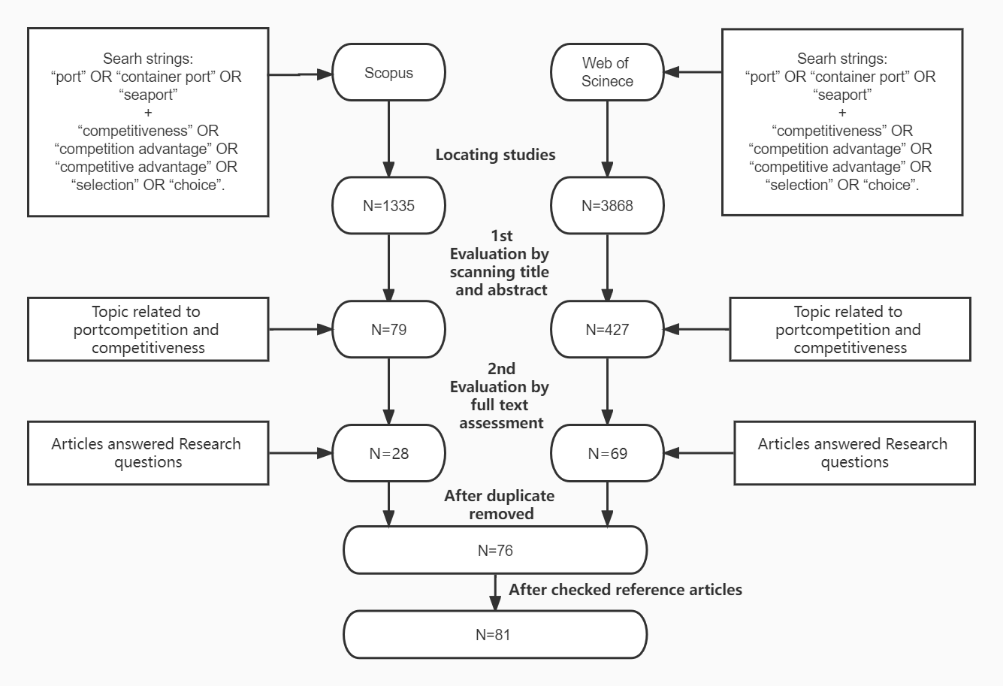
Figure 1. Paper selection process (sources: authors).

Findings
  - Descriptive analysis
In general, the number of identified papers relating to port competitiveness has been on a wavelike rise in the last two decades. The number of identified papers between 2004 and 2010 was relatively small, with no more than five papers published in any year. However, the following three years witnessed a surge in the number of identified articles, nine being published in 2011 and eight being published in 2013. This roughly confirms that, with the change of port roles and the increase of competition intensity, port competitiveness has gained a gradual increase in academic interest (Notteboom and Yap, 2012). It is worth noting that the number of articles has increased again over the past three years, especially in 2018, when the number of articles published peaked at 13. This suggests that the research need regarding port competitiveness is still rising, and the review of related fields needs to be continually updated. The detailed number of identified articles by year are illustrated in Figure 2.
Figure 2. Time distribution of the reviewed articles (sources: authors).

Journals of each publication in the sample were also counted and analyzed in order to have a better grasp of the quality of these articles. The sample included 81 papers published in a total of 25 journals, indicating that the issue of port competitiveness is of wide interest. Among these journals, Maritime Policy and Management has the most publications in the sample (18 papers), followed by the International Journal of Shipping and Transport Logistics (12 papers) and Transportation Research Part A-Policy and Practice (eight papers). Figure 3 illustrates the ranking of the number of articles published in each journal. In terms of journal quality, most of these papers were published in ABS 2 (38 papers) and ABS 1 (28 papers) journals, while only one paper was published in ABS 4, and seven papers were in ABS 3.
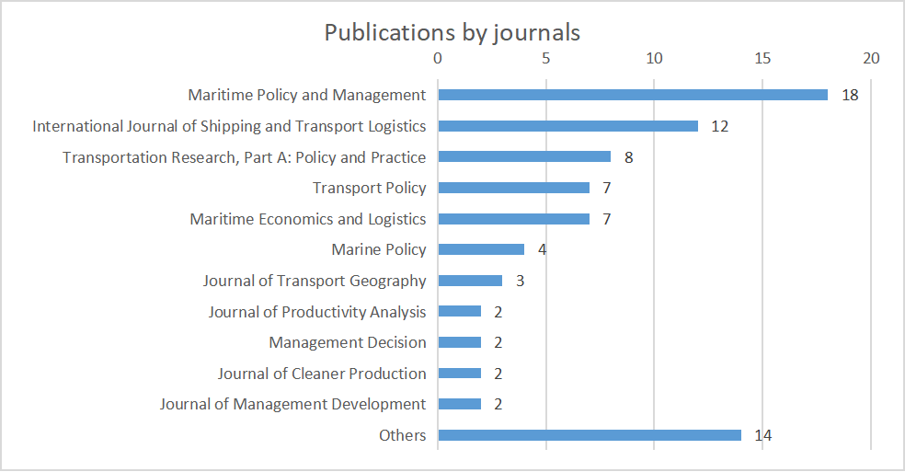
Figure 3. Publications by journals (sources: authors).
Because each port develops and executes specific operation and management strategies based on geographical location, scale, ownership, policy, management, and stakeholders, the research target of port competitiveness is often focused on a specific region (Dinwoodie et al., 2012). The geographical location of ports in 46 empirical studies was hence analyzed in order to understand the distribution of academic concerns. Ports in Asia (47.8%) and Europe (35.7%) were the regions attracting the most research focus. In terms of nations, ports most frequently studied were in China (14.9%), followed by ports in Spain (10.2%) and Turkey (6%). Figure 4 shows the detailed proportion of port geographical location in academic studies.

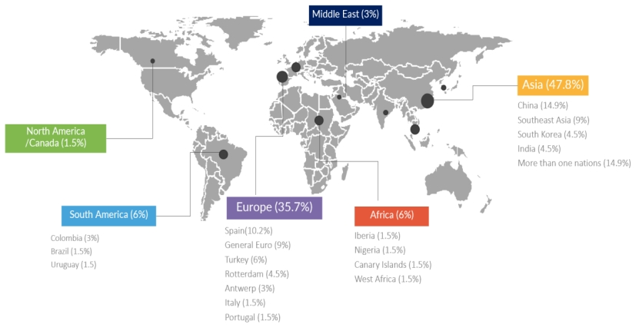Figure 4. Distribution of the ports’ geographical locations (sources: authors).

  - Research methods
The research methods of identified articles were classified based on their research type and method. All research papers were split into two major classifications: analytical research and empirical research (Wacker, 1998). To be more specific, analytical research can be further divided into three main categories: theoretical research, mathematical modelling, and simulation method and statistical analysis. On the other hand, empirical research can be classified into survey and case study according to the scope of the research objects and the different methods of obtaining data. In this study, the empirical approach (62.2%) was found to be more widely used than analytical research (37.8%) in the sample articles, which shows that port competitiveness is more concerned with the aspect of practical problems. Case study (32.4%) and survey (29.8%) are two more extensively used research methods compared with the other three. Table 3 illustrates the proportion of the three research types and five sub-categories of research methods.

Table 3. Research methodology distribution of the reviewed articles
Type of research | Proportion | Method | Proportion
Analytical research | 31% | Mathematical modelling and simulation  Statistical analysis  Theoretical research | 20.2%  10.8%  6.8%
Empirical research | 62.2% | Survey  Case study | 29.8%  32.4%

How collected data in the sample articles were processed was followed by analysis. A Multiple Criteria Decision Making (MCDM) method, Analytic Hierarchy Process (AHP) was most extensively applied in the sample articles (17 articles) in order to factor in various detriments of port competitiveness. Discrete Choice Modeling (10 articles) and Factor Analysis (nine articles) were also chosen with a certain frequency. Figure 5 shows the detailed number of articles in the data processing techniques.

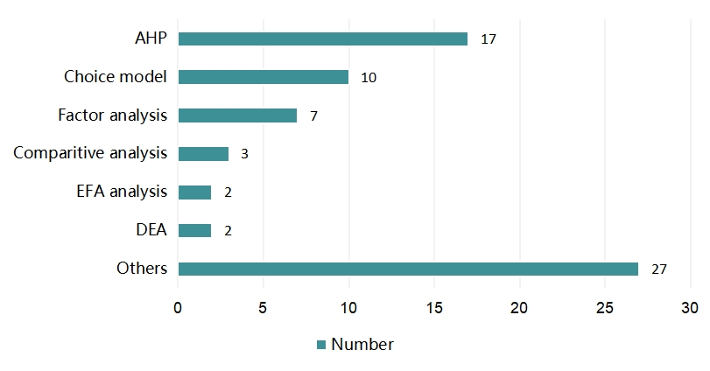
Figure 5. Number of articles by data analysis techniques (Source: Authors).
  - Thematic analysis
The studies of port competitiveness were previously categorized via various broad methods in academic research (Munim and Saeed, 2019). Through full-text analysis and comparison, this paper divided the research contents of identified articles into four aspects, considering possible overlaps.
One of the most obvious categories of articles evaluated the competitiveness of ports through different factors (33 articles), followed by 23 articles focusing on strategies to improve port competitiveness. On the other hand, 18 articles examined port competitiveness through the insight of port choice, while three articles aimed to analyze the competitiveness of ports by comparing the situation of two or more ports with competition relations. Table 4 shows the characteristics and differences of the four themes.

Table 4. Overview of four identified themes
Themes | Number of articles | Key terms of port competitiveness | Research perspectives | Extracted clustering
Port choice | 21 | Attractiveness | Shipping lines | Influencing factors
Evaluation | 33 | Capability of resources operation and management | Shipping lines or port expert
Strategies | 23 |  | Port operator | Improvement strategies
Port competition | 4 | Comparative advantages |  | Both influencing factors and improvement strategies

To achieve a better understanding of their similarities and differences, these four themes were compared from various angles. One of the most fundamental differences was how port competitiveness was understood during the research. As discussed in the previous section of the literature review, the concept of port competitiveness varied, and the different aims and methods of these categories were mostly influenced to some degree by the definition of port competitiveness. The article on port choice, for example, described port competitiveness as a port's attractiveness to its customers when the requisite services were offered. The aim of improving port competitiveness is to make the port preferred by port users to a large degree (Tongzon and Heng, 2005). In comparison, the concept of port competitiveness in the evaluation and strategy articles focused on the port's own capability in capital management and operation. Within these two groups, the target of port competitiveness improvement was to optimize the utilization of available infrastructure to provide high quality services. The final category, papers on port competition, brought a somewhat unique mindset to port competitiveness: examining the competitiveness of individual ports when comparing two or more ports with competing relationships. The comparative advantage of ports was reflected in their competitiveness.

The research theme of each category determined the main beneficiaries of the research objective. There were numerous port stakeholders who might influence port competitiveness, such as terminal operators, port administrators, shipping lines, port authorities, forwarders or cargo owners, policymakers, port employees, and academic experts, among many others (Yeo et al., 2011). While the next section analyzes the research perspectives classification for the sample articles, this part focuses on identifying the most relevant stakeholders for each theme. As a significant port service customer, shipping lines were an obvious research stakeholder on the theme of port choice articles. So this category primarily collected data through the targeted investigation of related personnel in the shipping lines. Similarly, multiple articles on the evaluation theme gathered data from the viewpoint of shipping lines, some papers using relevant port experts as study participants to gain a more comprehensive understanding. By contrast, the article on strategy and port competition categories focused mostly on the perspective of port operators. The aim of strategy papers was to investigate how a port obtained practicable operation and management strategies by researching the effect of specific variables on port competitiveness. Likewise, port competition articles examined the comparative advantages of a single port as well as the fields that needed to be strengthened when competing with peripheral ports.

Furthermore, two clusters were extracted from the three themes sample papers and were discussed in depth in the following subsection. The clustering includes the influencing factors of port competitiveness extracted from the port choice and evaluation articles as well as the improvement strategies extracted from the strategy theme articles. Table 4 shows the characteristics and differences of the four themes.
  - Content analysis
    - Port competitiveness factors
As various factors were pinpointed in the articles, irrespective of whether the theme was evaluation of port competitiveness or port choice, this study extracted factors on the theme of port choice and evaluation articles to enable frequency ranking and analyze the impact. Table 5 reports the top ten (out of 32) factors in descending order of frequency, including: cost, port facilities, operational efficiency, hinterland connectivity, location, services quality, customer issues, hinterland network, human resources and supply chain issues.

The most frequently studied competitiveness factor was port cost (1), including direct payment to the port and indirect cost caused by port berthing. For shippers, forwarders and shipping companies, such an economic-related factor was undoubtedly placed at the top of the port choice criteria, as it constituted an important part of the total cost of freight services (Merk, 2013). For terminal operators, due to the increasingly fierce competitive environment and pressure from shipping lines, it was necessary to have competitive prices for their survival and development (Notteboom, 2005).

Besides port cost, port facilities (2) and operational efficiency (3) were two other fundamental factors extensively cited as affecting port competitiveness. Ports needed to have the capability to provide appropriate port facilities and use them efficiently to meet the needs of customers (Paixao and Marlow, 2003). The composition of port facilities included, but was not limited to, port infrastructure, superstructure, equipment and inland logistics platform. The impact of different port facilities on competitiveness varied according to different types of ports (Yuen et al., 2012). Among them, the research on the importance of infrastructure to port selection was the most extensive (Acosta et al., 2010; Kadaifci et al., 2018). Operational efficiency included not only the productivity of cargo handling, but the whole wharf operation efficiency, such as warehousing of goods, ship turnover time and ship waiting time due to port congestion. Therefore, high operational efficiency with adequate port facilities was able to attract shipping companies to berth.

Hinterland connectivity (4) and hinterland network (8) were two external factors most affecting port competitiveness. On the one hand, hinterland connectivity, including the distance from inland hinterland and transport systems affected the efficiency of shipping logistic services. A strong connection between port and hinterland could increase cargo resources and improve their competitiveness compared with ports without close hinterlands (Wahyuni et al., 2020). On the other hand, the network formed by port and hinterland was also an important factor in port competitiveness. The scale of cargo through the port was, to a certain extent, affected by some elements of the hinterland network, such as hinterland proximity and economic development of the hinterland.

Furthermore, the geographical location (5) of a port is a nautical factor that has been repeatedly evaluated for its importance to the competitiveness of the port. A port with an excellent geographical location may rely on its inherent water area conditions (including sufficient water depth, stable water surface, and large area within ports) to meet the trend of the upsizing of container ships, or because of its strategic position in international trade (Ding et al., 2019). The impact of these factors on overall efficiency and the cost of routes was taken into account by shipping companies when making route plans.

It is worth noting that service quality (5) and customer-related issues (7) were two customer-focused determinants of port competitiveness that have attracted increasing research attention. Service quality refers to ports’ ability to provide both primary activities and other differentiated services that meet the various needs of customers. A number of authors recognized that port services can play an important role in improving port competitiveness (Kim, 2013; Lee et al., 2011). At the same time, a series of customer-related issues, including the overall experience and convenience of a service were argued to have a significant impact on maintaining port competitiveness (Caliskan and Soner, 2020).

Finally, two management and strategy factors, namely human resources (9) and supply chain issues (10) were considered by some researchers to have an impact on port competitiveness (Lee et al., 2011). Human resources management encompasses the management of port labour and work environment, as well as the acquisition and retention of talent. Supply chain issues were described as the management and coordination of a port's service spatial network (Talley et al., 2014). Despite the fact that many researchers emphasized that ports are an essential part of the supply chain system (Robinson 2002; Bichou and Bell, 2007; Tongzon et al., 2009), enhancing port competitiveness from a supply chain perspective has rarely been theoretically or empirically studied (Chang and Talley, 2019). Since the relationship between these two variables and port competitiveness is relatively indirect and challenging to measure, they did not rate highly, notwithstanding the fact that their effect on port competitiveness was obviously increasing.

To achieve a deeper understanding of the importance of influencing factors and explore the similarities and differences, all the ranking factors in this literature review were classified into four groups (Table 6): natural conditions, terminal offerings, management and strategies, and external environment factors. First, natural conditions represent the congenital conditions of a port, the influence of which is generally difficult to change. The literature review unveils 10.2% of factors shaping port competitiveness as belonging to this group. Second, the terminal offerings group refers to relevant factors about what is provided to the customer. This group accounted for the largest proportion of influencing factors, including the top three influencing factors in the ranking of study frequency. Thirdly, the management and strategies group, accounting for 24.5% of factors, is closely related to the operation mode and management strategy of a port. This group consists of the largest number of factors, many of which are considered to have the potential to improve port competitiveness. The final group is external environment factors, referring to the factors outside port operation and management. Although the factors in this group were not cited frequently (23.1%), the articles mentioning these factors were relatively new. Hence many factors in this group, such as government support, legal framework and green policy were likely to have room for more research.

Table 5. Identified drivers for port competitiveness
Rank | Key factors | Explanation | Number | References
1 | Cost | Tariff; storage; transportation; expenses incurred for berthing in a port | 26 | Casaca et al. (2013); Cullinane et al. (2005); Balci et al. (2018); Yoon et al. (2015); Musso et al. (2013); Yang and Chen (2016); Feng et al. (2012); Tovar et al (2015); Yeo et al. (2011); Hales et al. (2016); Cruz et al. (2013); Wang and Yeo (2019); Gohomene et al. (2015); Chang et al. (2008); Lau and Li (2015)Khalid and Al-Mamery (2019); Kim (2014); Kadaifci et al. (2018); Onut et al (2011); Mueller et al. (2020); Veldman et al. (2011); Rivelino et al. (2019); Veldman et al. (2013); Vega et al. (2019); Tongzon ans Sawant (2007); Rezaei et al. (2019)
2 | Port facilities | Infrastructure; superstructures; enough equipment and back-line land | 21 | Casaca et al. (2013); Acosta et al. (2010); Yoon et al. (2015); Musso et al. (2013); Hamid (2018); Haezendonck et al. (2011); Haezendonck and Langenus (2018); Yang and Chen (2016); Feng et al. (2012); Hales et al. (2016); Rios and Sousa (2014); Cruz et al. (2013); Ding et al (2019); Gohomene et al. (2015); Lau and Li (2015); Khalid and Al-Mamery (2019); Kim (2014); Onwuegbuchunam (2013); Kadaifci et al. (2018); Onut et al (2011); Rivelino et al. (2019)
3 | Operational efficiency | Cargo handling productivity; ship turnaround time; ship waiting times | 16 | Casaca et al. (2013); Balci et al. (2018); Wahyuni et al. (2020); Musso et al. (2013); Yang and Chen (2016); Feng et al. (2012); Tovar et al (2015); Brooks et al. (2011); Wu and Ling (2008); Castillo-Manzano et al. (2008); Ding et al (2019); Gohomene et al. (2015); Onwuegbuchunam (2013); Kadaifci et al. (2018); Onut et al. (2011); Rivelino et al. (2019)
4 | Hinterland connectivity | Efficiency and inland transport such as rail and road transport | 15 | Haezendonck et al. (2011); Haezzendonck and Langenus (2018); Feng et al. (2012); Tovar et al. (2015); Yeo et al. (2011); Brooks et al. (2011); Wu and Ling (2008); Castillo-Manzano et al. (2008); Cruz et al. (2013); Ding et al. (2019); Wang and Yeo (2019); Khalid and Al-Mamery (2019); Mueller et al. (2020); Veldman et al. (2013); Yeo et al. (2014)
5 | Location | Geographical location of container ports involves economy and geography to attract shipping companies to berth | 14 | Casaca et al. (2013); Balci et al. (2018); Yoon et al. (2015); Tovar et al. (2015); Hales et al. (2016); Ren et al. (2018); Ding et al. (2019); Gohomene et al. (2015); Chang et al. (2008); Lau and Li (2015); Kim (2014); Kadaifci et al. (2018); Onut et al. (2011); Rivelino et al. (2019)
6 | Service quality | The quality of cargo handling services and other differentiated services such as available storage and dock types | 14 | Casaca et al. (2013); Balci et al. (2018); Yoon et al. (2015); Haezendonck et al. (2011); Haezendonck and Langenus (2018); Yeo et al. (2011); Hales et al. (2016); Wu and Ling (2008); Ding et al. (2019); Lau and Li (2015); Kim (2014); Veldman et al. (2011); Tongzon and Sawant (2007); Yeo et al. (2014)
7 | Customer issues | Customer experience, convenience and other requirements | 12 | Yoon et al. (2015); Hamid (2018); Haezendonck et al. (2011); Haezendonck and Langenus (2018); Brooks et al. (2011); Rios and Sousa (2014); Cruz et al. (2013); Ding et al. (2019); Wang and Yeo (2019); Kim (2014); Vega et al. (2019); Rezaei et al. (2019)
8 | Hinterland network | Hinterland accessibility, hinterland economy | 12 | Haezendonck and Langenus (2018); Yoon et al. (2015); Feng et al. (2012); Yeo et al. (2011); Brooks et al. (2011); Cruz et al. (2013); Ren et al. (2018); Ding et al. (2019); Wang and Yeo (2019); Chang et al. (2008); Onut et al. (2011); Yeo et al. (2014)
9 | Human resources | Labor issues; working environment; reserve of talent | 9 | Casaca et al. (2013); Yoon et al. (2015); Hamid (2018); Haezendonck et al. .(2011); Haezendonck and Langenus (2018); Castillo-Manzano et al. (2008); Ding et al. (2019); Lau and Li (2015); Rivelino et al. (2019)
10 | Supply chain issues | Supply chain management; port service chain | 9 | Casaca et al. (2013); Haezendonck et al. .(2011); Haezendonck and Langenus (2018); Feng et al. (2012); Yeo et al. (2011); Lee et al. (2011); Onwuegbuchunam (2013); Rivelino et al. (2019); Yeo et al. (2014)
Other drivers (in decreasing order of citation number):
(11-13) Reputation, Cargo volume, Economic environment, (14) Government support, (15-17) Information technology, Ocean services, Safety/security, (18) Legal framework, (19-21) (Cargo) Damage/loss performance, Port cooperation, Maritime connectivity, (22,23) Information sources, Feeder service, (24-32) Shipment size, Responsiveness of terminal, Innovation, Port risks, Institutional structure, Firm strategy, Flexibility criteria, Coast lines, Green policy.

Table 6. Aspect of port competitiveness
Aspect of port competitiveness | Nautical conditions (10.2%) | Terminal offerings  (42.1%) | Management and strategies  (24.5%) | External environment (23.1%)
Port competitiveness factors: (numbers of articles) | Location (14)  Cargo volume (7)  Coast lines (1) | Cost (26)  Infra and superstructures (21)  Operational efficiency (16)  Services quality (14)  Customer issues (12)  Shipment size (1)  Responsiveness of terminal (1) | Human resources (9)  Supply chain issues (9)  Reputation (7)  Information technology (5)  Ocean services (5)  Safety/security (5)  (Cargo) Damage/loss performance (3)  Port cooperation (3)  Information sources (2)  Innovation (1) Port risks (1)  Institutional structure (1)  Firm strategy (1) Flexibility criteria (1) | Hinterland connectivity (15)  Hinterland network (12)  Economic environment (7)  Government support (6)  Legal framework (4)  Maritime connectivity (3)  Feeder service (2)  Green policy (1)

    - Port competitiveness strategies
The frequency ranking of port competitiveness strategy was summarized based on the analysis of port strategy papers. Unlike the evaluation and port selection groups, each article could extract several influencing factors, whereas each strategy paper considered the influence of one variable on competitiveness as the research objective and derived the associated strategy. Predicting changes in significant competitive variables in markets and reacting to aspects signifying threats by establishing preemptive defense strategies is the most productive approach for defending market shares (Jensen and Bergqvist, 2013). In this study, a total of ten strategic elements were extracted from the 23 strategic articles, five of them being highlighted twice or more. Table 7 reports five main strategic factors in descending order of frequency, including: inland connectivity, cooperation or co-opetition, cost, facility or capacity and value-added services. In the light of these strategic factors, inland connectivity and port collaboration were two salient strategic factors studied in the sample articles. Strategies relating to cost, facility or capacity and value-added services also received attention.

Table 7. Strategies for port competitiveness
Rank | Strategic factors | Potential strategies | Number | References
1 | Inland Connectivity | Strengthen intermodal system and dry port connection | 6 | Wilmsmeier et al. (2011); Jensen and Bergqvist (2013); Tovar et al. (2015); Garcia-Alonso et al. (2017); Jeevan et al. (2018); Aksoy and Durmusoglu (2020);
2 | Cooperation/co-opetition | Cooperate with neighbouring seaports or dry ports; clear regional relationship | 5 | Mclaughlin and Fearon (2013); Lau and Li (2015); Notteboom et al., (2017); Hintjens (2018); Kramberger et al., (2018)
3 | Cost | Offer the most competitive tariff; Cut cost, Cost refined management; | 3 | Lam and Yap (2006); Bossche and Gujar (2010); Tongzon and Heng (2005)
4 | Facility/capacity | Properly use facilities, improve capacity | 2 | Gaur et al. (2011); Ana et al. (2018)
4 | Value-added services | Offer differentiated services, Identify potential value-added services | 2 | Martino and Morvillo (2008); Okorie et al. (2015)
Other strategic factors:
Human capital; Environment concerns; Operation and information technology; Port privatization; Subsidy policies

The literature on the significant contribution of hinterland connectivity to port competitiveness is extensive (Lee et al., 2014). Notteboom and Rodrigue (2005) argued that the emergence of the “Port regionalization” phase led to inland distribution becoming the most prominent part of port competition. Improving hinterland connectivity has become a strategy to enhance port competitiveness, since ports have been combined with wider and more discontinuous hinterlands. In other words, transport cost determined by hinterland connectivity has been allocated more importance under such a situation (De Langen, 2007). Many attempts have been made to propose optimization possibilities for hinterland connectivity from different angles. From the perspective of transport systems, improving dry port intermodal transport connections have been argued to increase the level of port competitiveness on the struggle for hinterland (Aksoy and Durmusoglu, 2020; Wilmsmeier et al., 2011). From the perspective of graph theory, port transport networks have been built in many strategy articles calling for an understanding of the relationship between each pair of connected ports (Tovar et al., 2015). Although most of these articles focused on specific port regions, the strategy was considered to be a reference for most hinterland dependent ports.

The second most frequent group of strategy-related articles focused on cooperative relationships between ports. In order to remain competitive in a rapidly changing world, ports have recognized that there should be increasing levels of cooperation between them rather than direct competition (Mclaughlin and Colm, 2013). In fact, developing a mixed combination of cooperation and competition relationship between ports, known as “coopetition”, has long been argued as a win-win strategy (Heaver et al., 2001). However, the actual competition for hinterland and investors between many neighboring ports was intense. Based on this, a number of studies have been carried out on what kind of cooperation is appropriate from the actual situation of port cooperation (Lau and Li, 2015). In addition, there were studies focusing on cooperation between seaports and inland ports in order to improve the competitiveness of ports in the region as a whole (Hintjens, 2018; Kramberger et al., 2018).

It is worth mentioning that cost-related strategies emerged in three papers in the database. From an economic standpoint, a port user's choice to call at a specific terminal was most influenced by cost, much as cost was ranked top among port competitiveness factors in the earlier section. Strategies on costs could be varied due to consideration of various types of port costs and the cost of maritime supply chain from shipping lines. How to reduce port operating expenses and set a proper tariff can determine the development and success of a port (Bossche and Gujar, 2010). Although terminal handling charges play a significant part in determining a container terminal's appeal, its users were ultimately concerned with the total expense of utilizing the facility (Lam and Yap, 2006). So, rather than pursuing aggressive price rivalry, this sort of strategy stressed maintaining a competitive price to meet the growth and renewed demand for their services.

There were also two articles in each database that mentioned the strategic possibilities relating to port facility or capacity and port value-added services. On the one hand, the degree of utilization of port facilities and port capacity may impact port performance, and because of the agglomeration economics and scale and network effects, port throughput helped to postively attract traffic (Martínez Pardo et al., 2018). Cullinane and Wang (2009) reflected on port capacity and ability as two major categories of port competitiveness indicators. Overcoming the port capacity constraint has proven to be a successful tactic for ports, particularly in developing nations, to improve their competitiveness. On the other hand, innovative value-added services were increasingly seen by terminal operators as an important asset in competition, earning reputation, customer loyalty or legal changes (Protic et al., 2020). Okorie et al. (2016) concluded that value-added services had the ability to both attract and retain port customers based on an analysis of port-user perspectives and hypothesis test findings.

3.4.3 Mechanism analysis
In the aim of clarifying how port competitiveness is influenced by the different elements in the sample literature, the mechanisms behind port competitiveness and its correlation with factors are further analyzed. The factors influencing port competitiveness and relevant strategic factors in the first two sections have been extracted for a more in-depth analysis and synthesis based on their presentation in the literature. Figure 6 illustrates the ways in which different drivers or strategic factors may impact on port competitiveness.

Due to the multi-dimensional nature of port competition and the varying understandings of port competitiveness in the literature, port competitiveness can be divided into three categories: port ability, port attractiveness and the comparative advantage of the port in the competition. Of these, port ability is divided into the port's ability to own resources and the ability to use them, while port attractiveness is divided into appeal to customers and appeal to investors. The impact of factors on port competitiveness can occur in six distinct ways based on the objectives, five of which are presented at the top of the diagram as having an impact on each of the five sub-categories of port competitiveness. Some factors, such as cost and port location, appear in multiple groups because they can affect port competitiveness in a variety of ways. It is apparent that the number of factors in the group that influence port customer attraction is remarkable. A special set of factors at the bottom of figure were analyzed as having a potential impact on the port's sustainable competitiveness, or the port's ability to maintain competitiveness at a high level over time.
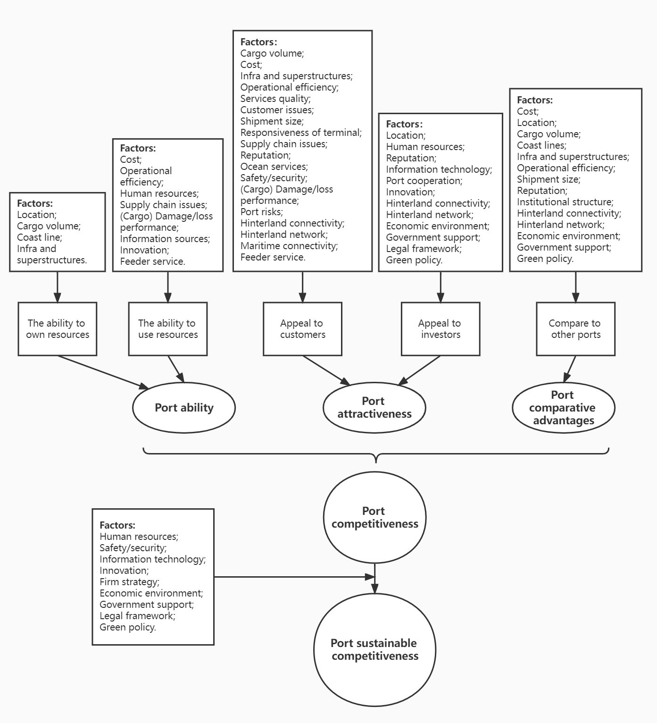
Figure 6. Mechanism of port competitiveness factors' influence

Discussion
This research has utilized a systematic literature review to examine the structure and content of port competitiveness performance and strategies, providing detailed empirical data to support its findings. In this section, findings regarding the pre-defined research questions are discussed in an attempt to provide answers.

  - RQ1: What are the existing trends in port competitiveness research?
From the overall analysis of the trends in a number of published articles, it can be seen that the research interest on port competitiveness appeared early. However, the number of publications in this field have increased significantly since the last decade, especially in the last five years. The reason for such an increase may be the trends of globalization and intensification of port competition. This result is consistent with the findings of Lagoudis et al. (2017), who reviewed and summarized the publications of topic relating to competition from 1990 to 2011. The difference in this review is that the time (2000 to 2020) and quality (ABS journal) of publications were updated.

From a geographical point of view, a major trend in this field is that the research object is gradually tending towards regional ports, rather than specific ports. Since the author's affiliation strongly influences the data of an empirical study, most previous studies on port competitiveness were quite localized (Pallis et al., 2010). Among the samples in this review, a large proportion of the empirical studies took a specific terminal, specific port or specific national port system as the research object, while other research dealt with regional ports in Asia or Europe. However, due to the high flexibility of inland transport and re-routing containers, port competition is being fought out beyond their physical boundaries (Mueller et al., 2020). As a result, the extent of international and regional collaboration has increased, and so has the relevant research interest.

It is important to note that under the influence of globalization, port competition is moving in the direction of internationalization. The existing literature tends to focus on strategies to increase the competitiveness of ports in the context of a particular country, while comparisons of the connotation of port competitiveness between different countries are generally lacking. This is because countries with different levels of development face various challenges and have distinctly different strategies on port competitiveness (Cheng et al., 2022). It is also noted that government plays a essential role in port competitiveness since it influences many areas of the commercial environment (Porter et al., 2007). However, no nation can be competitive across all industries; instead, it can only do so in those specific industries that are successful and properly develop port to contribute to the growth of the entire national economy (Wan et al., 2018). To promote prosperity in ports, what exactly the role of government should be and how policies can be coordinated across government departments is worth to consider.

On the whole, quantitative methods for data collection and processing were more popular for port competitiveness evaluation papers when the relevant economic impact factors were considered. A large part of the study on port competitiveness was to carry out empirical research on specific ports or port areas based on the extraction and classification of influencing factors in the existing literature. Port competitiveness drivers identified from secondary data were reasonable as the existing literature was sufficient for the initial obtainment. The quality of collected data was essential due to the diversity of characteristics and competition environment of ports. Port stakeholders and relevant research scholars were interviewed or surveyed by the researchers in order to collect effective port competitiveness drivers and to measure these drivers. In addition, the significance of mathematical modelling methods in the study of port competitiveness also deserves to be highlighted, such as the game theory approach, which plays a catalytic role in the study of competitive networks and pricing strategies in ports (Ishii et al., 2013).

In the review of the sample articles, the research of port competitiveness was divided into four themes, of which evaluation, port choice and strategy articles accounted for the main proportion. A steady stream of papers aimed at evaluating the factors that contribute to port competitiveness showed the significance and urgency of such an attempt (Miraj et al., 2020). It is clear that key factors of port competitiveness could be identified through the analysis of this kind of literature, but there were still difficulties in analyzing the degree of influence of these factors due to the multidimensional and multifaceted nature of the port (Parola et al., 2017). Compared to evaluation articles, port choice articles were not published frequently until the last decade. The articles on this topic were primarily modelled from the customer's perspective, which suggests that understanding the demand of shipping companies has become a new trend in the study of port competitiveness due to the promotion of its strategy position. The research objectives of the strategy papers in the sample were relatively diverse; therefore it is expected that there will be more such papers in the future because of their guiding significance to the practice.

Port competitiveness evaluation articles were generally designed to measure the degree of influence of a number of factors on the comprehensive competitiveness of ports, or to evaluate and compare the competitive performance of a specific port or port cluster. The difficulty of port competitiveness evaluation was that there was a wide diversity of variables whose impact on port competitiveness was difficult to quantify. Based on this, Multiple Criteria Decision Making (MCDM) approaches were recognized by many researchers as appropriate when dealing with the uncertainty of factors (Yeo et al., 2008). In particular, the AHP method, a fuzzy methodology to measure port competitiveness based on experts’ judgement, was the most preferred data analysis technique in the sample articles (John et al., 2014). Additionally, there were also attempts to utilize Factor Analysis method to explore the relations between influencing factors in different situations (Lee et al., 2011). An article using this method is more inclined to make theoretical contributions by constructing a conceptual framework and a comparative analysis.

The article on the strategy of improving port competitiveness amongst the reviewed articles generally focused on a certain influencing factor and port competitiveness to study its relationship with port competitiveness. Synthesis of this kind of research showed that most of the opinions to improve competitiveness were related to the influencing factors in port evaluation, even though some of them were not the extensively studied. Management strategies regarding the strategic factors of inland connectivity and cooperation were extensively proposed in the sample articles. Given the limitations of regional port studies, these specific port strategies were sometimes not applicable to other areas or types of ports. In this respect, geographical similarity became a prime consideration when practitioners borrowed from these strategies.

As a conclusion, a content framework for port competitiveness was constructed based on the literature sample and the results of data analysis. As depicted in Figure 7, the relationship between port competitiveness and its four sub-themes is different based on their respective objectives. It is apparent that the strategies category seeks to develop a variety of strategies to increase the port's competitiveness, while the Port competition group aims to reflect where the port's competitive advantages lie through a comparison of port competition relationships. Relatively complex are the assessment and port choice categories, whose relationship with port competitiveness is mainly linked through the drivers of port competitiveness. The drivers shown through the analysis of the assessment article not only directly influence port competitiveness, but also stimulate the generation of relevant strategies. The choice considerations of port customers are mainly determined by these drivers and the degree of port competition.

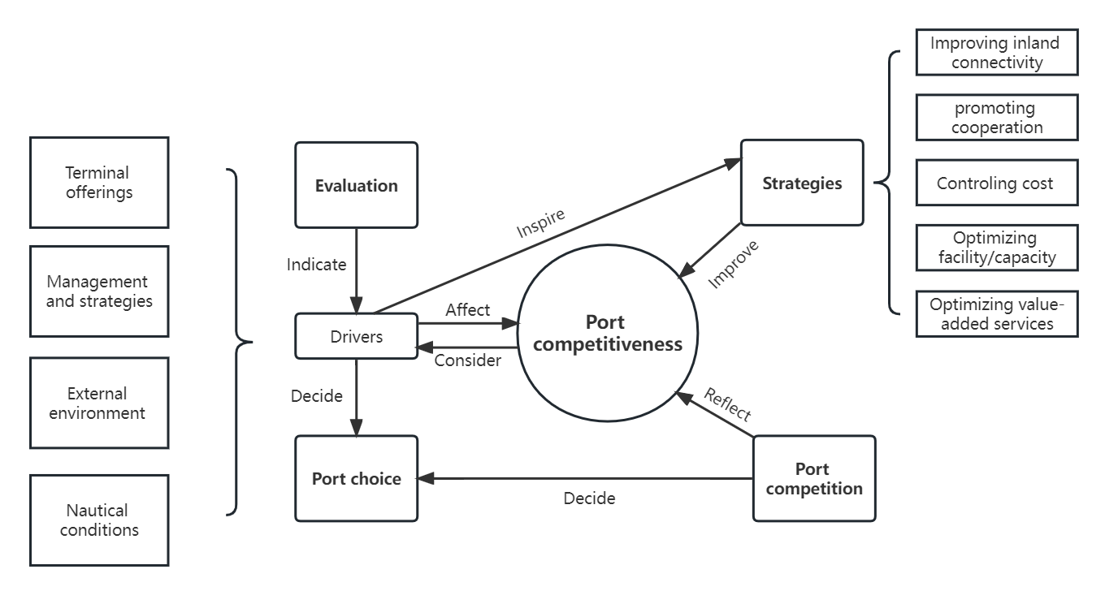
Figure 7. Content framework of port competitiveness

  - RQ2: What gaps in this research can be identified and what future directions proposed?
The analysis of research themes in the reviewed literature showed that although articles evaluating port competitiveness were rich, few studies conducted comparative research on port competition by developing and evaluating the indicators of port competitiveness. This implies a lack of convincing evidence in the literature for decision makers in implementing port management and strategy formulation. Indeed, it is challenging to indicate and compare the actual competitiveness of ports due to the multifaceted nature of port competitiveness, and the diversity and variability of port governance (Parola et al., 2017). Future research is hence expected to empirically investigate the role of port competitiveness in a specific, highly competitive port or port region.

Previous research perspectives have mainly focused on port stakeholders/port users and the service providers of port activities. The most significant two types of research were based on what criteria port customers use to choose ports, and how port operators improve their service capabilities. However, it should be noted that the position of the port has been extended from maritime activity-related services to inland supply chain support (Bichou and Bell, 2007). Although port integration with supply chains has been researched for about two decades, most of the literature aimed to measure how or to what extent ports integrated with supply chains rather than considering the supply chain management perspective as a strategy to improve port competitiveness. There was a lack of literature on port competitiveness from the perspective of partners in the whole service supply chain, apart from a few conceptual framework articles (Lam and Yap, 2011; Tally et al., 2014). In future research on port competitiveness strategy, there may be more possibilities to study the strategy of improving the efficiency and benefits of the whole supply chain from this perspective.

Although the literature on the influencing factors of port competitiveness is relatively abundant at present, the underlying mechanisms of how these factors affect port competitiveness, either positively or negatively, and whether they are interlinked, are not well represented in the sample literature. According to the results of the mechanistic analysis of port competitiveness factors, there are factors in ports that do not necessarily have a direct impact on port competitiveness but are potentially significant for the long-term maintenance of port competitiveness. It is noted that among these factors, there are still some cutting-edge factors, such as Information technology and Green policy, whose influence on port competitiveness is seems to have not been fully reflected. However, as these factors are increasingly paid attention by the port supply chain industry, their potential impact on port competitiveness is argued as huge in the future. In recent years, the investment of ports in technological innovation has increased significantly in order to comply with the development of science and technology, and high efficiency requirements. With the continuous expansion of ports and increased competition, these emerging technologies are being innovated, researched, and applied to shipping and supply chain activities. In particular, some emerging technologies, such as blockchain technology and terminal automation, are still in the initial stages of application (Liu et al., 2021). Therefore, it is It is worth further investigation whether these emerging technologies can effectively increase port performance and advantages in the competition, and whether the massive investment in the early stages of technological innovations is worthwhile (Wang et al., 2021).

Finally, the emergence of the concept of green ports and port sustainability has led to the performance of sustainability become a non-negligible indicator for assessing port competitiveness (Kim and Chiang, 2017). Building green ports and managing the balance between ports and the environment has become a new direction for ports because environmental damage can impede the development process of ports. Although this factor was not frequently recognized in the rankings for this review, it is expected to have a growing influence on port competitiveness in the future. Environmental sustainability puts forward new requirements for port operation management and technological innovation (Yap and Lam, 2019). However, there is still uncertainty about how the restrictions of environmental policy and the implementation of green strategies might affect the competitiveness of ports. Additionally, the understanding of port sustainability in many ports lies in avoiding negative impacts on the environment while neglecting the economic and social dimensions. The conceptual nexus between economic and social sustainability and port competitiveness is also likely to be discussed in future literature.

Conclusion
Fueled by a lack of comprehensive literature reviews on the topic of port competitiveness, this paper conducted a systematic literature review to understand the existing research characteristics of port competitiveness and provide potential insights for future study. To search, select and analyze the literature, this paper adopted a four-stage SLR process, consistent with the new protocol proposed by Denyer and Tranfield (2009) for producing a SLR, especially in the domain of management.

The value and contributions of this study might be concluded as follows. First, it contributes to the expansion of overall knowledge on port competitiveness by analyzing and synthesizing the characteristics and evidence of relevant articles. Second, the study provides a hierarchy of port competitiveness drivers and strategies based on their research frequency in the literature, categorizing them into four representative groups and analysing their intrinsic influencing mechanisms. The result of this analysis is useful for the reference of port stakeholders, especially decision makers, in implementing port operations and producing strategies. Thirdly, through the discussion of the research questions, the current research trends and existing research contents of port competitiveness are summarized. The outcome could enrich the understanding of port competitiveness evaluation and improving strategies in both academia and practice. Finally, the gaps and challenges in this area have also been investigated from different perspectives. The argument on some issues to be studied could provide insights for the future research.

Despite the valuable contribution provided by this study, there are some inherent limitations that should be addressed in future research. First, in the literature locating and selecting process, the inclusion criteria were limited to ABS journals only, due to the large amount of related literature and pursuit of high quality articles. This might limit evidence on a comprehensive understanding in the domain of port competitiveness from the reviewed literature, because of the possibility of highly relevant articles in other journals. Second, this review primarily examined data and discussed associated questions from the viewpoints of port operators and port users, while other port stakeholders' perspectives may differ or be more innovative. Finally, ports vary greatly according to the type of goods and location. This paper focused on the competitiveness of general ports, as not all types of port were clarified in the articles. It would be challenging but meaningful if future research could review the port competitiveness literature by port category.

Data Availability Statement
The data that support the findings of this study are available from the corresponding author, upon reasonable request.

References
Acosta, M., Daniel C., and Ma, D.M.C., 2011. Bunkering Competition and Competitiveness at the Ports of the Gibraltar Strait. Journal of Transport Geography, 19(4), 911-16.
Aksoy, S., and Yalcin D., 2019. Improving Competitiveness Level of Turkish Intermodal Ports in the Frame of Green Port Concept: A Case Study. Maritime Policy & Management, 47(2), 203-20.
Bichou, K., and Gray, R., 2005. A Critical Review of Conventional Terminology for Classifying Seaports. Transp. Res. Part A, 39(1), 75-92.
Bichou, K., and Bell, M.G., 2007. Internationalisation and Consolidation of the Container Port Industry: Assessment of Channel Structure and Relationships. Maritime Economics & Logistics, 9, 35–51.
Boell, S.K., and Cecez-Kecmanovic, D., 2015. “What is ‘Information’ beyond a definition?”, ICIS Thirty Sixth International Conference on Information Systems, Fort Worth, TX, 1-20.
Bossche, M.V., and Gujar, G., 2010. Competition, excess capacity and pricing of dry ports in India: some policy implications. International Journal of Shipping and Transport Logistics, 2(2), 151-167.
Brooks, M.R., Tony, S., and Athanasios, A.P.A., 2011. Systematic Approach for Evaluating Port Effectiveness. Maritime Policy & Management, 38(3), 315-34.
Caliskan, A., and Soner, E., 2019. An Assessment of Port and Shipping Line Relationships: The Value of Relationship Marketing. Maritime Policy & Management, 47 (2), 240-57.
Carbone, V., and Martino, M.D., 2003. The changing role of ports in supply-chain management: an empirical analysis. Maritime Policy & Management, 30(4), 305-320.
Chang, Y., Choi, K., Jo, A., and Park, H., 2018. Top 50 Authors, Affiliations, and Countries in Maritime Research. International Journal of Shipping and Transport Logistics, 10, 87–111.
Chang, Y. T., and Talley, W. K., 2019. Port competitiveness, efficiency, and supply chains: A literature review. Transportation Journal, 58 (1), 1–20.
Cheng, J., Lian, F. and Yang, Z., 2022. The impacts of port governance reform on port competition in China. Transportation Research Part E: Logistics and Transportation Review, 160, p.102660.
Clarke, R., and Davison, R.M., 2020. Research perspectives: Through whose eyes? The critical concept of researcher perspective. Journal of the Association for Information Systems, 21(2), 1.
Cullinane, K., and Wang, Y., 2009. A Capacity-Based Measure of Container Port Accessibility. International Journal of Logistics Research and Applications, 12 (2): 103–117.
De Langen, P.W., 2007. Port competition and selection in contestable hinterlands; the case of Austria. European Journal of Transport and Infrastructure Research, 7(1).
Denyer, D., and Tranfield, D., 2009. Producing a systematic review. The Sage Handbook of Organizational Research Methods.
Ding, J.F., Kuo J.F., Shyu, W.H, and Chou, C.C., 2019. Evaluating Determinants of Attractiveness and Their Cause-Effect Relationships for Container Ports in Taiwan: Users’ Perspectives. Maritime Policy & Management, 46(4), 466-90.
Dinwoodie, J., Tuck, S., and Knowles, H., 2012. Assessing the environmental impact of maritime operations in ports: a systems approach. In Maritime Logistics: Contemporary Issues. Group Publishing Limited, Emerald, pp. 263–284
Fan, Y.Y., and Mark, S., 2018. A Review of Supply Chain Risk Management: Definition, Theory, and Research Agenda. International Journal of Physical Distribution & Logistics Management, 48 (3), 205-30.
Ferrari, C., Tedeschi, A., and Percoco, M., 2010. Ports and local development: Evidence from Italy. Ports and Local Development, 1000-1022.
Fransoo, J.C., and Lee, C.Y., 2013. The critical role of ocean container transport in global supply chain performance. Production and Operations Management, 22(2), 253-268.
Fink, A., 2013. Conducting research literature reviews: From the Internet to paper. Sage Publications.
Garousi, V., Michael F., and Mika, V.M., 2019. Guidelines for Including Grey Literature and Conducting Multivocal Literature Reviews in Software Engineering. Information and Software Technology, 106, 101-21.
Ghadge, A., Dani, S., and Kalawsky, R., 2012. Supply chain risk management: present and future scope. International Journal of Logistics Management, 23(3), 313-339.
Gu, Q, and Patricia L., 2009. Exploring Service-Oriented System Engineering Challenges: A Systematic Literature Review. Service Oriented Computing and Applications 3(3), 171-88.
Guo, J., Huang, Q., and Cui, L., 2021. The impact of the Sino-US trade conflict on global shipping carbon emissions. Journal of Cleaner Production, 316,128381.
Heaver, T.D., 1995. The implications of increased competition among ports for port policy and
management. Maritime Policy & Management, 22(2), 125–133.
Heaver, T., Meersman, H., and Van, D.V.E,. 2001. Co-Operation and Competition in International Container Transport: Strategies for Ports. Maritime & Policy Management, 28(3), 293-305.
Hintjens, J., 2018. A Conceptual Framework for Cooperation in Hinterland Development between Neighbouring Seaport Authorities. Maritime Policy & Management, 45(6), 819-36.
Hossain, T., Adams, M., & Walker, T. R. (2021). Role of sustainability in global seaports. Ocean & Coastal Management, 202, 105435.
Huang, W.C., Teng, J.Y., Huang, M.J., and Kou, M.S., 2003. Port competitiveness evaluation by fuzzy multicriteria grade classification model. Journal of Marine Science and Technology, 11(1), 53–60.
Ishii, M., Lee, P.T.W., Tezuka, K. and Chang, Y.T., 2013. A game theoretical analysis of port competition. Transportation Research Part E: Logistics and Transportation Review, 49(1), pp.92-106.
Jensen, A. and Bergqvist, R., 2013. Seaport strategies for pre-emptive defence of market share under changing hinterland transport system performance. International Journal of Shipping and Transport Logistics, 5(4/5), 432–448.
John, A., Paraskevadakis, D., Bury, A., Yang, Z., Riahi, R. and Wang, J., 2014. An integrated fuzzy risk assessment for seaport operations. Safety science, 68, pp.180-194.
Kadaifci, C., Umut A., Seyda S., and Umut, A., 2018. A New Rule-Based Integrated Decision Making Approach to Container Transshipment Terminal Selection. Maritime Policy & Management, 46 (2), 237-56.
Kim, J.Y., 2013. Port User Typology and Representations of Port Choice Behavior: A Q-Methodological Study. Maritime Economics & Logistics, 16(2), 165-87.
Kim, S., and Chiang, B.G., 2017. The role of sustainability practices in international port operations: an analysis of moderation effect. Journal of Korea Trade, 21(2), 125–144.
Kramberger, T., Monios, J., Strubelj, G., and Rupnik, B., 2018. Using dry ports for port co-opetition: the case of Adriatic ports. International Journal of Shipping and Transport Logistics, 10(1), 18-44.
Lagoudis, I.N., Theotokas, I., and Broumas, D., 2017. A literature review of port competition research. International Journal of Shipping and Transport Logistics, 9(6), 724-762.
Lam, J.S., and Yap, W.Y., 2006. A measurement and comparison of cost competitiveness of container ports in Southeast Asia. Transportation, 33(6), 641-654.
Lam, J.S.L, and Yap, W.Y., 2011. Dynamics of Liner Shipping Network and Port Connectivity in Supply Chain Systems: Analysis on East Asia. Journal of Transport Geography, 19(6), 1272-81.
Lau, K., and T. Li., 2015. Co-Opetition between the Ports in Hong Kong and Shenzhen from the Users' Perspective. International Journal of Information Systems and Supply Chain Management, 8, 1-26.
Lee, S., Lee, K.W., Kang, H.J., and Lee, M.B., 2011. The Strategy of Busan Port for Northeast Asia Hub Port. African Journal of Business Management, 5(26), 10492-10498.
Light, R.J., and Pillemer, D.B., 1984. Summing up: The science of reviewing research. Cambridge, MA: Harvard University Press.
Lim, S., Stephen P., Wessam A., and Anthony Beresford., 2019. Port Sustainability and Performance: A Systematic Literature Review. Trans. Res. Part D: Transport and Environment, 72, 47-64.
Liu, J., Zhang, H., and Zhen, L., 2021. Blockchain technology in maritime supply chains: applications, architecture and challenges. International Journal of Production Research, 1-17.
Luo, M., Chen, F., and Zhang, J., 2022. Relationships among port competition, cooperation and competitiveness: A literature review. Transport Policy.
Martínez Pardo, A., García Alonso, M.L., and Orro, A., 2018. The role of the degree of use of the facilities in the port choice process: the Spanish dockside cranes case. International Journal of Shipping and Transport Logistics, 10.
McLaughlin, H., and Colm, F., 2013. Understanding the Development of Port and Regional Relationships: A New Cooperation/Competition Matrix. Maritime Policy & Management, 40(3), 278-94.
Merk, O., 2013. The competitiveness of global port-cities: synthesis report.
Miraj, P, and Mohammed, A.B., 2020. Teuku Yuri Zagloel, Mustika Sari, and Gunawan Saroji. Research Trend of Dry Port Studies: A Two-Decade Systematic Review. Maritime Policy & Management, 1-20.
Mueller, M.A., Wiegmans, B., and van Duin, J.H.R., 2020. The Geography of Container Port Choice: Modelling the Impact of Hinterland Changes on Port Choice. Maritime Economics & Logistics, 22(1), 26-52.
Munim, Z.H., and Saeed, N., 2019. Seaport competitiveness research: the past, present and future. International Journal of Shipping and Transport Logistics, 11(6), 533-557.
Nalebuff, B., and Brandenburger, A., 1996, Co-opetition, ISL Förlag AB, Oskarshamn.
Narasimha, P.T., Jena, P.R., and Majhi, R., 2021. Impact of COVID-19 on the Indian seaport transportation and maritime supply chain. Transport Policy, 110, 191–203
Notteboom, T.E., and Rodrigue, J.P., 2005. Port regionalization: Towards a new phase in port development. Maritime Policy & Management, 32(3), 297–313.
Notteboom, T., Yap, W.Y., 2012. Port Competition and Competitiveness. The Blackwell Companion to Maritime Economics, 549–570.
Okorie, C., Tipi, N., and Hubbard, N., 2016. Analysis of the potential contribution of value-adding services (VAS) to the competitive logistics strategy of ports. Maritime Economics & Logistics, 18(2), 158-173.
Paixão, A.C., and Peter, B.M., 2003. Fourth Generation Ports – a Question of Agility? International Journal of Physical Distribution & Logistics Management, 33(4), 355-76.
Pallis, A. A., Vitsounis, T. K., and de Langen, P. W., 2010. Port Economics, policy and management: Review of an emerging research field. Transport Reviews, 30(1), 115–161.
Parola, F., Risitano, M., Ferretti, M., and Panetti, E., 2017. The drivers of port competitiveness: a critical review. Transport Reviews, 37(1), 116–138.
Pettit, S. J., and Beresford, A.K.C., 2009. Port development: From gateways to logistics hubs. Maritime Policy & Management, 36(3), 253–267.
Pittaway, L., Robertson, M., Munir, K., Denyer, D., and Neely, A., 2004. Networking and innovation: a systematic review of the evidence. International Journal of Management Reviews, 5(3‐4), 137-168.
Porter, M.E., Ketels, C. and Delgado, M., 2007. The microeconomic foundations of prosperity: findings from the business competitiveness index. The global competitiveness report, 2008, pp.51-81.
Protic, S. M., Fikar, C., Voegl, J., and Gronalt, M., 2020. Analysing the impact of value added services at intermodal inland terminals. International Journal of Logistics Research and Applications, 23(2), 159–177.
Robinson, R., 2002. Ports as Elements in Value-Driven Chain Systems: The New Paradigm. Maritime Policy & Management, 29, 241–55.
Rupnik, B., Gregor S., Tomaz K., and Jason M., 2018. Using Dry Ports for Port Co-Opetition: The Case of Adriatic Ports. International Journal of Shipping and Transport Logistics, 10(1).
Song, D.W., and Photis M.P., 2008. Global Supply Chain and Port/Terminal: Integration and Competitiveness. Maritime Policy & Management, 35(1), 73-87.
Talley, W. K., Ng, M., and Marsillac, E., 2014. Port Service Chains and Port Performance Evaluation. Trans. Res. Part E: Logistics and Transportation Review, 69, 236–47.
Taljaard, S., Slinger, J.H., Arabi, S., Weerts, S.P., and Vreugdenhil, H., 2021. The natural environment in port development: a ‘green handbrake’ or an equal partner? Ocean Coast Management, 199.
Tongzon, J., and Wu, H., 2005. Port Privatization, Efficiency and Competitiveness: Some Empirical Evidence from Container Ports (Terminals). Trans. Res. Part A: Policy and Practice, 39 (5), 405-24.
Tongzon, J., Y. Chang, and S. Lee., 2009. How Supply Chain Oriented is the Port Sector? International Journal of Production Economics, 122, 21–34.
Tovar, B., Rubén H., and Héctor R.D., 2015. Container Port Competitiveness and Connectivity: The Canary Islands Main Ports Case. Transport Policy, 38, 40-51.
Tranfield, D., Denyer, D., and Smart, P., 2003. Towards a methodology for developing evidence-informed management knowledge by means of systematic review. British Journal of Management, 14, 207–22
UNCTAD, 2021. Review of maritime transport 2021. (United Nations publication. Sales No. E.19.II.D.20. New York and Geneva).
Wacker, J.G., 1998. A definition of theory: research guidelines for different theory-building research methods in operations management. Journal of Operations Management, 16, 361–385.
Wahyuni, S., Alif A.T., and Felix, K.P.H., 2020. Exploring Key Variables of Port Competitiveness: Evidence from Indonesian Ports. Competitiveness Review: An International Business Journal, 30(5),529-53.
Wan, C., Zhang, D., Yan, X. and Yang, Z., 2018. A novel model for the quantitative evaluation of green port development–A case study of major ports in China. Transportation Research Part D: Transport and Environment, 61, pp.431-443.
Wang, J., Liu, J., Wang, F. and Yue, X., 2021. Blockchain technology for port logistics capability: Exclusive or sharing. Transportation Research Part B: Methodological, 149, pp.347-392.
Wen, J.R., Nie, J.Y., and Zhang, H.J., 2001, April. Clustering user queries of a search engine. In Proceedings of the 10th international conference on World Wide Web, 162-168.
Wilmsmeier, G., Jason M., and Bruce L., 2011. The Directional Development of Intermodal Freight Corridors in Relation to Inland Terminals. Journal of Transport Geography, 19(6),1379-86.
Yap, W.Y., and Lam, J.S.L., 2019. 80 million-Twenty-Foot-Equivalent-Unit Container Port? Sustainability Issues in Port and Coastal Development. Ocean & Coastal Management, 71, 13-25.
Yeo, G. T., Roe, M., and Dinwoodie, J., 2008. Evaluating the competitiveness of container ports in Korea and China. Trans. Res. Part A: Policy and Practice, 42(6), 910–921.
Yeo, G.-T., M. Roe, and Dinwoodie, J., 2011. Measuring the Competitiveness of Container Ports: Logisticians’ Perspectives. European Journal of Marketing, 45(3), 455–470.
Yuen, C. L. A., Zhang, A., and Cheung, W., 2012. Port competitiveness from the users’ perspective: An analysis of major container ports in China and its neighboring countries. Research in Transportation Economics, 35(1), 34–40.

