Participant ID_______________
(To be completed by researcher)
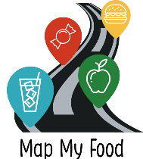
Map My Food Study Online Interviews

CONSENT FORM - For completion by parent

Please initial

the box
(e.g. T. R)

- I confirm that I have read and understand the information sheet (version 3.0, dated 12/08/20) for the Map My Food Study Online Interviews. I have had the opportunity to consider the information and ask questions via email

- I agree for my adolescent to take part in this study
- I understand that my adolescent’s participation is voluntary and that I am free to withdraw their participation at any time, without giving a reason
- I understand that data collected during the study will only be used for ethically approved health research
- I give permission for my adolescent to take part in an online interview, either as part of a group or on a one-to-one basis
- I give permission for the interview to be recorded

- I give permission for my adolescent’s unidentifiable data to be included in a final dataset that may be shared with other researchers for studies about health and wellbeing

- I give permission to be contacted about my adolescent’s participation in the follow-up phase of this study

Parent/carer email address: __________________________________________________________

Parent/carer phone number: _________________________________________________________

[These details will only be used for the purpose of this research]

Adolescent’s first name: | Adolescent’s surname:

________________________ _______________________ ____________________
Name of Parent Signature Date

