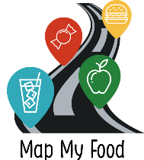
Participant ID_______________
(To be completed by researcher)
Map My Food Study

CONSENT FORM - For completion by parent

Please initial

the box
(e.g. T. R)

- I confirm that I have read and understand the information sheet (version 3.0, dated 12/08/20) for the Map My Food Study. I have had the opportunity to consider the information and ask questions via email

- I agree for my adolescent to take part in this study

- I understand that my adolescent’s participation is voluntary and that I am free to withdraw their participation at any time, without giving a reason

- I understand that data collected during the study will only be used for ethically approved health research

- I give permission for my adolescent to:
Complete the research questionnaires

Use the Map My Food App on their own mobile phone for 7 days

- I give permission for my adolescent’s unidentifiable data to be included in a final dataset that may be shared with other researchers for studies about health and wellbeing

Parent/carer email address: __________________________________________________________

Parent/carer phone number: _________________________________________________________

[These details will only be used for the purpose of this research]

Adolescent’s first name: | Adolescent’s surname:

_______________________ _______________________ ____________________
Name of Parent Signature Date

