Changing Soil Response during Episodic Cyclic Loading in
Direct Simple Shear Tests

Noor Laham, Katherine Kwa, David White and Susan Gourvenec
University of Southampton
Southampton, United Kingdom

Andrew Deeks and Yusuke Suzuki
Norwegian Geotechnical Institute
Oslo, Norway

Undrained cyclic loading of normally consolidated clays, interspersed with consolidation (i.e., episodic cyclic loading), has been shown to lead to softening followed by hardening, manifested by evolving parameters such as strength, stiffness, and coefficient of consolidation. The current evidence base is drawn from tests in which soil strength has been fully mobilized in each cycle of loading, whereas in practice, changes in stress around a geotechnical infrastructure typically occur only at a prefailure level. This paper presents results from a set of stress-controlled episodic cyclic direct simple shear tests imposing prefailure stress reversals in each cycle. Differences in soil response are identified for the same total number of cycles of loading but imposed through packets of different numbers of cycles and, consequently, different numbers of intervening consolidation stages. The results highlight the effect of load history on operational soil properties and quantify the effect of the undrained prefailure cyclic loading history on the evolution of the soil properties, supporting the application of whole-life geotechnical design in practice.

KEY WORDS: Offshore engineering, geotechnics, direct simple shear, clay.

NOMENCLATURE

$c_{v}$ Coefficient of consolidation
D Damage ratio between the excess pore water pressure generation and the consolidation effective stress
$e$ Void ratio
$e_{0}$ Initial void ratio
$G_{s}$ Specific gravity of solid fraction
$s_{u}$ Undrained strength
$s_{u0}$ Monotonic undrained strength
$γ$ Shear strain
$Δu$ Excess pore water pressure generation
$κ_{0}$ Slope of one-dimensional swelling line
$λ_{0}$ Slope of one-dimensional normal compression line
$σ_{v}^{'}$ Vertical effective stress
$σ_{v0}^{'}$ Equilibrium vertical effective stress
$σ_{vc}^{'}$ Consolidation vertical effective stress
$τ$ Shear stress
$ϕ^{'}$ Angle of internal friction

INTRODUCTION

Renewable Energy Future
The global energy industry is going through a significant period of transition aiming to net zero greenhouse gas emissions in the coming decades, and renewable energy is expected to be one of the fastest-growing energy sources globally (International Energy Agency, 2021). In line with the Paris Agreement for climate neutral energy or energy with no greenhouse gas emissions in the coming 30 years, investments and technologies are needed to decarbonize the energy system. East Asia is responsible for 34% of the global energy-related emissions, where a 53% reduction in carbon emissions by 2050 is planned through the transition to renewable energies (International Renewable Energy Agency, 2019). Asia’s share of the global offshore wind market is expected to grow from 24% in 2019 to 42% in 2025 (ReGlobal, 2020). In addition, Europe is aiming to increase its offshore capacity from wind and other types of ocean energy (e.g., wave and tidal) to at least 340 GW by 2050—that is, multiplying the capacity for offshore renewable energy by nearly 30 (European Commission, 2020). In parallel, the United Kingdom is aiming to quadruple the amount of offshore wind generated to 50 GW by 2030 (HM Government, 2022) and to 100 GW or more by 2050 (Climate Change Committee, 2020).
Figure 1 presents a forecast of the global growth of the offshore wind market in the coming years (Global Wind Energy Council, 2022), showing a significant increase in installation rate. To cope with the rapid development of offshore wind, efficient design processes for offshore renewable energy structures are required. This paper specifically considers optimization of geotechnical design for foundations and anchors to support future offshore wind infrastructure. Figure 2 illustrates a range of offshore renewable energy structures and different foundation and anchor solutions.
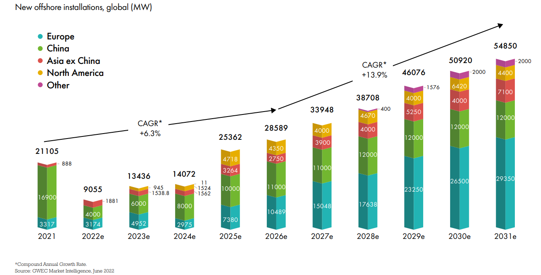

Fig. 1 Forecast global offshore wind growth (Global Wind Energy Council, 2022)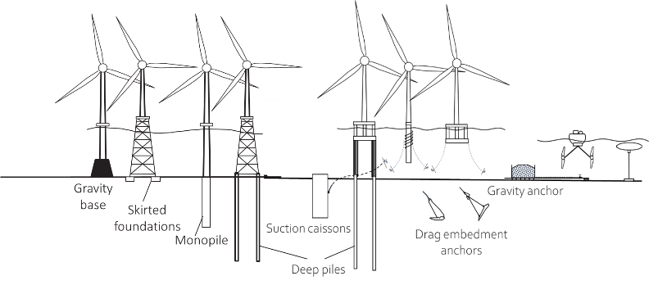Fig. 2 Offshore renewable energy structures and their foundations and anchors (Gourvenec et al., 2022)

Offshore Foundations and Anchoring Systems
A whole-life geotechnical design approach is applicable to various offshore structures and can be applied to foundations, anchors, pipelines, and cables (Gourvenec, 2018). Environmental conditions, such as extreme weather events that involve high amplitude cycles followed by low amplitude calm weather cycles, and seasonal storms occurring in the winter followed by low intensity activity periods in the summer, enable consolidation during low activity periods during which the soil may reconsolidate. In soft soils, this leads to increases in soil strength and stiffness (i.e., hardening of soil) and an associated increase in coefficient of consolidation. As a result of the environmental loading conditions, loads can be simulated as packets of cycles (i.e., a storm period) followed by a period of consolidation (a low intensity activity period) that are transferred to the foundations or anchoring system, causing changes in the seabed properties (Gourvenec, 2018).

Whole-life Geotechnical Response and Design Approach
Offshore infrastructure is continuously subjected to cyclic loads, which are transmitted to the foundation or anchoring system. These whole-life loads affect the geotechnical properties of the seabed, which can cause variations in the current capacity, stiffness and reliability of the infrastructure (Gourvenec, 2018). In traditional geotechnical design, reduction in seabed strength is commonly adopted to reflect undrained cyclic softening because of the generation of excess pore water pressure. Dissipation of excess pore water pressure after loading (or during extended periods of loading) can lead to a strength gain, or “hardening,” and associated increases in stiffness and coefficient of consolidation, which are not typically considered in design. Capturing the full range of whole-life soil response in geotechnical design offers potential to unlock efficiencies and increased reliability.
A whole-life geotechnical design (WLGD) approach has been recently proposed as an alternative to traditional geotechnical design (Gourvenec, 2020). The basis of WLGD is the same as for traditional design in —that a design action does not cause a design limit state to be exceeded. However, in a whole-life design approach, this check is made repeatedly throughout the life of the structure or system rather than just once for the worst-case combination of maximum action and minimum resistance or stiffness, as is generally the case for traditional offshore geotechnical design.
Efficiencies from WLGD can be accrued at the initial design stage for optimal sizing, throughout the life of the structure/system for assessing or predicting cumulative displacements or changes in resistance, and from comparing assumptions in the initial design against observed performance. By extension, these insights can be used to predict the actual remaining design life, for relifing or repurposing, and for decommissioning.

Direct Simple Shear for Whole-Life Characterization
Cyclic softening and hardening have been demonstrated with flow-around penetrometers (Hodder et al., 2013; Cocjin et al., 2014) and interface shear tests (Boukepti and White, 2017); however, these approaches are limited to simulating full remolding of soil in each shearing episode (and in the case of penetrometer tests must be carried out in situ or on large samples at 1g or in a geotechnical centrifuge). Pre-failure stress states are experienced around most seabed infrastructure, such as foundations or anchors, with mobile pipelines and sliding foundations being exceptions that feature sliding failure by design (Cocjin, et al., 2014) (White & Bransby, 2017). Direct simple shear (DSS) element tests offer a practical option to capture evolving soil properties resulting from prefailure cyclic shearing and intervening consolidation requiring only small soil samples, to inform WLGD.
Previous frameworks have used DSS data to assess the effect of cyclic loading on soil softening to quantify the buildup of excess pore pressures through pore pressure S-N contour diagrams (e.g., Andersen, 2015). For application of whole-life geotechnical design to offshore geotechnical infrastructure, recent research has considered monotonic episodic loading with intervening consolidation stages within a DSS test to capture soil hardening as well as soil softening, which showed promising results (Laham et al., 2021). In the current paper, the use of the DSS apparatus is extended to explore softening and hardening under the more complex loading history of cyclic episodic loading with intervening consolidation stages. This illustrates how a seabed will respond differently depending on the sequence and duration of whole-life loading—for example, to a single severe storm or to consecutive seasons of moderate or light storms. According to the results from this study, traditional S-N contour diagrams, defining the relationship between mobilizable stress as a function of cycles of loading, could be extended to capture consolidation effects, resulting in a new advanced framework suited to whole-life geotechnical design.

Aim and Outline of the Paper
The study presented in this paper quantifies the degree of softening and reconsolidation of a reconstituted and initially lightly overconsolidated natural clay under packets of undrained cyclic loading with intervening consolidation through a set of DSS tests. The tests follow an episodic cyclic loading stress path of packets of different numbers of cyclic loads and a period of rest that enables full consolidation between packets. Each loading packet could be analogous to an extreme weather event with repeated packets representing an additional season. In general, the test sequence represents intermittent loading actions that occur over a timescale that allows consolidation to take place. The tests presented here are novel in that cycling is stress controlled, and the samples are subjected to prefailure stress levels in each cycle with intervening consolidation periods. By contrast, most previous investigations of episodic loading with intervening consolidation have considered shearing to failure between periods of reconsolidation or monotonic loading, or both; for example, see Hodder et al. (2010), Cocjin et al. (2014, 2017), Deeks et al. (2014), and Laham et al. (2021).
This paper also demonstrates the changing soil response with cyclic episodes via changes in the void ratio and stress-strain relationship, which is then converted to evolving soil parameters (strength, stiffness, coefficient of consolidation) for each cycle or packet of loading. Such an approach affords new insight into and versatility in interpreting the experimental results in each cycle and not only after each packet of loading.
Changes in stress and volume are interpreted within a critical state soil mechanics (CSSM) framework (Schofield and Wroth, 1968). The CSSM framework is well suited to capture the softening as a result of excess pore water pressures generated during undrained cyclic loading and reduction in the void ratio from dissipation of the excess pore water pressures during consolidation leading to hardening of the soil. The softening and hardening responses lead to reductions and increases, respectively, of strength, stiffness, and coefficient of consolidation. The results from this study demonstrate the different outcomes for a fixed total number of cycles of fixed magnitude depending on the number of cycles per packet, $n$, and therefore the number of packets, $N$.

EXPERIMENTAL PROGRAM

DSS Apparatus
A set of stress-controlled DSS element tests were performed at the University of Southampton using a GDS Instruments 10 kN electromechanical dynamic cyclic simple shear (EMDCSS) apparatus (Fig. 3). The apparatus is composed of two linear actuators controlling the vertical and the horizontal movements of the loading rams. Two displacement transducers and a load cell are connected to the actuators through a feedback loop, enabling load-controlled and displacement-controlled testing. The soil specimen is surrounded by Teflon-coated stainless steel stacked rings to maintain a zero lateral strain boundary condition. The apparatus deformation and lateral confinement system were calibrated immediately prior to the test program, and all vertical displacements and shear stresses have been corrected based on these calibrations in agreement with ASTM International Standard ASTMD6528-07 (ASTM, 2007). During the shear stages, constant height conditions were applied to ensure a constant sample volume, according to the method outlined in Dyvik et al. (1987). Therefore, the sample excess pore pressures that developed during the shear stage were estimated from the differences between the consolidation stress applied and normal stress measured from the top and bottom platens.
The components of the EMDCSS apparatus pertaining to this research are labeled in Fig. 3 and summarized as follows:
- Axial compression load cell
- Shear load cell
- Horizontal compression load cell
- Top actuator (axial loading cylinder)
- Bottom actuator (horizontal sliding plate)

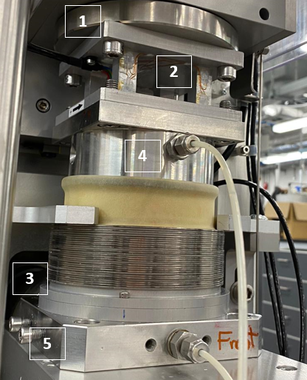
Fig. 3 Direct simple shear apparatus

Table 1 Characteristics of Onsøy clay (Gundersen et al., 2019)
Properties | Onsøy clay
Liquid limit (%) | 70
Plastic limit (%) | 44
Specific gravity Gs | 2.76
Angle of internal friction φ′ (°) | 30
Normalized undrained shear strength $s_{u0}/{σ'}_{v0}$ | 0.43

Specimen Preparation, Assembly, and Loading
The tests were carried out on fully saturated samples of reconstituted, lightly overconsolidated Onsøy clay with properties as listed in Table 1. The samples were recovered from the national Norwegian Geo-Sites (NGTS) 2016 field testing program (Gundersen et al., 2019). The reconstituted specimens were prepared as a slurry at a water content of 75%, close to the liquid limit of the Onsøy clay material, and then transferred to a 70.5 mm diameter tube and consolidated to a maximum vertical stress of 60 kPa to target a minimum strength that is practical for sample preparation. The consolidation took about 72 hours to complete, after which time individual specimens with a diameter of 70.5 mm and an initial height of 20 mm were extruded from the tube and placed into the removable base of the DSS, where the metal stacked rings and rubber membrane had already been assembled. Porous plates were placed at the top and the bottom of the specimen. The base was gently placed and secured in the bottom of the DSS apparatus.
A small vertical stress (<3 kPa) was applied as a seating pressure, and the settlements were monitored for about an hour to ensure the sample was no longer settling before the consolidation stage commenced. This displacement was used in the calculation of the final specimen height. Finally, the rubber membrane was pulled up and sealed with O-rings around the top and bottom platens.
The specimens were consolidated in the DSS apparatus to 70 kPa, representing a vertical effective stress level at about 10 m depth. Samples were then subjected to episodic cyclic loading sequences composed of $N$ packets, each of $n$ individual shearing cycles applied under constant sample volume, or undrained conditions. Each packet of cyclic shear was interspersed with a consolidation period, allowing excess pore pressures to fully dissipate. Four cyclic tests were carried out, each with the same total number of cycles (20 cycles) but applied in a different number of packets (i.e., $n$= 20, $N$ = 1; $n$ = 10, $N$ = 2; $n$ = 4, $N$ = 5; and

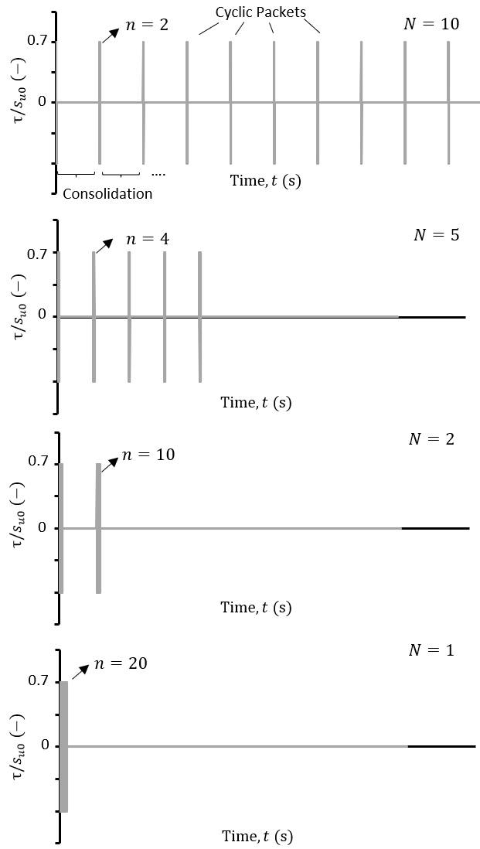
Fig. 4 Loading sequence followed during DSS testing for varying number of cycles per packet n and number of packets N

$n$ = 2, $N$ = 10). The imposed cyclic stress was symmetric (i.e., average shear stress $τ_{avg}$ = 0 kPa), and with a constant magnitude $τ_{cyc}=0.7s_{u0}$. This constant applied cyclic shear stress of 0.7$s_{u0}$ was selected to be sufficient to ensure a noticeable soil response yet sufficiently far from failure in each cycle. Soil response to additional levels of shear stress would be interesting to explore but is beyond the scope of this paper. The cyclic frequency was set to 0.1 Hz (i.e., 10 s for each cycle). This frequency is typical of a wave during a storm (Andersen et al., 1988). The loading patterns of the four tests making up this study are illustrated in Fig. 4.

RESULTS AND ANALYSIS

The following sections present and discuss the fundamental stress path, stress-strain response, excess pore water pressure response, and void ratio changes measured in each of the episodic cyclic DSS tests. The relationship between these responses and the evolution of geotechnical properties is then introduced.

Stress Path and Stress-Strain Response
The form of the stress path followed in each test is illustrated in Fig. 5a for the example of the test with two packets each of 10 cycles (i.e., $n$ = 10, $N$= 2). The stress path from the packet 1 is shown in blue and packet 2 in grey. It is clear that a lower effective stress is reached in 10 cycles in the first packet compared the second packet. This results from a decrease in excess pore water pressure generation between packets as a result of the intervening consolidation stage that densifies the soil and reduces the tendency for generation of excess pore water pressure.
The relationship between the change in vertical effective stress during shear and the subsequent change in the void ratio during consolidation for the same test ($n$= 10, $N$ = 2) is shown in Fig. 5b. The lower incremental reduction in the void ratio following the second packet of loading compared with that following the first packet is clear. It can be seen that both the change in effective stress and void ratio decreased after the first packet of loading and consolidation. The reduction in volume—that is, the denser material at the end of consolidation—explains the lower generated excess pore pressure and therefore smaller reduction in effective stress in a subsequent packet—in this case, packet 2 compared with packet 1. The hardening behavior is also evident in the stress-strain relationship as shown in Fig. 5c, where the second packet exhibits less cyclic shear strain accumulation than the first, although the same shear stress and number of cycles were applied in both. This indicates that the soil is becoming stiffer with a decreasing tendency to deform under shearing.
During the first packet of loading, the EMDCSS apparatus was not able to achieve the targeted applied constant shear stress at higher shear strains. This is because the apparatus reached a limiting horizontal driving speed that was not sufficient to keep up with the rate at which the sample softened during the first loading packet. This was not an issue in subsequent packets, once the sample hardened and became stiffer after the first consolidation stage. Figure 5d illustrates the hardening behavior, showing that settlement during the second consolidation phase is 50% less than during the first consolidation stage.

Pore Water Pressure Response
Excess pore pressure, $u,$ is developed during each constant volume cyclic shearing stage, is shown against shear strain in Fig. 6 for the tests n = 20, N = 1 and n = 2, N = 10, indicating that the number of intervening consolidation stages affects the excess pore water pressure generation and shear strain response during cyclic loading packets. Significantly higher excess pore water pressures and shear strains were generated in the sample that was subjected to 20 cycles in a single packet ($n$= 20,$N$

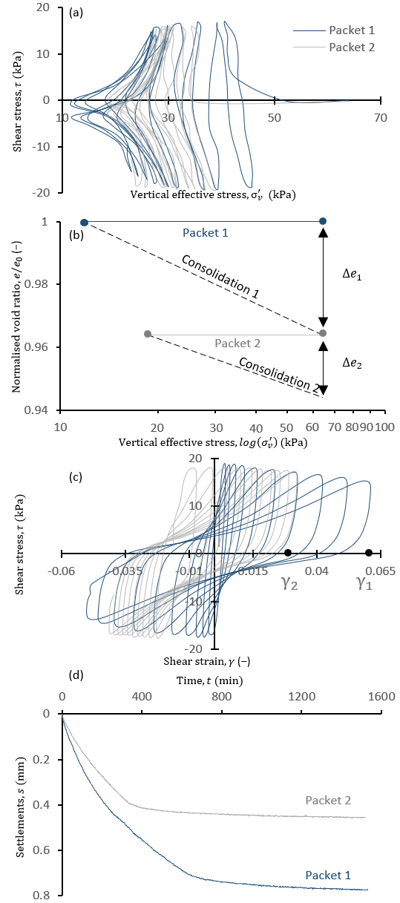

Fig. 5 Results from DSS tests corresponding to $n$ = 10, $N$ = 2: (a) Stress path, (b) e-log ($σ_{v}^{'}$), and (c) stress-strain response; (d) soil settlements change for the DSS test results corresponding to $n$= 10, $N$ = 2 test (Note: Labels $γ_{1}and γ_{2}$refer to the hypothetical case study presented at the end of the paper.)

= 1; blue data line) compared with the final packet of the test, where the sample was again subjected to 20 cycles but in 10 packets ($n$= 2, $N$= 10; grey data line). A rapid excess pore water pressure increase can be observed in the initial cycles in the test with $n$ = 20, $N$ = 1, which was accompanied by small shear strains. During the later cycles in the packet, the rate of excess pore water pressure buildup and the shear strains increase, forming a tornado-shaped response that was typical in all tests. This response was a result of the tendency of the sample to soften with cycles during the constant volume cyclic shear stages. In the sample subjected to the highest number of packets, $N,$ but the lowest number of cycles per packet, $n,$ (e.g., $n$= 2, $N$= 10), the excess pore water pressure and shear strain generated decreased in each subsequent packet, as samples tended to densify and harden during the intervening consolidation stages, which reduced the tendency to generate positive excess pore water pressure and soften in the following shearing stages. The smallest excess pore water pressure buildup and shear strains per cycle were measured in the final packet. The decrease in applied stress during the first packet of loading, as noted in Figure 5c, is manifested here by the asymmetry of excess pore water accumulation. By considering excess pore pressure at zero strain for the follow-on analysis, the variation in excess pore pressure across the cycle is not considered to be significant.
Another approach to assess the effect of the number of packets of cyclic loading and intervening consolidation episodes on the excess pore water pressure response is to introduce a soil damage parameter, $D$:

$$D=Δu/σ_{vc}^{'}$$ | (1)
where 0 < $D$< 1, and $σ_{vc}^{'}$ is the applied vertical consolidation stress (which was constant in the four tests presented in this paper, $σ_{vc}^{'}$= 70 kPa). Therefore, the damage parameter represents the effect of the different cyclic loading sequences on the excess pore water pressure generation. The damage parameter is shown against the number of cycles, for each of the four tests carried out for this study in Fig. 7. It is clear that the damage was highest in the test where 20 cycles were applied in a single packet ($n$= 20, $N$ = 1) because no intervening consolidation period influenced the response. As the number of load packets, $N,$—and hence the intervening consolidation periods—increased, the damage with the increasing number of cycles decreased as the samples hardened during the reconsolidation intervals, resulting in a minimum damage of $D$< 0.1.

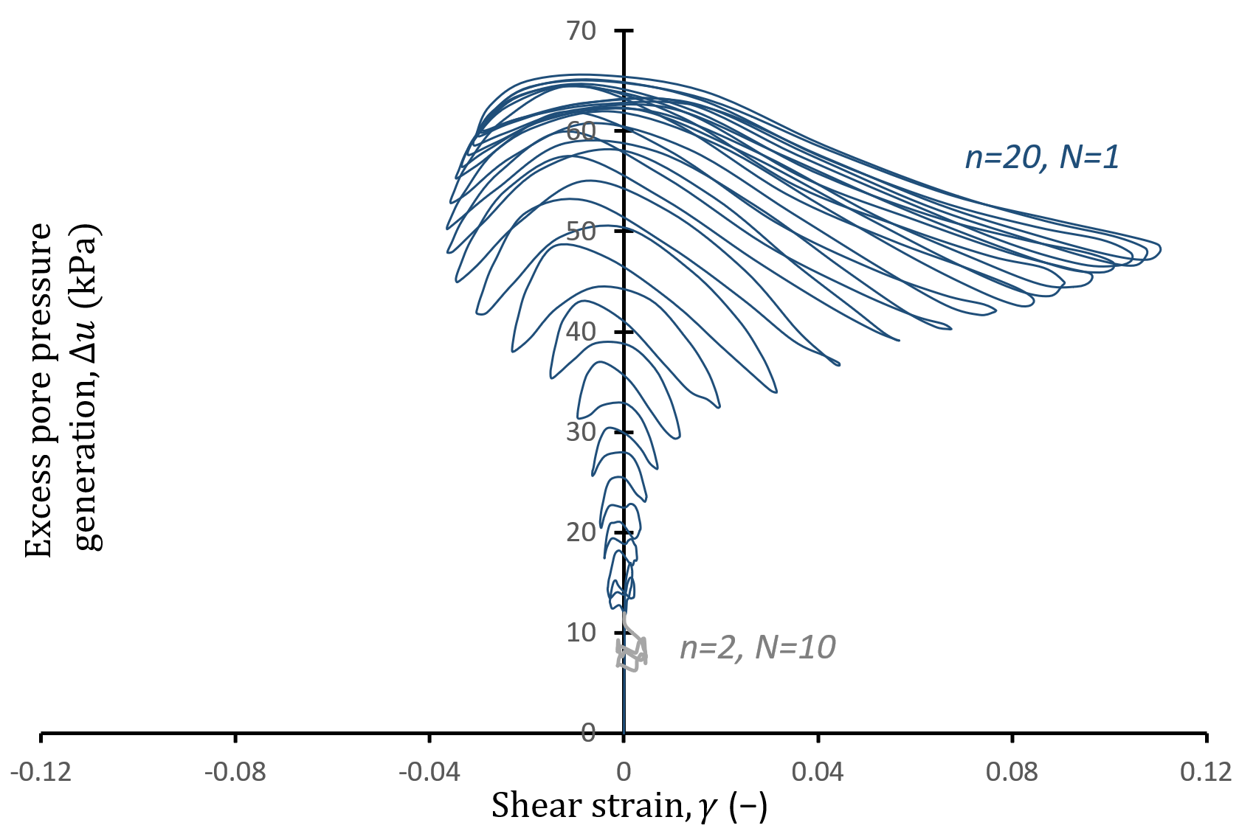
Fig. 6 Excess pore water pressure generation as a function of shear strain mobilization for tests $n$= 20, $N$= 1 and $n$= 2, $N$= 10 (where n = 2 represents the 19th and the 20th cycles)
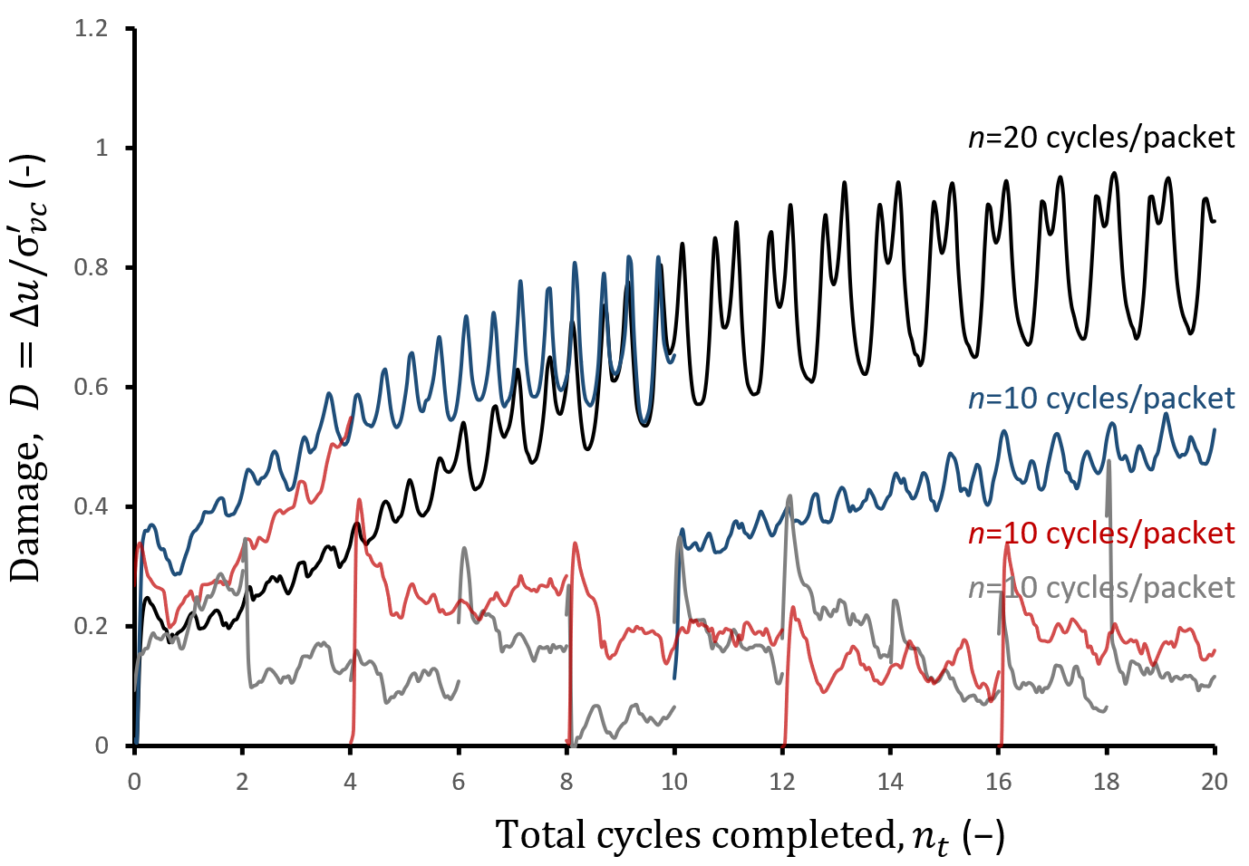
Fig. 7 Damage accumulation during each loading packet as a function of total cycles completed $n_{t}$ for tests with different number of cycles, $n$per packet

The results show that the change in the damage depends on two factors:
- The loading duration, or the number of cycles per loading packet.
- The number of consolidation intervals between loading cycles.
The same trends as seen in Fig. 7 are illustrated in Fig. 8a, which shows the final damage accumulated at the end of each loading packet against the total number of cycles applied, $n_{t}$. For a higher $N$or number of consolidation intervals, the damage decreased for each subsequent applied load packet. This is also observed in Fig. 8b, which compares the damage generated at the end of the final loading packet for the four tests.

Void Ratio and Compression Response
Void ratio reduced as a result of the dissipation of excess pore pressure for the lightly overconsolidated conditions (i.e., on the wet side of the critical state) that are considered in this study; that is, samples densified and hardened during each intervening consolidation period, applied between loading packets. The higher the excess pore water pressure (or damage) generated in a preceding load packet, the greater the reduction in the void ratio during the following consolidation period as the excess pore pressures dissipated. This is illustrated in Fig. 9 in the $e$ versus $\log{σ_{v}^{'}}$ space for each of the four tests. Void ratios have been normalized by the initial void ratio, $e_{0}$, after the initial consolidation stress $σ_{vc}^{'}$ was applied for each sample. Smaller generated excess pore pressures led to a smaller incremental reduction in the void ratio during the intervening consolidation periods.
This trend can also be observed when plotting changes in the void ratio against the total number of cycles (Fig. 10). Greater reductions in the void ratio were observed in samples that were cyclically loaded in fewer packets (i.e., more cycles per packet), consistent with the trends in excess pore water pressure buildup (or damage) in Fig. 8, as would be expected. For instance, for $the n$= 2, $N$= 10 test, the void ratio seems to approach a final void ratio of about $e/e_{0}$ ~ 0.98, and the limit tends toward a lower $e/e_{0}$ as the number of packets decreases. This is because the excess pore water pressures generated during a packet's cycles decrease with subsequent packets as a result of the intervening consolidation periods, as evidenced in Figs. 7 and 8.
The reduction in the void ratio resulting from the generation and dissipation of excess pore water pressure during the episodes of undrained cyclic loading and consolidation leads to increases in shear strength, stiffness, and coefficient of consolidation. In previous studies we have explored how critical state-based models for soil strength allow these changes in voids ratio to be used to estimate changes in undrained strength (Laham et al., 2021). With these models, the changing strength throughout the episodic cyclic loading can be inferred, as well as the strength measured directly at the end of the test.

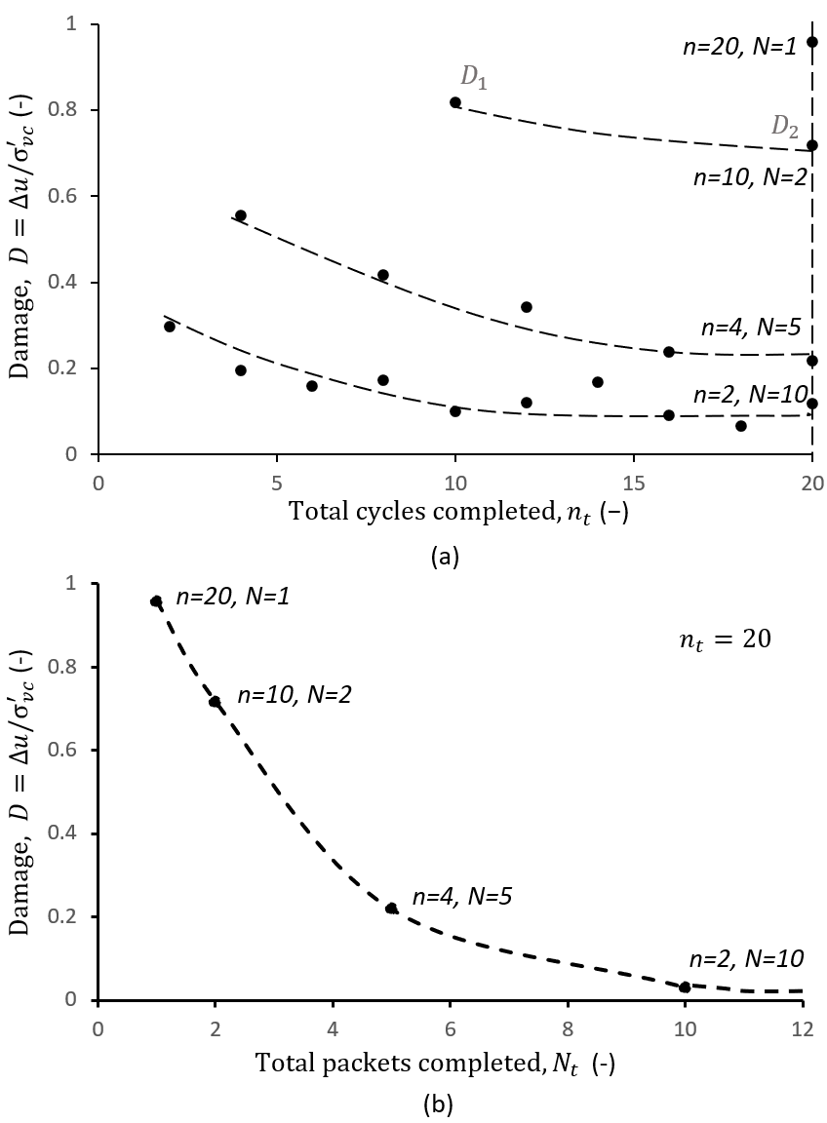
Fig. 8 Soil damage as a function of the total number of cycles completed $n_{t}$ (a) and total number of packets completed $N_{t}$ (b) for the four DSS tests performed at varying numbers of cycles per packet $n$ and varying numbers of packets $N$ (Note: Labels $D_{1}$and$D_{2}$refer to the hypothetical case study presented at the end of the paper.)

Changes in compressive stiffness can be observed directly from the $e$versus$log(σ_{v}^{'})$ plot, as shown in Fig. 9. The $κ_{0}$ slope values derived from the unload-reload lines vary with the number of cycles, as shown in Fig. 11. It can be observed that the unload-reload slope $κ_{0}$ decreases with episodes for all tests, regardless of the number of cycles per packet. Lower absolute values of $κ_{0}$indicate that the soil compresses less for the same change of applied vertical effective stress, indicating increased stiffness. The initial value of $κ_{0}$ (at $n_{t}=0)$was measured from oedometer results on the reconstituted Onsøy sample.
Another consequence of the reduction in the void ratio is a change in the rate of consolidation described by the coefficient of consolidation $c_{v}$, the coefficient of consolidation. The value of $c_{v}$can be calculated using the Taylor root time method from the settlement response during each reconsolidation stage (Taylor, 1948). As the soil sample compresses and stiffens after an episode of cyclic loading and reconsolidation, less time is required by the soil in the subsequent episode to fully consolidate, as evidenced previously in Fig. 5d, which indicates increased $c_{v}$. An implication of this trend is that changes in strength and stiffness as a result of episodic cyclic loading will happen at an increasing rate because of the faster consolidation rate following each packet of shear and reconsolidation.

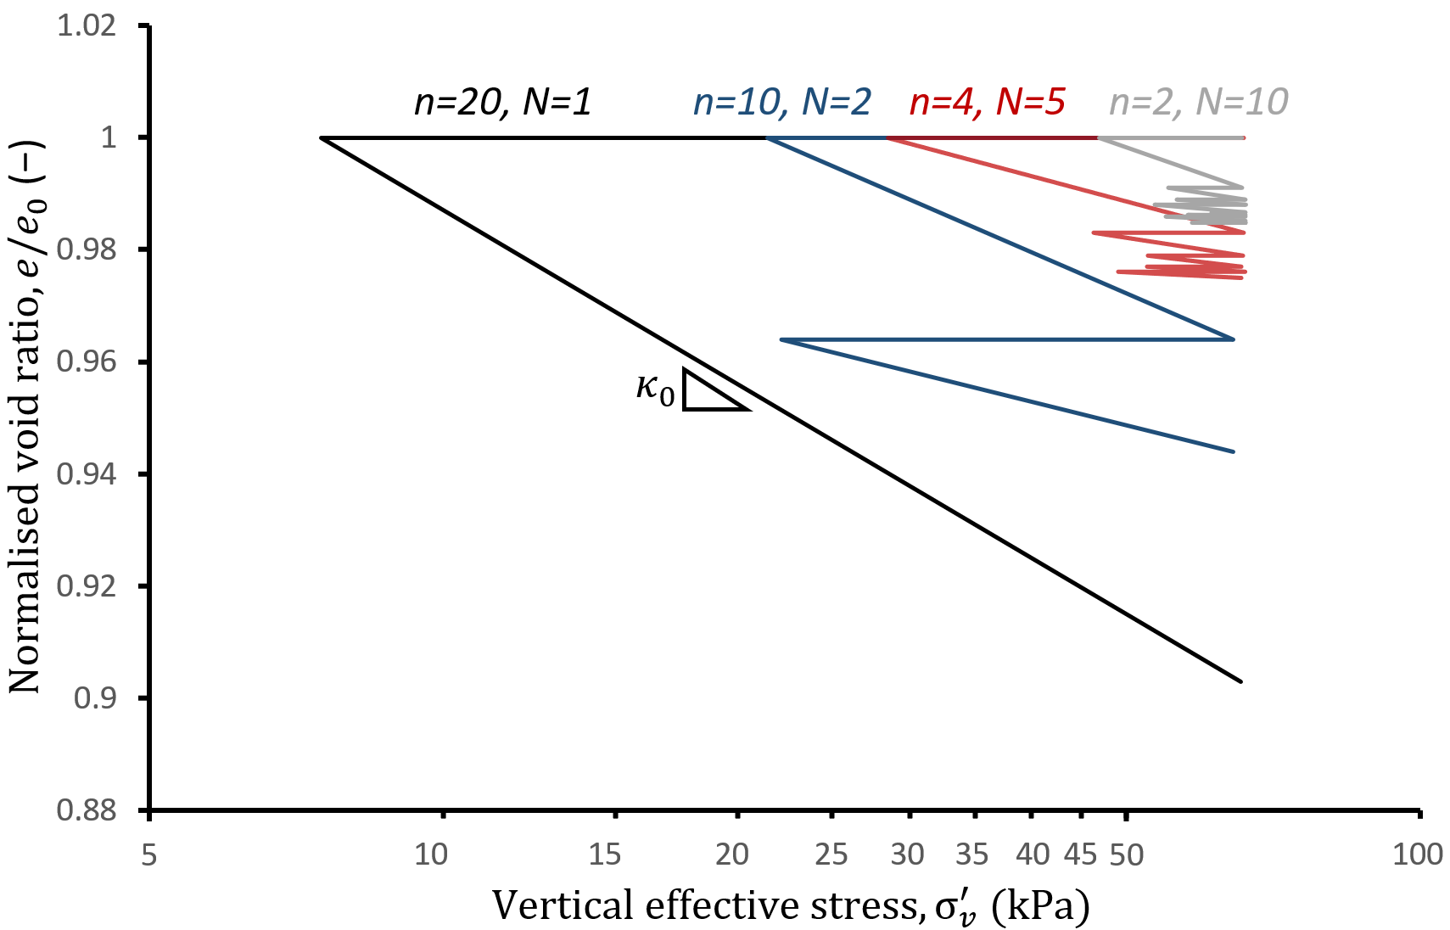
Fig. 9 Effective stress paths during undrained shear followed by full consolidation for the same total cycles ($n_{t}=20)$ but varying numbers of consolidation periods ($N_{t}=$1-10)
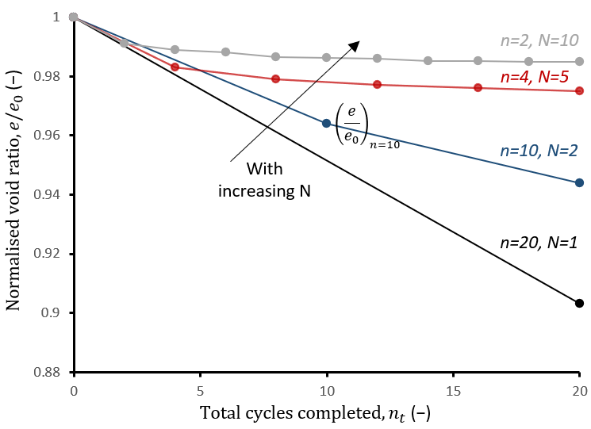
Fig. 10 Changes in the void ratio during consolidation stages in between packets of loading for the same total cycles $\left(n_{t}=20\right)$ but varying consolidation periods ($N_{t}=$1-10) (Note: Label ${\left(e/{e_{0}}\right)}_{n=10}$refers to the hypothetical case study presented at the end of the paper.)

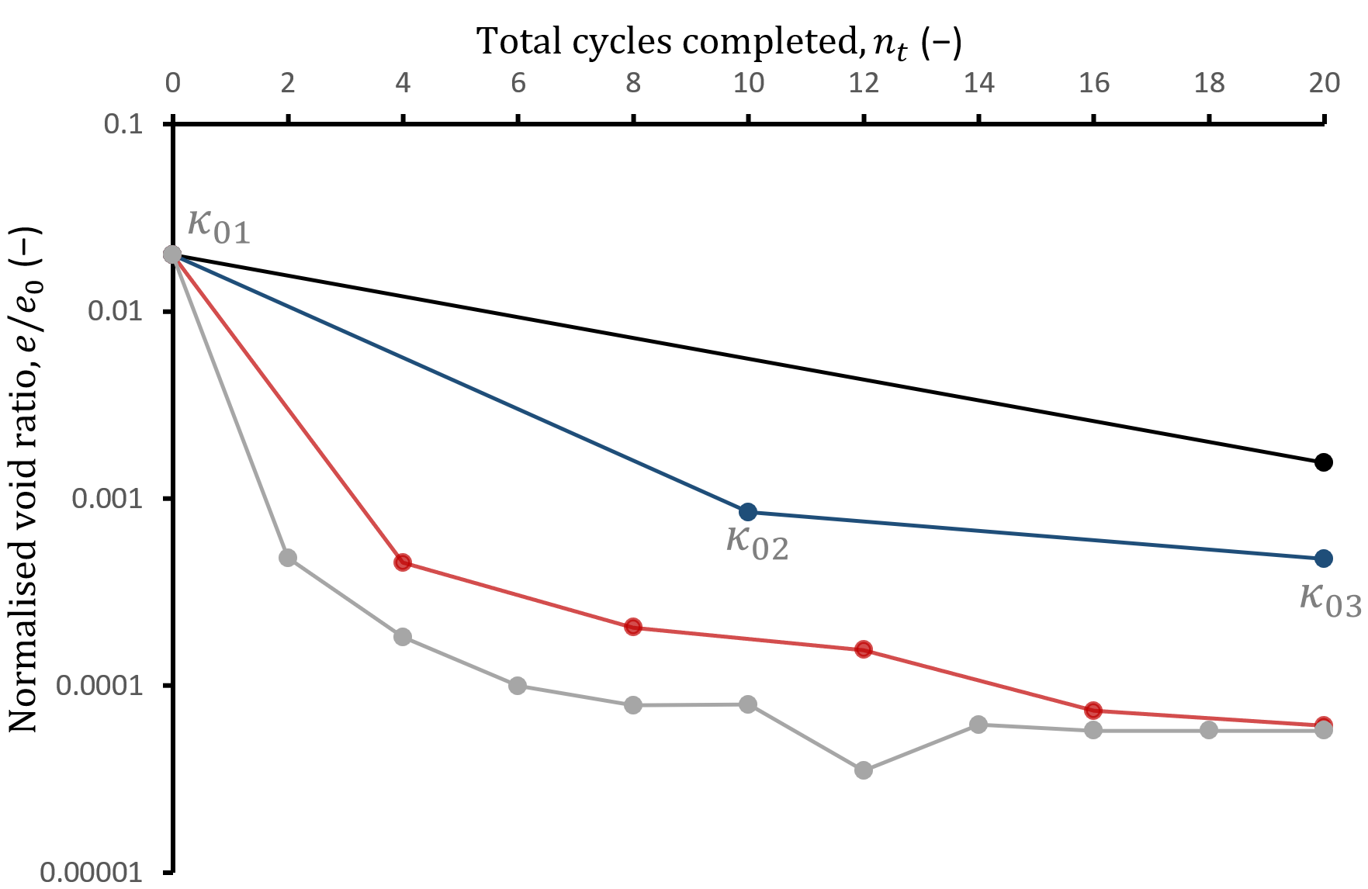

Fig. 11 Changes in the unload–reload line slope $κ_{0}$ during consolidation stages in between packets of loading for the same total cycles ($n_{t}=20$) but varying consolidation periods ($N_{t}=$1-10). (Note: Labels ${κ_{0}}_{1}, {κ_{0}}_{2}, and {κ_{0}}_{3}$refer to the hypothetical case study presented at the end of the paper.)

WHOLE-LIFE CASE STUDY

A hypothetical case study is presented to illustrate how the findings presented in this paper can be used to forecast seabed response for whole-life geotechnical design. For the illustration, a winter storm season is defined as a series of significant loading events, and the irregular waves with variable cyclic loads simulate an equivalent number of peak loading cycles of constant amplitude, according to established practice. The high intensity loading experienced in winter is followed by lower intensity loading during the calmer weather seasons, during which time consolidation dominates the soil response. For the case study, a two-year period is considered, and in each year, the key storm loading during the winter season is characterized by 10 cycles of loading at an amplitude of 0.7 of the initial monotonic undrained soil strength. In the terminology of the results presented in this paper, the forecast is made using the data series $N$ = 2 (for the two-year period) and$n$= 10 (for the number of equivalent cycles characterizing the winter season).
In the first year, the generated excess pore pressure or damage during this period is about 80% of the initial applied consolidation stress, determined from Fig. 8a (point${ D}_{1}$). During the subsequent calmer weather seasons, full consolidation is assumed to take place, and no additional significant loads lead to further damage (i.e., all loading is assumed to be below the shakedown threshold). During this period, the damage or the excess pore pressure generated during the winter storms dissipates, with an associated reduction in the void ratio (see Fig. 10, ${\left(e/{e_{0}}\right)}_{n=10}$). This results in an increase in the volumetric stiffness of the soil, demonstrated as a reduction in the coefficient $κ_{0}$by a factor of 10 compared with the initial value, as shown in Fig. 11 ($κ_{01}$ to $κ_{02}$).
During the following year’s winter season, in which the loading is considered to be identical to that in year 1, excess pore pressure generation or damage is 10% less than that of the first year because of the lower void ratio, as shown in Fig. 8a (point${ D}_{2}$), and the shear strain generated is half that generated during the first winter (see Fig. 5c, $γ_{1}$ to $γ_{2}$). A further increase in the volumetric stiffness is observed through a further reduction in $κ_{0}$ compared with year 1 during summer (Fig. 11, $κ_{02}$ to $κ_{03}$). In the following calm weather season, consolidation takes place about 1.5 times faster than the consolidation during the previous year, as indicated by the time difference to reach primary consolidation between the first year and the second (Fig. 5d).
This example, although idealized, is intended to illustrate that the results presented can quantify the evolution of soil response for application to whole-life geotechnical design, providing a basis to unlock the benefits of reconsolidation between loading events through the life of a structure.

CONCLUSIONS

This paper presents the results from episodic cyclic DSS tests on reconstituted lightly overconsolidated clay. Each test comprised packets of undrained prefailure cycles of shearing with intervening consolidation between each packet. These loading conditions are relevant to in-service conditions for a variety of offshore structures, such as foundation and anchoring systems that are dominated by environmental loads, where hardening from consolidation in between periods of storm activity is a function of time.
The results presented in this paper show that a fixed number of cycles and fixed magnitude of loading have different soil softening and hardening outcomes depending on the episodic sequence (i.e., the number of cycles per packet, or the number of packets with intervening periods of consolidation). The trends of soil softening and hardening show that for the same number of cycles of loading of the same magnitude, longer damage duration periods result in higher softening but greater potential hardening in the subsequent consolidation period.
The DSS results presented here have illustrated that soil response under different cyclic durations and intervening consolidation periods can be predicted through linking the changes in the stress-strain behaviour and void ratio to the evolution of soil strength, stiffness, and coefficient of consolidation. The outcome is being employed in establishing a generalized theoretical framework, extending the preexisting excess pore water pressure contour diagrams (e.g., Andersen, 2015), by capturing the effects of consolidation in between packets of undrained cyclic loading. Such a framework would support routine use of consolidation-driven soil response for whole-life geotechnical design, contributing to the optimization of a reliable, cost-effective renewable offshore infrastructure.

ACKNOWLEDGEMENTS

This study forms part of the activities of the Royal Academy of Engineering Chair in Emerging Technologies Centre of Excellence for Intelligent & Resilient Ocean Engineering (IROE) at the University of Southampton through the collaboration project “Characterization of Geotechnical Properties for Whole Life Design” with the Norwegian Geotechnical Institute (NGI). Financial support from the Norwegian Research Council under its basic funding program for NGI is acknowledged. This project was also supported by the Royal Academy of Engineering under the Research Fellowship programme, which also supports K. Kwa. S. Gourvenec is supported by the Royal Academy of Engineering under the Chairs in Emerging Technologies scheme. D. White is supported by the Engineering and Physical Sciences Research Council (EPSRC) Offshore Renewable Energy Supergen Hub (EPSRC Grant EP/S000747/1).

REFERENCES

Andersen, K (2015). “Cyclic Soil Parameters for Offshore Foundation Design,” 3rd Int Symp Front Offshore Geotech, Oslo, Norway, Norwegian Geotechnical Institute, 517‒539.
Andersen, K, Kleven, A, and Heien, D (1988). “Cyclic Soil Data for Design of Gravity Structures,” J Geotech Eng, 114(5), 517‒539.
ASTM (2007). Standard Test Method for Consolidated Undrained Direct Simple Shear Testing of Cohesive Soils, ASTM International Standard D6528-07, ASTM International, 9 pp.
Boukepti, N, and White, D (2017). “Interface Shear Box Tests for Assessing Axial Pipe-soil Resistance,” Géotechnique, 67(1), 18‒30.
Climate Change Committee (2020). The Sixth Carbon Budget: The UK’s Path to Net Zero, Report, Committee on Climate Change, 447 pp.
Cocjin, ML, Gourvenec, SM, White, DJ, and Randolph, MF (2014). “Tolerably Mobile Subsea Foundations—Observations of Performance,” Géotechnique, 64(11), 895‒909.
Cocjin, ML, Gourvenec, SM, White, DJ, and Randolph, MF (2017). “Theoretical Framework for Predicting the Response of Tolerably Mobile Subsea Installations,” Géotechnique, 67(7), 608‒620.
Deeks, A, et al. (2014). “Design of Direct on Seabed Sliding Foundations,” ASME 2014 33rd Int Conf Ocean, Offshore Arct Eng, San Francisco, CA, USA, ASME, OMAE2014-24393.
Dyvik, R, Berre, T, Lacasse, S, and Raadim, B (1987). “Comparison of Truly Undrained and Constant Volume Direct Simple Shear Tests,” Géotechnique, 37(1), 3‒10.
European Commission (2020). Boosting Offshore Renewable Energy for a Climate Neutral Europe, Report, European Commission, 2 pp.
Global Wind Energy Council (2022). GWEC Market Intelligence—Global Offshore Wind Growth to 2030, https://gwec.net/green-recovery-data-analysis/Accessed:08/02/2023.
Gourvenec, S (2018). “The Role of Centrifuge Modelling on Capturing Whole-life Response for Optimization of Offshore Foundation Design,” Proc 9th Int Conf Phys Modell Geotech, London, Taylor & Francis, Chap 5, 25 pp.
Gourvenec, S (2020). “Whole-life Geotechnical Design: What Is It? What’s It for? So What? And What Next?: Keynote,” Proc 4th Int Symp Front Offshore Geotech, Austin, TX, USA, Deep Foundations Institute, 206‒246.
Gourvenec, S, Strut, F, Reid, E, and Trigos, F (2022). “Global Assessment of Historical, Current, and Forecast Ocean Energy Infrastructure: Implications for Marine Space Planning, Sustainable Design and End-of-engineered-life Management,” Renewable Sustainable Energy Rev, 154, 111794.
Gundersen, A, et al. (2019). “Characterization and Engineering Properties of the NGTS Onsøy Soft Clay Site,” AIMS Geosci, 5(3), 665‒703.
HM Government (2022). British Energy Security Strategy, Policy paper, Her Majesty’s Government, 33 pp.
Hodder, M, White, D, and Cassidy, M (2010). “Analysis of Soil Strength Degradation during Episodes of Cyclic Loading,” Int J Geomech, 10(3), 117‒123.
Hodder, M, White, D, and Cassidy, M (2013). “An Effective Stress Framework for the Variation in Penetration Resistance Due to Episodes of Remoulding and Reconsolidation,” Géotechnique, 63(1), 30‒43.
International Energy Agency (2021). Global Energy Review 2021, Report, International Energy Agency, 32 pp.
International Renewable Energy Agency (2019). Energy Transformation: East Asia, Global Renewables Outlook report, International Renewable Energy Agency, 8 pp.
Laham, N, Kwa, K, Gourvenec, S, and White, D (2021). “Episodic Simple Shear Tests to Measure Strength Changes for Whole Life Geotechnical Design,” Géotechnique Lett, 11(1), 103‒111.
ReGlobal (2020). Asia Pacific to Become Largest Offshore Wind Market by 2030: GWEC, https://reglobal.co/asia-pacific-to-become-largest-offshore-wind-market-by-2030-gwec/Accessed:13/04/2022.
Schofield, A, and Wroth, C (1968). Critical State Soil Mechanics, McGraw-Hill, 310 pp.
Taylor, D (1948). Fundamentals of Soil Mechanics, John Wiley & Sons, 700 pp.
White, D. and Bransby, F., (2017). “Pipe–Seabed Interaction” Encyclopedia of Maritime and Offshore Engineering, pp.1-25. Wiley. ISBN: 978-1-118-47635-2

