**Launching and Manipulation of Higher-Order In-Plane Hyperbolic Phonon Polaritons in Low-Dimensional Heterostructures**

Guanyu Lu1, Zhiliang Pan1, Christopher R. Gubbin2, Ryan A. Kowalski3, Simone De Liberato2, Deyu Li1, Joshua D. Caldwell*, 1

1. Department of Mechanical Engineering, Vanderbilt University, Nashville, Tennessee 37212, United States

2. School of Physics and Astronomy, University of Southampton, Southampton SO17 1BJ, United Kingdom

3. Interdisciplinary Materials Science, Vanderbilt University, Nashville, Tennessee 37212, United States

[*josh.caldwell@vanderbilt.edu](mailto:*josh.caldwell@vanderbilt.edu)

**Abstract**

Hyperbolic phonon polaritons (HPhPs) are stimulated by coupling infrared (IR) photons with the polar lattice vibrations. Such HPhPs offer low-loss, highly confined light propagation at subwavelength scales with out-of-plane or in-plane hyperbolic wavefronts. For HPhPs, while a hyperbolic dispersion implies multiple propagating modes with a distribution of wavevectors at a given frequency, so far it has been challenging to experimentally launch and probe the higher-order modes that offer stronger wavelength compression, especially for in-plane HPhPs. In this work, we report the experimental observation of higher-order in-plane HPhP modes stimulated on a 3C-SiC nanowire (NW)/α-MoO3 heterostructure where leveraging both the low-dimensionality and low-loss nature of the polar NWs, higher-order HPhPs modes within two-dimensional α-MoO3 crystal are launched by the one-dimensional 3C-SiC NW. We further study the launching mechanism and determine the requirements for efficiently launching of such higher-order modes. In addition, by altering the geometric orientation between the 3C-SiC NW and α-MoO3 crystal, we demonstrate the manipulation of higher-order HPhP dispersions as a method of tuning. This work illustrates an extremely anisotropic low dimensional heterostructure platform to confine and configure electromagnetic waves at the deep-subwavelength scales for a range of infrared applications including sensing, nano-imaging, and on-chip photonics.

**Keywords:** hyperbolic dispersion, hyperbolic phonon polaritons, in-plane, low-symmetry material, nanowire

**Introduction**

In a hyperbolic medium[1-3] at least one of the principal components of the real part of the dielectric permittivity is opposite in sign with respect to the other two principal components. This distinctive optical property renders the dispersion in the isofrequency contour (IFC) to become hyperbolic, i.e., the IFCs are hyperboloids. The hyperbolic dispersion gives rise to a strong enhancement in the photonic density of states, allowing for observation of effects such as negative refraction and hyperlensing.[1-3] This expansion in the density of states is the result of multiple higher-order hyperbolic modes being supported at the same frequency.[4] Such extremely anisotropic optical properties are useful for a range of applications, such as subwavelength imaging,[5] focusing,[6] waveguiding,[7] and enhanced spontaneous[8] and thermal emission.[9] Metamaterials comprised of artificially layered metal-dielectric structures[5] and nanowire arrays within a dielectric host[10] were first employed to observe these hyperbolic optical responses. More recently, natural low-symmetry materials have been found to exhibit hyperbolic dispersions within the Reststrahlen bands of the polaritonic medium,[11-15] with this band referring to a spectral range bound by the transverse (TO) and longitudinal optic (LO) phonon frequencies of the polar materials in the infrared (IR).[16]

Within the Reststrahlen bands of low-symmetry polar crystals, hyperbolic phonon polaritons (HPhPs) are supported, offering highly confined, low-loss, and ray-like light propagation within the volume of the medium featuring wavelengths much shorter than the free-space wavelength at the same frequency.[17-19] HPhPs are induced through the coupling of IR light to oscillating polar charges (optic phonons) within the low-symmetry polar dielectric materials. HPhPs in natural materials were first reported in quartz[20, 21] and in the uniaxial medium hBN[22, 23]. In the case of the latter, the in-plane dielectric response is isotropic, resulting in two Reststrahlen bands with negative permittivity observed in-plane (out-of-plane) in the higher (lower) frequency regimes. Such uniaxial hyperbolicity results in polaritons propagating radially in plane.[4, 24-26] Very recently, in-plane hyperbolicity was reported within biaxial crystals, such as α-MoO3[27, 28] and V2O5[29], where the polariton propagation is restricted to the allowed in-plane direction according to the hyperbolic IFCs, with more exotic forms of in-plane hyperbolicity reported in lower symmetry crystals such as hyperbolic shear polaritons within monoclinic crystals.[30, 31] This extremely anisotropic response offers new opportunities for confining and configuring electromagnetic waves at deep-subwavelength scales, especially in localized energy confinement,[32-39] topological transitions,[40-46] and planar polariton optics.[47-54] In addition, through stacking the in-plane hyperbolic medium with another polaritonic medium to form heterostructures and twisting the heterostructures to a prescribed misorientation angle, recent studies have opened the door for the emerging field of twist-optics.[14, 19, 40-43, 55]

A hyperbolic dispersion implies multiple propagating HPhPs with different in-plane momenta being supported at a given frequency. These higher-order modes exhibit increased momenta, and significantly shorter wavelengths in their propagation direction. This means higher-order HPhPs modes can confine free-space IR light more strongly than the fundamental mode studied thus far. So far, experimentally launching and probing these higher-order modes has been challenging. Only very recently, higher-order out-of-plane HPhPs were observed near hBN flake edges[24] and in isotopically enriched hBN[56] in near-field experiments employing scattering-type scanning near-field optical microscopy (s-SNOM). However, to date there have been no experimental observations of higher order in-plane HPhPs in natural low-symmetry materials.

In this work, we experimentally demonstrate efficient launching and precise manipulation of higher-order in-plane HPhP modes. This is realized by scattering free-space light off of a 3C-SiC nanowire (NW) transferred onto an α-MoO3 flake. In the spectral region where α-MoO3 exhibits in-plane hyperbolicity, a 3C-SiC NW supports non-hyperbolic surface phonon polaritons within its own Reststrahlen band, with characteristic wavelengths far below that of free-space light. As a result, high-wavevector evanescent fields and strong near-field resonances are introduced. By utilizing these excitations, the 3C-SiC NW is able to bridge the wavevector mismatch between free-space light and the higher-order, high momenta HPhPs modes within the α-MoO3. The higher-order in-plane hyperbolic modes are directly imagined using s-SNOM, with the resulting near-field maps being in excellent agreement with our theoretical calculations and electromagnetic simulations. We further study the launching mechanism and determine the requirements for efficiently launching such higher-order modes: a low-loss, highly reflective and resonant scatterer with a size smaller or comparable to the polariton wavelength. Therefore, our choice of one-dimensional 3C-SiC NW is ideal for such applications, and by changing the size of NW, the specific higher-order branches of HPhPs can be selectively stimulated. Furthermore, the energy-momenta HPhP dispersion can be precisely controlled via controlling the misorientation angle between the 3C-SiC NW long axis and α-MoO3 principal crystal axes, which is unambiguously revealed by our near-field experiments and theoretical calculations. In addition, by rotating 3C-SiC NW, the polariton wavelength can be further compressed, with up to 127 times increased compression of the wavelength with respect to free-space IR photon for higher-order HPhP modes. This also provides an opportunity to tune the in-plane HPhPs without the restrictions and additional losses induced via nanofabrication. Therefore, we present a novel low dimensional heterostructure platform to explore extremely anisotropic light-matter interactions with ultrahigh photon confinement at the nanoscale, which can also be extended to other emerging material systems hosting ghost and shear polaritons[30, 57], with immense potential in IR sensing, routing, nano-imaging, and on-chip photonics.

**Results**

The biaxial crystal α-MoO3 can support low-loss HPhPs in three partially overlapping Reststrahlen bands, with the lower (RB1, is negative in 545-851 cm-1) and middle Reststrahlen bands (RB2, is negative in 822-962 cm-1) exhibiting in-plane hyperbolic response, while the upper Reststrahlen band hosting out-of-plane hyperbolic behavior (RB3, is negative in 957-1007 cm-1).[58] Within the two in-plane hyperbolic regions, the propagation of polaritons is only allowed in the direction exhibiting a negative real part of the dielectric permittivity following the IFCs, i.e. hyperboloid opening is in [100] (*y*) direction for RB1 and hyperboloid opening is in [001] (*x*) direction for RB2 (Figure. S1). In this work, we focus on the middle Reststrahlen band, as this spectral region (RB2) overlaps with the Reststrahlen band of another polar material, SiC (797-973 cm-1 for 3C-SiC, cubic polytype of SiC). SiC is also a well-studied polar material for low-loss IR nanophotonics,[59] exhibiting exemplary results in chemical sensing,[60, 61] nonlinear optics,[62, 63] and thermal emission applications.[64, 65] By placing an individual 3C-SiC NW (diameter: 100 nm) on top of the α-MoO3 flake (thickness: 120 nm) to form a low-loss one-dimensional/two-dimensional heterostructure (methods), we can directly nano-image in-plane HPhPs launched in the α-MoO3 crystal by the 3C-SiC NW using the s-SNOM setup (Figure. 1a, methods). Simultaneously, we can compare those results with polaritons stimulated in the same α-MoO3 flake scattered off of the edge away from the NW, which is a widely used method to launch in-plane HPhPs.[27, 28] For simplicity, we first investigate the case where a 3C-SiC NW is placed perpendicular to the allowed [001] (*x*) direction so that the in-plane wavevector direction is normal to the 3C-SiC NW (Figure. 1a).

Near-field real-space mapping of HPhPs reveals the different behaviors between polaritons stimulated from 3C-SiC NW and α-MoO3 flake edge. From the s-SNOM mapping recorded at 900 cm-1, parallel polariton fringes are observed near both the long edge of 3C-SiC NW and α-MoO3 flake edge in the allowed [001] (*x*) direction, with hyperbolic wavefronts exhibited near the 3C-SiC NW ends (Figure. 1b). The hyperbolic wavefronts with the opening direction of the hyperboloid along the [001] (*x*) direction are the signatures of in-plane HPhPs. However, in the regions near 3C-SiC NW long edge, the observed polaritons have much shorter periodicities compared to that near the α-MoO3 flake edge. This is more apparent in the extracted line profiles provided in Figure. 1d, with extracted polariton wavelengths of 874 nm for modes launched by the s-SNOM tip and reflected by the α-MoO3 flake edge (half polariton wavelength, $0.5λ_{p}$, exhibited in the observed polariton fringes) and a much shorter polariton wavelength of 168 nm for the modes launched by the NW (full polariton wavelength, $λ_{p}$, exhibited in the observed polariton fringes). We note that the designation of the half and full polariton wavelengths agree with previous studies[28, 66]: one running trip for polaritons near the 3C-SiC NW that are directly launched by NW and probed by the oscillating metallic AFM tip (See SI Figure. S2a), and two running trips for polaritons near the α-MoO3 flake edge that are launched by the tip and reflected back by the α-MoO3 flake edge (See SI Figure. S2b). We attribute the mode at 900 cm-1 reflected by the α-MoO3 flake edge as the fundamental in-plane HPhPs mode ($l=0$), and the mode with a much shorter polariton wavelength launched from the 3C-SiC NW as the higher-order in-plane HPhP mode ($l=1$). We should note that we also observe the fundamental HPhPs ($l=0$) launched from 3C-SiC NW (Figure. S3). Therefore, we report the experimental observation of the propagation of higher-order in-plane hyperbolic modes with much stronger light confinement, which have not been previously reported in investigations of this low-loss material. Interestingly, only the fundamental mode is observed for HPhPs launched from the 3C-SiC NW at higher frequencies, such as 930 cm-1 (Figure. 1c). This is presumed to be the result of the maximum momenta imparted by the metallic tip used in our current study being on the order of $5×{10}^{5} cm^{-1}$ (about $1/r_{tip}$, where $r_{tip}$ is the radius of metallic tip used in our experiments, which is about 20 nm), which makes the observation of polariton modes with larger momenta difficult.[22]

To further justify the assignment of the much shorter wavelength mode as a higher-order in-plane HPhP launched directly by scattering off of the 3C-SiC NW, we extracted the in-plane wavevectors from the measured polariton fringes as a function of incident frequency following standard procedures for extracting the polariton dispersion (Figure. S3 in SI). The extracted in-plane HPhPs reflected from the α-MoO3 flake edge and launched from the 3C-SiC NW are also compared with the calculated phonon polariton dispersion along [001] (*x*) direction of α-MoO3 crystal (Figure. 1e and Figure. 1f). The theoretical dispersion is reported as the calculated reflection coefficient for 120 nm thick α-MoO3 slab on 300 nm thick SiO2 layer on Si substrate (same geometry as the actual device used in our experiments) using transfer matrix method (TMM). The experimental dispersion of in-plane HPhPs reflected from the α-MoO3 flake edge agree well with our calculated fundamental mode (the first branch in the hyperbolic dispersions, $l=0$), which also coincides with the previous studies where only the fundamental mode was experimentally observed.[27, 28] Furthermore, the extracted dispersions for HPhPs launched from the 3C-SiC NW agree with our calculated dispersions of both fundamental ($l=0$) and higher-order modes ($l=1$), confirming our assignment. Compared to the fundamental HPhPs at 900 cm-1, the higher-order mode exhibits about five times higher free-space photon confinement (about five times shorter polariton wavelength), coinciding with one of the primary goals of nanophotonics, i.e., concentrating light on the scale much shorter than the free-space wavelength. In addition, the SiC NW/α-MoO3­ heterostructure provides an opportunity for tuning of such deeply subwavelength polariton modes via the misorientation angle between the one-dimensional NW and two-dimensional material, which will be further below.

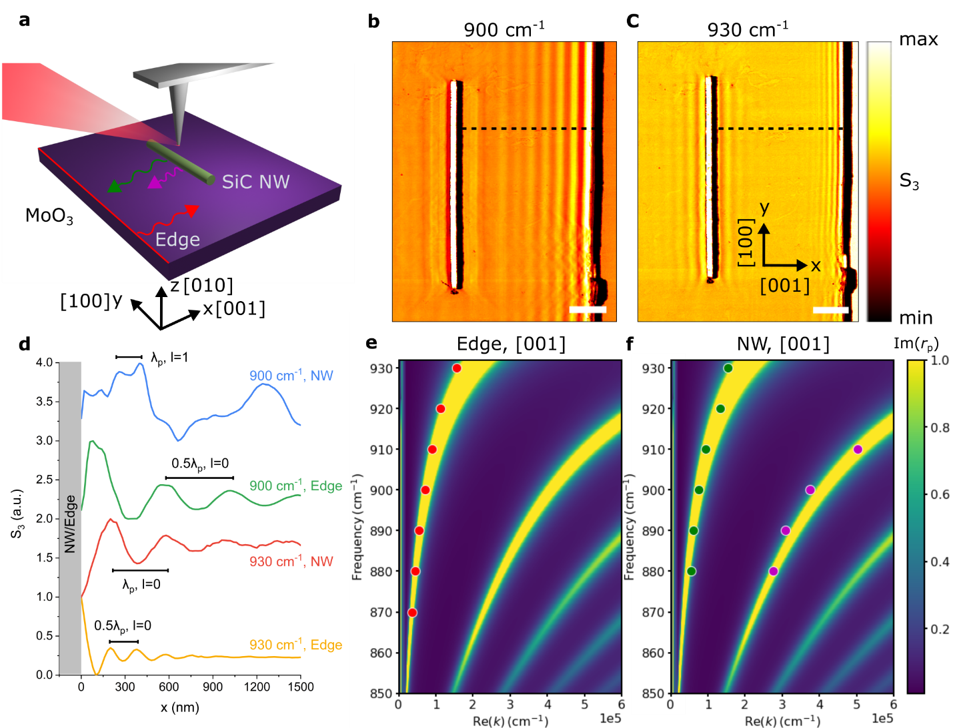

**Figure 1. In-plane hyperbolic phonon polaritons (HPhPs) launched from the flake edge and nanowire.** (a) 3C-SiC nanowire (NW)/ α-MoO3 device schematic in a scattering-type scanning near-field optical microscope (s-SNOM). Note the free-space IR beam and the oscillating metallic AFM tip are artistically showing in the schematic. In practice, the IR beam has a beam spot on the order of the measured α-MoO3 flake at the laser working frequency. 3C-SiC NW is placed in the direction along [100] (x) direction of α-MoO3. Red arrow represents the fundamental HPhPs mode ($l=0$), which is reflected from the α-MoO3 flake edge and is only allowed along [001] direction in the spectral region of interest. Green arrow represents the fundamental HPhPs mode launched from the 3C-SiC NW in the allowed [001] direction. Magenta arrow represents the higher-order HPhPs mode ($l=1$) launched from the NW with much shorter in-plane polariton wavelength compared with the fundamental mode. (b) s-SNOM mapping of 3C-SiC NW (diameter: 100 nm)/ α-MoO3 (thickness: 120 nm) sample at 900 cm-1. (c) s-SNOM mapping of the same 3C-SiC NW/ α-MoO3 sample at 930 cm-1. Third-harmonic amplitude channel (S3) from s-SNOM mappings is shown in (b) and (c), and scale bar in (b) and (c) is 1 μm. (d) Near-field line profiles extracted from (b) and (c) show polaritons launched from the NW and reflected from flake edge. $λ_{p}$ is the polariton wavelength. Full polariton wavelength is exhibiting in the observed polariton fringes for NW launched HPhPs, while half polariton wavelength is exhibiting in the observed polariton fringes for flake edge reflected HPhPs. Line profiles in (d) are normalized and shifted for clarity. (e) Phonon polariton dispersion along [001] direction calculated from the imaginary part of the p-polarized reflection coefficient with the experimental data for HPhPs from flake edge (only fundamental mode observed, $l=0$). (f) Calculated phonon polariton dispersion with the experimental data for NW launched HPhPs (both fundamental and higher-order modes observed, $l=0$ and $l=1$).

To further study the mechanism by which the higher-order mode can be stimulated and probed efficiently using a 3C-SiC NW launcher, we performed finite element method (FEM) simulations using the same geometry as our experiments (methods). The calculated out-of-plane electric field (*E*z) at 900 cm-1 reveals the existence of both the fundamental ($l=0$) and high-order ($l=1$) HPhPs modes launched from the 3C-SiC NW, with ray-like light propagation within the α-MoO3 slab (Figure. 2a). By extracting the line profiles 60 nm above α-MoO3 slab at 900 cm-1 (blue line in Figure. 2c) and performing a FFT (Fast Fourier Transform) filter on the extracted line profile (similar procedure as in the previous studies[24, 67]), the polariton components from the fundamental (green line in Figure. 2c) and higher-order modes (magenta in Figure. 2c) are separated, further confirming our experimental observation of the higher order in-plane HPhPs. Similar to our experimental observations, at a higher frequency (930 cm-1), the simulated electric field primarily exhibits the fundamental mode (Figure. 2b). The one-dimensional NW we studied is a deeply subwavelength launcher; therefore, as discussed in the supplementary information, the cross-sectional shape does not play a significant role in the in-plane HPhPs launched.

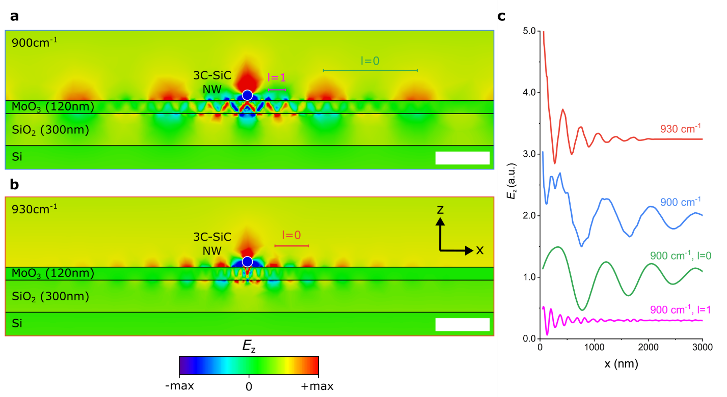

**Figure 2. Higher-order in-plane HPhPs launched from 3C-SiC NW.** Simulated field profile (Ez) of the same SiC NW/ α-MoO3 device as used in the experiments at 900 cm-1 (a) and 930 cm-1 (b). Scale bar in (a) and (b) is 500 nm. Coordinates in (a) and (b) are the same as in Figure 1. (c) Extracted line profiles from (a) and (b) at 60 nm above α-MoO3 surface (to mimic the actual s-SNOM measurements). FFT filter is used in the line profile at 900 cm-1 (blue line) to show the component of fundamental mode ($l=0$, green line) and higher-order mode ($l=1$, magenta line). Plots in (c) are shifted for clarity.

As the momenta that can be officially launched in this approach is driven by the size of the 3C-SiC NW, we further explore the launching mechanism of the higher-order HPhPs by exploring the diameter dependence of modes excited (Figure. 3a). At 900 cm-1, by increasing the diameter of 3C-SiC NW, the higher-order mode ($l=1$) with the polariton wavelength of 151 nm gradually disappears and the diameter at which the polariton can no longer be stimulated occurs when it approaches the polariton wavelength. This transition of the higher-order HPhPs mode is also visible in reciprocal space (or momentum space) after FFT of the extracted field profiles (Figure. S5), which suggests that only a launcher with a comparable or smaller size than the polariton wavelength can efficiently stimulate the higher-order mode with increased momentum. Therefore, our choice of one-dimensional NW launcher is preferable for such applications. This also suggests an opportunity for selectively choosing which modes can be stimulated by altering the size of the 3C-SiC NW, i.e., higher-order modes can be turned on and off by changing the NW diameter.

To further demonstrate that the efficient launching of higher-order HPhPs is a result of the low-loss Reststrahlen response of the 3C-SiC NW, we explored other low-dimensional heterostructures by changing the NW material to gold and silicon in our simulations. We tracked the cut-off diameter for the higher-order HPhP modes stimulated by other NW materials, taking into account the previous discussion of the 3C-SiC NW size effects (Figure. 3b-c). As gold is essentially a lossy metal in the IR region, although it can also scatter free-space light to overcome the momentum mismatch for higher-order HPhPs, the gold NW primarily expels the incident electric field in a non-resonant manner. As a result, only gold NWs with diameters much smaller than the polariton wavelength, and therefore much smaller than the corresponding cut-off diameter for 3C-SiC NW, can efficiently launch higher-order HPhPs. The transition diameter for the gold NWs (40 nm) was found to be far below that of 3C-SiC NW as illustrated in Figure. S5. Similarly, the silicon NW fails to efficiently launch the higher-order HPhPs. This is because silicon exhibits a positive dielectric permittivity in this spectral range and does not provide sub-diffractional confinement, leading to a significantly reduced capability to match the momenta of such sub-diffractional modes. As a result, the cut-off diameter of the silicon NW is also much smaller than that of 3C-SiC. However, the silicon NW performs better than gold NW as its cut-off diameter is about twice that of gold NW, which is also illustrated in Figure. S5. This is due to the fact that the silicon NW used in our simulation is a lossless material, while gold is a lossy metal (Figure. S4). Therefore, our choice of 3C-SiC NW, a one-dimensional, low-loss polar material featuring a Reststrahlen band overlapping with that of the in-plane hyperbolic band of α-MoO3, fulfills the requirements for efficiently launching the higher-order HPhPs with much shorter wavelengths.

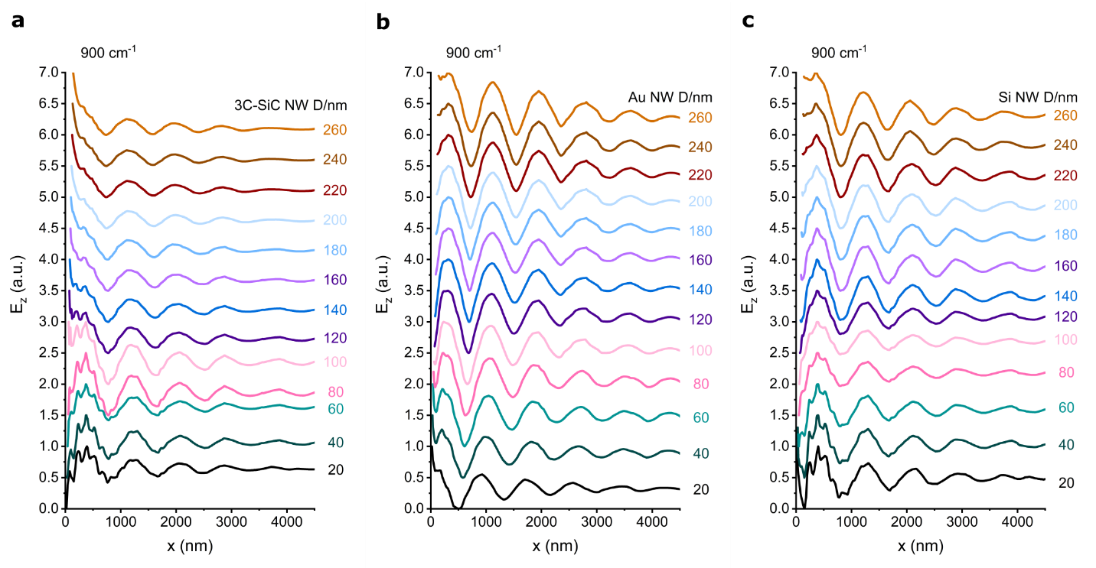

**Figure 3. Higher-order in-plane HPhPs launched from NWs with different diameters and materials.** Simulated field profile (Ez) of the NW/ α-MoO3 heterostructures at 900 cm-1 with different NW diameters for 3C-SiC (a), gold (b), and silicon (c). Except the NW material and diameter, other geometries used in the simulations are the same as that in Figure. 2.

Based on our understanding of the higher-order in-plane HPhPs launched by the 3C-SiC NW within the α-MoO3, we further perform precise manipulation of the higher-order in-plane hyperbolic modes via changing the geometric orientation within the heterostructures. To do so, we alter the angle between the 3C-SiC NW and the [100] (*x*) direction of α-MoO3 crystal by a misorientation angle $θ$, which also represents the angle between the in-plane propagation direction of HPhPs with respect to the allowed [001] direction (*x* axis). The direction-dependent phonon polariton dispersion is governed by

$$\begin{aligned}k=\frac{Ψ}{d}\left[\operatorname{atan}\left(\frac{ε_{1}}{ε_{z}}Ψ\right)+\operatorname{atan}\left(\frac{ε_{3}}{ε_{z}}Ψ\right)+lπ\right], \#\left(1\right)\end{aligned}$$

where $Ψ=i\sqrt{\frac{ε_{z}}{ε_{x}\cos^{2}{θ}+ε_{y}\sin^{2}{θ}}}$, $d$ is the thickness of α-MoO3 flake, is the order of mode, $ε_{1}$ and $ε_{3}$ are the permittivity of the surrounding medium (top and bottom medium respectively).[68] Furthermore, in the spectral region of interest, directionally dependent HPhP propagation is only supported when $\tan{θ<\sqrt{-\frac{ε_{x}}{ε_{y}}}}$ based on Eq. 1. We record the s-SNOM mapping of the same 3C-SiC NW and the same α-MoO3 flake for different geometric orientations (Figure. 4, $θ=0°, 15°, 30°, 45°, 90°$), which unambiguously reveals the direction-dependent properties of the propagating HPhPs launched from the 3C-SiC NW. This dependence was made possible within the same heterostructure by employing a home-built micromanipulator to rotate the 3C-SiC NW on the α-MoO3 flake following the completion of the s-SNOM measurements. As expected, higher-order in-plane HPhPs modes were also launched from the 3C-SiC NW when rotating the 3C-SiC NW, with changes of propagation direction and the polariton wavelength observed as a function of the misorientation angle $θ$, as can be seen in the near-field mapping recorded at 900 cm-1. Furthermore, only certain misorientation angles can support HPhPs based on Eq. 1, even for the fundamental mode, as is highlighted in the real-space mapping at higher frequency 930 cm-1, showing that no polariton fringes are observed when $θ≥45°$. This observation provides an opportunity to tune the in-plane HPhPs without requiring nanofabrication, which usually restricts the ability to tune the response once the structure is made, while also inducing additional loss into the material.

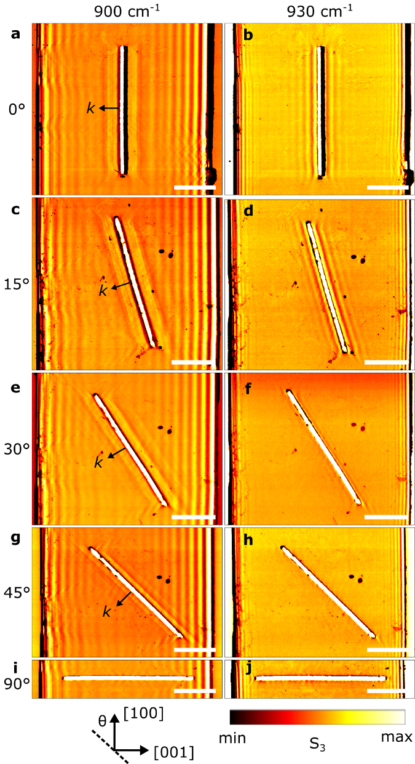

**Figure 4. Manipulate higher-order in-plane hyperbolic modes via geometric orientation.** s-SNOM mapping of 3C-SiC NW/ α-MoO3 device for different geometric orientation and frequencies: (a) θ=0° at 900 cm-1, (b) θ=0° at 930 cm-1, (c) θ=15° at 900 cm-1, (d) θ=15° at 930 cm-1, (e) θ=30° at 900 cm-1, (f) θ=30° at 930 cm-1, (g) θ=45° at 900 cm-1, (h) θ=45° at 930 cm-1, (i) θ=90° at 900 cm-1, (j) θ=90° at 930 cm-1. The angle θ specifies the angle between the SiC NW and [100] direction of α-MoO3 crystal (schematic in the bottom). Third-harmonic amplitude channel (S3) from s-SNOM mappings is showing in (a-j), and scale bar is 2 μm in (a-j). All the measurements are performed on the same α-MoO3 and 3C-SiC NW (note the dusts on the right of the flake).

To corroborate our tuning of higher-order in-plane HPhPs, we calculated the direction-dependent phonon polariton dispersions based on Eq. 1 in Figure. 5a-d and compare the theoretical dispersion with our measured wavevectors (real part of *k*, which is $2π/λ_{p}$). Both the extracted fundamental ($l=0$) and higher-order ($l=1$) modes from the near-field measurements agree well with our theoretical calculations for different misoriented angles. Furthermore, by increasing the misorientation angle $θ$, the in-plane wavevector of HPhPs is further enhanced (or polariton wavelength is further reduced). At $θ=45°$, we experimentally observed a free-space photon confinement ratio ($β=λ_{0}/ λ_{p}$, where $λ_{0}$ is the free-space wavelength) of up to 127 for the higher-order mode ($l=1$). However, when increasing the misorientation angle $θ$ the spectral region where in-plane HPhPs are supported is also reduced, as is highlighted in Figure. 5a-d. Therefore, our theoretical calculations together with our experimental data clearly demonstrate the manipulation of in-plane HPhPs dispersions based on the misorientation angle of the low-loss low dimensional heterostructure.

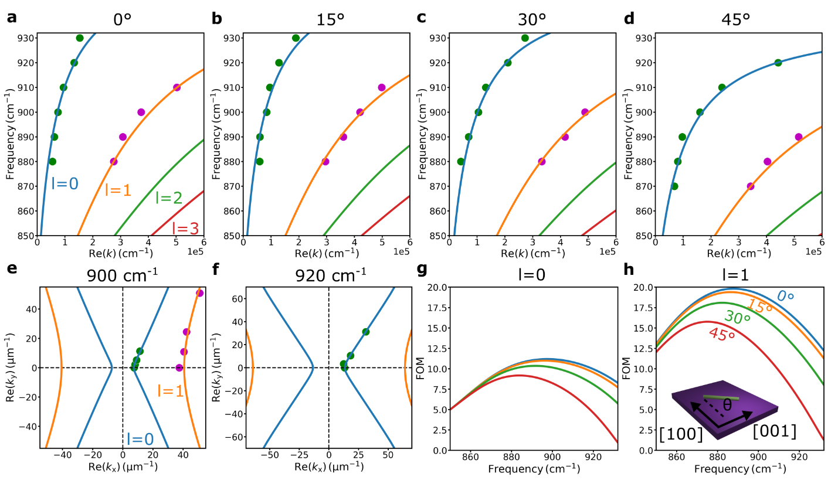

**Figure 5. Direction-dependent dispersions, isofrequency contours (IFCs), and figure of merit (FOM) for in-plane hyperbolic phonon polaritons.** Calculated direction-dependent phonon polariton dispersions with experimental data extracted from NW launched modes for θ=0° (a), θ=15° (b), θ=30° (c), θ=45° (d). Calculated IFCs with experimental data extracted from NW launched modes at 900 cm-1 (e) and 920 cm-1 (f). (g) Re(kx) and Re(ky) are real parts of in-plane wavevectors. Calculated directional-dependent FOM for the fundamental mode (l=0), and (h) higher-order mode (l=1). The angle θ specifies the angle between the NW and [100] direction (inset in h), which is also the in-plane propagation direction with respect to the [001] direction of α-MoO3 crystal.

To better illustrate the in-plane dispersions of HPhPs for both fundamental and higher-order modes, we plot the calculated IFCs with the measured in-plane wavevectors ( $k_{x}$ and $k_{y}$) for different misorientation angles $θ$ (Figure. 5e and Figure. 5f). At 900 cm-1, both the fundamental and higher-order modes launched from the 3C-SiC NW are observed, which agrees well with our theoretical calculations. The fundamental ($l=0$) and higher-order ($l=1$) modes follow different in-plane hyperbolic contours, with the higher-order modes exhibiting much higher in-plane wavevectors (Figure. 5e). At a higher frequency, only the fundamental mode is observed for the angle measured (Figure. 5f). Note we have plotted 920 cm-1 instead of 930 cm-1 in Figure. 5f because at 930 cm-1 for 45°, there are only hyperbolic wavefronts near the ends of the 3C-SiC NW, which are not the direction-dependent HPhPs excited from the long axis of the 3C-SiC NW that we focused on in this study. We also calculated the FOM (figure of merit, calculated a*s $FOM=Re(k)/Im(k)$* ), which offers an indication of the loss-induced limitations on the polariton propagation[19]) of different geometric orientations for both fundamental (Figure. 5g) and high-order (Figure. 5h) HPhPs. As can be seen in the calculations, the higher-order HPhP mode exhibits higher FOMs when compared to that of the fundamental mode at the same frequency and the same angle $θ$. This suggests the difference between the hyperbolic materials and non-hyperbolic materials in terms of polariton confinement: the free-space photon confinement comes at a cost for non-hyperbolic materials, which means the mode propagation will decay faster in non-hyperbolic materials. In contrast, the free-space photon confinement can be increased with better propagation lengths for higher-order modes in hyperbolic materials. In addition, in the spectral range of interest, there are peaks for FOMs of both the fundamental and higher-order modes, and the peaks will decrease their amplitude and move to lower frequency when increasing the misorientation angle $θ$. Therefore, our calculations reveal that even though a larger angle $θ$ will exhibit a shorter polariton wavelength, this will come at the sacrifice in the FOM of HPhPs.

**Conclusion**

In summary, we demonstrated the efficient launching and precise manipulation of highly confined, directionally dependent in-plane hyperbolic light propagation in a heterostructure composed of a 3C-SiC NW on α-MoO3 flake. These results provide the first experimental evidence of preferential and direct launching of higher-order in-plane HPhPs modes from the one-dimensional, low-loss 3C-SiC NW. By altering the geometrical orientation between the 3C-SiC NW and the α-MoO3 crystal on the same device, we demonstrate the directional dependence of in-plane HPhPs and a tuning method to modify both the fundamental and higher-order HPhPs modes. Furthermore, a free-space photon confinement ratio of up to 127 is experimentally observed for the higher-order HPhPs mode. Our work therefore showcases the efficient and precise manipulation of the extremely anisotropic light-matter interactions at the deeply subwavelength scale, opening opportunities for a wide range of IR applications.

**Methods**

Sample preparation

First, we exfoliated α-MoO3 bulk crystals from 2D Semiconductors onto SiO2 (300 nm)/Si substrate. Uniform α-MoO3 flakes were examined under optical microscope and s-SNOW mappings. 3C-SiC NWs used in this study are commercially available (ACS Material). Power-form 3C-SiC NWs were dispersed in reagent alcohol then sonicated for about 5 minutes. Then 3C-SiC NWs dispersion was drop-casted onto polydimethylsiloxane (PDMS) surface. Individual 3C-SiC NW was picked up utilizing a built-in micromanipulator with a sharp tip (tip radius: 100 nm). 3C-SiC NW was carefully aligned with α-MoO3 flake axis under the optical microscope and repositioned after each s-SNOW measurement to explore the direction-dependent dispersions. The angle between the nanowire and [100] direction of MoO3 flake was measured from optical images as a reference and then confirmed by AFM scans performed simultaneous with s-SNOM measurements.

Near-field characterization

For near-field characterization of the 3C-SiC NW/ α-MoO3 heterostructure, we used a commercial s-SNOM setup from Neaspec. Conventional metal-coated tip (Nanoworld) is used for the measurements. The tip tapping frequency is set to about 270 kHz and tip tapping amplitude is set to about 60 nm. For the nanoimaging (s-SNOM mapping) of 3C-SiC NW/ α-MoO3, the sample is illuminated by *p*-polarized quantum cascade laser (Daylight). We recorded the images with an integration time of 10 ms per pixel and the pixel size of the images is 20 nm. The detector signal is demodulated a frequency of 2Ω and above (3Ω are used for all the figures in the main text).

Numerical simulation

Finite element method (FEM) simulations were performed in CST Studio Suite 2018 using the structure mentioned in the main text. The unit-cell boundary conditions and a plane wave excitation are used in the simulations. To mimic the s-SNOM setup used in the experiments, the incident angle of the plane wave is chosen as 60°, and *p­*-polarized light is used in the simulations. The dielectric function used for α-MoO3 was derived from that presented in Ref[58].

**Acknowledgements**

J. D. C. gratefully acknowledge support for this work by the National Science Foundation under grant number NSF DMR-2128240 and Office of Naval Research grant N00014-22-12035.G. L. is supported through Army Research Office Small Business Technology Transfer (W911NF-22-P-0029). S.D.L. is supported by a Royal Society Research fellowship and the Philip Leverhulme prize. The authors acknowledge support from the Royal Society Grant No. RGF\EA\181001 and the Leverhulme Trust Grant No. RPG-2019-174. This work was supported by a NASA Space Technology Graduate Research Opportunities Award (R.A.K.). Z.P. and D.L. acknowledge support for this work by the National Science Foundation under grant number CBET-2114278.

**Supporting Information**

The Supporting Information is available free of charge at xxx.

**Conflict of Interest**

The authors declare no conflict of interest.

**Data Availability Statement**

The data that support the findings of this study are available from the corresponding author upon reasonable request.

**References**

1. Poddubny, A., et al., *Hyperbolic metamaterials.* Nature Photonics, 2013. **7**(12): p. 948-957.

2. Ferrari, L., et al., *Hyperbolic metamaterials and their applications.* Progress in Quantum Electronics, 2015. **40**: p. 1-40.

3. Lee, D., et al., *Hyperbolic metamaterials: fusing artificial structures to natural 2D materials.* eLight, 2022. **2**(1).

4. Caldwell, J.D., et al., *Photonics with hexagonal boron nitride.* Nature Reviews Materials, 2019. **4**(8): p. 552-567.

5. Liu, Z., et al., *Far-field optical hyperlens magnifying sub-diffraction-limited objects.* Science, 2007. **315**(5819): p. 1686.

6. Smith, D.R., et al., *Partial focusing of radiation by a slab of indefinite media.* Applied Physics Letters, 2004. **84**(13): p. 2244-2246.

7. Cui, Y., et al., *Ultrabroadband light absorption by a sawtooth anisotropic metamaterial slab.* Nano Lett, 2012. **12**(3): p. 1443-7.

8. Noginov, M.A., et al., *Controlling spontaneous emission with metamaterials.* Opt Lett, 2010. **35**(11): p. 1863-5.

9. Guo, Y., et al., *Broadband super-Planckian thermal emission from hyperbolic metamaterials.* Applied Physics Letters, 2012. **101**(13).

10. Yao, J., et al., *Optical negative refraction in bulk metamaterials of nanowires.* Science, 2008. **321**(5891): p. 930.

11. Basov, D.N., M.M. Fogler, and F.J. Garcia de Abajo, *Polaritons in van der Waals materials.* Science, 2016. **354**(6309): p. aag1992.

12. Low, T., et al., *Polaritons in layered two-dimensional materials.* Nat Mater, 2017. **16**(2): p. 182-194.

13. Basov, D.N., et al., *Polariton panorama.* Nanophotonics, 2020. **10**(1): p. 549-577.

14. Zhang, Q., et al., *Interface nano-optics with van der Waals polaritons.* Nature, 2021. **597**(7875): p. 187-195.

15. Wu, Y., et al., *Manipulating polaritons at the extreme scale in van der Waals materials.* Nature Reviews Physics, 2022.

16. Adachi, S., *Handbook on Physical Properties of Semiconductors*. 2004, Boston: Kluwer Academic Publishers. 1-344.

17. Caldwell, J.D., et al., *Low-loss, infrared and terahertz nanophotonics using surface phonon polaritons.* Nanophotonics, 2015. **4**(1): p. 44-68.

18. Foteinopoulou, S., et al., *Phonon-polaritonics: enabling powerful capabilities for infrared photonics.* Nanophotonics, 2019. **8**(12): p. 2129-2175.

19. He, M., et al., *Anisotropy and Modal Hybridization in Infrared Nanophotonics Using Low-Symmetry Materials.* ACS Photonics, 2022. **9**(4): p. 1078-1095.

20. Falge, H.J. and A. Otto, *Dispersion of Phonon-Like Surface Polaritons on α-Quartz Observed by Attenuated Total Reflection.* physica status solidi (b), 1973. **56**(2): p. 523-534.

21. Rodrigues da Silva, R., et al., *Using phonon resonances as a route to all-angle negative refraction in the far-infrared region: the case of crystal quartz.* Phys Rev Lett, 2010. **105**(16): p. 163903.

22. Dai, S., et al., *Tunable phonon polaritons in atomically thin van der Waals crystals of boron nitride.* Science, 2014. **343**(6175): p. 1125-9.

23. Caldwell, J.D., et al., *Sub-diffractional volume-confined polaritons in the natural hyperbolic material hexagonal boron nitride.* Nat Commun, 2014. **5**: p. 5221.

24. Dai, S., et al., *Subdiffractional focusing and guiding of polaritonic rays in a natural hyperbolic material.* Nat Commun, 2015. **6**: p. 6963.

25. Li, P., et al., *Hyperbolic phonon-polaritons in boron nitride for near-field optical imaging and focusing.* Nat Commun, 2015. **6**: p. 7507.

26. Yoxall, E., et al., *Direct observation of ultraslow hyperbolic polariton propagation with negative phase velocity.* Nature Photonics, 2015. **9**(10): p. 674-678.

27. Ma, W., et al., *In-plane anisotropic and ultra-low-loss polaritons in a natural van der Waals crystal.* Nature, 2018. **562**(7728): p. 557-562.

28. Zheng, Z., et al., *Highly Confined and Tunable Hyperbolic Phonon Polaritons in Van Der Waals Semiconducting Transition Metal Oxides.* Adv Mater, 2018. **30**(13): p. e1705318.

29. Taboada-Gutierrez, J., et al., *Broad spectral tuning of ultra-low-loss polaritons in a van der Waals crystal by intercalation.* Nat Mater, 2020. **19**(9): p. 964-968.

30. Passler, N.C., et al., *Hyperbolic shear polaritons in low-symmetry crystals.* Nature, 2022. **602**(7898): p. 595-600.

31. Hu, G., et al., *Real-space nanoimaging of hyperbolic shear polaritons in a monoclinic crystal.* Nature Nanotechnology, 2022.

32. Zheng, Z., et al., *A mid-infrared biaxial hyperbolic van der Waals crystal.* Sci Adv, 2019. **5**(5): p. eaav8690.

33. Dai, Z., et al., *Edge-oriented and steerable hyperbolic polaritons in anisotropic van der Waals nanocavities.* Nat Commun, 2020. **11**(1): p. 6086.

34. Dong, W., et al., *Broad-Spectral-Range Sustainability and Controllable Excitation of Hyperbolic Phonon Polaritons in alpha-MoO3.* Adv Mater, 2020. **32**(46): p. e2002014.

35. Barcelos, I.D., et al., *Ultrabroadband Nanocavity of Hyperbolic Phonon–Polaritons in 1D-Like α-MoO3.* ACS Photonics, 2021. **8**(10): p. 3017-3026.

36. Huang, W., et al., *Van der Waals Phonon Polariton Microstructures for Configurable Infrared Electromagnetic Field Localizations.* Advanced Science, 2021. **8**(13).

37. Yu, S.J., et al., *Ultrahigh-Quality Infrared Polaritonic Resonators Based on Bottom-Up-Synthesized van der Waals Nanoribbons.* ACS Nano, 2022. **16**(2): p. 3027-3035.

38. Ye, M., et al., *Nano‐Optical Engineering of Anisotropic Phonon Resonances in a Hyperbolic α‐MoO3 Metamaterial.* Advanced Optical Materials, 2022.

39. Yang, J., et al., *High-Q Phonon-polaritons in Spatially Confined Freestanding α-MoO3.* ACS Photonics, 2022. **9**(3): p. 905-913.

40. Hu, G., et al., *Topological polaritons and photonic magic angles in twisted alpha-MoO3 bilayers.* Nature, 2020. **582**(7811): p. 209-213.

41. Chen, M., et al., *Configurable phonon polaritons in twisted alpha-MoO3.* Nat Mater, 2020. **19**(12): p. 1307-1311.

42. Duan, J., et al., *Twisted Nano-Optics: Manipulating Light at the Nanoscale with Twisted Phonon Polaritonic Slabs.* Nano Lett, 2020. **20**(7): p. 5323-5329.

43. Zheng, Z., et al., *Phonon Polaritons in Twisted Double-Layers of Hyperbolic van der Waals Crystals.* Nano Lett, 2020. **20**(7): p. 5301-5308.

44. Duan, J., et al., *Enabling propagation of anisotropic polaritons along forbidden directions via a topological transition.* Sci Adv, 2021. **7**(14).

45. Zhang, Q., et al., *Hybridized Hyperbolic Surface Phonon Polaritons at alpha-MoO3 and Polar Dielectric Interfaces.* Nano Lett, 2021.

46. Hu, H., et al., *Doping-driven topological polaritons in graphene/α-MoO3 heterostructures.* Nature Nanotechnology, 2022.

47. Duan, J., et al., *Planar refraction and lensing of highly confined polaritons in anisotropic media.* Nat Commun, 2021. **12**(1): p. 4325.

48. Martin-Sanchez, J., et al., *Focusing of in-plane hyperbolic polaritons in van der Waals crystals with tailored infrared nanoantennas.* Sci Adv, 2021. **7**(41): p. eabj0127.

49. Zheng, Z., et al., *Controlling and Focusing In-Plane Hyperbolic Phonon Polaritons in alpha-MoO3 with a Curved Plasmonic Antenna.* Adv Mater, 2022. **34**(6): p. e2104164.

50. Qu, Y., et al., *Tunable Planar Focusing Based on Hyperbolic Phonon Polaritons in alpha-MoO3.* Adv Mater, 2022. **34**(23): p. e2105590.

51. Alvarez-Perez, G., et al., *Negative reflection of nanoscale-confined polaritons in a low-loss natural medium.* Sci Adv, 2022. **8**(29): p. eabp8486.

52. Zhang, Q., et al., *Unidirectionally excited phonon polaritons in high-symmetry orthorhombic crystals.* Sci Adv, 2022. **8**(30): p. eabn9774.

53. Sternbach, A.J., et al., *Negative refraction in hyperbolic hetero-bicrystals.* Science, 2023. **379**(6632): p. 555-557.

54. Hu, H., et al., *Gate-tunable negative refraction of mid-infrared polaritons.* Science, 2023. **379**(6632): p. 558-561.

55. Herzig Sheinfux, H. and F.H.L. Koppens, *The Rise of Twist-Optics.* Nano Lett, 2020. **20**(10): p. 6935-6936.

56. Giles, A.J., et al., *Ultralow-loss polaritons in isotopically pure boron nitride.* Nat Mater, 2018. **17**(2): p. 134-139.

57. Ma, W., et al., *Ghost hyperbolic surface polaritons in bulk anisotropic crystals.* Nature, 2021. **596**(7872): p. 362-366.

58. Alvarez-Perez, G., et al., *Infrared Permittivity of the Biaxial van der Waals Semiconductor alpha-MoO3 from Near- and Far-Field Correlative Studies.* Adv Mater, 2020. **32**(29): p. e1908176.

59. Caldwell, J.D., et al., *Low-loss, extreme subdiffraction photon confinement via silicon carbide localized surface phonon polariton resonators.* Nano Lett, 2013. **13**(8): p. 3690-3697.

60. Berte, R., et al., *Sub-nanometer Thin Oxide Film Sensing with Localized Surface Phonon Polaritons.* ACS Photonics, 2018. **5**(7): p. 2807-2815.

61. Folland, T.G., et al., *Vibrational Coupling to Epsilon-Near-Zero Waveguide Modes.* ACS Photonics, 2020. **7**(3): p. 614-621.

62. Razdolski, I., et al., *Resonant Enhancement of Second-Harmonic Generation in the Mid-Infrared Using Localized Surface Phonon Polaritons in Subdiffractional Nanostructures.* Nano Lett, 2016. **16**(11): p. 6954-6959.

63. Gubbin, C.R. and S. De Liberato, *Theory of Four-Wave-Mixing in Phonon Polaritons.* ACS Photonics, 2017. **5**(2): p. 284-288.

64. Greffet, J.J., et al., *Coherent emission of light by thermal sources.* Nature, 2002. **416**(6876): p. 61-64.

65. Lu, G., et al., *Engineering the Spectral and Spatial Dispersion of Thermal Emission via Polariton-Phonon Strong Coupling.* Nano Lett, 2021. **21**(4): p. 1831-1838.

66. Zhang, Y., et al., *Tunable Cherenkov Radiation of Phonon Polaritons in Silver Nanowire/Hexagonal Boron Nitride Heterostructures.* Nano Lett, 2020. **20**(4): p. 2770-2777.

67. He, M., et al., *Guided Mid-IR and Near-IR Light within a Hybrid Hyperbolic-Material/Silicon Waveguide Heterostructure.* Adv Mater, 2021. **33**(11): p. e2004305.

68. Álvarez-Pérez, G., et al., *Analytical approximations for the dispersion of electromagnetic modes in slabs of biaxial crystals.* Physical Review B, 2019. **100**(23).

**TOC figure:**

Highly confined, directionally dependent in-plane hyperbolic light propagation is demonstrated in a heterostructure composed of a 3C-SiC NW on α-MoO3 flake. Such low-dimensional heterostructure showcases the efficient and precise manipulation of the extremely anisotropic light-matter interactions at the deeply subwavelength scale, opening opportunities for a wide range of IR applications.