Optical and electrical properties characterisation of photovoltaic spatial-light modulators

Supporting information:

- Organic photovoltaic unit preparation
Organic solar cells are multilayer structures and were prepared at the Icube laboratory (Strasbourg, France) using the following recipe: 20mm² ITO glass-covered substrates from Lumtec were used as electrodes. These substrates were cleaned using a series of ultrasonic baths for 15min, first in soapy water followed by deionised water both at 60°C, then in acetone at 45°C followed by isopropanol also at 45°C, to ensure a clean surface. The substrates were dried using a nitrogen gun and stored under UV-ozone for a minimum of 15min before deposition of the first PVU layer. The first layer is polyethyleneimine-ethoxylated (PEIE) from Sigma-Aldrich, dissolved in isopropanol (0.4wt% of PEIE), and deposited by spin-coating in air at 5000rpm for 1min using a dynamic spin-coating procedure. The expected thickness using this recipe is 10nm. This material facilitates the transfer of electrons between the bulk hetero junction (BHJ) and the ITO layer and acts as a cathode buffer layer for the PVU [24,25]. The PEIE layer was then annealed at 100°C for 15min in air and transferred in a glovebox with a controlled oxygen free environment, to avoid the oxidation of the other layers. The BHJ, the active layer of the PVU, was deposited on top of PEIE. Depending on the desired structure, the BHJ was either a mixture of poly(3-hexylthiophene) (P3HT) with indene-C60 (ICBA) in a 1:0.7 ratio or PBDB-T-2F (PM6) with ICBA in a 1:1 ratio. P3HT was provided by Solaris Chem, ICBA was provided by Solenne B.V and the PM6 polymer was synthetised using the method described by S. Fall et al. [13]. These mixtures were dissolved prior deposition in chlorobenzene (CB) and kept stirred at 70°C for a night under nitrogen. The concentration used was 20mg/mL for both mixtures. The BHJ were deposited by spin-coating under nitrogen at 4000rpm for 3min, and the P3HT:ICBA cells were then annealed at 150°C for 15min under nitrogen. The PM6:ICBA cells were not annealed due to the high temperature sensibility of PM6 that would degrade the BHJ performance. The cells were then placed in an evaporation chamber at a high vacuum (10⁻⁶ to 10⁻⁷ bars) to depose a 7nm thick layer of molybdenum oxide (MoO₃) through evaporation. An 80nm thick layer of PEDOT:PSS (HTL-solar from Heraeus) was then deposited by spin-coating at 4000rpm for 1min on P3HT:ICBA cells, and at 4000 rpm for 3min on PM6:ICBA. The longer spinning time on PM6:ICBA was to help the evaporation of the solvents, as high temperature annealing is not possible on this structure. The PEDOT:PSS layer was then annealed under nitrogen at 150°C for 15min and at 100°C for 5min for the P3HT:ICBA and PM6:ICBA designs, respectively. Finally, a thin layer of P3HT (5mg/mL dissolved in CB) was deposited on top of these two structures using spin-coating at 4000rpm, and then annealed under nitrogen at 100°C for 10min. This last layer was later gently rubbed to align the polymer side chains and be used as the alignment layer of the PSLM.
Dektak profiler measurements on reference cells estimated the total PVU thickness to be 120nm in average using this protocol.

- Assemblage of the PSLMs and liquid crystals used
Liquid crystal planar cells are made of two substrates covered with an alignment layer or treated to align a liquid crystal material sandwiched between them. For PSLMs, one or both substrates are PVUs.
In this study, the PVU protocol described in the previous chapter was used to produce one of the two substrates, the second one being covered by a single layer of P3HT deposed by spin-coating (4000rpm, 5mg.mL⁻¹ in CB) on a 20x20mm² ITO substrate. The two substrates were then rubbed using commercial rubbing equipment (Holmarc) with a rotating velvet cloth. After rubbing, two substrates were assemble facing each other, having parallel rubbing direction to ensure a planar PSLM, using the following configuration: ITO-PVU facing P3HT-ITO and slightly shifted from one substrate to the other to keep the access to a contact of both ITO layers. A gap between the PVU and the P3HT of the other substrate was ensured by using an UV-curable glue mixed with 7.75μm spacers (Cospheric), which approximately define the LC layer thickness. The assembled empty PSLMs were then exposed to UV for 12min under nitrogen to fix the glue at the gap between the two substrates, with special care to hide as much as possible of the PVU that was not covered by the glue, as exposition to intense UV light may degrade the organic polymers used in the BHJ, and thus, the PVU efficiency. The PSLMs were then placed on a hot plate under nitrogen at 70°C for 3min to then introduce the liquid crystals by capillarity force in their isotropic phase. Once the PSLMs were filled, the heating was turned off and the PSLMs were slowly cooled down to room temperature using the cooling inertia of the hot plate. The fully assembled PSLMs were then brought back to the air environment for a final control of the LC alignment and to seal the cells using an Araldite epoxy glue. Due to the application of the glue and spacer, along with the configuration used, the total area filled with liquid crystal is approximately 10x15mm² on average. We take this as the PSLM active.
PSLMs were filled using nematic LCs E7 from Instec, and QYTN-004 (QYTN), a low threshold voltage LC from Qingdao QY Liquid Crystals Co.
Birefringence measurements of these LCs were performed in the Unité de Catalyse et de Chimie du Solide (Lens, France) using ellipsometry measurements. Dielectric constants measurements were obtained by measuring the capacitance of standard polyimide cells using an automatic precision bridge (B905) from Wayne Kerr, before and after filling them with a LC. By measuring these capacitance ratios (C_{filled}/C_{empty}) using an homeotropic and a planar alignment, we were able to obtain respectively the parallel (ε//) and perpendicular (ε⊥) components of the dielectric tensor for each LCs.

- Modelling of cross-polarised intensity and data analysis of LC devices
This section cites Bennett et al. [21] and aims to describe the core equations and procedures used by the OMPA to fit CPI traces and extract liquid crystal characteristics of planar devices. Note that to be applied to PSLMs devices, we must take into account the PVU contribution, detailed in the main manuscript.
  - Modelling of cross polarised intensity for planar liquid crystal cells
Because we are working at high frequency (10kHz) and the voltage amplitude changes only gradually (steps of 0.02V), we can neglect fluid motion in the liquid crystal and model its alignment using the Frank-Oseen theory. We identify the plane of the liquid crystal cell with the (x, y)-coordinate plane, with the entry facet at $z=0$. The director field $\hat{n}$ is assumed to be uniform in x and y and is identified by the angle $θ$ that it forms with the x-axis, $\hat{n}=[cos⁡(θ\left(z\right)),0,sin(θ(z))]$. The governing equation takes the form:
$$γ_{1}\frac{∂θ}{∂t}=K_{1}\cos^{2}\left(θ\right)+K_{3}\sin^{2}\left(θ\right)\frac{∂^{2}θ}{{∂z}^{2}}+\frac{K_{3}-K_{1}}{2}\sin\left(2θ\right){\left(\frac{∂θ}{∂z}\right)}^{2}+\frac{ε_{α}ε_{0}}{2}{\left(\frac{∂ϕ}{∂z}\right)}^{2}sin(2θ) ,$$ | (S1)
The electric potential is given by:
 | $$ϕ(z,t)=\int_{0}^{z}{\frac{V\left(t\right)}{1+\frac{ε_{α}}{ε_{Ʇ}}\sin^{2}\left(θ\right)}}dz'{\left(\int_{0}^{d}{\frac{1}{1+\frac{ε_{α}}{ε_{Ʇ}}\sin^{2}\left(θ\right)}}dz'\right)}^{-1} ,$$ | (S2)
In these equations, $γ_{1}$ is the liquid crystal rotational viscosity, $K_{1}$ and $K_{3}$ are the splay and bend elastic constants, $ϵ_{0}$ is the vacuum permittivity, $ϵ_{α}=ϵ_{⫽}-ϵ_{Ʇ}$ is the dielectric anisotropy of the nematic, with $ϵ_{⫽}$ and $ϵ_{Ʇ}$ the component of permittivity along and orthogonal to the director, respectively, and $V(t)$ is the amplitude of the voltage applied to the liquid crystal layer. The boundary conditions on Eq. (S1) are that the liquid crystal alignment at the boundaries is equal to the pretilt.
We define the CPI to be the ratio between the output and input intensity, so that it is normalized in the interval [0,1]. With a given solution for $θ(z, t)$, the CPI, $I(t)$, is given by:
 | $$I(t)=\sin^{2}\left(\frac{π}{λ}\int_{0}^{d}{\left[n_{0}-n_{eff}(θ)\right]dz}\right) ,$$ | (S3)
where $n_{eff}$ is the effective refractive index seen by the component of polarization in the plane of the director,
 | $$n_{eff}\left(θ\right)=\frac{n_{e}n_{0}}{\sqrt{n_{0}^{2}\cos^{2}\left(θ\right)+n_{e}^{2}\sin^{2}\left(θ\left(z\right)\right)}} .$$ | (S4)
Here, $n_{0}$and $n_{e}$ are the optical ordinary and extra-ordinary refractive indexes, respectively.

  - OMPA fitting procedure
The region below the Fredericks transition is mainly sensitive to the liquid crystal thickness $d$ and the pretilt angle $θ_{0}$. The splay elastic constant $K_{1}$ plays a role in the neighborhood of the Frederiks transition, while the bend elastic constant $K_{3}$ controls the high voltage part of the CPI.
We use the following fitting procedure for a single CPI trace: First, the program detects all the minima and maxima and from their number obtains an approximate liquid crystal thickness. Then it fits the low voltage part of the curve (up to the first extremum) using the liquid crystal thickness, the pretilt angle and $K_{1}$ as fitting parameters, while keeping the given values for $K_{3}$. Refractive indices and dielectric constants of the liquid crystal are assumed known. These can be either taken from the liquid crystal data sheets or measured separately. After that, we fit the whole CPI trace, taking the already found values for $d$ and $θ_{0}$ and using $K_{1}$ and $K_{3}$ as fitting parameters. Details regarding the fitting of large area are presented in [21].

- Figures

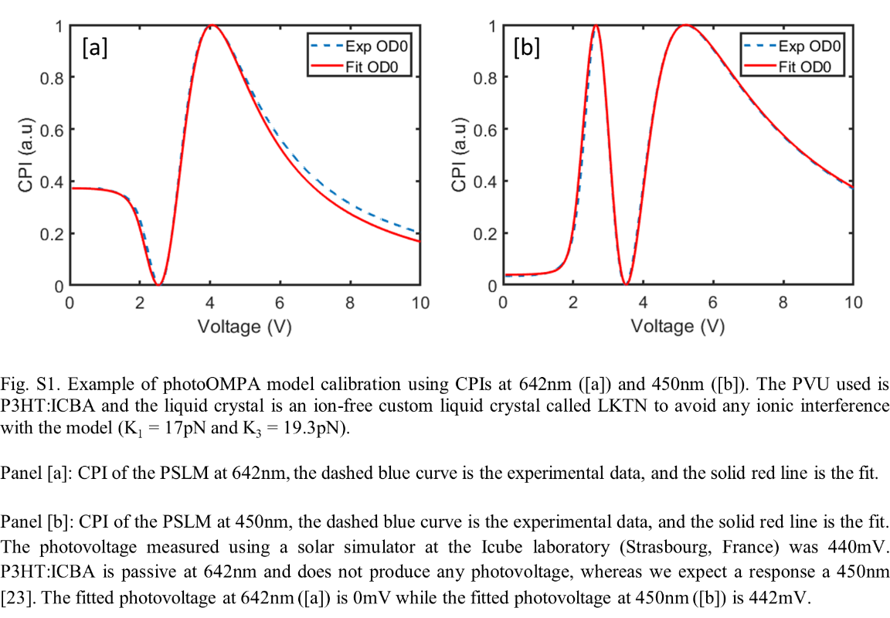
Fig. S1. Example of photoOMPA model calibration using CPIs at 642nm ([a]) and 450nm ([b]). The PVU used is P3HT:ICBA and the liquid crystal is an ion-free custom liquid crystal called LKTN to avoid any ionic interference with the model (K₁ = 17pN and K₃ = 19.3pN).

Panel [a]: CPI of the PSLM at 642nm, the dashed blue curve is the experimental data, and the solid red line is the fit.
Panel [b]: CPI of the PSLM at 450nm, the dashed blue curve is the experimental data, and the solid red line is the fit. The photovoltage measured using a solar simulator at the Icube laboratory (Strasbourg, France) was 440mV. P3HT:ICBA is passive at 642nm and does not produce any photovoltage, whereas we expect a response a 450nm [23]. The fitted photovoltage at 642nm ([a]) is 0mV while the fitted photovoltage at 450nm ([b]) is 442mV.

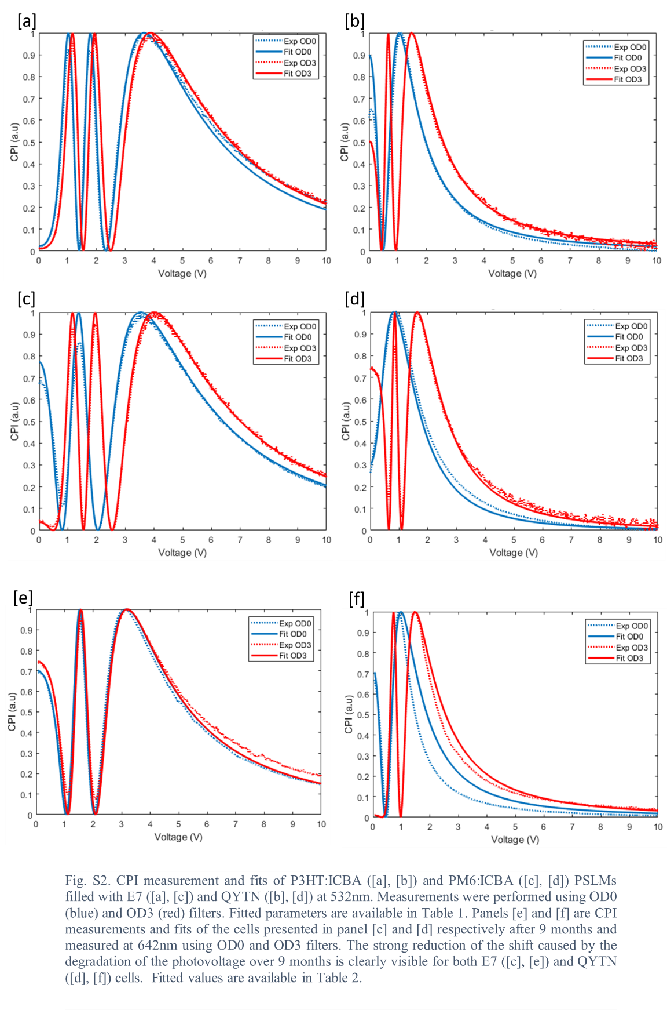
Fig. S2. CPI measurement and fits of P3HT:ICBA ([a], [b]) and PM6:ICBA ([c], [d]) PSLMs filled with E7 ([a], [c]) and QYTN ([b], [d]) at 532nm. Measurements were performed using OD0 (blue) and OD3 (red) filters. Fitted parameters are available in Table 1. Panels [e] and [f] are CPI measurements and fits of the cells presented in panel [c] and [d] respectively after 9 months and measured at 642nm using OD0 and OD3 filters. The strong reduction of the shift caused by the degradation of the photovoltage over 9 months is clearly visible for both E7 ([c], [e]) and QYTN ([d], [f]) cells. Fitted values are available in Table 2.

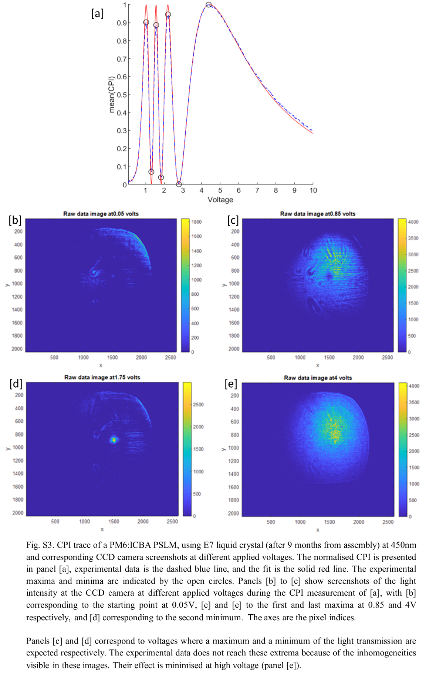
Fig. S3. CPI trace of a PM6:ICBA PSLM, using E7 liquid crystal (after 9 months from assembly) at 450nm and corresponding CCD camera screenshots at different applied voltages. The normalised CPI is presented in panel [a], experimental data is the dashed blue line, and the fit is the solid red line. The experimental maxima and minima are indicated by the open circles. Panels [b] to [e] show screenshots of the light intensity at the CCD camera at different applied voltages during the CPI measurement of [a], with [b] corresponding to the starting point at 0.05V, [c] and [e] to the first and last maxima at 0.85 and 4V respectively, and [d] corresponding to the second minimum. The axes are the pixel indices.
Panels [c] and [d] correspond to voltages where a maximum and a minimum of the light transmission are expected respectively. The experimental data does not reach these extrema because of the inhomogeneities visible in these images. Their effect is minimised at high voltage (panel [e]).

