Successful Dose Reduction of Dupilumab in Atopic Dermatitis

Running title: Dupilumab dosing

Words: 747

Figures: 1

Michael R. Ardern-Jones^{1,2}, Emily E. Buchanan², Samba Njungu^{1,} Daniel O’Driscoll ¹
¹Department of Dermatology, University Hospital Southampton NHS Foundation Trust, Southampton, Hampshire SO16 1DU, U.K.
²Clinical Experimental Sciences, Faculty of Medicine, University of Southampton, Southampton, Hampshire SO16 1DU, UK.

Corresponding author:
Michael R. Ardern-Jones
m.aj@soton.ac.uk

Funding sources: none

Declarations of Interests:
MAJ has been a consultant/speaker/PI for Almirall, AbbVie, Amgen, Galderma, Janssen, Leo, Lilly, Pfizer, Sanofi Genzyme, Ducentis, Heptares, and Unilever.
EEB: None
SN: None
DOD has been a consultant/speaker/PI for Pfizer, AbbVie

Successful Dose Reduction of Dupilumab in Atopic Dermatitis

Dear Editor,

Dupilumab, an interleukin (IL)-4 and IL-13 signalling inhibitor (1), has shown impressive success in treatment of atopic dermatitis (AD) (2). Following a health economic analysis, National Institute for Health and Care Excellence (NICE) recommended dupilumab 300mg alternate weekly for the treatment of moderate-to-severe AD after failure, intolerance or contraindication of one classical immunosuppressive systemic therapy and demanded that treatment continuation was justified only in those achieving an Eczema Area and Severity Index score (EASI 50) and a 4‑point reduction in the Dermatology Life Quality Index (DLQI) (1). The health economic analysis of the treatment is closely dependent upon the dosing, which affects the cost of therapy. Therefore, dose reduction would increase the cost effectiveness of this therapy and be cost saving in the NHS or potentially lessen the threshold for managing access to treatment.

Current working UK (3), USA (4), and European (5) AD guidelines do not address dupilumab dose reduction, when AD has become well-controlled. Locally, our approach for management of AD with dupilumab has been to aim for 12 months of good disease control, as indicated by disease clear or nearly clear (modified Investigators global assessment, IGA, equal to 0 or 1). In those who achieved this measure, with a patient-physician shared decision making approach, we offered a trial of dose reduction. Here, we retrospectively audit our cohort of patients on dupilumab at the reduced dose.

Following approval by the local review board, electronic records were analysed from adults treated with dupilumab for atopic dermatitis in 2020 and 2021. Pre-dupilumab treatment measurements of disease severity were termed ‘baseline’, and the last measurement of disease severity on standard dose termed ‘standard’. Cases with missing disease severity data were excluded. A two-tailed paired t-test was used to calculate the difference between baseline, pre-treatment and standard dose EASI, and Fisher exact test to compare IGA outcomes (clear or almost clear versus not).

All AD patients prescribed dupilumab at lower dose were included in the cohort (n=17; mean age 41.5 years; females 11.67%). All included cases were initially prescribed standard dose treatment with dupilumab (300mg alternate weekly) and had shown a significant improvement in EASI (mean EASI -16.05, P=0.0039 [-25.47, -6.62]). 100% had achieved the NICE recommended target EASI 50, whereas only 70% achieved EASI 75 and 50% achieved the most stringent EASI 90 target.

Dose reduction was undertaken by changing standard doses to 300mg three or four weekly as per patient centred discussion. In one case the dose was reduced to 200mg alternate weekly. After dose reduction disease severity was assessed at approximately 12 months (mean 12.4 months). 100% of dose reduced AD patients maintained EASI 50 and the proportion of patients achieving EASI 75 and EASI 90 increased to 86% and 57% respectively (Fig. 1a). Mean IGA in the dose reduction cohort was higher (1.42) than standard dose (1.00) but this was not statistically significant (p =0.21, Fig 1b). Comparing baseline and reduced dose EASI scores demonstrated that disease control was maintained with reduced dosing (mean EASI -20.10, P=0.0018 [-29.30, -10.90]).

Limitations of this study include its small sample size and missing data caused by COVID-19. However, these results represent early data supporting the concept of dupilumab dose reduction in well controlled AD. In a recent study of dupilumab serum drug levels 83-87% of cases maintained stable disease control (as determined by EASI) despite dose reduction (6). In our study of a UK cohort, more patients on lowered doses achieved EASI 75 and EASI 90 than those at standard dose. Whilst there is some previous observational data to support the use of low dose dupilumab from baseline, this approach seems to have a lower overall efficacy (7). This is most likely because the strong responders were not selected out for dose reduction as per our approach which offered dose reduction only after initial treatment with the licensed dose.

These results suggest that the effective dose of dupilumab reduces as disease becomes controlled and that further improvement in disease control can occur with prolonged treatment even at lowered doses as has been reported for standard treatment (8). As well as reduced frequency of dupilumab 300mg, dose reduction can be achieved with pre-filled injections of 200mg s/c but are equivalent cost in the UK. Ultimately, these results support the need for a randomised clinical trial to examine the safety and effectiveness of reduced frequency dosing in well controlled AD patients with the potential to saving at least of 33% of costs for dupilumab prescribing in selected patients.

References
1 National Institute for Health and Care Excellence. Available at: https://bnf.nice.org.uk/drug/dupilumab.html (last accessed 26 July 2022).
2 Wang FT Z et al. Dupilumab treatment in moderate-to-severe atopic dermatitis: A systematic review and meta-analysis. J Dermatol Sci. 2018 May; 90(2):190-198
3 Lewis-Jones S, Mugglestone MA; Guideline Development Group. Management of atopic eczema in children aged up to 12 years: summary of NICE guidance. BMJ 2007; 335(7632):1263-4.
4 Sidbury R et al. Guidelines of care for the management of atopic dermatitis. Journal of the American Academy of Dermatology 2014; 71(2):327-349.
5 Wollenberg A et al. ETFAD/EADV Eczema task force 2020 position paper on diagnosis and treatment of atopic dermatitis in adults and children. Journal of the European Academy of Dermatology and Venereology 2020; 34(12):2717-2744.
6 Spekhorst L S et al. Patient-centred dupilumab dosing regimen leads to successful dose reduction in persistently controlled atopic dermatitis. Allergy 2022; doi: 10.1111/all.15439. PMID: 35837880.
7 Lee Y et al. Real Clinical Practice Data of Monthly Dupilumab Therapy in Adult Patients With Moderate-to-Severe Atopic Dermatitis: Clinical Efficacy and Predictive Markers for a Favorable Clinical Response. Allergy Asthma Immunol Res. 2021 Sep; 13(5): 733–745.
8 Armstrong A et al. Continued Treatment with Dupilumab is Associated with Improved Efficacy in Adults with Moderate-to-Severe Atopic Dermatitis Not Achieving Optimal Responses with Short-Term Treatment. Dermatology and therapy 2021; 12(1):195-202.

Legends
Fig 1.
- EASI scores for 13 patients where Dupilumab dose was lowered, including their pre-treatment (baseline), standard dose and lowered dose scores.
Paired two-tailed t test ** p<0.005
- IGA scores for 15 patients where Dupilumab dose was lowered, including their pre-treatment (baseline), standard dose and lowered dose scores.
Fisher’s exact test: ** p <0.005, ****p < 0.0001

Figure 1a.
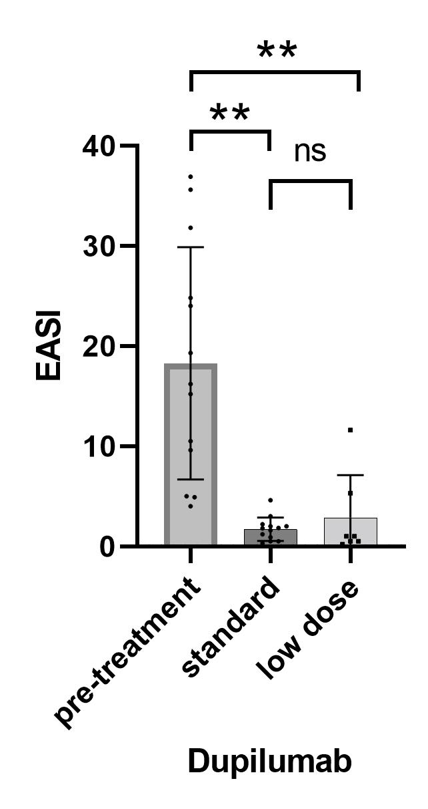

Figure 1b.
