Subject category and title
Adaptive river basin planning: Negotiating Nile infrastructure management should consider climate change uncertainties

Author list
Mohammed Basheer ^{1, *}, Victor Nechifor ^{2,3}, Alvaro Calzadilla ², Solomon Gebrechorkos ⁴, David Pritchard ⁵, Nathan Forsythe ⁵, Jose M. Gonzalez ¹, Justin Sheffield ⁴, Hayley J. Fowler ^{5,6}, Julien J. Harou ^{1,7}
¹ Department of Mechanical, Aerospace and Civil Engineering, The University of Manchester, Manchester, UK.
² Institute for Sustainable Resources, University College London, London, UK.
³ Joint Research Centre, European Commission, Seville, Spain.
⁴ School of Geography and Environmental Science, University of Southampton, Southampton, UK.
⁵ School of Engineering, Newcastle University, Newcastle upon Tyne, UK.
⁶ Tyndall Centre for Climate Change Research, Newcastle University, Newcastle upon Tyne, UK.
⁷ Department of Civil, Environmental and Geomatic Engineering, University College London, London, UK.

*Correspondence to: mohammed.basheer@manchester.ac.uk

Standfirst
We find high uncertainty in the projected socio-economic and environmental impacts of climate change on the Nile’s economies and water-dependent sectors. Managing the Grand Ethiopian Renaissance Dam (GERD) cooperatively and adaptively while adopting a multisector, multi-country approach, considering climate uncertainties, can produce biophysical and economy-wide benefits for Ethiopia, Sudan, and Egypt.

The policy problem
Planning management strategies for large dams requires adopting a multi-dimensional approach to foster synergies, identify the lowest tradeoffs, and optimize economic efficiency. Dam negotiations between the Nile riparian countries have traditionally used biophysical metrics only, such as irrigation water supplies and hydropower generation, even though governments often build dams to achieve wider economic goals. The implications of climate change uncertainty for the Nile hydrology (e.g., streamflow and irrigation demands) and the economies of its riparian countries (e.g., economic development pathways, population growth, and climate policies) can render many non-adaptive dam management plans inefficient. The construction of the GERD on the Nile triggered political tensions between Ethiopia, Sudan, and Egypt, with negotiations between the countries yet to reach an agreement. While negotiations over the GERD have been ongoing since 2011, economy-wide metrics alongside climate change uncertainties have not been considered in developing and evaluating dam operation proposals for the Nile.

The findings
Based on 29 climate projections, we find that both the sign and magnitude of potential changes in naturalized streamflow of the Nile in 2021-2050 are highly uncertain. These uncertainties necessitate an adaptive and cooperative approach. We show that cooperative adaptive management of the GERD can yield compromise solutions with economy-wide benefits to Ethiopia, Sudan, and Egypt compared to a proposal discussed in Washington D.C. in 2020 (Fig. 1). Under an example compromise solution (Fig. 1), the mean (based on 29 projections) discounted (at 3%) real GDP increases by 0.77, 0.67, and 0.18 billion USD in 2020-2045 for Ethiopia, Sudan, and Egypt, respectively, relative to the Washington Draft Proposal. These benefits are more pronounced under extreme climate scenarios, with rises in discounted real GDP of up to 15.8, 6.3, and 3.0 billion USD over 2020-2045 for Ethiopia, Sudan, and Egypt, respectively. Our results should be complemented by evaluating the impacts on ecology, groundwater, and riparian populations.
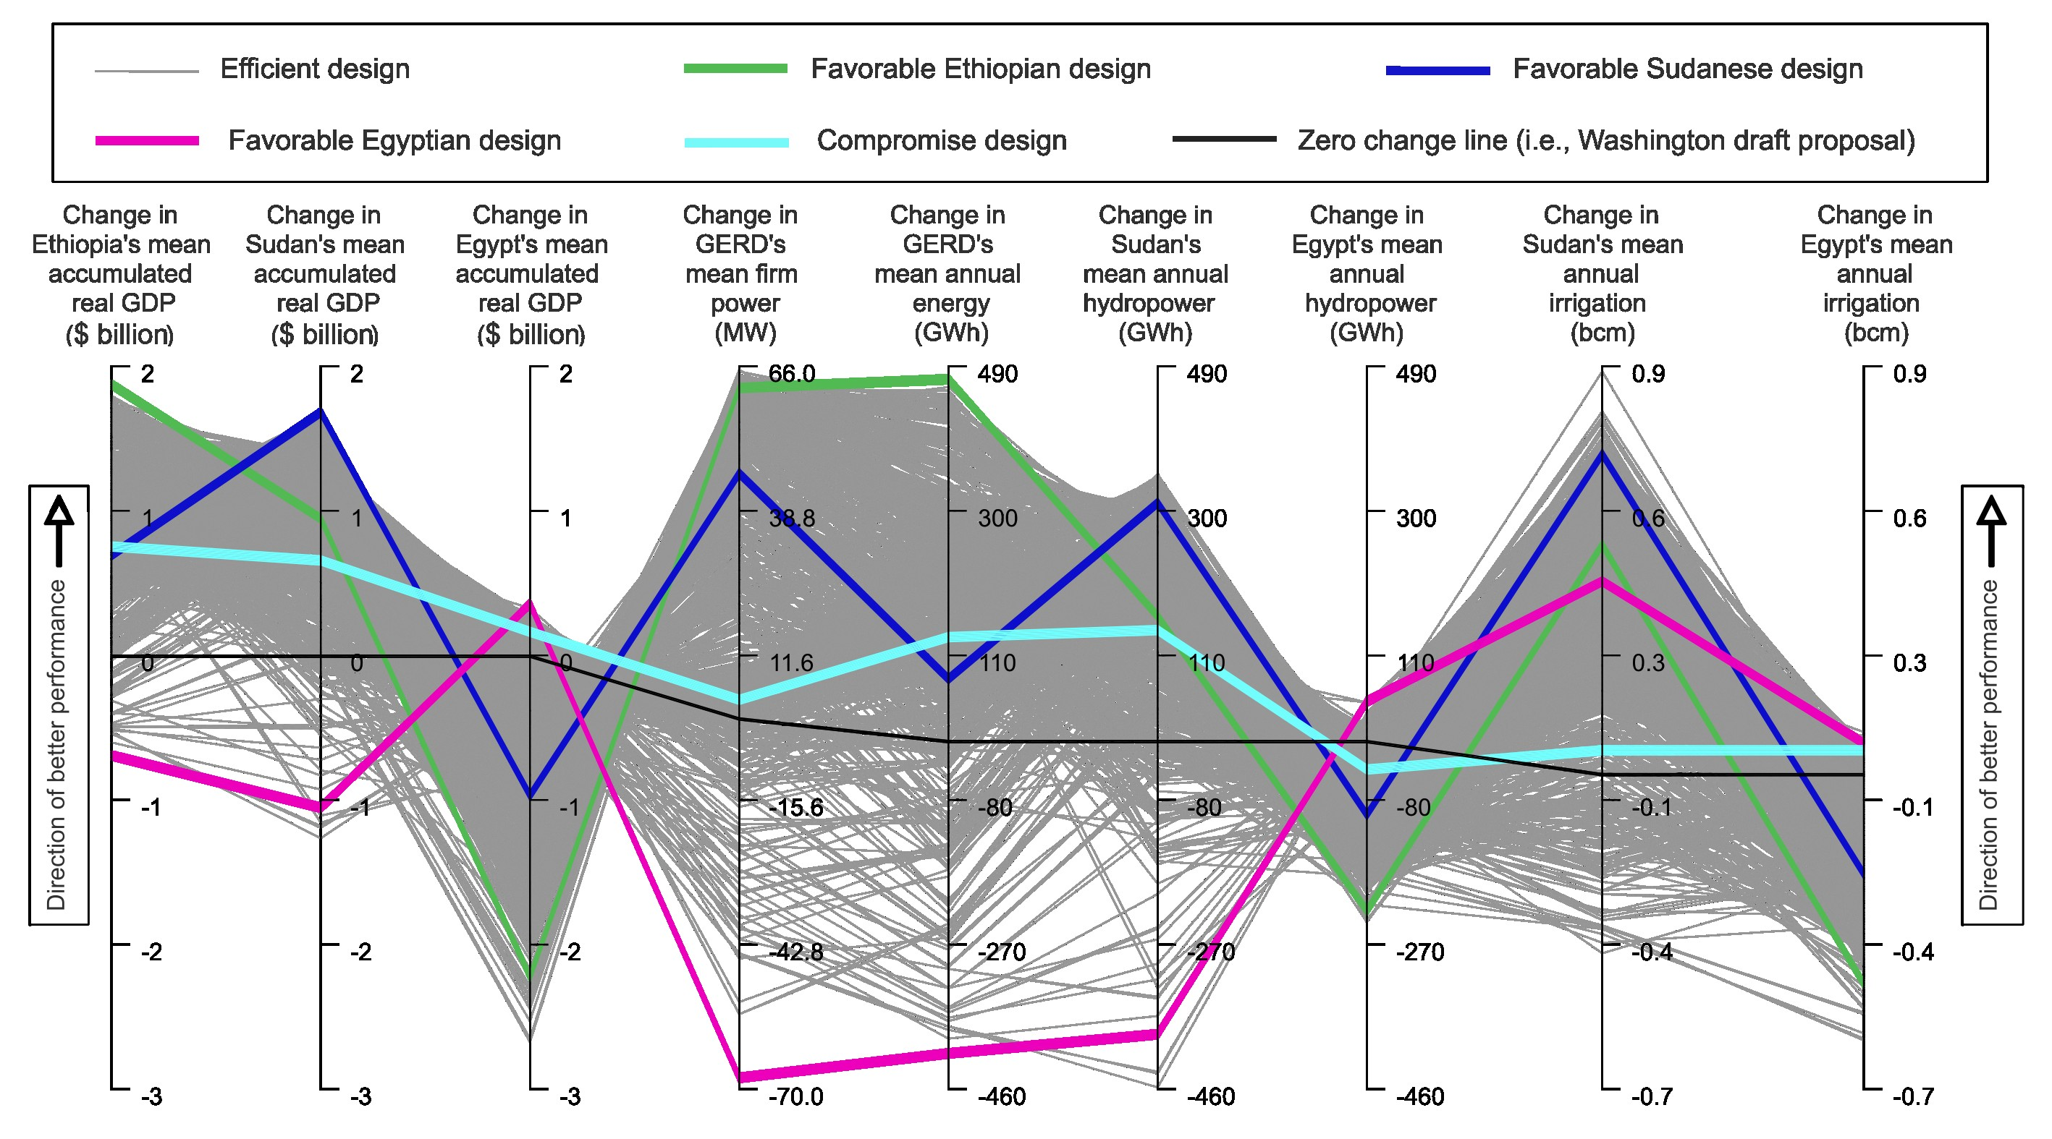
Fig. 1 Parallel coordinates plot of the Ethiopian, Sudanese, and Egyptian economy-wide and river system performance under efficient designs of an adaptive GERD management policy across 29 climate change projections for 2020-2045. All change values are calculated from a baseline in which the GERD is operated based on the Washington draft proposal. The upward direction on each axis is desirable (i.e., a ‘perfect adaptive plan’ would be a straight line across the top), and diagonal lines between neighboring axes indicate tradeoffs, whereas horizontal ones show synergies. The firm power values are calculated based on a 90% reliability, and the GDP values are discounted at a 3% rate.

The study
We developed a planning framework for Nile infrastructure management considering the socio-economic and hydrological uncertainties of climate change. The framework integrates hydrological, economy-wide, and river system simulators driven by climate and socio-economic data from the Coupled Model Intercomparison Project (CMIP) 6. This framework enables the estimation of multiple economy-wide and engineering performance metrics under various infrastructure management plans and climate change projections. The simulators were calibrated and validated, and the climate change data were bias-corrected and downscaled before being used. The climate scenario ensemble includes members synthesized to address the wetting tendency of climate models known as the “East Africa climate paradox.” The most efficient cooperative and adaptive operational management plans for the GERD were identified by linking the integrated simulators with an artificial intelligence search algorithm over thousands of iterations. We then compared the performance under the identified efficient, optimized plans with that of the Washington Draft Proposal.

Messages for Policy
- There are deep uncertainties around the impacts of climate change on the Nile streamflow, reservoir evaporation rates, crop evapotranspiration, and socio-economic development.
- Adaptive management plans for Nile infrastructure are vital for coping with climate change uncertainty; such plans involve short-term actions and adaptation mechanisms as climate change unfolds.
- Cooperative adaptive management of the Grand Ethiopian Renaissance Dam provides economy-wide and biophysical benefits to Ethiopia, Sudan, and Egypt compared to the Washington Draft Proposal.
- Adaptive management plans of the Grand Ethiopian Renaissance Dam that focus on maximizing the economy-wide gains of one country result in losses for at least one of the other two countries.

Source research
Basheer, M., Nechifor, V., Calzadilla, A., Gebrechorkos, S., Pritchard, D., Forsythe, N., Gonzalez, J.M., Sheffield, J., Fowler, H.J., Harou, J.J., 2022. Cooperative adaptive management of the Nile River with climate and social uncertainties. Nature Climate Change.

Further Reading
Basheer, M., Nechifor, V., Calzadilla, A., Siddig, K., Etichia, M., Whittington, D., Hulme, D., Harou, J.J., 2021. Collaborative management of the Grand Ethiopian Renaissance Dam increases economic benefits and resilience. Nature Communications 12, 5622. https://doi.org/10.1038/s41467-021-25877-w
This study describes the integrated economy-wide and river system simulation used to model the interlinkages between the Nile river system and the economies of Ethiopia, Sudan, and Egypt.

Basheer, M., Nechifor, V., Calzadilla, A., Ringler, C., Hulme, D., Harou, J.J., 2022. Balancing national economic policy outcomes for sustainable development. Nature Communications 13, 5041. https://doi.org/10.1038/s41467-022-32415-9
This article connects economy-wide simulation with artificial intelligence search and machine learning. This shows that the multiobjective design approach used in the present study is general; it can be used in a wide range of contexts to find efficient policies and the trade-offs and synergies they imply.

O’Neill, B.C., Tebaldi, C., Van Vuuren, D.P., Eyring, V., Friedlingstein, P., Hurtt, G., Knutti, R., Kriegler, E., Lamarque, J.F., Lowe, J., Meehl, G.A., Moss, R., Riahi, K., Sanderson, B.M., 2016. The Scenario Model Intercomparison Project (ScenarioMIP) for CMIP6. Geoscientific Model Development 9, 3461–3482. https://doi.org/10.5194/gmd-9-3461-2016
This paper describes the climate change scenarios of the Coupled Model Intercomparison Project (CMIP) 6, from which some scenarios have been bias-corrected, downscaled, and then used in simulating the impacts of climate change on the Nile Basin and its riparian economies. More scenarios were synthesized to address the “East Africa climate paradox.”

Marchau, V.A.W.J., Walker, W.E., Bloemen, P.J.T.M., Popper, S.W., 2019. Decision making under deep uncertainty: from theory to practice. Springer Nature. https://doi.org/10.1007/978-3-030-05252-2
This book provides a review of methods for decision-making under deep uncertainty (such as climate change), which motivated the adaptive management formulation used for the GERD in our study.

Edrees, M., 2020. Letter from the permanent representative of Egypt to the United Nations addressed to the President of the Security Council. https://digitallibrary.un.org/record/3931750?ln=en
This document is a letter from the permanent representative of Egypt to the United Nations to the President of the United Nations Security Council in which the Washington Draft Proposal for filling and operating the GERD is annexed.

Acknowledgments
M.B.'s doctoral degree is funded by the Faculty of Science and Engineering of the University of Manchester. This work was supported by the UK Research and Innovation Economic and Social Research Council [ES/P011373/1] as part of the Global Challenges Research Fund through the "Future Design and Assessment of water-energy-food-environment Mega Systems" (FutureDAMS) research project, in which J.J.H. served as research director. The authors thank GAMS Software GmbH for providing optimization solver licenses compatible with deploying the economy-wide simulation on supercomputers. The authors acknowledge the use of the Computational Shared Facility (CSF) and High-Performance Computing (HPC) of the University of Manchester. The views expressed in this paper are the responsibility of the authors and do not necessarily reflect those of their institutions.

Competing interests
The authors declare no competing interests.

